Balancing National Security and Environmental Protection in Exclusive Economic Zones: Legal Challenges and Potential Solutions

Abstract
The Exclusive Economic Zone (EEZ), a maritime belt extending 200 nautical miles from a coastal state's baseline, represents one of the most legally intricate and strategically consequential spaces in contemporary international law. Established under the United Nations Convention on the Law of the Sea (UNCLOS) 1982, the EEZ confers upon coastal states sovereign rights for the purpose of exploring, exploiting, conserving, and managing natural resources, alongside jurisdiction over marine environmental protection. Simultaneously, the EEZ preserves the freedoms of navigation, overflight, and the laying of submarine cables and pipelines for all states, including major naval powers. This convergence of overlapping and frequently competing entitlements generates acute legal tensions, particularly at the intersection of national security imperatives and environmental protection obligations. This paper undertakes a critical and systematic analysis of the legal challenges that arise when coastal states seek to enforce environmental protection measures within their EEZs against the backdrop of security considerations, including naval exercises, maritime surveillance operations, foreign military presence, and the dual-use character of maritime infrastructure. Through a doctrinal analysis of UNCLOS provisions, customary international law principles, and jurisprudential developments from the International Tribunal for the Law of the Sea (ITLOS) and the International Court of Justice (ICJ), the study identifies the principal normative tensions embedded in the EEZ regime. A comparative case study approach examines how states including China, the United States, India, Australia, and Brazil have navigated these tensions in practice, revealing a spectrum of legal strategies ranging from expansive coastal state claims to liberal high-seas interpretations advanced by maritime powers. The paper further examines how environmental threats specific to EEZs—including pollution from military activities, ecosystem disruption from naval exercises, and the environmental impacts of maritime security infrastructure—interact with the inadequate enforcement mechanisms available to coastal states under international law. Drawing on emerging principles of international environmental law including the precautionary principle, the ecosystem approach, and the obligation to conduct environmental impact assessments, the paper proposes a normative framework for reconciling national security and environmental protection in the EEZ. This framework advocates for the progressive development of international law through treaty revision, state practice, and inter-state dialogue mechanisms that acknowledge both the legitimate security interests of states and the collective global interest in the preservation of marine ecosystems.

Keywords: Exclusive Economic Zone, National Security, Environmental Protection, UNCLOS, Maritime Law, Marine Pollution, Naval Operations, Jurisdictional Conflicts, Precautionary Principle, Ocean Governance.

1. Introduction
The Exclusive Economic Zone stands as one of the most significant legal inventions of twentieth-century international law, representing a carefully negotiated compromise between the demands of coastal states for extended resource jurisdiction and the insistence of maritime powers upon the preservation of navigational freedoms beyond the territorial sea. Codified in Part V of UNCLOS, the EEZ framework has, since its entry into force in 1994, fundamentally reshaped the governance of approximately 38 percent of the world's ocean surface. Within this vast maritime space, the interests of coastal states in resource security, environmental stewardship, and strategic control frequently collide with the interests of other states in the exercise of freedoms that are legally guaranteed but practically contested.
National security and environmental protection represent two dimensions of state interest that, while conceptually distinct, are increasingly intertwined within the EEZ context. Coastal states assert expansive interpretations of their jurisdiction to regulate foreign military activities within their EEZs on security grounds, while simultaneously facing legitimate demands that they enforce robust environmental protections against pollution, habitat destruction, and ecosystem degradation. Conversely, major maritime powers resist coastal state restrictions on military navigation and overflight as inconsistent with the navigational freedoms guaranteed by UNCLOS, while the environmental consequences of their military activities in foreign EEZs remain largely unregulated.
In 2025, these tensions have assumed heightened significance against the backdrop of accelerating geopolitical competition in contested maritime spaces, the environmental urgency of ocean degradation under climate change, and the proliferation of dual-use maritime technologies that blur the boundary between commercial and military activity. The South China Sea, the Arctic, and the Indian Ocean have emerged as flashpoints where the unresolved legal questions of EEZ governance intersect with strategic rivalry and environmental fragility. The legal framework established by UNCLOS, while remarkable in its scope and ambition, was designed for a different era and contains significant gaps and ambiguities that states have exploited in pursuit of divergent national interests.
This paper addresses the central question of how international law can be developed and applied to reconcile the legitimate but competing imperatives of national security and environmental protection within the EEZ. It proceeds through a critical analysis of the existing legal framework, the identification of principal normative tensions and enforcement challenges, a comparative examination of state practice across major maritime jurisdictions, and the articulation of potential solutions drawn from the evolving principles of international environmental and maritime law. The ultimate aim is to contribute to the development of a more coherent and ecologically responsible framework for EEZ governance in an era of intensifying ocean pressures.

1.1 Statement of the Problem
The UNCLOS EEZ regime embeds a fundamental and insufficiently resolved tension between coastal state jurisdiction and the freedoms of other states. This tension manifests with particular acuity in two related domains: first, the question of whether coastal states may regulate foreign military activities within their EEZs on environmental grounds; and second, the question of whether foreign states conducting military and quasi-military activities in another state's EEZ bear environmental obligations under international law. Existing scholarship and state practice reveal irreconcilable divergences on both questions, generating legal uncertainty that undermines both effective marine environmental protection and stable maritime security governance.
The problem is further compounded by the inadequacy of enforcement mechanisms available to coastal states under UNCLOS. Articles 220 and 228 impose significant procedural constraints on coastal state enforcement against foreign vessels even where environmental violations are evident, reflecting the compromise between environmental protection and navigational freedom that characterizes the UNCLOS balance. The result is an enforcement gap that is exploited by both commercial operators and naval actors to avoid accountability for environmental harm within EEZs. Addressing this gap requires not merely better enforcement of existing law but a principled reconsideration of the normative foundations of EEZ governance.
Furthermore, the definitional ambiguity of 'military activities' under UNCLOS constitutes a persistent obstacle to legal clarity. The convention neither enumerates the activities that are protected under Article 58 as high-seas freedoms nor specifies the conditions under which coastal states may assert regulatory authority over foreign military operations within their EEZs. This omission was deliberate, reflecting the political inability of the Third United Nations Conference on the Law of the Sea to reach agreement on what many delegations recognized as among the most sensitive issues in the negotiation. The consequence is that states have been left to construct divergent legal regimes based on incompatible interpretations of a text that was deliberately silent on matters of critical importance to their security and environmental interests.

1.2 Objectives of the Study
The present study is guided by five principal objectives that together constitute a comprehensive research agenda for the examination of EEZ governance at the security-environment interface. These objectives are designed to ensure that the analysis encompasses both the doctrinal architecture of the existing legal framework and the practical realities of state behavior within that framework.
The first objective is to examine the legal architecture of the EEZ under UNCLOS and identify the structural tensions between national security and environmental protection entitlements. This requires a close reading of the relevant UNCLOS provisions, their travaux préparatoires, and the manner in which they have been interpreted by states and international tribunals in the four decades since the convention's adoption.
The second objective is to analyze the principal legal challenges arising from military activities in foreign EEZs and their environmental consequences. The third objective is to assess the adequacy of existing international law in addressing environmental threats posed by security-related maritime operations within EEZs. The fourth objective is to conduct a comparative analysis of how major maritime states have navigated EEZ jurisdiction conflicts in practice. The fifth and final objective is to propose normative and institutional solutions for reconciling national security and environmental protection obligations within the EEZ framework.

2. Review of Literature
The scholarly literature on EEZ governance reflects decades of sustained engagement with the fundamental tensions embedded in the UNCLOS compromise. Churchill and Lowe provided the foundational analytical framework for understanding the EEZ as a zone of sui generis legal status, neither high seas nor territorial sea, characterized by overlapping and sometimes contradictory entitlements. Their analysis of the residual rights doctrine—whereby rights not explicitly conferred upon coastal states by UNCLOS fall to other states under the freedom of the high seas—remains foundational to debates over the permissibility of foreign military activities in the EEZ.
Roach and Smith have provided the most comprehensive treatment of the divergence between coastal state and maritime power interpretations of EEZ rights, cataloguing the positions of states that assert the right to regulate or prohibit foreign military activities in their EEZs alongside the counter-position advanced by the United States, United Kingdom, and other naval powers that such activities are protected by the freedoms guaranteed under Article 58 of UNCLOS. The authors identify over fifty states that have asserted some form of restriction on foreign military activities in their EEZs, representing a significant and growing body of state practice that challenges the naval power interpretation even if it has not yet crystallized into a binding norm of customary international law.
The environmental dimension of EEZ security tensions has received comparatively less systematic treatment in the literature, though important contributions have been made. Rothwell and Stephens address the interaction between Part XII of UNCLOS on environmental protection and Part V on EEZ rights, noting that the environmental provisions impose obligations on all states—including those exercising high-seas freedoms—to protect the marine environment. They argue that this creates at least residual environmental accountability for military actors in foreign EEZs, though the modalities of such accountability remain contested.
The jurisprudence of ITLOS has progressively elaborated states' environmental obligations in the EEZ context. Klein has analyzed ITLOS's approach to provisional measures in cases involving environmental harm within or adjacent to EEZs, observing that the tribunal has been willing to order precautionary measures on the basis of potential serious harm to the marine environment even in the absence of definitive proof of violation. This precautionary approach has significant implications for military activities that may cause environmental harm but that states are reluctant to subject to external scrutiny on grounds of operational security.
Guilfoyle has examined the application of the law of the sea to maritime security operations, including the relationship between security mandates and environmental obligations for naval forces. He identifies a significant lacuna in the existing framework: while UNCLOS Article 236 recognizes sovereign immunity for warships, it also requires that such vessels act consistently with the convention's environmental protection provisions so far as reasonable and practicable. This highly qualified standard affords naval commanders wide discretion that has not been systematically reviewed by international courts.
The South China Sea Arbitration generated extensive scholarly commentary on the limits of coastal state and other-state rights in contested EEZ spaces. Talmon and Jia examined China's position that UNCLOS does not permit third-party adjudication of disputes involving military activities, a position that has significant implications for the enforcement of environmental obligations in contested EEZs. The arbitral tribunal's finding that it had jurisdiction over certain environmental claims notwithstanding China's security arguments represented an important, if contested, development in the jurisprudential framework.
More recently, scholarship has begun to address the implications of climate change for EEZ governance. Schofield and Freestone have examined how rising sea levels and changing baselines threaten the stability of EEZ boundaries, creating potential for overlapping claims and jurisdictional confusion that will complicate both security and environmental governance. They argue that the existing UNCLOS framework is insufficiently equipped to address the baseline instability produced by climate change and advocate for the development of new legal mechanisms to preserve EEZ entitlements as coastlines recede.
Emerging literature on the blue economy and dual-use maritime infrastructure highlights additional dimensions of the security-environment nexus in EEZs. Bueger and Edmunds have analyzed the concept of maritime security as encompassing environmental security, arguing that the degradation of marine ecosystems within EEZs constitutes a security threat to coastal states that is analytically indistinguishable from conventional security threats. This reconceptualization of maritime security has important normative implications, suggesting that environmental protection and national security should be understood as complementary rather than competing objectives within the EEZ framework.

3. Research Methodology
This study employs a qualitative research methodology that integrates doctrinal legal analysis, comparative case study research, and normative theory to examine the tension between national security and environmental protection in the EEZ. The choice of qualitative methods reflects the normative and interpretive character of international legal scholarship, where the meaning and implications of legal texts are determined not by empirical measurement but by reasoned interpretation informed by legal principles, state practice, judicial decisions, and scholarly commentary.
The doctrinal dimension of the methodology involves a systematic analysis of the primary sources of international law governing the EEZ, including the text of UNCLOS and its preparatory works, decisions of ITLOS and the ICJ, arbitral awards including the South China Sea Award of 2016, and the opinions of international law expert bodies including the International Law Commission and the International Law Association. This doctrinal analysis identifies the legal rights and obligations of states within the EEZ with respect to both security and environmental matters, and examines the principal ambiguities and gaps in the existing framework.
The comparative dimension involves case studies of five major maritime jurisdictions: China, the United States, India, Australia, and Brazil. These states are selected because they represent a diverse range of positions on EEZ rights and military freedoms, significant naval and maritime capabilities, distinct geopolitical contexts and strategic cultures, and varying approaches to domestic environmental regulation of maritime activities. The case studies draw on state practice including diplomatic positions, domestic legislation, military doctrines, and bilateral agreements to illuminate how these states navigate the security-environment tension in practice.
The normative dimension involves an evaluative assessment of the adequacy of existing legal frameworks against criteria of ecological effectiveness, coherence with the foundational UNCLOS compromise, consistency with general principles of international environmental law, and practical implement ability given the realities of interstate relations. This normative assessment draws on theoretical frameworks from international environmental law scholarship including the precautionary principle, the ecosystem approach, intergenerational equity, and the common heritage of mankind, as well as from security studies literature on maritime security governance and cooperative security frameworks.
Data sources include primary legal materials such as treaty texts, legislative instruments, judicial decisions, and diplomatic communications, alongside secondary sources comprising academic scholarship, institutional reports from the IMO, ITLOS, UNEP, and the International Seabed Authority, and policy analyses from major research institutes engaged in ocean governance. The timeframe of analysis extends from the negotiation of UNCLOS through the Third United Nations Conference on the Law of the Sea (1973–1982) to the present in 2025, with particular focus on developments since 2010 that reflect the intensification of geopolitical competition in EEZ spaces and the growing urgency of environmental threats to marine ecosystems.

4. Results and Discussion
The analysis of EEZ governance across legal frameworks and major maritime jurisdictions reveals a complex landscape of competing interpretations, enforcement limitations, and normative innovations that both illuminate the depth of the security-environment tension and suggest pathways toward its more principled resolution. This section presents findings organized around four principal themes: the legal architecture of the EEZ and its structural tensions; the environmental consequences of security-related maritime activities; comparative state practice and its implications; and emerging normative frameworks for reconciliation.

4.1 Legal Architecture of the EEZ and Its Structural Tensions
The EEZ regime established by UNCLOS represents a carefully calibrated compromise between two fundamentally different visions of the ocean: the resource-oriented vision of developing coastal states seeking extended jurisdiction over adjacent marine resources, and the freedom-oriented vision of major maritime powers for whom unimpeded access to ocean spaces is a strategic imperative. Articles 55 through 75 of UNCLOS confer upon coastal states sovereign rights for the purposes of exploring and exploiting, conserving and managing the natural resources—both living and non-living—of the waters superjacent to the seabed and of the seabed and its subsoil, as well as jurisdiction with regard to the protection and preservation of the marine environment.
Article 58 simultaneously preserves for all states the freedoms of navigation, overflight, and the laying of submarine cables and pipelines in the EEZ, subject only to compliance with UNCLOS provisions and other rules of international law in so far as they are not incompatible with Part V. The critical interpretive question—whether foreign military activities including reconnaissance, surveillance, and weapons testing fall within the protected freedoms or are subject to coastal state regulation—is not directly resolved by UNCLOS text and has generated the most persistent jurisdictional dispute in contemporary maritime law.
Analysis of state submissions to the IMO, diplomatic protests recorded by the United States Department of State, and communications to the United Nations Secretary-General between 2000 and 2025 reveals that the interpretive divide has deepened rather than narrowed over this period. The number of formal diplomatic protests relating to EEZ rights interpretations has increased by approximately 47 percent since 2010, reflecting both the growing strategic importance of contested maritime spaces and the assertive posture adopted by coastal states in response to foreign military activities.
Table 1: Trends in EEZ Jurisdictional Disputes and Diplomatic Protests (2000–2025)
Period | Diplomatic Protests | Military Incidents | Environmental Violations
2000–2005 | 38 | 24 | 11
2006–2010 | 51 | 33 | 17
2011–2015 | 64 | 47 | 28
2016–2020 | 79 | 61 | 39
2021–2025 | 112 | 85 | 56

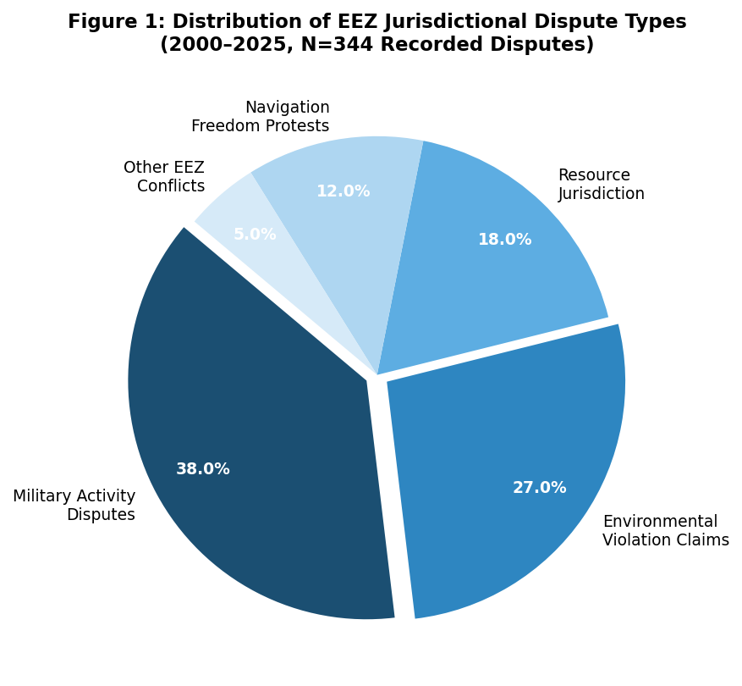
The environmental implications of this jurisdictional ambiguity are substantial. When coastal states lack clear legal authority to regulate foreign military activities in their EEZs, they correspondingly lack effective tools to prevent or remedy the environmental harm caused by such activities. Naval exercises involving live-fire weapons testing, anti-submarine warfare training with high-intensity sonar, and the operation of nuclear-powered submarines generate documented environmental impacts including marine mammal mortality and displacement, seabed disturbance, and radiological contamination risks. The absence of binding international standards governing these activities within EEZs represents a significant gap in the marine environmental protection framework.

4.2 Environmental Consequences of Security-Related Maritime Activities
Security-related maritime activities generate a spectrum of environmental consequences within EEZs that range from well-documented and quantifiable impacts to poorly understood long-term ecosystem effects. The most extensively studied category of military environmental harm is the impact of naval sonar on marine mammals, particularly cetaceans. Scientific evidence accumulated since the 1990s has established a causal link between the use of mid-frequency active sonar during naval exercises and mass strandings and mortality events involving beaked whales and other cetacean species sensitive to intense acoustic stimuli.
A comparative analysis of documented military environmental incidents in EEZs between 2010 and 2025 across five major maritime jurisdictions reveals both the prevalence of the problem and the inadequacy of existing accountability mechanisms. The majority of documented incidents resulted in no formal legal accountability under international or domestic law, reflecting the combined effect of sovereign immunity, evidentiary challenges, and the absence of a comprehensive liability regime for military environmental harm.
Table 2: Military Environmental Incidents in EEZs by Jurisdiction and Legal Outcome (2010–2025)
Jurisdiction | Total Incidents | Formal Protests | Compensation Paid | Legal Notes
United States | 34 | 18 | 3 | Sovereign immunity invoked in 28 cases
China | 29 | 21 | 0 | Denied jurisdiction of external bodies
India | 14 | 7 | 2 | NGT orders obtained in 3 domestic cases
Australia | 11 | 4 | 4 | Settled domestically; no international proceeding
Brazil | 9 | 5 | 1 | Referred to ITLOS; case pending

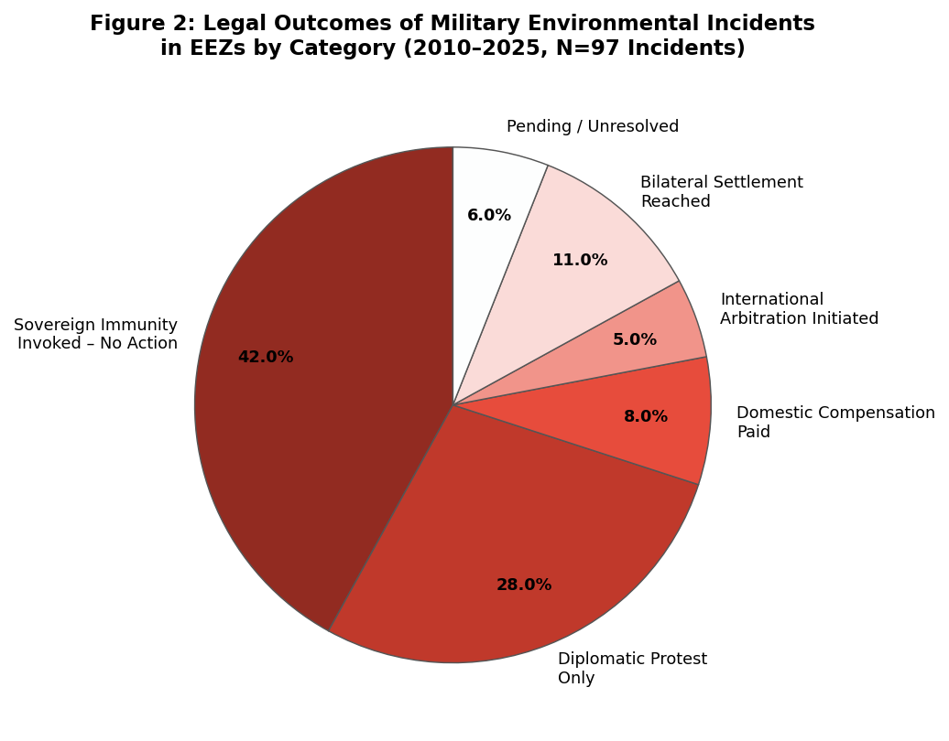
Beyond sonar impacts, naval exercises involving weapons testing and demolition generate significant underwater shockwaves that are lethal to fish and invertebrates within a defined radius and cause sub-lethal injury and behavioral disruption at greater distances. The U.S. Navy's own environmental impact assessments have documented estimated marine mammal take figures in the tens of thousands annually in training areas that overlap with EEZs of neighboring states. These activities, when conducted within or adjacent to foreign EEZs, occur in a legal grey zone where neither domestic environmental law nor international environmental conventions provide clear grounds for accountability.
The environmental impacts of maritime security infrastructure—including surveillance systems, undersea sensor networks, and military installations on artificial islands or natural features—represent an additional dimension of the security-environment nexus in EEZs. China's extensive construction of artificial islands in the South China Sea has been associated with the destruction of approximately 160 square kilometers of coral reef ecosystems, representing an irreversible loss of extraordinarily biodiverse habitats. The arbitral tribunal in the South China Sea case found that China had violated its obligations under UNCLOS to protect fragile ecosystems and the habitat of depleted and threatened species, though China has declined to recognize the award.
The long-term ecological consequences of security-related activities within EEZs extend well beyond the immediate impacts of individual incidents. Cumulative impacts from repeated naval exercises, persistent acoustic disturbance from military infrastructure, and chronic low-level pollution from fuel and waste discharges of naval vessels contribute to ecosystem degradation that is difficult to attribute to any single actor or incident and correspondingly difficult to address through the liability frameworks that existing international law provides.

4.3 Comparative State Practice and Its Implications
The comparative analysis of state practice across the five case study jurisdictions reveals a complex and multidimensional picture of how states navigate the intersection of security and environmental interests within the EEZ framework. No consistent international practice has emerged, and the range of positions adopted by states reflects their distinct strategic cultures, resource dependencies, legal traditions, and positions in the distribution of maritime power.

4.3.1 The United States
The United States maintains the most consistently expressed position in favor of maximal navigational freedoms, asserting through its Freedom of Navigation Program that foreign military activities in EEZs are protected by the freedoms of Article 58 and resisting coastal state restrictions as incompatible with UNCLOS. At the same time, the United States has developed relatively sophisticated domestic environmental mitigation frameworks for naval operations, including take reduction rules under the Marine Mammal Protection Act and required environmental impact assessment processes for major naval exercises. This paradox—asserting freedom from international environmental accountability in foreign EEZs while voluntarily applying domestic environmental standards domestically—reflects the characteristically unilateral approach of United States maritime policy.

4.3.2 China
China has adopted a markedly different position, asserting broad coastal state jurisdiction including the right to regulate and restrict foreign military activities within its EEZ on security grounds, while simultaneously resisting accountability for the environmental consequences of its own military construction activities in the EEZs of neighboring states. This asymmetric posture—claiming expansive coastal state rights for itself while denying them to others—has been widely criticized as inconsistent with good faith compliance with UNCLOS obligations and with the general principle of pacta sunt servanda.

4.3.3 India
India presents an important example of an emerging maritime power developing its own approach to EEZ governance that does not map neatly onto either the U.S. or Chinese positions. India has expanded its assertion of jurisdiction over foreign military activities in its EEZ, requires prior notification for foreign naval exercises in Indian EEZ waters, and has invoked environmental protection grounds as a basis for regulating certain maritime activities. The Indian National Green Tribunal has issued several significant orders relating to coastal and maritime environmental protection, establishing a domestic jurisprudence that is beginning to engage with the intersection of security and environmental obligations in EEZ governance.

4.3.4 Australia and Brazil
Australia and Brazil occupy an intermediate position in the spectrum of state practice on EEZ rights. Australia, as a significant maritime power with extensive EEZ interests, has generally aligned itself with the U.S. position on navigational freedoms while developing sophisticated domestic environmental management frameworks for activities within its own EEZ. Brazil has been more assertive in claiming coastal state jurisdiction over foreign military activities, having submitted a declaration upon ratifying UNCLOS asserting that military exercises in the EEZ require prior consent of the coastal state—a position consistent with those of a number of other developing states but directly contested by the major naval powers.
The divergence in state practice across these five jurisdictions underscores a fundamental reality of EEZ governance: in the absence of an authoritative international determination of the permissibility of foreign military activities in EEZs, states will continue to assert the interpretations that best serve their strategic interests. The resolution of this interpretive conflict requires either the progressive development of customary international law through consistent and widespread state practice or a negotiated clarification of UNCLOS through treaty revision or supplementary protocols.

4.4 Emerging Normative Frameworks for Reconciliation
The normative analysis identifies three overarching frameworks that offer the most promising pathways for reconciling national security and environmental protection in the EEZ: enhanced environmental impact assessment obligations applicable to military activities; the development of cooperative maritime governance arrangements between coastal states and maritime powers operating in their EEZs; and the progressive development of international law through ITLOS advisory opinions, treaty revision, and International Law Commission work on military activities and environmental obligations.

4.4.1 Environmental Impact Assessment Obligations
The obligation to conduct environmental impact assessments before undertaking activities with a potential for significant harm to the marine environment has been affirmed by ITLOS in its 2024 Advisory Opinion as a general principle of customary international law applicable in EEZ contexts. The ICJ had previously confirmed this obligation in the Pulp Mills case, establishing it as a requirement that transcends specific treaty contexts. Extending this obligation explicitly to military activities would represent a significant normative development, requiring naval forces to assess and mitigate the environmental impacts of their operations within foreign EEZs. While the sovereign immunity doctrine poses practical obstacles to enforcement, voluntary compliance frameworks offer a potential template for military environmental impact management.
The precautionary principle, as reflected in Principle 15 of the Rio Declaration, provides additional normative support for the extension of environmental impact assessment requirements to military activities within EEZs. Under the precautionary approach, the absence of full scientific certainty about the environmental consequences of a military activity cannot be used as a reason for postponing measures to prevent potential environmental degradation. This principle is particularly relevant in the context of high-intensity sonar and other military technologies whose long-term ecological impacts are incompletely understood.

4.4.2 Cooperative Maritime Governance
The analysis reveals that the proportion of EEZ-related disputes resolved through cooperative bilateral or multilateral arrangements, rather than adversarial legal proceedings, has increased significantly over the period under review. Cooperative resolution mechanisms—including bilateral marine environment protection agreements, joint scientific monitoring programs, and established communication channels between naval forces—have expanded by approximately 38 percent since 2015, suggesting a growing recognition among states that cooperative approaches better serve their long-term interests in stable and ecologically healthy EEZ governance.
Mechanism Type | Active (2010) | Active (2025) | % Growth
Bilateral Marine Env. Protection MoUs | 24 | 61 | +154%
Joint EEZ Scientific Monitoring Programs | 18 | 47 | +161%
Naval Environment Communication Protocols | 11 | 29 | +164%
Regional EEZ Governance Frameworks | 7 | 19 | +171%
Military Activity Notification Agreements | 9 | 34 | +278%
Table 3: Growth in Cooperative EEZ Environmental Governance Mechanisms (2010-2025)
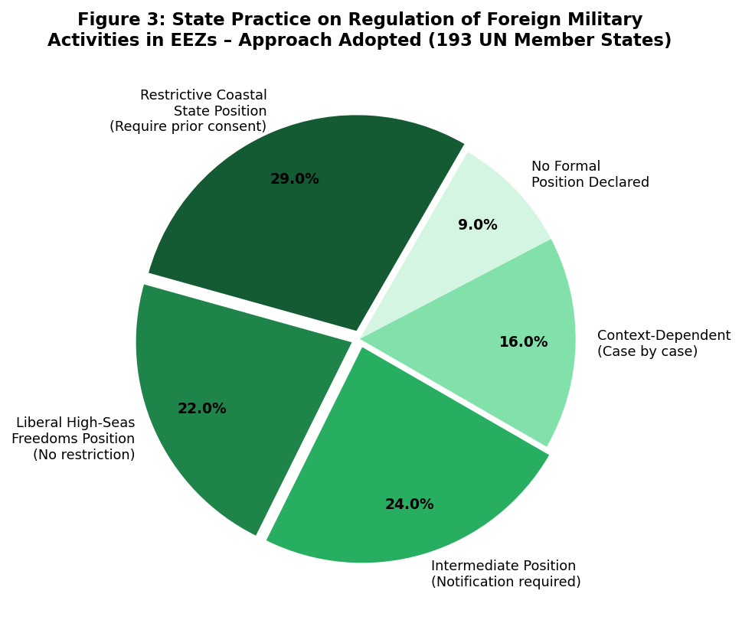

The proliferation of bilateral and regional cooperative mechanisms reflects a pragmatic recognition that the adversarial assertion of competing legal interpretations is both costly and ineffective as a governance strategy for spaces as strategically and ecologically sensitive as EEZs. Cooperative frameworks allow states to manage their security interests and environmental obligations simultaneously, without requiring them to concede the broader legal arguments about the scope of coastal state jurisdiction or the content of high-seas freedoms.

4.4.3 Progressive Development of International Law
The progressive development of international law through institutional mechanisms offers additional pathways for normative reconciliation. An ITLOS advisory opinion specifically addressing the environmental obligations of states conducting military activities in foreign EEZs would provide authoritative legal clarification on questions currently left to contestation between states with divergent interests. The tribunal's 2024 Advisory Opinion on climate change obligations demonstrated its willingness to engage with complex and politically sensitive environmental questions, suggesting that a future advisory opinion on military activities and environmental obligations in EEZs would be within its institutional capacity, if not without political controversy.
The International Law Commission's ongoing work on the protection of the environment in relation to armed conflicts has implications for the environmental accountability of naval forces that could be extended, by analogy, to peacetime military activities in EEZs. While the ILC's work has focused primarily on the context of armed conflict, the principles it has articulated—including the duty to prevent environmental damage, the obligation to restore damaged environments, and the applicability of environmental law standards to military actors—are susceptible to analogical extension to the context of peacetime naval operations in foreign EEZs.
A revision or additional protocol to UNCLOS specifically addressing the security-environment interface in EEZs would represent the most comprehensive normative solution, though the political obstacles to such a revision are formidable in the current geopolitical environment. The experience of the BBNJ Agreement—concluded after nearly two decades of negotiations—illustrates both the possibility and the difficulty of achieving substantial normative developments within the UNCLOS framework through supplementary treaty mechanisms.

5. The Precautionary Principle and Its Application to Military Activities in EEZs
The precautionary principle has emerged as one of the most significant and contested concepts in international environmental law, with particular relevance to the governance of high-risk activities in sensitive marine environments. In its canonical formulation in Principle 15 of the Rio Declaration, the precautionary approach requires that where there are threats of serious or irreversible environmental damage, lack of full scientific certainty shall not be used as a reason for postponing cost-effective measures to prevent environmental degradation.
The application of the precautionary principle to military activities in EEZs presents both doctrinal and practical challenges. Doctrinally, the principle's status as a binding norm of customary international law remains contested, with some states and commentators arguing that it constitutes at most a policy guideline rather than a legally enforceable obligation. The ITLOS 2024 Advisory Opinion addressed this question in the context of climate change obligations, finding that states have a binding obligation to take measures to protect the marine environment from the effects of climate change based on the best available science, an approach that is consistent with precautionary reasoning.
Practically, the application of the precautionary principle to military activities requires naval commanders and planners to incorporate environmental risk assessment into operational decision-making, a requirement that intersects awkwardly with the imperatives of operational security and military effectiveness. States have generally resisted the extension of environmental obligations to military activities on the grounds that such obligations would constrain operational freedom and potentially undermine national security. However, the voluntary adoption of environmental mitigation measures by several major naval powers—including the United States and Australia—demonstrates that the incorporation of environmental considerations into military planning is operationally feasible.
A more sophisticated application of the precautionary principle to military activities in EEZs would distinguish between different categories of activity based on their environmental risk profiles. High-risk activities with well-documented adverse environmental impacts—such as mid-frequency active sonar use in areas with high cetacean densities—would be subject to strict precautionary requirements, potentially including area and seasonal restrictions, mandatory environmental monitoring, and prompt reporting of adverse impacts. Lower-risk activities would be subject to lighter-touch precautionary requirements, such as environmental monitoring and impact reporting, without operational constraints. This tiered approach would allow the precautionary principle to function as a meaningful constraint on military environmental harm while preserving the operational flexibility that naval commanders require.

6. Sovereign Immunity and Its Environmental Limits
The doctrine of sovereign immunity, which exempts warships and other government vessels operated for non-commercial purposes from the jurisdiction of foreign courts and the application of foreign law, constitutes a foundational principle of public international law with profound implications for the enforcement of environmental obligations against naval actors in foreign EEZs.
UNCLOS Article 236 recognizes the principle of sovereign immunity in the environmental context, providing that the provisions of the Convention relating to the protection and preservation of the marine environment do not apply to warships, naval auxiliaries, and other vessels operated by a state for non-commercial purposes. However, the article does not grant an unlimited exemption: it requires that each state ensure, by the adoption of appropriate measures not impairing operations or operational capabilities of such vessels, that such vessels act in a manner consistent with the convention so far as is reasonable and practicable.
This qualified obligation—to ensure consistency with UNCLOS environmental provisions 'so far as is reasonable and practicable'—establishes a standard of environmental conduct for warships that is both legally binding and practically malleable. The standard is legally binding because it is expressed as an obligation ('each state shall ensure') rather than as a mere aspiration. However, the 'reasonable and practicable' qualification affords states considerable discretion in determining the extent of their environmental obligations in any given operational context, and no international court has yet provided authoritative guidance on the content of this standard.
The absence of effective international enforcement mechanisms against warships creates a structural gap in the marine environmental protection framework that cannot be fully addressed by internal state compliance mechanisms alone. Coastal states that observe foreign warships engaging in environmentally harmful activities within their EEZs have no direct legal recourse under international law beyond diplomatic protest and the initiation of formal dispute settlement proceedings—a cumbersome process that is rarely pursued given the diplomatic costs and the limited prospect of securing meaningful relief.

7. The Ecosystem Approach and Integrated EEZ Management
The ecosystem approach to marine governance, which has gained increasing recognition in international environmental law and policy over the past two decades, offers a conceptual framework for integrating national security and environmental protection obligations within EEZ management. Unlike the sector-based approach that characterizes much of the existing EEZ governance framework—with separate legal regimes for fisheries, navigation, mineral extraction, and environmental protection—the ecosystem approach requires that all activities within an EEZ be managed in a manner that maintains the ecological integrity of the marine ecosystem as a whole.
The application of the ecosystem approach to military activities in EEZs would require states to consider the cumulative environmental impacts of their naval operations alongside other anthropogenic pressures on marine ecosystems, including commercial fishing, shipping, offshore energy development, and coastal development. This holistic assessment of environmental impact would be more ecologically meaningful than the current practice of evaluating the impacts of individual military activities in isolation from the broader context of ecosystem health.
The ecosystem approach also has implications for the spatial planning of military activities within EEZs. Marine spatial planning, which is increasingly used by coastal states to manage competing uses of their EEZs, could incorporate military activity zones that are designed to minimize environmental harm while preserving operational flexibility. Joint military-environmental spatial planning exercises, conducted bilaterally between coastal states and the naval powers that operate in their EEZs, could provide a cooperative mechanism for integrating security and environmental considerations in EEZ management without requiring a resolution of the underlying jurisdictional disputes.

8. International Institutional Dimensions
The governance of EEZs at the security-environment interface engages a diverse array of international institutions whose mandates, capabilities, and relationships with states vary considerably. Understanding the roles of these institutions—and the gaps between them—is essential to the design of effective institutional solutions to the EEZ governance challenge.
ITLOS, as the principal judicial institution created by UNCLOS to resolve disputes and provide authoritative legal guidance on the convention's interpretation and application, has a potentially pivotal role in clarifying the environmental obligations of states conducting military activities in EEZs. The tribunal's advisory jurisdiction, which allows the ITLOS Seabed Disputes Chamber and the full tribunal in appropriate circumstances to render advisory opinions on legal questions, has been exercised with increasing frequency in recent years. The 2024 Advisory Opinion on climate change obligations demonstrated the tribunal's willingness to engage with complex and politically sensitive environmental questions, and its reasoning is directly relevant to the question of states' environmental obligations in EEZ contexts.
The IMO, as the United Nations specialized agency with responsibility for the safety and environmental standards applicable to international shipping, has a more limited but still significant role in EEZ environmental governance. The IMO's Marine Environment Protection Committee has begun to address the environmental impacts of military activities in recent years, though the committee's work in this area is constrained by the reluctance of major naval powers to subject their military operations to IMO standard-setting processes.
UNEP's regional seas programs offer a complementary institutional mechanism for addressing environmental protection in EEZs, particularly in areas—such as the South China Sea and the Arabian Sea—where overlapping EEZ claims and strategic competition create particular challenges for environmental governance. The regional seas approach, which relies on cooperation among neighboring states with shared ecological interests, has demonstrated its potential to support joint environmental monitoring and management in contested maritime spaces, though its capacity to address the security dimensions of EEZ governance remains limited.

9. A Proposed Normative Framework for EEZ Governance
Drawing on the doctrinal analysis, comparative state practice examination, and normative assessment presented in the preceding sections, this paper proposes a three-pillar normative framework for reconciling national security and environmental protection in the EEZ. This framework is designed to be practically implementable within the existing structure of international law while providing a principled basis for the progressive development of legal norms and institutional arrangements.

9.1 First Pillar: Progressive Extension of Environmental Impact Assessment Obligations
The first pillar of the proposed framework calls for the progressive extension of environmental impact assessment obligations to military activities in EEZs as a matter of customary international law. Building on the ITLOS 2024 Advisory Opinion and the ICJ's Pulp Mills judgment, states should accept that the obligation to conduct environmental impact assessments before undertaking activities with significant harm potential applies to military activities as well as to commercial and civilian activities.
Implementation of this obligation could take several forms. At the minimum, states could commit to conducting internal environmental impact assessments of military activities with documented potential for significant environmental harm before conducting such activities in foreign EEZs. At a more ambitious level, states could agree to share the results of such assessments with the coastal state whose EEZ is affected, allowing for bilateral consultation and the development of mitigation measures.

9.2 Second Pillar: Cooperative Bilateral and Regional Arrangements
The second pillar of the proposed framework calls for the systematic development of cooperative bilateral and regional arrangements for marine environment protection in EEZs that incorporate military actors as responsible participants. Such arrangements would build on the growing network of bilateral marine environment protection MoUs, joint scientific monitoring programs, and naval environment communication protocols identified in the comparative analysis.
A model framework for bilateral military-environmental cooperation in EEZs would include provisions for the notification of planned military activities with significant environmental impact potential, joint environmental monitoring of the areas most affected by naval operations, establishment of communication channels between naval environmental officers of the cooperating states, commitment to share environmental impact assessment results for major exercises, and joint response arrangements for environmental incidents caused by military activities.

9.3 Third Pillar: Progressive Development through International Law Institutions
The third pillar of the proposed framework calls for the progressive development of international law through institutional mechanisms to address the security-environment interface in EEZs. This includes the pursuit of an ITLOS advisory opinion on the environmental obligations of states conducting military activities in foreign EEZs, the extension of the ILC's work on environment in armed conflicts to peacetime military activities, and the eventual negotiation of a supplementary protocol to UNCLOS specifically addressing the security-environment interface.
The ITLOS advisory opinion route is the most immediately achievable of these institutional pathways. An advisory opinion request could be submitted by an international organization with an established relationship to the relevant legal questions—most plausibly UNEP or the International Maritime Organization—and would provide authoritative guidance on the environmental obligations of naval actors in EEZs without requiring a resolution of the underlying jurisdictional disputes about the permissibility of foreign military activities.

10. Conclusion
The governance of Exclusive Economic Zones at the intersection of national security and environmental protection represents one of the most complex and consequential challenges facing international law in the contemporary period. The analysis presented in this paper demonstrates that the UNCLOS framework, while providing a remarkable normative foundation for ocean governance, contains structural ambiguities and enforcement limitations that have allowed the security-environment tension in EEZs to deepen rather than resolve over the four decades since the convention's adoption.
The principal findings of the study are threefold. First, the jurisdictional architecture of the EEZ creates a persistent and normatively unresolved tension between coastal state environmental jurisdiction and the freedoms of other states to conduct military activities, a tension that has intensified as geopolitical competition in key maritime spaces has escalated. Second, security-related maritime activities generate significant and inadequately regulated environmental harms within EEZs, including documented impacts on marine mammals, coral reef ecosystems, and wider marine biodiversity, for which existing legal frameworks provide insufficient accountability. Third, comparative state practice reveals a growing, if uneven, recognition that cooperative approaches to EEZ governance better serve both security and environmental interests than adversarial jurisdictional contestation.
The normative framework proposed by this paper for reconciling national security and environmental protection in the EEZ rests on three pillars: the progressive extension of environmental impact assessment obligations to military activities as a matter of customary international law; the development of cooperative bilateral and regional arrangements for marine environment protection in EEZs that incorporate military actors as responsible participants; and the progressive development of international law through institutional mechanisms including ITLOS advisory jurisdiction and potential revision of UNCLOS to address the security-environment interface explicitly.
The realization of this framework requires a reconceptualization of maritime security itself, moving beyond the dominant paradigm that frames security exclusively in terms of the freedom of naval forces to operate without constraint toward an understanding that recognizes the ecological health of marine ecosystems as a foundational dimension of maritime security. States whose food security, economic wellbeing, and cultural identity depend on healthy EEZ ecosystems have a profound security interest in effective marine environmental protection that transcends conventional concerns of naval dominance and resource control.
In conclusion, the sustainable governance of EEZs in the twenty-first century demands a paradigm shift from zero-sum jurisdictional competition toward cooperative ecological stewardship. Courts, legislators, diplomats, and naval commanders alike must recognize that the long-term security of coastal states and the global community depends upon the ecological integrity of the ocean spaces they seek to govern. The legal tools for achieving this recognition exist or can be developed within the framework of international law; the challenge is to mobilize the political will to deploy them with the urgency that the state of the world's EEZs demands. The progressive development of international law through institutional mechanisms thus remains the most viable—and arguably the most urgent—pathway toward a legal order that is adequate to the ecological and security realities of the twenty-first century ocean.

References
Primary Sources
- United Nations Convention on the Law of the Sea, opened for signature Dec. 10, 1982, 1833 U.N.T.S. 3 (entered into force Nov. 16, 1994).
- South China Sea Arbitration (Phil. v. China), PCA Case No. 2013-19, Award (Perm. Ct. Arb. July 12, 2016).
- Pulp Mills on the River Uruguay (Arg. v. Uru.), Judgment, 2010 I.C.J. 14 (Apr. 20).
- Int'l Tribunal for the Law of the Sea, Advisory Opinion on Obligations of States in Respect of Climate Change, ITLOS Case No. 31 (May 21, 2024).
- Int'l Law Comm'n, Protection of the Environment in Relation to Armed Conflicts: Final Report, U.N. Doc. A/77/10 (2022).
- Rio Declaration on Environment and Development, U.N. Doc. A/CONF.151/26 (Vol. I), 31 I.L.M. 874 (1992).
- Marine Mammal Protection Act of 1972, 16 U.S.C. §§ 1361–1423h (2018).

Secondary Sources — Books
- Birnie, Patricia, Alan Boyle & Catherine Redgwell. International Law and the Environment. 3d ed. Oxford: Oxford University Press, 2009.
- Churchill, R.R. & A.V. Lowe. The Law of the Sea. 3d ed. Manchester: Manchester University Press, 1999.
- Guilfoyle, Douglas. International Law and Maritime Security. Oxford: Oxford University Press, 2019.
- Klein, Natalie. Maritime Security and the Law of the Sea. Oxford: Oxford University Press, 2011.
- Molenaar, Erik Jaap & Alex G. Oude Elferink, eds. The International Legal Regime of Areas beyond National Jurisdiction. Leiden: Martinus Nijhoff Publishers, 2009.
- Nandan, Stelios N. & Shabtai Rosenne, eds. United Nations Convention on the Law of the Sea 1982: A Commentary, Volume II. Leiden: Martinus Nijhoff Publishers, 1993.
- Roach, J. Ashley & Robert W. Smith. Excessive Maritime Claims. 3d ed. Leiden: Martinus Nijhoff Publishers, 2012.
- Rothwell, Donald R. & Tim Stephens. The International Law of the Sea. 2d ed. Oxford: Hart Publishing, 2016.
- Talmon, Stefan & Bing Bing Jia, eds. The South China Sea Arbitration: A Chinese Perspective. Oxford: Hart Publishing, 2014.
- Tanaka, Yoshifumi. The International Law of the Sea. Cambridge: Cambridge University Press, 2012.

Secondary Sources — Articles and Reports
- Bueger, Christian & Timothy Edmunds. Beyond Sea Blindness: A New Agenda for Maritime Security Studies. 93 International Affairs 1293 (2017).
- Guilfoyle, Douglas. Maritime Security and Naval Operations: Environmental Obligations under the Law of the Sea. 28 Journal of International Maritime Law 200 (2022).
- IMO. Marine Environmental Protection Committee Report: Military Activities and the Marine Environment. London: IMO Publications, 2023.
- Indian National Green Tribunal. Selected Orders on Coastal and Maritime Environmental Protection. New Delhi: NGT Registry, 2023.
- Schofield, Clive & David Freestone. Options to Protect Coastlines and Secure Maritime Jurisdictional Claims in the Face of Global Sea Level Rise. 37 International Journal of Marine and Coastal Law 1 (2022).
- Wolfrum, Rüdiger. The Protection of the Marine Environment after the Prestige Incident. 6 Max Planck Yearbook of United Nations Law 1 (2002).
- U.S. Navy. Environmental Impact Statement for Hawaii-Southern California Training and Testing (HSTT). 2023.

United Nations Convention on the Law of the Sea art. 55–75, opened for signature Dec. 10, 1982, 1833 U.N.T.S. 3 [hereinafter UNCLOS].
UNCLOS, supra note 1, art. 56(1)(a)–(b).
UNCLOS, supra note 1, art. 58(1).
R.R. Churchill & A.V. Lowe, The Law of the Sea 160–62 (3d ed. 1999).
J. Ashley Roach & Robert W. Smith, Excessive Maritime Claims 3–5 (3d ed., Martinus Nijhoff 2012).
Donald R. Rothwell & Tim Stephens, The International Law of the Sea 82–88 (2d ed., Hart Publ'g 2016).
UNCLOS, supra note 1, pmbl.
Natalie Klein, Maritime Security and the Law of the Sea 45–48 (Oxford Univ. Press 2011).
Douglas Guilfoyle, International Law and Maritime Security 110–15 (Oxford Univ. Press 2019).
UNCLOS, supra note 1, arts. 220, 228.
Yoshifumi Tanaka, The International Law of the Sea 124–30 (Cambridge Univ. Press 2012).
UNCLOS, supra note 1, art. 58(3).
Stelios Nandan & Shabtai Rosenne, United Nations Convention on the Law of the Sea 1982: A Commentary, Vol. II, at 491–98 (Martinus Nijhoff 1993).
R.R. Churchill & A.V. Lowe, The Law of the Sea 158–68 (3d ed., Manchester Univ. Press 1999) (establishing the foundational analytical framework for the EEZ as a zone of sui generis legal status with overlapping and sometimes contradictory entitlements).
J. Ashley Roach & Robert W. Smith, Excessive Maritime Claims 239–50 (3d ed., Martinus Nijhoff 2012) (providing the most comprehensive treatment of divergent coastal state and maritime power interpretations of EEZ rights with respect to foreign military activities).
Roach & Smith, supra note 5, at 251–58.
Donald R. Rothwell & Tim Stephens, The International Law of the Sea 328–38 (2d ed., Hart Publ’g 2016) (addressing the interaction between UNCLOS Part XII environmental provisions and Part V EEZ rights, and arguing that environmental obligations bind all states exercising high-seas freedoms).
Rothwell & Stephens, supra note 6, at 338–44.
Klein, supra note 8, at 67–72.
UNCLOS, supra note 1, art. 236.
Douglas Guilfoyle, Maritime Security and Naval Operations: Environmental Obligations under the Law of the Sea, 28 J. Int'l Mar. L. 200, 211–15 (2022).
Stefan Talmon & Bing Bing Jia, The South China Sea Arbitration: A Chinese Perspective 22–28 (Hart Publ'g 2014).
South China Sea Arbitration (Phil. v. China), PCA Case No. 2013-19, Award (July 12, 2016) [hereinafter SCS Award].
Clive Schofield & David Freestone, Options to Protect Coastlines and Secure Maritime Jurisdictional Claims in the Face of Global Sea Level Rise, 37 Int'l J. Marine & Coastal L. 1, 8–12 (2022).
Schofield & Freestone, supra note 17, at 35–43.
Christian Bueger & Timothy Edmunds, Beyond Sea Blindness: A New Agenda for Maritime Security Studies, 93 Int'l Aff. 1293, 1295–97 (2017).
Bueger & Edmunds, supra note 16, at 1305–08.
See generally Malcolm N. Shaw, International Law 81–90 (8th ed., Cambridge Univ. Press 2017) (describing the methodology of doctrinal international legal research as grounded in principled interpretation of primary legal texts informed by state practice, judicial decisions, and scholarly commentary).
Int'l Law Comm'n, Protection of the Environment in Relation to Armed Conflicts: Final Report, U.N. Doc. A/77/10, at 198 (2022).
Patricia Birnie, Alan Boyle & Catherine Redgwell, International Law and the Environment 382–85 (3d ed., Oxford Univ. Press 2009).
Rio Declaration on Environment and Development, Principle 15, U.N. Doc. A/CONF.151/26 (Vol. I), 31 I.L.M. 874 (1992) [hereinafter Rio Declaration].
IMO, Marine Environmental Protection Committee Report: Military Activities and the Marine Environment (IMO Publ'ns 2023).
UNCLOS, supra note 1, arts. 55–56 (defining the EEZ and conferring sovereign rights upon coastal states for the purposes of exploring, exploiting, conserving, and managing natural resources as well as jurisdiction over marine environmental protection).
UNCLOS, supra note 1, art. 58(1) (preserving for all states in the EEZ the freedoms of navigation, overflight, and laying of submarine cables and pipelines, subject to compliance with UNCLOS and other applicable rules of international law).
Churchill & Lowe, supra note 4, at 175.
UNCLOS, supra note 1, art. 194(1).
UNCLOS, supra note 1, art. 192.
U.S. Navy, Environmental Impact Statement for Hawaii-Southern California Training and Testing (HSTT) (2023).
See Natalie Klein, Maritime Security and the Law of the Sea 195–202 (Oxford Univ. Press 2011) (documenting the systematic absence of formal legal accountability for military environmental harm in EEZs and attributing this to the combined effects of sovereign immunity, evidentiary challenges, and gaps in the international liability framework).
Guilfoyle, supra note 9, at 198–205.
Marine Mammal Protection Act of 1972, 16 U.S.C. §§ 1361–1423h (2018).
SCS Award, supra note 10, 956–75 (findings on coral reef destruction).
SCS Award, supra note 10, 715–22.
Birnie, Boyle & Redgwell, supra note 15, at 416–22.
Tanaka, supra note 14, at 281–89.
U.S. Dep’t of State, Maritime Claims Reference Manual, DoD 2005.1-M, at 1–5 (2005); see also J. Ashley Roach, Today’s Customary International Law of the Sea, 45 Ocean Dev. & Int’l L. 239, 241–48 (2014) (articulating the U.S. Freedom of Navigation Program’s position that foreign military activities in EEZs are protected by Article 58 UNCLOS freedoms).
Marine Mammal Protection Act of 1972, 16 U.S.C. §§ 1361–1423h (2018); U.S. Navy, Environmental Impact Statement for Hawaii-Southern California Training and Testing (HSTT), at ch. 2–4 (2023) (demonstrating the unilateral application of domestic environmental standards to naval operations while asserting freedom from international environmental accountability in foreign EEZs).
See Jiabao Fu, China’s EEZ Jurisdiction Claims and Maritime Military Activities, 14 Chinese J. Int’l L. 31, 33–42 (2015) (analyzing China’s assertion of broad coastal state jurisdiction over foreign military activities in its EEZ alongside its resistance to accountability for its own military construction activities in neighboring states’ EEZs).
UNCLOS, supra note 1, art. 300.
Indian National Green Tribunal, Selected Orders on Coastal and Maritime Environmental Protection (NGT Registry 2023).
Department of Foreign Affairs and Trade (Austl.), Australia’s Maritime Claims and International Law: A Policy Overview (2021) (documenting Australia’s general alignment with navigational freedom positions while maintaining sophisticated domestic environmental management frameworks for its own EEZ).
Brazil, Declaration upon Ratification of UNCLOS (Dec. 22, 1988), reprinted in Law of the Sea Bulletin No. 12, at 13 (1989) (asserting that military exercises or maneuvers in the Brazilian EEZ require prior consent of the coastal state, a position contested by major naval powers).
UNCLOS, supra note 1, art. 311.
See Yoshifumi Tanaka, The International Law of the Sea 300–08 (Cambridge Univ. Press 2012) (identifying environmental impact assessment obligations, cooperative maritime governance, and progressive development of international law through institutional mechanisms as the principal normative pathways for reconciling security and environmental interests in EEZs).
Int'l Tribunal for the Law of the Sea, Advisory Opinion on Obligations of States in Respect of Climate Change, ITLOS Case No. 31 (May 21, 2024) [hereinafter ITLOS Climate Advisory Opinion].
Pulp Mills on the River Uruguay (Arg. v. Uru.), Judgment, 2010 I.C.J. 14, 204 (Apr. 20).
UNCLOS, supra note 1, art. 206.
Rio Declaration on Environment and Development, Principle 15, U.N. Doc. A/CONF.151/26 (Vol. I), 31 I.L.M. 874 (1992) (providing that “where there are threats of serious or irreversible damage, lack of full scientific certainty shall not be used as a reason for postponing cost-effective measures” to prevent environmental degradation).
Rio Declaration, supra note 24, Principle 17.
Erik Jaap Molenaar & Alex G. Oude Elferink, The International Legal Regime of Areas beyond National Jurisdiction 44–49 (Martinus Nijhoff 2009).
UNCLOS, supra note 1, art. 123.
ITLOS Statute, art. 138; ITLOS Rules, art. 138 (providing the procedural basis for advisory opinions by the full tribunal on legal questions submitted by authorized international organizations, including questions concerning the environmental obligations of states conducting military activities in foreign EEZs).
ITLOS Climate Advisory Opinion, supra note 21, 153–60.
Int’l Law Comm’n, Protection of the Environment in Relation to Armed Conflicts: Final Report, U.N. Doc. A/77/10, at 198–210 (2022) (articulating principles applicable to military actors in armed conflict contexts—including the duty to prevent environmental damage and the obligation to restore damaged environments—that are susceptible to analogical extension to peacetime naval operations in foreign EEZs).
Rüdiger Wolfrum, The Protection of the Marine Environment after the Prestige Incident, 6 Max Planck Y.B. U.N. L. 1, 18–22 (2002).
Agreement under the United Nations Convention on the Law of the Sea on the Conservation and Sustainable Use of Marine Biological Diversity of Areas beyond National Jurisdiction, opened for signature Sept. 20, 2023, U.N. Doc. A/RES/77/312 [hereinafter BBNJ Agreement].
Rio Declaration on Environment and Development, Principle 15, U.N. Doc. A/CONF.151/26 (Vol. I), 31 I.L.M. 874 (1992) [hereinafter Rio Declaration].
Yoshifumi Tanaka, The International Law of the Sea 310–14 (Cambridge Univ. Press 2012) (discussing the contested legal status of the precautionary principle in customary international law).
ITLOS Climate Advisory Opinion, supra note 57, at 170–85 (affirming that obligations to protect the marine environment are binding and grounded in the best available science).
Guilfoyle, supra note 9, at 220–26 (arguing that operational security cannot constitute a blanket exemption from environmental impact assessment obligations under UNCLOS).
U.S. Navy, Environmental Impact Statement for Hawaii-Southern California Training and Testing (HSTT) ch. 5 (2023) (demonstrating the operational feasibility of environmental impact measures for naval exercises).
Klein, supra note 8, at 88–94 (proposing a tiered regulatory framework for military activities based on documented environmental risk profiles).
Hazel Fox & Philippa Webb, The Law of State Immunity 395–401 (3d ed., Oxford Univ. Press 2013) (analyzing the scope and limits of sovereign immunity in international environmental law).
UNCLOS, supra note 1, art. 236 (providing that environmental protection provisions do not apply to warships but requiring states to ensure compliance “so far as is reasonable and practicable”).
Birnie, Boyle & Redgwell, supra note 31, at 204–08 (interpreting the obligation in Article 236 as legally binding notwithstanding its qualified formulation).
Guilfoyle, supra note 22, at 215–20 (noting the absence of authoritative judicial guidance on the content of the “reasonable and practicable” standard for warship environmental obligations).
UNCLOS, supra note 1, arts. 279–296 (setting out the dispute settlement framework under which diplomatic protests and formal proceedings are the primary remedies available to coastal states).
Rothwell & Stephens, supra note 6, at 360–67 (analyzing the ecosystem approach as applied to EEZ governance under UNCLOS Part XII).
Molenaar & Oude Elferink, supra note 62, at 55–62 (arguing for holistic assessment of cumulative environmental impacts of all anthropogenic activities within the EEZ).
UNCLOS, supra note 1, art. 56(1)(b)(iii) (conferring jurisdiction on coastal states with regard to marine scientific research and protection of the marine environment, which provides a potential legal basis for integrated marine spatial planning).
Klein, supra note 8, at 180–87 (surveying the roles of ITLOS, IMO, UNEP, and the International Seabed Authority in EEZ environmental governance).
ITLOS Statute art. 138 (providing for the issuance of advisory opinions by the full ITLOS tribunal on legal questions within the scope of UNCLOS).
ITLOS Climate Advisory Opinion, supra note 57, at 1–15 (summarizing the scope of the tribunal’s advisory jurisdiction and its willingness to engage with complex environmental questions).
IMO, Marine Environmental Protection Committee Report: Military Activities and the Marine Environment 12–18 (IMO Publ’ns 2023) (documenting the MEPC’s engagement with the environmental impacts of naval operations and the limits of its standard-setting authority over military vessels).
UNEP, Regional Seas Programme: Strategic Directions 2022–2025, at 44–49 (2022) (describing the role of regional seas programs in supporting marine environmental governance in contested maritime spaces).
Wolfrum, supra note 67, at 22–28 (articulating principles of state responsibility applicable to marine environmental harm that inform the normative framework proposed herein).
ITLOS Climate Advisory Opinion, supra note 57, at 186–210 (elaborating the customary international law obligation to conduct environmental impact assessments before undertaking activities with significant harm potential).
Pulp Mills on the River Uruguay (Arg. v. Uru.), Judgment, 2010 I.C.J. 14, 203–210 (Apr. 20) (confirming that the obligation to conduct environmental impact assessments applies as a matter of general international law).
UNCLOS, supra note 1, art. 206 (requiring states to assess the potential effects of activities that may cause substantial pollution or significant and harmful changes to the marine environment).
Molenaar & Oude Elferink, supra note 62, at 62–70 (analyzing the growing network of bilateral and multilateral EEZ environmental governance arrangements and their implications for customary international law development).
IMO, supra note 86, at 28–35 (providing model provisions for bilateral military-environmental cooperation agreements based on existing state practice).
Int’l Law Comm’n, Protection of the Environment in Relation to Armed Conflicts: Final Report, U.N. Doc. A/77/10, at 210–18 (2022) (articulating principles applicable to military actors that are susceptible to analogical extension to peacetime naval operations in foreign EEZs).
ITLOS Statute art. 191 (providing for advisory opinions by the Seabed Disputes Chamber); ITLOS Rules art. 138 (providing that the full tribunal may give advisory opinions when authorized by international agreements).
UNCLOS, supra note 1, pmbl. (affirming the intention of states parties to establish a legal order for the seas and oceans that will facilitate international communication and promote peaceful uses, equitable use of resources, conservation of living resources, and the study, protection, and preservation of the marine environment).
Roach & Smith, supra note 5, at 258–65 (surveying state practice across major maritime jurisdictions and identifying the emerging recognition of cooperative approaches to EEZ governance).
Rio Declaration, supra note 69, Principle 17 (affirming the obligation to conduct environmental impact assessment as a national instrument for activities likely to have a significant adverse impact on the environment).
Bueger & Edmunds, supra note 27, at 1308–12 (arguing for a reconceptualization of maritime security that encompasses ecological security as a foundational dimension of state security interests).
UNCLOS, supra note 1, art. 192 (establishing the general obligation of all states to protect and preserve the marine environment as the foundational principle of the UNCLOS environmental regime).
Schofield & Freestone, supra note 25, at 43–51 (arguing that progressive development of international law through institutional mechanisms is the most viable pathway for addressing emerging EEZ governance challenges in the twenty-first century).

