Awareness and Utilisation of Cloud Computing Technologies for Library Services: A Survey of Librarians in Anambra State

ABSTRACT
This study investigated the level of awareness and extent of utilisation of cloud computing technologies for library services among librarians in tertiary institutions in Anambra State, Nigeria. The study adopted a descriptive survey research design. Area: The study was conducted in Anambra State, Nigeria. The population comprised 112 librarians from federal and state tertiary institutions. Using the Yaro Yamane formula, a sample of 88 librarians was selected. A structured 4-point Likert scale questionnaire titled "Cloud Computing Awareness and Utilisation Questionnaire (CCAUQ)" was used for data collection. Data were analysed using mean (X̄) and standard deviation to answer research questions, with a decision benchmark of 2.50, while the z-test was used to test the hypothesis at a 0.05 significance level. Extent of responses was interpreted using the following scale: Very High Extent (3.50–4.00), High Extent (2.50–3.49), Low Extent (1.50–2.49), and Very Low Extent (1.00–1.49). Findings revealed a High Extent of awareness of cloud computing concepts (aggregate mean = 2.98) but a Low Extent of utilisation (aggregate mean = 2.34) for core library services. Librarians from both federal and state institutions exhibited a Low Extent of utilisation, with federal librarians scoring marginally higher (X̄ = 2.41) than state librarians (X̄ = 2.28). Key benefits included enhanced remote access and cost reduction, both rated at a Very High Extent, while major challenges were poor internet connectivity and irregular power supply, also rated at a Very High Extent. The hypothesis test showed no significant difference between federal and state institution librarians' utilisation (z-cal = 1.24 < z-crit = 1.96). The study recommended mandatory ICT capacity-building workshops, increased funding for cloud subscriptions, and development of state-wide internet backbone for libraries.
Keywords: Cloud Computing, Library Services, Awareness, Utilisation, Digital Libraries, ICT in Libraries, Anambra State.

1. INTRODUCTION
The development of library information services from analog to digital, and then to cloud-based information services has brought tremendous revolution in information management and services to users. From traditional libraries where printed materials such as books, journals and others were stored and kept within the four walls of the libraries to serve users within vicinity, the development of digital libraries in late 20th century where computerized catalogues, CD-ROM, databases and local area networks were introduced to store and manage information (Rahmanova, 2025). However, the most recent development is the emergence of cloud libraries where computing resources, storage, and applications are hosted on remote servers and accessed via the internet by users (Kolawole, 2023). This change from traditional to digital to cloud-based information services, therefore, is not just a matter of change from print to digital but a paradigm shift in the way library services are to be delivered to users. Cloud computing, as defined by National Institute of Standards and Technology (NIST, 2020), is a model or data center, which enables ubiquitous on-demand access to shared pools of configurable system resources and services, which can be rapidly provisioned with minimal management effort or service provider interaction. Cloud computing delivers three layers of services namely: Infrastructure as a Service (IaaS), Platform as a Service (PaaS) and Software as a Service (SaaS). IaaS provides virtualized computing resources over the internet on a pay-as-you-use basis. PaaS on the other hand, provides hardware and software tools and development environment to users over the internet. The Software as a Service (SaaS) model is one of the most common service delivery models in the field of cloud computing. In SaaS, the software is provided by service providers and is executed on remote servers. The users access the software applications via the Internet. The usage is “pay as you use” (Sunyaev, 2024). In the context of libraries, SaaS is highly relevant, because in SaaS mode, the integrated library systems (ILS), the digital repository software as well as the discovery tools can be booked by the library on a subscription basis. The library does not have to invest and to operate servers and the necessary IT infrastructure (Indraji & Naikar, 2025).
The importance of cloud computing to contemporary library services is immense. It has resulted in the creation of digital repositories where rare manuscripts, theses, and institutional publications can be stored and accessed worldwide. It has resulted in the creation of electronic libraries (e-libraries) which are not subject to physical opening hours. The advent of cloud computing had brought about resource sharing and inter-library collaboration. This new development has made it possible for libraries in Anambra State to share resources and even go into inter-library collaborations through the use of cloud-based library management systems. They can now access the catalogs and online databases of other libraries both within and outside the country, like for instance those in Lagos without having to invest in duplicating physical structures (Ezeibe et al., 2025). This is also in line with the National educational policy which suggested that public institutions should adopt cloud-first strategies to save cost and ensure continuity of service (NITDA, 2021).
The modernization of libraries in Nigeria is however being hindered by a host of challenges confronting the sector. The funds required to carry out technology revolution in the library are not available; the problem of power failure is constant; the cost of broadband connectivity is too high and there is a huge skill gap that confronts the library professionals (Anyaoku et al., 2023). However, a foundational problem that exacerbates all others is the low awareness and poor utilisation of emerging technologies. In Anambra State, many librarians in federal and state tertiary institutions continue to rely on manual or standalone automated systems. While anecdotal evidence suggests some awareness of cloud computing concepts like Google Drive or Dropbox, the professional utilisation of specialised cloud library platforms (e.g., Koha, EBSCOhost, DSpace) remains an under-researched area. This study, therefore, addresses the gap in literature by specifically surveying librarians in Anambra State to determine their awareness and actual utilisation of cloud computing technologies for core library services.

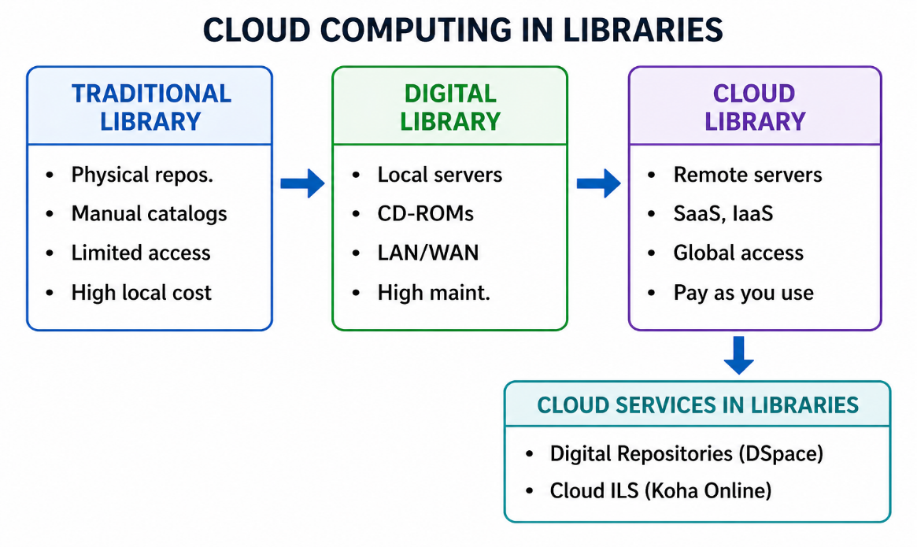
Figure 1: Cloud Computing in Libraries

2. CONCEPTUAL FRAMEWORK
This study is anchored on the Technology Acceptance Model (TAM) by Davis (1989), which posits that perceived usefulness and perceived ease of use determine an individual's attitude toward using a technology, which in turn predicts actual usage behaviour. In the context of this study, a librarian's awareness of cloud computing forms the cognitive foundation (perceived usefulness), while utilisation is the behavioural outcome. However, external factors such as infrastructure and institutional policy mediate this relationship.
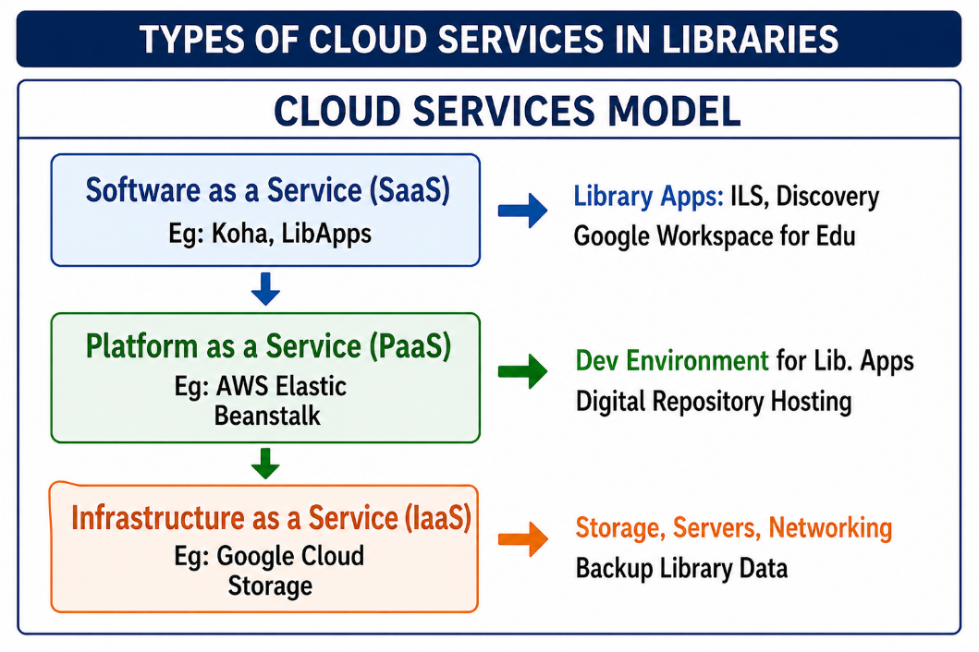
Figure 2: Types of Cloud Services in Libraries
3. PURPOSE OF THE STUDY
This study assessed the level of awareness and use of cloud computing by librarians and their application to the delivery of library and information services in tertiary institutions in Anambra State of Nigeria. Specifically, the study sought to:
- Establish the level of awareness of cloud computing tools and services amongst librarians in the tertiary institutions in Anambra State.
- Determine the extent to which cloud computing services are being utilized for delivery of library and information services.
- Identify the benefits of utilising cloud computing technologies in libraries in Anambra State.
- Identify the challenges affecting the utilisation of cloud computing technologies in libraries in Anambra State.

4. RESEARCH QUESTIONS
The study answered the following research questions:
- What is the level of awareness of cloud computing technologies among librarians in Anambra State?
- What is the extent of utilisation of cloud computing technologies for library services in Anambra State?
- What are the benefits of utilising cloud computing technologies for library services in Anambra State?
- What are the challenges affecting the utilisation of cloud computing technologies for library services in Anambra State?

5. HYPOTHESIS
The following null hypothesis was tested at 0.05 level of significance:
Ho₁: There is no significant difference between the mean responses of librarians in federal tertiary institutions and those in state tertiary institutions in Anambra State on the extent of utilisation of cloud computing technologies for library services.

6. METHODOLOGY
Design: The study adopted a descriptive survey research design, which is appropriate for collecting data from a sample of a population to describe their opinions, attitudes, and characteristics.
Area of the Study: The study was conducted in Anambra State, south-eastern Nigeria. The state has a concentration of federal and state tertiary institutions, including Nnamdi Azikiwe University (NAU) Awka, Chukwuemeka Odumegwu Ojukwu University (COOU) Igbariam, Federal College of Education (Technical) Umunze, Federal Polytechnic Oko, and other state and Federal Institutions.
Population: The target population consisted of all 112 professional and paraprofessional librarians currently employed in the tertiary institutions in Anambra State, as obtained from the registers of the respective university, polytechnic college of education libraries.
Sample and Sampling Technique: The sample size was determined, using the Yaro Yamane formula: n = N / (1 + N(e)²). Where N = 112 and e = 0.05 (margin of error). Thus, n = 112 / (1 + 112*0.0025) = 112 / (1 + 0.28) = 112 / 1.28 = 87.5, approximated to 88 librarians. The stratified random sampling technique was used to select librarians proportionally from federal (n=51) and state (n=37) institutions.
Instrument: The instrument for data collection was a structured questionnaire titled “Cloud Computing Awareness and Utilisation Questionnaire (CCAUQ)” developed by the researchers. Section A elicited demographic data. Sections B, C, D, and E comprised items on awareness (9 items), utilisation (8 items), benefits (7 items), and challenges (7 items) measured on a 4-point Likert scale: Very High Awareness/Great Extent = 4, High Awareness/Moderate Extent = 3, Low Awareness/Little Extent = 2, No Awareness/No Extent = 1.
Validity and Reliability: Face and content validity were established by three experts from the Department of Library and Information Science, Nnamdi Azikiwe University, Awka. Reliability was determined using a test-retest method on 15 librarians from Enugu State (outside the study area). A Cronbach alpha reliability test gave a coefficient of 0.86 which translates to a very internal consistency.
Data Collection: Data Collection: The researchers administered 88 copies of the questionnaire directly to the sampled librarians during a professional development workshop at the Anambra state international conference center to ensure a high return rate. All 88 copies were retrieved and found usable, representing a 100% return rate.
Data Analysis: Research questions were answered using mean (X̄) and standard deviation (SD). The decision rule was that any item with a mean score of 2.50 and above was considered “Accepted” (high awareness, great extent, agreed benefit, or serious challenge), while any item below 2.50 was “Rejected” (low awareness, little extent, etc.). The null hypothesis was tested using a z-test for two independent means at a 0.05 significance level.
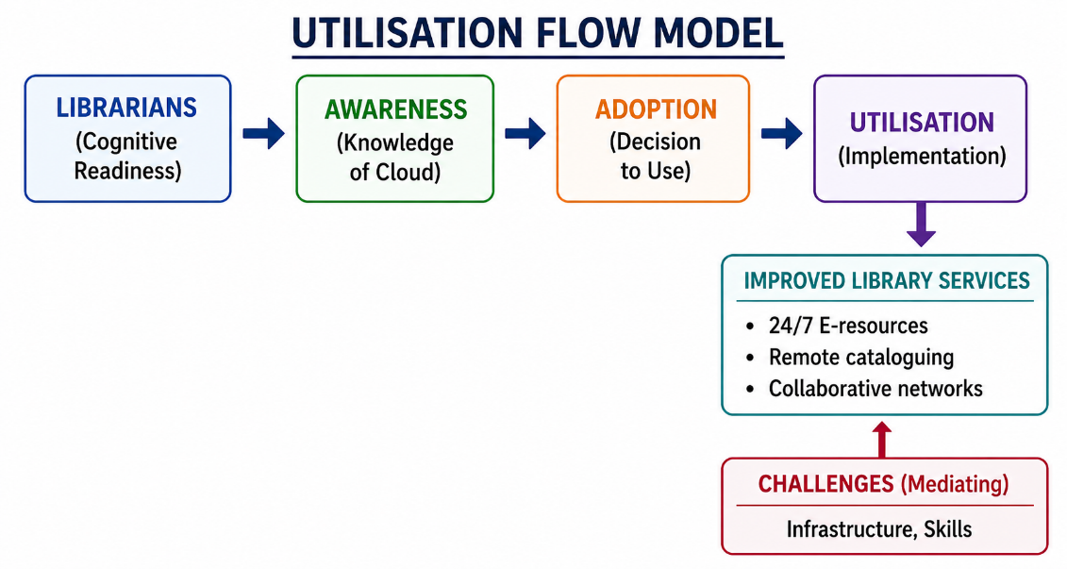
Figure 3: Utilisation Flow Model

7. RESULTS
This section presents the analysis of data collected from 88 librarians.
Table I: Awareness of Cloud Computing Technologies among Librarians
S/N | Items | N | X̄ | Std. Dev | Remark
1 | Awareness of SaaS (e.g., cloud-based ILS like Koha) | 88 | 3.21 | 0.67 | Accepted (High)
2 | Awareness of IaaS (cloud storage like Google Drive) | 88 | 3.45 | 0.55 | Accepted (High)
3 | Awareness of PaaS for library app development | 88 | 2.10 | 0.89 | Rejected (Low)
4 | Awareness of cloud-based digital repositories (e.g., DSpace) | 88 | 2.98 | 0.76 | Accepted (High)
5 | Awareness of data security protocols in cloud | 88 | 2.31 | 0.92 | Rejected (Low)
6 | Awareness of multi-tenancy in cloud services | 88 | 2.85 | 0.81 | Accepted (High)
7 | Awareness of subscription models for cloud libraries | 88 | 3.02 | 0.70 | Accepted (High)
8 | Awareness of API integration for cloud services | 88 | 2.22 | 0.88 | Rejected (Low)
9 | Awareness of regulatory compliance (NITDA cloud policy) | 88 | 2.68 | 0.79 | Accepted (High)
Aggregate Mean |  |  | 2.98 |  | High Awareness

Items 1, 2, 4, 6, 7 and 9 of Table I were accepted with mean scores above the 2.50 benchmark. This means that librarians in Anambra State are highly aware of general cloud concepts such as SaaS, IaaS, digital repositories and subscription models. However, items 3, 5, and 8 were rejected (means below 2.50), indicating low awareness of technical aspects such as PaaS, security protocols, and API integration. The aggregate mean of 2.98 confirms a generally high level of awareness among the librarians.
Table II: Extent of Utilisation of Cloud Computing for Library Services
S/N | Items | Group | N | X̄ | Std. Dev | Remark
1 | Using cloud-based ILS for cataloguing and circulation | Federal | 51 | 2.48 | 0.82 | Low Extent
 |  | State | 37 | 2.41 | 0.89 | Low Extent
2 | Using cloud storage (OneDrive/Dropbox) for library docs | Federal | 51 | 3.58 | 0.55 | Very High Extent
 |  | State | 37 | 3.51 | 0.62 | Very High Extent
3 | Hosting institutional repository on cloud platform | Federal | 51 | 2.01 | 0.88 | Low Extent
 |  | State | 37 | 1.94 | 0.95 | Low Extent
4 | Using cloud discovery tools (EDS, Primo) for OPAC | Federal | 51 | 2.25 | 0.81 | Low Extent
 |  | State | 37 | 2.16 | 0.88 | Low Extent
5 | Utilising cloud-based reference management (Zotero, Mendeley) | Federal | 51 | 2.70 | 0.74 | High Extent
 |  | State | 37 | 2.63 | 0.81 | High Extent
6 | Using cloud for remote access to e-databases (EBSCOhost) | Federal | 51 | 2.92 | 0.69 | High Extent
 |  | State | 37 | 2.85 | 0.76 | High Extent
7 | Using cloud for inter-library loan management | Federal | 51 | 1.88 | 0.85 | Low Extent
 |  | State | 37 | 1.81 | 0.92 | Low Extent
8 | Using cloud for patron authentication and analytics | Federal | 51 | 2.15 | 0.83 | Low Extent
 |  | State | 37 | 2.08 | 0.90 | Low Extent
Grand Mean & Std. Dev |  | Federal |  | 2.41 | 0.77 | Low Extent
 |  | State |  | 2.28 | 0.82 | Low Extent

Table II reveals a mixed but predominantly low utilisation pattern across both federal and state institution librarians. Item 2 (using cloud storage for library documents) was rated at a Very High Extent by both federal (X̄ = 3.58) and state (X̄ = 3.51) librarians. Items 5 and 6 (cloud-based reference management and remote access to e-databases) were rated at a High Extent by both groups, with federal librarians scoring slightly higher (X̄ = 2.70 and 2.92) than their state counterparts (X̄ = 2.63 and 2.85). However, items 1, 3, 4, 7, and 8 were rated at a Low Extent by both groups (mean scores ranging from 1.81 to 2.48), indicating low utilisation of core library services such as cloud-based integrated library systems, institutional repository hosting, discovery tools, inter-library loan management, and patron authentication. The grand mean for federal librarians (X̄ = 2.41) and state librarians (X̄ = 2.28) both fall within the Low Extent range, confirming that librarians from both federal and state institutions exhibit a low overall extent of utilisation of cloud computing for professional library services, with state librarians showing a marginally lower extent.
Table III: Benefits of Utilising Cloud Computing in Libraries
S/N | Items | N | X̄ | Std. Dev | Remark
1 | Enables 24/7 access to library resources | 88 | 3.78 | 0.45 | Accepted
2 | Reduces cost of local server maintenance | 88 | 3.65 | 0.52 | Accepted
3 | Facilitates resource sharing among institutions | 88 | 3.55 | 0.60 | Accepted
4 | Enhances data backup and disaster recovery | 88 | 3.48 | 0.63 | Accepted
5 | Improves collaboration among librarians | 88 | 3.30 | 0.71 | Accepted
6 | Provides automatic software updates | 88 | 3.22 | 0.75 | Accepted
7 | Increases scalability of library services | 88 | 3.12 | 0.80 | Accepted
Aggregate Mean |  |  | 3.44 |  | Strong Benefits

The means for all of the items in Table III were above 2.50 and an aggregate mean of 3.44. All of the librarians in the study believed that the benefits of cloud computing far outweighed the benefits of accessing library resources 24/7 (M = 3.78), cost reductions (M = 3.65), and resource sharing (M = 3.55).
Table IV: Challenges Affecting Utilisation of Cloud Computing in Libraries
S/N | Items | N | X̄ | Std. Dev | Remark
1 | Poor internet connectivity | 88 | 3.88 | 0.33 | Accepted
2 | Irregular power supply | 88 | 3.82 | 0.39 | Accepted
3 | Lack of adequate training on cloud platforms | 88 | 3.70 | 0.46 | Accepted
4 | High cost of data subscription | 88 | 3.55 | 0.55 | Accepted
5 | Fear of data privacy and security breaches | 88 | 3.40 | 0.62 | Accepted
6 | Inadequate institutional policy on cloud adoption | 88 | 3.35 | 0.68 | Accepted
7 | Low bandwidth allocation to libraries | 88 | 3.28 | 0.72 | Accepted
Aggregate Mean |  |  | 3.57 |  | Serious Challenges

All seven challenges recorded mean scores above 2.50, with an aggregate mean of 3.57. The most critical challenges are poor internet connectivity (3.88) and irregular power supply (3.82), followed by lack of training (3.70). These are perceived as serious impediments to cloud utilisation.
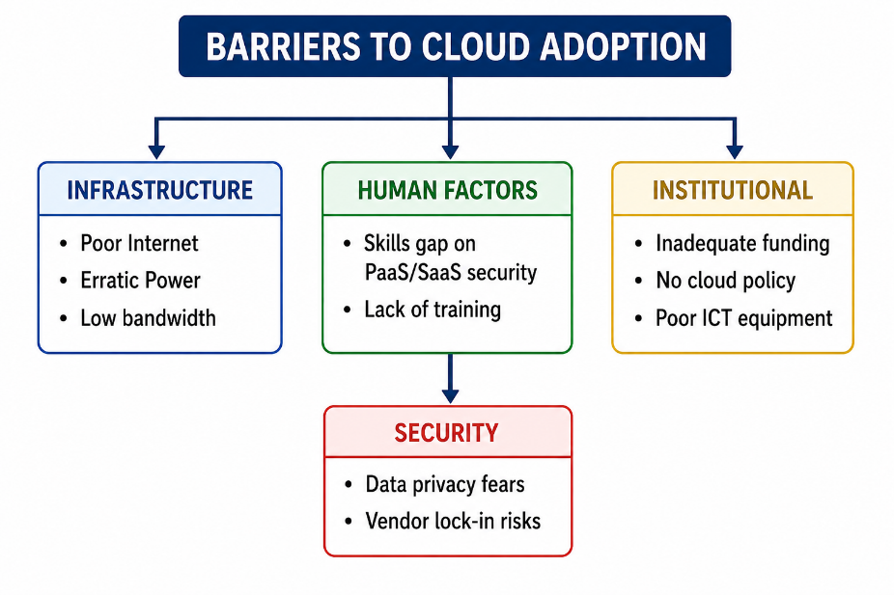
Figure 4: Barriers To Cloud Adoption in Libraries

8. TEST OF HYPOTHESIS
Ho₁: There is no significant difference between the mean responses of librarians in federal tertiary institutions and those in state tertiary institutions in Anambra State on the extent of utilisation of cloud computing technologies for library services.
Table V: Z-test Analysis of Federal vs. State Institution Librarians’ Utilisation
Institution Type | N | Mean (X̄) | Std. Dev | df | z-cal | z-crit | Decision
Federal | 51 | 2.41 | 0.56 | 86 | 1.24 | 1.96 | Accept Ho (Not significant)
State | 37 | 2.28 | 0.49

The calculated z-value (z-cal = 1.24) is less than the critical z-value (z-crit = 1.96) at the 0.05 significance level. Therefore, the null hypothesis is accepted. This means that there is no significant difference between the mean responses of librarians in federal institutions (X̄ = 2.41) and those in state institutions (X̄ = 2.28) regarding the extent of utilisation of cloud computing technologies. Both groups exhibited similarly low levels of utilisation.

9. DISCUSSION
The findings of this study reveal a critical disconnect between awareness and practice. Regarding research question one, librarians in Anambra State demonstrated high awareness of cloud computing, particularly general concepts like SaaS and IaaS. This aligns with the findings of Dumbiri et al. (2024) who reported high cloud awareness among Nigerian librarians in the South-South, but contrasts with earlier studies by Idahosa and Eireyi-Edewede (2023) that found that librarians in university libraries in South-South Nigeria have low level of awareness of cloud computing technology. The high awareness in Anambra may be attributed to increased internet penetration and mobile device usage among professionals. However, the low awareness of technical aspects (PaaS, API, security protocols Alabi et al., (2024).
The most striking finding is in research question two: despite high awareness, the extent of utilisation of cloud for core professional library services was low (aggregate mean 2.34). Librarians use basic cloud storage (e.g., Google Drive) and reference managers but fail to deploy cloud-based integrated library systems (ILS) or institutional repositories. The results are in agreement with the findings of Ejedafiru (2024) who found that librarians have knowledge of cloud-based technology but identified other issues such as inadequate technical skills, poor infrastructure, high cost, gaps in computing literacy, erratic power supply and poor maintenance culture. This “awareness-utilisation gap” is a direct consequence of the challenges identified in research question four. As shown in Table IV, poor internet connectivity (3.88) and erratic power supply (3.82) are not mere inconveniences but fundamental barriers that make real-time cloud adoption impossible for critical library services. This supports Haruna (2025) who observed that Nigerian libraries are caught in a “hybrid hell” where the cloud potential is recognised but the infrastructure impedes its realization.
On benefits, librarians strongly agreed on advantages of cloud computing, especially 24/7 access and cost reduction. Dumbiri et al. (2024) validated these advantages such as storage capacity, better performance, data security and low maintenance costs. The hypothesis test established that there is no significant difference in the utilisation of librarians in federal as well as state institutions. This contradicts the assumptions that federal institutions, with better funding, would have higher adoption. Dumbiri et al. (2024) studied only federal institutions and found low utilisation of professional cloud systems - identical to state institutions in the present study - confirming that both sectors suffer equally from poor broadband and unreliable electricity.

10. RECOMMENDATIONS
Based on the findings and the validated challenges, the following recommendations are made:
- Mandatory Technical Training: The National Library of Nigeria, in collaboration with the Librarians’ Registration Council of Nigeria (LRCN), should develop a mandatory certification program on cloud library systems (Koha, DSpace, FOLIO) focusing on PaaS, APIs, and security protocols, not just general awareness.
- Infrastructure-as-a-Utility for Libraries: The Anambra State Government through its ICT Agency should create a dedicated VSAT-backed, solar-powered internet backbone for all tertiary institution libraries, treating connectivity as a utility.
- Consortia-Based Cloud Subscription: All tertiary institutions in Anambra State should form a library consortium that will negotiate and subscribe to cloud based ILS and discovery tools at reduced rates and share the cost and technical support.
- Institutional Cloud Policy Mandate: Each institution’s management should issue a directive mandating the migration of all library digital assets (theses, journals, rare collections) to accredited cloud repositories within the next two academic sessions.
- Provision of Alternative Power: Libraries should be prioritised for independent solar inverter systems dedicated solely to powering cloud-access terminals and routers, separate from general university power.

11. CONCLUSION
This study conclusively established that while librarians in Anambra State possess a high level of general awareness of cloud computing technologies, the actual utilisation of these technologies for delivering modern library services remains dismally low. The findings underscore a dangerous paradox: knowing what is possible but being unable to achieve it due to infrastructural poverty. Poor internet connectivity, irregular power supply, and a lack of hands-on technical training are not peripheral issues but the central barriers preventing the digital transformation of libraries. The lack of meaningful difference between federal and state institutions suggests a systemic failure throughout the Nigerian educational sector. For libraries to transition from their current analog-digital hybrid state to genuine cloud-based information centers, a deliberate, multi-stakeholder intervention is required. This intervention needs to move from policy and workshop rhetoric to real investment in infrastructure and mandatory certification of skills. The future of library service in Anambra State depends on bridging the chasm between cloud awareness and cloud action.
12. REFERENCES
Alabi, C., Omekwu, C., & Martins, O. (2024). Adoption of Cloud Computing in Nigerian University Libraries: Challenges and Strategies. Niger Delta Journal of Library and Information Science, 5(1), 132-143.
Anyaoku, E. N., Echedom, A. U. N., & Baro, E. E. (2019). Digital preservation practices in university libraries: an investigation of institutional repositories in Africa. Digital Library Perspectives, 35(1), 41-64.
Davis, F. D. (1989). Perceived usefulness, perceived ease of use, and user acceptance of information technology. MIS Quarterly, 13(3), 319–340.
Dumbiri, R., Babatope, S., & Owairu, P. (2024). Awareness and Utilisation of Cloud Computing Technologies for Library Services: A Survey of Librarians in Colleges of Education Libraries in Nigeria. Niger Delta Journal of Library and Information Science, 5(2), 108-124.
Ejedafiru, E. F. (2024). Librarians' Awareness, Perceptions, and Adoption of Cloud Technologies in the Four State-Owned Universities of Delta State, Nigeria. Library Waves, 10(2), 122-135.
Ezeibe, R., Aloysius, D., & Richard, E. O. (2025). Cloud computing competencies of librarians and information service delivery in federal university libraries in South-South and South-East, Nigeria. International Journal of Research, 12, 34-48.
Haruna, A. (2025). Revitalizing Nigerian Libraries through Digital Infrastructure: A Blueprint for Equitable National Knowledge Access. Journal of Science Innovation and Technology Research.
Idahosa, M., & Eireyi-Edewede, S. (2023). Librarians’ awareness and attitude towards deployment of cloud computing technologies in university libraries in South-South Nigeria. International Journal of Librarianship, 8(1), 82-95.
Indraji, C., & Naikar, S. (2025). Application of cloud computing in libraries: Prospects and challenges. International Journal of Novel Research and Development (IJNRD), 10(2), 315-322.
Kolawole, A. (2023). The perception of librarians on cloud computing technology for library service delivery in public universities in Ekiti State, Nigeria. Asian Journal of Education and Social Studies, 48(3), 31-41.
National Institute of Standards and Technology (NIST). (2020). The NIST definition of cloud computing (SP 800-145). U.S. Department of Commerce.
National Information Technology Development Agency (NITDA). (2021). National cloud computing policy and implementation strategy. Federal Republic of Nigeria.
Rahmanova, A. (2025). Evolution of libraries in the digital era: Redefining access, education, and cultural preservation. Kütüphane Arşiv ve Müze Araştırmaları Dergisi, 6(1), 23-38.
Sunyaev, A. (2024). Cloud computing. In Internet computing: Principles of distributed systems and emerging internet-based technologies (pp. 165-209). Cham: Springer Nature Switzerland.

