National Education Policy 2020: An Assessment of Higher Educational Inclusion of Students with Disabilities in India
Author: Sagar Kumar Majhi.
(P.H.D) Research Scholar, Department of Political Science Berhampur University Ganjam Odisha.
Corresponding Author, Sagar Kumar Majhi.
Email Id. Sagarmajhi795@gmail.com

Abstract
Inclusive education has taken a center stage in the modern educational policy systems throughout the globe with the focus on fair access to good education by all learners irrespective of their physical, sensory, intellectual and socio-economic variations. Students with disabilities (SwDs) have traditionally had a hard time attending higher education in India because of the infrastructures, social stigma, unsuccessful institutional support, and policy implementation gaps. The National Education Policy (NEP) 2020 is a radical reform agenda aimed at changing the Indian education system by ensuring accessibility, equity, and inclusivity. Inclusion of socially and educationally disadvantaged groups such as students with disabilities in tertiary education institutions is one of the key areas of concern of the policy. This paper is a critical analysis of what NEP 2020 says in the area of disability inclusion in higher education and the level to which these provisions focus on the structural and institutional barriers confronting students with disabilities.
Keywords: Inclusive education, Students with disabilities (SwDs), National Education Policy (NEP) 2020, social stigma

Introduction
Education is one of the basic human rights and an important tool that can facilitate social inclusion, economic growth, and human empowerment. Availability of good education makes people able to realize their intellectual potential, to gain professional skills and to be active in social and economic life (Sharma et al., 2012). Education is particularly important to persons with disabilities as a means of structural inequalities overcoming and attaining independence and social mobility. Although the world is making efforts to ensure that all people enjoy inclusive education, people with disabilities have been facing obstacles to accessing education opportunities. Reports suggest that the percentage of disabled individuals who graduate to higher education is lower than the non disabled. These gaps are usually blamed on unavailable learning conditions, lack of support structures and social discrimination (Government of India, 2020). The engagement of students with disabilities in education in India has been a longstanding problem that was attributed to different structural and socio-economic factors. Despite a few legislative policies that have been implemented by India in efforts to ensure inclusion of disability, inequality in accessing higher education is still high. National census records have shown that a large percentage of people with disabilities in India have little access to education opportunities beyond secondary school. The bridge between school education and higher education is still a very difficult aspect among students with disabilities because of financial reasons, unavailability of facilities and institutions lack support. The Indian government has over the last several decades implemented a number of policy initiatives that would facilitate inclusive education (Government of India, 2016). The efforts comprise the Persons with Disabilities Act (1995), the Right to Education Act (2009), and the Rights of Persons with Disabilities (RPWD) Act (2016). The RPWD Act broadened the concept of disability greatly and the necessity to have inclusive education at all the levels of the educational system.
Methodology
The current research is founded on the data gathered through the diverse credible sources. They consist of the official National Education Policy 2020 document, the government policy reports, the scholarly journals and academic research papers on the topic of inclusive education, the reports of the disability advocacy organizations, and publications of higher educational establishments. These sources are extensive sources of information on policy frameworks, institutional practice and academic insights into including students with disabilities in higher education in India. In the study, content analysis and policy evaluation are used in conducting the analysis. The systematic study of the provisions and guidelines in the National Education Policy 2020 on disability inclusion is done through content analysis. Moreover, the procedures of policy evaluation are used to determine the effectiveness, and implications of such provisions to the institutions of higher learning.
Theoretical Framework: Disability and Inclusive Education
Inclusive education is a form of education that provides equal opportunities to learn to all students by eliminating workplace barriers which interfere with learning and performance. In contrast with the conventional models of education, which separate students with disabilities in their special institutions, inclusive education focuses on the inclusion of all learners in mainstream education systems (Singal, 2016). Inclusive education has a number of core principles under which it is based. The core values of the concept of inclusive education are equity and equality. The purpose of providing an inclusive educational system is to ensure that every learner, irrespective of his/her physical, cognitive and socio-economic background, has an equal access to educational resources as well as the full-fledged access to learning activities. Equity might not just mean giving equal treatment to students, but may mean having an appreciation of the varied needs of the students and having relevant support systems in place to help all the students to realize their academic potential. In the case of students with disability, this principle would mean that the institutions should eliminate systemic disadvantages and ensure that they receive the appropriate academic and social assistance where they can learn in an environment that acknowledges diversity and equity. Another important aspect of realization of inclusive education is accessibility. Schools need to make sure that the learning settings are available physically, technologically, and pedagogically. Physical accessibility means that there should be barrier-free infrastructure (ramps, elevators, tactile pathways, accessible classrooms) that can enable students with mobility impairment to move around campuses without assistance (Sharma & Deppeler, 2017). Universal Design of Learning (UDL) is another important concept that is linked with inclusive education. UDL is an instructional model, which encourages adaptable instructional methods and learning conditions that are intended to serve the various needs of every learner(Miles & Singal, 2010). Rather than changing educational practice once challenges have been identified, UDL prompts educators to prepare the curriculum, assessment systems, and teaching materials that can be readily available to as large a population of learners as possible. This would involve offering various forms of representation, expression, interaction in such a way that learners that have varied learning profiles and capabilities can learn in an effective manner (Sharma & Deppeler, 2017).
Evolution of Disability Inclusion in Indian Education Policy
The history of disability inclusion in education in India is a history of the social and political changes on the other hand. It was observed that early educational policies were majorly directed to segregated learning institutions of persons with disabilities. Nonetheless, the progressive trend in the global society to embrace inclusive education has had a slow impact on policy change in India. Persons with Disabilities Act of 1995 was the first legislative move to facilitate equal opportunities of persons with disabilities in India. The act focused on the access of education, employment and social welfare services to persons with disabilities. Later, the Right to Education Act of 2009 supported the inclusive education doctrine through ensuring that all children between the ages of six and fourteen years obtain free and compulsory education. Though this act mainly addressed the education in schools, it provided the background towards the inclusive education practices (United Nations, 2006). One of the biggest achievements in the field of disability rights was the adoption of the Right of Persons with Disabilities Act (RPWD), 2016, which increased the list of the officially accepted disabilities to twenty-one categories. The act requires schools to offer accessible infrastructures, assistive technologies, and reasonable accommodations to the disabled students. The National Education Policy 2020 is based on these legislative frameworks and aims at incorporating the idea of inclusive education throughout the educational system (UNESCO, 2020).
The Disability Inclusion in Higher Education and the National Education Policy 2020
The National Education Policy (NEP) 2020 proposes a number of significant implications that should fortify the role of students with disabilities in educational institutions of higher learning. This policy acknowledges the importance of eliminacy structuring of barriers that limit access to education and focuses on establishment of an equitable and inclusive academic environment. NEP 2020 aims to make students with disabilities fully engaged in higher education by making higher education more accessible, technologically supported, inclusively pedagogic, and institutionalized to meet the needs of students with disabilities (Figure 1).
Accessible Infrastructure
NEP 2020 has placed an emphasis on the creation of the barrier-free campuses to make the physical access to the disabled students more accessible. Schools and colleges are advised to implement mobility and independent infrastructure. This involves laying of ramps, elevators, tactile walkways to visually impaired students, accessible classrooms, and sanitation facilities that are friendly to the disabled. These infrastructural developments are vital in ensuring that students with disabilities move freely in the campuses and engage in activities in the campuses (World Bank, 2019).
Assistive Technologies
The policy emphasises the need to incorporate the use of assistive technologies in enhancing the learning accessibility among students with disabilities. Assistive technologies are important in facilitating learning in students with visual, auditory, and learning impairments as it allows them to access educational materials in different forms. They are screen readers, speech recognition software, audiobooks, captioning systems, and digital learning platforms. Such technologies can make the learning process of pupils with disabilities much more effective and decrease the obstacles on the way of academic engagement (World Bank, 2019).
Inclusive Pedagogy and Curriculum
NEP 2020 will encourage the use of an inclusive curriculum design and methods of teaching that embrace the diverse learning needs. The policy supports the educators to employ adaptive teaching methods that accommodate diverse students with different abilities and learning styles. These are visual learning aids, collaborative learning strategies and differentiate instruction strategies. Inclusive pedagogy would allow educational institutions to establish a learning environment in which every student can be exposed to academic material in a meaningful way (MHRD, 2019).
Teacher Training
It is found that teacher training is a very important element in the successful execution of inclusive education. NEP 2020 proposes that disability awareness and inclusive teaching methodologies should be incorporated in teacher education. The approach of training teachers on inclusive pedagogy provides a teacher with the competencies to learn the needs of learners with disabilities and to incorporate the right learning strategies to enable the student to learn effectively. (University Grants Commission, 2018).
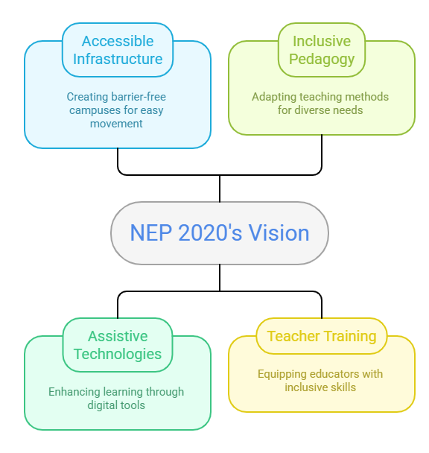
Figure 1: National Education Policy 2020 impact on higher education for student with disabilities
Challenges in Implementing Inclusive Higher Education
Even though NEP 2020 has progressive provisions, some challenges still remain in the way of successfully implementing inclusive higher education in India. These are issues associated with infrastructural constraints, financial constraints, a shortage of trained personnel, and social barriers that inhibit the involvement of the students with disability (Figure 2).
Infrastructural Barriers
The weaknesses of the institutions of higher learning in terms of accessibility infrastructure are one of the key challenges. Many colleges and universities still do not have the basic amenities including ramps, elevators, touch-sensitive walkways and accessible classes. Such infrastructural constraints render mobility impaired students hard to journey in campus environments, and to be an active group engaged in academic endeavors (Borg et al., 2011).
Financial Constraints
It takes a lot of financial investment in infrastructure development, assistive technologies, and support service to implement inclusive education. Most organizations are financially constrained and they cannot afford to have such facilities. Consequently, the level of assistive technologies and access resources can be insufficient (MHRD, 2019).
Lack of Trained Faculty
The other significant issue is lack of faculty members who are trained on inclusive pedagogy. Most teachers do not have adequate knowledge and skills on how to meet the learning needs of students with disabilities. Educators cannot develop supportive and accessible learning environments without the necessary training in the area of inclusive teaching practices (Rao et al., 2014).
The Attitudes of Society and Culture
There are also social and cultural misunderstandings of disability that are a strong impediment of inclusion. There is a possibility that negative attitudes and stereotypes about persons with disabilities can result in the phenomenon of discrimination and marginalization in schools. These perceptions may have an impact on the academic self-esteem and social inclusion of the disabled students (WHO & World Bank, 2011).
Policy Implementation Gaps
Despite the policies supporting the implementation of inclusive education, their application is usually different in different institutions. Lack of coordinated effort, weak monitoring mechanisms and poor institutional accountability may create gaps in policy provisions and actual practice. These challenges of implementing inclusive higher education have to be addressed so that the objectives of inclusive higher education can effectively be achieved (Miles & Singal, 2010).
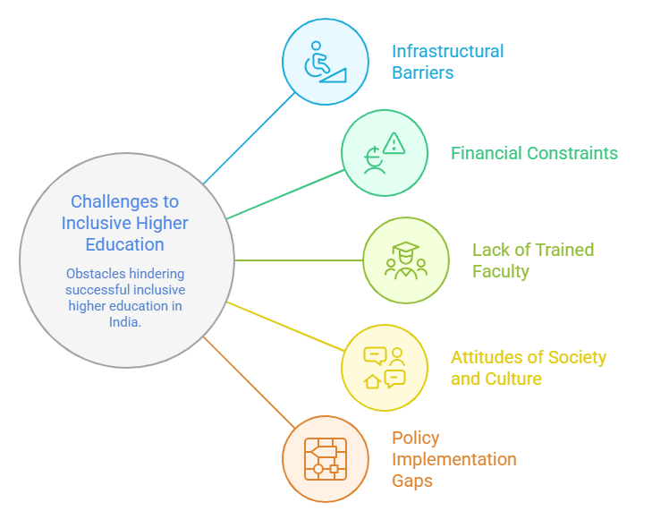
Figure 2: Challenges in Implementing Inclusive Higher Education
Policy Recommendations
A few key policy interventions are necessary in enhancing the inclusion of the disabled in higher learning institutions. Increasing financial assistance on accessibility infrastructure and assistive technology is one of the most important steps. Proper financing would help the institutions create barrier free campuses and availability of learning resources and the use of technological resources that could assist students with disabilities. The other significant step is to set up disability support centers, which are obligatory in every institution of higher learning. These facilities can be used to offer academic counseling, assistive technology, and guidance support services to students with disabilities enabling them to successfully engage in education and campus life (Rao et al., 2014). Also, it is necessary to introduce extensive training programs on educators to encourage inclusive education. Adaptive pedagogy and inclusive classroom settings should be made available to faculty members so that they can be prepared to meet the needs of various learners using adaptive teaching methods. The emergence of easily available digital learning systems is also imperative in the contemporary education. Learning management systems, online resources, and digital content can be very beneficial in improving educational access among the students with visual and auditory disabilities as well as learning disabilities (Rose & Meyer, 2002).
Conclusion
The National Education Policy 2020 is a revolutionary project which is meant to foster inclusive and equitable education in India. The policy aims at providing an educational setting that meets the needs of the learners in various ways because it focuses on accessibility, inclusive pedagogy, and technological integration. Nevertheless, meaningful inclusion takes years of commitment by the policy makers, schools and the entire society. Infrastructural barriers, teacher training, and proper policy implementation are the critical issues that can be discussed to enhance access to higher education among people with disabilities to NEP 2020 and help establish a more inclusive and equal society.
References
- Borg, J., Lindström, A., & Larsson, S. (2011). Assistive technology in developing countries: A review from the perspective of the Convention on the Rights of Persons with Disabilities. Prosthetics and Orthotics International, 35(1), 20–29. https://doi.org/10.1177/0309364610389351
- Government of India, Ministry of Education. (2020). National education policy 2020. Government of India. https://www.education.gov.in
- Government of India. (2016). The Rights of Persons with Disabilities Act, 2016. Ministry of Law and Justice. https://legislative.gov.in
- MHRD. (2019). All India survey on higher education (AISHE) report 2018–2019. Ministry of Human Resource Development, Government of India.
- Miles, S., & Singal, N. (2010). The education for all and inclusive education debate: Conflict, contradiction or opportunity? International Journal of Inclusive Education, 14(1), 1–15. https://doi.org/10.1080/13603110802265125
- Rao, K., Ok, M. W., & Bryant, B. R. (2014). A review of research on universal design educational models. Remedial and Special Education, 35(3), 153–166. https://doi.org/10.1177/0741932513518980
- Rose, D. H., & Meyer, A. (2002). Teaching every student in the digital age: Universal design for learning. Association for Supervision and Curriculum Development.
- Sharma, U., & Deppeler, J. (2017). Integrated education in India: Challenges and prospects. International Journal of Inclusive Education, 21(3), 295–310. https://doi.org/10.1080/13603116.2016.1197320
- Sharma, U., Loreman, T., & Forlin, C. (2012). Measuring teacher efficacy to implement inclusive practices. Journal of Research in Special Educational Needs, 12(1), 12–21. https://doi.org/10.1111/j.1471-3802.2011.01200.x
- Singal, N. (2016). Education of children with disabilities in India and Pakistan: Critical analysis of developments in the last 15 years. Prospects, 46(1), 171–183. https://doi.org/10.1007/s11125-016-9383-3
- UNESCO. (2020). Global education monitoring report 2020: Inclusion and education – All means all. UNESCO Publishing.
- United Nations. (2006). Convention on the rights of persons with disabilities. United Nations.
- University Grants Commission. (2018). Guidelines for higher education institutions for students with disabilities. UGC, Government of India.
- WHO & World Bank. (2011). World report on disability. World Health Organization.
- World Bank. (2019). Disability inclusion and accountability framework. World Bank.

