Enhancing Fraud Detection in Banking With Deep Learning: Graph Neural Networks and Auto encoders for Real-Time Credit Card Fraud Prevention

Katuri Keerthi Naidu Assistant professor in CSE Annamacharya University Rajampet India
katurikeerthinaidu@gmail.com
Dr.P.Changamma Assistant professor in CSE Annamacharya University Rajampet India
changammapolicherla16@gmail.com
Akhil Kumar Reddy Yanamala Department of CSE Annamacharya Institute of Technology and Sciences Rajampet India akhi4uy@gmail.com

Ajay Ganthala Department of CSE Annamacharya Institute of Technology and Sciences Rajampet India sh8v5a1@gmail.com
Abhishek Aenumala Department of CSE Annamacharya Institute of Technology and Sciences Rajampet India abhishekaenumula@gmail.com
Ajay kumar Mallepalli Department of CSE Annamacharya Institute of Technology and Sciences Rajampet India mallepalliajaykumar4@gmail.com

Abstract-Deep learning is an artificial intelligence (AI) subfield that could deliver effective skills in the processing of complex data and enhance prediction quality. This paper discusses its applications to banking fraud detection, its Graph Neural Networks (GNNs) and Autoencoders specialization. The GNN- based lambda architecture of real-time fraud detection and the Autoencoder based model of detecting anomalies in credit card transactions are some suggestions that we are making. The methods are validated according to the transaction data of two financial institutions and can demonstrate high performance with the balancing of the accuracy and recall. Python implementation is dynamic and capable of analysing large datasets hence offering a real time decision making. Our findings indicate that deep learning has a prospect of improving the fraud prevention systems and improving the working efficiency of the banking environment..
Keywords—Deep learning, credit card fraud, Graph Neural Networks (GNNs), Autoencoders, anomaly detection.

INTRODUCTION
Banking fraud can be rather long-term, and it comprises identity theft, credit card fraud, check fraud and account takeovers, and phishing attacks [1]. Fraud detection systems that can potentially analyze a transaction in real time are also adopted as part of the
effort by financial institutions to mitigate these threats, thereby detecting suspicious activity in a short period of time[2].Other methods of strong customer authentication are also in place, such as two-factor authentication(2FA) and biometric verification[2].
This notwithstanding, a huge challenge of fraud detection is still facing banks [3]. The rule based methods are also not effective since the fraudsters are continuously moving their methods in order to exploit the loophole within the system. The huge volumes of daily transactions also make it hard to spot, manual inspection is too long and it is not sufficient to show subtle anomalies. In addition, the institutions need to strike a balance between fraud prevention and customer convenience; too strict limits will create a false-positive and interfere with the legitimate users.
Deep learning has become a potential solution to such problems [4]. Through the use of sophisticated algorithms, such models can handle large amounts of data and can be trained using historical data on transactions [5], which can help to find unusual transactions that can be signs of fraud. Notably, deep learning systems evolve throughout their lifespan since they are exposed to new data, thus they are robust to the changing fraud schemes [6]. They also minimize false positives because they make use of contextual information in decision making.

In this work, the authors examine the detection of fraud on credit card transactions with the help of Graph Neural Networks (GNNs) and Autoencoders. The most important contributions are the following:
- Deep learning application to graph structures to identify fraudulent online transactions.
- Posting of a GNN based lambda architecture of real time fraud detection and an Autoencoder based methodology of anomaly detection of credit card usage.
- Case study validation of the proposed models by use of transaction data of two Pakistani banks.

- Comparative studies bringing out the difference between the current practices of operation and new deep learning based practices.

LITERATURE REVIEW
Machine learning (ML) and deep learning (DL) methods have been widely used in detecting fraud in the banking industry. Nevertheless, the current methods are typically limited in terms of scalability, flexibility, and precision. Table 1 summarizes the main contributions by the previous studies as well as their limitations.
Ref. Name | Technique Method Used | Limitations
Bao et al. [7] | Machine learning and deep learning sentiment detection; random forest and big data analytics. | Concentrated on analysis of tone of satisfaction and not  financial fraud; no model specific to fraud.
Mahalle et al. [8] | ML & DL in business intelligence; big data management | Problems with working with large volumes of data; the absence of a specific fraud detection infrastructure.
Recent advancements [9][10] | Behavioural models, biometrics, ML, DL models. | Difficulty in  changing the fraud patterns; lack of real-time flexibility.
Liu et al. [13]  – HA-GNN | Attention  modules and adjacency | High  computational cost; complex

 | matrices Hierarchical Attention GNN. | design increases inference time.
Kanan et al. [11] | GNN vs. tree- based models | GNN is more precise and takes more time to inquire.
Bouguettaya et al. [12] | Multi-view heterogeneous GNN  propagation of labels. | Relies on the quality of the graphs; large  datasets have scalability  problems.
CSO-DCNN [7] | Competitive Swarm Optimization + Deep CNN | The performance is not similar in all areas; needs huge amounts of data and  optimization.
Achary & Shelke [13] | ANN, SVM,  Logistic Regression, Random Forest | Accuracy topped at  around 92; monitored approaches require labelled information and do not work on  concealed fraud.
Liu et al. [14] | DL + BI  integration framework | Theoretical model; does not have practical fraud detection  implementation.
Liu et al. [15] | Autoencoder + Variational Autoencoder (VAE) | The methods  based on  reconstruction do not work in those cases when fraud is similar to  transactions.
Bukhori et al. [16] | Autoencoder + Decision Tree | The performance of AE  reconstruction; generalization is limited with  respect to evolving fraud.
- Methodology (Problem statements, Algorithms, Architecture)
  - Problem Statement

Credit card detection in the banking sector has been an extremely complicated and dynamic issue. The fraudsters evolve at a high rate and sometimes they evade customary rule-based detection systems that use fixed patterns. Simultaneously, data produced by banking institutions comprises of enormous and constantly evolving datasets that are highly unbalanced, with the true transactions significantly exceeding the fraudulent ones. Such disparity renders the manual inspection infeasible and constrains the performance of traditional supervised learning methods.
An additional layer of complexity appears with real- time detection because systems have to work with very low latency, and also must be highly accurate. Current machine learning and deep learning systems are often unable to capture the latent relational relationships between accounts, merchants, and transactions which are vital in detecting organized fraudulent activity. Therefore, there is an urgent requirement of the integrated deep learning framework capable of processing both past and real- time data, adjust to the change of fraud tactics, and provide a stable work in the banking setting.
The purpose of this paper is to propose and test such a framework with the following objectives, which will improve accuracy in the detection task, minimize false positives, allow real-time decision-making, and be scalable to work with large and dynamic financial data.
  - Dataset Preparation
The data that was used to study in this paper was sourced in Pakistan in Meezan Bank and UBL Bank. It comprises 284,807 transactions, where there are 492 transactions that are fraudulent, which makes the imbalance of legitimate and fraudulent cases severe. Every transaction has time, amount, merchant, cardholder and card metadata. In order to deal with the skewed distributions, Min-Max Scaling was used to normalize the data. To train and evaluate the model, the dataset was split into two, the first 11 months of the transactions training the historical model and the last month of data was left as real time test data. This division makes sure that the models are tested on the unknown and temporally related data which is simulating the conditions of real world deployment.
  - Algorithms Used
    - Graph Neural Network (GNN)
The intricate nature of transaction, account and merchant relationships with one another was captured using Graph Neural Networks. GNNs use graphs to model interactions and identify hidden patterns of frauds unlike the traditional model which treats each transaction separately. The GNN used in this research was built to work with semi supervised node classification such that the model can learn using both labeled and unlabeled data.
Key techniques integrated into the GNN include: Increase its effectiveness of fraudulent transactions detection in dynamic banking settings. To begin with, the temporal transaction graphs were modeled to depict sequencing activity to enable the model to capture the change in behavior with the passage of time. The Gated Temporal Attention Network (GTAN) was used to add more effectiveness to the consideration of temporal dependencies, which allowed learning time-related information during sequence transactions. The graph learning based on attributes was also used to infuse transaction specific features directly in the graph structure, so that the contextual information like the merchants and cardholder attributes were part of the learning process.
The graph message passing was used in obtaining relational modeling to enable transfer of information across the interconnected nodes and better detecting of concealed fraud. In order to deal with the limited number of labeled data, masked label learning was proposed, which enabled the model to utilize partially labeled graphs and remain robust. Lastly, multi-head temporal attention was incorporated to enhance feature extraction and enhance detection accuracy every aspect of temporal and relational dependencies at the same time. The combination of these methods formed a GNN architecture that could accurately detect a fraudulent behavior in a real-time situation and model intricate transaction networks.
This structure enables the GNN to detect patterns of fraud that develop over a period of time and on a collection of accounts which would be quite useful in detecting real time fraud.
    - Autoencoder
Autoencoders were also used as an unsupervised method of detecting anomalies. The model is taught the normal distribution of transaction behavior and anomalies are detected in terms of reconstruction

error. The transactions that differ a lot with the learned ones are identified as possible fraud.
The Autoencoder consists of three main components:
- Encoder – compresses transaction features into a lower-dimensional representation.
- Latent bottleneck layer – captures the essential characteristics of normal transactions.
- Decoder – reconstructs the original input from the latent representation.
Anomaly score is the difference between the input and reconstructed output which is calculated using the Mean Squared Error (MSE). Those transaction with high error are regarded as fraudulent whereas those with low error are considered as genuine. This method is especially useful in disequilibrium datasets, where it does not use extensive volumes of frauds data indicated as such.
  - Algorithms
Past research studies have examined several algorithms that can be used to detect fraud and analyze anomalies. Random Forests and other deep learning models have been used as conventional machine learning methods to work with large data sets and attain a high level of robustness and accuracy in their work as sentiment detectors and so on [7]. Nevertheless, these methods were not created with financial fraud in mind so their application is not as broad.
In business intelligence, the ML and DL models have been applied in the management of large volumes of data and decision making [8]. Although these methods are scalable, they do not have a specific fraud detection framework. The more recent works have incorporated behavioral analysis, biometrics, and deep learning models to banking systems [9][10] to offer real time detection and to adapt to emerging fraud patterns, but dealing with newer techniques has remained a challenge.
Graph based methods have attracted attention due to their capability of modeling the complex relationships. The Hierarchical Attention based GNN (HA GNN) of Liu et al. [13] has multi level attention mechanisms, which are used to model transaction graphs to enhance the detection accuracy, but it consumes substantial computational resources. In a similar way, Kanan et al. [11] has shown that GNNs are better than tree based models in classification tasks, but their inference time is higher. Bouguettaya et al. [12] followed this effort with a multi view heterogeneous GNN with label propagation with superior accuracy that had a problem with scaling with extremely large datasets. There are also suggestions of hybrid deep learning models. The CSO DCNN architecture [16] is a hybrid of Competitive Swarm Optimization and Deep
Convolutional Neural Networks and provides good performance in terms of anomalies detection in domains including insurance, credit card fraud and so on. ML comparisons Classical ML comparisons between Achary and Shelke [13] revealed that deep learning models presently outperform ANN, SVM, and Logistic Regression with a high of 92% precision, however, supervised learning still relies on labeled data.
Autoencoder based approaches are popular in detecting anomaly. Liu et al. [15] used VAE to detect credit card fraud and they performed better than traditional anomaly detectors as they are able to learn the complex nonlinear patterns. Bukhori et al. [16] used the Autoencoders with Decision Trees to come up with the interpretable models with better performance, and performance is largely influenced by reconstruction quality. The temporal modeling has been studied too: The Temporal Graph Attention Network (TGAT) proposed by Xu et al. [17] is able to capture time sensitive fraud behavior, and Stacked Denoising Autoencoders by Vincent et al. [24] can be used to detect fraud even when the data is noisy.
Although the simple ML and DL models give good baselines, they may not adequately describe the relationship dependencies present in financial transactions. The aspect of fraudulent activity is not thought out in a vacuum and as such, it entails a cluster of accounts, traders and recurring patterns of transactions. It is of particular use to graph based approaches, which are able to represent such relationships directly. The GNNs computing expensive and the complexity of graph construction are however impediments to application in the real world especially in large banking systems. Autoencoders are however better at identifying anomalies without supervision which is needed, as the quantity of data of fraud labeled with labels is small. They are able to identify the deviations with the knowledge of the normal transactions distribution without having to waste a lot of time manually labeling the deviations. Nevertheless, reconstruction based methods fail in some instances when there is a close relationship between the fraudulent and real behaviour. The latter disadvantage promotes hybrid approaches, which apply Autoencoders to other classifiers (or portions thereof) into larger structures.Our work is based on these findings as it combines GNNs to model relationships with Autoencoders to detect anomalies, resulting in a single framework that allows us to balance scalability, accuracy, and adaptability. The two-fold strategy enables us to identify fraud trends on the network of transactions and at the same time trace abnormalities in the use of individual credit cards. Through testing the models using real banking data

we show that this integration offers a realistic solution to both the historical analysis and real time fraud prevention.
  - Architecture
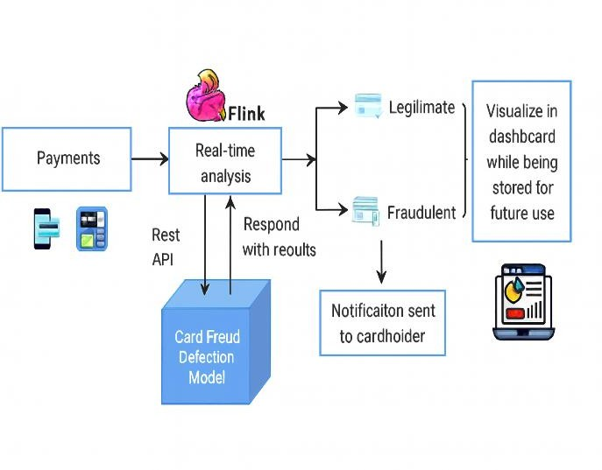

Fig. 1. Real-time payment fraud detection system architecture using streaming analysis and notification workflow.
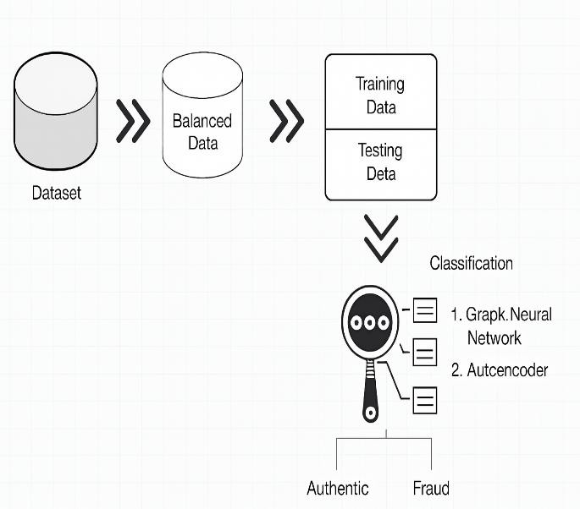
Fig. 2. Machine learning pipeline for fraud detection including data balancing, training, testing, and classification.
- Experimental results (Proposed outcomes)
The suggested framework was compared with two complementary models a Graph Neural Network (GNN) with the Gated Temporal Attention Network (GTAN) and an Autoencoder to detect anomaly- related transactions based on the reconstruction error.Two real banking datasets were used to measure the performance of the proposed framework. under varying conditions.
  - GNN Experimental Results
The GTAN model was evaluated using Average Precision (AP), Area Under the Curve (AUC), and F1-macro scores across different labeled-data training ratios ranging from 10% to 80%. The results demonstrate that GTAN consistently outperforms baseline approaches across all ratios. Even with only 10% labeled data, the model achieved significantly higher AUC scores compared to competing methods. The performance improved further as the percentage of labeled data went up to 50-80%, which proves the scalability of the method. It is important to note that the UBL dataset was found to be not very sensitive to the changes in trainings ratios, so the variance was not more than 2%, which also demonstrates the strength of GTAN even when the training is done on small labeled sets. Overall, the experiments confirm that GTAN delivers stable and reliable performance under limited supervision.
Ablation study was carried out in order to examine more the contribution of the separate components. Three different variants were tested, which included; GTAN A (attribute only), GTAN R (residual based) and entire GTAN model. The complete model always reported the highest scores in AP and AUC indicating that combining attribute and residual learning is important. Two layers of GNN gave the best performance, and architecture depth resulted in over smoothing and worse performance. Propagation mechanism was discovered to be especially productive in seizure and representation of pattern in fraud over time, which justifies the worth of the complete GTAN design. These results support the fact that the combined GTAN design offers greater fraud detection than the incomplete ones.
  - Autoencoder Experimental Results
The Autoencoder was evaluated using reconstruction error, confusion matrices, precision–recall curves, and AUC metrics. For these experiments, 26 attributes were available, but only three—transaction time, amount, and status—were selected to reduce dimensionality. The dataset was split into 80% for training and 20% for testing, with Min–Max scaling applied to address imbalance.
The Autoencoder was able to identify all the 306 fraud cases on the training set consisting of the 3,000 transactions and correctly classified 2,694 of the genuine transactions with only 7 false positives of genuine transactions. This gave a 99.76% accuracy in training. The model was again found to identify all

the 217 cases of fraud and 1,778 genuine transactions and only five false positives on the testing set of 2,000 transactions and a testing accuracy of 99.75%. Reconstruction error analysis showed that there were distinct fraud and real transactions. The cases of frauds showed significant errors in reconstruction continually, whereas valid transactions had low levels of error, thus the anomalies can be accurately detected by setting a threshold. Precision-threshold analysis also revealed that adding more classification threshold to the model caused the model to become more conservative but minimally decreased true positives and more false negatives. Both sensitivity and specificity are attested by the high AUC values, which prove a good separation of fraudulent and non fraudulent transaction.
  - System Output for Real-Time Fraud Detection
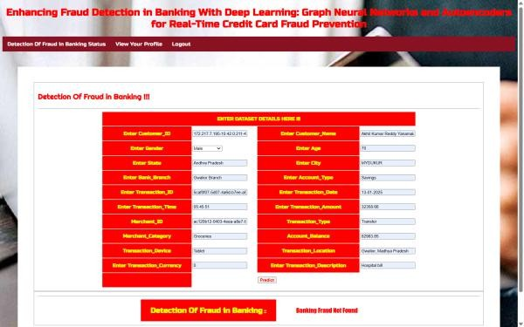
Fig. 3. The proposed framework of fraud detection experimental output where predicted results and analytical output of transaction details are shown on the monitoring dashboard.
- Challenges and Future work
The sphere of experience of banking system fraud detection is complicated by numerous issues that should be resolved, to guarantee the stable and scalable use of machine learning and graph-based systems. One of the main challenges is the dynamism of the techniques of fraud. The fraudsters are continuously improving their methods and will render the machine learning model and the rule-based systems that are not adapted inefficient in the future. This calls on new flexible structures, which are able to learn on the basis of new trends.
The other significant challenge is the highly skewed nature of banking information. The ratio of fraud cases is generally far too small relative to the overall activity, which leads to bias in the training and it
lowers detectives. Moreover, minimal-latency real- time-detecting is computationally costly, especially when operating a deep learning model such as Graph Neural Networks (GNNs), which have a reputation of being very complicated to run.
Graph-based models remain a significant issue in terms of scalability. GNNs need to process millions of nodes and edges when applied to a large network of banks, which is computationally infeasible on real time networks. This is further complicated by the fact that dynamic, temporal transaction graphs cannot be constructed without much thought and a great deal of computing power to offer good relational modeling. Another sensitive point is fraud detection vs. customer convenience. Too many detection systems may wind up labelling non-malicious transactions and thus leave a poor user experience and reducing trust in the system. Furthermore, it is also true that the quality of the available data determines the success of deep learning models. Unresolved attributes, incorrect inputs and inconsistent metadata might drastically worsen the performance of the model.
The fact that semi-supervised and unsupervised learning models, such as GNNs and Autoencoders, are used, also limits their usage by the relatively small amount of labeled instances of fraud. This affects generalization and optimization of models. In addition, the training and the inference time of the computations may need high-performance devices particularly in temporal GNN models like GTAN and TGAT, which may not always be affordable in every institution. Finally, the adoption of these advanced models into the existing banking system would create a logistical issue as well as a financial one that would require the system to be revamped and its expansion to the tune of big ticket.
There are several research opportunities available in a prospective look. The detection accuracy can be enhanced through incorporation of other deep learning models such as the hybrid anomaly detectors and the rule based systems. The retraining on a periodical foundation of the model, with the now titled transactions is required to capture the new fraud patterns. The framework can also be extended to the rest of the areas, which include money laundering, phishing, account takeover, and insurance fraud.
Application of such models to real life production systems is also a significant activity and is also a

concern of optimization of storing of graphs, messages and update processes that can handle the large amounts of transactions. The other concern is that the accuracy of GNN architectures should be improved since the level of their performance does not always reflect the potential level of performance in real life. The application of the information given by the deep learning and the business intelligence tools could also help in making decisions in the realm of banking operations. In addition, a more extensive set of features, such as the metadata of devices, their location history, and cross-channel behavior may become useful to increase the fraud detection. New technologies such as federated learning can be used to take up future directions in the field of secure, distributed model training across institutions without violating the privacy of data. Lastly, transparency can be improved through the use of explainable AI (XAI), which will enable risk analysts and auditors to make better sense of fraud decisions.
- Conclusion
This paper has shown that deep learning methods are effective in strengthening fraud detection in the banking industry. Combining Graph Neural Networks (GNNs) with temporal attention mechanisms and Autoencoders to detect anomalies, we offer a unified framework, which is able to process relational and transactional data. Through experimentation, it has been established that the proposed models are highly accurate, robust on few labeled data, and the models separate fraudulent and genuine transactions.
This work has two folds of contribution: 1) the GNN supported lambda architecture can be applied to detect changing patterns of frauds in network of transactions in real time; 2) the Autoencoder model can be used to detect anomalies in highly imbalanced datasets with high level of confidence. Combined, these strategies minimize false positives, increase the accuracy of detection, and assist financial institutions in scalable fraud prevention.
To conclude, the application of deep learning to business intelligence is an effective and viable avenue to the current fraud detection processes. Banks that use artificial intelligence to process dynamic financial data will be able to improve security, efficiency, and keep up with the ever- changing environment of financial fraud.
- References
- P. Tiwari, S. Mehta, N. Sakhuja, J. Kumar, and
A. K. Singh, ‘‘Credit card fraud detection using machine learning: A study,’’ 2021, arXiv:2108.10005.
- T. Micro, ‘‘Deep security? Software,’’ Tech.
Rep., 2020.
[3]G.K.Kulatilleke,‘‘Challengesandcomplexitiesinma chinelearningbased credit card fraud detection,’’ 2022, arXiv:2208.10943.
- S. K. Hashemi, S. L. Mirtaheri, and S. Greco, ‘‘Fraud detection in banking data by machine learning techniques,’’ IEEE Access, vol. 11, pp. 3034–3043, 2023.
- R. B. Sulaiman, V. Schetinin, and P. Sant, ‘‘Review of machine learning approach on credit card fraud detection,’’ Hum.-Centric Intell. Syst., vol. 2, nos. 1–2, pp. 55–68, 2022.
[6]E.Btoush,X.Zhou,R.Gururaian,K.Chan,andX.Tao,‘ ‘Asurveyoncredit card fraud detection techniques in banking industry for cyber security,’’ in Proc. 8th Int. Conf. Behav. Social Comput. (BESC), Oct. 2021, pp. 1–7.
- Y. Bao, G. Hilary, and B. Ke, ‘‘Artificial intelligence and fraud detection,’’ in InnovativeTechnologyattheInterfaceofFinanceandOp erations,vol.1, 2022, pp. 223–247.
- A. Mahalle, J. Yong, X. Tao, and J. Shen, ‘‘Data privacy and system security for banking and financial services industry based on cloud computing infrastructure,’’ in Proc. IEEE 22nd Int. Conf. Comput. Supported Coop erat. Work Design ((CSCWD)), Nanjing, China, May 2018, pp. 407– 413, doi: 10.1109/CSCWD.2018.8465318.
- N. Karkashadze, G. Shanidze, M. Shalamberidze, and S. Mikabadze, ‘‘Modern challenges in agribusiness,’’ Int. J. Innov. Technol. Economy, vol. 2, no. 38, Jun. 2022, doi: 10.31435/rsglobal_ijite/30062022/7828.
- F. Manessi, A. Rozza, and M. Manzo, ‘‘Dynamic graph convolutional networks,’’ 2017, arXiv:1704.06199.
- T. Kanan, A. Mughaid, R. Al-Shalabi, M. Al- Ayyoub, M. Elbes, and O. Sadaqa, ‘‘Business intelligence using deep learning techniques for social media contents,’’ Cluster Comput., vol. 26, no. 2, pp. 1285–1296, Apr. 2023, doi: 10.1007/s10586-022-
03626-y.
- A. Bouguettaya, H. Zarzour, A. Kechida, and A.
M. Taberkit, ‘‘Machine learning and deep learning as

new tools for business analytics,’’ in Hand book of Research on Foundations and Applications of Intelligent Bus. Analytics, 2022, doi: 10.4018/978-1- 7998-9016-4.ch008.
- Y. Liu, Z. Sun, and W. Zhang, ‘‘Improving fraud detection via hierarchical attention-based graph neural network,’’ J. Inf. Secur. Appl., vol. 72, Feb. 2023, Art. no. 103399, doi: 10.1016/j.jisa.2022.103399.
- H. A. Bukhori and R. Munir, ‘‘Inductive link prediction banking fraud detection system using homogeneous graph-based machine learning model,’’ in Proc. IEEE 13th Annu. Comput. Commun. Workshop Conf. (CCWC), Mar. 2023, pp. 246–251, doi: 10.1109/CCWC57344.2023.10099180.
- Z. Li, B. Wang, J. Huang, Y. Jin, Z. Xu, J.
Zhang, and J. Gao, ‘‘A graph-powered large-scale fraud detection system,’’ Int. J. Mach. Learn. Cybern., vol. 15, no. 1, pp. 115–128, Jan. 2024, doi: 10.1007/s13042 023-01786-w.
- T. Karthikeyan, M. Govindarajan, and V. Vijayakumar, ‘‘An effective fraud detection using competitive swarm optimization based deep neural network,’’ Measurement, Sensors, vol. 27, Jun. 2023, Art. no. 100793, doi: 10.1016/j.measen.2023.100793.
- R. Jain and S. Deshwal, ‘‘Anomaly detection in bank transactions using machine learning,’’ Tech. Rep.
- R. Achary and C. J. Shelke, ‘‘Fraud detection in banking transactions using machine learning,’’ in Proc. Int. Conf. Intell. Innov. Tech nol. Comput., Electr. Electron. (IITCEE), Jan. 2023, pp. 221–226, doi: 10.1109/IITCEE57236.2023.10091067.
- R. Koldehofe, J. Treder, and A. Wagenknecht, ‘‘A design science research agenda,’’ in Proc. 15th Int. Conf. Wirtschaftsinformatik, vol. 1, 2019, pp. 1378–1392. [Online]. Available: https://aisel.aisnet.org/wi2019/1378/
- J. H. Kim, H. Y. Kim, and Y. H. Kim, ‘‘Credit card fraud detection,’’ Tech. Rep., 2020.
- J. Lewandowski and M. Ossowski, ‘‘Non- singular extension of the Kerr NUT-(anti) de sitter spacetimes,’’ 2021, arXiv:2101.05802.
- S. Bhattacharyya, S. Jha, K. Tharakunnel, and J.
C. Westland, ‘‘Data mining for credit card fraud: A comparative study,’’ Decis. Support Syst., vol. 50, no. 3, pp. 602–613, Feb. 2011. [23] S. Xiang, D.
Cheng, C. Shang, Y. Zhang, and Y. Liang,
‘‘Temporal and heterogeneous graph neural network
for financial time series prediction,’’ in Proc. 31st
ACM Int. Conf. Inf. Knowl. Manage., Oct. 2022.
- P. Vincent, H. Larochelle, I. Lajoie, Y. Bengio,
P. A. Manzagol, and L. Bottou, ‘‘Stacked denoising autoencoders: Learning useful representations in a deep network with a local denoising criterion,’’ J. Mach. Learn. Res., vol. 11, pp. 3371–3408, Dec. 2010.
- X. Fan, C. Xiang, L. Gong, X. He, Y. Qu, S.
Amirgholipour, Y. Xi, P. Nanda, and X. He, ‘‘Deep learning for intelligent traffic sensing and prediction: Recent advances and future challenges,’’ CCF Trans. Per vas. Comput. Interact., vol. 2, no. 4, pp. 240–260,
Dec. 2020, doi: 10.1007/s42486-020-00039-x
- S. Verma and J. Dhar, “Credit card fraud detection: A deep learning approach,” Tech. Rep., Sep. 2024, arXiv:2409.13406.
- A. Sharma, R. Gupta, and P. Singh, “Deep learning for credit card fraud detection: A review of algorithms and applications,” IEEE Access, vol. 12,
pp. 45120–45135, 2024, doi: 10.1109/ACCESS.2024.10595068.
- M. Al-Khatib, L. Chen, and Y. Wang, “A systematic review of AI-enhanced techniques in credit card fraud detection,” J. Big Data, vol. 11, no. 48, pp. 1–22, 2024, doi: 10.1186/s40537-024-01048-

- D. Cheng, Y. Zou, S. Xiang, and C. Jiang, “Graph neural networks for financial fraud detection: A review,” Front. Comput. Sci., vol. 19, no. 199609,
pp. 1–17, Jan. 2025, doi: 10.1007/s11704-024-40474-
y.
- NVIDIA Corporation, “Supercharging fraud detection in financial services with graph neural networks,” NVIDIA Developer Blog, 2024.
- B. Ay, “Detecting anomalies in financial transactions using autoencoder neural networks,” GitHub Repository, 2023.
- G. Kumar and P. K. Verma, “Anomaly prediction based on LSTM and autoencoders using federated learning in financial transactions,” Int. J. Eng. Sci., vol. 12, no. 3, pp. 45–56, 2024.
- H. Zhang, L. Wu, and Y. Zhao, “Enhanced autoencoder model for robust anomaly detection in financial datasets,” in Proc. Int. Conf. Advances in AI and Data Science, Singapore, 2024, pp. 155–167, doi: 10.1007/978-981-96-7005-5_13.

