KWAME NKRUMAH UNIVERSITY OF SCIENCE AND TECHNOLOGY

KUMASI, GHANA

COLLEGE OF SCIENCE, FACULTY OF BIOSCIENCES
DEPARTMENT OF THEORETICAL AND APPLIED BIOLOGY

EFFECTS OF SOIL MOISTURE STRESS ON FOUR VARIETIES AND FOUR GENOTYPES OF COCOA SEEDLINGS IN GHANA

THIS DISSERTATION IS PRESENTED TO THE
DEPARTMENT OF THEORETICAL AND APPLIED BIOLOGY
IN PARTIAL FULFILLMENT FOR THE REQUIREMENT FOR THE AWARD OF
BSc (Hons) DEGREE IN BIOLOGICAL SCIENCES

BY

DERICK ODURO
AND
NANA OPOKU AGYEMAN

AUGUST 2022

DECLARATION
“We declare that this research has been wholly undertaken by us under the supervision of Dr. Ebenezer J. D. Belford and that except portions where references have been duly cited, this dissertation is the outcome of our research”.

DERICK ODURO .………………………….. ..……………….......
(STUDENT) SIGNATURE DATE

NANA OPOKU AGYEMAN .…………………………. ..……………….......
(STUDENT) SIGNATURE DATE

DR. EBENEZER J. D. BELFORD .………………………….. ..……………….......
(SUPERVISOR) SIGNATURE DATE

DEDICATION

This work is dedicated to the Almighty God, our families and friends, and to all our love ones.

ACKNOWLEDGEMENT
We are so grateful to God Almighty for His grace and mercies upon us throughout our study. We wish to express our profound and heartfelt gratitude to our supervisor Dr. Ebenezer J. D. Belford for his mentorship, invaluable support, patience, guidance, comments, criticisms and his fatherly pieces of advice and intellectual contribution to this project. We especially thank him as he is the brain behind the success of this work.

We could not have completed this project without the financial support of our parents. We will forever be indebted to them for their love and immeasurable support. We also appreciate the unconditional love, inspiration and morale support of our entire family.

We cannot leave Mr. Isaac Appiah (Department of Horticulture, KNUST) for his unflinching support throughout the course of this work. Special thanks to Mr. Francis Nkansah (Lecturer, AAMUSTED-Kumasi), Mr. Lawrence and Mr. Nazif (Laboratory Technicians, Department of Theoretical and Applied Biology, KNUST) for their support and help.

ABSTRACT
Understanding water stress signaling mechanisms and screening for tolerant cocoa varieties and genotypes are major challenges when facing prolonged dry and rainy seasons in cocoa-producing areas. Drought adversely affects growth and yield of crops to various extents. Growing of drought tolerant crops is a good option to obtain economical yields from water stress areas for which quick method to screen drought tolerant plants, particularly in the vegetative stages of their growth is important. The aim of this study was to investigate the morphological, physiological and anatomical responses of cocoa (Theobroma cacao) on different soil moisture conditions and to compare the performance of four cocoa varieties and four cocoa genotypes. In view of this, a greenhouse experiment was conducted at the Department of Horticulture, KNUST to evaluate the four cocoa varieties and four cocoa genotypes as affected by soil moisture stress. The four varieties of cocoa were Forastero, Trinitario, Criollo and Hybrid and the four genotypes were PA150, PA7, C42 and C75. The experiment was laid out in the Complete Randomized Design (CRD) in four factorial arrangements with four replicates making one hundred and twenty-eight experimental units. The three factors considered are varieties/genotypes, treatments and watering regimes. Data on number of leaves, leaf area, plant height, stem thickness, leaf and soil relative water content, chlorophyll content (NDVI), root anatomy, germination percentage and soil analysis were evaluated. Data were analyzed using Analysis of variance and mean are separated using least significant difference.
There was a significant interaction between treatments in some varieties and genotypes for leaf area, chlorophyll content and plant height. However, there was no significant interaction between treatments, varieties and genotypes for stem thickness and number of leaves. Genotype PA150, and Forastero variety showed better performance in terms of number of leaves, plant height, leaf

area, stem thickness. It is evident that PA150 performed better than other varieties and genotypes and can be selected for further studies on drought tolerance cocoa variety for marginal regions of Ghana.

TABLE OF CONTENT
DECLARATION ii
DEDICATION iii
ACKNOWLEDGEMENT iv
ABSTRACT v
LIST OF TABLES x
LIST OF FIGURES xi
LIST OF PLATES ……………………………………………................................................... xii
CHAPTER ONE 1
1.0 INTRODUCTION 1
1.1 Background 1
1.2 Problem statement 3
1.3 Justification 3
1.4 Objectives 4
1.4.1 Main objective 4
1.4.2 Specific objectives 4
2.0 LITERATURE REVIEW 5
2.1 Cocoa Plant: Classification, Origin, Distribution and Production 5
2.2 Importance and uses of cocoa 6
2.3 Growth stages in cocoa 6
2.4 Characteristics of cocoa plant 8
2.5 Climatic requirements for the growth and development of cocoa 8
2.5.1 Light 8
2.5.2 Temperature 9
2.5.3 Rainfall 9
2.5.4 Soil 10
2.6 Effects of soil moisture stress on plants 10
2.6.1 Effect of soil moisture stress on crop growth and yield 11
2.6.2 Effect on soil moisture stress on root 12
2.6.3 Effect on soil moisture stress on photosynthesis and chlorophyll content 13
2.6.4 Effect on soil moisture stress on soil nutrients 15
2.6.5 Effect on anatomical and morphological characteristics of plants 16
2.7 Effect on soil moisture cocoa plant 17
2.7.1 Effect on morphological charateristics of cocoa 17
2.7.2 Effect on physiological charateristics of cocoa 17
2.7.3 Effect on anatomical charateristics of cocoa 19
2.8 Plants adaptive mechanisms to moisture Stress 19
2.8.1 Drought escape mechanism 19
2.8.2 Drought avoidance mechanism 20
2.8.3 Drought tolerance mechanism 21
2.9 Efforts made by CRIG to breed for drought-tolerance in cocoa 21
CHAPTER THREE 22
3.0 MATERIALS AND METHODS 22
3.1 Collection and sources of cocoa seeds 22
3.2 Experimental site 24
3.3 Preparation of plant materials 24
3.4 Determination of percentage germination 27
3.5 Soil moisture stress experimental layout 28
3.6 Application of moisture stress 29
3.7 Data collection 30
3.7.1 Effects of soil moisture stress on morphological features 30
3.7.2 Effects of soil moisture stress on physiological features 31
3.7.2.1 Determination of leaf relative water content 31
3.7.2.2 Determination of soil relative water content 31
3.7.2.3 Determination of normalized difference vegetation index 32
3.8 Effects of soil moisture stress on root anatomical features 32
3.9 Data analysis 33
CHAPTER FOUR 34
4.0 RESULTS 34
4.1 Percentage germination of seeds of cocoa varieties and genotypes 34
4.2 Soil analysis before and after soil moisture stress of cocoa seedlings 35
4.3 Effects of soil moisture stress on the morphological features of cocoa seedlings 37
4.3.1 Appearance of leaves showing drought symptoms 37
4.3.2 Effects of soil moisture stress on number of leaves of cocoa seedlings 38
4.3.3 Effects of soil moisture stress on stem thickness of cocoa seedlings 41
4.3.4 Effects of soil moisture stress on leaf area of cocoa seedlings 42
4.3.5 Effects of soil moisture stress on plant height of cocoa seedlings 44
4.4 Effects of soil moisture stress on the physiological features of cocoa seedlings 48
4.4.1 Effects on leaf relative water content of cocoa seedlings 48
4.4.2 Effects on soil relative water content of cocoa seedlings 51
4.4.3 Effects on chlorophyll content of cocoa seedlings 55
4.5 Effect of soil moisture stress on root anatomy of cocoa seedlings 58
4.5.1 Xylem 58
CHAPTER FIVE 60
5.0 DISCUSSION 60
5.1 Effects of soil moisture stress on morphological features 60
5.1.1 Appearance of leaves indicating drought symptoms 60
5.1.2 Number of leaves 60
5.1.3 Stem thickness 61
5.1.4 Leaf area 62
5.1.5 Plant height 63
5.2 Effects of soil moisture stress on physiological traits 64
5.2.1 Leaf relative water content 64
5.2.2 Soil relative water content 64
5.2.3 Chlorophyll content 65
5.3 Effect of soil moisture stress on root anatomical features 66
5.4 Effects of soil moisture stress on chemical properties of soil 67
CHAPTER SIX 70
6.0 CONCLUSION AND RECOMMENDATION 70
6.1 Conclusion 70
6.2 Recommendation 71
REFERENCES 72
APPENDICES 87

LIST OF TABLES
Table 1. Summary of Phenological Growth Stages of Cocoa Plants Using the BBCH Scale.........7
Table 2. Labels that were attached to the pots based on the various treatments............................28
Table 3. Chemical Properties of soil before and after moisture stress of cocoa seedlings............36
Table 4. Effects of soil moisture stress on number of leaves of cocoa seedlings..........................39
Table 5. Effects of soil moisture stress on stem thickness of cocoa seedlings..............................41
Table 6. Effects of soil moisture stress on leaf area of cocoa seedlings........................................43
Table 7. Effects of soil moisture stress on plant height of cocoa seedlings………………….......46
Table 8. Effects of soil moisture stress on chlorophyll content…………………...........................56

LIST OF FIGURES
Figure 1. Map of Bibiani-Anhwiaso-Bekwai Municipal 23
Figure 2. Percentage Germination of Seeds of Cocoa Varieties and Genotypes 34
Figure 3. Leaf Relative Water Content at the start of the Moisture Stress 48
Figure 4. Leaf Relative Water Content at day 5 of the Moisture Stress…………………………49
Figure 5. Leaf Relative Water Content at day 10 of the Moisture Stress 49
Figure 6. Leaf Relative Water Content at day 15 of the Moisture Stress 50
Figure 7. Leaf Relative Water Content at day 20 of the Moisture Stress 50
Figure 8. Leaf Relative Water Content at day 25 of the Moisture Stress 51
Figure 9. Soil Relative Water Content at day 0 of the Moisture Stress 52
Figure 10. Soil Relative Water Content at day 5 of the Moisture Stress 52
Figure 11. Soil Relative Water Content at day 10 of the Moisture Stress 53
Figure 12. Soil Relative Water Content at day 15 of the Moisture Stress 53
Figure 13. Soil Relative Water Content at day 20 of the Moisture Stress 54
Figure 14. Soil Relative Water Content at day 25 of the Moisture Stress 54

LIST OF PLATES
Plate 1. Weighing of Cocoa Pods Using Weighing Balance 26
Plate 2. Weighing of Cocoa Seeds Using Electronic Balance 26
Plate 3. Netlike Metallic Filter used for removing debris 26
Plate 4. Styrofoam providing shade to prevent sunlight reaching the seeds 27
Plate 5. Transverse sections of root put in a distilled water 33
Plate 6. Various visual symptoms of drought stress observed in seedlings 38
Plate 7. Varieties of cocoa collected from the cocoa farms…………………………………….117
Plate 8. Genotypes of cocoa collected from the Boako Seed Production Unit 117
Plate 9. Set up raised on benches to germinate seed of cocoa varieties and genotypes 118
Plate 10. Experimental setup at the greenhouse 118
Plate 11. Various visual symptoms of drought stress observed in seedlings 119
Plate 12: Calibrating the PlantPen NDVI 300 using cocoa seedling leaf………………………119
Plate 13: Cortical cells of the root of cocoa seedlings under high power………………………120

LIST OF ABBREVIATIONS

CRIG Cocoa Research Institute of Ghana

WAS Week After Sown

FC Field Capacity

FS Full Saturation

RWC Relative Water Content

LRWC Leaf Relative Water Content

SRWC Soil Relative Water Content

SOM Soil Organic Matter

SLW Specific Leaf Weight

TNC Total Non-structural Carbohydrate

CRD Completely Randomized Design

NDVI Normalized Difference Vegetation Index

CHAPTER ONE
1.0 INTRODUCTION
1.1 Background
Agriculture plays an important role in many countries by contributing to socio-economic development. It is the main source of employment and livelihood for the majority of the rural population. Ghana produces a variety of crops in various climatic zones, from dry savanna to moist forests. Crops such as grains, cocoa, oil palm and cola nuts form the basis of Ghana's economy. Cacao is the main crop grown in Ghana, mainly in tropical and semi-evergreen rainforests, and is the third most important beverage crop after tea and coffee.

Cocoa is an important ingredient in the production of cocoa powder (beverages, chocolates, various chocolate-based products, cookies, confectionery). Processed cocoa beans are also used in the production of candies, sweeteners, cocoa butter, cosmetics and pharmaceuticals. The cocoa crop was first introduced in West Africa in the mid-19th century, and official records indicate that cocoa beans were introduced in Ghana by Dutch missionaries in 1815, but generally acknowledged by Tetteh Quarshie in 1879 (COCOBOD, 2016). There are three main varieties of cultivated cocoa trees in Ghana, one of which is a hybrid. The three varieties are Forastero, Criollo and Trinitario. Trinitarios are a natural hybrid between Forasteros and Criollos.

Despite its importance, cocoa production faces major challenges that not only result in yield losses, but also raise concerns about harvest sustainability. One of these challenges is climate change. Water scarcity is one of the key factors affecting crop growth and productivity in most parts of the world. It also has a profound effect on many aspects of plant morphogenesis.
Cacao's response to drought and other stress conditions varies greatly. Water loss under drought stress leads to growth retardation and changes in plant metabolism and physiology (Das and Kar, 2018; Khalvandi et al., 2021; Yang et al., 2021; Zhou et al., 2021). Water is a very important requirement for cocoa cultivation. As a result, cocoa production is often affected by regular droughts due to seasonal changes in weather patterns that extend the dry cycle. Therefore, cocoa generally does not tolerate drought (Belsky and Siebert, 2003; Wood and Lass, 2001).

The Cocoa Research Institute of Ghana (CRIG) in Akim Tafo is a mandated institution that conducts research on all aspects of the growth and production of cocoa and other mandated crops (coffee, shea, cashew, etc.) and they have done extensive work resulting in the production of improved cocoa varieties for distribution to Ghanaian cocoa farmers. However, CRIG researchers have made some efforts to screen and breed drought-tolerant cocoa hybrids. As a result, several cocoa varieties with potential drought tolerance were identified (Adu-Ampomah and Frimpong, 2002; Adu-Ampomah et al., 2001 and Amponsah, 1973).

Extensive research has been conducted on drought tolerance of other crops (e.g., rice, maize, cowpea etc.) but compared to these other crops, relatively very little research has been done to screen for the potential drought-tolerance in different varieties and genotypes of cocoa even though as has been already been alluded to, the crop is very important to the confectionary industry and most importantly, to the economy of Ghana.

1.2 Problem Statement
Cocoa (Theobroma cacao L.) beans serve as the highest exported crop in the country. Its production provides a source of employment for many people hence generating income for them. Many cocoa farmers suffer losses during the dry season since the majority of their seedlings die due to lack of irrigation. They are also uninformed of the impact of soil moisture stress (drought) on the various varieties and genotypes of cocoa seedlings in Ghana. Since cocoa is the country's top export crop, persistent drought can result in significant losses for the agriculture industry. Now, the question is, which variety or genotype of cocoa should be grown during the dry season or which variety/genotype of cocoa seedling does well with little or no availability of water?

1.3 Justification
Since water is a very important component of cocoa agriculture, periodic droughts brought on by changes in seasonal weather patterns with extended dry cycles frequently have a negative impact on cocoa production. Because cocoa seedlings are extremely delicate and distinctive, they require particular weather conditions for vigorous growth. Due to the sensitivity of cocoa plant, drought has a profound impact on its growth and it is therefore necessary to conduct this study in order to identify the variety or genotype of cocoa seedlings that can withstand soil moisture stress, or drought, in order to protect the livelihood of people living in the country's cocoa-growing regions and its economic contribution.

  - Objectives
1.4.1 Main Objective
The main objective of this research is to determine effects of soil moisture stress on four varieties and four genotypes of cocoa (Theobroma cacao L.) seedlings in Ghana.

1.4.2 Specific Objectives
The specific objectives are:
- To determine the effects of moisture stress on morphological characteristics (number of leaves, plant height, stem thickness, leaf area and appearance of leaves showing drought symptoms) of four varieties and four genotypes of cocoa seedlings in Ghana.
- To determine the effects of moisture stress on physiological traits (leaf and soil relative water content and chlorophyll content) of four varieties and four genotypes of cocoa seedlings in Ghana.
- To determine the effects of moisture stress on root anatomical features of four varieties and four genotypes of cocoa seedlings in Ghana.

CHAPTER TWO

2.0 LITERATURE REVIEW

2.1 Cocoa Plant: Classification, Origin, Distribution and Production
Cocoa is a fruited perennial tree species of the class Magnoliopsida, order Malvales, family Malvaceae, genus Theobroma, and species Cacao that grows in tropical forests (Alverson et al., 1999, Argout et al., 2001; CEPLAC, 2001; Alexandre et al., 2015; Kongor et al, 2016). Charles de L'Ecluse, a pioneering French botanist, was the first to refer to cocoa in botanical literature as Cacao fructus (Carolus Clusius). Later that year, in 1737, Carl von Linné (Carl Linnaeus) named it Theobroma fructus. However, the same Carl Linnaeus proposed the scientific term Theobroma cacao in 1753, which is still in use today.

The cocoa tree, which originated in South America's lowland tropical evergreen forests, is now commercially farmed across the world's tropical lowlands, mainly in West Africa, Latin America, the Caribbean, and South-east Asia (Argout et al., 2008; Borrone et al., 2004; Wicks, 2003; Motamayor et al., 2002). Delgado-Ospina et al., 2021; Farrell et al., 2018).

Contrary to popular hearsays, Tetteh Quarshie was not the first to introduce cocoa to Ghana, as it was cultivated by Dutch missionaries in the coastal districts as early as 1815, and Basel missionaries planted cocoa at Aburi in 1857. However, the spread of cocoa planting did not occur until Tetteh Quarshie travelled to and returned from Fernando Po with cocoa pods in 1876. He built a farm in Akwapim Mampong in the Eastern area, from which farmers purchased pods to cultivate. As a result, cocoa planting from the Akwapim region spread to other parts of the eastern region. Ghana today has six cocoa-growing districts: Eastern, Ashanti, Brong-Ahafo, Central, Volta, and Western, with annual precipitation ranging from 1,000 to 1,500 mm. As a result of irregular rainfall and deteriorating soil fertility, production has shifted westward, and the Western area is now Ghana's principal cocoa producer.

2.2 Importance and Uses of Cocoa
Cocoa is the third most important globally traded raw resource, trailing only sugar and coffee. On a global basis, the cocoa market is approximately US$73 billion (Ploetz, 2007). It is currently a major cash crop in many tropical countries, employing an estimated 14 million people worldwide (Argout et al., 2008).

Cocoa beans are the main ingredient in chocolate (Krähmer et al., 2015). Recent research has also discovered that cocoa has some medicinal properties, such as the capacity to reduce inflammation, reduce the chance of developing heart and brain diseases, and support healthy bowel motions. The crop is a key source of income for rural communities in various West African countries, particularly Ghana and Cote d'Ivoire, and it actively contributes to the economies of these countries (Ofori et al., 2017).

2.3 Growth Stages in Cocoa
The vegetative and reproductive stages of the cocoa plant are the two primary stages of growth. The vegetative stage is the period of growth that occurs between germination and flowering. The roots, stalks, and leaves are created during this period. Plants are similarly active at this time, doing photosynthesis and amassing nutrients for flowering and reproduction. The reproductive stage is also the time of development from flowering to fruit production. This period is distinguished by the production of flowers (which encourage pollination), the formation of fruits (cocoa pods), and the formation of seeds (cocoa beans).
The German system of Biologische Bundesanstalt, Bundessortenamt, and Chemical industry (BBCH) can also be used to define the phenological growth stages of the cacao tree, from germination to tree senescence (Hack et al., 1992). (Table 1). The BBCH scale describes the pattern of development regardless of time variance. The BBCH scale (Bleiholder et al., 1991) and the enlarged BBCH scale (Hack et al., 1992) take into account ten primary growth phases ('macro stages') numbered from 0 to 9, and each macro stage takes into account ten secondary growth stages numbered from 0 to 9.

Table 1. Summary of Phenological Growth Stages of Cocoa Plants Using the BBCH Scale
Principal growth stage 0 | Germination–vegetative propagation
Principal growth stage 1 | Leaf development on the main shoot of the young plant and on the fan branches
Principal growth stage 2 | Main stem elongation, formation of jorquette of fan branches and chupon
Principal growth stage 3 | Fan branch elongation
Principal growth stage 5 | Inflorescence emergence
Principal growth stage 6 | Flowering
Principal growth stage 7 | Development of fruit
Principal growth stage 8 | Ripening of fruit and seed
Principal growth stage 9 | Senescence

2.4 Characteristics of Cocoa Plant
Cacao thrives under the canopy of big forest trees, which shade the plants (Jagoret et al., 2017). When cultivated, it is a perennial woody species that grows to a height of 3-5 m. (Almeida and Valle, 2007). It can, however, reach heights of 10 m and higher (Wicks, 2003). It is a dicotyledon with an established shoot and root system for absorbing and disseminating water and nutrients.

Cacao seedling shoots grow orthogonally anisotropically with spiral phyllotaxis (Amoah, 1995). Seedlings bear plagiotropic branches (three to five shoots emerging from the shoot apex) (Wicks, 2003) that develop at an angle to the horizontal (Amoah, 1995) and create the cocoa tree's crown (Cuatrecas, 1964). Jorquette is the development point of these fan-shaped branches, while Chupon is the vertical stem (Wicks, 2003; Amoah, 1995). The cocoa leaf features stomata that only appear on the underside of the leaf (it is hypostomatous), hairs that are mostly thick and short, and a multicellular spherical head (Abo-Hamed et al., 1983).

The root system of a cocoa tree is made up of tap roots, which are located relatively deep underground and offer structural support as well as water absorption, and lateral roots, which are principally responsible for water and nutrient uptake (Amoah, 1995). The morphological and physiological features of cocoa vary significantly (Daymond et al., 2002).

2.5 Climatic Requirements for the Growth and Development of Cocoa

2.5.1 Light
Since cocoa is a tropical undergrowth plant, it can tolerate a lot of shadow. Shading is necessary for seedling establishment and can be eliminated gradually as the plant matures (Amoah, 1995). A seedling's growth is delayed when exposed to full sunshine; yet, nutrients may be more crucial for seedling establishment than shade (Okali and Owusu, 1975). Excessive shade in older trees can diminish yield and increase disease prevalence (Alvim, 1977). When nutrients are accessible, there is a positive relationship between cocoa yields and light (Ahenkorah et al., 1987; Vernon, 1967). However, because of the increased yield under unshaded conditions, the productive life is shorter and the fertilizer requirements are higher (Owusu, 1978).

2.5.2 Temperature
Cocoa is a tropical shrub that thrives in warm, humid climates. Because it is cold-intolerant, frosts are lethal to the cocoa plant (Wicks, 2003). Plant growth and development are extremely temperature dependent, since temperatures below and above the ideal range cause a drop in photosynthetic rates (Raja Harun and Hardwick, 1988). Maximum and minimum temperatures should thus be between 30-32ºC and 18-21ºC (ICCO, 2013), with an absolute minimum of 10ºC. (Amoah, 1995).

2.5.3 Rainfall
The temperature and rainfall need of the plant dictate the limits of elevations and latitudes where cocoa may be cultivated profitably (Amoah, 1995). Cocoa thrives in areas with annual rainfall ranging from 1,100 to 3,000 mm, a dry season of no more than three months, and a minimum monthly rainfall of about 100 mm. Nonetheless, the ideal rainfall range is 1,500 to 2,000 mm per year (Amoah, 1995). The entire annual rainfall in Ghana's cocoa-growing regions is less than 2000 mm (Anim-Kwapong and Frimpong, 2005). Cocoa trees tend to be particularly susceptible to water logging (Wicks, 2003; Amoah, 1995), hence rainfall distribution is more critical than total rainfall (Amoah, 1995).

2.5.4 Soil
Cocoa can be grown in a variety of soil types; however, the soil should be able to maintain moisture throughout the year and have sufficient drainage because, as previously said, cocoa trees are extremely sensitive to water logging (Wicks, 2003; Amoah, 1995). The suitability of a particular type of soil for cocoa cultivation varies with climate, because the soil's moisture holding capacity becomes a limiting issue only when rainfall is not evenly distributed (Amoah, 1995). A soil that is high in nutrients, has a moderate water retention capacity, is permeable, has a pH range of 5.5 -7.5 (Wicks, 2003), and can support a strong root-hold is preferred (Amoah, 1995).

2.6 Effect of Soil Moisture Stress on Plants
Soil moisture stress, often known as soil water or drought stress, is one of the most important abiotic variables influencing plant growth and agricultural physiology (Losel and Akinci, 2012). Physiological drought occurs in crop production when there is inadequate moisture in the soil to support plant growth and development. This can happen due to unpredictable and inadequate rainfall distribution, as well as poor cultural practices that diminish soil water content, causing the plant to become water stressed (Mabhaudhi, 2009). Soil moisture stress is a physiological stress that a plant experiences as a result of a lack of accessible moisture or a low water potential. It is one of the most serious threats to global food security, and because the world's water supply is limited, future food demand from the world's exponentially growing population is anticipated to exacerbate the impact of drought (Farooq et al., 2009).
A plant's growth is always influenced by a combination of stimuli, which might be biotic, abiotic, or both. The most important environmental factor impacting cocoa output is rainfall (Wood 1985). According to Alvim (1977), an average rainfall of 1400 to 2000 mm per year is sufficient to maintain the growth of cocoa trees, whereas less than 1200 mm per year leads in soil water shortages and lower growth and production.

It can create drought, which is common in rain-fed areas due to intermittent precipitation and inadequate irrigation (Wang et al., 2005). This frequently results in soil moisture stress, which is a physiological stress experienced by a plant as a result of a lack of accessible moisture or a low water potential. It is one of the most serious threats to global food security, and because the world's water supply is limited, future food demand from the world's exponentially growing population is anticipated to exacerbate the impact of drought (Farooq et al., 2009).
.
2.6.1 Effect of soil moisture stress on crop growth and yield
Three major processes are involved in plant growth. Cell division, cell expansion, and differentiation are examples of these processes. Water deficiency in the soil has an impact on these processes. Soil moisture stress reduces turgor pressure, which affects cell expansion and other important physiological processes required for plant growth. It causes membrane degradation, which results in severe metabolic failure (Tripathy et al., 2000). Serious water stress disrupts the passage of water from the xylem vessels to the surrounding elongating cells, reducing cell elongation, which is a crucial component of plant growth (Nonami, 1998; Taiz and Zeiger, 2002; Farooq et al., 2009).

Drought stress has been shown to have a negative impact on germination and seedling stand (Kaya et al., 2006). Limiting water input in the soil reduces crop germination, stand, following growth, and final yield (Okçu et al, 2005). In crop production, polyethylene glycol-induced water deficit reduced germination potential, epicotyl length, fresh and dry weight, but increased root length (Zeid and Shedeed, 2006).

Inadequate water in the soil has a strong effect on cell division and nutrient uptake. Nutrients in the soil reach the surface of the root for uptake via mass flow and diffusion, which are both positively associated with soil moisture content; thus, a decrease in soil moisture content may hamper nutrient uptake by roots (Khaton et al., 2016). Some plants' lateral root growth is suppressed as an adaptive response to drought stress (Xiong et al., 2006).

For water stress, the severity, duration, and timing of stress, as well as plant responses following stress removal, and the relationship between stress and other factors, are critical. Cassava output is impacted by water stress shortage because its tubers are not large due to drought escape mechanisms (Agili and Pardales, 1999; Santos et al., 2012). Prolonged drought has been observed to impair oil palm growth and development, resulting in lower output and a direct impact on the formation of fresh fruit bunches (Culman M, De Farias CM, Bayona C, et al., 2019; Noor MRM, Harun MH 2004).

2.6.2 Effect of soil moisture stress on root
The fresh and dry weights of roots decrease as the soil moisture deficiency increases (Saddam et al., 2014). Soil moisture stress results in a uniform distribution of roots in the soil (Blum and Arkin,
1984). According to Bawazir and Idle (1989), differences in sorghum genotypes' root structure and morphology affect their ability to endure dry or drying soil. Soil moisture stress reduces root length density and the number of nodal roots substantially (Salih et al., 1999). Drought tolerance has been linked to root features such as root thickness, root length density, the number of thick roots, root volume, and root dry weight. Drought-tolerant plants frequently have robust and deep root systems (Blum et al., 1997). A lack of moisture in the soil during the seedling stage resulted in an increase in root length with a decrease in diameter (Plaut et al., 1996; Pace et al., 1999).

Soil moisture stress reduces the number of late metaxylem (LMX) considerably (Salih et al., 1999). Plants having an effective water transport system minimize dryness of the plant's leaf and aboveground components during droughts (Camacho et al., 1974). Large vessel diameter in both seminal and nodal roots indicates improved survivability to soil water deficiency under less constrained growing environments (Bawazir and Idle, 1989).

2.6.3 Effect of soil moisture stress on photosynthesis and chlorophyll content
Drought stress reduces photosynthesis by limiting leaf expansion, impairing photosynthetic machinery, and causing premature leaf senescence, resulting in decreased food production (Farooq et al., 2009). Non-stomatal photosynthesis restrictions are far more severe than stomatal photosynthesis limitations. This implies that, in addition to CO2 uptake, additional processes are hampered by drought. Furthermore, drought-induced stomatal closure is critical, and in such cases, a limited supply of CO₂ to the photosystems can harm it (Cornic and Massacci, 1996).

Water stress alters the photosynthetic pigment and its associated components (Anjum et al, 2003), causing damage to chloroplast biochemistry and chlorophyll fluorescence (Fu and Huang, 2001), as well as interfering with the activities of Calvin cycle enzymes, resulting in decreased crop yield (Monakhova and Cherniad'ev, 2002).

The processes by which water stress affects photosynthesis are still being debated. Stomatal closure and metabolic impairment are the two main processes. In recent years, however, stomatal closure has become widely acknowledged as the primary predictor of reduced photosynthesis under stress. When accessible soil water is moderately or severely limited, plants' initial option is to seal stomata, reducing CO2 influx and freeing up more electrons for the creation of active oxygen species. Flexas and Medrano, 2002; Cornic and Massacci, 1996; Maroco et al., 1997; Tezara et al., 1999). Furthermore, severe droughts reduce Rubisco activity and RuBP concentration, limiting photosynthetic activity (Flexas and Medrano, 2002; Bota et al., 2004).

According to Saddam et al. (2014), the least altered physiological feature in their investigation was chlorophyll content. Drought and other abiotic activities generate reactive oxygen species such as O2 and H2O2, which cause lipid peroxidation and, as a result, chlorophyll degradation (Foyer et al., 1994). Short-term stress during the vegetative stage increased chlorophyll content in the leaves, while long-term stress during the vegetative and reproductive stages decreased chlorophyll content (Younis et al., 2000). Reduced cell growth and development is one of the key reactions of plants to dry stress. Drought reduces chlorophyll production, photosynthesis, and respiration, and also causes stomatal closure. Furthermore, dryness causes leaf senescence, slows leaf growth and development, and reduces leaf area, which directly reduces the photosynthetic rate of the plant.

2.6.4 Effect of soil moisture stress on soil nutrients
Water stress is another critical issue that impacts crop development and yield by limiting the availability of macro and micro nutrients required for photosynthesis and other metabolic processes (Mahajan and Tuteja, 2005; Miletic et al., 2010; Ashraf et al., 2016). Mineral nutrients play an active role in reducing photo-oxidative damage induced by reactive oxygen species (ROS) formation in drought-tolerant plants (Cakmak, 2005; Wang et al., 2005; Ashraf et al., 2016). As a result, a lack of water has a negative impact on plant development and metabolic processes (Ashraf et al., 1998), whereas adequate availability of macro and micro nutrients leads to higher plant productivity under drought/water deficit circumstances (Hussain et al., 2004).

Water stress, for example, can create nutrient deficits even in fertilized areas, because the physiochemical characteristics of soil can lead to reduced mobility and absorbance of specific minerals (Amtmann and Blatt, 2009; Ashraf et al., 2016). Mineral nutrients are important chemical ingredients for plant development and reproduction that are obtained mostly from the soil in the form of inorganic ions (Taiz and Zeiger, 2006; Barker and Pilbeam, 2007; Silva et al., 2011). Several studies have demonstrated that adequate nitrogen input to crops is critical for plant development and output (Mann et al., 2002; Bhadoria et al., 2003; Rashid and Ryan, 2004; Welch and Graham, 2004; Gupta, 2005).

2.6.5 Effects on morphological, anatomical and physiological characteristics of plants
Drought-tolerant plants frequently have xeromorphic structures such as smaller and thicker leaves, more epidermal trichomes, and smaller and denser stomata (Fang & Xiong, 2015; Ashton & Berlyn, 1994). These plants also protect themselves against drought by curling their leaves or having mechanical tissues such as sclerenchyma. The properties of a plant's stomata have been discovered to be beneficial as an indicator of its drought-tolerance capacity in plants (Hetherington & Woodward, 2003).

Drought-tolerant species, in general, maintain a high-water status regardless of soil moisture level (Naveed, 2008). The Relative Water Content (RWC) of plant leaves is a measurement that indicates the plant's internal water status. Weatherly (1950 and 1951) initially described relative water content, which has since become widely regarded as a reliable and relevant indicator of plant water status (Barrs, 1968; Yamasaki, 1999). Many researchers have utilized RWC to successfully quantify water stress in leaf tissues (Obeng-Bio, 2010; Naveed, 2008; Balasimha, 1988).

The RWC expresses a leaf's water content (in percent) at a certain moment in relation to the water content of a fully turgid leaf. The use of leaf RWC can readily generate a distinction between drought-tolerant and drought-sensitive plants (Naveed, 2008) by proving that drought-tolerant plants generally have greater Leaf RWCs than drought-sensitive plants under similar water stress situations.

2.7 Effects of Soil Moisture Stress on Cocoa Plant
In general, cocoa is drought sensitive (Anim-Kwapong and Frimpong, 2005; Wicks, 2003), which may be linked to its fine root structure (Moser et al., 2010). Drought causes seedlings to become permanently wilted, from which they cannot recover (Carr and Lockwood, 2011). Drought stress reduces the phenotypic expression of all seedling and physiological variables, including germination percentage, shoot length, root length, number of leaves, leaf area, and total dry matter. In more extreme water stress conditions, these consequences were more severe (Bibi et al., 2010; Saddam et al., 2014).

    - Effects on morphological characteristics of cocoa
Drought has a range of consequences on the development of the cocoa crop, including a reduction in leaf area (Orchard and Saltos, 1988), flowering (Sale, 1970), and, eventually, output (Moser et al., 2010). Drought stress manifests itself visually in cocoa as yellowing of basal leaves, wilting, premature leaf fall (abscission of increasingly younger leaves), tiny leaves, and delayed trunk growth (Carr and Lockwood, 2011). Drought causes seedlings to become permanently wilted, from which they cannot recover (Carr and Lockwood, 2011).

    - Effects on physiological characteristics of cocoa
During a drought, the rate of transpiration and net carbon assimilation decrease (Hutcheon, 1977b). When the crop is subjected to drought stress, the rate of photosynthesis and stomatal conductance both decrease significantly (Antwi, 1994). Alvim (1959) demonstrated that stomatal openings of cocoa seedlings decreased significantly when soil moisture decreased by 50-60%. Drought stress causes physiological changes in cocoa plants such as the build-up of the amino acid proline (Balasimha, 1988), abscisic acid and polyamines (Bae et al., 2008), changes in relative water content etc.

Proline is a compatible solute that plants acquire during water stress in order to contribute to the negative of the cytosol's osmotic potential and so preserve turgor. It is the most easily absorbed chemical in plants exposed to water stress (Hayat et al., 2012; Karamanos, 1995). Drought-induced proline accumulation has been seen in a variety of plants, including coconut (Gomes et al., 2010), wheat (Dib et al., 1994; Karamanos et al., 1983), barley (Riazi et al., 1985), and cocoa (Riazi et al., 1985). (Bae et al., 2009; Balasimha, 1988).

However, the precise role of proline in each species is unknown. Gomes et al. (2010) discovered, for example, that proline accumulation did not correspond to osmotic adjustment and that it may operate to protect cellular membranes. Blum and Ebercon (1976), on the other hand, claimed that proline serves as a source of carbon for energy release and nitrogen, which improves tissue regeneration after stress release.

According to Janani et al., (2019), a decrease in SPAD values during drought indicates that drought stress degrades chlorophyll content via an intrinsic alteration in the thylakoid membrane. In a similar vein, Ghaffari et al., (2012) discovered that in drought conditions, the tolerant sunflower line had a higher SPAD value than the susceptible line.

2.7.3 Effects on anatomical characteristics of cocoa
Soil moisture stress impacts the cells of plant leaves by reducing the size of epidermal and mesophyll cells while increasing cell density (Bosabalidis et al., 2002). Stomata grew in quantity and size, whereas non-glandular hairs (trichomes) proliferated dramatically.

2.8 Plants Adaptive Mechanisms to Moisture Stress
Plants adapt physiological, biochemical, and molecular changes to deal with water scarcity (Arora et al., 2002). Drought resistance is mediated by the preservation of plant water potential, which is caused by the roots' ability to absorb water or by the reduction of moisture loss by the plant's aboveground portions (Turner, 1997). Plants use four adaptation processes in response to dehydration stress, according to research (Fang and Xiong, 2015; Mitra, 2001). Drought avoidance, drought tolerance, drought escape, and drought recovery are the four options.

2.8.1 Drought Escape Mechanism
Plants can avoid drought stress by shortening or lowering their life cycle or crop length. This enables plants to reproduce before the soil dries out (Araus et al., 2002). Crop longevity, for example, is regulated by genotype and the environment, and it impacts the crop's ability to withstand environmental challenges such as drought (Dingkuhn and Asch, 1999). Drought escape occurs when the plant's growing season successfully matches seasonal rainfall patterns (soil moisture availability), when the growing season is shorter and terminal drought stress predominates (Araus et al., 2002).

Flowering period is an important environmental adaptation feature for crops, especially when terminal dryness and high temperatures limit the growing season. Because early maturity helps the crop avoid the time of stress, developing short-duration cultivars has been an effective technique for limiting yield loss from terminal dryness (Kumar and Abbo, 2001). However, under favourable growth conditions, yield is often connected with crop duration, and any decrease in crop duration below the optimum would place a burden on yield (Turner et al., 2001).

2.8.2 Drought Avoidance Mechanism
Drought avoidance refers to plants' ability to retain "normal" physiological processes under mild or moderate drought stress circumstances by modifying specific morphological structures or adjusting growth rates to avoid the detrimental consequences of drought stress. It is distinguished by the preservation of high plant water potentials in the face of a water scarcity (Luo, 2010; Mitra, 2001).
Many plant species, including alfalfa, tobacco, and rice, use three tactics to avoid (or accomplish) drought: limiting water loss through quick stomatal closure, leaf rolling (Tardieu, 2013), and increased wax build-up on the leaf surface (Islam et al., 2009; Cameron et al., 2006; Zhang et al., 2005) ; improving water uptake through a well-developed root system (especially increased rooting depth, rooting density, or root/shoot ratio); and improving water storage abilities in specific organs (such as fleshy water-storing tissues of cacti, candlenut truck, earthnuts, or tubers of some plants, etc). (Tardieu, 2013; Ogburn, 2010; Sawidis et al., 2005); speeding or decelerating the transition from vegetative to reproductive development in order to avoid total abortion at the stage of extreme drought stress (Luo, 2010; Mitra, 2001).

2.8.3 Drought Tolerance Mechanism
Drought tolerance is a plant's ability to sustain or conserve plant function in the presence of a water deficiency. This technique is uncommon in agricultural plants. It is frequently present in seed embryos but is lost after germination (Turner et al., 2001; Kavar et al., 2008). It is the ability of a plant to tolerate water deficiency stress while maintaining appropriate physiological processes to regulate and safeguard cellular and metabolic integrity at the tissue and cellular levels (Tuinstra et al., 1997; Xiong et al., 2006).

Plants with drought resistance, also known as "real xerophytism" (Maximov, 1929), are able to continue their normal physiological/metabolic functions unaffected even at high degrees of dehydration stress (Scott, 1979). Drought tolerance is described as plants' ability to maintain a specific level of physiological activity under severe drought stress circumstances by regulating hundreds of genes and a number of metabolic pathways to reduce or repair stress damage (Luo, 2010; Mitra, 2001; Passioura, 1997).

Plants frequently exhibit protoplasmic tolerance by boosting osmoregulatory molecules in cells to maintain cell turgor pressure and altering the activity of cell defense enzymes to limit the build-up of dangerous chemicals. Drought-tolerant crops yield more than other genotypes under similar drought stress circumstances (Naveed, 2008).

2.9 Efforts Made by CRIG to breed for Drought-Tolerance in Cocoa
Several researchers have examined and reported on plant responses to drought stress using a number of methodologies, either under complete drought circumstances or partial drought conditions with some type of watering. Frimpong et al. (1999) chose three drought-tolerant cocoa genotypes under shade circumstances for "drought alone" evaluation. Padi et al. (2013) discovered some drought-tolerant cocoa genotypes that were not grown in shade.

Other studies were carried out to determine the physiological basis of the reported drought tolerance in particular cocoa genotypes. Frimpong and Boafo (1994) measured specific leaf weight (SLW) and Frimpong et al. (2001, 1997a, 1997b) total non-structural carbohydrate (TNC) accumulation in seedling roots under non-stress and drought stress conditions. Frimpong and Boafo (1994) discovered that cocoa genotypes with high drought tolerance potential had higher SLW and thus thicker leaves or thicker epidermal cells; however, these same authors admitted that the difficulty in selecting leaves with similar morphological characteristics even from the same canopy limits the use of SLW in screening for drought resistance.

CHAPTER THREE

3.0 MATERIALS AND METHODS
3.1 Collection and Sources of Cocoa Seeds
In this study, four (4) cocoa varieties namely Forastero, Trinitario, Criollo, and Hybrid, were collected from chosen cocoa farms in the Bibiani-Anhwiaso-Bekwai Municipality at Dominibo No. 2, Wenchi, and Tanoso (Figure 1). Bibiani-Anhwiaso-Bekwai is one of the nine administrative municipals and districts that comprise the Western North Region, which was formed by the division of the Western Region.

Bibiani-Anhwiaso-Bekwai Municipal is located in the North-Eastern section of the Western North Region and shares borders with the Atwima district in the Ashanti Region in the north, and the Upper Denkyira district in the Central region and the Amansie East District in the Ashanti Region in the east. Wassa-Amenfi and Sefwi Wiawso Municipal in the Western North Region border it on the south and west, respectively.

The municipality covers an area of 873 square kilometers. The vegetation is tropical rainforest, with moist semi-deciduous woods generating a diverse range of tree species. The municipal economy is primarily agricultural. Crop production includes both staple and cash crops. Cassava, plantain, rice, yam, maize, cocoyam, and vegetables are staple crops, whereas cocoa, coffee, oil palm, rubber, citrus, and black pepper are cash crops. Cocoa accounts up roughly half of the municipal's total arable land.
The principal soil found in the area is forest ochrosols. This type of soil contains greater quantities of nutrients and are generally alkaline. From the view point of crop production, they are the best soils in the country (Ghana Statistical Service, 2014).
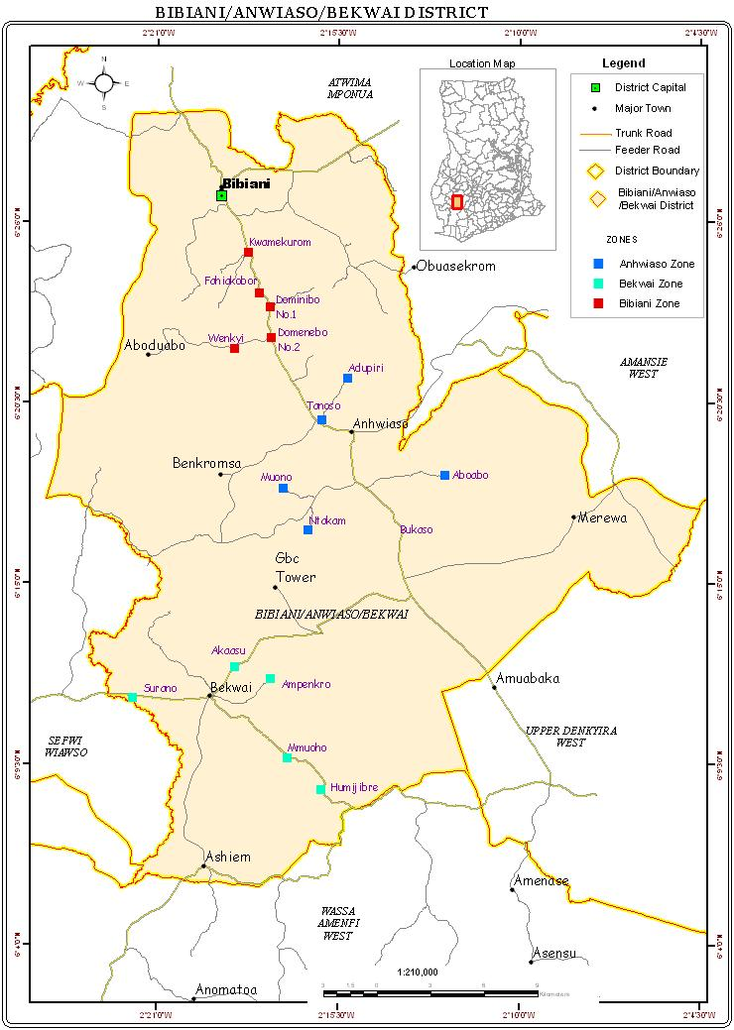
Figure 1. Map of the Bibiani-Anhwiaso-Bekwai Municipal, Western North Region, Ghana

In addition, four cocoa genotypes, PA150, PA7, C42, and C75, were obtained from the Boako Seed Production Division (SPD) in the Western North Region. This division is a cocoa station in charge of controlling the cocoa swollen shoot viral disease, raising cocoa seedlings for distribution to cocoa farmers, rehabilitating old and inefficient cocoa fields, and providing extension services. PA7 is a Parinari clone from the Maraón genetic group, while PA150 is also from the Maraón genetic group.

3.2 Experimental Site
The study (soil moisture stress on cocoa seedlings) was carried at the greenhouse of the Department of Horticulture, College of Agriculture and Natural Resources, KNUST, Kumasi in the Ashanti Region of Ghana, between the periods of April and August 2022. The relative humidity of the experimental site throughout the study ranged between 29 and 89% and the temperature was between 28ºC and 36ºC. Benches with a height of 80cm were provided in the greenhouse for this experiment. Hygrometer was used to measure the relative humidity and a thermometer was used to measure the ambient air temperature of the study site on a tri-daily basis (at 08:00GMT, 12:00 GMT and 16:00GMT) throughout the study period.

3.3 Preparation of Plant Materials
Using a weighing balance, the cocoa pods of each variety and genotype were weighed collectively and the results were recorded (Plate 1). The pods were split open after the recording to release the seeds. Each pod's seeds were put into a sachet, and their weights were also recorded using an electronic scale (Plate 2). Each variety and genotype seed were collected in a single bucket, cleansed of any excess pulp, and allowed to germinate.
An amount of 650kg of loamy sandy soil was excavated from a farmland that has been used for cocoa cultivation for more than 20 years to the Horticulture Department, KNUST. The soil was collected up to a depth 25 cm with a pickaxe and shovel. The soil was air-dried before and passed through a netlike metallic filter sieve (Plate 3) to remove stones, roots and any other debris. A sample of the soil was taken to the Soil Sciences Department, College of Agriculture and Natural Resources, KNUST and the properties of the soil were determined.

The soil was transferred into plastic buckets (height 17cm and diameter 20 cm). These buckets were used as pots in order to increase the water holding capacity of the root environment and provide greater volume of rooting medium for increased provision of nutrients for root extension and normal seedling growth. A minimum of three (3) holes were carefully punched at the bottom of each bucket or pot.

All pots filled with 5kg of soil were slowly saturated with water until water was seen dripping from the bottom of the pots (assumed indicative of Full Saturation – FS) and allowed to drain overnight to field capacity which was 1200ml. The germinated seeds were sown at a depth of 3cm from the surface and 2cm apart at the minimum rate of three (3) seeds per pot. This was to increase the chance of survival of at least one germinated seedling per pot.

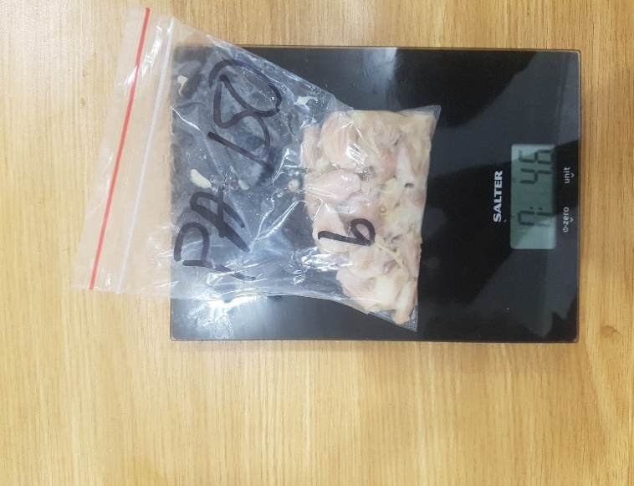
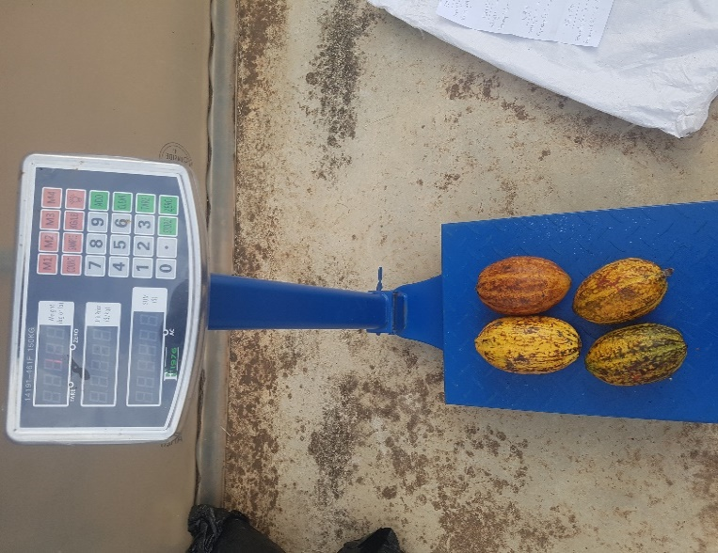

Plate 1. Weighing of cocoa pods using weighing Plate 2. Weighing of cocoa seeds using
balance electronic balance

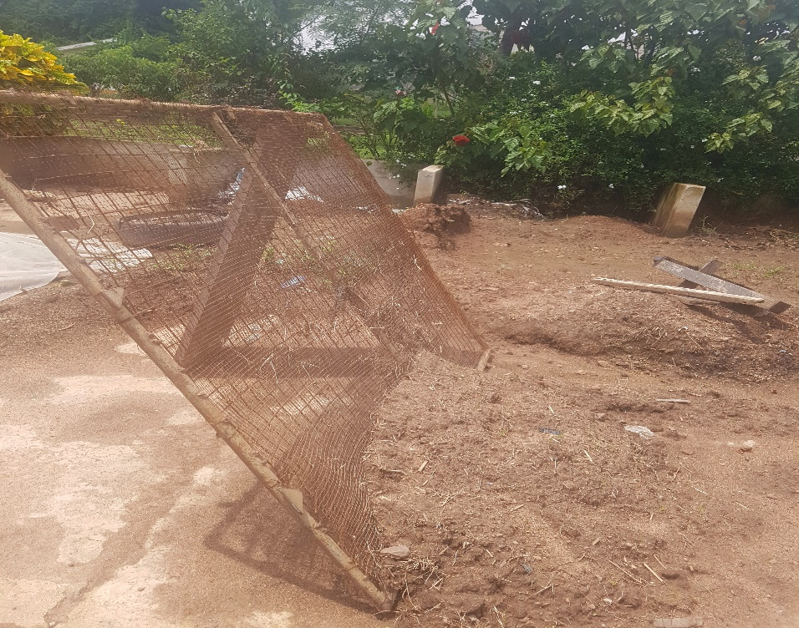
Plate 3. Netlike Metallic Filter used for removing debris

3.4 Determination of Percentage Germination
Since there were four cocoa varieties and four genotypes, eight styrofoams (Plate 4) with an area of 30cm x 19cm were employed to create shading to prevent sunlight from reaching the seeds. A plastic sack of comparable size was placed beneath each styrofoam. Because the benches were so high, the plastic sacks were utilized to assist retention of water. Then, three 7cm × 7cm cloths (one for each replication) were placed on the plastic sack. The cloths were then sprinkled with water to get them moist.

The seeds of each variety/genotype of cocoa were counted, separated into three sections, and placed on a moist cloth, with the number of seeds per replication recorded. For two weeks, the seedlings were watered daily and germination records were kept.
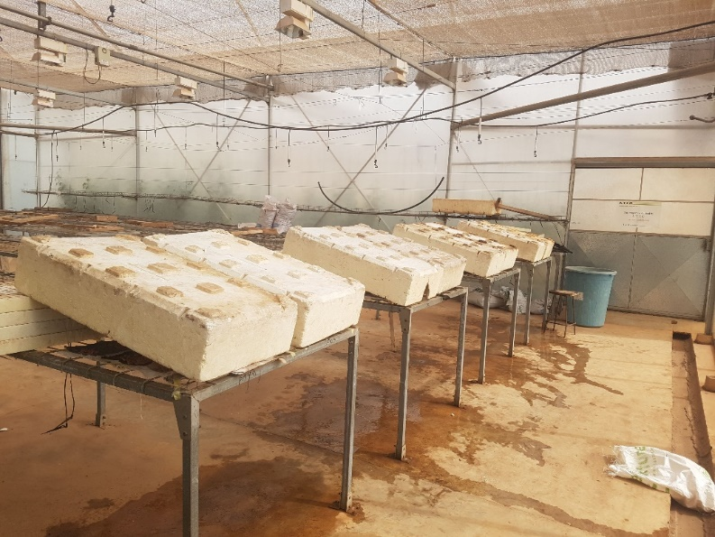

Plate 4. Styrofoam providing shade to prevent sunlight reaching the seeds

3.5 Soil Moisture Stress Experimental Layout
There were four varieties and four genotypes of cocoa, four (4) field capacities (100%, 50%, 25% and 0%) depending on the percentage of saturation representing a well-watered (control), moderate stress (MS), high stress (HS), and severe stress (SS) respectively, one (1) watering frequency (7-day intervals) and four (4) replications resulting in one hundred and twenty-eight (128) experimental units (pots) arranged in Completely Randomized Design (CRD).

After the germinated seeds have been placed in the pots, they were watered (3-days intervals) with 200ml of water till the seedlings were established. During the first and second week, shoots were seen sprouting from the pots. However, most of the shoots had sprouted and were thinned to two (2) seedlings per pot at three (3) weeks after sown (WAS), thus, the second leaf-stage. This was to reduce competition of water by seedlings which may contribute to errors. The pots were then labelled according to the variety placed in it and the stress to be applied to it (Table 2).
Table 2. Labels that were attached to the pots based on the various treatments
Variety | Stress to be Applied | Label
Forastero | Severely Stressed | FSS
Forastero | Highly Stressed | FHS
Forastero | Moderately Stressed | FMS
Forastero | Control | FC
Trinitario | Severely Stressed | TSS
Trinitario | Highly Stressed | THS
Trinitario | Moderately Stressed | TMS
Trinitario | Control | TC
Criollo | Severely Stressed | CSS
Criollo | Highly Stressed | CHS
Criollo | Moderately Stressed | CMS
Criollo | Control | CC
Hybrid | Severely Stressed | HSS
Hybrid | Highly Stressed | HHS
Hybrid | Moderately Stressed | HMS
Hybrid | Control | HC
PA7 | Severely Stressed | PA7 SS
PA7 | Highly Stressed | PA7 HS
PA7 | Moderately Stressed | PA7 MS
PA7 | Control | PA7 C
PA150 | Severely Stressed | PA150 SS
PA150 | Highly Stressed | PA150 HS
PA150 | Moderately Stressed | PA150 MS
PA150 | Control | PA150 C
C42 | Severely Stressed | C42 SS
C42 | Highly Stressed | C42 HS
C42 | Moderately Stressed | C42 MS
C42 | Control | C42 C
C75 | Severely Stressed | C75 SS
C75 | Highly Stressed | C75 HS
C75 | Moderately Stressed | C75 MS
C75 | Control | C75 C

3.6 Application of Moisture Stress
A week after the seedlings has been properly established (thus 9WAS), the stress settings were applied. The stress settings were such that pots labelled MS (moderately stressed) were watered 50% FC once a week, HS (highly stressed) were watered 25% FC once a week and SS (severely stressed) were not watered at all throughout the experiment. However, the C (control) were also watered to FC (100%) once a week for the duration of the experiment.

Prior to the application of the stress, the number of leaves, stem thickness, plant height, initial Leaf Relative Content (RWC) and Soil Moisture Content (SMC) measurements were made. For this study, observable symptoms of drought stress in the cocoa seedlings included: rapid yellowing of leaves starting from the leaf margin and/ or lamina, necrosis of leaf lamina, death of tender leaves, wilting and paling of leaves.

3.7 Data Collection
3.7.1 Effects of soil moisture stress on morphological features
Data on some of the morphological parameters (plant height, stem thickness, leaf area, number and colouring of leaves) was collected at 9WAS, 10WAS, 11WAS, 12WAS and 13WAS. The number of leaves were determined by simple counting. Measuring tape was used to measure the plant height from the base of the stem at soil level to tip of the shoot. Stem thickness was measured using a vernier calliper.

- Determination of leaf area
Fresh physiologically expanded fourth leaves were collected and enclosed in plastic self-sealing bags, and then taken to the laboratory of the Department of Theoretical and Applied Biology, KNUST. The leaf area was determined using a graph. Leaf area is assumed to be proportional to the product of the leaf length and width. For each replicate, three leaves were placed on a graph, traced and the length and width of the leaves were measured using a ruler. The leaf area was calculated as follows:
Leaf Area = length of leaf × width of leaf

    - Effects of soil moisture stress on physiological traits
3.7.2.1 Determination of leaf relative water content (LRWC)
The water condition of the seedlings was evaluated, thus, the Leaf Relative Water Content (LRWC) from fourth leaves from the apex of each seedling was measured. Fully physiologically expanded fourth leaves (i.e. two) were collected from three of the replicates of each variety/genotype. Using a sharp 2cm inner cork-borer, the leaves were cut into discs of uniform size, placed in a clean glass vial and weighed, i.e., Fresh Weight (FW). They were then immediately floated on distilled water at 25ºC in the dark. After 4 hours, the Turgid Weight (TW) was measured and the discs dried in an oven at 50ºC for 24 hours to obtain the Dry Weight (DW). The LRWC was calculated as follows:

LRWC (%) = Fresh Weight (FW) – Dry Weight (DW) × 100
Turgid Weight (TW) – Dry Weight (DW)

Where, FW: Fresh weight, DW: Dry weight, TW: Turgid weight.

3.7.2.2 Determination of soil relative water content (SRWC)
Soils normally contain a fine amount of water, which can be expressed as the “soil moisture content”. The Soil Relative Water Content (SRWC) was determined by taking two soil samples from each replicate at a depth of 5cm using a 2cm inner diameter tube, dropped into a petri dish, covered and weighed to determine the weight of moist soil (M) with a balance but before that, the empty dish was weighed. The soil was dried overnight at 105ºC in an oven, removed and allowed to cool before measuring the weight of the dried soil (D). The SRWC was calculated as follows:
SRWC (%) = weight of moist soil (M) – weight of the dry soil (D) × 100
weight of the dry soil (D)

3.7.2.3 Determination of Normalized Difference Vegetation Index (NDVI)
The PlantPen model NDVI 300 measures Normalised Difference Vegetation Index, which is an important indicator of chlorophyll content in plants. The pigment in plant leaves, chlorophyll, strongly absorbs visible light (from 0.4 to 0.7um) for use in photosynthesis. In this study, PlantPen model NDVI 300 was used to measure the chlorophyll content of the leaves. The calibration of the device was done by placing a white sample at the leaf-clip, pressed set button to confirm the calibration and waited till the calibration step was completed. The device was ready to measure leaf samples. Leaves were not collected from plants, rather NDVI was measured directly from the plants by the opening of the leaf-clip and placing the physiologically expanded third leaf from the apex of the cocoa seedling. After that, the leaf-clip was closed and the device was set to measure.

3.8 Effects of Soil Moisture Stress on Root Anatomical Features (RAF)
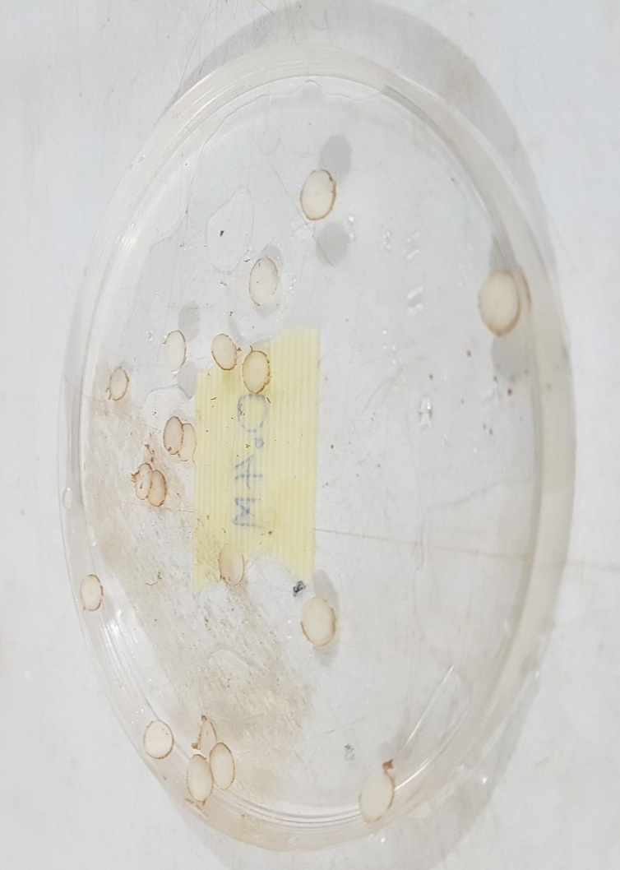
Roots were carefully removed from the soil and washed fastidiously to eradicate dirt. Very thin root sections, about 2 - 5cm between the tip (root apex) and root-shoot junction were collected for anatomical studies. Collected samples were placed in a distilled water for 1- 2minutes for study of root anatomy (Plate 5). For anatomical studies, samples were hand sectioned with microtome knife. Root section were stained with iodine stains for 3 – 5 minutes, mounted in glycerine on the slide and observed under a simple optical light microscope with 100X magnification. At least two images root images per replicate and tissue position were considered for measuring anatomical traits. The traits analysed were the piths, the cortex, the epidermis and phloem using a software called AmScope. Images were taken using MU series camera coupled with the software Amscope 3.7.

Plate 5. Transverse sections of root put in a distilled water

3.9 Data Analysis
The data was analysed statistically and presented in tables and graphs. The analysis of variance test (ANOVA) was used to assess the data for the responses of the varieties and genotypes to water deficit stress treatments. The average values of water-stressed seedlings were compared using Tukey Bª to determine differences in varieties and genotypes average value (means) at 5% level of probability.

CHAPTER FOUR

4.0 RESULTS

4.1 Percentage Germination of Seeds of Cocoa Varieties and Genotypes
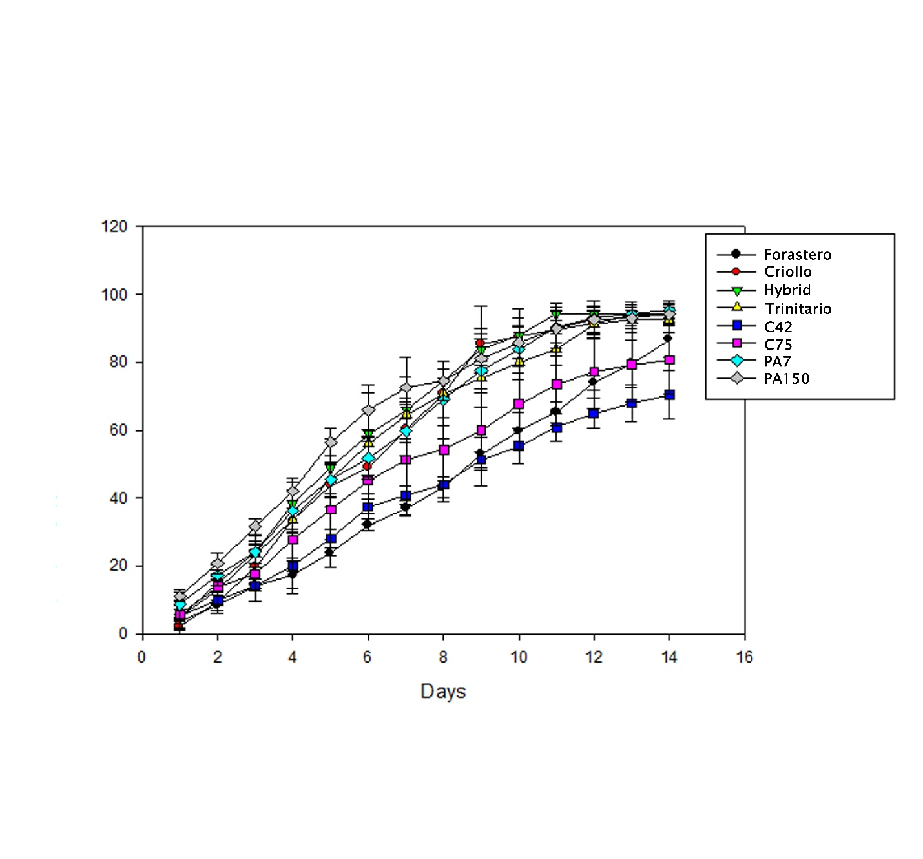
The percentage germination of seeds of four cocoa varieties and four genotypes are presented in Figure 2. The highest (95.40) and least (70.45) mean number of germinations were recorded in genotype PA7 and C42 at day 14 respectively. At day 7, PA150 recorded the highest mean number (72.55) of germination with forastero showing the lowest mean number (37.03).

Figure 2. Percentage germination of cocoa seeds within 14 days

4.2 Soil Analysis before and after Soil Moisture Stress of Cocoa Seedlings
Soil varies in terms of physicochemical properties and nature of the crops over the years. The chemical properties of the sandy loamy soil used to evaluate the four genotypes and four varieties of cocoa seedlings in the greenhouse for three months and the effect the water stress had on the soil after the experiments is presented in Table 3. Water deficit causes major changes in the physical, chemical and biological nature of soils (Table 3). As shown in Table 3, moisture stress had a significant effect on the soils’ chemical properties. There was also a significant interaction between the treatments.

Table 3. Chemical Properties of soil before and after moisture stress of cocoa seedlings
Soil Property | Initial Content | Final Contents after Moisture Stress
Soil Property | Initial Content | Control | M. Stressed | H. Stressed | S. Stressed
pH | 6.293±0.172 | 6.323±0.091 | 6.323±0.074 | 6.503±0.021 | 6.633±0.015
Available P (mg/kg) | 21.937±1.146 | 21.170±0.175 | 12.283±0.146 | 11.803±0.031 | 13.210±0.105
Total N (%) | 0.114±0.001 | 0.118±0.002 | 0.113±0.001 | 0.107±0.002 | 0.115±0.001
Exchangeable K (cmol/kg) | 0.415±0.020 | 0.265±0.055 | 0.082±0.003 | 0.405±0.003 | 0.535±0.004
Exchangeable Ca (cmol/kg) | 4.520±0.087 | 8.607±0.031 | 6.100±0.100 | 8.120±0.072 | 7.433±0.012
Exchangeable Mg (cmol/kg) | 2.547±0.170 | 5.000±0.020 | 3.707±0.101 | 4.500±0.092 | 3.587±0.031
Exchangeable Na (cmol/kg) | 0.059±0.004 | 0.077±0.012 | 0.064±0.020 | 0.088±0.001 | 0.061±0.005
Organic Carbon (%) | 1.484±0.007 | -1.481±0.003 | -1.362±0.003 | -1.284±0.002 | -1.400±0.002
Organic Matter (%) | 2.558±0.012 | 2.554±0.005 | 2.349±0.005 | 2.214±0.004 | 2.414±0.004
Total Zn (mg/kg) | 22.967±2.919 | 62.473±1.550 | 67.147±5.906 | 60.680±2.841 | 79.893±3.091
Total Ni (mg/kg) | 0.733±0.037 | 0.790±0.037 | 0.634±0.034 | 0.700±0.036 | 0.699±0.015
Total Mn (mg/kg) | 7.270±0.419 | 148.600±4.629 | 102.033±1.504 | 163.167±4.389 | 94.247±0.442
Total As (mg/kg) | 0.881±0.029 | 0.864±0.036 | 0.738±0.022 | 0.676±0.023 | 0.638±0.056
Total Fe (mg/kg) | 273.167±45.608 | 2634.667±43.108 | 2404.667±16.442 | 5915.333±58.620 | 5424.000±1594.094
Total Cu (mg/kg) | 5.877±0.305 | 64.260±1.502 | 67.647±6.340 | 102.763±7.146 | 57.607±4.939
Total Pb (mg/kg) | 0.652±0.028 | 0.624±0.011 | 0.551±0.012 | 0.523±0.009 | 0.472±0.007
Total Cd (mg/kg) | 0.564±0.044 | 1.847±0.121 | 1.580±0.327 | 1.167±0.095 | 3.480±0.310
Total Hg (mg/kg) | 0.393±0.044 | 0.521±0.006 | 0.434±0.025 | 0.557±0.038 | 0.370±0.023

4.3 Effects of Soil Moisture Stress on the Morphological Features of Cocoa Seedlings
4.3.1 Appearance of leaves showing drought symptoms
The seedlings used for the study exhibited varied symptoms of drought stress even within the same genotype/varieties. The visual symptoms indicative of drought symptoms in this study included: rapid yellowing of leaves starting from the leaf margin and/ or lamina, necrosis of leaf lamina, drooping and death of young tender leaves, wilting and paling starting from the leaf margin and lamina similar to the observations made by Osei-Bonsu (2011).
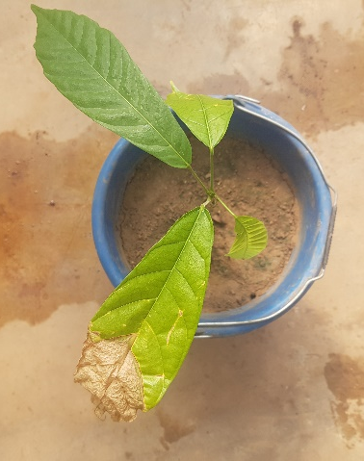
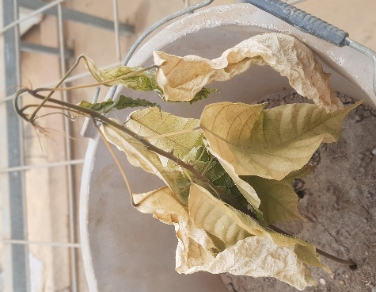
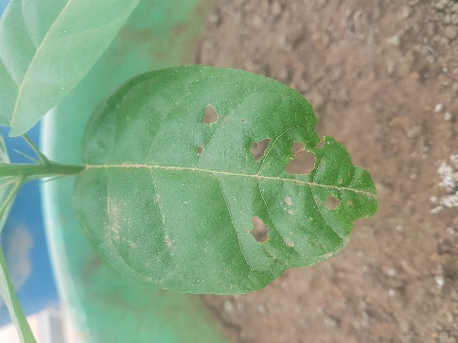

(A) (B) (C)

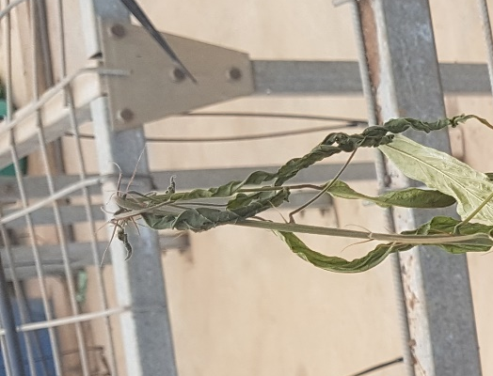
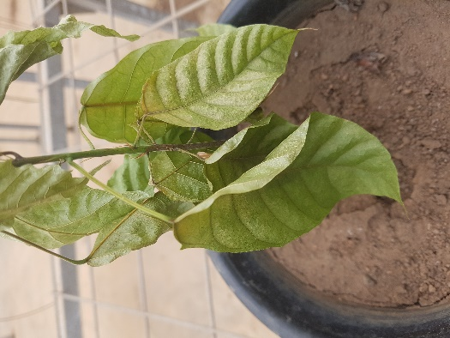

(D) (E)

Plate 6. Various visual symptoms of drought stress observed in seedlings of the different genotypes and varieties of cocoa, indicative of drought symptoms (A) Perforation of matured green leaves (B) Necrosis on leaf apex (C) Browning of leaves (D) Paling starting from leaf margin and lamina (E) Shrinking of physiologically immature leaves

4.3.2 Effects of soil moisture stress on number of leaves
The effect of soil moisture stress on the number of leaves of four genotypes and four varieties of cocoa is presented in Table 4. Soil moisture stress had no significant reduction (P >0.05, Appendix A) in the number of leaves in some of the genotypes and varieties. However, treatment levels had a significant difference in the number of leaves for some of the varieties and genotypes. The highest (25.500) and least (21.250) mean number of leaves were recorded in genotype PA150 at control and highly stressed respectively. PA7 recorded the lowest number of leaves under both moderate and severe stresses, 13.500 and 8.500 respectively.

Table 4. Effects of soil moisture stress on number of leaves of cocoa seedlings
Variety | Treatments | Day after application of moisture stress
Variety | Treatments | 0 | 5 | 10 | 15 | 20 | 25
Hybrid | Control | 9.750±1.26^{ab} | 16.250±4.27ª | 18.750±3.95^{bc} | 21.250±4.35^{cd} | 22.000±4.69^{cde} | 23.000±3.50^{cd}
Hybrid | MS | 10.250±1.71^{ab} | 14.500±3.11ª | 17.000±2.58^{abc} | 20.000±3.27^{bcd} | 20.750±3.40^{cde} | 21.250±3.10^{cd}
Hybrid | HS | 9.500±2.08^{ab} | 16.250±7.59ª | 15.750±3.69 ^{abc} | 17.000±2.71^{abcd} | 18.000±2.16^{abcde} | 18.250±2.63^{abcd}
Hybrid | SS | 11.000±1.41^{ab} | 15.000±1.83ª | 15.500±2.38 ^{abc} | 16.000±2.94^{abcd} | 16.000±2.94^{abcde} | 16.500±3.11^{abcd}
Criollo | Control | 12.750±4.19^{ab} | 16.000±4.69ª | 18.500±4.43^{abc} | 19.500±4.20^{bcd} | 21.250±3.59^{cde} | 21.750±3.86^{cd}
Criollo | MS | 9.500±0.58^{ab} | 12.500±0.58ª | 14.750±1.71^{abc} | 17.250±3.50^{abcd} | 18.000±3.16^{abcde} | 18.750±3.10^{bcd}
Criollo | HS | 10.250±1.71^{ab} | 13.250±1.50ª | 14.500±1.73^{abc} | 15.250±1.71^{abcd} | 15.750±2.22^{abcde} | 16.250±2.22^{abcd}
Criollo | SS | 12.250±2.22^{ab} | 14.250±2.06ª | 15.000±2.00^{abc} | 15.500±1.73^{abcd} | 15.750±1.59^{abcde} | 15.750±1.89^{abcd}
Forastero | Control | 11.750±2.22^{ab} | 14.250±3.59ª | 17.000±4.97^{abc} | 18.500±3.87^{abcd} | 20.000±3.16^{cde} | 20.500±2.38^{cd}
Forastero | MS | 12.500±2.65^{ab} | 16.000±2.94ª | 17.500±3.11^{abc} | 19.000±2.31^{bcd} | 19.750±2.63^{bcde} | 20.250±2.06^{cd}
Forastero | HS | 13.500±1.73^{b} | 16.750±2.06ª | 18.250±0.96^{abc} | 19.000±1.83^{bcd} | 19.750±1.71^{bcde} | 20.000±1.41^{cd}
Forastero | SS | 11.750±0.96^{ab} | 14.250±2.06ª | 14.750±2.22^{abc} | 15.000±1.83^{abcd} | 15.250±1.71^{abcde} | 15.750±1.50^{abcd}
Trinitario | Control | 11.750±1.71^{ab} | 16.250±4.27ª | 18.250±5.12^{abc} | 23.250±4.43^{d} | 24.500±5.32e | 25.000±5.35^{d}
Trinitario | MS | 10.500±1.29^{ab} | 14.500±1.73ª | 16.250±2.63^{abc} | 19.000±0.82^{bcd} | 19.750±0.96^{bcde} | 20.000±1.41^{cd}
Trinitario | HS | 11.000±2.16^{ab} | 14.750±3.59ª | 17.500±3.87^{abc} | 19.500±4.12^{bcd} | 19.750±4.11^{bcde} | 20.000±4.08^{cd}
Trinitario | SS | 9.750±1.71^{ab} | 15.500±3.11ª | 16.500±2.65^{abc} | 17.250±1.89^{abcd} | 17.250±1.89 ^{abcde} | 17.250±1.89^{abcd}
PA150 | Control | 13.750±3.20^{b} | 17.750±2.99ª | 20.250±3.40^{c} | 22.000±3.16^{cd} | 24.250±2.87de | 25.500±3.11^{d}
PA150 | MS | 13.250±2.87^{b} | 16.500±1.00ª | 18.250±0.96^{abc} | 19.500±3.08^{bcd} | 21.000±1.63^{cde} | 21.750±1.50^{cd}
PA150 | HS | 12.000±2.16^{ab} | 15.500±5.07ª | 17.000±5.94^{abc} | 19.500±5.74^{bcd} | 20.500±5.26^{cde} | 21.250±5.56^{cd}
PA150 | SS | 12.250±3.64^{ab} | 16.750±2.22ª | 17.000±2.71^{abc} | 17.000±2.71^{abcd} | 17.000±1.71^{abcde} | 17.000±2.71^{abcd}
PA7 | Control | 10.000±1.41^{ab} | 12.750±0.96ª | 14.250±0.96^{abc} | 15.750±1.89^{abcd} | 16.500±1.91^{abcde} | 17.000±2.16^{abcd}
PA7 | MS | 8.000±0.58^{ab} | 11.250±2.65ª | 9.500±5.51^{ab} | 12.500±3.51^{abc} | 13.250±3.51^{abc} | 13.500±4.00^{abc}
PA7 | HS | 10.250±1.50^{ab} | 11.750±1.89ª | 12.250±1.50^{abc} | 13.500±1.29^{abcd} | 13.500±1.29^{abc} | 14.000±0.82^{abc}
PA7 | SS | 5.500±2.89ª | 7.500±4.58ª | 8.250±4.58ª | 8.500±4.16ª | 8.500±4.16ª | 8.500±4.16ª
C42 | Control | 8.000±1.83^{ab} | 11.500±4.20ª | 13.500±4.20^{abc} | 15.500±4.20^{abcd} | 16.500±3.70 ^{abcde} | 17.250±3.77^{abcd}
C42 | MS | 8.000±1.83^{ab} | 13.500±3.70ª | 15.500±4.20^{abc} | 16.000±4.97^{abcd} | 16.500±4.80^{abcde} | 16.750±4.99^{abcd}
C42 | HS | 9.000±1.83^{ab} | 11.750±0.96ª | 13.000±1.15^{abc} | 14.000±1.63^{abcd} | 14.000±1.63^{abcd} | 14.000±1.63^{abc}
C42 | SS | 8.500±1.29^{ab} | 12.500±3.32ª | 14.250±2.63^{abc} | 14.500±2.38^{abcd} | 14.500±2.38^{abcde} | 14.500±2.38^{abc}
C75 | Control | 12.250±2.87^{ab} | 15.000±1.41ª | 18.500±2.89^{abc} | 20.250±2.87^{cd} | 21.000±2.83^{cde} | 21.500±3.11^{cd}
C75 | MS | 11.750±1.89^{ab} | 16.000±4.40ª | 17.250±4.65^{abc} | 18.750±4.92^{bcd} | 19.500±4.20^{bcde} | 20.000±3.92^{cd}
C75 | HS | 10.000±1.41^{ab} | 14.250±2.36ª | 16.750±2.06^{abc} | 17.250±2.22^{abcd} | 17.750±2.63^{abcde} | 17.750±2.63^{abcd}
C75 | SS | 8.250±2.65^{ab} | 9.750±3.46ª | 9.750±3.46^{ab} | 9.750±3.46^{ab} | 9.750±3.46^{ab} | 9.750±3.46^{ab}

4.3.3 Effects of soil moisture stress on stem thickness of cocoa seedlings
The effect of soil moisture stress on stem thickness of four genotypes and four varieties of cocoa seedlings are presented in Table 5. There was no significant variation (P > 0.05, Appendix A) in stem thickness for all varieties and genotypes under all treatments. However, there were significant differences in stem thickness between some varieties and genotypes under some treatments. Trinitario recorded the highest stem thickness (4.35mm) in control with PA7 recording the least (1.70mm) under severely stressed. Under moderately stressed, Forastero recorded the highest (4.13mm) while PA7 recorded the least (2.55mm).

Table 5. Effects of soil moisture stress on stem thickness of cocoa seedlings
Variety | Treatments | Day after application of moisture stress
Variety | Treatments | 10 | 15 | 20
Hybrid | Control | 2.525±0.34ª | 3.075±0.17^{abc} | 3.425±0.29 ^{bcdef}
Hybrid | MS | 3.025±0.43ª | 3.400±0.55 ^{bc} | 3.600±0.55 ^{cdef}
Hybrid | HS | 2.850±0.29ª | 3.225±0.17 ^{abc} | 3.300±0.18 ^{bcdef}
Hybrid | SS | 3.200±0.22ª | 3.025±0.17 ^{abc} | 2.800±0.14 ^{abcde}
Criollo | Control | 2.450±0.66ª | 3.025±0.43 ^{abc} | 3.500±0.42 ^{cdef}
Criollo | MS | 2.950±0.72ª | 3.275±0.69 ^{abc} | 3.400±0.59 ^{bcdef}
Criollo | HS | 2.350±0.58ª | 2.625±0.54 ^{abc} | 2.725±0.54 ^{abcde}
Criollo | SS | 2.650±0.31ª | 2.525±0.24 ^{abc} | 2.450±0.17 ^{abc}
Forastero | Control | 3.175±0.31ª | 3.900±0.32 ^{c} | 4.350±0.42 ^{f}
Forastero | MS | 3.525±0.59ª | 3.850±0.65 ^{c} | 4.125±0.67 ^{def}
Forastero | HS | 3.400±0.33ª | 3.700±0.34 ^{c} | 3.875±0.38 ^{cdef}
Forastero | SS | 3.000±0.51ª | 2.900±0.55 ^{abc} | 2.850±0.51 ^{abcdef}
Trinitario | Control | 3.475±0.34ª | 3.825±0.38 ^{c} | 4.350±0.33 ^{f}
Trinitario | MS | 3.525±0.34ª | 3.700±0.33 ^{c} | 4.125±0.29 ^{def}
Trinitario | HS | 3.275±0.22ª | 3.500±0.12 ^{bc} | 3.875±0.10 ^{cdef}
Trinitario | SS | 2.875±0.30ª | 2.675±0.24 ^{abc} | 2.850±0.17 ^{abcdef}
PA150 | Control | 3.425±0.30 ª | 3.875±0.34 ^{c} | 4.225±0.39 ^{ef}
PA150 | MS | 3.700±0.27 ª | 3.900±0.22 ^{c} | 4.125±0.24 ^{def}
PA150 | HS | 2.875±0.41 ª | 3.125±0.46 ^{abc} | 3.325±0.41 ^{bcdef}
PA150 | SS | 2.875±0.34 ª | 2.800±0.29 ^{abc} | 2.675±0.32 ^{abcd}
PA7 | Control | 2.725±0.31 ª | 3.025±0.31 ^{abc} | 3.225±0.31 ^{bcdef}
PA7 | MS | 2.300±0.21 ª | 2.450±0.31 ^{abc} | 2.550±0.26 ^{abc}
PA7 | HS | 2.725±0.39 ª | 2.875±0.39 ^{abc} | 2.975±0.36 ^{abcdef}
PA7 | SS | 2.125±0.72 ª | 1.850±0.49ª | 1.700±0.42 ª
C42 | Control | 2.125±0.22 ª | 2.475±0.22 ^{abc} | 2.875±0.19 ^{abcdef}
C42 | MS | 2.375±0.38 ª | 2.450±0.34 ^{abc} | 2.575±0.35 ^{abc}
C42 | HS | 2.350±0.19 ª | 2.375±0.17 ^{abc} | 2.400±0.18 ^{abc}
C42 | SS | 2.325±0.33 ª | 2.100±0.24 ^{ab} | 1.950±0.21 ^{ab}
C75 | Control | 2.800±0.33 ª | 3.075±0.25 ^{abc} | 3.525±0.29 ^{cdef}
C75 | MS | 2.875±0.50 ª | 3.125±0.46 ^{abc} | 3.400±0.37 ^{bcdef}
C75 | HS | 2.975±0.10 ª | 3.150±0.13 ^{abc} | 3.250±0.10 ^{bcdef}
C75 | SS | 2.275±0.15 ª | 2.100±0.17 ^{ab} | 1.950±0.26 ^{ab}

4.3.4 Effects of soil moisture stress on leaf area of cocoa seedlings
The effect of soil moisture stress on leaf area of four genotypes and four varieties of cocoa are shown in Table 6. There was no significant variation (P > 0.05, Appendix A) in leaf area for all varieties and genotypes under all treatments. However, there were significant differences in leaf area between some varieties and genotypes under some treatments. PA150 recorded the highest leaf area (157.71cm²) in control with PA7 recording the least (78.09cm²) under highly stressed. Under moderately stressed, PA150 recorded the highest (116.04cm²) while C42 recorded the least (31.05cm²) under severely stressed.
Table 6. Effects of soil moisture stress on leaf area of cocoa seedlings
Variety | Treatments | Day after application of moisture stress
Variety | Treatments | 0 | 10 | 20
Hybrid | Control | 81.1567±12.29^{ab} | 89.3400±7.71^{bcd} | 99.4800±11.99^{cdefg}
Hybrid | MS | 88.8633±3.98 ^{ab} | 90.7600±3.99^{bcd} | 92.2100±4.83^{bcdefg}
Hybrid | HS | 93.4400±3.94 ^{ab} | 93.4400±3.43^{bcd} | 93.1833±2.52^{bcdefg}
Hybrid | SS | 79.4767±12.39 ^{ab} | 74.9767±13.72^{abc} | 56.4133±21.00^{abc}
Criollo | Control | 91.8867±6.43 ^{ab} | 114.6200±16.00^{cde} | 132.5433±18.79^{ghi}
Criollo | MS | 94.2067±4.97 ^{ab} | 98.4667±3.38^{bcde} | 101.4867±5.23^{cdefgh}
Criollo | HS | 79.9900±13.72 ^{ab} | 77.8500±13.21^{abc} | 78.4467±13.34^{bcde}
Criollo | SS | 82.7033±8.70 ^{ab} | 78.3533±7.29^{abc} | 67.5567±10.27^{abcd}
Forastero | Control | 107.9833±30.04 ^{ab} | 128.5167±36.16de | 143.2267±38.48^{hi}
Forastero | MS | 101.3200±17.70 ^{ab} | 107.0967±16.73^{cde} | 110.4633±18.44^{defgh}
Forastero | HS | 97.6967±12.74 ^{ab} | 97.7733±11.67^{bcde} | 98.3433±11.22^{cdefg}
Forastero | SS | 93.2167±5.86 ^{ab} | 86.3333±5.96^{bcd} | 72.8767±11.52^{bcde}
Trinitario | Control | 85.6567±19.20 ^{ab} | 102.9233±24.66^{bcde} | 113.0567±27.36^{defgh}
Trinitario | MS | 89.3567±3.76 ^{ab} | 91.4900±4.51^{bcd} | 92.7900±4.43^{bcdefg}
Trinitario | HS | 79.6133±5.33 ^{ab} | 79.8567±5.69^{abc} | 79.9233±4.74^{bcde}
Trinitario | SS | 85.5067±5.46 ^{ab} | 78.6167±7.41^{abc} | 68.2933±7.48^{abcd}
PA150 | Control | 112.4567±10.93^{b} | 135.7267±13.09e | 157.7100±23.10^{i}
PA150 | MS | 108.2267±10.61 ^{ab} | 112.7733±9.82^{cde} | 116.0433±10.41^{efgh}
PA150 | HS | 95.3300±9.71 ^{ab} | 96.8400±10.27^{bcde} | 97.4367±10.00^{cdefg}
PA150 | SS | 89.6667±4.08 ^{ab} | 83.4233±3.34^{abc} | 76.9400±4.89^{bcde}
PA7 | Control | 84.2633±13.35 ^{ab} | 89.6067±11.60^{bcd} | 101.1433±15.27^{cdefgh}
PA7 | MS | 90.4700±5.96 ^{ab} | 92.0033±6.58^{bcd} | 93.4800±6.87^{bcdefg}
PA7 | HS | 78.8800±12.64 ^{ab} | 78.2867±12.76^{abc} | 78.0900±12.89^{bcde}
PA7 | SS | 72.6433±14.80ª | 60.0200±23.90^{ab} | 50.5233±21.04^{ab}
C42 | Control | 88.9400±4.37 ^{ab} | 103.8133±7.22^{cde} | 115.0967±6.83^{efgh}
C42 | MS | 77.6067±18.81 ^{ab} | 81.6200±18.30^{abc} | 85.4400±18.22^{bcdef}
C42 | HS | 82.0600±6.28 ^{ab} | 81.1100±5.38^{abc} | 80.5400±4.66^{bcde}
C42 | SS | 72.0767±21.29ª | 43.2100±27.54ª | 31.0500±13.46ª
C75 | Control | 89.2533±7.02 ^{ab} | 105.7500±8.87^{cde} | 128.1333±10.04^{fghi}
C75 | MS | 84.4000±7.54 ^{ab} | 88.3867±8.43^{bcd} | 97.1300±10.79^{cdefg}
C75 | HS | 88.2933±3.52 ^{ab} | 89.4867±3.73^{bcd} | 89.5400±3.86^{bcdefg}
C75 | SS | 85.6933±3.63 ^{ab} | 75.4433±4.53^{abc} | 63.2633±9.54^{abc}

4.3.5 Effects of soil moisture stress on plant height of cocoa seedlings
The effect of soil moisture stress on plant height of four genotypes and four varieties of cocoa are presented in Table 7. There was no significant variation (P > 0.05, Appendix B) in plant height for all varieties and genotypes under all treatments. However, there were significant differences in plant height between some varieties and genotypes under some treatments. PA150 recorded the highest plant height (39cm) in control with C42 recording the least (19cm) under highly stressed. Under severely stressed, Criollo recorded the highest (31cm) while PA7 recorded the least (11.25 cm).

Table 7. Effects of soil moisture stress on plant height of cocoa seedlings
Variety | Treatments | Day after application of moisture stress
Variety | Treatments | 0 | 5 | 10 | 15 | 20
Hybrid | Control | 18.5000±7.19^{abcd} | 20.0000±7.44 ^{abcd} | 23.5000±6.19 ^{abc} | 27.5000±5.45 ^{abc} | 29.0000±4.69 ^{abcd}
Hybrid | MS | 16.5000±7.19 ^{abcd} | 18.5000±8.58 ^{abcd} | 21.5000±10.47 ^{abc} | 25.5000±11.27 ^{abc} | 26.7500±12.04 ^{abcd}
Hybrid | HS | 19.0000±3.56 ^{abcd} | 21.5000±4.51 ^{abcd} | 25.5000±5.07 ^{abc} | 26.5000±5.26 ^{abc} | 27.2500±5.91 ^{abcd}
Hybrid | SS | 21.2500±1.50 ^{abcd} | 23.0000±0.82 ^{abcd} | 25.2500±2.63 ^{abc} | 27.0000±2.71 ^{abc} | 27.5000±3.11 ^{abcd}
Criollo | Control | 23.5000±7.14 ^{abcd} | 26.0000±7.12 ^{abcd} | 28.0000±8.29 ^{abc} | 30.0000±8.91 ^{abc} | 31.5000±8.10 ^{bcd}
Criollo | MS | 19.0000±2.45 ^{abcd} | 22.0000±4.24 ^{abcd} | 24.0000±6.00 ^{abc} | 26.5000±6.56 ^{abc} | 27.5000±6.61 ^{abcd}
Criollo | HS | 19.5000±2.65 ^{abcd} | 21.7500±2.63 ^{abcd} | 23.25000±3.30 ^{abc} | 25.0000±3.27 ^{abc} | 26.5000±3.11 ^{abcd}
Criollo | SS | 27.2500±3.59^{cd} | 28.2500±2.36^{bcd} | 29.2500±1.71 ^{bc} | 30.5000±1.91 ^{abc} | 31.000±2.45 ^{bcd}
Forastero | Control | 24.2500±2.99^{bcd} | 27.5000±5.45 ^{bcd} | 29.7500±8.06 ^{bc} | 33.0000±8.29^{bc} | 35.2500±8.22 ^{bcd}
Forastero | MS | 22.7500±2.99 ^{abcd} | 25.500±3.51 ^{abcd} | 27.7500±3.50 ^{abc} | 29.7500±4.27 ^{abc} | 31.0000±4.32 ^{bcd}
Forastero | HS | 29.2500±2.99^{d} | 32.0000±4.16^{d} | 34.2500±4.11^{c} | 36.2500±5.32^{c} | 37.2500±6.18 ^{cd}
Forastero | SS | 23.5000±3.79 ^{abcd} | 24.2500±3.86 ^{abcd} | 25.5000±4.43 ^{abc} | 26.5000±4.51 ^{abc} | 26.7500±4.99 ^{abcd}
Trinitario | Control | 28.0000±4.32 ^{cd} | 29.7500±4.57 ^{bcd} | 30.7500±4.79 ^{bc} | 33.5000±4.80 ^{bc} | 35.0000±5.72 ^{bcd}
Trinitario | MS | 24.2500±1.71 ^{bcd} | 25.5000±2.52 ^{abcd} | 28.0000±2.83 ^{abc} | 29.7500±3.30 ^{abc} | 30.7500±3.86 ^{abcd}
Trinitario | HS | 20.0000±2.58 ^{abcd} | 21.5000±3.00 ^{abcd} | 23.0000±3.56 ^{abc} | 24.500±4.36 ^{abc} | 25.2500±4.27 ^{abcd}
Trinitario | SS | 19.2500±7.37 ^{abcd} | 20.0000±8.12 ^{abcd} | 20.7500±9.60 ^{abc} | 21.5000±10.50 ^{abc} | 21.7500±10.31 ^{abcd}
PA150 | Control | 26.2500±6.95 ^{bcd} | 30.5000±7.14^{cd} | 32.0000±7.87 ^{bc} | 36.0000±8.41^{c} | 39.0000±8.83 ^{d}
PA150 | MS | 27.0000±7.16 ^{cd} | 28.2500±7.63 ^{bcd} | 29.7500±6.70 ^{bc} | 32.0000±6.38^{bc} | 34.2500±6.34 ^{bcd}
PA150 | HS | 22.5000±8.35 ^{abcd} | 24.2500±8.77 ^{abcd} | 27.2500±9.95 ^{abc} | 28.500±10.15 ^{abc} | 29.7500±10.56 ^{abcd}
PA150 | SS | 26.2500±2.99 ^{bcd} | 27.7500±3.59 ^{bcd} | 28.7500±4.35 ^{bc} | 29.5000±3.70 ^{abc} | 29.5000±3.70 ^{abcd}
PA7 | Control | 19.5000±5.07 ^{abcd} | 21.5000±4.51 ^{abcd} | 22.7500±5.12 ^{abc} | 24.7500±5.12 ^{abc} | 26.0000±4.97 ^{abcd}
PA7 | MS | 12.2500±4.62 ^{ab} | 14.7500±5.13 ^{abc} | 17.0000±7.02 ^{abc} | 18.7500±7.55 ^{abc} | 19.7500±7.51 ^{abcd}
PA7 | HS | 19.5000±4.20 ^{abcd} | 20.7500±3.77 ^{abcd} | 21.7500±4.57 ^{abc} | 23.0000±5.48 ^{abc} | 23.2500±5.85 ^{abcd}
PA7 | SS | 9.7500±6.56 ª | 10.2500±6.66 ª | 10.5000±7.21 ª | 11.2500±6.24 ª | 11.2500±6.24 ª
C42 | Control | 14.2500±5.38 ^{abc} | 16.5000±7.05 ^{abcd} | 17.5000±7.85 ^{abc} | 19.0000±8.68 ^{abc} | 20.2500±8.62 ^{abcd}
C42 | MS | 17.5000±3.11 ^{abcd} | 21.0000±5.29 ^{abcd} | 23.5000±6.45 ^{abc} | 25.7500±6.55 ^{abc} | 26.5000±5.74 ^{abcd}
C42 | HS | 14.7500±4.19 ^{abc} | 16.5000±4.65 ^{abcd} | 18.0000±4.97 ^{abc} | 18.5000±4.80 ^{abc} | 19.0000±5.29 ^{abc}
C42 | SS | 16.7500±2.63 ^{abcd} | 18.0000±2.71 ^{abcd} | 18.5000±3.00 ^{abc} | 19.2500±3.59 ^{abc} | 19.2500±3.59 ^{abcd}
C75 | Control | 24.7500±6.65 ^{bcd} | 27.7500±8.34 ^{bcd} | 29.7500±10.34 ^{bc} | 31.7500±11.53^{bc} | 33.2500±11.67 ^{bcd}
C75 | MS | 23.7500±4.03 ^{abcd} | 25.7500±4.43 ^{abcd} | 27.2500±5.68 ^{abc} | 28.7500±5.56 ^{abc} | 29.5000±5.97 ^{abcd}
C75 | HS | 17.7500±1.89 ^{abcd} | 19.7500±1.71 ^{abcd} | 21.2500±2.50 ^{abc} | 21.7500±2.22 ^{abc} | 22.5000±3.70 ^{abcd}
C75 | SS | 13.500±1.00 ^{abc} | 14.2500±0.00 ^{ab} | 14.5000±0.58 ^{ab} | 15.0000±1.00 ^{ab} | 15.5000±1.53 ^{ab}

4.4 Effects of Soil Moisture Stress on the Physiological Features of Cocoa Seedlings

4.4.1 Effects on LRWC of cocoa seedlings
The effect of soil moisture stress on leaf relative water content of four genotypes and four varieties of cocoa is shown in (Figure 3 to Figure 8). There was no significant variation within and between all varieties and genotypes but under some treatments. The highest leaf relative water content (83.71) was observed in Criollo under control followed by Trinitario (81.14) under moderately stressed. Hybrid recorded least leaf relative water content under control. Under severe stressed, the highest leaf relative water content (63.30) was observed in C42, followed by Forastero (57.10).

Figure 3. Leaf Relative Water Content at the start of the moisture stress

Figure 4. Leaf Relative Water Content at day 5 of the moisture stress

Figure 5. Leaf Relative Water Content at day 10 of the moisture stress

Figure 6. Leaf Relative Water Content at day 15 of the moisture stress

Figure 7. Leaf Relative Water Content at day 20 of the moisture stress

Figure 8. Leaf Relative Water Content at day 25 of the moisture stress

4.4.2 Effects on SRWC of cocoa seedlings
The effect of soil moisture stress on soil relative water content of four genotypes and four varieties of cocoa is shown in (Figure 9 to Figure 14). There was no significant variation within and between some varieties and genotypes but under some treatments. The highest soil relative water content (6.04) was observed in C75 under control followed by PA7 (5.19) under moderately stressed. Forastero recorded least soil relative water content under control. Under highly stressed, the highest leaf relative water content (7.78) was observed in Trinitario, followed by PA7 (5.92), Criollo (5.78), PA150 (3.75), C75 (2.71), C42 (2.64), Hybrid (2.08) and Forastero (1.92).

Figure 9. Soil Relative Water Content at day 0 of the moisture stress

Figure 10. Soil Relative Water Content at day 5 of the moisture stress

Figure 11. Soil Relative Water Content at day 10 of the moisture stress

Figure 12. Soil Relative Water Content at day 15 of the moisture stress

Figure 13. Soil Relative Water Content at day 20 of the moisture stress

Figure 14. Soil Relative Water Content at day 25 of the moisture stress

4.4.3 Effects on chlorophyll content (NDVI) of cocoa seedlings
The effect of soil moisture stress on chlorophyll content, normalized difference vegetation index (NDVI) of four genotypes and four varieties of cocoa are presented in Table 8. There was no significant variation (P > 0.05, Appendix A) in chlorophyll content for all varieties and genotypes under all treatments. However, there were significant differences in chlorophyll content between some varieties and genotypes under some treatments. Hybrid recorded the highest chlorophyll content (67.02) in control with PA7 recording the least (21.35) under moderately stressed. Under highly stressed, Trinitario recorded the highest (61.23) while C42 recorded the least (24.15).

Table 8: Effects of soil moisture stress on chlorophyll content (NDVI) over a period of 30 days
Variety | Treatments | Day after application of moisture stress
Variety | Treatments | 5 | 10 | 15 | 20 | 25
Hybrid | Control | 32.4400±2.49ª | 41.1875±3.06 de | 56.2400±3.36 ^{h} | 62.3425±4.16 ^{j} | 67.0200±2.75 e
Hybrid | MS | 31.2625±7.57 ª | 42.2075±2.37 de | 51.6225±4.08 ^{fgh} | 53.4975±4.08 ^{fghij} | 55.2800±3.93^{def}
Hybrid | HS | 34.5850±7.06 ª | 35.5400±7.03 ^{abcde} | 37.0800±6.51 ^{cdefg} | 38.1450±6.54 ^{bcdef} | 39.5325±5.75 ^{ab}
Hybrid | SS | 42.3625±7.70 ª | 33.4625±5.41 ^{abcde} | 28.3550±6.02 ^{abcd} | 24.2050±3.35 ^{ab} | 18.3250±0.62 ª
Criollo | Control | 33.3025±3.23 ª | 41.9900±1.99 de | 51.8975±6.33 ^{fgh} | 59.1975±2.52 ^{j} | 63.2275±2.40 e
Criollo | MS | 34.3350±2.94 ª | 37.2775±5.12 ^{bcde} | 44.8625±6.16 ^{defgh} | 50.1700±4.63 ^{efghij} | 54.1500±3.51 ^{cdef}
Criollo | HS | 34.5850±1.78 ª | 35.6425±2.58 ^{abcde} | 37.1400±2.95 ^{cdefg} | 38.4925±2.53 ^{bcdef} | 39.4900±2.84 ^{ab}
Criollo | SS | 36.3050±6.83 ª | 30.3275±3.31 ^{abcde} | 28.3525±3.54 ^{abcd} | 25.6550±2.56 ^{abc} | 18.3425±2.10 ª
Forastero | Control | 34.4225±3.44 ª | 40.9400±1.24 de | 54.1225±4.28 ^{gh} | 60.1150±6.17 ^{j} | 64.2700±6.30 e
Forastero | MS | 31.6175±0.63 ª | 38.9475±2.88 ^{cde} | 48.7725±5.42 ^{efgh} | 52.6475±3.62 ^{fghij} | 57.0175±1.57 ^{ef}
Forastero | HS | 31.2850±2.93 ª | 32.6500±2.94 ^{abcde} | 33.6925±2.64 ^{bcde} | 35.9400±2.64 ^{bcde} | 37.7050±3.13 ^{b}
Forastero | SS | 41.0250±9.76 ª | 35.6200±8.78 ^{abcde} | 30.1250±4.83 ^{abcd} | 27.2175±5.06 ^{abcd} | 20.9275±4.25 ª
Trinitario | Control | 28.4950±5.81 ª | 39.6675±2.36 ^{cde} | 48.7700±1.86 ^{efgh} | 59.1625±1.53 ^{j} | 65.0900±3.75 e
Trinitario | MS | 30.1150±3.82 ª | 40.3175±3.07 ^{cde} | 50.4125±3.58 ^{efgh} | 53.4775±3.42 ^{fghij} | 55.5675±3.30^{def}
Trinitario | HS | 37.2725±2.88 ª | 37.7750±2.89 ^{bcde} | 38.8875±2.89 ^{defgh} | 39.7350±2.62 ^{bcdefg} | 41.2250±3.03 ^{bcd}
Trinitario | SS | 37.0125±8.18 ª | 27.9925±5.25 ^{abcde} | 21.7425±4.16 ^{abc} | 20.3600±4.89 ª | 15.5350±3.95 ª
PA150 | Control | 33.7125±2.88 ª | 38.5300±2.19 ^{cde} | 54.1725±1.58 ^{gh} | 58.0350±2.79 ^{ij} | 62.4875±2.53 e
PA150 | MS | 34.4450±2.82 ª | 43.6900±2.46 de | 53.3800±5.55 ^{fgh} | 55.2525±3.70 ^{ghij} | 56.9000±3.66^{ef}
PA150 | HS | 34.3075±1.47 ª | 35.0225±1.48 ^{abcde} | 36.5150±2.21 ^{cdefg} | 37.7600±2.33 ^{bcdef} | 39.7725±2.84 ^{ab}
PA150 | SS | 25.6950±8.37 ª | 22.6375±6.41 ^{abc} | 19.1325±6.92 ^{ab} | 16.2250±5.77 ª | 12.5725±4.78 ª
PA7 | Control | 36.5925±6.65 ª | 45.2800±4.99 e | 50.0550±3.99 ^{efgh} | 54.8525±4.85 ^{ghij} | 58.0575±4.57 e
PA7 | MS | 25.4850±3.69 ª | 30.7100±3.11 ^{abcde} | 36.1300±1.33 ^{cdef} | 38.5800±1.69 ^{bcdef} | 39.3650±1.03 ^{ab}
PA7 | HS | 34.5875±3.59 ª | 35.4875±3.24 ^{abcde} | 36.5675±3.84 ^{cdefg} | 37.8750±3.55 ^{bcdef} | 38.7800±3.65 ^{b}
PA7 | SS | 24.1225±8.92 ª | 20.5650±7.93 ^{ab} | 14.6775±7.53 ª | 11.8750±5.87ª | 7.4100±3.12 ª
C42 | Control | 35.4575±4.07 ª | 43.7550±3.61 de | 54.9875±5.15 ^{h} | 58.9575±5.65 ^{j} | 62.3525±5.10 e
C42 | MS | 33.6275±2.90 ª | 41.0500±5.98 de | 48.1800±5.36 ^{efgh} | 56.3275±5.02 ^{hij} | 57.4100±4.77 ^{ef}
C42 | HS | 38.3400±4.90 ª | 39.2075±5.08 ^{cde} | 40.1475±5.04 ^{defgh} | 40.6800±4.49 ^{cdefgh} | 41.8875±3.82 ^{bcd}
C42 | SS | 33.1000±6.60 ª | 26.4300±2.29 ^{abcd} | 16.6050±3.44 ª | 13.6900±2.47 ª | 9.1350±0.70 ª
C75 | Control | 28.5600±7.43 ª | 38.5900±5.05 ^{cde} | 55.0375±3.99 ^{h} | 58.8325±2.32 ^{j} | 62.3275±2.97 e
C75 | MS | 30.9075±3.60 ª | 41.2900±7.85 de | 49.8125±8.00 ^{efgh} | 53.2425±6.68 ^{fghij} | 54.5225±6.03^{def}
C75 | HS | 39.1200±2.46 ª | 39.7650±2.09 ^{cde} | 40.6975±2.33 ^{defgh} | 41.9925±2.56 ^{defghi} | 42.5825±2.72 ^{bcde}
C75 | SS | 24.2775±10.50 ª | 19.4250±7.46 ª | 14.6475±3.06 ª | 12.5275±2.85 ª | 8.2250±1.59 ª

4.5 Effects of soil moisture stress on the root anatomy of cocoa seedlings
4.5.1 Xylem
The effect of soil moisture stress on the xylem of the root is presented in Table 11. Treatment levels had significant differences in some varieties and genotypes.
Table 11. Effects of soil moisture stress the xylem of the root
Variety | Treatments | The description of the xylem tissues after moisture stress
Variety | Treatments | Under low power
Hybrid | Control | Tissues are comparatively larger and abundant
Hybrid | MS | Xylem tissue looks polygonal
Hybrid | HS | Tissues are comparatively smaller and have a limited number
Hybrid | SS | Absence of xylem tissue
Criollo | Control | Tissues are comparatively smaller
Criollo | MS | Tissues are smaller and few
Criollo | HS | Tissues are comparatively larger and abundant
Criollo | SS | Tissues look small, opaque and specialised
Forastero | Control | Tissues show secondary growth, larger and abundant
Forastero | MS | Tissues are few and smaller
Forastero | HS | Tissues are abundant and angular
Forastero | SS | Tissues are abundant with opaque lumen
Trinitario | Control | Tissues look larger specialised
Trinitario | MS | Tissues have limited number
Trinitario | HS | Tissues show four circular structures close to the pith
Trinitario | SS | Few xylem tissues in the cortex
PA150 | Control | Tissues are smaller and few
PA150 | MS | Tissues are larger but few
PA150 | HS | Tissues are smaller and concentrated in cortex
PA150 | SS | Tissues are smaller and abundant
PA7 | Control | Tissues are comparatively larger and limited
PA7 | MS | Tissues are smaller and stacked at the pith
PA7 | HS | Tissues are smaller and few
PA7 | SS | Absence of xylem tissues
C42 | Control | Tissues are smaller and abundant
C42 | MS | Tissues are larger but few
C42 | HS | Tissues are smaller and few
C42 | SS | Tissues are smaller
C75 | Control | Tissues are smaller and abundant
C75 | MS | Tissues are smaller and thick
C75 | HS | Tissues are comparatively smaller
C75 | SS | Tissues are absent

CHAPTER FIVE

5.0 DISCUSSION

5.1 Effects of soil moisture stress on morphological features

5.1.1 Appearance of leaves indicating drought symptoms
Some of the observable symptoms or signs of early drought-stress noticed in the four cocoa genotypes and four cocoa varieties used in this study, for example the drooping of leaves (especially the young and tender leaves) has been reported earlier by Osei Bonsu (2011) and Bae et al. (2009). Carr and Lockwood (2011) and Osei-Bonsu (2011) also previously noted the yellowing of the basal leaves from the margins of the leaves of the studied cocoa genotypes (2011).

Compared to the leaves of other food crops that are often evaluated for their potential drought resistance, cocoa leaves are stiffer and have more wax (Osei-Bonsu, 2011). This makes it more difficult to observe the early signs of drought. This happens in the older, mature green cocoa leaves, where drought symptoms were usually only quite visible when the drought stress was really severe, leading to permanent wilting and eventual death (i.e., fatal) (Osei-Bonsu, 2011).

5.1.2 Number of leaves
The mean number of leaves were higher in genotype PA150 irrespective of the treatments while genotype PA7 had the lowest mean number of leaves, according to the results. This confirms that genotype PA7 is least adapted to soil moisture stress as number of leaves are the main growth parameters of seedling establishment (Atayese et al., 2013). Several studies of reduction in leaf number under water deficits have been reported in a number of plants including field beans (Karamanos, 1978), potatoes (Deblonde and Ledent, 2001), barley (Nicholls and May, 1963) and

sunflower (Helianthus annuus) (Marc and Palmer, 1976). In a review on water stress induced anatomical changes in higher plants, Shao et al. (2008) noted that, water stresses reduce the number of leaves in plants. However, in the present study there was no effect of water stress on the number of leaves in hybrid, criollo, forastero, trinitario, PA150, C75 and C42. This concurs with the reports in some plants, including flax (Milthorpe, 1945) and sugar beet (Morton and Watson, 1948). This may be because, the plants were robust and had some resistant to water stress (scientific opinion).

Researchers have suggested potential methods by which water stress may drive the decline in leaf production. By affecting the rate at which leaf primordia form or the start of blooming (i.e. flowering), water stress may lower the overall number of leaves (Marc and Palmer, 1976). Water stress causes stomatal closure, which reduces CO2 absorption (Brix, 1962). This could limit the availability of carbohydrates to the shoot apical cells' ability to produce leaves (Marc and Palmer, 1976). Water stress diminishes plant leaf production by lowering the soil's water potential (Anjum et al., 2011). Additionally, as an adaptive response to droughts, plants limit the number of leaves they produce in an effort to minimize the overall area of transpiration since plant leaf area is influenced by both the area of each individual leaf and the number of leaves (Liu et al., 2003).

5.1.3 Stem thickness
According to the results, there was no significant difference in the stem thickness for all varieties and genotypes. However, in Forastero, Trinitario and PA7, there was a significant difference on stem thickness in control, control and severely stressed respectively. Water stress may decrease

stem thickness by triggering stomatal closure (Bibi et al., 2010). This lowers the amount of photo assimilates that are taken in by dividing cells and decreases carbon absorption. Due to the drop in turgor pressure, cell growth and division are among the physiological processes that are most vulnerable to dryness (Anjum et al., 2011). This lowers its effectiveness, strains shoot growth, and thus results in a decrease in stem thickness (diameter) (Bibi et al., 2010). As a drought avoidance measure, plants also devote the majority of their photosynthetic output to root growth when there is a lack of water.

5.1.4 Leaf Area
The results revealed that the treatments had significant effects on leaf area in some of the varieties and genotypes under some treatments. The treatments negatively affected the leaf area and as the severity of water stress increased, the leaf area decreased more. The lowest leaf area was observed in severely stressed treatment for genotype C42 at day 30. In addition, the mean value of leaf area in severely stressed treatment of C42 was negatively affected compared to control (full irrigation) of PA150. Considering the results at day 30, there was a decrease in all leaf area as the extent of water scarcity and water stress affected plants severely. The highest mean leaf area was recorded in PA150.

Water stress negatively affects cell growth and development, therefore alters overall plant growth (Capell et al., 2004). Upon continuous exposure to stress factors, plants close their stomata and photosynthesis is negatively affected. The plant growth and development retards and leaf area decrease as a consequence of a morphological outcome (Jefferies, 1993; Kesiime et al., 2016;

Michel et al., 2019). In our study, although it was observed that water stress decreased leaf area, providing water also promoted increase in leaf area.

5.1.5 Plant height
According to the results, soil moisture stress had significant difference in plant height for some varieties and genotypes under some treatments at day 10, thus, Forastero (HS) and PA7(SS). PA150 recorded the highest mean plant height while genotype PA7 had the lowest. Water stress affects plant growth by preventing xylem from transporting water to the surrounding elongating cells. This inhibits the cell elongation which is an important factor of plant growth (Nonami, 1998; Taiz and Zeiger, 2002; Farooq et al., 2009).

Due to the fact that plant growth is a result of cell division and enlargement, and water stress directly inhibits growth (height) by inhibiting CO₂ assimilation through stomatal closure and inhibiting cell division and elongation, plant height may be decreased by water stress (Anjum et al., 2011; Bibi et al., 2010). As a result of decreased turgor pressure and increased leaf senescence in plants under water stress, it can also be explained by a decline in cell size and growth (Manivannan et al., 2007). In addition, drought-adapted plants accumulate starch and dry matter preferentially in the root rather than the shoot when under water stress, which is known as assimilate proportioning. This lowers the number of photons allocated for shoot growth, resulting in a decrease in height. (De Souza and Da Silva, 1987). Drought stress inhibits carbohydrate metabolism and lowers photosynthetic rate, which results in decreased shoot growth (Kim et al., 2000).

5.2 Effects of soil moisture stress on physiological traits

5.2.1 Leaf relative water content (LRWC)
There were substantial disparities in the treatments of the varieties/genotypes in this study. LRWC values were higher in the varieties Forastero and C42 than in the PA7, which had one of the lowest values. Similar results have been reported in the use of LRWC to look for drought tolerance ability in cacao seedlings over a lengthy dry season in Indonesia (Zakariyya et al., 2017). In another study, Janani et al. (2019) employed LRWC to differentiate cocoa clones in India based on their drought tolerance ability. Plant LRWC has been observed to decrease as water stress increases (Boughalleb et al., 2016).

Moreover, Belford et al., (2000) found out that, P. erosus has an appreciable capacity to avoid dehydration of its leaf tissue as a crop’s recovery from continued decrease in LRWC and maintaining a high LRWC similar to that of controls in stressed plants.

5.2.2 Soil relative water content (SRWC)
According to the findings of this study, genotypes with high SRMC exhibited high LRWC, which is a significant driver of drought tolerance in plants. Variety Criollo and C42 genotype with high SRMC values corresponded with high LRWC values, but genotypes PA7 and PA150 showed lower SRMC and LRWC values. The findings of this study demonstrated that the direct correlations between LRWC and SRMC as screening criteria for drought tolerance in cacao may be influenced by other factors as well. Variety Forastero, for example, had a reasonably high mean LRWC (63.33%) and a lower mean SRMC (1.23%).

These findings appear to implicate other environmental parameters, such as temperature and vapour pressure deficit, in screening for drought resistance in plants (Grossiord et al., 2020; Novick et al., 2016). As a result, any of the cocoa varieties or genotypes that demonstrated strong drought-tolerance potential were most likely attributable to their low water use and transpiration rate as a result of other traits. This validates Nunes' (1967) findings that enhanced drought-tolerance potential in some cocoa genotypes can be ascribed to stomatal behavior and transpiration rate.

However, soil moisture content alone cannot be utilized as a criterion in determining/selecting drought tolerant cocoa genotypes unless it is evaluated concurrently with additional parameters such as Leaf RWC and free proline buildup in the leaves of seedlings growing in them (Osei-Bonsu, 2011). Despite the fact that LRWC and SRMC at FADS were low, it appears that the breakpoints in soil water availability between field capacity and wilting point in cacao may be sufficient to elicit physiological and biochemical changes in cacao in a water deficit environment.

5.2.3 Chlorophyll content (NDV1)
According to the results, soil moisture stress had significant effect on chlorophyll content for all varieties and genotypes under some treatments. This study agrees with the finding of (Zhang and Kirkham, 1996), who reported a decrease in sunflower under water stress (Anjum et al., 2013).

When plants are subjected to water stress, chlorophyll content significantly decreased as compared to 100 % field capacity. Reduction in NDVI values under drought shows that the water stress

blemishes the chlorophyll content through an internal modification in the thylakoid membrane. Similar to this finding, Ghaffari et al. (2012) stated that the tolerant sunflower line had a higher NDVI value than the susceptible line in drought condition. Among the four varieties and four genotypes screened for drought tolerance, the higher chlorophyll content was found in forastero under stress condition. Due to imposed water stress, a reduction in chlorophyll content was observed in all varieties and genotypes.

Chlorophyll content was decreased based on irrigation levels. It is known that chlorophyll content declines due to decreasing relative water content of plants under water stress. The decrease in chlorophyll content could be due to water stress inhibiting the biosynthesis of chlorophyll precursors (Makhmudov, 1983). Drought in plants can also lead to lipid peroxidation and as a result, chlorophyll destruction (Foyer et al., 1994) and chloroplast damage by active oxygen species (Manivannan et al., 2007).

5.3 Effects of soil moisture stress on root anatomical features
Soil moisture stress had significant effect on the root anatomy Table 11. Cells at the cortical region were carefully observed and there were differences in all varieties and genotypes under all treatments.

Water stress negatively affects cell growth and development, therefore alters overall plant growth (Capell et al., 2004). Due to the drop in turgor pressure, cell growth and division are among the physiological and anatomical processes that are most vulnerable to dryness (Anjum et al., 2011).

Due to the fact that plant growth is a result of cell division and enlargement, and water stress directly inhibiting cell division and elongation, cells in plant including the root tissues may be decreased by water stress (Anjum et al., 2011; Bibi et al., 2010). As a result of decreased turgor pressure in plants under water stress, it can also be explained by a decline in cell size and growth (Manivannan et al., 2007).

5.4 Effects of soil moisture stress on chemical properties of soil
In this study, depending on the increase in water stress, the P, organic carbon, organic matter, Ni, As, Pb and Cd values of the soil were significantly reduced. The lowest P (11.803mgkg⁻¹), organic carbon (-1.284%), organic matter (2.214%), Cd (1.167mgkg⁻¹) contents were found to be under the highly stressed treatment, Ni (0.634mgkg⁻¹) was found to be under moderately stressed, As (0.638mgkg⁻¹) and Pb (0.472mgkg⁻¹) contents were found to be under the severely stressed treatment. In all the treatments, soil total Fe and Cu elements with microelements of Zn and Mn contents increased.

When the effects of the water regime applications on the elemental concentrations in soils were examined, it was seen that Fe, P, organic carbon, organic matter and available phosphorus contents were adversely affected by water treatments. Nutrients are essential components required by living plants for growth and development. Water stress affected soil properties as like organic matter, macro and micro elements. Some studies demonstrated that water stress tends to reduce mineralization of organic matter in soils (Sardans et al. 2008). Changes in the chemical properties of soils might affect plant growth and crop production due to reduced release of essential plant nutrients for plant uptake.

Soil organic matter (SOM) is known to play a major role in soil fertility due to its effects on the physical, chemical and biological properties of soils (Quiroga et al., 2006). Soil organic matter increases soil nutrient status, structure and water holding capacity (Sparkling, 1992; Von Lützow et al., 2002). Badiane et al. (2012) at the National Center for Agricultural Research Bambey in Senegal under water stress, in their study in the field of vegetable production, found water restriction to decrease by soil organic matter, and it was stated that the risk was important for farmers. Soil organic matter is very important for the effects of soil retention and water use of plants (Ankenbauer and Loheide, 2017).

Dostal (2002) stated that the balance of organic matter is an important indicator of sustainability in agriculture. The macro and micro nutrients (P, K, Ca, Mg, Fe, Na, Cu, Mn and Zn) were generally decreased by increasing the water stress in all plants. Each nutrient played a different role in crop growth and development. The phosphorus uptake decreased by decreasing the soil moisture in various crops such as pepper (Turner, 1985) and wheat (Ashraf et al., 1998; Abu-Muriefah, 2013). It was determined that soil organic matter increases the amount of phosphorus that is present by delaying the reactions of the available phosphorus with Al, Fe and Ca (Tomer et al., 1984). In this study, the effects of water restriction on the macro and micro nutrients in soils varied depending on the genotypes or varieties.

Most previous studies have reported that nutrient uptake is mostly affected by low soil moisture (Marschner, 1997; Raynaud and Leadley 2004; Sardans et al., 2008). Alam (1999) also illustrated that drought (water stress) reduces both nutrient uptake by roots and transport from the roots to

shoots, due to decreased transpiration rates and impaired active transport and membrane permeability.

CHAPTER SIX

6.0 CONCLUSION AND RECOMMENDATIONS

6.1 Conclusion
Among the four varieties and four genotypes investigated, genotype PA150 and the Forastero variety were the most drought-tolerant. They possessed the most leaves, leaf area, LRWC and plant height. The genotypes PA7 and C42 appeared to be the least drought-tolerant among the four varieties and four genotypes investigated. Both genotypes exhibited some of the lowest mean LRWC values; the only genotype with a lower mean LRWC value was PA7 (42.76%). After 4 hours, cocoa leaf discs floated in distilled water reached their maximum turgidity. Cocoa is extremely susceptible to environmental factors Oyekale et al. (2009), as well as being heterogeneous (Chessman,1944). This capacity, which exhibits a wide range of morphological and physiological characteristics, should be further investigated to find innate characteristics that could lead to increased adaptability to various ecologies of the growing region and climate change.

Mean Soil Moisture Content (SMC) cannot be utilized as a criterion in the selection of drought-tolerant cocoa varieties and genotypes. It must be studied concurrently with other parameters such as the accumulation of free proline in cocoa plant leaves, the presence/absence of leaf trichomes, the width dimensions of leaf anatomical features such as the thickness of upper and lower cuticle, the width of epidermis, the presence/absence of hypodermis, the width of palisade and spongy mesophyll, the width of lower epidermis, the width of lower cuticle, and the presence/absence (particularly the lower epidermis).

Furthermore, data from the number of leaves, leaf area, plant height, stem thickness, LRWC, SRMC, chlorophyll content, and root structure revealed that PA150 and Forastero were the most drought resistant of the four varieties and four genotypes investigated. According to the findings of this study, the drought-tolerant cacao varieties or genotypes chosen may increase their survival in water-stressed situations and increase cocoa yield, hence driving the economy of Ghana and other countries.

6.2 Recommendations
More researches into the influence of soil moisture stress on reproductive growth in cocoa is needed, since this was not included in this study. Moreover, more research should be done on the transpiration rates and other morphological features of the different cocoa genotypes available, such as stomatal behaviour and the thickness of the waxy cuticle of the leaves, in order to improve and better understand why relatively drought-tolerant genotypes of cocoa are efficient users of water.

REFERENCES
Abo-Hamed, S., Collin, H.A., Hardwick, K. (1983). Biochemical and physiological aspects of leaf development in cocoa (Theobroma cacao L.). VII. Growth, orientation, surface structure and water loss from developing flush leaves. New Phytol. 95:9-17.
Acar, O. (1999) Investigation of superoxide dismutase (Sod) activities in some drought-resistant barley (Hordeum spp.) cultivars, PhD Thesis, Ege University Institute of Science, İzmir, p. 75-88.
Adu-Ampomah, Y., Frimpong, E. B., and Mante, S.O. (2001). Breeding for easy establishment in degraded environment, p 73–74. In: Rep. Cocoa Res. Inst. Ghana, 1998/99. 203p. Cocoa Research Institute of Ghana (CRIG), Ghana.
Adu-Ampomah, Y., and Frimpong, E. B. (2002). Breeding for easy establishment in degraded environment, p 65–69. In: Rep. Cocoa Res. Inst. Ghana, 1999/2000. 217p. Cocoa Research Institute of Ghana (CRIG), Ghana.
Ahenkorah, Y., Halm, B.J., Appiah, M.R., Akrofi, G.S. and Yirenkyi, J.E.K. (1987). Twenty years’ results from a shade and fertilizer trial on Amazon cocoa (Theobroma cacao) in Ghana. Exp. Agric. 23:31-39.
Almeida, A.-A. F. de and Valle R.R. (2007). Ecophysiology of the cacao tree. Braz. J. Plant Physiol. 19(4):425-448.
Alverson, W.S., Whitlock, B.A., Nyffeler, R., Bayer, C., Baum, D.A. (1999). Phylogeny of the core Malvales: evidence from ndhF sequence data. Am. J. Bot. 86:1474- 1486.
Alvim, P. de T. (1977). Cacao, p 279-313. In: Alvim P. de T., Kozlowski T.T. (eds.) Ecophysiology of Tropical Crops. Academic Press, London.

Alvim, P. de T. (1959). Stomatal opening as a practical indicator of moisture deficiency in cacao, p 283-293. Proc. 7th International American Cacao Conference, Palmira, Columbia.
Amoah, J.E.K. (1995). Commercial production of cocoa, p 21-36. In: Cocoa outline series 1. Development of consumption, commercial production and marketing. Jemre, Accra, Ghana.
Amponsah, J. D. (1973). Akumadan drought tolerance trial p 154–155. In: Rep. Cocoa Res. Inst. Ghana, 1971/72. 233p. Cocoa Research Institute of Ghana (CRIG), Ghana.
Amtmann, A and Blatt M. R. (2009). Regulation of macronutrient transport. New Phytologist, 181: 35 MR-32.
Anim-Kwapong, G. J. and Frimpong, E. B. (2005). Vulnerability of Agriculture to Climate – change impact of climate on Cocoa production. Cocoa Research Institute of Ghana. Retrieved May 15 2015 http://www.nlcap.net/fileadmin/NCAP/Countries/Ghana.2008
Anjum, F., Yaseen, M., Rasool, E., Wahid, A., and Anjum, S. (2003). Water stress in barley (Hordeum vulgare L.) on chemical composition and chlorophyl contents. Pakistan Journal of Agriculture Science, 40(1–2), 45–49.
Antwi, A. (1994). The effects of water deficit on growth and development in young cocoa plants (Theobroma cacao L.). An Msc dissertation, University of West Indies, St. Augustine, Trinidad and Tobago.
Araus, J. L., Slafer, G. A., Reynolds, M. P., and Royo, C. (2002). Plant Breeding and Drought in C3 Cereals: What Should We Breed For? Annals of Botany, 89(7), 925–940. https://doi.org/10.1093/aob/mcf049
Argout, X., Fouet, O., Wincker, P., Gramacho, P., Legavre, T., Sabau, X., Resterucci, A.M., Da Silva, C., Cascardo, J., Allegre, M., Kuhn, D., Verica, J., Courtois, B., Loor, G., Babin, R., Sounigo, O., Ducamp, M., Guiltinan, M.J., Ruiz, M., 116 Alemanno, L., Machado, R.,

Philips, W., Schnell, R., Gilmour, M., Rosenquist, E., Butler, D., Maximosa, S. and Lanaud, C. (2008). Towards the understanding of the cocoa transcriptome: Production and analysis of an exhaustive dataset of ESTs of Theobroma cacao L. generated from various tissues and under various conditions. BMC University of Ghana http://ugspace.ug.edu.gh 81 Genomics 9:512-530. Retrieved April 4, 2016 from BioMed Central database on the world wide web: http://www.biomedcentral.com/1471- 2164/9/512.
Arora, A., Sairam, R. K., and Srivastava, G. C. (2002). Oxidative stress and antioxidative system in plants. Current Science, 82(10), 1227–1238.
Ashraf, M.Y., Mahmood K., Ashraf M., Akhter J., and Hussain F. (2016). Optimal Supply of Micronutrients Improves Drought Tolerance in Legumes, 25: 637- 657.
Ashraf, M.Y., Ala SA and Bhatti A. S. (1998). Nutritional imbalance in wheat (Triticum aestivum L.) genotypes grown under soil water deficit. Acta physiologiae plantarum, 20: 307-311.
Bae, H., Kim, S.-H., Kim, M. S., Sicher, R. C., Lary, D., Strem, M. D., Natarajan, S. and Bailey, B.A. (2008). The drought response of Theobroma cacao (cacao) and the regulation of genes involved in polyamine biosynthesis by drought and other stresses. Plant Physiology and Biochemistry 46:174-188.
Bae, H., Sicher, R. C., Kim, M. S., Kim, S.-H., Strem, M. D., Melnick, R. L. and Bailey, B. A. (2009). The beneficial endophyte Trichoderma hamatum isolate DIS 216d promotes growth and delays the onset of the drought response in Theobroma cacao. J. Exp. Bot. 60(11):3279-3295.
Balasimha, D. (1988). Water relations, growth and other indicators of plant water stress in cocoa under drought, p 215-217. In: Proc. 10th Int. Cocoa Res. Conf., Santo Domingo, Dominican Republic.

Bawazir, A. A. A., and Idle, D. B. (1989). Drought resistance and root morphology in sorghum.
Plant and Soil, 119(2), 217–221. https://doi.org/10.1007/BF02370411
Barker, A. V., and Pilbeam, D. V. (2007). Handbook of Plant Nutrition (1ndEdn), CRC Taylor and Francis, NY, pp: 636.
Barrs, H. D. (1968). Determination of water deficits in plant tissues, p 235-368. In: T. T. Kozlowski, (ed.) Water Deficits and Plant Growth, Vol. 1. Academic Press.
Belford, E. J. D., Karim, A. B., and Schroder, P. (2000). Exploration of the Tuber Production Potential of Yam Bean (Pachyrhizuz erosus (L.) Urban) under Field Conditions in Sierra Leone. Received September 13, 2000.
Belsky, J. M and Siebert, S. F. (2003). Cultivating cacao: implications of sun-grown cacao on local food security and environmental sustainability. Agric. Human Values 20:277-285.
Bhadoria, P.B.S., Prakash, Y.S., and Rakshit, A. (2003). Relative efficacy of organic manures on rice production in lateritic soil. Soil Use and Management, 19: 80-82.
Blum, A. and A. G. . (1984). Sorghum root growth a n d water-use as affected by water supply and growth duration. Field Crops Research, 9, 131–142.
Blum, A., Golan, G., Mayer, J., and Sinmena, B. (1997). The effect of dwarfing genes on sorghum grain filling from remobilized stem reserves, under stress. Field Crops Research, 52(1–2), 43–54. https://doi.org/10.1016/S0378-4290(96)03462-4

Borrone, J. W., Kuhn, D. N., and Schnell, R. J. (2004). Isolation, characterization and development WRKY genes as useful genetic markers in Theobroma cacao. Theor. Appl. Genet. 109: 495-507.
Bota, J., Medrano, H., and Flexas, J. (2004). Is photosynthesis limited by decreased Rubisco activity and RuBP content under progressive water stress? New Phytologist, 162(3), 671–681.

https://doi.org/10.1111/j.1469-8137.2004.01056.x
Camacho-B, S. E., Hall, A. E., and Kaufmann, M. R. (1974). Efficiency and regulation of water transport in some woody and herbaceous species. Plant Physiology, 54(2), 169–172. https://doi.org/10.1104/pp.54.2.169
Cameron, K. D., Teece, M. A., Smart, L. B. (2006). Increased accumulation of cuticular wax and expression of lipid transfer protein in response to periodic drying events in leaves of tree tobacco. Plant Physiol 140:176–183
Cakmak, I. (2005). Role of potassium in alleviating the detrimental effects of abiotic stress plants. Journal of Soil Science and Plant Nutrition, 168: 521-530.
Capell, T., Bassie, L., and Christou, P. (2004). “Modulation of the polyamine biosynthetic pathway in transgenics rica confers tolerance to drought stress”, Pnas., 101(26), 9909-9914.
COCOBOD. (2016). The history of cocoa and its production in Ghana. Retrieved May 13, 2016 from the Ghana Cocoa Board (COCOBOD) website on the world wide web: http://www.cocobod.gh/history.php.
Cornic, G., and Massacci, A. (1996). Leaf Photosynthesis Under Drought Stress. Photosynthesis and the Environment, 347–366. https://doi.org/10.1007/0-306-48135-9_14
Das, S., and Kar, R. K. (2018). Abscisic acid mediated differential growth responses of root and shoot of Vigna radiata (L.) Wilczek seedlings under water stress. Plant Physiol. Biochem. 123, 213 – 221.
Daymond, A.J., Hadley, P., Machado, R.C.R., and Ng, E. (2002). Canopy characteristics of contrasting clones of cacao (Theobroma cacao). Exp. Agric. 38:359-367.
Dingkuhn, M., and Asch, F. (1999). Phenological responses of Oryza sativa, O. glaberrima and inter-specific rice cultivars on a toposquence in West Africa. Euphytica, 110(2), 109–126.

https://doi.org/10.1023/A:1003790611929
Fang, Y., & Xiong, L. (2015). General mechanisms of drought response and their application in drought resistance improvement in plants. Cellular and Molecular Life Sciences, 72(4), 673–689
Farooq, M., Wahid, A., Basra, N. K. D. F. S. M. A., Fujita, N. K. D., and Plant, S. M. A. B. (2009). Plant drought stress : effects , mechanisms and management To cite this version : HAL Id : hal-00886451 Review article. Agronomy For Sustainable Development, 29, 185–212. https://doi.org/10.1051/agro:2008021
Flexas, J., and Medrano, H. (2002). Drought-inhibition of photosynthesis in C3plants: Stomatal and non-stomatal limitations revisited. Annals of Botany, 89(2), 183–189. https://doi.org/10.1093/aob/mcf027
Foyer, C. H., Leiandais, M., and Kunert, K. J. (1994). Photooxidative stress in plants. Physiologia Plantarum, 92, 696–717. https://doi.org/10.1111/j.1399-3054.1994.tb03042.x
Fu, J., and Huang, B. (2001). Involvement of antioxidants and lipid peroxidation in the adaptation of two cool-season grasses to localized drought stress. Environmental and Experimental Botany, 45(2), 105–114. https://doi.org/10.1016/S0098-8472(00)00084-8
Ghaffari, M., Toorchi, M., Valizadeh, M., Shakiba, M. R. (2012). Morpho-physiological screening of sunflower inbred under drought stress condition. Turk. J Field Crops; 17(2):185-190.
Gomes, F.P., Oliva, M.A., Mielke, M.S., Almeida A.-A. F. and Aquino, L.A. (2010). Osmotic adjustment, proline accumulation and cell membrane stability of leaves in Cocos nucifera submitted to drought stress. Scientia Horticulturae 126(3):379- 384.

Grant, O. M. (2011). “Understanding and exploiting the impact of drought stress on plant physiology. In Abiotic Stress Responses in Plants”, Springer, 89-104, DOI: 10.1007/978-1-4614-0634-1_5, New York.
Gupta, A. P. (2005). Micronutrient status and fertilizer use scenario in India. J Trace Element Med Biol., 18:325- 331.
Hack, H., Hess, M., Barralis, G., Bleiholder, H., Buhr, L., and Eggers, T. H. (1992). Use of the extended BBCH scale-general for the descriptions of the growth stages of mono; and dicotyledonous weed species.
Hayat, S., Hayat, Q., Alyemeni, M. N., Wani, A. S., Pichtel, J., & Ahmad, A. (2012). Role of proline under changing environments: a review. Plant Signaling & Behavior, 7(11), 1456–66. http://doi.org/10.4161/psb.21949
Hetherington, A.M., and Woodward, F. I. (2003). The role of stomata in sensing and driving environmental change. Nature 424:901–908
Hussain, A., Chaudhry, M. R., Wajad, A., Ahmed, A., Rafiq, M., Ibrahim, G., and Goheer, A. R. (2004). In fluence of water stress on growth, yield and radiation use efficiency of various wheat cultivars. International Journal Agriculture and Biology, 6:1074-1079.
Hutcheon, W. V. (1977b). Water relations and other factors regulating the seasonal periodicity and productivity of cocoa in Ghana, 233–244. In: Proc. 5th Int. Cocoa Res. Conf., Ibadan, Nigeria.
ICCO. (2013). Growing Cocoa. Retrieved January 5, 2016, from www.icco.org/aboutcocoa/growing-cocoa.html

Islam, M. A., Du, H., Ning, J., Ye, H., and Xiong L. (2009). Characterization of Glossy1- homologous genes in rice involved in leaf wax accumulation and drought resistance. Plant Molecular Biology 70:443–456
Jefferies, R. A. (1993). “Responses of potato genotypes to drought. I. Expansion of individual leaves and osmotic adjustment”, Ann. Appl. Biol., 122, 93–104, doi: 10.1111/j.1744-7348.1993.tb04017.x.
João, P., Maroco, J. S. P., and M. M. C. (1997). Stomatal Responses to Leaf-to-Air Vapour Pressure Deficit in Sahelian Species. Australian Journal of Plant Physiology, 24, 381–387. https://doi.org/10.1071/PP96062
Karamanos, A. J. (1995). The involvement of proline and some metabolites in water stress and their importance as drought resistance indicators. Bulgarian Journal of Plant Physiology 21(2-3): 98-110
Karamanos, A.K., Drossopoulos, J. B., Niavis, C. A. (1983). Free proline accumulation during development of two wheat cultivars with water stress. Journal of Agricultural Science, Cambridge 100: 429-439
Kavar, T., Maras, M., Kidrič, M., Šuštar-Vozlič, J., and Meglič, V. (2008). Identification of genes involved in the response of leaves of Phaseolus vulgaris to drought stress. Molecular Breeding, 21(2), 159–172. https://doi.org/10.1007/s11032-007-9116-8
Kaya, M. D., Okçu, G., Atak, M., Çikili, Y., and Kolsarici, Ö. (2006). Seed treatments to overcome salt and drought stress during germination in sunflower (Helianthus annuus L.). European Journal of Agronomy, 24(4), 291–295. https://doi.org/10.1016/j.eja.2005.08.001
Kesiime, V. E., Tusiime, G., Kashaija, I. N., Edema, R., Gibson, P., Namugga, P., Kakuhenzire, R. (2016) “Characterization and evaluation of potato genotypes (Solanum tuberosum L) for

tolerance to drought in Uganda”, Am. J. Potato Res., 93, 543–551, doi: 10.1007/s12230-016-9533-5.
Khalvandi, M., Siosemardeh, A., Roohi, E., Keramati, S. (2021). Salicylic acid alleviated the effect of drought stress on photosynthetic characteristics and leaf protein pattern in winter wheat. Heliyon 7 (1), e05908.
Khaton, M.A., Sagar, A., Tajkia, J. E., Islam, M.S., Mahmud, M.S. (2016). Effect of moisture stress on morphological and yield attributes of four sorghum varieties. Progressive Agriculture, 27(3), 265–271. https://doi.org/10.3329/pa.v27i3.30806
Kumar, J., and Abbo, S. (2001). Genetics of Flowering Time in Chickpea and Its Bearing on Productivity in Semiarid. Advances in Agronomy, 72, 107–138. https://doi.org/10.1016/s0065-2113(01)72012-3
Liu, F., Jensen, C. R., and Andersen, M. N. (2003). Hydraulic and chemical signals in the control of leaf expansion and stomatal conductance in soybean exposed to drought stress. Functional Plant Biology, 30, 65–73. https://doi.org/10.1071/FP02170
Mabhaudhi, T. (2009). Tafadzwanashe Mabhaudhi Submitted in partial fulfilment of the requirements for the Degree of Master of Science in Agriculture ( Crop Science ) Crop Science Department School of Agricultural Sciences and Agribusiness Faculty of Science and Agriculture Uni. Kwa-Zulu Natal.
Mahajan, S. and Tuteja, N. (2005). Cold, salinity and drought stresses. Archives of biochemistry and biophysics, 444: 139-158.
Mann, E. N., Resende, P. M., Mann, R. S., De Carvalho, J. G., and Von Pinho, E. V. D. (2002). Effect of manganese application on yield and seed quality of soybean. Pesquisa Agropecuaria Brasileira, 37: 1757-1764.

Maximov, N. A. (1929). The plant in relation to water. George Allen and Unwin, Ltd., London
Scott, T. (1979). Plant Regulation and World Agriculture (1 ed.) New York: Springer. Doi: 10.1007/978-1-4684-3512-2
Miletic, R. P. R., Dodig, D., Milutinovic, S., Mihajlovic, I., and Nikodijevic, S. M. (2010). Strategies for solving the problem of drought in Eastern Serbia. http://www.wgcrop.icidonline.org/40doc.pdf
Mitra, J. (2001). Genetics and genetic improvement of drought resistance in crop plants. Curr. Sci. 80(6):758-763. MMYE, (2006). Labour practices in cocoa production in Ghana (Pilot survey). Ministry of Manpower, Youth and Employment (MMYE), Accra, Ghana, 120p
Monakhova, O. F., and Cherniad’ev, I. I. (2002). Protective role of kartolin-4 in soil drought in wheat plants. Applied Biochemistry and Microbiology, 38(4), 373–380. Retrieved from http://www.ncbi.nlm.nih.gov/pubmed/12325301
Moser, G., Leuschner, C., Hertel, D., Holscher, D., Kohler, M., Leitner, D., Michalzik, B., Prihastanti, E., Tjitrosemito, S., and Schwendenmann, L. (2010). Response of cocoa trees (Theobroma cacao) to a 13-month desiccation period in Sulawesi, Indonesia. http://www.springerlink.com/content/q231330232348383/fulltext.html.

Motamayor, J.C. (2005). Can we select for shorter cocoa plants? INGENIC Newsletter, St. Augustine, Trinidad & Tobago. September 2005 (10):16-19.
Naveed, A. (2008). The potential of breeding okra (Abelmoschus esculentus L. Moench) for water stress tolerance. A PhD thesis, University of Agriculture, Faisalabad, Pakistan.
Nonami, H. (1998). Plant water relations and control of cell elongation at low water potentials. Journal of Plant Research, 111(3), 373–382. https://doi.org/10.1007/BF02507801

Obeng-Bio, E. (2010). Selection and ranking of local and exotic maize (Zea mays) genotypes to drought stress in Ghana. An MSc Dissertation, Kwame Nkrumah University of Science and Technology, Kumasi, Ghana.
Ogburn, R., Edwards, E. J. (2010). The ecological water-use strategies of succulent plants. Advances in Botanical Research 55:179–225
Okali, D.U.U., and Owusu, J.K. (1975). Growth analysis and photosynthetic rates of cocoa (Theobroma cacao L.) seedlings in relation to varying shade and nutrient regimes. Ghana J Agric Sci 8:51-67.
Okçu, G., Kaya, M. D., and Atak, M. (2005). Effects of Salt and Drought Stresses on Germination and Seedling Growth of Pea ( Pisum sativum L .). Turk. J. Agric. For., 29, 237–242.
Owusu, J. K. (1978). Light requirements of cocoa: a review, p 112-121. In: Proc. Int. Conf. Cocoa and Coconuts, Kuala Lumpur, Malaysia.
Pace, P. F., Cralle, H. T., El-halawany, S. H. M., Cothren, J. T., and Senseman, S. A. (1999a). Drought-induced Changes in Shoot and Root Growth of Young Cotton Plants. The Journal of Cotton Science, 3, 183–187.
Pace, P. F., Cralle, H. T., El-halawany, S. H. M., Cothren, J. T., and Senseman, S. A. (1999b). Drought-induced Changes in Shoot and Root Growth of Young Cotton Plants. Journal of Cotton Science, 3, 183–187.
Padi, F. K., Adu-Gyamfi, P., Akpertey, A., Arthur, A., and Ofori, A., (2013). Differential response of cocoa (Theobroma cacao) families to field establishment stress. Plant Breeding 132(2): 229-326. Doi: 10.1111/pbr.12039
Passioura, J. (1997) Drought and drought tolerance. Drought tolerance in higher plants: genetical, physiological and molecular biological analysis. Springer, Netherlands.

Plaut, Z., Carmi, A., and Grava, A. (1996). Cotton root and shoot responses to subsurface drip irrigation and partial wetting of the upper soil profile. Irrigation Science, 16(3), 107–113. https://doi.org/10.1007/BF02215618
Ploetz, R.C. (2007). Cacao diseases: important threats to chocolate production worldwide. Phytopathology 97:1634–1639. doi: 10.1094/PHYTO-97-12-1634.
Raja Harun, R.M., and Hardwick, K. (1988). The effect of different temperatures and water vapour pressure deficits on photosynthesis and transpiration of cocoa leaves. In: Proc. 10th Int. Cocoa Res. Conf. 211-214, Santo Domingo, Dominican Republic.
Rashid, A., and Ryan, J. (2004). Micronutrient constraints to crop production in soils with Mediterranean type characteristics: a review. J Plant Nutrition, 27:959- 975.
Riazi, A., Matsuda, K. and Arslan, A. (1985). Water-stress induced changes in concentrations of proline and other solutes in growing regions of young barley leaves. J. Exp. Bot. 36:1716-1725(abs). http://jxb.oxfordjournals.org/content/36/11/1716.abstract.
Saddam, S., Bibi, A., Sadaqat, H. A., and Usman, B. F. (2014). Comparison of 10 Sorghum (Sorghum bicolor L) Genotypes under various Water stress Regimes. The Journal of Animal and Plant Sciences, 24(6), 1811–1820.
Salih, A. A., Ali, I. A., Lux, A., Luxova, M., Cohen, Y., Sugimoto, Y., and Inanaga, S. (1999). Rooting, water uptake, and xylem structure adaptation to drought of two sorghum cultivars. CropScience,39(1),168–173https://doi.org/10.2135/cropsci1999.0011183X003900010027x
Sawidis, T., Kalyva, S., Delivopoulos, S. (2005). The root-tuber anatomy of Asphodelus aestivus. Flora - Morphology Distribution Functional Ecology of Plants 200:332–338
Silva, E. C., Nogueina, R.J.M.C., Silva, M.A., and Albuquerque, M.B. (2011). Drought stress and plant nutrition. Plant Stress. (Special Issue 1): 32-41.

Taiz, L., and Zeiger, E. (2002). Plant Physiology. Annals of Botany (3rd Ed). Sinauer Associates Inc. Publishers, Massachusetts. https://doi.org/:10.1093/aob/mcg079
Taiz, L., and Zelger, E. (2006). Plant physiology (4th Edn), Sinauer Associates, Massachusetts, pp:69.
Tardieu, F. (2013) Plant response to environmental conditions: assessing potential production, water demand, and negative effects of water deficit. Front Physiol 4:17
Tezara, W., Mitchell, V. J., Driscoll, S. D., and Lawlor, D. W. (1999). Water stress inhibits plant photosynthesis by decreasing coupling factor and ATP. Nature, 401(6756), 914–917. https://doi.org/10.1038/44842
Tripathy, J. N., Zhang, J., Robin, S., Nguyen, T. T., and Nguyen, H. T. (2000). QTLs for cell-membrane stability mapped in rice (Oryza sativa L.) under drought stress. Theoretical and Applied Genetics, 100(8), 1197–1202. https://doi.org/10.1007/s001220051424
Tuinstra, M. R., Grote, E. M., Goldsbrough, P. B., and Ejeta, G. (1997). Genetic analysis of post-flowering drought tolerance and components of grain development in Sorghum bicolor (L.) Moench. Molecular Breeding, 3, 439–448. https://doi.org/10.1023/A:1009673126345
Turner, N. C. (1997). Futher Progress in Crop Water Relations. Advances in Agronomy, 58, 293–338.
Vernon, A.J. (1967). Yield and light relationships in cocoa. Trop. Agric. 44:223-228.
Wang, Z. Y., Ge, Y.X., Main, R., and Baker, J. (2005). Development of highly tissue culture responsive lines of Lolium temulentum by another culture. Plant Science, 168:203-211.
Welch, R.M., and Graham, R.D. (2004). Breeding for micronutrients in staple food crops from a human nutrition perspective. Journal Experimental Botany, 55: 353-3.

Wicks, C. (2003). Cocoa. Fact sheet FF3. Northern Territory Government, Darwin, Australia. Retrieved March 25, 2011 from the Northern Territory Government database on the world wide web: http://www.nt.gov.au/d/Content/File/p/Fruit/FF3_cocoa.pdf.
Wood, G. A. R., and Lass, R. A. (2001). Cocoa (4th ed). p620. Oxford: Blackwell Science. Wiley.
Xiong, L., Wang, R.-G., Mao, G., and Koczan, J. M. (2006). Identification of Drought Tolerance Determinants by Genetic Analysis of Root Response to Drought Stress and Abscisic Acid. Plant Physiology, 142(3), 1065–1074. https://doi.org/10.1104/pp.106.084632
Yamasaki, S., & Dillenburg, L. R. (1999). Measurements of leaf relative water content in Araucaria angustifolia. Revista Brasileira de Fisiologia Vegetal, 11(2), 69–75.
Yang, L., Zhang, L., Jiang, L., Zhang, Y. G., Fan, G. Z. (2021). Quercetin alleviates seed germination and growth inhibition in Apocynum venetum and Apocynum pictum under mannitol-induced osmotic stress. Plant Physiol. Biochem. 159, 268–276.
Younis, M. E., El-Shahaby, O. A., Abo-Hamed, S. A., and Ibrahim, A. H. (2000). Effects of water stress on growth, pigments and 14CO₂ assimilation in three sorghum cultivars. Journal of Agronomy and Crop Science, 185(2), 73–82. https://doi.org/10.1046/j.1439-037X.2000.00400.x
Zeid, I. M., and Shedeed, Z. A. (2006). Response of alfalfa to putrescine treatment under drought stress. Biologia Plantarum, 50(4), 635–640. https://doi.org/10.1007/s10535-006-0099-9
Zhang, J. Y., Broeckling, C. D., Blancaflor, E. B., Sledge, M. K., Sumner, L. W., Wang, Z. Y. (2005) Overexpression of WXP1, a putative Medicago truncatula AP2 domaincontaining transcription factor gene, increases cuticular wax accumulation and enhances drought tolerance in transgenic alfalfa (Medicago sativa). Plant Journal 42:689–707

Zhou, H., Zhou, G., He, Q., Zhou, L., Ji, Y., Li, X. (2021). Capability of leaf water content and its threshold values in reflection of soil–plant water status in maize during prolonged drought. Ecol. Indicat. 124

APPENDICES
APPENDIX A
ANALYSIS OUTPUT
a) Tukey Ba analysis for the means of number of leaves
Number_Leaves_day_0
Rep | N | Subset for alpha = 0.05
Rep | N | 1a | 2b
PA7SSD0 | 4 | 5.5000
PA7MSD0 | 4 | 8.0000 | 8.0000
C42CD0 | 4 | 8.0000 | 8.0000
C42MSD0 | 4 | 8.0000 | 8.0000
C75SSD0 | 4 | 8.2500 | 8.2500
C42SSDO | 4 | 8.5000 | 8.5000
C42HSD0 | 4 | 9.0000 | 9.0000
HyHSD0 | 4 | 9.5000 | 9.5000
CrMSD0 | 4 | 9.5000 | 9.5000
HyCD0 | 4 | 9.7500 | 9.7500
TrSSD0 | 4 | 9.7500 | 9.7500
PA7CD0 | 4 | 10.0000 | 10.0000
C75HSD0 | 4 | 10.0000 | 10.0000
HyMSD0 | 4 | 10.2500 | 10.2500
CrHSD0 | 4 | 10.2500 | 10.2500
PA7HSD0 | 4 | 10.2500 | 10.2500
TrMSD0 | 4 | 10.5000 | 10.5000
HySSD0 | 4 | 11.0000 | 11.0000
TrHSD0 | 4 | 11.0000 | 11.0000
FoCD0 | 4 | 11.7500 | 11.7500
FoSSD0 | 4 | 11.7500 | 11.7500
TrCD0 | 4 | 11.7500 | 11.7500
C75MSD0 | 4 | 11.7500 | 11.7500
PA150HSD0 | 4 | 12.0000 | 12.0000
CrSSD0 | 4 | 12.2500 | 12.2500
PA150SSD0 | 4 | 12.2500 | 12.2500
C75CD0 | 4 | 12.2500 | 12.2500
FoMSD0 | 4 | 12.5000 | 12.5000
CrCD0 | 4 | 12.7500 | 12.7500
PA150MSD0 | 4 |  | 13.2500
FoHSD0 | 4 |  | 13.5000
PA150CD0 | 4 |  | 13.7500
Means for groups in homogeneous subsets are displayed.
a. Uses Harmonic Mean Sample Size = 4.000.

Numb_Leaves_day_5
Tukey Bª
Rep | N | Subset for alpha = 0.05
Rep | N | 1a
PA7SSD5 | 4 | 7.5000
C75SSD5 | 4 | 9.7500
PA7MSD5 | 4 | 11.2500
C42CD5 | 4 | 11.5000
PA7HSD5 | 4 | 11.7500
C42HSD5 | 4 | 11.7500
CrMSD5 | 4 | 12.5000
C42SSD5 | 4 | 12.5000
PA7CD5 | 4 | 12.7500
CrHSD5 | 4 | 13.2500
C42MSD5 | 4 | 13.5000
CrSSD5 | 4 | 14.2500
FoCD5 | 4 | 14.2500
FoSSD5 | 4 | 14.2500
C75HSD5 | 4 | 14.2500
HyMSD5 | 4 | 14.5000
TrMSD5 | 4 | 14.5000
TrHSD5 | 4 | 14.7500
HySSD5 | 4 | 15.0000
C75CD5 | 4 | 15.0000
TrSSD5 | 4 | 15.5000
PA150HSD5 | 4 | 15.5000
CrCD5 | 4 | 16.0000
FoMSD5 | 4 | 16.0000
C75MSD5 | 4 | 16.0000
HyCD5 | 4 | 16.2500
HyHSD5 | 4 | 16.2500
TrCD5 | 4 | 16.2500
PA150MSD5 | 4 | 16.5000
FoHSD5 | 4 | 16.7500
PA150SSD5 | 4 | 16.7500
PA150CD5 | 4 | 17.7500
Means for groups in homogeneous subsets are displayed.
a. Uses Harmonic Mean Sample Size = 4.000.

Number_of_Leave_10
Tukey Bª
Rep | N | Subset for alpha = 0.05
Rep | N | 1a | 2b | 3c
PA7SSD10 | 4 | 8.2500
PA7MSD10 | 4 | 9.5000 | 9.5000
C75SSD10 | 4 | 9.7500 | 9.7500
PA7HSD10 | 4 | 12.2500 | 12.2500 | 12.2500
C42HSD10 | 4 | 13.0000 | 13.0000 | 13.0000
C42CD10 | 4 | 13.5000 | 13.5000 | 13.5000
PA7CD10 | 4 | 14.2500 | 14.2500 | 14.2500
C42SSD10 | 4 | 14.2500 | 14.2500 | 14.2500
CrHSD10 | 4 | 14.5000 | 14.5000 | 14.5000
CrMSD10 | 4 | 14.7500 | 14.7500 | 14.7500
FoSSD10 | 4 | 14.7500 | 14.7500 | 14.7500
CrSSD10 | 4 | 15.0000 | 15.0000 | 15.0000
HySSD10 | 4 | 15.5000 | 15.5000 | 15.5000
C42MSD10 | 4 | 15.5000 | 15.5000 | 15.5000
HyHSD10 | 4 | 15.7500 | 15.7500 | 15.7500
TrMSD10 | 4 | 16.2500 | 16.2500 | 16.2500
TrSSD10 | 4 | 16.5000 | 16.5000 | 16.5000
C75HSD10 | 4 | 16.7500 | 16.7500 | 16.7500
HyMSD10 | 4 | 17.0000 | 17.0000 | 17.0000
FoCD10 | 4 | 17.0000 | 17.0000 | 17.0000
PA150HSD10 | 4 | 17.0000 | 17.0000 | 17.0000
PA150SSD10 | 4 | 17.0000 | 17.0000 | 17.0000
C75MSD10 | 4 | 17.2500 | 17.2500 | 17.2500
FoMSD10 | 4 | 17.5000 | 17.5000 | 17.5000
TrHSD10 | 4 | 17.5000 | 17.5000 | 17.5000
FoHSD10 | 4 | 18.2500 | 18.2500 | 18.2500
TrCD10 | 4 | 18.2500 | 18.2500 | 18.2500
PA150MSD10 | 4 | 18.2500 | 18.2500 | 18.2500
CrCD10 | 4 | 18.5000 | 18.5000 | 18.5000
C75CD10 | 4 | 18.5000 | 18.5000 | 18.5000
HyCD10 | 4 |  | 18.7500 | 18.7500
PA150CD10 | 4 |  |  | 20.2500
Means for groups in homogeneous subsets are displayed.
a. Uses Harmonic Mean Sample Size = 4.000.

Number_of_Leave_day_15
Tukey Bª
Rep | N | Subset for alpha = 0.05
Rep | N | 1a | 2b | 3c | 4d
PA7SSD15 | 4 | 8.5000
C75SSD15 | 4 | 9.7500 | 9.7500
PA7MSD15 | 4 | 12.5000 | 12.5000 | 12.5000
PA7HSD15 | 4 | 13.5000 | 13.5000 | 13.5000 | 13.5000
C42HSD15 | 4 | 14.0000 | 14.0000 | 14.0000 | 14.0000
C42SSD15 | 4 | 14.5000 | 14.5000 | 14.5000 | 14.5000
FoSSD15 | 4 | 15.0000 | 15.0000 | 15.0000 | 15.0000
CrHSD15 | 4 | 15.2500 | 15.2500 | 15.2500 | 15.2500
CrSSD15 | 4 | 15.5000 | 15.5000 | 15.5000 | 15.5000
C42CD15 | 4 | 15.5000 | 15.5000 | 15.5000 | 15.5000
PA7CD15 | 4 | 15.7500 | 15.7500 | 15.7500 | 15.7500
HySSD15 | 4 | 16.0000 | 16.0000 | 16.0000 | 16.0000
C42MSD15 | 4 | 16.0000 | 16.0000 | 16.0000 | 16.0000
HyHSD15 | 4 | 17.0000 | 17.0000 | 17.0000 | 17.0000
PA150SSD15 | 4 | 17.0000 | 17.0000 | 17.0000 | 17.0000
CrMSD15 | 4 | 17.2500 | 17.2500 | 17.2500 | 17.2500
TrSSD15 | 4 | 17.2500 | 17.2500 | 17.2500 | 17.2500
C75HSD15 | 4 | 17.2500 | 17.2500 | 17.2500 | 17.2500
FoCD15 | 4 | 18.5000 | 18.5000 | 18.5000 | 18.5000
C75MSD15 | 4 |  | 18.7500 | 18.7500 | 18.7500
FoMSD15 | 4 |  | 19.0000 | 19.0000 | 19.0000
FoHSD15 | 4 |  | 19.0000 | 19.0000 | 19.0000
TrMSD15 | 4 |  | 19.0000 | 19.0000 | 19.0000
CrCD15 | 4 |  | 19.5000 | 19.5000 | 19.5000
TrHSD15 | 4 |  | 19.5000 | 19.5000 | 19.5000
PA150MSD15 | 4 |  | 19.5000 | 19.5000 | 19.5000
PA150HSD15 | 4 |  | 19.5000 | 19.5000 | 19.5000
HyMSD15 | 4 |  | 20.0000 | 20.0000 | 20.0000
C75CD15 | 4 |  |  | 20.2500 | 20.2500
HyCD15 | 4 |  |  | 21.2500 | 21.2500
PA150CD15 | 4 |  |  | 22.0000 | 22.0000
TrCD15 | 4 |  |  |  | 23.2500
Means for groups in homogeneous subsets are displayed.
a. Uses Harmonic Mean Sample Size = 4.000.

Numb_Leave_day_20
Tukey Bª
Rep | N | Subset for alpha = 0.05
Rep | N | 1a | 2b | 3c | 4d | 5e
PA7SSD20 | 4 | 8.5000
C75SSD20 | 4 | 9.7500 | 9.7500
PA7MSD20 | 4 | 13.2500 | 13.2500 | 13.2500
PA7HSD20 | 4 | 13.5000 | 13.5000 | 13.5000
C42HSD20 | 4 | 14.0000 | 14.0000 | 14.0000 | 14.0000
C42SSD20 | 4 | 14.5000 | 14.5000 | 14.5000 | 14.5000 | 14.5000
FoSSD20 | 4 | 15.2500 | 15.2500 | 15.2500 | 15.2500 | 15.2500
CrHSD20 | 4 | 15.7500 | 15.7500 | 15.7500 | 15.7500 | 15.7500
CrSSD20 | 4 | 15.7500 | 15.7500 | 15.7500 | 15.7500 | 15.7500
HySSD20 | 4 | 16.0000 | 16.0000 | 16.0000 | 16.0000 | 16.0000
PA7CD20 | 4 | 16.5000 | 16.5000 | 16.5000 | 16.5000 | 16.5000
C42CD20 | 4 | 16.5000 | 16.5000 | 16.5000 | 16.5000 | 16.5000
C42MSD20 | 4 | 16.5000 | 16.5000 | 16.5000 | 16.5000 | 16.5000
PA150SSD20 | 4 | 17.0000 | 17.0000 | 17.0000 | 17.0000 | 17.0000
TrSSD20 | 4 | 17.2500 | 17.2500 | 17.2500 | 17.2500 | 17.2500
C75HSD20 | 4 | 17.7500 | 17.7500 | 17.7500 | 17.7500 | 17.7500
HyHSD20 | 4 | 18.0000 | 18.0000 | 18.0000 | 18.0000 | 18.0000
CrMSD20 | 4 | 18.0000 | 18.0000 | 18.0000 | 18.0000 | 18.0000
C75MSD20 | 4 |  | 19.5000 | 19.5000 | 19.5000 | 19.5000
FoMSD20 | 4 |  | 19.7500 | 19.7500 | 19.7500 | 19.7500
FoHSD20 | 4 |  | 19.7500 | 19.7500 | 19.7500 | 19.7500
TrMSD20 | 4 |  | 19.7500 | 19.7500 | 19.7500 | 19.7500
TrHSD20 | 4 |  | 19.7500 | 19.7500 | 19.7500 | 19.7500
FoCD20 | 4 |  |  | 20.0000 | 20.0000 | 20.0000
PA150HSD20 | 4 |  |  | 20.5000 | 20.5000 | 20.5000
HyMSD20 | 4 |  |  | 20.7500 | 20.7500 | 20.7500
PA150MSD20 | 4 |  |  | 21.0000 | 21.0000 | 21.0000
C75CD20 | 4 |  |  | 21.0000 | 21.0000 | 21.0000
CrCD20 | 4 |  |  | 21.2500 | 21.2500 | 21.2500
HyCD20 | 4 |  |  | 22.0000 | 22.0000 | 22.0000
PA150CD20 | 4 |  |  |  | 24.2500 | 24.2500
TrCD20 | 4 |  |  |  |  | 24.5000
Means for groups in homogeneous subsets are displayed.
a. Uses Harmonic Mean Sample Size = 4.000.

Number_of_Leave_day_25
Tukey Bª
Rep | N | Subset for alpha = 0.05
Rep | N | 1a | 2b | 3c | 4d
PA7SSD25 | 4 | 8.5000
C75SSD25 | 4 | 9.7500 | 9.7500
PA7MSD25 | 4 | 13.5000 | 13.5000 | 13.5000
PA7HSD25 | 4 | 14.0000 | 14.0000 | 14.0000
C42HSD25 | 4 | 14.0000 | 14.0000 | 14.0000
C42SSD25 | 4 | 14.5000 | 14.5000 | 14.5000
CrSSD25 | 4 | 15.7500 | 15.7500 | 15.7500 | 15.7500
FoSSD25 | 4 | 15.7500 | 15.7500 | 15.7500 | 15.7500
CrHSD25 | 4 | 16.2500 | 16.2500 | 16.2500 | 16.2500
HySSD25 | 4 | 16.5000 | 16.5000 | 16.5000 | 16.5000
C42MSD25 | 4 | 16.7500 | 16.7500 | 16.7500 | 16.7500
PA150SSD25 | 4 | 17.0000 | 17.0000 | 17.0000 | 17.0000
PA7CD25 | 4 | 17.0000 | 17.0000 | 17.0000 | 17.0000
TrSSD25 | 4 | 17.2500 | 17.2500 | 17.2500 | 17.2500
C42CD25 | 4 | 17.2500 | 17.2500 | 17.2500 | 17.2500
C75HSD25 | 4 | 17.7500 | 17.7500 | 17.7500 | 17.7500
HyHSD25 | 4 | 18.2500 | 18.2500 | 18.2500 | 18.2500
CrMSD25 | 4 |  | 18.7500 | 18.7500 | 18.7500
FoHSD25 | 4 |  |  | 20.0000 | 20.0000
TrMSD25 | 4 |  |  | 20.0000 | 20.0000
TrHSD25 | 4 |  |  | 20.0000 | 20.0000
C75MSD25 | 4 |  |  | 20.0000 | 20.0000
FoMSD25 | 4 |  |  | 20.2500 | 20.2500
FoCD25 | 4 |  |  | 20.5000 | 20.5000
HyMSD25 | 4 |  |  | 21.2500 | 21.2500
PA150HSD25 | 4 |  |  | 21.2500 | 21.2500
C75CD25 | 4 |  |  | 21.5000 | 21.5000
CrCD25 | 4 |  |  | 21.7500 | 21.7500
PA150MSD25 | 4 |  |  | 21.7500 | 21.7500
HyCD25 | 4 |  |  | 23.0000 | 23.0000
TrCD25 | 4 |  |  |  | 25.0000
PA150CD25 | 4 |  |  |  | 25.5000
Means for groups in homogeneous subsets are displayed.
a. Uses Harmonic Mean Sample Size = 4.000.

ANALYSIS OUTPUT
b) Tukey Bª analysis for the means of stem thickness

Stem_Thickness_Day_10
Tukey Bª
Rep | N | Subset for alpha = 0.05
Rep | N | 1a
PA7SSD10 | 4 | 2.1250
C42CD10 | 4 | 2.1250
C75SSD10 | 4 | 2.2750
PA7MSD10 | 4 | 2.3000
C42SSD10 | 4 | 2.3250
C42HSD10 | 4 | 2.3500
CrHSD10 | 4 | 2.3500
C42MSD10 | 4 | 2.3750
CrCD10 | 4 | 2.4500
HyCD10 | 4 | 2.5250
CrSSD10 | 4 | 2.6500
PA7CD10 | 4 | 2.7250
PA7HSD10 | 4 | 2.7250
C75CD10 | 4 | 2.8000
HyHSD10 | 4 | 2.8500
TrSSD10 | 4 | 2.8750
PA150HSD10 | 4 | 2.8750
PA150SSD10 | 4 | 2.8750
C75MSD10 | 4 | 2.8750
CrMSD10 | 4 | 2.9500
C75HSD10 | 4 | 2.9750
FoSSD10 | 4 | 3.0000
HyMSD10 | 4 | 3.0250
FoCD10 | 4 | 3.1750
HySSD10 | 4 | 3.2000
TrHSD10 | 4 | 3.2750
FoHSD10 | 4 | 3.4000
PA150CD10 | 4 | 3.4250
TrCD10 | 4 | 3.4750
FoMSD10 | 4 | 3.5250
TrMSD10 | 4 | 3.5250
PA150MSD10 | 4 | 3.7000
Means for groups in homogeneous subsets are displayed.
a. Uses Harmonic Mean Sample Size = 4.000.

Stem_Thickness_Day_15
Tukey Bª
Rep | N | Subset for alpha = 0.05
Rep | N | 1a | 2b | 3c
PA7SSD15 | 4 | 1.8500
C42SSD15 | 4 | 2.1000 | 2.1000
C75SSD15 | 4 | 2.1000 | 2.1000
C42HSD15 | 4 | 2.3750 | 2.3750 | 2.3750
PA7MSD15 | 4 | 2.4500 | 2.4500 | 2.4500
C42MSD15 | 4 | 2.4500 | 2.4500 | 2.4500
C42CD15 | 4 | 2.4750 | 2.4750 | 2.4750
CrSSD15 | 4 | 2.5250 | 2.5250 | 2.5250
CrHSD15 | 4 | 2.6250 | 2.6250 | 2.6250
TrSSD15 | 4 | 2.6750 | 2.6750 | 2.6750
PA150SSD15 | 4 | 2.8000 | 2.8000 | 2.8000
PA7HSD15 | 4 | 2.8750 | 2.8750 | 2.8750
FoSSD15 | 4 | 2.9000 | 2.9000 | 2.9000
CrCD15 | 4 | 3.0250 | 3.0250 | 3.0250
HySSD15 | 4 | 3.0250 | 3.0250 | 3.0250
PA7CD15 | 4 | 3.0250 | 3.0250 | 3.0250
HyCD15 | 4 | 3.0750 | 3.0750 | 3.0750
C75CD15 | 4 | 3.0750 | 3.0750 | 3.0750
PA150HSD15 | 4 | 3.1250 | 3.1250 | 3.1250
C75MSD15 | 4 | 3.1250 | 3.1250 | 3.1250
C75HSD15 | 4 | 3.1500 | 3.1500 | 3.1500
HyHSD15 | 4 | 3.2250 | 3.2250 | 3.2250
CrMSD15 | 4 | 3.2750 | 3.2750 | 3.2750
HyMSD15 | 4 |  | 3.4000 | 3.4000
TrHSD15 | 4 |  | 3.5000 | 3.5000
FoHSD15 | 4 |  |  | 3.7000
TrMSD15 | 4 |  |  | 3.7000
TrCD15 | 4 |  |  | 3.8250
FoMSD15 | 4 |  |  | 3.8500
PA150CD15 | 4 |  |  | 3.8750
PA150MSD15 | 4 |  |  | 3.9000
FoCD15 | 4 |  |  | 3.9000
Means for groups in homogeneous subsets are displayed.
a. Uses Harmonic Mean Sample Size = 4.000.

Stem_Thickness_Day_20
Tukey Bª
Rep | N | Subset for alpha = 0.05
Rep | N | 1 | 2 | 3 | 4 | 5 | 6
PA7SSD20 | 4 | 1.7000
C42SSD20 | 4 | 1.9500 | 1.9500
C75SSD20 | 4 | 1.9500 | 1.9500
C42HSD20 | 4 | 2.4000 | 2.4000 | 2.4000
CrSSD20 | 4 | 2.4500 | 2.4500 | 2.4500
PA7MSD20 | 4 | 2.5500 | 2.5500 | 2.5500
C42MSD20 | 4 | 2.5750 | 2.5750 | 2.5750
PA150SSD20 | 4 | 2.6750 | 2.6750 | 2.6750 | 2.6750
CrHSD20 | 4 | 2.7250 | 2.7250 | 2.7250 | 2.7250 | 2.7250
HySSD20 | 4 | 2.8000 | 2.8000 | 2.8000 | 2.8000 | 2.8000
FoSSD20 | 4 | 2.8500 | 2.8500 | 2.8500 | 2.8500 | 2.8500 | 2.8500
TrSSD20 | 4 | 2.8500 | 2.8500 | 2.8500 | 2.8500 | 2.8500 | 2.8500
C42CD20 | 4 | 2.8750 | 2.8750 | 2.8750 | 2.8750 | 2.8750 | 2.8750
PA7HSD20 | 4 | 2.9750 | 2.9750 | 2.9750 | 2.9750 | 2.9750 | 2.9750
PA7CD20 | 4 |  | 3.2250 | 3.2250 | 3.2250 | 3.2250 | 3.2250
C75HSD20 | 4 |  | 3.2500 | 3.2500 | 3.2500 | 3.2500 | 3.2500
HyHSD20 | 4 |  | 3.3000 | 3.3000 | 3.3000 | 3.3000 | 3.3000
PA150HSD20 | 4 |  | 3.3250 | 3.3250 | 3.3250 | 3.3250 | 3.3250
CrMSD20 | 4 |  | 3.4000 | 3.4000 | 3.4000 | 3.4000 | 3.4000
C75MSD20 | 4 |  | 3.4000 | 3.4000 | 3.4000 | 3.4000 | 3.4000
HyCD20 | 4 |  | 3.4250 | 3.4250 | 3.4250 | 3.4250 | 3.4250
CrCD20 | 4 |  |  | 3.5000 | 3.5000 | 3.5000 | 3.5000
C75CD20 | 4 |  |  | 3.5250 | 3.5250 | 3.5250 | 3.5250
HyMSD20 | 4 |  |  | 3.6000 | 3.6000 | 3.6000 | 3.6000
FoHSD20 | 4 |  |  | 3.8750 | 3.8750 | 3.8750 | 3.8750
TrHSD20 | 4 |  |  | 3.8750 | 3.8750 | 3.8750 | 3.8750
FoMSD20 | 4 |  |  |  | 4.1250 | 4.1250 | 4.1250
TrMSD20 | 4 |  |  |  | 4.1250 | 4.1250 | 4.1250
PA150MSD20 | 4 |  |  |  | 4.1250 | 4.1250 | 4.1250
PA150CD20 | 4 |  |  |  |  | 4.2250 | 4.2250
FoCD20 | 4 |  |  |  |  |  | 4.3500
TrCD20 | 4 |  |  |  |  |  | 4.3500
Means for groups in homogeneous subsets are displayed.

a. Uses Harmonic Mean Sample Size = 4.000.

ANALYSIS OUTPUT
c) Tukey Bª analysis for the means of leaf area

Leave_Area_Day_0
Tukey Bª
Rep | N | Subset for alpha = 0.05
Rep | N | 1a | 2b
C42SSDO | 3 | 72.0767
PA7SSD0 | 3 | 72.6433
C42MSD0 | 3 | 77.6067 | 77.6067
PA7HSD0 | 3 | 78.8800 | 78.8800
HySSD0 | 3 | 79.4767 | 79.4767
TrHSD0 | 3 | 79.6133 | 79.6133
CrHSD0 | 3 | 79.9900 | 79.9900
HyCD0 | 3 | 81.1567 | 81.1567
C42HSD0 | 3 | 82.0600 | 82.0600
CrSSD0 | 3 | 82.7033 | 82.7033
PA7CD0 | 3 | 84.2633 | 84.2633
C75MSD0 | 3 | 84.4000 | 84.4000
TrSSD0 | 3 | 85.5067 | 85.5067
TrCD0 | 3 | 85.6567 | 85.6567
C75SSD0 | 3 | 85.6933 | 85.6933
C75HSD0 | 3 | 88.2933 | 88.2933
HyMSD0 | 3 | 88.8633 | 88.8633
C42CD0 | 3 | 88.9400 | 88.9400
C75CD0 | 3 | 89.2533 | 89.2533
TrMSD0 | 3 | 89.3567 | 89.3567
PA150SSD0 | 3 | 89.6667 | 89.6667
PA7MSD0 | 3 | 90.4700 | 90.4700
CrCD0 | 3 | 91.8867 | 91.8867
HyHSD0 | 3 | 92.7133 | 92.7133
FoSSD0 | 3 | 93.2167 | 93.2167
CrMSD0 | 3 | 94.2067 | 94.2067
PA150HSD0 | 3 | 95.3300 | 95.3300
FoHSD0 | 3 | 97.6967 | 97.6967
FoMSD0 | 3 | 101.3200 | 101.3200
FoCD0 | 3 | 107.9833 | 107.9833
PA150MSD0 | 3 | 108.2267 | 108.2267
PA150CD0 | 3 |  | 112.4567
Means for groups in homogeneous subsets are displayed.
a. Uses Harmonic Mean Sample Size = 3.000.

Leave_Area_Day_10
Tukey Bª
Rep | N | Subset for alpha = 0.05
Rep | N | 1a | 2b | 3c | 4d | 5e
C42SSD10 | 3 | 43.2100
PA7SSD10 | 3 | 60.0200 | 60.0200
HySSD10 | 3 | 74.9767 | 74.9767 | 74.9767
C75SSD10 | 3 | 75.4433 | 75.4433 | 75.4433
CrHSD10 | 3 | 77.8500 | 77.8500 | 77.8500
PA7HSD10 | 3 | 78.2867 | 78.2867 | 78.2867
CrSSD10 | 3 | 78.3533 | 78.3533 | 78.3533
TrSSD10 | 3 | 78.6167 | 78.6167 | 78.6167
TrHSD10 | 3 | 79.8567 | 79.8567 | 79.8567
C42HSD10 | 3 | 81.1100 | 81.1100 | 81.1100
C42MSD10 | 3 | 81.6200 | 81.6200 | 81.6200
PA150SSD10 | 3 | 83.4233 | 83.4233 | 83.4233
FoSSD10 | 3 |  | 86.3333 | 86.3333 | 86.3333
C75MSD10 | 3 |  | 88.3867 | 88.3867 | 88.3867
HyCD10 | 3 |  | 89.3400 | 89.3400 | 89.3400
C75HSD10 | 3 |  | 89.4867 | 89.4867 | 89.4867
PA7CD10 | 3 |  | 89.6067 | 89.6067 | 89.6067
HyMSD10 | 3 |  | 90.7600 | 90.7600 | 90.7600
TrMSD10 | 3 |  | 91.4900 | 91.4900 | 91.4900
PA7MSD10 | 3 |  | 92.0033 | 92.0033 | 92.0033
HyHSD10 | 3 |  | 93.4400 | 93.4400 | 93.4400
PA150HSD10 | 3 |  | 96.8400 | 96.8400 | 96.8400 | 96.8400
FoHSD10 | 3 |  | 97.7733 | 97.7733 | 97.7733 | 97.7733
CrMSD10 | 3 |  | 98.4667 | 98.4667 | 98.4667 | 98.4667
TrCD10 | 3 |  | 102.9233 | 102.9233 | 102.9233 | 102.9233
C42CD10 | 3 |  |  | 103.8133 | 103.8133 | 103.8133
C75CD10 | 3 |  |  | 105.7500 | 105.7500 | 105.7500
FoMSD10 | 3 |  |  | 107.0967 | 107.0967 | 107.0967
PA150MSD10 | 3 |  |  | 112.7733 | 112.7733 | 112.7733
CrCD10 | 3 |  |  | 114.6200 | 114.6200 | 114.6200
FoCD10 | 3 |  |  |  | 128.5167 | 128.5167
PA150CD10 | 3 |  |  |  |  | 135.7267
Means for groups in homogeneous subsets are displayed.
a. Uses Harmonic Mean Sample Size = 3.000.

Leave_Area_Day_20
Tukey Bª
Rep | N | Subset for alpha = 0.05
Rep | N | 1a | 2b | 3c | 4d | 5e | 6f | 7g | 8h | 9i
C42SSD20 | 3 | 31.0500
PA7SSD20 | 3 | 50.5233 | 50.5233
HySSD20 | 3 | 56.4133 | 56.4133 | 56.4133
C75SSD20 | 3 | 63.2633 | 63.2633 | 63.2633
CrSSD20 | 3 | 67.5567 | 67.5567 | 67.5567 | 67.5567
TrSSD20 | 3 | 68.2933 | 68.2933 | 68.2933 | 68.2933
FoSSD20 | 3 |  | 72.8767 | 72.8767 | 72.8767 | 72.8767
PA150SSD20 | 3 |  | 76.9400 | 76.9400 | 76.9400 | 76.9400
PA7HSD20 | 3 |  | 78.0900 | 78.0900 | 78.0900 | 78.0900
CrHSD20 | 3 |  | 78.4467 | 78.4467 | 78.4467 | 78.4467
TrHSD20 | 3 |  | 79.9233 | 79.9233 | 79.9233 | 79.9233
C42HSD20 | 3 |  | 80.5400 | 80.5400 | 80.5400 | 80.5400
C42MSD20 | 3 |  | 85.4400 | 85.4400 | 85.4400 | 85.4400 | 85.4400
C75HSD20 | 3 |  | 89.5400 | 89.5400 | 89.5400 | 89.5400 | 89.5400 | 89.5400
HyMSD20 | 3 |  | 92.2100 | 92.2100 | 92.2100 | 92.2100 | 92.2100 | 92.2100
TrMSD20 | 3 |  | 92.7900 | 92.7900 | 92.7900 | 92.7900 | 92.7900 | 92.7900
HyHSD20 | 3 |  | 93.1833 | 93.1833 | 93.1833 | 93.1833 | 93.1833 | 93.1833
PA7MSD20 | 3 |  | 93.4800 | 93.4800 | 93.4800 | 93.4800 | 93.4800 | 93.4800
C75MSD20 | 3 |  |  | 97.1300 | 97.1300 | 97.1300 | 97.1300 | 97.1300
PA150HSD20 | 3 |  |  | 97.4367 | 97.4367 | 97.4367 | 97.4367 | 97.4367
FoHSD20 | 3 |  |  | 98.3433 | 98.3433 | 98.3433 | 98.3433 | 98.3433
HyCD20 | 3 |  |  | 99.4800 | 99.4800 | 99.4800 | 99.4800 | 99.4800
PA7CD20 | 3 |  |  | 101.1433 | 101.1433 | 101.1433 | 101.1433 | 101.1433 | 101.1433
CrMSD20 | 3 |  |  | 101.4867 | 101.4867 | 101.4867 | 101.4867 | 101.4867 | 101.4867
FoMSD20 | 3 |  |  |  | 110.4633 | 110.4633 | 110.4633 | 110.4633 | 110.4633
TrCD20 | 3 |  |  |  | 113.0567 | 113.0567 | 113.0567 | 113.0567 | 113.0567
C42CD20 | 3 |  |  |  |  | 115.0967 | 115.0967 | 115.0967 | 115.0967
PA150MSD20 | 3 |  |  |  |  | 116.0433 | 116.0433 | 116.0433 | 116.0433
C75CD20 | 3 |  |  |  |  |  | 128.1333 | 128.1333 | 128.1333 | 128.1333
CrCD20 | 3 |  |  |  |  |  |  | 132.5433 | 132.5433 | 132.5433
FoCD20 | 3 |  |  |  |  |  |  |  | 143.2267 | 143.2267
PA150CD20 | 3 |  |  |  |  |  |  |  |  | 157.7100
Means for groups in homogeneous subsets are displayed.
a. Uses Harmonic Mean Sample Size = 3.000.

ANALYSIS OUTPUT
d) Tukey Bª analysis for the means of plant height
Plant_Height_day_0
Tukey Bª
Rep | N | Subset for alpha = 0.05
Rep | N | 1a | 2b | 3c | 4d
PA7SSD0 | 4 | 9.7500
PA7MSD0 | 4 | 12.2500 | 12.2500
C75SSD0 | 4 | 13.5000 | 13.5000 | 13.5000
C42CD0 | 4 | 14.2500 | 14.2500 | 14.2500
C42HSD0 | 4 | 14.7500 | 14.7500 | 14.7500
HyMSD0 | 4 | 16.5000 | 16.5000 | 16.5000 | 16.5000
C42SSDO | 4 | 16.7500 | 16.7500 | 16.7500 | 16.7500
C42MSD0 | 4 | 17.5000 | 17.5000 | 17.5000 | 17.5000
C75HSD0 | 4 | 17.7500 | 17.7500 | 17.7500 | 17.7500
HyCD0 | 4 | 18.5000 | 18.5000 | 18.5000 | 18.5000
HyHSD0 | 4 | 19.0000 | 19.0000 | 19.0000 | 19.0000
CrMSD0 | 4 | 19.0000 | 19.0000 | 19.0000 | 19.0000
TrSSD0 | 4 | 19.2500 | 19.2500 | 19.2500 | 19.2500
CrHSD0 | 4 | 19.5000 | 19.5000 | 19.5000 | 19.5000
PA7CD0 | 4 | 19.5000 | 19.5000 | 19.5000 | 19.5000
PA7HSD0 | 4 | 19.5000 | 19.5000 | 19.5000 | 19.5000
TrHSD0 | 4 | 20.0000 | 20.0000 | 20.0000 | 20.0000
HySSD0 | 4 | 21.2500 | 21.2500 | 21.2500 | 21.2500
PA150HSD0 | 4 | 22.5000 | 22.5000 | 22.5000 | 22.5000
FoMSD0 | 4 | 22.7500 | 22.7500 | 22.7500 | 22.7500
CrCD0 | 4 | 23.5000 | 23.5000 | 23.5000 | 23.5000
FoSSD0 | 4 | 23.5000 | 23.5000 | 23.5000 | 23.5000
C75MSD0 | 4 | 23.7500 | 23.7500 | 23.7500 | 23.7500
FoCD0 | 4 |  | 24.2500 | 24.2500 | 24.2500
TrMSD0 | 4 |  | 24.2500 | 24.2500 | 24.2500
C75CD0 | 4 |  | 24.7500 | 24.7500 | 24.7500
PA150CD0 | 4 |  | 26.2500 | 26.2500 | 26.2500
PA150SSD0 | 4 |  | 26.2500 | 26.2500 | 26.2500
PA150MSD0 | 4 |  |  | 27.0000 | 27.0000
CrSSD0 | 4 |  |  | 27.2500 | 27.2500
TrCD0 | 4 |  |  | 28.0000 | 28.0000
FoHSD0 | 4 |  |  |  | 29.2500
Means for groups in homogeneous subsets are displayed.
a. Uses Harmonic Mean Sample Size = 4.000.

Plant_Height_day_5
Tukey Bª
Rep | N | Subset for alpha = 0.05
Rep | N | 1a | 2b | 3c | 4d
PA7SSD5 | 4 | 10.2500
C75SSD5 | 4 | 14.2500 | 14.2500
PA7MSD5 | 4 | 14.7500 | 14.7500 | 14.7500
C42CD5 | 4 | 16.5000 | 16.5000 | 16.5000 | 16.5000
C42HSD5 | 4 | 16.5000 | 16.5000 | 16.5000 | 16.5000
C42SSD5 | 4 | 18.0000 | 18.0000 | 18.0000 | 18.0000
HyMSD5 | 4 | 18.5000 | 18.5000 | 18.5000 | 18.5000
C75HSD5 | 4 | 19.7500 | 19.7500 | 19.7500 | 19.7500
HyCD5 | 4 | 20.0000 | 20.0000 | 20.0000 | 20.0000
TrSSD5 | 4 | 20.0000 | 20.0000 | 20.0000 | 20.0000
PA7HSD5 | 4 | 20.7500 | 20.7500 | 20.7500 | 20.7500
C42MSD5 | 4 | 21.0000 | 21.0000 | 21.0000 | 21.0000
HyHSD5 | 4 | 21.5000 | 21.5000 | 21.5000 | 21.5000
TrHSD5 | 4 | 21.5000 | 21.5000 | 21.5000 | 21.5000
PA7CD5 | 4 | 21.5000 | 21.5000 | 21.5000 | 21.5000
CrHSD5 | 4 | 21.7500 | 21.7500 | 21.7500 | 21.7500
CrMSD5 | 4 | 22.0000 | 22.0000 | 22.0000 | 22.0000
HySSD5 | 4 | 23.0000 | 23.0000 | 23.0000 | 23.0000
FoSSD5 | 4 | 24.2500 | 24.2500 | 24.2500 | 24.2500
PA150HSD5 | 4 | 24.2500 | 24.2500 | 24.2500 | 24.2500
FoMSD5 | 4 | 25.5000 | 25.5000 | 25.5000 | 25.5000
TrMSD5 | 4 | 25.5000 | 25.5000 | 25.5000 | 25.5000
C75MSD5 | 4 | 25.7500 | 25.7500 | 25.7500 | 25.7500
CrCD5 | 4 | 26.0000 | 26.0000 | 26.0000 | 26.0000
FoCD5 | 4 |  | 27.5000 | 27.5000 | 27.5000
PA150SSD5 | 4 |  | 27.7500 | 27.7500 | 27.7500
C75CD5 | 4 |  | 27.7500 | 27.7500 | 27.7500
CrSSD5 | 4 |  | 28.2500 | 28.2500 | 28.2500
PA150MSD5 | 4 |  | 28.2500 | 28.2500 | 28.2500
TrCD5 | 4 |  | 29.7500 | 29.7500 | 29.7500
PA150CD5 | 4 |  |  | 30.5000 | 30.5000
FoHSD5 | 4 |  |  |  | 32.0000
Means for groups in homogeneous subsets are displayed.
a. Uses Harmonic Mean Sample Size = 4.000.

Plant_Height_day_10
Tukey Bª
Rep | N | Subset for alpha = 0.05
Rep | N | 1a | 2b | 3c
PA7SSD10 | 4 | 10.5000
C75SSD10 | 4 | 14.5000 | 14.5000
PA7MSD10 | 4 | 17.0000 | 17.0000 | 17.0000
C42CD10 | 4 | 17.5000 | 17.5000 | 17.5000
C42HSD10 | 4 | 18.0000 | 18.0000 | 18.0000
C42SSD10 | 4 | 18.5000 | 18.5000 | 18.5000
TrSSD10 | 4 | 20.7500 | 20.7500 | 20.7500
C75HSD10 | 4 | 21.2500 | 21.2500 | 21.2500
HyMSD10 | 4 | 21.5000 | 21.5000 | 21.5000
PA7HSD10 | 4 | 21.7500 | 21.7500 | 21.7500
PA7CD10 | 4 | 22.7500 | 22.7500 | 22.7500
TrHSD10 | 4 | 23.0000 | 23.0000 | 23.0000
CrHSD10 | 4 | 23.2500 | 23.2500 | 23.2500
HyCD10 | 4 | 23.5000 | 23.5000 | 23.5000
C42MSD10 | 4 | 23.5000 | 23.5000 | 23.5000
CrMSD10 | 4 | 24.0000 | 24.0000 | 24.0000
HySSD10 | 4 | 25.2500 | 25.2500 | 25.2500
HyHSD10 | 4 | 25.5000 | 25.5000 | 25.5000
FoSSD10 | 4 | 25.5000 | 25.5000 | 25.5000
PA150HSD10 | 4 | 27.2500 | 27.2500 | 27.2500
C75MSD10 | 4 | 27.2500 | 27.2500 | 27.2500
FoMSD10 | 4 | 27.7500 | 27.7500 | 27.7500
CrCD10 | 4 | 28.0000 | 28.0000 | 28.0000
TrMSD10 | 4 | 28.0000 | 28.0000 | 28.0000
PA150SSD10 | 4 |  | 28.7500 | 28.7500
CrSSD10 | 4 |  | 29.2500 | 29.2500
C75CD10 | 4 |  | 29.5000 | 29.5000
FoCD10 | 4 |  | 29.7500 | 29.7500
PA150MSD10 | 4 |  | 29.7500 | 29.7500
TrCD10 | 4 |  | 30.7500 | 30.7500
PA150CD10 | 4 |  | 32.0000 | 32.0000
FoHSD10 | 4 |  |  | 34.2500
Means for groups in homogeneous subsets are displayed.
a. Uses Harmonic Mean Sample Size = 4.000.

Plant_Height_day_15
Tukey Bª
Rep | N | Subset for alpha = 0.05
Rep | N | 1a | 2b | 3c
PA7SSD15 | 4 | 11.2500
C75SSD15 | 4 | 15.0000 | 15.0000
C42HSD15 | 4 | 18.5000 | 18.5000 | 18.5000
PA7MSD15 | 4 | 18.7500 | 18.7500 | 18.7500
C42CD15 | 4 | 19.0000 | 19.0000 | 19.0000
C42SSD15 | 4 | 19.2500 | 19.2500 | 19.2500
TrSSD15 | 4 | 21.5000 | 21.5000 | 21.5000
C75HSD15 | 4 | 21.7500 | 21.7500 | 21.7500
PA7HSD15 | 4 | 23.0000 | 23.0000 | 23.0000
TrHSD15 | 4 | 24.5000 | 24.5000 | 24.5000
PA7CD15 | 4 | 24.7500 | 24.7500 | 24.7500
CrHSD15 | 4 | 25.0000 | 25.0000 | 25.0000
HyMSD15 | 4 | 25.5000 | 25.5000 | 25.5000
C42MSD15 | 4 | 25.7500 | 25.7500 | 25.7500
HyHSD15 | 4 | 26.5000 | 26.5000 | 26.5000
CrMSD15 | 4 | 26.5000 | 26.5000 | 26.5000
FoSSD15 | 4 | 26.5000 | 26.5000 | 26.5000
HySSD15 | 4 | 27.0000 | 27.0000 | 27.0000
HyCD15 | 4 | 27.5000 | 27.5000 | 27.5000
PA150HSD15 | 4 | 28.5000 | 28.5000 | 28.5000
C75MSD15 | 4 | 28.7500 | 28.7500 | 28.7500
PA150SSD15 | 4 | 29.5000 | 29.5000 | 29.5000
FoMSD15 | 4 | 29.7500 | 29.7500 | 29.7500
TrMSD15 | 4 | 29.7500 | 29.7500 | 29.7500
CrCD15 | 4 | 30.0000 | 30.0000 | 30.0000
CrSSD15 | 4 | 30.5000 | 30.5000 | 30.5000
C75CD15 | 4 |  | 31.7500 | 31.7500
PA150MSD15 | 4 |  | 32.0000 | 32.0000
FoCD15 | 4 |  | 33.0000 | 33.0000
TrCD15 | 4 |  | 33.5000 | 33.5000
PA150CD15 | 4 |  |  | 36.0000
FoHSD15 | 4 |  |  | 36.2500
Means for groups in homogeneous subsets are displayed.
a. Uses Harmonic Mean Sample Size = 4.000.

Plant_Height_day_20
Tukey Bª
Rep | N | Subset for alpha = 0.05
Rep | N | 1a | 2b | 3c | 4d
PA7SSD20 | 4 | 11.2500
C75SSD20 | 4 | 15.5000 | 15.5000
C42HSD20 | 4 | 19.0000 | 19.0000 | 19.0000
C42SSD20 | 4 | 19.2500 | 19.2500 | 19.2500 | 19.2500
PA7MSD20 | 4 | 19.7500 | 19.7500 | 19.7500 | 19.7500
C42CD20 | 4 | 20.2500 | 20.2500 | 20.2500 | 20.2500
TrSSD20 | 4 | 21.7500 | 21.7500 | 21.7500 | 21.7500
C75HSD20 | 4 | 22.5000 | 22.5000 | 22.5000 | 22.5000
PA7HSD20 | 4 | 23.2500 | 23.2500 | 23.2500 | 23.2500
TrHSD20 | 4 | 25.2500 | 25.2500 | 25.2500 | 25.2500
PA7CD20 | 4 | 26.0000 | 26.0000 | 26.0000 | 26.0000
CrHSD20 | 4 | 26.5000 | 26.5000 | 26.5000 | 26.5000
C42MSD20 | 4 | 26.5000 | 26.5000 | 26.5000 | 26.5000
HyMSD20 | 4 | 26.7500 | 26.7500 | 26.7500 | 26.7500
FoSSD20 | 4 | 26.7500 | 26.7500 | 26.7500 | 26.7500
HyHSD20 | 4 | 27.2500 | 27.2500 | 27.2500 | 27.2500
HySSD20 | 4 | 27.5000 | 27.5000 | 27.5000 | 27.5000
CrMSD20 | 4 | 27.5000 | 27.5000 | 27.5000 | 27.5000
HyCD20 | 4 | 29.0000 | 29.0000 | 29.0000 | 29.0000
PA150SSD20 | 4 | 29.5000 | 29.5000 | 29.5000 | 29.5000
C75MSD20 | 4 | 29.5000 | 29.5000 | 29.5000 | 29.5000
PA150HSD20 | 4 | 29.7500 | 29.7500 | 29.7500 | 29.7500
TrMSD20 | 4 | 30.7500 | 30.7500 | 30.7500 | 30.7500
CrSSD20 | 4 |  | 31.0000 | 31.0000 | 31.0000
FoMSD20 | 4 |  | 31.0000 | 31.0000 | 31.0000
CrCD20 | 4 |  | 31.5000 | 31.5000 | 31.5000
C75CD20 | 4 |  | 33.2500 | 33.2500 | 33.2500
PA150MSD20 | 4 |  | 34.2500 | 34.2500 | 34.2500
TrCD20 | 4 |  | 35.0000 | 35.0000 | 35.0000
FoCD20 | 4 |  | 35.2500 | 35.2500 | 35.2500
FoHSD20 | 4 |  |  | 37.2500 | 37.2500
PA150CD20 | 4 |  |  |  | 39.0000
Means for groups in homogeneous subsets are displayed.
a. Uses Harmonic Mean Sample Size = 4.000.

ANALYSIS OUTPUT
e) Tukey Bª analysis for the means of Chlorophyll content (NDVI)
NDVI_Day_5
Tukey Bª
Rep | N | Subset for alpha = 0.05
Rep | N | 1a
PA7SSD5 | 4 | 24.1225
C75SSD5 | 4 | 24.2775
PA7MSD5 | 4 | 25.4850
PA150SSD5 | 4 | 25.6950
TrCD5 | 4 | 28.4950
C75CD5 | 4 | 28.5600
TrMSD5 | 4 | 30.1150
C75MSD5 | 4 | 30.9075
HyMSD5 | 4 | 31.2625
FoHSD5 | 4 | 31.2850
FoMSD5 | 4 | 31.6175
HyCD5 | 4 | 32.4400
C42SSD5 | 4 | 33.1000
CrCD5 | 4 | 33.3025
C42MSD5 | 4 | 33.6275
PA150CD5 | 4 | 33.7125
PA150HSD5 | 4 | 34.3075
CrMSD5 | 4 | 34.3350
FoCD5 | 4 | 34.4225
PA150MSD5 | 4 | 34.4450
HyHSD5 | 4 | 34.5850
CrHSD5 | 4 | 34.5850
PA7HSD5 | 4 | 34.5875
C42CD5 | 4 | 35.4575
CrSSD5 | 4 | 36.3050
PA7CD5 | 4 | 36.5925
TrSSD5 | 4 | 37.0125
TrHSD5 | 4 | 37.2725
C42HSD5 | 4 | 38.3400
C75HSD5 | 4 | 39.1200
FoSSD5 | 4 | 41.0250
HySSD5 | 4 | 42.3625
Means for groups in homogeneous subsets are displayed.
a. Uses Harmonic Mean Sample Size = 4.000.

NDVI_Day_10
Tukey Bª
Rep | N | Subset for alpha = 0.05
Rep | N | 1a | 2b | 3c | 4d | 5e
C75SSD10 | 4 | 19.4250
PA7SSD10 | 4 | 20.5650 | 20.5650
PA150SSD10 | 4 | 22.6375 | 22.6375 | 22.6375
C42SSD10 | 4 | 26.4300 | 26.4300 | 26.4300 | 26.4300
TrSSD10 | 4 | 27.9925 | 27.9925 | 27.9925 | 27.9925 | 27.9925
CrSSD10 | 4 | 30.3275 | 30.3275 | 30.3275 | 30.3275 | 30.3275
PA7MSD10 | 4 | 30.7100 | 30.7100 | 30.7100 | 30.7100 | 30.7100
FoHSD10 | 4 | 32.6500 | 32.6500 | 32.6500 | 32.6500 | 32.6500
HySSD10 | 4 | 33.4625 | 33.4625 | 33.4625 | 33.4625 | 33.4625
PA150HSD10 | 4 | 35.0225 | 35.0225 | 35.0225 | 35.0225 | 35.0225
PA7HSD10 | 4 | 35.4875 | 35.4875 | 35.4875 | 35.4875 | 35.4875
HyHSD10 | 4 | 35.5400 | 35.5400 | 35.5400 | 35.5400 | 35.5400
FoSSD10 | 4 | 35.6200 | 35.6200 | 35.6200 | 35.6200 | 35.6200
CrHSD10 | 4 | 35.6425 | 35.6425 | 35.6425 | 35.6425 | 35.6425
CrMSD10 | 4 |  | 37.2775 | 37.2775 | 37.2775 | 37.2775
TrHSD10 | 4 |  | 37.7750 | 37.7750 | 37.7750 | 37.7750
PA150CD10 | 4 |  |  | 38.5300 | 38.5300 | 38.5300
C75CD10 | 4 |  |  | 38.5900 | 38.5900 | 38.5900
FoMSD10 | 4 |  |  | 38.9475 | 38.9475 | 38.9475
C42HSD10 | 4 |  |  | 39.2075 | 39.2075 | 39.2075
TrCD10 | 4 |  |  | 39.6675 | 39.6675 | 39.6675
C75HSD10 | 4 |  |  | 39.7650 | 39.7650 | 39.7650
TrMSD10 | 4 |  |  | 40.3175 | 40.3175 | 40.3175
FoCD10 | 4 |  |  |  | 40.9400 | 40.9400
C42MSD10 | 4 |  |  |  | 41.0500 | 41.0500
HyCD10 | 4 |  |  |  | 41.1875 | 41.1875
C75MSD10 | 4 |  |  |  | 41.2900 | 41.2900
CrCD10 | 4 |  |  |  | 41.9900 | 41.9900
HyMSD10 | 4 |  |  |  | 42.2075 | 42.2075
PA150MSD10 | 4 |  |  |  | 43.6900 | 43.6900
C42CD10 | 4 |  |  |  | 43.7550 | 43.7550
PA7CD10 | 4 |  |  |  |  | 45.2800
Means for groups in homogeneous subsets are displayed.
a. Uses Harmonic Mean Sample Size = 4.000.

NDVI_Day_15
Tukey Bª
Rep | N | Subset for alpha = 0.05
Rep | N | 1a | 2b | 3c | 4d | 5e | 6f | 7g | 8h
C75SSD15 | 4 | 14.6475
PA7SSD15 | 4 | 14.6775
C42SSD15 | 4 | 16.6050
PA150SSD15 | 4 | 19.1325 | 19.1325
TrSSD15 | 4 | 21.7425 | 21.7425 | 21.7425
CrSSD15 | 4 | 28.3525 | 28.3525 | 28.3525 | 28.3525
HySSD15 | 4 | 28.3550 | 28.3550 | 28.3550 | 28.3550
FoSSD15 | 4 | 30.1250 | 30.1250 | 30.1250 | 30.1250
FoHSD15 | 4 |  | 33.6925 | 33.6925 | 33.6925 | 33.6925
PA7MSD15 | 4 |  |  | 36.1300 | 36.1300 | 36.1300 | 36.1300
PA150HSD15 | 4 |  |  | 36.5150 | 36.5150 | 36.5150 | 36.5150 | 36.5150
PA7HSD15 | 4 |  |  | 36.5675 | 36.5675 | 36.5675 | 36.5675 | 36.5675
HyHSD15 | 4 |  |  | 37.0800 | 37.0800 | 37.0800 | 37.0800 | 37.0800
CrHSD15 | 4 |  |  | 37.1400 | 37.1400 | 37.1400 | 37.1400 | 37.1400
TrHSD15 | 4 |  |  |  | 38.8875 | 38.8875 | 38.8875 | 38.8875 | 38.8875
C42HSD15 | 4 |  |  |  | 40.1475 | 40.1475 | 40.1475 | 40.1475 | 40.1475
C75HSD15 | 4 |  |  |  | 40.6975 | 40.6975 | 40.6975 | 40.6975 | 40.6975
CrMSD15 | 4 |  |  |  | 44.8625 | 44.8625 | 44.8625 | 44.8625 | 44.8625
C42MSD15 | 4 |  |  |  |  | 48.1800 | 48.1800 | 48.1800 | 48.1800
TrCD15 | 4 |  |  |  |  | 48.7700 | 48.7700 | 48.7700 | 48.7700
FoMSD15 | 4 |  |  |  |  | 48.7725 | 48.7725 | 48.7725 | 48.7725
C75MSD15 | 4 |  |  |  |  | 49.8125 | 49.8125 | 49.8125 | 49.8125
PA7CD15 | 4 |  |  |  |  | 50.0550 | 50.0550 | 50.0550 | 50.0550
TrMSD15 | 4 |  |  |  |  | 50.4125 | 50.4125 | 50.4125 | 50.4125
HyMSD15 | 4 |  |  |  |  |  | 51.6225 | 51.6225 | 51.6225
CrCD15 | 4 |  |  |  |  |  | 51.8975 | 51.8975 | 51.8975
PA150MSD15 | 4 |  |  |  |  |  | 53.3800 | 53.3800 | 53.3800
FoCD15 | 4 |  |  |  |  |  |  | 54.1225 | 54.1225
PA150CD15 | 4 |  |  |  |  |  |  | 54.1725 | 54.1725
C42CD15 | 4 |  |  |  |  |  |  |  | 54.9875
C75CD15 | 4 |  |  |  |  |  |  |  | 55.0375
HyCD15 | 4 |  |  |  |  |  |  |  | 56.2400
Means for groups in homogeneous subsets are displayed.
a. Uses Harmonic Mean Sample Size = 4.000.

NDVI_Day_20
Tukey Bª
Rep | N | Subset for alpha = 0.05
Rep | N | 1a | 2b | 3c | 4d | 5e | 6f | 7g | 8h | 9i | 10j
PA7SSD20 | 4 | 11.8750
C75SSD20 | 4 | 12.5275
C42SSD20 | 4 | 13.6900
PA150SSD20 | 4 | 16.2250
TrSSD20 | 4 | 20.3600
HySSD20 | 4 | 24.2050 | 24.2050
CrSSD20 | 4 | 25.6550 | 25.6550 | 25.6550
FoSSD20 | 4 | 27.2175 | 27.2175 | 27.2175 | 27.2175
FoHSD20 | 4 |  | 35.9400 | 35.9400 | 35.9400 | 35.9400
PA150HSD20 | 4 |  | 37.7600 | 37.7600 | 37.7600 | 37.7600 | 37.7600
PA7HSD20 | 4 |  | 37.8750 | 37.8750 | 37.8750 | 37.8750 | 37.8750
HyHSD20 | 4 |  | 38.1450 | 38.1450 | 38.1450 | 38.1450 | 38.1450
CrHSD20 | 4 |  | 38.4925 | 38.4925 | 38.4925 | 38.4925 | 38.4925
PA7MSD20 | 4 |  | 38.5800 | 38.5800 | 38.5800 | 38.5800 | 38.5800
TrHSD20 | 4 |  | 39.7350 | 39.7350 | 39.7350 | 39.7350 | 39.7350 | 39.7350
C42HSD20 | 4 |  |  | 40.6800 | 40.6800 | 40.6800 | 40.6800 | 40.6800 | 40.6800
C75HSD20 | 4 |  |  |  | 41.9925 | 41.9925 | 41.9925 | 41.9925 | 41.9925 | 41.9925
CrMSD20 | 4 |  |  |  |  | 50.1700 | 50.1700 | 50.1700 | 50.1700 | 50.1700 | 50.1700
FoMSD20 | 4 |  |  |  |  |  | 52.6475 | 52.6475 | 52.6475 | 52.6475 | 52.6475
C75MSD20 | 4 |  |  |  |  |  | 53.2425 | 53.2425 | 53.2425 | 53.2425 | 53.2425
TrMSD20 | 4 |  |  |  |  |  | 53.4775 | 53.4775 | 53.4775 | 53.4775 | 53.4775
HyMSD20 | 4 |  |  |  |  |  | 53.4975 | 53.4975 | 53.4975 | 53.4975 | 53.4975
PA7CD20 | 4 |  |  |  |  |  |  | 54.8525 | 54.8525 | 54.8525 | 54.8525
PA150MSD20 | 4 |  |  |  |  |  |  | 55.2525 | 55.2525 | 55.2525 | 55.2525
C42MSD20 | 4 |  |  |  |  |  |  |  | 56.3275 | 56.3275 | 56.3275
PA150CD20 | 4 |  |  |  |  |  |  |  |  | 58.0350 | 58.0350
C75CD20 | 4 |  |  |  |  |  |  |  |  |  | 58.8325
C42CD20 | 4 |  |  |  |  |  |  |  |  |  | 58.9575
TrCD20 | 4 |  |  |  |  |  |  |  |  |  | 59.1625
CrCD20 | 4 |  |  |  |  |  |  |  |  |  | 59.1975
FoCD20 | 4 |  |  |  |  |  |  |  |  |  | 60.1150
HyCD20 | 4 |  |  |  |  |  |  |  |  |  | 62.3425
Means for groups in homogeneous subsets are displayed.
a. Uses Harmonic Mean Sample Size = 4.000.

NDVI_Day_25
Tukey Bª
Rep | N | Subset for alpha = 0.05
Rep | N | 1a | 2b | 3c | 4d | 5e | 6f
PA7SSD25 | 4 | 7.4100
C75SSD25 | 4 | 8.2250
C42SSD25 | 4 | 9.1350
PA150SSD25 | 4 | 12.5725
TrSSD25 | 4 | 15.5350
HySSD25 | 4 | 18.3250
CrSSD25 | 4 | 18.3425
FoSSD25 | 4 | 20.9275
FoHSD25 | 4 |  | 37.7050
PA7HSD25 | 4 |  | 38.7800
PA7MSD25 | 4 |  | 39.3650 | 39.3650
CrHSD25 | 4 |  | 39.4900 | 39.4900
HyHSD25 | 4 |  | 39.5325 | 39.5325
PA150HSD25 | 4 |  | 39.7725 | 39.7725
TrHSD25 | 4 |  | 41.2250 | 41.2250 | 41.2250
C42HSD25 | 4 |  | 41.8875 | 41.8875 | 41.8875
C75HSD25 | 4 |  | 42.5825 | 42.5825 | 42.5825 | 42.5825
CrMSD25 | 4 |  |  | 54.1500 | 54.1500 | 54.1500 | 54.1500
C75MSD25 | 4 |  |  |  | 54.5225 | 54.5225 | 54.5225
HyMSD25 | 4 |  |  |  | 55.2800 | 55.2800 | 55.2800
TrMSD25 | 4 |  |  |  | 55.5675 | 55.5675 | 55.5675
PA150MSD25 | 4 |  |  |  |  | 56.9000 | 56.9000
FoMSD25 | 4 |  |  |  |  | 57.0175 | 57.0175
C42MSD25 | 4 |  |  |  |  | 57.4100 | 57.4100
PA7CD25 | 4 |  |  |  |  |  | 58.0575
C75CD25 | 4 |  |  |  |  |  | 62.3275
C42CD25 | 4 |  |  |  |  |  | 62.3525
PA150CD25 | 4 |  |  |  |  |  | 62.4875
CrCD25 | 4 |  |  |  |  |  | 63.2275
FoCD25 | 4 |  |  |  |  |  | 64.2700
TrCD25 | 4 |  |  |  |  |  | 65.0900
HyCD25 | 4 |  |  |  |  |  | 67.0200
Means for groups in homogeneous subsets are displayed.
a. Uses Harmonic Mean Sample Size = 4.000.

APPENDIX B
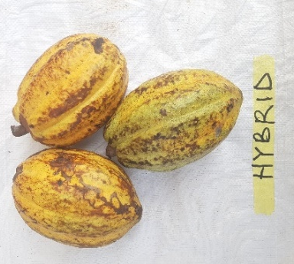
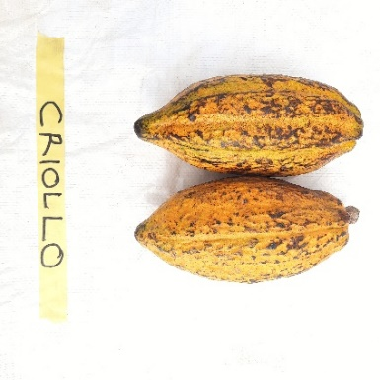
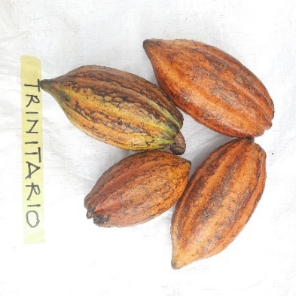
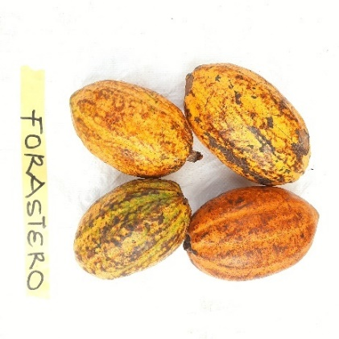
a) Cocoa pods

Plate 7. Varieties of cocoa collected from the cocoa farms according to the COCOBOD Manual
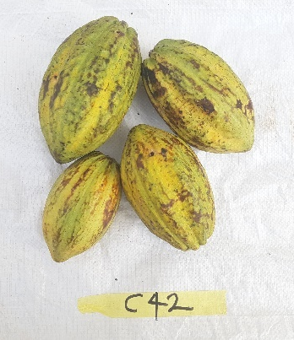
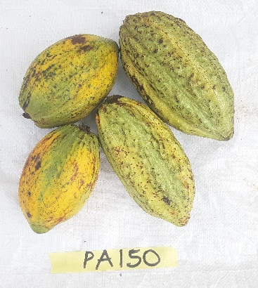
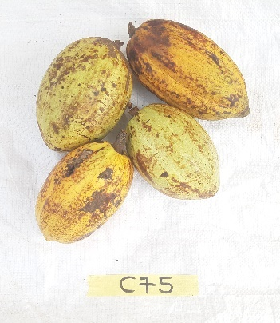
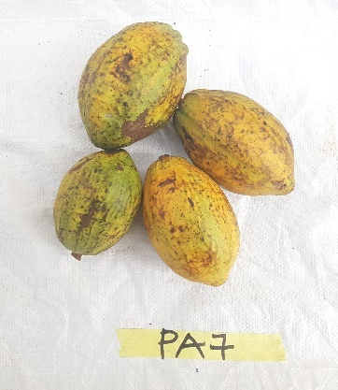

Plate 8. Genotypes of cocoa collected from the Boako Seed Production Unit

b) Greenhouse setup
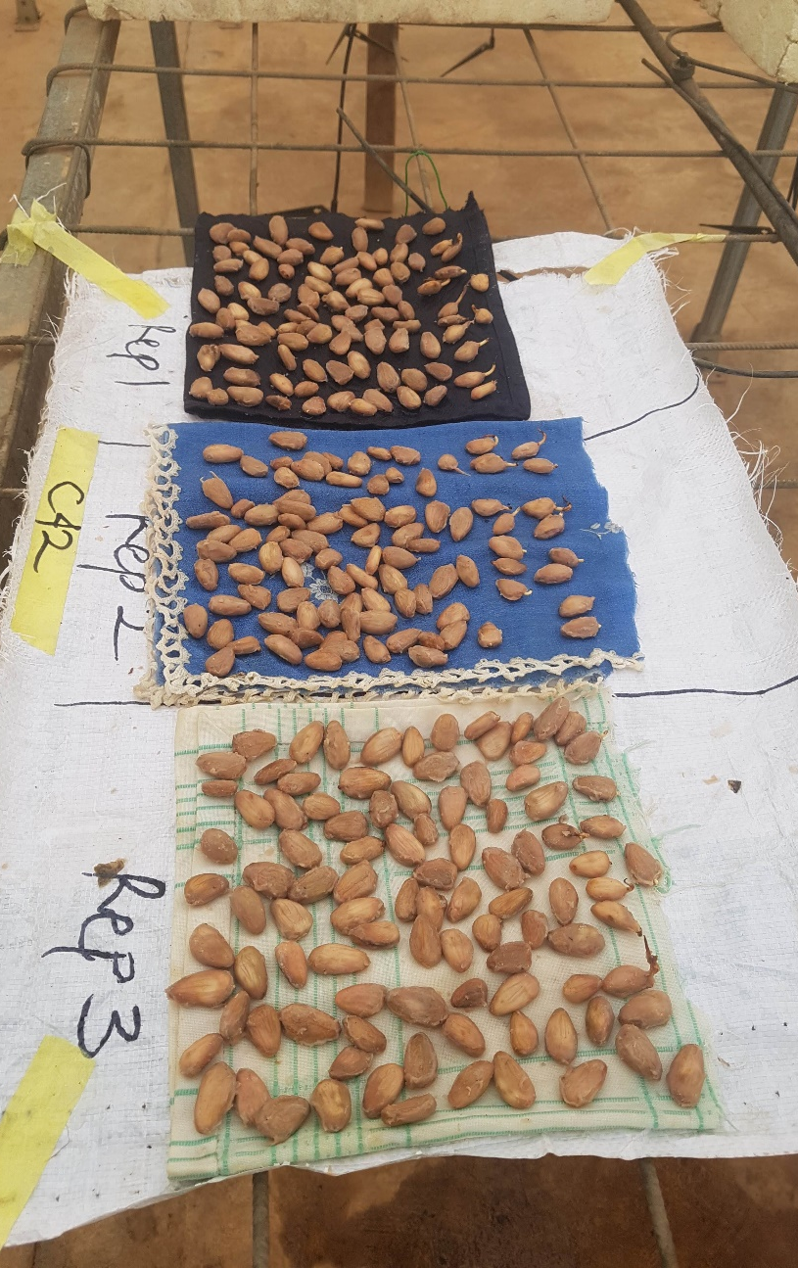

Plate 9. Set up raised on benches to germinate seed of cocoa varieties and genotypes
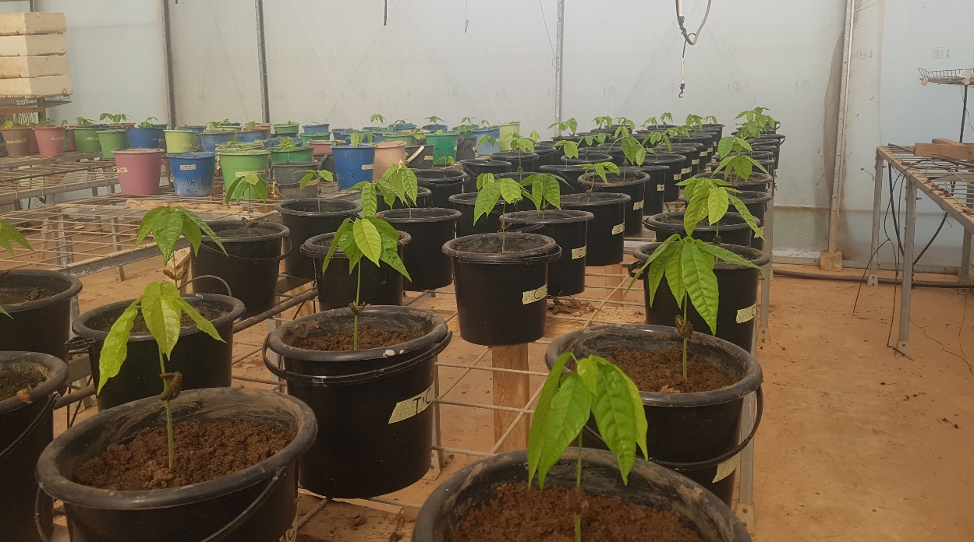

Plate 10. Experimental setup at the greenhouse

c) Symptoms on morphology
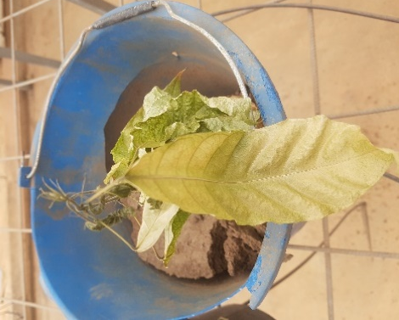
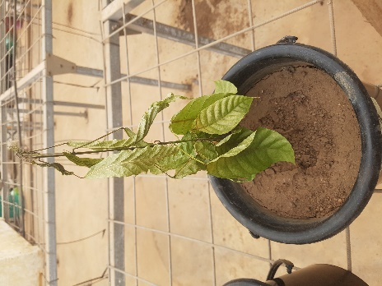
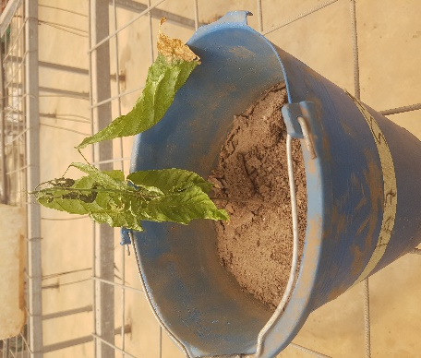
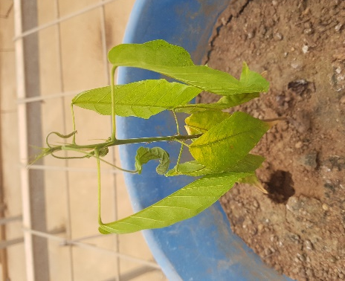

Plate 11: Various visual symptoms of drought stress observed in seedlings of the different genotypes and varieties of cocoa, indicative of drought symptoms
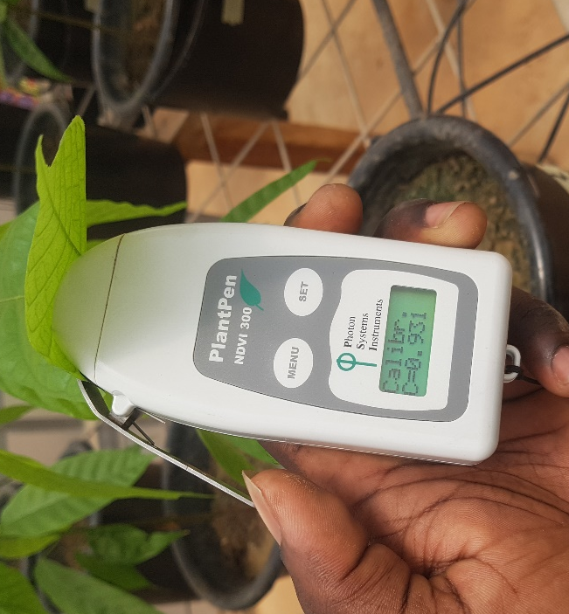
d) Instruments

Plate 12: Calibrating the PlantPen NDVI 300 using cocoa seedling leaf

e) Root microscopy
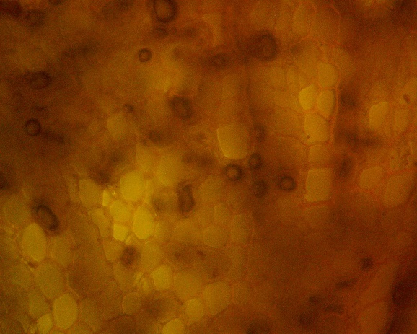
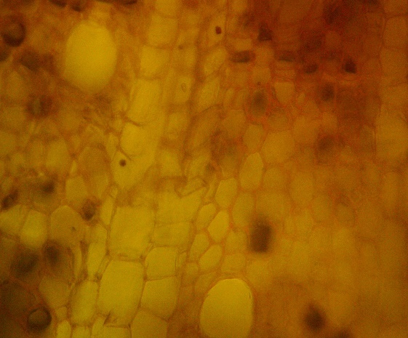

Control Stressed
Plate 13: Cortical cells of the root of cocoa seedlings under high powe

