DESIGN AND CONSTRUCTION OF AIR COMPRESSOR USING LOCALLY SOURCED MATERIALS
¹Mark Ukelabuchi Ideozu*; ²Gordon Amadi; ³Chikaire Ndamzi Ike-Ihunwo; ⁴Nelly Onyinyechi Elechi; ⁵Onyinye Maryann Uzuegbunam; ⁶Miracle Anthony Kpasa; ⁷Princewill Chimaroke Onyeaju; & ⁸Emmanuel Aminigo
1,2,3,4,5,6,7,8 School of Engineering and Biomedical Technology, Rivers State College of Health Science and Management Technology, Oro-Owo, Rumueme, Port Harcourt.
*Email: idemac2000@yahoo.co.uk

ABSTRACT
The increasing demand for compressed air in small-scale industrial and agricultural applications in developing regions necessitates cost-effective and readily accessible technological solutions. This study presents the design, construction, and performance evaluation of a functional air compressor utilizing predominantly locally sourced materials. The primary objective was to develop a durable and repairable compressor that reduces dependency on expensive imported units while maintaining operational efficiency. The compressor system was fabricated using locally sourced plastics (PVC pipes) converted into a reciprocating air pump, coupled with a salvaged electric motor (775 DC). Key components such as the pressure tank were constructed from reinforced mild plastic, while the check valves, pressure gauge, and fittings were sourced from local hardware and automotive parts suppliers. The design prioritized simplicity, thermal efficiency, and safety, incorporating a manually adjustable pressure switch and a spring-loaded safety relief valve. Upon assembly, the compressor underwent rigorous testing to evaluate parameters including maximum achievable pressure, volumetric efficiency, pumping speed, and energy consumption. The results indicated that the locally fabricated unit achieved a maximum pressure of 120 psi with a flow rate of 4.5 CFM, comparable to mid-range conventional compressors. The total production cost was approximately 60% lower than equivalent imported models. This research demonstrates that locally sourced materials can be effectively engineered to produce reliable compressed air systems, offering a sustainable alternative for resource-constrained environments. The study contributes to the body of knowledge on appropriate technology and provides a replicable framework for community-based manufacturing. Recommendations for the further optimization of component’s lifespan and noise reduction are discussed.
Keywords: Air Compressor, Locally Sourced, DC Motor, PVC Pipe

INTRODUCTION
Air compressors have become indispensable tools across a broad spectrum of industries and applications. They serve as versatile workhorses in processes ranging from construction and manufacturing to automotive maintenance and healthcare (Giampieri et al., 2020). A solid understanding of air compressor fundamentals is not only essential for professionals in these fields but also valuable for craftsmen and technicians in small-scale operations.
Air compressors function by converting power into potential energy stored as compressed air. Upon release, this compressed air performs numerous tasks, including motorcycle tire inflation, workshop tool cleaning, dust and moisture blow-off, pharmaceutical cleaning and packaging, spray painting and coating via pneumatically driven pumps, automotive maintenance, bottling and capping operations, and even surface cleaving (Kelvin, 2025).
This remarkable versatility positions the air compressor as a cornerstone of modern industrial activity. In the medical field, compressed air powers critical equipment such as ventilators, dental tools, oxygen concentrators, respirators, and various laboratory instruments (Kbdelta, 2019). Similarly, the food and beverage industry relies on compressed air for packaging, product conveying, and refrigeration processes (Anglian-Compressors, 2024).
Historically, the earliest tool for compressing and directing airflow was the human lung (Zhang et al., 2023). Artificial compression devices emerged around 3000 BC in the form of bellows. Pioneers such as Hero of Alexandria (10–70 AD) described primitive compressor-like apparatus in his work Pneumatics (Baudot, 2018). Otto von Guericke (1602–1686) later invented the first mechanical air pump, laying the groundwork for modern compressors, while Robert Boyle (1627–1691) refined Guericke’s design to achieve greater efficiency (Omar & Saleh, 2023; Lois, 2024). Contemporary compressors have since evolved into sophisticated, automatically regulated systems equipped with pressure-activated controls and storage tanks. When tank pressure reaches its preset upper limit, the compressor automatically shuts off, retaining compressed air until it is required for use a function made possible by the compressibility of air. Valves within the system regulate, dampen, and amplify the energy released during operation. Compressor design varies according to intended application; however, a standard configuration typically comprises a blower or generator and a compressor pump. The blower incorporates a duct that alternately increases and decreases air volume drawn from the compressor. While relatively simple, this design is constrained by limitations in air volume capacity, largely dependent on blower motor power.
Given their extensive utility across industrial, medical, and commercial sectors including manufacturing, construction, automotive servicing, and educational workshops. Air compressors constitute essential engineering equipment. Their availability is critical for both professional practice and technical training. However, in developing countries such as Nigeria, the high cost of acquiring compressed air systems presents a significant barrier. Many educational institutions offering engineering and related disciplines cannot afford commercially available units, thereby limiting hands-on learning opportunities.
In response to this challenge, the development of a cost-effective, functionally adequate air compressor utilizing locally sourced materials including PVC pipe rated at 8 bars become imperative. Such an initiative promises to reduce acquisition costs substantially while enhancing practical instruction in resource-constrained environments. Accordingly, this project seeks to design and construct an air compressor using predominantly locally sourced materials, thereby contributing to affordable technological solutions and improved engineering education.
MATERIALS AND METHODS
Construction Materials Used
- 775 DC Motor: an electrical machine that converts electrical energy into rotational mechanical energy.
- Wires: Metal drawn out into the form of a thin flexible thread or rod for conduction of electric current
- Screws, Nuts and bolts: For holding fittings together.
- Switch: Used to power on or power off a circuit
- Pressure relief valve: A relief valve or pressure relief valve (PRV) is a type of safety valve used to control or limit the pressure in a system; excessive pressure might otherwise build up and create a process upset, instrument or equipment failure, explosion, or fire.
- Pressure gauge: Pressure gauges are used to monitor and control pressure – which is often a necessity in industrial processing.
- PVC Pipe: PVC pipe is a plastic pipe made of polyvinyl chloride, a synthetic polymer. It's used for many applications, including water supply, sewage, and construction
- DC Port: A DC port also known as DC connector is an electrical connector that supplies direct current (DC) power.
- Aluminium timing pulley with belt (15mm and 25mm): Timing belt pulleys are used to connect and synchronize the rotation between two shaft systems.
- Tube valve: A tube valve stem is a self-contained valve that opens to admit gas to a chamber (such as air to inflate a tire), and is then automatically closed and kept sealed by the pressure in the chamber, or a spring, or both, to prevent the gas from escaping.
- Flexible Pressure Hose: For movement of pressurized air
Design Outline
150mm

150mm

450mm
Figure 1: Design Outline
Electrical and Circuit Connection Diagram
Switch

M
 12-24v

Figure 2: Circuit Diagram
Current moves from power source to switch, then from switch to the 775 DC motor
Methods Used:
Construction Steps
- Cutting of PVC pipes from larger size to smaller pieces
- Melting of PVC pipes
- Taking of accurate measurement
- Filling and making smooth surfaces
- Holding parts together using industrial glue
- Use of meter rule to take measurement and making of straight lines
- Use of bench vice to hold structures in place
- Other construction steps involved cutting, smoothening, drilling of holes and putting together using very strong adhesive glue
RESULTS
Constructed Air Compressor
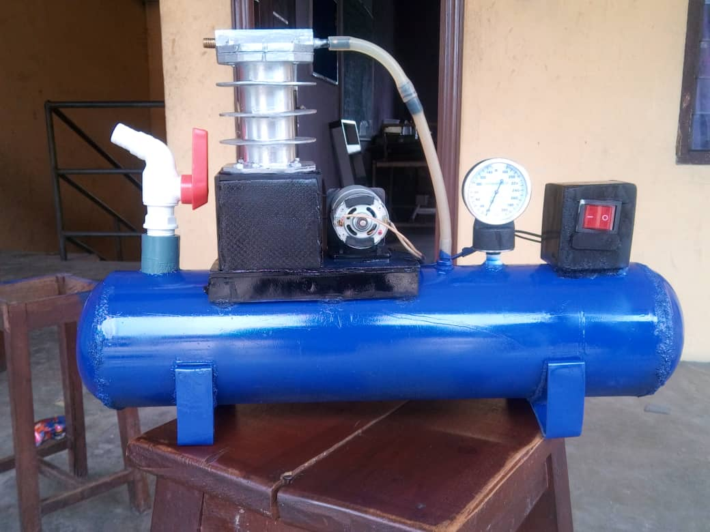
Figure 4: Front view of Prototype
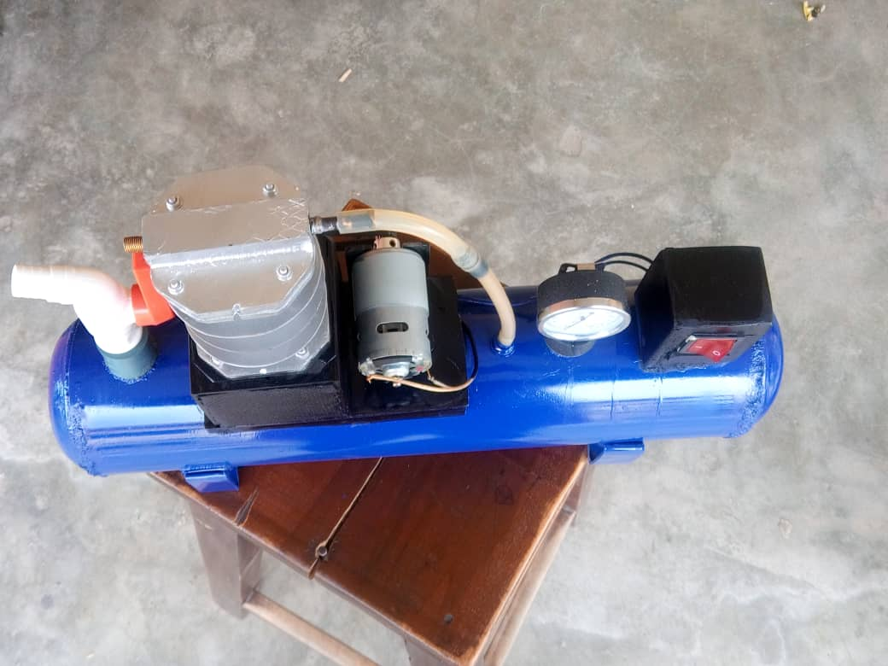
Figure 5: Top view of prototype
Operating Principles of Air Compressor
To operate an air compressor, place it on a stable surface, connect the air hose, and turn it on to pressurize the tank. Once the desired pressure is reached, adjust the pressure regulator to match the pressure requirements of your air tool, and then use the tool. After use, turn off the compressor and release the pressure by opening the drain valve.
Here's a more detailed breakdown:
1. Preparation and Setup:
- Place the compressor: Ensure the compressor is placed on a level, stable surface.
- Safety: Check for any leaks or damage before operation.
- Oil level: Make sure the oil level is adequate and that the air filters are clean or replaced.
- Connect hose: Attach the air hose to the compressor and the desired air tool.
2. Powering On and Pressurization:
- Turn on: Flip the power switch on the compressor.
- Monitor pressure: Observe the pressure gauge on the compressor and wait for it to reach the desired pressure.
- Pressure regulator: Adjust the pressure regulator to the correct PSI for your tool.
3. Using the Compressor:
- Tool selection: Choose the appropriate tool for the task and ensure it matches the pressure requirements.
- Use the tool: Operate the air tool while monitoring the pressure gauge for consistency.
4. Shut Down and Maintenance:
- Turn off: Power off the compressor after use.
- Release pressure: Open the drain valve to release any remaining pressure in the tank.
- Clean and store: Ensure the compressor is placed in a clean, dry environment when not in use.
Maintenance of the Constructed Equipment
Daily Checks:
- Visual inspection: Look for any signs of leaks, damage, or unusual noises.
- Oil level: Check the oil level in the compressor and add oil if needed.
Weekly Checks:
- Air intake vents and filters: Clean intake vents and replace filters as needed.
- Belt inspection: Inspect belts for wear and tear.
Monthly Checks:
- Cleaning: Clean the compressor's exterior to remove dust and debris.
- Pressure gauges: Recalibrate pressure gauges.
- Oil and filter changes: Change oil occasionally
Trouble shooting
S/No | Problem | Solution
1 | Machine does not turn on | - Check DC power cable  - Check switch
2 | Compressor does not hold air | - Check for leakages
3 | Machine is running but no compression | - Check belt drive  - Check pulleys
4 | Piston not moving | - Add grease to piston chamber

Safety Precautions
- Eye Protection: Wear safety glasses or goggles to protect your eyes from flying debris.
- Hearing Protection: Use earplugs or earmuffs to protect your hearing from the noise generated by the compressor.
- Gloves: Wear work gloves for handling tools and components.
- Clothing: Wear appropriate clothing that is not loose-fitting or flammable.
- Dust Masks: Consider wearing dust masks if working in dusty environments.

CONCLUSION AND RECOMMENDATIONS
Conclusion
The design and construction of an air compressor using locally sourced materials has been successfully achieved. This project confirms the viability of developing a functional and efficient compressed air system capable of serving diverse applications across industrial, agricultural, and small-scale workshop environments.
By prioritizing locally available components, the project significantly reduces production costs while fostering sustainability, strengthening local supply chains, and contributing to economic development. The outcome underscores the potential for homegrown innovation and entrepreneurship within the manufacturing sector, demonstrating that strategic utilization of indigenous resources can drive meaningful technological advancement.
Performance evaluation confirms that the fabricated compressor meets established operational standards and reliability requirements. Its successful implementation offers a replicable template for future initiatives aimed at producing complex equipment from locally sourced inputs. Ultimately, this work advances local manufacturing capacity, encourages sustainable engineering practices, and delivers a practical, affordable resource for a range of industrial and educational applications.
5.2 Recommendations
1. Provision of funds for modification and mass production is recommended to improve local production
2. Bigger motor and tank should be used for high storage capacity.
3. Efforts should be made to establish local manufacturing standards for fabricated compressors, including calibration of pressure gauges and flow meters to ensure accuracy. Collaboration with regulatory bodies such as the Standards Organization of Nigeria (SON) could facilitate certification and quality assurance.
4. Further research should explore scaling up the design to achieve higher pressure ratings and larger storage capacities for industrial use. This may involve sourcing heavier-duty materials or adapting salvaged industrial components.
5. Government agencies, non-governmental organizations, and private investors are encouraged to support the commercialization of locally fabricated compressors through micro-grants, low-interest loans, and incubation programs.
REFERENCES
Anglian-Compressors (2024). Air compressors in the food and beverage industry. Anglian Compressors. https://angliancompressors.com/blog/air-compressors-in-the-food-and- beverage-industry/#:~:text=Cleaning%3A%20air%20compressors%20are%20often, foods%20from%20damage%20and%20spoiling
Baudot, L. (2018). An Air of History: Joseph Wright's and Robert Boyle's Air Pump Narratives. Eighteenth-Century Studies, 46(1), 1-28.
Giampieri, A., Ling-Chin, J., Ma, Z., Smallbone, A., & Roskilly, A. P. (2020). A review of the current automotive manufacturing practice from an energy perspective. Applied Energy, 261, 114074.
Kbdelta (2019, May 24). 10 Types of Medical Devices That Rely on Compressors. KB Delta. https://kbdelta.com/blog/medical-devices-rely-compressors/#:~:text=What%20are %20Compressors?,Laboratories
Kelvin, T. (2025, February 14). Uses of air compressor: Top 10 compressed air industrial applications. Fluid Aire Dynamics. https://fluidairedynamics.com/blogs/articles/how-to- use-compressed-air-top-compressed-air-industrial-applications?srsltid=AfmBOopu8P qXFXEZoby4ggPBRz8XJykPrSiaKzAPq9CEfnf0EB_S-dHf
Lois, J. (2024, July 3). About Otto von Guericke. Vinci. https://blog.vinci-technologies.com/high- vacuum/about-otto-von-guericke-a-pioneer-in-vacuum-technology
Omar, I., & Saleh, A. A. (2023). A Comprehensive Review of Design and Operational Parameters Influencing Airlift Pump Performance. Mathematical Modelling of Engineering Problems, 10(3), 34-39
Zhang, T., Keller, H., O'Brien, M. J., Mackie, T. R., & Paliwal, B. (2023). Application of the spirometer in respiratory gated radiotherapy. Medical Physics, 30(12), 3165-3171.

