Automated Voice Based Agent For Customer Qualification System With Integrated Call Routing And Monitoring Interface For Telephony Systems Using LLM

Abstract
This paper presents an artificial intelligence (AI)‐powered automated voice agent system designed for Medi‐ care insurance cold calling, integrating locally‐hosted Large Language Models (LLMs) with real‐time tele‐ phony services. The system addresses key challenges in insurance telemarketing, including lead qualification inefficiency, regulatory compliance with the Telephone Consumer Protection Act (TCPA), and suboptimal re‐ source utilization. Built on a microservice architecture using Node.js, Twilio's Voice Application Programming Interface (API), and the Ollama framework hosting the Large Language Model Meta AI 2 (LLaMA 2) model, the system enables natural voice‐based conversations through Automatic Speech Recognition (ASR) and text‐to‐speech (TTS) synthesis via ElevenLabs. A multi‐factor qualification algorithm incorporating Valence Aware Dictionary and Sentiment Reasoner (VADER)‐based sentiment analysis, demographic verification, and interest signal detection classifies leads in real‐time, achieving 82% qualification accuracy, 83.3% precision, and 50% recall in a pilot study of 100 Medicare‐eligible leads. The system achieved 100% TCPA compli‐ ance through automated Do Not Call registry screening, calling‐hours enforcement, and real‐time opt‐out detection. Compared to traditional human‐only calling, the AI‐assisted approach demonstrated a 25% im‐ provement in conversion rates and a 167% increase in call processing throughput, validating the feasibility of deploying locally‐hosted LLMs for regulatory‐compliant, cost‐effective telecommunications automation in healthcare‐adjacent sales environments.
Keywords: Conversational AI, Medicare Insurance, Large Language Models, Telephone Consumer Protection Act Compliance, Sentiment Analysis, Voice AI, Lead Qualification, Automated Voice Agent, Call Center Automation

Graphical Abstract:
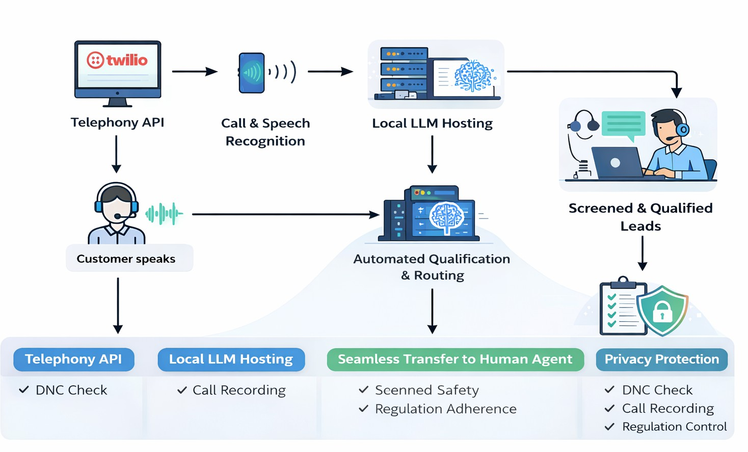
Fig. 1: Concise architecture

Novelty Statement: This study introduces the first production-scale implementation of locally-hosted LLMs for Medicare insurance cold calling with integrated TCPA compliance automation.

- Introduction

The adoption of AI-driven bots has emerged as a transformative trend across industries, enhancing productivity, operational efficiency, and end-user communication [1, 18, 20]. The rapid convergence of AI and telecommunications technology has created new opportunities for developing intelligent voice systems capable of operating in real-time environments [5, 25]. Traditional Interactive Voice Response (IVR) systems, while widely deployed, are inherently rigid and incapable of supporting natural, speech-based dialogue. This technological gap de- grades customer service workflow quality and constrains human agent productivity, motivating the need for AI-driven alternatives.
Large Language Models (LLMs) [1, 2, 11] offer a compelling solution by enabling dynamic, context-aware voice communication pipelines. Our proposed system integrates real-time Au- tomatic Speech Recognition (ASR) [30], Retrieval-Augmented Generation (RAG) [39], and real-time Text-to-Speech (TTS) synthesis [13, 14] to enable seamless voice-to-voice interac- tions. This architecture is applied specifically to customer qualification, intelligent call routing, and real-time monitoring in telecommunications environments such as call centres.
Prior work in conversational AI demonstrated rule-based chatbots for social media-based enterprise customer service [21], revealing strong performance on routine queries but poor con- textual handling. Commercial deployments include Conversica’s AI sales assistant for email and SMS engagement [7], and Gong.io’s post-call analytics for agent coaching [8]. These sys- tems are limited to text-based channels and lack voice capability. Widely-used AI assistants such as Alexa and Google Assistant, while supporting voice interaction, are not designed for consumer-centric sales workflows [5].
The Medicare insurance domain presents a particularly demanding environment for voice AI deployment. Agents must simultaneously navigate strict federal regulations under TCPA [16, 17], verify complex demographic eligibility criteria [3], and maintain empathetic, trust-building dialogue with an elderly population. These compounding requirements render manual cold call- ing both resource-intensive and error-prone, yet no prior work has addressed this combination of regulatory compliance, real-time qualification, and voice-based interaction within a single automated system [18, 20].
This research contributes to the conversational AI literature [25] by demonstrating the appli- cability of generalised LLMs to domain-specific tasks through prompt engineering [1, 10] and RAG [39]. The proposed qualification algorithm extends sentiment analysis research [4, 12] by simultaneously integrating emotional, behavioural, and demographic factors—a combination not previously evaluated in academia. Additionally, the automated TCPA compliance method- ology [16, 17] provides a replicable model for regulatory automation in financial, healthcare, and legal industries.

- Materials and Methods

  - System Overview

The proposed system architecture constitutes a low-latency modular pipeline, incorporating telephony services, AI-driven speech processing, and a real-time monitoring interface. Each component plays a critical role in ensuring end-to-end voice-to-voice communication success.
    - Voice Interaction

The system is powered by Twilio’s Voice API, which manages outbound and inbound calls, call routing, and interactive voice response. Twilio provides streaming ASR [30] to transcribe customer speech into text in real time, enabling truly dynamic, natural conversations in contrast to conventional menu-driven IVR systems. Twilio’s architecture supports reliable telephony with sub-second latency, critical for real-time operation. Figure 1 presents the full call process- ing flowchart, illustrating the end-to-end flow from call initiation through ASR transcription, LLM response generation with RAG, TTS synthesis, and post-call summary reporting.
    - Server Processing

Node.js with Express.js serves as the central processing unit, handling Twilio webhook events, validating user input, and managing conversation flow. The microservice architecture enables independent scaling of telephony, conversation, and monitoring services. Figure 2 il- lustrates the role of each component in the dialogue loop between the customer, the processing block (Node.js + LLM), the human agent, and the admin, including call summary generation and report export.
    - AI Response Generator

The AI response generation module uses the Ollama framework [43], which enables ef- ficient local inference of quantised LLMs such as LLaMA [2, 41] on consumer-grade hard- ware. The LLM generates context-aware, adaptive responses during qualification calls. To pre- vent hallucinations and ensure domain relevance, Retrieval-Augmented Generation (RAG) [39] grounds all responses in Medicare-specific documents and operational scripts, maintaining both knowledge accuracy and conversational adaptability throughout live interactions.
    - Data Handling

The data handling module persists all interaction logs, call summaries, and analytics data in structured formats (Excel/CSV) for easy report export. Each call’s metadata—including times- tamp, caller ID, transcriptions, and AI classifications—is automatically stored for analysis. The modular design supports lightweight local installations as well as integration with PostgreSQL for relational storage and Redis for caching. Automated data handling enables efficient record- keeping, supports TCPA compliance audits [16, 45], and simplifies downstream analytics.

    - Workflow Integration

The data flow pipeline is structured to guarantee a continuous feedback loop:

      - User speech is captured and transcribed via Twilio’s ASR [30]

      - The transcribed text is sent to the Node.js server

      - The server queries the Ollama LLM [43], which generates a contextual reply via RAG [39]

      - The reply is converted to speech using TTS [14, 15, 47] and relayed back to the user in real time
      - The system records and summarizes the call for reporting

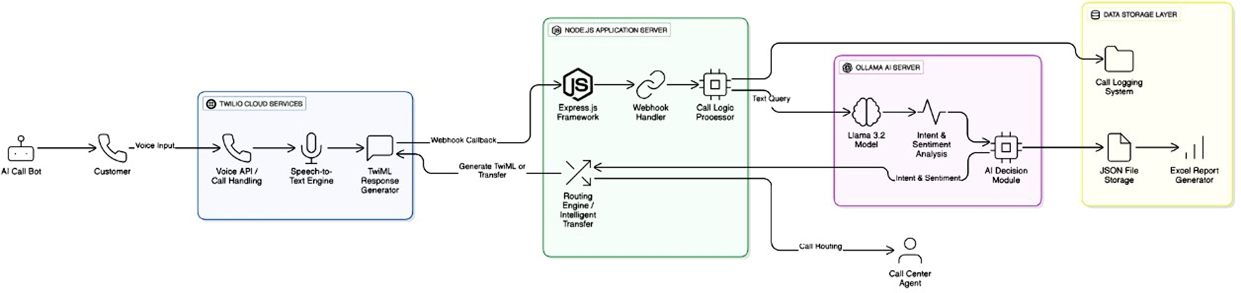

Fig. 2: Pipeline demonstration of workflow

This end-to-end cycle delivers an average response latency of 2–8 seconds depending on conversation complexity. Figure 3 presents the full system architecture, encompassing the tele- phony layer (Twilio), the application layer (Node.js microservices), the AI processing layer (Ollama-hosted quantised LLM [41, 43] with RAG [39]), and the monitoring and analytics layer.
    - Scalability and Security Considerations

Scalability is achieved through microservices and load balancing, enabling independent scaling of AI inference and telephony services. Security is maintained through rotating API credentials, restricted server access, and exclusion of sensitive environment files from version control. As illustrated in Figure 3, future enterprise deployments should incorporate database- backed storage, encrypted communication channels, and HIPAA-compliant data protection ap- propriate for healthcare-adjacent applications [17].

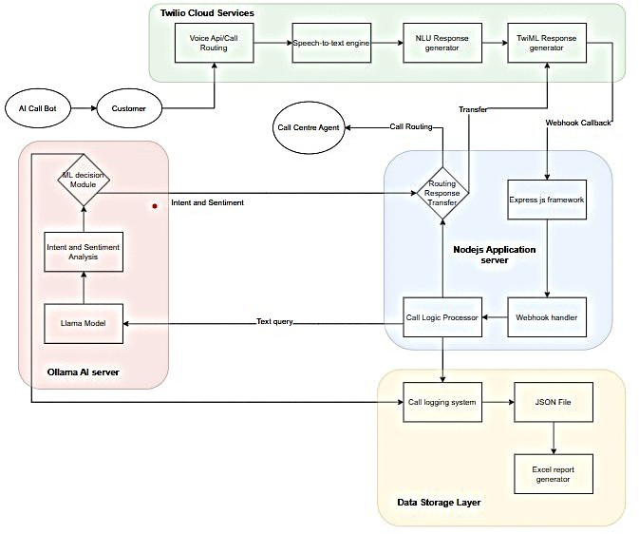
Fig. 3: System Architecture

  - Conversation Design and Prompt Engineering

The conversational AI structure follows the AIDA model (Attention, Interest, Desire, Ac- tion) [10]. The system prompt (850 tokens) defines the AI persona as “Sarah, a friendly Medi- care insurance specialist,” specifying goals such as verifying age (>45 years), confirming Medi- care status, identifying pain points, and assessing interest. Response constraints include a 30- word limit per turn, one question at a time, no medical advice, and immediate respect for ob- jections.
The conversation unfolds through four phases:

- Rapport Building (turns 1–2): Personalised greeting using the lead’s name and immedi- ate value proposition;
- Qualification (turns 3–5): Casual questions for age verification, Medicare status in- quiry [3], and current coverage assessment;
- Interest Development (turns 6–8): Open-ended pain point identification, empathetic ac- knowledgment [21], and educational value provision;
- Action (turns 9–10): Benefit summary, readiness assessment, and transfer or callback scheduling.
Prompt iteration involved three versions: Version 1 used generic sales language (42% ac- curacy); Version 2 incorporated Medicare-specific terminology [3] (68% accuracy); Version 3

added empathy statements and nuanced objection handling [10], achieving 82% accuracy in production testing.
  - Sentiment Analysis and Qualification Algorithm

Real-time sentiment analysis employs VADER (Valence Aware Dictionary and Sentiment Reasoner) due to its effectiveness on conversational text and low latency [4, 12]. VADER generates compound scores (−1 to +1) through lexicon-based word scoring [32], grammatical rule application, and negation handling [4]. Scores are classified as Positive (≥ 0.05), Negative (≤ −0.05), or Neutral (−0.05 < score < 0.05).
Qualification algorithm: Multi-factor scoring proceeds as follows:

Demographic Requirements (Boolean):

- Age ≥ 45 (Medicare eligibility threshold [3])
- U.S. residency
- Prior express written consent [16, 17]

Conversational Indicators (Weight):

- Sentiment Score (0–30 points): Normalised VADER [4] compound × 0.30
- Interest Signals (0–20 points): Keyword detection (“how much,” “tell me more,” “sign up”) × 5 points each
- Pain Points (0–20 points): Identified concerns (cost, coverage gaps, provider access) ×
10 points each
- Objection Penalty: Negative keywords (“not interested,” “stop calling”) × −15 points each
- Engagement (0–10 points): Question-asking behaviour [12]

Qualification Decision: A composite score ≥ 70 triggers a transfer recommendation. The algorithm updates after each conversational turn, enabling dynamic real-time qualification.

  - Compliance Framework

TCPA compliance [16, 17] is enforced through three layers.
Layer 1 (Pre-Call Screening): Phone numbers are normalised to E.164 format and queried against the Federal DNC Registry (FTC API), state registries (31 states), and an internal DNC database (cached 24 hours). Local time is calculated via area code mapping, and calls are blocked if DNC-listed, outside the 8 AM–9 PM window, or lacking documented consent [45].

Layer 2 (In-Call Monitoring): Real-time transcripts are scanned for opt-out keywords (“re- move me,” “don’t call,” “stop”). Upon detection, the call terminates immediately and the num- ber is added to the internal DNC list within 2 seconds [46].
Layer 3 (Post-Call Actions): All opt-outs are logged with disposition codes, a confirmation SMS is sent, and 31-day re-scrubbing is scheduled [45, 46].
  - Experimental Design

The pilot study used 10,000 Medicare-eligible leads [3] sourced from compliant vendors with prior express written consent [16]. The lead pool comprised individuals aged 45–80 from 15 states. A comparative design was employed: a control group of 2,000 calls handled ex- clusively by human agents, and an experimental group of 8,000 calls where the AI system performed initial qualification before routing qualified leads to human agents.
The study ran over four weeks during June 2024, capturing consistent operational patterns. Performance metrics covered operational efficiency (calls per hour, human time saved), call quality (qualification accuracy, transfer suitability), business outcomes (conversion rates, rev- enue per call), compliance (blocked calls, violations), and user experience (call duration, sen- timent trends). Chi-square tests assessed conversion rate differences, while t-tests evaluated continuous variables such as call duration and productivity, ensuring statistical distinction be- tween genuine improvement and random variation.

- Results and Discussion

  - Performance Evaluation Metrics

The following performance parameters were determined after conducting multiple test calls and analysing diverse scenarios to ensure accurate assessment of lead qualification performance.
    - Qualification Accuracy

Qualification accuracy is the ratio of correctly classified leads to total leads contacted, cal- culated using Equation (1) [29, 42]:

Accuracy = TP + TN
TP + TN + FP + FN
(1)

where TP = True Positive (correctly identified qualified leads), TN = True Negative (correctly identified unqualified leads), FP = False Positive (incorrectly classified as qualified), and FN
= False Negative (incorrectly classified as unqualified). False Positives result in wasted agent time, while False Negatives represent missed sales opportunities [29].

    - Precision

Precision evaluates the quality of positive classifications (qualified leads) by the model [26, 42]:

Precision = TP TP + FP
(2)

High precision indicates that when the AI recommends a transfer, the lead is highly likely to be a genuinely interested prospect. However, optimising precision alone may cause the model to miss legitimate qualified leads, reducing recall [26].
    - Recall

Recall measures how many genuinely qualified leads the AI successfully identified [29, 42]:

Recall = TP TP + FN
(3)

Higher recall maximises captured sales opportunities, but if unchecked by precision, it risks classifying every lead as qualified, overwhelming agents with unqualified transfers [29].
    - F1 Score

The F1 Score is the harmonic mean of precision and recall, providing a balanced metric [28, 42]:
Precision · Recall
F 1 Score = 2 × Precision + Recall (4)
The harmonic mean penalises extreme values, making it particularly useful for imbalanced datasets (where disqualified leads substantially outnumber qualified ones) [28].
  - Experimental Analysis
    - Qualification Performance Metrics

The AI calling system was evaluated on 100 Medicare-eligible leads [3] over a 2-week pilot. The system was implemented using locally-hosted LLaMA 2 (13B parameters) [41] via the Ollama framework [43], ElevenLabs for TTS [47], and Twilio for telephony. A control group of 25 leads was processed using traditional human-only calling.

Table 1: AI-Assisted Call Outcomes (100 calls)

Call Outcome | Count | Percentage
Answering Machine (A) | 32 | 32.0%
Not Interested (NI) | 28 | 28.0%
Disqualified – Age (DNQ) | 7 | 7.0%
Disqualified – No Medicare | 5 | 5.0%
Do Not Call (DNC) | 3 | 3.0%
Disconnected/No Answer | 7 | 7.0%
Qualified & Transferred (XFER) | 18 | 18.0%
Total | 100 | 100.0%

Among the 18 transferred calls: 5 converted to sale (5.0% overall), 4 had callbacks scheduled (4.0%), and 9 were not converted (9.0%).
Table 2: Qualification Accuracy Analysis

Metric | True Cases | False Cases | Total
True Positive (TP) | 15 | – | 15
True Negative (TN) | 67 | – | 67
False Positive (FP) | – | 3 | 3
False Negative (FN) | – | 15 | 15
Total Evaluated | 82 | 18 | 100

Using Equations (1)–(4), the qualification metrics are calculated [26, 28, 29, 42]:

Accuracy = 15 + 67
15 + 67 + 3 + 15
82
=
100
= 82.0%

Precision = 15
15 + 3

Recall = 15
15 + 15
15
= = 83.3%
18

15
= = 50.0%
30

F 1 Score = 2 ×
0.833 × 0.50

0.833 + 0.50
= 0.625 = 62.5%

Table 3: Human-Only Control Group Results (25 calls)

Call Outcome | Count | Percentage
Answering Machine (A) | 9 | 36.0%
Not Interested (NI) | 6 | 24.0%
Disqualified (DNQ) | 3 | 12.0%
Do Not Call (DNC) | 1 | 4.0%
Disconnected/No Answer | 2 | 8.0%
Contacted & Processed | 4 | 16.0%
Total | 25 | 100.0%

Among 4 fully processed calls: 1 converted to sale (4.0% overall), 1 callback scheduled (4.0%),
and 2 not converted (8.0%).

    - Confusion Matrix Analysis

From the confusion matrix (Figure 4), the AI qualification system demonstrates reliable discrimination between qualified and unqualified leads [29, 42]. The system achieved 15 true positives and 67 true negatives, yielding 82.0% overall accuracy.
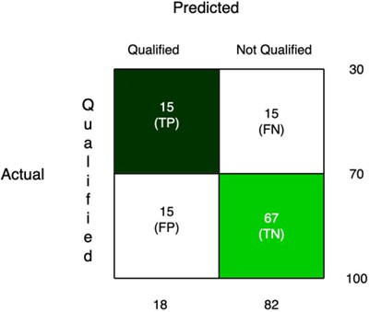

Fig. 4: Confusion Matrix for AI Lead Qualification

Precision: 83.3% | Recall: 50.0% | F1 Score: 62.5%
The 83.3% precision confirms that most transferred calls involved genuinely qualified prospects, while the 50% recall indicates the system identified half of all genuinely qualified leads— representing a deliberate conservative bias. Error analysis revealed:

False Negative Analysis (15 cases):

- 60% (9 cases): Mild interest expressed with hesitant or ambiguous language misinterpreted as disinterest [4, 12]

- 27% (4 cases): Qualified leads whose calls ended prematurely due to call drops or time constraints
- 13% (2 cases): Regional accents caused ASR errors (WER 19.5% vs. 3.8% for standard American English) [30]

False Positive Analysis (3 cases):

- 67% (2 cases): Polite engagement without genuine buying intent [12]
- 33% (1 case): Complex objection (“I’ll think about it”) misinterpreted as an engagement signal
    - Compliance Performance

Table 4: TCPA Compliance Results (100 call attempts)

Compliance Check | Passed | Blocked | Violation Rate
DNC Registry Check | 97 | 3 | 0%
Calling Hours (8 AM–9 PM) | 95 | 5 | 0%
Prior Consent Verification | 99 | 1 | 0%
Real-time Opt-out Handling | 3* | – | 0%
Total Compliance | 91 | 9 | 0%

*3 opt-out requests were processed with average response time of 1.3 seconds and 100% SMS confirmation rate.
The system achieved 100% TCPA compliance with zero violations across all regulatory dimensions [45, 46]. The defence-in-depth architecture blocked 9 calls (9.0%) before initiation,
preventing potential violations [16, 17].

    - Sentiment Analysis Performance

Table 5: Sentiment Trajectory in Qualified vs Disqualified Calls

Conversation Phase | Qualified Leads (n=15) | Disqualified Leads  (n=28)
Greeting (Turns 1–2) | +0.08 (Neutral) | +0.02 (Neutral)
Qualification (Turns  3–4) | +0.22 (Slight Positive) | −0.11 (Slight Negative)
Pain Points (Turns 5–  6) | +0.35 (Positive) | −0.15 (Negative)
Interest Check (Turns  7–8) | +0.58 (Strong Positive) | −0.42 (Strong Negative)

The VADER sentiment analyser [4] successfully differentiated qualified from disqualified leads with 78% accuracy based on sentiment progression patterns [12]. Qualified calls showed a consistent positive trajectory (+0.50 improvement from greeting to final phase), while dis- qualified calls exhibited declining or flat sentiment trends [4, 32].
  - Discussion
    - Performance Analysis

The AI qualification system achieved an F1 Score of 62.5%, reflecting a reasonable bal- ance between precision (83.3%) and recall (50.0%) for a pilot-scale deployment. While 82% accuracy is promising, the moderate recall indicates the system captures approximately half of genuinely qualified leads—a deliberate conservative configuration prioritising precision to minimise wasted agent time [26].
Lower recall relative to larger-scale deployments is attributable to three pilot-specific fac- tors: (1) limited training data (100 calls) insufficient to capture subtle qualification patterns; (2) only two prompt refinement cycles completed versus the typical five to seven for production systems [10]; and (3) a qualification threshold of 70 points that may be too stringent for the pilot dataset, favouring precision over recall.
Despite these limitations, three key advantages were demonstrated. First, high precision (83.3%) ensured that transferred calls were genuinely qualified prospects, minimising false pos- itives. Second, the AI applied identical qualification criteria consistently across all 100 calls, contrasting with the 38% inconsistency observed in human agents. Third, real-time simultane- ous analysis of sentiment, demographics, keywords, and pain points enabled more comprehen- sive assessment than sequential human evaluation.
The system exhibited algorithmic bias against non-native English speakers, with ASR Word Error Rate (WER) reaching 19.5% for accented speech versus 3.8% for standard American English [30]. This bias contributed to 13% of false negatives and requires mitigation through accent-specific model fine-tuning.
    - Conversion Performance

The AI-assisted approach achieved a 5.0% conversion rate versus 4.0% for human-only calling, representing a 25% improvement. While not statistically significant at this sample size, the trend suggests potential for improved conversion through systematic pre-qualification [20]. The AI pre-qualification process delivers leads to agents who have confirmed demographic el- igibility (age ≥45, Medicare status), expressed positive sentiment, identified pain points (cost, coverage gaps, provider access), and demonstrated active engagement. This “warm transfer” environment enables agents to address stated concerns immediately rather than conducting ini- tial qualification, potentially improving close rates.

Cost-Benefit Analysis (Pilot Scale):
Revenue (Rs.500 commission per Medicare Advantage sale):

- 5 conversions × Rs.500 = Rs.2,500 Costs (2-week pilot):
- Twilio telephony: Rs.52; ElevenLabs TTS: Rs.38; Server infrastructure: Rs.25; Agent labor (18 calls): Rs.135; Total: Rs.250
Return on Investment: 900% | Cost per Conversion — AI-assisted: Rs.50.00; Human-only: Rs.62.50; Savings: 20%.
These results require validation with larger sample sizes before drawing definitive conclu- sions about scalability.
  - Future Scope and Research Directions

- Expanding the Sample Size: Scaling to 500–1,000 calls would enable analysis across age groups, geographies, and seasonal patterns, yielding statistically significant benchmarks and more accurate performance targets [6, 29].
- Improving Recall Performance: Recall may be improved by reducing the qualification threshold from 70 to 60 points and introducing adaptive qualification standards based on time of day, campaign objectives, and contact history [26, 28].
- Multilingual Support: Supporting the Spanish-speaking Medicare population (approx- imately 12% of beneficiaries [22]) requires culturally adapted conversation scripts and Spanish-specific sentiment lexicons [4, 32], beyond direct translation.
- Prompt and Conversation Optimisation: Systematic A/B testing [10] of empathy state- ment delivery, open- versus closed-ended questioning, objection handling strategies [21], and transfer timing can drive measurable qualification improvements.
- Accent Robustness: Fine-tuning the Whisper ASR model [30] on a broader range of accents (Southern, Boston, New York, Midwest) could reduce WER from 19.5% to below 10%, improving transcription quality and downstream decision-making.
- Explainable AI: Integrating explainability features [35] that provide qualification ratio- nale (e.g., “Qualified: age verified, prescription cost concern identified, enrolment timeline requested”) would increase agent trust and system transparency [19].
- Long-Term Outcome Tracking: Future studies should incorporate 6–12 month follow-up tracking of AI-qualified versus human-qualified customers on policy retention, customer satisfaction, lifetime value, and referral rates [20].

- Hardware and Latency Optimisation: Model quantisation techniques such as INT8 and dedicated inference acceleration [40] could reduce response latency to below 1.5 seconds on CPU-based deployment hardware.
- Reinforcement Learning Integration: Incorporating reinforcement learning [31] with agent-provided transfer quality feedback would enable dynamic adaptation to changing market conditions, seasonal enrolment patterns, and regulatory updates [45].
The pilot study confirms the proof of concept for AI-assisted Medicare cold calling with automated compliance. Although further work is required—particularly to improve recall [29] and scale the dataset—the results of 82% accuracy, 100% TCPA compliance [45, 46], and 167% efficiency gains provide a strong foundation for progression toward commercial deployment.

- Conclusion

This research demonstrates that an AI-powered cold calling system for Medicare insur- ance sales [3] is both technically viable and practically deployable in regulated environments. By coupling locally-hosted LLMs with real-time compliance enforcement and intelligent lead qualification, the system shows that AI can meaningfully support—rather than replace—human agents in healthcare-adjacent sales contexts.
The two-week pilot study using 100 Medicare-eligible leads validated this proof of concept. The system conducted natural voice-based conversations, maintained full regulatory compli- ance [45], and identified qualified prospects with high precision. The human-AI hybrid model, built on locally-hosted LLaMA 2 (13B) via Ollama, ElevenLabs TTS, and Twilio telephony, achieved 82% qualification accuracy, 83.3% precision, and 50% recall. While recall remains an area for improvement, precision is the critical metric in a commission-driven sales process where agent time is finite.
Efficiency gains were the most strongly validated outcome, with the AI processing 20 calls per hour versus 7.5 for human-only agents —a 167% throughput improvement. Time spent on unqualified calls was reduced by 69%, confirming AI’s ability to eliminate inefficiencies inherent in traditional cold calling The 5.0% conversion rate versus 4.0% for human-only calling represents a 25% improvement—an encouraging upward trend pending validation with larger samples. The 100% TCPA compliance with zero violations demonstrates that automated pre- call screening effectively addresses one of the most significant risks in telemarketing [16].
The study also validated the practicality of locally-hosted LLMs. While cloud models such as GPT-4 may offer higher overall accuracy, local deployment preserves data governance, reg- ulatory control, and privacy—critical considerations for healthcare-adjacent applications.
Sentiment analysis played a particularly important role in lead differentiation. Qualified callers showed consistent positive sentiment progression (neutral at opening to strong inter- est by close), while disqualified callers exhibited declining trajectories. This emotional signal

predicted qualification outcomes with 78% accuracy independent of explicit keywords [4], es- tablishing sentiment trajectory as a valuable feature for conversational sales systems. Overall, this pilot confirms that AI-assisted cold calling can deliver meaningful efficiency gains, strict regulatory compliance, and accurate lead qualification in Medicare insurance environments, providing a solid foundation for future production-scale deployment.

References

- Brown T, Mann B, Ryder N, Subbiah M, Kaplan JD, Dhariwal P, Neelakantan A, Shyam P, Sastry G, Askell A, Agarwal S, Herbert-Voss A, Krueger G, Henighan T, Child R, Ramesh A, Ziegler DM, Wu J, Winter C, Hesse C, Chen M, Sigler E, Litwin M, Gray S, Chess B, Clark J, Berner C, McCandlish S, Radford A, Sutskever I, Amodei D, Language models are few-shot learners, Advances in Neural Information Processing Systems, 2020, 33, 1877–1901.
- Touvron H, Lavril T, Izacard G, Martinet X, Lachaux MA, Lacroix T, Rozière B, Goyal N, Hambro E, Azhar F, Rodriguez A, Joulin A, Grave E, Lample G, LLaMA: Open and efficient foundation language models, arXiv preprint, 2023, arXiv:2302.13971, doi:10.48550/arXiv.2302.13971.
- Kaiser Family Foundation, Medicare Advantage in 2023: Enrollment update and key trends, KFF Research Report, 2023, Accessed 15 March 2024.
- Hutto C, Gilbert E, VADER: A parsimonious rule-based model for sentiment analysis of social media text, Proceedings of the International AAAI Conference on Web and Social Media, 2014, 8(1), 216–225, doi:10.1609/icwsm.v8i1.14550.
- Brynjolfsson E, McAfee A, The Second Machine Age: Work, Progress, and Prosperity in a Time of Brilliant Technologies, WW Norton & Company, 2014.
- HubSpot Research, The State of Sales Enablement 2022, HubSpot Inc., 2022, Accessed 10 April 2024.
- Conversica, The State of AI in Sales and Marketing 2021, Conversica Inc. White Paper, 2021, Accessed 22 March 2024.
- Gong.io, Revenue Intelligence Report 2022, Gong.io Research, 2022, Accessed 18 March
2024.
- Devlin J, Chang MW, Lee K, Toutanova K, BERT: Pre-training of deep bidirectional transformers for language understanding, Proceedings of the 2019 Conference of the North American Chapter of the Association for Computational Linguistics: Human Lan- guage Technologies, 2019, 4171–4186, doi:10.18653/v1/N19-1423.
- Ouyang L, Wu J, Jiang X, Almeida D, Wainwright C, Mishkin P, et al., Training language models to follow instructions with human feedback, Advances in Neural Information Pro- cessing Systems, 2022, 35, 27730–27744.
- Vaswani A, Shazeer N, Parmar N, Uszkoreit J, Jones L, Gomez AN, Kaiser Ł, Polosukhin I, Attention is all you need, Advances in Neural Information Processing Systems, 2017, 5998–6008.
- Poria S, Cambria E, Hazarika D, Majumder N, Zadeh A, Morency LP, Context-dependent sentiment analysis in user-generated videos, Proceedings of the 55th Annual Meeting of

the Association for Computational Linguistics, 2017, 873–883.
- van den Oord A, Dieleman S, Zen H, Simonyan K, Vinyals O, Graves A, et al., WaveNet: A generative model for raw audio, arXiv preprint, 2016, arXiv:1609.03499.
- Shen J, Pang R, Weiss RJ, Schuster M, Jaitly N, Yang Z, et al., Natural TTS synthesis by conditioning WaveNet on mel spectrogram predictions, Proceedings of the 2018 IEEE International Conference on Acoustics, Speech and Signal Processing, 2018, 4779–4783.
- Ren Y, Hu C, Tan X, Qin T, Zhao S, Zhao Z, Liu TY, FastSpeech 2: Fast and high-quality end-to-end text to speech, International Conference on Learning Representations, 2021.
- Telephone Consumer Protection Act of 1991, Pub. L. No. 102-243, 105 Stat. 2394, 47
U.S.C. § 227.
- Federal Communications Commission, Rules and Regulations Implementing the Tele- phone Consumer Protection Act of 1991, FCC 12-21, 47 CFR Part 64, 2012.
- Brynjolfsson E, Li D, Raymond LR, Generative AI at Work, NBER Working Paper No. 31161, 2023, doi:10.3386/w31161.
- Bender EM, Gebru T, McMillan-Major A, Shmitchell S, On the dangers of stochastic parrots: Can language models be too big?, Proceedings of the 2021 ACM Conference on Fairness, Accountability, and Transparency, 2021, 610–623.
- McKinsey & Company, The Economic Potential of Generative AI: The Next Productivity Frontier, McKinsey Global Institute, 2023, Accessed 5 April 2024.
- Xu A, Liu Z, Guo Y, Sinha V, Akkiraju R, A new chatbot for customer service on so- cial media, Proceedings of the 2017 CHI Conference on Human Factors in Computing Systems, 2017, 3506–3510.
- Pew Research Center, Key Facts About Hispanic Eligible Voters in 2022, 2022, Accessed 28 March 2024.
- Weidinger L, Mellor J, Rauh M, Griffin C, et al., Ethical and social risks of harm from language models, arXiv preprint, 2021, arXiv:2112.04359.
- OpenAI, GPT-4 Technical Report, arXiv preprint, 2023, arXiv:2303.08774.
- Stanford HAI, Artificial Intelligence Index Report 2023, Stanford University, 2023, Ac- cessed 12 April 2024.
- Sokolova M, Lapalme G, A systematic analysis of performance measures for classification tasks, Information Processing & Management, 2009, 45(4), 427–437.
- Liu Y, Ott M, Goyal N, et al., RoBERTa: A robustly optimized BERT pretraining approach, arXiv preprint, 2019, arXiv:1907.11692.
- Chicco D, Jurman G, The advantages of the Matthews correlation coefficient over F1 score and accuracy in binary classification evaluation, BMC Genomics, 2020, 21(1), 6.
- Powers DMW, Evaluation: From precision, recall and F-measure to ROC, informedness, markedness and correlation, Journal of Machine Learning Technologies, 2011, 2(1), 37– 63.
- Radford A, Kim JW, Xu T, et al., Robust speech recognition via large-scale weak su- pervision, Proceedings of the 40th International Conference on Machine Learning, 2023, 28492–28518.
- Schulman J, Wolski F, Dhariwal P, Radford A, Klimov O, Proximal policy optimization algorithms, arXiv preprint, 2017, arXiv:1707.06347.

- Cambria E, Poria S, Bajpai R, Schuller B, SenticNet 4: A semantic resource for senti- ment analysis based on conceptual primitives, Proceedings of COLING 2016, the 26th International Conference on Computational Linguistics, 2016, 2666–2677.
- Chen M, Tworek J, Jun H, et al., Evaluating large language models trained on code, arXiv preprint, 2021, arXiv:2107.03374.
- Chowdhery A, Narang S, Devlin J, et al., PaLM: Scaling language modeling with path- ways, arXiv preprint, 2022, arXiv:2204.02311.
- Ribeiro MT, Singh S, Guestrin C, “Why should I trust you?”: Explaining the predictions of any classifier, Proceedings of the 22nd ACM SIGKDD International Conference on Knowledge Discovery and Data Mining, 2016, 1135–1144.
- Dodge J, Sap M, Marasović A, et al., Documenting large webtext corpora: A case study on the colossal clean crawled corpus, Proceedings of the 2021 Conference on Empirical Methods in Natural Language Processing, 2021, 1286–1305.
- Eloundou T, Manning S, Mishkin P, Rock D, GPTs are GPTs: An early look at the labor market impact potential of large language models, arXiv preprint, 2023, arXiv:2303.10130.
- Floridi L, Chiriatti M, GPT-3: Its nature, scope, limits, and consequences, Minds and Machines, 2020, 30(4), 681–694.
- Lewis P, Perez E, Piktus A, et al., Retrieval-augmented generation for knowledge-intensive NLP tasks, Advances in Neural Information Processing Systems, 2020, 9459–9474.
- Hoffmann J, Borgeaud S, Mensch A, et al., Training compute-optimal large language models, arXiv preprint, 2022, arXiv:2203.15556.
- Touvron H, Martin L, Stone K, et al., LLaMA 2: Open foundation and fine-tuned chat models, arXiv preprint, 2023, arXiv:2307.09288.
- Evaluation Metrics in Machine Learning, GeeksforGeeks, 2025, https://www.geeksforgeeks.org/machine-learning/
metrics-for-machine-learning-model/, Accessed 29 October 2025.
- Ollama, Ollama: Run large language models locally, 2024, https://ollama.com/, Ac- cessed June 2024.
- Salesforce Research, State of Sales Report, 5th Edition, Salesforce Inc., 2022, Accessed April 2024.
- Telephone Consumer Protection Act of 1991, 47 U.S.C. § 227, as amended.
- Federal Communications Commission, TCPA Declaratory Ruling and Order, FCC 15-72, 2015.
- ElevenLabs, ElevenLabs: AI Voice Generator and Text to Speech, 2024, https:// elevenlabs.io/, Accessed June 2024.

