Study of the Decorative Forms of Palembang Lepus Berakam Songket

ABSTRACT
Songket Lepus Berakam is a product of Palembang culture. The aim of this study is to examine the form and meaning of the decorative motifs of Palembang Lepus Songket, taking into account the environmental and socio-cultural conditions of the Palembang community. The study analyzes the form, colors, and philosophical values ​​of the decorative motifs of Songket Lepus Berakam to deepen our understanding of Songket weaving. The methodology employed is a qualitative study of the community's social culture. Songket Lepus Berakam consists of three motif areas: 1) border motifs, 2) motifs on the body of the fabric, and 3) motifs at the ends of the fabric. The border pattern depicts a decorative form of Umpak Bintang Simbar. The central area (body of the fabric) features a decorative pattern, Kembang Bintang Tanjung Mawar. The end-of-the-fabric pattern depicts bamboo shoots with turmeric flowers. The colors of the Songket are gold and maroon. All decorative patterns are systematically arranged and form various geometric shapes. This article aims to expand knowledge of Indonesian textile art and crafts, which are rich in decorative forms and colors unique to each region. It is hoped that the younger generation can preserve the rich cultural heritage of the Palembang community in harmony with current technological developments.
Keywords: Shape, Decorative Pattern, Lepus, Berakam, Palembang.

Introduction
Shape is a common part of a plane used as a design element. Shapes have diameter, height, and width. Commonly known basic shapes include circles, triangles, squares, and so on. The field of visual communication design studies shapes, including basic shapes and their derivatives. Shapes or planes can be formed and viewed from various positions and directions. Therefore, to create a plane, a designer will use several lines.
Based on the elements of art, shapes or planes can be categorized into three categories. First, geometric shapes, which are measurable shapes, such as triangles, circles, squares, squares, and so on. Second, natural shapes, which are shapes whose size can change and develop, such as the shapes of plants, animals, and human figures, which are living creatures. Natural shapes can be created through the creativity of designers, thus possessing aesthetic value according to the theme and style of each designer. Third, abstract shapes, which are shapes that are not clearly visible from the original object. Abstract shapes are created by simplifying forms found in nature, such as abstract shapes in the form of symbols on public facilities, traffic signs, and symbols from the surrounding natural resources.
In the field of fine arts, the relationship between form and decorative motifs is the fundamental link between visual objects or motifs in achieving their aesthetic goals. Therefore, decorative motifs are works of art derived from certain basic forms, then refined or simplified to enhance the aesthetic value of a surface or object, particularly the decorative motifs found on songket cloth.
Indonesia boasts a diverse array of traditional fabrics, often referred to as textile crafts. Textile crafts produced in Indonesia include weaving, batik, hand-stitching, embroidery, knitting, jumputan, patchwork, and more. Indonesian textile crafts produce a diverse array of decorative motifs, natural dyes, and supporting materials, all of which are hand-crafted. Likewise, each region's traditional fabrics possess distinctive characteristics, reflected in unique decorative motifs that symbolize historical backgrounds. Traditional fabrics are colored using natural dyes derived from plants such as turmeric, henna, cassava leaves, papaya leaves, teak leaves, and so on. Traditional fabric dyeing is done manually, requiring considerable time to complete a single piece of cloth and a long shawl.
In South Sumatra, the people of Palembang possess a diverse array of decorative motifs, including carvings on traditional houses, typical Palembang jewelry, household utensils and equipment, and even traditional Palembang fabrics. The songket lepus berakam cloth is one manifestation of local cultural identity and value systems. Songket lepus berakam is known as an artifact that has functional, historical, symbolic and social value, and is often used in traditional and ritual events of the Palembang community. According to Efrianto, lepus berakam songket is positioned as a traditional cloth from museum collections only, without in-depth academic study regarding the meaning of the decorative symbols attached to lepus berakam songket, materiality and the social functions inherent in it. Previous research has studied more about the cultural symbols of Palembang society in general, including songket lepus berakam, but has not specifically placed them as decorative artifacts of traditional cloth craft arts within the framework of basic decorative arts and culture (Efrianto 2012: 45-50).
Based on previous research, a study has been carried out on the Bungo Pacik Motif in Palembang Songket Weaving. This research explains that there are five indicators of fine art elements found in the songket bungo pacik motif, including the dot elements found in the bungo pacik shape at the edge of the songket body in the tretes motif which is located below the tretes motif itself. The line element is located in the center of the edge of the songket fabric, known as the "tali air" motif. The plane element has five parts: the bottom, top, middle, right, and left planes. The spatial element is found in the center of the songket, which contains the Bungo Pacik and Small Golden Heart motifs. The songket color element has three primary colors: red derived from the motif element, white from the dominant white cotton, and gold from the Small Golden Heart motif, which is a slight decoration in the Bungo Pacik songket motif (Mainur 2018:69). Based on the above research findings, the researcher conducted further research on other songket forms that are typical of traditional Palembang songket, specifically the Lepus Berakam songket. Furthermore, no researcher has yet examined the Lepus Berakam songket, located at the Balaputera Dewa State Museum of South Sumatra, through a specific academic study of Palembang songket weaving.
Thus, the research will examine the meaning of the form of songket lepus berakam which is the background of the natural conditions and socio-cultural society of Palembang, as well as examine the meaning of the decorative variety of songket lepus berakam based on the elements of craft art. The research was conducted aimed at examining the forms of motifs, colors and philosophical values ​​contained in the decorative motifs of songket lepus berakam Palembang. So that the benefits of this research can deepen the knowledge of songket craft art. As well as exploring the superior values ​​of the richness of traditional Indonesian decorative motifs, especially in Palembang songket crafts. Thus, this research raises the theme of the Study of the form of Songket Lepus Berakam Palembang.

Methodology
The methodology used in this study is a qualitative research method with a cultural perspective to examine the lepus berakam songket as a traditional cloth artifact of the Palembang community's cultural heritage. The unit of analysis of this study is the lepus berakam songket belonging to the Palembang community which is classified based on its function, shape, decorative motifs, size, composition, and color based on the elements of art and the principles of weaving crafts. So this research method uses an approach to collecting information in the socio-cultural environment of the Palembang community towards the study of the form of the Palembang Lepus Berakam songket. This research was conducted through a process of interviews, observations, and field observations to be used as tools in collecting data that supports this research (Deddy Mulyana, 2005: 150).

Songket Lepus Berakam Palembang (Songket Woven Cloth Artifact) of the Palembang Community
Data Collection: Field Observation and literature study, interviews with cultural experts
Analysis based on the elements of fine arts and crafts: shape, decorative motifs, size, color
Social and cultural practices. Analysis of the meaning of decorative forms
Implications of preserving cultural heritage as the identity of the Palembang community

Figure 1. Research Framework Source: Netty, 2026
- RESULTS
The simplest form in fine art is the point. A point alone has no size or dimension. However, a collection of several points can acquire meaning by placing them in a specific way. If the points are closely spaced along a path, they form a line. Several lines together can form a plane. Several planes together can form a space. Points, lines, planes, and space are fundamental forms of fine art. (Djelantik, 1999:21)
From an artistic perspective, form is defined as the organization, placement, or relationships of basic elements, such as line and color in songket weaving, or volume and space in songket art, to produce a coherent, formal structure of the artwork. (The Random House Dictionary, in Munro:3).
Songket art is a two-dimensional form. This can be seen in the songket ornament above. A group of points can form a line, and a group of lines arranged in a specific size can create a plane. This embodies the form desired by each creator. These forms can be seen in songket art, particularly in the ornaments on traditional songket cloth.
For example, the decorative motifs of tanjung star flowers, roses, bamboo shoots surrounded by turmeric flowers, waves, dragon snakes, and broken rice. These are formed by groups of lines and dots that form a measurable plane and space. Therefore, each motif in lepus berakam songket is inseparable from supporting elements such as color and size, which are symmetrical or asymmetrical, to create aesthetically pleasing ornaments. The image below represents lepus berakam songket based on its decorative form, color, size, material, texture, and function.
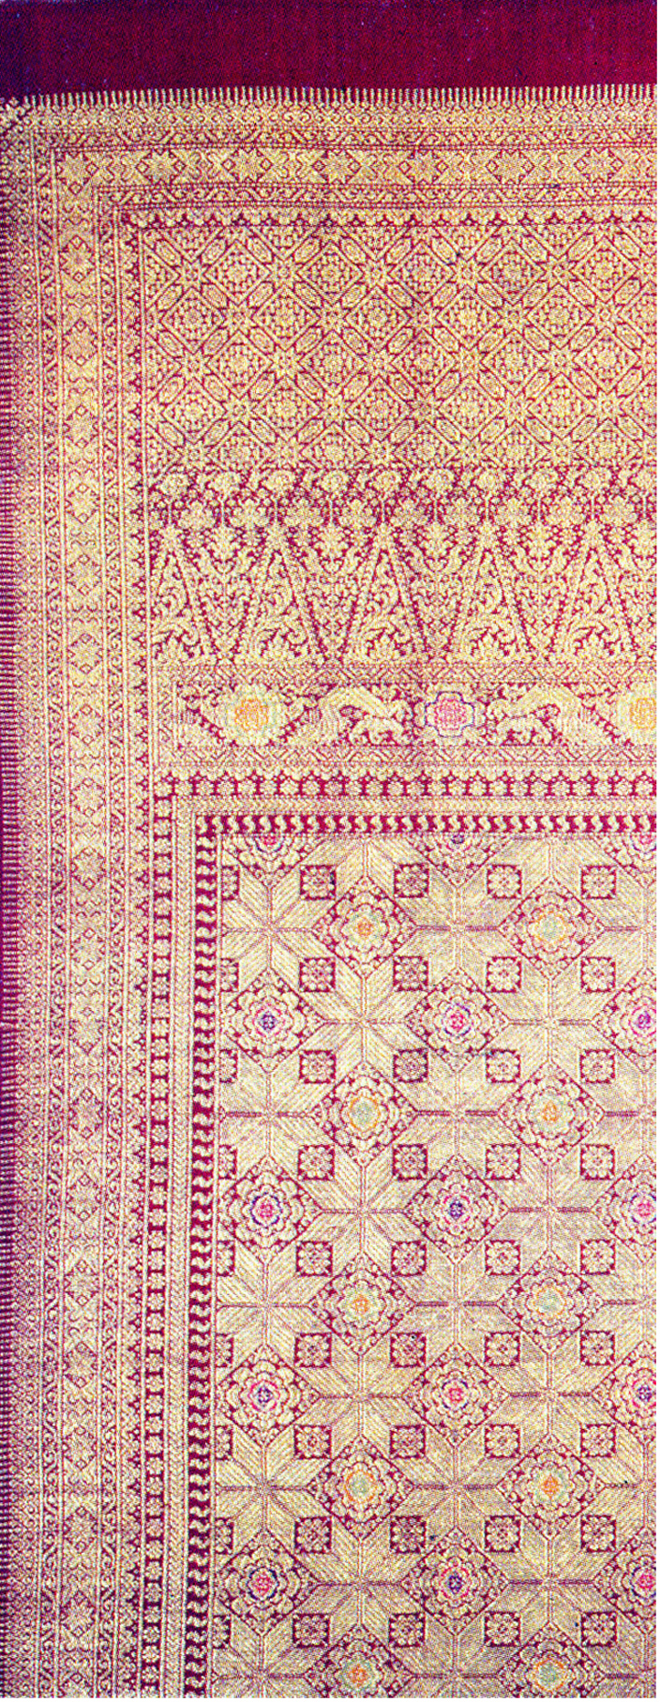
2 cm elbow nails
2 cm Simbar Star Umpak
Broken rice 1
1.5 cm waves
Tawur bintang bercadang 10 cm
10 cm turmeric flower shoot shoots
5 cm dragon base
Tanjung Mawar Star
"Central Flower"
5 cm three-way elbow
Tretes
(cloth edge)
Tumpal
“cloth head”

Figure 2. Composition of the Shape and Size of the Lepus Berakam Songket Decorative Motifs Source: Netty, 2026

a. This traditional cloth is called songket lepus berakam.
b. This traditional cloth functions as a shawl, measuring 87 cm long and 2 m wide. This cloth is usually worn by adult women during traditional wedding ceremonies.
c. This traditional cloth is a type of songket lepus weave.
d. The materials used in this traditional cloth are: the weft and warp threads are made of cotton. The additional weft threads are made of gold heart thread.
e. The background color of this traditional cloth is burgundy. The decorative motifs are golden yellow. The center flower petals are colored yellow, pink, blue, and green.
f. The decorative motifs found in this traditional berakam cloth are:
a. The edges/edges on the right, left, top, and bottom of the cloth are called tretes motifs by the people of Palembang. The tretes motif on this cloth features several decorative motifs, including: apit (water rope) (straight lines), waves (wavy lines), broken rice (triangular), a simple star base, and a small bamboo shoot (shaped like a bamboo shoot).
b. The body/center of the cloth features an octagonal star, roses, jasmine, and Tanjung star flowers. All the decorative motifs are arranged in a geometric grid. These motifs are complemented by three country ornaments (a twisted S-shape, apit (water rope), broken rice, and jasmine).
c. The edges of the cloth feature several decorative motifs, including eleven-bar waves, apit (water rope) (straight lines), broken rice (triangular), a rose base, a dragon shape, bamboo shoots with turmeric flowers, and a caged star ornament.
g. The texture of traditional berakam cloth is rather smooth and stiff. The decorative motifs use cukit 2 gold thread. This is the composition of the various decorative motifs of the lepus berakam songket above.

Lepus Berakam Songket Decorative Motif Pattern
According to Soepratno (1984), a motif pattern is a pattern or imitation of an artwork used in a medium, either identically or in a different style within a visual art composition.
According to Aries Kurniawan (2024), the term motif represents all elements of a design, while pattern refers to how these motif elements are arranged or repeated regularly.
In textile craft, motif patterns are inseparable from the process of becoming a songket product. Based on textile art and design, a motif is a basic element or single unit of geometric, floral, or animal form. Therefore, a motif pattern is the repetition of shapes and the arrangement of motifs in a regular manner to form a larger visual design. Therefore, the Lepus Berakam songket motif consists of three decorative patterns:
i. The decorative pattern structure of the berakam songket consists of the edges (tretes), the body (central flower), and the ends. This can be seen in the image below.
- The ornamental pattern structure on the edges (tretes) consists of angular nail ornaments, apit or water rope, "S" shapes, simbar star bases, and waves.
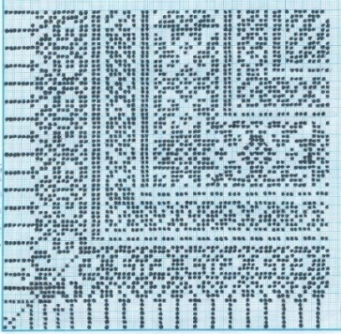
Figure 3. Tretes Pattern Sketch Source: Netty, 2026
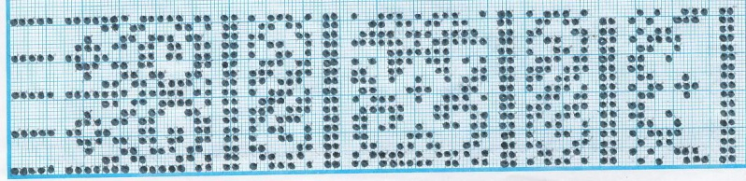
Figure 4. Sketch of the motif pattern on the edge of the Lepus Berakam Source: Netty, 2026
- The structure of the ornamental pattern on the body of the cloth (center flower) consists of tanjung flower, rose and jasmine ornaments.
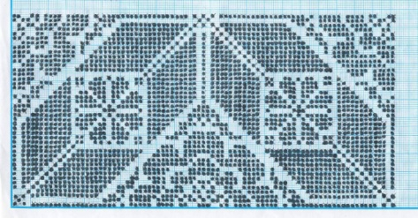
Figure 5. Sketch of the tanjung flower, rose and jasmine motif pattern Source: Netty, 2026
- The structure of the ornamental pattern on the edge of the cloth consists of a tawur star ornament with a cage, bamboo shoots with turmeric flowers, broken rice with the letter "S", a dragon rose base, eleven waves.
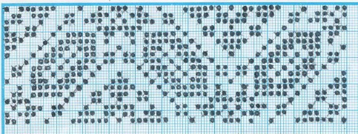
Gambar 6. Sketsa pola Tawur bintang berkandang Source: Netty, 2026
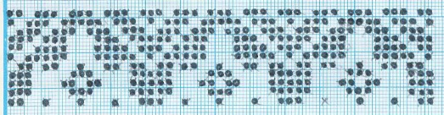
Figure 7. Sketch of Eleven Bar Wave Pattern Source: Netty, 2026
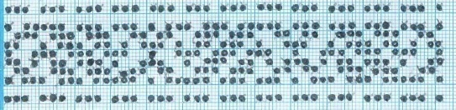
Figure 8. Sketch of the broken pattern of the letter "S" rice Source: Netty, 2026
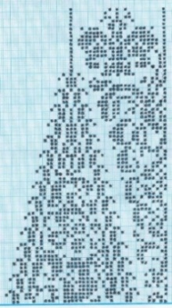
Figure 9. Sketch of bamboo shoot pattern with turmeric flower Source: Netty, 2026
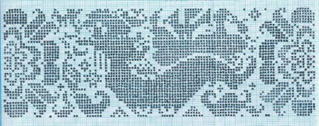
Figure 10. Sketch of the Dragon Rose Umpak Pattern Source: Netty, 2026

The Meaning of the Lepus Berakam Songket Decorative Motif
The decorative motifs applied to the Palembang Lepus Berakam songket have the following meanings:
First, the Nago Besaung motif originates from Chinese culture, originating from the image of facing dragons. The Nago Besaung motif represents the noble symbolism of Palembang songket. In Palembang traditional wedding ceremonies, the use of sewet songket with the Nago Besaung motif is believed to have philosophical value for the bride and groom. The Nago Besaung motif represents the symbol of a caged dragon, which symbolizes the maintenance of a lasting, durable, and well-preserved marital bond. In Palembang society, the dragon symbol represents the state and consciousness of the community, reflecting the strength, imagery, advice, and history of ancestors. The power of the dragon is embodied in the visualization of the Palembang sewet songket in the hope that it can represent the lives of the bride and groom or become a symbol of their identity. Therefore, Palembang wedding attire with sewet songket and the Nago Besaung motif is designed to convey the noble meaning and philosophical value of Palembang culture.
During the Srivijaya era, the Nago Besaung motif on songket was reserved for the royal court, particularly the sultan's family and princes. The Nago Besaung motif symbolizes two dragons facing each other, with a golden ball or gemstone between their heads. Palembang society believes that wearing songket with the Nago Besaung motif reflects the highest social strata.
Therefore, the Nago Besaung motif was worn by the king or Sultan of South Sumatra, symbolizing greatness and glory. The Nago Besaung pattern is quite intricate with minute details. Meanwhile, the common people of South Sumatra living in Palembang always wear Limar songket, which is simpler and embodies the values ​​of the daily lives of the local people. Therefore, it can be concluded that, based on the philosophy, Nago symbolizes rulership, and Besaung symbolizes power, prosperity, and glory. Therefore, the philosophy of the Nago Besaung motif is that a ruler or king is close to power, prosperity, and glory, defending his possessions with the power of the king.
Similarly, the colors featured are predominantly golden and maroon. Therefore, the shapes and colors displayed are predominantly influenced by elements of Chinese culture. In Chinese mythology, the dragon is depicted as a giant serpent with golden scales, horns, and four strong legs resembling those of a bird. Chinese mythology believes in the existence of dragons, and this is reflected in Chinese culture, which has been adopted by the people of Palembang. Thus, the dragon symbol is believed to bring positive influences to life and symbolize safety and fertility for humans.
Second, the bamboo shoot motif carries a positive meaning because it symbolizes bamboo, which is not easily uprooted by strong winds. Bamboo is a fast-growing and fertile plant, making it a prime choice for planting around royal palaces during historical times. The dense structure of bamboo makes it difficult for enemies to penetrate. Thus, palace guards could monitor enemy movements by observing or reading the movements of the bamboo groves. Philosophically, the bamboo shoot symbolizes the state's defenses on the outer layer of the palace or the Srivijaya kingdom during historical times. Logically, if an enemy army attempted to breach the palace grounds, it would have to pass through the bamboo grove first. Therefore, the enemy's movements or actions would generate noise or movement from the bamboo groves, which the troops must avoid.
Therefore, it is concluded that the natural geographical environment of the region can be reflected in the various Palembang songket ornaments, each of which has a specific symbolic meaning. A single piece of songket cloth features various motifs and symbols, creating a beautiful blend. The bamboo shoot motif symbolizes good and positive hope. Therefore, the bamboo shoot motif is always present in every Palembang songket cloth as a head decoration, also known as the tumpal. The use of the bamboo shoot motif in Palembang songket is intended to ensure the wearer always feels good wishes and good fortune in their life journey.
Third, the tretes motif is a motif on the edge of the cloth that forms a square or outermost motif of the songket because it is located in the main row of the five edge motifs. The shape of the nail is made to resemble a carved spearhead because the spearhead symbolizes a traditional weapon used for hunting or warfare. The nail shape symbolizes the palace's defense on the outermost layer, which is tasked with protecting the palace from enemies or the front line defense that serves as the foremost force of a palace or state.
The tretes motif functions as a dividing structure between groups of edge motifs, directing their entry into the body of the songket. The tretes motif is consistently located on the top, right, bottom, and left sides of the songket. In practice, these motifs are arranged in a repetitive, structured, and systematic manner.
In traditional Palembang houses, from historical times to the present day, the tretes ornament is placed on the top of the fence, further enhancing its cultural aesthetic value. When examined from the sources, there are similarities in traditional Chinese houses, namely that tretes ornaments are also applied to the upper perimeter of the fence. Therefore, for the Palembang people, tretes ornaments serve as fence decorations and also to demarcate the yard, even as a boundary between the Tenggalung fence and the living room.
Fourth, the Apit decorative motif, according to the Palembang community, refers to a shape in the middle, flanked by other objects. Apit is the third motif in the songket edge motif, symbolizing the shape of a bamboo shoot. The bamboo shoot motif symbolizes young bamboo shoots. During the Srivijaya era, bamboo was planted around the palace, and the bamboo shoot had a strong meaning as a plant, namely a plant with extraordinary strength and rapid growth.
Fifth, the umpak basak decorative motif is found on the fifth layer of the songket edge motif. This motif is generally characterized by the image of a dragon supporting its child. These symbols are often found in the umpak basak motif, and the motif is almost identical to the umpak basak, except that the umpak basak is located in the inner part of the songket. The umpak basak is shaped like a wave, while the umpak basak is a straight line.
In Palembang philosophy, the umpak basak ornament, embodied in these symbols, represents the innermost defense of a kingdom or nation. At this level, the defense system has reached a very advanced level within the context of a state or kingdom, with high-ranking soldiers selected for their qualities and loyalty to maintain the security of the state or kingdom. Defense at this level focuses on protecting the closest to the leader, within the palace grounds. Therefore, troops assigned to this security are selected based on predetermined criteria, including physical, mental, intelligence, and optimal posture, as they are tasked with safeguarding the security of the state and its leader.
Sixth, the wave-wave ornament is the final motif in the peripheral motif, located in the deepest part, near the central flower or core motif that surrounds the songket. This motif is called the wave-wave motif because the imagery or symbols used in this motif resemble waves. The philosophy contained in this motif's symbolism is that everything that occurs can be compared to waves. Like waves, events or threats that come our way encounter the power or protection that exists, namely the power of Almighty God.
The meaning of the wave-wave motif is that to reach the center of power, the enemy must overcome the layers of defense that protect that power. It won't be easy; even if they manage to get past several layers of defense, they'll face an incredibly powerful force. This force will attack and overcome the enemy with overwhelming force, like waves crashing against and rolling over everything.
Seventh, the silver tray decoration is usually reserved for members of the princely family who are not directly related to the Sultan, and other priyai (priyai) who have other names such as Mas Agus, Ki Agus, and Kemas. Two other motifs considered to complement royal attire are the silver tray and the Falling Bungo. The silver tray decoration is a derivative or development of the previous motif, the Nago Busauung decoration. In this songket, the decoration remains the Nago Besaung decoration. However, changes have been made in its development. Between the "dragons facing each other to fight for the golden ball," there is an empty space filled with flowers. While the flowers on the Nago Besaung are round, the flowers on the Silver Tray are rectangular, resembling a tray.

In Palembang, the silver tray motif applied to Palembang songket has symbolic meaning, representing the equipment used in traditional Palembang ceremonies. Among Palembang people, trays are used to bring good fortune, blessings, and respect to families during traditional ceremonies, such as Palembang weddings. The tray also symbolizes traditional equipment, specifically a container for delivering letters to the Sultan, both from external and internal sources.

Philosophically, the silver tray motif derives from the word "nampan," which during the Srivijaya era was used as a container for serving all the king's needs, such as food, drinks, and letters. Therefore, the silver tray motif symbolizes the glory and loyalty of royal servants, as well as their loyalty and devotion to the king.

Eighth, the jasmine flower ornament on Palembang songket features a variety of motifs, one of which is the jasmine flower. The jasmine flower symbolizes purity and beauty for the people of Palembang. Meanwhile, the rose flower motif symbolizes freedom and natural beauty. The songket features bright, contrasting colors, characteristic of Chinese songket, such as yellow, red, green, and blue. Chinese songket symbolizes nobility, courage, and fertility for the people of Palembang.
Ninth, the "tri-country" (sumu) motif, located in the center of the star of the Tanjung Mawar (rose star), is surrounded by the "tri-country" (sumu) motif. For Palembang people, the "tri-country" motif symbolizes unity, a sense of unity in the kingdom, customs, and religion. Therefore, this motif is not merely decorative but reflects the noble values ​​of Palembang culture that must be upheld.
First, for the people of Palembang, the kingdom represents a symbol of leadership and a governmental structure that serves as the primary foundation for the community in carrying out their respective duties and responsibilities.
Second, religion symbolizes the formation of moral values ​​within the spiritual fabric of the Palembang people.
Third, for the people of Palembang, customs are the norms that govern social life. Therefore, the three-nation tribe motif on Palembang songket symbolizes the harmony and balance of these three elements (kingdom, religion, and customs) in building a cultured and strong society.
Tenth, the angled nail motif for the Palembang people symbolizes steadfastness, responsibility, and trustworthiness. The angled nail symbol resembles the corners of a bat's wings, representing the obligations and responsibilities that must be carried out in life. Thus, the angled nail motif is located at the edge of the songket motif, surrounded by the angled nail motif.
Eleventh, the star motif is sometimes influenced by Hindu culture and beliefs, which teach a purification ritual for the universe, namely offerings to lower beings to the universe using offerings. This ritual is specifically designed to balance negative and positive energies, in the hope of realizing a harmonious relationship between humans and nature by purifying the environment. This ritual is performed before the Nyepi holiday. Thus, the tawur bintang berkandang symbol refers to the use of specially arranged offerings using star symbols or the five colors placed in a cage or offering container to purify negative forces and prevent them from harming humans. Furthermore, the star motif sometimes in Palembang songket symbolizes wealth and prosperity, the source of life, and the well-being of the community and rulers in Palembang culture.
Thus, the lepus berakam motif is characterized by the application of gold thread throughout the weft structure. This results in the Lepus motif being filled with gold thread that covers the entire surface of the songket fabric.
The forms of the lepus berakam motif are influenced by philosophical meanings derived from the surrounding natural environment, such as plants or flora that live in South Sumatra. Furthermore, the design of the lepus berakam songket motif is always influenced by local customs and social life. Therefore, the songket motif is a work of art that is symbolic and embodies the cultural values ​​of the surrounding community. The motif is drawn using stylization, simplifying the shape of the object without losing its distinctive characteristics. The simplification of the source object's form is based on aesthetic considerations, and the drawing must also be adapted to its function.

- CONCLUSION
Palembang's culture is diverse, encompassing dance, tie-dye, carving, traditional Palembang songs, traditional children's games, and Palembang songket weaving. This article examines the distinctive Palembang lepus berakam songket. Lepus berakam songket is woven manually using a handloom weaving machine (ATBM gedokan). The loom is woven by sitting on the floor with the legs extended forward, then a wooden stick and raffia rope are tied to the weaver's back waist. This ensures the warp threads are straight and taut during the weaving process. Two types of thread are used in Lepus berakam songket: gold thread and silk thread. Silk thread is used for the warp, and gold thread is used for the weft. The weft, or gold thread, forms the pattern on Lepus berakam songket.
Lepus berakam songket has three decorative groups: the border, the center, and the hem.
First, the decorative motifs on the edges or right, left, top, and bottom edges of the fabric (the tretes decorative motifs) consist of several forms: the apit or water rope (straight line); the waves (wavy line); the broken rice (triangular shape); the simbar star base (base), and the elbow nail (small bamboo shoot shape).
Second, the decorative motifs on the body or center of the lepus berakam songket fabric consist of several forms: the octagonal star, jasmine flowers, roses, and the tanjung star flower. All three decorative motifs are arranged in a regular geometric grid. This is followed by the three-country decorative motifs (S-shaped twists, the apit or water rope, broken rice, and jasmine shapes).
Third, the decorative motif group at the end of the lepus berakam songket cloth consists of several forms of decorative motifs, namely the eleven-bar wave decorative motif, apit or water rope (straight line shape), broken rice (triangular shape), dragon rose base, bamboo shoot with turmeric flower, and the tawur bintang decorative motif.
Based on the socio-cultural context of the Palembang community, the decorative motifs found on Lepus Berakam songket have the following symbolic meanings:
a. Tanjung flowers symbolize hospitality and welcome guests, roses symbolize protection or averting disasters, and jasmine symbolizes purity and politeness.
b. Bamboo shoots surrounded by turmeric flowers in Palembang songket symbolize good hopes or good fortune, while bamboo shoots represent young bamboo shoots, symbolizing growth and prosperity.
c. The dragon base on Palembang songket symbolizes wisdom, strength, and good fortune or blessings for the wearer.
d. The scattered stars on Palembang songket symbolize beauty, prosperity, and hope, thus conferring a sense of beauty and luxury on the surface of the songket worn by each wearer. Thus, the motifs of Lepus Berakam Palembang songket are influenced by the natural environment, history, and socio-cultural conditions of the Palembang community.

References
Arifin Zainal. (2006). Palembang Songket: The Beauty of a Heartfelt Weaving Tradition. Jakarta: Dian Rakyat.
Aris Kurniawan. (2024). Understanding Strategy – Levels, Types, Business, Integration, General, Experts.
Bagus, U., & Misnawati, D. 2023. The Symbolic Meaning of the Nago Besaung Motif on Songket Cloth at Fikri Songket, Palembang City. Nivedana: Journal of Communication and Language, 4(1), 57-64.
Efrianto. 2012. Palembang Songket: Inventory of Cultural Works Protection in South Sumatra Province. Padang: Ministry of Education and Culture.
Danesi, Marcel. 2012. Messages, Signs, and Meanings. Yogyakarta: Jalas Sutra.
Department of National Education, 2000, Traditional Weaving of South Sumatra, South Sumatra, Ministry of National Education.
Ministry of National Education, 2001, Lifecycle Ceremonial Equipment of the Palembang Community, South Sumatra, Ministry of National Education.
Dicky Maryoga Hutadjulu. 2022. Examining Multicultural Representation in Lepus Songket of Palembang. Socio-Cultural Dynamics, Vol. 24, No. 1, pp. 1–8, e-ISSN: 2580-8524. DOI: https://doi.org/10.26623/jdsb.v24i1.3336.
Efrianto, et al. 2012. Inventory of the Protection of Palembang Songket Cultural Works in South Sumatra Province. Padang: Center for the Preservation of Cultural Values, Ministry of Education and Culture.
Elza Nopriani. 2024. Songket Weaving and Local Culture in Building the Identity of the Palembang Community. Journal of Educational Management and Social Sciences (JMPIS). https://dinastirev.org/JMPIS. DOI: https://doi.org/10.38035/jmpis.v5i6.
Gustami, SP, 2000, Jepara Furniture Craftsmanship: An Aesthetic Study Through a Multidisciplinary Approach, Yogyakarta, Kanisius.
Lestari, A., & Hera, D.W., 2021. The Meaning of the Nago Besaung Motif on Bridal Songket Cloth at the Adis Songket House in Palembang. Ars: Journal of Fine Arts and Design, 24(2), 135-142.
Linny Oktovianny. 2021. Ethnolinguistic Study and Lexicon of Traditional Fabrics of the Palembang Community. Proceedings of the National Seminar on Linguistics and Literature (SEMANTIKS). ISBN: 978-623-94874-1-6. https://jurnal.uns.ac.id/prosidingsemantiks.
Maryeti, et al., 2010. Cultural Collection: Traditional Houses, the Palembang Songket Inheritance System, and Minangkabau Customs. West Sumatra: Padang Press.
Mainur, M, 2018. Bungo Pacik Motif on Palembang Songket Woven Cloth. Sitakara Journal, 3(1), 69-79.
Muhammad Fathur Hidayat. (2025). IMPLEMENTATION OF LOCAL WISDOM: APPLICATION OF PALEMBANG SONGKET CLOTH ORNAMENTS IN BUILDINGS, PUBLIC SPACES, AND INFRASTRUCTURE IN PALEMBANG CITY. ARCADE Architecture Journal.
National Museum. (2022). Collection. [Online]. Accessed from: https://www.museumnasional.or.id/category/koleksi/.
Rizali, Nanang, 2001, "A Philosophical and Semiotic Review of Kawung Batik," Bandung, Journal of Fine Arts Discourse, STISI.
Rustarmadi, 2012, "The Symbolic Meaning of Decorative Varieties of the Pendapa Terrace of Panataran Temple." Journal: Fine Arts, Surabaya State University.
Nanang, Rizali. 2003. "Art: Aesthetics, Logic, and Ethics." Journal of Fine Arts Discourse. Vol. 3 No. 6, 2003.
Nadina Sukma Salim. 2016. Palembang Songket Cloth with the Application of Batik Techniques as a Fashion Product. J. Vis. Art & Design, Vol. 7, No. 2, June 2016, 92-115. DOI: 10.5614/j.vad.2016.7.2.2.
Rahayu, Dwi, 2004, A Study of the Form and Meaning of Kasumedangan Batik, Bandung, Thesis, Faculty of Fine Arts and Design, Bandung Institute of Technology (ITB).
Syahrofie, 2007, Palembang Songket (Philosophical Values, Historical Traces, and Tradition). Palembang: National Education Office of South Sumatra Province.
Saripudin, Didin. 2007. Sociology and Anthropology of Education. Bandung. Masagi Foundation.
Sugiyono, 2005. Understanding Qualitative Research. Bandung: CV. Alfabeta.
Sumardjo, Jakob, 2000, Philosophy of Art, Bandung, ITB Printing House.
Sumardjo, Jakob, 2006, Aesthetic Paradox, Bandung, Sunan Ambu Press.
Suwati, 2007, “Varieties of Traditional Indonesian Ikat Woven Fabrics,” Jakarta: Gramedia Pustaka Utama.
Syafrial, 2006, "Visual Aesthetic Shifts in Pandai Sikek Songket Designs from West Sumatra," Bandung, Thesis, Faculty of Fine Arts and Design, Bandung Institute of Technology.
Syarofie, Yudhy. 2012. "Palembang Songket: Philosophical Values, Historical Traces, and Palembang Traditions." Palembang: South Sumatra Provincial Government, Department of Education, Arts and Culture Development and Creativity Activities.
Romas Tahrir, Tjetjep Rohendi Rohidi, & Sri Iswidayati. (2017). The Symbolic Meaning and Function of Dragon-Patterned Songket Woven Fabrics in the Malay Community of Palembang, South Sumatra. Katharsis: Journal of Art Education, Vol. 6 No. 1 (2017), 9–17.
Tabrani, Primadi, 2005, "The Language of Fine Arts," Bandung, Kelir Publishing House.
Widagdo, 2001, "Design and Culture," Bandung, Ministry of National Education.
Yan Yan Sunarya. (2010). Palembang Songket. Jakarta. Ministry of Culture and Tourism.

