Indian Neurotherapy in Obsessive–Compulsive Disorder (OCD) Management - A Case Report
Manvi Tara Aswani¹, Inderjeet Singh², Ranjan³
¹ M. Voc 2nd Year Student, Lajpat Rai Mehra Neurotherapy Research & Training Institute (LMNTRTI), Bikaner, Rajasthan, India
² Neurotherapist; Bachelor of Arts; Master of Arts (Yoga); Pharmacy (Ayurveda), LMNTRTI, Punjab, India
³ Neurotherapist and Yoga Therapist; Bachelor of Arts, LMNTRTI, Punjab, India
Corresponding Author:
Inderjeet Singh
Email: rgscholar1977@gmail.com

ABSTRACT
Background: Obsessive–Compulsive Disorder (OCD) affects 2.3% of the global population and is characterised by persistent intrusive thoughts and compulsive behaviours causing severe functional impairment. Despite pharmacological and psychotherapeutic advances, a substantial proportion of patients experience incomplete response, relapse, or limited access to evidence-based care. Indian Neurotherapy, a non-invasive naturopathic system employing targeted neuromuscular stimulation, offers a potentially viable complementary approach, yet remains undocumented in peer-reviewed clinical literature. Objective: To evaluate clinical outcomes of structured Indian Neurotherapy in a severe, treatment-refractory OCD case using the OCI-R as primary outcome measure, with 10-month follow-up. Methods: CARE-compliant observational single-case study at LMNTRTI, Punjab, India. Participant: 43-year-old female with 25-year OCD history, multiple comorbidities, and prior treatment failure across allopathic, Ayurvedic, and homoeopathic systems. OCI-R administered at baseline (14 June 2025), after 6 sessions (20 June 2025), post-intervention (22 August 2025), and followed up to 11 March 2026 (9 months). Results: OCI-R scores: 69/72 (severe) → 35/72 (49.3% reduction after 6 sessions) → 0/72 (complete remission at 10 weeks). At 9-month follow-up, the participant returned for general wellness goals with no OCD symptom recurrence. Conclusion: This CARE-compliant case report demonstrates complete, sustained remission of severe, long-standing OCD through Indian Neurotherapy, with mechanistic plausibility grounded in autonomic, vagal, serotonergic, and neurochemical regulatory pathways. Controlled trials are urgently warranted.
Keywords: Obsessive–Compulsive Disorder; Indian Neurotherapy; OCI-R; Integrative Mental Health; Autonomic Nervous System; Vagal Tone Modulation; LMNTRTI; Case Report; Complementary Medicine
1. INTRODUCTION
Obsessive–Compulsive Disorder (OCD) is a chronic and disabling mental health condition characterised by ego-dystonic obsessive thoughts, images, or urges generating significant anxiety, paired with time-consuming compulsive behaviours aimed at neutralising distress (APA, 2022). The World Health Organization has consistently ranked OCD among the top ten most debilitating illnesses globally due to the profound functional impairment it inflicts across occupational, social, and interpersonal domains (WHO, 2022). Epidemiological data indicate a lifetime prevalence of approximately 2.3%, with onset typically occurring in adolescence or early adulthood and a characteristically chronic, waxing-and-waning course (Ruscio et al., 2010). Among individuals with OCD, comorbid psychiatric and medical conditions are the rule rather than the exception, significantly compounding treatment complexity and prognosis (Sharma et al., 2021).
The neurobiological underpinnings of OCD are well characterised and primarily involve dysregulation of cortico-striato-thalamo-cortical (CSTC) circuits, serotonergic and glutamatergic neurotransmission, and aberrant fear-conditioning and habit-learning pathways (Stein et al., 2019; Goodman et al., 2021). First-line treatment with serotonin reuptake inhibitors (SSRIs) yields clinically meaningful response—defined as ≥25–35% symptom reduction—in approximately 40–60% of patients, while combined pharmacotherapy and cognitive behavioural therapy with exposure and response prevention (ERP) achieves superior but still incomplete outcomes in 60–70% (Skapinakis et al., 2016; Hirschtritt et al., 2017). Complete remission with pharmacological treatment alone remains rare, achieved in only 20–25% of patients (Skoog & Skoog, 1999). Furthermore, relapse upon medication discontinuation, intolerance of side effects, and limited accessibility—particularly in rural and resource-constrained Indian settings—represent ongoing barriers to effective care (Abramowitz et al., 2009).
These therapeutic gaps have stimulated growing interest in complementary and integrative approaches (Sarris et al., 2012). Indian systems of medicine—including Yoga, Ayurveda, and acupressure—are increasingly investigated for their neurophysiological plausibility and mental health utility (Mukherjee et al., 2017). Indian Neurotherapy, described in Box 1, is a non-invasive naturopathic system employing external manual pressure-based stimulation of anatomically mapped neuromuscular points, founded by Sh. Lajpatrai Mehra and grounded in the principles of Nadi Vigyan, Ayurveda, and modern physiology (Jyoti et al., 2021; Mehra, n.d.). The system is conceptualised as acting through peripheral mechanoreceptor activation, spinal reflex modulation, autonomic regulation, and neuroendocrine stimulation—mechanisms consistent with those reported in massage therapy, acupressure, physiotherapy, and vagal stimulation research (Bialosky et al., 2009; Field et al., 2010; Mehta et al., 2017). Despite anecdotal reports of clinical effectiveness across a range of neurological and psychiatric conditions, Indian Neurotherapy remains entirely undocumented in indexed peer-reviewed clinical literature.
Recent integrative medicine literature has increasingly explored the role of non-invasive neurophysiological interventions in chronic and systemic health conditions. Neurotherapy-based approaches have been reported to improve physiological regulation, autonomic balance, circulation, endocrine functioning, and symptom management across multiple clinical presentations. Dev and Dutta (2022) demonstrated a novel neurotherapy-based approach for polycystic ovarian syndrome (PCOS), reporting improvements in hormonal and reproductive outcomes—suggesting neurotherapy’s capacity to influence the hypothalamic–pituitary–gonadal axis. Dutta and Dev (2024) demonstrated significant improvement in subclinical hypothyroidism following structured neurotherapy intervention, including reduction in serum TSH without reported adverse effects. In a separate report, Dutta and Dev (2025) documented improvements in haemoglobin levels, fatigue, and functional wellbeing in a patient with beta-thalassemia intermedia following three-month neurotherapy intervention, suggesting broader systemic regulatory potential. In the pain management domain, Parihar and Gandhi (2023) evaluated neurotherapy in 92 patients with low back pain using the Visual Analogue Scale (VAS), finding a highly significant reduction in pain scores (t = 45.307, p < .01) following a 30-minute daily neurotherapy protocol over three months. Integrative approaches combining neurotherapy with yoga have further demonstrated superior outcomes: Parihar and Kashyap (2024) conducted a randomised controlled trial involving 120 participants across four groups, finding that combined yoga–neurotherapy interventions produced superior improvements in pain reduction, disability scores, and functional outcomes in chronic low back pain compared with either modality alone, findings corroborated in a controlled clinical investigation presented at the International Conference on Yoga as Art and Science of Living (Parihar, 2025). The theoretical framework of LMNT Neurotherapy, as foundationally described by Jyoti et al. (2021) and Mehra (n.d.), proposes that targeted pressure stimulation influences circulation, autonomic regulation, glandular functioning, and physiological homeostasis through neuromuscular and neurovascular pathways. These emerging cross-domain findings support further investigation of Indian Neurotherapy as a complementary non-pharmacological intervention in mental health conditions, including OCD.
This CARE-compliant case report aims to address this critical gap by systematically evaluating and reporting the clinical outcomes of structured Indian Neurotherapy in a 43-year-old female with severe, treatment-refractory OCD of 25 years duration, using the validated OCI-R as the primary outcome measure, with follow-up data to 10 months post-primary intervention.

Box 1. What is Indian Neurotherapy?
Indian Neurotherapy is a non-invasive, non-pharmacological therapeutic system rooted in Indian naturopathic tradition, formalised and standardised by the Lajpat Rai Mehra Neurotherapy Research & Training Institute (LMNTRTI). Founded by Sh. Lajpatrai Mehra and grounded in the ancient knowledge of ‘Nadi Vigyan’ (knowledge of the nervous system), Ayurveda, and the principles of anatomy and physiology, it is a drugless holistic system that employs precisely calibrated external manual pressure applied to anatomically mapped neuromuscular stimulation points corresponding to organ systems, endocrine glands, spinal nerve segments, and autonomic ganglia (Jyoti et al., 2021; Mehra, n.d.).
Treatments are individualised based on the patient’s clinical profile and administered by trained LMNTRTI-certified therapists. The therapeutic framework integrates contemporary neurophysiological principles—including peripheral mechanoreceptor activation, spinal reflex modulation, autonomic regulation, and neuroendocrine stimulation—with a holistic patient-centred philosophy. No medications, injections, or invasive procedures are used. Dietary modifications and lifestyle guidance accompany the hands-on treatment protocol.

2. CASE PRESENTATION
The participant was a 43-year-old married female homemaker from Haridwar, Uttarakhand, presenting voluntarily to LMNTRTI with a 25-year history of Obsessive–Compulsive Disorder. Her OCD was characterised by a pervasive, multi-domain symptom profile spanning all six OCI-R subscales: compulsive checking (doors, windows, gas taps, light switches), contamination-related handwashing, contamination fear, rigid ordering and arranging, intrusive and distressing thoughts, compulsive counting, and reluctance to discard objects. These behaviours had progressively dominated daily functioning, severely impairing domestic activities, social relationships, and quality of life across the preceding two and a half decades.
Significant psychiatric and medical comorbidities were documented at intake, including anxiety disorder, recurrent suicidal ideation, diabetes mellitus (10 years), hypertension (10 years), thyroid dysfunction (14 years), cholelithiasis, cervical pain, generalised weakness, and white vaginal discharge (Table 1). Body weight was 85 kg; sleep quality was average and non-restorative; appetite was poor. An obstructive sleep apnea (OSA) diagnosis was incidentally established during the treatment period (11 August 2025) following an acute nocturnal respiratory event. Prior treatments—allopathic, Ayurvedic, and homoeopathic—had failed to produce sustained OCD symptom relief over 25 years. The participant was referred to LMNTRTI by a prior patient of the centre.
Table 1. Participant Clinical Profile
CHARACTERISTIC | DETAILS
Age / Sex | 43 years / Female
Marital Status / Occupation | Married / Homemaker
Primary Diagnosis | Obsessive–Compulsive Disorder (OCD) — 25-year duration
Psychiatric Comorbidities | Generalised anxiety, suicidal ideation
Medical Comorbidities | Diabetes mellitus (10 yrs), hypertension (10 yrs), thyroid dysfunction (14 yrs), cholelithiasis, cervical pain, white vaginal discharge, generalised weakness
Obstructive Sleep Apnea | Diagnosed 11 August 2025 (AIIMS Rishikesh; incidental during treatment)
Weight / BMI Indicator | 85 kg (overweight)
Sleep / Appetite | Average (non-restorative) / Poor
Prior Treatments Tried | Allopathic ✔ Ayurvedic ✔ Homoeopathic ✔ (no sustained relief)
Dietary Restrictions (LMNTRTI) | No sour foods, no non-vegetarian food, no alcohol
Baseline OCI-R Score | 69/72 — Severe (maximum possible distress across 5 of 6 subscales)
Consent / Ethics | Written informed consent obtained; LMNTRTI / ICMR / GDPR compliant
Note. OCI-R = Obsessive–Compulsive Inventory-Revised. OSA = Obstructive Sleep Apnea.
3. METHODOLOGY
3.1 Study Design and CARE Compliance
An observational single-case study was conducted at LMNTRTI, Uttarakhand, India. The report was prepared in accordance with the Consensus-based Clinical Case Reporting (CARE) guidelines (Gagnier et al., 2013), including a patient timeline (Table 2), systematic outcome assessment, and patient perspective documentation. Written informed consent was obtained, and all data were anonymised in compliance with LMNTRTI institutional ethical guidelines, ICMR ethical standards for observational research, and GDPR principles.
3.2 Outcome Measure: OCI-R
OCD symptom severity was assessed using the Obsessive–Compulsive Inventory-Revised (OCI-R), a validated 18-item self-report scale (Foa et al., 2002). The OCI-R measures distress across six OCD symptom domains—Washing, Obsessing, Hoarding, Ordering, Checking, and Neutralising—each comprising three items rated on a five-point Likert scale (0 = Not at all to 4 = Extremely; range 0–72). A total score of ≥21 is the established clinical threshold indicating the presence of OCD (Foa et al., 2002). The OCI-R was administered at baseline (14 June 2025), after six sessions (20 June 2025), and at post-intervention (22 August 2025). Treatment response was defined as score reduction below the clinical threshold of 21; complete remission as a score of 0.
3.3 Treatment Protocol
The participant received structured Indian Neurotherapy sessions administered by a certified LMNTRTI therapist (Table 4). Sessions were conducted on consecutive weekdays during the initial phase (June 2025), followed by an extended maintenance schedule through August 2025 and into early 2026. Dietary restrictions were prescribed: avoidance of sour foods, non-vegetarian food, and alcohol.
On 11 August 2025, an acute OSA episode required emergency evaluation at AIIMS Rishikesh, resulting in OSA diagnosis. Physicians recommended an oxygen concentrator and pharmacological management. The participant elected to continue neurotherapy in parallel with medical treatment, and the protocol was subsequently modified to incorporate Oxygen Therapy, respiratory-supportive stimulation (Left Medulla + Left Gut + Left Parathoo), and enhanced cerebrovascular circulation protocols (M-Heparin).
Table 2. CARE Clinical Timeline (Symptom Onset to 10-Month Follow-up)
DATE | EVENT | CLINICAL FINDING / OUTCOME
∼2000 | OCD symptom onset (~age 18) | Compulsive checking, contamination fear, intrusive thoughts begin
2000–2025 | Multiple treatment attempts over 25 years | Allopathic, Ayurvedic, Homoeopathic — partial or no sustained relief
14 Jun 2025 | First LMNTRTI session; baseline OCI-R | OCI-R = 69/72 (Severe); informed consent signed
14–20 Jun 2025 | Sessions 1–6 (consecutive daily) | Progressive reduction in compulsive frequency and anxiety noted
20 Jun 2025 | Early follow-up OCI-R assessment | OCI-R = 35/72 (Moderate) — 49.3% reduction in 6 days
Jun–Aug 2025 | Continued sessions (7 onwards) | Ongoing improvement: sleep, appetite, anxiety, suicidal ideation resolved
11 Aug 2025 | Acute sleep apnea episode | Emergency evaluation, AIIMS Rishikesh; OSA diagnosed; oxygen concentrator advised
12 Aug 2025 | Protocol modification | Oxygen therapy and respiratory stimulation points added to protocol
22 Aug 2025 | Post-intervention OCI-R assessment | OCI-R = 0/72 — Complete remission across all 6 subscales
Sep–Oct 2025 | Maintenance sessions | Stable remission; continued general wellbeing improvement
Nov 2025–Feb 2026 | Continued maintenance | Same protocol; no OCD symptom recurrence
11 Mar 2026 | Return visit — new presenting goal | Patient presented for overall fitness and weight reduction — NOT for OCD. Sustained OCD remission confirmed at 9 months post-primary intervention
28 Apr 2026 | Last documented session | General wellness; no OCD symptom recurrence at 10+ months
Note. OSA = Obstructive Sleep Apnea. AIIMS = All India Institute of Medical Sciences.
4. RESULTS
4.1 OCI-R Score Progression and Clinical Significance
At baseline (14 June 2025), the participant recorded an OCI-R total score of 69/72, indicating extreme OCD symptom distress. This score is 229% above the established clinical threshold of 21 (Foa et al., 2002), consistent with the most severe end of the OCD spectrum. Scores of 12/12 (maximum) were recorded across five of six subscales (Washing, Obsessing, Ordering, Checking, Neutralising), with the Hoarding subscale scoring 9/12 (Table 3).
Following six consecutive Indian Neurotherapy sessions (20 June 2025), the OCI-R total score declined to 35/72—a reduction of 34 points representing 49.3% symptom improvement. This magnitude of reduction significantly exceeds the 25–35% threshold commonly used to define SSRI treatment response in OCD clinical trials (Skapinakis et al., 2016), achieved here within six days of intervention. The participant’s score remained above the clinical threshold of 21 at this point, indicating continued but moderately reduced OCD symptomatology.
At post-intervention assessment (22 August 2025), the OCI-R total score was 0/72—complete symptomatic remission across all 18 items and all six subscales. This represents a 100% reduction from baseline and places the participant well below the clinical OCD threshold. Table 3 presents subscale-level data; Figures 1 and 2 illustrate total score trajectory and subscale profiles respectively.
Table 3. OCI-R Subscale Scores Across Three Assessment Time Points
OCI-R SUBSCALE (Items) | Baseline 14 Jun 2025 | Follow-up 20 Jun 2025 | Post-Intervention 22 Aug 2025 | Max Score
Washing (5, 11, 17) | 12 | 6 | 0 | 12
Obsessing (6, 12, 18) | 12 | 6 | 0 | 12
Hoarding (1, 7, 13) | 9 | 5 | 0 | 12
Ordering (3, 9, 15) | 12 | 6 | 0 | 12
Checking (2, 8, 14) | 12 | 6 | 0 | 12
Neutralising (4, 10, 16) | 12 | 6 | 0 | 12
TOTAL SCORE | 69 | 35 | 0 | 72
% Change from Baseline | — | ↓ 49.3% | ↓ 100% | —
Severity Category | Severe | Moderate | None (Remission) | —
Clinical Threshold Met (OCI-R ≥21) | Yes | Yes | No | ≥21
Note. OCI-R clinical threshold: total score ≥21. Maximum per subscale = 12; total maximum = 72.
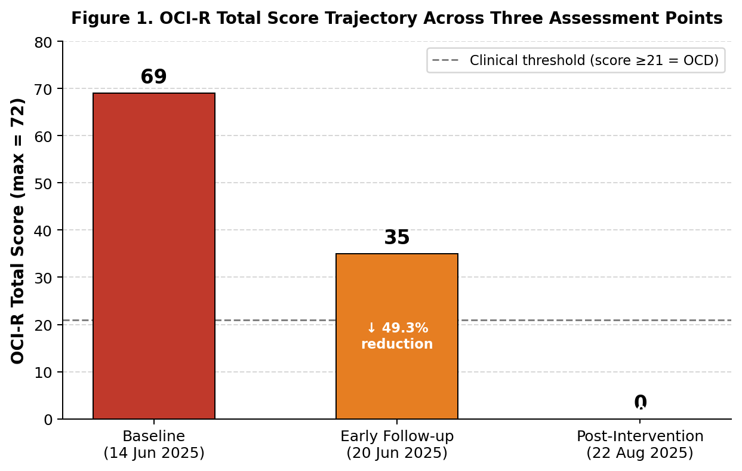
Figure 1. OCI-R total score trajectory. Dashed line = clinical OCD threshold (score ≥21). Percentage reductions shown within bars.
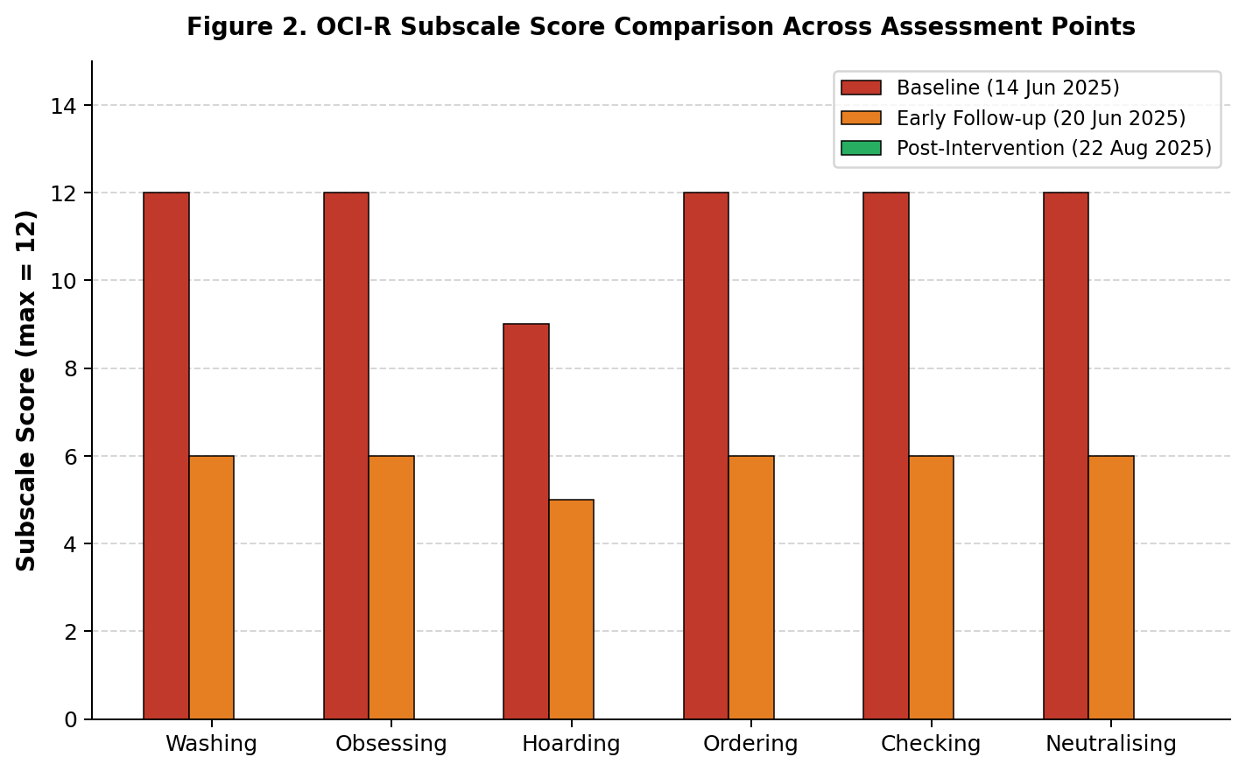
Figure 2. OCI-R subscale comparison across all three assessment points. All six subscales reached zero at post-intervention.
4.2 Extended Follow-up: 9-Month Sustained Remission
Treatment card data document that the participant continued maintenance sessions through late 2025 and into early 2026. On 11 March 2026—approximately nine months after the primary intervention phase—the participant returned to LMNTRTI with a new presenting health goal: overall physical fitness and weight reduction. Critically, the clinical record makes no reference to any OCD symptom recurrence at this visit or in subsequent sessions through 28 April 2026 (last documented). The participant’s decision to attend for a non-psychiatric wellness goal nine months after achieving OCD remission provides compelling clinical evidence of sustained remission. Figure 3 illustrates the extended outcome trajectory.
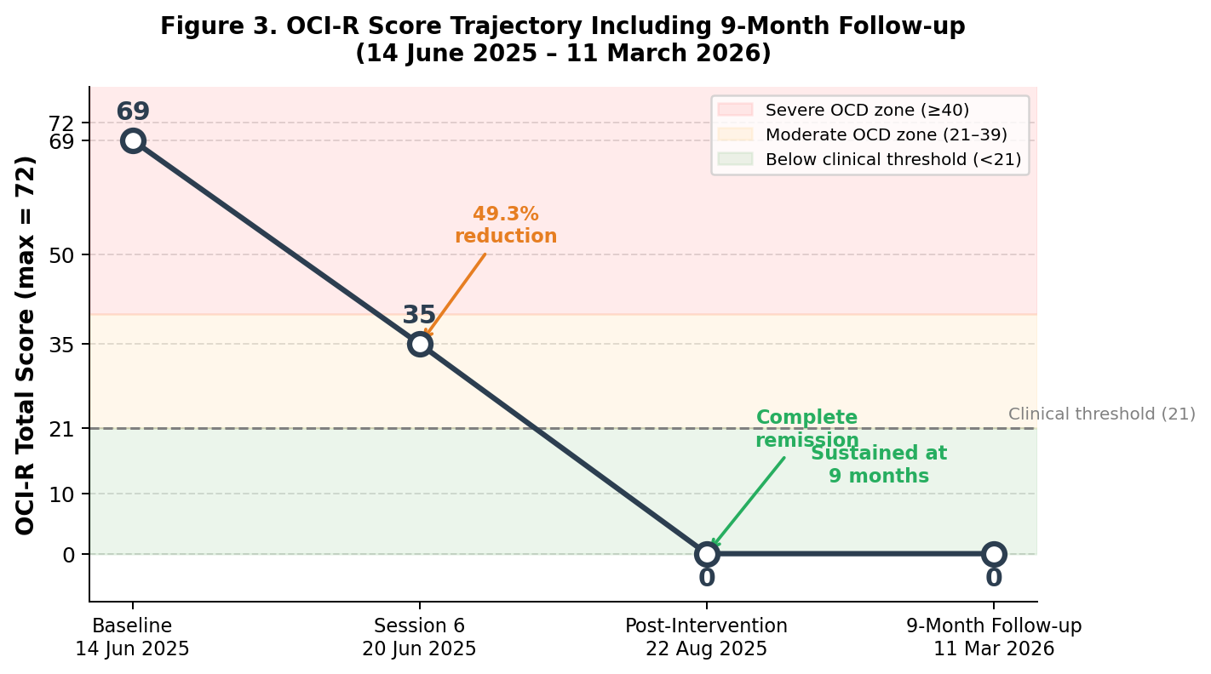
Figure 3. Extended OCI-R score trajectory including 9-month follow-up (11 March 2026). Score of 0 maintained at 9 months; patient presented for general wellness goals (weight management), not OCD. Coloured bands indicate OCD severity zones.
4.3 Clinical Observations
Progress notes across the treatment period documented progressive functional recovery. From the sixth session onward, the therapist recorded reductions in compulsive checking and cleaning frequency, decreased contamination anxiety, improved tolerance of ambiguity, resolution of suicidal ideation, and enhanced sleep quality. Appetite improved from poor to adequate. These observations align with the quantitative OCI-R trajectory and support convergent validity of the outcome data. The OSA episode and subsequent recovery, managed concurrently within the neurotherapy framework, demonstrated the adaptive capacity of the treatment protocol in the context of an acute medical complication.

5. PATIENT PERSPECTIVE
The participant had endured severe OCD for 25 years, having exhausted conventional allopathic, Ayurvedic, and homoeopathic treatment options without achieving durable relief. The psychological and functional burden of the disorder had permeated every domain of her daily life across more than two decades.
After the sixth Indian Neurotherapy session, the participant spontaneously expressed: “Thank you. I feel I have reborn.” This statement, documented in the clinical record, reflects a profound subjective shift in psychological state—a sense of restoration and relief that had been absent throughout 25 years of illness and treatment.
The most clinically meaningful expression of patient perspective, however, can be behavioural rather than verbal: the participant’s voluntary return to LMNTRTI nine months after achieving OCD remission, this time to address weight management and general fitness. This shift in health goals—from urgent psychiatric distress to proactive wellness—embodies the transformation that effective OCD treatment aims to achieve, and implicitly confirms the participant’s subjective experience of sustained recovery.
6. DISCUSSION
This CARE-compliant case report presents, to our knowledge, the first systematically documented and OCI-R-evaluated account of Indian Neurotherapy for Obsessive–Compulsive Disorder. The findings are clinically remarkable: complete and sustained remission—OCI-R from 69/72 to 0/72—in a participant with severe, treatment-refractory, 25-year-duration OCD, maintained at 9-month follow-up without pharmacological or invasive intervention.
6.1 Contextualisation Against Standard Treatment Benchmarks
To contextualise the magnitude of improvement, it is instructive to compare outcomes against established benchmarks for standard OCD treatments. First-line SSRI pharmacotherapy achieves treatment response (≥25–35% symptom reduction) in 40–60% of patients, with complete remission in approximately 20–25% (Skapinakis et al., 2016; Skoog & Skoog, 1999). Combined CBT with ERP achieves response in 60–70%, with remission rates higher but still rarely reaching 100% (Hirschtritt et al., 2017; Simpson et al., 2013). In this case, Indian Neurotherapy achieved 49.3% symptom reduction within six sessions—surpassing SSRI response benchmarks in less than one week—and 100% remission by 10 weeks, sustained at 9-month follow-up. While single-case data cannot be used to draw comparative efficacy conclusions, the magnitude and durability of observed outcomes warrant serious clinical attention.
6.2 Proposed Neurophysiological Mechanisms
The observed reduction in OCI-R scores can reflect neurophysiological modulation associated with autonomic balance and stress-response regulation—consistent with the broader systemic regulatory effects of Indian Neurotherapy previously documented in endocrine and haematological case studies (Dev & Dutta, 2022; Dutta & Dev, 2024; Dutta & Dev, 2025). These prior reports suggest that Indian Neurotherapy can exert systemic physiological effects beyond the primary presenting condition, supporting its relevance as a multi-domain integrative intervention. The mechanisms underlying such effects, and their applicability to psychiatric conditions such as OCD, are explored below.
The neurophysiological basis for these outcomes can be conceptualised within a multi-pathway autonomic and neurochemical regulatory framework. Manual pressure-based stimulation in Indian Neurotherapy activates cutaneous and fascial mechanoreceptors, engaging Aβ and C-fibre peripheral sensory pathways and spinal reflex arcs with downstream modulation of the autonomic nervous system—analogous to mechanisms described in massage therapy, acupressure, physiotherapy, and osteopathic manipulation (Bialosky et al., 2009; Field et al., 2010; Mehta et al., 2017).
The protocol’s medullary stimulation points (Points 1, 10, 11) specifically target serotonin release, acetylcholine neurotransmission, and hypothalamic homeostasis. Given that serotonergic dysregulation is the primary neurobiological correlate of OCD (Stein et al., 2019), targeted medullary stimulation represents a neurophysiologically plausible mechanism for OCD symptom reduction. The adrenal cortex stimulation point (Point 8) addresses cortisol dysregulation—a known correlate of chronic stress and anxiety—through HPA axis modulation (Hellhammer et al., 2009). Additionally, the OCD–heart rate variability (HRV) literature documents autonomic dysregulation as a measurable neurophysiological marker in OCD (Pittig et al., 2013); interventions that restore vagal tone and HRV are thus mechanistically relevant.
Vagal nerve engagement—plausibly arising from cervical, medullary, and respiratory stimulation in this protocol—activates the parasympathetic nervous system and suppresses sympathetic overactivity. Porges’ (2007) polyvagal theory establishes the vagus nerve as a fundamental regulator of emotional safety, social engagement, and stress resilience, while Thayer and Lane (2009) link vagal tone to inhibitory control—directly relevant to the compulsive symptom domain of OCD. George et al. (2005) demonstrated that vagal nerve stimulation produces durable psychiatric improvements including in treatment-resistant conditions, lending mechanistic credibility to vagally mediated effects of Indian Neurotherapy.
Notably, the gastrointestinal stimulation points (Points 5–7) in this protocol—targeting hepatic, mucosal, and intestinal function—can engage the gut–brain axis, an increasingly recognised pathway in psychiatric neuroscience (Cryan et al., 2019). The bidirectional microbiota-gut-brain axis modulates serotonin production (approximately 90% of the body’s serotonin is produced in the gut), stress responses, and emotional regulation, suggesting that visceral stimulation can contribute to central neurochemical normalisation. Furthermore, Davidson and McEwen (2012) established that mind-body interventions promote neuroplasticity and stress regulation through sustained neuromodulatory effects, providing a framework for understanding why long-term neurotherapy might yield durable rather than transient benefits.
6.3 Limitations and Future Directions
The present findings should be interpreted cautiously due to the single-case observational design. Several limitations must be acknowledged.
First, as a single-case observational study, the design cannot establish causality, support statistical generalisation, or rule out confounding factors including spontaneous symptom fluctuation, non-specific therapeutic effects (e.g., therapeutic alliance, attention), or the natural history of a disorder with a waxing-and-waning course. The absence of control conditions, randomisation, and blinding is an inherent constraint of this design.
Second, the concurrent diagnosis and treatment of obstructive sleep apnea—including prescription of an oxygen concentrator and pharmacological management from 11 August 2025 onward—represents a significant confounding variable that cannot be disentangled from the neurotherapy effect. Improved sleep quality, reduction of nocturnal hypoxia, and enhanced cerebral oxygenation following OSA treatment can have independently contributed to the observed OCD symptom reduction in the final weeks of intervention. Future studies should control for or systematically document concurrent medical treatments throughout the observation period.
Third, the OCI-R is a self-report measure administered in the clinical context of the treating institution. Responses can have been influenced by social desirability, therapeutic rapport, or demand characteristics. Independent, blinded administration of OCI-R and supplementary use of clinician-administered measures such as the Yale–Brown Obsessive Compulsive Scale (Y-BOCS) are recommended in future research to mitigate this risk.
Fourth, the post-intervention OCI-R score of 0/72—absolute zero distress across all 18 items—is an unusually extreme outcome that warrants cautious interpretation. This score reflects patient self-report at a single post-intervention time point and can not represent the participant’s typical day-to-day symptom burden. Floor effects in self-report instruments and the motivational context of the assessment cannot be excluded. Independent clinician-rated confirmation is recommended.
Fifth, the participant’s concurrent allopathic medications for diabetes, hypertension, and thyroid dysfunction were not systematically documented or controlled for throughout the intervention period. Certain pharmacological agents—including beta-blockers (prescribed for hypertension) and thyroid hormone replacement—are known to influence anxiety and autonomic tone, and their potential contribution to the observed psychiatric outcomes cannot be excluded. Comprehensive medication documentation is essential in future neurotherapy trials.
Finally, neurophysiological outcome measures such as heart-rate variability, salivary cortisol, or neuroimaging were not employed, precluding direct mechanistic validation. Long-term durability beyond 10 months, and the generalisability of outcomes to other patients or OCD subtypes, cannot be inferred from a single case. Controlled trials with rigorous methodology, larger and more diverse samples, standardised protocols, and extended follow-up are strongly recommended.
Future research should employ randomised controlled trial designs with adequate sample sizes, active or sham control conditions, standardised and manualized Indian Neurotherapy protocols, multi-modal outcome assessment (OCI-R, Y-BOCS, HRV, cortisol), and follow-up periods of at least 12 months. Neuroimaging studies examining pre- and post-treatment CSTC circuit activity could directly test proposed neurophysiological mechanisms. Multisite trials across diverse cultural and clinical populations are needed to assess generalisability.
7. CONCLUSION
This CARE-compliant observational case report documents complete and sustained remission of severe, 25-year-duration, treatment-refractory Obsessive–Compulsive Disorder following structured Indian Neurotherapy at LMNTRTI. OCI-R total scores declined from 69/72 (severe) at baseline to 0/72 (complete remission) over ten weeks, with 49.3% improvement observed within six sessions—a response magnitude exceeding standard SSRI benchmarks. Remission was sustained at 9-month follow-up, with the participant returning to care for general wellness goals rather than psychiatric symptoms.
The proposed neurophysiological mechanisms—mechanoreceptor-driven autonomic rebalancing, vagal tone modulation, serotonergic and adrenal stimulation, hypothalamic homeostasis support, and gut–brain axis engagement—are grounded in established neurophysiological principles and provide a scientifically plausible framework for the observed outcomes. Indian Neurotherapy represents a non-invasive, non-pharmacological, culturally accessible, and low-cost therapeutic modality with significant potential for integrative psychiatric care delivery. These preliminary but compelling findings demand urgent attention from clinical researchers: controlled trials with rigorous methodology are strongly warranted to validate therapeutic efficacy and establish evidence-based protocols for wider clinical implementation.
Table 4. Indian Neurotherapy Treatment Protocol: Stimulation Points and Physiological Rationale
# | TREATMENT POINT | TARGET SYSTEM | PHYSIOLOGICAL RATIONALE
1 | Medulla (8) | Central Nervous System | Stimulate serotonin release by the brain
2 | IF (20) + MNS (6) | Abdominal Pain Pathways | Visceral pain relief in abdominal region
3 | Pancreas (10) | Endocrine — Pancreas | Insulin production stimulation via β-cells
4 | Gall Bladder (3) | Hepatobiliary System | Bile secretion regulation
5 | Liver (12) | Hepatic Function | Ursodeoxycholic acid support (water-soluble acids)
6 | Mucus Membrane (7) | Gastrointestinal Mucosa | GI mucosal membrane integrity
7 | Large Intestine (6 Gas I) | GI Absorption | Nutrient absorption and final digestion
8 | Adrenal (6 Ads) | Adrenal Cortex | Cortisol regulation; electrolyte balance; anti-inflammation; stress management
9 | Thyroid (4) | Endocrine — Thyroid | Hormonal balance and metabolic regulation
10 | Medulla (15) | Neurotransmission | Acetylcholine stimulation for brain–body signal transmission
11 | Medulla (6) | Hypothalamic Regulation | Maintain homeostasis via hypothalamus
12 | Oxygen Therapy (added post-OSA) | Cellular Oxygenation | Increase oxygen level in all body cells
13 | Lt. Med + Lt. Gut + Lt. Parathoo | Pulmonary / Respiratory | Improve lung oxygen-absorbing capacity
14 | Heparin Treatment | Haematological | Improve systemic blood circulation
15 | M-Heparin | Cerebrovascular | Enhance cerebral blood circulation
Note. Lt = Left; GI = Gastrointestinal. Points 12–13 added following OSA diagnosis on 11 August 2025.
ETHICAL STATEMENT
Written informed consent was obtained from the participant prior to commencement of this study, in accordance with LMNTRTI institutional ethical guidelines, ICMR ethical standards for clinical and observational research (ICMR, 2017), and General Data Protection Regulation (GDPR) principles. No invasive procedures were employed at any stage. All patient identifiers were anonymised prior to reporting. No personal identifiers are disclosed in this publication. The study was conducted in accordance with the Declaration of Helsinki principles.
Conflict of Interest: The author declares no conflict of interest.
Funding: No external funding was received for this study.
Data Availability: De-identified treatment records and OCI-R scoring sheets are available on reasonable request to the corresponding author.
REFERENCES
- Abramowitz, J. S., Taylor, S., & McKay, D. (2009). Obsessive-compulsive disorder. The Lancet, 374(9688), 491–499. https://doi.org/10.1016/S0140-6736(09)60240-3
- American Psychiatric Association. (2022). Diagnostic and statistical manual of mental disorders (5th ed., text rev.). https://doi.org/10.1176/appi.books.9780890425787
- Bialosky, J. E., Bishop, M. D., Price, D. D., Robinson, M. E., & George, S. Z. (2009). The mechanisms of manual therapy in the treatment of musculoskeletal pain: A comprehensive model. Manual Therapy, 14(5), 531–538. https://doi.org/10.1016/j.math.2008.09.001
- Cryan, J. F., O’Riordan, K. J., Cowan, C. S. M., Sandhu, K. V., Bastiaanssen, T. F. S., Boehme, M., Sherwin, E., Moloney, G. M., & Dinan, T. G. (2019). The microbiota-gut-brain axis. Physiological Reviews, 99(4), 1877–2013. https://doi.org/10.1152/physrev.00018.2018
- Davidson, R. J., & McEwen, B. S. (2012). Social influences on neuroplasticity: Stress and interventions to promote well-being. Nature Neuroscience, 15(5), 689–695. https://doi.org/10.1038/nn.3093
- Dev, D., & Dutta, P. (2022). A novel approach to treat polycystic ovarian syndrome (PCOS) patients. Biomedicine, 42(4), 841–843. https://doi.org/10.51248/.v42i4.1503
- Dutta, P., & Dev, D. (2024). Effect of neurotherapy on subclinical hypothyroidism: A case report. Integrative Medicine Case Reports, 5(1), 14–17. https://doi.org/10.38205/imcr.05014
- Dutta, P., & Dev, D. (2025). Neurotherapy as a complementary approach for beta-thalassemia intermedia. Nigerian Medical Journal: Journal of the Nigeria Medical Association, 66(2), 818–825. https://doi.org/10.71480/nmj.v66i2.760
- Field, T., Diego, M., & Hernandez-Reif, M. (2010). Moderate pressure is essential for massage therapy effects. International Journal of Neuroscience, 120(5), 381–385. https://doi.org/10.3109/00207450903579475
- Foa, E. B., Huppert, J. D., Leiberg, S., Langner, R., Kichic, R., Hajcak, G., & Salkovskis, P. M. (2002). The Obsessive-Compulsive Inventory: Development and validation of a short version. Psychological Assessment, 14(4), 485–496. https://doi.org/10.1037/1040-3590.14.4.485
- Gagnier, J. J., Kienle, G., Altman, D. G., Moher, D., Sox, H., & Riley, D. (2013). The CARE guidelines: Consensus-based clinical case reporting guideline development. Journal of Medical Case Reports, 7(1), Article 223. https://doi.org/10.1186/1752-1947-7-223
- George, M. S., Rush, A. J., Marangell, L. B., Sackeim, H. A., Brannan, S. K., Davis, S. M., Howland, R., & Goodnick, P. (2005). A one-year comparison of vagus nerve stimulation with treatment as usual for treatment-resistant depression. Biological Psychiatry, 58(5), 364–373. https://doi.org/10.1016/j.biopsych.2005.07.028
- Goodman, W. K., Storch, E. A., & Sheth, S. A. (2021). Harmonizing the neuroscience and treatment of obsessive-compulsive disorder. JAMA Psychiatry, 78(12), 1321–1322. https://doi.org/10.1001/jamapsychiatry.2021.2870
- Hellhammer, D. H., Wüst, S., & Kudielka, B. M. (2009). Salivary cortisol as a biomarker in stress research. Psychoneuroendocrinology, 34(2), 163–171. https://doi.org/10.1016/j.psyneuen.2008.10.026
- Hirschtritt, M. E., Bloch, M. H., & Mathews, C. A. (2017). Obsessive-compulsive disorder: Advances in diagnosis and treatment. JAMA, 317(13), 1358–1367. https://doi.org/10.1001/jama.2017.2200
- Jyoti, S., Parihar, R. G., & Gandhi, A. (2021). Neurotherapy intervention: A novel approach of healing. Integrative Medicine Case Reports, 2(1), 28. https://doi.org/10.38205/imcr.020128
- Mehra, L. (n.d.). Dr. Lajpatrai Mehra's neurotherapy: A novel approach to diseases and their cure. LMNT Publications.
- Mehta, P., Dhapte, V., Kadam, S., & Dhapte, V. (2017). Contemporary acupressure therapy: Adroit cure for painless recovery of therapeutic ailments. Journal of Traditional and Complementary Medicine, 7(2), 251–263. https://doi.org/10.1016/j.jtcme.2016.06.004
- Mukherjee, P. K., Harwansh, R. K., Bahadur, S., Banerjee, S., Kar, A., Chanda, J., Biswas, S., Ahmmed, S. K. M., & Katiyar, C. K. (2017). Development of Ayurveda—Tradition to trend. Journal of Ethnopharmacology, 197, 10–24. https://doi.org/10.1016/j.jep.2016.07.030
- Parihar, R. G. (2025). Synergistic effects of yoga and Indian neurotherapy on lower back pain reduction: A clinical investigation. In Yoga as Art and Science of Living Conference Souvenir. International Conference on Yoga as Art and Science of Living.
- Parihar, R. G., & Gandhi, A. (2023). Impact of neurotherapy treatment in pain relief among patients having low back pain. International Journal of Indian Psychology, 11(3), 2060–2067. https://doi.org/10.25215/1103.191
- Parihar, R. G., & Kashyap, A. (2024). Integrating tradition and science: A holistic approach to lower back pain management with yoga and neurotherapy. Research Review International Journal of Multidisciplinary, 9(6), 87–100. https://doi.org/10.31305/rrijm.2024.v09.n06.013
- Pittig, A., Arch, J. J., Lam, C. W. R., & Craske, M. G. (2013). Heart rate and heart rate variability in panic, social anxiety, obsessive-compulsive, and generalized anxiety disorders at baseline and in response to relaxation and hyperventilation. International Journal of Psychophysiology, 87(1), 19–27. https://doi.org/10.1016/j.ijpsycho.2012.10.012
- Porges, S. W. (2007). The polyvagal perspective. Biological Psychology, 74(2), 116–143. https://doi.org/10.1016/j.biopsycho.2006.06.009
- Ruscio, A. M., Stein, D. J., Chiu, W. T., & Kessler, R. C. (2010). The epidemiology of obsessive-compulsive disorder in the National Comorbidity Survey Replication. Molecular Psychiatry, 15(1), 53–63. https://doi.org/10.1038/mp.2008.94
- Sarris, J., Camfield, D., & Berk, M. (2012). Complementary medicine, self-help, and lifestyle interventions for obsessive compulsive disorder (OCD) and the OCD spectrum: A systematic review. Journal of Affective Disorders, 138(3), 213–221. https://doi.org/10.1016/j.jad.2011.04.051
- Sateia, M. J. (2014). International classification of sleep disorders—third edition: Highlights and modifications. Chest, 146(5), 1387–1394. https://doi.org/10.1378/chest.14-0970
- Sharma, E., Sharma, L. P., Balachander, S., Lin, B., Bhavsar, V., Bhavsar, V., de Mamani, A., Bhugra, D., & Reddy, Y. C. J. (2021). Comorbidities in obsessive-compulsive disorder across the lifespan: A systematic review and meta-analysis. Frontiers in Psychiatry, 12, Article 703701. https://doi.org/10.3389/fpsyt.2021.703701
- Simpson, H. B., Foa, E. B., Liebowitz, M. R., Huppert, J. D., Cahill, S., Maher, M. J., McLean, C. P., Bender, J., Marcus, S. M., & Campeas, R. (2013). Cognitive-behavioral therapy vs risperidone for augmenting serotonin reuptake inhibitors in obsessive-compulsive disorder. JAMA Psychiatry, 70(11), 1190–1199. https://doi.org/10.1001/jamapsychiatry.2013.1932
- Skoog, G., & Skoog, I. (1999). A 40-year follow-up of patients with obsessive-compulsive disorder. Archives of General Psychiatry, 56(2), 121–127. https://doi.org/10.1001/archpsyc.56.2.121
- Skapinakis, P., Caldwell, D. M., Hollingworth, W., Bryden, P., Fineberg, N. A., Salkovskis, P., Welton, N. J., Baxter, H., Kessler, D., Churchill, R., & Lewis, G. (2016).
- Pharmacological and psychotherapeutic interventions for management of obsessive-compulsive disorder in adults: A systematic review and network meta-analysis. The Lancet Psychiatry, 3(8), 730–739. https://doi.org/10.1016/S2215-0366(16)30069-4
- Stein, D. J., Costa, D. L. C., Lochner, C., Miguel, E. C., Reddy, Y. C. J., Shavitt, R. G., van den Heuvel, O. A., & Simpson, H. B. (2019). Obsessive-compulsive disorder. Nature Reviews Disease Primers, 5(1), Article 52. https://doi.org/10.1038/s41572-019-0102-3
- Thayer, J. F., & Lane, R. D. (2009). Claude Bernard and the heart-brain connection: Further elaboration of a model of neurovisceral integration. Neuroscience & Biobehavioral Reviews, 33(2), 81–88. https://doi.org/10.1016/j.neubiorev.2008.08.004
- World Health Organization. (2022). World mental health report: Transforming mental health for all. https://www.who.int/publications/i/item/9789240049338

