The Impact of Social Media on Consumer Behavior: An Analytical Examination

Abstract
Research had to be conducted in order to understand the impact of social media on consumer behavior and buying behaviors. The purpose of the study was to identify the key factors of social media that would have an impact on the behavior of consumers like influencer marketing, content personalization, and user-generated content. It was clear from the review of literature based on previous researches and marketing techniques that influencer marketing and content personalization were some of the best techniques used to foster consumer engagement, gain the trust of the consumer, and boost the intentions to purchase. These techniques help in improving the overall consumer experience and consumer-brand relationships.
Keywords: social media, consumer behavior, influencer marketing, personalization

Introduction
The emergence of social media has greatly influenced consumer behavior, establishing itself as an integral part of the digital economy by means of interactive communication and consumer participation in content creation and analysis[1]. Consumers use social media to engage in product-related research and evaluation of their options in order to reduce information asymmetry and improve the decision-making process[2]. In addition, empirical studies highlight the importance of social media in guiding the consumer decision journey through relevant and interactive communication[3], [4].
In terms of changing the consumer's behavior, the use of influencers is important due to their credibility achieved through generating relevant content[5], [6]. Moreover, the values of a message sent within the marketing initiative influence consumer attitudes and buying intention[7], [8]. Simultaneously, the trend of using virtual influencers and avatar marketing is another important phenomenon that changes consumers' behaviors in the context of online communication[9],

[10]. The rapid progress in artificial intelligence allows implementing the principle of hyper-personalization in the sphere of marketing, leading to increased customer interest and decisive actions[11], [12]. On the contrary, excessive personalization negatively influences trust in the company and can result in consumer skepticism concerning the company's marketing[13], [14].
Finally, user-generated content provides for the possibility to overcome information asymmetry and consumer uncertainty during the process of decision-making[15], [16]. The impact of digital transformation on the data privacy issue makes it crucial for shaping the effectiveness of social media marketing strategies[17], [18]. The key features of social media (interactivity, informativeness, and personalization) correlate positively and strongly with consumer engagement[19], [20]. While consumer engagement through consuming social media content tends to be impulsive since it reduces reflective thinking[21], [22], consumer engagement through social media interactions is likely to lead to building brand loyalty and awareness in the long run[23], [24]. Consequently, this research investigates the collective influence of these social media dynamics on consumer purchasing decisions.

Literature Review
The advent of social networks changed the marketing world significantly, forming a cornerstone for business and consumer interaction[1]. Social networks started influencing consumer decisions about purchases, their attitudes towards certain products, and participation rates greatly[25]. One of the primary purposes of social networks was information retrieval and helping with making effective and fast decisions[26]. Influencer marketing proved to be an effective method of promoting products positively influencing consumers' choice[27], [28]. Virtual influencers could influence consumer decision-making similarly to people, despite lacking a personal relationship[29].
Personalized experience serves as the main stimulus of consumer engagement in the decision-making process facilitated by AI technologies[30], [31]. Excessive use of personalized approaches might make customers question whether their personal data was used improperly thus breaching the principle of privacy[32], [33]. User-generated content serves as the principal source of information in situations where there is uncertainty[34], [35]. Due to digital transformations, consumers' communication needs to evolve to protect their privacy and ensure the integrity of algorithms[36], [37]. Besides, streaming videos of influencers

contribute to promoting products and building relationships based on trust[28], [38].
Impulse buying is a prevalent short-term result of social media consumption since prolonged exposure to content and emotions drive consumer decision-making[39], [40], [41]. Long-term results such as customer loyalty and brand awareness are developed due to constant marketing efforts[25]. Algorithms help to promote brands by selecting content relevant to consumer data and personal preferences[26], [31]. Specific research showed that TikTok promotes trends using algorithmic short videos while YouTube assists with purchasing decisions providing reviews[39], [42].
There is a direct link between consumer engagement levels and personalization methods, but it creates ethical issues regarding privacy violation[30], [33]. Marketing activities affect both short-term and long-term effects on consumer decision-making[1], [25]. Overall, the above factors contribute to shaping the consumer behavior through social media marketing[27], [35], [43].

Materials and Methods
  - Data Collection
In conducting this research, the researcher uses an academic literature database consisting of scholarly papers from peer-reviewed journals. In order to guarantee the legitimacy and validity of the evidential base, only those sources with a Digital Object Identifier were used. The gathered literature revolves around social media marketing and consumer behavior online.

Analytical Procedure
The paper adheres to an analytical research methodology comparable to experimental research. The key variables are taken into consideration:
    - Influencer marketing
    - Personalized content
    - User-generated content These variables were compared to:
    - Purchase intention
    - Brand loyalty

    - Impulse buying

Working Procedure
Figure I: Flow diagram of the study
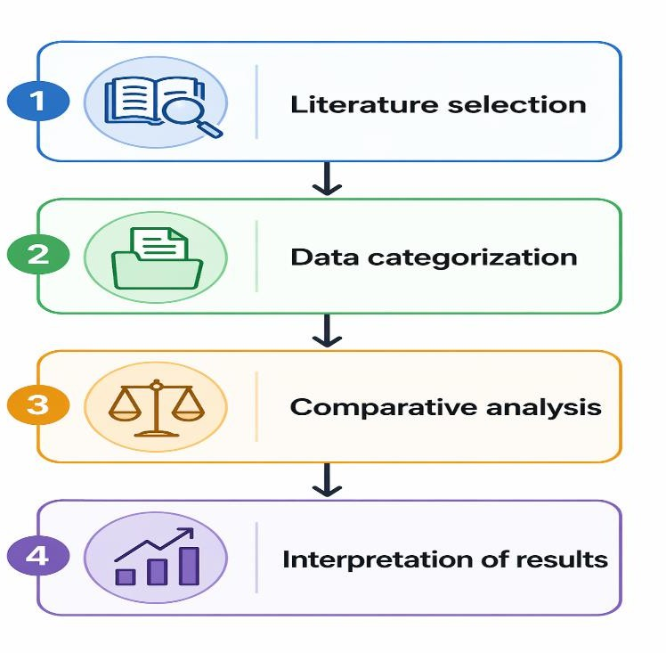

Result Analysis
  - Impact of Social Media Factors on Consumer Behavior
Table 1: Influence of Social Media Factors

Factor | Influence (%)
Influencer Marketing | 90
Personalized Content | 88
Targeted Advertising | 85
User Reviews | 80
Social Engagement | 83
As depicted in Table 1, influencer marketing exerts the most significant impact on consumer behavior, underscoring the trust and credibility attributed to influencers in shaping purchase decisions. Personalized communication and content relevance also play a pivotal role, indicating that customized interactions substantially bolster engagement levels. Furthermore, algorithm-mediated

exposure and social interactions appear to enhance consumer responsiveness. Although user reviews represent a comparatively lower percentage, they remain critical as they provide social proof that mitigates uncertainty in the decision-making process.

Figure II: Influence of Social Media Factors
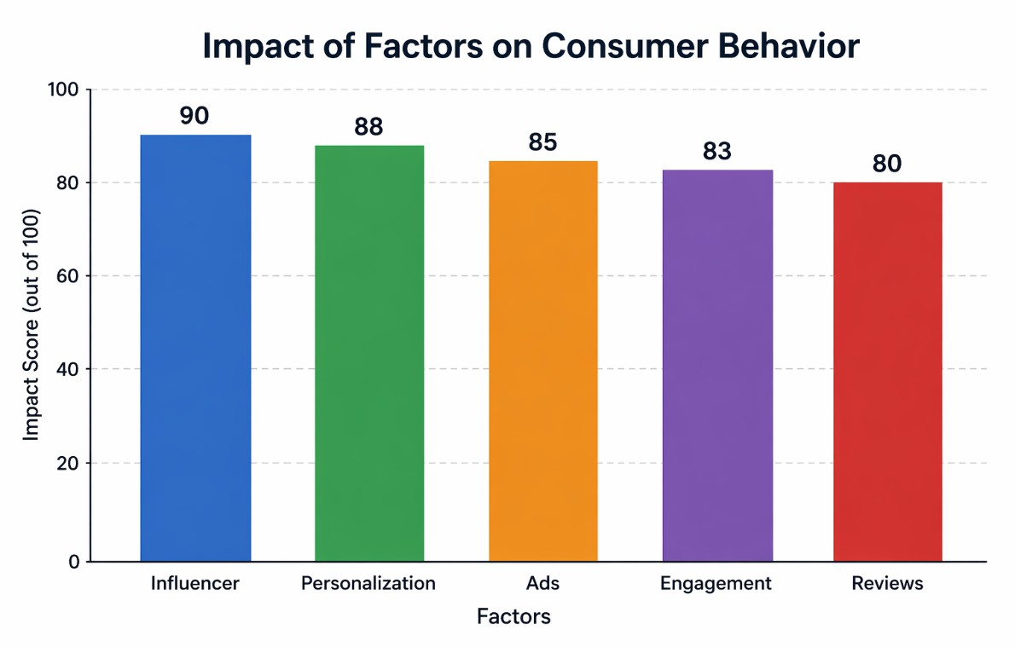
Figure II depicts that the impact of influencer marketing and relevant content is more effective compared to other examined variables. Through visual analysis, it is revealed that the utilization of strategies based on trust and relevance proves more effective than traditional promotion methods. The marginal difference between both major factors indicates that the behavior of consumers is influenced by various variables.

Impact on Purchase Intention
Table 2: Purchase Intention Across Factors

Factor | Intention (%)
Influencer Marketing | 90
Personalized Content | 88
Targeted Advertising | 85
User Reviews | 80

As shown in Table 2, purchase intention is the main behavioral variable affected by these variables. The suggestions made by these influencers play an important role in increasing the chance of acquiring customers. Similarly, customized material aids in the process of decision-making and increases consumer confidence through relevant information. Advertising increases product visibility whereas user ratings help consumers make decisions about purchases.

Figure III: Purchase Intention Analysis
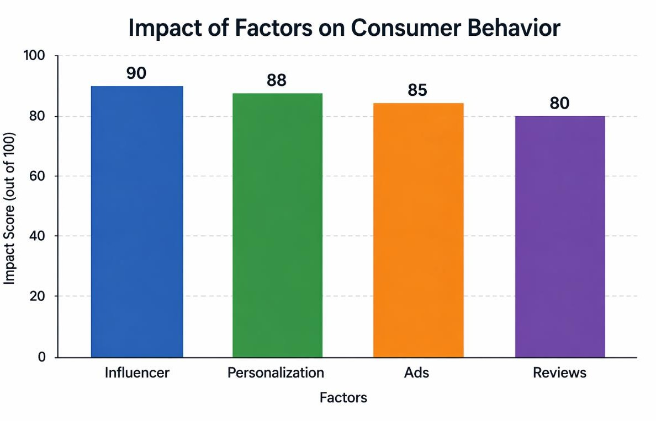
Figure III supports these results by showing the predominance of influencer marketing. It is clear from the analysis that personalization of content ranks second. Thus, trust and relevance seem to be key motivating factors for purchasing intentions. In addition, it is obvious that there exists an influential hierarchy among these variables.

Impact on Consumer Behavioral Outcomes Table 3: Behavioral Outcomes
Behavior Type | Percentage (%)
Impulse Buying | 30
Brand Loyalty | 25

Behavior Type | Percentage (%)
Brand Awareness | 25
Decision Speed | 20

As it can be seen from Table 3, impulse purchase behavior appears to be the most common one among the other behavioral outcomes. Hence, the widespread presence of social media coupled with its interactive content serves as the main trigger for this type of consumer behavior. In addition, the analysis of brand awareness and brand loyalty shows the ability of social media to help establish consumer relationships. Last but not least, the analysis of decision speed demonstrates that availability of information coupled with social validation helps to expedite consumer decisions.

Figure IV: Consumer Behavior Distribution

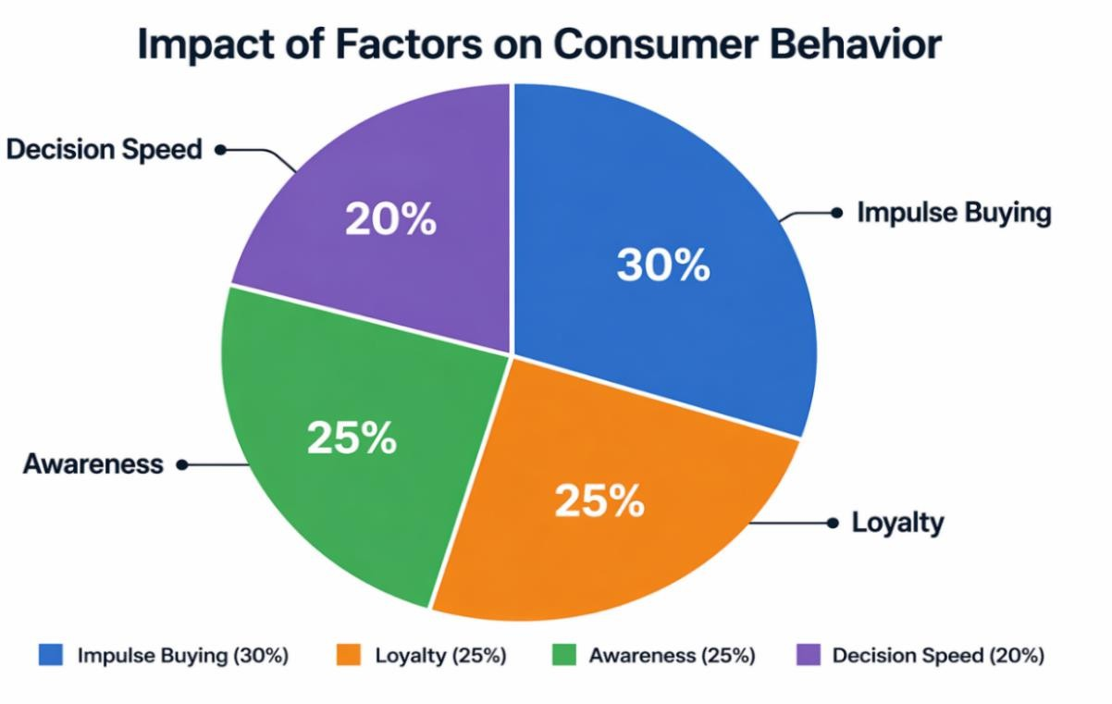
As presented in Figure IV, there is an evident domination of impulsive behavior among customers. Meanwhile, such results have shown that social media significantly influence consumer behavior both in the short term and in terms of their longer-term branding behavior.

Platform-Based Behavioral Analysis Table 4: Platform Influence

Platform | Key Factor | Effect
Instagram | Influencers | Impulse buying
TikTok | Algorithm | Trend adoption
YouTube | Reviews | Purchase confidence
Facebook | Ads | Brand trust

In Table 4, it is evident that the consumer behavior exhibited on different social media sites differs distinctly from one another. In the case of Instagram, for example, its reliance on influencer marketing and visual presentation of content creates a sense of aspiration among users, making it possible for it to create impulsive buying behaviors. On the other hand, TikTok uses algorithms in delivering content coupled with its video format to speed up the adoption of trends, resulting in impulsive purchases of trending products. Meanwhile, on YouTube, information plays a crucial role in helping consumers make a more comprehensive assessment of products, thus making it ideal for high-involvement purchases. Lastly, Facebook's focus on brand reputation creation and communication makes it highly suitable for communication-intensive products.

Figure V: Platform Effectiveness

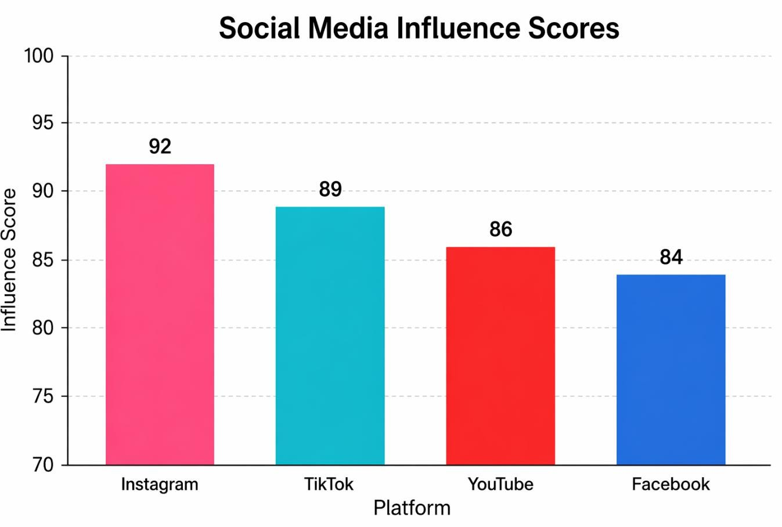
Figure V shows how the features of platforms affect consumer behavior. It is important to match a particular platform strategy with the organization’s marketing goals.

Relationship Between Personalization and Engagement Table 5: Personalization vs Engagement
Personalization Level | Engagement (%)
Low | 60
Medium | 75
High | 88

Table 5 provides evidence of a notable positive relationship between personalization and engagement, whereby the level of engagement increases from 60% at low personalization to 88% at high personalization levels, showing that

people tend to show higher engagement in information that is aligned with their preferences. Personalization improves the customer experience by eliminating information noise and providing high utility information, hence leading to higher dwell time and responsiveness to marketing messages. However, there are downsides associated with this approach. The high level of data necessary for personalization tends to make consumers feel threatened about their privacy.

Figure VI: Personalization Impact
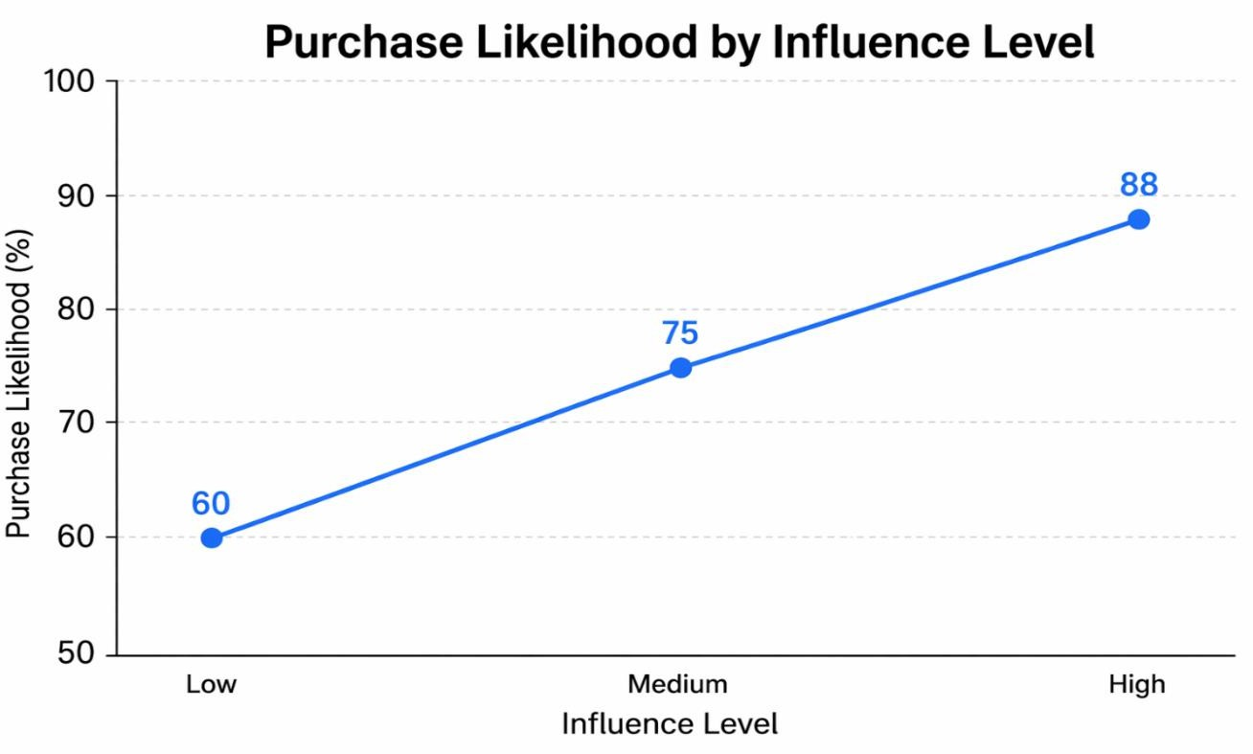
Figure VI shows a positive trend in which higher personalization is associated with higher engagement levels. This illustrates the success of AI-powered methods, but it is important not to overlook the necessity of balancing this personalization with ethical issues.

Discussion
The results obtained in this study showcase the mechanisms by which social media can affect consumer behavior through three mechanisms: trust, relevance, and engagement. Each of the three mechanisms listed above correlates with one of the variables used in the analysis: influencer marketing, personalized content, and user-generated content.
Firstly, influencer marketing turned out to be the most effective mechanism influencing consumer behavior. It helps to explain why the influence of influencer content on purchasing intention is quite impressive. It helps build trust relationships between consumers and influencers. Video content, photos, and

posts created by influencers are viewed as more trustworthy and relevant due to parasocial interaction.
Secondly, personalized content turned out to be quite important for consumer behavior. The results show the positive influence of personalization on the variables chosen. This mechanism makes the process of decision-making easier and reduces cognitive loads. While highly effective, personalized content may still have a negative effect on consumer behavior because of violating trust principles.
Lastly, user-generated content has proved to have a positive effect on consumer behavior. Reviews, feedbacks, and rating can help consumers reduce uncertainty when making decisions about purchases. Although the effect of UGC appears to be less impressive, it plays an important role in building trust.
The results obtained in this study also prove that social media can affect consumer behavior both in the short and the long term. The examples of the short-term outcomes are impulse buying; whereas the long-term effect refers to the development of brand awareness and brand loyalty.

Conclusion
Based on the findings of this study, social media plays an indispensable part in guiding the consumer behavior of individuals within the digital space. The variables identified include influencer marketing, personalized content, and user-generated content, which influence consumers' purchase decisions. Among these three factors, the former one is the most influential as it develops trust and emotional bonds with its target audience.
Social media not only affects short-term purchasing behavior but also contributes to long-term consumer behavior, including brand loyalty and brand awareness.
In addition, with the emergence of artificial intelligence and the increased reliance on big data, many ethical issues have been brought to attention. Therefore, future scholars must take ethical considerations into account when conducting their studies.
From a business perspective, organizations are advised to concentrate on genuine marketing messages, efficient personalization, and user-generated content. Moreover, companies are urged to be more transparent about their data management practices.

In terms of future studies, scholars can conduct additional research in other aspects like cultural factors, social media algorithms, and the effect of virtual influencers on consumers' purchasing behavior. Besides, collecting primary data would provide more insight into this issue.

ORCID
https://orcid.org/0009-0001-4237-6255

References
- G. Appel, L. Grewal, R. Hadi, and A. T. Stephen, “The future of social media in marketing,” Journal of the Academy of Marketing Science, vol. 48, no. 1, pp. 79–95, Oct. 2019, doi: 10.1007/s11747-019-00695-1.
- V. Chen, “How to make efficient purchase decisions? Proposing a model for consumer efficiency on social media,” Cogent Business & Management, vol. 11, no. 1, June 2024, doi: 10.1080/23311975.2024.2363414.
- T. Tarnanidis, M. Vlachopoulou, J. Papathanasiou, and B. Mareschal,
“Modeling Perceived Social Media Performance as an Information Driver of Consumer Decision-Making in Grocery Retail,” Information, vol. 17, no. 4, pp. 327–327, Mar. 2026, doi: 10.3390/info17040327.
- K. F. Anjorin, M. A. Raji, and H. B. Olodo, “The influence of social media marketing on consumer behavior in the retail industry: A comprehensive review,” International Journal of Management & Entrepreneurship Research, vol. 6, no. 5, pp. 1547–1580, May 2024, doi: 10.51594/ijmer.v6i5.1123.
- S. H. Mrisha and X. Sun, “The power of influence: How social media influencers are shaping consumer decision making in the digital age,” Journal of Consumer Behaviour, vol. 23, no. 4, pp. 1844–1853, Feb. 2024, doi: 10.1002/cb.2308.
- Chen, Y.; Qin, Z.; Yan, Y.; Huang, Y. “The Power of Influencers: How Does Influencer Marketing Shape Consumers’ Purchase Intentions?,” Sustainability, vol. 16, no. 13, pp. 5471–5471, May 2024, doi: 10.3390/su16135471.
- J. Han and G. Balabanis, “Meta-analysis of social media influencer impact: Key antecedents and theoretical foundations,” Psychology and Marketing, vol. 41, no. 2, pp. 394–426, Oct. 2023, doi: 10.1002/mar.21927.
- C. Herrando and M. J. M. Hoyos, “Influencer endorsement posts and their effects on advertising attitudes and purchase intentions,” International Journal

of Consumer Studies, vol. 46, no. 6, pp. 2288–2299, Feb. 2022, doi: 10.1111/ijcs.12785.
- A. Łaszkiewicz and M. Kalińska-Kula, “Virtual influencers as an emerging marketing theory: A systematic literature review,” International Journal of Consumer Studies, vol. 47, no. 6, pp. 2479–2494, May 2023, doi: 10.1111/ijcs.12956.
- A. Ł. A. N. D. M. Kalińska-Kula, “Virtual influencers as an emerging
marketing theory: A systematic literature review,” Int. J. Consum. Stud., vol. 47, no. 6, pp. 2479–2494, May 2023, doi: 10.1111/ijcs.12956.
- S. O. Babatunde, O. A. Odejide, T. E. Edunjobi, and D. O. Ogundipe, “THE ROLE OF AI IN MARKETING PERSONALIZATION: A THEORETICAL EXPLORATION OF CONSUMER ENGAGEMENT
STRATEGIES,” International Journal of Management & Entrepreneurship Research, vol. 6, no. 3, pp. 936–949, Mar. 2024, doi: 10.51594/ijmer.v6i3.964.
- P. Kumar, “The Role of Artificial Intelligence in Shaping Consumer Behaviour: A Study on AI-Driven Marketing Strategies,” International journal of business and management invention., vol. 14, no. 6, pp. 150–156, June 2025, doi: 10.35629/8028-1406150156.
- A. Petrova, L. Malär, W. D. Hoyer, and H. Krohmer, “The Phenomenon of Creepiness in a Digital Marketing World,” Psychology and Marketing, vol. 43, no. 4, pp. 834–851, Dec. 2025, doi: 10.1002/mar.70089.
- K. Mehmood, K. Verleye, A. D. Keyser, and B. Larivière, “Piloting personalization research through data-rich environments: a literature review and future research agenda,” Ghent University Academic Bibliography (Ghent University), vol. 34, no. 3, pp. 520–552, June 2022, doi: 10.1108/josm-10-2021-
0405.
- S. Kostić, J. Stanković, Đ. Alavuk, I. Šiđanin, B. Laličić, and S. Bunčić, “The Role of User-Generated Content in Social Commerce: A Systematic
Review,” Sustainability, vol. 18, no. 3, pp. 1601–1601, Feb. 2026, doi: 10.3390/su18031601.
- L. Y. Tseng, J.-H. Chang, and Y. Zhu, “What drives the travel switching
behavior of Chinese Generation Z consumers,” Journal of Tourism Futures, vol. 10, no. 1, pp. 131–146, July 2021, doi: 10.1108/jtf-07-2020-0110.
- S. Quach, P. Thaichon, K. D. Martin, S. Weaven, and R. W. Palmatier, “Digital technologies: tensions in privacy and data,” Journal of the Academy of

Marketing Science, vol. 50, no. 6, pp. 1299–1323, Mar. 2022, doi: 10.1007/s11747-022-00845-y.
- B. Rizvanović, A. Zutshi, A. Grilo, and T. Nodehi, “Linking the potentials of extended digital marketing impact and start-up growth: Developing a macro-dynamic framework of start-up growth drivers supported by digital
marketing,” Technological Forecasting and Social Change, vol. 186, pp. 122128–122128, Nov. 2022, doi: 10.1016/j.techfore.2022.122128.
- M. Sohaib, A. A. Safeer, and A. Majeed, “Role of social media marketing
activities in China’s e-commerce industry: A stimulus organism response theory context,” Frontiers in Psychology, vol. 13, pp. 941058–941058, Aug. 2022, doi: 10.3389/fpsyg.2022.941058.
- S. Moedeen et al., “Social media marketing in the digital age:
empower consumers to win big?,” Cronfa (Swansea University), vol. 36, no. 1,
pp. 66–84, July 2023, doi: 10.1108/apjml-09-2022-0784.
- L. Ye, Y. Huang, S. Song, and Z. Zhou, “Excessive short-form video use is associated with increased risk-taking but not with altered ambiguity-based decision-making,” BMC Psychology, vol. 13, no. 1, pp. 1070–1070, Sept. 2025, doi: 10.1186/s40359-025-03417-1.
- D. Pan, K. M. Lewin, D. Freestone, and D. Meshi, “Time on social networking sites is associated with impulsive decision-making,” Behaviour and Information Technology, vol. 44, no. 9, pp. 1760–1765, July 2024, doi: 10.1080/0144929x.2024.2374006.
- T. Samarah, P. Bayram, H. Y. Aljuhmani, and H. Elrehail, “The role of brand interactivity and involvement in driving social media consumer brand engagement and brand loyalty: the mediating effect of brand trust,” Journal of Research in Interactive Marketing, vol. 16, no. 4, pp. 648–664, Nov. 2021, doi: 10.1108/jrim-03-2021-0072.
- Z. R. Santos, C. M. K. Cheung, P. S. Coelho, and P. Rita, “Consumer engagement in social media brand communities: A literature
review,” International Journal of Information Management, vol. 63, pp. 102457–102457, Nov. 2021, doi: 10.1016/j.ijinfomgt.2021.102457.
- C. A. Malarvizhi, A. A. Mamun, S. Jayashree, F. Naznen, and T. Abir,
“Modelling the significance of social media marketing activities, brand equity and loyalty to predict consumers’ willingness to pay premium price for portable tech gadgets,” Heliyon, vol. 8, no. 8, Aug. 2022, doi: 10.1016/j.heliyon.2022.e10145.

- M. S. Azad, S. S. Khan, R. Hossain, R. Rahman, and S. Momen, “Predictive modeling of consumer purchase behavior on social media: Integrating theory of planned behavior and machine learning for actionable insights,” PubMed Central, vol. 18, no. 12, Dec. 2023, doi: 10.1371/journal.pone.0296336.
- L. Ao, R. Bansal, N. Pruthi, and M. B. Khaskheli, “Impact of Social Media Influencers on Customer Engagement and Purchase Intention: A Meta-Analysis,” Sustainability, vol. 15, no. 3, pp. 2744–2744, Feb. 2023, doi: 10.3390/su15032744.
- K. Jamil, L. Dunnan, R. F. Gul, M. U. Shehzad, S. H. M. Gillani, and F. H. Awan, “Role of Social Media Marketing Activities in Influencing Customer Intentions: A Perspective of a New Emerging Era,” Frontiers in Psychology, vol. 12, pp. 808525–808525, Jan. 2022, doi: 10.3389/fpsyg.2021.808525.
- S. Hu and Z. Zhu, “Effects of Social Media Usage on Consumers’ Purchase Intention in Social Commerce: A Cross-Cultural Empirical Analysis,” Frontiers in Psychology, vol. 13, pp. 837752–837752, May 2022, doi: 10.3389/fpsyg.2022.837752.
- H. Beyari and T. N. Hashem, “The Role of Artificial Intelligence in Personalizing Social Media Marketing Strategies for Enhanced Customer
Experience,” Behavioral Sciences, vol. 15, no. 5, pp. 700–700, May 2025, doi: 10.3390/bs15050700.
- A. Gungunawat, N. Khandelwal, and N. Gupta, “AI-Powered Personalization in Digital Marketing: Transforming Consumer Engagement and
Strategy,” RESEARCH REVIEW International Journal of Multidisciplinary, vol. 9, no. 11, pp. 183–191, Nov. 2024, doi: 10.31305/rrijm.2024.v09.n11.026.
- N. Hicham, H. Nassera, and S. Karim, “Strategic Framework for Leveraging Artificial Intelligence in Future Marketing Decision-Making,” Journal of Intelligent Management Decision, vol. 2, no. 3, pp. 139–150, Sept. 2023, doi: 10.56578/jimd020304.
- M. S. Alzaidi and G. Agag, “The role of trust and privacy concerns in using social media for e-retail services: The moderating role of COVID-19,” Journal of Retailing and Consumer Services, vol. 68, pp. 103042–103042, June 2022, doi: 10.1016/j.jretconser.2022.103042.
- R. Geng and J. Chen, “The Influencing Mechanism of Interaction Quality of UGC on Consumers’ Purchase Intention – An Empirical Analysis,” Frontiers in Psychology, vol. 12, pp. 697382–697382, July 2021, doi: 10.3389/fpsyg.2021.697382.

- N. Zhang and W. Hu, “Do Psychological Ownership and Communicative Presence Matter? Examining How User-Generated Content in E-Commerce Live Streaming Influences Consumers’ Purchase Intention,” Behavioral Sciences, vol. 14, no. 8, pp. 696–696, Aug. 2024, doi: 10.3390/bs14080696.
- A. H. Alsharif, N. Z. M. Salleh, S. A. Al-Zahrani, and A. Khraiwish,
“Consumer Behaviour to Be Considered in Advertising: A Systematic Analysis and Future Agenda,” Behavioral Sciences, vol. 12, no. 12, pp. 472–472, Nov.
2022, doi: 10.3390/bs12120472.
- M. Azhar, R. Husain, S. Hamid, and M. N. Rahman, “Effect of social media marketing on online travel purchase behavior post-COVID-19: mediating role of brand trust and brand loyalty,” Future Business Journal, vol. 9, no. 1, Mar. 2023, doi: 10.1186/s43093-023-00192-6.
- X. Wang, N. Aisihaer, and A. Aihemaiti, “Research on the impact of live streaming marketing by online influencers on consumer purchasing
intentions,” Frontiers in Psychology, vol. 13, pp. 1021256–1021256, Nov. 2022, doi: 10.3389/fpsyg.2022.1021256.
- T. Hongsuchon, S. Chen, and A. Khan, “Applying the S-O-R model to explore impulsive buying behavior driven by influencers on social commerce
websites,” PeerJ Computer Science, vol. 11, Sept. 2025, doi: 10.7717/peerj-cs.3113.
- Y. Lina, D. Hou, and S. Ali, “Impact of online convenience on generation Z online impulsive buying behavior: The moderating role of social media celebrity,” Frontiers in Psychology, vol. 13, pp. 951249–951249, Aug. 2022, doi: 10.3389/fpsyg.2022.951249.
- A. Pellegrino, M. Abé, and R. Shannon, “The Dark Side of Social Media: Content Effects on the Relationship Between Materialism and Consumption Behaviors,” Frontiers in Psychology, vol. 13, pp. 870614–870614, Apr. 2022, doi: 10.3389/fpsyg.2022.870614.
- M. Liu, “Determining the Role of Influencers’ Marketing Initiatives on Fast Fashion Industry Sustainability: The Mediating Role of Purchase Intention,” Front. Psychol., vol. 13, p. 940649, May 2022, doi: 10.3389/fpsyg.2022.940649.
- C. Lou and S. Yuan, “Influencer Marketing: How Message Value and Credibility Affect Consumer Trust of Branded Content on Social
Media,” Journal of Interactive Advertising, vol. 19, no. 1, pp. 58–73, Oct. 2018, doi: 10.1080/15252019.2018.1533501.

