Frequency Controlled Inductive Wireless Power Transfer

- Abstract:

Wireless power transfer technology provides a convenient and safe alternative to conventional wired charging systems. This paper presents a frequency-controlled inductive wireless power transfer system designed to improve power transfer efficiency under varying operating conditions. The proposed system employs resonant inductive coupling between transmitter and receiver coils tuned to the same resonant frequency. A high-frequency inverter converts DC supply into AC, which excites the transmitter coil to generate a magnetic field. The receiver coil captures this magnetic field and induces voltage, which is rectified and filtered to obtain DC output. To maintain resonance, frequency control is implemented using a DSP-based adaptive approach modeled in MATLAB. The controller dynamically adjusts switching frequency based on output power to maximize efficiency. The system is validated through simulation and hardware prototype. The proposed design demonstrates efficient short-range wireless power transfer suitable for applications such as two-wheeler electric vehicle charging.

Keywords: Wireless Power Transfer, Resonant Inductive Coupling, Frequency Control, Electric Vehicle Charging, MATLAB Simulation

- Introduction:
Wireless power transfer (WPT) enables transmission of electrical energy without physical connectors. Conventional wired charging systems suffer from wear and safety issues, especially in outdoor environments.

Inductive wireless power transfer uses magnetic coupling between coils to transfer power safely. However, fixed-frequency systems experience reduced efficiency due to coil misalignment and load variations. To address this issue, frequency-controlled operation is introduced. By adjusting the inverter switching frequency, resonance can be maintained dynamically. This improves power transfer efficiency and stability. In this work, a frequency-controlled inductive wireless power transfer system is designed and validated using MATLAB simulation and hardware implementation. The system is demonstrated using a two-wheeler electric vehicle charging application.
- Related work:
Inductive wireless power transfer systems operate on the principle of magnetic coupling between two coils. When alternating current flows through the transmitter coil, it generates a magnetic field that links with the receiver coil. The induced voltage in the receiver coil depends on mutual inductance, frequency, and coil alignment. Early inductive wireless power transfer systems were used for low-power applications such as electric toothbrushes and mobile phone charging. However, these systems suffered from limited transfer distance and low efficiency. Researchers have explored various coil geometries and shielding techniques to improve performance.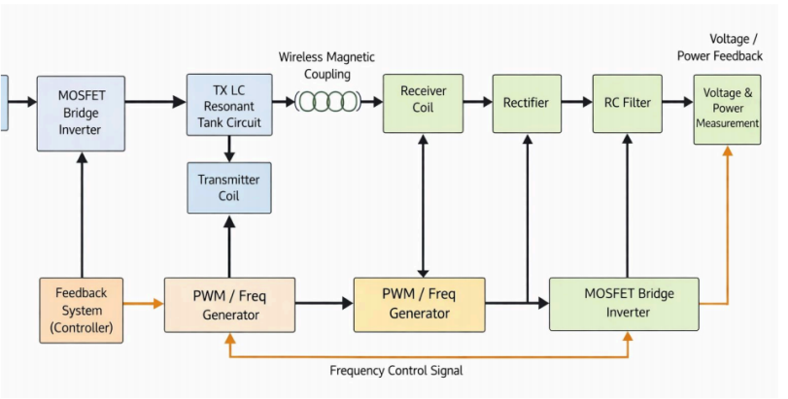
However, many existing systems operate at fixed frequency, leading to efficiency loss. The proposed work integrates resonant coupling with frequency control to enhance performance.
- System Design:
The proposed frequency controlled inductive wireless power transfer system consists of two main sections: the transmitter side and the receiver side. The transmitter section includes a DC input source, high-frequency inverter, resonant LC tank circuit, and transmitter coil. The receiver section consists of a receiver coil, rectifier, filter capacitor, and load. The transmitter coil and receiver coil are magnetically coupled through air gap, enabling wireless power transfer. The DC input supply, typically 12V, is converted into high-frequency alternating current using a switching inverter. The inverter generates square wave signals at variable frequency, which are then applied to the resonant LC tank circuit. The LC tank circuit is designed to operate at resonant frequency to maximize current flow and magnetic field strength. The transmitter coil produces an alternating magnetic field, which induces voltage in the receiver coil through mutual inductance. The receiver coil captures this energy and transfers it to the rectifier circuit. The rectifier converts high-frequency AC into DC voltage. A filter capacitor is used to reduce ripple and smooth the output voltage.

The filtered DC voltage is then applied to the load, representing the battery of a two-wheeler electric vehicle. Frequency control is implemented by
adjusting the inverter switching frequency to maintain resonance under varying conditions such as distance and alignment.
The resonant frequency of the LC circuit is given by:
f=1/2πsqrt(LC)
Selecting an inductance of 30 µH and capacitance of 0.33 µF,
f=1/2π(30×10−6×0.33×10−6f)
f≈50kHz

This frequency range is suitable for efficient inductive power transfer.
The output power requirement is assumed to be 20 W. For a 12 V output,
I=P/V=20/12=1.67
The coupling coefficient between coils depends on distance and alignment.
Assuming a coupling coefficient of 0.6, the induced voltage can be estimated.
After resonance amplification and rectification, the output voltage is regulated to 12 V.
Efficiency is calculated using:
η=Pout/Pin×100
If input power is 24 W and output power is 20 W,
η=20/24×100=83%

- Technical Specification:

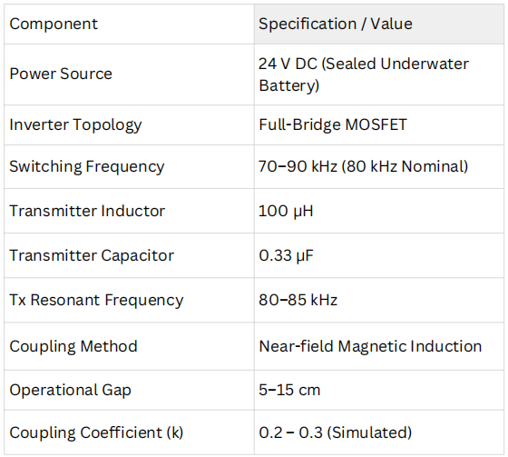
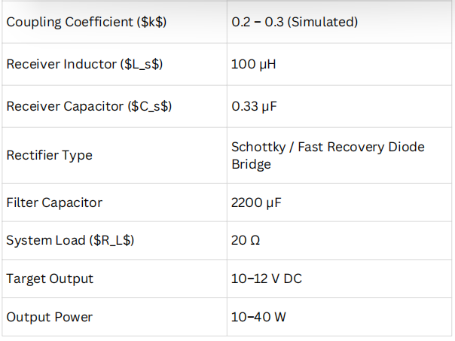

- Simulation:
The simulation of the proposed system is carried out using MATLAB/Simulink environment. The simulation model includes DC voltage source, inverter circuit, resonant LC tank, coupled coils, rectifier, filter, and load. The DC source provides 12V input to the inverter. The inverter is modeled using MOSFET switches controlled by pulse generator. The switching frequency of the inverter is varied to study resonance behavior. The output of inverter is applied to the resonant LC circuit, which

includes transmitter coil and capacitor. The transmitter coil is magnetically coupled to receiver coil using mutual inductance block. The receiver side consists of bridge rectifier and filter capacitor. A resistive load is connected to represent EV battery. Voltage measurement blocks are used to observe transmitter and receiver voltages. Current measurement blocks are used to analyze current flow. Scope blocks are connected to display wave forms. The simulation is run for different frequencies ranging from 20 kHz to 80 kHz. It is observed that maximum output voltage occurs near resonant frequency. This confirms efficient wireless power transfer. The simulation validates the effectiveness of frequency-controlled operation.
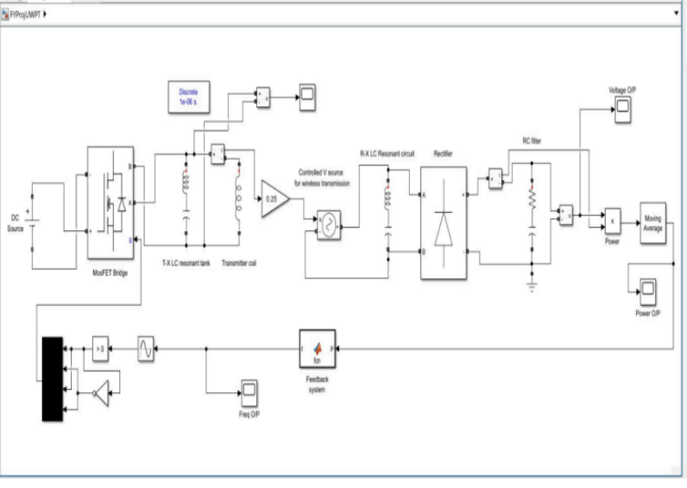
Code:
function f = fcn(P)
persistent f_prev P_prev dir
if isempty(f_prev)
f_prev = 80000;
P_prev = 0;
dir = 1;
end
step = 200;
if P > P_prev
f = f_prev + dir*step;
Else
% reverse direction
dir = -dir;
f = f_prev + dir*step;
end

% limit frequency range
if f < 70000
f = 70000;
end
if f > 90000
f = 90000;
end
% store for next cycle
P_prev = P;
f_prev = f;
End

- Frequency Control strategy:

The efficiency of inductive wireless power transfer strongly depends on maintaining resonance between transmitter and receiver coils. In practical conditions, the coupling coefficient changes due to variations in coil alignment, air gap distance, and load conditions. These variations shift the resonant frequency of the system, causing efficiency degradation. To overcome this issue, frequency control strategy is implemented in the proposed system. The inverter switching frequency is varied within a predefined range to track the resonant frequency. When the system operates at resonance, maximum current flows in the transmitter coil, producing stronger magnetic field and improving coupling. The frequency is adjusted based on output voltage or power measurement. When output voltage increases, the system moves closer to resonance. When output decreases, frequency is adjusted accordingly. This adaptive frequency control ensures maximum power transfer efficiency under varying conditions. The implementation of frequency control improves robustness and reliability of wireless charging system.

- Hardware Implementation:

1.The system is designed based on resonant inductive wireless power transfer (WPT) for underwater charging applications.

- A DC power source is converted into high-frequency AC using a MOSFET-based inverter

- The inverter output is fed into a transmitter LC resonant tank, tuned to approximately 80–85 kHz, ensuring maximum energy transfer efficiency.

4.The transmitter coil generates a time-varying magnetic field, which induces voltage in the receiver coil placed at a short distance (5–15 cm).

5.Since seawater is conductive, the system uses magnetic coupling instead of electrical conduction, avoiding energy loss through water.

6.A controlled voltage source model is used in simulation to emulate realworld magnetic coupling and misalignment effects.

7.The receiver side includes a resonant LC circuit, followed by a rectifier and RC filter to convert the received AC signal into usable DC power.

- Advantages of proposed system:

The proposed frequency controlled inductive wireless power transfer system offers several advantages. It eliminates the need for physical connectors, reducing wear and maintenance. The system improves safety by avoiding exposed conductive terminals. Frequency control maintains resonance and enhances efficiency. The system is compact and suitable for two-wheeler EV charging. Wireless charging improves user convenience by allowing automatic charging when vehicle is parked. The design is scalable and can be extended for higher power applications. The system also reduces risk of sparking and corrosion.

- Limitations:

Although the proposed system improves wireless power transfer efficiency, certain limitations exist. The transfer distance is limited to short range. Efficiency decreases with coil misalignment. High frequency operation may introduce switching losses. Proper shielding is required to reduce electromagnetic interference. Coil size increases with power rating. These limitations can be addressed in future work by improving coil design and implementing advanced control strategies.

- Results And Discussions:

The simulation results show that maximum output voltage is obtained at resonant frequency. The output voltage decreases when operating away
from resonance. This confirms importance of frequency control. The hardware results also show
similar behavior. At optimal alignment and distance of 3 cm, output voltage ranges between 10V and 12V. Efficiency is observed around 80–85%. Increasing distance reduces coupling and output power. Misalignment also reduces efficiency. The proposed system demonstrates stable wireless power transfer suitable for two-wheeler EV charging application. Frequency control improves system performance and compensates for variations in coil alignment.

- Conclusions:

A frequency-controlled inductive wireless power transfer system has been designed and implemented. The system uses resonant coupling to improve efficiency. MATLAB simulation confirms resonance behavior. Hardware prototype demonstrates wireless power transfer over short distance. Frequency control ensures maximum power transfer. The proposed system is suitable for two-wheeler electric vehicle charging applications. The system improves convenience and eliminates need for physical connectors

References:
- Kurs A., “Wireless Power Transfer via Strongly Coupled Magnetic Resonance,” MIT, 2007.
- G. A. Covic and J. T. Boys, “Inductive power transfer,” Proceedings of the IEEE, vol. 101, no. 6, pp. 1276–1289, Jun. 2013.
- S. Li and C. C. Mi, “Wireless power transfer for electric vehicle applications,” IEEE Journal of Emerging and Selected Topics in Power Electronics, vol. 3, no. 1, pp. 4–17, Mar. 2015.

- J. Zhang, L. Zhao, and X. He, “Frequency splitting analysis of wireless power transfer system,” IEEE Transactions on Power Electronics, vol. 29, no. 3, pp. 1050–1060, Mar. 2014.
- H. H. Wu, A. Gilchrist, K. D. Sealy, and D. Bronson, “A review on inductive charging for electric vehicles,” Renewable and Sustainable Energy Reviews, vol. 65, pp. 1084–1094, Nov. 2016.
- C. T. Rim and C. Mi, Wireless Power Transfer for Electric Vehicles and Mobile Devices. Hoboken, NJ, USA: Wiley, 2017.
- M. Budhia, G. A. Covic, and J. T. Boys, “Design and optimization of circular magnetic structures for lumped inductive power transfer systems,” IEEE Transactions on Power Electronics, vol. 26, no. 11, pp. 3096–3108, Nov. 2011.

