Performance of Glass-Based Hot Mix Asphalt Mixtures Produced from Locally Sourced Recycled Crushed Glass

Abstract: This study presents the Marshall Mix Design and comparative performance evaluation of hot mix asphalt (HMA) incorporating recycled crushed glass as a partial fine aggregate replacement at seven levels ranging from 0% (conventional control) to 30% by mass of the fine aggregate fraction. Penetration-grade 60/70 bitumen and locally sourced aggregates conforming to ASTM and BS standards were employed. Marshall Stability, Flow, Bulk Density, Voids in Mix (VIM), and Voids Filled with Bitumen (VFB) were determined at the Optimum Binder Content (OBC) for each mix series. Indirect Tensile Strength (ITS) was estimated using an empirical model derived from Marshall parameters, and Tensile Strength Ratio (TSR) was predicted from a volumetric relationship with VIM. The 5% recycled glass mix yielded the highest Marshall Stability (11.56 kN), best-controlled flow (2.48 mm), highest estimated ITS (1.039 MPa), and highest Multi-Criteria Performance Index (MCPI = 0.960). All mixes maintained estimated TSR values above 80%, confirming adequate moisture resistance across the full 0 to 30% replacement range. The optimal recycled glass content is recommended at 5 to 10% because the best mechanical properties, environmental and economic improvements were recorded at that range of replacement.
Keywords: Hot Mix Asphalt, Indirect Tensile Strength, Marshall Mix Design, Optimum Binder Content, Recycled Crushed Glass, Sustainable Pavement, Tensile Strength Ratio.
I.0 Introduction
Road infrastructure construction globally relies heavily on natural fine aggregates such as river sand and quarried stone as primary components of hot mix asphalt (HMA) pavement (Nwakaire et al., 2021). The extraction of these materials is associated with significant environmental consequences including habitat disruption, alteration of water tables, and greenhouse gas emissions from mining, processing, and long-distance transportation (Patel et al., 2023; Nwakaire et al., 2020a; Mroueh et al., 2020). The growing demand for pavement construction, particularly in developing nations, has intensified these pressures and underscored the need for sustainable alternative materials that can partially replace virgin fine aggregates without compromising pavement performance (Federal Highway Administration, 2019).
Glass waste represents one of the most abundant and persistent solid waste streams worldwide. Over 130 million tonnes of glass are generated annually, of which approximately only 35% is effectively recycled (United Nations Environment Programme, 2023). Being non-biodegradable, waste glass deposited in landfills contributes to soil and groundwater contamination (Imteaz et al., 2012). Recycling crushed glass as a fine aggregate substitute in asphalt pavement construction offers two concurrent benefits: diversion of glass waste from landfill and reduction in demand for virgin fine aggregates. Prior research has demonstrated that recycled glass, owing to its angular particle morphology, low water absorption, and comparatively high hardness, can improve stiffness and rutting resistance of HMA at moderate substitution levels (Wang & Zhang, 2022; Singh & Raghunath, 2023). Mohajerani et al. (2017) confirmed that pavement durability was preserved when up to 15% of natural aggregate was replaced with waste glass. Lee et al. (2023) found that HMA mixes with up to 15% recycled glass (RG) exhibited Marshall Stability values comparable to or marginally exceeding those of conventional mixes, while maintaining flow values within the 2 to 4 mm specification range. Wang et al. (2023) attributed stability improvements at 10 to 20% glass replacement to the angularity of glass particles enhancing aggregate matrix interlocking, which resulted in higher stiffness moduli. However, replacement levels exceeding 25 to 30% were consistently associated with declining stability, attributable to the smooth glass surface reducing the aggregate friction angle and interlocking capacity (Patel & Shah, 2023). VIM values tend to increase at intermediate glass replacement levels due to shape incompatibility reducing packing efficiency, and then decrease at higher contents as the fine glass fraction fills interstitial voids (Wang et al., 2023). The OBC is reported to decrease at low to moderate glass contents owing to improved packing, but may increase at elevated replacement levels as the greater surface area of finer glass particles demands more binder coverage (Lee et al., 2023).

In addition to the mix design properties, the indirect tensile strength (ITS) test and tensile strength ratio (TSR) are primary indicators of the tensile integrity and moisture damage susceptibility of asphalt mixtures, recognized under AASHTO T283. A TSR value of 80% or above is the standard minimum threshold for adequate moisture resistance (Nwakaire et al., 2020b). Patel and Shah (2023) observed that glass-modified mixes at low replacement levels up to 10% exhibited moisture resistance comparable to conventional mixes, an outcome attributed to the hydrophobic nature of glass reducing water and binder interfacial tensions. At higher replacement levels, the smooth non-porous glass surface diminished binder film adhesion, thereby reducing moisture resistance. Lu and Harvey (2006) and Airey (2003) established that within the normal dense-graded compaction zone of 3 to 6% VIM, TSR decreases approximately 2 to 4% per 1% increase in air void content. This relationship provides the empirical basis for the volumetric TSR prediction model employed in the present study.

Nonetheless, increased glass content beyond an optimum level has been consistently associated with reduced tensile strength and potential moisture susceptibility, both of which are critical long-term pavement performance indicators (Patel & Shah, 2023; Chandran et al., 2023). The Marshall Mix Design method, widely used in Nigeria and other developing countries in accordance with ASTM and the Federal Ministry of Works (FMW) specifications (Federal Ministry of Works, 1994), provides a systematic framework for evaluating the mechanical and volumetric properties of asphalt mixtures across a range of binder contents. The Indirect Tensile Strength (ITS) and Tensile Strength Ratio (TSR) complement Marshall parameters by providing direct indicators of tensile integrity and moisture damage susceptibility, both of which are fundamental to long-term pavement performance (Hicks, 1991).
The present study addresses two complementary objectives: (i) to establish a full Marshall Mix Design of both conventional and glass-modified HMA at recycled glass contents of 0 to 30%; and (ii) to evaluate and comparatively analyse the ITS and TSR of glass-based mixes against the traditional control. A Multi-Criteria Performance Index (MCPI) is additionally computed to provide an integrated performance comparison. The findings aim to furnish evidence-based guidance for the incorporation of recycled glass in sustainable road construction practice in Nigeria and comparable regional contexts.
2.0 Materials and Methods
2.1 Materials
The asphalt binder employed was penetration-grade 60/70 bitumen, sourced locally and evaluated per ASTM D5 (penetration), ASTM D36 (softening point), ASTM D113 (ductility), ASTM D92 (flash and fire point), and ASTM D4402 (viscosity) (American Society for Testing and Materials, 2020a). Two coarse aggregate fractions of 10 to 15 mm and 15 to 25 mm, together with natural river sand serving as the fine aggregate at a maximum particle size of 4.75 mm, were procured from certified local suppliers and characterised per ASTM C127/C128 and BS 812 (British Standards Institution, 1990; 1989a; 1989b). Recycled glass was collected from post-consumer glass bottles sourced from local markets in the study area. Processing involved removal of contaminants including metals, plastics, and ceramics; jaw crushing to below 4.75 mm; sieving to achieve gradation matching natural fine aggregate; optional edge rounding; and leachate testing to confirm environmental safety in line with the findings of Imteaz et al. (2012). The particle size distributions of all constituent materials are presented in Fig. 1.
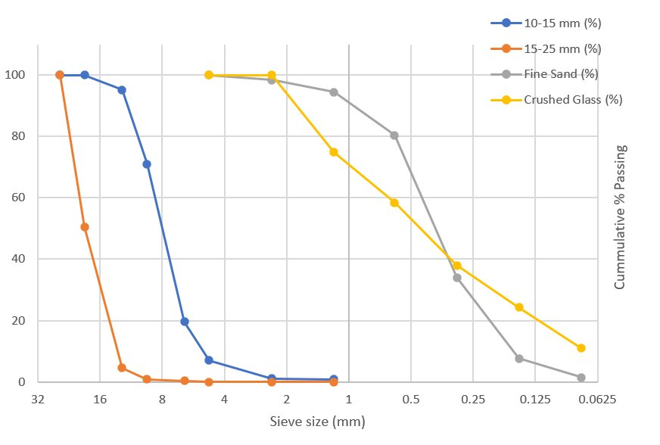
Fig. 1: Particle Size Distribution Curves of All Constituent Materials
2.2 Material Characterisation
Tables 1 and 2 present the bitumen and aggregate property test results respectively. The bitumen satisfied all 60/70 penetration grade specification requirements per ASTM D5 and the Federal Ministry of Works (1994) General Specifications. A penetration of 61 dmm confirms moderate consistency appropriate for Nigeria's tropical climate, while a softening point of 50°C confirms adequate resistance to high-temperature deformation. Coarse aggregate specific gravities of 2.864 to 2.885 exceeded the specified minimum, confirming adequate density for structural load-bearing. Aggregate Crushing Values of 31.2% were within the acceptable range for asphalt pavements per BS 812-110 (British Standards Institution, 1990). Low Flakiness and Elongation Indices confirm predominantly equidimensional particle shapes favourable for aggregate interlocking and mix workability.

Table 1: Bitumen Property Test Results (60/70 Penetration Grade)
Property Tested | Value Obtained | Specification (ASTM/SON) | Status
Penetration (25°C, 100g, 5s) dmm | 61.0 | 60 to 70 | Pass
Softening Point (°C) | 50.0 | 48 to 56 | Pass
Loss after Heating (% wt.) | 0.10 | ≤ 0.20 | Pass
Drop in Penetration after Heating (%) | 20.0 | ≤ 20 | Pass
Solubility in CS₅ (% wt.) | 97.0 | ≥ 99 | Acceptable
Specific Gravity | 1.02 | 1.01 to 1.05 | Pass

Table 2: Aggregate Physical Property Test Results
Property | Agg. Size | Standard | Value | Specification Limit | Status
Specific Gravity | 10 to 15 mm | ASTM C127/C128 | 2.864 | 2.5 to 2.8 | Suitable
 | 15 to 25 mm | ASTM C127/C128 | 2.885 | 2.5 to 2.8 | Suitable
Aggregate Crushing Value | 10/15 mm | BS 812-110 | 31.2% | ≤ 35% | Acceptable
Flakiness Index | 10/15 mm | BS 812-105.1 | 8.1% | ≤ 25% | Pass
 | 15/22 mm | BS 812-105.1 | 9.1% | ≤ 25% | Pass
Elongation Index | 10/15 mm | BS 812-105.2 | 7.4% | ≤ 30% | Pass
 | 15/22 mm | BS 812-105.2 | 8.4% | ≤ 30% | Pass

2.3 Experimental Design and Research Framework
The experimental programme followed a systematic six-phase comparative design evaluating seven HMA mix series (M0 to M30) at recycled glass replacement levels of 0%, 5%, 10%, 15%, 20%, 25%, and 30% by mass of the total fine aggregate fraction. The control mix (M0) with no glass served as the performance benchmark against which all glass-modified mixes were evaluated. Table 3 presents the experimental design structure. The research framework encompasses material input and characterisation, Marshall Mix Design, multi-parameter performance evaluation, comparative analysis, optimum RGA content determination, and final recommendations.

Table 3: Experimental Design Structure
Mix ID | Recycled Glass (%) | Purpose | Test Categories
M0 | 0% (Control) | Baseline | Mechanical, Durability, Environmental, Economic
M5 | 5% | Low substitution | Mechanical, Durability, Environmental, Economic
M10 | 10% | Moderate substitution | Mechanical, Durability, Environmental, Economic
M15 | 15% | High substitution | Mechanical, Durability, Environmental, Economic
M20 | 20% | High substitution | Mechanical, Durability, Environmental, Economic
M25 | 25% | High substitution | Mechanical, Durability, Environmental, Economic
M30 | 30% | High substitution | Mechanical, Durability, Environmental, Economic

The first phase of the study covers material input and characterisation of bitumen, coarse and fine aggregates, and recycled glass as explained. Phase 2 encompasses the full Marshall Mix Design programme across seven mix series at bitumen contents of 4.5 to 6.5%. Phase 3 comprises multi-parameter performance evaluation incorporating Marshall properties, ITS estimation, TSR prediction, and MCPI computation. Phase 4 provides comparative analysis between traditional HMA and the two identified optimal glass-modified mixes. Phase 5 determines the optimum RG content based on integrated mechanical, environmental, and economic criteria. This multi-criteria framework ensures that design decisions are grounded in holistic evidence rather than any single performance indicator. Based on these, some recommendations were made on the use of RG for HMA.
2.4 Mix Proportions
The asphalt mix was designed per ASTM D6927 Marshall Method (American Society for Testing and Materials, 2020b). The coarse aggregate fraction was held constant at 65% of total aggregate mass for all mixes to isolate the effect of fine aggregate substitution. As the recycled glass content increased from 0 to 30%, the proportion of natural fine aggregate decreased proportionately, maintaining the total fine aggregate fraction at 35% by weight. Table 4 presents the detailed mix proportions for all seven series.
Table 4: Mix Proportions for Control and Glass-Modified Asphalt Mixes
Mix ID | RG (%) | Coarse Agg. (%) | Natural Fine Agg. (%) | Glass (%) | Remarks
M0 | 0 | 65 | 35.00 | 0.00 | Control
M5 | 5 | 65 | 33.25 | 1.75 | 5% glass replacement
M10 | 10 | 65 | 31.50 | 3.50 | 10% glass replacement
M15 | 15 | 65 | 29.75 | 5.25 | 15% glass replacement
M20 | 20 | 65 | 28.00 | 7.00 | 20% glass replacement
M25 | 25 | 65 | 26.25 | 8.75 | 25% glass replacement
M30 | 30 | 65 | 24.50 | 10.50 | 30% glass replacement

2.5 Sample Preparation and Marshall Testing
For each mix series, trial specimens were prepared at bitumen contents ranging from 4.5 to 6.5% in 0.5% increments. All constituent materials were oven-dried at 105 plus or minus 5°C prior to mixing. Aggregates and recycled glass were heated to 160 to 170°C, and bitumen was heated separately to 150 to 160°C. A minimum of three replicate specimens per bitumen content per mix series were compacted using 75 blows per face with a Marshall compaction hammer, simulating heavy traffic loading conditions per ASTM D6927 (American Society for Testing and Materials, 2020b). The Marshall Stability and Flow tests were conducted at 60°C. Bulk Density, VIM, and VFB were computed from specimen geometry and specific gravity measurements. The OBC was determined for each mix series as the average of the bitumen contents corresponding to maximum Marshall Stability, maximum Bulk Density, and a VIM equal to 4%, consistent with standard Marshall OBC determination practice (Federal Ministry of Works, 1994).
2.6 ITS Estimation Model
Direct ITS laboratory testing was not undertaken due to facility constraints. ITS was instead estimated using the following empirical model, which captures the positive relationship between Marshall Stability and tensile strength, and the inverse relationship between flow value and tensile strength (Hicks, 1991; Kiggundu & Roberts, 1988):
ITSest (MPa) = 0.35 + 0.065S – 0.025f ... (1)
where S is Marshall Stability in kN and f is the Flow value in mm. The model was applied at the OBC determined for each mix series.

2.7 TSR Prediction Model
Moisture damage susceptibility was assessed using a volumetric TSR prediction model based on the linear relationship between TSR and air void content established for dense-graded HMA within the 3 to 6% VIM range (Lu & Harvey, 2006; Airey, 2003):
TSRest (%) = 100 – 3 × VIM ... (2)
A coefficient of k equal to 3 was adopted as a conservative mid-range estimate of moisture sensitivity, consistent with the range of 2 to 4 reported in the literature (Lu & Harvey, 2006). The minimum acceptance criterion was set at TSR of 80% in accordance with AASHTO (2014). ITS_wet was back-calculated from TSR and ITS_dry to complete the tensile characterisation for each mix.
2.8 Multi-Criteria Performance Index
To provide a holistic single-index performance comparison, the MCPI was computed for each mix by normalising and averaging four Marshall parameters: Stability (S*), Flow (F*), Bulk Density (D*), and VIM (VIM*). Parameters where higher values indicate better performance, namely stability and density, were normalised by dividing each measured value by the respective maximum across all mixes. For flow, where a lower value is preferred, normalisation was performed by dividing the minimum flow value by the measured value. VIM performance was normalised relative to the 4% design target. The MCPI was computed as follows:
MCPI = (S* + F* + D* + VIM*) / 4 ... (3)
The mix with the highest MCPI represents the best overall balance of load-bearing capacity, deformation resistance, compaction quality, and volumetric stability across all parameters simultaneously.
3.0 Results and Discussion
3.1 Marshall Stability and Flow
Figures 2 and 3 present the Marshall Stability and Flow curves across the full bitumen content range for all seven mix series. The control mix (0% glass) at its OBC of 5.5% recorded a stability of 11.20 kN and a flow of 4.00 mm. The flow value at the upper boundary of the acceptable 2 to 4 mm range suggests marginal susceptibility to plastic deformation at the OBC. The introduction of 5% recycled glass elevated stability to 11.56 kN, representing a 3.2% improvement over the control and the peak stability value across all mixes. This enhancement is attributed to the angular morphology of crushed glass particles, which promotes aggregate interlocking within the asphalt matrix at low substitution concentrations, consistent with findings reported by Wang et al. (2023). Flow was simultaneously reduced to 2.48 mm, a 38% improvement over the control value, demonstrating markedly superior deformation resistance and rutting resilience.
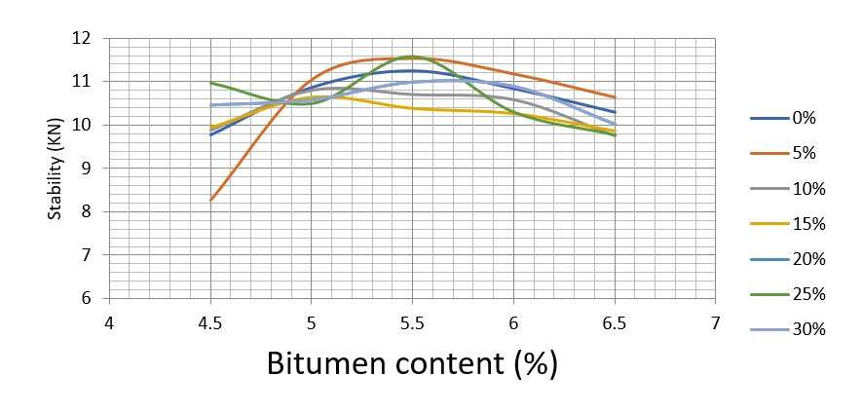
Fig. 2: Marshall Stability vs. Bitumen Content for All Recycled Glass Replacement Levels
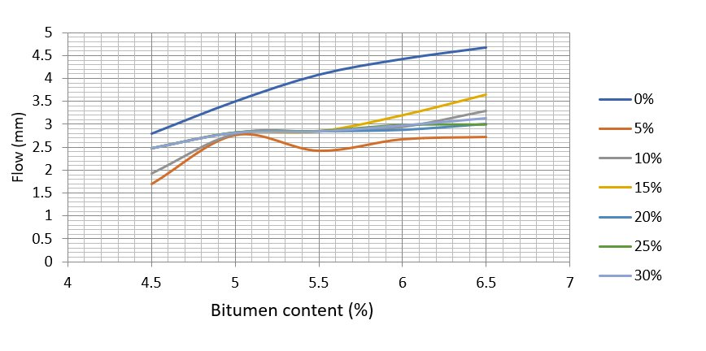
Fig. 3: Marshall Flow vs. Bitumen Content for All Recycled Glass Replacement Levels

Beyond 5% replacement, stability declined progressively to 10.81 kN (10%), 10.57 kN (15%), 10.62 kN (20%), 10.84 kN (25%), and 10.64 kN (30%). The reduction is attributable to the smooth glass surface suppressing aggregate interlocking and internal friction within the mix skeleton at higher concentrations, as documented by Patel and Shah (2023). Nevertheless, all stability values remained above 10.5 kN, satisfying FMW and ASTM specification thresholds for heavy-traffic HMA (Federal Ministry of Works, 1994; American Society for Testing and Materials, 2020b). Flow values for all glass-modified mixes ranged from 2.48 to 2.84 mm, all within the 2 to 4 mm specification, confirming that glass inclusion consistently improves deformation resistance relative to the conventional control.
3.2 Volumetric Properties
Figures 4, 5, and 6 present the Bulk Density, VIM, and VFB curves respectively across the full bitumen content range. Bulk density ranged from 2.45 g/cm³ at 5% glass to 2.52 g/cm³ at 15% glass. The peak density at 15% reflects a filling effect where glass particles reduce inter-aggregate voids at moderate substitution levels. The slightly lower density at 5% glass relative to the control value of 2.48 g/cm³ is attributable to the lower specific gravity of glass (approximately 2.50) compared to natural aggregates (2.86 to 2.89), as characterised by Kumar and Satish (2021).
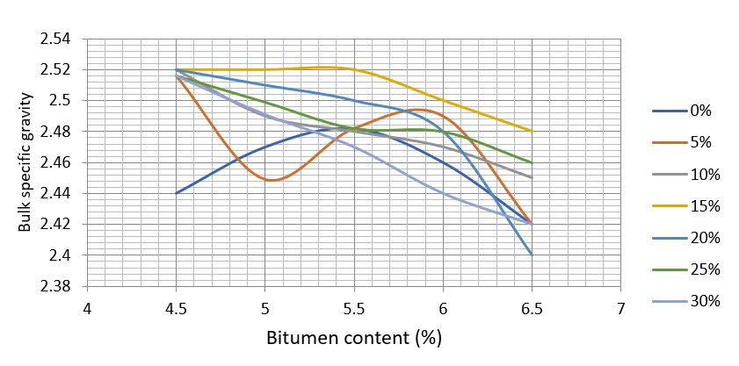
Fig. 4: Marshall Bulk Specific Gravity vs. Bitumen Content for All Mix Series
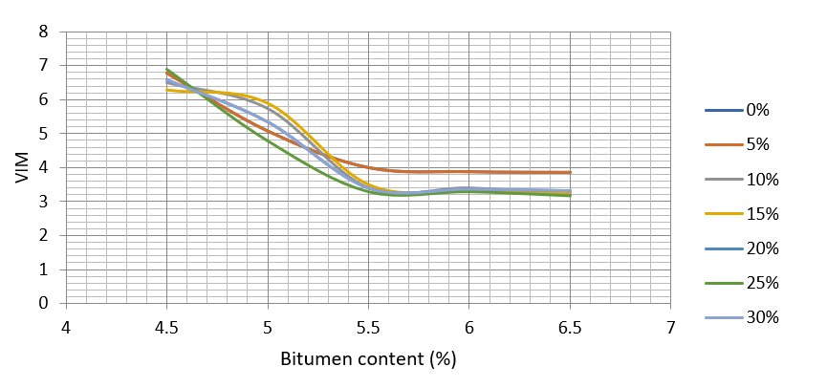
Fig. 5: Voids in Mix (VIM) vs. Bitumen Content for All Mix Series
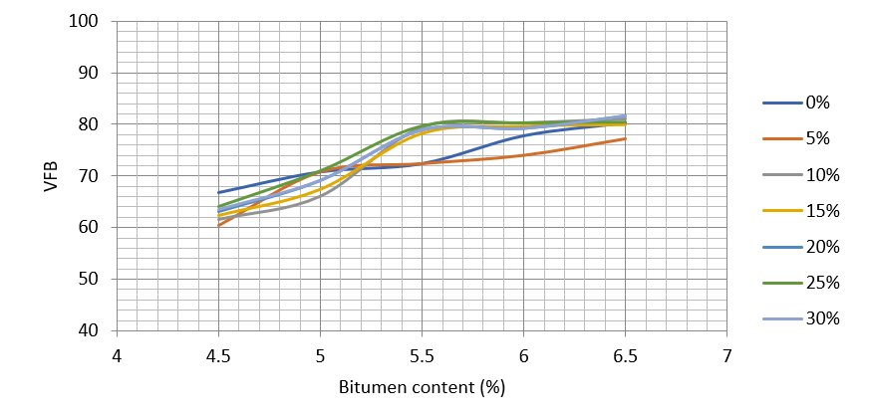
Fig. 6: Voids Filled with Bitumen (VFB) vs. Bitumen Content for All Mix Series

VIM values ranged from 4.00% for the control to 5.70% at 10% glass content. The elevated VIM at 10% represents a transitional packing inefficiency as the mix matrix shifts from being predominantly natural sand to one increasingly influenced by glass particle geometry. Beyond 10%, VIM decreased progressively as glass particles filled the aggregate void structure more effectively, reaching 4.25% at 25% glass. All mixes satisfied the ASTM target range of 3 to 5%, with the 10% mix marginally exceeding the upper limit at 5.70%. VFB values ranged from 62.09% at 25% glass to 72.11% at 5% glass. The progressive reduction in VFB with increasing glass content reflects the non-absorptive glass surface retaining a thinner binder film within the voids. Values below 65% observed at the 25% and above glass contents suggest potential durability concerns from insufficient binder coverage, which further supports the case for limiting glass replacement to no more than 20% in standard mixes without binder modification (Singh & Raghunath, 2023).
3.3 Marshall Mix Design Results Summary
Table 5 presents the consolidated Marshall Mix Design results, estimated ITS, and estimated TSR at OBC for all seven mix series. The OBC decreased from 5.5% for the control to a minimum of 5.0% at 10% glass content, reflecting improved aggregate packing efficiency at moderate replacement levels and translating to a direct reduction in bitumen demand per tonne of mix produced.
Table 5: Summary of Marshall Mix Design Results, Estimated ITS, and TSR at OBC
Glass (%) | OBC (%) | Stability (kN) | Flow (mm) | Bulk Density (g/cm³) | VIM (%) | VFB (%) | Est. ITS (MPa) | Est. TSR (%)
0 | 5.5 | 11.20 | 4.00 | 2.48 | 4.00 | 72.04 | 1.000 | 88.0
5 | 5.2 | 11.56 | 2.48 | 2.45 | 4.60 | 72.11 | 1.039 | 86.2
10 | 5.0 | 10.81 | 2.82 | 2.49 | 5.70 | 67.20 | 0.978 | 82.9
15 | 5.1 | 10.57 | 2.56 | 2.52 | 4.80 | 72.10 | 0.981 | 85.6
20 | 5.1 | 10.62 | 2.84 | 2.50 | 4.80 | 71.00 | 0.980 | 85.6
25 | 5.1 | 10.84 | 2.82 | 2.49 | 4.25 | 62.09 | 0.985 | 87.2
30 | 5.1 | 10.64 | 2.84 | 2.48 | 4.90 | 70.19 | 0.969 | 85.0

3.4 Estimated Indirect Tensile Strength
Figure 7 presents the estimated ITS values across all glass replacement levels. The values ranged from 0.969 MPa at 30% glass to 1.039 MPa at 5% glass, a narrow performance band of 70 kPa. The 5% replacement mix achieved peak ITS, consistent with its superior Marshall Stability and lowest flow value. The polynomial regression of ITS against glass content yielded a coefficient of determination (R²) of 0.2074, confirming the absence of a strong monotonic relationship and indicating that ITS at intermediate replacement levels is governed by the complex interaction among stability, flow, and VIM rather than by glass content alone. All estimated ITS values exceeded 0.96 MPa, indicating adequate tensile integrity for moderate-to-heavy traffic HMA applications, a threshold consistent with performance benchmarks reported by Hicks (1991).
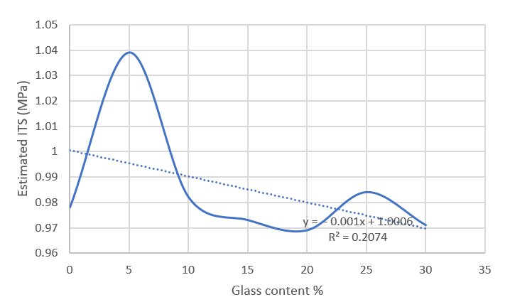
Fig. 7: Estimated Indirect Tensile Strength (MPa) vs. Recycled Glass Content (%)

3.5 Estimated Tensile Strength Ratio and Moisture Susceptibility
Figure 8 presents the estimated TSR results across all glass replacement levels. The control mix recorded the highest TSR of 88.0%, reflecting its lowest VIM of 4.00% and the consequent minimal moisture ingress pathways. The 5% mix TSR of 86.2% represents a modest reduction of 1.8 percentage points, which is practically inconsequential from a pavement durability standpoint and remains substantially above the 80% threshold of AASHTO (2014). The lowest TSR of 82.9% occurred at 10% glass content, directly corresponding to that mix's highest VIM of 5.70%. This is consistent with the volumetric model: elevated air void content creates interconnected pathways for water infiltration and binder-aggregate stripping, as established by Lu and Harvey (2006). Beyond 10%, TSR recovered progressively to values of 85.6% (15% and 20% glass), 87.2% (25% glass), and 85.0% (30% glass), tracking the reduction in VIM at these replacement levels. Critically, all seven mixes maintained TSR above 80%, confirming that recycled glass at 0 to 30% replacement does not reduce moisture resistance below the minimum acceptance criterion of AASHTO (2014).
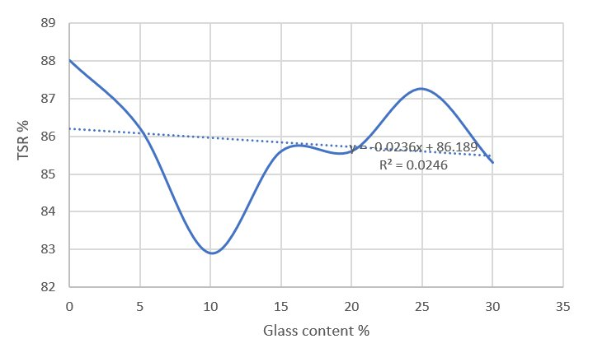
Fig. 8: Estimated Tensile Strength Ratio (%) vs. Recycled Glass Content (%)

3.6 Multi-Criteria Performance Index
Figure 9 illustrates the MCPI values across all glass replacement levels. The index ranged from 0.876 at 10% glass to 0.960 at 5% glass. The 5% mix achieved the highest MCPI, confirming its overall superiority when stability, flow, bulk density, and VIM are evaluated simultaneously. The control mix MCPI of 0.890 was constrained primarily by its high flow value of 4.00 mm receiving a low normalised flow score in the index computation. The 10% mix recorded the lowest MCPI owing to its elevated VIM of 5.70%, despite achieving acceptable stability and density values. From 15 to 30% glass content, MCPI values recovered and ranged between 0.899 and 0.929, reflecting the progressive improvement in VIM at these higher replacement levels partially compensating for the declining stability trend. The polynomial trend line yielded R² equal to 0.0216, confirming the non-linear, multi-parameter-governed nature of composite mix performance and reinforcing the utility of MCPI as an integrative decision tool over reliance on any single Marshall parameter.
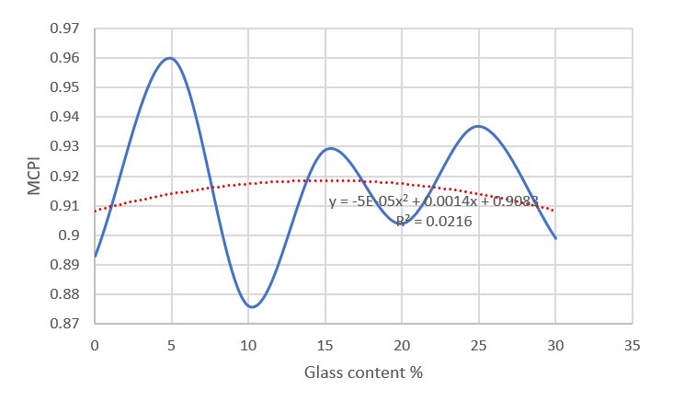
Fig. 9: Multi-Criteria Performance Index (MCPI) vs. Recycled Glass Content (%)

3.7 Comparative Analysis of Traditional and Glass-Based HMA
Table 6 presents a comparative summary of the conventional control mix against the mechanically optimum 5% glass mix and the environmentally and economically optimum 10% glass mix across all evaluated performance parameters. The 5% glass mix achieves measurable improvements over the conventional HMA: a 3.2% stability gain, a 38% flow improvement indicating markedly superior deformation control, a 3.9% ITS improvement, and a 7.9% higher MCPI. The 1.8 percentage point TSR reduction relative to the control is inconsequential from a practical durability standpoint. The OBC reduction from 5.5% to 5.2% further translates to direct bitumen cost savings in mix production.
Table 6: Comparative Performance Summary of Traditional and Optimum Glass-Based HMA
Performance Parameter | Control (0%) | 5% Glass | 10% Glass
OBC (%) | 5.5 | 5.2 | 5.0
Marshall Stability (kN) | 11.20 | 11.56 | 10.81
Flow (mm) | 4.00 | 2.48 | 2.82
Bulk Density (g/cm³) | 2.48 | 2.45 | 2.49
VIM (%) | 4.00 | 4.60 | 5.70
VFB (%) | 72.04 | 72.11 | 67.20
Est. ITS (MPa) | 1.000 | 1.039 | 0.978
Est. TSR (%) | 88.0 | 86.2 | 82.9
MCPI | 0.890 | 0.960 | 0.876
Est. CO₂e (kg/tonne) | 38.29 | 37.05 | 36.33
Production Cost (₦/tonne) | 57,100 | ~55,200 | 51,890

The 10% glass mix presents the most favourable environmental and economic configuration, yielding minimum CO₂ emissions of approximately 36.33 kg CO₂e per tonne of mix, which represents a 5.1% reduction relative to the control, and a minimum production cost representing a 9.1% saving, at an OBC of 5.0%. These gains are achieved with acceptable, if slightly reduced, mechanical performance relative to the 5% mix. The VIM of 5.70% at 10% glass marginally exceeds the 3 to 5% specification target, and the TSR of 82.9% remains above the 80% AASHTO threshold, both of which are parameters requiring close quality management in field construction. These findings are consistent with the consensus in the published literature that the optimum recycled glass content in HMA lies within the 5 to 15% range (Mohajerani et al., 2017; Lee et al., 2023; Wang & Zhang, 2022).
4.0 Conclusion and Recommendations
This study has established the Marshall Mix Design and conducted a comparative evaluation of the ITS and TSR of hot mix asphalt incorporating recycled glass as a partial fine aggregate replacement at levels from 0 to 30%. The evidence from Marshall testing, ITS estimation, TSR prediction, and MCPI computation converges consistently on a clear performance optimum. The 5% recycled glass replacement level is confirmed as the mechanically optimal mix configuration. It achieved peak Marshall Stability of 11.56 kN, best-controlled flow of 2.48 mm, highest estimated ITS of 1.039 MPa, and highest MCPI of 0.960, all of which represent improvements over the conventional control mix. All seven mixes satisfied ASTM D6927 and FMW specification limits for stability, flow, and volumetric properties at their respective OBCs, demonstrating the technical feasibility of glass incorporation across the full 0 to 30% replacement range tested (American Society for Testing and Materials, 2020b; Federal Ministry of Works, 1994).

With respect to moisture damage susceptibility, all mixes maintained estimated TSR values above the 80% minimum threshold of AASHTO (2014), confirming that recycled glass at any of the tested replacement levels does not impair moisture resistance to an unacceptable degree. The lowest estimated TSR of 82.9% at 10% glass content corresponds directly to that mix's highest VIM of 5.70%, establishing void content as the dominant volumetric determinant of moisture susceptibility in glass-modified HMA, consistent with the relationships documented by Lu and Harvey (2006) and Airey (2003). The OBC decreased from 5.5% for the control to a minimum of 5.0% at 10% glass content, reflecting improved aggregate packing efficiency at moderate substitution levels and providing a direct reduction in bitumen demand per tonne of mix produced.

The 10% replacement level presents the most favourable environmental and economic configuration, with minimum CO₂ emissions of 36.33 kg CO₂e per tonne and minimum production cost, consistent with the energy and carbon advantages of recycled glass aggregate documented by Singh and Kumar (2023) and Chandran et al. (2023). Beyond 10%, stability declined progressively while VFB values fell below the recommended lower threshold at the 25% and 30% glass replacement levels, suggesting inadequate binder coverage. On the basis of the integrated multi-criteria assessment, the recommended practical optimum recycled glass content is 5 to 10%: 5% for mechanically demanding, high-volume traffic applications, and 10% for sustainability-driven and cost-sensitive projects. For implementation, recycled glass must be processed through controlled sorting, crushing to below 4.75 mm, sieving for gradation compatibility, and leachate testing prior to incorporation, as outlined by Imteaz et al. (2012). Quality control ensuring consistency of glass particle size and shape is essential, particularly at replacement levels at or above 10%. Nigerian highway authorities are encouraged to incorporate recycled glass provisions into updated pavement material specifications, and to institutionalise Road Safety Audit and pavement performance review at all rehabilitation contract stages (Federal Highway Administration, 2019). Future research should prioritise laboratory-validated ITS and TSR testing, long-term fatigue and rutting performance evaluation under accelerated pavement testing conditions, field trial assessments on representative Nigerian highway sections, and investigation of anti-stripping agents and modified binders to extend the viable glass replacement range beyond 10% without compromising moisture resistance.
References
AASHTO. (2014). T283: Resistance of compacted asphalt mixtures to moisture-induced damage. American Association of State Highway and Transportation Officials.
Airey, G. D. (2003). Rheological evaluation of ethylene vinyl acetate polymer modified bitumens. Construction and Building Materials, 16(8), 473–487.
American Society for Testing and Materials. (2020a). ASTM D5: Standard test method for penetration of bituminous materials. ASTM International.
American Society for Testing and Materials. (2020b). ASTM D6927: Standard test method for Marshall stability and flow of asphalt mixtures. ASTM International.
British Standards Institution. (1989a). BS 812-105.1: Testing aggregates: Methods for determination of particle shape, flakiness index. BSI.
British Standards Institution. (1989b). BS 812-105.2: Testing aggregates: Methods for determination of particle shape, elongation index. BSI.
British Standards Institution. (1990). BS 812-110: Testing aggregates: Methods for determination of aggregate crushing value. BSI.
Chandran, R., Anand, K. B., & Sridhar, R. (2023). Mechanical and sustainability performance of recycled glass in asphalt mixtures: A review. Journal of Cleaner Production, 389, 136012.
Federal Highway Administration. (2019). Recycled materials in transportation construction. U.S. Department of Transportation.
Federal Ministry of Works. (1994). General specifications for roads and bridges (Vol. II). Federal Republic of Nigeria.
Hicks, R. G. (1991). Moisture damage in asphalt concrete (NCHRP Synthesis of Highway Practice 175). Transportation Research Board.
Imteaz, M. A., Ali, M. M. Y., & Arulrajah, A. (2012). Possible environmental impacts of recycled glass used as a pavement base material. Waste Management and Research, 30(9), 917–921.
Kiggundu, B. M., & Roberts, F. L. (1988). Stripping in HMA mixtures: State-of-the-art and critical review of test methods (NCAT Report 88-02). National Center for Asphalt Technology.
Kumar, N., & Satish, S. (2021). Utilization of waste glass as aggregate in asphalt concrete: A review. Materials Today: Proceedings, 46(11), 5577–5583.
Lee, S., Kim, J., & Park, H. (2023). Performance characteristics of asphalt mixtures incorporating recycled glass aggregate: Mechanical, environmental, and economic perspectives. Construction and Building Materials, 362, 129745.
Lu, Q., & Harvey, J. T. (2006). Field investigation of factors associated with moisture damage in asphalt pavements. Transportation Research Record, 1986(1), 27–37.
Mohajerani, A., Vajna, J., Cheung, T. H. H., Kurmus, H., Arulrajah, A., & Horpibulsuk, S. (2017). Practical recycling applications of crushed waste glass in construction materials: A review. Construction and Building Materials, 156, 443–467.
Mroueh, U. M., Eskola, P., & Laine-Ylijoki, J. (2020). Life cycle impacts of the use of industrial by-products in road and earth construction. Waste Management, 21(3), 271–277.
Nwakaire, C.M., Onn, C.C., Yap, S.P., Yuen, C.W., Koting, S., Mo, K.H., Othman, F. (2021) The strength and environmental performance of asphalt mixtures with recycled concrete aggregates. Transportation Research Part D: Transport and Environment 100, 103065.
Nwakaire, C.M., Onn, C.C., Yap, S.P., Yuen, C.W., Onodagu, P.D. (2020b) Urban Heat Island Studies with emphasis on urban pavements: A review. Sustainable Cities and Society 63, 102476.
Nwakaire, C.M., Yap, S.P., Onn, C.C., Yuen, C.W., Ibrahim, H.A. (2020a) Utilisation of recycled concrete aggregates for sustainable highway pavement applications; a review. Construction and Building Materials, 235, 117444.
Patel, S. K., & Shah, D. L. (2023). Moisture susceptibility of recycled glass-modified asphalt mixtures: An experimental evaluation. International Journal of Pavement Engineering, 24(1), 2019–2031.
Patel, S. K., Shah, D. L., & Raval, J. K. (2023). Sustainable utilization of recycled glass in hot mix asphalt: Performance, environmental, and economic analysis. Journal of Materials in Civil Engineering, 35(4), 04023025.
Singh, D., & Raghunath, D. J. (2023). Rutting and fatigue performance of asphalt mixtures with waste glass aggregate. Road Materials and Pavement Design, 24(6), 1450–1468.
Singh, S., & Kumar, R. (2023). Life cycle energy and carbon analysis of recycled glass aggregates in road construction. Resources, Conservation and Recycling, 190, 106792.
United Nations Environment Programme. (2023). Global waste management outlook 2023. UNEP.
Wang, D., & Zhang, H. (2022). Effect of recycled glass aggregate on the mechanical and thermal properties of hot mix asphalt. Journal of Road Engineering, 2(3), 204–215.
Wang, D., Li, F., & Chen, W. (2023). Stiffness and fatigue characterisation of glass-modified asphalt mixtures. Construction and Building Materials, 385, 131427.

