DIRECT ADAPTIVE FUZZY CONTROL FOR A QUADROTOR
Hoàng Bình Ngọc¹, Vũ Xuân Tùng^{2,*} , Lê Thị Thu Hà², Nguyễn Hoài Nam¹, Trần Gia Khánh³

¹Hanoi University of Science and Technology, ²Thainguyen University of Technology, ³Namdinh University of Technology Education
ARTICLE INFO |  | ABSTRACT
Received: |  | Quadrotor is a nonlinear, underactuated system. During its operation, it moves in different environments with unknown load and disturbance. Thus, it is difficult to obtain an exact model for the quadrotor. This paper studies and designes a direct adaptive fuzzy controller for quadrotors. First, a direct adaptive fuzzy controller is presented for second-order systems. The fuzzy system output based on Sugeno model is control signal applied directly to the plant. The fuzzy system parameters are updated through an adaptive mechnism. Then, this controller is utilized for the position and orientation of the quadrotor. The overall control system consists of 6 fuzzy logic systems with 6 corresponding adaptive laws. Simulations are taken to verify the proposed controller.
Revised:
Published:
KEYWORDS
Direct adaptive fuzzy controller
Nonlinear system
Lyapunov stability criterion

1. Introduction
In recent decades, unmanned aerial vehicles (UAVs), especially quadrotors, have become a major research focus due to their wide range of applications in both civil and military fields, as well as in search and rescue, mapping, and environmental monitoring [1], [2]. However, accurate control of a quadrotor remains a major challenge because of its strongly nonlinear dynamics, underactuated nature, instability, and susceptibility to disturbances and model uncertainties.
To address this problem, many control strategies have been proposed. Classical linear controllers such as PID and LQR are often preferred due to their simple structure and ease of practical implementation [3]. In addition, a fuzzy PID controller was designed in [4]. PID, fuzzy PID, and adaptive fuzzy PID controllers were compared in [5]. Besides, optimization techniques such as particle swarm optimization (PSO) have also been used to tune the parameters of an active disturbance rejection controller (ADRC) in order to achieve better trajectory tracking performance [6]. However, as pointed out in recent reviews [7], methods based on linearized models often exhibit limitations in robustness when system parameters vary or when the quadrotor operates under harsh conditions.
Many studies have moved toward more advanced control methods such as sliding mode control to improve disturbance rejection [8], adaptive sliding mode control [9] to reduce chattering on the sliding surface, twisting sliding mode combined with a finite-time observer [10], neural networks to learn uncertain components [11], rolling controllers based on neural networks [12] or fuzzy systems [13], [14], [15], and tracking control based on Q-learning [16]. Although effective, these methods often require complex computations or depend on the accuracy of the mathematical model.
To overcome the above limitations, fuzzy logic systems are one of the tools that have been proven to be powerful and effective in handling uncertain components in dynamic systems [17]. This study proposes a direct adaptive fuzzy controller. The core idea of the method is to use a fuzzy system to directly approximate the ideal control signals combined with an adaptive learning law established based on the Lyapunov stability criterion to update the fuzzy system parameters online.
The remainder of this paper is organized as follows. The next section introduces the mathematical model of the quadrotor. Direct adaptive fuzzy control is presented in Section 3. Section 4 designs the direct adaptive fuzzy controllers for the quadrotor. Simulation results verifying the controller performance are presented in Section 5. Finally, conclusions are given in the last section.

2. Quadrotor Dynamic Model
Consider the mathematical model of the quadrotor in the following form:
$\left\{\begin{aligned}&\ddot{x}=\frac{1}{m}\left(C_{ϕ}S_{θ}C_{ψ}+S_{ϕ}S_{ψ}\right)T-\frac{A_{x}}{m}\dot{x}+d_{x} \\ &\ddot{y}=\frac{1}{m}\left(C_{ϕ}S_{θ}S_{ψ}-S_{ϕ}C_{ψ}\right)T-\frac{A_{y}}{m}\dot{y}+d_{y} \\ &\ddot{z}=\frac{1}{m}\left(C_{ϕ}C_{θ}\right)T-\frac{A_{z}}{m}\dot{z}+d_{z} \\ &\ddot{ϕ}=\dot{θ}\dot{ψ}\frac{I_{yy}-I_{zz}}{I_{xx}}-\dot{θ}\frac{I_{r}}{I_{xx}}ω_{Γ}+\frac{τ_{ϕ}}{I_{xx}}+d_{ϕ} \\ &\ddot{θ}=\dot{ϕ}\dot{ψ}\frac{I_{zz}-I_{xx}}{I_{yy}}+\dot{ϕ}\frac{I_{r}}{I_{yy}}ω_{Γ}+\frac{τ_{θ}}{I_{yy}}+d_{θ} \\ &\ddot{ψ}=\dot{ϕ}\dot{θ}\frac{I_{xx}-I_{yy}}{I_{zz}}+\frac{τ_{ψ}}{I_{zz}}+d_{ψ}\end{aligned}\right.$ (1)
where the lift force generated by the four rotors is determined as:
$T=k\left(ω_{1}^{2}+ω_{2}^{2}+ω_{3}^{2}+ω_{4}^{2}\right)$, (2)
where $k$ ​ is the lift coefficient, $ω_{i}^{}$ is the angular speed of the i rotor, l is the distance between two opposite rotors, $A_{x}$, $A_{y}$, $A_{z}$ are the inertia moments, $d_{*}$ the disturbance component$*∈\{x,y,z,ϕ,θ,ψ\}$, $x,y,z$ are the coordinates of the quadrotor in the inertial frame, and , $ϕ,θ,ψ$ are the roll, pitch, and yaw angles of the quadrotor.
The torques acting on each rotational axis are:
$\left\{\begin{aligned}&τ_{ϕ}=kl(ω_{4}^{2}-ω_{2}^{2}) \\ &τ_{θ}=kl(ω_{3}^{2}-ω_{1}^{2}) \\ &τ_{ψ}=b(-ω_{1}^{2}+ω_{2}^{2}-ω_{3}^{2}+ω_{4}^{2})\end{aligned}\right.$ (3)
From (2) and (3), the angular velocities of each rotor can be obtained as:
$\left\{\begin{aligned}&ω_{1}=\sqrt{\frac{T}{4k}-\frac{τ_{θ}}{2kl}-\frac{τ_{ψ}}{4b}} \\ &ω_{2}=\sqrt{\frac{T}{4k}-\frac{τ_{ϕ}}{2kl}+\frac{τ_{ψ}}{4b}} \\ &ω_{3}=\sqrt{\frac{T}{4k}+\frac{τ_{θ}}{2kl}-\frac{τ_{ψ}}{4b}} \\ &ω_{4}=\sqrt{\frac{T}{4k}+\frac{τ_{ϕ}}{2kl}+\frac{τ_{ψ}}{4b}}\end{aligned}\right.$ (4)

The mathematical model in (1) will be used to simulate the quadrotor in Section 5.

3. Direct Adaptive Fuzzy Control
Fuzzy set theory was first introduced by Zadeh [18], opening a new approach for handling imprecise information and complex systems that are difficult to model using purely mathematical methods. Fuzzy logic systems have demonstrated their strength through universal approximation capability, allowing arbitrary nonlinear functions to be represented with arbitrary accuracy. The classical work of Wang laid the foundation for stable adaptive fuzzy controllers [19], affirming that the parameters of a fuzzy system can be updated online to guarantee global stability for nonlinear systems. Following this research direction, the works of Labiod and Guerra [20] developed direct adaptive laws that help the system self-adjust without requiring prior knowledge of the initial model.

Consider a general nonlinear plant of the form:
$x^{(n)}=f(x,\dot{x},...,x^{(n-1)})+bu$ (5)
where: $x^{(i)}=\frac{d^{i}x}{dt^{i}}$, $u$ is the input signal, $f$ and $b$ >0 are unknown functions and constants.
Set: $x=[x,\dot{x},....x^{(n-1)}]^{T}$.
The direct adaptive fuzzy controller is given as:
$u_{D}=θ^{T}ζ(x)$ (6)
where,$ζ(x)$ is the basis-function vector (with Gaussian membership functions).
The ideal control signal in the case of a known system is:
(7)
where, $y_{m}$ is the reference signal, $k=\left[k_{1} k_{2}…k_{n}\right]$ and $e=\left[e \dot{e} \ddot{e}…e^{(n-1)}\right]$ and $e=y-y_{m}.$
Substituting (6) and (7) into (5) and transforming yields:
$e^{(n)}=-k^{T}e+b(u^{*}-u_{D})$. (8)
$k$ is selected such that system (8) is stable when $u_{D}=u^{*}.$
Equation (8) can be rewritten in the following form:
$\dot{e}=Λe+b[u^{*}-u_{D}(x,θ)]$ (9)
where:
$Λ=\left[\begin{matrix}0 & 1 & 0 & 0 & … & 0 & 0 \\ 0 & 0 & 1 & 0 & … & 0 & 0 \\ … & … & … & … & … & … & … \\ -k_{1} & -k_{2} & -k_{3} & -k_{4} & … & -k_{n-1} & -k_{n}\end{matrix}\right]$
Denote:
$ω=sup⁡|u_{D}\left(X,θ^{*}\right)-u^{*}|$
where $θ^{*}$ is the optimal parameter vector of the fuzzy system. Equation (9) can then be rewritten as:
$\dot{e}=Λe+b(θ^{*}-θ)^{T}ζ\left(Χ\right)-bω$ (10)
Choose the Lyapunov function as:
$V=\frac{1}{2}e^{T}Pe+\frac{b}{2γ}{\left(θ^{*}-θ\right)}^{T}\left(θ^{T}-θ\right)$ (11)
with $γ>0$. Its derivative is:
$\dot{V}=-\frac{1}{2}e^{T}Qe+\frac{b}{γ}(θ^{*}-θ)^{T}[γe^{T}p_{n}ζ(X)-\dot{θ}]-e^{T}p_{n}ω$
where $p_{n}$ is the last column vector of matrix P.
Choose the adaptive law:
$\dot{θ}=γe^{T}p_{n}ζ(Χ)$, (12)

Where $γ>0$ is the learning coefficient.
Then we have:
$\dot{V}=-\frac{1}{2}e^{T}Qe-e^{T}p_{n}ω≤-{\left|e\right|}^{2}\frac{λ_{min}}{2}+|e||p_{n}|ω$
where $λ_{min}$ is the minimum eigenvalue of matrix $Q$.
When the tracking error lies outside the region: $Γ=\left\{e, |e|<\frac{2\left|p_{n}ω\right|}{λ_{min}}\right\}$ then $\dot{V}<0$. This means that the control error will progress towards the region $Γ$ containing the zero origin..

4. Design of Direct Adaptive Controllers for the Quadrotor
In this section, direct adaptive fuzzy controllers are designed for the position loop and attitude loop of the quadrotor based on controller (6) and adaptive law (12) for each component $x,y,z,ϕ,θ$ and $ψ.$
4.1. Design of the Attitude Controller for the Quadrotor
First, we construct the basis-function vectors of the attitude angles as follows:
$\left\{\begin{aligned}&ζ(ϕ)=G_{ϕ}(ϕ)⊗G_{\dot{ϕ}}(\dot{ϕ}) \\ &ζ(θ)=G_{θ}(θ)⊗G_{\dot{θ}}(\dot{θ}) \\ &ζ(ψ)=G_{ψ}(ψ)⊗G_{\dot{ψ}}(\dot{ψ})\end{aligned}\right.$ (13)
where $G_{*}$ are Gaussian function vectors, $g_{*i}\left(v\right)=e^{\frac{-{(v-c_{i})}^{2}}{2σ_{i}^{2}}}$, $c_{i}$ is the center and $σ_{i}^{}$ is the width,, $⊗$ is the Kronecker product. The fuzzy sets are selected as follows:

- The functions belonging to $G_{ϕ}(ϕ),G_{θ}(θ)$ are defined by $g_{ϕi}(ϕ),g_{θi}(θ_{i})$ with $i∈N;1≤i≤5$, the centers lie within the interval $\left[-\frac{π}{9},\frac{π}{9}\right]$ and are equally spaced $\frac{π}{18}$; the width is $\frac{π}{36}$
- The functions belonging to $G_{\dot{ϕ}}(\dot{ϕ}),G_{\dot{θ}}(\dot{θ})$ are defined by $g_{\dot{ϕ}i}({\dot{ϕ}}_{i}),g_{\dot{θ}i}({\dot{θ}}_{i})$) with $i∈N;1≤i≤6$, the centers lie in the interval $\left[-1.5,1.5\right]$and are equally spaced 0.6; the width is 0.3
- The functions belonging to $G_{ψ}(ψ)$ are defined by $g_{ψi}(ψ)$ with $i∈N;1≤i≤5$,, the centers lie in the interval $\left[-10^{-3},10^{-3}\right]$ and are equally spaced $5*10^{-4}$; The width is $2.5*10^{-4}$;
- The functions belonging to $G_{\dot{ψ}}(\dot{ψ})$ are defined by $g_{\dot{ψ}i}(\dot{ψ})$ with $i∈N;1≤i≤6$, the centers are in the interval $\left[-0.01,0.01\right]$ and are equally spaced $4*10^{-3}$; the width is $2*10^{-3}$.
4.2. Design of the Position Controller for the Quadrotor
Let $u_{x},u_{y},u_{z}$ be the position control signal, where:
$\left\{\begin{aligned}&u_{x}=\frac{T}{m}(\cos{ϕ}\sin{θ}\cos{ψ}+\sin{ϕ}\sin{ψ}) \\ &u_{y}=\frac{T}{m}(\cos{ϕ}\sin{θ}\sin{ψ}-\sin{ϕ}\cos{ψ}) \\ &u_{z}=\frac{T}{m}(\cos{ϕ}\cos{θ})-g\end{aligned}\right.$ (14)
First, we construct the basis-function vectors as follows:
$\left\{\begin{aligned}&ζ(x)=G_{x}(x)⊗G_{\dot{x}}(\dot{x}) \\ &ζ(y)=G_{y}(y)⊗G_{\dot{y}}(\dot{y}) \\ &ζ(z)=G_{z}(z)⊗G_{\dot{z}}(\dot{z})\end{aligned}\right.$ (15)

The fuzzy sets are chosen as follows:
- The functions belonging to $G_{x}(x){, G}_{y}(y)$ are defined by $g_{xi}(x),g_{yi}(y)$ with $i∈N;1≤i≤6$, the centers are in the interval $\left[-2.5,2.5\right]$and are equally spaced 1; the width is 0.5
- The functions belonging to $G_{\dot{x}}(\dot{x}),G_{\dot{y}}(\dot{y})$ are defined by $g_{\dot{x}i}(\dot{x}),g_{\dot{y}i}(\dot{y})$ with $i∈N;1≤i≤6$, the centers are in the interval $\left[-2,2\right]$and are equally spaced 0.8; The width is 0.4
- The membership functions $G_{z}(z)$ are defined by $g_{zi}(z)$ with $i∈N;1≤i≤6$, the centers are in the interval [0,3] and are equally spaced 0.6 apart; the width is 0.3
- The membership functions $G_{\dot{z}}(\dot{z})$ are defined by $g_{\dot{z}i}({\dot{z}}_{i})$ with $i∈N;1≤i≤6$, the centers are in the interval $\left[-1.5,1.5\right]$ and are equally spaced 0.6 apart; the width is 0.3

5. Simulation and Result Evaluation

The quadrotor parameters used in the simulation are selected as follows:
Parameter | Value | Parameter | Value
$$m$$ | 1.21 | g | 9.8
$$k$$ | 2..98e-5 | $$I_{xx}$$ | 0.01
$$b$$ | 3.23e-7 | $$I_{yy}$$ | 0.01
$$l$$ | 0.25 | $$I_{zz}$$ | 0.0148
Consider the reference trajectory as follows:
$\left\{\begin{aligned}&x_{d}=\cos{(}\frac{π}{20}t) \\ &y_{d}=\sin{(}\frac{π}{20}t) \\ &z_{d}=1; ψ_{d}=0 \\ &\end{aligned}\right.$

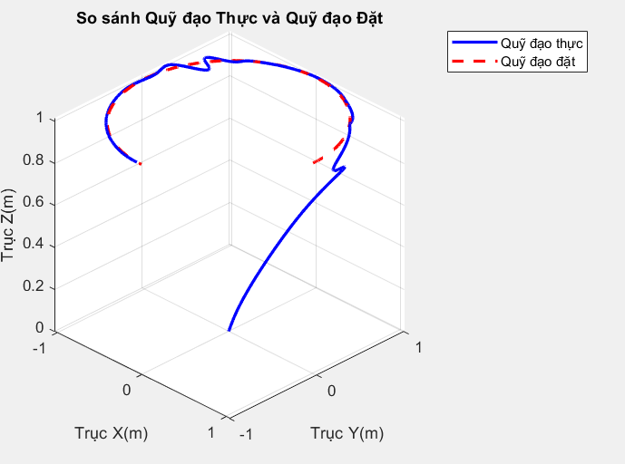  Figure 1. Quadrotor trajectory response | 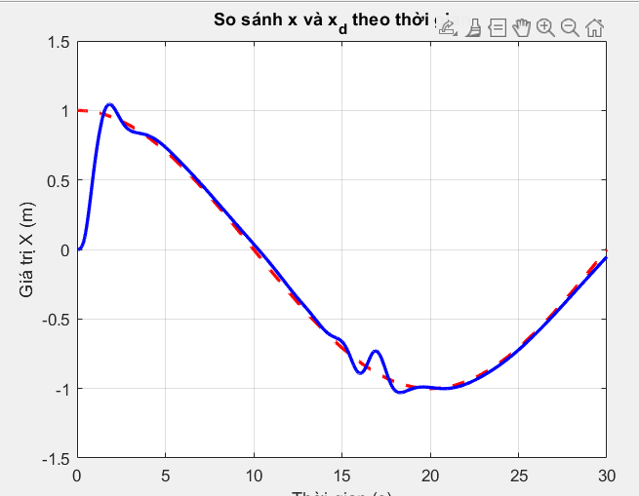  Figure 2. Quadrotor position along the x-axis
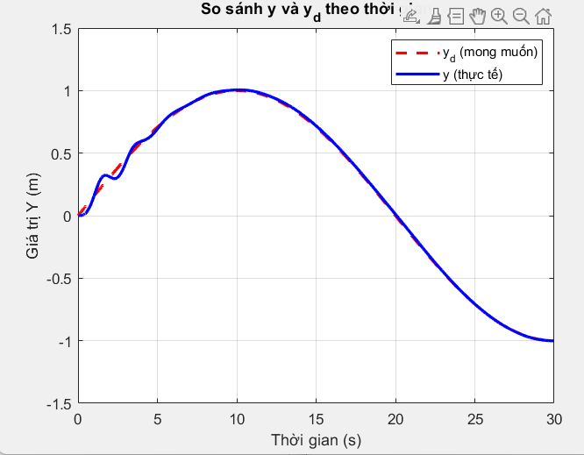  Figure 3. Quadrotor position along the y-axis | 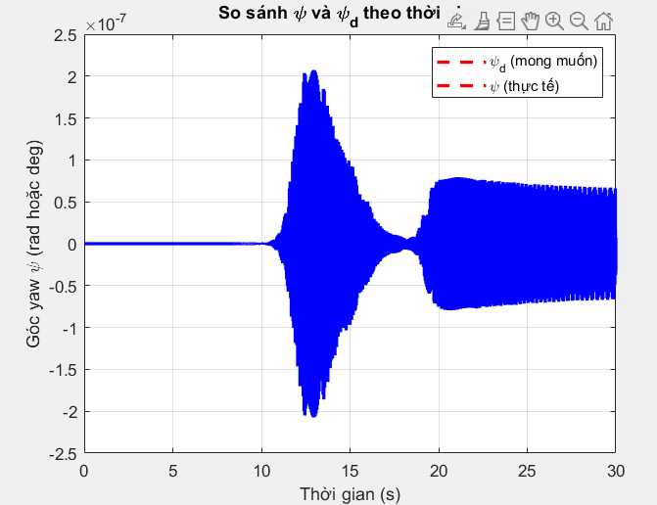  Figure 4. Angle $ψ$
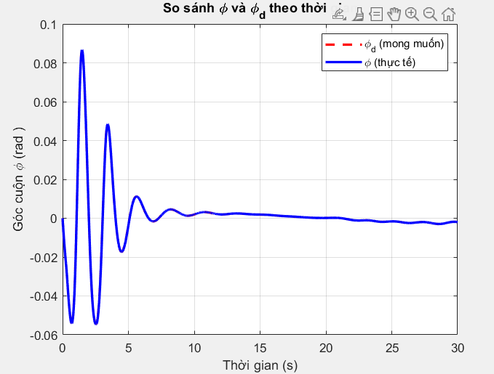  Figure 5. Angle $ϕ$ | 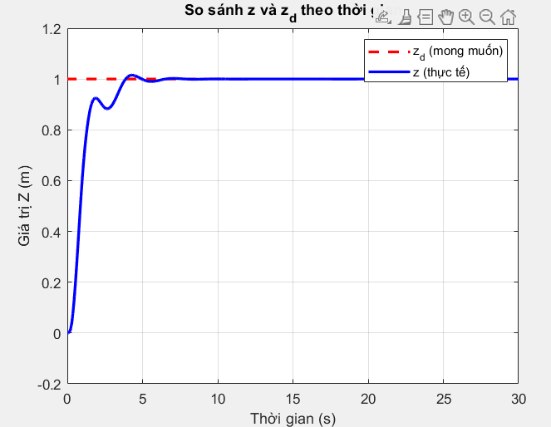  Figure 6. Quadrotor position along the z-axis
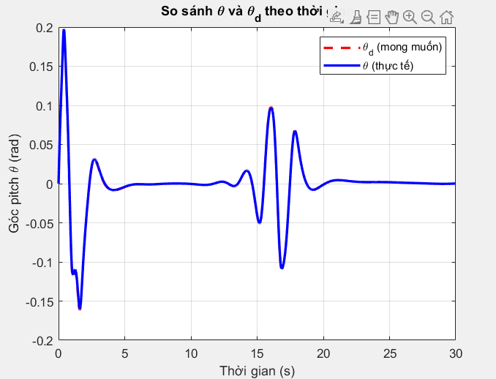
Figure 7. Angle $θ$

From the obtained results of the time responses of the positions and angles compared with their reference values shown in Figures 1 to 7, the self-adjusting capability of the adaptive fuzzy controller in the presence of quadrotor model uncertainty can be observed. This confirms the effectiveness of the proposed controller and its practical applicability.

6. Conclusion
This paper studied direct adaptive fuzzy control and its application to a quadrotor. Six Sugeno-type fuzzy systems were designed. The parameters of the fuzzy systems were updated online through adaptive laws. The proposed controller has the advantage that it does not require knowledge of the mathematical model, making it suitable for practical quadrotor systems where deriving an accurate mathematical model is not easy. Simulation results demonstrated the correctness and effectiveness of the proposed direct adaptive fuzzy controller. Future work will focus on implementing and testing the controller on a real quadrotor.

Acknowledgment: This work was supported by the project code T2025-NCS04 funded by Thai Nguyen University of Technology (TNUT).

REFERENCES

[1] M. Maaruf, M. S. Mahmoud, and M. A. Al-Ma’arif, "A survey of control methods for quadrotor UAV," Int. J. Robot. Control Syst., Vol. 2, No. 4, pp. 652–665, 2022.
[2] S. H. Derrouaoui, Y. Bouzid, A. Belmouhoub, M. Guiatni, H. Siguerdidjane, "Recent Developments and Trends in Unconventional UAVs Control: A Review," J Int Rob Syst, 109, 68, 2023.
[3] S. Khatoon, D. Gupta and L. K. Das, "PID & LQR control for a quadrotor: Modeling and simulation," 2014 International Conference on Advances in Computing, Communications and Informatics (ICACCI), Delhi, India, 2014, pp. 796-802.
[4] Gedefaw, E. A. et al, “ Improved trajectory tracking control using fuzzy PID surface for quadrotor UAV,” PLoS ONE, 19(11), pp. 1-36, 2024.
[5] Yasmine, Z. “Adaptive fuzzy logic control of quadrotor UAV,” International Journal of Robotics and
Control Systems, Vol. 4, No. 4, pp. 2095-2118, 2024.
[6] C. Peng, Y. Tian, et al., "ADRC trajectory tracking control based on PSO algorithm for a quad-rotor," In: 2013 IEEE 8th Conference on Industrial Electronics and Applications (ICIEA), pp. 800–805, 2013.
[7] P. J. D. de Oliveira Evald, V. M. Aoki, et al., "A review on quadrotor attitude control strategies," Int. J. Intell. Robot. Appl., pp. 1–21, 2024.
[8] Y. Huang, J. Chen, and H. Zhang, "Sliding mode control for quadrotor UAVs: A review of recent advancements," Journal of Intelligent & Robotic Systems, Vol. 94, pp. 211–225, 2019.
[9] Ren, Z. et al,” Adaptive fault-tolerant control for quadrotor UAV based on fuzzy gain sliding mode,”
Journal of Northeastern University, pp209-216, 2024
[10] Dou, J. et al. “ Trajectory tracking and formation control for quadrotor UAVs,” Scientific Reports, 15, 24039, pp. 1-30, 2025.
[11] T. Dierks and S. Jagannathan, "Output feedback control of a quadrotor UAV using neural networks," IEEE Trans. Neural Netw., Vol. 21, No. 1, pp. 50–66, 2010
[12] Z. Xu, T. Yan, S. X. Yang, and S. A. Gadsden, “Bioinspired backstepping sliding mode control and adaptive sliding innovation filter of quadrotor unmanned aerial vehicles,” Biomimetic Intelligence and Robotics, vol.3, no. 3, 2023.
[13] Li, C. et al, “Adaptive fuzzy tracking control for quadrotor UAV with disturbance observer,” Aerospace Science and Technology, vol. 128, 107784, pp. 1-11, 2022.
[14] Zhou, L. et al, “ Fuzzy adaptive backstepping trajectory tracking control for quadrotor systems,” International Journal of Fuzzy Systems, 2024
[15] Wei, P. et al, ” Adaptive backstepping neural control for quadrotor UAVs under disturbances,” Expert Systems with Applications, 296, pp. 1-24, 2025
[16] Tran, V. P. et al.” Robust fuzzy Q-learning tracking control for quadrotor systems,” IEEE Robotics research. 2022
[17] B. Erginer and E. Altug, "Design and implementation of a hybrid fuzzy logic controller for a quadrotor VTOL vehicle," International Journal of Control, Automation and Systems, Vol. 10, pp. 61–70, 2012.
[18] L. A. Zadeh, "Fuzzy sets," Information and Control, Vol. 8, No. 3, pp. 338–353, 1965.
[19] L. X. Wang, "Stable adaptive fuzzy control of nonlinear systems," IEEE Trans. Fuzzy Syst., Vol. 1, No. 2, pp. 146–155, 1993.
[20] S. Labiod and T. M. Guerra, "Adaptive fuzzy control of a class of SISO non-affine nonlinear systems," Fuzzy Sets and Systems, Vol. 158, No. 10, pp. 1126–1137, 2007.
[21] J. S. R. Jang, "ANFIS: adaptive-network-based fuzzy inference system," IEEE Trans. Syst., Man, Cybern., Vol. 23, No. 3, pp. 665-685, 1993.

