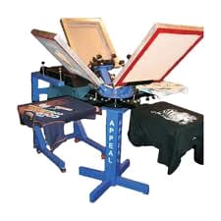

1 2
Fig: 1. Sample of Finished Screen Printing Machine Fig: 2.-3Dimensional rendering of sketch

