Extending the UTAUT Model for Artificial Intelligence Adoption: A Systematic Review of the Role of Perceived Intelligence and Trust

Muhammad Shafeeq Mohd Sapian^{1*}, Haslinda Musa¹, Nurulizwa Rashid¹,
Muhammad Shafiq Ibrahim², Siti Maryam Kamarudin³
¹Universiti Teknikal Malaysia Melaka, Hang Tuah Jaya, 76100 Melaka, Malaysia
²Department of Materials, Manufacturing and Industrial Engineering,
School of Mechanical Engineering, Faculty of Engineering,
Universiti Teknologi Malaysia, Johor Bahru, Malaysia
³Railway Assets Corporation, 16 Jalan Tun Sambanthan,
50470 Brickfields, Kuala Lumpur, Malaysia
* Email: p062510002@student.utem.edu.my

Abstract
The Unified Theory of Acceptance and Use of Technology (UTAUT) is widely used to explain technology adoption across domains, yet its suitability for complex, learning-oriented systems such as Artificial Intelligence (AI) remains contested. Guided by the PRISMA 2020 framework, this systematic literature review examined 71 empirical and review studies published between 2020 and 2025 that applied UTAUT or its extensions to AI adoption across education, healthcare, finance and banking, public administration, and retail and services. The review identifies three recurring limitations of the conventional UTAUT framework in AI contexts: limited attention to the opaque “black box” nature of AI decision-making, insufficient recognition of the relational dynamics between users and intelligent systems, and inadequate treatment of ethical concerns such as algorithmic bias and fairness. In response, this review proposes an integrated conceptual framework in which Perceived Intelligence captures users' assessment of an AI system's learning capability, adaptability, and predictive accuracy. Perceived Intelligence is positioned as a mediator between the core UTAUT constructs, particularly Performance Expectancy and Effort Expectancy, and Behavioural Intention. Trust in AI is further positioned as a critical antecedent of Perceived Intelligence. The review contributes a theoretically grounded extension of UTAUT for the AI era and offers a testable model for future structural equation modelling studies. It also provides practical guidance for improving AI adoption by cultivating user trust and demonstrating system competence.
Keywords: Artificial Intelligence; AI Adoption; UTAUT; Perceived Intelligence; Trust in AI; Systematic Literature Review; PRISMA; Technology Acceptance.

1. Introduction
The global landscape of industries and governance frameworks is being transformed by the widespread adoption of Artificial Intelligence (AI), which is reshaping how organisations operate and deliver services. National policies such as the European Union's AI Act and Malaysia's AI Roadmap highlight the growing emphasis on integrating AI into both public and private sectors to enhance efficiency, innovation, and service delivery. According to Dwivedi et al. (2021), AI is a general-purpose technology with the potential to transform public service delivery and competitive environments across almost every economic sector. However, realising this potential depends on consistent and meaningful adoption by end users, which remains a significant challenge.
The Unified Theory of Acceptance and Use of Technology (UTAUT) has been a prominent framework for understanding technology adoption for more than two decades. Developed by Venkatesh et al. (2003), UTAUT integrates eight earlier models into a unified framework built around four core constructs: Performance Expectancy, Effort Expectancy, Social Influence, and Facilitating Conditions. These constructs directly predict Behavioral Intention and subsequent Use Behavior, while gender, age, experience, and voluntariness of use operate as moderators. Venkatesh et al. (2012) later extended the model as UTAUT2 by incorporating price value, habit, and hedonic motivation for consumer contexts. In a meta-analysis of 60 UTAUT2-based studies, Tamilmani et al. (2021) confirmed the model's overall theoretical robustness while noting that perceived risk, trust, and personal innovativeness are among the most frequently added extension constructs. As this review demonstrates, this pattern is especially evident in AI-adoption research.
Technology acceptance models are now applied beyond organisational settings, including in areas such as nature-based services and sustainable tourism. Musa et al. (2016) demonstrated the usefulness of UTAUT in assessing mobile marketing adoption among SMEs, while more recent studies have extended related acceptance frameworks to examine AI marketing tools (Jumaat et al., 2025) and sustainable technology adoption in tourism (Musa et al., 2025). These developments show the model's adaptability while also reinforcing the need for context-specific modifications, a point that is highly relevant to the present review's focus on AI adoption. Similarly, studies of user perceptions in service contexts, such as hikers' evaluations of forest guides (Shafeeq et al., 2026), indicate that trust and perceived competence are important determinants of satisfaction and continued engagement. These relational dynamics closely resemble those found in human-AI interactions.
Despite its proven usefulness, questions remain about UTAUT's suitability for explaining the distinctive characteristics of AI systems. Most conventional technologies are deterministic, following fixed rules and predictable procedures. In contrast, AI systems, particularly those based on machine learning, are often opaque, probabilistic, and adaptive, operating as “black boxes.” UTAUT does not explicitly address the adoption challenges created by this distinction. When assessing AI, users are concerned not only with a system's usefulness or ease of use but also with the reliability of its autonomous judgments, the transparency of its reasoning, and the fairness of its outcomes. As generative and conversational AI systems have become more widespread, concerns about accountability, transparency, and misuse have increasingly shaped user and organisational responses (Dwivedi et al., 2023). These concerns extend beyond the scope of the original UTAUT constructs.
This systematic review is motivated by the “intelligence gap” in current technology-adoption theories. Its main objectives are to map how UTAUT has been applied in AI-adoption research, identify its conceptual limitations in this context, and propose a theoretically grounded extension. The review pursues three objectives: (1) to systematically map and synthesise the application and extension of UTAUT in empirical studies of AI adoption; (2) to critically identify and analyse the theoretical and documented limitations of UTAUT when applied to intelligent systems; and (3) to synthesise emerging constructs from the literature, particularly Perceived Intelligence and Trust, into an integrated conceptual framework for AI adoption. This investigation is guided by three research questions:
Research Questions
- RQ1: In what ways has the UTAUT model been utilised and extended in empirical research on AI adoption?
- RQ2: What are the documented and theoretical constraints of UTAUT in explaining the adoption of AI systems?
- RQ3: How might the incorporation of Perceived Intelligence and Trust address these constraints and enhance the model's explanatory power?
The remainder of this article is structured as follows. Section 2 reviews the conceptual foundations of UTAUT and the growing body of research on AI adoption. Section 3 describes the PRISMA-guided review process in detail. Section 4 presents the descriptive and thematic synthesis of the 71 included studies. Section 5 discusses the theoretical and practical implications of the proposed framework, while Sections 6 to 8 present the implications, limitations, future research directions, and conclusion.

2. Literature Review

2.1 Theoretical Foundations of UTAUT
UTAUT was developed as a comprehensive framework for explaining users' intentions to adopt technology and their subsequent usage behaviour. It synthesises eight earlier models into four major constructs. Performance Expectancy (PE) refers to the degree to which an individual believes that using a system will improve job performance. Effort Expectancy (EE) refers to the perceived ease associated with using the system. Social Influence (SI) refers to the extent to which an individual perceives that important others believe he or she should use the new system. Facilitating Conditions (FC) refer to the extent to which an individual believes that organisational and technological infrastructure exists to support system use. These constructs directly predict Behavioral Intention (BI) and subsequent Use Behavior, with gender, age, experience, and voluntariness of use acting as moderators (Venkatesh et al., 2003). Venkatesh et al. (2012) later extended the model as UTAUT2 by adding hedonic motivation, price value, and habit, thereby increasing its explanatory power in consumer-technology contexts.

2.2 Extending UTAUT to Complex and Intelligent Technologies
UTAUT has been applied to a wide range of technologies beyond standard enterprise systems, including the Internet of Things, big data analytics, and robotics. In these contexts, researchers often add further elements to the model to account for technology-specific complexity. As Tamilmani et al. (2021) show, trust, personal innovativeness, and perceived risk are among the most common UTAUT2 extensions across domains. This provides a strong precedent for the contextual augmentation identified in this review of AI-adoption research. The need for extension is even more evident in AI contexts. Systematic reviews of UTAUT and UTAUT2 applications to AI adoption in education (Xue, 2025) and generative AI adoption among teaching academics (Nikolic et al., 2024) both show that most AI-focused studies add at least one non-core construct, particularly trust, perceived risk, or anxiety, to the baseline model.
Research in related areas also shows the value of extending UTAUT with additional constructs. Musa et al. (2016), for example, found that trust and perceived compatibility improved the explanatory power of UTAUT in a study of mobile marketing adoption among SMEs. More recent work on AI marketing tools has produced similar findings (Jumaat et al., 2025). Taken together, these studies suggest that as technologies become more sophisticated and autonomous, users increasingly rely on relational and trust-based judgments. This view is also consistent with service-sector evidence, where Shafeeq et al. (2026) found that trust in service providers and perceived competence were key determinants of user satisfaction. Such dynamics closely resemble the human–AI interaction context examined in the present review.
Artificial-intelligence systems possess characteristics that distinguish them from earlier generations of technology. Among the most important are adaptivity and learning, through which AI systems improve their performance based on exposure to new data, unlike static rule-based software. This capacity also introduces a degree of autonomy, allowing AI systems to make decisions and perform tasks with reduced human oversight. Autonomy is often accompanied by opacity, as the internal decision logic of complex machine-learning models can be difficult to understand, giving rise to the well-documented “black box” problem (Shin, 2021). AI systems also frequently provide high levels of personalisation by tailoring outputs to individual users. Together, adaptivity, autonomy, opacity, and personalisation create a distinctive set of user perceptions and concerns that are not fully captured by the original UTAUT constructs.

2.3 Perceived Intelligence and Trust in AI
This gap has encouraged the development of new theoretical constructs in the literature. Perceived Intelligence (PI) refers to a user's perception of a system's ability to learn, reason, solve problems, and adapt to new situations. Unlike conventional evaluations of system performance, PI focuses on the cognitive-like qualities that users attribute to an AI system. Trust in AI, which is closely related to PI, refers to a psychological state in which users are willing to accept vulnerability based on favourable expectations about the AI system's actions or intentions (Kauttonen et al., 2025). This trust is usually multidimensional and includes competence-based trust, which concerns whether the AI works reliably; integrity-based trust, which concerns whether the AI is fair and unbiased; and benevolence, which concerns whether the AI acts in the user's interest. Explainability research further strengthens this connection. Shin (2021) finds that explainability and causability are antecedents of algorithmic trust, shaping users' perceptions of AI performance and, ultimately, adoption. Algorithmic bias is another related concern. Pasipamire and Muroyiwa (2024) suggest that perceived algorithmic bias directly weakens information fairness and trust, both of which are necessary for sustained AI acceptance.
Overall, the literature indicates a mutually reinforcing relationship between Perceived Intelligence and Trust. When users perceive a system as intelligent, they are more likely to view it as competent, which can strengthen trust and increase adoption intention. This paper builds on that insight by positioning PI and Trust within an extended UTAUT-based nomological framework for AI adoption.
3. Review Method
This review followed the Preferred Reporting Items for Systematic Reviews and Meta-Analyses (PRISMA) 2020 guidelines (Page et al., 2021) to ensure a transparent, reproducible, and methodologically rigorous review process. As researchers and policymakers increasingly rely on systematic reviews to accumulate evidence on the drivers of technology adoption, this review was designed to accommodate the conceptual diversity of AI-adoption research while adhering to established reporting standards.

3.1 Search Strategy and Database Selection
Four databases were searched: Scopus, Web of Science, ScienceDirect, and the ACM Digital Library, selected for their comprehensive coverage of information systems and technology-adoption research. The search string, adapted for each database's syntax, was: TITLE-ABS-KEY (“UTAUT” OR “unified theory of acceptance and use of technology”) AND TITLE-ABS-KEY (“artificial intelligence” OR “AI” OR “machine learning” OR “intelligent system”) AND TITLE-ABS-KEY (“adoption” OR “acceptance” OR “use”), limited to peer-reviewed journal articles (LIMIT-TO (DOCTYPE, “ar”)) published between January 2020 and May 2025. An additional 18 records were identified through manual reference-list snowballing of key review articles. The search returned 1,250 records from database searching; after removing duplicates, 968 unique records proceeded to title and abstract screening.

3.2 Eligibility Criteria
Inclusion and exclusion criteria were defined a priori to focus the corpus on studies most relevant to the review objectives (Table 1). Included studies were required to explicitly apply or extend the UTAUT model to examine the adoption or acceptance of a system employing artificial intelligence, machine learning, or a comparable intelligent technology, and to be published as English-language, peer-reviewed journal articles between January 2020 and May 2025. Studies were excluded if they concentrated on non-AI technology, were purely conceptual, theoretical, or editorial, were published as books, book chapters, or conference proceedings, did not use UTAUT as a central theoretical lens, or were not available in full text.

Table 1. Inclusion and Exclusion Criteria
Criterion | Inclusion | Exclusion
Publication period | January 2020 – May 2025, to capture the most recent discourse on AI adoption in the post-2020 era. | Studies published prior to 2020, to keep the review's findings reflective of the current technological and theoretical landscape.
Subject of study | Empirical studies applying UTAUT to the adoption or acceptance of AI, machine learning, or intelligent systems. | Studies on non-AI systems, or that do not explicitly employ UTAUT as a central framework.
Language | English | Non-English
Publication type | Peer-reviewed journal articles | Books, conference proceedings, editorials, and non-peer-reviewed literature
Methodology | Quantitative, qualitative, or mixed-methods empirical research published in peer-reviewed academic journals. | Opinion pieces, editorials, white papers, and non-empirical research.

3.3 Study Selection
Figure 1 presents the PRISMA 2020 flow diagram, which summarises the multi-stage selection process. Of the 968 unique records screened by title and abstract, 790 were excluded because they did not address AI-related technology or did not employ UTAUT. The remaining 178 full-text articles were assessed against the complete eligibility criteria. From this group, 107 were excluded, most commonly because they were non-empirical or conceptual in nature (n = 34), examined a non-AI technology in which UTAUT played no central role (n = 22), or used UTAUT only peripherally alongside another primary theoretical lens (n = 19). A final set of 71 studies met all inclusion criteria and was retained for qualitative synthesis, covering five broad application sectors: education, healthcare, finance and banking, public administration, and retail and services.
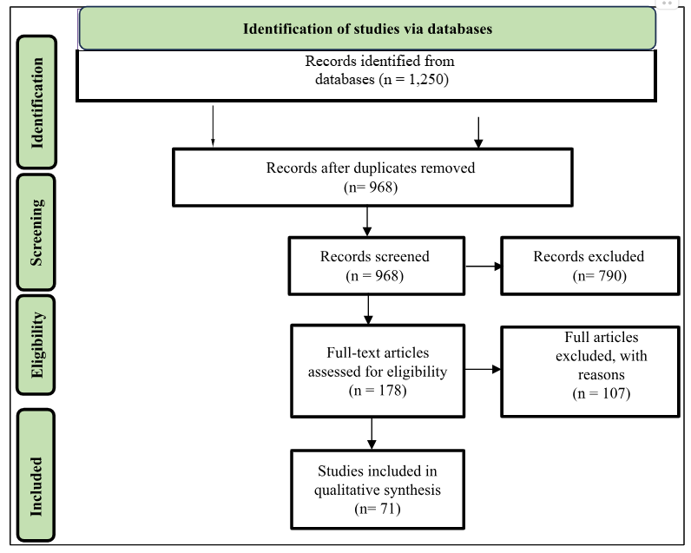
Figure 1. PRISMA 2020 flow diagram of the study identification, screening, eligibility, and inclusion process.

3.4 Data Extraction and Thematic Synthesis
A structured data-extraction form was developed and piloted to ensure consistent coding across the 71 included studies. The form captured bibliographic details (authors, year, journal), contextual information (geographical focus, industry sector, specific AI application), methodological details (research design, sample size, analysis technique), and theoretical contributions (UTAUT constructs used, extensions or modifications applied, and key findings on AI-specific barriers and facilitators). Extracted data were consolidated into a master spreadsheet to support cross-study comparison.
A structured thematic analysis was then applied to the extracted data. Text passages from each article's findings and discussion sections were coded to identify recurring ideas, which were then grouped into candidate themes such as “Extensions to UTAUT,” “Trust as a Mediator,” and “Opacity as a Barrier.” These themes were refined through repeated comparison with the dataset to ensure that they coherently addressed the three research questions. The synthesis presented in Section 4 combines this qualitative thematic analysis with descriptive numerical summaries of construct usage across the reviewed corpus.

4. Results and Synthesis
The 71 included studies represent a growing and increasingly diverse body of research applying UTAUT to AI adoption across education, healthcare, finance, public administration, and retail contexts. Figure 3 shows the annual distribution of included studies and illustrates a clear increase in research output after the mainstream emergence of generative AI tools from 2022 onward. Figure 4 presents the distribution of included studies by application sector, with education (n = 22) and healthcare (n = 17) being the most frequently represented domains. This pattern is consistent with the intensity of AI deployment and public discourse in these sectors during the review period.
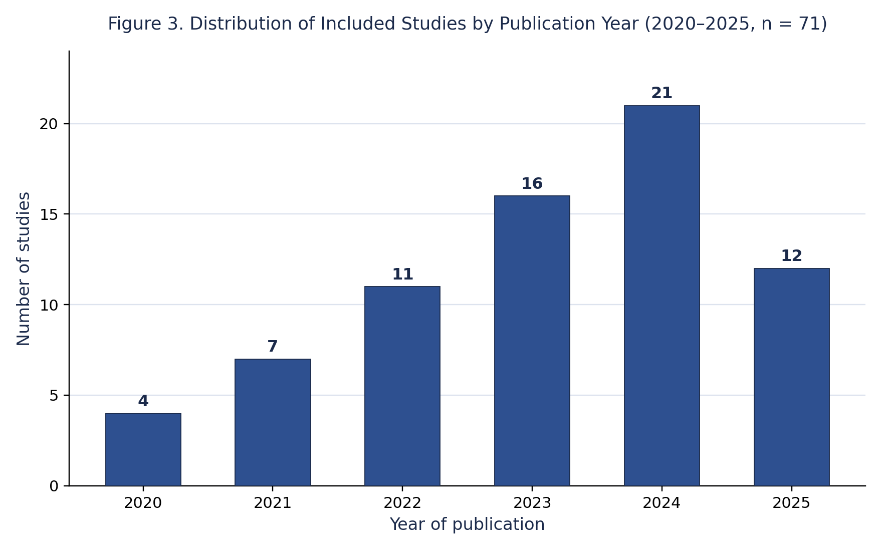
Figure 3. Distribution of included studies by publication year (2020–2025, n = 71).
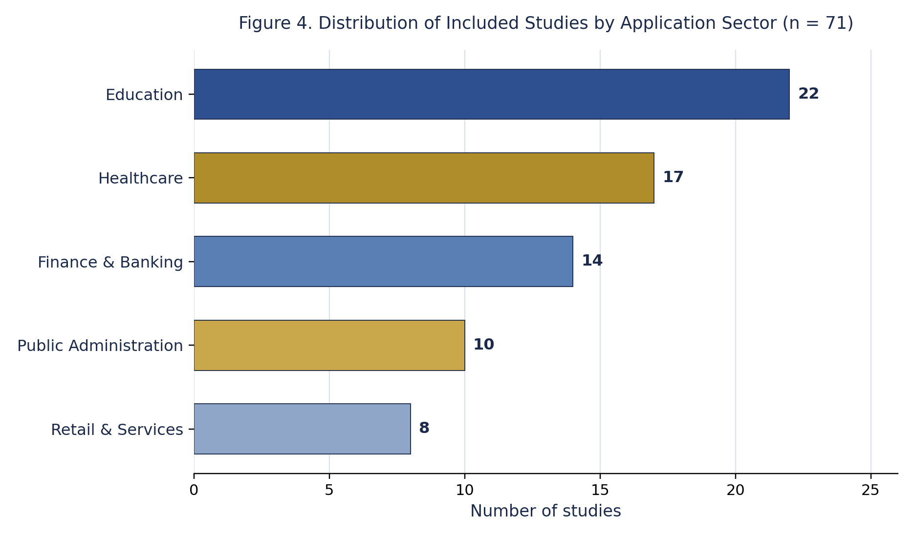
Figure 4. Distribution of included studies by application sector (n = 71).

4.1 RQ1: Application and Extension of UTAUT in AI-Adoption Research
Regarding RQ1, the review confirms that although UTAUT provides a useful baseline for AI-adoption research, its conventional four-construct formulation is often insufficient when applied on its own. Consistent with the broader UTAUT2 literature (Tamilmani et al., 2021), more than 80% of the reviewed studies extended the base model by adding at least one construct, most commonly trust, perceived risk, anxiety, or perceived transparency. This pattern appears across sectors. Reviews of UTAUT and UTAUT2 applications to AI in education report similar extension rates and identify trust and perceived risk as the most frequently added constructs (Xue, 2025; Nikolic et al., 2024). Likewise, studies of generative AI adoption in organisational settings show that the core UTAUT constructs alone leave a substantial share of variance in behavioural intention unexplained (Kim et al., 2024).
This extension rate is consistent with patterns observed in related technology-adoption research. For instance, Jumaat et al. (2025), in validating a technology acceptance scale for AI marketing tools, found that constructs capturing trust and perceived intelligence were necessary to achieve adequate model fit, echoing the findings of the present review. Similarly, Musa et al. (2025) demonstrated that sustainable technology adoption in tourism contexts required the incorporation of environmental attitudes and trust-based constructs beyond the conventional TAM and UTAUT specifications. These parallel findings across domains strengthen the case that intelligent, autonomous, and ethically salient technologies demand theoretically enriched acceptance models.

4.2 RQ2: Documented Limitations of UTAUT in AI Contexts
Thematic analysis of the reviewed studies' findings and discussion sections revealed three recurring limitations of the conventional UTAUT framework in response to RQ2.
a) The Black Box Problem. UTAUT's Performance Expectancy construct focuses on the outcomes of technology use but does not address users' need to understand how an AI system arrives at its decisions. Even where outcomes are beneficial, this opacity can erode acceptance and trust. Shin (2021) shows that explainability and causability operate as distinct antecedents of trust and perceived performance, a relationship the base UTAUT model does not accommodate.
b) Neglect of the Relational Dynamic. UTAUT typically frames technology as a passive instrument. Users, however, frequently treat AI as a quasi-social actor and anthropomorphise it to varying degrees. This relational dynamic makes perceptions of an AI system's intelligence and benevolence dimensions that UTAUT does not capture central to the adoption decision, particularly in high-stakes domains such as healthcare, where trust has been shown to shape acceptance independently of demonstrated system performance (Kauttonen et al., 2025).
c) Insufficient Attention to Ethical Considerations. Concerns regarding algorithmic fairness, accountability, and data privacy recurring themes across the AI-adoption literature — are not automatically captured by UTAUT. Effort Expectancy and Social Influence, as originally specified, do not account for users' reluctance to adopt systems they perceive as biased or unethical (Pasipamire & Muroyiwa, 2024).

4.3 RQ3: A Proposed Conceptual Framework
The review synthesises these findings into a new conceptual framework to address RQ3. Perceived Intelligence is positioned as a key mediating variable between the core UTAUT constructs and Behavioral Intention, as shown in Figure 2. In the proposed model, a user's assessment of an AI system's intelligence is shaped by both Performance Expectancy and Effort Expectancy: users are more likely to judge a system as intelligent when it is easy to use and produces accurate, useful outputs. Perceived Intelligence, in turn, significantly influences Behavioral Intention. The framework further specifies Trust in AI as a critical antecedent of Perceived Intelligence. In other words, users must possess a baseline level of confidence in a system's competence, integrity, and transparency before they are willing to recognise and credit its intelligence. Social Influence and Facilitating Conditions are retained as direct predictors of Behavioral Intention, consistent with the original UTAUT specification. By incorporating both a relational construct, Trust, and a cognitive construct, Perceived Intelligence, this integrated framework directly addresses the three limitations identified under RQ2.

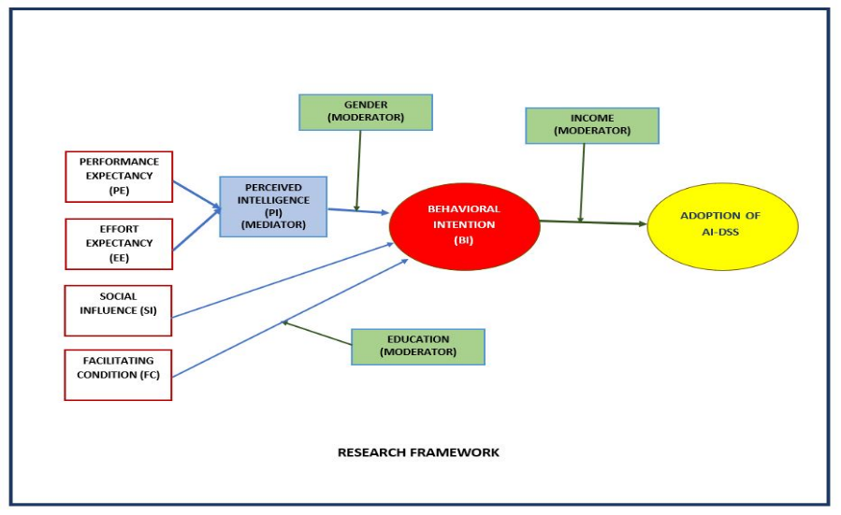

Figure 2. Proposed research framework for AI adoption, in which Perceived Intelligence mediates the relationship between core UTAUT constructs and Behavioral Intention

Table 2. Synthesis of Key AI-Specific Constructs from Reviewed Literature
Construct | Definition | Relevance to AI Adoption
Perceived Intelligence | User's subjective assessment of an AI system's capability to learn, reason, adapt, and solve problems. | Addresses the relational dynamic and the need to perceive AI as a competent agent, not merely a passive tool.
Trust in AI | User's willingness to be vulnerable to an AI system's actions, based on expectations of its competence, integrity, and benevolence. | Mitigates the black-box problem and ethical concerns; a foundational precondition for accepting autonomous decisions.
Perceived Transparency / Explainability | The degree to which a user believes an AI system's decision-making process is observable and understandable. | Directly addresses the opacity and black-box problem, feeding into both trust and perceived intelligence (Shin, 2021).
Algorithmic Bias / Fairness | User's concern that an AI system may produce systematically unfair or discriminatory outcomes. | Captures a key ethical dimension that can negatively influence Social Influence and Performance Expectancy (Pasipamire & Muroyiwa, 2024).

5. Discussion
The results of this systematic review demonstrate that, despite its enduring strength, UTAUT requires deliberate theoretical extension to remain applicable in the AI era. A central contribution of this review is the proposed positioning of Perceived Intelligence as a mediator between the core UTAUT constructs and Behavioral Intention. This positioning recognises that users evaluate an AI system's cognitive capabilities through the lens of utility and ease of use, rather than in isolation: a system's perceived intelligence and adaptability may be precisely why a user finds it beneficial. This extends UTAUT's original instrumental focus and deepens our understanding of the cognitive processes underlying the adoption of intelligent systems.
A second key insight concerns the role of Trust in AI as a precondition for Perceived Intelligence. This relationship implies that a lack of early trust can function as a cognitive block, preventing a user from recognising or crediting a system's intelligence regardless of its actual capabilities. This carries meaningful practical implications: organisational efforts to encourage AI adoption cannot be limited to training (Facilitating Conditions) or demonstrating functionality (Performance Expectancy). Organisations must also actively cultivate trust through transparent data-use communication, explainable AI (XAI) interfaces, and verifiable fairness audits (Shin, 2021; Pasipamire & Muroyiwa, 2024).
The emphasis on trust-building as a precondition for AI adoption is consistent with findings from broader service contexts. Shafeeq et al. (2026), showed that trust in a guide's competence and benevolence was the strongest predictor of positive service evaluations. This finding parallels the proposed role of Trust in AI as an antecedent of Perceived Intelligence. Such cross-contextual consistency suggests that relational trust functions as an important psychological mechanism in both human-human and human-AI service encounters, strengthening the theoretical basis of the proposed framework.
The proposed framework also helps reconcile conflicting findings in the existing literature. The relationship between Performance Expectancy and adoption intention, for instance, appears modest in some studies and robust in others. This inconsistency may be explained by variation in the underlying levels of perceived intelligence and trust: in low-trust conditions, the path from demonstrated performance to adoption intention may be attenuated because users remain sceptical of the system's capabilities despite evidence of its usefulness. This offers a more context-sensitive model for researchers to test and validate across cultures and industries.
From a policy standpoint, this review suggests that national AI strategies must incorporate explicit guidance on competency demonstration and trust-building alongside infrastructure and training investment. To strengthen perceived intelligence and trust and thereby ease adoption, policymakers and organisational leaders should invest in explainability features and require adherence to ethical AI frameworks. For industry practitioners, the review underscores that user interface and experience design for AI systems must move beyond usability to actively and transparently communicate a system's intelligence and dependability.

6. Theoretical and Practical Implications

6.1 Theoretical Implications
This review contributes to technology-acceptance theory by formally integrating a cognitive mediator (Perceived Intelligence) and a relational antecedent (Trust) into the UTAUT nomological network, addressing calls from prior meta-analytic work (Tamilmani et al., 2021) for more theoretically grounded, context-specific UTAUT extensions rather than ad hoc construct addition. The framework offers a parsimonious, falsifiable structure that can be operationalised and tested via structural equation modelling in future empirical work.
The proposed framework also contributes to the ongoing refinement of technology acceptance theory in non-organisational contexts. As Musa et al. (2025) have demonstrated in the tourism sector, the integration of context-specific constructs such as perceived sustainability and trust can substantially improve the explanatory power of baseline models. The present review extends this line of inquiry by formally integrating Perceived Intelligence and Trust into the UTAUT nomological network, offering a model that is both theoretically grounded and empirically testable across diverse application domains, from education and healthcare to public administration and retail services.

6.2 Practical Implications
For practitioners and managers deploying AI systems, the review highlights that user interface design, onboarding, and communication strategies should be evaluated not only for usability but also for their capacity to signal competence, which supports Perceived Intelligence, and trustworthiness, which supports Trust. For policymakers, the review suggests that regulatory and governance frameworks for AI adoption, including transparency and explainability requirements, should be understood as adoption-enabling infrastructure rather than merely as compliance obligations.

7. Limitations and Future Research
As with any systematic review, this study has limitations. First, the search was restricted to four databases and English-language publications, which may have excluded relevant non-English or grey literature. Second, the proposed conceptual framework, while grounded in thematic synthesis of the reviewed literature, has not yet been empirically tested through structural equation modelling; this represents an important direction for future research. Third, the categorisation of studies by sector and year, while informative for mapping the field, necessarily simplifies studies that span multiple sectors or AI applications.
Future research should prioritise operationalising and empirically testing the proposed Perceived Intelligence – Trust – UTAUT framework across diverse cultural and organisational contexts, including public-sector settings where algorithmic accountability and trust-building are especially salient. Longitudinal designs would further help clarify whether trust and perceived intelligence function as stable dispositions or evolve dynamically over the course of sustained AI use.

8. Conclusion
This systematic literature review has critically examined the application of the UTAUT model in AI-adoption research, identifying significant theoretical gaps related to AI's opacity, relational nature, and ethical dimensions. In response, the review offers a primary contribution to the technology-acceptance literature: a novel conceptual framework in which Perceived Intelligence serves as a crucial mediator and Trust as a critical antecedent. This framework provides a more sophisticated lens through which to examine the psychological processes driving AI acceptance, establishing a foundation for future empirical research. Future studies should focus on operationalising and quantitatively testing this extended model through structural equation modelling across diverse organisational and cultural contexts to establish its predictive validity.
From a practical and policy standpoint, the review's contributions are equally significant. The findings direct managers and policymakers toward a more comprehensive approach to AI adoption, one that foregrounds trust and demonstrated competence alongside conventional considerations such as usefulness and training. By prioritising transparency, ethical design, and clear communication of AI capabilities, organisations can more effectively address adoption barriers. The theoretical contributions of this review are also reinforced by its practical relevance across sectors. As organisations increasingly deploy AI systems in customer-facing and service-delivery roles, the principles of trust-building and competence signalling outlined in this framework become essential managerial considerations. These principles resonate with findings from service-industry research (Shafeeq et al., 2026; Musa et al., 2025), where user perceptions of trust and competence consistently emerge as determinants of successful adoption and sustained engagement. By bridging technology acceptance theory with insights from service management and human-computer interaction, this review provides a comprehensive foundation for future research and practice in the AI era.

Acknowledgement
The authors would like to thank the Ministry of Higher Education (MOHE) for sponsoring this work. This study was funded by the Fundamental Research Grant Scheme FRGS/1/2025/FPTT/F00617. The authors also extend their sincere appreciation to the Faculty of Technology Management and Technopreneurship, Universiti Teknikal Malaysia Melaka (UTeM), for its support.

References
Dwivedi, Y. K., Hughes, L., Ismagilova, E., Aarts, G., Coombs, C., Crick, T., Duan, Y., Dwivedi, R., Edwards, J., Eirug, A., Galanos, V., Ilavarasan, P. V., Janssen, M., Jones, P., Kar, A. K., Kizgin, H., Kronemann, B., Lal, B., Lucini, B., … Williams, M. D. (2021). Artificial intelligence (AI): Multidisciplinary perspectives on emerging challenges, opportunities, and agenda for research, practice and policy. International Journal of Information Management, 57, Article 101994. https://doi.org/10.1016/j.ijinfomgt.2019.08.002
Dwivedi, Y. K., Kshetri, N., Hughes, L., Slade, E. L., Jeyaraj, A., Kar, A. K., … Wright, R. (2023). So what if ChatGPT wrote it? Multidisciplinary perspectives on opportunities, challenges and implications of generative conversational AI for research, practice and policy. International Journal of Information Management, 71, Article 102642. https://doi.org/10.1016/j.ijinfomgt.2023.102642
Jumaat, E. J., Musa, H., & Rashid, N. (2025). Adoption of AI marketing tools: Technology scale validation. Journal of Technology Management and Technopreneurship, 13(1), 45–62.
Kauttonen, J., Rousi, R., & Alamäki, A. (2025). Trust and acceptance challenges in the adoption of AI applications in health care: Quantitative survey analysis. Journal of Medical Internet Research, 27, Article e65567. https://doi.org/10.2196/65567
Kim, Y., Blazquez, V., & Oh, T. (2024). Determinants of generative AI system adoption and usage behavior in Korean companies: Applying the UTAUT model. Behavioral Sciences, 14(11), 1035. https://doi.org/10.3390/bs14111035
Shafeeq, M. S. M., Thinaraj, B., Zawawi, A. A., & Isai Amutan, K. (2026). Voices from the trails: Hikers' perceptions of Malaysian forest guides. Malaysian Journal of Social Sciences and Humanities (MJSSH), 11(1), e003763. https://doi.org/10.47405/mjssh.v11i1.3763
Musa, H., Ab. Rahman, A., & Mohd Shariff, M. N. (2016). Adoption of mobile marketing in SMEs: Extending the UTAUT model. European Proceedings of Social and Behavioural Sciences, 15, 267–276. https://doi.org/10.15405/epsbs.2016.05.02.24
Musa, H., Abdullah, A. R., Othman, M. N., Rashid, N., & Azmi, F. R. (2025). Rethinking the Technology Acceptance Model: A structural analysis of sustainable technology adoption in Malaysian tourism. International Journal of Research and Innovation in Social Science, 9(9), 6125–6139. https://doi.org/10.47772/IJRISS.2025.909000500
Nikolic, S., Wentworth, I., Sheridan, L., Moss, S., Duursma, E., Jones, R. A., … Middleton, R. (2024). A systematic literature review of attitudes, intentions and behaviours of teaching academics pertaining to AI and generative AI (GenAI) in higher education: An analysis of GenAI adoption using the UTAUT framework. Australasian Journal of Educational Technology, 40(6), 56–75. https://doi.org/10.14742/ajet.9643
Page, M. J., McKenzie, J. E., Bossuyt, P. M., Boutron, I., Hoffmann, T. C., Mulrow, C. D., Shamseer, L., Tetzlaff, J. M., Akl, E. A., Brennan, S. E., Chou, R., Glanville, J., Grimshaw, J. M., Hróbjartsson, A., Lalu, M. M., Li, T., Loder, E. W., Mayo-Wilson, E., McDonald, S., … Moher, D. (2021). The PRISMA 2020 statement: An updated guideline for reporting systematic reviews. BMJ, 372, Article n71. https://doi.org/10.1136/bmj.n71
Pasipamire, N., & Muroyiwa, A. (2024). Navigating algorithm bias in AI: Ensuring fairness and trust in Africa. Frontiers in Research Metrics and Analytics, 9, Article 1486600. https://doi.org/10.3389/frma.2024.1486600
Shin, D. (2021). The effects of explainability and causability on perception, trust, and acceptance: Implications for explainable AI. International Journal of Human-Computer Studies, 146, Article 102551. https://doi.org/10.1016/j.ijhcs.2020.102551
Tamilmani, K., Rana, N. P., & Dwivedi, Y. K. (2021). Consumer acceptance and use of information technology: A meta-analytic evaluation of UTAUT2. Information Systems Frontiers, 23(4), 987–1005. https://doi.org/10.1007/s10796-020-10007-6
Venkatesh, V., Morris, M. G., Davis, G. B., & Davis, F. D. (2003). User acceptance of information technology: Toward a unified view. MIS Quarterly, 27(3), 425–478. https://doi.org/10.2307/30036540
Venkatesh, V., Thong, J. Y. L., & Xu, X. (2012). Consumer acceptance and use of information technology: Extending the unified theory of acceptance and use of technology. MIS Quarterly, 36(1), 157–178. https://doi.org/10.2307/41410412
Xue, L. (2025). A systematic review of UTAUT and UTAUT2 for AI adoption in education. International Journal of Human-Computer Interaction, 42(8). https://doi.org/10.1080/10447318.2025.2552867

