Characterization physico-chemical, microbiological of milk Curd (Mashanza) consumed in Bukavu, and evaluation of the preservative potential of bromelain and coconut milk
Melchior Kiriza Mugomoka ¹ François Mugisho Mushagalusa¹, Josué Nshokano Baharanyi ¹ , Heritier Ombeni Kalalizi ¹ Léon Shamavu Rudahaba ¹ , Janvier Bunani Ntabala ^{1 ,}André Cushulo Buhendwa¹ ,Jacques Nshokano Mulegwa¹ ,Abel Mwishingo Haliyamutu¹ ,Alexis Bashengezi Bagalwa¹, Murhula Mushoho Prince ² , Adela Kimanuka Patience^{4 ,}Chifundera Kusamba Zacharie ^{1,3}
¹Higher Institute of Agronomic and Veterinary Studies (ISEAV), Walungu
² Higher Institute of Rural Development of Kaziba ISDR KAZIBA
³ Lwiro Natural Sciences Research Centre
⁴ Higher pedagogical Institute (ISP) Bukavu
Contact : mushohop@gmail.com

ABSTRACT
Traditional curdled milk locally known as Mashanza is widely consumed in Bukavu (South Kivu Province, Democratic Republic of the Congo) and represents an important source of protein and calcium for the local population. However, its high perishability due to rapid acidification and microbial contamination limits its shelf life and poses potential public health risks. This study aimed to (i) characterize the physicochemical and microbiological quality of Mashanza marketed in Bukavu and (ii) evaluate the preservative efficacy of two natural agents: bromelain (5 mg/g) and coconut milk (10% v/w). Untreated samples exhibited rapid acidification, a marked decline in pH, significant dry matter loss, and exponential growth of total aerobic mesophilic flora, staphylococci, and coliforms, leading to complete sensory rejection after eight days of storage. Both bromelain and coconut milk significantly slowed acidification (p < 0.001), reduced microbial loads (p < 0.001), and preserved physicochemical stability and organoleptic quality. Coconut milk showed stronger inhibition of total flora and coliforms, whereas bromelain demonstrated greater specificity against staphylococci. The combined treatment did not produce a synergistic effect and suggested an antagonistic interaction. These findings indicate that bromelain and coconut milk represent promising natural biopreservatives for extending the shelf life of Mashanza under local conditions.
Keywords: Mashanza, curdled milk, bromelain, coconut milk, natural preservatives, dairy microbiology.

1. INTRODUCTION
Milk and dairy products constitute a fundamental component of human nutrition worldwide owing to their high content of essential nutrients, including high-quality proteins, calcium, and fat-soluble vitamins, thereby contributing significantly to the nutritional balance of diverse populations (Elysé & Djamena, 2023; Tadesse et al., 2023). Previous studies indicate that, in the absence of dairy products, a substantial proportion of the global population would encounter difficulties in meeting basic nutritional requirements (Januś et al., 2021). Among dairy commodities, cheese occupies a particularly prominent position, accounting for nearly one-third of global milk utilization and underscoring the economic and technological importance of this sector (Salih & Abdalla, 2020). Even after processing, cheeses retain considerable nutritional value due to their concentrated content of proteins, lipids, minerals, and vitamins (Birali et al., 2019). Milk processing serves multiple purposes: preserving nutritional quality, extending shelf life across time and geographical space, and generating a diversity of products that meet specific sensory, cultural, and market expectations (Jennifer et al., 2019; Mutwedu et al., 2018). Nevertheless, milk remains a highly perishable biological fluid that may undergo spoilage within hours of milking if appropriate preservation measures are not implemented (Boko et al., 2016; Mutwedu et al., 2018; Salih & Abdalla, 2020). Its rapid deterioration is attributable to its high water activity, near-neutral pH, rich nutrient composition, and heightened susceptibility to contamination during milking, storage, and transportation (Bacigale et al., 2023; Elysé & Djamena, 2023). Collectively, these characteristics create a favorable environment for the proliferation of a wide spectrum of microorganisms, potentially compromising quality and safety at various stages of the dairy value chain (Tadesse et al., 2023; Bacigale et al., 2023). To enhance milk preservation, several technological interventions have been developed, including thermal treatments such as pasteurization, sterilization, ultra-high temperature (UHT) processing, and thermization, as well as refrigeration and freezing (Bezie, 2019). Chemical preservation strategies, including the use of hydrogen peroxide and food-grade preservatives, have also been employed (Aganze & Buchaguzi, 2024; Arefin et al., 2017). In addition, fermentation, technological transformation, concentration, and drying constitute important alternative approaches, particularly in contexts where access to advanced processing technologies remains limited (Jennifer et al., 2019; Mutwedu et al., 2018; Prestes et al., 2022; Zhou et al., 2025). In South Kivu Province, particularly in Bukavu (eastern Democratic Republic of the Congo), milk is traditionally processed into a soft fermented cheese locally known as Mashanza. This product represents a long-standing method of preserving proteins, lipids, and minerals such as calcium and phosphorus. Mashanza is highly valued for its nutritional attributes and distinctive organoleptic properties, rendering it both culturally significant and economically important within the local food system (Mutwedu et al., 2018; Birali et al., 2019). Compared with other preservation techniques, Mashanza fermentation induces a substantial reduction in pH (approximately 3.5–3.8) and water activity (Aw < 0.80), thereby limiting the growth of numerous pathogenic microorganisms and extending shelf life to approximately one week, even in the absence of refrigeration (Birali et al., 2019; Mwamini, 2022). Cheese yield is relatively high, ranging from 21 to 24 kg per 100 kg of milk, thus contributing to the valorization of local dairy production (Jennifer et al., 2019). Furthermore, the compact texture of Mashanza facilitates handling and transportation to urban markets, enhancing its commercial viability (Grenzen, 2021; Nájera et al., 2021). Despite these advantages, Mashanza remains susceptible to physicochemical and microbiological deterioration. This vulnerability arises from the artisanal and non-standardized nature of its production, variability in raw milk quality, and the limited number of scientific investigations addressing determinants of its final quality (Jennifer et al., 2019; Birali et al., 2022). Product quality is closely influenced by manufacturing practices, milk composition, and processing conditions (Birali et al., 2019). Additionally, marketing conditions in Bukavu may exacerbate degradation, as some vendors reportedly incorporate non-dairy additives to increase economic returns, thereby altering the product’s natural composition (Salih & Abdalla, 2020). Studies on street-vended foods in Bukavu have revealed elevated microbial loads, reflecting inadequate hygiene conditions (Kajunju et al., 2023). Although Mashanza has not been specifically examined in this regard, it is likely exposed to comparable contamination risks. The average shelf life of Mashanza in the region rarely exceeds one week, and only a limited fraction of production surpasses this duration (Jennifer et al., 2019). Such instability is largely associated with lipid oxidation and the proliferation of spoilage microorganisms during post-production storage (Mileriene et al., 2020). Artisanal production systems continue to face constraints related to insufficient scientific knowledge and the absence of clearly defined quality standards (Birali et al., 2019). Within this framework, the use of natural preservatives emerges as a promising and locally sustainable strategy. Coconut milk exhibits antimicrobial activity primarily attributed to lauric acid, which is converted into monolaurin—a compound capable of inhibiting bacteria, viruses, and fungi through disruption of lipid membranes (Nitbani et al., 2022; Dayrit, 2015). Similarly, bromelain, a proteolytic enzyme complex derived from pineapple, possesses antimicrobial, digestive, and anti-inflammatory properties and is employed in the dairy industry for cheese texture modification and denaturation of specific bacterial proteins (Sarker, 2022; Gedif & Tkaczewska, 2024; Hafez et al., 2024; Oliver-Simancas et al., 2024; Zhang et al., 2024). However, its application as a preservative in traditional dairy products—particularly Mashanza—remains insufficiently documented within the Congolese context. To date, research conducted in Bukavu has primarily addressed microbial contamination of dairy products, physicochemical characterization of Mashanza, artisanal production practices, and vendor hygiene conditions. To the best of our knowledge, no study has evaluated the combined application of bromelain and coconut milk as natural biopreservatives for Mashanza. Accordingly, the present study aims to characterize the physicochemical and microbiological properties of Mashanza consumed in Bukavu and to assess the effectiveness of bromelain and coconut milk as natural preservatives. By improving product quality and extending shelf life, this research seeks to contribute to the development of local dairy value chains and to strengthen food security within the region. Positioned at the intersection of food microbiology, dairy technology, and the valorization of local natural resources, this work offers innovative perspectives for the advancement of the artisanal dairy sector in eastern Democratic Republic of the Congo.

2. METHODOLOGY

2.1 Study Area
The present study was conducted in Bukavu, located in South Kivu Province, eastern Democratic Republic of the Congo. Milk samples were collected from major local markets across the city’s three administrative communes: Ibanda, Kadutu, and Bagira.
Owing to its favorable agroecological conditions, Bukavu and its surrounding areas possess substantial agricultural and dairy production potential. Nevertheless, dietary patterns are progressively shifting from the consumption of locally produced fresh foods toward increased reliance on processed products (Ombeni et al., 2018). These transformations underscore the growing importance of assessing the quality and safety of locally marketed dairy products.

2.2 Experimental Site and Laboratory Analyses
The experimental work, including physicochemical and microbiological analyses, was carried out at the Laboratory of Microbiology and Food Technology of the Faculty of Agronomic Sciences and Environment at the Evangelical University in Africa, situated in the Panzi district of Ibanda commune, Bukavu. The laboratory is located at approximately 02°32′28.9″ South latitude and 028°51′47.2″ East longitude.
A geographical map illustrating the study area and the spatial distribution of the sampling sites is presented in the following figure.
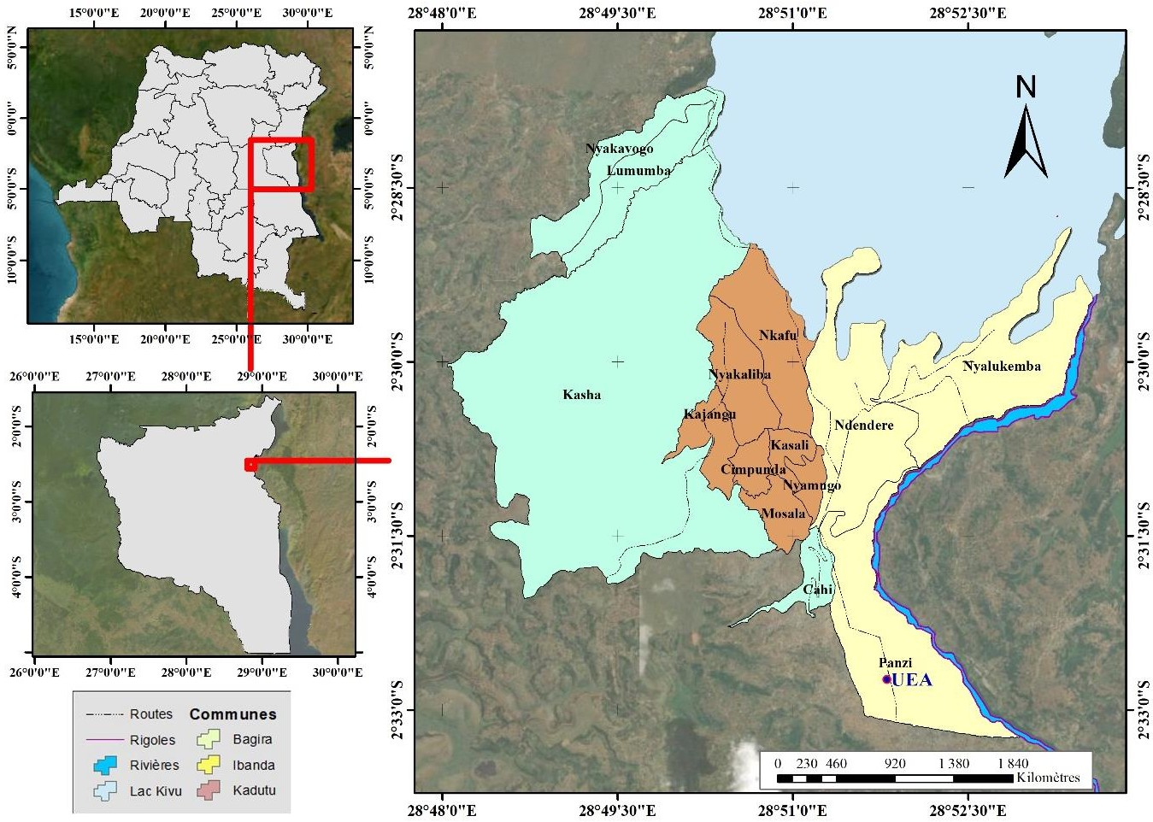
Figure 1. Mapping of the city of Bukavu (ArcGIS 10.4.1)

2.1 Study Area and Sample Collection
The study was conducted in Bukavu (South Kivu Province, Democratic Republic of the Congo), where the traditional curdled milk known as Mashanza is widely produced, marketed, and consumed. Samples were collected from both formal and informal markets and retail outlets, including Bagira, Brasserie, Bondeko, Kadutu, Feu Rouge, Nyawera, Nguba, Essence, and Kamagema. Each individual sample consisted of 50 g of curdled milk.
The minimum sample size was determined according to the method described by Serhier et al. (2020), using an estimated proportion of p = 0.5 to maximize sample size, with a 95% confidence level and a 5% margin of error (Lwanga and Lemeshow, 1991). The calculated minimum sample size was 384. Following homogenization and preparation of the composite sample, subsamples were stored at −20 °C until laboratory analysis.
Vendors were selected based on their geographic location within the communes of Ibanda, Kadutu, and Bagira, regularity of sales activity, voluntary consent to participate, and compliance with minimum observable hygiene standards. Occasional vendors, those declining participation, or those providing non-compliant samples were excluded from the study.

2.1.1 Physicochemical Analyses
The physicochemical parameters evaluated included pH, titratable acidity, moisture content, dry matter, fat, crude protein, lactose, density, and mineral content. pH was measured using a calibrated digital pH meter (Mettler-Toledo AG). Titratable acidity, expressed in Dornic degrees and lactic acid equivalents, was determined by titration with 0.1 N NaOH using phenolphthalein as an indicator (Aganze and Buchaguzi, 2024). Moisture content was determined by oven drying at 105 °C until constant weight, according to standard NF V04-401, and dry matter content was calculated by difference (Zebib et al., 2023). Fat content was determined by Soxhlet extraction using hexane as solvent, following the procedures described by Birali et al. (2022), Compaore et al. (2021), and Januś et al. (2021). Crude protein content was determined by the Kjeldahl method, while lactose.

3. RESULTS

3.1 Physicochemical Characteristics of Mashanza Treated and Untreated with Natural Preservatives

Table 1. Evolution of physicochemical parameters of Mashanza during storage as affected by natural preservatives
Values are expressed as mean ± standard deviation.
Different letters within the same column indicate significant differences according to Fisher’s LSD test (α = 0.05).
T0 = Control;
T1 = Bromelain (5 mg g⁻¹);
T2 = Coconut milk (10% v/w);
T3 = Bromelain + Coconut milk.

Day 1
Sample | Dry Matter (%) | Fat (%) | Protein (%) | Ash (%) | Phosphorus (mg) | Calcium (mg)
T0 | 13.80 ± 1.47 abc | 4.81 ± 0.05 ef | 8.97 ± 0.04 gh | 1.09 ± 0.09 a | 4.55 ± 0.40 abcde | 11.33 ± 0.12 h
T1 | 13.68 ± 0.56 abc | 5.57 ± 0.24 d | 18.15 ± 1.09 a | 1.08 ± 0.07 a | 4.67 ± 0.15 abcd | 11.62 ± 0.11 g
T2 | 13.30 ± 0.78 abc | 10.58 ± 0.17 a | 10.30 ± 0.10 f | 0.89 ± 0.14 abc | 4.97 ± 0.21 a | 12.01 ± 0.02 f
T3 | 12.15 ± 0.70 cd | 9.70 ± 0.42 b | 15.75 ± 0.27 c | 1.05 ± 0.11 ab | 4.88 ± 0.36 ab | 11.96 ± 0.07 def

Day 5
Sample | Dry Matter (%) | Fat (%) | Protein (%) | Ash (%) | Phosphorus (mg) | Calcium (mg)
T0 | 11.00 ± 2.00 d | 4.29 ± 0.22 gh | 8.99 ± 0.37 gh | 0.83 ± 0.06 bc | 4.27 ± 0.25 f | 11.83 ± 0.07 ef
T1 | 15.00 ± 1.00 a | 5.18 ± 0.25 f | 16.68 ± 0.53 b | 0.80 ± 0.26 cd | 4.67 ± 0.21 abcd | 11.81 ± 0.05 fg
T2 | 14.83 ± 1.76 a | 9.25 ± 0.33 c | 9.67 ± 0.44 fg | 0.58 ± 0.32 f | 4.73 ± 0.32 abc | 13.05 ± 0.06 b
T3 | 14.67 ± 1.53 ab | 9.36 ± 0.43 cd | 14.97 ± 0.28 d | 0.72 ± 0.07 cd | 4.60 ± 0.35 abcde | 12.57 ± 0.14 c

Day 8
Sample | Dry Matter (%) | Fat (%) | Protein (%) | Ash (%) | Phosphorus (mg) | Calcium (mg)
T0 | 7.47 ± 0.50 e | 4.21 ± 0.08 h | 8.52 ± 0.30 h | 0.33 ± 0.06 f | 4.20 ± 0.09 e | 11.81 ± 0.07 fg
T1 | 13.83 ± 0.47 abc | 4.71 ± 0.16 fg | 16.71 ± 0.08 b | 0.47 ± 0.06 ef | 4.47 ± 0.12 bcde | 12.08 ± 0.11 d
T2 | 12.67 ± 1.53 bcd | 8.94 ± 0.27 c | 9.59 ± 0.17 fg | 0.43 ± 0.06 ef | 4.53 ± 0.16 bcde | 13.29 ± 0.26 a
T3 | 11.97 ± 0.95 cd | 9.09 ± 0.08 c | 13.91 ± 0.65 e | 0.47 ± 0.06 ef | 4.35 ± 0.18 cde | 12.41 ± 0.04 c

ANOVA Results
Factor | Dry Matter | Fat | Protein | Ash | Phosphorus | Calcium
Days | *** | *** | *** | *** | ** | ***
Treatment | *** | *** | *** | ns | * | ***
Days × Treatment | ** | ** | . | ns | ns | ***
Significance levels:
*** p < 0.001
** p < 0.01
- p < 0.05
. p < 0.10
ns = not significant
Two-way ANOVA revealed that storage time (“Days”) had a highly significant effect (p < 0.001 or p < 0.01) on all nutritional parameters evaluated. The factor “Treatment” exerted a highly significant effect (p < 0.001) on fat, protein, and calcium contents, a significant effect (p < 0.05) on phosphorus, and no significant effect on ash content (p > 0.05). A significant interaction between storage time and treatment was observed for dry matter, fat, and calcium contents, indicating that the impact of natural preservatives varied over time.
- Evolution of Individual Parameters

Dry Matter
A marked decline in dry matter was observed in the control (T0), decreasing from 13.80% on Day 1 to 7.47% on Day 8. In contrast, treated samples maintained significantly higher dry matter levels at the end of storage:
- T1: 13.83%
- T2: 12.67%
- T3: 11.97%
The highest value (15.00%) was recorded for T1 on Day 5.

Fat Content
Samples treated with coconut milk (T2) and the combined treatment (T3) exhibited significantly higher fat levels (8.94–10.58%) compared to T0 and T1 (4.21–5.57%).
The highest fat content (10.58%) was observed in T2 on Day 1, while the lowest value (4.21%) was recorded in the control (T0) on Day 8.

Protein Content
Protein levels were significantly higher in T1 and T3 (13.91–18.15%) compared to T0 and T2 (8.52–10.30%). The maximum protein content (18.15%) was observed in T1 on Day 1, whereas the lowest value (8.52%) occurred in T0 on Day 8.

Ash and Phosphorus
Ash content decreased significantly over time in all treatments, dropping from approximately 0.89–1.09% on Day 1 to 0.33–0.47% on Day 8. Similarly, phosphorus levels showed a general downward trend during storage. The highest phosphorus concentration (4.97 mg) was recorded in T2 on Day 1, whereas the lowest value (4.20 mg) was observed in T0 on Day 8.

Calcium
Calcium content increased during storage across all treatments. Treatments containing coconut milk (T2 and T3) exhibited the most pronounced increases and the highest final values.
T2 reached the maximum calcium concentration on Day 8 (13.29 mg), significantly higher than all other treatments. The lowest calcium value (11.33 mg) was recorded in the control (T0) on Day 1.
  - curdled milk

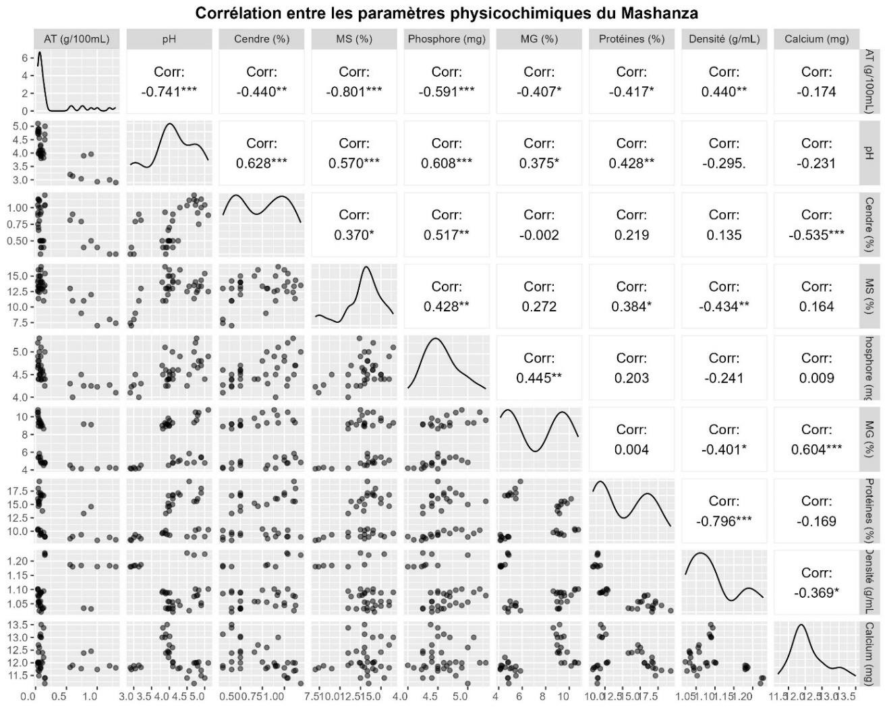

Analysis of Pearson’s correlation coefficients revealed several statistically significant associations among the physicochemical and nutritional parameters. A strong and highly significant negative correlation was observed between titratable acidity (TA) and pH (r = −0.741***), confirming the expected inverse relationship between acidity and pH.
Titratable acidity also exhibited highly significant negative correlations with dry matter (DM) (r = −0.801***) and phosphorus (r = −0.591***). In addition, significant negative correlations were found between titratable acidity and ash content (r = −0.440**), fat (r = −0.407*), and protein (r = −0.417*). Conversely, acidity showed a positive and significant correlation with density (r = 0.440**).
Consistent with these findings, pH displayed inverse trends relative to titratable acidity. It was positively and highly significantly correlated with dry matter (r = 0.570***), phosphorus (r = 0.608***), and ash (r = 0.628***). Significant positive correlations were also observed between pH and protein (r = 0.428**) as well as fat content (r = 0.375*).
Regarding mineral and nutritional components, ash content was positively correlated with dry matter (r = 0.370*) and phosphorus (r = 0.517**), but showed a highly significant negative correlation with calcium (r = −0.535***). Dry matter, in turn, was positively associated with phosphorus (r = 0.428**) and protein (r = 0.384*), while demonstrating a significant negative correlation with density (r = −0.434**).
A highly significant positive correlation was established between fat content and calcium (r = 0.604***). Phosphorus was also positively correlated with fat (r = 0.445**).
Finally, density exhibited a very strong and highly significant negative correlation with protein content (r = −0.796***), as well as significant negative correlations with fat (r = −0.401*) and calcium (r = −0.369*). Other tested associations, including those between protein and calcium and between phosphorus and calcium, were not statistically significant.

Quality organoleptic of the samples of milk quail Before And After 8 days conservation​
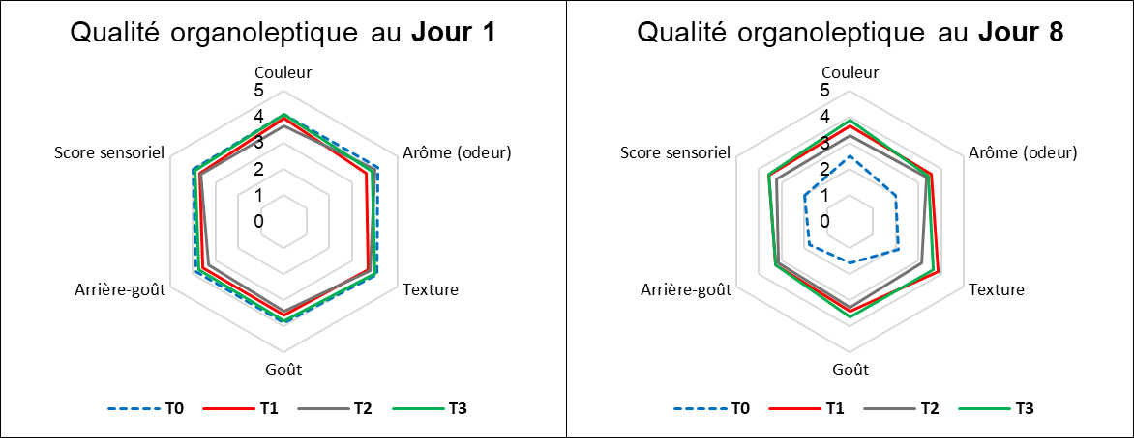

Radar chart analysis at Day 1 revealed a near superimposition of the sensory profiles for all samples (T0, T1, T2, and T3). All batches, including the control (T0), received very similar mean scores across all evaluated descriptors (color, aroma, texture, taste, aftertaste, and overall sensory score). Most attributes were rated around 4, corresponding to “pleasant,” indicating comparable initial organoleptic quality among treatments.
A marked divergence emerged at Day 8. The control sample (T0) exhibited pronounced sensory deterioration, with a substantial decline in scores across all descriptors. Aroma, taste, aftertaste, and overall sensory score decreased to values below 2 (“unpleasant”), reflecting clear rejection by the tasting panel. These results demonstrate that prolonged storage significantly affected the untreated milk, leading to a loss of organoleptic quality. This finding highlights the important role of the applied bio-preservatives in extending the shelf life of curdled milk marketed in Bukavu.
In contrast, the three treated batches (T1, T2, and T3) maintained significantly better sensory quality over the storage period. Samples T1 (bromelain) and T2 (coconut milk) showed the most favorable profiles at Day 8, with scores remaining close to 4 for most descriptors and closely resembling their initial Day 1 profiles. Treatment T3 (combination of bromelain and coconut milk) also preserved an acceptable sensory profile, with scores consistently above 3 (“neither pleasant nor unpleasant”) for all attributes. However, its ratings were slightly lower than those of T1 and T2, particularly for taste and aftertaste.

3.1.2. Antimicrobial Activity of Bromelain and Coconut Milk During Curdled Milk Preservation
Table 3. Microbial counts (×10³ CFU/g) in curdled milk treated with natural preservatives during 8-day storage. Values are mean ± SD.
Days | Sample | TAMF | Staphylococci | Coliforms | Salmonella spp. | Yeasts & Molds
Day 1 | T0 (Control) | 7.92 ± 4.73 b | 1.40 ± 1.06 c | 1.37 ± 1.24 b | - | +
 | T1 (Bromelain) | 9.42 ± 5.73 b | 1.90 ± 1.91 c | 2.50 ± 2.76 b | - | +
 | T2 (Coconut milk) | 16.62 ± 12.16 b | 1.17 ± 0.84 c | 1.07 ± 1.33 b | - | +
 | T3 (Combination) | 12.48 ± 5.88 b | 1.17 ± 0.55 c | 0.50 ± 0.53 b | - | +
Day 5 | T0 | 44.33 ± 12.46 a | 43.45 ± 10.24 a | 51.85 ± 4.67 a | - | +
 | T1 | 17.97 ± 5.51 b | 0.76 ± 1.31 c | 16.79 ± 15.35 b | - | +
 | T2 | 6.96 ± 8.64 b | 10.29 ± 16.62 bc | 6.73 ± 5.28 b | - | +
 | T3 | 10.58 ± 2.76 b | 18.18 ± 12.28 b | 7.18 ± 8.03 b | - | +
Day 8 | T0 | 54.55 ± 0.00 a | 48.85 ± 9.87 a | 54.55 ± 0.00 a | - | +
 | T1 | 16.15 ± 4.36 b | 2.73 ± 0.64 c | 17.03 ± 7.37 b | - | +
 | T2 | 9.15 ± 5.85 b | 8.50 ± 10.64 bc | 8.36 ± 2.66 b | - | +
 | T3 | 12.21 ± 1.55 b | 20.30 ± 10.45 b | 8.09 ± 3.96 b | - | +
LSD |  | 19.66 | 19.35 | 10.18
P-value (Days) |  | 0.0644 . | 0.00067 *** | 8.18e-05 ***
P-value (Sample) |  | 0.000232 *** | 4.55e-05 *** | 2.78e-06 ***
Thresholds: ‘’ p < 0.001; ‘’ p < 0.01; ‘’ p < 0.05; ‘.’ p < 0.1.
(-) Absence; (+) Presence.
T0: Control (untreated); T1: Bromelain alone (500 mg); T2: Coconut milk alone (10 mL); T3: Bromelain + Coconut milk.
Analysis of variance (ANOVA) indicated that the type of treatment had a highly significant effect (p < 0.001) on the evolution of all microbial groups evaluated. The storage duration (“Days”) also exhibited a significant effect on Staphylococci and Coliforms (p < 0.001) and a trend effect on total aerobic mesophilic flora (TAMF; p = 0.064). Salmonella spp. was absent from all samples, while yeasts and molds were consistently detected throughout the experiment.
TAMF counts revealed a pronounced increase in the control group (T0), which rose from 7.92 × 10³ CFU/g on Day 1 to 44.33 × 10³ CFU/g on Day 5, reaching 54.55 × 10³ CFU/g by Day 8. In contrast, all treated samples (T1, T2, T3) maintained significantly lower and relatively stable microbial loads throughout the storage period. At Day 8, T2 (coconut milk alone) exhibited the lowest TAMF (9.15 × 10³ CFU/g), followed by T3 (combination) with 12.21 × 10³ CFU/g and T1 (bromelain alone) with 16.15 × 10³ CFU/g.
A similar trend was observed for Staphylococci counts. The untreated sample (T0) experienced massive proliferation, increasing from 1.40 × 10³ CFU/g on Day 1 to 48.85 × 10³ CFU/g on Day 8. T1 (bromelain alone) was the most effective in controlling this pathogen, maintaining a low and stable load of 2.73 × 10³ CFU/g by Day 8. T2 (coconut milk) also demonstrated substantial inhibition (8.50 × 10³ CFU/g), whereas T3 (combination) showed a moderate load (20.30 × 10³ CFU/g) that remained significantly below T0.
Coliform counts followed the same pattern, with T0 exhibiting the highest proliferation, reaching 54.55 × 10³ CFU/g by Day 8. Treatments T2 and T3 were most effective at limiting coliform growth, maintaining low counts of 8.36 × 10³ and 8.09 × 10³ CFU/g, respectively. T1 (bromelain alone) displayed intermediate inhibition (17.03 × 10³ CFU/g), significantly lower than the control but less effective than T2 and T3.
These results indicate that both bromelain and coconut milk, individually or in combination, effectively reduced microbial proliferation in curdled milk, thereby enhancing its microbiological stability and potential shelf life.

3.2. Discussion
The present study aimed to characterize the traditional curdled milk, Mashanza, widely consumed in Bukavu, and to evaluate the preservative potential of two natural agents, bromelain and coconut milk, through their effects on physicochemical, microbiological, and organoleptic parameters. The results confirm both the high perishability of untreated Mashanza and the technological and sanitary benefits of the tested natural preservatives.
The control sample (T0) exhibited rapid deterioration, marked by a pronounced decline in pH and a significant increase in titratable acidity, corroborating the short shelf life of Mashanza previously reported in South Kivu (Jennifer et al., 2019). This excessive acidification reflects uncontrolled post-production fermentation, promoting syneresis and explaining the sharp decrease in dry matter. Similar phenomena have been reported in other fresh acidic cheeses, where deviation from the isoelectric point of caseins induces contraction of the protein network and expulsion of whey (Sinaga et al., 2017).
In contrast, treatments with bromelain (T1) and coconut milk (T2) significantly slowed acidification, preserving the structural integrity of the curd matrix and maintaining a more stable dry matter content. This stabilization is attributable to the reduction in microbial activity, the primary driver of lactic acid production. In the case of coconut milk, this effect aligns with the well-established antimicrobial properties of lauric acid and monolaurin, medium-chain triglycerides capable of disrupting bacterial lipid membranes (Dayrit, 2015; Nitbani et al., 2022). Bromelain similarly contributed to pH stabilization, likely through its inhibitory effect on microbial growth.
The higher fat content observed in coconut milk-treated batches reflects the exogenous lipid contribution, whereas the apparent increase in protein content in bromelain-treated batches should be interpreted with caution. The Kjeldahl method measures total nitrogen, and the presence of bromelain—a proteolytic protein—may have led to overestimation of milk proteins, as previously reported (Putriana et al., 2020). The observed increase in calcium concentration during storage is primarily a concentration effect due to water loss, with better retention in coconut milk-treated samples, likely associated with less extreme acidification.
Microbiological analyses revealed significant proliferation of total mesophilic aerobic flora, coliforms, and staphylococci in the control batch, confirming health concerns related to artisanal dairy products sold in Bukavu (Bacigale et al., 2023; Kajunju et al., 2023). These high bacterial loads explain the rapid deterioration in physicochemical and sensory characteristics. Treatments T1 and T2 demonstrated significant but differential antimicrobial activities: bromelain was particularly effective against staphylococci, consistent with its proteolytic activity, which can disrupt bacterial surface proteins and biofilms (Tayade and Narwade, 2024). Coconut milk, by contrast, exhibited stronger inhibition of total flora and coliforms, reflecting the bactericidal activity of lauric acid and monolaurin, including in fermented matrices (Dayrit, 2015; Nitbani et al., 2022; Isnaini and Trimulyono, 2024).
Unexpectedly, the combination of bromelain and coconut milk (T3) did not produce a synergistic effect; rather, it resulted in reduced inhibition for certain bacteria. This antagonistic interaction may be explained by adsorption of bromelain onto coconut milk fat globules, limiting its bioavailability, or by the release of peptides that certain bacteria can utilize, as observed in other complex food matrices.
Sensory analysis indicated no perceptible differences between treated and control samples on Day 1, demonstrating that the applied doses did not alter the initial organoleptic profile of Mashanza. However, the control batch experienced severe sensory degradation by Day 8, reflecting the combined effects of physicochemical and microbial instability. Simple treatments with bromelain and coconut milk effectively preserved the traditional sensory profile, maintaining high acceptability scores. Slight differences observed with the combined treatment are consistent with previous findings suggesting that interactions between lipids and proteolytic enzymes can subtly modify texture and flavor in dairy products (Antunes et al., 2023).

4. CONCLUSION AND RECOMMENDATIONS
This study sought to improve the quality and shelf life of traditional Mashanza curdled milk, a culturally and nutritionally important food in South Kivu. The investigation focused on characterizing the product and assessing the preservative potential of bromelain (from pineapple) and coconut milk.
The results highlight the extreme perishability of untreated Mashanza (T0), characterized by rapid acidification, significant loss of dry matter, high microbial proliferation (total mesophilic aerobic flora, staphylococci, and coliforms), and complete organoleptic rejection after eight days of storage.
From a physicochemical perspective, treatments with bromelain (T1), coconut milk (T2), and their combination (T3) slowed acidification and preserved the integrity of the curd matrix. Microbiologically, both natural preservatives exhibited significant inhibitory effects, with distinct spectra of action: coconut milk was more effective against total flora and coliforms, while bromelain demonstrated stronger inhibition of staphylococci. Unexpectedly, the combination of both agents exhibited an antagonistic effect, limiting its efficacy against certain microorganisms.
Sensory analysis confirmed that neither treatment produced initial organoleptic defects. After eight days, batches treated individually with bromelain or coconut milk maintained high acceptability and were perceived as very similar to their initial sensory profiles, validating their effectiveness in preserving Mashanza.
In conclusion, the individual application of bromelain (5 mg/g) or coconut milk (10%) provides a simple, natural, and effective biotechnological solution for extending the shelf life of Mashanza to at least eight days. Producers are encouraged to apply one of these preservatives immediately after draining, alongside strict hygiene measures. Future research should explore the mechanisms underlying the observed antagonistic interaction, optimize dosages, refine analytical methodologies, assess antifungal activity, and evaluate the economic feasibility of these preservation strategies. Public health initiatives should also aim to raise consumer awareness regarding the risks of consuming untreated Mashanza stored at ambient temperature.

  - REFERENCES
Abbas, S., Shanbhag, T., & Kothare, A. (2021). Applications of bromelain from pineapple waste towards acne. Saudi Journal of Biological Sciences, 28(1), 1001–1009. https://doi.org/10.1016/j.sjbs.2020.11.032
Adoum, A. B., Hissein, O. A., Mahamat, A., Haroun, A. L., Erbi, D., Adam, U., & Chad, B. (2010). Evaluation of the microbiological quality of “Charmoute” dried meats sold on Ndjamena/Chad City markets. International Journal of Agriculture and Technology, 4(4), 4–11.
Adoum, O. A., Ban-bo, B. A., & Djamalladine, M. M. D. (2010). Practical guide to microbiological analyses in the agri-food industries. University of N'Djamena.
Aganze, D., & Buchaguzi, D. (2024). Efficacy of acid preservatives and food hydrocolloids on the shelf life of raw milk at room temperature. Nature and Technology Review, 16(1), 11–27.
Aganze, J. M., & Buchaguzi, E. (2024). Evaluation of the effectiveness of traditional methods of preserving fresh milk in the South Kivu region. Journal of Food Safety and Hygiene, 10(1), 45–58.
Antunes, I. C., Bexiga, R., Pinto, C., Roseiro, L. C., & Quaresma, M. A. G. (2023). Cow's milk in human nutrition and the emergence of plant-based milk alternatives. Foods, 22(99), 1–21. https://doi.org/10.3390/foods12010099
Antunes, L. M., Ferreira, M. S., & Oliveira, C. A. F. (2023). Interactions between proteolytic enzymes and lipids in cheese matrices: Impact on texture and flavor. International Dairy Journal, 137, 105–112. https://doi.org/10.1016/j.idairyj.2022.105653
Arefin, M. S., Haque, M. E., & Sultana, S. (2017). Chemical preservatives in milk and milk products: A review. Bangladesh Journal of Animal Science, 46(2), 112–120.
Arefin, S., Sarker, M. A. H., Islam, M. A., Harun-ur-Rashid, M., & Islam, M. N. (2017). Use of hydrogen peroxide (H₂O₂) in raw cow's milk preservation. Journal of Advanced Veterinary and Animal Research, 4(4), 371–377. https://doi.org/10.5455/javar.2017.d236
Bacigale, S. B., Ayagirwe, R. B., Mutwedu, V. B., Mugumaarhahama, Y., Mugisho, J. Z., Nziku, Z., Fofana, M., Udomkun, P., & Mignouna, J. (2023). Assessing milk products quality, safety, and influencing factors along the dairy value chain in eastern Democratic Republic of the Congo. Frontiers in Sustainable Food Systems, 7, 1–19. https://doi.org/10.3389/fsufs.2023.1105515
Bacigale, S. B., Muhigwa, B. J. B., & Karume, K. (2023). Factors of microbial contamination of raw milk in the value chain in eastern DRC. Revue d'Élevage et de Médecine Vétérinaire des Pays Tropicaux, 76(1), 12–22. https://doi.org/10.19182/remvt.37025
Bang, J. (1962). Rapid methods for enumerating coliforms. Acta Pathologica et Microbiologica Scandinavica, 56(2), 158–172.
Bang, P. (1962). The estimation of numbers of coli bacteria in foods by means of a deep agar tube technique with a modified violet red bile agar. Acta Veterinaria Scandinavica, 3(1), 295–316. https://doi.org/10.1186/BF03547146
Banin, E., Hughes, D., & Kuipers, O. P. (2017). Editorial: Bacterial pathogens, antibiotics and antibiotic resistance. FEMS Microbiology Reviews, 41(3), 450–452. https://doi.org/10.1093/femsre/fux016
Bezie, A. (2019). The effect of different heat treatment on the nutritional value of milk and milk products and shelf-life of milk products. Journal of Dairy & Veterinary Sciences, 11(5), 1–8. https://doi.org/10.19080/jdvs.2019.11.555822
Bezie, A. (2019). The effect of different heat treatments on the nutritional quality and shelf life of milk. International Journal of Dairy Science, 14(3), 105–111.
Birali, M. J., Zola, S., & Walangululu, M. J. (2022). Contribution to the analysis of factors influencing the quality and stability of "Mashanza" fresh cheese. African Journal of Environment and Agriculture, 5(2), 2–10.
Birali, M., Habonimana, B., & Niyongabo, E. (2019). Physico-chemical and microbiological characterization of the traditional "Mashanza" cheese from South Kivu. Afrique Science, 15(6), 156–167.
Birali, M., Ndayishimiye, V., & Bangirinama, F. (2022). Evolution of the quality of artisanal curdled milk “Mashanza” during storage at room temperature. International Journal of Biological and Chemical Sciences, 16(1), 98–110. https://doi.org/10.4314/ijbcs.v16i1.9
Boko, C. K., Sessou, P., & Farougou, S. (2016). Degradation factors and methods of preserving raw milk in West Africa. Journal of Applied Biosciences, 98, 9285–9295.
Chanakan, S., Wichienchot, S., & Kwanbunjan, K. (2011). Development of a hedonic scale for sensory evaluation of Thai fermented milk. Asian Journal of Food and Agro-Industry, 4(5), 319–328.
Chevallier, A. (2023). The guide to healing plants. Eyrolles Publishing.
Compaore, H., Savadogo, A., & Traoré, A. S. (2021). Methods of analysis of dairy products in controlled and artisanal environments. Journal of the West African Chemical Society, 31, 45–56.
Dayrit, F. M. (2015). The properties of lauric acid and their significance in coconut oil. Journal of the American Oil Chemists' Society, 92(1), 1–15. https://doi.org/10.1007/s11746-014-2562-7
Elysé, M. B., & Djamena, A. T. (2023). Nutritional importance of dairy products in developing countries. Cahiers de Nutrition et de Diététique, 58(2), 78–89.
Feng, P., Weagant, S. D., & Grant, M. A. (2020). Enumeration of Escherichia coli and the coliform bacteria. In Bacteriological Analytical Manual (8th ed.). Food and Drug Administration.
Gedif, L. B., & Tkaczewska, J. (2024). Bromelain as a natural preservative in dairy products: Mechanisms and applications. Food Chemistry, 430, 137145.
Grenzen, J. (2021). Economic viability of traditional dairy processing in Sub-Saharan Africa: A case of fermented cheese. Journal of Agribusiness in Developing and Emerging Economies, 11(3), 345–360. https://doi.org/10.1108/JADEE-05-2020-0102
Gul, S., Siddique, A., & Farooq, U. (2021). Extraction and characterization of bromelain from pineapple core. Journal of Food Processing and Preservation, 45(3), e152167. https://doi.org/10.1111/jfpp.15267
Hafez, A. M., El-Sayed, H. S., & El-Dieb, S. M. (2024). Applications of proteolytic enzymes in cheese technology: A review. Egyptian Journal of Dairy Science, 52(1), 1–12.
Hare, T. M. (2013). Microbiological methods for dairy products. Dairy Practices Council.
Isnaini, A. A., & Trimulyono, G. (2024). Antibacterial activity of coconut yogurt against Streptococcus mutans in vitro. Lentera Bio, 13(3), 393–401. https://journal.unesa.ac.id/index.php/lenterabio/index
Isnaini, N., & Trimulyono, G. (2024). Antimicrobial activity of coconut milk (Cocos nucifera L.) in fermented food models. IOP Conference Series: Earth and Environmental Science, 126(1), 012045.

