Integration of Wind Energy Conversion System into a Medium-Voltage Network in Herat-City, Afghanistan

- Introduction
The worldwide energy division is experiencing a quick move toward renewable energy sources (RES) to relieve climate alter, improve energy security, and decrease dependence on fossil powers [1]. Among RES, wind energy has experienced exponential development, with worldwide introduced capacity surpassing 906 GW by the end of 2023 [2]. Be that as it may, the integration of wind control into electrical frameworks presents critical challenges due to its intermittency, inconstancy, and non-dispatchable nature [3]. Wind control has developed as one of the foremost promising and quickly growing arrangements, contributing essentially to power era in numerous nations. Afghanistan has colossal, attainable potential for creating different renewable energies, such as sun oriented, wind, hydro, biomass and geothermal energy, all through the nation. Among them, sun oriented energy, with 222,000 MW, and wind energy, with 66,000 MW, which are actually doable, can alter Afghanistan to an energy self-sufficient nation [5]. The copious wind energy assets, especially in western and southwestern districts uncommonly Herat, Farah, and Kandahar areas, where the normal wind speed surpasses 7-8 m/s at center stature, making them profoundly reasonable for utility-scale wind ranches [4]. Herat territory moreover has extreme power deficiencies, depending intensely on imports from Iran and Turkmenistan to meet its energy requests [6]. Previous studies have conducted resource assessment and siting analysis for Herat and the rest of Afghan provinces. For example, Ershad et al. evaluated the combined solar and wind resource potential for Balkh and Herat [7], while Anwarzai applied multi-criteria decision analysis and GIS techniques for renewable site identification, e.g., for Herat [8]. Mostafaeipour et al. also prioritized Afghan locations for wind-to-hydrogen production and considered the feasibility of a 900kW turbine in Herat [9], and Sadeghi et al. assessed Afghanistan's wind resources for hydrogen production, again identifying Herat as having high potential [10]. Additional activity consists of countrywide resource mapping and validation with National Renewable Energy Laboratory (NREL) data sets [11], Global Wind Atlas [12], and inter-comparative research of resource consistency between maps and weather stations. Da Afghanistan Breshna Sherkat (DABS) and its foreign partners have undertaken feasibility assessments for a 43.2 MW wind farm at Herat under a 200 MW development plan [13].
While these studies confirm the technical feasibility and strong wind potential in Herat, they are largely limited to resource assessments, siting analyses, hydrogen potential estimation, or project-level feasibility. To date, no prior work has modeled a DFIG-based wind energy system with back-to-back PWM converters and PI (Proportional-Integral)-based control of the rotor- and grid-side converters, explicitly integrated into a 20 kV medium-voltage network in MATLAB/Simulink. This research addresses this gap by proposing and simulating such a system for Herat Province, focusing on steady-state operation, grid code compliance, and effective control strategies for variable wind conditions.
To address these issues, endeavors are underway to create renewable energy (RE) ventures, counting a proposed wind control activity, pointed at lessening reliance on imported power and improving energy security [14]. In the event that effectively executed, such ventures might give a feasible and dependable control supply whereas supporting territorial financial development [15]. Luckily, Herat Territory has critical renewable energy assets, especially significant wind energy potential [16]. Meteorological information demonstrates normal wind speeds of 6.5-8.2 m/s at 80m center tallness over different destinations in Herat, making it one of the country's most promising locales for wind control era [17]. The province's geological area along the wind passage between the Hindu Kush mountains and Iranian level makes extraordinary conditions for wind cultivate advancement [18]. Preparatory evaluations propose Herat seem bolster over 2,000 MW of introduced wind capacity, which would considerably address the province's current 300 MW power shortfall [19]. This paper centers on the modeling and control of a 2 MW wind energy transformation framework employing a DFIG associated to an MV network to address Herat's energy challenges. The framework utilizes a back-to-back converter controlled by means of PWM signals, with PI controllers directing both rotor-side and grid-side converters. The control procedure guarantees compelling administration of dynamic and receptive control, contributing to effective control conveyance. This manuscript is structured into five sections: Section І is introduction and literature review, this section outlines the research problem, the significance of the study, research objectives, questions, hypotheses, scope and limitations, methodology, and the structure of the paper. And provides a comprehensive review of the existing literature related to wind energy. It discusses the global and national status of wind energy, the current situation in Herat province, wind turbine technology, wind power characteristics, energy conversion systems, and relevant studies carried out in the region. Section ІІ is the System Modeling and Methodology. This section presents the modeling of the wind turbine system using a 2 MW DFIG connected to a 20 kV grid. It includes a detailed description of the turbine structure, the back-to-back AC-DC-AC converter, control strategies for the rotor and grid sides, and the simulation environment developed in MATLAB/Simulink. The section ІІІ is simulation results. This section presents and interprets the results of the simulation. It focuses on the steady-state and dynamic behavior of the system under varying wind speeds. Key performance indicators such as output power, and current quality are discussed in detail. Section IV is dominated for discussion and the Section V is Conclusion. Based on the findings, this section summarizes the conclusions of the study. It also highlights recommendations for future research to enhance system performance, reliability, and integration with larger power networks.
- System Configuration and Modeling
  - Wind Turbine Overview
- Aerodynamic Power Extraction
The aerodynamic system transforms the kinetic energy of the moving wind into mechanical energy through the recovery of a slowly rotating shaft; afterwards, the gearbox boosts the turbine's low speed by adapting it to the generator speed [20]. The mechanical power extracted by a wind turbine from the wind is stated by the cube law [21]:
$P_{m}=\frac{1}{2}ρπR^{2}C_{P}\left(λ,β\right)ν_{W}^{3} (1)$
$P_{m}=\frac{1}{2}ρπR^{2}C_{P}\left(λ,β\right)ν_{W}^{3} (1)$$v_{ref}\left(t\right)=\sum_{r=1}^{(1+H)^{3}}{X^{\sum_{k}{n_{k}}}}\sqrt{2}V_{r}\sin{ω}t$
$v_{ref}\left(t\right)=\sum_{r=1}^{(1+H)^{3}}{X^{\sum_{k}{n_{k}}}}\sqrt{2}V_{r}\sin{ω}t$
where:
- ρ = air density (kg/m³)
- R = rotor blade radius (m)
- Cp​(λ,β) = power coefficient
- v_{w}​ = wind speed (m/s)

The power coefficient Cp(λ,β) be modeled as [21]:

$$C_{P}\left(λ,β\right)=0.73\left(\frac{151}{λ_{i}}-0.58∙β-0.002∙β^{2.14}-13.2\right)e^{\frac{-18.4}{λ_{i}}} (2)$$

where:
$$λ_{i}=\frac{1}{λ-0.02β}-\frac{0.003}{β^{3}+1} (3)$$

For a variable speed wind turbine, the aerodynamic efficiency of power cp is a function of the actual pitch angle θ and the tip speed ratio λ (equation 4), which is graphed in Figure 1.1.
.
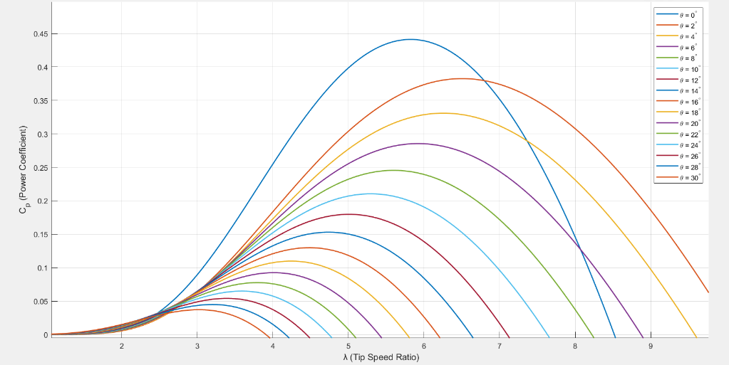
Fig. 1.1. Aerodynamic power efficient cp depending on the tip speed ratio λ and the pitch angle
2. Tip-Speed Ratio (λ) and Mechanical Torque
The tip-speed ratio is defined as [3]:

$$λ=\frac{ω_{t}∙R}{ν_{w}} (4)$$

where ω_{t} = turbine rotor speed (rad/s).
The mechanical torque Tm is:

$$T_{m}=\frac{P_{m}}{ω_{t}}=\frac{1}{2}ρπR^{3}\frac{C_{P}\left(λ,β\right)}{λ}ν_{W}^{2} (5)$$

3. Drive Train and Gearbox.
The drive train system is associated with blades attached to the low shaft which in turn connected to the gearbox. The primary function of a gearbox is that it aligns the necessary speed level of the generator and the wind turbine rotor by increasing the speed of the turbine rotor to the level required by the generator [20]. If the gearbox efficiency is 100%, then the gearbox ratio can be written as:
$$N=\frac{ω_{m}}{ω_{t}}=\frac{T_{m}}{T_{t}} (6)$$
where:
ωm and ωt are the generator and turbine rated speeds(rpm).
- Wind turbine design parameters
In MATLAB we can implement to model all the above equations to express actual behavior of wind turbine. For design and modeling 2MW wind turbine we may consider the following mechanical parameters (see table .1):

Table 1.1. mechanical parameters of wind turbine
Parameter | symbol | value
Mechanical Power (MW) | P_{t} | 2
Blade Radio (m) | R | 38
Gearbox ratio | N | 100
Inertia (kg*m²) | J | 90
air density (kg/m³) | ρ | 1.225
wind speed (m/s) | v_{w} | 12

- Doubly Fed Induction Generator (DFIG) General Configuration and Modeling
- Working principle
The most common configuration of the generator for present-day wind energy conversion systems (WECS), particularly for medium voltage (MV) power grid integration, is the Doubly Fed Induction Generator (DFIG). It enables speed control with the output power frequency maintained constant, this being one of the grid compatibility requirements.
The typical supply configuration of the DFIG is shown in Figure 2.1. The stator is directly connected to grid supplied by three-phase voltages at constant amplitude and frequency, creating the stator magnetic field [23, 24]. The rotor is also supply grid by three-phase voltages that take a different amplitude and frequency at steady state in order to reach different operating conditions of the machine (speed, torque, etc.). This is achieved by using a back-to-back three-phase converter, as represented in the simple schematic in the figure. This converter, together with the appropriate control strategy, is in charge of imposing the required rotor AC voltages to control the overall DFIG operating point and to perform the power exchange through the rotor to the grid. Although a voltage source converter is shown, different configurations or converter topologies could be utilized.
Fig. 2. 1.General supply configuration of DFIG

The doubly-fed induction generator wind turbine configuration uses a partial-scale frequency converter in the rotor circuit. It regulates the rotor voltage and hence independent active and reactive power control with a speed range of approximately ±30% of synchronous speed [25]. Compared to wind turbine configurations with full-scale frequency converter, the partial scale converter of the DFIG offers lower converter size, costs, and losses [26] and therefore the currently most promising generator concept for wind turbines is the doubly-fed induction generator. The power may be directed in two directions in the specified configuration. In the operating mode of an electric machine higher than the synchronous speed, power goes from the rotor to the power net, and, on the contrary, below the synchronous speed, average power is withdrawn by the rotor from the grid [27]. A grid-side converter ensures the stable link DC voltage. Moreover, it regulates the real as well as the reactive power transferring from the power net and the rotor. A rotor-side converter, on the contrary, varies the flux in order to manage the stator actual as well as the reactive power. Furthermore, a DFIG converter provides the reactive power feed. Figure 2.2 provides the scheme of the flow of the power of the DFIG. The generator may rotate below or above the synchronous speed. Power withdrawn by the converts, or the slip power, is determined by:
𝑷_{𝑹𝒐𝒕𝒐𝒓}= s 𝑷_{𝑺𝒕𝒂𝒕𝒐𝒓} (indicating zero stator and rotor losses) (2.1)
Stator true power of DFIG, Network power and mechanical power developed related by the following equation:

$$P_{Stator}=\frac{P_{Grid}}{(1-s)}=\frac{η_{g}∙P_{m}}{(1-s)} (2.2)$$
Fig. 2. 2. DFIG power flow

Where Pm represents the mechanical power and ηg is generator efficiency. The direction in which power flows between the rotor and the power network is determined by both positive and negative slip values. Whether the slip value is positive or negative, power moves from the stator to the power network [27].

- Equivalent Circuit of DFIG
The equivalent circuit of the Doubly Fed Induction Generator (DFIG) in an d-q reference frame (as shown in figure 2.2) (also referred to as the synchronously rotating reference frame) summarizes the physics of the machine in a compact form for analysis and control purposes. In the equivalent circuit, the time-dependent three-phase quantities (voltages, currents, and fluxes) are transformed into their d-q components, which are constant under steady-state conditions. This reference frame is much easier to use for understanding and controlling the performance of the DFIG especially for wind turbine applications.
Fig. 2. 3. DFIG d-q equivalent circuit
The stator voltage equations in the synchronous rotating reference frame are given by:

$$v_{ds}=R_{s}∙i_{ds}+\frac{{dψ}_{ds}}{dt}-ω_{s}∙ψ_{ds} (2.1)$$
$$v_{qs}=R_{s}∙i_{qs}+\frac{{dψ}_{qs}}{dt}-ω_{s}∙ψ_{qs} (2.2)$$

Similarly, the rotor voltage equations referred to the stator frequency (after transformation) are:

$$v_{dr}=R_{r}∙i_{dr}+\frac{{dψ}_{dr}}{dt}-{(ω}_{s}-ω_{r})∙ψ_{dr} (2.3)$$
$$v_{qr}=R_{r}∙i_{qr}+\frac{{dψ}_{qr}}{dt}-{(ω}_{s}-ω_{r})∙ψ_{qr} (2.4)$$

The flux linkages are defined as:

$$ψ_{ds}=L_{s}∙i_{ds}+ L_{m}∙i_{dr} (2.5)$$
$$ψ_{qs}=L_{s}∙i_{qs}+ L_{m}∙i_{qr} (2.6)$$
$$ψ_{dr}=L_{r}∙i_{dr}+ L_{m}∙i_{ds} (2.7)$$
$$ψ_{qr}=L_{r}∙i_{qr}+ L_{m}∙i_{qs} (2.8)$$
Where:
Rs and Rr are the stator and rotor resistances, Ls and Lr are the stator and rotor self-inductances, Lm is the mutual inductance, ωs is the synchronous speed, and ωr is the rotor electrical speed. These equations form the foundation for DFIG dynamic simulation and control design [28].
- Back-to-Back Converter Topology
- General Idea of RSC and GSC
In Doubly Fed Induction Generator (DFIG) based wind energy systems, the back-to-back converter is essential for maintaining control of the rotor-side and grid-side aspects of operation. The back-to-back converter consists of two voltage source converter (VSC) inverters coupled through a common DC-link capacitor. The rotor-side converter (RSC) governs the rotor currents allowing independent control of active power and reactive power. The grid-side converter (GSC) maintains the DC-link voltage and governs a sinusoidal current output to the grid. The RSC is controlled in the synchronous reference frame of the DFIG, and the RSC typically has the capability of vector control (field-oriented control) to independently control active torque and reactive flux within the DFIG. The RSC with vector control capability allows the RSC to perform maximum power point tracking (MPPT) as wind speeds constantly vary. The GSC maintains a constant DC-link voltage across the two converters when the generation fluctuates. The GSC also regulates the quality of the power being fed into the grid regarding harmonics and power factor requirements. The GSC output to the grid must be synchronized to the grid voltage waveform. A phase-locked loop (PLL) circuit is typically used for this purpose. In operation, both converters will regulate in switching control mode with the use of Pulse Width Modulation strategies. This switching will operate at several kilo Hertz (kHz). The effective switching frequency will ensure satisfactory harmonic distortion levels.
The benefits of using a back-to-back converter includes better dynamic characteristics, less mechanical stress on the wind turbine drive train, and the ability to operate under weak grid condition. In addition, it can also provide fault ride-through (FRT) capabilities because it can provide reactive power support during grid faults, thus complying with modern grid code requirements [28].
- Pulse Width Modulation (PWM) Generator
Pulse Width Modulation (PWM) is a key component in the control of power electronic converters and is commonly used for the back-to-back converter of a Doubly Fed Induction Generator (DFIG) system. The PWM generator modulates the switching signals of the Insulated Gate Bipolar Transistors (IGBTs) for both the rotor-side and grid-side converters. The PWM generator using sinusoidal PWM (SPWM) or space vector PWM (SVPWM) techniques to control the output voltage and current while minimizing the contribution of harmonic distortion from the converters. A comparison between a reference sinusoidal wave form and a high-frequency triangular carrier waveform yields the high-frequency switching signals from the PWM generator.
The advantages of having a back-to-back converter includes improved dynamic characteristics, reduced mechanical loading on the wind turbine drive train, and the versatility to be able to operate under weak grid conditions. It also provides "fault ride through" capabilities by providing reactive power support during grid faults and satisfying modern grid code requirements [28].

- Vector Control of DFIG Using an AC/DC/AC Converter
- General idea of Control
The control strategy of a DFIG is essential for ensuring efficient, stable, and flexible operation in changing wind and grid conditions. The DFIG system typically includes two main converters: the Rotor Side Converter (RSC) and the Grid Side Converter (GSC). These converters are linked through a DC-link capacitor (Fig .2.4).
Fig. 2. 4. control structure of the DFIG wind turbine: control stage for normal and fault operation

The control strategy of a Doubly Fed Induction Generator (DFIG) plays a pivotal role in ensuring efficient, stable, and flexible operation under varying wind and grid conditions. The DFIG system typically includes two key converters: the Rotor Side Converter (RSC) and the Grid Side Converter (GSC), which are connected via a DC-link capacitor.
The Rotor Side Converter (RSC) is primarily responsible for controlling the active and reactive power of the stator. It uses vector control, also known as Field-Oriented Control (FOC), to decouple the torque and flux components of the stator current. This control allows independent regulation of the electromagnetic torque and stator reactive power. The outer control loop implements Maximum Power Point Tracking (MPPT) by adjusting the reference torque based on wind speed, while the inner loop controls the d–q axis rotor currents using Proportional-Integral (PI) controllers.
The Grid Side Converter (GSC) maintains the DC-link voltage at a constant level and ensures a sinusoidal current injection into the grid. The GSC also supports reactive power exchange with the grid and contributes to voltage support during disturbances. A Phase-Locked Loop (PLL) is used for synchronization with grid voltage, and the GSC control is implemented in the synchronous reference frame to improve dynamic performance.
The control strategy also includes Fault Ride-Through (FRT) mechanisms, where the DFIG continues to operate during grid voltage dips by injecting reactive current into the grid. This is crucial for compliance with grid code requirements. Anti-windup techniques and current limiters are applied to ensure stable operation during transients.
This dual-loop PI control strategy ensures decoupled active and reactive power control, smooth grid interaction, and robust performance under various operating scenarios [28].
- Rotor Current Control Loops
In a Doubly Fed Induction Generator (DFIG), rotor current control loops are implemented as part of the Rotor Side Converter (RSC) control strategy using vector control in the rotating dq-reference frame. The main goal is to independently control the active and reactive power by decoupling the torque and flux components of the stator current.
The stator flux is aligned with the d-axis in the rotating reference frame. This allows the use of two separate Proportional-Integral (PI) controllers to regulate:
- The q-axis rotor current (i_{qr}) for active power (P) control
- The d-axis rotor current (i_{dr}) for reactive power (Q) control
Outer control loops are responsible for generating the current references (i_{qr}* and i_{dr}*) based on the desired active and reactive power. These references are fed into the inner current loops, where PI controllers regulate the actual rotor currents. The resulting voltage commands are then transformed back to the abc-frame and used to generate PWM signals for the RSC.
A typical control schematic diagram involves:

Fig. 2. 5. current control loops of the DFIG [23]

This rotor current control loop strategy ensures precise decoupling of power control, supports Maximum Power Point Tracking (MPPT), enhances dynamic response, and provides fault ride-through capability during grid disturbances.
- Power and Speed control loops
In DFIG-based wind turbines, power and speed control loops are integrated to ensure optimal energy extraction and stable grid interaction. The speed control loop operates primarily to implement Maximum Power Point Tracking (MPPT), which aims to maintain the optimal tip-speed ratio under varying wind conditions.
Once the current control loops and the flux angle calculation have been studied, the complete control system can be introduced. As the d-axis of the reference frame is aligned with the stator flux space vector, the torque expression in the dq frame can be simplified as follows [28]:

$$T_{em}=\frac{3}{2}P\frac{L_{m}}{L_{s}}∙\left(ψ_{qs}∙i_{dr}-ψ_{ds}∙i_{qr}\right) ⇒ T_{em}=-\frac{3}{2}P\frac{L_{m}}{L_{s}}\left|{\vec{ψ}}_{s}\right| i_{qr} ⇒T_{em}=K_{T}∙i_{qr} (2.9)$$

This expression clearly shows that the q-axis component of the rotor current i_{qr} is directly responsible for controlling the electromagnetic torque. Hence, by controlling i_{qr}, it is possible to influence the torque and, subsequently, the speed of the machine, depending on application requirements.
Similarly, by analyzing the reactive power in the stator, a compact relationship can be derived that highlights the role of the d-axis rotor current component idr. The stator reactive power Qs is initially given as:
$$Q_{s}=\frac{3}{2}\left(v_{qs}∙i_{ds}-v_{ds}∙i_{qs}\right) ⇒ Q_{s}=-\frac{3}{2}ω_{s}\frac{L_{m}}{L_{s}}\left|{\vec{ψ}}_{s}\right| \left(i_{dr}-\frac{\left|{\vec{ψ}}_{s}\right|}{L_{m}}\right)$$
$$⇒Q_{s}=K_{Q}∙\left(i_{dr}-\frac{\left|{\vec{ψ}}_{s}\right|}{L_{m}}\right) (2.10)$$
Therefore, because of the orientation chosen, it can be seen that both rotor current components independently allow us to control the torque and reactive stator power. In this way, based on these expressions,
Fig.2.5 illustrates the complete vector control of the DFIG. Maintaining the current loops studied in previous sections (Fig.2.5), a speed loop and a stator reactive power loop has been added. The necessity of the speed regulation depends on the application in which this machine is being used, and it could happen that the DFIM simply imposes an electromagnetic torque T_{em}, while the speed of the shaft is controlled by other elements.

Fig. 2. 6. Complete vector control of the DFIG

Simulation Results
This section examines the performance of the 2 MW DFIG-based wind energy system in MATLAB/Simulink software. The parameters of DFIG are used for the modeling and simulation in this paper are shown in Table 3.1.
Table. 3. 1. Electrical Parameters for 2MW DFIG
Parameter | symbol | value
Stator Active Power (MW) | Ps | 2
Stator Nominal Frequency (Hz) | fs | 50
Stator Line to Line Voltage(v) | Vs | 690
Stator Nominal Current(A) | Is | 1760
Nominal torque (N.m) | Tem | 12732
No. of Poles | P | 2
Synchronous speed (rpm) | n | 1800
Fig. 3.1 presents the electromagnetic torque control of the DFIG. The electromagnetic torque varies and tracks its reference value without overshooting and with a short settling time, showing that the rotor d-q axis current components are well decoupled. The performance affirms that the control actions on the RSC are working properly and that the mechanical system is responding well, ensuring smooth mechanical operation of the wind turbine.
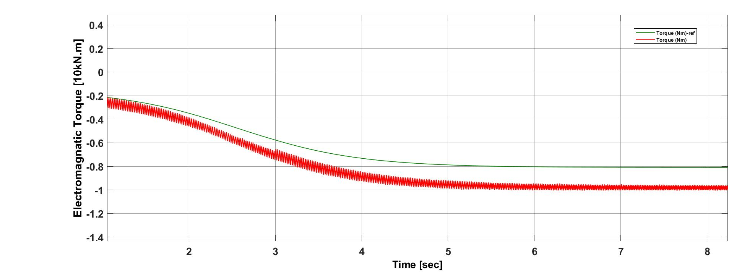
Fig. 3. 1. Electromagnetic torque produced by the generator.

The corresponding active power output is given in Fig. 3.2. The power output increases steadily to settle at 2 MW, which indicates successful power synchronization with excellent maximum power point tracking. The power output does not exhibit any ripple within this process, thus signifying effective implementation of the power control strategy developed.

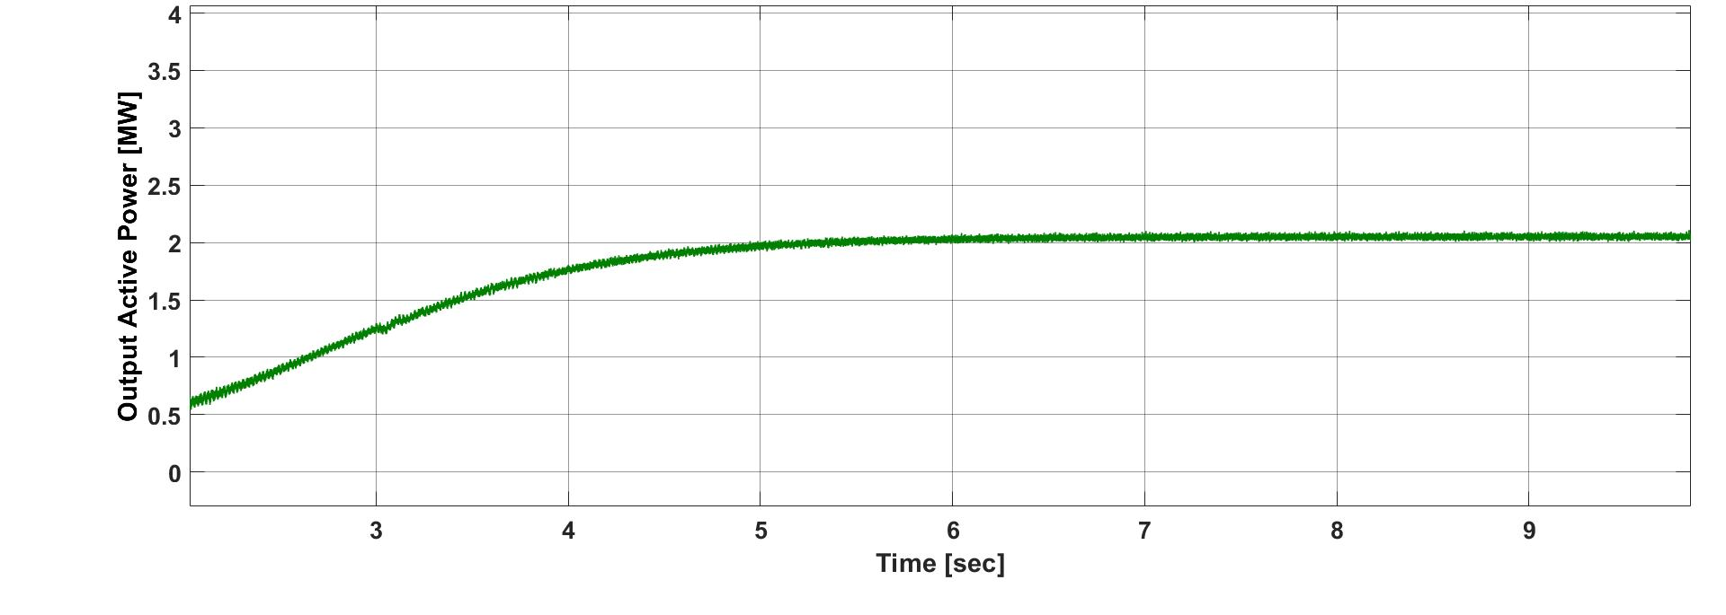
Fig. 3. 2. Active power output (P) to the grid

Reactive power performance of the system is depicted in Fig. 3.3. It can be noted that the system tracks its reference perfectly for reactive power control without any deviations, ensuring that the DFIG controller can control the system’s reactive power independently, which is a very effective process for voltage support in a weak network like the Herat Power Network.
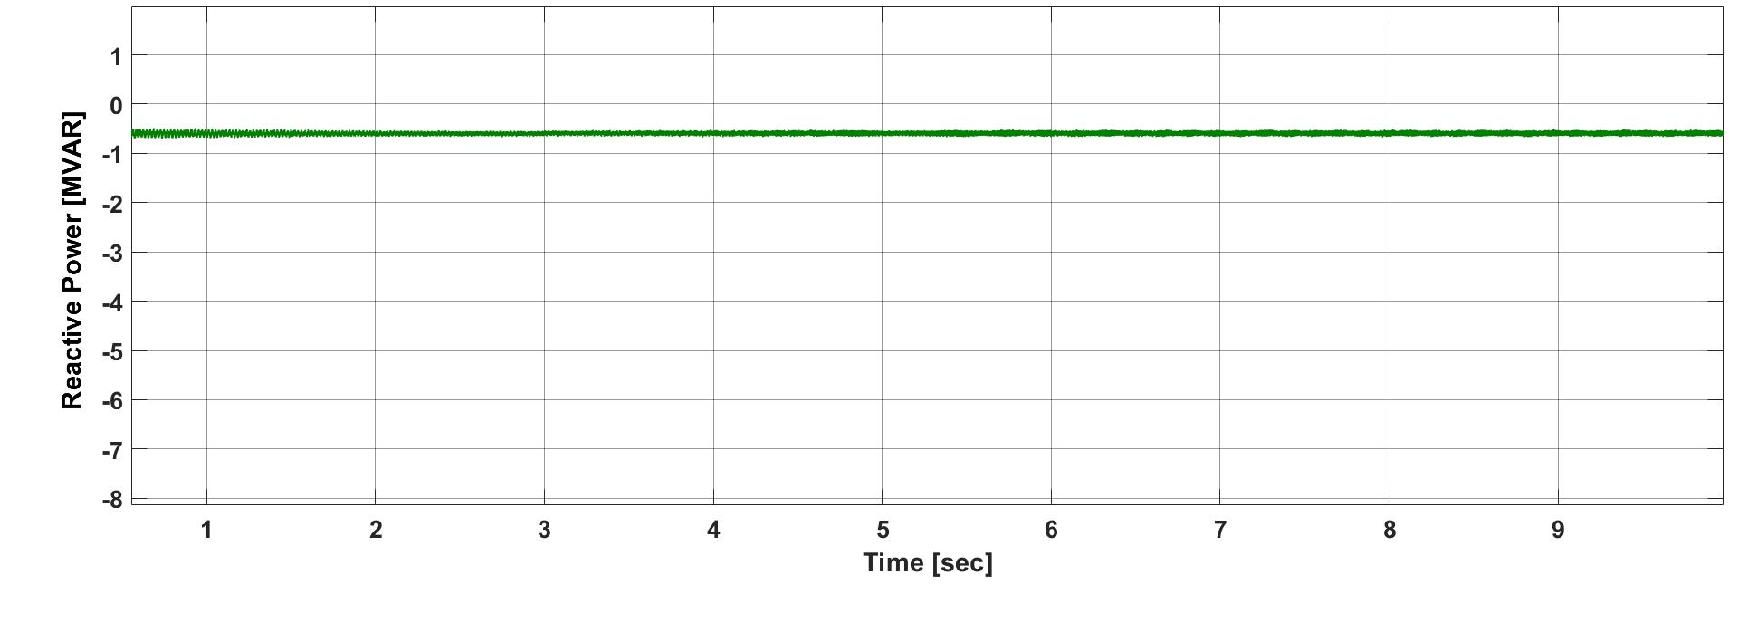
Fig. 3.3. Reactive power output (Q)to the grid.

Figure 3.4 above illustrates the DC-link voltage response in the back-to-back converter system. The DC-link voltage system behaves in such a way that it tries to maintain a constant nominal value without exhibiting larger transient deviations during the simulation period. This ensures proper functioning of the grid-side converter and reliable power flow from the rotor circuit to the grid system.

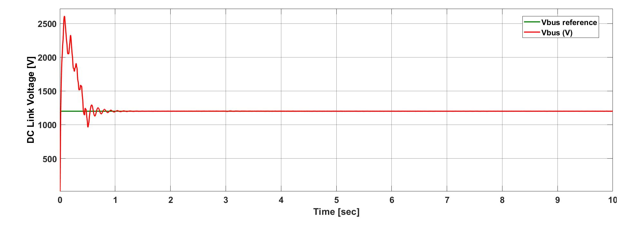
Fig. 3. 4.DC-link voltage across the capacitor in the back-to-back converter.

The stator line-to-line voltages are shown in Fig. 3.5. The stator voltages are balanced, sinusoidal, with equal amplitude and a phase difference of 120°. The sinusoidal shape of these voltages ensures optimum quality and thereby indicates that there is perfect grid synchronization along with effective elimination of harmonics that are produced due to PWM switching.
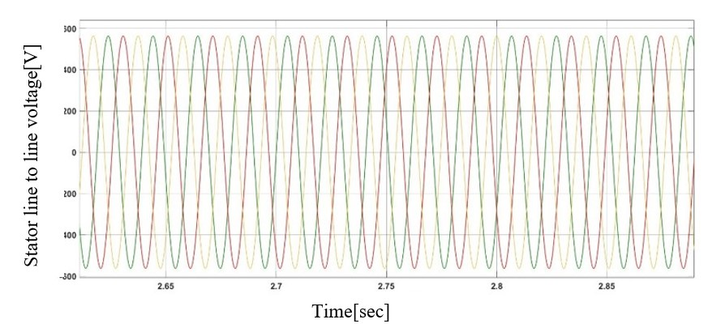
Figure 3.5. Stator Three Phase Voltage
Figure 3.6 shows the waveforms for the grid-side converter currents. The injected grid currents are sinusoidal and symmetric and demonstrate stability; hence, the power factor correction and/or the control of the currents injected into the grid by the grid-side converter are successful. This highlights the successful control of the currents injected into the grid by the grid-side converter.
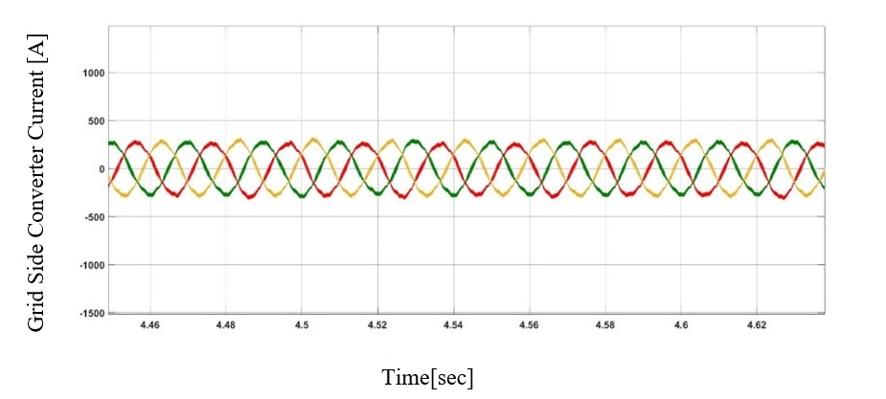
Figure 3.6. Grid Side Converter Current
Finally, Fig. 3.7 illustrates the performance of the rotor current. The value of the rotor current is bounded within its rated value, and there is a smooth waveform without distortions. This marks an effective performance of the rotor-converter controller, as the PI controllers have been tuned properly. A stable rotor current ensures that there is a smooth flow of electromagnetic torque with minimal electrical losses.
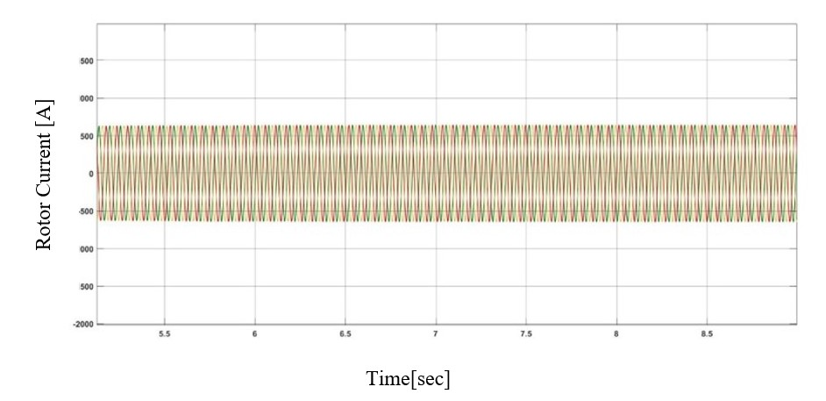
Figure 3.7. Rotor Current
In summary, from the results of simulation studies described above, it is seen that the developed 2 MW wind energy system based on DFIG with back-to-back PWM converter and PI control system proves effective for realizing a stable voltage and current waveform. Thus, this system proves useful for solving power deficiency issues of Herat Province by developing wind energy at a comparative advantage in Afghanistan.
IV. Discussion
The results underscore both the accuracy of the modeling approach and the efficiency of the implemented control strategy. Compared to earlier studies on DFIG wind systems, the present model shows significantly faster torque stabilization. For instance, Sobhy [30] reported a settling time of 0.14 s with conventional PI control, nonetheless with substantial torque peak, whereas our system achieves torque stabilization in under 1 s with reduced overshoot. From a fundamental perspective, the results validate theoretical advantages of vector control in DFIG systems, such as decoupled control of active/reactive power. The high correlation between and torque and the stabilization of near zero affirm the accuracy of the mathematical control framework described in classical literature (e.g., Mohapatra [31]). From an applicative perspective, the study examines the feasibility of integrating a 2 MW DFIG-based turbine into a 20 kV medium-voltage network, specifically in Herat, Afghanistan. The stable voltage and seamless active power delivery observed reflect that this system configuration can enhance local grid reliability—highlighting a marked improvement over fixed-speed induction generators, which typically lack such robustness under weak grid conditions. Recent advancements further contextualize these findings. Hete et al. [32] introduced an optimized NTM-PI controller, achieving a maximum overshoot of only 8.23% and a settling time of 0.93 s. Likewise, Boucetta [33] presented a fractional-order fuzzy logic controller (FOFLC) achieving 80% reduction in response time and substantial reductions in torque ripple and THD, signaling the potential of advanced controllers to further elevate performance. While this study focuses on steady-state behavior, its results lay the groundwork for examining dynamic challenges such as grid faults or large wind fluctuations. Future research may incorporate advanced control techniques like sliding mode or neural tuning forecasts to ensure stability under these demanding conditions.
In summary, the proposed control design demonstrates scientific significance, by validating theoretical control strategies, and practical relevance, by proving operational feasibility under realistic grid conditions. Thus, this work extends and refines existing DFIG control literature, paving the way for future developments in both theory and application.

V. Conclusion
This research presented the detailed modeling, control, and simulation of a 2 MW DFIG-based wind energy conversion system integrated into the 20 kV medium-voltage grid of Herat Province. The back-to-back converter with PI control effectively regulated both rotor and grid-side dynamics, ensuring stable delivery of active and reactive power. Simulation results showed excellent system stability, rapid dynamic response, accurate power regulation, and robust DC-link voltage maintenance. These findings demonstrate that DFIG-based wind systems represent a viable and technically sound solution for addressing Herat’s chronic electricity shortages. Future work may focus on fault ride-through enhancement, harmonics mitigation, and large-scale integration studies to further support wind energy deployment in Afghanistan.
Declarations
Funding: This research did not receive any specific grant from funding agencies in the public, commercial, or not-for-profit sectors.
Competing Interests: The authors declare no competing interests.
Acknowledgements: The authors would like to thank Kabul Polytechnic University for academic support.
References
[1] IPCC, 2023. Climate Change 2023: Synthesis Report. Intergovernmental Panel on Climate Change.
[2] GWEC, 2023. Global Wind Report 2023. Global Wind Energy Council.
[3] Milligan, M., Porter, K. and DeMeo, E., 2016. Wind power myths debunked. IEEE Power & Energy Magazine, 14(6), pp.89–99.
[4] National Renewable Energy Laboratory (NREL), 2020. Wind resource mapping in Afghanistan. U.S. Department of Energy, Technical Report NREL/TP-5000-78123.
[5] Ludin, G.A., Amin, M.A., Aminzay, A. and Senjyu, T., 2016. Theoretical potential and utilization of renewable energy in Afghanistan. AIMS Energy, 5, pp.1–19.
[6] Qureshi, A.S., 2020. Energy dependency in Afghanistan: A case study of Herat. Afghanistan Research and Evaluation Unit, Kabul.
[7] Ershad, H., et al., 2018. Renewable energy resource assessment for solar PV and wind in Balkh and Herat provinces of Afghanistan. University of Dayton.
[8] Anwarzai, A., 2019. Renewable energy resource assessment and site suitability in Afghanistan using GIS and MCDA. Tokyo University of Agriculture and Technology (TUAT)..
[9] Mostafaeipour, A., et al., 2020. Prioritization of locations for wind-to-hydrogen production in Afghanistan. International Journal of Hydrogen Energy, 45(47), pp.25413–25428.
[10] Sadeghi, P., et al., 2024. Evaluation of wind energy potential for hydrogen production in Afghanistan. Energy Reports, 10, pp.1–10.
[11] National Renewable Energy Laboratory (NREL), 2014. Afghanistan and Pakistan Wind Atlas. NREL, Golden, CO, USA.
[12] DTU/World Bank, 2020. Global Wind Atlas 3.0 – Afghanistan. Technical University of Denmark.
[13 Da Afghanistan Breshna Sherkat (DABS), 2019. Herat Wind Power Project – Feasibility Study. Kabul, Afghanistan.
[14] DABS, 2023. Renewable Energy Development Plan for Herat, Afghanistan. Da Afghanistan Breshna Sherkat.
[15] World Bank, 2021. Afghanistan Renewable Energy Potential Assessment. World Bank Group.
[16] Mahmoodi, A., 2021. Renewable Energy Assessment of Herat Province. Afghanistan Research and Evaluation Unit, Kabul. 2021.
[17] National Renewable Energy Laboratory (NREL), 2020. Wind resource mapping in Afghanistan. U.S. Department of Energy, Technical Report NREL/TP-5000-78123.
[18] Popal, M., et al., 2022. Geospatial analysis of wind energy potential in western Afghanistan. IEEE Transactions on Sustainable Energy, 13(2), pp.1124–1135.
[19] World Bank, 2021. Afghanistan Renewable Energy Atlas. Report 147256-AF.
[20] Aye, M.T. and Nang, S.Y.K., 2015. Performance analysis of doubly fed induction generator using vector control technique. International Journal of Electrical & Computer Engineering, 5, pp.929–938.
[21] Freris, L.L., 1990. Wind Energy Conversion System. Prentice-Hall, Upper Saddle River, New Jersey.

[22] Michalke, G., 2007. Variable Speed Wind Turbines – Modelling, Control, and Impact on Power Systems. PhD thesis, Wind Energy Department, Risø National Laboratory.
[23] Abad, G., López, J., Rodríguez, M.A. and Marroyo, L., 2011. Doubly Fed Induction Machine: Modeling and Control for Wind Energy Generation. John Wiley & Sons, Inc.
[24] Pena, R., Clare, J.C. and Asher, G.M., 1996. Doubly fed induction generator using back-to-back PWM converters and its application to variable-speed wind energy generation. IEE Proceedings - Electric Power Applications, 143(3), pp.231–241.
[25 Leonhard, W., 2001. Control of Electrical Drives. 3rd ed. Springer Verlag, Stuttgart.
[26] Hansen, A.D., Iov, F., Sørensen, P. and Blaabjerg, F., 2004. Overall control strategy of variable speed induction generator wind turbine. In: Nordic Wind Power Conference, 1–2 March, Chalmers University of Technology, Göteborg.
[27] Venkateshwarlu, S., Samyuktha, S., Sujatha, P. and K.N., 2018. Improvement of dynamic performance of DFIG-based wind turbine. Helix, 8(3), pp.3362–3367.
[28] Zhang, D., Wang, Y., Hu, J., Ma, S., He, Q. and Guo, Q., 2016. Impacts of PLL on the DFIG-based WTG’s electromechanical response under transient conditions: analysis and modeling. CSEE Journal of Power and Energy Systems, 2(2), pp.30–39.
[29] Abu-Rub, H., Malinowski, M. and Al-Haddad, K., 2014. Power Electronics for Renewable Energy Systems, Transportation and Industrial Applications. Wiley-IEEE Press.
[30] Sobhy, H. “Enhanced PI control for wind turbine DFIG systems,” Energy Reports, vol. XX, pp. XXX–XXX, 2025.
[31] Mohapatra.A, “MIMO linear quadratic regulator for DFIG wind turbines,” Clean Energy, vol. 8, no. 1, pp. 153–169, 2024.
[32] Hete, S., Shyam, R., Nagar, S. K. and Rajesh, K. “An efficient controller based on NTM–PI for wind turbine driven DFIG,” Scientific Reports, vol. 14, no. 1, pp. 1–15, 2024.
[33] A. Boucetta, “Fractional-order fuzzy logic controller for DFIG-based WECS,” Future Internet, vol. 7, no. 2, pp. 80–92, 2025.

