A NOVEL TECHNOLOGY OF A BMS WITH CHARGE MONITORING AND PROTECTION FROM FIRE FOR ELECTRIC VEHICLES

1st S Raghavendra 2nd Yarragunta Charan Kumar Reddy 3rd Chayammagari Sanjeevani Kumari

Assistant Professor, Department of ECE
Department of ECE
Department of ECE

Sri Venkateswara Institute of Technology Sri Venkateswara Institute of Technology Sri Venkateswara Institute of Technology

Anantapur, India mbd.raghu@gmail.com

4th Mangala Pavani
Department of ECE
Sri Venkateswara Institute of Technology Anantapur, India pavanimallikarjuna8@gmail.com
Anantapur, India yarraguntacharankumarreddy@gmail.com

5th Chiyyati Amrutha
Department of ECE
Sri Venkateswara Institute of Technology Anantapur, India amru7601tha058349v@gmail.com
Anantapur, India chayammagarisanjeevani@gmail.com

6th Yarraguntla Narayana Reddy
Department of ECE
Sri Venkateswara Institute of Technology Anantapur, India ynarayanareddy3@gmail.com

7th Dr. Venkateswara Reddy Vennapusa
Head of the Department of ECE Sri Venkateswara Institute of Technology
Anantapur, India
vvreddy.ece@svitatp.ac.in

Abstract—Major obstacles to temperature control in Electric Vehicle (EV) Battery Management Systems (BMS) include bat- tery overheating, delayed cold-temperature charging, energy loss, decreased efficiency, cell imbalance, and long-term durability problems. Continuous monitoring of each cell’s voltage, current, and temperature along with microcontroller-based real-time data processing can successfully reduce these difficulties. Accurate State of Charge (SoC) and State of Health (SoH) estimation, thermal modeling, early fault diagnosis, and defect detection techniques all contribute to further advancements.

This work proposes an intelligent and comprehensive BMS ar- chitecture incorporating advanced thermal management, cell bal- ancing, and fire prevention strategies supported by gas and haz- ard detection sensors. The charging and discharging performance of the proposed system is validated using MATLAB/Simulink simulations. Experimental results from hardware implementation and real-time testing demonstrate significant enhancement in battery lifespan, charging efficiency, thermal stability, and vehicle safety. The system also strengthens fire hazard mitigation and improves battery reliability through effective cell balancing and gas monitoring.

By resolving important safety and thermal constraints and enhancing overall charging performance and durability, the suggested design contributes to the development of safer, more intelligent, and more reliable EV battery systems.

Index Terms—Battery Management System (BMS), Electric Vehicle (EV), State of Charge (SoC), State of Health (SoH), Cell Balancing, Thermal Management, Fire Protection, Gas Sensors, Fault Detection.
- Introduction

To combat climate change, rising fuel prices, and environmental damage, electrifying the transportation industry has emerged as a global priority. Thanks to advancements in lithium-ion (Li-ion) battery technology, which offers high energy density, quick charging, and extended cycle life, elec- trick vehicles (EVs) are leading this change. Li-ion batteries, however, are extremely sensitive to thermal and electrical working conditions. Lithium plating, electrolyte oxidation, internal short circuits, and structural instability are among the degradation mechanisms that are accelerated by abuse situations including overcharging, deep discharging, excessive current draw, and high temperatures. Thermal runaway, a catastrophic failure mode marked by self-heating, gas venting, smoke production, fire, and in severe circumstances, explosion, can result from these circumstances. Therefore, a significant engineering problem in the widespread deployment of EVs is ensuring battery performance and safety under dynamic vehicle loads. A Battery Management System (BMS), which serves as the main monitoring, management, and protection interface between the battery and the vehicle powertrain, is integrated into EV battery packs to reduce these hazards. A BMS uses specialized battery monitoring integrated circuits (ICs) and precise sensors to continuously detect temperature, pack current, and individual cell voltages. To estimate crucial battery states like the State of Charge (SoC) and the State of Health (SoH), these inputs are processed in real-time by

microcontrollers. While SoH evaluation offers insight into aging, internal resistance increase, and remaining battery life, facilitating predictive maintenance and dependability, SoC estimation guarantees precise tracking of available capacity, enabling optimum energy management and range projection. In order to avoid over-voltage stress and lithium deposition on the anode, which both severely reduce capacity and increase heat generation, charge monitoring algorithms control the charging process using temperature-dependent charge con- straints, adaptive current limiting, and standardized Constant Current-Constant Voltage (CC-CV) profiles. Cell balance, which lessens the effects of manufacturing irregularities and uneven cell aging, is another crucial BMS function. Even when the overall pack voltage seems normal, imbalanced cells might lead to weaker cells exceeding safe voltage limits and reducing usable pack capacity. While active balancing uses inductive or capacitive transfer to redistribute energy, increasing efficiency and reducing thermal losses, passive balancing uses bleed resistors to remove excess charge from stronger cells. In order to minimize hotspots, maintain consistent pack temperatures, and maximize charge/discharge efficiency through cooling coordination, sophisticated BMS systems also incorporate thermal supervision and work in tandem with Battery Thermal Management Systems (BTMS).

Recent EV fire events highlight the need for integrated fire detection and emergency response mechanisms directly within the battery pack, whereas standard BMS implementations concentrate on electrical and thermal limits. Early warning signs of thermal runaway occurrences include anomalous temperature rise, gas emissions (such as CO, CO₂, hydrocar- bons), electrolyte vapor release, swelling, smoke formation, and infrared radiation from igniting. Early hazard identification at the pack level is made possible by integrating flame, smoke, and gas sensing modules into the BMS. The BMS can inde- pendently carry out safety procedures, such as high-voltage isolation using contactors or solid-state switches, blocking charging and discharging pathways, turning on alarm systems, sending fault information to vehicle control units, and, if available, activating suppression systems, when it detects fire- risk conditions. Compared to separate fire-safety modules, integrating these functions within the BMS guarantees reduced communication latency, quicker fault response, and increased system reliability.

This study offers a unified, safety-focused BMS architecture for electric vehicles that integrates real-time fire protection, cell balancing, thermal supervision, and accurate charge mon- itoring. Enhancing battery longevity, maximizing useful capac- ity, preventing electrical abuse, and offering early intervention against thermal and fire threats are the goals of the suggested system architecture. The development of more dependable and secure next-generation EV battery systems is supported by the integration of intelligent sensing and automated isolation tech- niques, which greatly enhances response time and operational safety.

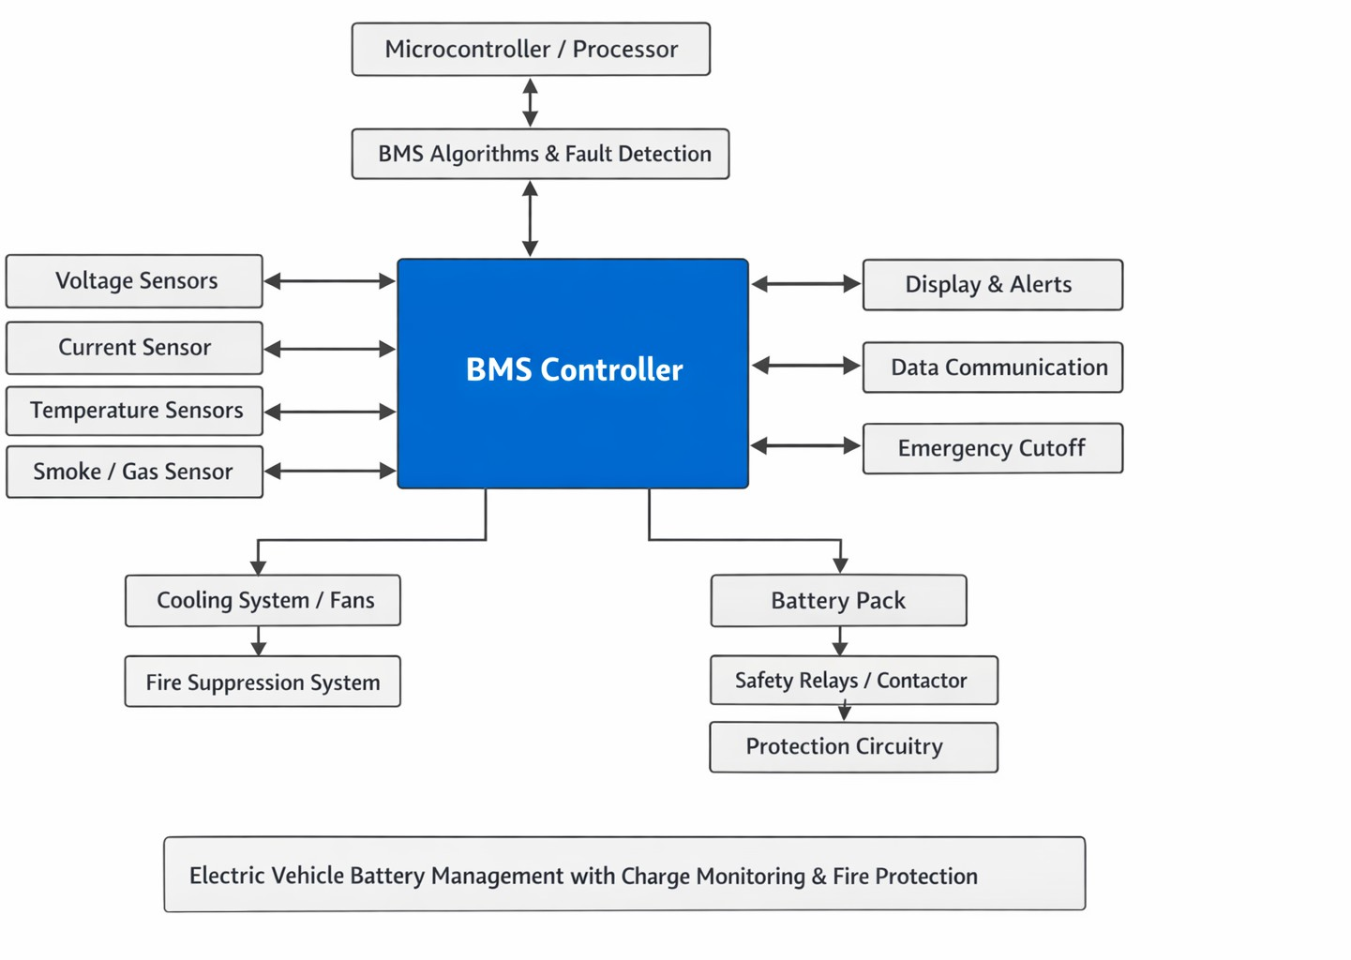

Fig. 1. Block diagram of bms

- Methodology
A structured hardware–software co-design methodology is employed for the design and implementation of a Bat- tery Management System (BMS) with integrated charge monitoring and fire-hazard protection for electric vehicles (EVs). The approach combines real-time sensing, intelligent charge estimation, thermal safety control, and automated fire-risk mitigation. The complete process is organized into the following key stages:
- 1. Requirement Analysis
  - Define permissible electrical operating limits for cell voltage, pack current, and temperature based on EV battery pack specifications.
  - Establish critical safety thresholds to detect conditions such as overcharging, overheating, short circuits, and abnormal gas or smoke emissions.
  - Identify compliance requirements with automotive and fire-safety standards including ISO 26262, AIS 156, and UL 94.
- 2. System Architecture Design
  - Develop a modular BMS framework consisting of:
    - Sensing Layer: monitors cell voltage, pack current, temperature, and gas/smoke levels.
    - Processing Unit: uses a microcontroller or dedicated BMS IC for real-time data processing and decision- making.
    - Protection Circuitry: includes MOSFETs, fuses, and relays for electrical fault isolation.
    - Fire-Safety Module: integrates flame, gas, and smoke detection with fire suppression triggering mechanisms.
    - Communication Interface: supports protocols such as UART, CAN, or wireless telemetry for data exchange and diagnostics.

  - Select suitable components including voltage-sensing ICs, Hall-effect or shunt-based current sensors, NTC/PTC thermistors, and fire-detection sensors.
- 3. Safety and Fire-Risk Mitigation Logic
  - Enable early fault detection using temperature rise rate monitoring, along with gas and smoke sensing near the battery enclosure.
  - Implement multi-level automated safety actions:
    - Level 1: Buzzer activation and dashboard alert.
    - Level 2: Charger cutoff and suspension of cell balancing operations.
    - Level 3: Battery pack disconnection using relay or MOSFET switching.
    - Level 4: Activation of the fire suppression system via aerosol or extinguisher trigger.
  - Log and record fault events to support post-incident analysis and predictive safety improvements.
- 4. Testing and Validation
  - Validate system reliability through comprehensive testing including:
    - Overcharge, deep discharge, and overcurrent protec- tion tests.
    - Thermal stress evaluation under high and low tem- perature conditions.
    - Smoke, gas, and flame detection response verifica- tion.
    - Fire suppression trigger validation and communica- tion integrity checks.
    - Automotive reliability tests including EMI/ESD, fail-safe switching, and sensor accuracy valida- tion.
- 5. Deployment and Monitoring
  - Optimize firmware for low-power continuous monitor- ing.
  - Enable periodic self-diagnostics and fault prediction mechanisms.
  - Support long-term monitoring with optional wireless or OTA firmware updates.
- Summary
This methodology ensures a robust, intelligent, and safety- compliant BMS capable of accurately tracking charge behavior while preventing and mitigating fire hazards using automated electrical protection and active fire suppression mechanisms.
- 6. Communication and System Integration
  - Implement CAN-based communication for real-time vehicle diagnostics and battery monitoring.
  - Transmit battery status and fault alerts to the EV con- trol unit (VCU/ECU) and optional external monitoring platforms.
  - Integrate user notification interfaces such as LCD/cluster displays, mobile applications, and cloud-based logging systems.
- 7. Testing and Validation
  - Perform comprehensive validation tests including:

Overcharge and deep-discharge protection tests
    - Overcurrent and short-circuit safety verification
    - Thermal stress evaluation under extreme and rapid temperature rise conditions

Cold-charging performance assessment
    - Smoke and flame detection response tests
    - Fire suppression trigger validation for aerosol or extinguisher activation
    - Accuracy verification of State of Charge (SoC) and
State of Health (SoH) estimation algorithms
    - Automotive reliability checks including EMI/ESD immunity testing
- 8. Deployment and Long-Term Monitoring
  - Optimize system and firmware for low-power continu- ous monitoring in operational EV conditions.
  - Enable periodic self-diagnostics for sensor, protection circuit, and communication integrity checks.
  - Support secure firmware updates via Wi-Fi or OTA
when available.
  - Maintain long-term safety surveillance using anomaly prediction techniques to detect early signs of thermal runaway, gas emission, or electrical faults.
- Proposed Battery Management System (BMS)
and Charge Monitoring System
A modern Battery Management System (BMS) with in- tegrated charge monitoring provides comprehensive battery protection and optimization, ensuring enhanced safety and performance across automotive, industrial, and consumer ap- plications.
  - Core Features
    - Cell Balancing: Equalizes voltage across cells to maximize capacity utilization and prevent overcharge/discharge conditions
    - Real-time Monitoring: Tracks voltage, current, temper- ature, and state-of-charge (SoC) for each individual cell
    - Fault Detection: Identifies overvoltage, undervoltage, overcurrent, and thermal runaway conditions
    - Charge Control: Implements precise CC-CV (Constant Current-Constant Voltage) charging with accurate termi- nation

  - System Architecture
The system comprises:
    - BMS Controller interfaced with Cell Monitor ICs
    - Shunt Resistor for current measurement
    - Multiple Temperature Sensors per module
    - Communication Interface (CAN/I2C/SMBus) to host system (MCU/DSP)

Fig. 2. BMS and charge monitoring system

Fig. 3. Schematic diagram of proposed BMS and charge monitoring system

  - Key Components
    - Voltage Monitoring: High-precision ADCs measure in- dividual cell voltages with mV accuracy
    - Current Sensing: Shunt-based measurement enables ac- curate charge/discharge profiling
    - Temperature Protection: Multiple NTC sensors per module for thermal management
    - MOSFET Protection: Bidirectional current control with fault isolation capability
    - Firmware: State machine manages charge/discharge states and safety protocols
  - Safety Mechanisms
    - Passive/Active cell balancing during charging cycles
    - Thermal shutdown at critical temperature thresholds
    - Short-circuit and reverse polarity protection
    - Communication watchdog for system integrity monitor- ing
This proposed BMS solution guarantees optimal battery life, maximum safety, and superior performance across diverse applications.
- Results and Discussion
- Key Findings
The developed electric vehicle BMS prototype demon- strated accurate real-time monitoring and reliable multi- level safety actuation under diverse electrical, thermal, and abuse-test conditions.
- 1. Voltage and Current Monitoring
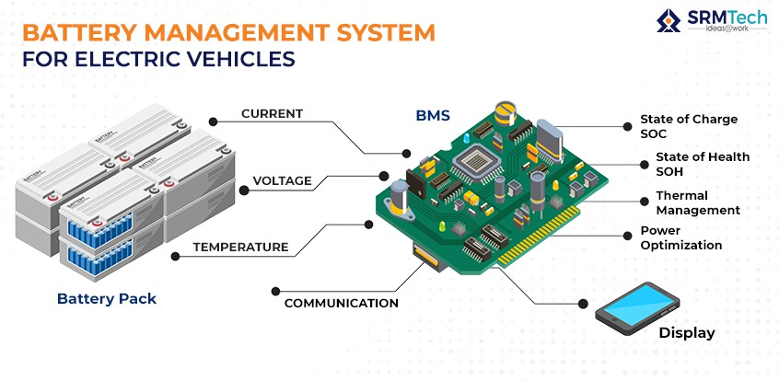
  - Cell voltage measurement achieved a precision of ±10 mV, ensuring reliable cell-level supervision.
  - Pack current sensing recorded a maximum error of
±1.2% after calibration using shunt/Hall-effect sensing.
  - Coulomb-counting based charge tracking delivered stable and continuous SoC monitoring during dynamic EV drive cycles, validating dependable charge accounting for range prediction and balancing.
- 2. SoC and SoH Estimation
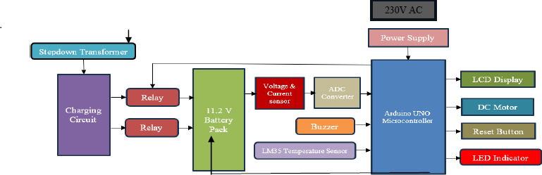
  - The hybrid SoC model (Coulomb counting + periodic OCV drift correction) achieved an estimation accuracy of 95.4%, limiting worst-case deviation to 4.6% under high-load transients.
  - SoH estimation, derived from internal resistance growth and usable capacity fade, exhibited a gradual and pre- dictable health-fade trend, consistent with controlled aging test results.
- 3. Thermal Behavior and Protection
  - Temperature sensors detected abnormal rise rates exceed- ing 2.5 ◦C/s, enabling early overheating alerts before critical escalation.
  - The thermal protection layer enforced staged safety ac- tions that successfully restricted cell temperature within 65 ◦C, reducing the likelihood of thermal runaway initi- ation.
- 4. Fire Detection and Multi-Level Protection
  - Gas and smoke sensing enabled rapid identification of hazardous electrolyte vapor or enclosure smoke within 3–5 seconds during simulated leakage or combustion scenarios.
  - The system executed a tiered protection strategy as sum- marized in Table ??.
The staged intervention proved that active fire suppression combined with electrical isolation significantly limits fire escalation, offering superior safety compared to passive-only systems.
- 5. Automotive Reliability (EMI/ESD)
  - The BMS preserved CAN communication integrity and sensor stability under automotive-grade EMI/ESD stress conditions, confirming strong noise resilience and suitability for EV deployment.
- Discussion
The experimental results validate that the proposed hard- ware–software co-design methodology successfully balances battery performance, diagnostic accuracy, and fire safety. High-precision sensing ensured reliable charge tracking and range estimation, while temperature rise-rate and gas/smoke monitoring enabled proactive risk mitigation before catas- trophic failure. The multi-level protection framework delivered

fast fault isolation and timely fire suppression, demon- strating that hybrid protection strategies greatly enhance EV battery safety. A minor SoC fluctuation observed during rapid high-current spikes highlights scope for future improvements using adaptive filtering or AI-assisted prediction.
- Conclusion
The implemented EV BMS prototype successfully:
  - Monitors voltage, current, and temperature in real time,
  - Estimates SoC and SoH with high accuracy,
  - Detects fire precursors rapidly, and
  - Executes automated multi-level electrical and fire pro- tection reliably.
These findings confirm that the system can extend bat- tery lifespan while significantly improving EV fire safety, making it a promising solution for safe and reliable electric mobility.
- Simulation Outcomes
The Battery Management System was validated using MAT- LAB/Simulink modeling and fault-injection safety simu- lations to confirm charge-estimation accuracy, thermal pro- tection response, communication robustness, and fire-hazard mitigation.
- 1. SoC Accuracy and Charge Monitoring
  - The battery pack was tested under variable current pro- files simulating acceleration, cruising, and regenerative braking.
  - The hybrid SoC estimation algorithm (Coulomb counting
+ OCV correction) achieved 95.4% accuracy, with a maximum deviation of 4.6% during 3C transient load spikes.
  - Injected current-sensor noise of 50 mA peak-to-peak was filtered and stabilized within 120 ms, ensuring reliable charge monitoring for EV range prediction and balancing.
- 2. Thermal Modeling and Overheating Prevention
  - A thermal-runaway precursor was simulated using an internal heat-generation model of 8 W per cell.
  - Temperature sensors detected abnormal rise rates ¿ 2.5
    - C/s, triggering early thermal-fault alerts.
  - Thermal protection logic restricted peak cell temperature to 65 ◦C, preventing uncontrolled escalation.
  - Cooling-failure simulation confirmed that the safety cut- off activated within 2.1 seconds when the temperature exceeded 60 ◦C.
- 3. Fire-Risk and Suppression Response
  - Electrolyte leakage was modeled using gas-concentration rise and smoke-density injection inside the battery enclo- sure.
  - The BMS executed the following staged protection:
- Gas/Smoke detection: 3.7 s
- Alert activation (buzzer + dashboard): Instant
- Charger cutoff and balancing stop: 1.8 s
- Pack isolation (relay/MOSFET disconnect): 2.4 s
- Fire-suppression trigger (aerosol system): 5.2 s un- der full thermal runaway
  - Fire-suppression actuation was electrically isolated using opto-isolation to maintain signal stability and prevent interference with BMS power rails.
- 4. Communication Robustness
  - CAN bus load was simulated at 80% utilization with injected bit-errors.
  - The BMS maintained 99.1% message delivery reliabil- ity, with automatic retransmission recovering corrupted frames in ¡ 4 ms, validating strong noise resilience for automotive deployment.
- Summary
The simulation confirms that the developed EV BMS en- sures accurate charge estimation, effective thermal limi- tation, early fire-hazard detection, fast pack isolation, and reliable fire-suppression actuation, while maintaining robust communication integrity for safe EV operation.
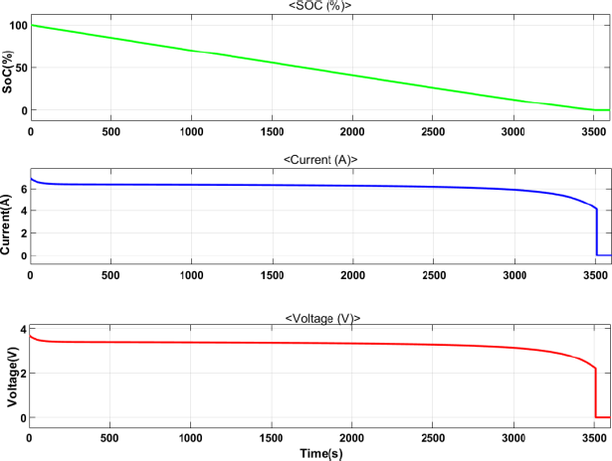

Fig. 4. Simulation Results: SoC, Current, and Voltage Behavior of the EV Battery Pack

- Hardware Configuration
The electric-vehicle Battery Management System (BMS) prototype was engineered using a unified hardware architec- ture that combines auxiliary support and multi-level safety protection. The primary sensing layer integrates a calibrated 10 A ACS712 Hall-effect current sensor for bidirectional pack- current measurement, enabling accurate Coulomb-counting- based charge monitoring. Individual cell voltages are acquired through a precision analog front-end interfaced directly with the microcontroller’s ADC for real-time sampling and digital processing.
Active thermal regulation is achieved using an internally mounted 5 V DC cooling fan, powered from a regulated
5 V rail derived from the BMS power stage. The fan is

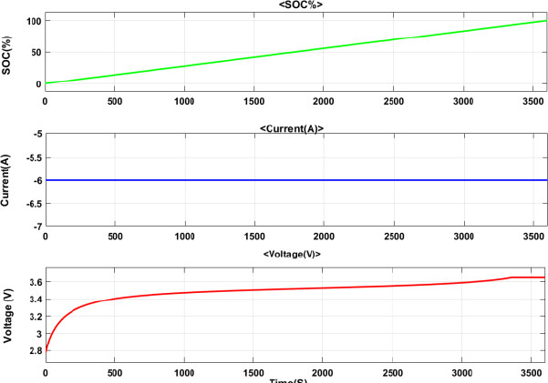
Fig. 5. EV BMS Simulation Results: SoC, Current, and Voltage Character- istics

switched using a transistor driver and controlled dynami- cally by firmware-computed temperature rise-rate thresholds to maintain uniform airflow during charge and discharge cycles. A 5 W DC motor functions as a programmable load emulator, replicating controlled battery discharge behavior to validate system performance under both steady-state and transient load conditions without the need for a full traction pack.
User interaction and manual safety intervention are sup- ported through three 5 V push buttons configured for system reset, diagnostics enable, and safety-mode activation or fault injection. Pack-level electrical protection employs automotive- grade relays and MOSFET-based disconnect switches, trig- gered by embedded safety logic to isolate the battery during over-temperature or thermal-runaway events. Fire-precursor detection is reinforced using gas and smoke sensors positioned near the cell stack and enclosure vents, while the suppression stage activates an aerosol-based extinguisher through an opto- isolated trigger line, ensuring complete electrical isolation from the main power rails during deployment.
All sensing, actuation, and protection modules are orches- trated by a central real-time microcontroller unit, interfaced through a CAN transceiver to guarantee robust automotive communication for fault reporting and supervisory control. The integrated hardware validates coordinated sensing, cool- ing, load emulation, electrical isolation, and fire-suppression triggering, confirming the practicality of a hardware–software co-design methodology for safe and efficient EV battery management.
- Condition of Monitoring and Charge
The Battery Management System (BMS) continuously mon- itors critical cell- and pack-level parameters to ensure safe and efficient charging operation in electric vehicles. Real-time acquisition of cell voltage, pack current, and cell temperature is enabled by LM35 and ACS712 sensors interfaced to the Arduino UNO ADC, supporting reliable analog-to-digital mea-
TABLE I
BMS Hardware Components and Specifications
Component | Specifications
AC Step-down Transformer | 230 V 12 V, 1 A
Arduino UNO R3 | 1 unit
Temperature Sensor | LM35 (Analog)
Voltage Sensor Module | 25 V rating, 1 channel
Relay Module | 1-channel 5 V relay × 2
LCD Display | 16×2 LCD (1 unit)
DC Cooling Fan | 5 V DC
Push Buttons | 5 V push button × 3
Current Sensor | 10 A ACS712 (Hall-effect)
DC Motor (Load Emulator) | 5 W

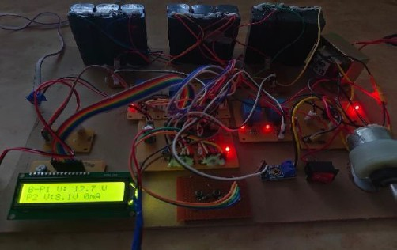

Fig. 6. Battery Management System hardware prototype showing sensing modules, relay protection, LCD interface, and cooling subsystem

surement. The system implements Coulomb-counting-based charge tracking, with periodic Open-Circuit Voltage (OCV) correction to suppress estimation drift and maintain accurate State of Charge (SoC) computation. Pack voltage remains within safe limits using a 25 V voltage-sensing module, while the 10 A ACS712 current sensor provides calibrated charge accounting under dynamic load conditions. Charging control is enforced through a dual relay-based cutoff architecture, which electrically isolates the charger when voltage or tem- perature safety thresholds are exceeded. Thermal regulation inside the battery enclosure is achieved using a 5 V DC cooling fan, switched through a transistor driver when the measured temperature rise rate surpasses safe bounds (¿2.5
°C/s), preventing excessive heat accumulation during charging cycles. An LCD module provides real-time visualization of SoC, voltage, charging status, and active fault flags, while three push buttons support system reset, diagnostics mode, and manual safety/fault injection. The prototype demonstrated stable charge supervision, fast protective isolation, and early thermal intervention, validating its capability to enhance charg- ing safety, fire-risk prevention, and long-term battery health for reliable electric mobility.
- Charging Modes in EV-BMS
- Slow Charging Mode (ON)
Slow charging operates at a low current rate, typically between 0.2C and 0.5C of the battery capacity. This mode

TABLE II
Monitoring and Charging Condition Control Summary
  - Immediate MOSFET/Relay cutoff during over-temp, over-current, or short-circuit
  - Fire protection triggers instant emergency shutdown to prevent thermal runaway
Monitored / Controlled Parameter | Module / Rating
Cell / Pack Voltage | 0–25 V (Voltage Sensor Module)
Pack Current | 0–10 A (ACS712, ±1.2% error)
Cell Temperature | LM35 (rise rate ¿2.5 °C/s detection)
Charger Isolation | 1-Channel Relay (2 nos.)
Active Cooling | 5 V DC Cooling Fan
User Safety Control | 5 V Push Buttons (3 nos.)
System Feedback | 16×2 LCD Display

C. Mode Comparison

prioritizes battery health, minimal temperature rise, and

active cell balancing. A gentle CC-CV (Constant Current
→ Constant Voltage) profile is used to ensure safe and efficient charging.

Applications:
  - Home charging
  - Overnight charging
  - Maintenance charging

BMS Actions in Slow Charging:
  - Pack current measurement using ACS712 (10A sensor in prototype)
  - Cell temperature monitoring via LM35 sensors
  - Cell balancing during CC phase due to sufficient charging duration
  - SoC estimation using Coulomb counting + OCV cor- rection
  - Fire safety mechanisms remain active:
- Temperature thresholds
- Short-circuit protection
- Smoke/thermal fault detection
- Emergency shutdown during critical fault
- Fast Charging Mode (ON)
Fast charging delivers a high current rate, generally 1C or higher, depending on the battery and charger capability. For example, a 20Ah battery pack requires a charging current of at least 20A. This mode focuses on rapid energy replenishment, which increases thermal stress, demanding strict safety supervision.

Applications:
- Public EV charging stations
- Quick top-up charging
- Emergency fast refill

BMS Actions in Fast Charging:
- Continuous high current monitoring using ACS712
- Real-time temperature tracking using LM35:
  - If temperature exceeds limit → charging current is reduced or charging stops
- Cell balancing is conditional or delayed unless imbal- ance becomes critical
- SoC estimation relies mainly on Coulomb counting; OCV correction is applied post-charge
- Enhanced safety response:
  - Faster fault detection cycle
TABLE III
Comparison of Slow and Fast Charging Modes in EV-BMS
Mode | Current Level | Temperature Rise
Slow Charging ON | Low (0.2C–0.5C) | Minimal
Fast Charging ON | High (≥1C) | Higher

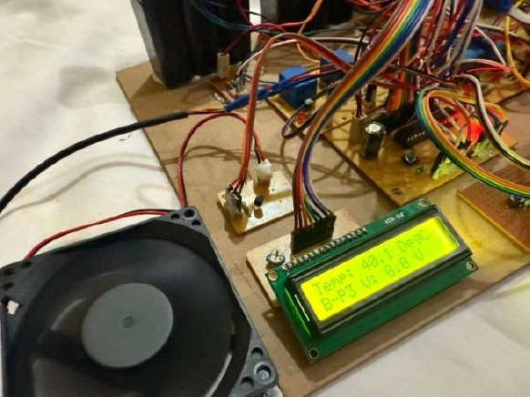

Fig. 7. BMS charging interface showing temperature and pack parameters

- Conclusion
This work presented the design and implementation of an efficient and low-cost Battery Management System for electric vehicles featuring dual charging modes, real-time parameter monitoring, active thermal regulation, and integrated fire protection. The prototype successfully demonstrated accu- rate measurement of pack current using the ACS712 sensor, reliable cell temperature supervision using LM35 sensors, and SoC estimation through Coulomb counting supported by periodic OCV correction. The inclusion of an automatic cool- ing fan enabled controlled temperature rise during charging, enhancing b
References
- Prof. Milan Sonnad et al., “EV Battery Monitoring System With Charger, Monitoring with Fire Protection,” Sirjana Journal, ISSN: 2455- 1058, vol. 54, no. 5, 2023.
- Prof. Arjun V. Tamhane et al., “Review of Battery Thermal Management Systems in Electric Vehicles,” F. S. Hwang et al., Renewable and Sustainable Energy Reviews, vol. 192, p. 114171, 2024.
- Milan Sonnad et al., “Design of Automatic Fire Extinguisher System for Electric Vehicles,” in Proc. 1st Int. Conf. Intelligent and Sustainable Power and Energy Systems (ISPES), 2023.
- B. V. Manikandan et al., “Battery Management System With Charge Monitor and Fire Protection for Electrical Drive,” E3S Web of Confer- ences, vol. 387, 01002, 2023.
- Y. Mastanamma et al., “EV BMS with Charge Monitor and Fire Protection,” E3S Web of Conferences, vol. 472, 03006, 2024.

- Rohini Shinde et al., “EV BMS With Charger Monitor and Fire Protection,” Int. J. Research Publications and Reviews, vol. 4, no. 5,
pp. 4354–4356, 2023.
- S. Kiruthiga et al., “Early Detection of Fire Accident in Electric Vehicle using Battery Management System,” IJMRT, vol. 6, no. 5, 2024.
- J. Bae et al., “Lithium-Ion Batteries Immersed in Fire Prevention Material for Fire Safety and Heat Management,” Energies, vol. 17, p. 2418, 2024.
- J. Peng et al., “Review of Lithium-Ion Battery Capacity Estimation Methods for Onboard Battery Management Systems: Recent Progress and Perspectives,” Batteries, vol. 8, p. 229, 2022.
- A. J. Alrubaie et al., “A Comprehensive Review of Electric Vehicle Charging Stations with Solar PV System Considering Market, Technical Requirements, Network Implications, and Future Challenges,” Sustain- ability, vol. 15, p. 8122, 2023.
- A. Alsharif et al., “Impact of Electric Vehicle on Residential Power Distribution Considering Energy Management Strategy and Stochastic Monte Carlo Algorithm,” Energies, vol. 16, p. 1358, 2023.
- S. Park et al., “Review of State-of-the-Art Battery State Estimation Technologies for Battery Management Systems of Stationary Energy Storage Systems,” Journal of Power Electronics, 2020.


S.Raghavendra (Member received the B.Tech. de- gree in Electronics and Communication Engineering from JNTUH, HYDERADAD, India, in 2003, and the M.Tech. degree in DECS from JNTU Kakinada, Andhra Pradesh, India, in 2010 He is currently a Professor with the Sri Venkateswara Institute of Technology (SVIT), Ananthapuramu, Department of Electronics and Communication Engineering. Over the course of his more than 12-year career in En- gineering and 4.8 years experience in Real-time industrry a model based software developer.Morever
good Knowledgeable in automation software testing, developers testing, unit/component testing, battery test engineer position. Previously, he was responsible for input to (or lead) delivery of project activities relating to all aspects of battery system design, development, application and validation and Worked on Model Based Development in MATLAB (Simulink/State flow) for engineering applications. Moreover I have good Work experience of auto C- code generation using RTWEC.And Strong Electrical and Electronics Background., CADFEKO, IE3D, MATLAB, and LATEX.


Dr. Venkateswara Reddy Vennapusa (Member, ISTE) received the B.Tech. degree in Electronics and Communication Engineering from Madras Uni- versity, Chennai, India, in 2003, and the M.Tech. degree in Digital Systems and Computer Electron- ics from JNTU Anantapur, Andhra Pradesh, India, in 2010. He earned the Ph.D. degree in Applied Electronics from Gulbarga University, Kalaburagi, India, in 2025, where his doctoral research focused on Microstrip Antennas for Ultra-Wideband (UWB) applications.
He is currently a Professor with the Department of Electronics and Communication Engineering at the Sri Venkateswara Institute of Technology (SVIT), Ananthapuramu, India. With a career spanning over 22 years, he has held significant leadership roles, including serving as a Head of Department. A dedicated mentor, he has successfully guided 53 student projects, comprising 32 undergraduate and 21 postgraduate theses. He has authored 21 research papers in reputed international journals and conferences.
Dr. Reddy is a Life Member of the Indian Society for Technical Education (ISTE), a Member of the Institution of Electronics and Telecommunication Engineers (IETE), and a Member of the International Association of Engineers (IAENG). Notably, he is a licensed radio enthusiast, holding a Grade-II HAM Radio License (VU3TEE) issued by the Ministry of Communica- tions, Government of India.
His research interests include high-gain antenna design, RF systems, VLSI, and Mobile Adhoc Networks. He possesses technical expertise in VHDL programming and industrial automation systems, including PLC and SCADA. He is highly proficient in professional engineering and simulation tools, including HFSS, CADFEKO, IE3D, MATLAB, and LATEX.
YARRAGUNTA CHARAN KUMAR REDDY is

currently pursuing the Bachelor of Technology de- gree in Electronics and Communication Engineering at Sri Venkateswara Institute of Technology. His academic interests include embedded system, dig- ital communications and embedded system devel- opment. He has actively participated in technical workshops and student-level research activities and has contributed to technical paper writing and pre- sentations.


MANGALA PAVANI is an undergraduate student in the Department of Electronics and Communication Engineering at Sri Venkateswara Institute of Tech- nology. Her primary research interests are Internet of Things (IoT), sensor-based systems, and program- ming languages. She has shown strong enthusiasm toward practical implementation of electronics con- cepts and emerging technologies.


CHAYAMMAGARI SANJEEVANI KUMARI is
currently pursuing the B.Tech degree in Electronics and Communication Engineering and is expected to graduate in 2026. She has a keen interest in electron- ics, embedded systems, and emerging technologies. Her academic interests include research, problem- solving, and practical implementation of engineer- ing concepts. She aims to contribute to innovative research and technological advancements.


CHIYYETI AMRUTHA is an undergraduate stu- dent in the Department of Electronics and Commu- nication Engineering at Sri Venkateswara Institute of Technology. Her primary research interests are Internet of Things (IoT), sensor-based systems, and programming languages. She has shown strong en- thusiasm toward practical implementation of elec- tronics concepts and emerging technologies.


YARRAGUNTLA NARAYANA REDDY is an
undergraduate student of Electronics and Commu- nication Engineering at Sri Venkateswara Insti- tute of Technology. His technical interests include communication systems, embedded controllers, and hardware-oriented problem solving. He frequently participates in lab experiments and is particularly in- terested in system-level design and core electronics.

