DR.Rais Abdul Hamid
Khan¹, B.Vardhini², V.HimaBindhu³, Y.Sanjana reddy⁴,Syeda irtaqa dawar⁵.
¹Professor,SOCSE,Sandip University,Nashik.
² ³ ⁴ ⁵ B.TECH Scholar,School of Computer Science and Engineering,Sandip University,Nashik,India.

Abstract

Social justice and diversity in institutions focus on building fair, inclusive, and equitable systems that respect and value differences among individuals from varied social, cultural, economic, and demographic backgrounds. Social justice emphasizes equality, human rights, and the elimination of discrimination, while diversity highlights the recognition and inclusion of differences related to gender, caste, ethnicity, religion, language, disability, and socioeconomic status. Institutions such as educational organizations, workplaces, and government bodies play a crucial role in promoting these principles through inclusive policies, equal opportunities, and ethical governance.
By integrating social justice and diversity into institutional frameworks, barriers faced by marginalized and underrepresented groups can be reduced. Inclusive practices help ensure access to education, employment, leadership roles, and decision-making processes for all individuals. Diversity within institutions encourages mutual respect, cultural understanding, innovation, and collaborative problem-solving. Furthermore, socially just institutions strengthen democratic values, promote accountability, and support sustainable social and economic development. Overall, the promotion of social justice and diversity is essential for creating inclusive institutions that contribute positively to societal progress and social harmony.

Social justice and diversity

- Introduction
- Social justice and diversity are essential principles that guide institutions toward fairness, equality, and inclusiveness in society. Social justice refers to the idea that every individual deserves equal rights, opportunities, and access to social, economic, and political resources, irrespective of their background. It seeks to eliminate discrimination, exploitation, and inequality while promoting human dignity and social well-being. Diversity emphasizes the recognition, respect, and acceptance of differences among individuals, including differences in race, caste, gender, ethnicity, religion, language, age, disability, sexual orientation, and socio-economic status. Together, social justice and diversity aim to create environments where all individuals feel valued, respected, and empowered.
- Institutions—such as educational institutions, workplaces, healthcare organizations, legal systems, and government bodies—play a vital role in shaping societal structures and influencing individual opportunities. These institutions often reflect broader social inequalities; therefore, their commitment to social justice is critical in addressing historical and systemic disadvantages faced by marginalized and underrepresented groups. By implementing inclusive policies, equitable practices, and anti-discriminatory frameworks, institutions can actively reduce barriers that limit participation and access to resources.
- Diversity within institutions enhances social justice by ensuring representation of varied perspectives and experiences. When institutions include people from diverse backgrounds in leadership, decision-making, and daily operations, they promote fairness and mutual understanding. Diverse institutional environments encourage dialogue, challenge stereotypes, and foster innovation by integrating multiple viewpoints. This inclusivity leads to more informed decisions, improved problem-solving, and stronger institutional performance.
- Educational institutions, in particular, serve as powerful platforms for promoting social justice and diversity. Through inclusive curricula, equitable admission policies, and supportive learning environments, they help students understand social inequalities and develop respect for diversity. Similarly, workplaces that prioritize diversity and fairness create equal employment opportunities, prevent bias, and promote professional growth for all employees. In healthcare and governance, socially just and diverse institutions ensure that services are accessible, culturally sensitive, and responsive to the needs of all communities.
- In today’s globalized and multicultural world, the importance of social justice and diversity in institutions has become even more significant. Institutions that fail to address inequality risk perpetuating social divisions and exclusion. Conversely, those that actively promote social justice and diversity contribute to social cohesion, democratic values, and sustainable development. By fostering equity, inclusion, and respect for differences, institutions play a crucial role in building a just society where every individual has the opportunity to thrive.

- Concept of social justice

- Social justice refers to the idea of creating a society based on equality, fairness, and respect for human dignity, where every individual enjoys equal rights and opportunities. It aims to remove social, economic, and political inequalities and ensure that all people, especially disadvantaged and marginalized groups, are treated justly.

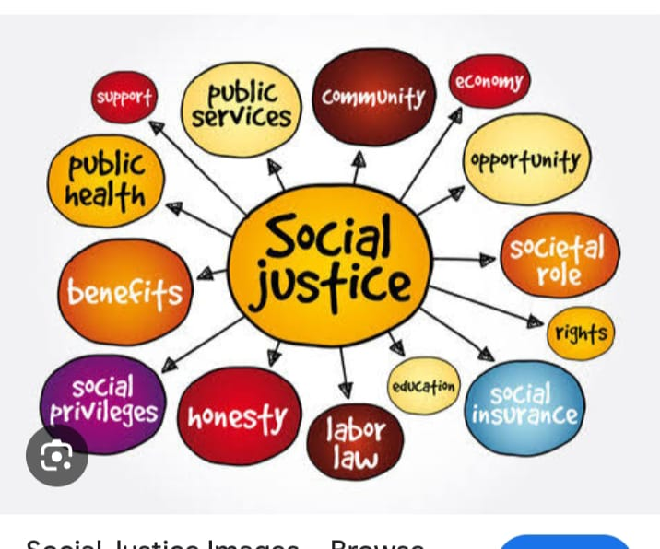

- The concept of social justice emphasizes that equality does not mean treating everyone the same, but treating everyone fairly by providing special support to those who are socially or economically backward. It focuses on equity, ensuring that people who start from unequal positions receive help to achieve equal outcomes 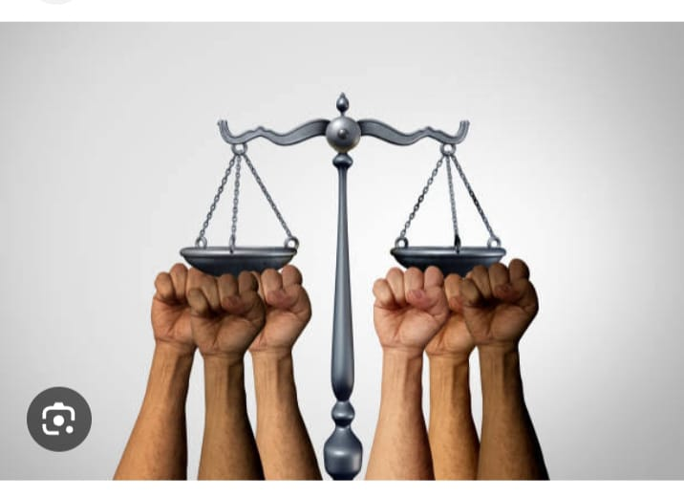

- Social justice is closely linked to human rights, such as the right to education, healthcare, employment, freedom, and a dignified life. It also involves the fair distribution of resources and opportunities so that wealth and services are not concentrated in the hands of a few. Laws and policies play an important role in promoting social justice by protecting weaker sections from discrimination, exploitation, and injustice.
- In a democratic society, social justice ensures social inclusion, meaning that all individuals—regardless of caste, gender, religion, disability, or economic status—can participate fully in social, economic, and political life. Measures like reservation policies, welfare schemes, equal pay laws, and anti-discrimination acts are practical steps toward achieving social justice.
- Overall, social justice is essential for building a peaceful, harmonious, and progressive society. It strengthens democracy, promotes social unity, reduces inequality, and helps create an environment where everyone can live with dignity and equal opportunity.
- 

- Concept of diversity
- Social diversity is the variety of social identities and cultural expressions that exist within a society. It represents the differences among people in terms of ethnicity, religion, language, culture, gender, age, abilities, and socio-economic background. These differences make each individual or group unique and contribute to the richness of society as a whole. Social diversity is not just about acknowledging differences; it is about valuing, respecting, and integrating them into social, educational, and professional systems.
- In today’s globalized world, social diversity has become a key aspect of human interaction, as societies are increasingly interconnected. It encourages dialogue, understanding, and collaboration among people from varied backgrounds, creating opportunities for innovation, learning, and growth.
- Importance of Social Diversity

- Promotes Social Harmony: Encourages mutual respect and reduces discrimination or social conflict.

- Encourages Innovation and Creativity: Diverse perspectives lead to better problem-solving and innovation.

- Strengthens Democracy and Inclusion: Ensures representation and participation of all social groups.

- Fosters Learning and Understanding: Exposure to different cultures, ideas, and experiences broadens knowledge.

- Supports Inclusive Development: Societies that value diversity create equal opportunities for education, employment, and healthcare.

- Examples of Social Diversity

- India: Multiple religions, languages, cultures, and castes coexist, making it a global example of social diversity.

- United States: A country of immigrants from different ethnicities and cultural backgrounds.

- South Africa: Diverse racial and cultural communities live together, promoting multicultural policies.

- 

- 

- 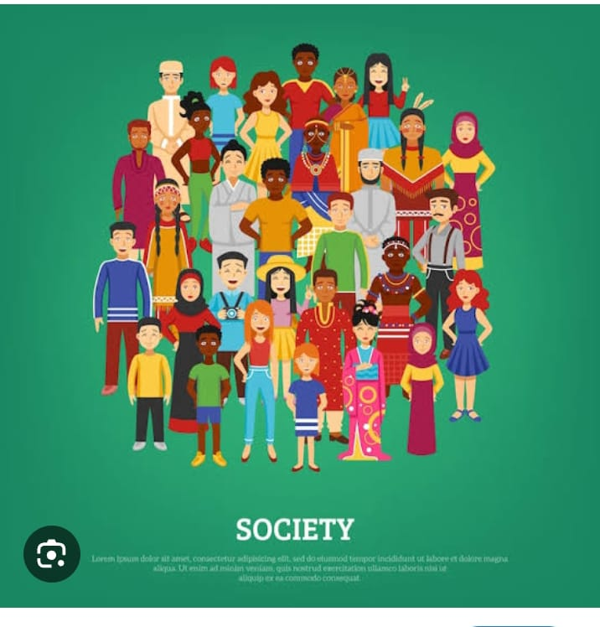

- Importance of social justice and diversity
1. Ensures Equality
- Treats all individuals fairly, regardless of caste, gender, religion, or economic status.

2. Protects Human Rights
- Safeguards basic rights like education, freedom, and dignity.

3. Reduces Poverty and Inequality
- Promotes equal access to resources and opportunities.

4. Promotes Social Harmony
- Prevents discrimination and social conflicts.

5. Encourages Inclusive Growth
- Helps all sections of society contribute to development.

6. Strengthens Democracy
- Ensures equal participation in political and social processes.

7. Empowers Marginalized Groups
- Supports women, minorities, and disadvantaged communities.

- Importance of Diversity
1. Encourages Mutual Respect
- Helps people understand and value differences.

2. Enhances Creativity and Innovation
- Diverse ideas lead to better problem-solving.

3. Builds Stronger Communities
- Promotes unity while respecting differences.

4. Promotes Cultural Awareness
- Preserves traditions, languages, and values.

5. Improves Learning and Thinking
- Exposure to different perspectives broadens knowledge.

6. Supports Social Inclusion
- Ensures no group feels excluded or ignored.

7. Prepares for Global Society
- Helps individuals adapt in multicultural environments.

- Why Social Justice and Diversity Together Matter
- Social justice ensures fairness
- Diversity ensures representation
- Together, they create an inclusive, peaceful, and progressive society

- Inclusive Policies and Practices

- Meaning

Inclusive policies and practices are rules, strategies, and actions designed to ensure equal access, participation, and opportunities for all people, regardless of differences such as gender, disability, caste, religion, language, ethnicity, age, or socioeconomic background.

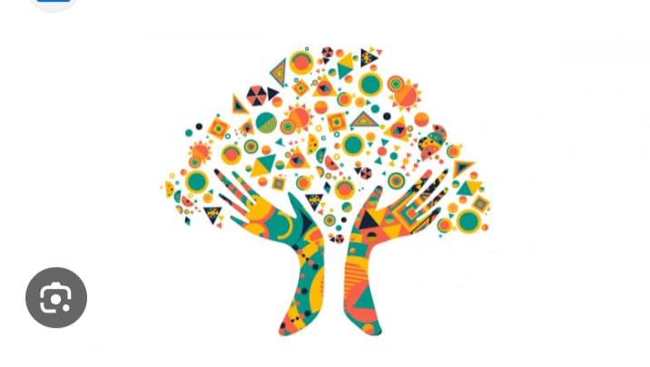

- Inclusive Policies
- Definition

Inclusive policies are formal guidelines or laws that promote equity, fairness, and non-discrimination.

- Examples
• Reservation policies for SC/ST/OBC and persons with disabilities
• Right to Education (RTE) Act
• Gender equality and anti-harassment policies
• Disability rights policies (ramps, assistive tools, accommodations)
• Inclusive language and anti-bullying policies



- Inclusive Practices
- Definition
Inclusive practices are the actual actions and methods used to implement inclusive policies in daily life.

- Examples

• Using multiple teaching methods to suit different learners
• Providing sign language interpreters or captions
• Encouraging participation from all genders and backgrounds



- CONCLUSION
Social justice and diversity play a crucial role in shaping institutions that are fair, inclusive, and responsive to the needs of a diverse society. Institutions such as educational organizations, workplaces, government bodies, and social institutions serve as foundations for social development, and their commitment to justice and inclusivity directly influences social equality and cohesion. By promoting social justice, institutions work to eliminate discrimination, reduce systemic inequalities, and ensure that every individual is treated with dignity, respect, and fairness. This involves creating equitable policies, providing equal opportunities, and addressing historical and structural disadvantages faced by marginalized and underrepresented groups.
Diversity, on the other hand, brings together people from different social, cultural, economic, and ideological backgrounds, enriching institutional environments through varied perspectives, experiences, and talents. When diversity is genuinely embraced, institutions become more innovative, adaptable, and effective in problem-solving and decision-making. Inclusive institutional practices encourage participation, representation, and a sense of belonging, which strengthens trust and collaboration among members. Diversity also promotes cultural awareness, tolerance, and mutual respect, helping institutions reflect the pluralistic nature of society.

- REFERENCE
- Rawls, J. (1971). A Theory of Justice. Harvard University Press.
- Sen, A. (2009). The Idea of Justice. Harvard University Press.
- Banks, J. A. (2015). Cultural Diversity and Education: Foundations, Curriculum, and Teaching. Pearson Education.
- UNESCO (2017). A Guide for Ensuring Inclusion and Equity in Education. UNESCO Publishing.
- United Nations (2015). Transforming Our World: The 2030 Agenda for Sustainable Development. UN Publications.
- Bell, L. A. (2016). Teaching for Diversity and Social Justice. Routledge.
- Bourdieu, P. (1986). The Forms of Capital. In Handbook of Theory and Research for the Sociology of Education.
- OECD (2018). Equity in Education: Breaking Down Barriers to Social Mobility. OECD Publishing.
- Nussbaum, M. C. (2011). Creating Capabilities: The Human Development Approach. Harvard University Press.
- Government of India (2014). National Policy for Social Justice and Empowerment. Ministry of Social Justice and Empowerment.

