India’s Emerging Solar PV Market
Rahul Kumar
Vikrant University, India
DOI: https://doi.org/10.47772/IJRISS.2026.10190020
Received: 21 January 2026; Accepted: 28 January 2026; Published: 14 February 2026
ABSTRACT
India’s solar photovoltaic (PV) sector has undergone unprecedented acceleration between 2024 and 2030; driven by record solar installations, strengthened domestic manufacturing, and transformative policy initiatives such as the PM Surya Ghar Yojana. Annual solar additions are projected to exceed 50 GW in 2026, positioning
India as the world’s second-largest solar market behind China. This IEEE-formatted report refines and reorganizes existing findings, integrating verified datasets from MNRE, NSEFI, JMK Research, BloombergNEF, and global efficiency databases. The study evaluates technology trends, state-wise deployment, efficiency benchmarks, and India’s strategic trajectory toward achieving 500 GW of non-fossil capacity by 2030.
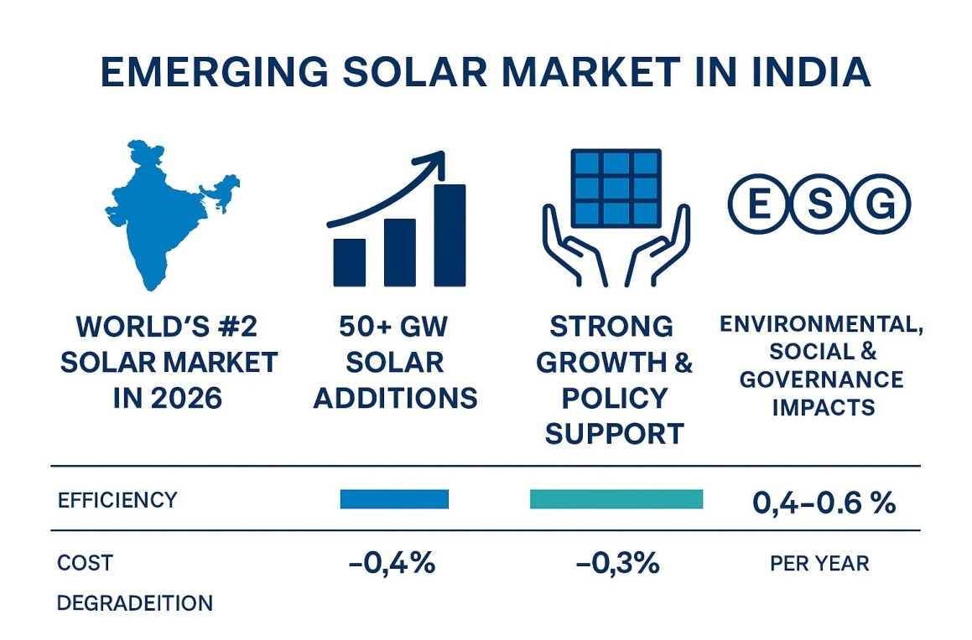
INTRODUCTION
India’s solar sector has emerged as one of the most dynamic renewable energy markets globally. Year-wise achievement data from MNRE indicate a significant rise in annual solar additions—from 6.5 GW in FY2020– 21 to 23.8 GW in FY2025–26—reflecting strong upward momentum. State-level deployment remains concentrated in Rajasthan, Gujarat, Tamil Nadu, Karnataka, and Maharashtra, which together contribute more than half of the nation’s installed PV capacity. Technological advances such as perovskite and perovskite– silicon tandem solar cells further strengthen India’s long-term competitiveness by offering higher conversion efficiencies beyond crystalline silicon’s practical limitations.
Future Trends in Solar Technology
Recent breakthroughs include NREL-certified 34.85% tandem efficiencies (LONGi, 2025), commercial-scale perovskite module shipments (Oxford PV), and increased adoption of AI-driven optimization, floating solar plants, and bifacial modules. These advancements are expected to shape India’s technological landscape through 2030.
Solar Cell Types
- Crystalline Silicon (c-Si): Market dominant; record cell efficiency ~27%.
- Single-Junction Perovskite: Rapid rise to ~26.95% efficiency (lab-certified).
- Perovskite–Silicon Tandem: Global record 34.85% (NREL-certified, LONGi 2025).
- Heterojunction (HJT): High efficiency with temperature stability.
- Interdigitated Back Contact (IBC): Premium performance, high energy yield.
- CdTe Thin Film: Strong performance in high-temperature utility environments.
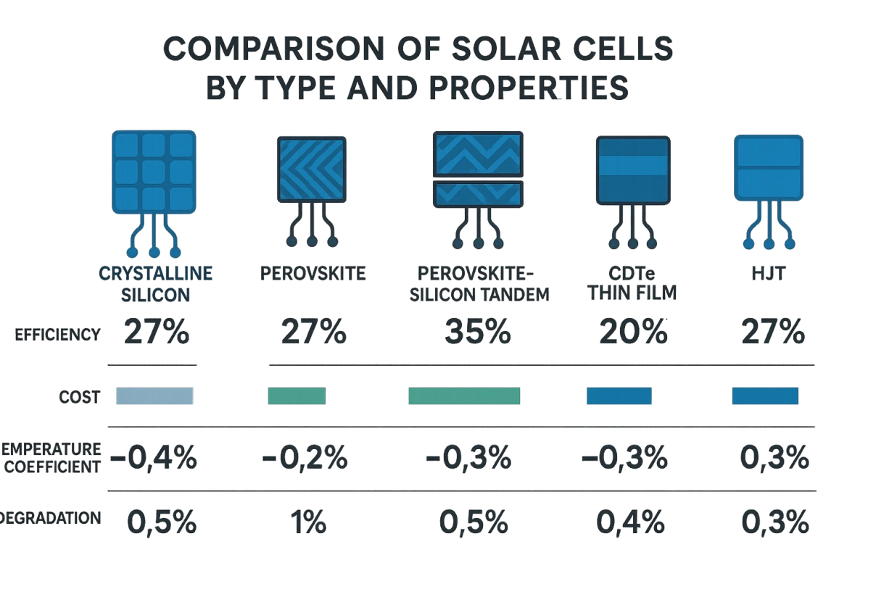
Technology Share and Efficiency Benchmarks
Crystalline silicon technologies constitute approximately 95% of global PV shipments, while CdTe thin film contributes ~4% and emerging perovskite technologies hold ~1%. Efficiency benchmarks show crystalline silicon nearing its theoretical limit (~27%), while perovskite and tandem cells exhibit superior performance trajectories with certified efficiencies of 26.95% and 34.85%, respectively.
India’s Emerging Market Dynamics (2025–2026)
India’s solar deployment reached unprecedented levels during 2025–2026. According to JMK Research, CY2025 saw 37.9 GW of new solar capacity—a 54.7% increase over CY2024—driven by accelerated commissioning of utility-scale projects and ISTS waiver deadlines. Rooftop solar additions stood at 7.9 GW, supported by the PM Surya Ghar Yojana, while off-grid systems added over 1.3 GW. MNRE reports that 2024 itself witnessed 24.5 GW of solar additions, with major contributions from Rajasthan, Gujarat, and Tamil Nadu. BloombergNEF forecasts India surpassing the US in 2026 to become the second-largest global solar market, supported by more than 35 GW deployed in the first 11 months of 2025 and sustained manufacturing expansion above 200 GW module and cell capacity.
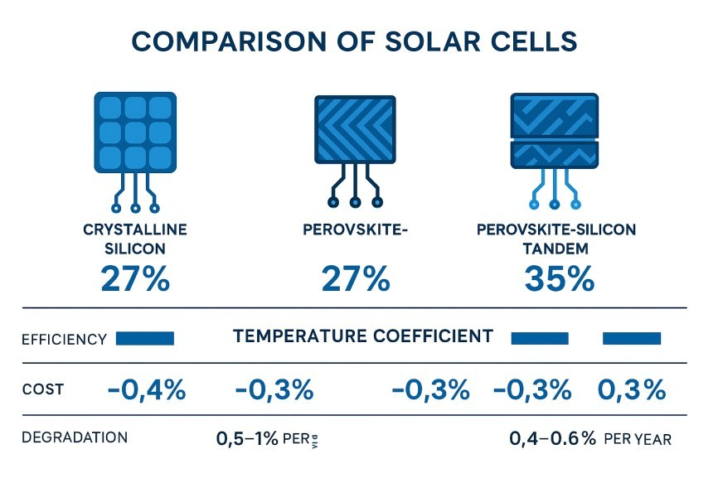
CONCLUSION
India’s solar PV ecosystem is undergoing a structural transformation driven by rapid technological advancement, robust domestic manufacturing, and supportive policy instruments. The 2025–2026 cycle establishes a strong foundation for the nation’s march toward 500 GW non-fossil capacity by 2030, with nextgeneration technologies, hybrid systems, and storage solutions expected to play central roles in the coming decade.
TOPCon solar remain in market till 2030, after growth of IBC & Perovskite tandem market will make little changes, efficiency and UVID , PID remain main concern.
Summary: The Road to 2035
Today–2028: TOPCon dominates; HJT grows in premium; Perovskite moves to pilot/early commercialization.
2028–2035: Tandem (Perovskite-Silicon) emerges as the high-efficiency, premium, or even new mainstream standard.
2035: The market will likely be a mix of high-efficiency Tandem cells for premium/space-constrained projects, with TOPCon remaining the low-cost, high-volume standard. None of these are disappearing, but rather evolving.
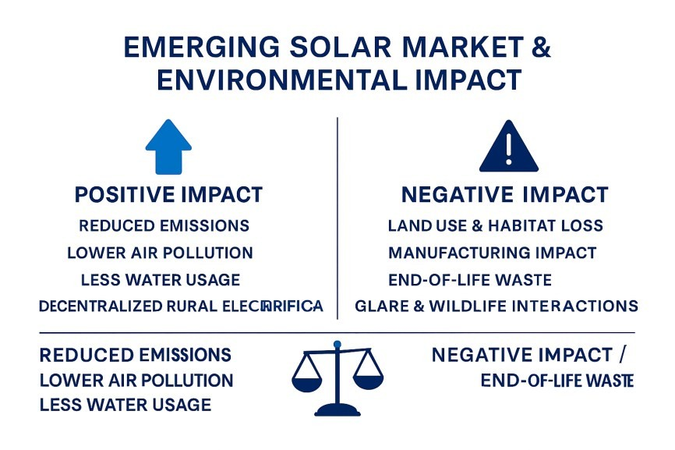
REFERENCES
- MNRE, Year-Wise Renewable Energy Achievement Data (2020–2026).
- NSEFI, Figures and Statistics Report, 2025.
- JMK Research & Analytics, India Adds Record 37.9 GW Solar in CY2025, 2026.
- Fluxim, Highest Perovskite Solar Cell Efficiencies (2026 Update).
- LONGi Solar, NREL-Certified 34.85% Tandem Efficiency Record (2025).
- ET EnergyWorld, India to Overtake US as Second-Largest Solar Market by 2026 (BloombergNEF).

