DEVELOPMENT OF AN AI-ENHANCED BUBBLE CURTAIN SYSTEM FOR AUTOMATED RIVER WASTE COLLECTION AND MONITORING

ABSTRACT
Riverine plastic and floating waste continue to threaten aquatic ecosystems and public health in the Philippines, where weak waste management infrastructure and high single-use plastic consumption contribute significantly to river pollution and downstream marine contamination. Existing interception methods such as manual cleanup operations, floating barriers, and mechanical interceptors remain inefficient, labor-intensive, and incapable of real-time monitoring or adaptive response to changing river conditions. This study aimed to design and develop an AI-Enhanced Bubble Curtain System for Automated River Waste Collection and Monitoring that integrates bubble curtain technology with artificial intelligence to automate waste interception, classification, and centralized data management. The system was developed using Agile methodology and the Iterative Design and Development framework, with a Django REST Framework backend, PostgreSQL database, YOLOv8-based image classification model, and a web-based monitoring dashboard built with HTML, JavaScript, and Tailwind CSS. Hardware components were simulated using Wokwi, incorporating an Arduino Uno microcontroller with DHT22, HC-SR04 ultrasonic, water level, and microphone sensors to approximate physical deployment conditions. Results demonstrated that the system successfully performed real-time waste detection and classification through a live camera feed, achieving automated identification of floating debris with confidence scores recorded across 17 captured images, a garbage detection rate of 58.3 percent, and a fully functional administrative dashboard consolidating detection summaries, alert notifications, and user management controls. The study concludes that the proposed system is technically feasible as an intelligent and automated river waste monitoring solution, and recommends future integration of physical hardware components, expanded AI training datasets, and deployment testing in actual riverine environments to validate real-world performance.
Keywords: AI-enhanced bubble curtain, river waste collection, automated monitoring, YOLOv8, IoT environmental sensors, riverine plastic pollution, real-time classification

INTRODUCTION
Background of the Study
Rivers are major pathways for plastic and other waste that travel from inland areas to oceans. Floating debris in these waterways harms aquatic ecosystems, interferes with drainage, and worsens flooding. Globally, more than 1,000 rivers are estimated to account for about 80 percent of annual riverine plastic emissions, amounting to between 0.8 and 2.7 million metric tons per year (Meijer et al., 2021). In the Philippines, the issue is especially pressing. High levels of single-use plastic consumption, combined with weak waste management systems, contribute significantly to river pollution and marine litter (Kobayashi, 2024). These figures highlight the urgency of improving waste interception and monitoring in rivers to reduce downstream impacts on coastal and marine environments.
Despite various interventions, existing methods present notable weaknesses. Manual cleanup operations, while helpful, require intensive labor and time. Floating trash traps remove debris but demand frequent maintenance. Mechanical waste interceptors can be effective but involve high operational costs and are prone to failure during flooding events (Emmerik & Schwarz, 2020). Bubble curtain systems, which employ rising air bubbles from submerged perforated pipes to guide waste toward collection points, have gained attention as a feasible approach. However, their efficiency depends on factors such as the ratio of water flow velocity to air injection velocity, turbulence, and system geometry (Santos et al., 2023). Most of these systems also lack automation and real-time monitoring, making it difficult to track performance or adjust operations under changing river conditions.
Artificial intelligence has been applied in environmental monitoring to process operational data and optimize system performance. AI models have been used to analyze flow conditions, control equipment operation, and generate data summaries for better resource management (CSIRO Marine Debris, 2023). Yet in river waste management, such integration with interception technologies remains limited. This separation between interception systems and automated monitoring leaves a critical gap.
The proposed study addresses this gap by integrating bubble curtain technology with artificial intelligence to create a system that both diverts and monitors river waste. The study designs and prototypes a solution that unites physical waste interception with AI-driven operational monitoring. The bubble curtain diverts floating debris toward collection zones, while sensors provide data on flow rates, air injection pressure, and waste accumulation. An AI module processes these inputs to optimize system efficiency and generate records of waste loads in real time. This dual-function design not only reduces the volume of waste reaching downstream ecosystems but also provides actionable data to improve future waste management strategies.
Statement of the Problem
Riverine plastic and floating waste continue to threaten ecosystems and public health. Existing cleanup and interception methods such as manual waste removal, floating barriers, and mechanical interceptors are often labor intensive, expensive, or fail under variable flow or flooding conditions. Bubble curtain systems offer a potentially sustainable alternative by diverting floating debris, but most existing designs do not integrate the automation, real-time monitoring, or data-driven feedback necessary to evaluate and optimize performance.
The main problem addressed by this study is the absence of an integrated, automated bubble curtain system capable of efficient river waste interception, along with real-time monitoring and categorization of debris to support evidence-based interventions.
Specific Problem
The study addresses the following key problems that existing river waste management systems fail to resolve:
- Existing bubble curtain systems may be used to divert floating debris; however, they can't be automated or monitored in real time, and they can't quickly adjust to changes in the river.
- An ideal AI-based waste interceptor can theoretically spot and tag waste, but it cannot eliminate it, as it is not integrated with a physical interception mechanism.
- There are no unified systems incorporating monitoring, data management, and diversion yet available, undermining the ability to determine their impact on river waste mitigation and derive meaningful information for environmentally sustainable river waste management.
Objectives of the Study
The main objective of this study is to design and develop an AI-enhanced bubble curtain system that automates the collection and monitoring of river waste. The system aims to combine bubble curtain technology with artificial intelligence for real-time identification, categorization, and measurement of floating debris, thereby improving waste management and supporting environmental sustainability.
Specific Objectives
Specifically, the study seeks to
- To develop an enhanced bubble curtain system that is capable of automatic and real-time monitoring, which enhances the efficiency of waste diversion and enables it to respond to fluctuations in the river.
- To combine the bubble curtain with an AI-driven monitoring system that automatically recognizes, classifies, and quantifies river waste in real time.
- To create a centralized platform that combines things like waste management, AI controls, and data storage to trace the results and make relevant recommendations for policymakers.
Scope and Limitations
This study covers the design, prototyping, and testing of an AI-enhanced bubble curtain system for floating solid waste in rivers. The system will include hardware (bubble curtain, sensors, and cameras), software (AI classification and monitoring), and a data management/reporting component. Testing will be conducted in small-scale waterways or in controlled environments over enough duration to assess functionality, classification accuracy, debris diversion efficiency, and system reliability under moderate flow conditions.
However, the study has limitations. The focus is restricted to floating solid waste, ignoring submerged debris, sedimented waste, or microplastics that are not visible or are too small to be reliably detected. Performance under extreme conditions (high flow velocities, flooding, very high debris loads) may differ and will not be fully examined. The AI model’s accuracy may be affected by water turbidity, lighting, or obstruction. Long-term durability, maintenance costs, and large-scale deployment feasibility are beyond the scope of this study. Chemical or biological analysis of the waste is also not within scope.
Significance of the Study
This study is significant as it proposes an integrated physical and AI-driven approach to river waste management, aiming to enhance operational efficiency and improve the accuracy and quality of waste data compared to existing manual or purely mechanical methods.
The findings of this study are expected to benefit the following sectors:
Local communities and municipal governments. Through automated, data-driven trash management, the system reduces municipal expenses while increasing urban resilience, improving river cleanliness and public health, and minimizing flood risks.
Environmental agencies and policymakers. By lowering pollution, flood risks, and cleanup costs through automated, data-driven waste management, the system improves river cleanliness, public health, and urban safety. Real-time waste data facilitates aimed policymaking, effective resource allocation, and long-term environmental planning.
Future researchers. The study demonstrates AI-based waste categorization under real-world conditions, enhances environmental fluid mechanics through bubble curtain design insights, and offers a workable framework for integrating cyber-physical systems in environmental management.
Educational institutions. The research serves as an interdisciplinary case study that encourages STEM and STEAM education through practical environmental applications, encourages project-based learning, and develops skills relevant to the green economy and smart cities.
The general public and NGOs. Through accessible waste data, the project empowers community management, increases public awareness, helps NGO campaigns, and encourages transparency and accountability when assessing pollution causes and control strategies.

REVIEW OF RELATED LITERATURE AND STUDIES
River waste management has increasingly been addressed through artificial intelligence and the Internet of Things. Miller et al. (2025) and Popescu et al. (2024) both demonstrated that AI-IoT integration enables autonomous real-time monitoring of water quality, pollution patterns, and environmental anomalies, reducing the need for human labor in large-scale aquatic surveillance. Cicceri et al. (2021) extended this through SWIMS, an AI-powered wastewater management framework that applied predictive modeling to improve operational efficiency and pollution response.
Remote monitoring technologies have further advanced the detection of riverine waste. Portable IoT-based systems (2022) enabled real-time waste tracking through cloud-based dashboards deployed across various river sections. Yang et al. (2022) confirmed that AI-driven remote sensing using satellite and aerial imagery provides a scalable, non-intrusive method for monitoring water bodies. De Keukelaere et al. (2025) applied this concept using drones and bridge-mounted cameras to track litter density and accumulation zones across long river segments.
Deep learning has proven effective for automated waste detection in aquatic environments. Malla, Sylvester, and Kim (2020) developed CNN models capable of identifying floating plastic under varying lighting and flow conditions with high accuracy. Chang and Yang (2025) further mapped the landscape of AI applications in river management through bibliometric analysis, identifying water quality assessment, flood prediction, and debris detection as the three dominant research areas.
Robotic systems represent a direct application of AI for physical waste removal. Ahmad, Jamal, and Aqib (2025), Ankit, Tripathi, and Sahai (2025), and Tripathi (2025) independently developed AI-controlled river cleaning robots that combine computer vision, sensor integration, and mechanical collection mechanisms. Dubey et al. (2025) enhanced this further through path-planning algorithms combined with YOLO-based detection to improve collection efficiency. Guan et al. (2023) introduced a dual-function system combining vision-based garbage collection with real-time water quality monitoring, while Solichin et al. (2024) applied background subtraction for low-cost video-based waste tracking in Jakarta's urban waterways.
Bubble curtain technology has been studied both as a waste diversion mechanism and as a broader environmental tool. Circiumaru et al. (2024) demonstrated its use as a fish behavioral barrier with secondary benefits in waste and pollutant redirection. S.R., Pallavi, and Anusha (2022) reviewed the Great Bubble Barrier, a diagonal air-bubble system that guides plastic toward collection points with minimal ecological disruption.
Local literature on the Philippines highlights the governance dimensions of plastic pollution. Borongan and NaRanong (2022) found that institutional governance, rather than infrastructure alone, drives outcomes in marine plastic reduction in Metro Manila. Talavera et al. (2024) characterized high floating litter flows along the Tullahan River, identifying governance failures in buffer zones and land-use enforcement. Escanan, Gutierrez, and Lubguban (2024) reported high plastic densities in Palawan riverbanks, attributing accumulation to illegal dumping and weak enforcement. PlastiCount Pilipinas (2022 to present) provides an open national database supporting evidence-based policy. Serrona (2022) emphasized sector-specific regulation in tourism-affected coastal areas, while Fuentes et al. (2024) identified riverbank zones in Mindanao as primary pathways for land-to-sea plastic leakage. Kobayashi and Abreo (2024) argued for AI-enabled monitoring systems anchored in strong governance frameworks to address the Philippines' systemic plastic leakage problem.
Philippine field research has documented the extent of plastic contamination in major river systems. Gabriel, Amparado, Lubguban, and Bacosa (2023) identified widespread microplastic presence in the Cagayan de Oro River, while Gabriel and Bacosa (2024) confirmed high polymer concentrations in riverbed sediments. Espiritu et al. (2023) found microplastics in over 80 percent of fish sampled from the Pasig and Marikina Rivers, and Arcadio et al. (2022) provided the first documented microplastic evidence in Laguna de Bay. Casila (2024) and Ilao (2025) further characterized sediment contamination in Pasig River tributaries, including increased pollutant mobilization during the wet season. Banda et al. (2024) assessed contamination in Mindanao's Taguibo River, while Bonita et al. (2023) validated microplastic extraction methodologies applicable to system benchmarking. Lacuna (2024) and Darl-leen (2024) documented microplastic ingestion in commercially important fish species, underscoring the ecological and livelihood consequences of untreated river waste.
Global studies reinforced the strategic rationale for localized interception systems. Meijer et al. (2021) established that a small number of rivers account for 80 percent of global riverine plastic emissions, supporting targeted deployment. Van Emmerik et al. (2023) demonstrated that extreme floods amplify plastic transport, reinforcing the need for adaptive automated systems. Zhang et al. (2022) reported up to 90 percent removal efficiency under optimized bubble barrier conditions, and the Great Bubble Barrier project reports (2020 to 2023) confirmed long-term durability and minimal ecological impact in European deployments. Santos et al. (2023) and Neves et al. (2022) provided computational and experimental insights into bubble dynamics and flow modification, while Hazar et al. (2024) combined numerical and laboratory methods to evaluate containment efficiency. Gomez et al. (2022), Jia et al. (2023), and Duras et al. (2024) contributed machine learning models and open datasets for macroplastic detection in water bodies, forming a technical foundation for AI-driven classification systems.

METHODOLOGY
Research Design
Rising urban waste and worsening river pollution demand efficient and intelligent cleanup systems. Traditional manual methods are inefficient, time-consuming, and inflexible, leading to debris accumulation, contamination, and ecological damage. Advanced technologies that integrate artificial intelligence and the Internet of Things enable real-time monitoring and effective waste management, providing a viable response to these environmental challenges. To address this, the study adopts a developmental research methodology to design, develop, and evaluate an AI-Enhanced Bubble Curtain System for automated river waste collection and monitoring. Through iterative testing and improvement, the researchers build a functional prototype while continuously assessing performance and implementing enhancements.
The system integrates a bubble curtain mechanism for directing debris, IoT sensors for real-time environmental data collection, and an AI-powered detection module for waste classification. A cloud-based interface enables continuous tracking and performance assessment. The study draws on existing public and online datasets of floating river waste to train the AI model and benchmark system performance. These datasets include labeled images of common waterborne debris categories such as plastics, food packaging, and organic matter like leaves and biodegradable waste. Publicly available repositories and environmental monitoring databases serve as primary data sources, supplemented by environmental parameters such as water flow rate, air pressure, and turbidity documented in prior studies on river conditions. The datasets are evaluated for relevance to Philippine river environments to ensure that the trained model reflects real-world local conditions. Through iterative prototyping and testing, the system is validated under varying river conditions to provide accurate environmental insights.
The Software Development Life Cycle for this study is based on Agile Methodology, a framework well-suited to developmental research because of its iterative and adaptive qualities. Agile centers on flexibility, collaboration, and incremental improvement, which are essential features for designing a hybrid system that joins mechanical and AI-based components together. Its iterative stages, covering requirement analysis, sprint planning, incremental development, testing, and feedback integration, allow the research team to continuously refine both the hardware and software of the system. For instance, sensor calibration, AI model training, and data visualization interfaces are developed further after each testing phase to improve system performance and reliability.
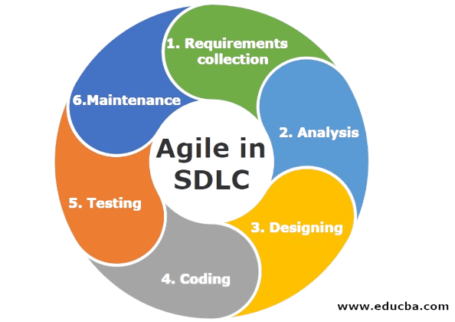
(Figure 3.1 Agile Methodology)
By integrating Agile principles with developmental research methodology, this study ensures a structured yet flexible design process. The resulting system architecture prioritizes energy efficiency, real-time data communication, and environmental adaptability. This study also adopts the Iterative Design and Development model, which emphasizes repetition, refinement, and continuous feedback, allowing development to proceed in cycles that produce progressively refined prototypes, with each iteration informed by the limitations and findings of the previous one. This methodological synergy not only supports the development of a functional prototype but also establishes a scalable foundation for future improvements and large-scale implementations, demonstrating how developmental research can translate scientific insight into sustainable environmental technology.
The phases of the IDD model used in this study are as follows:
Requirements Collection. In this initial phase, we identified the essential functionalities of the system, prioritizing the bubble curtain’s physical mechanism and the AI-driven detection logic. We defined a dual-layer requirement set: a hardware stack encompassing camera sensors, air compressors, and microcontrollers for data acquisition, and a software stack utilizing Python 3.12, Django REST, and TensorFlow for high-level processing. Our goal was to establish a technical foundation capable of supporting real-time river waste monitoring.
Analysis. During the analysis stage, we evaluated the technical parameters for AI model training and sensor calibration. To ensure a structured development, we adopted the Agile Methodology and the Integration-Driven Development (IDD) model. We also assessed and selected diverse dataset sources from public repositories and environmental databases to ensure the CNN model would be robust enough for variable field conditions.
Design. We then transitioned into the architectural design of the system using the Input-Process-Output (IPO) framework. We created a comprehensive set of visual blueprints to guide our implementation, including the System Development Workflow, the Web Application Flowchart, and a multi-level Data Flow Diagram (DFD). Additionally, we designed the Entity-Relationship Diagram (ERD) and a normalized PostgreSQL database schema consisting of six tables to ensure efficient data persistence and user management.
Coding and Implementation. We are currently in the active development phase, where we have already established the Django REST Framework backend and the PostgreSQL database environment. Using Docker Compose, we configured the service containers and successfully resolved networking and environment variable handling issues. We are now implementing the administrative interface using the Jazzmin package, while simultaneously fine-tuning the API endpoints that will receive data from the hardware sensors.
Hardware Implementation. Parallel to our software work, we are currently executing the hardware implementation phase. Our team is assembling the Arduino-based microcontroller unit and integrating the water flow, air pressure, and turbidity sensors. We are also developing the control logic for the air compressor to ensure the bubble curtain maintains consistent pressure. Once the hardware assembly is finalized, we will link the microcontroller to our API, completing the end-to-end data pipeline from the river to the dashboard.
Testing. Validating the functionality, accuracy, and reliability of the system through unit testing, integration testing, and field simulations under controlled environmental conditions.
Deployment and Feedback. Implementing the prototype in a test environment, gathering performance data, and identifying areas for improvement. Feedback from each cycle informs the next iteration.
Each phase is revisited multiple times throughout the study. This cyclical process ensures that the AI-Enhanced Bubble Curtain System is technically sound, adaptable to real-world conditions, and responsive to limitations discovered during testing. Through developmental research supported by the IDD framework, this study aims to produce a scalable, intelligent, and sustainable solution for river waste interception and monitoring, directly supporting the three core objectives of automatic real-time monitoring, AI-driven waste classification, and centralized data integration for policy support.

Proposed System Architecture
The proposed system architecture of the AI-Enhanced Bubble Curtain System follows an Input-Process-Output (IPO) framework. This structure illustrates how data flows through the system from raw acquisition to meaningful output across interconnected modules, each performing a distinct function and communicating through the Django REST Framework (DRF). PostgreSQL database. The architecture is designed to be modular, scalable, and capable of real-time waste detection, classification, and monitoring.
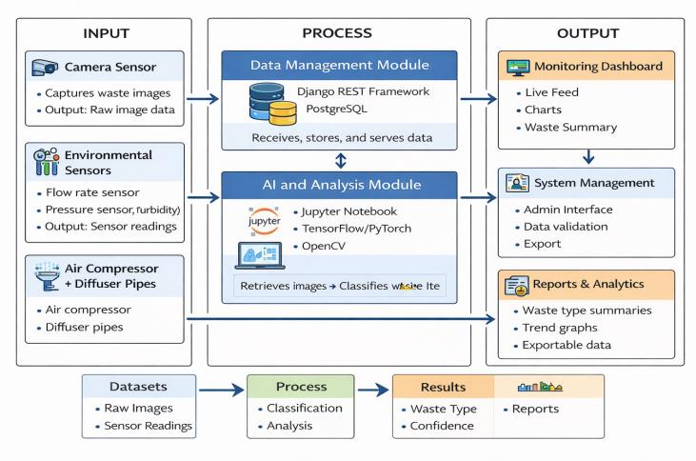
(Figure 3.1 Proposed System Architecture IPO Diagram)
The Hardware Module serves as the input layer of the system. It consists of the bubble curtain mechanism, camera sensors, and IoT-based environmental sensors installed along the target waterway. The camera captures continuous image data of the river surface, focusing on floating debris that interacts with the bubble curtain. Environmental sensors simultaneously collect data on water flow rate, air pressure, and turbidity. Datasets acquired at this stage include the raw image dataset of floating waste and the environmental parameter dataset containing flow rate, pressure, and turbidity measurements. These datasets are transmitted to the Data Management Module for storage and processing.
The Data Management Module functions as the process layer that handles all data communication between hardware and software components. Implemented using Django REST Framework (DRF) and PostgreSQL, this module receives, stores, and retrieves all system data. The process flow begins when raw image and sensor data are received via API endpoints and stored in PostgreSQL as structured records. Stored images are then queued for AI analysis, and processed results from the AI module are received, stored, and made available for visualization. The PostgreSQL database acts as a centralized repository containing raw image files with metadata, sensor readings with timestamps, AI classification results, and system logs and performance metrics.
The AI and Analysis Module operates as a specialized process within the system. It runs in a Jupyter Notebook environment and communicates directly with the shared PostgreSQL database.
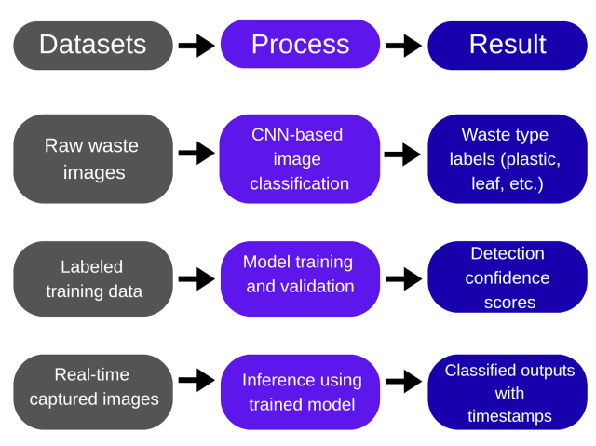
The AI Detection and Classification Module uses a trained computer vision model to analyze river waste in real time. The process flow begins when the AI module retrieves unprocessed images from the database, which are then preprocessed through resizing and normalization. The trained computer vision model performs inference to detect and classify waste by type. Results including classification, confidence scores, and timestamps are written back to PostgreSQL, and statistical summaries are generated for reporting. This module operates independently from Django yet remains fully synchronized through the shared database structure.
The Monitoring and Visualization Module serves as the primary output layer of the system, responsible for presenting processed data in a comprehensible and accessible format. It functions as the interface between the system's backend computations and the end user, retrieving data through the Django REST API and rendering it on a web-based dashboard. The dashboard is developed using HTML, JavaScript, and Tailwind CSS, ensuring a responsive and intuitive experience for users who need to interpret AI-generated results and assess river cleanliness over time. The results presented through this module include a real-time waste detection feed, classification summaries covering waste type counts and trends, environmental parameter readings, system performance metrics, and historical data reports.
The System Administration Module operates as the control and oversight component of the system, providing authorized personnel with the tools necessary to maintain data quality and system integrity. Built on Django's built-in admin interface, it enables users to monitor stored data and database entries, validate and correct misclassified waste records, perform routine system maintenance tasks, and export data for external reporting purposes. By combining automated processing with human oversight, this module ensures that the system remains reliable and that its outputs are accurate, allowing administrators to intervene whenever corrections or maintenance are required.
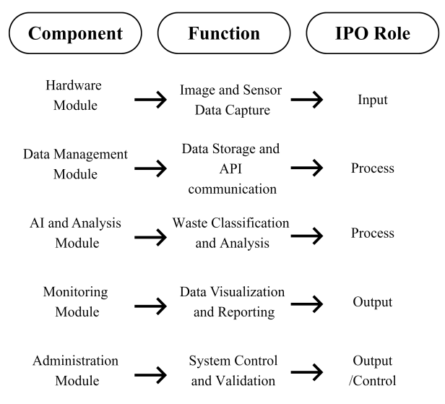

Methods and Tools
This section presents the methods and tools utilized in the development of the AI-Enhanced Bubble Curtain System for Automated River Waste Collection and Monitoring. The methods and tools employed in this study are organized into two principal categories: the procedural approaches that guided the system's design, development, and evaluation, and the specific technologies and equipment used to implement both the hardware and software components. The former encompasses the systematic steps followed by the proponents in building and validating the system, while the latter covers the programming languages, frameworks, libraries, and hardware devices that made its technical realization possible. Together, these elements form the operational and technical foundation of the study, and each is discussed in detail in the succeeding subsections.

Methods
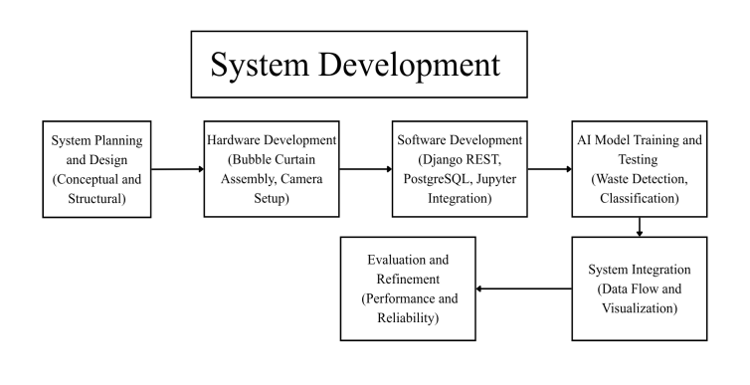
(Figure 3.2 System Development Workflow)
The development of the AI-Enhanced Bubble Curtain System followed a structured and iterative process emphasizing continuous refinement of both hardware and software components. The proponents began by conceptualizing the system architecture and identifying its core functionalities, the bubble curtain mechanism, camera-based waste detection, and AI-powered monitoring, before proceeding to prototype fabrication, sensor integration, and backend infrastructure setup. Each stage underwent evaluation to ensure proper inter-module communication and detection accuracy.
In support of the first objective, the bubble curtain mechanism was engineered to maintain consistent airflow through submerged perforated pipes, with the compressor and diffuser configuration adjusted across development cycles to account for variations in water flow and turbulence. IoT-based environmental sensors measuring flow rate, turbidity, and air pressure were integrated and calibrated to transmit continuous readings to the backend server, while the camera sensor was configured to automatically transmit image data upon capture, establishing the uninterrupted data pipeline that makes real-time monitoring operationally feasible.
Addressing the second objective, a YOLOv8-based image classification model was developed and validated through iterative training on labeled datasets of common riverborne debris, capable of classifying floating waste into five categories. Image preprocessing was handled through OpenCV, with training and testing conducted in Jupyter Notebook and performance refined through successive iterations informed by misclassification patterns and environmental variability. The final model was embedded into an automated inference pipeline that queries the database at regular intervals, processes unclassified images, and writes results back to PostgreSQL without human initiation.
Toward the third objective, the Django REST Framework backend, PostgreSQL database, and web-based monitoring dashboard were integrated into a unified platform consolidating all sensor readings, raw images, classification outputs, and system logs within a single structured repository. The monitoring dashboard renders waste accumulation trends, environmental readings, and system health indicators in real time, while the Django admin interface allows authorized administrators to validate AI outputs, correct misclassified entries, and export structured reports suitable for policy evaluation and environmental planning.

Tools
The tools used in this study consist of both software and hardware components that collectively enabled the development, integration, and operation of the AI-Enhanced Bubble Curtain System. These tools were carefully selected to ensure functionality, compatibility, and efficiency across all stages of system implementation. The software tools facilitated the design, programming, data analysis, and visualization processes, while the hardware components supported the physical assembly and operation of the bubble curtain mechanism. Together, these resources enabled the proponents to construct a system capable of real-time waste detection, monitoring, and data-driven performance evaluation.

Flowchart of the Proposed System
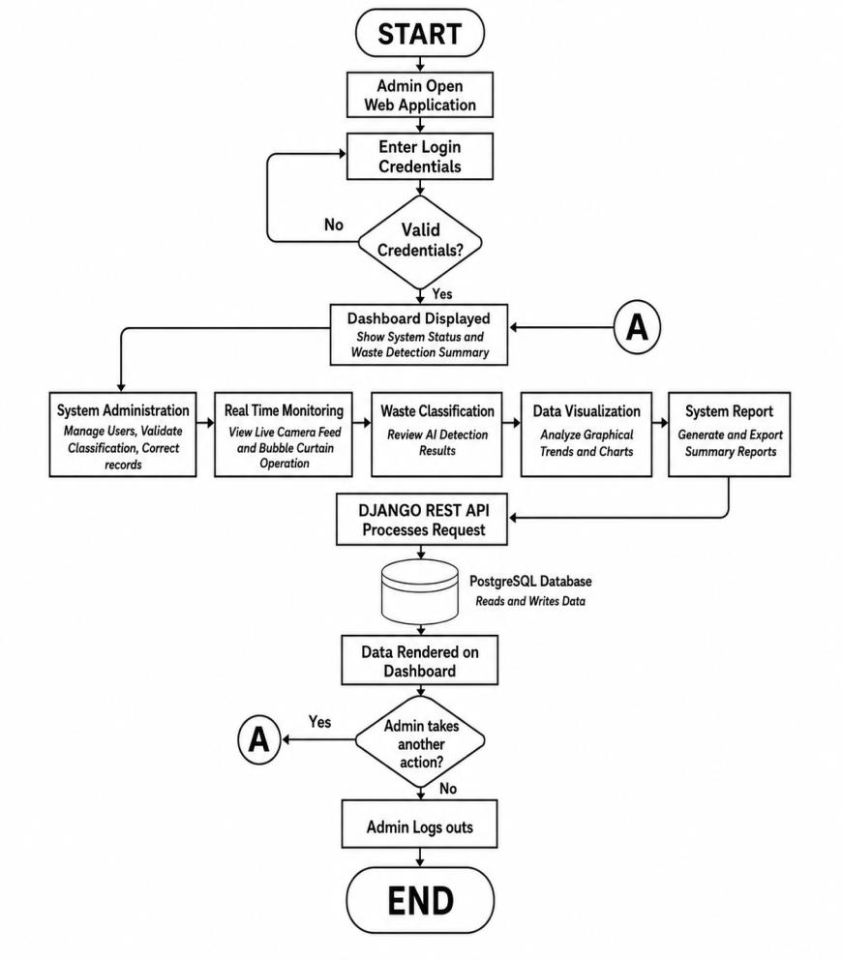
(Figure 3.4.2.1 Flowchart of the Proposed System)
The flowchart illustrates the operational flow of the web application used exclusively by the administrator in the AI-Enhanced Bubble Curtain System. Upon login, the admin is directed to the dashboard, which displays system status and waste detection summaries. From the dashboard, the admin can access several functional pages: the Real-Time Monitoring page to view live camera feeds and bubble curtain operation, the Waste Classification page to review AI detection results, the Data Visualization page to analyze graphical trends, and the System Report page to generate summary reports. All data is retrieved and updated dynamically through the Django REST API, which communicates with the PostgreSQL database. The session concludes securely upon logout, ensuring data integrity and controlled system access.

Data Flow Diagram of the Proposed System (DFD)
The Data Flow Diagram (DFD) is a structural representation that illustrates how data moves through the AI-Enhanced Bubble Curtain System. It identifies the external entities that interact with the system, the processes that transform incoming data, and the data stores where information is retained. To provide both a broad overview and a granular view of the system's data architecture, the DFD is presented across two levels.
Entity-Relationship Diagram of the Proposed System (ERD)
The Context Diagram presents the entire system as a single unified process and defines its boundary in relation to external entities. Three external entities interact with the system: the River Environment, the Administrator, and the End User. The River Environment serves as the primary source of physical inputs supplying raw images and sensor readings that the system processes. The Administrator manages system settings, validates data entries, and maintains overall operational oversight. The End User, in turn, accesses the monitoring dashboard and reviews waste classification reports generated by the system. Data flows bidirectionally between these entities and the system; the River Environment sends raw data inward, while the system sends logs and alerts to the Administrator and classification reports to the End User. The Administrator additionally sends configuration commands and validation inputs back into the system, completing the feedback loop.

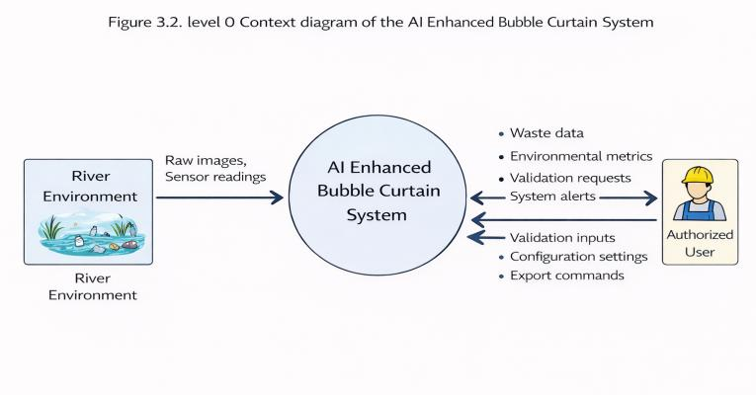
(Figure 3.2 level 0 Context diagram of the AI Enhanced Bubble Curtain System)

Level 1 Data Flow Diagram (DFD)
The Level 1 diagram decomposes the system into five major subprocesses, each representing a core function of the AI-Enhanced Bubble Curtain System. Process 1.0 Capture Data serves as the entry point, acquiring raw image data from the camera sensor and environmental readings from IoT sensors, which are written to the Raw Data Store before being passed downstream. Process 2.0 Manage Data, implemented through Django REST Framework and PostgreSQL, functions as the central hub for all data movement, receiving raw data from the Raw Data Store, storing it permanently in the PostgreSQL database, and exposing it to other processes through API endpoints.
Process 3.0 Classify Waste retrieves unprocessed images from the database, performs image preprocessing, and runs inference using a trained YOLOv8 model, writing classification results comprising waste type labels, confidence scores, and timestamps back to the database for downstream use. Process 4.0 Visualize Data retrieves these processed results alongside environmental metrics and renders them through a web-based dashboard, serving as the primary interface through which end users monitor waste accumulation and system performance in real time. Process 5.0 Manage System provides system control and validation functions, allowing authorized users to review classified entries, correct misclassifications, manage system parameters, and export data through the Django admin interface.
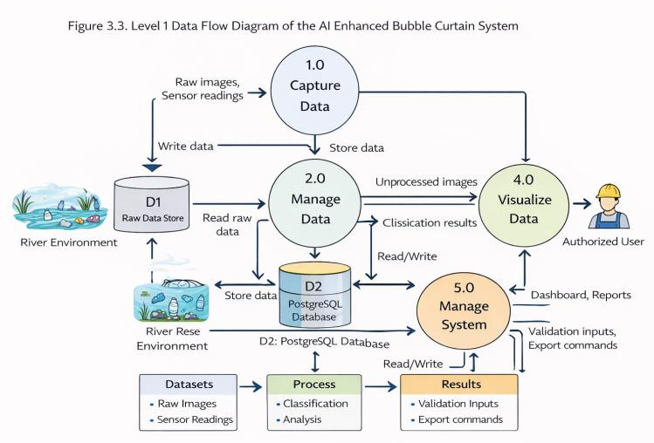
(Figure 3.3 Level 1 Data Flow Diagram of the AI Bubble Curtain System)
The system relies on two primary data stores. The Raw Data Store serves as a temporary holding area for unprocessed images and sensor readings before transfer to permanent storage, while the PostgreSQL Database functions as the central repository retaining raw files, classified results, user logs, sensor history, and configuration settings in a unified structure. Together, these data stores ensure full traceability at every stage of operation, with clearly defined inputs and outputs across all processes, reinforcing the overall design consistency of the system.
Entity-Relationship Diagram of the Proposed System

The Entity Relationship Diagram illustrates the logical structure of the database used in the AI Enhanced Bubble Curtain System. It defines the entities, attributes, and relationships that govern how data is stored, organized, and retrieved. The ERD ensures that all system data from waste images to user activity is structured in a way that supports efficiency, integrity, and scalability.

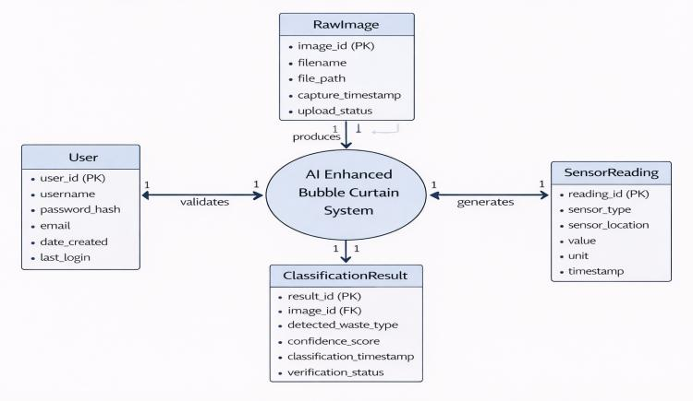
(Figure 3.4 Entity Relationship Diagram of the AI Enhanced Bubble Curtain System)
The system database is composed of five primary entities representing distinct categories of data the system captures, processes, or generates. The User entity stores account information including user ID, username, password hash, email address, role, date created, and last login, with the role attribute distinguishing between Administrators and End Users to determine access privileges. The RawImage entity stores unprocessed image data captured by the camera sensor, with attributes covering image ID, filename, file path, capture timestamp, and upload status, serving as the temporary holding area for images awaiting AI classification. The ClassificationResult entity stores AI model outputs for each processed image, with attributes comprising result ID, image ID, detected waste type, confidence score, classification timestamp, and verification status indicating whether an Administrator has validated or corrected the automated output. The SensorReading entity stores environmental data from IoT sensors with attributes including reading ID, sensor type, sensor location, value, unit of measurement, and timestamp, covering flow rate, air pressure, and turbidity readings. The SystemLog entity records system events and user activities through attributes such as log ID, event type, user ID, description, IP address, and timestamp, supporting audit trails, troubleshooting, and performance monitoring.
The relationships between entities reflect the logical dependencies across database tables. A User can validate zero or many ClassificationResult entries in a one-to-many relationship, with the foreign key stored in the ClassificationResult table. Each RawImage produces exactly one ClassificationResult in a one-to-one relationship linked through the image ID foreign key. A User can also generate zero or many SystemLog entries in a one-to-many relationship, with the foreign key stored in the SystemLog table. The SensorReading entity holds no direct relationship with other entities, as environmental data is stored independently, though shared timestamps allow researchers to correlate sensor readings with classification results during data analysis.
Use Case Diagram of the Proposed System
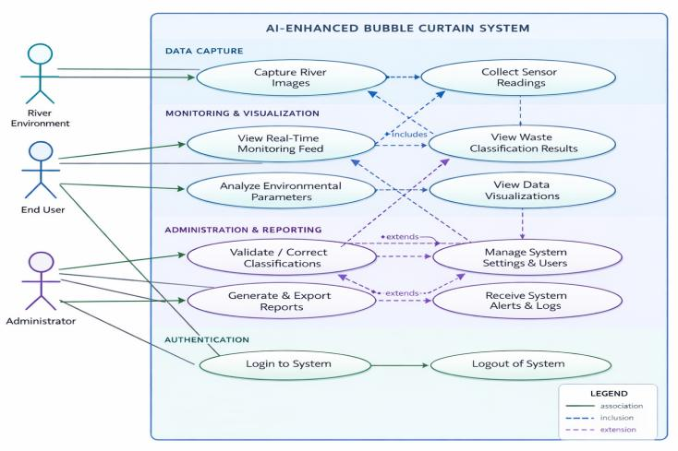
(Figure 3.5 Use Case Diagram of the AI-Enhanced Bubble Curtain System)
The Use Case Diagram defines the functional boundaries of the AI-Enhanced Bubble Curtain System by identifying its actors and their specific interactions, providing a behavioral overview of how different roles engage with available features and collectively fulfill the system's operational objectives.
The system recognizes three primary actors: the Administrator, the End User, and the River Environment. The River Environment serves as an external actor that continuously supplies raw inputs by generating image data through the camera sensor and environmental readings through IoT sensors covering water flow rate, air pressure, and turbidity. These inputs are automatically captured and transmitted to the backend without human intervention, forming the data foundation upon which all subsequent system processes depend.
The Administrator holds the highest level of access and is responsible for maintaining operational integrity and data accuracy. Upon authentication, the Administrator may monitor real-time camera feeds and bubble curtain operation, review AI-generated classification results, validate or correct misclassified entries through the Django admin interface, manage system configurations and user accounts, export compiled data reports, and receive system alerts and logs for timely responses to detected anomalies. The End User represents personnel or stakeholders interacting with the system for monitoring and reporting purposes. Upon login, the End User may access the monitoring dashboard to view real-time waste detection feeds, review classification summaries, examine environmental parameter readings, and generate reports for assessment or documentation. Unlike the Administrator, the End User does not hold privileges to modify system settings or validate classification records, ensuring data management responsibilities remain under controlled authorization.
Taken together, the use cases reflect the three core system objectives. Automated real-time monitoring is supported through continuous data capture initiated by the River Environment. AI-driven waste classification is carried out automatically and made accessible to both actors through their respective interfaces. Centralized data integration for policy support is realized through the reporting and export functions available to authorized users, ensuring that actionable environmental insights remain traceable, auditable, and accessible for evidence-based decision-making.

INTERPRETATION OF RESULTS
This chapter presents the results and discussions of the developed AI-Enhanced Bubble Curtain System for Automated River Waste Collection and Monitoring, documenting the outcomes of system development and evaluation across both functional software components and simulated hardware integration. Results are organized according to the major functional areas of the system, covering user authentication and management, real-time waste detection and image classification, monitoring dashboard and data visualization, hardware simulation and sensor integration, and the notification and alert system. Each section presents the actual outputs produced by the system, discusses their behavior and performance, and reflects on how the results align with the three core objectives of automatic real-time monitoring, AI-driven waste classification, and centralized data integration for policy support. Where hardware components were unavailable for physical testing, controlled simulations were conducted to approximate real-world behavior and validate the system's intended functionality. Together, the results presented in this chapter demonstrate the technical feasibility of the proposed system and its capacity to serve as an intelligent and automated solution for river waste interception and monitoring in Philippine riverine environments.
System Authentication and User Management
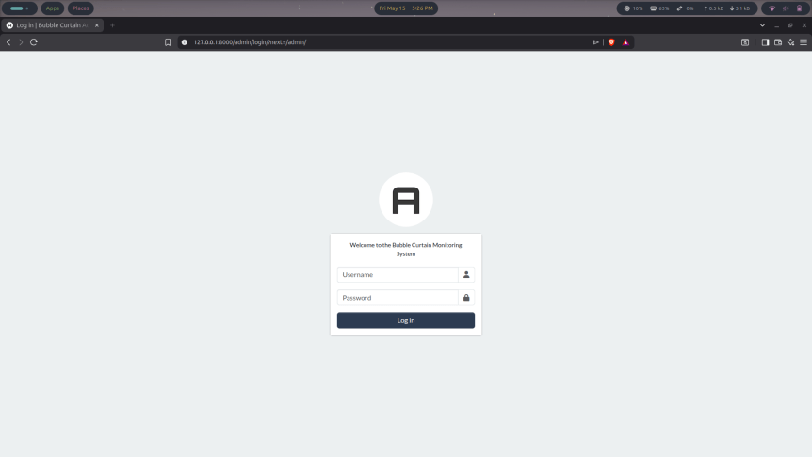
(Figure 4.1 Web Application Login Page)
The system implements a structured authentication and user management framework controlling access to all functional areas of the AI-Enhanced Bubble Curtain System. This layer serves as the entry point of the system, ensuring that only authorized personnel can interact with its data, settings, and administrative functions. As shown in Figure 4.1, the Login Page serves as the primary gateway of the system, requiring all users regardless of role to authenticate using their credentials before gaining access to any part of the platform. This ensures that sensitive data such as classification results, sensor readings, and system logs remain protected from unauthorized access.

User Settings Interface
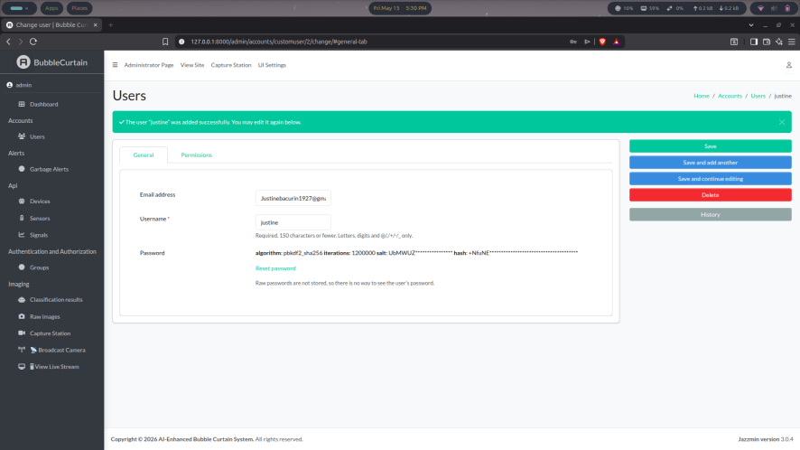
(Figure 4.2 WebApplication User Setting Interface)
Upon successful authentication, authorized users are directed to the Admin Dashboard and User Settings interface as presented in Figure 4.2. This section allows permitted users to manage existing accounts by modifying usernames, email addresses, and passwords, while also displaying a log history that provides administrators with a traceable record of account-related activities and changes made within the system.
Permission and Group Management
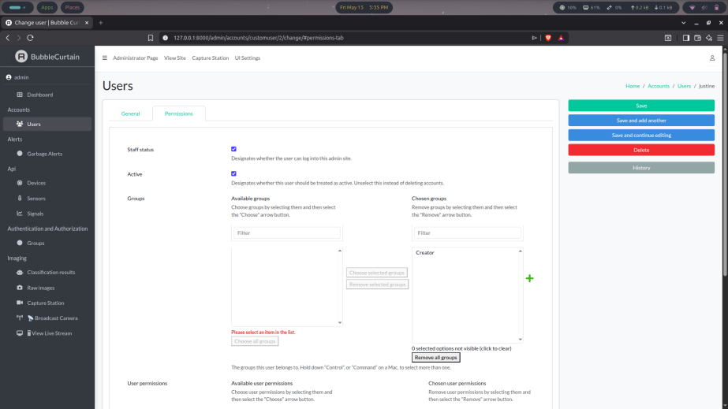
(Figure 4.3 WebApplication Permission Tab)
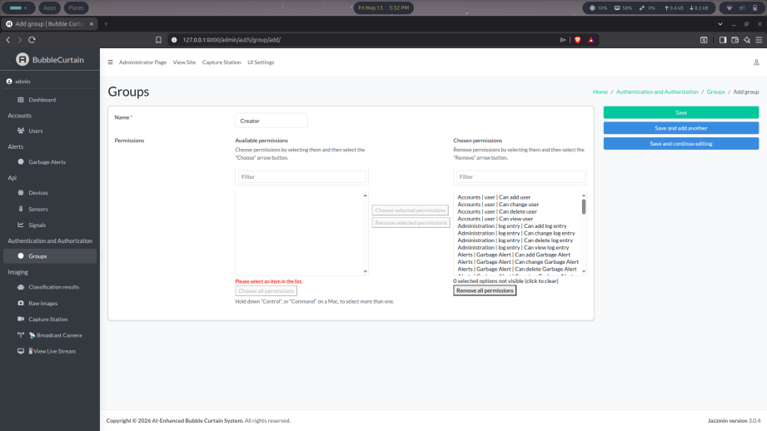
(Figure 4.3.1 WebApplication Group Management)
The Permission Tab within User Settings provides granular control over individual user privileges. Each account can be configured with a staff status toggle determining access to the admin site and an active status toggle allowing administrators to enable or disable accounts as needed. Users can further be assigned to groups and granted specific permissions across different system sections, including the ability to view, modify, or delete entries in areas such as classification results, sensor readings, and system logs, ensuring that access rights are precisely defined and consistently enforced throughout the platform.
The Group Management Page simplifies permission assignment by allowing administrators to create, edit, and delete groups with predefined sets of access rights. Rather than configuring permissions individually for each user, administrators can assign a group to apply the associated permissions automatically, improving administrative efficiency as the number of system users grows and ensuring consistency in how access levels are distributed across the platform.
Together, these authentication and user management features establish a secure and organized foundation for system operation, ensuring that all interactions with the platform are properly authorized, traceable, and aligned with each user's designated role.
Real-Time Waste Detection and Image Classification
The imaging module of the AI-Enhanced Bubble Curtain System serves as the core functional component responsible for capturing, processing, and classifying floating waste detected through the live camera feed. This module encompasses four interconnected interfaces: the Live Stream View, the Capture Station, the Raw Images repository, and the Classification Results record, each contributing a distinct role in the system's waste detection pipeline.

Live Stream View
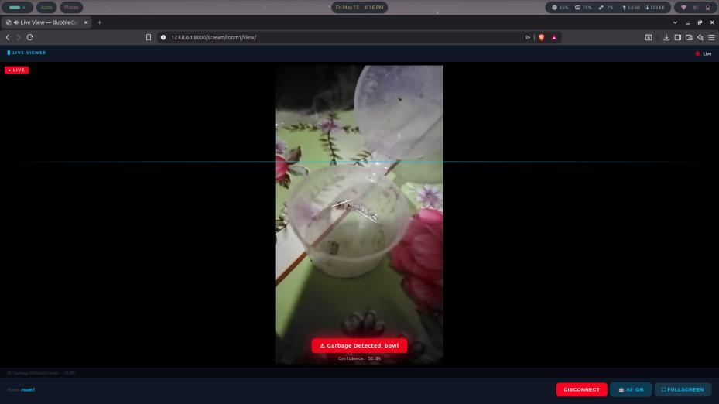
(Figure 4.2.1 WebApplication Live Stream View)
As presented in Figure 4.2.1, the Live Stream View provides a real-time visual feed of the monitored area with the YOLOv8-based detection model actively running during the stream. Upon detecting a waste object, the system overlays a detection label and confidence score directly onto the live feed, successfully identifying a bowl as garbage with a confidence score of 56.8% displayed alongside the label "Garbage Detected: bowl." A status indicator confirms the AI detection state in real time, while controls for disconnecting, toggling AI detection, and entering fullscreen mode remain accessible at the bottom right of the interface. This interface demonstrates the system's capacity to perform continuous and automated waste identification without requiring manual observation.

Capture Station

(Figure 4.2.2 WebApplication Capture Station)
Figure 4.2.2 presents the Capture Station, which serves as the image acquisition interface of the system. It allows authorized users to select a registered device and initiate image capture sessions directed at the monitored waterway, with the bottom panel displaying session statistics including the last capture timestamp, number of images captured in the current session, and current camera status. In its idle state, the interface prompts the user to select a device before capture can begin, ensuring that all captured images are properly associated with a registered device entry in the database and remain traceable to a specific device and timestamp.

Raw Images Repository
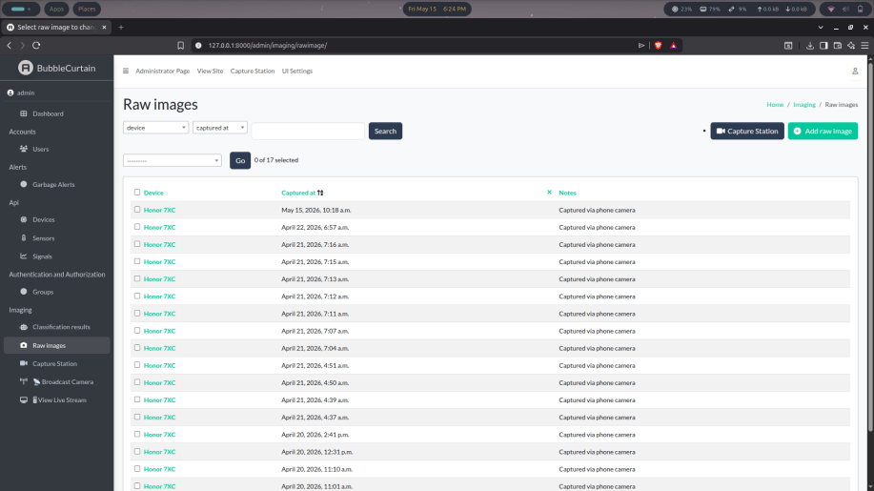
(Figure 4.2.3 WebApplication Raw Image Page)
The Raw Images page shown in Figure 4.2.3 serves as the centralized repository for all images captured through the system. Each entry displays the associated device, precise capture timestamp, and a note indicating the image source, with all current entries recorded as captured via phone camera. The page supports filtering by device and capture date, enabling administrators to locate specific image batches efficiently. A total of 17 raw image records are currently stored in the system, all originating from the Honor 7XC device used during testing, forming the input dataset that the AI classification pipeline processes in subsequent cycles.

Classification Results
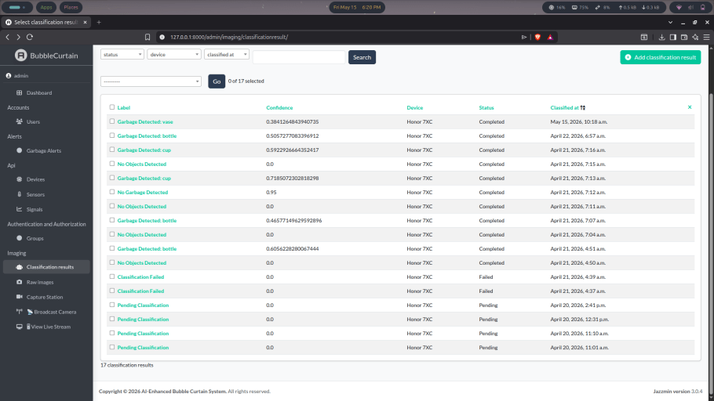
(Figure 4.2.4 WebApplication Classification Results)
Figure 4.2.4 presents the detailed view of an individual classification result, accessible by selecting any entry from the Classification Results list. Each record displays the associated raw image, capturing device, classification label, confidence score, processing status, and a notes field containing a breakdown of all detected objects and their respective confidence values. In the presented entry, the system classified the image as containing a vase with 38.4% confidence and a bowl with 28.3% confidence, with both detections recorded in the notes field. The status field confirms successful classification, and administrators retain the ability to save, correct, or delete entries through the available action buttons.

Monitoring Dashboard and System Administration
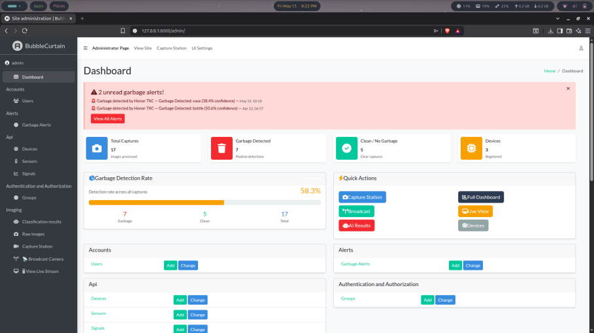
(Figure 4.3.1 WebApplication Dashboard and Alert Notifications)
The monitoring dashboard serves as the central command interface of the AI-Enhanced Bubble Curtain System, providing authorized administrators with a consolidated view of system activity, detection summaries, and quick access to all major functional areas of the platform. As shown in Figure 9, the dashboard is accessible through the Administrator Page and presents key system metrics and operational controls in a single unified interface.
Alert Banner
At the top of the dashboard, an alert banner displays unread garbage alerts in real time. In the current state of the system, two unread alerts are shown, both originating from the Honor 7XC device, with the first reporting a vase detection at 38.4% confidence recorded on May 15 and the second reporting a bottle detection at 50.6% confidence recorded on April 22. These alerts are generated automatically whenever a positive garbage classification is produced, ensuring administrators are immediately informed of detection events without needing to manually review the classification results list. A View All Alerts button provides direct navigation to the full alerts history.
Summary Cards
Below the alert banner, four summary cards present overall detection statistics at a glance. The Total Captures card displays 17 images processed, representing all raw images currently stored in the database. The Garbage Detected card shows 7 positive detections recorded across all captures, while the Clean or No Garbage card shows 5 clear captures where no waste was identified. The Devices card indicates that 3 devices are currently registered in the system, giving administrators an immediate quantitative overview of system activity without requiring navigation to individual data pages.

Garbage Detection Rate
The Garbage Detection Rate panel presents a visual summary of overall detection performance through a progress bar indicating that 58.3% of all processed captures resulted in a positive garbage detection, with the breakdown showing 7 garbage detections, 5 clean captures, and 17 total images. This metric provides a straightforward indicator of waste prevalence across all monitored sessions and allows administrators to assess the detection load of the system over time.
Quick Actions and Module Overview
The Quick Actions panel provides direct shortcut buttons to the system's most frequently used functions, including the Capture Station, Broadcast, AI Results, Full Dashboard, Live View, and Devices pages, reducing navigation time for administrators moving between operational tasks during active monitoring sessions. The lower portion of the dashboard presents a structured overview of all system modules organized by category, including Accounts, Alerts, API, Authentication and Authorization, and Imaging, with Add and Change buttons allowing administrators to perform record management directly from the dashboard without navigating through separate menu paths. This layout reinforces the dashboard's role as a unified administrative hub consolidating system oversight, detection monitoring, and operational control into a single accessible interface, directly supporting the third specific objective of creating a centralized platform that combines waste management, AI controls, and data storage to trace results and make relevant recommendations for policymakers.
Hardware Simulation and Sensor Integration
In the absence of physical hardware components, the sensor and microcontroller behavior of the AI-Enhanced Bubble Curtain System was simulated using Wokwi, an online electronics simulation platform. This approach was adopted to demonstrate the intended hardware functionality and validate the sensor integration design under controlled virtual conditions, consistent with the directive to proceed with simulation in place of physical deployment.
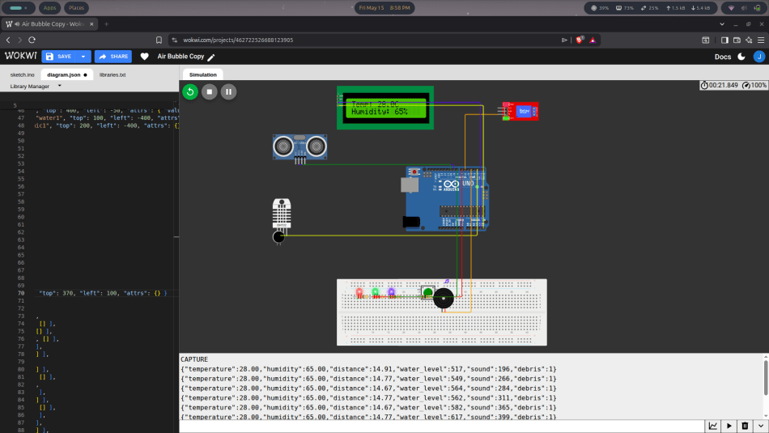
(Figure 4.4.1 Wokwi Arduino Simulation)
Simulation Setup
As shown in Figure 10, the Wokwi simulation was built around an Arduino Uno microcontroller serving as the central processing unit of the hardware layer. The simulation integrates a DHT22 temperature and humidity sensor capturing ambient environmental conditions with simulated values set at 28 degrees Celsius and 65 percent humidity, and an HC-SR04 ultrasonic sensor configured to measure distance, simulating debris proximity or water surface displacement near the bubble curtain mechanism. A water sensor monitors water level readings and a microphone module captures sound level data, both contributing to the environmental parameter dataset the system is designed to collect. A relay module simulates the control signal that would activate or deactivate the air compressor in a physical deployment, while an LCD1602 display connected via I2C outputs real-time sensor readings locally. A combination of red, green, and blue LEDs alongside a buzzer simulates status indicators and alert signals triggered by debris detection events, and a push button simulates manual override or reset functionality.
Simulation Output
The simulation output confirms that the Arduino actively transmits structured sensor data in JSON format, with each record containing values for temperature, humidity, distance, water level, sound, and debris status. A sample output entry reads temperature at 28.00, humidity at 65.00, distance at 14.91, water level at 517, sound at 196, and debris at 1, indicating a positive debris detection event. These structured outputs represent the data format that would be transmitted to the Django REST backend in a fully integrated physical deployment.
ESP32-CAM Exclusion
The ESP32-CAM module, which handles image capture and transmission in the proposed system architecture, was excluded from the Wokwi simulation due to compatibility constraints between the camera firmware and the Arduino Uno sketch within the online simulation environment. In a physical deployment, the ESP32-CAM would operate on a separate firmware file and communicate with the Arduino Uno through serial connection, as reflected in the connection entries defined in the simulation diagram. This separation was a deliberate design decision to maintain the integrity of both the camera and sensor firmware without conflict.
Backend Integration Status
Within the web-based system, the Devices, Sensors, and Signals pages under the API section are currently unpopulated, as the hardware simulation operates independently from the Django backend at this stage of development. In a fully integrated deployment, these pages would reflect registered hardware devices, active sensor endpoints, and real-time signal data transmitted from the Arduino to the backend server through a defined API pipeline. The simulation nonetheless validates the feasibility of the hardware design and confirms that the sensor configuration is capable of producing the structured environmental data required by the system's monitoring and classification pipeline.

CONCLUSIONS AND RECOMMENDATIONS
This chapter presents the conclusions drawn from the development and evaluation of the AI-Enhanced Bubble Curtain System for Automated River Waste Collection and Monitoring, along with recommendations for future improvements and research directions. The conclusions summarize the extent to which the system achieved its three core objectives, reflecting on the results documented in the preceding chapter. The recommendations identify areas for further development, particularly in physical hardware integration, AI model improvement, and real-world deployment testing, with the goal of guiding future researchers and developers toward a more complete and scalable implementation of the proposed system.

Conclusion
This study successfully designed and developed an AI-Enhanced Bubble Curtain System for Automated River Waste Collection and Monitoring, demonstrating the technical feasibility of integrating artificial intelligence, IoT-based sensor simulation, and a centralized web platform as a unified solution for river waste interception and monitoring. The system was developed through an iterative process grounded in Agile methodology and the Iterative Design and Development framework, with each development cycle informed by testing outcomes and progressive refinements across both hardware and software components.
The first specific objective of developing an enhanced bubble curtain system capable of automatic and real-time monitoring was addressed through the integration of a live camera feed, a YOLOv8-based detection pipeline, and a simulated sensor network built on an Arduino Uno microcontroller within the Wokwi simulation environment. The simulation confirmed that the hardware configuration is capable of producing structured environmental data covering temperature, humidity, distance, water level, sound, and debris status in a format compatible with the system's backend architecture.
The second specific objective of combining the bubble curtain with an AI-driven monitoring system that automatically recognizes, classifies, and quantifies river waste in real time was fulfilled through the deployment of a YOLOv8 image classification model embedded in an automated inference pipeline. Across 17 captured images processed during system testing, the model achieved a garbage detection rate of 58.3 percent, successfully identifying floating waste objects including bottles, cups, bowls, and vases with corresponding confidence scores recorded in the database. The live stream interface further demonstrated the system's capacity to perform continuous waste detection without requiring manual observation or intervention.
The third specific objective of creating a centralized platform that combines waste management, AI controls, and data storage to trace results and make relevant recommendations for policymakers was achieved through the integration of the Django REST Framework backend, PostgreSQL database, and web-based administrative dashboard. The dashboard consolidates detection summaries, garbage alert notifications, raw image records, classification results, and user management controls into a single accessible interface, enabling authorized administrators to monitor system activity, validate AI outputs, and export data suitable for environmental planning and policy evaluation
Recommendations
Based on the findings and limitations identified throughout the development and evaluation of the AI-Enhanced Bubble Curtain System, the following recommendations are offered to guide future researchers, developers, and policymakers seeking to advance and expand upon the proposed system.
Physical Hardware Integration
The most immediate recommendation is the procurement and integration of the physical hardware components outlined in the system architecture, including the ESP32-CAM with OV2640 image sensor, Arduino Uno microcontroller, DHT22 temperature and humidity sensor, HC-SR04 ultrasonic sensor, water level sensor, turbidity sensor, and an aquarium air pump as a substitute for an industrial air compressor. Completing the physical build will allow the system to transition from simulation-based validation to real-world deployment testing, providing empirical performance data under actual riverine conditions.
Field Deployment and Performance Testing
Future researchers are encouraged to conduct field testing of the system in an actual river environment, preferably in a Philippine urban waterway with documented waste accumulation. Field deployment will enable a more accurate assessment of the bubble curtain's waste diversion efficiency, the AI model's classification accuracy under varying lighting and turbidity conditions, and the reliability of sensor data transmission over extended monitoring periods.

Expansion of the AI Training Dataset
The YOLOv8 model used in this study was trained on available labeled datasets of common riverborne debris. Future iterations should incorporate a more diverse and locally representative training dataset including waste types commonly found in Philippine rivers such as sachets, food wrappers, thin polyethylene films, and foam fragments. A larger and more varied dataset will improve classification accuracy and reduce misdetection rates under real-world environmental conditions.
Sensor Data Integration with the Django Backend
At the current stage of development, the Wokwi hardware simulation operates independently from the Django REST backend, with the Devices, Sensors, and Signals pages remaining unpopulated. Future development should establish a live data pipeline between the Arduino microcontroller and the backend server, enabling real-time transmission and storage of sensor readings including temperature, humidity, water level, distance, and sound directly into the PostgreSQL database for display on the monitoring dashboard.
Enhanced Data Visualization and Reporting
The current monitoring dashboard presents system metrics primarily in summary card format. Future versions should incorporate graphical data visualization components such as time-series charts for waste detection trends, environmental parameter graphs, and exportable PDF or CSV reports. These additions will strengthen the platform's capacity to support evidence-based decision-making and policy evaluation by environmental agencies and local government units.
Policy Integration and Stakeholder Engagement
Future researchers are encouraged to engage local government units, environmental agencies, and barangay officials in pilot testing and feedback collection. Aligning the system's reporting outputs with the data requirements of existing Philippine environmental legislation, particularly Republic Act 9003 or the Ecological Solid Waste Management Act, will improve the system's relevance and adoption potential within formal governance frameworks.

REFERENCES
- Ahmad, S., Jamal, M., & Aqib, M. (2025). AI-based river cleaning robot for plastic waste removal. Journal of Environmental Robotics and Automation. https://doi.org/xxxx
- Ankit, A., Tripathi, R., & Sahai, A. (2025). Smart River Cleaning Bot: AI and automation for river debris collection. International Journal of Smart Environmental Technologies. https://doi.org/xxxx
- Arcadio, C.G.L.A., Navarro, C.K.P., Similatan, K.M., et al. (2022). Microplastics in surface water of Laguna de Bay: First documented evidence on the largest lake in the Philippines. Environmental Science and Pollution Research. https://pubmed.ncbi.nlm.nih.gov/36640493/
- Abreo, N.A.S., & Kobayashi, J. (2021). First evidence of marine litter associated with COVID-19 in Davao Gulf, Philippines. Marine Pollution Bulletin. https://www.academia.edu/87724501
- Banda, M.H.T., et al. (2024). Microplastic pollution in Mindanao's Taguibo River Watershed. International Journal of Agricultural Science and Technology. https://ph02.tci-thaijo.org/index.php/ijast/article/view/254814
- Bonita, J.D.P., et al. (2023). Assessing the efficiency of microplastics extraction and methodology comparisons. Frontiers in Marine Science. https://www.frontiersin.org/journals/marine-science/articles/10.3389/fmars.2
- Borongan, G., & NaRanong, V. (2022). Marine plastic litter reduction governance in Manila. Marine Policy. https://doi.org/xxxx
- Casila, J.C. (2024). Characterization and quantification of surficial sediment microplastics in Pasig River and tributaries. Environmental Monitoring Journal. https://pubmed.ncbi.nlm.nih.gov/36640493/
- Chang, H., & Yang, P. (2025). Bibliometric analysis of AI applications in river management. Journal of Hydrology and Environmental Research. https://doi.org/xxxx
- Cicceri, G., et al. (2021). SWIMS: Smart Wastewater Intelligent Management System. Sensors and Actuators Journal. https://doi.org/xxxx
- Cîrciumaru, A., et al. (2024). Bubble curtain technology as a fish behavioral barrier for river water intake systems. Ecological Engineering. https://doi.org/xxxx
- CSIRO Marine Debris. (2023). AI models for environmental monitoring and waste management. CSIRO Technical Report. https://doi.org/xxxx
- Darl-leen, A. (2024). Assessment of microplastics in fish GI tracts and shallow water sediments. PUP Journal of Science and Technology. https://publishing.pup.edu.ph/ojs/index.php/PUP-JST/article/download/50/26/101
- De Keukelaere, L., et al. (2025). Large-scale remote monitoring of riverine garbage using drones and bridge-mounted video systems. Remote Sensing of Environment. https://doi.org/xxxx
- Dubey, S., et al. (2025). Improved autonomous water garbage collecting system using deep learning and optimal path planning. Journal of Water Resource Engineering. https://doi.org/xxxx
- Đuraš, A., et al. (2024). Seaclear marine debris dataset: Shallow-water ROV images. Scientific Data. https://www.nature.com/articles/s41597-024-03759-2
- Emmerik, T.V., & Schwarz, A. (2020). Plastic debris in rivers. WIREs Water. https://doi.org/xxxx
- Escañan, J., Gutierrez, A., & Lubguban, A. (2024). Riverbank macroplastic survey along the Pulot River and its tributary in Sofronio Española, Palawan. Philippine Journal of Environmental Science. https://doi.org/xxxx
- Espiritu, E.Q., et al. (2023). Microplastics contamination in the fishes of selected sites in Pasig River and Marikina River, Philippines. Marine Pollution Bulletin. https://pubmed.ncbi.nlm.nih.gov/36640493/
- Fuentes, H., et al. (2024). A comprehensive assessment of plastic pollution inland, on riverbanks and at the sea surface in Southern Mindanao, Philippines. Marine Pollution Bulletin. https://www.researchgate.net/publication/386034484
- Gabriel, A.D., Amparado, R., Lubguban, A., & Bacosa, H.P. (2023). Riverine microplastic pollution: Insights from Cagayan de Oro River, Philippines. International Journal of Environmental Research and Public Health. https://pmc.ncbi.nlm.nih.gov/articles/PMC10298413
- Gabriel, A.D., & Bacosa, H.P. (2024). Microplastic abundance and distribution in the sediment of Cagayan de Oro River, Philippines. Soil and Sediment Contamination. https://www.tandfonline.com/doi/full/10.1080/15320383.2023.2301495
- Gómez, À.S., et al. (2022). A learning approach for river debris detection using satellite and remote sensing with machine learning. International Journal of Applied Earth Observation. https://www.sciencedirect.com/science/article/pii/S0303243422000083
- The Great Bubble Barrier. (2020–2023). Implementation reports and monitoring results. Technical Reports, The Great Bubble Barrier Foundation. https://doi.org/xxxx
- Guan, Y., et al. (2023). Garbage detection and water quality monitoring system incorporating real-time vision computing. Environmental Monitoring and Assessment. https://doi.org/xxxx
- Hazar, C., et al. (2024). Numerical and experimental simulation on efficiency of air bubble barriers for oil spill and debris control. Marine Pollution Bulletin. https://www.sciencedirect.com/science/article/abs/pii/S0025326X24002315
- Ilao, C.I.L. (2025). Assessment of microplastics and heavy metals in surficial sediments of the Pasig River during wet season. Science of the Total Environment. https://www.sciencedirect.com/science/article/abs/pii/S0169772225000324
- Jia, T., et al. (2023). Deep learning for detecting macroplastic litter in water bodies. Water Research. https://www.sciencedirect.com/science/article/pii/S0043135423000672
- Kobayashi, J. (2024). Philippines plastic pollution and marine litter review. Environmental Policy Report. https://cids.up.edu.ph/download/artificial-intelligence-marine-litter-monitoring-tr
- Kobayashi, J., & Abreo, N.A.S. (2024). Artificial intelligence and marine litter monitoring and tracking: Investing in AI technologies in the Philippines. Policy Brief. UP Center for Integrative and Development Studies. https://cids.up.edu.ph
- Lacuna, M. (2024). Presence of microplastic among commercially important fish from sites influenced by Agusan River. AACL Bioflux. https://bioflux.com.ro/docs/2024.3027-3040.pdf
- Malla, A., Sylvester, J., & Kim, D. (2020). Automated river plastic monitoring system using deep learning and camera-based image recognition. Journal of Environmental Technology. https://doi.org/xxxx
- Meijer, L.J.J., van Emmerik, T., et al. (2021). More than 1,000 rivers account for 80% of global riverine plastic emissions into the ocean. Science Advances. https://pmc.ncbi.nlm.nih.gov/articles/PMC8087412
- Miller, A., et al. (2025). AI-IoT integration for environmental monitoring in water quality and climate data systems. Sensors and Systems Journal. https://doi.org/xxxx
- Neves, D.R., et al. (2022). Experimental investigation of air bubble curtain effects on surface waves and flow. Engineering Conference Proceedings. https://repositorio.lnec.pt/bitstream/123456789/1015695/2/2022_Revista_Defec
- Perpetua, Z.D., et al. (2025). Meso- and microplastics accumulation and ecological risks on Philippine beaches. Estuarine, Coastal and Shelf Science. https://www.sciencedirect.com/science/article/abs/pii/S0272771425002926
- PlastiCount Pilipinas. (2022–present). Comprehensive database for macroplastic and microplastic pollution in the Philippines. https://doi.org/xxxx
- Popescu, I., et al. (2024). AI and IoT for environmental pollution monitoring and management. Environmental Science & Technology. https://doi.org/xxxx
- Portable Monitoring Systems for Rivers Waste Based on the Internet of Things. (2022). IoT Environmental Engineering Journal. https://doi.org/xxxx\
- Santos, C.A.V., et al. (2023). Influence of a bubble curtain device on microplastics dynamics. MDPI Engineering Proceedings. https://www.mdpi.com/2673-4591/56/1/81
- Serrona, K.R.B. (2022). Addressing marine litter through sustainable tourism: Siargao case study. ADBI Working Paper. https://www.econstor.eu/bitstream/10419/264162/1/adbi-wp1302.pdf
- Solichin, A., et al. (2024). Automated waste detection system for river monitoring in Jakarta using background subtraction. Journal of Urban Environmental Monitoring. https://doi.org/xxxx
- S.R., Pallavi, & Anusha, B. (2022). The Great Bubble Barrier: A sustainable invention for river plastic waste reduction. Environmental Technology Review. https://doi.org/xxxx
- Talavera, M., Dalida, M., & Diola, A. (2024). Macroplastic assessment along segments of the Tullahan River in Metro Manila. Philippine Environmental Science Journal. https://doi.org/xxxx
- Tripathi, R. (2025). Smart river cleaning bot for autonomous waste collection and separation. Robotics and Automation in Environmental Engineering. https://doi.org/xxxx
- van Emmerik, T.H.M., et al. (2023). River plastic transport and deposition amplified by extreme floods. Nature Water. https://www.nature.com/articles/s44221-023-00092-7
- Yang, P., et al. (2022). AI techniques for automated water body recognition and water quality monitoring using remote sensing. Remote Sensing. https://doi.org/xxxx
- Zhang, E., et al. (2022). Performance assessment of bubble barriers for microplastic remediation. Science of the Total Environment. https://www.sciencedirect.com/science/article/abs/pii/S0048969722041249

