PHYTONUTRACEUTICAL VALUE OF BURO BITOON: A CANCER CHEMOPREVENTIVE AND ANTI-INFLAMMATORY AGENT

Lyanne T. H. Jover, Almahden C. Lumidseg, Roden C. Yumol
jover.kyan@gmail.com
lalmahden@gmail.com

Abstract— Cancer is the second leading cause of mortality worldwide. Over 10 million new patients are diagnosed with cancer annually with over 6 million associated deaths, representing roughly 12 percent of worldwide mortality. The occurrence of new cancer cases is expected to grow by about 70 percent over the next two decades and estimated to reach over 15 million new cases diagnosed annually by the year 2020. This study investigated the anti-angiogenic, cytotoxic activity, anti-inflammatory property, and antioxidative property of Barringtonia asiatica (Buro bitoon). Ethanolic extracts of Barringtonia asiatica fruit and leaves were subjected to phytochemical screening and qualitative chemical analysis revealed the presence of alkaloids, flavonoids, saponins, phenols, and tannins. Test for angiogenesis revealed a strong pro-angiogenic property of ethanolic extract at 1000 mg and 500 mg. Median lethal concentrations were found to be 147.91 and 338.84 for the leaves and the seeds, respectively. LC50 of the extracts were higher than the 20 microgram per milliliter limit, this implies that the extract can have minimal toxicity toward human body cells. Leaves and seed extracts of Barringtonia asiatica have demonstrated anti- inflammatory properties comparable to the positive control which suggests that it has potential to act as an alternative anti-inflammatory agent. Evaluation for antioxidant property of the leaf extract exhibits an IC50 value of 379.6 µg/ml while the seed extract exhibits an IC50 value of 363.58 µg/ml. Results demonstrated the bioactive property of the Barringtonia asiatica can be a possible natural chemotherapeutic drug in battling cancer which can serve for future pharmacological use.

Keywords— angiogenic, Barringtonia asiatica, cytotoxicity, cancer, phytochemical

I. INTRODUCTION
Cancer is the second leading cause of mortality worldwide. Over 10 million new patients are diagnosed with cancer annually with over 6 million associated deaths, representing roughly 12% of worldwide mortality [18]. The occurrence of new cancer cases is expected to grow by about 70% over the next two decades and estimated to reach over 15 million new cases diagnosed annually by the year 2020 [7]. Angiogenesis, the formation of new blood vessels from pre-existing capillaries and circulating endothelial precursors, plays a critical role in a various physiological and pathological processes such as embryonic development, wound healing, chronic inflammation, tumor growth, and metastasis [21]. Many of these mutations alter the expression or activity of key gene products, causing unregulated cell division leading to cancer.
Currently, the main cancer treatment modalities are surgery, radiation-based therapy, chemotherapy, gene therapy, and/or hormonal therapy, either singly or in combination [18]. The most commonly used chemotherapy drugs are antimetabolites, DNA-interacting agents, anti-tubulin agents, hormones, and molecular targeting agents, all of which work to destroy cancerous cells or limit their proliferation [15]. However, most cytotoxic drugs act on both cancerous and healthy cells and therefore elicit side effects such as hair loss, bone marrow suppression, drug resistance, gastrointestinal lesions, neurologic dysfunction, and cardiac toxicity [15]. Consequently, development of new anticancer agents with higher efficacy, selectivity, and little or no side effects is an urgent goal. More than 47% of current anticancer drugs on the market are natural products, their derivatives or natural product synthetic mimics, and more than 25,000 identified phytochemicals have been shown to possess potent anticancer activities.
Natural products, especially phytochemicals, have been used to help mankind sustain health since the dawn of medicine [14]. Phytotherapy (also called herbalism or herbal medicine) has provided remedies for ailments, including cancer, to the present day [16]. Dietary phytochemicals have many built-in advantages over synthetic compounds due to their proven safety, low cost, and oral bioavailability. However, it is only recently that researchers have begun to elucidate the mode of action of plant-derived agents at the molecular, cellular, and tissue level [5]. Many natural products have now been extensively researched, and numerous compounds have exhibited anticancer and other beneficial actions in modern controlled studies. Most anti-cancerous natural products interfere with the initiation, development, and progression of cancer by modulating various mechanisms including cellular proliferation, differentiation, apoptosis, angiogenesis, and metastasis.
This study aims to find out the ethnopharmacological property of Barringtonia asiatica by testing the presence of major bioactive metabolites in the extracts, determining the degree and nature of angiogenic reaction elicited by Barringtonia asiatica and assessing the toxicity of the extract by determining the median lethal concentration (LC₅₀) [5, 14, 15, 18, 23].

A. Methods and Experimental Details

1. Ethanolic Extraction
Ethanolic extract was prepared by 100gms of powdered plant seed and leaves soaked in 500ml of ethanol in room temperature for 72 hrs. The extracts were filtered through Whatman filter paper. After the crude ethanolic extraction of Barringtonia asiatica, it was then subjected to rotary evaporation in Notre Dame of Dadiangas University to get the pure extract.
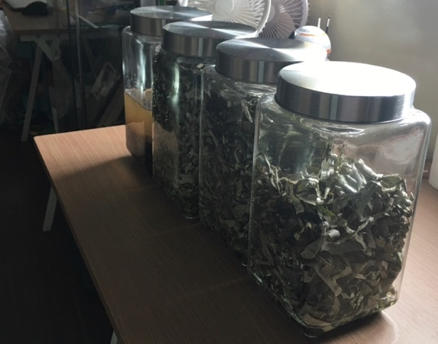
Figure 1. Soaking of B. asiatica Leaf and Seed for Ethanolic Extraction

2. Phytochemical Screening
In the present study, ethanol was used to extract the phytochemicals from Barringtonia asiatica by using standard protocols as cited in Tiwari et al., 2016.

- Test for Alkaloids (Mayer’s Test)
One (1) ml Filtrates were treated with Mayer’s reagent (Potassium Mercuric Iodide). Formation of a yellow-colored precipitate indicates the presence of alkaloids.

- Test for Tannins
One (1) ml of extract and sodium chloride. Formation of white precipitate indicated the presence of tannins.

- Test for Saponins (Foam test)
One (1) ml extract was diluted with two (2) mL distilled water and shaken in a test tube for 15 minutes.

- Test for Phenols
One (1) ml extract was treated with 3-4 drops of ferric chloride solution. Formation of bluish black color indicates the presence of phenols.

- Test for Flavonoids (Alkaline Reagent Test)
Extracts were treated with few drops of sodium hydroxide solution. Formation of intense yellow color, which becomes colorless on addition of dilute acid, indicates the presence of flavonoids.
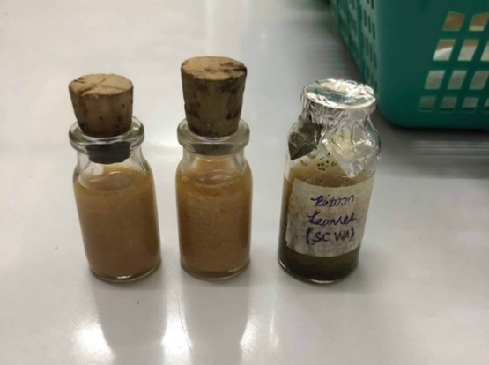
Figure 2. Phytochemical screening of B. asiatica and its crude extract

3. Duck Chorioallantoic Membrane (CAM) Assay
The assessment of angiosuppressive potential was conducted using a modified duck Chorioallantoic Membrane (CAM) assay, adapted from the methodologies established by Miller et al. (2004). Initially, one-day-old fertilized duck eggs underwent a rigorous cleaning process and were acclimatized in a high-humidity environment to ensure embryonic viability. Experimental treatments were formulated by dissolving specific masses of plant extracts in sterile distilled water to achieve a range of concentrations from 50 µg/10µL to 1000 µg/10µL. Simvastatin served as the pharmacological positive control, while sterile distilled water was utilized as the negative control to establish a baseline for normal vascular development. This controlled preparation phase was critical for determining the dose-dependent inhibitory effects of the extracts on the developing vascular system.
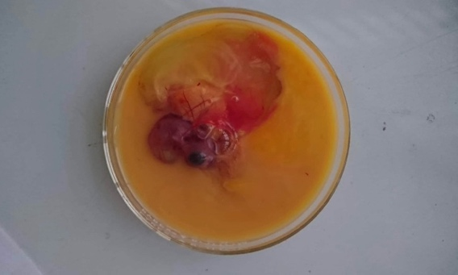
To facilitate treatment, a 1 X 1 cm window was precisely excised from each eggshell to expose the underlying CAM for direct manipulation. A small volume of egg fluid was aspirated to create space, after which filter paper discs impregnated with 10 µL of the test substances were applied directly to the membrane. The eggs were hermetically sealed and incubated, targeting the period between days 8 and 10 when the CAM vasculature is most responsive to regulatory stimuli. On the twelfth day of gestation, the CAMs were harvested by carefully removing the hard shell to reveal the intact soft membrane. Quantitative analysis was then performed by counting the number of blood vessel branch points to evaluate the degree of vascular suppression.

Figure 3. CAM of an incubated duck embryo

4. Brine Shrimp Lethality Assay
The cytotoxicity test conducted in this study followed the protocol of Quazi, Fatema and Mir in 2017. The Artemia salina specie were hatched in a rectangular aquarium filled with artificial seawater that was prepared through dissolved 25g of salt in one liter (1L) of distilled water (salinity of natural seawater ~25 ppt). The aquarium that was used in the process was divided into 2 unequal compartments by a perforated (2mm) dam (Hossen et al, 2011).
Fifteen grams of brine shrimp eggs were sprinkled at the top water level of the aquarium and were mixed with the water. A light that was 60-100 Watt bulb was used and placed few inches away from the aquarium. The setup of the eggs and photophilic nauplii was incubated in a room with a temperature of 28-30°C for a period of 20-24 hours and was observed. The newly hatched photophilic nauplii were then collected from the small illuminated compartment using a pasteur pipette. Hatched nauplii must be separated from the empty eggs by turning off the air as well as the lamp. Afterwards, the empty eggs floated while the brine shrimp concentrated in the water column (Quazi et al, 2017).
A 10 nauplii was transferred to each test tube using Pasteur pipettes. The nauplii was exposed to: T₁: 1000 µg/ml, T₂: 500µg/ml, T_{3:} 50µg/ml concentration of B.asiatica extract. After 24 hours, the number of survivors were counted and calculate the percentage of death using percentage of death formula.

$\%Death=\frac{Number of dead nauplii}{Number of dead nauplii+Number of live nauplii}×100$
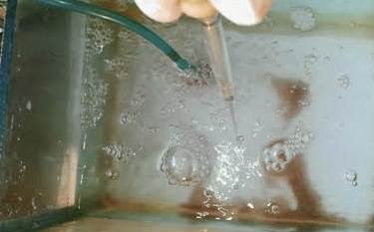

Figure 4. Brine Shrimp Collection for Cytotoxicity Test

5. Anti-inflammatory Assay
In this study, the anti-inflammatory properties of B. Asiatica seed and leaves using formalin induced hind paw edema in rats, and acetic acid induced abdominal writhing in mice was investigated. A total of 12 Albino mice/Mus musculus were used for the anti-inflammatory study. In the anti-inflammatory assay, 12 mice were divided into 4 groups of 3 rats each. Group I(Med) served as a positive control group and received diclofenac, Group II(Water) served as a negative control and received 0.02mL of distilled water, Group III(Leaf) received the leaf ointment, Group IV(Seed) received the seed ointment. The paws of the mice were then measured every hour for four hours, recorded, and subjected to statistical analysis.
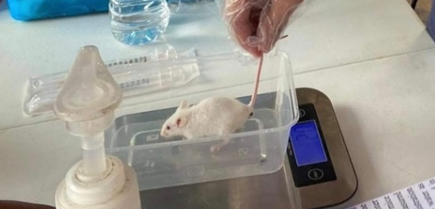
Figure 5. Preparation of Mice for Anti-inflammatory Testing

6. Scavenging Assay
The hydrogen peroxide scavenging assay was performed following the protocol of Ruch et al. in 1987 to assess the ability of the plant extract to scavenge hydrogen peroxide free radicals. Forty (40) mM of hydrogen peroxide is prepared in phosphate buffer solution (pH 7.4, 50mM). B. bitoon seed and leaf extracts and standard were prepared in various concentration (200µg/ml, 400µg/ml, 600µg/ml, 800µg/ml, and 1000µg/ml). Ascorbic acid was used as reference or standard. 0.1mL of the samples and standard were added to 0.6mL of hydrogen peroxide solution and incubated in a dark room at 30ᴼC for 10 minutes to complete the reaction. The absorbance was estimated at 230nm in a spectrophotometer against a blank solution containing phosphate buffer without hydrogen peroxide. Hydrogen peroxide in phosphate buffer will be used as control.
$$H_{2}O_{2} Scavenging Activity \%=\frac{AbsC-AbsS}{AbsC}×100$$
Where AbsC is the absorbance of the control and AbsS is the absorbance of the sample.
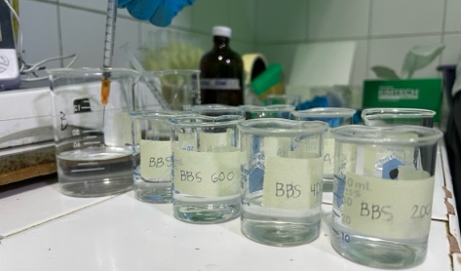

Figure 6. Preparation of Extract for Scavenging Activity Testing

B. Results and Discussion

7. Phytochemical Screening
The phytochemicals like phenol, flavonoid, saponin, alkaloid, and terpenoid, can scavenge free radicals. These compounds have previously shown strong anticancer and antimicrobial activity. The table below shows the bioactive compounds present in Barringtonia asiatica.
TABLE 1
Phytochemical Analysis of Barringtonia asiatica Extract
Class of Compounds | Seed Extract | Leaf Extract
Alkaloids | + | +
Flavonoids | + | +
Saponins | + | +
Phenols | + | +
Tannins | + | +
(+): present; (-): absent
Qualitive chemical analysis done on the ethanol extracts of Barringtonia asiatica indicated the presence of alkaloids, flavonoids, phenols, tannins and saponins and had no negatives for the extract.

8. CAM Assay
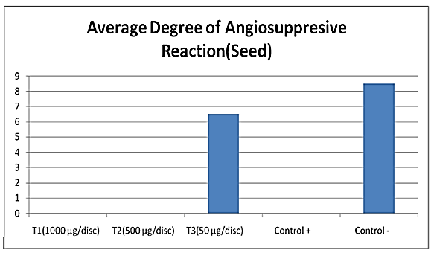

Figure 7. Result of Angiosuppressive Activity of Seeds
Figure 7 shows the degree of angiosuppresive ability of Simvastatin (positive control) and B. asiatica seed extracts, and were found to be inversely dependent with the dosage concentration. It was found that embryos reached 100% mortality at concentrations greater than 50mg/mL. This only shows that the greater concentration the higher angiosuppresive ability elicited by the extracts causing the degeneration of vessels, leading to mortality. Other than promoting vessel growth, the extracts also imposed toxicity toward the blood vessels, thus leading to death.

TABLE 2
Descriptives of Angiosuppressive Activity of Barringtonia asiatica Seeds
Treatments | N | Mean | Std. Deviation
Negative  Positive  1000 µg/ml  500 µg/ml  50 µg/ml  Total | 3  3  3  3  3  15 | 8.667  0.000  0.000  0.000  6.333  3.000 | 1.528  0.000  0.000  0.000  1.155  3.946
^{a.} 0.05 Level of Significance
Table 2 shows the descriptive of treatments. The negative control has the mean of 8.667 with the standard deviation of 1.528. Positive control has the mean of 0.000. The test extracts on the other hand have the mean of 6.333 with the standard deviation of 1.155.
TABLE 3
Analysis of Variance Angiosuppressive Reaction of Seeds
 | Sum of Squares | df | Mean Square | F | p-value
Between Groups | 210.667 | 4 | 52.667 | 71.818 | .000
Within Groups | 7.333 | 10 | 0.733
Total | 218.000 | 14
^{a.} 0.05 Level of Significance
Table 3 presents the results of the ANOVA, which present the p-value 0.000 which is lower than the set standard 0.05 confidence level. There is a significant difference between the average angiosuppressive reaction among treatments. As follows, B. asiatica extract has angiosuppressive activities as shown on the table.

TABLE 4
Table for Multiple Comparison for the Angiosuppressive Activity (Seeds)
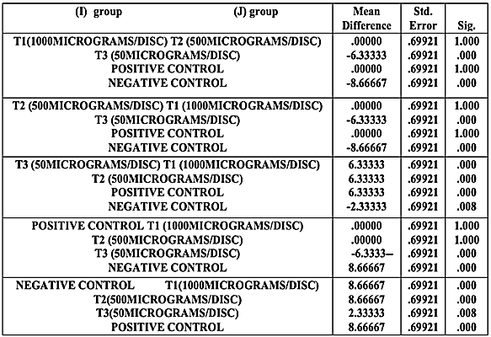

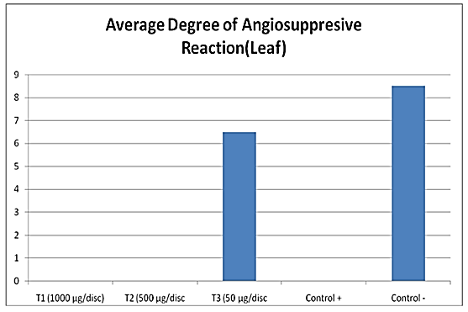
Table 4 shows that treatment 1, 2 and positive control have comparable results. Treatment 3 and negative control have comparable results in terms of its angiosuppressive reaction. The results revealed that the high the concentration of extract caused degeneration of vessels leading to mortality.

Figure 8. Result of Angiosuppressive Activity of Leaves
Figure 2 shows similar degree of angiosuppressive ability of Simvastatin (positive control) and B. asiatica extracts as in the seed extract, and were found to be inversely dependent with the dosage concentration. It was found that embryos reached 100% mortality at concentrations greater than 50mg/mL. This only shows that the greater concentration the higher angiosuppressive ability elicited by the extracts causing the degeneration of vessels, leading to mortality. Other than promoting vessel growth, the extracts also imposed toxicity toward the blood vessels, thus leading to death.
TABLE 5
Descriptives of Angiosuppressive Activity of Barringtonia asiatica Seeds
Treatments | N | Mean | Std. Deviation
Negative  Positive  1000 µg/ml  500 µg/ml  50 µg/ml  Total | 3  3  3  3  3  15 | 8.667  0.000  0.000  0.000  6.667  3.067 | 1.528  0.000  0.000  0.000  1.528  4.026
^{a.} 0.05 Level of Significance
Table 5 shows the descriptive of treatments. The negative control has the mean of 8.667 with the standard deviation of 1.528. Positive control has the mean of 0.000. The test extracts on the other hand have the mean of 6.667 with the standard deviation of 1.1528.
TABLE 6
Analysis of Variance Angiosuppressive Reaction of Seeds
 | Sum of Squares | df | Mean Square | F | p-value
Between Groups | 217.600 | 4 | 54.400 | 58.826 | .000
Within Groups | 9.333 | 10 | 0.933
Total | 226.933 | 14
^{a.} 0.05 Level of Significance
Table 6 presents the results of the ANOVA, which present the p-value 0.000 which is lower than the set standard 0.05 confidence level. There is a significant difference between the average angiosuppressive reaction among treatments. As follows, B. asiatica extract has angiosuppressive activities as shown on the table.

TABLE 7
Table for Multiple Comparison for the Angiosuppressive Activity
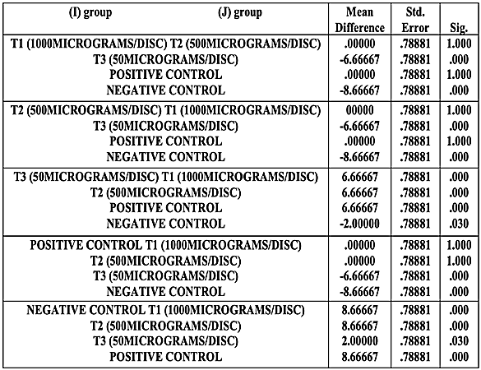
Table 7 shows that treatments 1, 2, and positive control have comparable results. Treatment 3 and negative control have comparable results in terms of its angiosuppressive reaction. The results revealed that high concentration of extract caused degeneration of vessels leading to mortality.

8. Brine Shrimp Lethality Assay
TABLE 8
Percentage Mortality and LC₅₀ of Barringtonia asiatica Leaf Extract
Concentration  (μg/mL) | log10 (concentration) | No. of Mortality |  |  | Total | Mortality % | Probit | LC50
Concentration  (μg/mL) | log10 (concentration) | R1 | R2 | R3
1000 | 3 | 8 | 8 | 8 | 24 | 80 | 5.84 | 147.91
500 | 2.699 | 6 | 7 | 6 | 19 | 63.33 | 5.33 | 147.91
100 | 2 | 3 | 4 | 4 | 11 | 36.67 | 4.64 | 147.91
0 | 0 | 1 | 0 | 1 | 2 | 6.67 | 3.45 | 147.91
Table 8 shows that the computed LC₅₀ is 147.91 which is greater than 20 μg/mL which indicates that the Barringtonia asiatica root extract was considered nontoxic. This suggests that the extract will not have adverse effect upon pharmacological applications.
TABLE 9
Percentage Mortality and LC₅₀ of Barringtonia asiatica Seed Extract
Concentration  (μg/mL) | log10 (concentration) | No. of Mortality |  |  | Total | Mortality % | Probit | LC50
Concentration  (μg/mL) | log10 (concentration) | R1 | R2 | R3
1000 | 3 | 6 | 7 | 7 | 20 | 66.67 | 5.41 | 338.84
500 | 2.699 | 5 | 6 | 6 | 17 | 56.67 | 5.15 | 338.84
100 | 2 | 2 | 2 | 3 | 7 | 28.33 | 4.42 | 338.84
0 | 0 | 1 | 0 | 1 | 2 | 6.67 | 3.45 | 338.84
Table 9 shows that the computed LC₅₀ is 338.84 which is greater than 20 μg/mL which indicates that the Barringtonia asiatica root extract was considered nontoxic. This suggests that the extract will not have adverse effect upon pharmacological applications.
9. Anti-inflammatory Test
TABLE 10
Descriptives of Paw Size Measurements for 4 Hours
Treatments | Mass | Paw Size Before Experiment | Inflamed Paw Size | Paw Size After 1 Hr | Paw Size After 2 Hrs | Paw Size After 3 Hrs | Paw Size After 4 Hrs
+ Control R1 | 16.4 | 22 | 23 | 24 | 23 | 22 | 22
+ Control R2 | 16.4 | 20 | 23 | 22 | 21 | 20 | 20
+ Control R3 | 13 | 19 | 23 | 22 | 21 | 20 | 20
AVERAGE | 15.27 | 20.33 | 23 | 22.67 | 21.67 | 20.67 | 20.67
- Control R1 | 14.4 | 20 | 23 | 22 | 22 | 21 | 21
- Control R2 | 15 | 20 | 23 | 22 | 22 | 21 | 21
- Control R3 | 14.3 | 21 | 24 | 23 | 23 | 22 | 22
AVERAGE | 14.57 | 20.33 | 23.33 | 22.33 | 22.33 | 21.33 | 21.33
T1:Leaves R1 | 15.3 | 21 | 24 | 22 | 21 | 21 | 21
T1:Leaves R2 | 14.4 | 22 | 25 | 23 | 22 | 22 | 22
T1:Leaves R3 | 15.04 | 21 | 24 | 22 | 21 | 21 | 21
AVERAGE | 14.91 | 21.33 | 24.33 | 22.33 | 21.33 | 21.33 | 21.33
T2:Seeds R1 | 15.6 | 21 | 24 | 22 | 21 | 21 | 21
T2:Seeds R2 | 15.7 | 21 | 24 | 22 | 21 | 21 | 21
T2:Seeds R3 | 15.1 | 20 | 23 | 21 | 20 | 20 | 20
AVERAGE | 15.47 | 20.67 | 23.67 | 21.67 | 20.67 | 20.67 | 20.67

In the table above, it can be noted that there are changes in the sizes of the mice’s paws during the four-hour observation period with one-hour intervals, after the inoculation of the treatments. All treatments have shown a constant rate of decrease in the average paw sizes of the mice over the period of four hours. To further specify the rate of change in paw size, the percent rate was calculated, which is shown in table 11.

TABLE 11
Percent of Change in Paw Size for Four Hours
TREATMENTS | AFTER 1HR OF TREATMENT | AFTER 2HRS OF TREATMENT | AFTER 3HRS OF TREATMENT | AFTER 4HRS OF TREATMENT
+ Control R1 | 4.00 | 8.00 | 12.00 | 12.00
+ Control R2 | 4.35 | 8.70 | 13.04 | 13.04
+ Control R3 | 4.35 | 8.70 | 13.04 | 13.04
AVERAGE | 4.23 | 8.46 | 12.70 | 12.70
- Control R1 | 4.35 | 4.35 | 8.70 | 8.70
- Control R2 | 4.35 | 4.35 | 8.70 | 8.70
- Control R3 | 4.17 | 4.17 | 8.33 | 8.33
AVERAGE | 4.29 | 4.29 | 8.57 | 8.57
T1:LeavesR1 | 8.33 | 12.50 | 12.50 | 12.50
T1:LeavesR2 | 8.00 | 12.00 | 12.00 | 12.00
T1:LeavesR3 | 8.33 | 12.50 | 12.50 | 12.50
AVERAGE | 8.22 | 12.33 | 12.33 | 12.33
T2:Seeds R1 | 8.33 | 12.50 | 12.50 | 12.50
T2:Seeds R2 | 8.33 | 12.50 | 12.50 | 12.50
T2:Seeds R3 | 8.70 | 13.04 | 13.04 | 13.04
AVERAGE | 8.45 | 12.68 | 12.68 | 12.68
Table 11 describes the average percent of change in the paw sizes of each control group in every hour interval during the four-hour observation period. It is shown in the first hour after the treatment, the treatments with the highest to lowest percent of change in paw sizes are Seeds, Leaves, Negative Control, and Positive Control with 8.45, 8.22, 4.29, and 4.23 percentages, respectively. After the second hour, the Seeds continue to lead at 12.68% followed by Leaves at 12.33%, while the positive control has overtaken the negative control with an 8.46% change in comparison to the latter’s consistent 4.29. After the third and fourth hour of observation, the positive control has taken the lead at 12.70% with the seeds, leaves, and negative control following at 12.68, 12.33, and 8.57 percentages, respectively.

TABLE 12
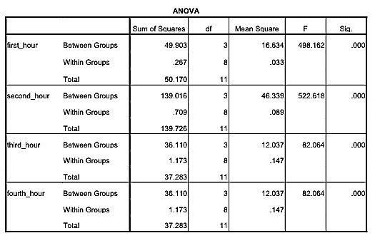
Analysis of Variance of Percent of Change in Paw Size

Analysis of Variance (ANOVA) was then conducted on the percent of change in paw size in order to ascertain the significant difference among the treatments, with a significance level of 0.05. Based on table 3, there is a significant difference in the percent of change of paw sizes in every hour interval for the entire four-hour observation period. Posthoc analysis was then done using Least Significant Difference in order to further specify the significant differences between treatment groups.

TABLE 13
Least Significant Difference on Percent Change of Paw Size After 1 Hour
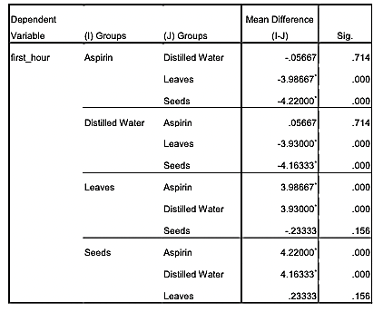
For the first hour, as seen in the table above, there is no significant difference in the percent change in paw size between the positive control (Aspirin) and negative control (Distilled water) as its sig. value is at .714 which is greater than the 0.05 level of significance. There is also no significant difference between the leaves (treatment 1) and seeds (treatment 2), as its significance level is .156, which is greater than the level of significance at 0.05. On the other hand, there is a significant difference in the percent change between the leaves (treatment 1), positive control (Aspirin), and negative control (Distilled water) as its sig. value is at .000 which is less than the significance level at 0.05. The seeds (treatment 2), positive control (Aspirin), and negative control (Distilled water) also have a sig. level of .000 which is less than the significance level at 0.05, and thus, are significantly different from each other.

TABLE 14
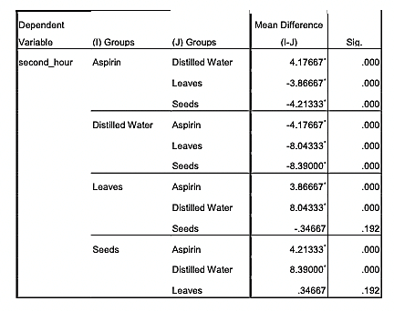
Least Significant Difference on Percent Change of Paw Size After 2 Hour

After the second hour, as seen in the table above, there is no significant difference in the percent change in paw size between the leaves (treatment 1) and seeds (treatment 2) as its sig. value is at .192 which is greater than the 0.05 level of significance. On the other hand, there is a significant difference in the percent change between the positive control (Aspirin) and the other treatments as its sig. value is at .000 which is less than the significance level at 0.05. There is also a significant difference between the negative control (Distilled water) and the other treatments at .000 level of significance, which is less than the significance level at 0.05.

TABLE 15
Least Significant Difference on Percent Change of Paw Size After 3 Hour
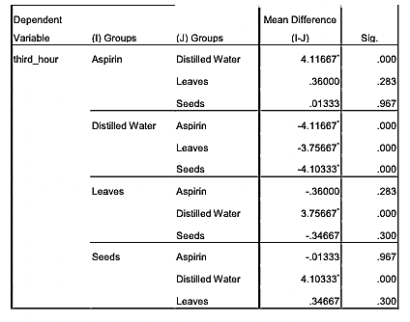
For the third hour, as seen in the table above, there is no significant difference in the percent change in paw size between the positive control (Aspirin), leaves (treatment 1) and seeds (treatment 2) as its sig. values are greater than the 0.05 level of significance. On the other hand, there is a significant difference in the percent change between the negative control (Distilled water) and the other treatments as its sig. value is at .000 which is less than the significance level at 0.05.

TABLE 16
Least Significant Difference on Percent Change of Paw Size After 4 Hour
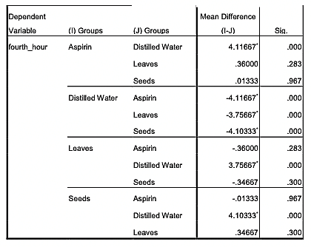
For the fourth hour, as seen in the table above, there is no significant difference in the percent change in paw size between the positive control (Aspirin), leaves (treatment 1) and seeds (treatment 2) as its sig. values are greater than the 0.05 level of significance. On the other hand, there is a significant difference in the percent change between the negative control (Distilled water) and the other treatments as its sig. value is at .000 which is less than the significance level at 0.05.
This goes to show that the leaf and seed extracts exhibit anti-inflammatory properties that are comparable with the positive control (Aspirin), making it a potential alternative to commercial anti-inflammatory products.

10. Hydrogen Peroxide Scavenging Assay
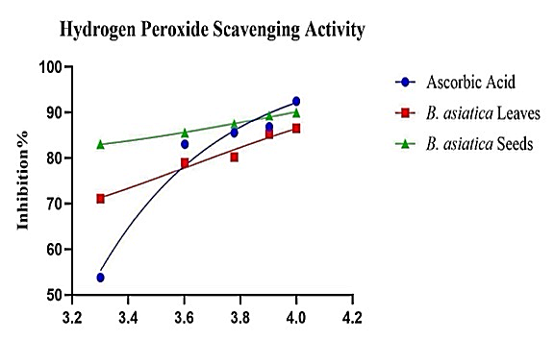

Figure 9. Hydrogen Peroxide Scavenging Assay
The percentage inhibition of the ascorbic acid revealed an IC50 value of 0.02625 mg/ml, which shows that it is a potent source of anti-oxidative compounds. However, both the seed and leaf extracts have also shown promising results based off the percentage inhibition, with the seed extract showing an IC50 value of 20.94 mg/ml and the leaf extract showing an IC50 value of 55.71 mg/ml. The IC50 value of both extracts are within the potency margin of 0-100 mg/ml which proves its potency as an anti-oxidative agent.

II. CONCLUSION

Results of the investigation had supported the bioactive property of the ethanol extracts of Barringtonia asiatica. Putative bioactive compounds are present in the extracts (alkaloids, flavonoids, saponin,s phenols, and tannins) that showed potent sources of pharmacological products. Toxicity analysis revealed the feasibility of the Barringtonia asiatica for pharmacological application. The extracts of Barringtonia asiatica were found to be ideal source of putative compounds; thus, causes minimal side effects on human body cells which make it a good drug candidate. Leaves and seed extracts have shown anti- inflammatory properties that are comparable with positive control and can be an alternative anti-inflammatory agent. These extracts have also shown a respectable anti-oxidative property which strengthens its ability overcome any harmful free radicals. The angiogenic investigation showed Barringtonia asiatica could be a good source of new novel angiosuppresive compounds for treating clinical diseases involving deregulations of neovascularization.

ACKNOWLEDGEMENT
The researcher could have never accomplished this humble work without the persistent support and inspiration from the people who has contributed to this study and helped him trail this research endeavor despite all the odds and obstacles amidst the pandemic.
First and foremost, would like to thank his family and relatives, especially his parents, Dr. Lyanne Kristoff M. Jover and Sandra May H. Jover, for the love and support throughout the whole process. The financial aid assistance and encouragement they had given to help the researchers remain positive especially during the trying times.
The researchers are indebted to his research adviser, Mr. Roden C. Yumol, Freshel Arra A. Egkao, Almahden C. Lumidseg and Mr. John Malayang for the time, effort, and guidance he has given him. His patience and selfless spirit have inspired the researchers to push through with the study. The researcher would also show gratitude to Shalom Crest Wizard Academy and its teachers for helping in critiquing and correcting the paper. The researcher thanks Shalom Crest Wizard Academy for the opportunity they have given the researcher.
Much appreciation is given to the researcher’s friends and classmates for the assistance, critiquing, and support for both the study and the researcher.
Above all else, none of these would have been possible without the guidance, wisdom, diligence, and grace that our Omnipotent God has given the researcher to accomplish the study. Without his blessings, this research would not be possible.
REFERENCES
[1] Ajuru, M.G., L.F. Williams, and G. Ajuru. "Qualitative and Quantitative Phytochemical Screening of Some Plants Used in Ethnomedicine in the Niger Delta Region of Nigeria ." Journal of Food and Nutrition Sciences, 2017: 198-205.
[2] Alamgir, A.N.M. "Secondary Metabolites." In Phenols, sometimes called phenolics, are a class of chemical compounds consisting of a hydroxyl group (—OH) bonded directly to an aromatic hydrocarbon group. , by A.N.M. Alamgir, 194-202. New York City: Springer, 2018.

[3] Altemimi, A., N. Lakhssassi, A. Baharlouei, D. Watson, and D. Lightfoot. "Phytochemicals: Extraction, Isolation,and Identification of Bioactive Compounds from Plant Extracts." Plants, 2017: 1-23.
[4] Begum, T.N., M.H.M. Ilyas, and A.A.V. Anand. "Antipyretic activity of azima tetracantha in experimental animals." International Journal of Current Biomedical and Pharmaceutical Research , 2011: 41-44.
[5] de Albuquerque, U., and M. Medeiros. "The pharmacy of the Benedictine monks: The use of medicinal plants in Northeast Brazil during the nineteenth century (1823–1829)." Journal of Ethnopharmacology, 2011.
[6] Elhardallou, S. B. "Cytotoxicity and Biological Activity of Selected Sudanese Medicinal Plants." Research Journal of Medicinal Plants, 5, 2011: 201-229.
[7] Franks, P.J., C.J. Moffatt, and D.C. Doherty. "Assessment of health-related quality of life in patients with lymphedema of the lower limb." Wound Repair Regen 14(2), 2006: 110-118.
[8] Gabrielli, M.G., and D. Accilli. "The Chick Chorioallantoic Membrane: A Model of Molecular, Structural, and Functional Adaptation to Transepithelial Ion Transport and Barrier Function during Embryonic Development." BioMed Research International, 2010: 1-12.
[9] Gaichu, D.M., A.M. Mawia, G.M. Gitonga, M.P. Ngugi, and D.N. Mburu. "Phytochemical screening and antipyretic activities of Ximenia americana in rat." Jounral of Herbmed Pharmacology 6(3), 2017: 107-113.Encyclopedia Britannica, 2014
[10] Galor, S., and F. F. Benzie. "Chapter 1: Herbal Medicine." In Herbal Medicine: Biomolecular and Clinical Aspects. 2nd edition., by S. Galor and F. F. Benzie. Boca Raton: CRC Press/Taylor & Francis, 2011.
[11] Herrea, A., and E. Amor. "Formation of new vessels is a tightly regulated complex process, its success largely depends on the balance between pro-and anti-angiogenic signals thus; the success of new vessel growth depends on the sensitive equilibrium between these two participatin." Journal of Medicinal Plants Research Vol. 5(13), 2011: 2637-2646.
[12] Levy, B.I. "Blood pressure as a potential biomarker of the efficacy angiogenesis inhibitor." Annals of Oncology, Volume 20, Issue 2, 2009: 200-203.
[13] Miller, W.J., et al. "A novel technique for quantifying changes in vascular density, endothelial cell proliferation and protein expression in response to modulators of angiogenesis using the chick chorioallantoic membrane (CAM) assay." J Transl Med, 2004.
[14] Moghadamtousi, S. Z., E. Rouhollahi, H. Karimian, M. Fadaeinasab, M. Firoozinia, and M. A Abdulla. "The chemopotential effect of Annona muricata leaves against azoxymethane-induced colonic aberrant crypt foci in rats and the apoptotic effect of acetogenin annomuricin E in HT-29 cells: a bioassay-guided approach." PLoS ONE 10:e0122288 10.1371/journal.pone.0122288, 2015.
[15] Nussbaumer, S., P. Bonnabry, J.L. Veuthey, and F. Sandrine. "Analysis of anticancerdrugs: A review." Talanta, 85, 2011: 2265-2289.
[16] Phytochemicals, Info. Phytochemicals.2016. https://www.phytochemicals.info/ (accessed September 16, 2019).
[17] Rady, I., et al. "Anticancer Properties of Graviola (Annona muricata): A Comprehensive Mechanistic Review." Oxid Med Cell Longev, 2018.
[18] Rady, I., H. Mohamed, M. Rady, I.A. Siddiqui, andH. Mukhtar. "Cancer preventive and therapeutic effects of EGCG, the major polyphenol in green tea." Egyptian Journal of Basic and Applied Sciences , 2017.
[19] Ribatti, D. "The Chick Embryo Chorioallantoic Membrane as an In Vivo Assay to Study Antiangiogenesis." Pharmaceuticals, 2010: 482-513.
[20] Ribatti, D., B. Nico, A. Vacca, L. Roncali, P.H. Burri, and V. Djonov. "Chorioallantoic membrane capillary bed: a useful target for studying angiogenesis and anti-angiogenesis in vivo." Anat. Rec. , 2001: 317–324.
[21] Risau, W. "Mechanisms of Angiogenesis." Nature 386, 1997: 671-674.
[22] Sayhan, H., S.G. Beyaz, and A. Celiktas. "The Local Anesthetic and Pain Relief Activity of Alkaloids." IntechOpen, 2017: 58-76.
[23] Siegel, R.L., K.D. Miller, and A. Jemal. "Cancer Statistics." CA Cancer J Clin, 2018: 7-30.
[24] Sisdharan, S., Y. Chen, D. Saravanan, K.M. Sundram, and L.Y. Latha. "Extraction, Isolation and Characterization of Bioactive Compounds from Plants' Extracts." African Journal of Traditional, Complementary, and Alternative Medicines,2010: 1-10.
[25] Stuart, G. Philippine Medicial Plants.June 2018. http://www.stuartxchange.org/Botong.html (accessed September 16, 2019).

[26] Thangaraji, R., et al. "Traditional usages of ichthyotoxic plant Barringtonia asiatica (L.) Kurz. by the Nicobari tribes." Journal of Marine and Island Cultures, 2015: 76-80.
[27] Wang, H., et al. "Plants Against Cancer: A Review on Natural Phytochemicals in Preventing and Treating Cancers and Their Druggability." Anticancer Agents Med Chem, 2012: 1281-1305.
[28] Young-soo, S. Medicinal Plants in Papua New Guinea.Manila: World Health Organization, 2009.
[29] R. Gomathi, T N. Umamaheswari, Roland Prethipa, “Evaluation of Antioxidant, Anti-inflammatory, and Antimicrobial Activities of Raspberry Fruit Extract: An In Vitro Study.” 2024.
[30] Tiwari, Prashant & Kumar, Bimlesh & Kaur, M. & Kaur, G. & Kaur, H.. (2011). Phytochemical screening and Extraction: A Review. Internationale Pharmaceutica Sciencia. 1. 98-106.

