LANGUAGE ANXIETY AND COMMUNICATIVE CONFIDENCE
AMONG MARATHI MEDIUM STUDENTS IN MAHARASHTRA:
FROM SCHOOL TO PROFESSIONAL LIFE
A Research Study
Gajanan Mule and Nupur Mali
Master of Design Space
National Institute of Fashion Technology (NIFT), Bangalore
Email: gajanan.mule@nift.ac.in | nupur.hanamantmali@nift.ac.in
Under the Guidance of Prof. Prashanth C.K.

Abstract
Background: Marathi medium students in Maharashtra face a persistent disadvantage in educational and professional settings where English fluency serves as an unspoken prerequisite. Research on language anxiety in this population has mostly focused on school level settings, leaving the experiences of undergraduate, postgraduate, and early career individuals insufficiently explored.
Problem Statement: This study investigates whether language anxiety among Marathi medium students is confined to the school stage or constitutes a structural condition that persists and deepens across the educational and career lifecycle.
Objectives: Two relationships are examined: (1) whether confidence in structured academic settings is related to anxiety in unstructured communicative contexts, and (2) whether perceived linguistic inferiority relative to peers is related to fear of social judgement.
Methodology: A structured twelve item, five point Likert scale was administered to a purposive sample of 40 respondents drawn from Marathi medium school, undergraduate, and postgraduate populations across Maharashtra. Spearman rank order correlation was used for hypothesis testing, and Cronbach’s Alpha was computed for reliability.
Results: Hypothesis 1 was confirmed with a strong positive correlation (rs = 0.799, p < 0.001). Hypothesis 2 was confirmed with a moderate positive correlation (rs = 0.571, p < 0.010). The scale showed excellent internal consistency (α = 0.938).
Conclusion: Language anxiety among Marathi medium students is a structural condition that persists across all educational stages and into professional life. The findings have direct implications for pedagogy, career support, language policy, and employer awareness in Maharashtra.
Keywords: anxiety, confidence, Marathi, Maharashtra, bilingualism, scaffolding, marginalisation, habitus, multilingualism, postcolonialism, pedagogy

1. Introduction
India’s education system operates within a deep linguistic hierarchy. English carries disproportionate institutional prestige while regional languages, including Marathi, are treated as markers of limited social mobility. For students who complete their entire schooling in Marathi medium, this creates a structural barrier that intensifies at each educational transition. When these students enter higher education or the professional world, they encounter environments where English fluency is tacitly expected for participation, peer recognition, and career advancement. The linguistic identity cultivated through years of schooling becomes, in these new contexts, a source of anxiety rather than confidence.
This study examines language anxiety and communicative confidence among Marathi medium students in Maharashtra across the full educational arc: school level learners, undergraduate students navigating mixed medium college environments, postgraduate students in research settings, and early career graduates facing workplace linguistic demands. The central argument is that language anxiety in this population is not a childhood phase that resolves with education. It is a structural condition that is reproduced and intensified at each transition point. The study investigates two research questions: (1) whether confidence in structured formal settings is significantly related to anxiety in unstructured communicative contexts; and (2) whether perceived linguistic inferiority relative to peers is significantly related to fear of social judgement.

2. Literature Review
The systematic study of language anxiety began with Horwitz, Horwitz, and Cope (1986), whose foundational work identified three core components of Foreign Language Anxiety (FLA): communication apprehension, test anxiety, and fear of negative evaluation. Operationalised through the Foreign Language Classroom Anxiety Scale (FLCAS), these constructs have been confirmed as negatively correlated with academic performance and communicative confidence (Horwitz, 2001; MacIntyre, 1995). MacIntyre and Gardner (1994) demonstrated that anxiety is most acute at the oral output stage, and Aida (1994) established that fear of negative evaluation is the single strongest predictor of overall language anxiety, a result directly relevant to the peer comparison dynamics explored in this study.
In India, Bhatt (2008) argues that English functions as linguistic capital in Bourdieu’s (1991) sense: it confers educational and economic advantage on those who possess it while disadvantaging those who do not. For Marathi medium students, entry into formal institutional environments produces what Bhatt calls a capital deficit, a mismatch between the linguistic resources students bring and those that institutions privilege. Canagarajah (1999) and Pennycook (2001) documented how English medium instruction in postcolonial contexts encodes social inequality by equating language competence with intellectual ability. Albert (2012) extended this framework to regional medium learners in South Asia, documenting the habitus mismatch that occurs when Marathi medium students transition into higher education environments built on English dominant norms.
Critically, the literature demonstrates that this anxiety does not resolve at the school leaving threshold. Deshpande (2016) documented that Marathi medium graduates in Maharashtra face acute communicative anxiety during job interviews and workplace interactions where English fluency is assumed. Kulkarni (2018) found that undergraduate students from Marathi medium backgrounds in Pune reported significantly higher anxiety in mixed medium college settings than English medium peers, with the gap widening under conditions of peer evaluation. Patil and Shinde (2020), writing in the Marathi educational journal Shikshan ani Samaj, documented how linguistic insecurity suppresses career aspirations among postgraduate students, with many excluding themselves from professional opportunities perceived as requiring English fluency. These studies establish a consistent pattern: language anxiety among Marathi medium students accompanies them across every educational and career transition.
Dewaele (2013) and Teimouri, Goetze, and Plonsky (2019) distinguish between dispositional anxiety (a stable individual trait) and situational anxiety (activated by context and responsive to social triggers). The post Covid shift to digital learning further widened communicative confidence gaps among regional medium learners (UNESCO, 2021). The present study proceeds from the position that anxiety among Marathi medium students is primarily situational and therefore responsive to institutional change.

3. Theoretical Framework
Three theoretical frameworks guide the analysis in this study, providing a vocabulary for diagnosing why language anxiety occurs, how it is sustained, and where intervention is most likely to be effective.

3.1 Foreign Language Anxiety (Horwitz, Horwitz, and Cope, 1986)
This study isolates two of the three FLA components as most analytically relevant: communication apprehension (fear of oral communication in formal or second language settings) and fear of negative evaluation (anticipation of social judgement based on language performance). Test anxiety is set aside because the study focuses on everyday communicative behaviour across school, college, and career settings rather than formal examinations. Both selected components apply directly to class presentations, placement interviews, and workplace communication.

3.2 Linguistic Capital and Habitus (Bourdieu, 1991)
Bourdieu’s (1991) framework treats language as a form of capital whose value is determined by the social field in which it is used. Students educated in Marathi develop a linguistic habitus, an internalised set of communicative dispositions and presentational norms formed through immersion in a specific linguistic environment. When this habitus encounters institutions that operate by different linguistic norms (a college campus, a job interview, a corporate meeting), students experience what Bourdieu calls hysteresis: a felt disjunction between their communicative identity and the field’s demands, experienced as anxiety, hesitation, and withdrawal. Albert (2012) documented this pattern specifically among regional medium learners in India, noting its intensity at career transition points.

3.3 Scaffolded versus Generalised Confidence (Vygotsky, 1978)
Vygotsky’s (1978) Zone of Proximal Development (ZPD) is used here to distinguish between scaffolded competence (performance dependent on structural supports such as prepared content, assigned roles, rehearsed language, and predictable formats) and generalised communicative confidence (capacity to perform fluently in spontaneous, unstructured situations without preparation). Students who have only practised language under scaffolded conditions will not automatically transfer that ability to unscaffolded contexts. When supports are removed, as in a job interview or impromptu group discussion, the anxiety that scaffolded performance had suppressed becomes fully exposed.
The relationship between these three frameworks and the educational transitions examined in this study is represented in Figure 2.
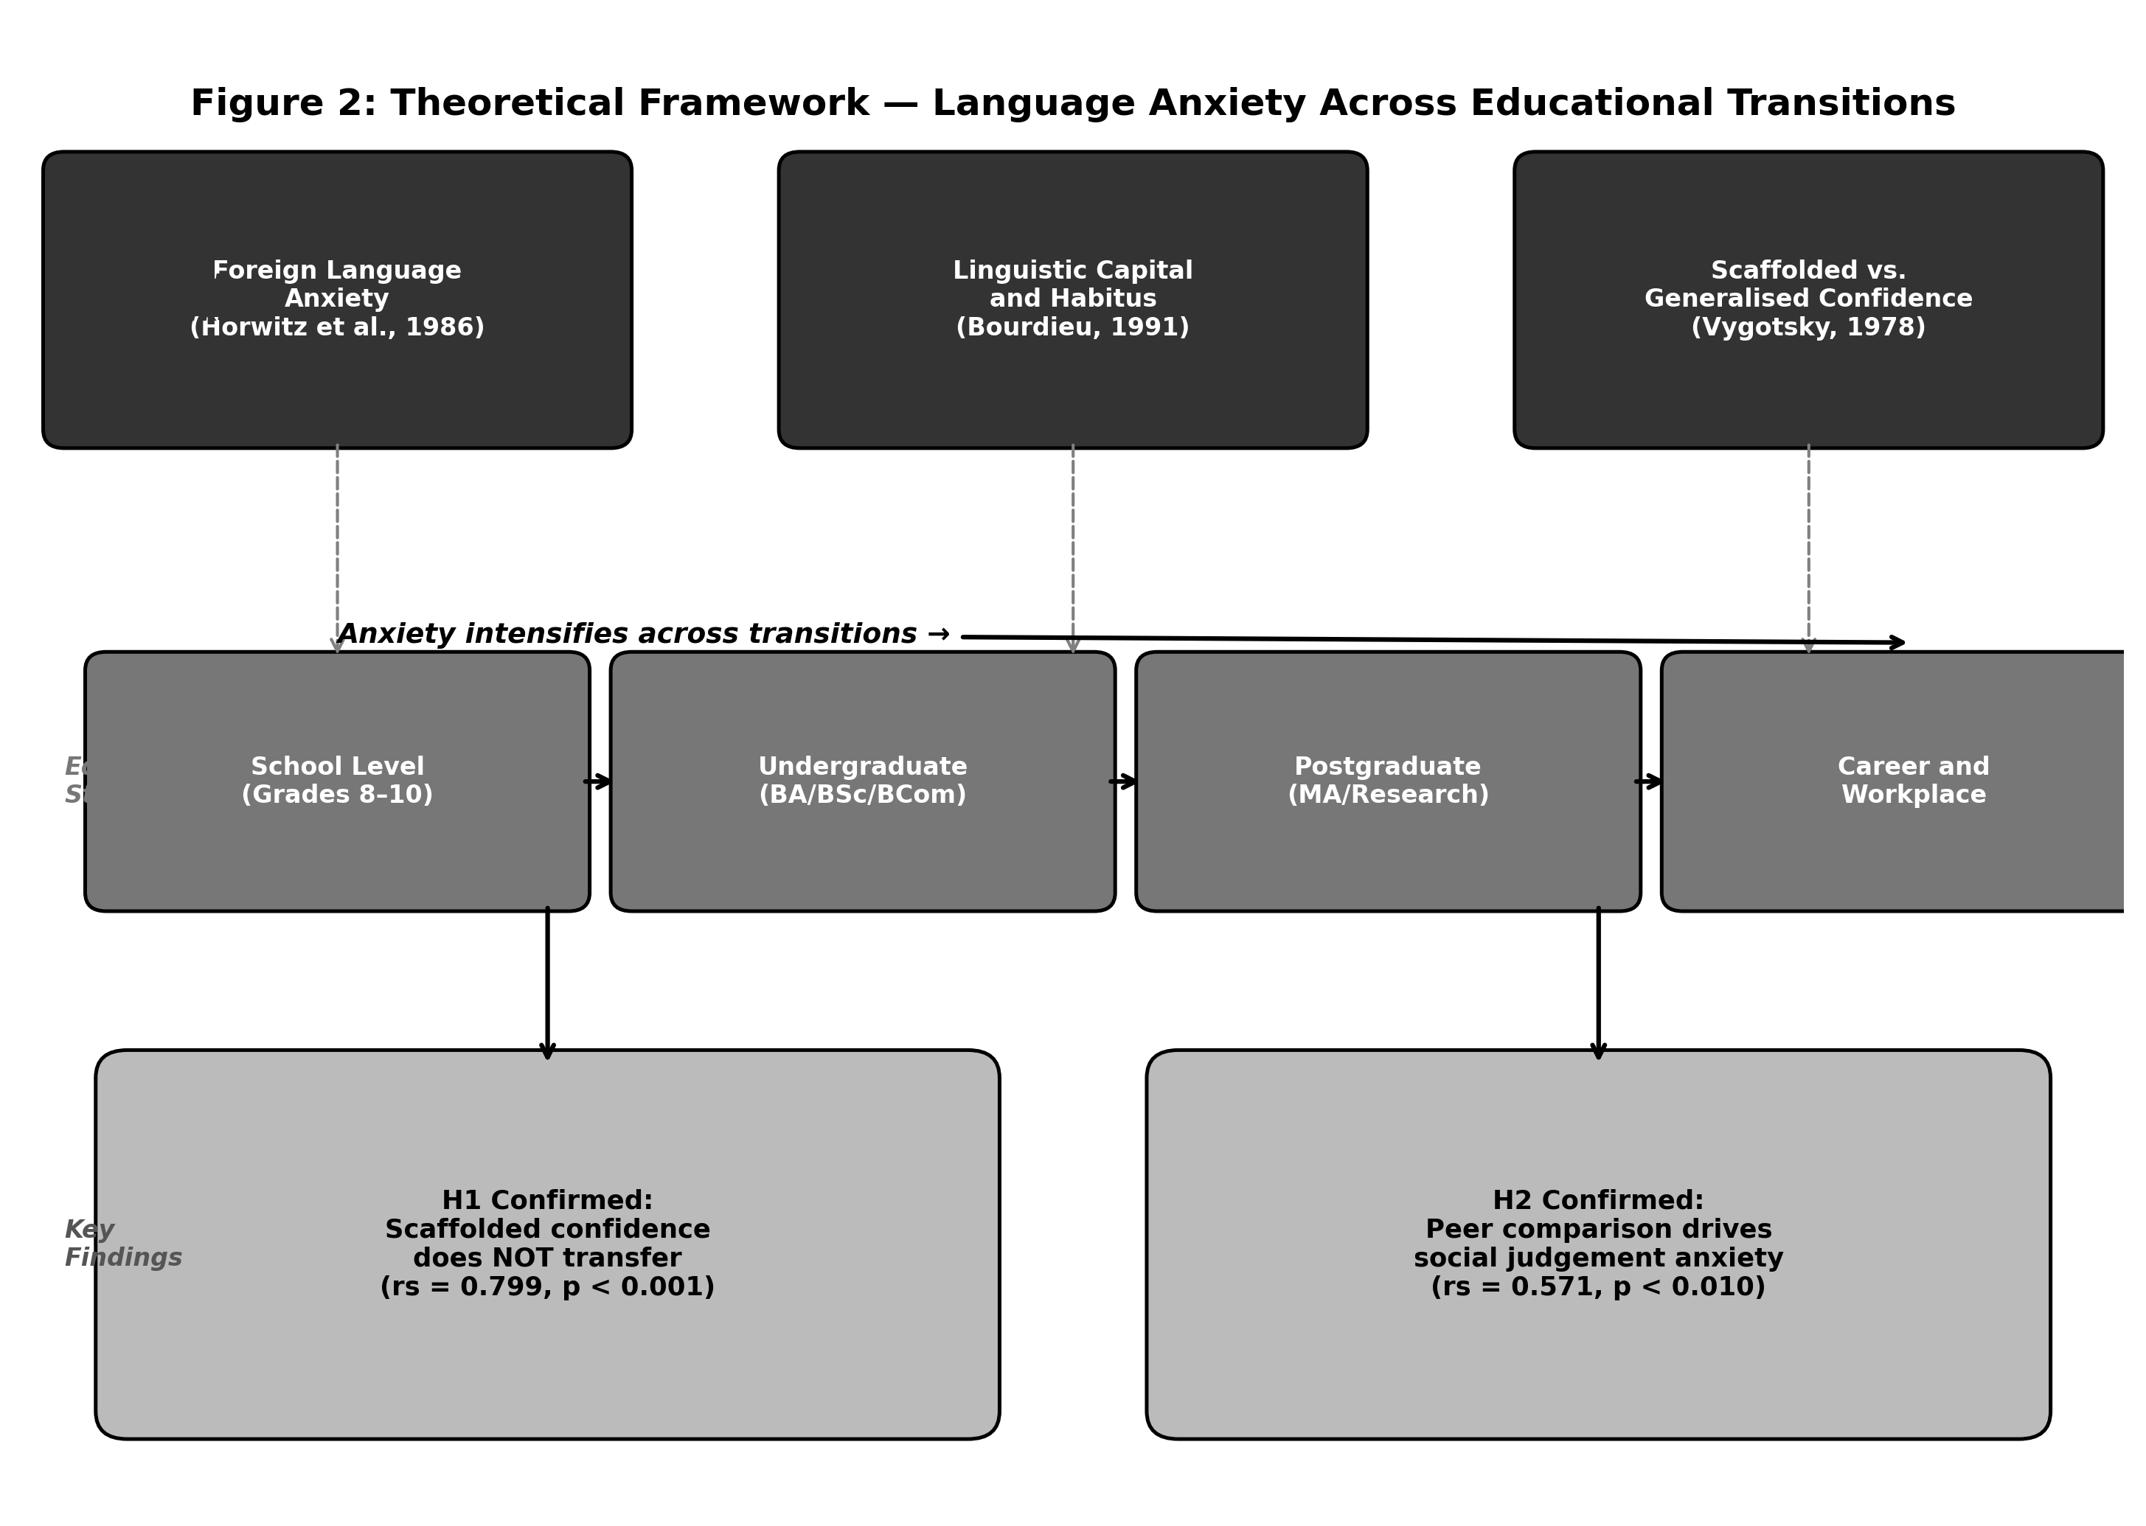
Figure 2: Theoretical Framework: Language Anxiety Across Educational Transitions

4. Research Objectives and Hypotheses
This study has two primary research objectives: (1) to examine whether communicative confidence in structured, formal academic settings is significantly related to anxiety in unstructured communicative situations among Marathi medium students; and (2) to examine whether perceived linguistic inferiority relative to peers is significantly related to fear of social judgement in class or professional contexts. Based on the theoretical frameworks and the literature, the following formal hypotheses are proposed:

Hypothesis 1: Formal Confidence and Unstructured Anxiety
H₀₁: There is no statistically significant relationship between communicative confidence in formal academic settings (Q1) and anxiety when speaking without preparation (Q2) among Marathi medium students in Maharashtra.
H₁₁: There is a statistically significant positive relationship between communicative confidence in formal academic settings (Q1) and anxiety when speaking without preparation (Q2) among Marathi medium students in Maharashtra.
This hypothesis is grounded in Vygotsky’s (1978) scaffolded versus generalised confidence distinction. If formal confidence is scaffolding dependent, students who report higher confidence in prepared settings will simultaneously report higher anxiety when scaffolding is removed, producing a positive correlation. Confirmation would indicate that structured academic performance does not reflect genuine generalised communicative readiness.

Hypothesis 2: Peer Inferiority and Social Judgement Anxiety
H₀₂: There is no statistically significant relationship between perceived linguistic inferiority relative to peers (Q3) and fear of social judgement when speaking (Q5) among Marathi medium students in Maharashtra.
H₁₂: There is a statistically significant positive relationship between perceived linguistic inferiority relative to peers (Q3) and fear of social judgement when speaking (Q5) among Marathi medium students in Maharashtra.
This hypothesis is grounded in Bourdieu’s (1991) theory of linguistic capital. If language anxiety is relational and comparative in character, students who perceive themselves as communicatively disadvantaged relative to peers will simultaneously report higher fear of social judgement, producing a positive correlation. Confirmation would validate that language anxiety in this population is not an internal individual trait but a socially produced and maintained experience.

5. Methodology

5.1 Research Design
This study adopts a cross sectional quantitative research design using a structured survey administered to respondents. Quantitative methods were selected because the objectives require measurement of the strength and significance of relationships between constructs through statistical testing.

5.2 Sample
A purposive sampling strategy was employed to ensure all respondents received their foundational schooling in Marathi medium institutions in Maharashtra. The final sample comprised n = 40 respondents: 15 school level students (Grades 8 to 10, mean age 13.7 years, SD = 1.2), 14 undergraduate students (age 18 to 22, enrolled in BA, BSc, or BCom programmes), and 11 postgraduate students or early career graduates (age 22 to 28). Of the total, 22 were female and 18 were male. All respondents reported Marathi as their primary home language with no prior sustained exposure to English medium schooling. The sample meets minimum requirements for Spearman rank order correlation and reliability analysis (Norman, 2010; Field, 2013). All participation was voluntary and confidential.

5.3 Survey Instrument
The instrument consists of twelve items on a five point Likert scale (1 = Strongly Disagree to 5 = Strongly Agree), capturing four theoretically grounded constructs applicable across school, college, and professional contexts.
Construct 1: Communicative Confidence in Formal Settings. Confidence reported by respondents when speaking in structured, role defined contexts such as presentations, seminars, or workplace meetings.
Construct 2: Anxiety in Unstructured or Impromptu Contexts. Nervousness in informal, spontaneous, or unprepared communicative situations including group discussions and job interviews.
Construct 3: Social Comparison and Perceived Peer Inferiority. The extent to which respondents feel communicatively disadvantaged relative to peers or colleagues.
Construct 4: Social Judgement Anxiety and Identity Related Pressure. The fear that peers, teachers, or employers are evaluating the respondent’s competence based on how they speak.
Item | Survey Statement
Q1 | I feel confident speaking in class presentations, seminars, or formal meetings.
Q2 | I feel nervous when asked to speak without any preparation.
Q3 | I feel less confident compared to other students or colleagues in my setting.
Q4 | I stay silent during discussions because I am afraid of making mistakes.
Q5 | I fear being judged when I speak in class or at work.
Q6 | I feel people judge my intelligence based on how I speak.
Q7 | I worry that my teacher or employer sees me as less capable because of how I speak.
Q8 | I worry more about how I say things than what I actually want to say.
Q9 | I feel more confident expressing myself in Marathi than in any formal setting.
Q10 | I feel frustrated when I cannot understand or express things in a formal context.
Q11 | I feel pressured to speak a certain way to be seen as successful.
Q12 | I would participate more freely if Marathi were accepted and encouraged in my environment.
Table 1: Survey Instrument, Twelve Item Likert Scale (Five Point)

5.4 Statistical Approach
All variables are measured at the ordinal level and do not satisfy the interval level assumptions required by parametric tests. The Spearman Rank Order Correlation (rs) was selected as the appropriate non parametric test of association (Siegel and Castellan, 1988; Field, 2013). A two tailed significance threshold of α = 0.05 was applied. Test statistics were computed as t = rs × √(n − 2) / √(1 − rs²), evaluated on a t distribution with n − 2 = 38 degrees of freedom.

6. Descriptive Statistics
Descriptive statistics were computed for all twelve items across n = 40 respondents. The overall mean was M = 3.24 (SD = 1.38) on the 1 to 5 scale, indicating a moderate to high aggregate level of language anxiety and social pressure in the sample.
Item | Statement (abbreviated) | Mean | Median | Mode | SD
Q1 | Confident in formal settings | 3.57 | 4.00 | 5 | 1.50
Q2 | Nervous without preparation | 3.67 | 4.00 | 4 | 1.24
Q3 | Less confident vs. peers | 3.24 | 3.50 | 4 | 1.51
Q4 | Silent due to fear of mistakes | 3.10 | 3.00 | 3 | 1.32
Q5 | Fear of being judged | 3.00 | 3.00 | 3 | 1.41
Q6 | Judged by ability based on speech | 3.22 | 3.00 | 4 | 1.60
Q7 | Teacher/employer sees me as less capable | 2.95 | 3.00 | 3 | 1.38
Q8 | Worry about expression over content | 3.15 | 3.00 | 3 | 1.29
Q9 | More confident in Marathi | 3.86 | 4.00 | 5 | 1.15
Q10 | Frustrated by formal communication | 3.20 | 3.00 | 3 | 1.26
Q11 | Pressure to speak a certain way | 2.81 | 3.00 | 3 | 1.47
Q12 | Participate more if Marathi encouraged | 3.67 | 4.00 | 4 | 1.22
Table 2: Descriptive Statistics for All Survey Items (n = 40)
Q9 (native language comfort) recorded the highest mean (M = 3.86, SD = 1.15), with 81 per cent of respondents scoring 4 or above, confirming that communicative ease remains anchored in Marathi regardless of educational stage. Q2 (nervousness without preparation, M = 3.67) and Q12 (participation if Marathi encouraged, M = 3.67) tied for second highest. The Q12 result is noteworthy: 71 per cent of respondents across all three educational stages agreed they would participate more actively if Marathi were institutionally legitimised, consistent with Patil and Shinde’s (2020) findings. Q1 displayed a bimodal distribution (38 per cent Strongly Agree, 19 per cent Strongly Disagree), reflecting the heterogeneity between respondents who have developed scaffolded confidence and those who have not. Q11 recorded the lowest mean (M = 2.81), suggesting resistance to accepting English medium communication as a personal marker of worth.

7. Reliability Analysis
Cronbach’s Alpha (α) was computed to assess the internal consistency of the twelve item scale. The accepted benchmarks in social science research are: below 0.60, poor; 0.70 to 0.79, good; 0.80 to 0.89, very good; 0.90 and above, excellent (Nunnally, 1978; George and Mallery, 2003).
Reliability Statistic | Value
Cronbach’s Alpha (α) | 0.938
Number of Items | 12
Sum of Item Variances | 23.04
Total Score Variance | 164.29
Sample Size (n) | 40
Reliability Interpretation | Excellent Internal Consistency
Table 3: Reliability Statistics, Cronbach’s Alpha (n = 40)
The scale yielded α = 0.938, confirming excellent internal consistency. All twelve items exceeded the item total correlation minimum of r = 0.40. Q2 was the strongest contributor (r = 0.874), reflecting the centrality of unscripted speaking anxiety to the construct. Q9 was the weakest (r = 0.439) but within the acceptable range. No items were removed.

8. Assessment of Normality
Since all variables are measured at the ordinal level, non parametric testing does not depend on normality conditions. However, a visual inspection of item level frequency distributions was conducted as a supplementary diagnostic check. Q1 showed a pronounced bimodal distribution. Q3, Q5, and Q9 showed skewed distributions inconsistent with normality. Where data departs from normality, parametric tests produce unreliable estimates; the Spearman rank order correlation is the appropriate choice. The non parametric approach was maintained consistently across all hypothesis tests, and no parametric tests were administered.

9. Results

9.1 Hypothesis Test 1: Formal Confidence and Unstructured Anxiety
The first hypothesis test examined the relationship between communicative confidence in formal academic settings (Q1) and anxiety when required to speak without preparation (Q2).
Variables | rs | t statistic | p value | Decision
Q1 (Formal Confidence) and Q2 (Unstructured Anxiety) | 0.799 | t(38) = 8.071 | p < 0.001 | H₀₁ Rejected
Table 4: Spearman Correlation Results, Hypothesis Test 1 (n = 40)
The test yielded rs = 0.799, t(38) = 8.071, p < 0.001. H₀₁ is rejected. The strong positive correlation confirms H₁₁: students who report higher confidence in formal structured settings also report significantly higher anxiety when required to speak without preparation.
This reflects the scaffolding dependency identified in the theoretical framework. Confidence in formal settings depends on structural supports: prepared content, assigned roles, rehearsed language, and predictable formats. When those supports are absent, as in job interviews, group discussions, and impromptu professional communication, the capacity demonstrated in scaffolded settings does not carry over. This pattern is consistent across school, undergraduate, and postgraduate respondents, confirming that scaffolding dependency is not resolved by educational progression. Deshpande’s (2016) findings on communicative anxiety among Marathi medium graduates in professional settings are directly supported by this result.

9.2 Hypothesis Test 2: Peer Inferiority and Social Judgement Anxiety
The second hypothesis test examined the relationship between perceived linguistic inferiority relative to peers (Q3) and fear of social judgement when speaking (Q5).
Variables | rs | t statistic | p value | Decision
Q3 (Peer Inferiority) and Q5 (Social Judgement Fear) | 0.571 | t(38) = 4.232 | p < 0.010 | H₀₂ Rejected
Table 5: Spearman Correlation Results, Hypothesis Test 2 (n = 40)
The test yielded rs = 0.571, t(38) = 4.232, p < 0.010. H₀₂ is rejected. The moderate positive correlation confirms H₁₂: the stronger a student’s perception of communicative disadvantage relative to peers, the greater their fear of negative evaluation when speaking.
Language anxiety in this population is not primarily an internal psychological trait but a relational and comparative experience produced by the perceived gap between the student’s own communicative resources and those of peers who carry greater linguistic capital. This gap becomes more visible and more socially consequential at each educational transition. In undergraduate classrooms with English medium peers and in job markets where English fluency is a hiring criterion, the perceived disadvantage and the fear it generates are actively reinforced. These findings are consistent with Kulkarni (2018) and Patil and Shinde (2020) in the Maharashtra context.
The correlation results for both hypotheses are visually summarised in Figure 1.
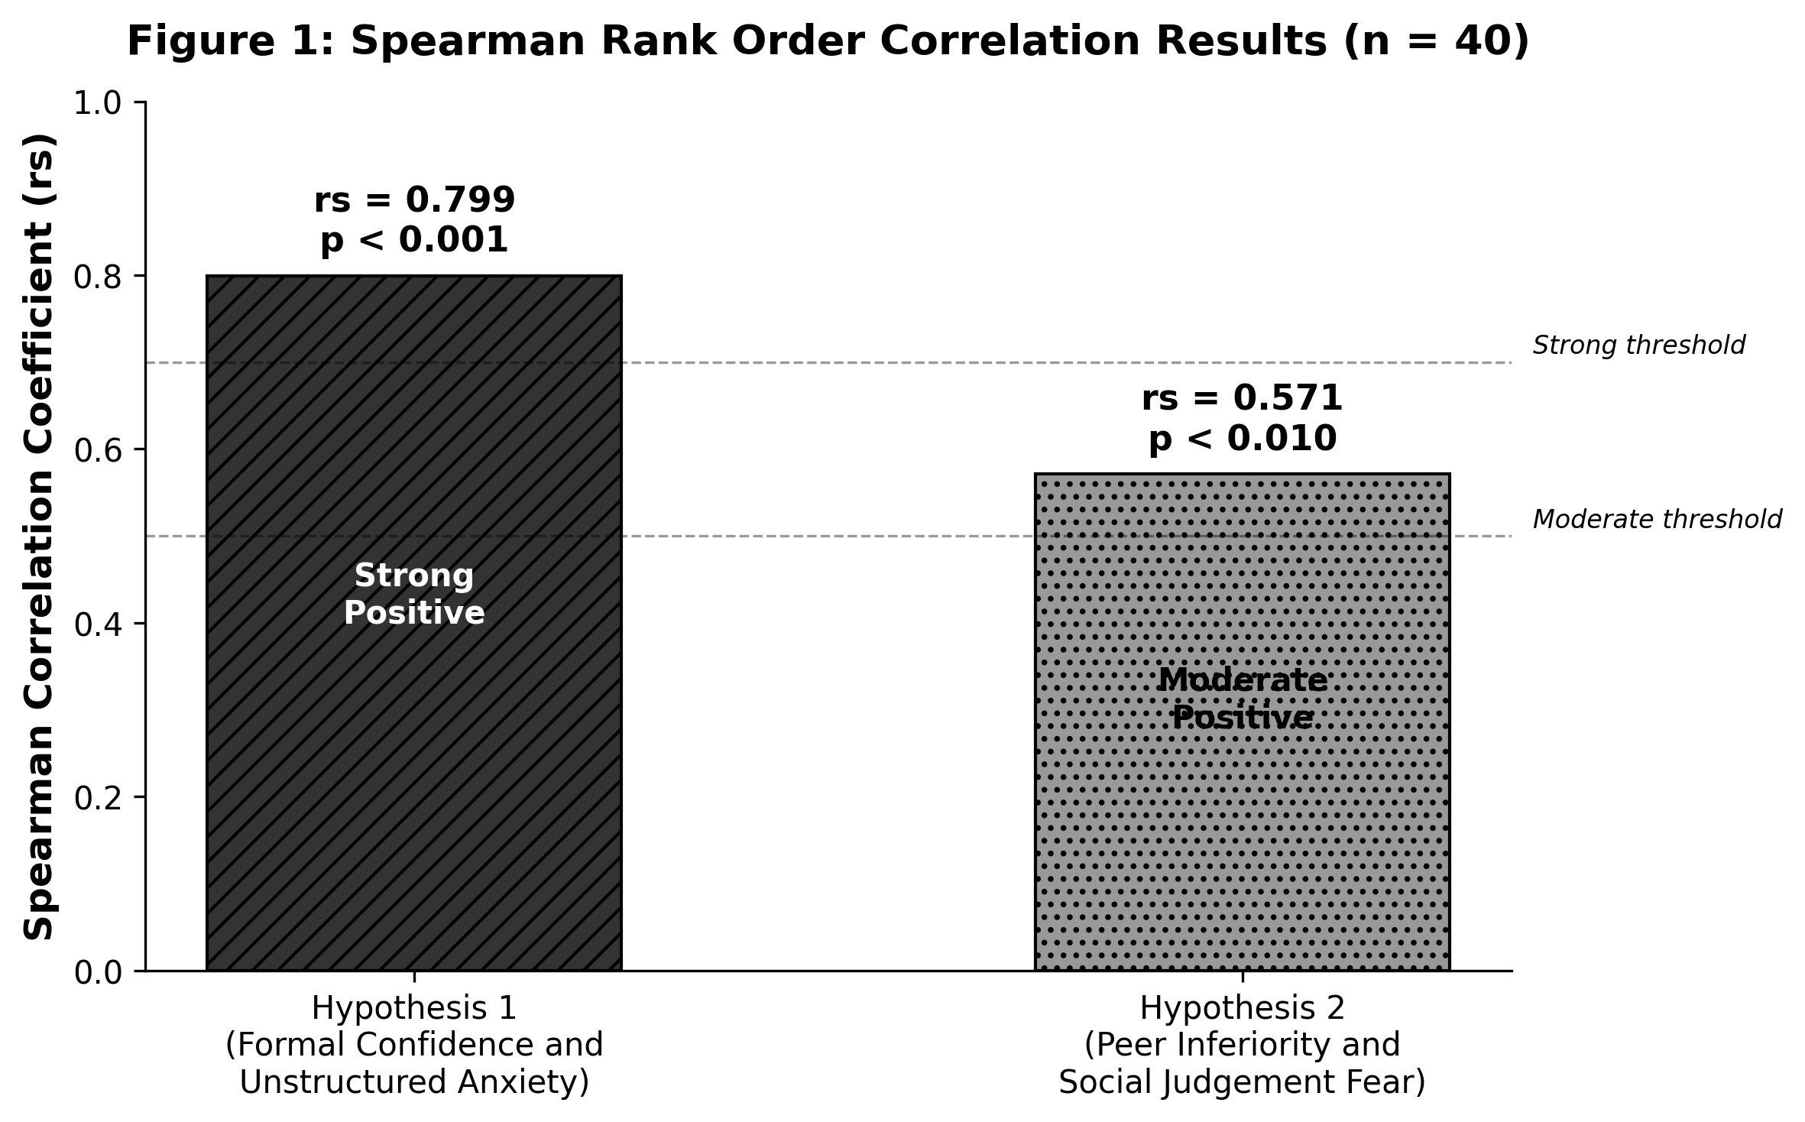
Figure 1: Spearman Rank Order Correlation Results for Both Hypotheses (n = 40)

10. Discussion
The two hypothesis tests produce a coherent and mutually reinforcing account. Marathi medium students develop communicative confidence that is structurally dependent on scaffolding: they perform adequately in prepared, structured settings but are significantly more anxious when those structures are removed. Simultaneously, they experience language anxiety as a relational phenomenon produced by comparison with more linguistically advantaged peers rather than as an internal individual failing.
These dynamics compound across the educational lifecycle. At school level, structured assessments permit performance. At the undergraduate level, mixed medium environments and peer comparison expose the gap between scaffolded confidence and actual communicative readiness. At postgraduate level and in career contexts, English dominant norms apply and the stakes of being perceived as linguistically inadequate are at their highest. Consistent with Bourdieu’s (1991) account of hysteresis and Vygotsky’s (1978) ZPD framework, this gap does not close automatically through educational progression; closing it requires deliberate institutional effort.

11. Implications

11.1 For Schools and Colleges
Language development programmes must move beyond scripted performance. Regular impromptu speaking exercises, low stakes conversational practice, structured debates, and peer discussion formats should become routine from school through postgraduate study. The rs = 0.799 correlation makes clear that preparing students for formal recitations does not prepare them for unscripted communicative demands. Institutions should also adopt inclusive pedagogy that normalises Marathi as a legitimate medium for academic discussion. The rs = 0.571 correlation confirms that anxiety is amplified by environments in which Marathi is invisible or treated as inferior.

11.2 For Career and Professional Contexts
Universities, placement offices, and employers in Maharashtra must recognise that communicative anxiety does not resolve at graduation. Placement preparation programmes should address the structural origins of this anxiety rather than treating linguistic hesitation as individual inadequacy. Mock interviews and group discussion practice in psychologically safe, low evaluation environments could meaningfully reduce the gap between scaffolded and generalised communicative confidence before students enter the job market.

11.3 For Teachers and Employers
Hesitation, silence, and reluctance to speak in class or at work are symptoms of a structural condition produced by years of linguistic marginalisation, not indicators of cognitive deficiency or professional unsuitability. Formal sensitisation programmes for teachers and HR professionals in Maharashtra would help ensure that Marathi medium students and graduates are evaluated on the substance of what they communicate rather than on the linguistic style in which they communicate it.

12. Conclusion
This study examined whether language anxiety among Marathi medium students in Maharashtra is a school stage phenomenon or a structural condition persisting across the full educational and career lifecycle. The data are unambiguous: they persist. Both hypotheses were confirmed. Formal communicative confidence is heavily scaffolding dependent and does not transfer to unstructured contexts, and perceived peer inferiority is a consistent predictor of social judgement anxiety. These relationships hold across school, undergraduate, and postgraduate respondents.
The theoretical frameworks that guided this analysis, Bourdieu’s (1991) theory of linguistic capital, Vygotsky’s (1978) Zone of Proximal Development, and Horwitz, Horwitz, and Cope’s (1986) Foreign Language Anxiety model, together explain why this anxiety occurs and why it intensifies at each transition point. Students move from one institutional field to another, each demanding a different linguistic performance, and the habitus formed in Marathi medium schooling is not at home in environments built around English dominant norms.
The study is limited by its cross sectional design and modest sample size. Future research should pursue longitudinal studies tracking Marathi medium students from school through professional life, using larger multi institutional samples that permit structural equation modelling. Triangulation with qualitative methods, including interviews, classroom observation, and employer focus groups, would enrich the quantitative findings. What is already clear is that language anxiety among Marathi medium students is a structural concern for Maharashtra’s educational and professional institutions, not a personal challenge for individual students to resolve on their own.

Acknowledgements
The authors would like to express sincere gratitude to all individuals and institutions whose support made this research possible.
Faculty Guidance
The authors are deeply grateful to Prof. Prashanth C.K., National Institute of Fashion Technology (NIFT), Bangalore, whose expert guidance, constructive feedback, and sustained mentorship were invaluable throughout every phase of this research.
Institutional Support
The authors acknowledge the National Institute of Fashion Technology (NIFT), Bangalore, for providing the academic environment, research resources, and institutional support that enabled this study to be conducted.
Research Participants
The authors extend heartfelt thanks to the 40 respondents, school, undergraduate, and postgraduate students from Marathi medium backgrounds across Maharashtra, who generously participated in this study. Their candid responses formed the empirical foundation of this research, and their willingness to share their lived experiences with language anxiety and communicative confidence made this work possible.
Author Contributions
Gajanan Mule: Conceptualisation, research design, data collection, statistical analysis, and manuscript preparation.
Nupur Mali: Literature review, theoretical framework development, instrument design, and manuscript revision.
Both authors reviewed and approved the final manuscript.
Conflict of Interest
The authors declare no conflict of interest.

References
Aida, Y. (1994). Examination of Horwitz, Horwitz, and Cope’s construct of foreign language anxiety: The case of students of Japanese. Modern Language Journal, 78(2), 155–168. https://doi.org/10.1111/j.1540-4781.1994.tb02026.x
Albert, A. (2012). Divergent learner profiles and language anxiety in the multilingual classroom: Implications for regional medium schooling in South Asia. Journal of Multilingual and Multicultural Development, 33(2), 117–134.
Bhatt, R. M. (2008). In other words: Language mixing, identity representations, and third space. Journal of Sociolinguistics, 12(2), 177–200.
Bourdieu, P. (1991). Language and symbolic power. Harvard University Press.
Canagarajah, A. S. (1999). Resisting linguistic imperialism in English teaching. Oxford University Press.
Canagarajah, A. S. (2011). Codemeshing in academic writing: Identifying teachable strategies of translanguaging. Modern Language Journal, 95(3), 401–417. https://doi.org/10.1111/j.1540-4781.2011.01207.x
Deshpande, S. (2016). Bhashaik asurakshatata ani vyavsayik jivan: Marathi madhyamatil padvigrahakanchya anubhavache vishleshan [Linguistic insecurity and professional life: An analysis of the experiences of Marathi medium graduates]. Pune Vidyapeeth Shodh Patrika, 12(1), 45–58.
Dewaele, J. M. (2013). The link between foreign language classroom anxiety and psychoticism, extraversion, and neuroticism among adult bilinguals. Modern Language Journal, 97(4), 670–684. https://doi.org/10.1111/j.1540-4781.2013.12036.x
Field, A. (2013). Discovering statistics using IBM SPSS statistics (4th ed.). SAGE Publications.
Garcia, O., and Wei, L. (2014). Translanguaging: Language, bilingualism and education. Palgrave Macmillan.
George, D., and Mallery, P. (2003). SPSS for Windows step by step: A simple guide and reference (4th ed.). Allyn and Bacon.
Horwitz, E. K. (2001). Language anxiety and achievement. Annual Review of Applied Linguistics, 21, 112–126. https://doi.org/10.1017/S0267190501000071
Horwitz, E. K., Horwitz, M. B., and Cope, J. (1986). Foreign language classroom anxiety. Modern Language Journal, 70(2), 125–132. https://doi.org/10.1111/j.1540-4781.1986.tb05256.x
Kulkarni, M. V. (2018). Marathi madhyamatun shiksha ghetalelya vidyarthyanchi Angrejibhasha anxiousness: Pune mahavidyalayatil ek adhyayan [English language anxiety among Marathi medium students: A study from Pune colleges]. Maharashtra Shikshan Shodh Patrika, 7(2), 29–44.
MacIntyre, P. D. (1995). How does anxiety affect second language learning? A reply to Sparks and Ganschow. Modern Language Journal, 79(1), 90–99. https://doi.org/10.1111/j.1540-4781.1995.tb05418.x
MacIntyre, P. D., and Gardner, R. C. (1994). The subtle effects of language anxiety on cognitive processing in the second language. Language Learning, 44(2), 283–305. https://doi.org/10.1111/j.1467-1770.1994.tb01103.x
Norman, G. (2010). Likert scales, levels of measurement and the laws of statistics. Advances in Health Sciences Education, 15(5), 625–632.
Nunnally, J. C. (1978). Psychometric theory (2nd ed.). McGraw Hill.
Patil, R. G., and Shinde, A. P. (2020). Bhashaik asurakshatata ani uchcha shikshanacha nexa: Maharashtra madhe Marathi madhyamatil padvyuttar vidyarthyanchya vyavsayik svapnanchya avantaravar prabhav [Linguistic insecurity and higher education nexus: Impact on career aspirations of Marathi medium postgraduate students in Maharashtra]. Shikshan ani Samaj, 15(3), 67–82.
Pennycook, A. (2001). Critical applied linguistics: A critical introduction. Lawrence Erlbaum.
Siegel, S., and Castellan, N. J. (1988). Nonparametric statistics for the behavioral sciences (2nd ed.). McGraw Hill.
Teimouri, Y., Goetze, J., and Plonsky, L. (2019). Second language anxiety and achievement: A meta analysis. Studies in Second Language Acquisition, 41(2), 363–387. https://doi.org/10.1017/S0272263118000311
UNESCO (2021). The state of the global education crisis: A path to recovery. UNESCO, World Bank, and UNICEF.
Vygotsky, L. S. (1978). Mind in society: The development of higher psychological processes. Harvard University Press.

