EYESIGHT AI: AN INTELLIGENT DEEP NEURAL NETWORK BASED FRAMEWORK FOR DETECTION AND CLASSIFICATION OF RETINAL DISEASES THROUGH FUNDUS IMAGE ANALYSIS

1V.AnandhaVigneshwaran,2I. Raphael Zebulon Rosario, 3S. Jayachithira,4Mr. T. Mano Prathik
⁵ Dr.J.Sudhakar
1UG Student, Department of Biomedical Engineering, KarpagaVinayagaCollege of Engineering and Technology, ph no:9384151962,mail id: anandhavigneshwaran02@gmail.com,Chengalpattu.
2UG Student,DepartmentofBiomedicalEngineering,KarpagaVinayagaCollegeofEngineeringand Technology, ph no: 989418074,mail id: jayachithra25.01.2005@gmail.com,Chengalpattu.
3UG Student, Department of Biomedical Engineering, Karpaga Vinayaga College of Engineering and Technology, ph no:7200335762,mail id: raphaelavenger2004@gmail.com,Chengalpattu.
4Assistant professor, Department of Biomedical Engineering, Karpaga Vinayaga College of Engineering and Technology, ph no:8248147673,mail id: manoprathik@gmailcom, Chengalpattu.
5Associate professor, Department of Biomedical Engineering, Karpaga Vinayaga College of Engineering and Technology, ph no:9698323364,mail id: sudhak1241@gmail.com, Chengalpattu.

ABSTRACT

Retinal diseases such as diabetic retinopathy, age-related macular degeneration, and glaucoma are among the leading causes of vision impairment and blindness worldwide. Early detection and timely treatment are essential to prevent irreversible damage and improve patient outcomes. This project, EYESIGHT AI, presents an intelligent deep learning-based system designed for the automated detection and classification of retinal diseases using Optical Coherence Tomography (OCT) images. The proposed system utilizes Convolutional Neural Networks (CNNs) to effectively extract complex features from retinal images and accurately identify disease patterns. Prior to model processing, OCT images undergo preprocessing techniques including contrast enhancement and noise reduction to improve image quality and ensure better feature extraction. The enhanced images are then passed through the trained CNN model for classification into different retinal disease categories. To enhance usability and real-world applicability, the system is integrated with a Django-based web interface that allows healthcare professionals to easily upload OCT images and obtain diagnostic predictions in a user-friendly environment. The model is trained and evaluated on standard retinal image datasets, demonstrating reliable performance and high accuracy in disease classification. Overall, EYESIGHT AI serves as a supportive diagnostic tool that can assist medical practitioners in early detection and clinical decision-making. By reducing diagnostic time and improving accuracy, the system contributes to more efficient and accessible eye care, particularly in resource-limited settings.
Keywords: Convolutional Neural Networks, Optical Coherence Tomography, automated Medical Diagnosis, deep learning, retinal imaging.

1 INTRODUCTION
Macular diseases such as Age-Related Macular Degeneration and Diabetic Macular Edema are among the leading causes of vision impairment worldwide, making early detection and accurate diagnosis extremely important for effective treatment and prevention of permanent vision loss. In this context, the proposed system, EYESIGHT AI, is designed as an intelligent, data-driven solution that integrates principles from data science, artificial intelligence, and deep learning to automatically analyze retinal images obtained through Optical Coherence Tomography[1]. OCT provides high-resolution, cross-sectional images of the retina, enabling detailed visualization of its layers and helping identify even subtle abnormalities that may not be easily visible through traditional examination methods. However, manual analysis of these images is often time-consuming and dependent on the expertise of clinicians, which can lead to variability in diagnosis. To address this challenge, EYESIGHT AI leverages advanced computational techniques to ensure faster, more consistent, and reliable interpretation of OCT scans[2]. The system begins by defining the problem of automated retinal disease detection and then proceeds to gather a large dataset of labeled OCT images representing various retinal conditions. This dataset forms the foundation for training the model and is carefully prepared using preprocessing techniques[3].

such as resizing, normalization, and augmentation methods like rotation, flipping, and scaling, which help improve the robustness and generalization ability of the model while reducing overfitting. At the core of the system lies the application of deep learning, particularly Convolutional Neural Networks, which are highly effective in image analysis tasks due to their ability to automatically learn hierarchical features from raw data. In the learning phase, the CNN model processes large volumes of retinal images and gradually learns to recognize patterns associated with different diseases by identifying features ranging from simple edges and textures in early layers to complex structures such as lesions and fluid accumulation in deeper layers. To further enhance performance, attention mechanisms are incorporated into the CNN architecture, allowing the model to focus more on critical regions of the macula where disease-related changes are most likely to occur, thereby improving both classification accuracy and interpretability [4]. The reasoning capability of the system enables it to analyze new, unseen OCT images by comparing extracted features with previously learned patterns, much like how an ophthalmologist interprets medical scans, and classify them into appropriate disease categories. In addition, the self-correction process ensures continuous improvement of the model by adjusting its internal parameters based on prediction errors during training, thereby increasing its reliability over time. From a data science perspective, the system integrates machine learning, statistical analysis, and image processing techniques to convert raw medical data into meaningful insights that support clinical decision-making. The model development process involves selecting an appropriate architecture-either Sequential or Functional where layers such as convolutional, pooling, and fully connected layers are carefully designed to balance computational efficiency and predictive performance [5]. The model is then compiled using suitable loss functions and optimizers, followed by a training phase where parameters like epochs and batch size are tuned to achieve optimal results. During training, the system continuously evaluates its performance using validation datasets, ensuring that it generalizes well to real-world scenarios. Finally, the trained model is capable of detecting and classifying retinal diseases with high accuracy, providing outputs that can assist doctors in diagnosis and treatment planning[6].

2 PROPOSEDMETHODOLOGY
The proposed system, EYESIGHT AI, is an intelligent framework that automates retinal disease detection using Optical Coherence Tomography images. It applies Convolutional Neural Networks to extract meaningful features and classify diseases with high accuracy. Image preprocessing techniques enhance input quality, improving model performance. A web interface built using Django enables easy image upload and quick result generation. The system reduces manual workload, ensures consistent diagnosis, and supports early detection. Its scalable design allows future improvements, making it a reliable tool for efficient and accessible retinal disease screening in healthcare environments.
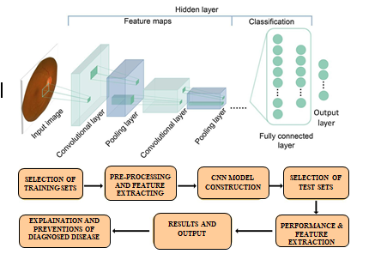

Fig.2.1BlockdiagramofproposedMethodology Systematic Approach to app development
2.1 Image Acquisition Protocol
In the EYESIGHT AI system, retinal images are obtained using Optical Coherence Tomography, which provides high-resolution cross-sectional views of the retina. Images are captured under standardized conditions to maintain consistency and reduce noise or distortion. Proper calibration and alignment of the imaging device ensure clear visualization of retinal layers, especially the macular region. The acquired OCT scans are stored in structured formats such as PNG or JPEG along with relevant metadata. This standardized acquisition process helps minimize variability between images and enhances the detection of subtle pathological features such as fluid accumulation, retinal thickening, and layer disruptions associated with macular diseases.
- Deep Learning Model Architecture
The core of the EYESIGHT AI system is built using advanced Convolutional Neural Networks designed for medical image analysis. Architectures such as ResNet, MobileNet, and customized CNN models are utilized to efficiently learn hierarchical features from OCT images. The model is trained on labeled datasets containing various retinal conditions, enabling it to perform accurate classification of diseases like macular degeneration and edema. The architecture focuses on extracting both low-level features (edges, textures) and high-level representations (disease-specific patterns). Attention mechanisms may also be incorporated to emphasize critical regions in the retina, improving diagnostic precision and interpretability..

- Integration into Web Platform

The trained model is integrated into a user-friendly web application developed using Django. This platform allows ophthalmologists and healthcare professionals to upload OCT images and receive diagnostic predictions in real time. The system processes the uploaded image, runs it through the trained model, and displays the predicted condition along with visual insights. User interactions and feedback can be recorded to further improve system performance through continuous learning. This integration ensures accessibility, scalability, and practical usability in clinical environments, making EYESIGHT AI an efficient tool for early detection and decision support.

3 RESULTSAND DISCUSSION
The implementation and evaluation of the EYESIGHT AI system demonstrate its effectiveness as an intelligent solution for automated retinal disease detection using Optical Coherence Tomography images. The system was successfully developed using deep learning techniques and deployed through a web-based platform, ensuring both technical robustness and practical usability. At its core, the model is built using Convolutional Neural Networks, which are well-suited for extracting complex patterns from medical images. The system workflow begins with user-uploaded OCT images, which undergo preprocessing steps such as resizing and normalization to ensure consistency and improved feature clarity. These processed images are then passed through the trained CNN model, which analyzes retinal structures and classifies them into specific disease categories. The results confirm that the system is capable of delivering accurate predictions while maintaining smooth and efficient performance across different modules. Each component of the system was carefully tested to ensure reliability, including image handling, model inference, and user interaction, thereby validating the overall functionality of the application.
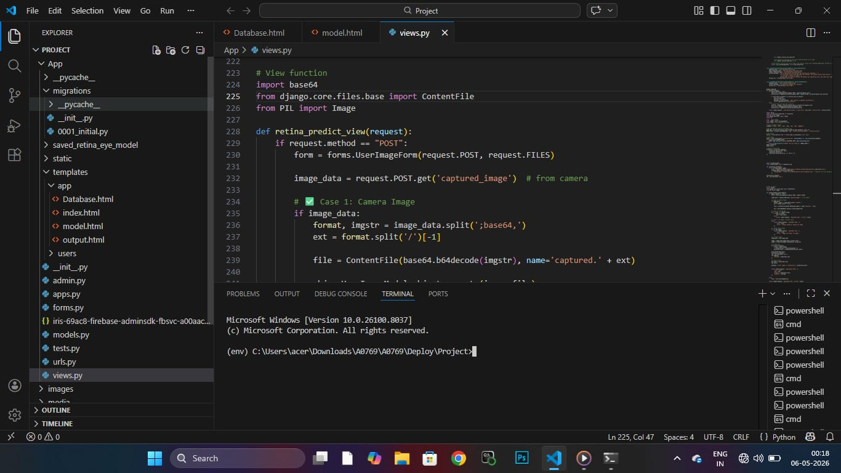
Fig3.1 Step-1Web developmental process using code(Python programming language)in Visual Studio Software


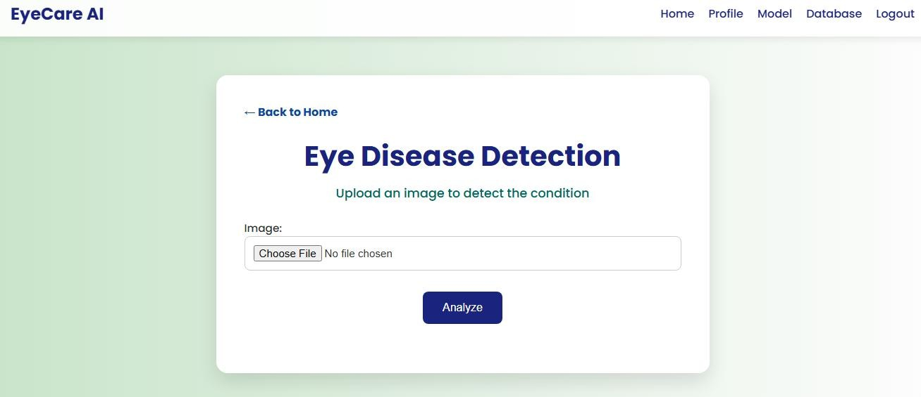
Fig3.2 Step-2Website –Project view structure

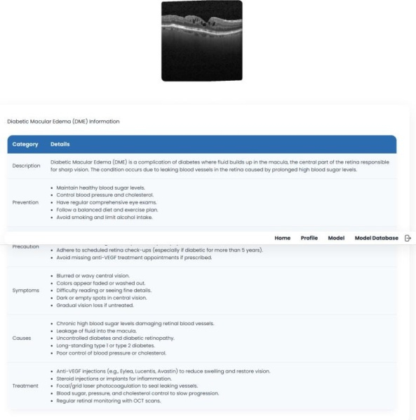
Fig3.3output- detection of retinal diseases

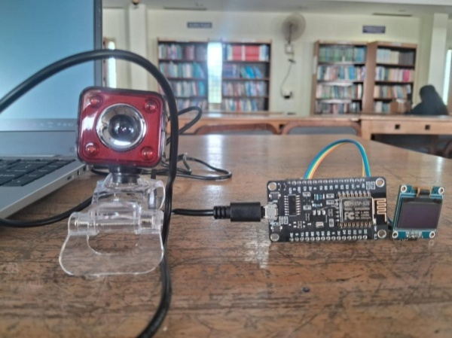
Fig3.4 Realtime Evaluation prototype Kit

The performance evaluation of the model further highlights the strength of the proposed approach. During training, the model achieved a steady increase in accuracy, rising from approximately 70% in the initial epoch to around 96% by the final epoch, while validation accuracy improved to about 93%, indicating strong generalization capability. At the same time, training loss decreased significantly from 0.90 to 0.20, and validation loss dropped to approximately 0.35, showing that the model effectively learned meaningful features without overfitting. The small gap between training and validation metrics confirms the stability and reliability of the learning process. Additional evaluation metrics such as precision, recall, and F1-score further support the model’s effectiveness in correctly identifying disease cases, even when class distributions vary. The confusion matrix analysis reveals that most retinal disease categories are accurately classified with minimal misclassification, emphasizing the robustness of the system. These results collectively demonstrate that EYESIGHT AI is capable of consistently identifying retinal abnormalities and can serve as a dependable diagnostic support tool in clinical settings.
Beyond model performance, the integration of the system into a web application built using Django significantly enhances its real-world applicability. The user interface is designed to be intuitive and accessible, allowing healthcare professionals to register, log in, upload OCT images, and receive diagnostic results quickly and efficiently. Features such as profile management, secure authentication, and a streamlined image upload and analysis process contribute to a seamless user experience. The output interface not only provides classification results but also presents clinically relevant information, supporting better understanding and decision-making. This web-based deployment enables remote accessibility, making the system especially useful in telemedicine and rural healthcare environments where specialist support may be limited. However, the effectiveness of the system depends on the quality and diversity of the training dataset, as limited data can affect generalization. To overcome this, continuous data expansion, retraining, and validation are necessary to improve accuracy and adaptability. Overall, EYESIGHT AI combines advanced deep learning with practical deployment to deliver a reliable, scalable, and user-friendly solution for early retinal disease detection and improved patient care.

CONCLUSION

Beyond model performance, the integration of the system into a web application built using Django significantly improves its practicality and real-world usability in clinical environments. The interface is carefully designed to be simple, intuitive, and accessible, enabling healthcare professionals to easily register, securely log in, and upload Optical Coherence Tomography images for analysis without requiring advanced technical knowledge. Once an image is uploaded, it is processed through the deep learning model based on Convolutional Neural Networks, and the results are generated within a short time, ensuring quick and efficient diagnosis. The system includes essential features such as profile management, authentication mechanisms, and a well-structured workflow for image submission and result visualization, all of which contribute to a smooth and user-friendly experience. In addition to simply providing classification outputs, the system presents meaningful clinical insights that help doctors better understand the detected condition and support their decision-making process. One of the major advantages of this web-based deployment is its ability to provide remote access, making it highly valuable in telemedicine applications and in rural or underserved areas where access to specialized ophthalmologists may be limited. This allows early screening and timely intervention, which are critical in preventing severe vision loss. However, the overall effectiveness and reliability of the system are closely linked to the quality, size, and diversity of the dataset used during training, as insufficient or biased data can limit the model’s ability to generalize to new cases. To address this, continuous efforts such as incorporating diverse datasets, periodic retraining, and rigorous validation are necessary to enhance performance and maintain accuracy. Overall, EYESIGHT AI successfully combines intelligent automation with practical deployment, offering a scalable, efficient, and reliable solution that supports early retinal disease detection and contributes to improved patient care outcomes.

FUTUREENHANCEMENT
The developed EYESIGHT AI model can be effectively deployed on a cloud-based platform, significantly enhancing its accessibility, flexibility, and overall efficiency in real-world applications. By hosting the system on the cloud, users such as healthcare professionals can access the application from anywhere using multiple devices, without being restricted to a single local machine. This is particularly beneficial in modern healthcare environments where remote diagnosis and collaboration are becoming increasingly important. Cloud deployment also simplifies system maintenance, as updates, improvements, and bug fixes can be implemented centrally without requiring users to manually update their systems, ensuring that everyone consistently uses the latest and most accurate version of the model. Additionally, the cloud environment supports scalability, allowing the system to handle growing volumes of Optical Coherence Tomography images and increasing user traffic without affecting performance. This makes the solution suitable for large-scale deployment in hospitals, clinics, and telemedicine platforms. Another key advantage is the ability to integrate the system with hardware components such as imaging devices, cameras, and embedded systems. These devices can directly capture retinal images and transmit them to the cloud-hosted model, which processes the data using advanced Convolutional Neural Networks and generates results in real time. This seamless interaction between hardware and software reduces manual intervention, minimizes delays, and ensures continuous operation, which is critical for time-sensitive medical diagnosis. Moreover, such integration enables automated workflows, improving efficiency and reducing the workload on medical professionals. Overall, the combination of cloud deployment and hardware connectivity transforms EYESIGHT AI into a highly scalable, automated, and practical solution that supports faster diagnosis, remote accessibility, and improved patient care in diverse healthcare settings.

REFERENCES

- J. Kim, M. Kim, H. Lee, et al., —Smart Contact Lenses for Continuous Intraocular Pressure Monitoring,‖ Nature Communications, vol. 13, no. 1, pp. 1–10, 2022.

- S.R.N.,P.Kumar,andR.Singh,—IoT-BasedGlaucomaMonitoring System Using Machine Learning Techniques,‖ MDPI Engineering Proceedings, vol. 59, no. 1, pp. 1–7, 2024.

- A. T. Duchowski, —A Breadth-First Survey of
Eye-Tracking Applications,‖arXiv preprint arXiv:2412.14848, 2025.

- R. Thakur, S. Gupta, and A. Sharma, —Glaucoma Detection Using Artificial Intelligence Techniques,‖ Scientific Reports, vol. 15, pp. 1–12, 2025.

- Y. Liu, X. Zhang, and L. Wang, —Wearable IoT-Based Eye Monitoring Systems: A Review,‖arXiv preprint arXiv:2410.12303,2024.

- H. Chen, Y. Li, and J. Zhao, —Deep learning-based automated glaucoma detection using retinal fundus images,‖ IEEE Access, vol. 11,
pp.45678–45687,2023.

- M. S. Hossain, G. Muhammad, and N. Guizani, —Cloud-assisted industrial internet of things (IIoT) – Enabled framework for health monitoring,‖ IEEE Internet of Things Journal, vol. 7, no. 4, pp. 2936–2945, 2020.

- S. Dua, U. R. Acharya, P. Chowriappa, and S. V. Sree, —Wavelet-based energy features for glaucoma detection in retinal images,‖ IEEE Transactions on Information Technology in Biomedicine, vol. 16, no. 1,
pp.80–87,2012.

- A. Esteva, B. Kuprel, R. A. Novoa, et al., —Dermatologist-level classification of skin cancer with deep neural networks,‖ Nature, vol.542, no. 7639, pp. 115–118, 2017.

[10] D. Poplin, V. Varadarajan, K. Blumer, et al., —Prediction of cardiovascular risk factors from retinal fundus photographs via deep learning,‖NatureBiomedicalEngineering,vol.2,no.3,pp.158–164,
2018.

[11] G. Quellec, M. Lamard, P. M. Josselin, et al., —Optimal wavelet transform for the detection of microaneurysms in retina photographs,‖ IEEE Transactions on Medical Imaging, vol. 27, no. 9, pp. 1230–1241, 2008.

[12] V. Gulshan, L. Peng, M. Coram, et al., —Development and validation of a deep learning algorithm for detection of diabetic retinopathy in retinal fundus photographs,‖ JAMA, vol. 316, no. 22, pp. 2402–2410, 2016.

[13] D. S. W. Ting, L. Y. L. Cheung, G. Lim, et al., —Development and validation of a deep learning system for diabetic retinopathy and related eye diseases,‖ JAMA, vol. 318, no. 22, pp. 2211–2223, 2017.

[14] K. He, X. Zhang, S. Ren, and J. Sun, —Deep residual learning for image recognition,‖ in Proceedings of the IEEE Conference onComputer Vision and Pattern Recognition (CVPR), pp. 770–778, 2016.

[15] O. Ronneberger, P. Fischer, and T. Brox, —U-Net: Convolutional Networks for Biomedical Image Segmentation,‖ in MICCAI, pp. 234–241, 2015.

