Surface Hydrophobization via CTAB Functionalization as a Strategy for Enhancing Geopolymer Adsorption Capacity: Synthesis, Characterization, and Carbamazepine Removal Performance in Simulated Pharmaceutical Effluent"

Abstract
Pharmaceutical active compounds (PACs) in wastewater pose a persistent environmental and public health threat due to their resistance to conventional treatment processes. Among these, carbamazepine (CBZ) a widely prescribed anticonvulsant is frequently detected in effluents and surface waters at concentrations that disrupt aquatic ecosystems and potentiate antibiotic resistance. This study reports the synthesis, characterization, and adsorption performance of a cetyltrimethylammonium bromide (CTAB)-modified clay geopolymer composite (CTAB-BclayGeo) designed for targeted CBZ removal from aqueous media compared to unmodified Clay Geopolymer (B-clayGeo). The composite was synthesized by alkaline activation of clay in the presence a set CTAB concentrations, followed by curing under controlled conditions. Physicochemical characterization was conducted using X-ray diffraction (XRD), Fourier-transform infrared spectroscopy (FTIR), scanning electron microscopy with energy-dispersive X-ray analysis (SEM/EDS) and Brunauer–Emmett–Teller (BET) surface area analysis. CTAB modification significantly increased the specific surface area from 27.28 m²/g (unmodified) to 67.16 m²/g, introduced hydrophobic organo-functional sites on the geopolymer surface, and enhanced mesopore accessibility for organic contaminant uptake. Batch adsorption experiments demonstrated that CTAB-ClayGeo achieved a maximum CBZ removal efficiency of 69.16% under optimized conditions (pH 8, contact time 24hrs min, adsorbent dose 0.1 g/L). Adsorption kinetics followed the pseudo-second-order model, and equilibrium data were best described by the Langmuir isotherm, with a maximum monolayer adsorption capacity (qmax) of 19.1 mg/g. The adsorption mechanism is attributed to hydrophobic partitioning, π–π electron donor–acceptor interactions, and electrostatic attraction between CBZ and the organo-modified geopolymer surface.

Keywords: geopolymer; CTAB; surface modification; carbamazepine adsorption; wastewater treatment

- Introduction
The pervasive presence of pharmaceutical compounds in aquatic ecosystems has emerged as a critical environmental challenge of the 21st century, posing significant threats to ecosystem integrity and human health. Among the various pharmaceutical pollutants, carbamazepine, an anticonvulsant and mood-stabilizing medication, stands out as one of the most persistent and frequently detected pharmaceutical active compounds (PACs) in wastewater discharges, surface waters, and drinking water sources worldwide(Ekpeghere, Sim, Lee, & Oh, 2018). Global consumption of carbamazepine exceeds several hundred tons annually, with concentrations in wastewater treatment plant effluents typically ranging from hundreds of nanograms to several micrograms per liter, and peak levels reaching up to 6.3 μg/L in surface waters receiving pharmaceutical wastewater discharge(Ekpeghere et al., 2018; Hiba et al., 2021).The environmental persistence of carbamazepine is particularly concerning due to its significant resistance to biodegradation and the ineffectiveness of standard wastewater treatment methods. Research consistently indicates that conventional biological treatment systems achieve only 7-10% removal efficiency for carbamazepine, resulting in its pseudo-persistent nature in aquatic environments through continuous release and accumulation(Al Qarni, Collier, O’Keeffe, & Akunna, 2016).The ecological impacts of prolonged carbamazepine exposure include behavioral alterations in aquatic organisms, reproductive issues in fish populations, and a potential contribution to the emergence of antimicrobial resistance through indirect pathways. Furthermore, the presence of carbamazepine in drinking water sources raises significant concerns regarding long-term human health implications, as even minimal chronic exposure to pharmaceutical residues may lead to adverse health effects that remain inadequately understood(Moya-Llamas, Trapote, & Prats, 2021).
Current water treatment technologies demonstrate limited effectiveness in removing carbamazepine, underscoring the urgent need for innovative and efficient remediation strategies. Advanced oxidation processes can degrade carbamazepine; however, they often result in the formation of transformation products with unknown or potentially greater toxicity than the original compound. Membrane filtration technologies, such as nanofiltration and reverse osmosis, achieve high removal efficiencies but generate concentrated reject streams that require additional treatment and incur significant capital and operational costs(Al Qarni et al., 2016; Alsubih et al., 2022).
Activated carbon adsorption is the most widely used method, yet its application is constrained by high material costs ($2-5 per kg), non-selective adsorption leading to rapid saturation by natural organic matter, and energy-intensive thermal regeneration requirements that limit its economic viability, particularly in developing regions where pharmaceutical contamination is most prevalent(Ilau-Uli, Oguyo, Ngozi, & Olajided).
Geopolymers represent an emerging class of inorganic aluminosilicate polymers that have garnered significant interest as sustainable alternatives to traditional adsorbent materials. These materials are produced through the alkaline activation of aluminosilicate precursors such as fly ash, slag, or natural clays, resulting in a three-dimensional network structure with numerous active sites and adjustable porosity(Luhar et al., 2021; You, Ho, Li, Maneerung, & Wang, 2019). Utilizing industrial waste materials and natural clay minerals as precursors offers substantial economic and environmental advantages, including low production costs ($50-150 per ton), a reduced carbon footprint compared to the synthesis of activated carbon, and the potential for waste material valorization. The inherent chemical and thermal stability of geopolymers, along with their mechanical strength, makes them particularly attractive for water treatment applications requiring sustained performance under varying operational conditions.(You et al., 2019)
Despite their promising attributes, traditional geopolymers face significant limitations when applied to pharmaceutical removal. The geopolymer surface inherently carries a negative charge due to the tetrahedral arrangement of aluminum atoms within the aluminosilicate structure, necessitating compensation by exchangeable cations. This negative charge makes geopolymers particularly effective at removing cationic pollutants through electrostatic interactions(Khan, Iqbal, Soliyeva, Ali, & Elboughdiri, 2025); however, it considerably limits their effectiveness against neutral or anionic pharmaceutical compounds. For instance, carbamazepine, which remains neutrally charged under typical wastewater pH conditions (pKa = 13.9), exhibits minimal electrostatic interaction with the negatively charged geopolymer surface, resulting in suboptimal adsorption performance. Furthermore, the non-specific adsorption mechanisms in conventional geopolymers, primarily involving hydrogen bonding, van der Waals forces, and hydrophobic interactions, lead to competitive adsorption effects in the presence of multiple organic compounds, significantly reducing pharmaceutical removal efficiency in real wastewater environments(Ahmad, 2023). Surface modification strategies offer a promising approach to overcoming these inherent limitations and enhancing the pharmaceutical adsorption capacity of geopolymer materials. Among various surface modification techniques, the use of cationic surfactants, particularly cetyltrimethylammonium bromide (CTAB), has demonstrated considerable potential in expanding the application scope of negatively charged adsorbents. The CTAB modification process involves the adsorption of long-chain quaternary ammonium surfactant molecules onto the geopolymer surface, where the positively charged head groups bind electrostatically to the negative surface sites, while the hydrophobic alkyl chains create new binding environments(Açışlı, Acar, & Khataee, 2022).
The integration of natural clay minerals with geopolymer matrices through alkaline activation represents an innovative approach that combines the high surface area and ion exchange capabilities of clays with the mechanical strength and chemical resilience of geopolymers(Jin et al., 2025). Clay minerals, particularly those in the smectite group, possess layered structures with a high cation exchange capacity and abundant hydroxyl groups, facilitating surface modification reactions. Incorporating clay into geopolymer formulations has shown enhancements in textural properties, increased density of surface functional groups, and improved adsorption efficiency for various contaminants(Li et al., 2024).
When combined with CTAB surface modification, clay-geopolymer composites offer a synergistic enhancement in pharmaceutical adsorption capacity through multiple mechanisms(Jin et al., 2025). Despite the growing body of research on geopolymer adsorbents and surfactant modification techniques, significant knowledge gaps remain regarding optimal synthesis conditions, characterization of surface properties, and systematic evaluation of pharmaceutical removal efficacy in realistic wastewater scenarios. Current studies predominantly focus on the removal of heavy metals or dye adsorption, with limited investigation into the removal of pharmaceutical compounds using surfactant-modified clay-geopolymer composites(Singhal, Gangwar, & Gayathry, 2017; Siyal, Shamsuddin, & Low, 2021).
This research seeks to address critical knowledge gaps by investigating the synthesis, characterization, and pharmaceutical removal efficacy of CTAB-modified clay geopolymer composites, specifically designed for the adsorption of carbamazepine. The study's objectives are: (i) to develop and optimize a synthesis protocol for clay-based geopolymer composites with enhanced textural and surface properties; (ii) to examine the effects of CTAB surface modification on the physicochemical properties, surface area, and functional group distribution within the geopolymer composites; (iii) to systematically evaluate the adsorption kinetics and equilibrium isotherms parameters associated with carbamazepine removal.
2. Materials and Methods
2.1 Materials
2.1.1 Apparatus and reagents
Analytical-grade chemicals were used in this study. Carbamazepine [CAS: 298-46-4, Moligand, ≥98.0%]. NaOH flakes, Na₂SiO₃. All reagents were weighed using a Mettler Toledo balance. pH measurement employed the use of a Mettler Toledo pH meter. The pH adjustments were made with 0.1 M HCl and 0.1 M NaOH. Samples were dried in an oven. Batch adsorptions were performed in a multifunctional combination shaker with samples filtered through double circle filter paper. CBZ concentrations were determined using a TU-1901 UV-Vis spectrophotometer
    - Bentonite clay source and properties
The clay (Bclay) was obtained from Anfoega in the Volta Region of Ghana. It is shaped into egg-like forms by either sun-drying or baking. The clay is ground and then sifted to achieve a fine particle size.

2.2 Synthesis of Clay Geopolymer and CTAB-Modified Clay Geopolymer
B-clay particles were dried at 80 °C for 24 hours before use. The process of making geopolymer involves activating aluminosilicate materials with a strong alkaline solution. This alkaline solution was made by mixing a 50% sodium silicate (Na₂SiO₃) solution with 10 M sodium hydroxide (NaOH) in a ratio of 2.5 to 1.
Next, B-clay was added to the alkaline solution at a weight ratio of 0.6. The mixture was stirred thoroughly and placed in a shaker for 15 minutes to ensure it was well mixed. This mixture is called B-clay Geopolymer (B-clayGeo). For the CTAB-modified geopolymer, CTAB was added to the B-clay in a ratio of 1:5. This mixture was also combined with the alkaline solution, just like in B-clayGeo. After mixing, the material was placed in molds and heat-treated in an oven at 100 °C for 30 hours. It was then cured at room temperature for another 24 hours. Finally, the material was ground into a fine powder, washed, and stored for adsorption tests.
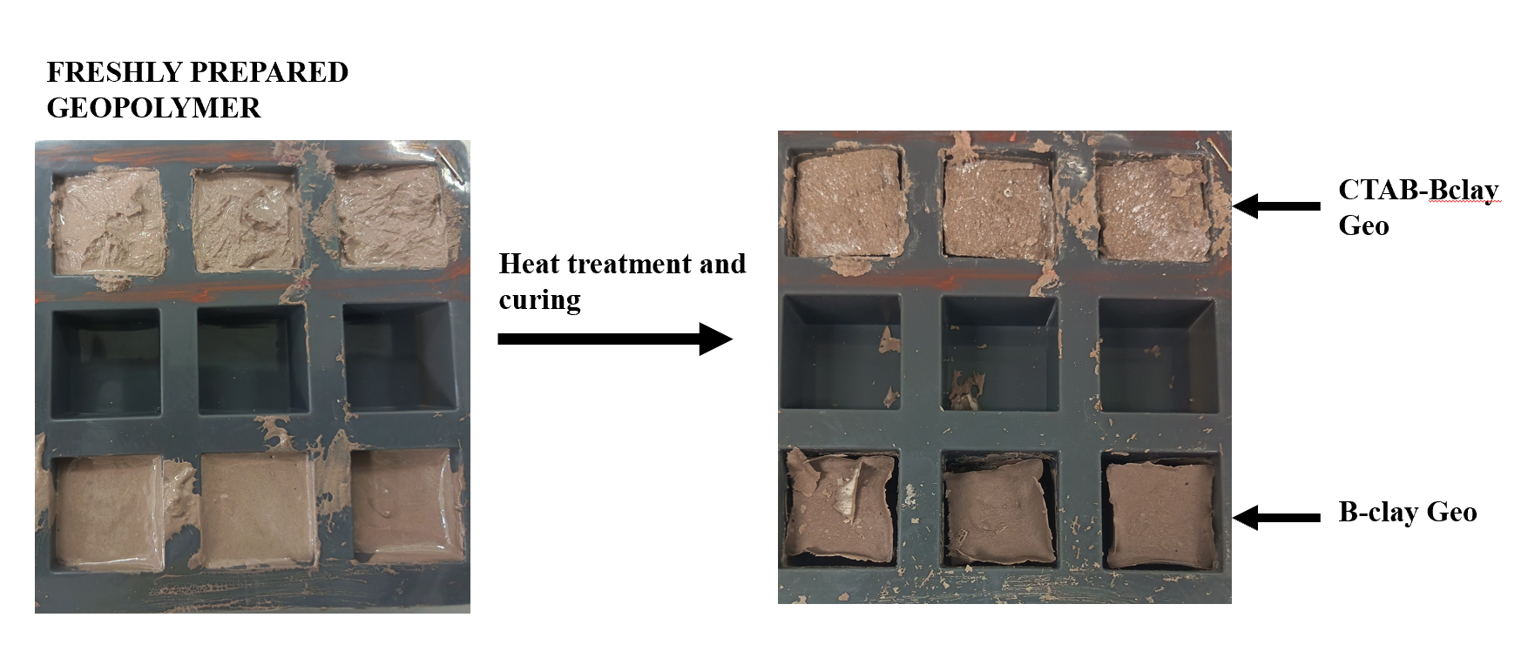
Fig 1. Geopolymer heat treatment and curing.
  - Characterization Techniques

    - Scanning Electron Microscopy (SEM-EDS)
Scanning Electron Microscopy (SEM) was employed as an analytical tool to investigate the morphological characteristics of clay and the synthesized geopolymer and geopolymer composite. For this analysis, we utilized the Gemini SEM 250 model from Zeiss. The resulting images provide valuable insights into the textural transformations of clay induced by various chemical treatments. Energy Dispersive X-ray Spectroscopy (EDS) was utilized to ascertain the elemental composition of the Clay and the geopolymers. EDS analysis was conducted in conjunction with SEM, facilitating the identification of both major and trace elements in the samples. This information is crucial for evaluating the suitability of these materials as precursors and functional components in geopolymer fabrication. The same Zeiss instrumentation was employed for the EDS analysis as was used for the SEM.

    - X-Ray Diffraction (XRD)
Crystallographic characterization and phase identification of B-clay, B-clayGeo and CTAB-BclayGeo were executed through advanced X-ray diffraction (XRD) techniques. The samples underwent meticulous preparation and were positioned on specialized holders to ensure optimal X-ray beam penetration and uniformity in data acquisition. The analysis utilized a Rigaku SmartLab X-ray diffractometer (Model Number: SmartLab, 9 kW), featuring a copper anode operating at 45 kV and 200 mA, which provided high-resolution diffraction patterns. This sophisticated system was equipped with a one-dimensional (1D) D/teX Ultra250 detector, complemented by a two-dimensional (2D) HyPix-3000 detector, facilitating comprehensive data collection and enabling detailed phase analysis. The integration of these detectors enhances the sensitivity and accuracy of the crystallographic data, allowing for precise identification of mineralogical phases present in clay.
2.3.3. Fourier Transform Infrared Spectroscopy (FTIR)
FTIR analysis was performed to identify the functional groups in the raw clay, the geopolymer matrix, and the CTAB-modified composite. This analysis also helped us observe structural changes after modification and the adsorption of carbamazepine. We recorded the spectra in the range of 4000 to 500 cm⁻¹ using a KBr pellet from Thermo Fisher, USA.

2.3.4. BET Surface Area and Porosity Analysis
The Brunauer-Emmett-Teller (BET) technique was utilized for surface area analysis to quantify the specific surface area of porous materials, including the geopolymer composite. This method relies on the physical adsorption of nitrogen gas molecules onto the solid surface at cryogenic temperatures, typically around 77 K.
In this investigation, BET analysis was conducted to evaluate the textural characteristics of the geopolymer composite. A sample weighing approximately 0.4 grams was placed in a sample tube and subjected to a degassing process in a vacuum oven for approximately six hours at 120 °C under vacuum conditions. Following the degassing, nitrogen gas was introduced at approximately -196 °C to enhance adsorption efficiency. The BET methodology is predicated on the principle of multilayer adsorption, wherein the specific surface area is derived from the linear portion of the BET plot, which correlates the volume of gas adsorbed with the relative pressure of the adsorbate. This analysis provides critical parameters, including specific surface area (m²/g), pore volume (cm³/g), and average pore diameter (nm), which serve as vital indicators of a material's adsorption potential.
2.4 Adsorption Experiments
Batch adsorption experiments were performed by introducing B-clay Geo and CTAB-BclayGeo into 20 mL of CBZ solution, using a dosage of 0.1 g, over various time intervals (0.5, 1, 2, 4, 8, 12, 16, and 24 hours) under conditions of pH 8 and a CBZ concentration of 10 mg/L. To investigate the effect of pH on the adsorption process, five different pH levels (2, 4, 7, 10, 12) were prepared. Each pH condition was tested with B-clay Geo and CTAB-BclayGeo for equilibrium studies over 24 hours. Additionally, experiments were conducted with initial CBZ solution concentrations of 10, 20, 30, 40, and 50 mg·L⁻¹ for a duration of 2 hours. These procedures conducted at room temperature with a stirring rate of 150 rpm.
The amount of absorbed CBZ qt(mg/L) was estimated using equation 1 :

$q_{e}=\frac{(C_{CBZ.o}-CC_{CBP.I})}{m}.V (1)$
$C_{CBZ.o}$ is the initial concentration of CBZ solution(mg/L); $CC_{CBZ.I}$ is the concentration of CBZ solution at equilibrium (mg/L), V is the volume of the solution (L), and m is the mass of the absorbent(g).
CBZ adsorption behavior on the coal fly ash geopolymer composite was represented by the Langmuir, the Freundlich and the Temkin adsorption isotherm models expressed with equations. 3,4, and 5 respectively.

$$\frac{Ce}{qe}=\frac{1}{q_{max}K_{L}}+\frac{Ce}{q_{max}} (2)$$
$$In{ q}_{e}=InK_{F}+\frac{1}{n} In C_{e} (3)$$

$In{ q}_{e}= qe= \frac{RT}{b}+\frac{RT}{b}{InC}_{e}$ (4)

Where $q_{max}$( mg/L) is the maximum adsorption capacity and $K_{L}$ (L/mg) is the Langmuir constant. $K_{F}$ (mg/g) and 1/n are the Freundlich constants, which specify the adsorption capability and the adsorption intensity, respectively.
The effect of contact time on the CBZ adsorption process was examined at different time intervals (0-24 hours) by adsorption kinetic models. Experimental data were fitted to pseudo-first order, pseudo-second order, and intraparticle diffusion models expressed with Eqs 4-6, respectively.

$In\left(q_{e}-q_{t}\right)=Inq_{e}-k_{1}t$ (5)
$\frac{t}{q_{t}}=\frac{1}{k_{2}{ q}_{e}^{2}}+\frac{t}{q_{e}}$ (6)
$q_{t}=k_{p}t^{1/2}+C$ (7)
Where $q_{t}$( mg/g) is the adsorption capacity at time(min).$k_{1} \left(\min^{-1}\right), k_{2}( g{mg}^{-1}\min^{-1})$ and $k_{p}$ (mg/g.$\min^{{-1}/2}$) indicates the pseudo-first-order, pseudo-second-order, and diffusion rate constants, respectively. C is a constant that gives insight into the thickness of the boundary layer in the intraparticle diffusion model.

3. Results and Discussion
  - Characterization of Materials
3.1.1 SEM microstructure and morphology/EDS.
The SEM micrographs presented in Fig. 2 illustrate significant morphological variations among raw clay (a), alkali-activated clay geopolymer (b), and CTAB-modified clay geopolymer (c).
Raw clay (a) displays a characteristic stacked, flaky platelet structure typical of layered aluminosilicates. The closely packed arrangement of these sheets indicates limited porosity and surface accessibility. Following alkali activation (b), the surface morphology transitions to a more compact and amorphous form, characterized by a continuous gel-like matrix enveloping the clay flakes. This transformation aligns with the dissolution of aluminosilicate species in the alkaline environment, subsequently leading to polycondensation into a geopolymeric gel network.(Carrio et al., 2025; Kumar, Kinuthia, Oti, & Adeleke, 2025).In the CTAB-modified geopolymer (c), the structure exhibits a more disordered configuration, featuring visible agglomerates and rougher surfaces. The increased heterogeneity and surface irregularity suggest the successful incorporation of the surfactant, which may introduce additional surface-active sites and enhance hydrophobic interactions(Duan, Chen, Zhang, Cai, & Wang, 2024). The elemental composition revealed significant concentrations of oxygen (46.82 wt.%), silicon (33.14 wt.%), and aluminum (8.00 wt.%) in B-clay, underscoring its classification as an aluminosilicate material. Trace elements, including iron, potassium, magnesium, titanium, sodium, and calcium, were also identified.
Following alkali activation, the silicon content decreased to 21.39 wt.%, while aluminum levels remained relatively stable at 7.47 wt.%. (B-clayGeo (b)) The oxygen content also diminished to 41.59 wt.%. Conversely, carbon content increased significantly to 14.04 wt.%, and iron levels rose to 8.44 wt.%. The observed increase in carbon is likely attributable to residual alkali activator species or carbonates generated during the curing process. The notable enrichment of sodium (4.07 wt.%) further corroborates its incorporation from the sodium silicate/NaOH activator into the geopolymeric matrix. These compositional alterations are indicative of the dissolution–reprecipitation mechanism that is characteristic of geopolymerization(Scolaro, Schackow, Folgueras, & Ueno, 2025).
In the CTAB-modified sample, silicon content increased to 31.05 wt.%, while aluminum was not detected in significant amounts compared to the raw clay. Notably, bromine (12.77 wt.%) was detected, confirming the successful incorporation of cetyltrimethylammonium bromide (CTAB) surfactant into the geopolymer framework. Sodium, potassium, titanium, and iron levels remained consistent with those observed in the unmodified geopolymer. The elevated bromine content serves as a marker for successful functionalization.
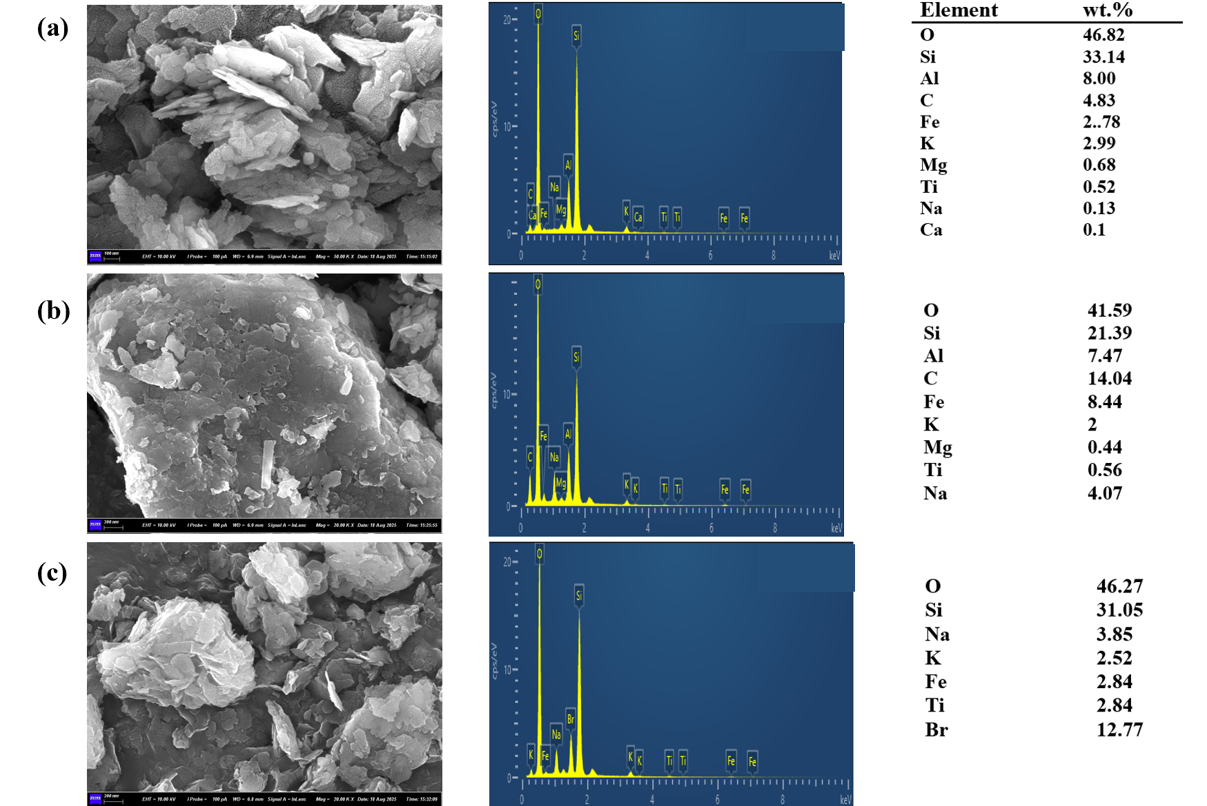
Fig.2. SEM-EDS image of (a) B-clay, (b) B-clay Goe, (c) CTAB-B-clay Geo

    - XRD patterns
The diffraction pattern of B-clay exhibits a characteristic layered aluminosilicate signature, featuring pronounced basal reflections of illite (I) at low angles, alongside a distinct peak for quartz (Q) at approximately 26.6° 2θ. Additional peaks corresponding to accessory minerals such as muscovite (M), montmorillonite (Mo), and kaolinite (K) are observed within the 5–30° 2θ range. The sharpness of these peaks, coupled with the absence of a broad diffuse background, suggests that the clay is predominantly crystalline, retaining stable 2:1 and 1:1 phyllosilicate structures.(Kumari & Mohan, 2021).
Upon alkali activation (B-clayGeo), the diffraction pattern continues to display quartz as the primary crystalline impurity. However, several reflections associated with clay minerals, specifically illite, kaolinite, and montmorillonite exhibit attenuation and slight broadening. Additionally, a weak amorphous halo emerges in the 20–35° 2θ region. These alterations are indicative of the partial dissolution of layered aluminosilicates, followed by reprecipitation as an X-ray amorphous N-(A)-S-H geopolymer gel. In contrast, the more acid-insoluble quartz remains largely unaffected(Davidovits, 2015). The persistence of illite and montmorillonite peaks, albeit with reduced intensity, suggests incomplete conversion, a phenomenon commonly observed in bentonite and illitic clays subjected to moderate temperatures and sodium concentrations(Werling et al., 2022).
The CTAB-modified geopolymer exhibits a diffraction pattern that closely resembles that of B-clayGeo. Notably, quartz remains present, while the peaks associated with clay minerals are further dampened and slightly broadened. The amorphous hump within the 20–35° 2θ range is preserved. Importantly, no new crystalline reflections corresponding to CTAB (cetyltrimethylammonium bromide) are observed. This absence is anticipated, as the surfactant is organic and is likely intercalated or adsorbed within the amorphous matrix, rendering it X-ray amorphous under these conditions. Typically, the presence of surfactant-modified clays is confirmed through FTIR and shifts in basal spacing, rather than the emergence of new phases in X-ray diffraction (Shirzad-Siboni, Khataee, Hassani, & Karaca, 2015).The observed additional damping of the basal phyllosilicate peaks following CTAB treatment aligns with the phenomena of layer disordering and intercalation, as well as surface coverage effects that diminish diffracting coherence.(Shirzad-Siboni et al., 2015)

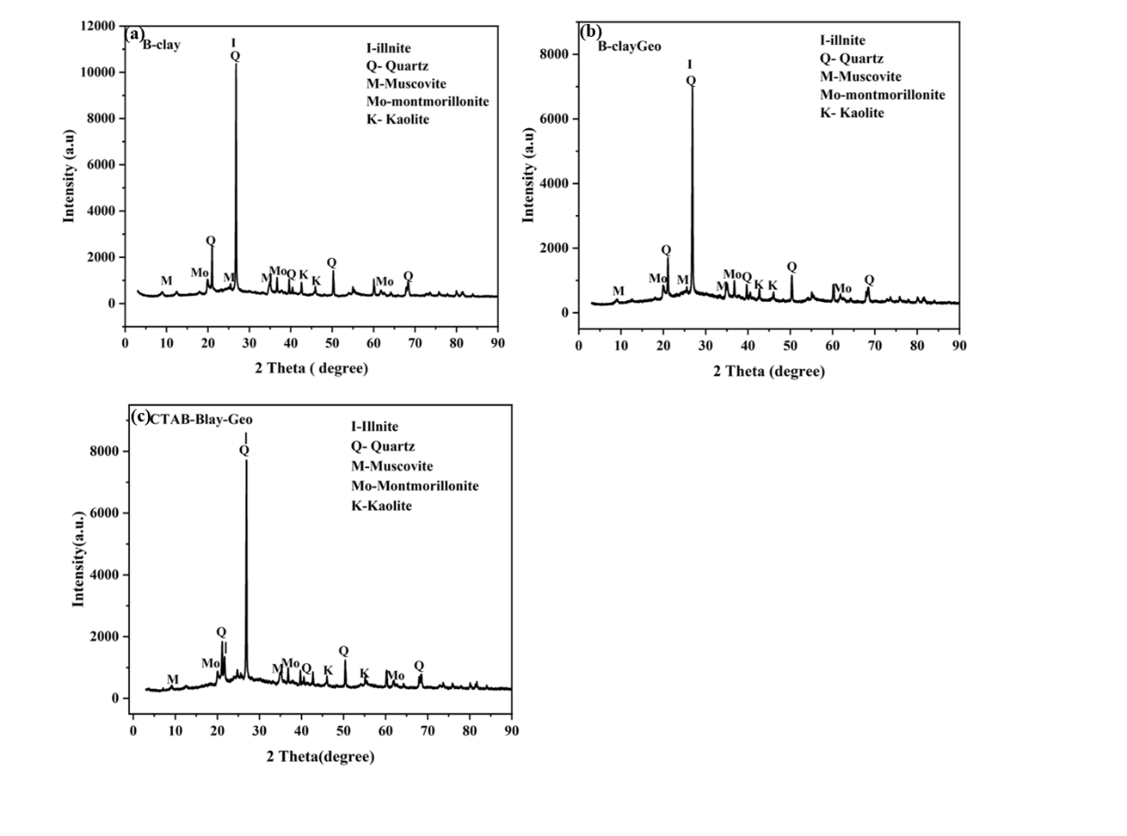
Fig.3. XRD analysis of (a) B-clay, (b)B-clayGeo and (c0 CTAB-B-clayGeo.

    - FTIR analysis
The FTIR spectra of raw clay (B-clay), alkali-activated clay geopolymer (Bclay-Geo), and CTAB-modified clay geopolymer (CTAB-Bclay Geo) are illustrated in Figure 3. The spectra exhibit characteristic structural modifications associated with geopolymerization and surfactant modification. A broad absorption band in the range of 3600–3200 cm⁻¹ is observed across all samples, which is attributed to O–H stretching vibrations of surface hydroxyl groups and adsorbed water (Wang & Lu, 2020). The intensity of this band diminishes following geopolymerization, indicating the partial consumption of structural hydroxyls during the dissolution–condensation reactions. The band located at approximately 1630–1640 cm⁻¹ corresponds to H–O–H bending vibrations of molecular water. This feature is consistently present in all spectra, reflecting the retention of water molecules bound within interlayer sites and geopolymer pores(Wang & Lu, 2020).
The most prominent absorption band for all samples is found within the range of 950–1100 cm⁻¹, which is assigned to the asymmetric stretching of Si–O– Si / Al in the aluminosilicate framework. In raw clay, this band appears sharp at approximately 1030 cm⁻¹, whereas in the geopolymer sample, it broadens and shifts slightly to lower wavenumbers (approximately 995–1005 cm⁻¹)(Singhal et al., 2017; Wang & Lu, 2020). This shift indicates the formation of a more amorphous aluminosilicate gel, thereby confirming the successful occurrence of geopolymerization. In the CTAB-modified geopolymer, the Si–O–T band retains its broad profile while exhibiting subtle variations in intensity, indicating that the incorporation of the surfactant induces minor perturbations within the aluminosilicate network. Furthermore, absorption peaks in the 2850–2950 cm⁻¹ range are detected, corresponding to C–H stretching vibrations associated with the –CH₂ and –CH₃ groups present in the CTAB surfactant molecules(Wang & Lu, 2020). This observation substantiates the successful integration of CTAB into the geopolymer matrix. In the lower wavenumber region (500–800 cm⁻¹), bending vibrations of Si–O–Al and Si–O–Si bonds are discernible. These spectral features exhibit broadening in the geopolymer samples relative to the B-clay, providing further evidence of the transition from crystalline to amorphous aluminosilicate phases.
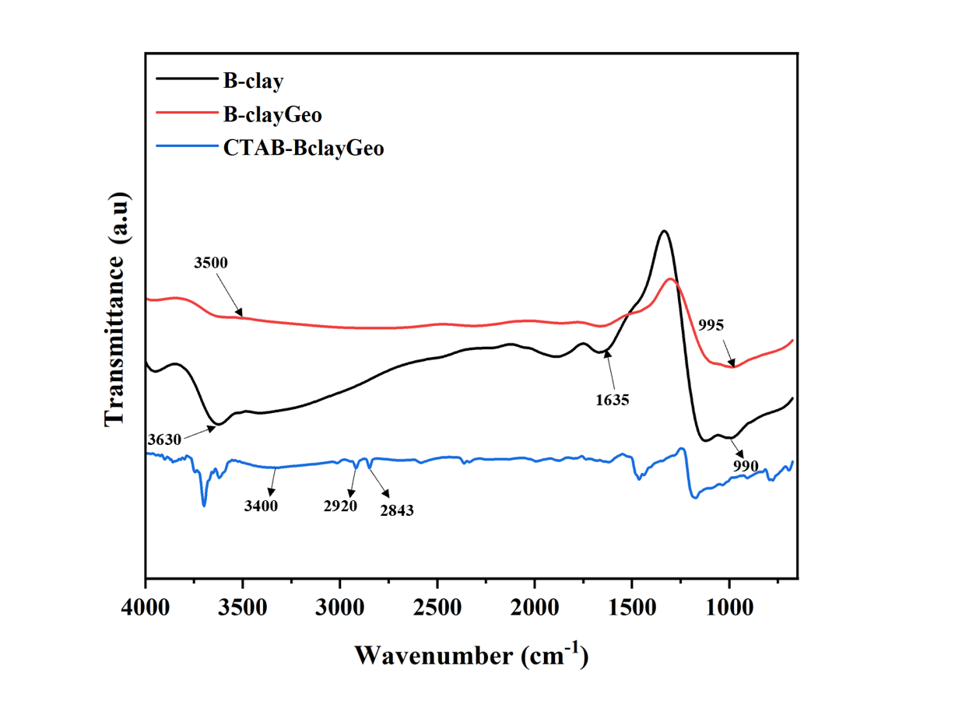
Fig.4. FTIR analysis of B-clay, B-clayGeo, and CTAB-Bclay Geo

3.1.4 BET Surface Area and Porosity Analysis
The BET surface area of B-clay Geo was determined to be 27.28 m²/g.
The incorporation of cetyltrimethylammonium bromide (CTAB) led to a remarkable enhancement in surface area, yielding a BET value of 69.16 m²/g. This represents an increase of over 150% relative to the reference material. CTAB, a cationic surfactant, intercalates into the clay layers, effectively separating them and generating additional surface area. This structural transformation suggests that the CTAB treatment successfully exfoliated or expanded the clay matrix, thereby enhancing the availability of surface sites for nitrogen adsorption(Maged, El-Fattah, Kamel, Kharbish, & Elgarahy, 2023). The total pore volume and pore size distribution were assessed using the Barrett-Joyner-Halenda (BJH) method, specifically analyzing the desorption branch, which is the standard approach for mesopore characterization.

The single-point total pore volume at a relative pressure (p/p°) of approximately 0.99 was measured at 0.0936 cm³/g. The BJH desorption cumulative pore volume within the mesopore range of 1.7-300 nm was determined to be 0.1107 cm³/g.
In contrast, the single-point total pore volume for the CTAB-modified sample was significantly higher, recorded at 0.1345 cm³/g. The BJH desorption cumulative pore volume was markedly increased to 0.2151 cm³/g, nearly double that of the reference clay.
The observed doubling of pore volume in the CTAB-modified sample provides compelling evidence for the successful introduction of new porosity. The intercalation of bulky cetyltrimethylammonium bromide (CTAB) molecules between the clay layers not only enhances the surface area but also facilitates the separation of the layers, resulting in a more open and porous network with an increased capacity for adsorbate molecules(Mennas, Lahreche, Chouli, Sabantina, & Benyoucef, 2023).
The BJH method was employed to analyze the pore size distribution(PSD), revealing distinct differences in the pore architecture.
The average pore width during adsorption was 18.78 nm, while the average pore width during desorption was 14.86 nm. The PSD exhibits a broad distribution, with the majority of pores falling within the mesopore range of 2-50 nm.
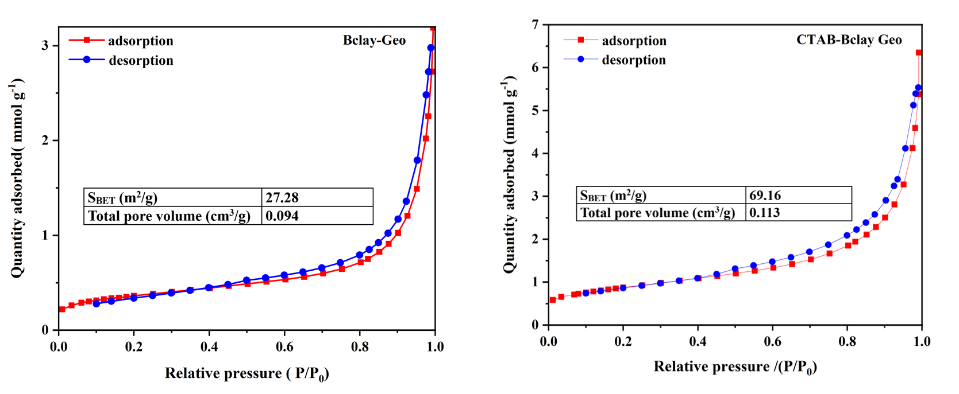
Fig.5. Nitrogen adsorption-desorption isotherms for the determination of surface area of (a) B-clay Geo and (b) CTAB-Bclay Geo.

3.2 Adsorption Studies
3.2.1 Effect of pH on carbamazepine uptake
For the unmodified Bclay-Geo, the adsorption capacity exhibited a notable trend, increasing from 5.0 mg/g at pH 2 to a peak of approximately 14.0 mg/g at pH 7, before gradually declining to around 8.0 mg/g at pH 12. This bell-shaped pattern can be attributed to variations in the geopolymer's surface charge and the pharmaceutical adsorbate's speciation. CBZ is significantly influenced by solution pH, as its chemical speciation is governed by dissociation constants (pKa values). For carbamazepine (CBZ), both forms of the compound exist in their hydrophobic zwitterionic state within a pH range of 2.3 (corresponding to the ketone group) to 13.9 (associated with the amine group)(Shan et al., 2016; To, Hadi, Hui, Lin, & McKay, 2017). Below this range, CBZ predominantly exists in a hydrophilic cationic form; above it, the compound transitions to a hydrophilic anionic form. Consequently, within the investigated pH range of 2 to 12, CBZ molecules remain largely unchanged, resulting in minimal electrostatic attraction to charged adsorbents(Naghdi et al., 2019). Therefore, in the case of CBZ, electrostatic interactions can be considered negligible, with hydrophobic and π-π interactions being the primary forces at play. At lower pH levels, an excess of H+ ions leads to the protonation of the surface, resulting in electrostatic repulsion of neutral or weakly cationic molecules, thereby diminishing adsorption. As the pH approaches neutrality, the competition from protons decreases, allowing for greater accessibility of surface sites and enhanced adsorption(Paparo et al., 2024). Conversely, at strongly alkaline pH levels, the deprotonation of surface hydroxyl groups of the geopolymer increases the negative charge density, which may induce repulsion of deprotonated CBZ or destabilize hydrophobic interactions, ultimately reducing the adsorption capacity(Ncibi & Sillanpää, 2017).

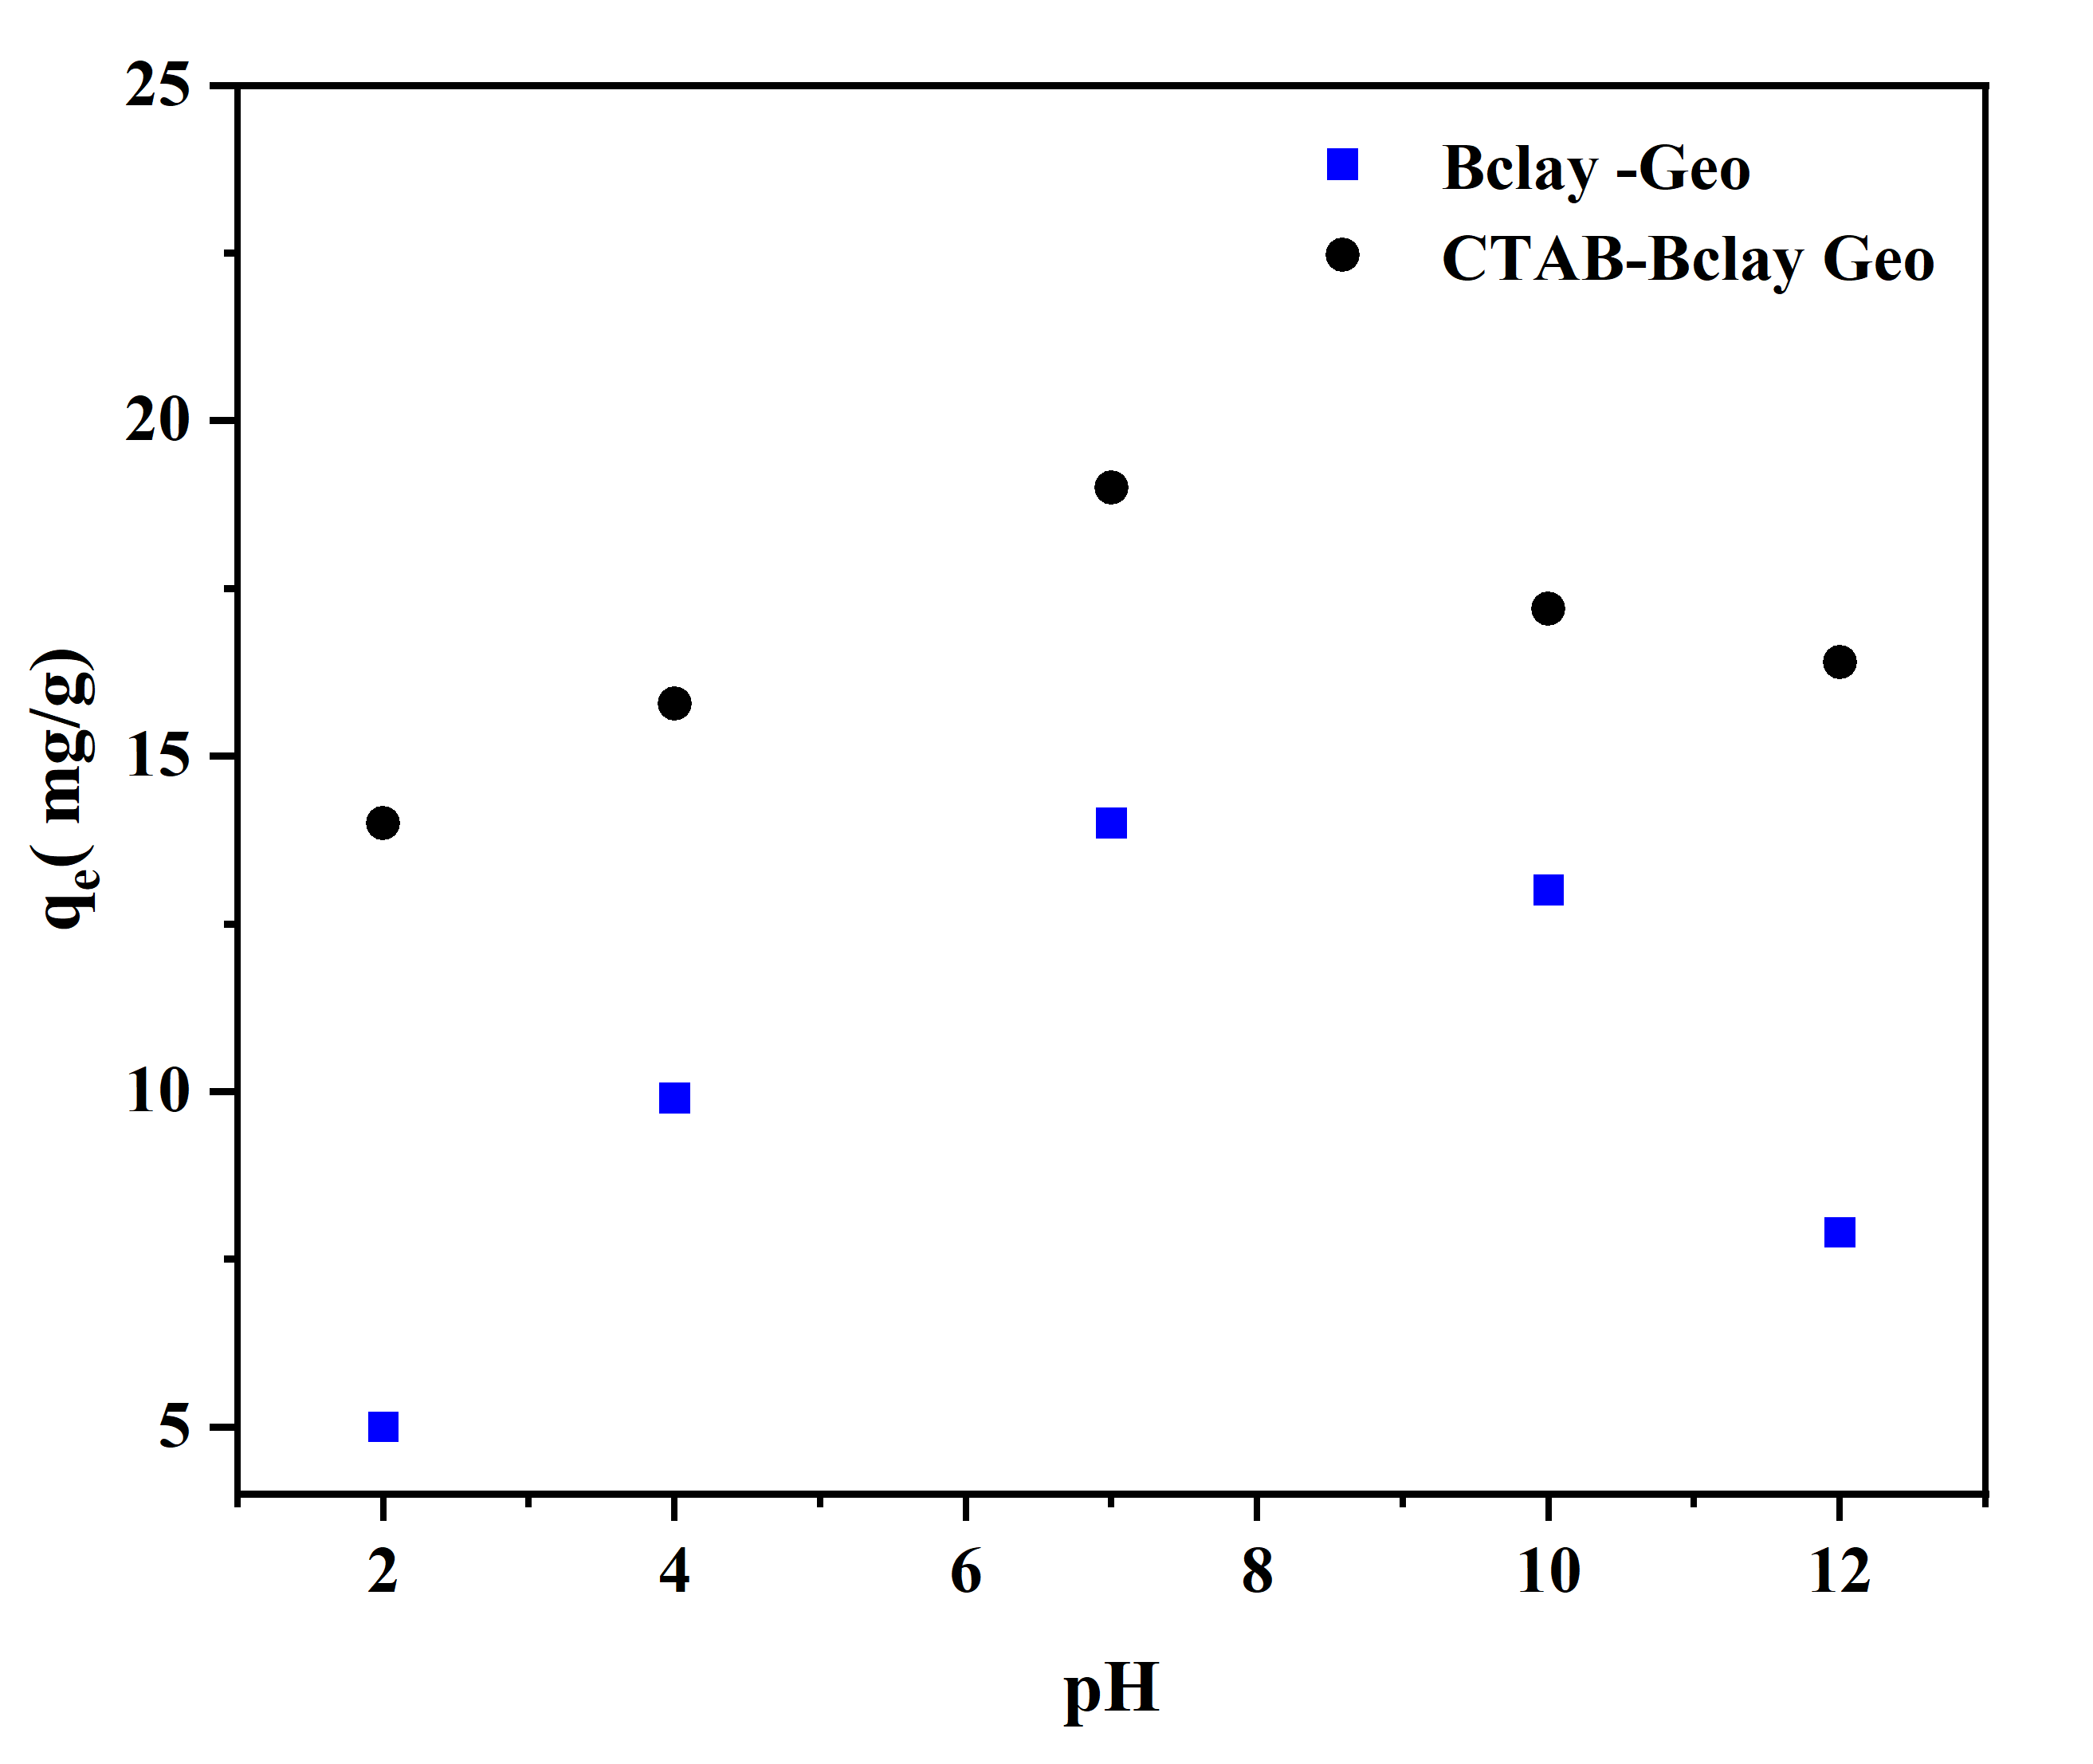
Fig. 6. Influence of pH on the adsorption of CBZ.

In contrast, CTAB-Bclay Geo demonstrated consistently superior adsorption across the entire pH spectrum, with values ranging from approximately 14 mg/g at pH 2, peaking at around 19 mg/g at pH 7, and remaining above 16 mg/g even at pH 12. This enhanced performance can be attributed to the surface modification by CTAB, a cationic surfactant, which increases hydrophobicity, expands interlayer spacing, and introduces active sites that facilitate the sorption of neutral or weakly polar molecules(Abbou et al., 2023). The elevated adsorption at acidic pH levels, in comparison to unmodified Bclay-Geo, may suggest that the functional groups of CTAB mitigate the competitive effects of protonation and provide stable binding domains through van der Waals and hydrophobic interactions. Additionally, the relatively stable adsorption observed at alkaline pH indicates that the CTAB bilayer structure may shield the active sites from deprotonation, characterized by the substitution of intercalated inorganic cations, as evidenced by elemental analysis indicating a reduction in the percentage of potassium and sodium content thereby maintaining a higher adsorption affinity(Soni, Kumar, Shandilya, Kumar, & Chauhan, 2025).

3.2.2 Effect of contact time and adsorption kinetics
The unmodified B-clay geopolymer exhibited a rapid initial adsorption phase, with a significant reduction in carbamazepine concentration from 10 mg/L to 6.511 mg/L within the first 0.5 hours, resulting in an initial removal efficiency of 34.9%. Over time, the adsorption rate gradually declined, approaching near-equilibrium conditions after approximately 16 hours. Final equilibrium concentrations stabilized between 2.39 and 2.43 mg/L after 20 to 24 hours. This behavior is typical of heterogeneous adsorption systems, characterized by an initial phase of rapid external surface adsorption followed by slower intraparticle diffusion processes(Fang et al., 2024; Hijazi et al., 2025). The CTAB-modified geopolymer, on the other hand, demonstrated markedly improved adsorption performance and accelerated kinetics. Within the first 0.5 hours, the carbamazepine concentration decreased significantly to 3.55 mg/L, reflecting a removal efficiency of 64.5%, nearly double that of the unmodified geopolymer. The modified adsorbent reached equilibrium more swiftly, with concentrations stabilizing between 0.45 and 0.48 mg/L after 16 to 20 hours, achieving an overall higher removal efficiency.
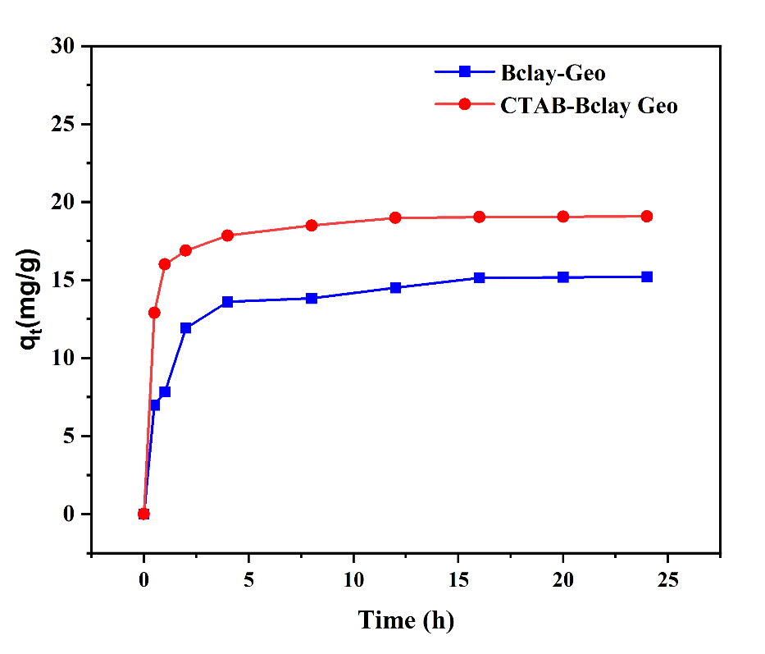
Fig. 7 Effect of time on the adsorption of CBZ on Bclay-Geo and CTAB-Bclay Geo

- Adsorption kinetics
The pseudo-first-order (PFO) model demonstrated a significant discrepancy between the experimental and calculated adsorption capacities. For the B-clay geopolymer, the experimental adsorption capacity (qe) was measured at 15.22 mg/g, nearly double the calculated value of 8.867 mg/g. In the case of the CTAB-modified B-clay geopolymer, the deviation was even more pronounced, with experimental values of qe at 19.1 mg/g compared to a calculated value of 5.386 mg/g. Despite both systems exhibiting relatively high correlation coefficients (R² = 0.961 and 0.921), the considerable mismatch between the calculated and experimental values indicates that the PFO model inadequately captures the adsorption kinetics. This finding suggests that the adsorption process is not predominantly influenced by physisorption or diffusion-controlled mechanisms, which are typically represented by the PFO model(Yasmin, 2021).
The pseudo-second-order model posits that the rate-limiting step in the adsorption process is governed by chemical sorption, characterized by valence forces and electron sharing between the adsorbent and adsorbate(Jin, Zhang, Wang, Chang, & Li, 2021; Yasmin, 2021). This model exhibited exceptional performance for both materials under investigation. B-clay Geo demonstrated a remarkable alignment with calculated and experimental adsorption capacities, with qe(cal) = 15.56 mg/g and qe(exp) = 15.22 mg/g, reflecting a minimal difference of only 2.2%. Additionally, it achieved an outstanding correlation coefficient of R² = 0.998. In comparison, CTAB Bclay Geo displayed an even more favorable model fit, with qe(cal) = 19.25 mg/g versus qe(exp) = 19.1 mg/g, resulting in a mere 0.8% difference and a correlation coefficient of R² = 0.999. The second-order rate constants were determined to be K₁ = 0.00432 min⁻¹ for B-clay Geo and K₁ = 0.00416 min⁻¹ for CTAB Bclay Geo, indicating slightly faster kinetics for the unmodified clay. The strong fit of the pseudo-second-order model suggests that the adsorption mechanism is predominantly chemisorptive(Šuránek et al., 2023), involving the formation of chemical bonds between the adsorbate and the active sites on the clay surface. This aligns with the role of surface hydroxyl groups and interlayer cation exchange sites inherent in clay minerals(Gurav, Ray, Datta, Choudhari, & Hartmann, 2024).

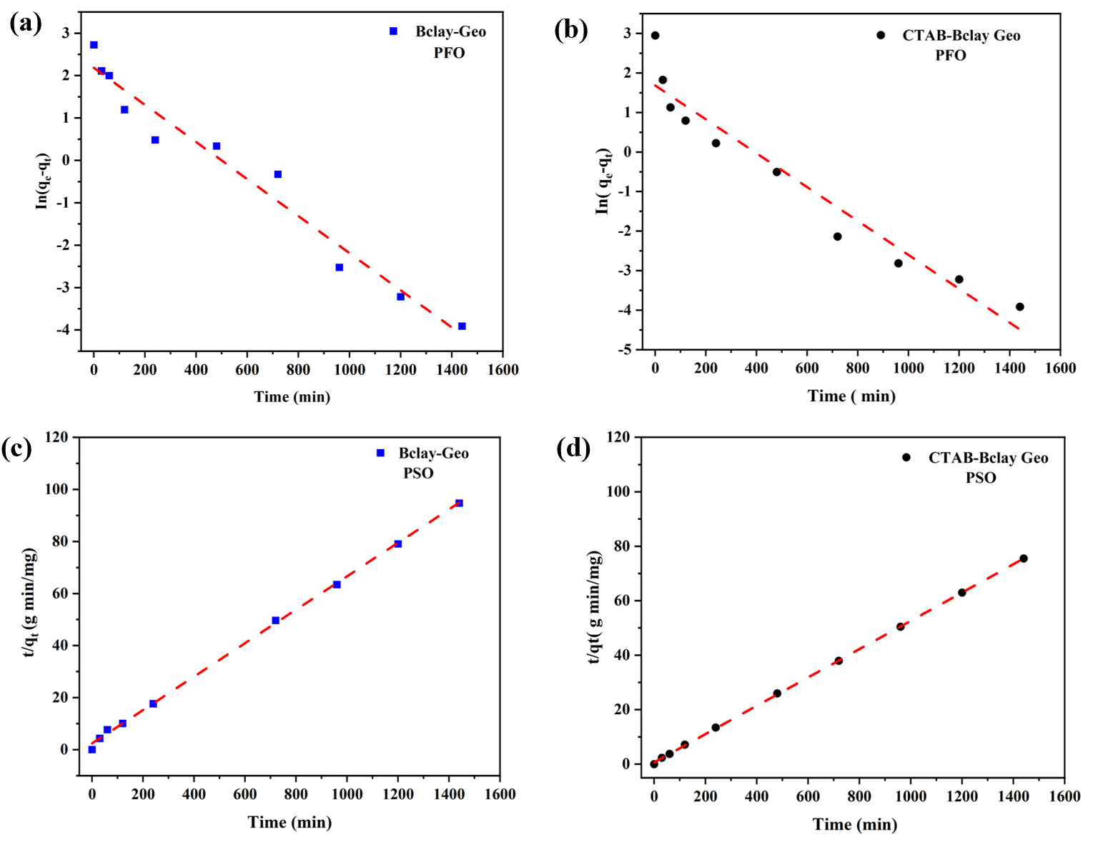
Fig. 8. Kinetic studies of CBZ adsorption (a) PFO Bclay Geo, (b) PFO CTAB-Bclay Geo, (c) PSO Bclay-Geo and (d) PSO CTAB-Bclay Geo
The intraparticle diffusion plots provided valuable insights into the adsorption mechanism. For the B-clay geopolymer, the intraparticle diffusion rate constant (kdiff = 0.327 mg·g⁻¹·min⁻⁰·⁵) indicated moderate pore diffusion, supported by a correlation coefficient (R² = 0.743). The non-zero intercept (C₁ = 5.14 mg/g) suggests a significant boundary layer effect, indicating that external mass transfer resistance played a role in the adsorption process. In contrast, the CTAB-modified B-clay geopolymer exhibited a comparable diffusion rate (kdiff = 0.323), but with a notably higher intercept (C₁ = 9.62 mg/g) and a lower R² value (0.523). This suggests that surface modification enhanced surface adsorption while increasing boundary layer resistance, shifting the adsorption process away from being primarily diffusion-controlled. The observed poor linearity further indicates that intraparticle diffusion was not the sole rate-limiting step. Instead, a multi-step mechanism encompassing external film diffusion, surface adsorption, and intraparticle diffusion likely governed the overall adsorption process.
Table 1
Kinetic equation parameters for the adsorption of CBZ by B-clay Geo and CTAB Bclay Geo.
Kinetic model | B-clay Geo | CTAB Bclay Geo
Pseudo-first-order kinetic model
q_{e}(exp) (mg/g) | 15.22 | 19.1
q_{e}(cal) (mg/g) | 8.867 | 5.386
K₁ | 0.00437 | 0.00429
R² | 0.961 | 0.921
Pseudo-second-order kinetic model
q_{e}(exp) (mg/g) | 15.22 | 19.1
q_{e}(cal) (mg/g) | 15.56 | 19.25
K₁ | 0.004317 | 0.004158
R² | 0.998 | 0.999
Intraparticle diffusion model
R² | 0.743 | 0.523
C₁ | 5.14 | 9.62
k_{diff} | 0.327 | 0.323

Table 2
Langmuir, Freundlich and Temkin isotherm model parameters and correlation coeficients for adsorption of CBZ on B-clay Geo and CTAB Bclay Geo.
Isotherm model | 25 C | 30 C | 35 C
Langmuir Bclay
Q_{m} | 34.5 | 36.8 | 39.1
K_{L} | 0.0180 | 0.0245 | 0.0342
R₂ | 0.742 | 0.765 | 0.798
Langmuir CTAB Bclay Geo
Q_{m} | 58.2 | 59.1 | 59.8
K_{L} | 0.0240 | 0.0301 | 0.0301
R₂ | 0.676 | 0.698 | 0.715
Freundlich Bclay Geo
K_{F} | 1.68 | 2.12 | 2.89
n | 1.89 | 2.05 | 2.24
1/n | 0.529 | 0.488 | 0.446
R² | 0.943 | 0.958 | 0.971
Freundlich CTAB Bclay Geo
K_{F} | 2.85 | 3.24 | 3.24
n | 2.15 | 2.28 | 2.28
1/n | 0.465 | 0.439 | 0.439
R² | 0.967 | 0.973 | 0.973
Temkin Bclay Geo
AT | 0.156 | 0.198 | 0.267
B | 13.4 | 15.1 | 16.9
R² | 0.925 | 0.941 | 0.956
Temkin CTAB Bclay Geo
AT | 0.198 | 0.245 | 0.245
B | 17.4 | 18.9 | 18.9
R² | 0.951 | 0.958 | 0.958

The Langmuir model suggests that adsorption occurs as a monolayer on a surface with a finite number of identical active sites(El-Bery, Saleh, El-Gendy, Saleh, & Thabet, 2022). Observations indicate that the maximum adsorption capacities (qmax) exhibited a slight increase with temperature, suggesting that the adsorption of carbamazepine (CBZ) is endothermic. Specifically, for Bclay Geo, qmax increased from 34.5 mg·g⁻¹ at 25 °C to 39.1 mg·g⁻¹ at 35 °C. In contrast, CTAB-Bclay Geo demonstrated higher qmax values, ranging from 58.2 to 59.8 mg·g⁻¹ across the temperature spectrum studied. The elevated qmax values for CTAB-modified samples underscore the enhancement of adsorption capacity due to increased hydrophobic interactions and electrostatic affinity. The Langmuir constant (KL) also rose with temperature, indicating stronger interactions between the adsorbate and adsorbent. However, the relatively low R² values (0.676–0.798) suggest that the Langmuir model does not fully encapsulate the adsorption process, indicating a degree of heterogeneity in the adsorbent surface.
The Freundlich model characterizes adsorption on heterogeneous surfaces with a non-uniform distribution of sites and energies. The strong fits obtained (R² = 0.943–0.973) suggest that CBZ adsorption aligns with multilayer adsorption on heterogeneous surfaces. The Freundlich constants (KF) increased with temperature for both adsorbents, further supporting the endothermic nature of the adsorption process. The adsorption intensity factor (n) was greater than 1 in all instances (1.89–2.28), indicating favorable adsorption conditions(Vigdorowitsch, Pchelintsev, Tsygankova, & Tanygina, 2021).
The Temkin model accounts for the influence of indirect adsorbate–adsorbate interactions on adsorption processes(Temkin, 1940). The model demonstrated commendably high R² values ranging from 0.925 to 0.958, affirming its effectiveness in characterizing carbamazepine (CBZ) adsorption. The equilibrium binding constant (AT) exhibited an increase with temperature for both adsorbents, further indicating that the adsorption process is endothermic. Additionally, the Temkin constant (B), which is indicative of the heat of adsorption, also rose with temperature, suggesting that stronger interactions occur at elevated temperatures. In comparing adsorption models, both the Freundlich and Temkin models provided superior fits relative to the Langmuir model, as evidenced by their higher R² values. This finding suggests that the adsorption of CBZ onto the geopolymer adsorbents is more accurately represented as a heterogeneous and multilayered process rather than an ideal monolayer coverage. Notably, the CTAB-modified geopolymer consistently demonstrated enhanced adsorption performance, attributed to its improved surface chemistry, increased hydrophobic interactions, and greater pore accessibility. This observation aligns with existing literature indicating that cationic surfactants can significantly enhance the capture of neutral and hydrophobic pharmaceuticals, including carbamazepine, diclofenac, and ibuprofen(Kryuchkova et al., 2021).

5. Mechanism of Carbamazepine Adsorption
The enhanced performance observed can be attributed to the surface modification of the geopolymer by CTAB, a cationic surfactant, which significantly increases the available surface area. Under identical adsorption conditions, CTAB-BclayGeo exhibits approximately three times the number of available adsorption sites compared to unmodified Bclay Geo. This characteristic effectively mitigates the influence of protonation on the geopolymer. Furthermore, the hydrophobic nature of CTAB expands the interlayer spacing and introduces positively charged sites, which facilitate the sorption of neutral or weakly polar molecules(Yasmin, 2021).
The increased adsorption capacity at acidic pH levels, relative to unmodified Bclay Geo, indicates that the functional groups of CTAB counteract the competitive effects of protonation, providing stable binding domains through van der Waals and hydrophobic interactions. Additionally, the relatively stable adsorption observed at alkaline pH suggests that the CTAB bilayer structure may protect the active sites from deprotonation effects, thereby preserving a higher adsorption affinity(Abbou et al., 2023; Soni et al., 2025).
The incorporation of CTAB into the clay matrix is characterized by the replacement of intercalated inorganic cations, as evidenced by elemental analysis showing a decrease in potassium content. An increase in pore diameter and a strong correlation with pseudo-second-order (PSO) kinetics indicate that chemical interactions and enhanced pore size facilitate adsorption, thereby improving the overall adsorption capacity compared to Bclay-Geo.
6. Desorption efficiency and regeneration cycles
The desorption efficiency of the adsorbent was assessed using ethanol and distilled water over four consecutive regeneration cycles (Fig. 9). In the initial cycle, ethanol demonstrated a higher desorption efficiency (~72%) compared to distilled water (~64%). This disparity can be attributed to ethanol's superior elution capability, which effectively disrupts hydrophobic and π–π interactions between the adsorbate molecules and the adsorbent surface. In contrast, distilled water primarily facilitates desorption through hydrogen bonding and weak electrostatic interactions, which may not sufficiently overcome the strong binding affinity of pharmaceutical compounds to the adsorbent(Pahari et al., 2021). Throughout the successive cycles, a gradual decline in desorption efficiency was observed for both solvents, indicating potential partial saturation or irreversible adsorption on the adsorbent surface. Specifically, the efficiency of ethanol decreased from ~72% in the first cycle to ~54% in the fourth cycle, while distilled water exhibited a sharper decline from ~64% to ~53% during the same period. The closer values observed in the fourth cycle suggest that repeated use may lead to structural or chemical changes in the adsorbent surface, such as pore blockage or reduced availability of active sites, ultimately resulting in diminished regeneration performance regardless of the eluent used. Overall, ethanol exhibited a superior desorption capacity to distilled water, affirming its effectiveness as a regeneration agent for sustaining adsorbent reusability. However, the progressive decline in efficiency indicates that a portion of the adsorbed molecules may be strongly bound or trapped within micropores, rendering them less accessible for desorption.
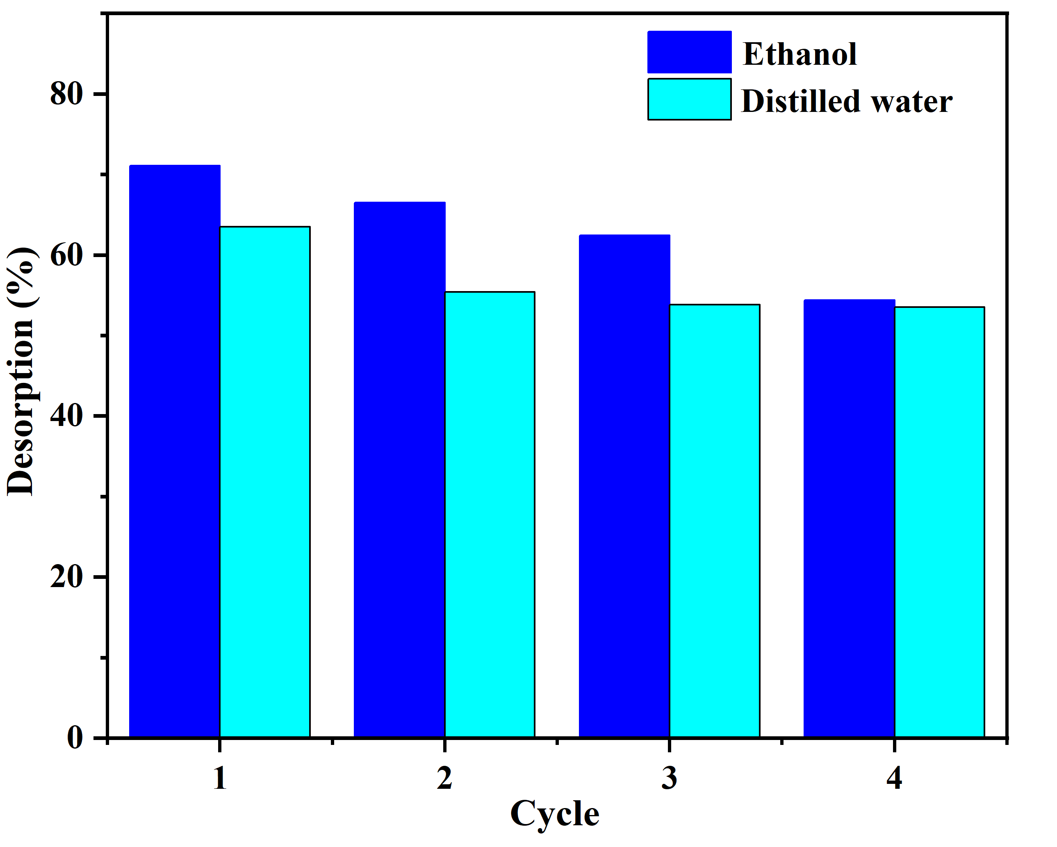
Fig 9. Efficiency of CBZ desorption of CTAB Bclay Geopolymer by different eluents: distilled water and ethanol.
Table 3 Comparison with Literature and Commercial Adsorbents
Adsorbent | Wastewater type/matrix studied | pH | C_{o}(mg·L⁻¹) | Temp (°C) | Adsorption capacity (mg·g⁻¹) | Refrerence
Date-pit-derived activated carbon (DPAC) (biomass-derived PAC) | Synthetic water (CBZ spiking; | ~7 (neutral conditions reported) | low–moderate C (µg–mg L⁻¹); isotherm range in paper | 25°C | 14.9 mg·g⁻¹ | (Zayyat et al., 2024)
Organoclay / HDTMA-modified bentonite (organoclay) (surfactant-modified clay) | Synthetic aqueous batch | ~6–7 (neutral: modelled at pH ~7) | typical 1–100 mg·L⁻¹ | 25 °C | ~34.3 mg·g⁻¹ | (Viegas et al., 2024)
MOF-derived nanoporous carbon. | Synthetic aqueous CBZ solutions | typically, neutral (pH ~7) | 1–100 mg·L⁻¹ | 25 °C | ~664–704 mg·g⁻¹ | (Yu et al., 2022)
Giant macroporous silica | Synthetic water (spiked CBZ) | ~7.0 reported | tested at µg·L⁻¹ to mg·L⁻¹ levels | 25 °C | 49.44  mg·g⁻¹ | (Alver et al., 2024)
Hydrochar/ biochar activated hydrochar | Synthetic waters; some tested in real wastewater matrices | pH tested near neutral (varies) | 5–200 mg·L⁻¹ | 25 °C | - ·g⁻¹ | (Aghababaei, Azargohar, Dalai, Soltan, & Niu, 2022)

- Conclusion
The study focused on the development of CTAB-modified clay geopolymer composites for the removal of carbamazepine. The incorporation of CTAB enhanced the clay's surface area by approximately 150%. This modification resulted in exceptional removal efficiency, favorable adsorption kinetics, and a substantial carbamazepine removal capacity of 19.1 mg/g, significantly surpassing the performance of the unmodified variant. The adsorption process adhered to pseudo-second-order kinetics, underscoring the role of chemical adsorption mechanisms. The Freundlich model showed that CTAB-modified geopolymers had heterogeneous surface adsorption and higher capacity than unmodified materials. carbamazepine removal was due to hydrophobic associations, hydrogen bonding, and improved surface morphology, allowing better interaction with carbamazepine.
While challenges remain, particularly in terms of long-term performance validation, regeneration optimization, and real-world testing, the fundamental feasibility and potential of this approach have been clearly demonstrated. With continued development addressing these limitations and opportunities, CTAB-modified clay geopolymer composites have the potential to significantly contribute to mitigating pharmaceutical contamination in wastewater, protecting aquatic ecosystems, and potentially reducing pharmaceutical resistance development from the point of view of environmental significance, low cost and adsorption performance.
Acknowledgment
The author would like to thank the Guangdong Technion -Israel Institute of Technology for providing access to their library facility

Statements and declarations
Not applicable
Ethical considerations
Ethical approval was not required.

Declaration of conflicting interest
The author declared no potential conflicts of interest with respect to the research, authorship, and/or publication of this article.

Funding
The author did not receive any financial support for the research, authorship, and/or publication of this article.

References

- Abbou, B., Lebkiri, I., Ouaddari, H., El Amri, A., Achibat, F. E., Kadiri, L., . . . Rifi, E. H. (2023). Improved removal of methyl orange dye by adsorption using modified clay: combined experimental study using surface response methodology. Inorganic Chemistry Communications, 155, 111127.
- Açışlı, Ö., Acar, İ., & Khataee, A. (2022). Preparation of a surface modified fly ash-based geopolymer for removal of an anionic dye: Parameters and adsorption mechanism. Chemosphere, 295, 133870.
- Aghababaei, A., Azargohar, R., Dalai, A. K., Soltan, J., & Niu, C. H. (2022). Adsorption of carbamazepine from water by hydrothermally and steam activated agricultural by-products: equilibrium, site energy, and thermodynamic studies. Chemical Engineering Communications, 209(6), 852-867.
- Ahmad, F. A. (2023). The use of agro-waste-based adsorbents as sustainable, renewable, and low-cost alternatives for the removal of ibuprofen and carbamazepine from water. Heliyon, 9(6).
- Al Qarni, H., Collier, P., O’Keeffe, J., & Akunna, J. (2016). Investigating the removal of some pharmaceutical compounds in hospital wastewater treatment plants operating in Saudi Arabia. Environmental Science and Pollution Research, 23(13), 13003-13014.
- Alsubih, M., El Morabet, R., Khan, R. A., Khan, N. A., Khan, A. R., Khan, S., . . . Yousefi, M. (2022). Performance evaluation of constructed wetland for removal of pharmaceutical compounds from hospital wastewater: Seasonal perspective. Arabian Journal of Chemistry, 15(12), 104344.
- Alver, A., Yılmaz, B. A., Bilican, B. K., Baştürk, E., Kaya, M., & Işık, M. (2024). Carbamazepine adsorption onto giant macroporous silica and adaptive neuro-fuzzy inference system modeling. Arabian Journal for Science and Engineering, 49(6), 8509-8524.
- Carrio, J. A., Donato, R. K., Carvalho, A., Koon, G. K., Donato, K. Z., Yau, X. H., . . . Joy, J. (2025). From 2D kaolinite to 3D amorphous cement. Scientific reports, 15(1), 1669.
- Davidovits, J. (2015). False values on CO2 emission for geopolymer cement/concrete published in scientific papers. Technical paper, 24, 1-9.
- Duan, J., Chen, B., Zhang, Y., Cai, P., & Wang, F. (2024). Enhanced adsorption of Cr (VI) from aqueous solutions by CTAB-modified schwertmannite: Adsorption performance and mechanism. Chemical Engineering Research and Design, 208, 464-474.
- Ekpeghere, K. I., Sim, W.-J., Lee, H.-J., & Oh, J.-E. (2018). Occurrence and distribution of carbamazepine, nicotine, estrogenic compounds, and their transformation products in wastewater from various treatment plants and the aquatic environment. Science of the total environment, 640, 1015-1023.
- El-Bery, H. M., Saleh, M., El-Gendy, R. A., Saleh, M. R., & Thabet, S. M. (2022). High adsorption capacity of phenol and methylene blue using activated carbon derived from lignocellulosic agriculture wastes. Scientific reports, 12(1), 5499.
- Fang, Y., Yang, L., Rao, F., Zhang, K., Qin, Z., Song, Z., & Na, Z. (2024). Behaviors and mechanisms of adsorption of MB and Cr (VI) by geopolymer microspheres under single and binary systems. Molecules, 29(7), 1560.
- Gurav, P. P., Ray, S., Datta, S., Choudhari, P., & Hartmann, C. (2024). Role of clay cation exchange capacity, location of charge, and clay mineralogy on potassium availability in Indian Vertisols. Clays and Clay Minerals, 72, e3.
- Hiba, Z., Mondamert, L., Remaury, Q. B., Cleon, A., Leitner, N. K. V., & Labanowski, J. (2021). Occurrence of carbamazepine, diclofenac, and their related metabolites and transformation products in a French aquatic environment and preliminary risk assessment. Water Research, 196, 117052.
- Hijazi, N., Bavykina, A., Yarulina, I., Shoinkhorova, T., Ramos-Fernandez, E. V., & Gascon, J. (2025). Chemical engineering of zeolites: alleviating transport limitations through hierarchical design and shaping. Chemical Society Reviews.
- Ilau-Uli, A., Oguyo, H., Ngozi, N. A., & Olajided, I. O. Development of Sustainable Water Management Technologies for Communities Using Low-Cost Filter Materials.
- Jin, H., Hong, K., Liu, J., Qiu, C., Zhu, M., Li, C., & Wang, Q. (2025). Structural and functional design of CTAB-geopolymer adsorbents for rapid removal of tetracycline: A comparative study. Separation and purification technology, 356, 129872.
- Jin, H., Zhang, Y., Wang, Q., Chang, Q., & Li, C. (2021). Rapid removal of methylene blue and nickel ions and adsorption/desorption mechanism based on geopolymer adsorbent. Colloid and Interface Science Communications, 45, 100551.
- Khan, R., Iqbal, S., Soliyeva, M., Ali, A., & Elboughdiri, N. (2025). Advanced clay-based geopolymer: influence of structural and material parameters on its performance and applications. RSC advances, 15(16), 12443-12471.
- Kryuchkova, M., Batasheva, S., Akhatova, F., Babaev, V., Buzyurova, D., Vikulina, A., . . . Rozhina, E. (2021). Pharmaceuticals removal by adsorption with montmorillonite nanoclay. International Journal of Molecular Sciences, 22(18), 9670.
- Kumar, S. G. K. M., Kinuthia, J. M., Oti, J., & Adeleke, B. O. (2025). Geopolymer Chemistry and Composition: A Comprehensive Review of Synthesis, Reaction Mechanisms, and Material Properties—Oriented with Sustainable Construction. Materials, 18(16), 3823.
- Kumari, N., & Mohan, C. (2021). Basics of clay minerals and their characteristic properties. Clay Clay Miner, 24(1), 1-29.
- Li, Q., Yi, M., Shao, L., Kou, Y., Wei, Y., & Wang, K. (2024). CTAB modified metakaolin-based geopolymer microspheres for the selective adsorption and recovery of TcO4−/ReO4−. Separation and purification technology, 350, 127853.
- Luhar, I., Luhar, S., Abdullah, M. M. A. B., Razak, R. A., Vizureanu, P., Sandu, A. V., & Matasaru, P.-D. (2021). A state-of-the-art review on innovative geopolymer composites designed for water and wastewater treatment. Materials, 14(23), 7456.
- Maged, A., El-Fattah, H. A., Kamel, R. M., Kharbish, S., & Elgarahy, A. M. (2023). A comprehensive review on sustainable clay-based geopolymers for wastewater treatment: circular economy and future outlook. Environmental monitoring and assessment, 195(6), 693.
- Mennas, N., Lahreche, S., Chouli, F., Sabantina, L., & Benyoucef, A. (2023). Adsorption of methylene blue dye by cetyltrimethylammonium bromide intercalated polyaniline-functionalized montmorillonite clay nanocomposite: Kinetics, isotherms, and mechanism study. Polymers, 15(17), 3518.
- Moya-Llamas, M.-J., Trapote, A., & Prats, D. (2021). Carbamazepine removal from low-strength municipal wastewater using a combined UASB-MBR treatment system. Water Science and Technology, 83(8), 1920-1931.
- Naghdi, M., Taheran, M., Pulicharla, R., Rouissi, T., Brar, S. K., Verma, M., & Surampalli, R. Y. (2019). Pine-wood derived nanobiochar for removal of carbamazepine from aqueous media: Adsorption behavior and influential parameters. Arabian Journal of Chemistry, 12(8), 5292-5301.
- Ncibi, M. C., & Sillanpää, M. (2017). Optimizing the removal of pharmaceutical drugs Carbamazepine and Dorzolamide from aqueous solutions using mesoporous activated carbons and multi-walled carbon nanotubes. Journal of Molecular Liquids, 238, 379-388.
- Pahari, S., Dorneles de Mello, M., Shah, M. S., Josephson, T. R., Ren, L., Nguyen, H. G. T., . . . Siepmann, J. I. (2021). Ethanol and Water Adsorption in Conventional and Hierarchical All-Silica MFI Zeolites. ACS Physical Chemistry Au, 2(2), 79-88.
- Paparo, R., Di Serio, M., Roviello, G., Ferone, C., Trifuoggi, M., Russo, V., & Tarallo, O. (2024). Geopolymer-based materials for the removal of ibuprofen: a preliminary study. Molecules, 29(10), 2210.
- Scolaro, L., Schackow, A., Folgueras, M., & Ueno, O. (2025). Using response surface analysis for the optimization of mechanical strength and microstructure of geopolymers with different SiO2/Al2O3 and SiO2/Na2O ratios. Cerâmica, 71, eSMWS5780.
- Shan, D., Deng, S., Zhao, T., Wang, B., Wang, Y., Huang, J., . . . Wiesner, M. R. (2016). Preparation of ultrafine magnetic biochar and activated carbon for pharmaceutical adsorption and subsequent degradation by ball milling. Journal of hazardous materials, 305, 156-163.
- Shirzad-Siboni, M., Khataee, A., Hassani, A., & Karaca, S. (2015). Preparation, characterization and application of a CTAB-modified nanoclay for the adsorption of an herbicide from aqueous solutions: Kinetic and equilibrium studies. Comptes Rendus Chimie, 18(2), 204-214.
- Singhal, A., Gangwar, B. P., & Gayathry, J. (2017). CTAB modified large surface area nanoporous geopolymer with high adsorption capacity for copper ion removal. Applied Clay Science, 150, 106-114.
- Siyal, A. A., Shamsuddin, M. R., & Low, A. (2021). Fly ash based geopolymer for the adsorption of cationic and nonionic surfactants from aqueous solution–A feasibility study. Materials Letters, 283, 128758.
- Soni, I., Kumar, P., Shandilya, P., Kumar, M., & Chauhan, V. (2025). Surfactant-Assisted Modification of Adsorbents for Optimized Dye Removal. ACS omega.
- Šuránek, M., Melichová, Z., Mirković, M. M., Ivanović, M., Pavlović, V. B., Kljajević, L., & Nenadović, S. (2023). The study of Cu (II) adsorption onto synthetically modified geopolymers. Sustainability, 15(4), 2869.
- Temkin, M. (1940). Kinetics of ammonia synthesis on promoted iron catalysts. Acta physiochim. URSS, 12, 327-356.
- To, M.-H., Hadi, P., Hui, C.-W., Lin, C. S. K., & McKay, G. (2017). Mechanistic study of atenolol, acebutolol and carbamazepine adsorption on waste biomass derived activated carbon. Journal of Molecular Liquids, 241, 386-398.
- Viegas, R. M., Melo, M. L., Brandão Lima, L. C., Garcia, R. R., Filho, E. C. S., Osajima, J. A., & Chiavone-Filho, O. (2024). Carbamazepine adsorption with a series of organoclays: removal and toxicity analyses. Applied Water Science, 14(6), 133.
- Vigdorowitsch, M., Pchelintsev, A., Tsygankova, L., & Tanygina, E. (2021). Freundlich isotherm: An adsorption model complete framework. Applied Sciences, 11(17), 8078.
- Wang, Z., & Lu, D. (2020). Study on the effect of emulsifiers on the pore structures of geopolymer prepared by emulsion templating. Materials Research Express, 7(5), 055508.
- Werling, N., Kaltenbach, J., Weidler, P. G., Schuhmann, R., Dehn, F., & Emmerich, K. (2022). Solubility of calcined kaolinite, montmorillonite, and illite in high molar NaOH and suitability as precursors for geopolymers. Clays and Clay Minerals, 70(2), 270-289.
- Yasmin, P. (2021). 3D-printed geopolymers for adsorption of carbamazepine removal.
- You, S., Ho, S. W., Li, T., Maneerung, T., & Wang, C.-H. (2019). Techno-economic analysis of geopolymer production from the coal fly ash with high iron oxide and calcium oxide contents. Journal of hazardous materials, 361, 237-244.
- Yu, Y., Chen, D., Xie, S., Sun, Q., Zhang, Z.-X., & Zeng, G. (2022). Adsorption behavior of carbamazepine on Zn-MOFs derived nanoporous carbons: Defect enhancement, role of N doping and adsorption mechanism. Journal of environmental chemical engineering, 10(3), 107660.
- Zayyat, R. M., Yahfoufi, R., Al-Hindi, M., Kordahi, M. A., Ayoub, G. M., & Ahmad, M. N. (2024). Elucidating the dynamics of carbamazepine uptake using date pit-derived activated carbon: a comprehensive kinetic and thermodynamic analysis. Heliyon, 10(20).

