Simulation of IC Engine Crank Gear and Valve Gear Mechanism

ABSTRACT

This study presents a C++-based simulation of crank and valve gear mechanisms for a dual-cycle compression ignition (CI) engine used in sport utility vehicles (SUVs). The simulation incorporates empirical relations and thermodynamic equations to analyze engine performance, vehicle resistance, and piston kinematics. Key performance parameters such as brake power, torque, brake mean effective pressure (BMEP), brake-specific fuel consumption (BSFC), and mechanical efficiency were evaluated. Vehicle resistance due to air, rolling, and gradient forces was also modeled. Results show a direct relationship between vehicle speed and required power, with a peak of 79.75 kW at 130 km/h. Maximum brake power reached 105.9 kW at 4240 rpm, while torque and BMEP peaked at mid-range speeds. The model estimated a peak cylinder pressure of 107.8 bar and accurately predicted piston motion and engine geometry. The developed simulation provides a reliable and efficient tool for performance evaluation and design optimization of CI engines.
Keywords: Diesel engine modeling, Dual-cycle engine analysis, Computer simulation, Engine performance, Engine kinematics
- INTRODUCTION
Enhancing the performance of internal combustion engines (ICEs) remains a major focus in mechanical engineering research. While empirical methods yield accurate results, they are often expensive and time-consuming. In contrast, theoretical and simulation-based approaches offer cost-effective alternatives for early-stage analysis and optimization. Recent reviews have emphasized the growing reliance on computational and simulation-based strategies for CI engine development, highlighting their efficiency and predictive capabilities [1].
Computer simulations have become essential in evaluating the behavior of ICE subsystems, such as crank and valve gear mechanisms, especially for sport utility vehicles (SUVs). These tools enable engineers to virtually assess performance, optimize timing and geometry, and reduce the need for physical prototyping [2]. The crank mechanism, consisting of a crankshaft and connecting rod, converts linear piston motion into rotational energy, directly affecting engine efficiency and durability.
Detailed kinematic formulations and force analysis, such as those described by [3], provide a basis for simulating crankshaft behavior under dynamic loads. The valve gear mechanism, depending on its configuration (e.g., OHC or OHV), governs air exchange and impacts power output, fuel efficiency, and responsiveness. Studies like [4] have modeled valve motion in high-performance engines using advanced dynamic simulations. Additionally, material choice and geometry optimization in crankshafts significantly influence their mechanical behavior, as explored by [5]. Flow characteristics and valve geometry can also be optimized through DOE techniques, as demonstrated by [6].
Mathematical models aid in simulating thermodynamic and kinematic behavior, especially for dual-cycle CI engines commonly used in SUVs. These models often rely on numerical methods and dynamic system formulations, as outlined by [7], to capture transient engine responses. Advanced simulation tools like GT-Power, AVL FIRE, and LEs oft support engine analysis, offering multi-domain integration capabilities. Their accuracy, however, depends heavily on the quality of input parameters and boundary conditions [8].
Simulation frameworks also provide valuable insights into system-level performance and have become instrumental in guiding automotive technology development strategies [9]. Comparative evaluations of these tools for control and performance prediction have been discussed in works such as [10].
This study presents a C++-based simulation of crank and valve gear mechanisms in a dual-cycle CI engine. It evaluates engine performance, vehicle resistance, and piston kinematics to validate model reliability and provide insights for design optimization.
Statement of Novelty
This study introduces a new, all-in-one simulation tool, built from the ground up in C++, to analyze the critical moving parts inside a modern diesel engine. Rather than studying the crank or valve systems in isolation, our framework models them together, capturing how they interact in a dual-cycle engine typical of SUVs. While powerful commercial software exists, our solution is designed to be lean, transparent, and fast packing engine performance calculations, road load analysis, piston motion physics, and combustion thermodynamics into a single, coherent program. A key feature is its use of simple harmonic motion to realistically simulate valve movement, paired with a complete mechanical analysis of the crankshaft and connecting rod forces. We’ve validated the model against real engine specs, confirming its accuracy. Ultimately, this integrated simulator serves as a practical and adaptable platform for initial design checks and performance assessment, especially useful in academic or industrial settings with limited access to expensive, proprietary simulation suites.
Statement of Industrial Relevance
For automotive engineers, particularly in growing markets, this simulation tool provides a practical, cost-effective resource for engine development. It accurately forecasts vital performance figures like power, torque, fuel consumption, and efficiency, allowing teams to virtually test and refine diesel engine designs long before building physical prototypes. By simulating internal dynamics such as piston motion, peak cylinder pressures, and valve timing events, the model offers clear guidance for boosting durability, fuel economy, and power delivery. The integrated vehicle resistance calculation also ensures the engine is well-matched to real-world driving demands, aiding in the development of more efficient SUV drivetrains. Especially for small to mid-sized manufacturers, this tool can shorten development cycles, lower costs, and help meet stringent efficiency standards without relying on high-end commercial software.
- Methodology
A C++-based simulation was developed to analyze the performance of a dual-cycle CI engine used in SUV applications. Key engine metrics such as brake power, torque, BMEP, BSFC, and mechanical efficiency were computed over a range of speeds using empirical and analytical models. Design points included maximum brake torque, peak brake power, and maximum engine speed. Recent studies such as [11] have highlighted the critical role of simulation in improving thermal efficiency, while [12] demonstrated how statistical validation techniques can enhance confidence in single-zone thermodynamic modeling approaches for CI engines.
The crank mechanism, comprising crankshaft and connecting rod, was modeled to analyze piston displacement, velocity, and acceleration. The importance of accurately capturing these dynamics in ICE modeling is well documented, particularly in studies like [13], which evaluate the influence of design parameters on spark ignition engine performance. The valve gear mechanism, focusing on valve lift, duration, and timing, was modeled for various valve types. [14] highlighted how crankshaft dynamics and vibration control strategies can significantly improve engine performance and reliability. Additionally, fuel design and combustion control strategies, such as those discussed by [15], rely heavily on coordinated valve actuation and timing mechanisms. The timing system ensured synchronization between crankshaft and camshaft motions (Fig. 1), a factor critical to volumetric efficiency and emission control. Enhanced valve timing configurations, as demonstrated by [16], and optimized injection strategies like those presented by [17], further emphasize the value of precise valvetrain modeling in performance tuning and emission reduction.
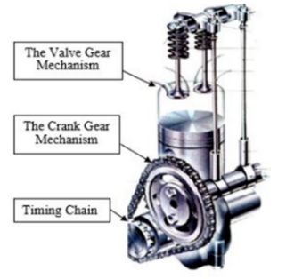
Figure 1: Crank and Valve Gear Mechanisms of a Reciprocating IC Engine
Four modules were implemented: (i) vehicle resistance modeling; (ii) engine performance simulation from 1000 to 4600 rpm; (iii) piston kinematics via crank angle; and (iv) dual-cycle thermodynamic analysis.
The SUV model is based on the DD640C with an R425DOHC CI engine (2.499 L, 105 kW at 4000 rpm, CR=17.5). Transmission is 5-speed constant mesh. Tables 1–3 summarize engine, drive-train, and geometry specifications. Assumptions include: FWD layout, headwind neglected, gear ratio ~1, and tire radius derived from suspension height.
Table 1: Main Technical Parameter Specification of engine
Engine Type | Direct-injection, Water cooled, four-stroke
Configuration | 4 cylinders, bore*stroke = 92*94 mm
Displacement | 2.499 L
Compression ratio | 17.5
Rated Power | 105kW@4000 rpm
Lowest fuel consumption under full load | 210 g/Kw.hr
Maximum Torque | 340 Nm@2000 rpm
Inlet valve open | 15.6º (before top dead center)
Inlet valve closed | 64.4º (after bottom dead center)
Exhaust valve open | 66º (before bottom dead center)
Exhaust valve closed | 32º (after top dead center)
Fuel-Injection | High-pressure common-rail system
Lubricating | Pressure and splash combined; 5.5-6.5 L oil capacity
Dimensions | 710*630*765 mm (without fan)
Dry weight | 278 kg
Table 2: Transmission characteristics
Items | Specification
Transmission models | JC538T3, JC538T8, JC538T9 constant mesh, 5-speed
Number of gears | Gear ratio
1st gear | 4.016
2nd gear | 2.318
3rd gear | 1.401
4th gear | 1.000
5th gear | 0.778
Reverse gear | 3.549
Final drive | 6.776
Weight of transmission | 50 kg (no oil)

Table3: Vehicle geometry
Description | Size
Length | 4620 mm
Width | 1860 mm
Height | 1830 mm
Wheelbase | 2730 mm
Max. speed | 130 km/h.
Approaching angle/Departure angle | 26/28
Seating capacity | 5 people
Vehicle speed (V), wheel velocity (Vw), and angular speed (ωw) are related via wheel radius. Resistance forces—air, rolling, and gradient—were modeled using standard formulations. Power demand at maximum speed (130 km/h) was calculated using combined resistance forces.
$r_{w}=\frac{2(h_{T}+14 )}{2}$ (1)
$V=V_{w}=ω_{w} x r_{w}$ (2)
$V_{max}=\frac{2π}{60} x r_{w} x\frac{3.6N_{@Pbmax}}{{GR}_{t}}$ (3)
$ω_{w}=\frac{ω}{ {GR}_{i}x{GR}_{fd}}$, Where; $ω=\frac{2π x N}{60}$ (4)
R$=R_{a}+R_{r}+R_{g}$ (5)
$P_{rq}=R_{max} x V_{max}$ (6)
Empirical relations determined power, torque, pressures, efficiencies, and fuel consumption. These include brake power, torque, bmep, imep, mechanical efficiency, and bsfc models as functions of engine speed.
$P_{b}=P_{b-max}x \frac{N}{N_{@Pb-max}}x\left[0.87+\left(1.13 x{\frac{N}{N_{@Pb-max}}}\right)-{\left(\frac{N}{N_{@Pb-max}}\right)}^{2}\right]$$P_{b}=P_{b-max}x \frac{N}{N_{@Pb-max}}x\left[0.87+\left(1.13 x{\frac{N}{N_{@Pb-max}}}\right)-{\left(\frac{N}{N_{@Pb-max}}\right)}^{2}\right]$ (7)
$T_{b}=\frac{60xP_{b}}{2πxN}x1000$ (8)
$bmep=\frac{4πxT_{b}}{E_{c}x{10}^{5}}$ (9)
$imep=bmep+fmep$ (10)
$η_{m}=\frac{bmep}{imep}x100$ (11)
$bsfc={bsfc}_{@Pb-max} x\left[1.55-\left(1.55 x{\frac{N}{N_{@Pb-max}}}\right)+{\left(\frac{N}{N_{@Pb-max}}\right)}^{2}\right]$ (12)
$η_{v}=\frac{m_{a}}{( ρ_{i} x v_{s} x ncps) }$ (13)
Engine dimensions (bore, stroke, crank radius, con-rod length) were derived from swept volume and compression ratios. Piston motion, velocity, and acceleration were computed with respect to crank angle using established kinematic formulas (Fig. 2).
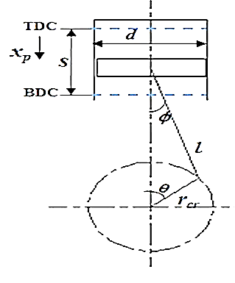
Figure 2: Engine piston motion [18]
$V_{s}=\frac{E_{c}}{z}$ (14)
$d= {\left(\frac{4 x V_{s}}{π x {ratio}_{SD}}\right)}^{1/3}$ (15)
$S={ratio}_{SD} x d$ (16)
$r_{cr}=\frac{S}{2}$ (17)
$l_{con}=\frac{r_{cr}}{λ}$ (18)
$x_{p}=r_{cr}\left((1-cosθ)+\frac{λ \sin^{2}θ}{2}\right)$ (19)
$v_{p}=ωr_{cr}\left(sinθ+\frac{λ sin2θ}{2}\right)$ (20)
$V_{pm-max}=\frac{2 xS x{ N}_{max} }{60}≈\frac{{ V}_{pmax} }{1.6}$ (21)
$α_{p}=ω^{2}r_{cr}\left(cosθ+λ cos2θ\right)$ (22)
Forces including gas pressure, inertia, piston side thrust, and con-rod loading were modeled. Radial and tangential forces were used to compute crankshaft torque.
$F_{g-max}=P_{g-max} x A_{p}$ (23)
$F_{i}=m_{r} x a_{p}$ (24)
$F_{p}=F_{g}±F_{i}$ (25)
$F_{s}=F_{p} x\tan{ϕ}$ (26)
$F_{con}=\frac{F_{p} }{\cos{ϕ}}$ (27)
$F_{r}=\frac{F_{p} x cos⁡(θ+ϕ)}{\cos{ϕ}}=F_{con} x cos⁡(θ+ϕ)$ (28)
$F_{t}=\frac{F_{p} x sin⁡(θ+ϕ)}{\cos{ϕ}}=F_{con} x sin⁡(θ+ϕ)$ (29)
$T=F_{t} x r_{cr}$ (30)
Indicated mean effective pressure (IMEP) was derived using the dual-cycle equation considering pressure and cutoff ratios. Results were compared against analytical prediction.
$imep=\frac{p1[r^{γ}r_{p}γ\left(r_{c}-1\right)+r^{γ}\left(r_{p}-1\right)-r^{1-γ}\left(r_{p}{r^{2}}_{c}-1\right)]}{(γ-1)(r-1)}$ (31)
Valve dynamics were analyzed using simple harmonic motion (SHM). Lift, velocity, acceleration, and jerk were modeled as a function of cam angle, with follower lift based on geometric ratios.
$y=\frac{h_{f} }{2}\left(1-\cos{\frac{πθ }{β}}\right)$ (32)
$y'=\frac{h_{f}π }{2β}\left(\sin{\frac{πθ }{β}}\right)$
$y''=\frac{h_{f}π^{2} }{2β^{2}}\left(\cos{\frac{πθ }{β}}\right)$
$y'''=\frac{h_{f}π^{3} }{2β^{3}}\left(\sin{\frac{πθ }{β}}\right)$
$h_{f}=h x\frac{l_{f} }{l_{v}+l_{f}}$ (33)
- Results and Discussion
The simulation modeled power requirements for a front-wheel-drive (FWD) vehicle operating on a level road. Required power increased linearly with vehicle speed, peaking at 79.75 kW at 130 km/h (Fig. 3).
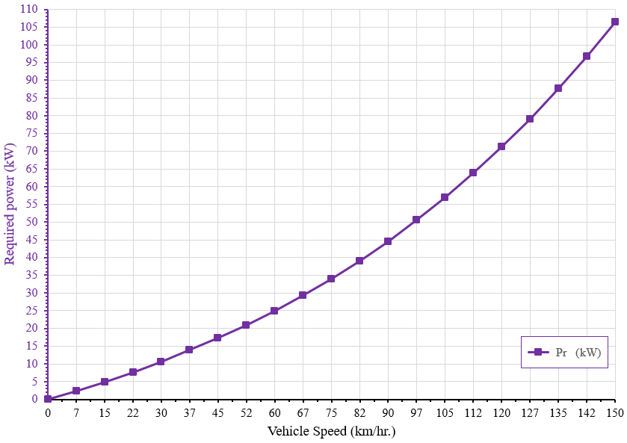
Figure 3: Required Power ($P_{rq}$) versus Vehicle Speed on a Level Road.
Engine simulations produced performance curves for brake power, torque, BMEP, BSFC, and mechanical efficiency (Fig. 4A–E). Brake power increased to a maximum of 106 kW at 4600 rpm before declining. Torque peaked at 297.6 Nm between 2080–2440 rpm, corresponding with a BMEP maximum of 14.96 bar. BSFC reached its minimum (0.2 kg/kWh) at 2800–3160 rpm, indicating optimal efficiency. Mechanical efficiency decreased from 92.15% at low rpm to 78% at high speed.

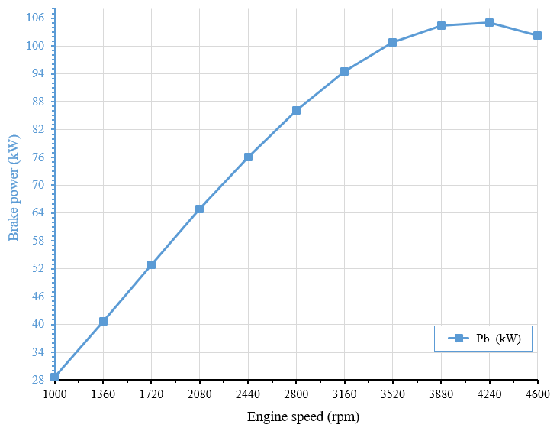a)
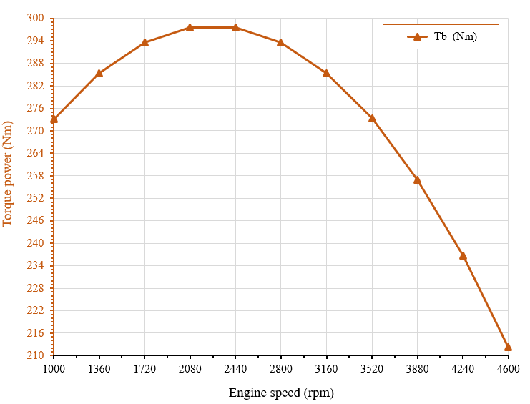
b)
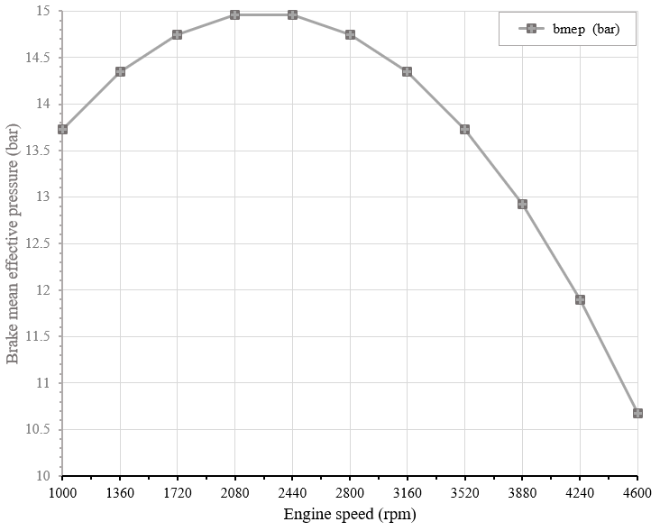 c)
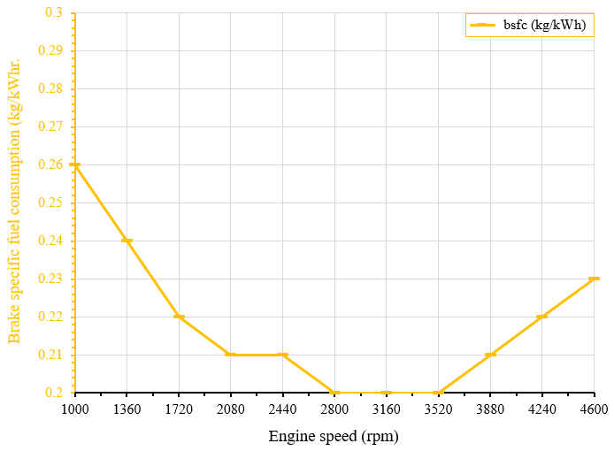
d)
e)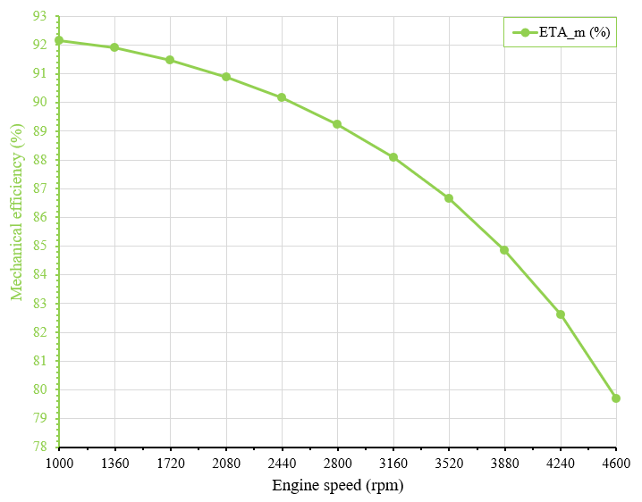
Figure 4: Engine Performance versus Speed at Full Load: A) Brake Power, B) Torque, C) BMEP, D) BSFC, and E) Mechanical Efficiency
Simulated geometry values showed strong agreement with manufacturer specifications. For example, bore (94.23 mm), stroke (96.27 mm), and crank radius (48.14 mm) closely matched theoretical and measured data (Table 4).
Table 4: Engine Size Comparison-Simulation, Theoretical, and Measured Values
Parameter | Simulation | Theoretical | Measured
Engine Capacity (cc) | 2498.799 | 2499 | -
Swept Volume (cc) | 624.7 | 624.75 | -
Bore Diameter (mm) | 94.23 | 91.955 | 94
Stroke (mm) | 96.27 | 93..9 | 96
Crank Radius (mm) | 48.14 | 47 | 48
Connecting Rod L. (mm) | 192.55 | 188 | 192

Piston motion analysis indicated displacement of 0.91 mm, velocity of 4.36 m/s, and peak acceleration of 10,300 m/s². Velocity peaked around 80° crank angle, while acceleration reversed near 60°, consistent with theoretical motion profiles (Fig. 5).
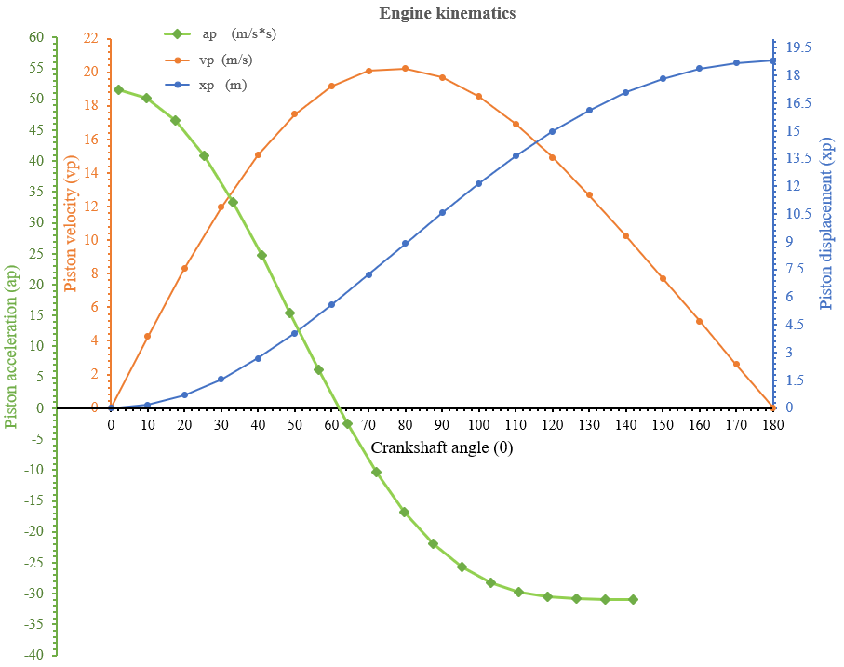
Figure 5: Piston displacement, velocity, acceleration vs crank angle
Using dual-cycle thermodynamic modeling, the simulation yielded a pressure ratio of 1.4 and cutoff ratio of 2.4. The computed IMEP was 14.01 bar, and peak cylinder gas pressure reached 107.8 bar between 360°–370° crank angle (Fig. 6). These results align with expected CI engine performance behavior.
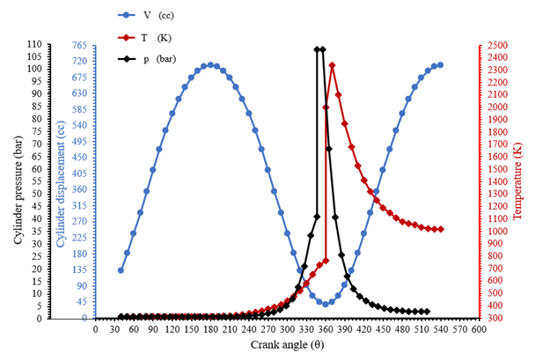
Figure 6: Cylinder Displacement, Pressure, and Temperature versus Crank Angle.
- Conclusion
The C++ simulation model effectively captured the dynamic behavior of crank and valve mechanisms in a dual-cycle CI engine. Key findings include:
- a direct correlation between vehicle speed and power demand;
- peak brake power of 105 kW at 4240 rpm;
- validated piston dynamics and pressure profiles; and accurate reproduction of engine geometry and thermodynamic behavior. The model offers a reliable tool for design evaluation and performance prediction in resource-limited settings.
Acknowledgment
The authors gratefully acknowledge the support provide by Adama Science and Technology University and the Ethiopian Bishoftu Automotive Industry for facilitating this research. Special appreciation to Assistant Professor Melesse Haile for his valuable guidance and technical insight throughout the course of the study.
Funding Statement
This research has been financially supported by the Ministry of Education of the Federal Democratic Republic of Ethiopia, under the Research and Development Grant Program
Conflict of Interest Statement
The authors declare that there is no conflict of interest regarding the publication of this paper. The research was not influenced by any commercial relationships that could be constructed as a potential conflict of interest.
Data Availability Statement
The data that support the findings of this study are available from the corresponding author upon reasonable request. All simulation codes developed in C++ and associated output data used for performance analysis are stored securely and can be shared for academic or non-commercial research purposes.
Ethics Statement
This study did not involve human participants, human data or tissue, or animals. Therefore, ethical approval was not required.
REFERENCE
1. Salam, S., Choudhary, T., Pugazhendhi, A., Verma, T.N., & Sharma. A review on recent progress in computational and emprical studies of compression ignition internal combustion engine. Fuel, 2020; 279,118469.
2. Tarchiani, M., Romani, L., Raspanti, S., Bosi, L., Ferrara, G., Trassi, P., & Fiaschi. Dynamic Analysis of Intake and Exhaust Valve Motion in a High-Performance four Stroke Engine. Part 2-Development of a Numerical Model for the Simulation of the Valvetrain. 2025; (No. 2024-32-0084). SAE Technical Paper.
3. Li, Y., Chen, X., Han, X., Xu, N., Zhai, Z., Lu, K., ... AND Wang, G. Application of Computer Simulation Technology in the Development of Tractor Transmission Systems. Agriculture, 2024; 14(9), 1547.
4. Nigus, H. Kinematics and load formulation of engine crank mechanism. Mechanics, Materials Science and Engineering Journal, 2015.
5. Nazha, H. M., Adrah, M., Osman, T., Shash, M., and Juhre, D. Modeling and Simulation of Material Type Effects on the Mechanical Behavior of Crankshafts in Internal Combustion Engines. Modelling, 2024; 5(4), 1550-1567.
6. Olivetti, M., Monterosso, F. G., Marinaro, G., Frosina, E., and Mazzei, P. Valve geometry and flow optimization through an automated DOE approach. Fluids, 2020; 5(1), 17.
7. Vlase, S., Marin, M., Elkhalfi, A., and Ailawalia, P. Mathematical model for dynamic analysis of internal combustion engines. Journal of Computational Applied Mechanics, 2023; 54(4), 607-622.
8. Khanyi, N., Inambao, F. L., & Stopforth, R. A Comprehensive Review of the GT-POWER for Modelling Diesel Engines. Energies, 2025; 18(8), 1880.
9. Orynycz, O., Tucki, K., Wasiak, A., and Mruk, R. Computer modelling of automobile engine performance as the source of implications for automobile technology management. In IOP Conference Series: Materials Science and Engineering, 2019 December; (Vol. 710, No. 1, p. 012007). IOP Publishing.
10. Chan, K., Ordys, A., Volkov, K., and Duran, O. Comparison of engine simulation software for development of control system. Modelling and Simulation in Engineering, 2013; 2013(1), 401643.
11. Dahham, R. Y., Wei, H., & Pan, J. Improving thermal efficiency of internal combustion engines: recent progress and remaining challenges. Energies, 2022; 15(17), 6222.
12. Gautam, P. S., Vishnoi, P. K., and Gupta, V. K. A single zone thermodynamic simulation model for predicting the combustion and performance characteristics of a CI engine and its validation using statistical analysis. Fuel, 2022; 315, 123285.
13. Akinfaloye OA and Onwuamaeze IP, Evaluating Parameters Affecting the Performance of the Spark Ignition Engine. Saudi J Eng Technol, 2022; 16(8): 232-241.
14. R. Mahdisoozani, H., Mohsenizadeh, M., Bahiraei, M., Kasaeian, A., Daneshvar, A., Goodarzi, M., and Safaei, M. R. Performance enhancement of internal combustion engines through vibration control: state of the art and challenges. Applied Sciences, 2019; 9(3), 40615.
15. Nagaya, K., H. Kobayashi, and K. Koike, Valve timing and valve lift control mechanism for engines. Mechatronics, 2006; 16: p. 121-129.
16. Lu, X., D. Han, and Z. Huang, Fuel design and management for the control of advanced compression-ignition combustion modes. Progress in Energy and Combustion Science, 2011; 37(6): p. 741-783.
17. Omanovic, A., Zsiga, N., Soltic, P., and Onder, C. Increased internal combustion engine efficiency with optimized valve timings in extended stroke operation. Energies, 2021; 14(10), 2750.
18. Agnew, Brian. "12. The design of engine characteristics for vehicle use." An Introduction to Modern Vehicle Design (2001): 371.

