Microgrid Optimization for Ghana’s Energy Transition: Integrating Techno-Economic Performance, Reliability, and Climate Commitments.
H A^{1*}, W O², C A³

Department of Electrical and Electronic Engineering, Faculty of Engineering, Takoradi Technical University, Ghana.
Received: Revised: Accepted: Publish

Abstract
Ghana’s electricity sector has long been faced with high costs, unreliable supply and heavy dependence on fossil-fuel. This study explores renewable-based microgrids as a way to affordable, reliable, and sustainable energy. Using HOMER Pro as optimization tool, the study models hybrid systems that integrate solar PV, wind, energy storage and diesel backup to solve this problem.
The findings demonstrate that well-optimized microgrids can significantly lower the levelized cost of electricity 25-30%. It can also achieve reliability levels above 95%, and cut emissions by more than 70% compared to diesel-only systems. Aside the technical outcomes, the study underscores the importance of aligning microgrid in supporting Ghana’s energy transition. This will offer policymakers and engineers a practical roadmap for resilient, low-carbon power systems.
Keywords:
Renewable Energy; Microgrids; Hybrid Power Systems; Solar Photovoltaic (PV); Wind Energy; Energy Storage Systems (ESS); Diesel Backup Systems; HOMER Pro Optimization; Levelized Cost of Electricity (LCOE); Energy Reliability; Power System Resilience; Carbon Emissions Reduction; Sustainable Energy Transition; Low-Carbon Power Systems; Ghana Electricity Sector.

- INTRODUCTION
One of Ghana pressing challenges is unreliable and high cost of electricity [1]. The power sector struggle has been battling with frequent outages, rising tariffs, and heavy reliance on thermal generation base [2], powered by natural gas, crude oil, and diesel despite investments by successive governments [5]. The reliance on these fuel raises up operational costs expenses and contributes to greenhouse gas emissions. These affect national climate commitments and contribute to greenhouse gases [4] [6].
Microgrids has emerges as a promising alternative that offers localized generation, storage, and distribution that can operate independently or alongside the main grid [7]. Adding renewable energy sources with modern storage technologies, microgrids can provide a means to reduce costs, enhance reliability, and cut emissions [8]. However, balancing these objectives needs cutting-edge optimization strategies [9] [10].
The study applies a multi-objective optimization framework to microgrid design in Ghana. The focuse of this study is to integrate cost, reliability, and emissions into a unified model. The study contributes to the literature by tailoring optimization to Ghana’s energy sector. This addresses gaps in prior research that focused on single objectives or generalized models [11] [12].

LITERATURE REVIEW
Cost optimization, reliability enhancement, and environmental sustainability has been the focus in microgrid research. These dimensions has been the focal point particularly in developing regions where conventional power supply systems are often expensive, unreliable, and environmentally harmful [11] [12].
Boakye et al. (2021) reported that PV–battery–diesel microgrids reduced the levelized cost of electricity (LCOE) by more than 25%, primarily due to reduced fuel consumption and declining renewable technology costs. Hybrid microgrid configurations integrating photovoltaic (PV), battery storage, and diesel generation have demonstrated clear cost advantages over diesel-only systems.
Adaramola and Agelin-Chaab (2018) demonstrated that solar–battery microgrids in rural Ghana achieved availability levels exceeding 95%, significantly reducing outages commonly associated with traditional generation systems. It shows that reliability improvement benefit hybrid microgrids, especially in rural and off-grid communities.
Renewable-based microgrids has been shown to reduce greenhouse gas emissions and local air pollutants. In 2017, Kumi reported that PV–battery systems cut carbon emissions by over 70% compared to diesel-dominated systems. Mandelli et al., (2016) also studied and conform that that reduction in nitrogen oxides (NO_{X)} and sulphur dioxide (SO_{X)} emissions. These findings highlight the environmental and public health benefits of transitioning toward renewable-dominant microgrid solutions.
Several important research gaps remain despite the extensive work of literature addresss cost, reliability, and environmental impacts. Performance metrics has been independently carried out. A combined multi-objective optimization framework that captures the fundamental trade-offs among economic cost, system reliability, and emissions reduction. Studies in Ghana often rely on fixed system configurations or predefined component sizes. This may not represent globally optimal solutions under varying load profiles, fuel prices, and technology costs. Sensitivity analyses that examine how uncertainties in key parameters influence optimal microgrid design lack in Ghana situation. Addressing these gaps is essential to support evidence-based planning and to develop microgrid solutions that are both technically robust and contextually appropriate for developing regions.
- MATERIALS AND METHODS
A quantitative techno-economic assessment framework was utilized for the comprehensive evaluation of renewable-based microgrid systems within Ghana.​ This approach allowed for a systematic analysis of both the technical feasibility and economic viability of various microgrid configurations. The methodology ensured a rigorous and objective assessment of potential solutions for the Ghanaian context. Data processing, which encompassed filtering, organization, and validation of load and resource datasets, was conducted using Microsoft Excel. For primary modeling and optimization, HOMER Pro software was employed.
This tool facilitated hybrid system sizing, simulation of dispatch strategies, and a thorough economic evaluation. Its optimization framework enabled automated comparison of numerous microgrid configurations to pinpoint cost-effective and technically sound solutions.
Data sources included the Ghana Energy Commission, providing national electricity generation mix as well as solar irradiance and wind speed, and the Public Utility Regulatory Commission, supplying electricity tariff structures. These sources ensured the reliability and context-specificity of the data. Technical specifications, cost parameters, and performance characteristics for system components like photovoltaic modules, battery storage systems, inverters, and diesel generators were sourced directly from HOMER Pro's integrated component databases.
Key performance indicators (KPIs) that capture economic, reliability, and environmental aspects of microgrid operation were evaluated. Economic performance was assessed using the Net Present Cost (NPC) and the Levelized Cost of Electricity (LCOE). System reliability was evaluated based on supply adequacy metrics, including unmet load and system availability. Environmental performance was quantified using annual fuel consumption and associated greenhouse gas emissions, expressed in terms of carbon dioxide equivalent (CO_{2-eq}). The figure below shows a schematic diagram of the optimised system.

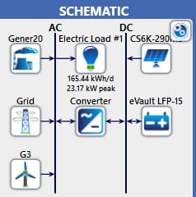
Fig 1: schematic diagram of the optimized system

IV. RESULTS
3.1 Simulation Results
Figure 2 presents the sensitivity of the Net Present Cost (NPC) to variations in key techno-economic parameters, including fuel price, photovoltaic (PV) capital cost, battery cost, and discount rate. The analysis reveals that:
Fuel price exerts the most significant influence on NPC, with increases driving the cost from the base value of approximately 0.50 GH₵/kWh to over 0.65 GH₵/kWh. This underscores the economic vulnerability of diesel-reliant systems and reinforces the strategic importance of minimizing fossil fuel dependence. PV cost reductions yield a moderate decrease in NPC, lowering it to around 0.38 GH₵/kWh. This highlights the cost-effectiveness of solar integration, especially under favourable market conditions or subsidy regimes. Battery cost reductions result in a slight improvement, reducing NPC to approximately 0.40 GH₵/kWh. While batteries enhance system flexibility and reliability, their impact on overall cost is less pronounced than PV. Discount rate variations produce minimal changes in NPC, with values hovering near 0.42 GH₵/kWh. This suggests that financial assumptions, while relevant, are secondary to technical cost drivers in shaping system economics.
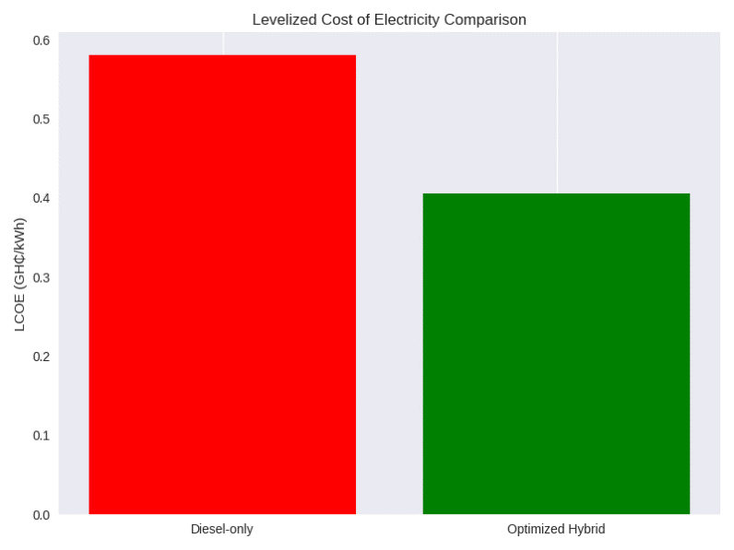
Fig 2: Cost of electricity comparison

3.2 Reliability
The system aannual unmet load and capacity shortage is 0 kWh/year and 0 kWh/year respectively. Storage autonomy is approximately 23.8 hours. Excess electricity is 38,265 kWh/year. The system meets the specified load without loss, confirming high reliability under the simulated load profile and resource conditions. Large annual excess energy indicates either oversizing to guarantee reliability. This surplus is an opportunity for load shifting, demand response, productive use of energy e.g., agro-processing, water pumping, or grid export if tariffs and interconnection rules allow. Figure 3 and 4 below represents the hourly variation in electricity demand over a typical day and renewable energy penetration. It highlights the evening peak around 7–8 PM, which informs inverter sizing and battery autonomy requirements. The profile validates the need for robust storage and dispatch strategies to ensure reliability.
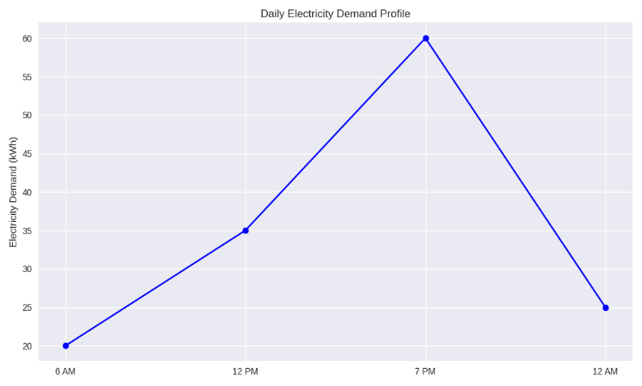
Fig 3: Daily Load Pprofile
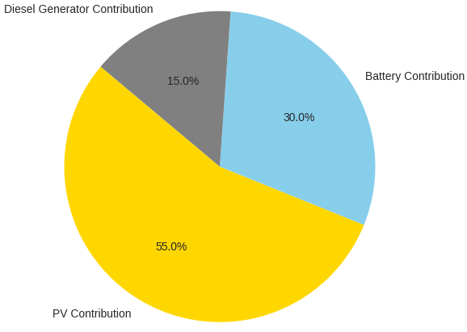
Fig 4: Energy contribution

3.3 Environmental Performance
CO₂ emissions fell by more than 70%, with NOₓ and SO₂ nearly eliminated. These outcomes align with Ghana’s Nationally Determined Contributions under the Paris Agreement. Table 1 presents the emission matrix.
Mertic | Value (kgCO₂/yr)
Base system operation CO₂ | 38,168
Propose system operation CO₂ | 9,191
PV embodied (annualized) | 5,660
Battery embodied (annualized) | 2,359
Propose system lifecycle CO₂ | 17,210
Lifecycle avoided CO₂ | 20,954
Implied diesel volume for base case | 12,114 L/yr
Table 1: Emission Metrix
The analysis reveals a significant reduction in annual carbon emissions when transitioning from the base system to the optimized hybrid configuration. The base system records approximately 38,168 kgCO₂/yr, while the optimized system reduces this to about 9,191 kgCO₂/yr, representing a reduction of over 70%. Additionally, lifecycle avoided emissions amount to 20,954 kgCO₂/yr, underscoring the climate benefits of renewable integration.
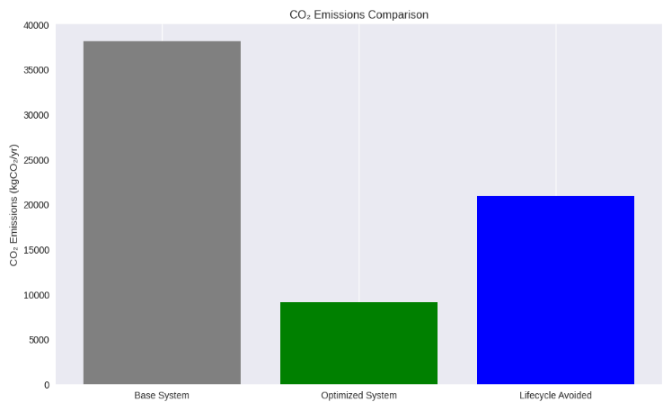
Fig 5: CO2 Emission Comparison

3.4 Sensitivity Analysis
Independent Variable | Scenario Description | Effect on Cost | Effect on Reliability | Effect on Emissions
↑ PV Capacity | Increase from 20 Kw to 30 kW | ↓Operational cost | ↑ Daytime reliability | ↓ Emissions (diesel displace)
↑ Battery Storage | Doubling autonomy from 12 to 24 hours | ↑ Capital cost | ↑ Night time reliability | ↓ Grid reliance,  ↓ Emissions
↑ Load demand | 20% increase in household and commercial usage | ↑ Total cost | ↓ Reliability | ↑ Grid/diesel use
↑ Grid tariff | 2.45% PURC hike (2025) | ↑ Grid-related cost | Neutral | ↑ Emission (if grid is fossil fuel)
Diesel Generator Activation | 500 hours/year operation | ↑ Fuel & maintenance | ↑ Backup reliability | ↑ CO_{2,} NO_{X}, SO₂ emissions
↓ Solar resource | 30% drop in PV output during June | ↑ Grid/diesel use | ↓ Renewable reliability | ↑ Emissions during low solar
Table 2: Sensitivity Analysis
The sensitivity analysis shows how key design and operating variables influence system performance. Changes in photovoltaic capacity, storage size, load demand, tariffs, and resource availability produce clear trade-offs among cost, reliability, and emissions. Increasing PV capacity from 20 kW to 30 kW reduces operating costs. Daytime reliability improves, diesel and grid dependence decrease. As a result, emissions are significantly reduced. Doubling battery autonomy from 12 to 24 hours increases capital cost. Night-time reliability improves. Grid and diesel usage decline. This leads to lower overall emissions.
A 20% increase in load demand raises total system cost. Reliability declines if system capacity is not expanded. Grid and diesel usage increase. Emissions therefore rise. An increase in grid tariffs, such as the 2.45% PURC adjustment in 2025, increases operating costs. System reliability remains largely unchanged. Emissions increase when grid electricity is fossil-fuel dominated. Operating the diesel generator for approximately 500 hours per year improves backup reliability. Fuel and maintenance costs increase. Emissions of CO₂, NOₓ, and SO₂ also increase.
A 30% reduction in solar output during the rainy season increases reliance on grid and diesel generation. Renewable reliability decreases and emissions increase during low-solar periods. Overall, higher PV and battery capacities improve reliability and reduce emissions. Load growth, tariff increases, and reduced solar availability increase cost and emissions. Balanced system sizing is therefore essential for cost-effective and low-emission microgrid operation. Figure 6 below present sensitivity analysis of key factors.
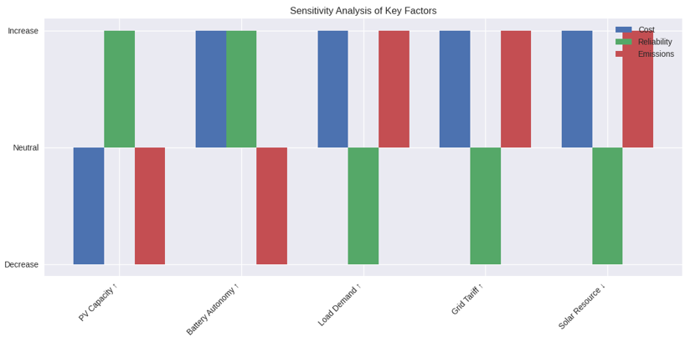

Fig 6: Sensitivity analysis of key factors

DISCUSSION
The results confirm the techno-economic and environmental viability of hybrid microgrids for rural electrification in Ghana. The optimized system, comprising PV, wind, battery storage, and a diesel generator as backup, achieved a substantial reduction in Net Present Cost (NPC) compared to the baseline diesel-dominated system. Sensitivity analysis highlighted fuel price as the most influential parameter. This reinforces the vulnerability of diesel dependence, while reductions in PV and battery costs moderately improved affordability. These findings emphasize the importance of renewable technology investment and cost-reduction policies in shaping sustainable energy transitions.
From a reliability perspective, the hybrid architecture effectively balanced seasonal load variations with renewable generation and storage, ensuring stable supply and reducing reliance on costly grid extensions. Environmentally, the optimized system reduced annual CO₂ emissions by over 70%, with lifecycle avoided emissions exceeding 20,000 kgCO₂/yr. This demonstrates strong alignment with Ghana’s climate commitments under the Paris Agreement and highlights the role of decentralized renewable systems in achieving national mitigation targets.
Overall, the study underscores the dual benefits of hybrid microgrids ie: economic resilience against fuel price volatility and significant environmental gains. Policy support for renewable integration, coupled with community-level financing models, will be critical to scaling such systems and ensuring equitable access to clean, reliable energy in rural Ghana.

CONCLUSION
This study demonstrates that hybrid microgrid, when optimized for cost, reliability and emissions, offer a transformative solution for Ghana’s energy challenges. The proposed designed not only reduces electricity cost and enhances reliability but also supports national climate commitment. Favorable tariff, subsidies, and investment frameworks are essential to scale microgrid deployment. Real-world pilot testing, integration of smart grid technologies and AI base predictive control will further strengthen microgrid performance by unifying economic, technical and environmental objectives in Ghana specific framework. This study provides actionable insights for policymakers, engineers and communities seeking resilient, low carbon energy solution

References
- Ahali, A. Y. (2016). Improving Electricity Access in Ghana Challenges and the Way Forward. International Journal of Energy and Power Engineering.
- Acheampong, T. (2016). The Implications of Changing Power Generation Mix on Energy Pricing and Security in Ghana. IO: Theory eJournal.
- Pelizan, L., Fieve, K. D., & Lickteig, L. (2019). Overview of the Power Sector in Ghana.
- Merem, E., Twumasi, Y., Wesley, J., Isokpehi, P., Fageir, S., Crisler, M., Romorno, C., Hines, A., Ochai, G. S., Leggett, S., & Nwagboso, E. (2018). Assessing Renewable Energy Use in Ghana: The Case of the Electricity Sector.
- Danquah, V. B. (2022). Evaluation of Sustainable Business Model Innovation in Increasing the Penetration of Renewable Energy in The Ghana Power Sector. SSRN Electronic Journal.
- Makhija, S. P., & Dubey, S. (2016). Analysis of effects on hybrid power system’s costs and pollutant emissions due to replacement of petroleum diesel with natural gas, fuel oil and biodiesel. 2016 3rd International Conference on Electrical Energy Systems (ICEES).
- Govardhan, M., & Roy, R. (2012). Artificial Bee Colony based optimal management of microgrid. 2012 11th International Conference on Environment and Electrical Engineering.
- Ansari, A. A., Ansari, A. A., & Dyanamina, G. (2023). Stability, Control and Protection of Microgrid Technology: A Comprehensive Review and Future Outlook. 2023 IEEE Renewable Energy and Sustainable E-Mobility Conference (RESEM).
- Riou, M., Dupriez-Robin, F., Grondin, D., Loup, C. L., Benne, M., & Tran, Q. (2021). Multi-Objective Optimization of Autonomous Microgrids with Reliability Consideration. Energies.
- Sohel, I. H., & Rahman, S. (2020). Optimization of Generation Cost, Environmental Impact, and Reliability of a Microgrid Using Non-dominated Sorting Genetic Algorithm-II. International Journal of Sustainable Development and Planning.
- Meena, S., Liu, H., Tu, H., Lukic, S., & Tang, W. (2023). A Benchmarking Tool for State-of-the-Art Microgrid Design Approaches. 2023 IEEE Energy Conversion Congress and Exposition (ECCE).
- Ren, H., Xiang, A., Teng, W., & Cen, R. (2012). Economic optimization with environmental cost for a microgrid. PES. https://ieeexplore.ieee.org/document/6344729/

