The Convergence of Record Rainfall, Anthropogenic Destabilization, and Overlooked Geomorphological History: A Systematic Review of the 2022 Tupul Landslide
Kosygin Leishangthem
Assistant Professor, Manipur tehnicalUniversity
Email: Kosygin_l@mtu.ac.in
Abstract - The landslide at Tupul, Manipur (June 29-30, 2022) is one of the most catastrophic geo-disasters in Northeast India, causing 54 to 61 casualties and extensive damage to the Jiribam-Imphal railway project. Four main academic contributions from this systematic review were synthesized to identify the various drivers of the slope failure. Recent studies have pointed to the extreme meteorological triggers (June rainfall was 130% greater than the decadal average), in addition to the destabilizing effects of human "yard-cutting" for the Tupul railway station platform[1], [2].
This review adds a key and often ignored factor from recent field observations: a massive historic landslide scarp has been identified by high-resolution satellite imagery and field investigations 350 meters uphill from the project site and is approximately 1100 meters long and 300 meters deep, showing that the slope was inherently unstable and had fractured and weakened soil masses long before construction began, and that the railway engineering removing the "toe" of the slope and saturating these weakened masses during the monsoon resulted in reactivation of a pre-existing geohazard.
This review compares different methodologies, including geospatial remote sensing, finite element analysis, and regional susceptibility mapping, and highlights a critical gap in standard geotechnical survey protocols that did not adequately account for the surrounding geomorphology, arguing for a new paradigm in Himalayan infrastructure planning that mandates 1km-radius geohazard assessments, includes historical academic hazard warnings, and incorporates real-time monitoring systems. In the end, the Tupul event becomes a case study in the outcomes of "slope-unfriendly" development in geologically susceptible mountainous landscapes [1], [3].
Keywords: Rainfall triggered landslides, Terrain, NF Railway. Tupul landslide, Landslide Reactivation, Anthropogenic Destabilization
1. INTRODUCTION
The 111-km Jiribam-Imphal railway project, which is a part of the strategic infrastructure development plan for Northeast India, has an alignment that runs through the geologically unstable Indo-Myanmar Range, where high seismicity and major structures such as the Noney and Dalong faults exist [1], [4]. The extreme tectonic intensity of the region has historically been classified as Seismic Zone V, but the Bureau of Indian Standards has introduced Seismic Zone VI in the 7th revision of IS 1893: 2025[5], which means that the region needs unprecedented engineering precautions.
This geological weakness came to a head on the night of June 29–30, 2022, at the Tupul railway construction site where two separate episodes of failure at 12:30 AM and 6:00 AM buried a Territorial Army camp and labor residences [2]. The landslide killed between 54 and 61 people, destroyed about 435 to 500 meters of the railway line, and dammed the Ijai River, forming a perilous temporary lake that threatened downstream populations with flash flooding [2], [3].
The immediate cause of the disaster was an extreme monsoon event, with June 2022 rainfall 130% higher than the decadal average, but the underlying causes involved a combination of natural and anthropogenic factors [1], [4]. The underlying lithology (mostly weak and weathered shale, mudstone, and sandstone of the Barail Group) offered an inherently unstable base [1], [4]. The disaster was made even more likely by "yard-cutting" of the slope toe of the Tupul railway yard, removing the natural structural support of the hillside [1], [3].
This systematic review summarizes existing research to assess these causative factors and identifies a key "missing link" in the geotechnical analysis of the project. Results show that the 2022 event was a reactivation of a 1100-meter-long dormant historical scarp, 350 meters above the site [1]. Combining geological data, engineering modeling, and remote sensing analysis, this review fills a key gap in traditional site surveys and offers critical safety recommendations for future infrastructure development in high-risk seismic zones.

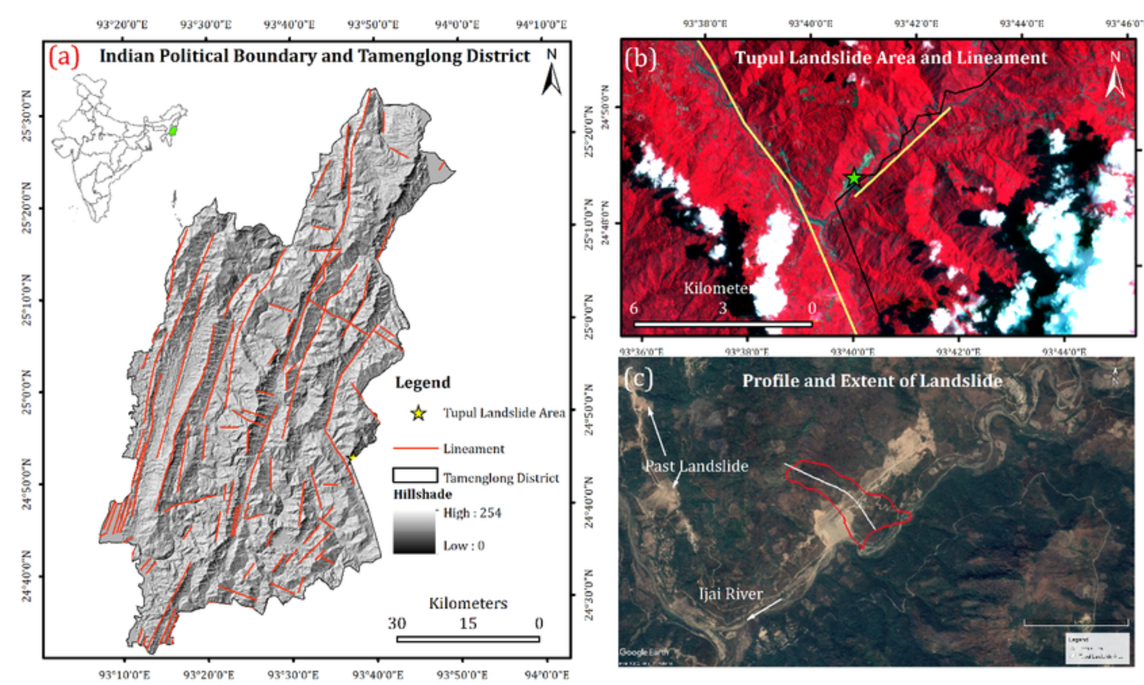
Figure 1: Location Map and Regional Tectonic Setting.
Description: A multi-panel map showing the Tupul railway station within the Noney district of Manipur, including major tectonic features like the Noney and Dalong faults [3].
2. METHODOLOGICAL COMPARATIVE ANALYSIS
The four studies analyzed used different scientific frameworks to study the event, from regional susceptibility mapping to site-specific engineering physics, and used a wide range of tools, from GIS-based statistical modeling to finite element engineering simulations, to provide a multi-scalar understanding of the disaster (et al., 2024; Baruah et al., 2023; Singh et al., 2022, 2023).
Table 1: Comparative Framework of Primary Research Sources
Parameter | Baruah et al. | Singh et al. | Singh et al. | Dolendro et al.
Scientific Approach | Remote Sensing & Geospatial Analysis | Field Geomorphology & Disaster Management | GIS-based Statistical Susceptibility | Finite Element Analysis
Failure Mechanism | Mass Movement & Debris Flow | Rotational Slumping | Regional Susceptibility Pattern | Shear Strength Reduction
Reported Casualties | 61 Deaths, 18 Injuries | 54 Deaths | 54 Deaths | 61 Deaths - Focus on engineering metrics
Primary Trigger | Rainfall (130% above avg) | Rainfall (Preceding 11 days) | Geological & Topographic variables | Yard-cutting & Hydrological stress
Key Contribution | Delineation of Ijai River blockage impact. | Call for "bottom-up" policy coordination. | Classification of 37% of corridor as medium risk. | Identification of 2007 warning signs.

3. SYNTHESIS OF CAUSATIVE FACTORS
The 2022 Tupul landslide was not the result of a singular occurrence but rather a synergistic interaction between extreme meteorological events, inherent geological fragility, and intensive anthropogenic modifications.
3.1 Meteorological Triggers
The 2022 Tupul landslide was not caused by a single event but was the result of a combined effect of extreme meteorological events and geological fragility, coupled with intensive anthropogenic modifications. The primary trigger was an intense monsoon event, as rainfall during June 2022 was nearly 130% above the average annual rainfall recorded over the last 10 years (2012–2021) [2]. High intensity precipitation over an 11-day period of continuous rainfall [3] caused a large amount of moisture to infiltrate into the slope, resulting in an increase in pore-water pressure and a decrease in the shear strength of the soil and rock interface, causing the slope to move into a critical state of failure [1], [3]. The failure occurred in two well-defined, discrete stages: the first at 12:30 AM and the second at 6:00 AM on June 30th [2].
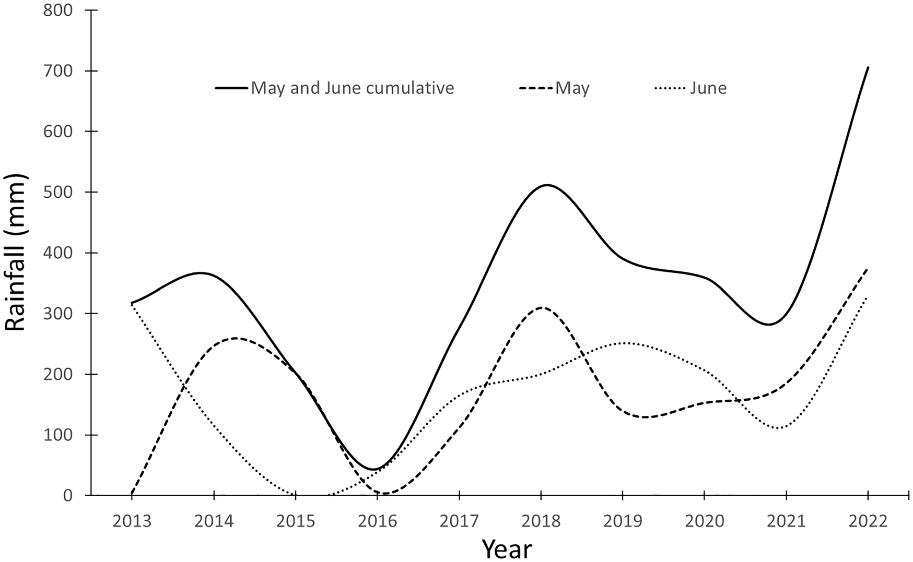
Figure 2: Rainfall Intensity and Cumulative Precipitation Graph.
Description: A graph comparing the June 2022 rainfall (which was 130% higher than the decadal average) against the 2012–2021 baseline [2].
3.2 Geological and Topographical Vulnerability
The lithological composition of the Noney district was a key factor, as it is dominated by the Barail Group of weak, highly weathered, interbedded shale, mudstone, and sandstone [2]–[4], which are naturally prone to rapid weathering and erosion due to prolonged saturation [3]. Topographically, the steep slopes (averaging approximately 42°) and proximity to major tectonic features such as the Noney and Dalong faults, which further compounded the inherent instability [1], [4], have been found to classify 37% of the Imphal-Jiribam railway corridor as being medium to high susceptibility, with the Tupul site falling within the most vulnerable areas [4].
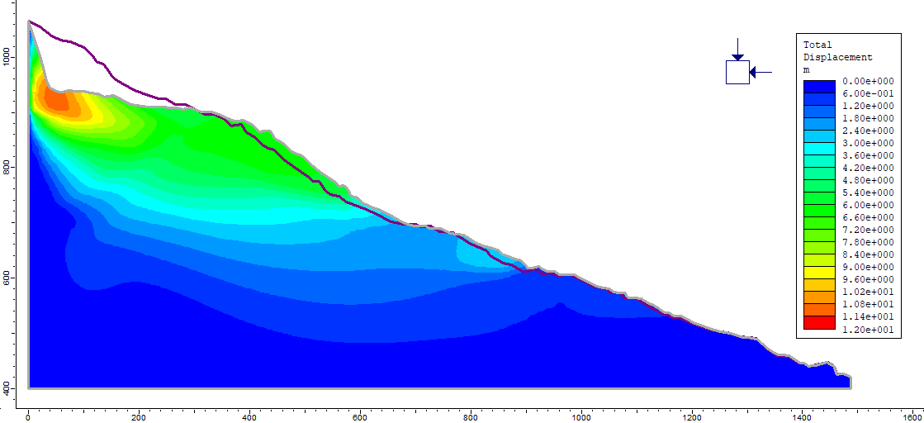
Figure 3: Cross-Section and Finite Element Analysis Modeling.
Description: A diagram showing the slope's factor of safety before and after the "yard-cutting" modifications [1].

3.3 Anthropogenic Drivers and Infrastructure Impact
Human interventions drastically reduced the natural factor of safety of the hillslope, and the most important of these was the "yard-cutting" of the toe of the slope to make it a flat area for the Tupul railway station [1]. This removal of the structural base along with massive deforestation for railway construction removed the natural mechanical reinforcements of the slope [1], [2], confirmed by engineering analysis using Finite Element Methods [1]. The resulting mass movement destroyed 435 to 500 m of the under-construction railway line, buried the railway yard, and blocked the Ijai River, forming a temporary hazard lake that immediately threatened downstream populations with a flood [2], [3].
4. COMPARATIVE ANALYSIS: SIMILARITIES AND DIFFERENCES
The four articles analyzed in this systematic review provide complementary yet distinct perspectives on the 2022 Tupul landslide. The following analysis delineates the convergences and divergences in their methodologies, findings, and contributions.
4.1 Key Similarities
Table 2: Convergent Findings Across Studies
Aspect | Consensus Across Studies | Supporting Sources
Primary Trigger | Three studies identify extreme monsoon rainfall as the immediate catalyst for the landslide | [1], [3], [4]
Geological Context | Three studies acknowledge the role of weak lithology (Barail Group: shale, mudstone, sandstone) and tectonic proximity in predisposing the slope to failure | [1]–[3]
Infrastructure Impact | All four studies reference the destruction of the Jiribam-Imphal railway project and the burial of the Tupul railway station | [1]–[4]
Anthropogenic Role | Three studies recognize that human activities—specifically slope cutting for railway construction—exacerbated the natural vulnerability | [1]–[3]
Mitigation Need | All advocate for improved planning, early warning systems, and better coordination between research and construction agencies | [1]–[4]

4.2 Methodological Divergences
Table 3: Comparative Methodological Approaches
Study | Primary Methodology | Spatial Scope | Technical Tools
[2]  (Baruah et al., 2023) | Remote Sensing & Geospatial Analysis | Site-specific | Sentinel 2B MSI data, NDVI, Principal Component Analysis
[3]  (Singh et al., 2022) | Field Survey & Visual Interpretation | Site-specific | ALOS PALSAR DEM (12.5m), longitudinal profiling
[4]  (Singh et al., 2023) | GIS-based Statistical Modeling | Regional (111km corridor) | Frequency Ratio, Information Value, Weight of Evidence, WLC
[1]  (Dolendro et al., 2024) | Finite Element Analysis | Site-specific | Phase2 software, CARTOSAT DEM, shear strength reduction

The main methodological difference is in the spatial scale: [3], [2], [4] and [1] all focus on the Tupul landslide site, whereas [4] includes a corridor-wide susceptibility assessment covering the entire Imphal-Jiribam railway alignment, which allows [4] to contextualize the Tupul event within a regional risk framework, finding that 34% of the railway corridor is located in high to very high susceptibility zones [4].
4.3 Variations in Key Findings
4.3.1 Rainfall Quantification
Three studies concur on the role of rainfall but disagree on the quantification:
- Baruah et al. indicate June 2022 rainfall was approximately 130% higher than the decadal average (2013–2022) [2],
- Singh et al. report cumulative precipitation data (216.3mm between June 15–29, 2022, with peak intensity on June 23rd), [3] and
- Dolendro et al. describe rainfall thresholds conceptually, referencing early work by Endo, Onodera et al., Campbell, and Caine [1].
- Singh et al. do not provide rainfall data, instead modeling statistical susceptibility[4].
4.3.2 Failure Mechanism Descriptions
- Singh et al. describe the movement as a rotational failure of fast-moving debris, with debris traveling an average distance of 500m on a slope of 25° [3].
- Dolendro et al. include engineering parameters, citing the slope angle as 42° and estimating the volume of debris at around 4.3 lakh cubic meters (430,000 m³) [1].
- Baruah et al. identify the landslide as happening in two distinct episodes: at 12:30 AM and again at 6:00 AM on June 30th [2].
4.3.3 Casualty Reporting
The reported number of fatalities is significantly lower:
- 61 deaths [1][2] and 18 injuries [2],
- 54 deaths [3], [4] do not specify casualty counts, focusing instead on technical and engineering aspects.
4.3.4 Susceptibility Classification
Singh et al. (2023) identified the Tupul railway station area as having medium susceptibility (average value of 0.58), with the broader corridor having 37% in medium susceptibility and 34% in high/very high susceptibility [4]. Dolendro et al. [1] were more critical, noting that the area had been identified as "high to very high hazard" in an unpublished 2007 doctoral thesis.
4.4 Unique Contributions
Baruah et al. emphasize the temporal sequence of the failure (two episodes) and include the most comprehensive remote sensing analysis using Sentinel 2B imagery to delineate the landslide extent [2], as well as the blockage of the Ijai River and the formation of a temporary hazard lake. Singh et al. promote a bottom-up approach to disaster management with increased emphasis on coordination between government agencies, researchers, and construction companies [3], and include detailed topographic profiling using ALOS PALSAR DEM, including the concave slope geometry. Singh et al. include a regional perspective that the Tupul site was not unique but was representative of a corridor-wide susceptibility pattern [4], and their statistical validation (AUC of 0.913 for IoV method) provides quantitative confidence in their susceptibility mapping. Dolendro et al. employ finite element modeling to simulate the slope failure, which represents engineering validation that the predicted failure zones matched the actual landslide incidence [1], and their identification of the 2007 thesis warning represents a critical historical context that is missing from the other studies.
4.5 Synthesis of Complementary Insights
The four studies together present a comprehensive picture of the Tupul disaster: the spatial-temporal framework (remote sensing, failure sequence) [3], the field-based geomorphological characterization (rotational mechanism, slope profiling) [4], the regional risk context (corridor-wide susceptibility, statistical validation) [1], and the engineering physics (finite element analysis, shear strength reduction, historical warnings) [2]. This multidisciplinary convergence confirms that the Tupul landslide was an event that could have been anticipated as the result of the convergence of extreme rainfall, geological fragility, and anthropogenic destabilization—factors that were identified by three of the studies and collectively neglected during the planning phase of the project.

5. DISCUSSION
The 2022 Tupul landslide can be considered a textbook example of the failure of infrastructure planning when geomorphological history is ignored. This section synthesizes the technical findings of the literature reviewed [1]–[4] along with critical field observations that highlight the inherent instability of the site.
5.1 The Role of Historical Instability in Current Disasters
A major insight from this review is that the Tupul event was not an isolated event but was a reactivation of a large historical landslide. A dormant scarp about 1100 m long and 300 m deep, identified by field interpretations and satellite data, was located just 350 m above the project site. These features mark zones of fractured rock and "relict" soil masses that are permanently weakened and therefore prone to failure.
This historical vulnerability is borne out in the literature: Fifteen years prior to the disaster, an unpublished doctoral thesis (Dolendro et al., [1]) had identified this exact region as a high to very high hazard zone. The failure to incorporate these historical indicators into the survey and design phases of the railway project shows a systemic problem in geotechnical investigation protocols.

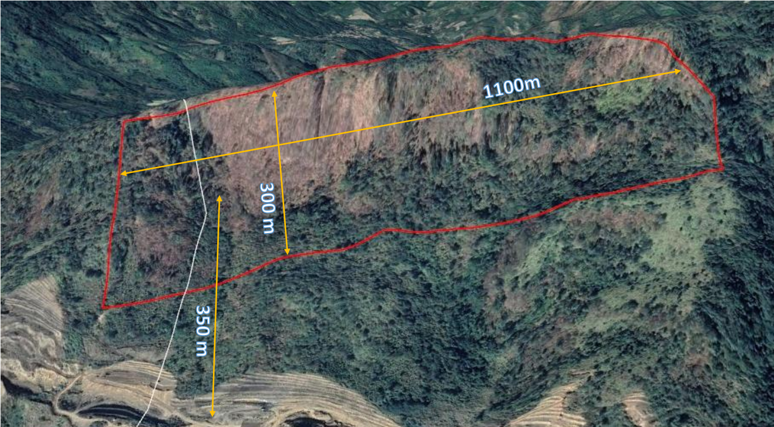
Figure 4: Pre-development Google Earth Satellite Imagery.
Description: A prominent landslide scarp, approximately 1,100 meters in length and 300 meters in depth, is located roughly 350 meters upslope from the project site.
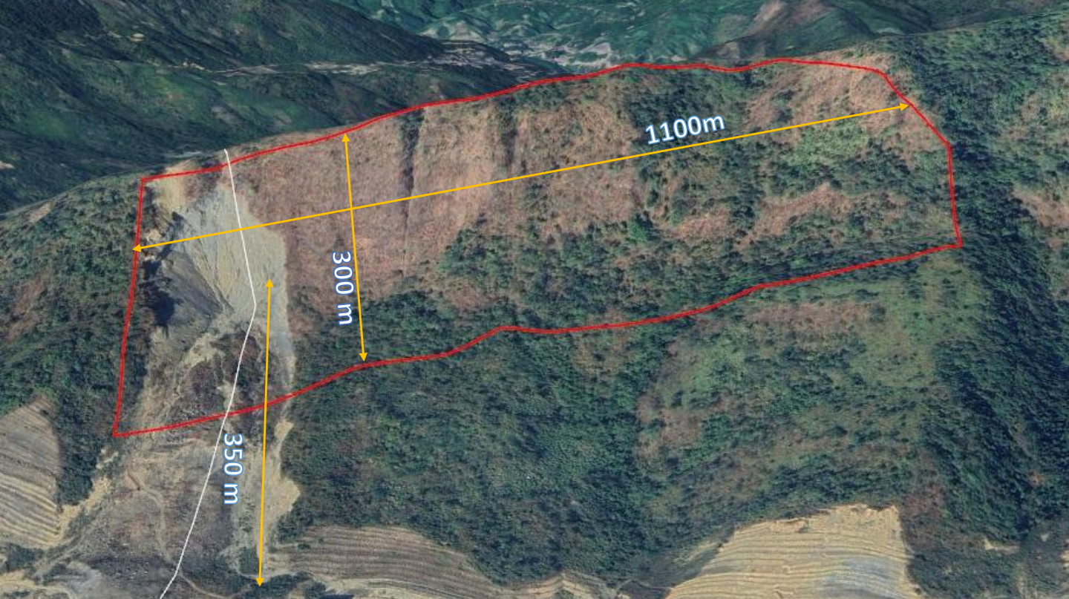
Figure 5: Post-event Google Earth Satellite Imagery.
Description: The landslide scarp remains intact and represents a significant ongoing hazard for future slope failure. Any proposed construction in the vicinity must undergo rigorous geotechnical review and risk assessment due to the proximity of this 1,100-meter-long and 300-meter-deep feature, located 350 meters upslope from the site.
5.2 Anthropogenic Destabilization vs. Meteorological Triggers
While extreme precipitation was the immediate trigger, human intervention significantly compounded the scale of the disaster. In June 2022, rainfall was 130% above the decadal average (2012–2021) [2], and this volume of water over the course of 11 days [3] penetrated the weakened historical landslide mass, raising pore-water pressure and destabilizing it.
At the same time, the "yard-cutting" modifications to create a platform for the Tupul railway station had eliminated the "toe" of the slope, which is the natural structural buttress of the hillside, and the factor of safety of the slope was significantly lowered by finite element analysis [1]. A massive rotational failure [3] transformed into a debris flow that wiped out 435 to 500 m of the railway line and dammed the Ijai River [2].
5.3 Gaps in Infrastructure Planning and Geo-Technical Surveys
This is a serious flaw: many infrastructure projects in mountainous regions restrict stability analysis to the immediate footprint of the project, while for any project in a landslide-prone corridor, analysis should extend to the surrounding geomorphological environment. The 1100-meter scarp uphill from the station was a "ticking time bomb" that was outside the standard site-specific investigation zone. Additionally, while 37% of the Imphal-Jiribam corridor had been mapped as medium to high susceptibility in regional mapping [4], there was a disconnect between academic hazard mapping and engineering execution, a common trend in the literature reviewed [3].
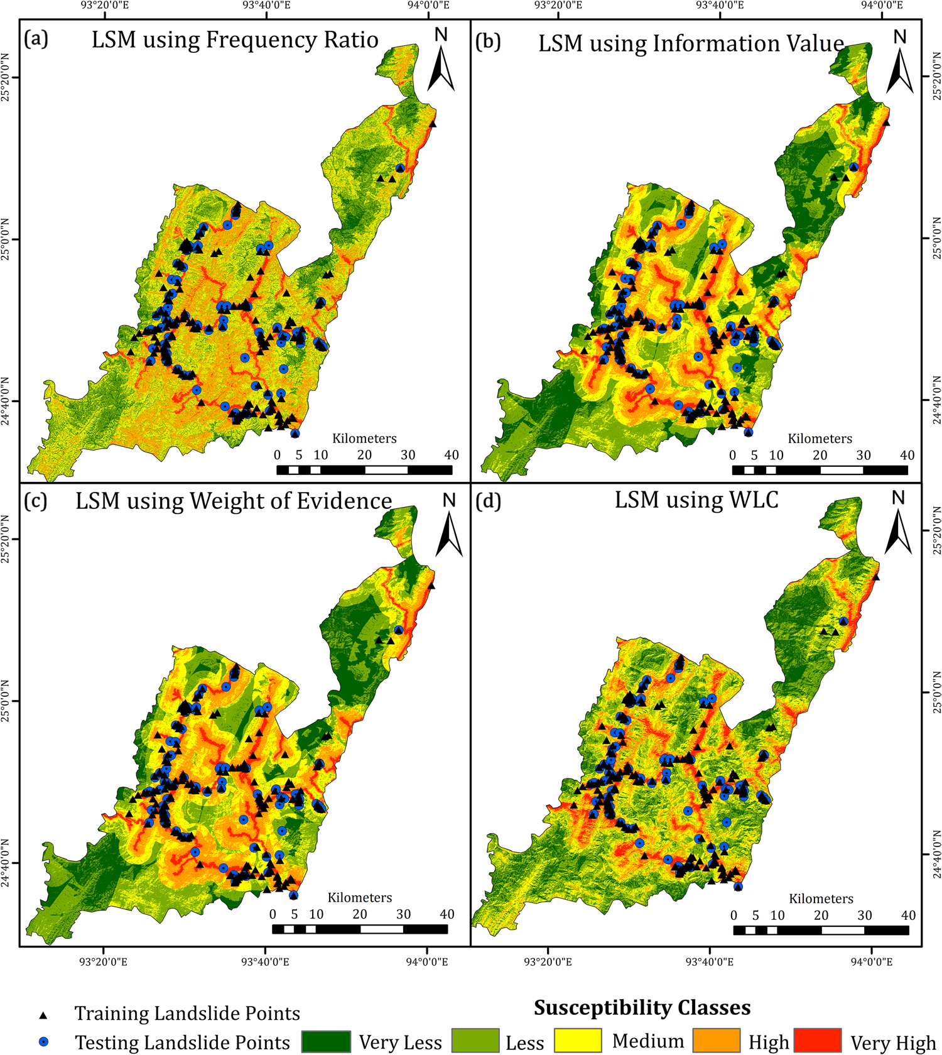
Figure 6: Regional Landslide Susceptibility Map.
Description: A GIS-based map showing the Imphal-Jiribam corridor, highlighting the 34–37% of the area classified as high/medium susceptibility[4].

5.4 Strategies for Disaster Risk Reduction
To mitigate future risk in the rapidly developing Northeast Himalayan region, this review suggests the following:
- Mandatory Slope Stability Radius: Geotechnical investigations for large projects should require a 1km-radius geomorphological survey to identify historical scarp features;
- Integrated Early Warning Systems: Installation of automatic weather stations to monitor rainfall thresholds in real-time is crucial, since record-breaking monsoons have become more frequent [1], [2];
- Slope-Friendly Engineering: Design phases must prioritize the natural drainage and structural integrity of the slope rather than depending on aggressive "toe-cutting" for flat platforms [1], [3];
- Policy-Researcher Synergy: A platform for construction agencies to access and use local geological research (such as university theses and susceptibility maps) can bring scientific warning to practical safety [3], [4].

6. CONCLUSION
The 2022 Tupul landslide serves as a tragic example of how disregarding historical geomorphological evidence in the pursuit of infrastructure development can lead to catastrophic failure. This systematic review of the literature [1]–[4] shows that although the disaster was precipitated by unprecedented rainfall (exceeding the decadal average by about 130% [2]), the conditions for failure were set in place by a combination of natural geological vulnerability and excessive human engineering.
One of the most important findings from this analysis was the location of a large, pre-existing historical landslide scarp, about 1100 m long and 300 m deep, immediately above the project site, suggesting that the slope was marginally stable, with fractured, weakened rock masses [1]. The substantial "yard-cutting" of the slope toe to accommodate the Tupul railway station platform removed the final structural supports of this dormant landslide, enabling extreme monsoon precipitation to reactivate the slide with devastating results [1], [3].
A combination of several policy and engineering shifts is needed to avoid a repeat of the above in the future, particularly in the high-risk Imphal-Jiribam railway corridor where 37% of the area falls in the high susceptibility zone [4]:
- Wider Survey Scope: Geotechnical investigations need to go beyond the immediate construction footprint to include a minimum 1km-radius geomorphological assessment to identify historical dormant scarps.
- Academic-Engineering Integration: The local research and historical hazard documentation (e.g., the 2007 doctoral warning [1]) need to be made mandatory during planning and design phases.
- Engineering for the Slope: Himalayan infrastructure design needs to move away from heavy "toe-cutting" and adopt drainage-centric, low-impact engineering solutions that preserve the natural structural integrity of the hillside [1], [3].
Thus, the 54 to 61 lives lost at Tupul [2], [3] reminds us of the critical importance of a more comprehensive, geologically aware approach to development in the North-Eastern Himalayas, where every future project must consider the terrain not only as a site for construction but also as a living, geomorphological system with a past that influences its present and future stability.
REFERENCE
[1] T. Dolendro, A. Kumar, and M. Sanoujam, “Is the Tupul (Makhuam) Landslide of 29-30 June 2022 in Manipur, India Recognized as one of the Rainfall Induced Massive Landslide?,” Int. J. Multidiscip. Res., vol. 6, no. 2, 2024, doi: 10.36948/ijfmr.2024.v06i02.16229.
[2] S. Baruah, C. Dey, and M. Sanoujam, “Preliminary account on the 30th June 2022 Tupul, Manipur landslide of Northeast India,” Landslides, vol. 20, no. 7, pp. 1547–1552, 2023, doi: 10.1007/s10346-023-02074-y.
[3] A. Singh, A. Adaphro, N. K.C., Nitesh, C. S. Dubey, and D. P. Shukla, “Analysing the causes and lessons learned from Tupul Landslide, Noney district, Manipur,” Res. Sq., 2022, doi: 10.21203/rs.3.rs-2166051/v1.
[4] A. Singh, A. Ashuli, K. Niraj, N. Dhiman, C. S. Dubey, and D. P. Shukla, “Evaluating causative factors for landslide susceptibility along the Imphal-Jiribam railway corridor in the North-Eastern part of India using a GIS-based statistical approach,” Environ. Sci. Pollut. Res., vol. 31, no. 41, pp. 53767–53784, 2023, doi: 10.1007/s11356-023-28966-z.
[5] I. 1893 (Part 1) : 2025, “Design Earthquake Hazard and Criteria for Earthquake-Resistant Design of Structure,” 2025. [Online]. Available: https://www.bis.gov.in/?lang=en.

