Rishikesh on a Plate: A Lesson in Eating with the Seasons
Travel often teaches us lessons in unexpected ways. Sometimes it is the landscape, sometimes the people, and sometimes it is the food that reveals the true character of a place. My recent visit to Rishikesh was one such experience. Like countless visitors, I arrived captivated by the sacred Ganga flowing through the foothills of the Himalayas. The evening aarti, the chants drifting across the river, the suspension bridges, and the breathtaking Garhwal hills created memories that will stay with me for years. Yet one of the most meaningful lessons from this journey came not from the riverbanks or temples, but from a dining table at the resort where I was staying.


Pic 1: In the Banks of Ganga
The resort menu was impressive. It offered cuisines from different parts of India and several international dishes. Looking at it, I realised that if someone arrived there without knowing where they were, the menu would hardly reveal that they were in Garhwal, nestled among the Himalayas beside the Ganga.
The staff, noticing that I was Bengali, warmly offered to prepare macher jhol and aloo posto. It was a thoughtful gesture and a reminder of home. But I politely declined. I had not travelled all the way to Rishikesh to eat what I could easily enjoy in Kolkata or Ahmedabad. Instead, I requested local Garhwali cuisine. The staff seemed pleasantly surprised. Not many guests ask for regional non-vegetarian dishes. After a brief discussion, they agreed to prepare something truly local.
Soon, a beautiful platter arrived at my table.nAt its heart was Himalayan trout sourced from the cold mountain waters of the region, accompanied by local red rice and seasonal vegetables. As Bengalis, we might affectionately describe it as a Garhwali version of macher jhol. The fish was cooked with local mountain spices that enhanced its delicate flavour without overpowering it.What made the experience even more special was learning that I had arrived during the ideal season to enjoy this delicacy. The pre-monsoon period is considered the best time for Himalayan trout. Once the monsoon begins, the breeding season starts, allowing fish populations to regenerate naturally. The meal was therefore not only local but also seasonal.The trout was fresh, flavourful, and perfectly suited to the cool mountain climate. The red rice had a nutty texture and earthy richness unlike the polished white rice commonly served in hotels. Every element on the plate felt connected to the landscape outside my window.
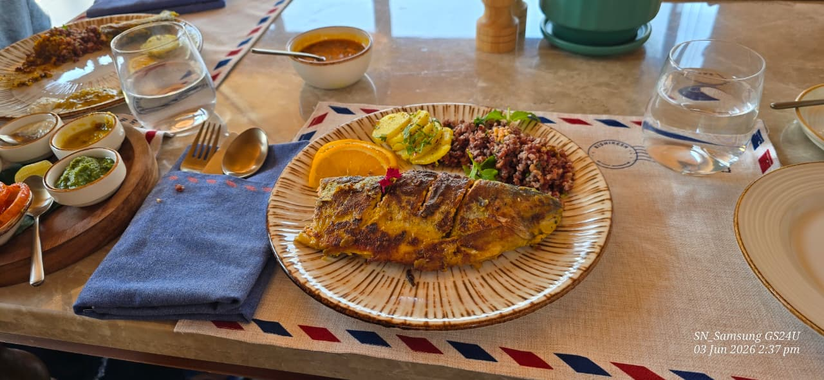
Pic 2: The Local Platter
As I enjoyed the meal, I found myself remembering my grandmother.

She firmly believed that every season had its own gifts. Summer meant mangoes, and she would insist that we eat as many as we could during our summer vacations. "Enjoy them now," she would say, "because you won't get them later. "At the time, it seemed like a simple household instruction. Today, I realise it was also a lesson in sustainabilityBack then, fruits appeared when nature intended them to and disappeared when their season ended. Today, thanks to cold storage, refrigeration, and long-distance transportation, mangoes can be found almost throughout the year.While this convenience may delight consumers, it comes with a hidden environmental cost. Storing, packaging, refrigerating, and transporting food over long distances consumes energy and increases carbon emissions.

Pic 3: Mango eating
My grandmother may never have used terms like "carbon footprint" or "sustainable consumption," but she instinctively understood something important: food tastes best and makes the most ecological sense when consumed in its natural season. The same principle applies to the Himalayan trout I enjoyed in Rishikesh. It belonged to that landscape and that particular season. It was not simply a meal; it was an expression of local ecology, culture, and tradition. This experience reminded me that tourism and sustainability are closely linked. When resorts source trout from nearby fish farmers or purchase rice and vegetables from local growers, they support local livelihoods. When travellers choose local seasonal food, they reduce food miles and encourage the preservation of traditional agricultural and culinary practices. A traveller's plate can become an environmental statement.By eating what grows nearby and what the season naturally offers, we participate in a more responsible and meaningful form of tourism.
As a teacher, I am often reminded of how much our food habits have changed. During lunch breaks, I frequently notice students bringing strawberries in their tiffin boxes almost throughout the year. Yet strawberries, like many fruits, have a natural harvesting season when they are freshest, most nutritious, and most sustainable. Seeing strawberries in every season makes me think of my grandmother's mangoes. Somewhere along the way, we have started believing that every fruit should be available every day of the year. Convenience has gradually replaced seasonality.

Pic 4: Tiffin Box with strawberries
Perhaps we need to teach children that seasonal food is not a limitation but a celebration. The arrival of mangoes in summer, strawberries in winter, or local fish during the appropriate season creates a connection with nature's rhythm that modern food systems often obscure. Standing beside the Ganga in Rishikesh, I felt that this traditional wisdom deserves renewed attention. The river sustains life because it remains connected to its source. In much the same way, food becomes meaningful when it remains connected to the land, season, and community from which it originates.
As travellers, perhaps we should ask a simple question whenever we visit a new destination:
"What is the local seasonal food here? "Not what is trending on social media. Not what reminds us of home.
But what local farmers grow, what local communities eat, and what nature offers at that particular time of year. My meal of Himalayan trout, local red rice, and seasonal vegetables was much more than lunch. It was a taste of Garhwal's landscape, culture, and ecology. It was also a reminder of my grandmother's wisdom and a lesson that I now see reflected in the tiffin boxes of my students. Sometimes the most authentic way to experience a place is not through sightseeing, but through eating what the land and the season are willing to share.

Written By- Baishali Niyogi

