EVALUATION OF THE PROTECTIVE EFFECT OF TOMATO SEED AQUEOUS EXTRACT ON STATIN DRUG INDUCED LIVER DAMAGE OF ALBINO RATS

ABSTRACT
Statins (simvastin) are among the drug most commonly used for lowing blood cholesterol, but sometimes associate with adverse effects. Tomato seed extract has been found to exert hepatoprotective effect through its anti-inflammatory and bioactive properties. The aim of the study was carried out to evaluate the protective effect of tomato seed extract on the stastin induce liver damage of albino rats damaged. Twenty (25) albino rats weighing 150-200 grams were used, and grouped into five groups of five animals each. The experimental group (1-3) received orally stastin 100mg/kg b.wt for 14 days and varying doses of 200 mg, 300mg, 400mg, of tomato seed extract for 28 days respectively. Group 4 (control) received orally stastin 100mg/kg b.wt for 14days while group 5 (normal control) received only food and water. At the end of the animals treatment, blood samples and the liver tissue were collected for biochemical and histological analysis.
Results: There was significant elevation of the liver enzyme parameters, ALT, AST, ALP. Histomorphological examination revealed that the low dose exerted a significant healing effect than the higher doses. The hepatotoxic protective effects appear to be dose-dependent

Keywords; Statins, Hepatoprotective, Tomato Seed

INTRODUCTION

Background of the study
Statins, also known as HMG-CoA reductase inhibitors, are widely prescribed as lipid lowering agents that inhibit the cholesterol synthesis (Istvan et al., 2001). Clinical evidence demonstrates that statin therapy effectively reduces low-density lipoprotein cholesterol (LDL-C) levels by 20–50%, triglyceride concentrations by 10–20%, and modestly increase serum high-density lipoprotein cholesterol (HDL-C) levels by 5–10% (Taylor et al., 2013). Despite these benefits, the potential impact of statins on liver function remains area of active investigation, particularly in experimental models such as rats, where both hepatotoxicity and therapeutic effects are being explored (Björnsson, 2017). Russo reported 22 cases of statin-associated drug-induced liver injury (DILI) from a prospective registry of 1,188 patients (2004–2012). Most cases were female (68%), time from statin start to symptom onset varied widely (34 days to 10 years; median 155 days). Histomorphological patterns suggested multiple mechanisms. Some patients progressed to chronic liver disease, predominantly with an autoimmune phenotype (Russo et al, 2014)
Furthermore, statins may reduce hepatic inflammation by inhibiting of small guanosine triphosphate hydrolases (GTP) binding proteins thereby lowering oxidative stress. (Chong et al, 2015)
Animal studies link high dose statins to liver tumors. Yet, clinical trial suggest reduction in liver cancers with statins. (McGlynn et al, 2015).
Tomato seeds are rich in antioxidants (lycopene, phenolics, flavonoids) and unsaturated fatty acids, which help reduce oxidative stress, inflammation, and hepatic lipid accumulation supporting liver health (Sahin et al, 2010; Allaqaband et al , 2022).

Problem Statement
Statins are established as effective lipid lowering agents, with proven benefits in reducing cardiovascular risk through modulation of cholesterol and triglyceride levels. However, their potential impact on hepatic function remains incompletely understood. While clinical studies have reported instances of hepatotoxicity, the mechanisms underlying these effects and their relevance to long-term therapy are still debated. Experimental models, particularly in rats, provide a valuable platform for investigating both the therapeutic and adverse hepatic consequences of statin administration. At the same time, liver disease burden continues to rise globally, accounting for millions of deaths annually. Despite the widespread use of statins, their role in modulating liver disease progression, whether protective or harmful remains unclear. This gap highlights the necessity of systematic research into the hepatotoxicity and potential therapeutic effects of statins in experimental models. Understanding these dual aspects could inform clinical practice, guide safer use of statins in populations at risk of liver disease, and contribute to strategies aimed at reducing the global burden of hepatocellular disorders.
Significant of the study
Tomato seeds are a valuable source of diverse bioactive compounds are rich in antioxidants such as lycopene, phenolics, and flavonoids, they play a crucial role in neutralizing free radicals, thereby reducing oxidative stress and preventing hepatocellular damage. In addition, the presence of flavonoids has been associated with anti-inflammatory and anti-carcinogenic properties, as these compounds modulate cellular signaling pathways and inhibit the production of pro-inflammatory cytokines. Tomato seeds also contain unsaturated fatty acids, which help lower hepatic lipid accumulation and improve liver function, reducing the risk of fatty liver disease. Importantly, the synergistic effects of these bioactive molecules extend beyond liver protection, offering potential in the prevention of chronic diseases. Evidence further suggests that whole tomato products, including seeds, demonstrate stronger protective effects against cancer compared to purified lycopene alone, underscoring the importance of the natural food matrix in enhancing bioactivity. Collectively, these findings highlight tomato seeds as a promising natural intervention with antioxidant, anti-inflammatory, and disease-preventive properties.
Justification of study
The liver is a vital organ for metabolism, storage, and excretion, yet it is highly vulnerable to drug-induced damage. Tomato seeds contain carotenoids such as lycopene with strong antioxidant properties that may protect against hepatic injury. They are also rich in dietary fiber, which is metabolized by intestinal microbiota into short chain fatty acids like acetic acid. Acetic acid cannot be utilized by cancerous colonies, thereby inhibiting their growth and reducing related health risks. Studying the effects of tomato seed constituents on a drug damaged liver is therefore justified, as it may reveal natural hepatoprotective mechanisms and potential dietary interventions for liver health.
Aim of Study
The overall aim of this research is to evaluate the protective effect of tomato seed extract on statin induced liver damage on albino rats.
Objectives of study
The study aims of the study the following specific objectives;
To examine the most effective dose concentration of aqueous tomato seed extract on statin induced liver injury of albino rats.
To evaluate some biochemical effect of aqueous tomato seed extract on albino rats with induced Statin liver damage
To determine histomorphological effect of tomato seed extract on statin induced the liver damage of albino rats.

Hypothesis
Null Hypothesis (H₀): Tomato seeds extract therapy has no significant effect on hepatic injury in experimental rat models.
Alternative Hypothesis (H₁): tomato seed therap extract administration significantly reduces hepatotoxic effects, reflected in altered liver enzyme levels and histological changes in experimental rat models compared to untreated controls.
LITERATURE REVIEW
The human liver filters off all the blood in the body and breaks down poisonous substances, such as alcohol and drugs. It also aids in the production of bile, conversion of excess glucose into glycogen for storage, and bilirubin clearance. The type of damage caused by the statin is a drug-induced liver injury (DILI), it is one of the most common and significant causes of acute liver failure and acute hepatitis (Devarbhavi et al, 2021). It progresses from steatosis, which is a non-alcoholic fatty liver disease, to cirrhosis and hepatocellular carcinoma (Devarbhavi et al, 2023).
Types of Hepatotoxicity
Drug-induced liver injury (DILI): The most common, responsible for up to 50% of acute liver failures worldwide. Caused by prescription drugs, over-the-counter medications, or herbal supplements.
Alcohol-induced hepatitis: Often progresses to cirrhosis in chronic or heavy alcohol use.
Chemical-induced hepatitis: Exposure to industrial or environmental toxin such as CCl₄ and vinyl chloride.
Nutritional/supplement-related: Excessive intake of vitamin A, bodybuilding supplements, or contaminated and unregulated herbal remedies.
Common Causes of Liver Injury
Medications: Acetaminophen, NSAIDs (diclofenac, ibuprofen), Antibiotics (e.g., amoxicillin-clavulanate, isoniazid, nitrofurantoin), Statins (atorvastatin, simvastatin), Chemotherapy and immunotherapy drugs overdose usually result in mild, transient enzyme elevations leading cause of acute liver failure.

Symptoms of Hepatic Injury
Early signs: Fatigue, nausea, abdominal pain, loss of appetite.
Advanced signs: Jaundice (yellow skin/eyes), dark urine, itchy skin, ascites (fluid buildup), confusion (encephalopathy).
Severe cases: Vomiting blood, delirium, bruising, coma which may indicate acute liver failure.

Diagnosis of Hepatic Injury
Blood tests: Liver function tests (ALT, AST, ALP, bilirubin).
Imaging: Image viewing through CT, MRI, ultrasound to assess liver structure.
Biopsy: Liver tissues are sometimes needed to confirm cause.
Pattern classification:
Hepatocellular injury leads to elevated ALT/AST.
Cholestatic injury causes high ALP.
Mixed injury result in both elevated.

Prevention & Management
Monitoring liver enzymes (ALT, AST, ALP, bilirubin) during drug therapy and follow drug prescription.
Avoiding excessive alcohol and unregulated supplements intake.
Overdose uses of antidotes like N-acetylcysteine or acetaminophen.
Ensure occupational safety to limit chemical or toxin exposures
Severe cases: Liver transplantation may be required.
National Institute of Diabetes and Digestive and Kidney Diseases (NIDDK) (2024).
STATIN
In 2014, Russo reported a total of 22 cases involving statin use in a prospective registry of 1188 patients with drug-induced liver injury between 2004 and 2012. Of these patients, the majority were female (68%), with a varied latency of onset from 34 days to 10 years (median 155 days) associated with a variety of cellular injury mechanisms. Interestingly, they reported that the condition of four of these patients progressed to chronic liver disease, mainly of the autoimmune phenotype (Russo et al, 2014).
Their beneficial effects, including reduction of mortality and cardiovascular events, have been established in randomized clinical trials. (Mary et al, 2014).
In mouse models, statins inhibit angiogenesis (formation of new blood cells) and growth of hepatocellular carcinoma (Tijeras-Raballand et al, 2010).
Treatment of dyslipidemic patients with a combination of statins, which inhibit endogenous cholesterol synthesis, and ezetimibe, a cholesterol uptake inhibitor, to reduce plasma low density lipoprotein cholesterol levels, improved hepatic steatosis. (Nakade et al, 2017)
The observational study reported only one case of rhabdomyolysis and one case of muscle weakness amongst 20,000 patients treated with a type of statin. (Yokote et al, 2011).
Hepatotoxicity of Statins
Several studies have investigated the hepatotoxic effects of statins in rat models. Statins can induce liver enzyme alterations, indicating potential liver damage. For instance, a study by Nakahara et al, 2002 reported that high doses of atorvastatin caused significant increases in serum Alanine aminotransferase (ALT) and Aspartate aminotransferase (AST) levels in rats, markers indicative of liver injury.
Mechanisms of Liver Injury
The mechanisms by which statins might induce liver injury include oxidative stress and mitochondrial dysfunction. A study by Bhardwaj and Khanna demonstrated that simvastatin induced oxidative stress in rat liver tissues, leading to increased lipid peroxidation and reduced levels of antioxidant enzymes. This oxidative stress can result in hepatocyte apoptosis and necrosis ( Bhardwaj et al, 2016).
Dose-Dependent Effects
Dose- dependent report indicated that rats administered with high doses of lovastatin showed significant liver histopathological changes, including hepatocyte ballooning and inflammation, compared to those given lower doses ( Zhang et al, 2008).
Protective Effects and Benefits
Some studies suggest that statins may also have hepatoprotective effects at lower doses or in certain pathological conditions. For instance, research by Basiglio et al, 2010 indicated that atorvastatin could reduce liver fibrosis and inflammation in a rat model of non-alcoholic steatohepatitis potentially through anti-inflammatory and antifibrotic mechanisms.
TOMATOES:
Scientific Classification

Botanical Taxonomy
Kingdom: Plantae
Order: Solanales
Class: Magnoliopsida
Family: Solanaceae (nightshade family)
Genus: Solanum
Species: Solanum lycopersicum (domesticated tomato)
(Integrated Taxonomic Information System, 2024).

Ethobotanical survery
There are many tomato species, only two are considered edible: Solanum pimpinellifolium and Solanum lycopersicum var. cerasiforme (the cherry tomato) (De Broglie et al., 2005).
The cultivated tomato is Solanum lycopersicum. Its closest wild relative is Solanum pimpinellifolium, differing by only 0.6% of nucleotide base pairs (Tomato Genome et al, 2012). The wild tomatoes are generally small compared to the domesticated ones.
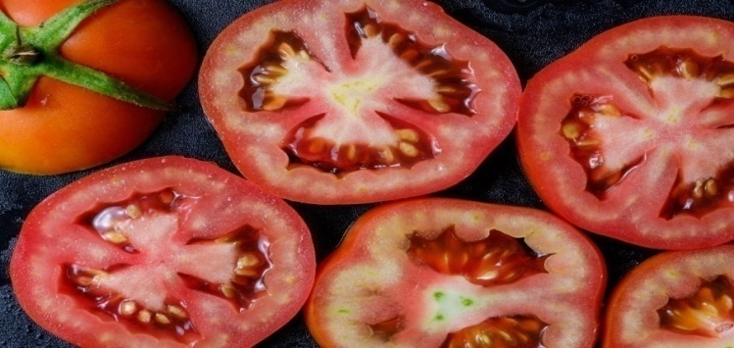
Tomato specie of Solanum lycopersicum.
Nutritional Composition of Tomato Seeds:
Tomato seeds are rich in bioactive compounds that contribute to their nutritional value, including:
Proteins: Tomato seeds are a notable source of protein, which contains essential amino acids vital for human health (Periago, 2008).
Lipids: The seeds contain significant amounts of lipids, particularly unsaturated fatty acids such as oleic acids, which are beneficial for cardiovascular health (Silva et al, 2019).
Fibers: They are also rich in dietary fibers, which supports digestive health and can help in controlling blood sugar levels (Silva et al, 2019).

Also, tomatoes contain a lot of nutrients for example, vitamin C, Lycopene, Carotenoid. Due to their antioxidant properties, lycopene and other carotenoids are said to protect against carcinogenesis by preventing oxidative damage in DNA and proteins through antioxidant mechanisms (Basu et al, 2007).
Mechanisms of Action of tomato seeds
Antioxidant Defense: At optimal doses, the antioxidants in tomato seeds reduce markers of oxidative stress, by neutralizing free radicals and enhancing the liver’s defense system preventing liver cell damage (Sharaf et al, 2015).
Anti-inflammatory Effects: Tomato seeds can reduce pro-inflammatory cytokines in the liver, for example Interleukin-6, reducing inflammation and promoting liver health (Morsi et al, 2012).
Lipid Metabolism: Tomato seeds, through their high unsaturated fatty acid content, can influence lipid metabolism by preventing the accumulation of fats in the liver, through breakdown of fats, and thus protecting against non-alcoholic fatty liver disease (Morsi et al, 2012).
Modulation of apoptosis: Tomato seed studies have been shown to balance apoptosis by reducing the expression of pro-apoptotic factors, such as Bax and increasing anti-apoptotic factors like Bcl-2. This balance helps protect the liver from premature death that can be caused by inflammation, oxidative stress (Aydemir et al, 2012).

MATERIALS AND METHOD

Animal procurement and acclimatization
Twenty- five (25) albino rats weighing 150-200 grams were gotten from ESCOM animal house and acclimated in a well-ventilated iron cage for a period of 14 days. The experiment was conducted according to the institutional guidelines and ethics on use of animals.
Sample collection and Preparation of tomato seed aqueous extract
The tomatoes were locally sourced at Ogbete market, Enugu North local government area of Enugu State, The tomato seeds were collected from fresh tomatoes, air dried and ground into a fine powdery form using blender.
250 grams of the ground tomato seeds were mixed with 1000 ml of water. The mixtures were left in the fridge at a temperature of 10°C for 24 hours before filtrations. The mixture was filtered using muslin cloth and Whatman No. 1 filter paper. Crude extra was stored in plastic air tight container and placed in refrigerator set at 4⁰C until needed (Oliveira et al, 2009)
Drug procurement
Statin (simvastatin) used was purchased at Open heaven pharmaceutical store at Park Avenue GRA.
Study design
The rats in group 1 to 5 were weighed after purchase, prior to experiment day 0
Type: Experimental, randomized controlled trial.
Duration: 4 weeks
Subjects: 25 healthy albino rats, weighing 150-200 grams..
Animal Inducement method
The statin 100 mg/ kg body weight were intraperitoneal administered for 14 days to group 1-4 while group 5 serves as negative control. (Nagaska, 2012 ; Bahrami, 2010)
Experimental design
The animals grouped into 5 groups of 5 rats.
Group 1 | Food, water, statin 100mg/ kg b. wt and Low dose (200 mg/kg b.wt) of Solanum lycopersicum for 28 days
Group 2 | Food, water, statin 100 mg/ kg b.wt and moderate dose (300 mg/kgb.wt) of solanum lycopersicum for 2days
Group 3 | Food, water and statin 100 mg/ kg b.wt and high dose(400mg/kgb.wt) for 28 days
Group 4 | Food, water and statin 100 mg/ kg b.wt (Control) for 28 days
Group 5 | Food and water (Normal control)

Sample and Specimen Collection
The rats were sacrificed under Chloroform anesthesia at the end of the treatment and the organ, liver was carefully excised using standard technique
Histological Sample Analysis
The excised tissue was fixed in 10% formal saline and taken to the laboratory for tissue processing. The tissue harvested were processed through dehydration, clearing, impregnation in wax, embedding, sectioning, staining with hematoxylin and eosin stain, mounted and analyzed photomicrography under the microscope..
Biochemical Analysis
Blood samples were collected through retro-orbital plexus, and serum obtained was used in analysis of liver enzyme parameters.
Statistical Analysis
The data generated from the experiment will be analyzed. The results were analyzed for statistical significance using Tukey’s post‑hoc multiple comparison test, P values < 0.05, were considered statistically significant.
RESULTS
Table 1. Effect of Tomato Seed Extract on Alanine Aminotransferase (ALT) Activity in Statin‑Induced Hepatotoxicity in Albino Rats

Group | ALT (u/l)
Low dose | 112.40 ± 6.06ª
Medium | 110.63 ± 17.83ª
High dose | 134.47 ± 22.33ª
Control | 140.30 ± 6.95ª
Normal control | 106.67 ± 10.51ª
F (4, 10) | 2.0037
p‑value | 0.1683

Values are mean ± SD (n = 3). Means that do not share a superscript letter differ significantly (p < 0.05, Tukey HSD).
Description of Table 1 and Figure 1
As presented in Table 1 and Figure 1, serum ALT activity did not differ markedly among the experimental groups. The statin‑treated control group recorded a mean ALT of 140.30 ± 6.95 u/l, while the low‑dose, medium‑dose, and high‑dose extract groups recorded means of 112.40 ± 6.06 u/l, 110.63 ± 17.83 u/l, and 134.47 ± 22.33 u/l, respectively. The normal control group had the lowest numerical ALT (106.67 ± 10.51 u/l). ANOVA revealed no statistically significant difference among the groups (F = 2.0037, p = 0.1683). These data indicate that, at the doses tested, tomato seed extract did not produce a significant shift in ALT, and statin administration alone did not induce a pronounced ALT elevation under the conditions of this study.

Figure 1. Effect of Tomato Seed Extract on Alanine Aminotransferase (ALT) Activity in Statin‑Induced Hepatotoxicity in Albino Rats

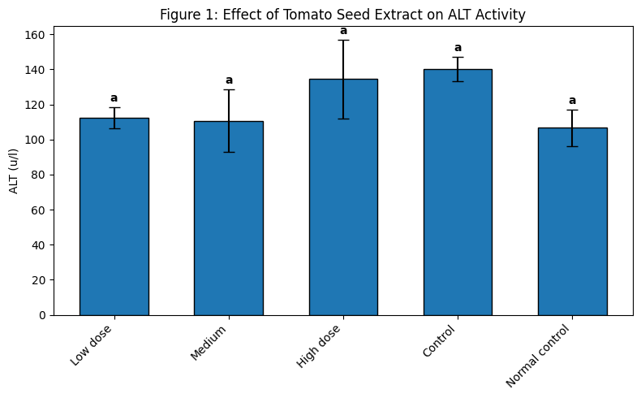

Bars represent Mean ± SD (n = 3). Bars with different superscript letters differ significantly at p < 0.05 using Tukey’s post‑hoc multiple comparison test.

Table 2. Effect of Tomato Seed Extract on Aspartate Aminotransferase (AST) Activity in Statin‑Induced Hepatotoxicity in Albino Rats

Group | AST (u/l)
Low dose | 179.91 ± 1.35ª
Medium | 252.21 ± 9.54^{b}
High dose | 190.61 ± 53.83^{ab}
Control | 252.44 ± 17.85^{b}
Normal control | 176.00 ± 14.56ª
F (4, 10) | 4.9026
p‑value | 0.0183*

Values are mean ± SD (n = 3). Means that do not share a superscript letter differ significantly (p < 0.05, Tukey HSD).

Description of Table 2 and Figure 2
As shown in Table 2 and Figure 2, serum AST activity varied significantly across the experimental groups. Statin administration (control) caused a pronounced elevation in AST (252.44 ± 17.85 u/l) relative to the normal control (176.00 ± 14.56 u/l) and low‑dose extract groups (179.91 ± 1.35 u/l). The medium‑dose group (252.21 ± 9.54 u/l) remained similarly elevated, while the high‑dose extract (190.61 ± 53.83 u/l) produced an intermediate AST level that did not differ significantly from either the normal or the control groups. One‑way ANOVA confirmed a significant overall effect (F = 4.9026, p = 0.0183). These findings point to a dose‑dependent hepatoprotective effect of tomato seed extract, with the high dose partially attenuating statin‑induced hepatocellular enzyme leakage.

Figure 2. Effect of Tomato Seed Extract on Aspartate Aminotransferase (AST) Activity in Statin‑Induced Hepatotoxicity in Albino Rats

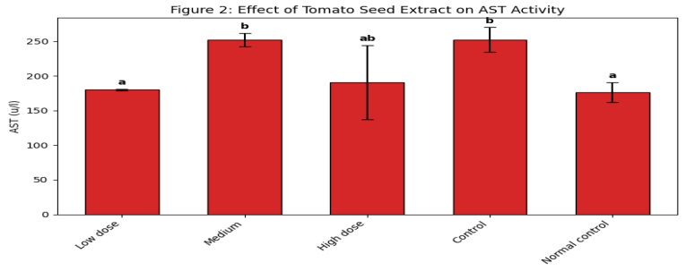

Bars represent Mean ± SD (n = 3). Bars with different superscript letters differ significantly at p < 0.05 using Tukey’s post‑hoc multiple comparison test.

Table 3. Effect of Tomato Seed Extract on Alkaline Phosphatase (ALP) Activity in Statin‑Induced Hepatotoxicity in Albino Rats

Group | ALP (u/l)
Low dose | 406.31 ± 66.28ª
Medium | 394.12 ± 44.40ª
High dose | 375.18 ± 89.06ª
Control | 484.39 ± 18.87ª
Normal control | 370.13 ± 43.47ª
F (4, 10) | 1.3750
p‑value | 0.3097

Values are mean ± SD (n = 3). Means that do not share a superscript letter differ significantly (p < 0.05, Tukey HSD).

Description of Table 3 and Figure 3
As displayed in Table 3 and Figure 3, serum ALP activity followed a numerical pattern similar to that of the transaminases but did not reach statistical significance. The statin‑control group exhibited the highest mean ALP (484.39 ± 18.87 u/l), whereas the normal control (370.13 ± 43.47 u/l) and the extract‑treated groups (low dose 406.31 ± 66.28 u/l; medium dose 394.12 ± 44.40 u/l; high dose 375.18 ± 89.06 u/l) recorded lower values. Analysis of variance yielded F = 1.3750, p = 0.3097, indicating no statistically significant difference among the groups. Thus, tomato seed extract did not significantly alter ALP activity, suggesting that statin‑induced hepatobiliary stress, if any, was not sufficient to produce a detectable rise in this marker under the conditions tested.

Figure 3. Effect of Tomato Seed Extract on Alkaline Phosphatase (ALP) Activity in Statin‑Induced Hepatotoxicity in Albino Rats

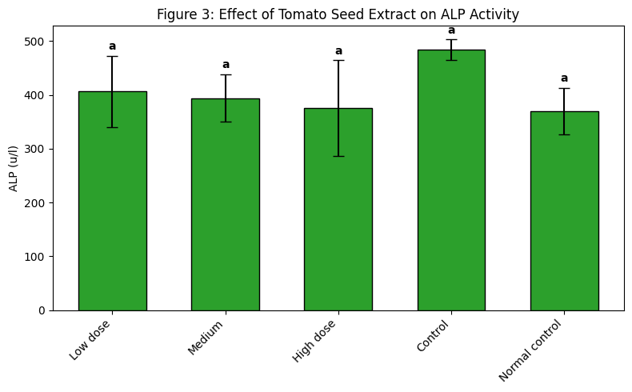

Bars represent Mean ± SD (n = 3). Bars with different superscript letters differ significantly at p < 0.05 using Tukey’s post‑hoc multiple comparison test.

Table 4. Effects of Tomato Seed Extract on Serum Liver Enzyme Markers (ALT, AST, and ALP) in Statin‑Induced Hepatotoxicity in Albino Rats

Group | ALT (u/l) | AST (u/l) | ALP (u/l)
Low dose | 112.40 ± 6.06ª | 179.91 ± 1.35ª | 406.31 ± 66.28ª
Medium | 110.63 ± 17.83ª | 252.21 ± 9.54^{b} | 394.12 ± 44.40ª
High dose | 134.47 ± 22.33ª | 190.61 ± 53.83^{ab} | 375.18 ± 89.06ª
Control | 140.30 ± 6.95ª | 252.44 ± 17.85^{b} | 484.39 ± 18.87ª
Normal control | 106.67 ± 10.51ª | 176.00 ± 14.56ª | 370.13 ± 43.47ª
F (4, 10) | 2.0037 | 4.9026 | 1.3750
p‑value | 0.1683 | 0.0183* | 0.3097

Values are mean ± SD (n = 3). Superscript letters indicate Tukey groupings within each column. F‑ and p‑values correspond to one‑way ANOVA for each parameter. *p < 0.05.

Description of Table 4 and Figure 4
Table 4 and Figure 4 provide a consolidated view of the serum liver enzyme profile. Statin administration (Control) consistently produced the highest or near‑highest values for all three enzymes, most notably AST, which was significantly elevated relative to the normal control and low‑dose groups (p < 0.05). The high‑dose tomato seed extract partly reversed this trend, bringing AST to an intermediate level (190.61 ± 53.83 u/l) that was no longer significantly different from normal. ALT and ALP showed similar numerical patterns but failed to reach statistical significance (p = 0.1683 and p = 0.3097, respectively). The grouped summary confirms a dose‑dependent hepatoprotective tendency of the extract, most clearly evident in the attenuation of AST activity.

Figure 4. Effects of Tomato Seed Extract on Serum Liver Enzyme Markers (ALT, AST, and ALP) in Statin‑Induced Hepatotoxicity in Albino Rats

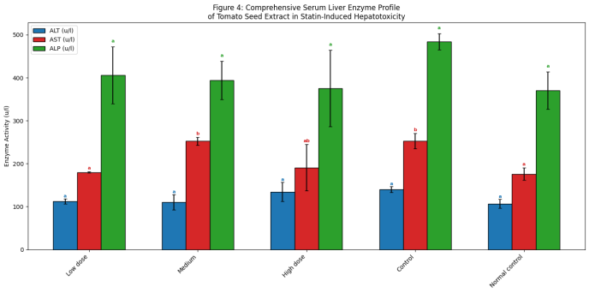

Bars represent Mean ± SD (n = 3). Bars with different superscript letters differ significantly at p < 0.05 using Tukey’s post‑hoc multiple comparison test. Colour coding: ALT = blue, AST = red, ALP = green.

Photomicrography
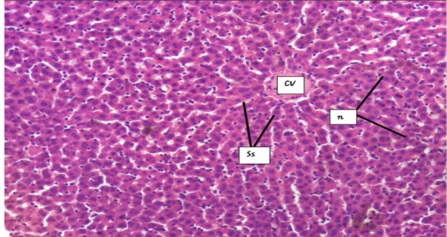
FIG I- Light photomicrograph of Liver section from rat treated with low dose of Solanum lycopersicum seed extract (Group 1) after liver injury induction with statin showing intact tissue parenchyma. The hepatocytes (nH- normal hepatocytes) around the central veins (CV), portal tracts and mid-zonal areas appear intact with no obvious lesion, indicating the protective effect of Solanum lycopersicum seed extract on hepatic tissue at low dose (200 mg/kg b.wt) (Stain: Haematoxylin & Eosin; Mag: x100)
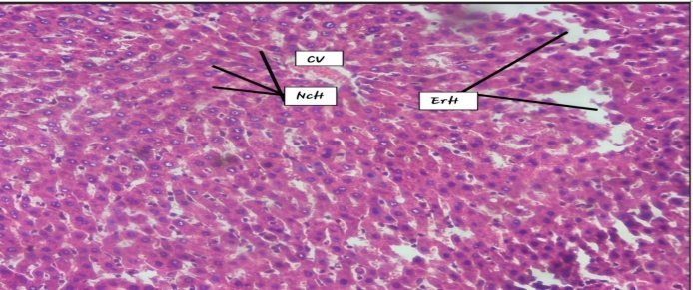
FIG II- Light photomicrograph of Liver section from rat treated with medium dose of Solanum lycopersicum seed extract (Group 2) after liver injury induction with statin showing some obvious histo-morphological alterations; Some hepatocytes are eroded around the mid-zonal region (ErH) while some hepatocytes are necrotic (NcH) around the central vein (CV), (Stain: H&E; Mag: 100)
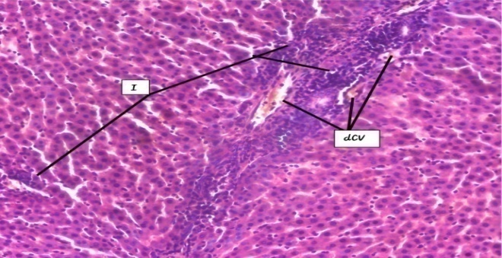
FIG III- Light photomicrograph of Liver section from rat treated with high dose of Solanum lycopersicum seed extract (Group 3) after liver injury induction with Statin showing some obvious histo-morphological alterations; disruption of the central veins (dCV) and marked inflammatory cellular infiltration (Stain: H&E; Mag: 100)
.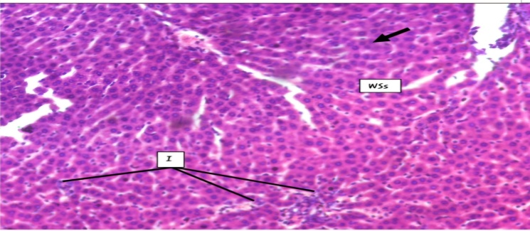
FIG IV- Light photomicrograph of Liver section from rat treated with 100 mg/kg Statin only (Negative Control-group 2) showing some obvious histo-architectural alterations. Features observed include: marked inflammatory cellular infiltration (Ic); necrotic hepatocytes (thick arrow) and widened sinusoidal spaces (WSs). (Stain: Haematoxylin & Eosin; Mag: x100)
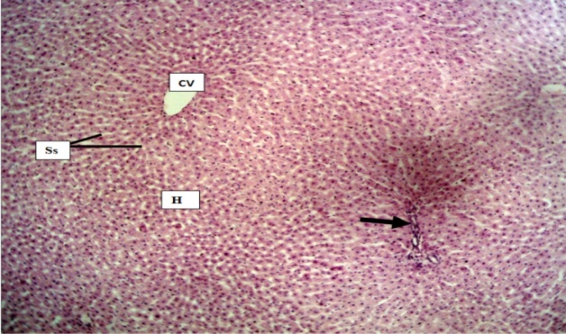
FIG V- Light photomicrograph of Liver section from normal control rat (Group 1) showing normal histo-architecture of the hepatic tissue. Normal features observed include; central veins (CV), hepatocytes (H), portal tract (arrow) and sinusoidal spaces (Ss) appear normal. (Stain: Haematoxylin & Eosin; Mag: x100)
DISCUSSION, CONCLUSION AND RECOMMENDATION
Treatment with Solanum lycopersicum over a 28-day period produced notable changes in biochemical parameters, suggesting a partial protective effect against statin-induced liver damage in albino rats. The hepatoprotective properties of tomato seed extract are attributed to its high content of bioactive compounds, which enhance the liver’s antioxidant defense mechanisms by inhibiting lipid peroxidation and modulating gene expression related to antioxidant activity.
Previous studies support these findings. Ahmed and Ali (2018) reported improved liver enzyme profiles in rats treated with tomato seed extract, with significant reductions in alanine aminotransferase (ALT) and aspartate aminotransferase (AST), both markers of liver injury. Similarly, tomato extract at 30 mg/kg body weight demonstrated hepatoprotective effects, significantly lowering liver enzyme activities (Uchendu et al., 2018). At higher doses, such as 80 mg/kg, phytochemical agents provided strong protection against drug-induced hepatotoxicity (Buabeid, 2024).
Dose-dependent effects were evident. Low to moderate doses (200–250 mg/kg body weight) consistently improved liver enzyme profiles, reducing ALT, AST, and alkaline phosphatase levels (Sahin et al., 2010; Al-Jameel, 2014). However, high doses (300 mg/kg and above) produced mixed outcomes. While antioxidant properties initially provided hepatoprotection, excessive intake led to increased oxidative stress and potential liver damage due to overaccumulation of bioactive compounds. Sharaf et al. (2015) reported that extremely high doses (1000 mg/kg) elevated oxidative stress markers, suggesting that excessive intake may overwhelm the liver’s antioxidant capacity.
Histological examinations further reinforced these biochemical findings. Zhang et al. (2019) observed reduced inflammation and necrosis in liver tissues of rats treated with tomato seed extract compared to untreated controls, indicating preservation of tissue structure and function. Nonetheless, the partial protective effect observed in this study may be influenced by factors such as extraction methods, bioavailability of active compounds, dosage, administration route, and the specific pathways affected by statins. Longer study durations and advanced experimental models may provide deeper insights into these mechanisms

Conclusion
This study demonstrates that tomato seed extract possesses hepatoprotective properties, particularly at low to moderate doses, by reducing liver enzyme activity, inhibiting lipid peroxidation, and preserving tissue integrity. However, high doses may paradoxically increase oxidative stress, highlighting the importance of dose optimization.
The findings emphasize the complexity of liver injury mechanisms and the potential role of dietary phytochemicals in mitigating statin-induced hepatotoxicity. Tomato seeds, with their rich composition of antioxidants, flavonoids, and unsaturated fatty acids, represent a promising natural intervention for liver protection. Future research should explore different extraction methods, varied dosages, and the combined use of whole tomato components—including pulp and skin—to maximize therapeutic benefits. Clinical trials will be essential to validate these protective effects in humans and to establish tomato seed extract as a complementary strategy alongside conventional pharmacological therapies.
REFERENCES
- Ahmed, S., & Ali, R. (2018). Hepatoprotective potential of tomato seed extract in rats: A biochemical study. Pharmaceutical Biology, 56(2), page 120-125.
- Al-Jameel, S. S. (2014). "Protective effect of tomato seed oil on thioacetamide-induced liver cirrhosis in rats." Journal of Advanced Research, 5(4), page 453-462.
- Allaqaband, S., Dar, A. H., Patel, U., Kumar, N., Nayik, G. A., Khan, S. A., Ansari, M. J., Alabdallah, N. M., Kumar, P., Pandey, V. K., Kovács, B., & Shaikh, A. M. (2022). Utilization of fruit seed-based bioactive compounds for formulating nutraceuticals and functional food: A review. Frontiers in Nutrition, 9, 902554. https://doi.org/10.3389/fnut.2022.902554
- Arathi B.P., Sowmya P.R.R., Kuriakose G.C., Vijay K., Baskaran V., Jayabaskaran C., Lakshminarayana R. Enhanced Cytotoxic and Apoptosis Inducing Activity of Lycopene Oxidation Products in Different Cancer Cell Lines. Food Chemical Toxicology (2016);97: page 265–276.
- Aydemir, G., Kasiri, Y., Birta, E., Beke, G., Tóth, N., & Rühl, R. (2012). Lycopene-derived bioactive retinoic acid receptors as modulators of liver metabolism. Journal of Nutritional Biochemistry, 23(9), page 1130-1137.
- Bahrami, G., Mohammadi, B., & Kamali, N. (2010). Statins-induced liver toxicity in rats: Histopathological and biochemical findings. Toxicology and Applied Pharmacology, 246(2), page 88-93.
- Basiglio, C. L., Arriaga, S. M., Pelusa, H. F., Roma, M. G., Sánchez Pozzi, E. J., & Mottino, A. D. (2010). Atorvastatin reduces liver fibrosis in a rat model of non-alcoholic steatohepatitis by decreasing oxidative stress and inflammation. Liver International, 30(5), 682–693. https://doi.org/10.1111/j.1478-3231.2010.02239.
- Basu, A. and Imrhan, V(2007) Tomatoes versus Lycopene in Oxidative Stress and Carcinogenesis: Conclusions from Clinical Trials European Journal of Clinical Nutrition, vol 61,pg 295–303.
- Bhardwaj, S., & Khanna, D(2016). Simvastatin induced oxidative stress and hepatotoxicity in rats. Pharmacological Reports, volume 68(1), page 106-112.
- Björnsson E.S.(2017) Hepatotoxicity of statins and other lipid-lowering agents. Liver International: volume 37(2): page 173-178
- Buabeid, M. A. (2024). Multimodal modulation of hepatic ischemia/reperfusion-induced injury by phytochemical agents: A mechanistic evaluation of hepatoprotective potential and safety profiles. International Immunopharmacology, 138, 112445. https://doi.org/10.1016/j.intimp.2024.112445
- Chong LW, Hsu YC, Lee TF, (2015). Fluvastatin attenuates hepatic steatosis-induced fibrogenesis in rats through inhibiting paracrine effect of hepatocyte on hepatic stellate cells. BMC Gastroenterol. Volume 15(1): page 22.
- De Broglie L.A. and Guéroult D (2005). Tomatoes of yesterday and today. Paris, Hoëbeke. Page 143
- Devarbhavi H, Joseph T, Sunil Kumar N, Rathi C, Thomas V, Prasad Singh S. (2021)The Indian network of drug-induced liver injury: etiology, clinical features, outcome and prognostic markers in 1288 patients.Journal of Clinical and experimental Hepatology. ;vol 11: page 288-298.
- Devarbhavi Harshad, Yvonne Ayerki Nartey.(2023)Global burden of liver disease:. Update. Journal of Hepatology. 79(2), page 516–537
- Integrated Taxonomic Information System. (2024). Solanum lycopersicum L. In ITIS report. Retrieved from https://www.itis.gov
- Istvan, E.S., and Deisenhofer, J. (2001) Structural Mechanism For Statin Inhibition of HMG-CoA Reductase. Science, 292 (5519) II60-1164 DOI: 10.1126/science.1059344. PMID: 11349148
- Mary A. De Vera, Vidula Bhole, Lindsay C. Burns, Diane Lacaille (2014) Impact of statin adherence on cardiovascular diseases and mortality outcomes. Volume.78,pg 684-698
- McGlynn KA, Hagberg K, Chen J(2015) Statin use and risk for primary liver cancer in the clinical practice research datalink. Journal of National Cancer Institute; 107(4)
- Morsi, H. M., & Abdel-Rahman, M. S. (2012). Dose-dependent hepatoprotective effect of tomato seed extract against carbon tetrachloride-induced liver damage in rats. International Journal of Pharmacology, 8(7), page 524-532.
- Nagasaka, R., & Watanabe, H. (2012). "Tomato seed extract attenuates carbon tetrachloride-induced hepatic injury in rats." Journal of Medicinal Food, 15(3), page 311-317.
- Nakade Y, Murotani K, Inoue T (2017) Ezetimibe for the treatment of non-alcoholic fatty liver disease: a meta-analysis. Hepatology Research ;47(13): page1417–1428.
- Nakahara, T., Kojima, Y., Ijuin, H., (2002). Hepatotoxicity of high doses of atorvastatin in rats. Toxicology Letters, 129(1-2), page 93-100.
- National Institute of Diabetes and Digestive and Kidney Diseases. (2024). Liver disease: Hepatotoxicity and its types. U.S. Department of Health and Human Services. Retrieved June 29, 2026, from https://www.niddk.nih.gov
- Oliveira, A. C., Valentim, I. B., Goulart, M. O. F., Silva, C. A., Bechara, E. J. H., & Trevisan, M. T. S. (2009). "Vegetable oils as sources of polyphenols and vitamin E: Comparison between seed and olive oils." Food Chemistry, 121(3), page 957-962.
- Periago, M. J. (2008). Nutritional evaluation of tomato seeds: Protein and amino acid composition. In V. K. Sawhney & I. S. Sheoran (Eds.), Tomatoes and tomato products: Nutritional, medicinal and therapeutic properties (pp. 13–25). CRC Press.
- Russo MW, Hoofnagle JH, Gu J, (2014) Spectrum of statin hepatotoxicity: experience of the drug-induced liver injury network. Hepatol Baltim Md. 2014; vol 60(2): page 679–686.
- Sahin, N., & Sahin, K. (2010). Tomato powder supplementation in rats enhances the hepatic antioxidant status and reduces lipid peroxidation. Journal of Nutrition, 140(6), page 1159-1164.
- Saini R.K., Rengasamy K.R.R., Mahomoodally F.M., Keum Y.S.(2020) Protective Effects of Lycopene in Cancer, Cardio-Vascular, and Neurodegenerative Diseases: An Update on Epidemiological and Mechanistic Perspectives. Pharmacology Research; Vol 155
- Sharaf, H. K., & Al-Rasheed, N. M. (2015). Hepatoprotective effect of tomato seed oil in rats subjected to ethanol-induced oxidative stress. Journal of Ethnopharmacology, 176, page 227-236.
- Silva, Y. S., Santos, K. F., Oliveira, L. C., & Lima, D. M. (2019). Nutritional composition and lipid profile of tomato seed oil. Journal of Food Science and Technology, 56(1), page, 297-304.
- Taylor F, Huffman MD, Macedo AF, (2013). Statins for the primary prevention of cardiovascular disease. Cochrane Database System, vol 1.
- Tijeras-Raballand, A., Hainaud-Hakim, P., Contreres, J.O., Gest, C., Le Henaff, C., Levy, B.I., Pocard, M., Soria, C. and Dupuy, E.,(2010) Rosuvastatin counteracts vessel arterialisation and sinusoid capillarisation, reduces tumour growth, and prolongs survival in murine hepatocellular carcinoma. Gastroenterology Research and Practice, (1), page 640-797.
- Tomato genome, C., Sato, S., Tabata, S., Hirakawa, H., Asamizu, E., Shirasawa, K., Isobe, S., Kaneko, T., Nakamura, Y.,Fawcett, J.,Zamir, D., Liang, C.,Gundlach, H.(2012)The tomato genome sequence provides insights into fleshy fruit evolution.Nature,485,635
- Uchendu, I. K., Agu, C. E., Orji, O. C., Nnedu, E. B., Arinze, C., & Okongwu, U. C. (2018). Effect of tomato (Lycopersicon esculentum) extract on acetaminophen-induced acute hepatotoxicity in albino Wistar rats. Bioequivalence & Bioavailability International Journal, 2(1), 000119. https://doi.org/10.23880/beba-16000119 (doi.org in Bing)
- Yokote K, Shimano H, Urashima M, Teramoto T (2011). Efficacy and safety of pitavastatin in Japanese patients with hypercholesterolemia: LIVES study and subanalysis. Expert review of cardiovascular therapy; 9 (5):555–562.
- Zhang H, Ono,H., Kotake-Nara.(2003)A novel cleavage product formed by autoxidation of lycopene induces apoptosis in HL-60 cells. Free Radical Biology, ; 35(12): page 1653-1663.
- Zhang, L., Wang, T., & Liu, Y. (2019). Histopathological and biochemical analysis of liver protection by tomato seed extract in rats. Toxicology Reports, 6, page 212-218.
- Zhang, Y., Liu, J., Ma, Y., & Zhang, L. (2008). Dose-dependent hepatotoxicity of lovastatin in rats. Food and Chemical Toxicology, 46(9), page 3185-3189.

