AWARENESS LEVEL OF CONSUMERS TOWARDS ECO-FRIENDLY FMCG PRODUCTS
Dr. LM Thorat, DV Garad, HB Late, SD Mane[Vasantrao Kale College Of Management Science Kallam]

Abstract - Customers ‘perception is changing towards the environment to encourage innovation for conservation and the benefits from this source of innovation are certain to outlive our current generation. Eco-friendly products are those products which are environmentally safe or does not create any threat to environment‖. Several activities are involved in eco- friendly marketing which includes product modification, packaging and advertising. This research study is based on the FMCG eco-friendly products but specifically on Consumers ‘Perception towards Eco-friendly FMCG Products. This paper investigates consumer perception and beliefs on environment protection and buying behavior of eco-friendly products.
A quantitative approach was adopted for the study by using a questionnaire, 440 respondents data were collected through internet by using Google.doc surveys. In present study independent samples t-test is used to test to compare the perception, awareness, satisfaction level of respondents with different demographic characteristics like gender, age and monthly family income.
The findings of this work indicate that age has no significant effect on awareness of consumers towards eco-friendly products and availability of the eco-friendly products. Different age groups of consumers are having equal awareness towards eco-friendly products.
Keywords: Eco-friendly products, Perception, Environmental awareness.

INTRODUCTION
Consumer Perception Consumer perception is the study of individual customer who is involved in procuring and using goods and services. All the activities associated with the purchase, use and disposal of goods and services, including the consumer's emotional, mental and behavioral responses that precede or follow these activities. Consumer perception is about how customers look at the product, what they expect from the products and from the manufacturers. It is a big task for manufacturer to understand the perception of customers. Consumer perception involves the psychological processes that consumers, make recognizing the needs, finding ways to solve these needs collect and interpret information, make plans, and implement these plans, making purchase decisions and post purchase behavior.

Eco-Friendly Products
―Eco-friendly products are products that do not harm the environment whether in their production, use or disposal‖. (all-reAcycling-facts.com) Eco friendly products are usually having basic two goals –maximizing
Resource efficiency and reducing waste. Eco-friendly products are manufactured by using environmentally-friendly procedures and toxic- free ingredients. It is certified by recognized organizations like Forest Stewardship Council, Energy star, etc.

Fast Moving Consumer Goods
Fast-moving consumer goods (FMCG) are products that are sold quickly and at a relatively low cost. In India Fast Moving Consumer Goods (FMCG) is an important and very fast growing sector. Large populations of India are depending on FMCG in one or another way. As per India Info line News Service, Mumbai, January 6, 2016, Indian FMCG sector, which is the fourth largest in economy with market size of US$ 3.1 billion. Consumers are mainly depending on FMCG sector for their day to day activities. The products like soaps, detergents, tooth paste, food products, beverages, cosmetics and other products comes under FMCG category. (Wikipedia, 2019)

REVIEW OF LITERATURE
Patnaik et al in their Study the consumer attitude towards green FMCG products are correlated with price, product, place, awareness, brand knowledge, pre-purchase and post purchase behavior. Nowadays people are careful about their daily product like cosmetics, baby products, body care, food etc. The quality of the products is the most important factor that influences the purchase of green FMCG products.
Pandey et al this research study took place in Delhi NCR Region, researcher analyze the consumer‘s attitude towards organic food products. In India the concept of eco-friendly food is still in the primary stage. The marketer must create awareness through advertisement and publicity of organic food product, so that the market size of organic food products is increased. The researcher study showed that most of the consumers were aware about the organic food products like better in quality, better in taste, food products free from pesticides, purchased by the publicity through word of mouth. But most of the consumer said that organic foods products are not easily available in market places, more expensive and the information related to eco-friendly foods products is very limited.
Kata it innovative study analyzed the Consumer behavior towards green products of FMCG, the authors found that consumers are becoming more concerned and aware about the environment friendly products. Many companies are doing their best by adopting Green Production Process. Consumer attitude is well affected by their product attributes, product knowledge and existing culture.
Unnamable conducted a study on consumer Attitudes towards Green Fast Moving Consumer Goods with Special Reference to Tiruchirapalli Town. The usage and awareness of green FMCG products is very low among the peoples. Most of the people have no knowledge

About the eco-friendly products. But majority of people are having consciousness about the eco-friendly environment and they are trying to save earth from pollution.
Yusuf et al conducted a study on consumer attitude and perception towards green products. consumers has awareness about the implication of global warming, harmful impact of pollutants, non-biodegradable solid waste etc., both consumer and marketer are switching to eco-friendly products and most of companies have accepted their responsibility not to waste the natural resources and not to harm the environment. Samples were selected through random sampling, near about 70 college going students participated in the research. For this sample statistical analysis Pearson correlation was used.
Kumar et al this study aimed to gain knowledge about consumer behavior towards organic products Consumption and Market potential of the Organic food products. The results concluded that marketing of organic product is very poor and demand for organic product is increases, most of the consumer prefer organic food product. The major reasons are organic food producer are low, sufficient market facility is not there, lack of awareness, few number of shops and so on. But if farmer and government give interest to improve production of organic food product as well as quality, good packaging and market system, it helps to get better standard of living farmer and it helps to government and also it healthy to environment.

Research Objectives
    - To study the awareness level of Consumers towards green FMCG Products.
    - To find out the Consumer Perception towards environment friendly FMCG products.

RESEARCH METHODOLOGY

Data Collection
Primary data is termed as data collected by the researcher for specific purpose. To analysis of consumer perception towards eco-friendly food products a well framed closed ended questionnaire was filled in by the respondents and the findings are presented as figures and facts found during the analysis. This study is mainly based on the information and data obtained from the primary sources.

Data Analysis
Statistical techniques were used with the help of Statistical Package for Social Sciences (SPSS) for hypothesis testing. In present study independent samples t-test and One-Way ANOVA is used for hypothesis testing.
Sample Size. For this research, a sample of 440 respondents was selected.


Gender of Respondents
From the above table it is found that 51.1% representation is obtained from male consumers of Eco- friendly food products and 48.9 % female respondents which are involved in the purchase of Eco- friendly products.

Hypothesis Testing
Awareness of consumers towards Eco-friendly products
H0 (B2): Age has no significant effect on awareness of consumers towards eco-friendly products.
H1 (B2): Age has an effect on awareness of consumers towards eco- friendly products.
Applying One-Way ANOVA using IBM SPSS statistics 21.0 Software
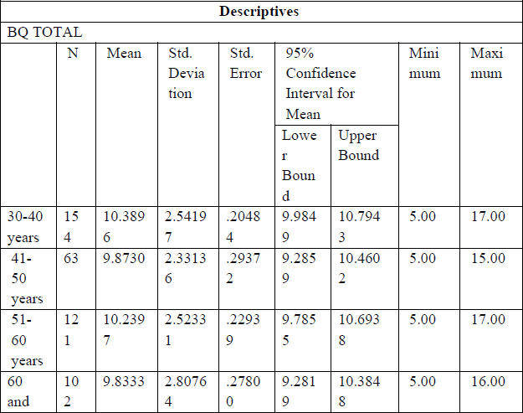
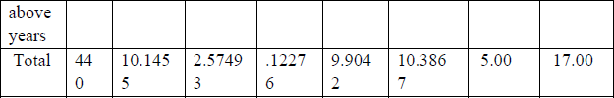

Table 4.1: Age descriptive for Awareness of consumers towards Eco- friendly products
The mean of each group in Descriptive table, it can be concluded that there is homogeneity of variances.

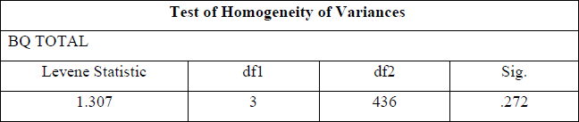

Table 4.2: Test of Homogeneity of Variances for Awareness of consumers towards Eco-friendly products with respect to age of the Respondents

According to Levine’s Test for homogeneity of Variances, if significance value of Levine’s Test for Homogeneity of Variances test is more than
0.05 then there is homogeneity of variances.
Here, significance value of Levine’s Test for Homogeneity of Variances test is 0.272 which is more than 0.05. Hence there is homogeneity of variances.
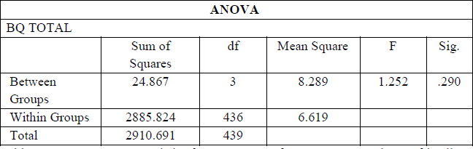

Table 4.3: ANOVA Test Statistics for Awareness of consumers towards Eco-friendly products with respect to age of the Respondents

From the ANOVA table the Sig. value is 0.290 which is more than 0.05. Hence null hypothesis (H0) is accepted. So it can be concluded that age has no significant effect on awareness of consumers towards eco-friendly products.

FINDINGS
Age has no significant effect on awareness of consumers towards eco- friendly products. Different age groups of consumers are having equal awareness towards eco-friendly products.

CONCLUSION
The findings of the study clearly confirm that, in Indore most of the consumers have favorable perception towards eco-friendly products. Consumers are aware about environment degradation, global warming etc. Consumers are having more concerned towards the environment and have moderate awareness on Eco-friendly FMCG products. The consumers is buying Eco-friendly products as it is healthy and safe for

The environment and as well as for the human beings. The consumers are also satisfied with the eco- friendly products. The main barrier for buying Eco-friendly FMCG products are too high price as it is compared to non-Eco-friendly products price.

REFERENCES
  - Patnaik and S. K. Pradhan, "A Study on consumer attitude towards green FMCG Products," International Journal of Scientific Development and Research, vol. 1, no. 12, pp. 83-91, 2016.
  - Pandey and P. Mishra, "Consumer‘s Attitude Towards Organic Food Products with Reference to Delhi NCR," International Journal of Research and Analytical Reviews, vol. 3 , no. 21, pp. 2349-5138, 2016.
  - S. K. kata it, "Consumer behavior towards green products of FMCG," International Journal of Commerce and Management Research, vol. 2, no. 8, pp. 43-4, 2016.
  - T. Unnamable, "A Study on Consumer Attitudes towards Green Fast Moving Consumer Goods (FMCG) With Special Reference to Tiruchirapalli Town," International Journal of Engineering and Management Research, vol. 6, no. 4, pp. 380-389, 2016.
  - S. Yusuf and Z. Fatima, "Consumer Attitude and Perception towards Green Products," The International Journal of Indian Psychology, vol. 2, no. 3, pp. 140-146, 2015.
  - S. Kumar AD and H. M. Chandrasekhar, "A Study on Consumers Behavior towards Organic Food Products in Mysore City," International Journal of Management Research, vol. 5, no. 11, pp. 1082-1091, 2015.

####

