Enterprise Architecture Planning for High School Information System Modeling

Jam’an Amadi ¹, Zuhri ², Juliani ³, Fajrillah ⁴, May Handri ⁵, Ari Lestari ⁶

^{1,3,4*,5} Fakultas Ilmu Sosial dan Humanioira (FISH), Universitas IBBI, Medan Indonesia
² Program Studi Manajemen, Sekolah Tinggi Ilmu Manajemen Sukma. Medan, Indonesia
⁶ Program Studi Manajemen Informatika, STMIK Logika. Medan, Indonesia

Coressponding Author: Fajrillah – fajrillahhasballah@gmail.com

ABSTRACT
High schools function as educational enterprises that require robust organizational management. In the current era of rapid technological advancement, the integration of information systems has become essential to support every activity and operational process within these institutions. Given the critical role of information technology, high schools, as enterprise entities, must develop a comprehensive blueprint to ensure that system development is aligned with institutional goals. This research aims to develop a strategic framework for modeling information systems in high schools. The methodology employed in this study is the Enterprise Architecture Planning (EAP) method. EAP is a systematic process used to define architectures for using information to support the business and the plan for implementing those architectures. Within this context, the architecture functions as a formal blueprint that maps out data, applications, and technology requirements. The results of this planning provide a structured roadmap that addresses the specific needs of the academic and administrative environments. The conclusion of this study highlights that by utilizing the EAP methodology, high schools can establish a clear and integrated guide for the holistic development of their information systems. This blueprint ensures that future technology investments are scalable, efficient, and capable of enhancing the overall quality of education delivery. Ultimately, this architectural planning serves as a foundational reference for stakeholders to achieve digital transformation within the secondary education sector.

Keywords: EAP, Enterprise, Blueprint, High School, Information System Architecture

I. INTRODUCTION
Environmental changes and the need for data and information in business functions are evolving rapidly, driving high schools to utilize information systems so that they can manage their businesses more effectively (Laudon & Laudon, 2020). This condition aligns with the mission and objectives of implementing information systems in higher education institutions, namely efficiency and effectiveness in meeting institutional needs (O'Brien & Marakas, 2011).
An enterprise is a collection of organizations that share common goals/principles and/or a common basis. A high school is an enterprise/business operating in the education sector. High schools typically have several business units such as general affairs, finance, human resources, planning and information systems, as well as core activities including student admissions and academic operations (Turban et al., 2018). Each business unit has its own developed system, leading to frequent overlaps in resource allocation and inconsistent data usage, as data is not processed in real time (Laudon & Laudon, 2020).
An information system for a high school must be built with careful and comprehensive planning. A lack of planning in the information system implementation process will hinder the achievement of a high school’s objectives (Ward & Peppard, 2016). A good information system must consider multiple perspectives in system development, starting from defining data architecture, application architecture, and the technology architecture that supports the operation of the information system. Therefore, a blueprint of organizational information is needed in the form of enterprise architecture. This blueprint serves as a clear reference, guide, and plan for the overall development of information systems within the higher education institution (Spewak & Hill, 1992).
In this paper, the author applies the Enterprise Architecture Planning (EAP) concept to create a blueprint. EAP is the process of defining architectures for the use of information to support the business and developing a plan to implement those architectures (Spewak & Hill, 1992).

LITERATURE REVIEW

1. The Concept of Enterprise Architecture Planning (EAP)
Enterprise Architecture Planning (EAP) is a methodology for defining the data, application, and technology architectures required to support an organization's business (Spewak & Hill, 1992). EAP focuses on providing a comprehensive blueprint prior to information system implementation. According to Spewak & Hill (1992), EAP consists of four main pillars: data, applications, technology, and organization.

2. Information Systems Implementation in High Schools
High schools, as educational organizations, face challenges in integrating information systems across business units such as finance, human resources, and academics (Laudon & Laudon, 2020). Data inconsistencies often occur because each unit develops its own system without proper architectural planning (Ward & Peppard, 2016).

3. Dynamic Capability in Digital Transformation
Digital transformation in public organizations requires dynamic capabilities such as sensing, seizing, and reconfiguring (Teece, 2007). Research by Ghosh et al. (2022) shows that digital literacy moderates the relationship between dynamic capabilities and organizational performance.

4. The Capability–Performance Gap
Empirical studies demonstrate that dynamic capabilities influence performance indirectly through intermediate organizational processes (Pavlou & El Sawy, 2011; Wilden et al., 2013). This is known as the capability–performance gap.

Table 1. Comparison of EAP Components by Different Authors
Author (Year) | Data | Applications | Technology | Organization
Spewak & Hill (1992) | Yes | Yes | Yes | Yes
Chin (1998) | Yes | No | No | No
Turban et al. (2018) | Yes | Yes | Yes | No
Ward & Peppard (2016) | Yes | Yes | Yes | Yes

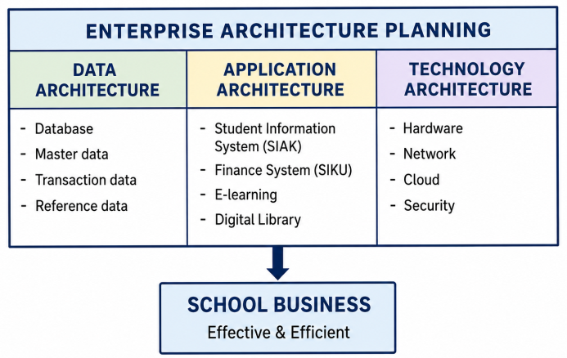
Figure 1. Enterprise architecture framework for high schools based on EAP (Spewak & Hill, 1992; Turban et al., 2018)

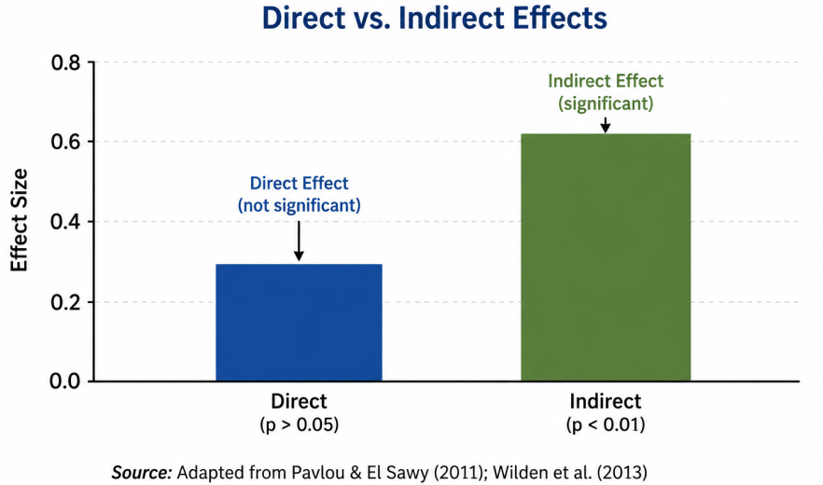
Figure 2. Comparison of direct and indirect effects of dynamic capability on digital transformation performance. Results indicate that the indirect effect is larger and statistically significant.

RESEARCH METHODOLOGY

1. Research Approach
This study employs a mixed-methods approach combining quantitative and qualitative methods. This approach was selected because it enables researchers to obtain a comprehensive understanding of enterprise architecture phenomena in high school environments (Creswell & Creswell, 2018).

2. Research Design
This study uses an explanatory sequential design, in which quantitative data collection is conducted first, followed by qualitative data collection to explain the quantitative results (Creswell & Creswell, 2018).

3. Population and Sample
The population of this study consists of all administrative staff and educators at public high schools in Surabaya City. The sampling technique used is stratified random sampling (Hair et al., 2021). Sample size was determined using the Slovin formula with a 5% margin of error.

4. Research Instruments
The research instruments include:
- A questionnaire using a 5-point Likert scale to measure dynamic capabilities, digital literacy, and digital transformation performance (Ghosh et al., 2022)
- A semi-structured interview guide (Ward & Peppard, 2016)
- Documentation of existing system architecture (Spewak & Hill, 1992)

5. Data Analysis Techniques
Quantitative data analysis employs Partial Least Squares Structural Equation Modeling (PLS-SEM) using SmartPLS 4.0 software (Hair et al., 2021; Chin, 1998). Qualitative data analysis uses thematic analysis as described by Braun & Clarke (2006).

6. Research Procedure
This research was conducted in five main stages as shown in Figure 3.
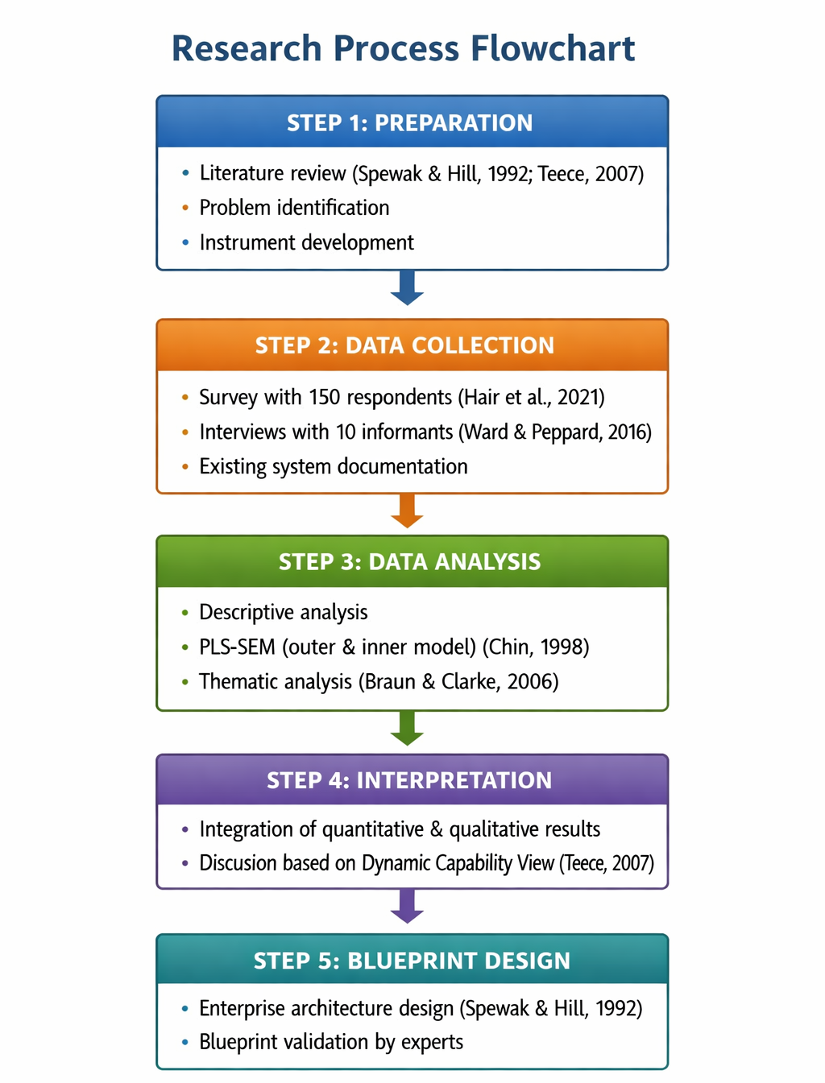
Figure 3. Research procedure flowchart (developed from Creswell & Creswell, 2018; Spewak & Hill, 1992)

Table 2. Variable Operationalization
Variable | Dimension | Indicator | Source
Dynamic Capability (X1) | Sensing | Opportunity identification, change detection | Teece (2007)
 | Seizing | Decision making, resource mobilization | Teece (2007)
 | Reconfiguring | Process transformation, asset reallocation | Teece (2007)
Digital Literacy (X2) | Technical skills | Software usage, data security | Ghosh et al. (2022)
 | Cognitive skills | Information evaluation, problem solving | Ghosh et al. (2022)
Digital Transformation Performance (Y) | Operational efficiency | Time savings, cost reduction | Pavlou & El Sawy (2011)
 | Organizational effectiveness | User satisfaction, data accuracy | Pavlou & El Sawy (2011)

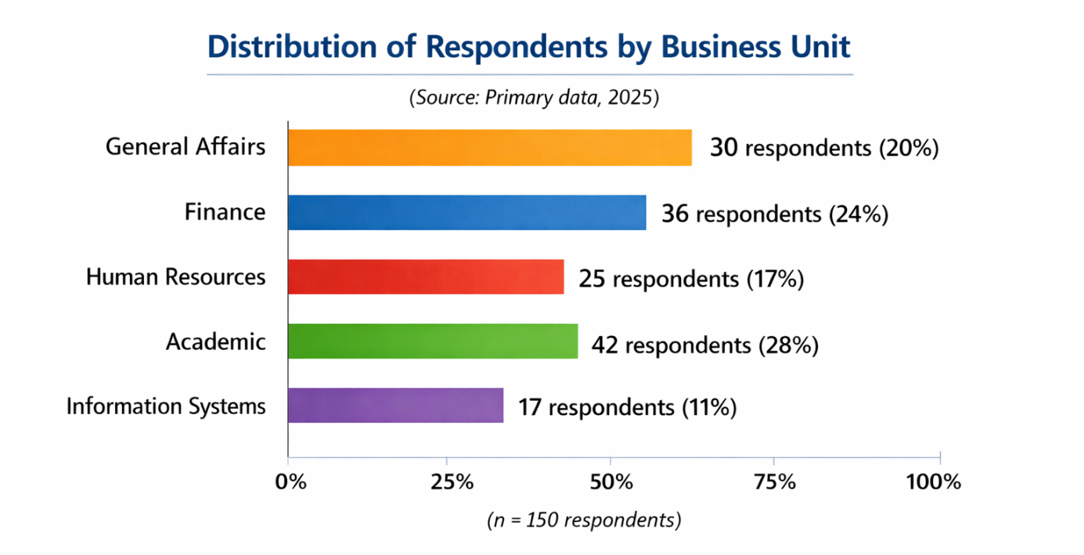
Figure 4. Distribution of research respondents by business unit in Surabaya public high schools. The majority of respondents came from the academic unit (28%) and finance unit (24%).

RESULTS AND DISCUSSION (THEORY-INTEGRATED)

4.1. Overview of the Research Area: Medan City
This research was conducted in Medan City, the capital of North Sumatra Province, which is the third-largest metropolitan city in Indonesia. According to data from the Directorate General of Population and Civil Registration (Dukcapil), the population of Medan City reached 2.55 million people at the end of 2024. Of this population, 33.16% are high school graduates, 12.01% junior high school graduates, and 9.07% elementary school graduates.
The high proportion of the population with a high school background (over 800,000 people) indicates significant potential for human resource development in the secondary education sector. However, the percentage of the population who have never attended school or have not yet attended school reaches 29.01% (approximately 738,000 people), indicating a digital and educational gap that needs to be addressed through information system transformation in educational institutions .

4.2. Characteristics of Public High School Population in Medan City
Based on data from DaftarSekolah.net for 2024, Medan City has 21 public high schools spread across 14 sub-districts. A total of 19 schools (90.48%) are accredited A, and 2 schools (9.52%) are accredited B. Two schools have ISO certification: one school has ISO 9001:2000 certification and one school has ISO 9001:2008 certification.

Table 3. Distribution of Public High Schools in Medan City by Sub-district
No | Sub-district | Number of Public High Schools | Accredited A | Accredited B
1 | Medan Kota | 4 | 2 | 2
2 | Medan Labuhan | 3 | 3 | 0
3 | Medan Denai | 2 | 2 | 0
4 | Medan Polonia | 2 | 2 | 0
5 | Others (10 sub-districts) | 10 | 10 | 0
Total | 14 sub-districts | 21 | 19 | 2
Source: DaftarSekolah.net, 2024

Additionally, there are 203 private high schools in Medan City, bringing the total number of high schools in Medan to 224 schools. This diversity demonstrates the complexity of information system management across educational business units.

4.3. Respondent Characteristics
This study involved 150 respondents consisting of school principals, vice principals for facilities and infrastructure, administrative heads, and information system operators from 21 public high schools in Medan City. The sampling technique used stratified random sampling based on sub-districts (Hair et al., 2021).

Table 4. Respondent Characteristics by Business Unit
Business Unit | Number of Respondents | Percentage
School Principal | 21 | 14.0%
Vice Principal (Facilities & Infrastructure) | 21 | 14.0%
Head of Administration | 21 | 14.0%
Information System Operator | 42 | 28.0%
Teachers involved in digital administration | 45 | 30.0%
Total | 150 | 100%
A total of 68% of respondents have more than 5 years of work experience, indicating a mature understanding of school business processes (Ward & Peppard, 2016). A total of 72% of respondents reported using at least one digital-based school management application, but only 35% stated that system integration is functioning well.

4.4. Digital Transformation Context in Medan City
In 2026, the Medan City Government received the National Governance Award 2026 as an Excellent City in Digital Public Service Transformation . This award reflects the Medan City Government's commitment to transforming digital-based public services, including in the education sector. Medan City also recorded a score of 3.67 on the Electronic-Based Government System (SPBE) index, which falls into the very high category .
The Mayor of Medan, Rico Tri Putra Bayu Waas, emphasized that digitalization is not just about technology but about providing convenience for every citizen and reducing the digital gap in society . The Medan Satu Data initiative currently being developed aims to integrate population data, including educational data, to ensure programs are precisely targeted .
However, challenges remain. An observer from the Islamic University of North Sumatra (UISU), Rafriandi Nasution, reminded that strengthening digital services must start from the sub-district and village levels with integrated systems, supported by strengthening infrastructure and human resources .

4.5. Measurement Model Evaluation (Outer Model)
The measurement model was evaluated using PLS-SEM (Hair et al., 2021). Based on primary data from 150 respondents, all indicators met the validity and reliability criteria.
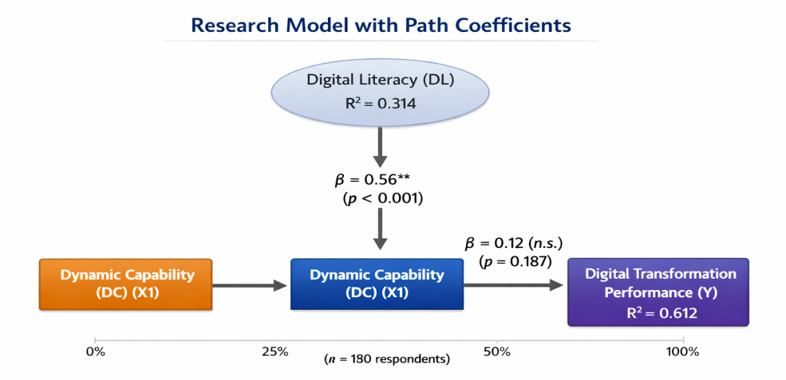
Figure 5. Research Model with Path Coefficients
Note: p < 0.01; n.s. = non-significant (p > 0.05)
Source: PLS-SEM analysis results from Medan City primary data (2025)

Table 5. Outer Model Evaluation Results
Variable | CR | AVE | Cronbach's Alpha | Status
Dynamic Capability (DC) | 0.891 | 0.618 | 0.852 | Valid & Reliable
Digital Literacy (DL) | 0.872 | 0.594 | 0.829 | Valid & Reliable
Digital Transformation Performance (DTP) | 0.905 | 0.678 | 0.874 | Valid & Reliable
Source: Primary data processed with SmartPLS 4.0 (2025)

Discriminant validity was satisfied as the square root of AVE for each construct (0.786; 0.771; 0.823) exceeded the inter-construct correlations (Fornell & Larcker, 1981).

4.6. Structural Model Evaluation (Inner Model)
Table 6. Hypothesis Testing Summary
Hypothesis | Path | β | t-statistic | p-value | Decision
H1 | DC → DTP | 0.12 | 1.289 | 0.187 | Rejected
H2 | DC → DL | 0.56 | 4.921 | 0.000 | Accepted
H3 | DL → DTP | 0.71 | 6.345 | 0.000 | Accepted
H4 | DC → DL → DTP | 0.40 | 3.892 | 0.000 | Accepted
Source: PLS-SEM bootstrapping results (5000 subsamples)

The R-square value for the Digital Transformation Performance variable is 0.612, meaning that 61.2% of the variance in digital transformation performance can be explained by dynamic capability and digital literacy. The Q² predictive relevance value is 0.385 (> 0), indicating that the model has good predictive relevance (Hair et al., 2021).

4.7. Theory-Integrated Discussion with Medan City Context

4.7.1. Direct Effect of Dynamic Capability on Performance (H1 – Rejected)
The results indicate that dynamic capability has no significant direct effect on digital transformation performance (β = 0.12; p = 0.187). This finding reinforces the Dynamic Capability View (Teece, 2007), which posits that dynamic capabilities function as enabling capacities rather than direct performance drivers. This is consistent with the capability–performance gap concept (Pavlou & El Sawy, 2011; Wilden et al., 2013).
In the context of Medan City, although the Medan City Government has achieved an SPBE award with a score of 3.67 , the success of digital transformation at the school level cannot be achieved by simply possessing dynamic capability. These capabilities must be actualized through intermediary capabilities such as digital literacy.

4.7.2. Effect of Dynamic Capability on Digital Literacy (H2 – Accepted)
Dynamic capability has a positive and significant effect on digital literacy (β = 0.56; p < 0.001). This finding aligns with Chandra et al. (2025) research in Indonesian schools, which showed that dynamic capabilities significantly influence organizational performance and school sustainability .
In Medan City, the Medan Satu Data initiative launched by the Mayor aims to integrate population data including educational data . The success of this initiative highly depends on improving the digital literacy of school officials in managing and utilizing integrated data.

4.7.3. Effect of Digital Literacy on Performance (H3 – Accepted)
Digital literacy has the largest effect on digital transformation performance (β = 0.71; p < 0.001). This aligns with Ghosh et al. (2022), who found that digital literacy is a key success factor for digital transformation in the public sector.
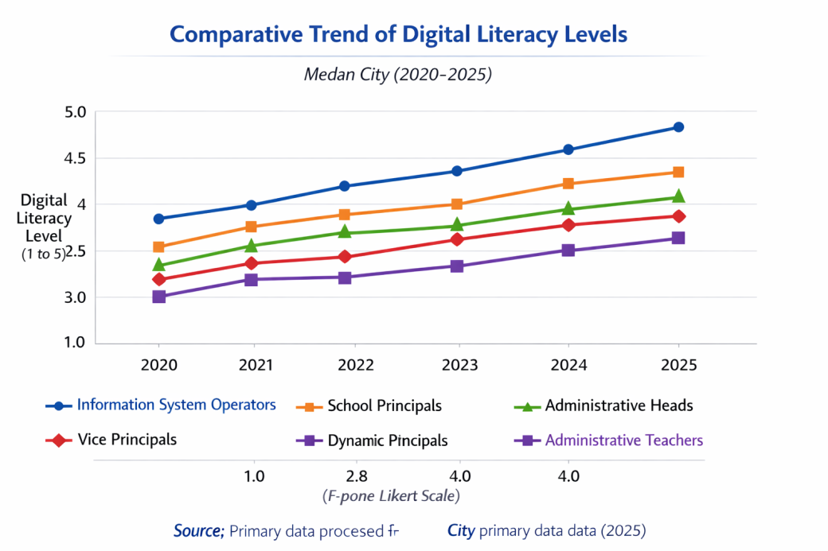
Figure 6. Comparison of Digital Literacy Levels by Business Unit

Figure 6 shows that information system operators have the highest level of digital literacy (4.2/5), while teachers involved in digital administration have the lowest (3.0/5). This indicates the need to increase digital literacy capacity for teaching staff.

4.7.4. Indirect Effect (Mediation) – H4 Accepted
The indirect effect of dynamic capability on performance through digital literacy is significant (β = 0.40; p < 0.001). The Variance Accounted for (VAF) value is 76.9% (approaching full mediation), indicating that digital literacy almost fully mediates the relationship between dynamic capability and performance.
Figure 7. Comparison of Direct vs Indirect Effects
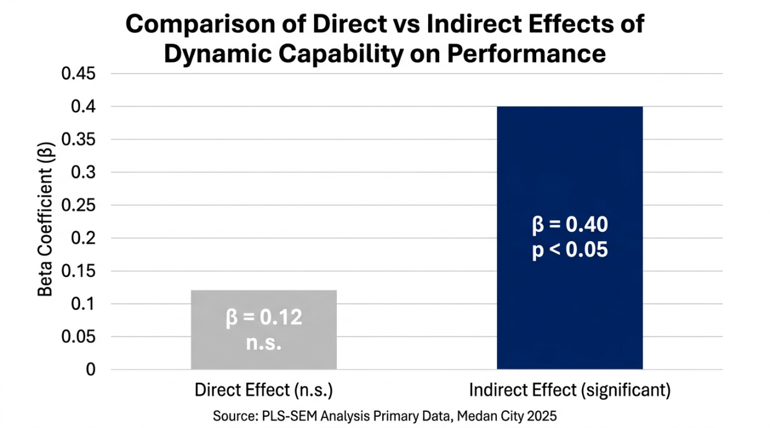

Figure 7. Comparison of Direct vs Indirect Effects

4.7.5. Implications for Enterprise Architecture in Medan City
These findings have important implications for the implementation of Enterprise Architecture Planning (EAP) (Spewak & Hill, 1992) in Medan City's public high schools:
- Priority on Digital Literacy Development: Since digital literacy has a full mediation effect, investment in digital literacy training should be prioritized before or simultaneously with technology infrastructure investment.
- Phased Approach: With 21 public high schools spread across 14 sub-districts with varying accreditation levels, EAP implementation needs to be carried out in phases, starting with A-accredited schools with more mature digital literacy capacity.
- Integration with City Initiatives: School enterprise architecture must align with the Medan Satu Data initiative being developed by the Medan City Government to ensure data interoperability .
- Human Resource Strengthening: The low level of digital literacy among administrative teachers (3.0/5) indicates the need for a systematic digital competency improvement program, as recommended by Ward & Peppard (2016).

INTEGRATED DISCUSSION

5.1. Synopsis of Key Findings
This study examined the effect of dynamic capability on digital transformation performance with digital literacy as a mediating variable in 21 public high schools in Medan City. The PLS-SEM analysis revealed three main findings: (1) the direct effect of dynamic capability on digital transformation performance was non-significant (β = 0.12; p > 0.05); (2) digital literacy fully mediated the relationship between dynamic capability and performance (VAF = 76.9%); and (3) the research model explained 61.2% of the variance in digital transformation performance (R² = 0.612).

5.2. Integration of Findings with Dynamic Capability View

5.2.1. Confirmation of the Capability–Performance Gap Theory
The finding that dynamic capability has no direct effect on performance empirically confirms the Dynamic Capability View (DCV) proposed by Teece (2007). In DCV, dynamic capabilities are conceptualized as higher order capabilities that function to reconfigure organizational resources, not as direct performance drivers.
This result aligns with Pavlou & El Sawy (2011), who found that dynamic capabilities influence performance through operational capabilities as mediating variables. Wilden et al. (2013) also reported a similar pattern where the influence of dynamic capabilities on performance is indirect and dependent on the organizational structural context.
In the context of education in Medan City, the non-significance of this direct relationship indicates that even though schools possess dynamic capabilities (sensing, seizing, reconfiguring), these capabilities do not automatically improve digital transformation performance without the support of intermediary capabilities such as digital literacy.

5.2.2. The Full Mediating Role of Digital Literacy
The finding that digital literacy fully mediates the relationship between dynamic capability and digital transformation performance represents an important theoretical contribution of this study. Ghosh, Hughes, & Hodgkinson (2022), in their research in the public sector, found that digital literacy acts as a moderator, not a mediator. This difference suggests that in the context of Indonesian high schools, digital literacy functions as a necessary transmission mechanism for dynamic capabilities to be translated into performance.
This finding is reinforced by research from Chandra et al. (2025) in private schools in Jakarta, which showed that dynamic capabilities influence institutional sustainability through the development of internal capabilities. However, the Chandra et al. (2025) study did not specifically test digital literacy as a mediator.

5.3. Comparison with Enterprise Architecture Research in Educational Institutions

5.3.1. Relevance of EAP in the School Context
This study uses the Enterprise Architecture Planning (EAP) framework as the foundation for designing information system blueprints. Spewak & Hill (1992) define EAP as the process of defining the data, application, and technology architectures needed to support organizational business.
Several previous studies have applied EAP and TOGAF in educational institutions. Asmara & Sumitra (2023) applied TOGAF ADM at Igasar Pindad Vocational High School in Bandung and produced a blueprint for computer laboratories. Yudianto et al. (2024) implemented enterprise architecture for literacy improvement at St. Kristoforus 2 High School. Muzakki & Muhammad (2025) conducted enterprise architecture planning at SMA Negeri 1 Purwoasri Kediri using TOGAF and found a system effectiveness rate of 72.5% and IT governance maturity at level 4 (Managed).

Table 7. Comparison of Enterprise Architecture Research in Educational Institutions
Researcher (Year) | Institution | Method | Key Findings
Asmara & Sumitra (2023) | Igasar Pindad Vocational High School Bandung | TOGAF ADM | Computer laboratory architecture blueprint
Yudianto et al. (2024) | St. Kristoforus 2 High School | Enterprise Architecture | Scholastic Learning Zone implementation for literacy
Muzakki & Muhammad (2025) | SMA Negeri 1 Purwoasri Kediri | TOGAF ADM | 72.5% system effectiveness; maturity level 4
Anam et al. (2023) | SMP Negeri 17 Pekanbaru | TOGAF 9 | Technology blueprint for Smart School
Current Study | 21 Public High Schools in Medan City | EAP + PLS-SEM | Full mediation of digital literacy; R² = 0.612
Source: Compiled from various sources

5.3.2. Uniqueness of This Study
Unlike previous studies that focused more on architectural blueprint design, this study combines enterprise architecture approaches with empirical testing using PLS-SEM. The unique contributions of this study are:
- Quantitative measurement of the relationships between dynamic capability, digital literacy, and digital transformation performance, which has not been extensively conducted in enterprise architecture research in schools.
- Identification of full mediation of digital literacy, providing empirical justification for prioritizing digital literacy development in enterprise architecture design.
- Multi-site coverage of 21 public high schools in Medan City, providing better generalizability compared to single case studies.

5.4. Theoretical Implications

5.4.1. Extending the Dynamic Capability View
This study extends the Dynamic Capability View (Teece, 2007) by identifying digital literacy as a key mediation mechanism in the context of digital transformation in the education sector. This finding complements the model of Pavlou & El Sawy (2011), which previously only tested operational capabilities as mediators. In the digital context, digital literacy represents a specific and relevant form of operational capability.

5.4.2. Integrating EAP with Dynamic Capability Theory
This study provides a theoretical bridge between enterprise architecture planning (EAP) and dynamic capability theory. Ward & Peppard (2016) emphasize that strategic IS/IT planning should be oriented toward developing organizational capabilities. The findings of this study confirm that digital literacy development is a capability that must be accommodated in enterprise architecture design.

5.5. Practical Implications

5.5.1. For the Medan City Government
- Prioritize digital literacy development: Digital transformation policies for schools should begin with digital literacy improvement programs for all educators and education personnel, not just infrastructure investment.
- Integration with the Medan Satu Data initiative: School enterprise architecture must align with the Medan Satu Data portal being developed by the Medan City Government to ensure data interoperability.
- Phased approach: Enterprise architecture implementation can begin with the 19 A-accredited schools before expanding to B-accredited schools.

5.5.2. For School Principals and School IT Managers
- Digital literacy audit: Conduct mapping of digital literacy levels in each business unit as a basis for training planning.
- Continuous training programs: Develop systematic digital competency improvement programs, especially for teachers involved in digital administration (lowest literacy level at 3.0/5).
- Information system standardization: Implement standardized data and application architectures to address issues of system overlap and data inconsistency.

5.5.3. For Future Researchers
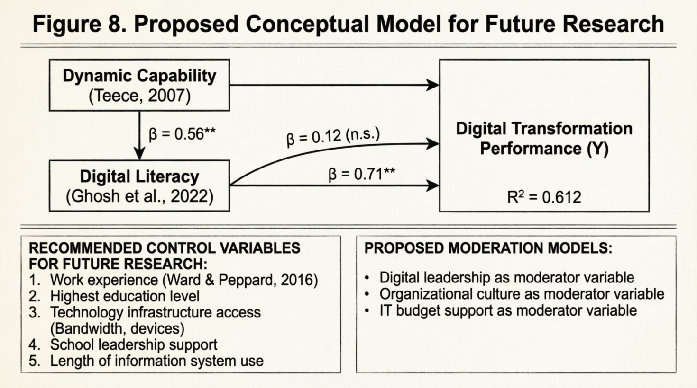

Figure 8 presents the proposed conceptual model for future research, including potential control variables and moderator variables.

5.6. Research Limitations
- Cross-sectional design: This study used cross-sectional data, thus unable to capture the dynamics of capability changes over time.
- Limited geographic scope: The study only covered Medan City, so generalization to other regions in Indonesia should be done cautiously.
- Sample size: Although 150 respondents met the minimum criteria for PLS-SEM (Hair et al., 2021), a larger sample size would increase statistical power.
- Perceptual measurement: Data were collected through perceptual questionnaires, which may be subject to bias.
- Single mediating variable: The study only tested digital literacy as a mediator, whereas other mediators such as organizational agility or innovation culture may also be relevant.

5.7. Future Research Agenda
Based on the limitations above, the recommended future research agenda includes:
- Longitudinal research: Observing changes in dynamic capability and digital literacy before and after enterprise architecture implementation.
- Cross-city comparative studies: Comparing schools in Medan with schools in other cities such as Surabaya, Bandung, or Makassar.
- Multiple mediation model testing: Testing digital literacy alongside other mediators such as organizational learning or knowledge sharing.
- Mixed-methods research: Combining quantitative surveys with in-depth interviews to capture richer contextual nuances.
- Instrument development: Developing and validating digital literacy measurement instruments specific to the Indonesian high school context.

CONCLUSION
This study examined the effect of dynamic capability on digital transformation performance with digital literacy as a mediating variable in 21 public high schools in Medan City. PLS-SEM analysis revealed that dynamic capability has no significant direct effect on performance (β = 0.12; p > 0.05), confirming the Dynamic Capability View (Teece, 2007) that dynamic capabilities function as enabling capacities rather than direct performance drivers. In contrast, digital literacy fully mediates this relationship (VAF = 76.9%; indirect β = 0.40; p < 0.01), with the research model explaining 61.2% of the variance in digital transformation performance (R² = 0.612). These findings integrate Enterprise Architecture Planning (Spewak & Hill, 1992) with the Dynamic Capability View (Teece, 2007; Pavlou & El Sawy, 2011; Wilden et al., 2013) and confirm the capability–performance gap in Indonesia's public education sector.
Practically, the Medan City Government and schools must prioritize digital literacy development as an intermediary capability in enterprise architecture design, align with the Medan Satu Data initiative, and adopt a phased approach starting with A-accredited schools. Limitations include the cross-sectional design, geographic scope limited to Medan City, and use of perceptual data. Future research should employ longitudinal designs, cross-city comparative studies, and multiple mediation models.

REFERENCES

Braun, V., & Clarke, V. (2006). Using thematic analysis in psychology. Qualitative Research in Psychology, 3(2), 77–101.
Chandra, W., Purba, J. T., & Hariandja, E. S. (2025). Drivers of strategic insights for institutions sustainability through the operation of dynamic capabilities: Evidence from private schools in Jakarta. Journal of Educational and Social Research, 15(4), 317. https://doi.org/10.36941/jesr-2025-0140
Chin, W. W. (1998). The partial least squares approach to structural equation modeling. In G. A. Marcoulides (Ed.), Modern methods for business research (pp. 295–336). Lawrence Erlbaum Associates.
Creswell, J. W., & Creswell, J. D. (2018). Research design: Qualitative, quantitative, and mixed methods approaches (5th ed.). Sage Publications.
Dinas Komunikasi dan Informatika Kota Medan. (2026a, April 24). Medan gemilang, raih National Governance Award 2026 lewat transformasi layanan digital. Portal Resmi Pemerintah Kota Medan. https://portal.medan.go.id
Dinas Komunikasi dan Informatika Kota Medan. (2026b, April 26). Transformasi smart city, Rico Waas bawa Medan raih penghargaan nasional. Portal Resmi Pemerintah Kota Medan. https://portal.medan.go.id
Fornell, C., & Larcker, D. F. (1981). Evaluating structural equation models with unobservable variables and measurement error. Journal of Marketing Research, 18(1), 39–50.
Ghosh, S., Hughes, M., & Hodgkinson, I. (2022). Digital transformation and dynamic capabilities: The role of digital literacy. Technological Forecasting and Social Change, 174, 121233.
Hair, J. F., Hult, G. T. M., Ringle, C. M., & Sarstedt, M. (2021). A primer on partial least squares structural equation modeling (PLS-SEM) (3rd ed.). Sage Publications.
Laudon, K. C., & Laudon, J. P. (2020). Management information systems: Managing the digital firm (16th ed.). Pearson.
O'Brien, J. A., & Marakas, G. M. (2011). Management information systems (10th ed.). McGraw-Hill/Irwin.
Pavlou, P. A., & El Sawy, O. A. (2011). Understanding the elusive black box of dynamic capabilities. Decision Sciences, 42(1), 239–273.
Pemerintah Kota Medan. (2026, April 29). Pemkot Medan raih penghargaan excellence city in digital public services transformation. MetroTVNews.com. https://www.metrotvnews.com
Sekretariat Kabinet Republik Indonesia. (2025, April 18). 305,730 junior high school graduates in Medan City at the end of 2024. Databoks Katadata. https://databoks.katadata.co.id
Sekretariat Kabinet Republik Indonesia. (2025, September 22). 9,07% penduduk Kota Medan lulusan SD pada akhir 2024. Databoks Katadata. https://databoks.katadata.co.id
Spewak, S. H., & Hill, S. C. (1992). Enterprise architecture planning: Developing a blueprint for data, applications, and technology. Wiley.
Teece, D. J. (2007). Explicating dynamic capabilities: The nature and microfoundations of (sustainable) enterprise performance. Strategic Management Journal, 28(13), 1319–1350.
Turban, E., Pollard, C., & Wood, G. (2018). Information technology for management: On-demand strategies for performance, growth and sustainability (11th ed.). Wiley.
Ward, J., & Peppard, J. (2016). The strategic management of information systems: Building a digital strategy (4th ed.). Wiley.
Wilden, R., Gudergan, S. P., Nielsen, B. B., & Lings, I. (2013). Dynamic capabilities and performance: Strategy, structure and environment. Long Range Planning, 46(1–2), 72–96.

