THE IMPACT OF LEARNING MANAGEMENT SYSTEM ON STUDENT ENGAGEMENT OF UNDERGRADUATES IN SRI LANKAN STATE UNIVERSITIES

Abstract

The use of Learning Management Systems (LMS) in higher education continues to grow, yet the amount of engagement in student outcomes is still developing. This study investigates the relationship between LMS and student engagement in the state universities of Sri Lanka.
The LMS can be defined as a digital learning environment that manages all aspects of an institution’s academic efforts. It also manages user information for personalized delivery including their user profile, individual performance, and preferences. LMS is further addressed within three dimensions; system quality, information quality, and service quality. Student engagement can be defined as, a measure of a student's level of interaction with others, plus the quantity of involvement in and quality of effort directed toward academic activities that lead to persistence and completion.
The researcher used convenience sampling method to collect primary data, among the state university undergraduates. The researcher used a quantitative technique used to assess the impact of LMS on student engagement. Results of the univariate analysis indicated that there is a high level of LMS usage in state universities in Sri Lanka and also a high level of student engagement in state universities in Sri Lanka. The Pearson Coefficient correlation indicated that there is a strong positive relationship between LMS and student engagement. The r-squared value indicated 0.701, i.e., 70.1% of the variation in student engagement is explained by system quality, information quality, and service quality. And finally, reached the conclusion that LMS has a positive impact on the student engagement of undergraduates in state universities in Sri Lanka.
Keywords: Learning Management System (LMS), Student Engagement, System Quality, Information Quality and Service Quality.

Introduction
Learning Management Systems (LMS) is a software that is designed to assist administrative activities and facilitate how students interact with e-learning materials, classes and events, it is very much easy and time-saving to track and report the student’s progress (Rashida, 2018). From a student’s perspective, LMS can help them to plan the process of their learning according to their individual progress and communicate with colleagues and lecturers (Jin, Lin, Zhao, Yu, & Su, 2021). According to Coates, James & Baldwin (2005); Trowler (2013), there has been a lack of research exploring student engagement in LMS environments. Dawson & McWilliam (2008) indicated, LMS data may be used to measure student engagement for use in institutional planning. However, research is lacking that investigates relationships between student engagement and LMS usage data. Only through assessing the engagement within the LMS activities and student outcomes will researchers be able to make informed decisions about instructional implementation (Coates, James, & Baldwin, 2005). So, the present study specifically try to identify the impact of Learning Management Systems on Student Engagement.
Therefore, the research question of this study is;
“What is the Impact of Learning Management Systems on Student Engagement of Undergraduates in Sri Lankan State Universities?”
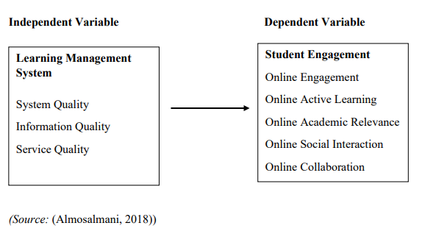

Figure 01: Conceptual Framework
Materials and Methods
The time horizon for this study is cross-sectional and quantitative technique is used in this study. This research is limited to the State Universities of Sri Lanka, so the undergraduates of the state universities listed by the Universities Grants Commission (UGC) were considered as the population of this study. The sample that has been identified for this study is 100 undergraduates who are following a bachelor’s degree program in some of the state universities of Sri Lanka. Data, which are collected from the respondents through the questionnaire are used for the analysis and evaluated by using univariate, and bivariate. The Statistical Package for Social Science (SPSS 25.0) simplifies the analysis work of this study.
Results and Discussion

Overall Cronbach’s alpha value for the LMS is 0.955 and Overall Cronbach’s alpha value for the student engagement is 0.950.
According to Table 1, it is clear that System Quality, Information Quality, Service Quality, and LMS are at a High Level as all mean values of those four variables are between (3.5 < Xi ≤ 5.0).
Further, as per the decision criteria, Online Engagement and Online active learning show a high level as their mean values are ranging within 3.5 & 5.0. At the same time, Online Academic Relevance, Online Collaboration, Online Social Interaction, and Student Engagement show a moderate level as their mean value range between 2.5 & 3.5.
Dimension | Mean | Standard Deviation | Decision Attribute
System Quality | 3.57 | 0.989 | High Level
Information Quality | 3.73 | 0.918 | High Level
Service Quality | 3.50 | 0.864 | High Level
LMS | 3.60 | 0.860 | High Level
Online Engagement | 3.61 | 0.894 | High Level
Online Active Learning | 3.66 | 0.876 | High Level
Online Academic Relevance | 3.47 | 0.909 | Moderate Level
Online Collaboration | 3.36 | 0.932 | Moderate Level
Online Social Interaction | 3.36 | 0.899 | Moderate Level
Student Engagement | 3.49 | 0.787 | Moderate Level
Table 01: Descriptive Statistics
The Table 02, clearly shows the correlation analysis between Learning Management System and Student Engagement. It indicates that, there is a linear positive correlation between Learning Management System and Student Engagement. The correlation coefficient (r) value between Learning Management System and Student Engagement is 0.836 at a 0.05 significant level of the decision rule. This provides a strong positive relationship between the Learning Management System and Student Engagement of undergraduates of State Universities in Sri Lanka.
According to Table 03, "R Square" statistic indicates that the three independent variables in the regression model accounted for 70.1 percent of the total variation in student engagement. In other words, 70.1% of the variation in student engagement is explained by system quality, information quality, and service quality.
The Table 04, ANOVA findings also confirm the existing correlation between the independent and dependent variables. As it indicates that the P-value is 0.000 which is less than 0.05 it shows that the model is statistically significant in explaining the impact of LMS on Student Engagement.

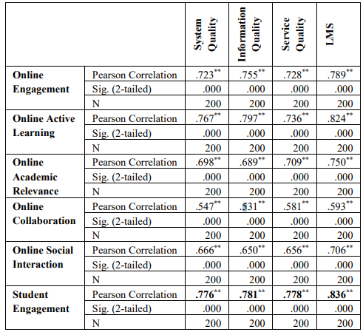
Table 02: Correlation Analyses Between LMS and Student Engagement
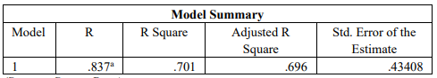
Table 03: Model Summary

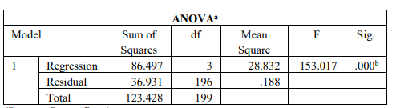
Table 04: Anova
The Table 05 shows that, unstandardized constant statistic is 0.697 units. It shows that the model would predict that value if all of the three independent variables were zero. The b coefficient for System Quality is 0.177. This means that on average if the System Quality scale goes up by 1 point, Student Engagement will increase by 0.177 units. The b coefficient for Information Quality is 0.294. This means that on average if the Information Quality scale goes up by 1 point, Student Engagement will increase by 0.294 units. The b coefficient for Service Quality is 0.305. This means that on average if the Service Quality scale goes up By 1 Point, Student Engagement Will Increase By 0.305 Units. According To The P-Values, Information Quality And Service Quality Are Significant At 0.000, And System Quality Is Significant At 0.006. This Means There Will Be A Strong Positive Relationship Between Service Quality, Information Quality, And Service Quality On Student Engagement In This Study. Based On The Table 5 , The Equation For The Regression Line Is: Y = 0.697 + 0.177X₁ + 0.294X₂ + 0.305X₃.
Where,
Y= Student Engagement
X₁ ₌ System Quality
X₁ =Information Quality
X₃ =Service Quality
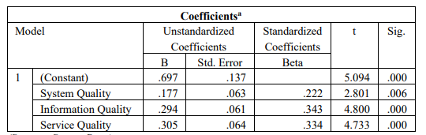

Table 05: Regression Analyses between System Quality, Information Quality, Service Quality, and Student Engagement
Conclusion
To arrive at conclusions for this study with regard to the research questions, descriptive statistics, correlation, and regression were used. The study is conducted by two hundred undergraduates who are currently following a bachelor’s degree in any of the state universities of Sri Lanka. The level of Learning Management Systems and its dimensions of system quality, information quality, and service quality; and the level of Student Engagement and its dimension indicates high levels in the state universities in Sri Lanka.
The results of the correlation analysis indicated that there is a strong positive correlation between Learning Management Systems and Student Engagement. As well as the variables of LMS have a strong positive relationship between student engagement and system quality, information quality, and service quality separately. The results of regression analysis indicated that there is a positive impact of Learning Management Systems on Student Engagement.
References
Almosalmani, Y. (2018). Effectiveness of Student Engagement Using Learning Management System in the Blended Learning Environment at Saudi Electronic University.
Coates, H., James, R., & Baldwin, G. (2005). A critical examination of the effects of learning management systems on university teaching and learning. Tertiary education and management.
Dawson, S., & McWilliam, E. (2008). Investigating the application of IT generated data as an indicator of learning and teaching performance . Queensland University of Technology and the university of British Columbia .
Jin, Y. Q., Lin, C.-L., Zhao, '., Yu, S.-W., & Su, Y.-S. (2021). A Study on Traditional Teaching Method Transferring to E-Learning Under the Covid-19 Pandemic: From Chinese Students' Perspectives. Frontiers in Psychology.
Prabowo, H., Yuniarty, & Ikhsan, R. B. (2022). Student Engagement Mechanism of Online Learning: The Effect of Service Quality on Learning Management System. International Journal of Informatics Visualization.
Rashida, M. F. (2018). Learning Management System in Higher Education Institutions . Journal of Informtion Systems & Information Technology.
Trowler, V. (2013). Leadership practises for student engagement in challenging conditions. Perspectives: Policy and Practise in Higher Education.

