STOCK MARKET ANALYSIS USING MACHINE LEARNING

Abstract— Stock Market Price and Trend Prediction are very Challenging and different tasks in Stock
Market for every Investor and Trader. Market Repeat History itself, Analyse the current and historical data of the market. Data include Total Volume, LTP (Last
Trade Price), Closing Price, Opening Price, Total OI
(Open Interest), Last Swing, etc. Machine Learning
algorithms Play an important role in Stock Market for
Price Prediction and forecasting. LSTM (Long Sort
Term Memory) ML Model is the Best Method for
Stock Price Prediction. which is RNN (Recurrent
Neural Network) that can remember information over a long period of time, thus making them extremely useful for predicting stock prices. We use Machine
Learning for predicting the stock price in various forms. Stock or indices, such as future index, Future
value of opening price, the closing price, Volume, etc.
This Research Paper is all about discussing techniques, setup, rules, and technical and fundamental analysis. This will help all investors and traders to have a better understanding of the stock market and faster and right decisions.

Keywords: Stock market Prediction, Machine
Learning (LSTM), RNN

INTRODUCTION
A share market is a Place Where to Trade in Public Listed Companies. It Determines the Future Value of the Company Stock. Stock Market is an important part of the country's economy and a vital role in the growth of industry and commerce in the country affects the country's economy. Many people are involved in the stock market such as retailer investors, other domestic institutions, foreign investors, and industry. He wants to know whether some stock prices will rise or fall over a certain period. Stock Market is the primary source for any company to raise funds through IPO (Initial Price Offering) for business expansion. It is based on the demand and supply concept.
If the demand for company stock is high, then the share price of a company is increasing and if the demand for company stock is low, then the share price of a company is decreasing. Share price all depends on demand and supply. Stock market analysis and price prediction will reveal the market pattern and predict the right time to purchase stock, the stock market repeat history itself. machine learning is a method of more data analysis from historical data and automatically analyzing model building using algorithms, machine learning allows computers to find hidden information.
Mostly two methods are widely used for stock analysis and price prediction namely Fundamental Analysis and Technical Analysis. machine learning algorithms application focused on technical analysis and fundamental analysis.


Fig.1

Stock Market

Fundamental Analysis
Fundamental Analysis is the art of value investing in stock to find long-term investing opportunities and study the intrinsic value of stock and financial statements of the company, also study whether LTP is higher or lower than the real value of the stock, Ratio, and Balance Sheet.

Technical Analysis
Technical Analysis is a method for identifying the trend of a stock and predicting stock movements based on historical data on the market, current price, chart patterns, and volume. Also, analyse support and resistance with the help of forming price action on the market. The trend is your friend gives you more opportunities to trade or invest in the short term.

LITERATURE REVIEW
Predicting stock prices using machine learning algorithms: A systematic literature review (2018) by Bao, Yue, and Rao.
This literature review provides a comprehensive overview of research papers that have used various machine learning algorithms for stock price prediction. The authors analyze the strengths and weaknesses of different machine learning techniques, such as support vector machines (SVM), artificial neural networks (ANN), and decision trees, for stock price prediction. They highlight the challenges associated with predicting stock prices, including the non-linearity and volatility of stock prices, and the impact of external factors on stock prices. The review also discusses the performance evaluation metrics used in the literature and identifies potential future research directions, such as the use of deep learning techniques and ensemble methods for stock price prediction.

A survey on stock market prediction using machine learning and data mining techniques (2017) by Hafezalkotob, Ashour, and Al-Jumeily.
This survey provides an overview of the use of machine learning and data mining techniques for stock market prediction. The authors review the literature on various machine learning algorithms, including SVM, ANN, decision trees, and genetic algorithms, for stock market prediction. They discuss the features used in stock market prediction, such as technical indicators, market sentiment, and macroeconomic indicators. The survey also highlights the challenges in stock market prediction, such as data quality, data preprocessing, and overfitting, and suggests potential future research directions, such as the use of big data analytics and sentiment analysis for stock market prediction.

Stock market prediction using machine learning algorithms: A literature review (2019) by Heliövaara, Järvenpää, and Niska.
This literature review provides an overview of research papers that have used machine learning algorithms for stock market prediction. The authors discuss the different machine learning techniques used, including SVM, ANN, random forests, and LSTM (Long Short-Term Memory) networks. They review the features used in stock market prediction, such as technical indicators, fundamental indicators, and market sentiment. The review also discusses the challenges in stock market prediction, such as the availability of reliable data, the efficiency of machine learning algorithms, and the interpretability of results. The authors highlight potential future research directions, such as the use of deep learning techniques and ensemble methods, and the integration of external data sources for stock market prediction.

Deep learning in finance: A literature review (2020) by Conlon and McGinnity.
This literature review provides an overview of the use of deep learning techniques in finance, including stock market analysis. The authors review the literature on various deep learning algorithms, such as convolutional neural networks (CNN), recurrent neural networks (RNN), and generative adversarial networks (GAN), for stock market prediction. They discuss the features used in stock market analysis, such as historical stock prices, financial statements, and news sentiment. The review also highlights the challenges in applying deep learning techniques to stock market analysis, such as data scarcity, overfitting, and interpretability of results. The authors suggest potential future research directions, such as the use of transfer learning and attention mechanisms, and the integration of multiple data sources for stock market analysis.

PROPOSED SYSTEM

The proposed system would involve the use of various machine learning techniques to analyze stock market data and make predictions about future stock prices.

The first step in developing a stock market analysis system using machine learning would be to collect historical stock market data. This data would include information such as stock prices, trading volumes, last swing, and other relevant financial indicators. Once the data has been collected, it can be preprocessed to remove any outliers or anomalies that may impact the accuracy of the analysis.

Next, various machine learning algorithms such as decision trees, LSTM, and neural networks can be applied to the preprocessed data. These algorithms would be trained on historical data to identify patterns and relationships between various financial indicators and stock prices. Once the algorithms have been trained, they can be used to make predictions about future stock prices based on new data.

To evaluate the accuracy of the system, the predictions made by the machine learning algorithms can be compared to actual stock prices. If the system is accurate, it can be used to inform investment decisions and help investors make informed decisions about which stocks to buy, sell or hold.

In addition to predicting stock prices, the proposed system could also be used to identify potential risks and opportunities in the stock market using different setups such as 5 EMA, 2.20 setup, RSI, VWAP, support, and resistance. For example, the system could analyze market trends and identify sectors that are likely to perform well or poorly in the future.

Data Analyze and preprocessing (Stock Historical data)

Feature extraction and selection (Technical indicator)

Optimizing and training with setup and strategy

Testing with setup

Prediction signal
Proposed System Flow diagram

Overall, the proposed system of stock market analysis using machine learning has the potential to provide investors with valuable insights and help them make more informed investment decisions. However, it is important to note that machine learning algorithms are not perfect and there is always a risk of error or bias in the analysis. It is therefore important to use the system in conjunction with other sources of information and to exercise caution when making investment decisions based on machine learning predictions.

Table 1
Sr. N | Stock Prediction
Sr. N | Read in research paper | Now new add
1 | Artificial Neural Network | 5EMA
2 | Long Short-Term Memory | 2.20
3 | Recurrent Neural Network | RSI
4 | Time Series Linear Model | Support Resistance

METHODOLOGY
The methodology of stock market analysis using machine learning typically involves the following steps:

- Data collection: The first step in stock market analysis using machine learning is to collect data. This data may include historical prices, trading volumes, financial statements, news articles, and other relevant information.
- Data pre-processing: The collected data needs to be pre-processed to ensure that it is in a format suitable for machine learning analysis. This may involve cleaning the data, removing outliers, and transforming the data into a format that can be used by machine learning algorithms.
- Feature engineering: After pre-processing, the data needs to be prepared for analysis by selecting the relevant features. Features may include various technical indicators such as moving averages, relative strength indices, and Bollinger bands, as well as fundamental data such as earnings per share, price-toearnings ratios, and dividend yields.
- Algorithm selection: There are various machine learning algorithms that can be used for stock market analysis, including decision trees, random forests, neural networks, and support vector machines. The appropriate algorithm depends on the specific problem being addressed and the characteristics of the data.
- Model training: Once the algorithm has been selected, the data is split into a training set and a testing set. The training set is used to train the machine learning model, while the testing set is used to evaluate the performance of the model.

- Model evaluation: The performance of the machine learning model is evaluated using various metrics such as accuracy, precision, recall, and F1 score. The performance of the model can be further improved by adjusting hyperparameters such as the learning rate, regularization strength, and number of hidden layers.
- Deployment: Once the model has been trained and evaluated, it can be deployed in a real-world application. This may involve integrating the model into a trading algorithm or using it to make investment decisions.
- Recurrent Neural Network: Recurrent Neural Network is a technique that is used for backpropagation to learn, this model predicts stock price based on previous data history.
- Artificial Neural Network: An artificial neural network (ANN) is a type of machine learning algorithm that is commonly used in stock market analysis. ANNs are modeled after the structure of the human brain and are designed to recognize patterns and relationships in data. In the context of stock market analysis, an ANN is typically used to predict stock prices based on historical data.
Overall, the methodology of stock market analysis using machine learning is a complex and iterative process that requires expertise in both machine learning and finance. It is important to carefully evaluate the performance of the model and to use caution when making investment decisions based on machine learning predictions.

RESULT

Artificial Neural Network: An Artificial Neural Network is a machine learning technique that is commonly used in the stock market to predict stock prices.
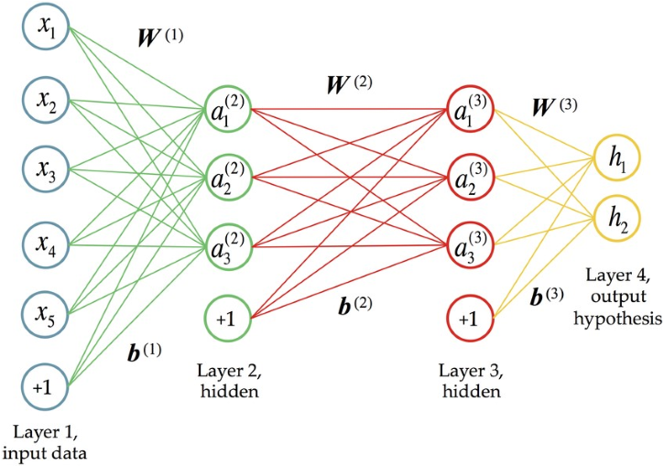

Fig.2 Artificial Neural Network

5 EMA Setup: 5ema setup is an Exponential Moving Average setup that predicts the stock market with high accuracy. It is simple and easy to apply whenever the 15min candle body settles below the 5ema line without touching the candle body high in the 5ema line this candle body is the alert candle when a candle breaks the alert candle high and then goes to the up-trend market. See in Fig. 3.1 Whenever the 5min candle settles above the 5ema line without touching the candle body low, it's the alert candle that breaks the alert candle body low and then signals to fall market, see in Fig. 3.2.
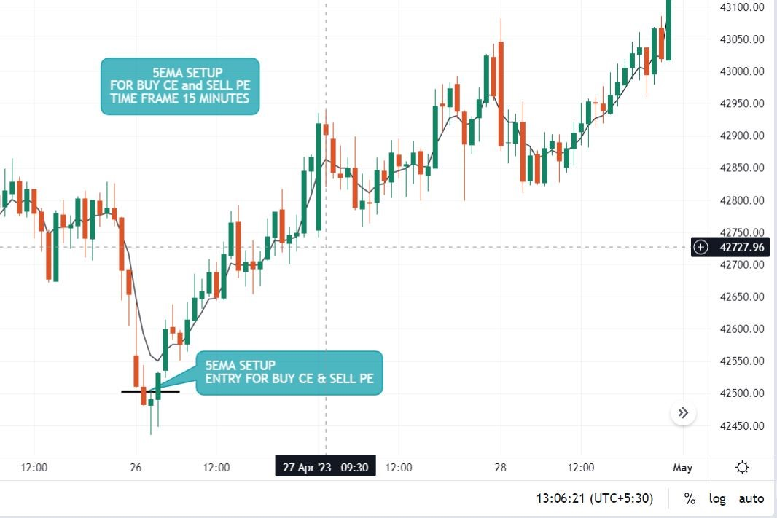
Fig.3.1 5EMA

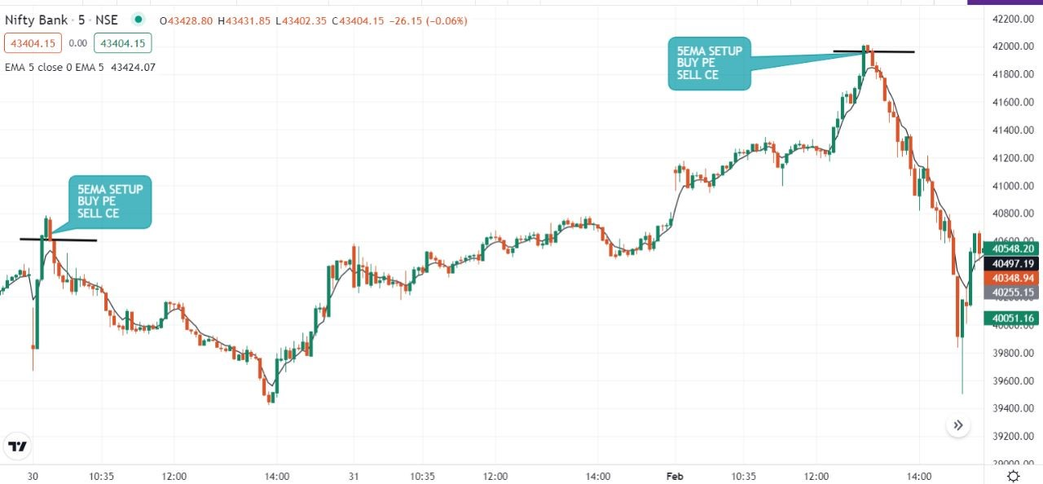
Fig.3.2 5EMA

2.20 Setup: 5min candle settled open at 2.20 and closing at 2.25 it’s an alert candle that breaks alerts candle body low then the market goes to fall see in Fig. 4.1. If breaks the alert candle body high then goes to an uptrend market, see in Fig.4.2.
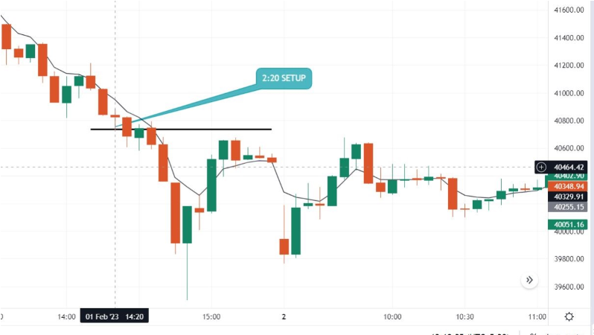

Fig.4.1 2.20 Setup

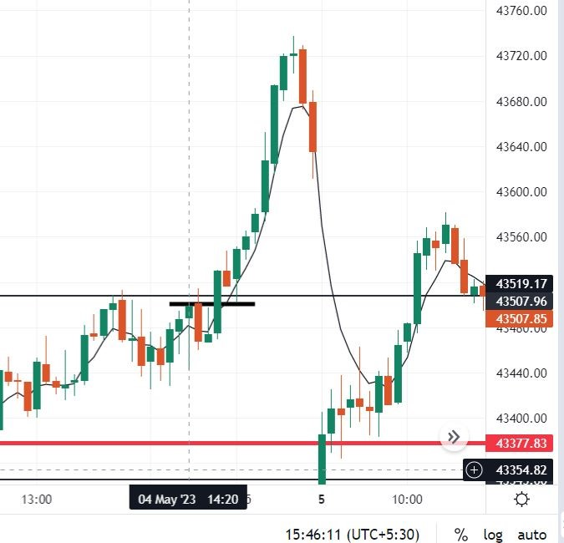
Fig.4.2 2.20 Setup

Table 2
Sr. N | Setup Name | Time Frame in Minutes | Use For | Accuracy
1 | 5EMA | 15 | Buy CE and  Sell PE | 65-72%
2 | 5EMA | 5 | Buy PE and Sell CE | 75-80%
3 | 2.20 | 5 | Buy CE, PE, and Sell CE, PE | 82-85%

FUTURE WORK
Improving model interpretability: While machine learning models have shown great predictive power, their lack of interpretability can be a drawback in the finance industry. Researchers could focus on developing models that are more transparent in their decision-making processes, allowing traders and analysts to better understand the models' predictions.
Incorporating alternative data sources: In addition to traditional financial data like stock prices and market indices, machine learning algorithms can be trained on a vast array of alternative data sources, such as social media sentiment, news articles, weather patterns, satellite images, and even web traffic. Incorporating these data sources can potentially yield more accurate predictions of stock prices.
Encouraging more retail participation: Currently, retail investors make up a relatively small percentage of the Indian stock market. Future work could involve developing more user-friendly platforms for retail investors and increasing financial literacy to encourage more people to participate in the market.
Exploring more advanced machine learning techniques: While regression analysis, decision trees, and neural networks are commonly used in stock market analysis, there are other advanced machine learning techniques, such as deep learning, reinforcement learning, and transfer learning, which may be better suited for certain tasks, such as anomaly detection or portfolio optimization.
Overall, the future of stock market is likely to be exciting and full of potential. By incorporating new data sources, advanced deep learning models, and reinforcement learning techniques, researchers could develop more accurate and robust models for predicting stock prices and developing optimal trading strategies.

CONCLUSION
In conclusion, stock market analysis using machine learning is a rapidly growing area that has the potential to revolutionize the way investors make decisions. With the vast amounts of data available in the financial industry, machine learning algorithms can be used to analyze and predict trends, identify anomalies, and generate investment insights that are more accurate and timelier than traditional methods.
Machine learning techniques such as regression analysis, decision trees, random forests, and neural networks can be used to build models that can predict stock prices, identify market trends, or make investment decisions. These models can be trained on historical data and can be fine-tuned using hyperparameter optimization techniques to improve their performance.
However, it's important to note that machine learning is not a silver bullet for stock market analysis. There are limitations and challenges to be considered, such as the risk of overfitting, the need for high-quality data, and the potential for biases in the data or models. In addition, machine learning models should always be used in conjunction with human expertise and judgment, and not as a replacement for it.
Overall, stock market analysis using machine learning has the potential to provide investors with new insights, faster decision-making, and improved returns. However, it's important to approach this technology with caution and to ensure that best practices in data science, machine learning, and ethics are followed at all times.

ACKNOWLEDGMENT
While bringing out this final to its final form, we came across a number of people whose contributions in various ways helped our field of research and they deserve special thanks. It is a pleasure to convey my gratitude to all of them. Ramamurthy for their invaluable encouragement, suggestions, and support from the early stage of this research and for providing us with extraordinary experiences throughout the work. We are grateful to all of the faculty members in the Computer Application Department for their motivation and encouragement in completing this project.
Finally, I m very much thankful to my parents and my husband who have directly or indirectly contributed to our research work.
REFERENCES
- Naeini MP, Taremian H, Hashemi HB (2010) Stock market value prediction using neural networks. IEEE
- Khan ZH (2011) Price prediction of share market using artificial neural network. Int J Comput Appl (IJCA)
- Das SP, Padhy S (2014) Support vector machines for prediction of futures prices in Indian stock market. Int J Comput Appl (IJCA)
- Chavan PS (2013) Parameters for stock market prediction. Int J Comput Technol Appl (IJCTA)
- Sheta AF (2015) A comparison between regression, artificial neural networks and support
- Eapen J, Bein D, Verma A. Novel deep learning model with CNN and bi-directional LSTM for improved stock market
- Preethi G, Santhi B (2012) Stock market forecasting techniques: a survey. J Theor Appl Inf
- Khaidem L, Dey SR. Predicting the direction of stock market prices using random forest. 2016. pp. 1–20.
- Kim K, Han I. Genetic algorithms approach to feature discretization in artificial neural networks for the prediction of stock price index. Expert Syst Appl. 2000;19:125–32. https://doi.org/10.1016/S0957-4174(00)00027-0.
- Lee MC. Using support vector machine with a hybrid feature selection method to the stock trend prediction. Expert Syst Appl. 2009;36(8):10896–904.
https://doi.org/10.1016/j.eswa.2009.02.038.
- Lei L. Wavelet neural network prediction method of stock price trend based on rough set attribute reduction. Appl Soft Comput J. 2018;62:923–32.
https://doi.org/10.1016/j.asoc.2017.09.029.
- Lin X, Yang Z, Song Y. Expert systems with applications short-term stock price prediction based on echo state networks. Expert Syst Appl. 2009;36(3):7313–7. https://doi.org/10.1016/j.eswa.2008.09.049.
- Liu G, Wang X. A new metric for individual stock trend prediction. Eng Appl Artif Intell. 2019;82(March):1–12. https://doi.org/10.1016/j.engappai.2019.03.019.
- Liu S, Zhang C, Ma J. CNN-LSTM neural network model for quantitative strategy analysis in stock markets.
2017;1:198–206. https://doi.org/10.1007/978-3-319-70096-0.
- Long W, Lu Z, Cui L. Deep learning-based feature engineering for stock price movement prediction. Knowl Based Syst. 2018;164:163–73.
https://doi.org/10.1016/j.knosys.2018.10.034.
- Malkiel BG, Fama EF. Efcient capital markets: a review of theory and empirical work. J Finance. 1970;25(2):383– 417.
- McNally S, Roche J, Caton S. Predicting the price of bitcoin using machine learning. In: Proceedings—26th Euromicro international conference on parallel, distributed, and network-based processing, PDP 2018. pp. 339–43. https://doi.org/10.1109/PDP2018.2018.00060.
- Nagar A, Hahsler M. News sentiment analysis using R to predict stock market trends. 2012.
http://past.rinfnance.com/agenda/2012/talk/Nagar+Hahsler.p df. Accessed 20 July 2019.
- Nekoeiqachkanloo H, Ghojogh B, Pasand AS, Crowley M. Artificial counselor system for stock investment. 2019. ArXiv Preprint arXiv:1903.00955.
- Ni LP, Ni ZW, Gao YZ. Stock trend prediction based on fractal feature selection and support vector machine. Expert Syst Appl. 2011;38(5):5569–76.
https://doi.org/10.1016/j.eswa.2010.10.079.
- Pang X, Zhou Y, Wang P, Lin W, Chang V. An innovative neural network approach for stock market prediction. J Supercomput. 2018.
https://doi.org/10.1007/s11227-017-2228-y

.

