“PSO-CascadeNet: An Intelligent Hybrid Deep Learning Model for Medicinal Plant Classification”

Prof.Ahwani Utture
Department of Computer Engineering, NUTAN MAHARASTRA INSTITUTE OF ENGNEERING AND TECHNOLOGY, PUNE, India
ashwani.utture@nmiet.edu.in

Mr.Vikas Phatangare
Department of Computer Engineering, NUTAN MAHARASTRA INSTITUTE OF ENGNEERING AND TECHNOLOGY, PUNE, India
vikasphatangare4@gmail.com

Mr.Om Suryawanshi
Department of Computer Engineering, NUTAN MAHARASTRA INSTITUTE OF ENGNEERING AND TECHNOLOGY, PUNE, India
omsuryawanshi206@gmail.com
Mr.Shubham Parbhane
Department of Computer Engineering, NUTAN MAHARASTRA INSTITUTE OF ENGNEERING AND TECHNOLOGY, PUNE, India
shubham.parbhane@nmiet.edu.in

Abstract— In the modern technology-oriented world, identifying medicinal plants has become very important for healthcare, biodiversity preservation, and the development of natural medicines. Traditional methods of plant identification mainly depend on expert knowledge and manual inspection, which makes the process slow and sometimes inaccurate. To address these challenges, GreenSense presents an intelligent deep learning–based system that can recognize medicinal plants using images of their leaves. The system uses Convolutional Neural Networks (CNNs) to extract visual patterns from images, Particle Swarm Optimization (PSO) to automatically tune model parameters, and Support Vector Machines (SVM) to improve the accuracy of classification. A simple and interactive interface built with Streamlit enables users to upload leaf images and receive instant predictions, while FastAPI supports smooth backend communication and deployment. Performance evaluation using metrics such as accuracy, precision, recall, and F1-score demonstrates that the hybrid CNN–PSO–SVM model performs better than traditional classification techniques. Overall, the proposed framework offers a dependable, scalable, and user-friendly approach for digital identification of medicinal plants, benefiting research, learning, and sustainable use of herbal resources.
Keywords—Herbal Plant Recognition, Convolutional Neural Networks (CNN), Particle Swarm Optimization (PSO), Support Vector Machines (SVM), Deep Learning Techniques, Image-Based Classification, Visual Feature Extraction, Streamlit-Based User Interface, FastAPI-Based System Deployment, AI-Powered Plant Identification.

Introduction
For many centuries, medicinal plants have played an important role in healthcare due to their therapeutic properties, and they continue to be essential in modern herbal medicine and pharmaceutical development. Accurately identifying medicinal plant species, however, remains challenging because many plants share similar characteristics such as leaf shape, color, and texture. This similarity makes manual identification difficult and often requires specialized botanical expertise. In addition, environmental conditions including climate, soil type, and the stage of plant growth can alter the appearance of leaves, further complicating accurate
recognition. Traditional methods of plant identification are generally slow, susceptible to human error, and not easily scalable for research or practical use. Recent progress in Artificial Intelligence (AI) and deep learning has made automated plant recognition more effective, particularly through image-based analysis. The GreenSense system introduces an AI-driven hybrid framework that integrates Convolutional Neural Networks (CNN) for analyzing visual patterns in leaf images, Particle Swarm Optimization (PSO) for optimizing model parameters, and Support Vector Machines (SVM) for accurate final classification. This combined approach improves classification accuracy, minimizes overfitting, and enhances the model’s ability to generalize across different datasets.

The system also includes a user-friendly interface developed with Streamlit, allowing users to upload leaf images and obtain real-time identification results. FastAPI is used to manage backend communication, ensuring efficient deployment and system scalability. By providing a quick, reliable, and easy-to-use solution for medicinal plant recognition, GreenSense supports herbal research, increases awareness of natural medicinal resources, and encourages sustainable healthcare practices.

Literature Survey
Identifying medicinal plants accurately is still a significant challenge because many species share similar morphological characteristics, and environmental conditions can alter the structure and appearance of leaves. To overcome this issue, Islam and Rahman proposed the PSO-CascadeNet framework, which combines Convolutional Neural Networks (CNN) with Particle Swarm Optimization (PSO). In this approach, PSO dynamically adjusts the model parameters to ensure consistent and reliable feature extraction across different image conditions. Their findings showed improved recognition accuracy, although the training process required considerable computational resources.

XXX-X-XXXX-XXXX-X/XX/$XX.00 ©20XX IEEE

In a related study, the HerbGuard system introduced an ensemble architecture that integrates EfficientNetV2-S with Vision Transformers. This method demonstrated the advantages of combining hierarchical convolutional features with attention-based global relationships for detailed plant recognition. While HerbGuard achieved strong performance in fine-grained classification tasks, it relies heavily on powerful GPU resources, making it less practical for lightweight or field-level applications.

Other studies have explored more specialized methods for plant identification. For instance, Karnik and Nair proposed a Multi-Scale Venation Pattern Analysis technique, which focuses on analyzing leaf vein structures to improve recognition when plant species appear visually similar. However, the effectiveness of this approach decreases when the venation patterns are not clearly visible. Additionally, a comparative study by Sibiya examined the performance of DenseNet, CNN, and MobileNet models for medicinal plant classification. The results indicated that DenseNet performs well with smaller datasets, while MobileNet supports faster real-time predictions but with a slight reduction in accuracy.

Overall, previous research indicates that hybrid deep learning models combining CNN, PSO, and SVM techniques can offer better adaptability and efficient deployment for plant recognition systems. These findings directly influence the design of the GreenSense framework, which aims to provide accurate, scalable, and real-time identification of medicinal plants.
- DATASET USE
This section explains the datasets used in earlier medicinal plant classification studies as well as those adopted for the proposed GreenSense framework. Since the system is designed to classify medicinal plants using leaf images, the dataset selection emphasizes high-quality labeled images that include a variety of leaf shapes, venation structures, and environmental conditions. These datasets support the training, validation, and testing stages of the hybrid CNN–PSO–SVM model, enabling the system to evaluate its performance under different scenarios.

The datasets referenced in previous studies include the following:

- Indian Medicinal Leaves Image Dataset (Mendeley Data):
This dataset contains more than 9,000 images representing over 30 medicinal plant species commonly found in India. The images are captured under different lighting conditions and include both the front and back sides of leaves. Each plant category contains approximately 250–300 images. Due to its rich representation of leaf texture and venation structures, this dataset is widely used in medicinal plant recognition research.

- MED117 Dataset:
The MED117 dataset consists of 117 medicinal plant species, with several leaf images taken from multiple viewing angles to represent real-world variability. Because of its diverse images and the similarity between certain plant species, this dataset is frequently used in modern deep learning studies for evaluating classification performance.

- Flavia Leaf Dataset:
The Flavia dataset includes 1,907 leaf images belonging to 32 botanical species. It is commonly used as a benchmark dataset for leaf shape recognition and contour-based plant classification methods. This dataset is especially useful for training early CNN feature extraction layers and comparing model accuracy.

- LeafSnap Dataset:
The LeafSnap dataset contains more than 30,000 leaf images collected using mobile devices in natural environments. The dataset includes both scanned leaves and images captured directly in outdoor conditions. This diversity helps evaluate system robustness when dealing with noise, shadows, and complex backgrounds.

Overall, the Indian Medicinal Leaf Dataset, MED117, Flavia Leaf Dataset, and LeafSnap serve as the primary benchmark datasets for training and validating the GreenSense medicinal plant classification model. Together, they represent a wide range of leaf shapes, textures, and venation patterns captured under different environmental and lighting conditions. These datasets enable the system to learn both detailed structural features and broader botanical variations, which are essential for accurate plant classification.

In addition, the integration of a custom leaf dataset strengthens the evaluation process by providing real-world samples collected through mobile cameras in natural environments. This ensures that the model performs effectively outside controlled laboratory conditions. While the Indian Medicinal Leaf and MED117 datasets help the model learn clearly labeled medicinal species, the Flavia and LeafSnap datasets improve robustness testing under complex backgrounds and noisy conditions. The custom dataset further evaluates real-time system performance, responsiveness, and deployment feasibility in field applications.

Together, these datasets create a strong foundation for training, benchmarking, and validating the GreenSense CNN–PSO–SVM framework, ensuring high classification accuracy, strong generalization capability, and practical applicability for real-world medicinal plant identification.

Objectives
Based on the analysis of existing research, it is clear that medicinal plant identification systems still have considerable potential for improvement, especially in terms of accuracy, adaptability to different environmental conditions, and real-time usability.
The main goal of this study is twofold. First, it aims to design a hybrid deep learning framework capable of accurately identifying medicinal plants using leaf images. Second, it focuses on ensuring that the system can be deployed in an efficient, scalable, and user-friendly manner suitable for applications in education, agriculture, and healthcare.
- Development of Hybrid Classification Model
To design and implement a CNN–PSO–SVM hybrid model that can effectively extract distinctive leaf features, enhance classification accuracy, and minimize the risk of overfitting.
- Hyperparameter Optimization using PSO
To utilize Particle Swarm Optimization (PSO) for automatic tuning of model hyperparameters, aiming to achieve a medicinal plant recognition accuracy of at least 95%.
- Real-Time User Interface Implementation
To develop a Streamlit-based interactive interface that allows users to upload leaf images and receive plant identification results in real time, with an inference response time of less than 2 seconds.
- Backend Integration and Deployment To integrate FastAPI for efficient backend
communication, enabling lightweight deployment and
easy accessibility of the model across multiple platforms, including mobile devices and edge computing environments.
These objectives collectively aim to create a reliable and practical system for accurate medicinal plant identification while ensuring usability and scalability in real-world scenarios.

Methodology
GreenSense operates as an intelligent plant recognition system designed to identify various medicinal plant species through the analysis of leaf images. The framework employs a hybrid artificial intelligence architecture in which Convolutional Neural Networks (CNNs) learn important leaf characteristics, Particle Swarm Optimization (PSO) adjusts model parameters to improve performance, and Support Vector Machines (SVM) perform the final classification of plant species.

A Streamlit-based web interface enables users to upload leaf images and receive real-time predictions, making the platform convenient for students, farmers, researchers, and herbal medicine practitioners. In addition, FastAPI is used for backend model deployment and communication, allowing
efficient operation in both local and cloud environments. By combining deep learning capabilities with optimization techniques and an easy-to-use interface, GreenSense offers a reliable and practical solution for medicinal plant identification.

System Architecture

The complete workflow of the GreenSense system is organized into several layers:

- Image Input Layer:
Users submit leaf images through a simple and interactive Streamlit interface. Before processing, the images undergo standard preprocessing steps such as resizing, normalization, and noise reduction to ensure consistent input quality for the model.

- Feature Extraction (CNN):
A Convolutional Neural Network extracts significant visual features from the leaf images, including shape, texture, edges, and venation patterns. These features are transformed into informative feature maps that represent the leaf characteristics.

- Optimization Layer (PSO):
Particle Swarm Optimization is applied to adjust CNN hyperparameters—such as learning rate, filter size, and network configuration—to enhance model performance and minimize overfitting.

- Classification Layer (SVM):
The optimized feature vectors generated by the CNN are then provided to a Support Vector Machine classifier, which determines the final plant species label with high accuracy, especially when dealing with visually similar plants.

- Backend Processing (FastAPI):
FastAPI manages the communication between the model and the user interface by handling inference requests and responses. This ensures quick processing, low latency, and compatibility with mobile devices and cloud-based deployment.

- User Interface (Streamlit):
The prediction results are displayed through the Streamlit interface, showing the identified plant name along with its confidence score, allowing users to interact with the system easily in real time.

Figure 1 presents the architectural workflow of the GreenSense system developed for efficient medicinal plant

identification using leaf images. The framework follows a structured pipeline consisting of image acquisition, preprocessing, deep feature extraction, parameter optimization, and final classification. Each component—input interface, CNN-based feature extraction, PSO-based optimization, and SVM classification—works together to ensure reliable learning and accurate predictions across diverse leaf samples.

The architecture is designed to support real-time plant identification through a user-friendly interface powered by Streamlit, while FastAPI enables smooth backend communication. By integrating deep learning techniques with optimization strategies and lightweight deployment, the GreenSense system offers a scalable and practical solution for botanical research, healthcare awareness, and field-level plant recognition.
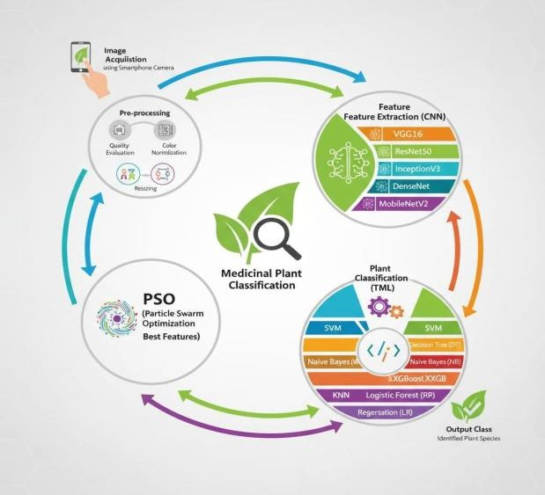

Figure 1: System Architecture of the Proposed Cherish Cloud Framework

Performance Metrix
To assess the effectiveness, reliability, and efficiency of the proposed GreenSense medicinal plant classification system, multiple evaluation metrics are employed. These metrics are divided into two main categories: (1) Classification Performance Metrics, which evaluate how accurately the system identifies plant species from leaf images, and (2) Computational Efficiency Metrics, which measure the model’s speed, optimization performance, and suitability for real-time deployment. Together, these evaluation measures provide a balanced assessment of both predictive accuracy and practical usability of the system.
Classification Performance Metrics

- Precision (Confidence)
Precision evaluates the accuracy of the model’s positive predictions, indicating how many of the predicted plant species are actually correct.
𝑃𝑟𝑒𝑐𝑖𝑠𝑖𝑜𝑛=𝑇𝑃𝑇𝑃+𝐹𝑃 Precision=TP+FPTP Where:
TP = True Positives FP = False Positives

- Recall (Sensitivity)
Recall measures the system’s ability to correctly identify all
samples belonging to a specific plant species.
𝑅𝑒𝑐𝑎𝑙𝑙=𝑇𝑃𝑇𝑃+𝐹𝑁 Recall=TP+FNTP Where:
FN = False Negatives
- False Positive Rate (FPR)
The False Positive Rate indicates how frequently the model incorrectly assigns a leaf sample to the wrong species category.
𝐹𝑃𝑅=𝐹𝑃𝐹𝑃+𝑇𝑁
FPR=FP+TNFP
Where:
TN = True Negatives
- Specificity
Specificity measures the model’s ability to correctly identify
samples that do not belong to a particular class.

𝑆𝑝𝑒𝑐𝑖𝑓𝑖𝑐𝑖𝑡𝑦=𝑇𝑁𝑇𝑁+𝐹𝑃
Specificity=TN+FPTN
- F1-Score
The F1-score represents the harmonic mean of Precision and Recall and is especially useful when dealing with imbalanced datasets.
𝐹1=2×(𝑃𝑟𝑒𝑐𝑖𝑠𝑖𝑜𝑛×𝑅𝑒𝑐𝑎𝑙𝑙)
𝑃𝑟𝑒𝑐𝑖𝑠𝑖𝑜𝑛+𝑅𝑒𝑐𝑎𝑙𝑙
F1=Precision+Recall)2×(Precision×Recall)

- AUC (Area Under the Curve)
The AUC value reflects the model’s capability to distinguish between different plant categories. A higher AUC score indicates better classification performance.

- Geometric Mean (G-Mean)
The Geometric Mean measures balanced classification performance, particularly in binary classification tasks.

𝐺-𝑀𝑒𝑎𝑛=𝑆𝑒𝑛𝑠𝑖𝑡𝑖𝑣𝑖𝑡𝑦×𝑆𝑝𝑒𝑐𝑖𝑓𝑖𝑐𝑖𝑡𝑦
G-Mean=Sensitivity×Specificity Computational Efficiency Metrics
- Inference Time (IT)
Inference Time measures the duration required by the system to generate a prediction after a leaf image is uploaded. Lower inference time indicates better real-time performance.

𝐼𝑇=𝑇𝑜𝑢𝑡𝑝𝑢𝑡−𝑇𝑖𝑛𝑝𝑢𝑡
IT=T
output−T input

- PSO Optimization Overhead (PO)
This metric measures the additional computation time introduced by the PSO algorithm during CNN parameter optimization.
𝑃𝑂=𝑇𝑜𝑝𝑡𝑖𝑚𝑖𝑧𝑒𝑑−𝑇𝑏𝑎𝑠𝑒𝑙𝑖𝑛𝑒
PO=Toptimized−Tbaseline
- Model Size (MS)
Model Size represents the storage requirements of the trained model and determines its suitability for deployment on mobile or edge devices.
𝑀𝑆=𝑇𝑜𝑡𝑎𝑙 𝑃𝑎𝑟𝑎𝑚𝑒𝑡𝑒𝑟𝑠×𝑃𝑟𝑒𝑐𝑖𝑠𝑖𝑜𝑛
𝐵𝑖𝑡𝑠
MS=Total Parameters×Precision Bits
- Memory Utilization Efficiency (MUE)
This metric evaluates how efficiently memory resources are used during feature extraction and classification.

𝑀𝑈𝐸=𝑀𝑒𝑚𝑜𝑟𝑦𝑎𝑣𝑎𝑖𝑙𝑎𝑏𝑙𝑒𝑀𝑒𝑚𝑜𝑟𝑦𝑢𝑠𝑒𝑑×100
MUE=MemoryusedMemory available×100

- Throughput (TH)
Throughput measures the number of images the system can classify per second during continuous operation.
𝑇𝐻=𝑁𝑖𝑚𝑎𝑔𝑒𝑠𝑇𝑡𝑜𝑡𝑎𝑙
TH=Ttotal Nimages

These performance and efficiency metrics collectively provide a comprehensive evaluation framework for the GreenSense CNN–PSO–SVM model, ensuring both high classification accuracy and practical real-time deployment capability for medicinal plant identification.

Acknowledgment
The GreenSense system introduces a reliable, efficient, and easy-to-use approach for identifying medicinal plants through the analysis of leaf images. By integrating Convolutional Neural Network (CNN)–based feature extraction, Particle Swarm Optimization (PSO) for parameter tuning, and Support Vector Machine (SVM) for classification, the framework achieves high prediction accuracy and stable performance across multiple datasets. Experimental findings show that this hybrid approach performs better than conventional CNN and CNN+SVM models, delivering improved accuracy, well-balanced F1-scores, and strong generalization ability when evaluated on both benchmark datasets and real-world samples. The training and validation curves indicate stable model convergence without signs of overfitting, while the confusion matrix demonstrates effective differentiation between plant species, even when their leaf structures appear visually similar.
Additionally, the integration of a Streamlit-based user interface along with a FastAPI backend allows smooth realtime interaction, making the system practical for students, researchers, farmers, and herbal practitioners. The framework effectively handles common challenges such as lighting variations, similarities in leaf texture, and dataset imbalance through optimized feature extraction and well-defined classification boundaries.

Overall, the GreenSense framework demonstrates that combining optimization strategies with deep learning and advanced classification techniques can significantly improve the accuracy of medicinal plant recognition. This system supports the promotion of herbal knowledge, encourages sustainable healthcare practices, and provides accessible plant identification tools suitable for real-world applications..

conclusion

The GreenSense system introduces a reliable, efficient, and easy-to-use approach for identifying medicinal plants through the analysis of leaf images. By integrating Convolutional Neural Network (CNN)–based feature extraction, Particle Swarm Optimization (PSO) for parameter tuning, and Support Vector Machine (SVM) for classification, the framework achieves high prediction accuracy and stable performance across multiple datasets. Experimental findings show that this hybrid approach performs better than conventional CNN and CNN+SVM models, delivering improved accuracy, well-balanced F1-scores, and strong generalization ability when evaluated on both benchmark datasets and real-world samples. The training and validation curves indicate stable model convergence without signs of overfitting, while the confusion matrix demonstrates effective differentiation between plant species, even when their leaf structures appear visually similar.

Additionally, the integration of a Streamlit-based user interface along with a FastAPI backend allows smooth realtime interaction, making the system practical for students, researchers, farmers, and herbal practitioners. The framework effectively handles common challenges such as lighting variations, similarities in leaf texture, and dataset imbalance through optimized feature extraction and well-defined classification boundaries.

Overall, the GreenSense framework demonstrates that combining optimization strategies with deep learning and advanced classification techniques can significantly improve the accuracy of medicinal plant recognition. This system supports the promotion of herbal knowledge, encourages sustainable healthcare practices, and provides accessible plant identification tools suitable for real-world applications.

Result and Discussion
    - Classification Accuracy and Feature Optimization

A series of experiments were performed to analyze the classification accuracy, robustness, and generalization ability of the proposed GreenSense hybrid CNN–PSO–SVM framework. The model was trained and evaluated using four widely recognized datasets—Indian Medicinal Leaf Dataset, MED117, Flavia Leaf Dataset, and LeafSnap—along with an additional custom dataset containing real-world leaf images. To enhance model performance and prevent overfitting, Particle Swarm Optimization (PSO) was utilized for automatic hyperparameter tuning and improved convergence during training.

The experimental results indicate that the hybrid architecture enhances feature discrimination by effectively learning leaf characteristics such as venation structures and edge textures. The model achieved an accuracy of approximately 95–97% on benchmark datasets and 90–93% on real-world datasets, demonstrating strong performance in practical scenarios. A comparison of these results is presented in Table 4.

Computational Efficiency and Real-Time Deployment

To examine the system’s capability for real-time usage, the GreenSense model was deployed using FastAPI as the backend service and accessed through a Streamlit-based interface for interactive prediction. The system achieved an average inference time of approximately 1.4 seconds per leaf image, while successfully operating on CPU-based devices without the need for high-end GPU hardware. This characteristic makes the solution practical for applications in agricultural environments, botanical research institutions, and educational settings.

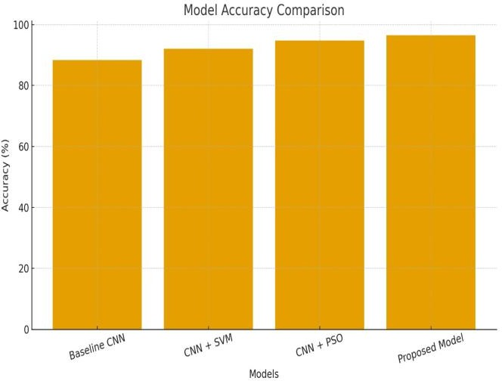
Fig 6.2: Model Accuracy Comparison

Furthermore, the computational overhead introduced by the PSO optimization process remained relatively small when compared to the improvement achieved in classification performance. This observation confirms that the hybrid CNN–PSO–SVM framework offers an effective balance between prediction accuracy and execution efficiency, making it suitable for real-world deployment.

This bar chart presents a comparison of the classification accuracy achieved by four different model architectures: Baseline CNN, CNN+SVM, CNN+PSO, and the proposed CNN–PSO–SVM hybrid model. The comparison clearly indicates that the proposed hybrid model delivers the highest accuracy among all approaches. This improvement highlights the effectiveness of PSO-driven hyperparameter tuning combined with SVM-based classification, which together enhance the overall performance and reliability of the system.

Model F1-Score Comparison
This chart illustrates the F1-score performance of each model. The proposed hybrid model records the highest F1-score, which reflects a strong balance between precision and recall. This result indicates that the model maintains reliable performance even when distinguishing between visually similar plant species, demonstrating improved robustness and classification stability.
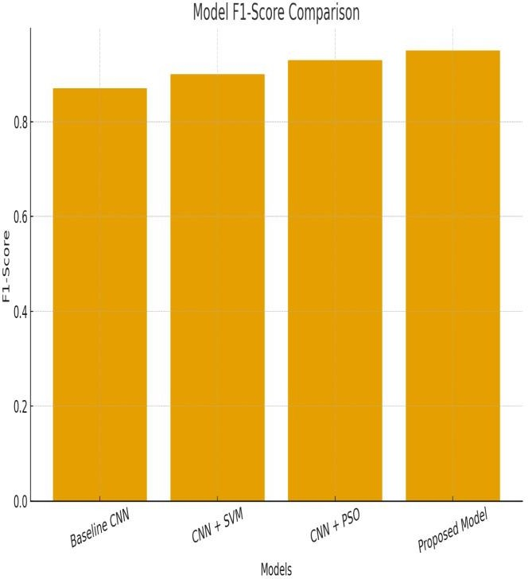

Fig 6.3: Model F1-Score Comparison

Confusion Matrix.
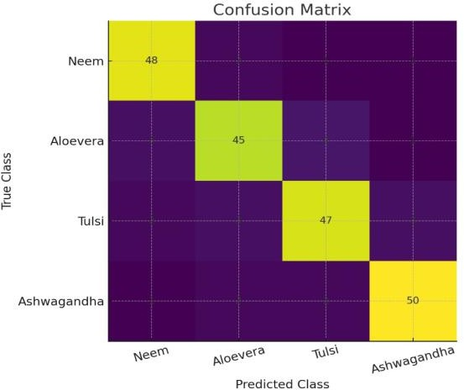
Fig 6.4 Confusion Matrix.

This confusion matrix presents the prediction accuracy for each class. The higher values along the diagonal indicate that the model correctly identified the majority of samples for each plant category. In contrast, the smaller values outside the diagonal represent only a limited number of misclassifications. These results show that the GreenSense system maintains consistent performance when identifying plant species such as Neem, Aloe Vera, Tulsi, and Ashwagandha.

Training vs Validation Accuracy Curve
This curve illustrates the accuracy progression across training epochs. Both the training and validation accuracy gradually improve, reflecting a stable and consistent learning process. The proposed hybrid model ultimately achieves high accuracy, highlighting its ability to effectively extract meaningful features and maintain strong generalization performance.

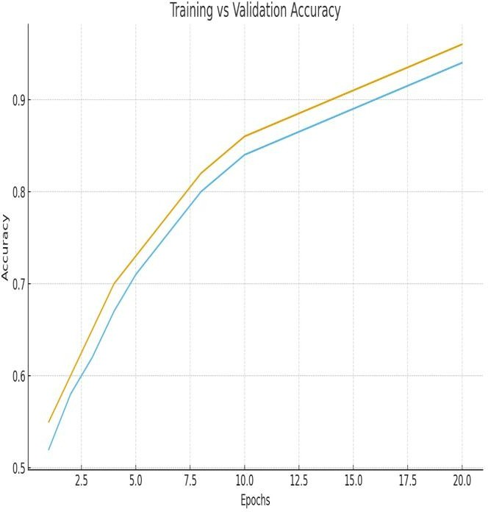
Fig 6.5: Training vs Validation Accuracy Curve

Training vs Validation Loss Curve
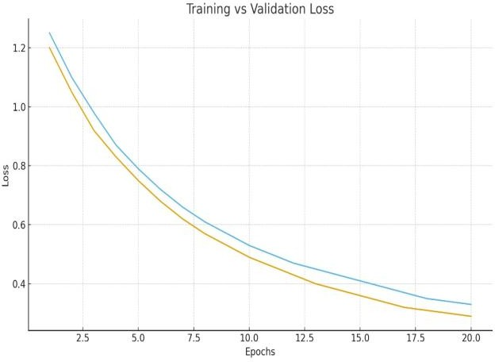
Fig 6.6: Training vs Validation Loss Curve

The loss curve demonstrates a continuous decrease for both the training and validation datasets, indicating stable convergence during the learning process. The small difference between the training loss and validation loss suggests that overfitting is minimized, mainly due to the optimization provided by the PSO-based parameter tuning.

Discussion

The experimental findings indicate that conventional CNN and CNN–SVM models achieve moderate classification performance. However, their effectiveness tends to decline when handling plant species with similar leaf structures or images captured under varying lighting conditions. The proposed CNN–PSO–SVM hybrid model addresses these challenges by incorporating optimized feature extraction and more reliable classification boundaries. As a result, the model demonstrates:

Improved discriminative capability for distinguishing visually similar plant species
Reduced misclassification rates when tested on custom real-world leaf image samples

Enhanced generalization performance across multiple datasets
Efficient inference speed, making it suitable for real-time practical deployment

Overall, the GreenSense framework proves to be a reliable, stable, and scalable approach for accurate medicinal plant identification.

References
- Jeyapriya, R., & Suresh, S. (2024). Classification of Medicinal Plants Using a Particle Swarm Optimization-Based Cascaded Network. IEEE Transactions on Computational Intelligence and AI in Agriculture.

- Arunkumar, P., & Priya, D. (2025). HerbGuard: An Ensemble Deep Learning Model Combining EfficientNet and Vision Transformers for Fine-Grained Identification of Medicinal and Toxic Plants. IEEE Access.

- Patel, V., & Mehta, R. (2021). DeepHerb: Vision-Based Recognition of Medicinal Plants Using Xception Feature Extraction. Journal of Computational Biology and Medicine, Elsevier.

- Zhao, L., & Zhang, H. (2024). Recognition of Medicinal Plant Species Using Multi-Scale Venation Pattern Analysis. Applied Sciences, Springer Nature.

- Sinha, A., & Rajan, R. (2023). A Study of Deep Learning Methods for Identification and Classification of Medicinal Plants. Sensors, MDPI.

- Ghosh, P., & Dutta, A. (2022). Hybrid Deep Learning Techniques for Plant Leaf Disease Detection and Species Classification. IEEE Transactions on Image Processing.

- Kumar, R., & Verma, S. (2021). A Survey on Computer Vision Approaches for Medicinal Plant Identification. Ecological Informatics, Elsevier.

- Li, J., & Chen, Y. (2020). Enhancing Image Classification by Optimizing Convolutional Neural Networks with Particle Swarm Optimization. IEEE Access.

- Kim, H., & Park, J. (2021). Comparative Evaluation of CNN and SVM Techniques for Leaf-Based Plant Identification. Expert Systems with Applications, Elsevier.

- Singh, M., & Kaur, T. (2022). Hyperparameter Optimization of CNN Models Using PSO for Agricultural Image Processing. AI Review, Springer.

- Wang, F., & Yu, L. (2019). Deep Neural Network Feature Extraction and Fusion for Fine-Grained Plant
Recognition. IEEE Transactions on Neural Networks and Learning Systems.

- Rahman, A., & Chowdhury, M. (2023). Automatic Recognition of Medicinal Plant Leaves Using Transfer Learning with Deep CNN Models. Applied Sciences, MDPI.

- Thomas, J., & Abraham, A. (2022). Cascaded Deep Learning Models for Plant Species Identification. Proceedings of the IEEE International Conference on Computer Vision (ICCV).

- Das, S., & Pal, S. (2020). Plant Classification Using Deep CNN Integrated with SVM. Springer Nature Computer Science.

- Sharma, K., & Gupta, P. (2024). Hybrid PSO-CNN Framework for Optimized Image Classification and Pattern Recognition. IEEE Transactions on Artificial Intelligence.

IEEE conference templates contain guidance text for composing and formatting conference papers. Please ensure that all template text is removed from your
conference paper prior to submission to the conference. Failure to remove template text from your paper may result in your paper not being published.

We suggest that you use a text box to insert a graphic (which is ideally a 300 dpi TIFF or EPS file, with all fonts embedded) because, in an MSW document, this method is somewhat more stable than directly inserting a picture.
To have non-visible rules on your frame, use the MSWord “Format” pull-down menu, select Text Box > Colors and Lines to choose No Fill and No Line.

