Intelligent Handover Decision Algorithm for Future Heterogeneous Networks (HetNets) Using Machine Learning Technique
Smera Duragkar
Artifical Intelligence & Cyber Security
Ramdeobaba University
Nagpur, India
duragkarsa@rknec.edu

Pranali Dandekar
Artifical Intelligence & Cyber Security
Ramdeobaba University
Nagpur, India
dandekarpr@rknec.edu
Madhav Gupta
Computer Science and Engineering
Ramdeobaba University
Nagpur, India
guptamr_2@rknec.edu
Priya Parkhi
Artifical Intelligence & Cyber Security
Ramdeobaba University
Nagpur, India
parkhip@rknec.edu
Yogesh Thakre
Artifical Intelligence & Cyber Security
Ramdeobaba University
Nagpur, India
thakareyn@rknec.edu

Abstract—5G New Radio (NR) millimeter-wave (mmWave) small cells coexist with 4G LTE macro-cells in today's heterogeneous mobile networks. Compared to homogeneous 4G deployments, managing handovers in such environments—determining when and how to switch a user between cells and radio access technologies—is far more challenging. The traditional 3GPP A3-event rule ignores throughput, user mobility, and temporal signal trends and fails about 30% of the time on actual mmWave 5G data. It initiates a handover based only on a static received signal threshold and a fixed time-to-trigger (TTT) window.
The University of Minnesota's publicly accessible Lumos5G-v1.0 dataset (68,118 real-world records) was used to validate the eight-stage machine learning (ML) pipeline for intelligent handover decision-making presented in this paper. Using 23 engineered features, four complementary models are created and assessed: a Random Forest classifier, a Gradient Boosting (XGBoost) classifier, a Transformer-based sequence classifier, and a Dueling Double Deep Q-Network (DDQN) reinforcement learning agent. In comparison to the A3 baseline, the top-performing model (Random Forest) reduces the handover failure rate from 17.5% to 3.5% and the ping-pong rate from 12% to 2.2% with an accuracy of 95.25% and ROC-AUC of 0.973. A real-time ping-pong risk score, confidence tiers, and per-decision explanations are all provided by a Decision Support System (DSS) based on SHAP values. The suggested system is the only one with built-in explainability on a real-world dataset, and it achieves the highest accuracy and lowest failure rates when compared to nineteen cutting-edge techniques.
Keywords—Heterogeneous Networks, Vertical Handover, Machine Learning, Random Forest, SHAP, Decision Support System, 5G NR, Lumos5G, Dueling DDQN, Transformer

Introduction
The global deployment of fifth-generation New Radio (5G NR) technology represents one of the most significant revolutions in wireless communication infrastructure since the move from 3G to 4G LTE a decade or more ago. Perhaps no aspect of this revolution is more evident than in the millimetre wave (mmWave) band of frequencies above 24 GHz, in which the theoretical peak rates that can be achieved are orders of magnitude higher than ever before possible in a wireless system. However, this ability is accompanied by a physical reality that systems operating in the sub-6 GHz band do not: mmWave signals travel a short distance before attenuating significantly, scattering unpredictably off surfaces, and being completely blocked by a human body, a vehicle, or even a rain-saturated atmosphere [18], [19]. This "spatial volatility," which happens on timescales measured in tens of milliseconds, is the key engineering challenge for mmWave-based 5G, and there is nothing like it in the propagation environment for LTE.
On account of these limitations in propagation, 5G mmWave technology is not rolled out by network operators in a standalone manner to replace LTE technology. Instead, 5G is integrated with existing LTE technology and macro cell infrastructure in a heterogeneous network, or "HetNet." This is a term used by the standards community to refer to a 5G and LTE technology hybrid, where LTE technology is used to provide a guarantee of service reach over an entire service zone, while 5G technology is used to provide high density service in a very defined zone of optimal channel conditions [7], [10].
The mechanisms that govern these transitions can be divided into two broad categories. Horizontal handovers involve a device moving from one cell to another that uses the same Radio Access Technology, e.g., LTE to LTE or 5G to 5G. Vertical handovers involve a change of Radio Access Technology altogether, e.g., from LTE to 5G NR or vice versa [6], [8]. In a dual technology environment, the vertical handover is arguably the more important of the two handovers, with the wrong decision having a much higher cost.
The pathologies of a handover control system which has not been well-calibrated are well-known. Call drop, where a connection is torn down prematurely before a target cell has been confirmed ready to receive a connection, represents one of the more obvious failure modes. The worst form of a malfunctioning handover control system is represented by a phenomenon known as 'ping-pong' — a condition in which a device repeatedly flips back and forth between two cells over a short space of time, owing to neither cell being able to sustain an advantage over the other over any significant period of time [11], [12].
The standard industry solution to this problem is the A3 event trigger, which is specified in 3GPP TS 36.331, a technical specification for the measurement and reporting framework in LTE systems. However, it is intrinsically unsuitable for the conditions that mmWave 5G systems typically experience, as it takes into account only a single signal strength measurement, completely ignores all previous trajectory of the user through the channel, takes no account of device velocity or application, and offers no way to specify a confirmation interval based on the degree of uncertainty in the channel conditions [1], [3].
The limitations of reactive and threshold-based handover rules have stimulated an increasing body of research into machine learning techniques that promise to capture the temporal and contextual dependencies of handover decisions in a more sophisticated manner [1], [2], [5], [11], [13], [16].
The research gap identified in the literature review is addressed in this paper by providing four specific and substantiated contributions. Secondly, the development of four structurally and paradigmatically diverse models, consisting of a Random Forest ensemble representing classical discriminative learning, a Gradient Boosting ensemble representing sequential error correction, a Transformer model utilizing self-attention within the measurements, and a Dueling Double Deep Q-Network representing sequential decision processes within handover control utilizing a maximization paradigm [5], [14]. Fourth, a proposed benchmark places the proposed system in the context of nineteen recent state-of-the-art studies from the handover and radio resource management literature, demonstrating superiority across all primary evaluation criteria and yielding a rigorous baseline for future research in the domain [15]–[19].

Literature Survey
The evolution of handover decision mechanisms in heterogeneous networks has been extensively studied, and it started from traditional rule-based and supervised approaches.
Munir and Gordon-Ross presented a handover framework based on multi-attributes in HetNets by using utility functions. They reported 74.8% accuracy. Although their approach was better than the simple A3 approach in terms of accuracy, the utility weights were set manually. However, the system failed to generalize well to unseen environments[14]. Islam et al. presented a supervised classifier to filter out unnecessary handovers. They reported that the number of unnecessary handovers was reduced by approximately 18%. However, the classifier was periodically retrained in an offline manner[1][13]. Mistry et al. improved the system by incorporating online retraining. However, the system performance was affected at high [15].
With the progress of machine learning, researchers started to investigate the neural network-based models to further enhance the accuracy and flexibility of handover decisions.
Samuel et al. was one of the first studies to use feedforward neural networks in handover classification in HetNet environments. The authors reported 80.1% accuracy in simulation[7]. Siddiqui et al. used online learning to dynamically adjust the threshold in a multi-RAT system. They reported 81.4% accuracy[2]. Rashid et al. developed an AI-based handover system in vehicular networks (IoV), which reported 85.9% accuracy in vehicular environments. However, no generalisation was done to pedestrians[6]. Shen et al. employed a data-driven MLP in ultra-dense 5G small cell handover. They reported 88.6 [17].
With the emergence of the limitations of static and supervised models, reinforcement learning models started to attract more attention due to their potential to learn dynamically in response to changing network environments.
Yadav et al. studied Q-learning with dynamic clustering for resource optimization in IoT systems but found its scalability to be an issue[3]. Ndikumana et al. proposed deep RL for energy-aware dense HetNets and achieved a 19.4% ping-pong rate. However, they found that the proposed algorithm had slow convergence[10]. Li et al. proposed a Double DQN algorithm for handover management in HetNets and achieved 89.4% accuracy with low overestimation bias[12]. Wang et al.proposed a multi-agent DRL algorithm for joint optimization of handover and power allocation in HetNets and achieved 87.2% accuracy with high training complexity[5].
In addition to this, further improvements have been made by integrating temporal learning and hybrid deep learning models to learn from sequential dependencies in network behaviors.
Hmila et al. introduced a Hybrid AI LSTM+DQL approach that achieves 91.2% accuracy with a 24% ping-pong rate. This is the most similar work to ours, but without considering multi-class classification or SHAP explainability[9]. Ahmed et al. employed LSTM for multi-step RSRP prediction with a prediction RMSE < 2 dBm. However, they used this predictor along with a static threshold [11]. Polese et al. demonstrated the feasibility of DRL-based traffic steering using an O-RAN near-RT RIC xApp. This shows that ML policies are deployable within 5G standards[4]. Tawfik et al. optimized 5G handover decisions using RSRP and load-aware metrics, resulting in a 21.2% ping-pong reduction [8].
In addition to model-specific research, there have been several research efforts to provide data-driven insights and surveys to better comprehend the research landscape.
Eze et al.employed ML in predicting neighbor cell using real drive test data in San Francisco, reaching 84.2% accuracy with geolocation awareness[18]. El-Baz et al.surveyed ML in proactive handover in 5G+, attaining 90.1% accuracy. The authors also identified deep RL and hybrid predictive architectures as the most promising, which is exactly the focus of the current work[19]. Bairagi et al. surveyed ML in handover in 6G MEC, attaining 88.9%. The authors also emphasized the importance of latency-sensitive edge intelligence. The critical aspect, however, is that none of the surveyed literature employed real-world multi-technology data, four different paradigms of ML, multi-class handover classification, and SHAP-based explainability, as done in the current work[20].
Table 1: Comprehensive Comparison with 19 State-of-the-Art Works
Ref. | Method | Year | Accuracy | HO Fail | PP Rate | XAI
[7] | NN HetNet Handover | 2015 | 80.1 % | ~19 % | — | No
[2] | NN Multi-RAT Learning Agent | 2018 | 81.4 % | ~16 % | — | No
[14] | Multi-attr. HO Decision | 2016 | 74.8 % | ~25 % | ~30 % | No
[1] | ML-HO Execution (Supervised) | 2020 | 78.2 % | ~18 % | — | No
[5] | Multi-Agent DRL Joint Opt. | 2020 | 87.2 % | ~13 % | ~20 % | No
[12] | Double Deep Q-Network (DDQN) | 2020 | 89.4 % | ~10 % | 20.8 % | No
[6] | AI Handover in IoV | 2021 | 85.9 % | ~14 % | — | No
[8] | Improved 5G HO (RSRP+Load) | 2021 | 86.3 % | ~13 % | 21.2 % | No
[15] | Auto  Adaptive ML HO | 2021 | 79.3 % | ~17 % | — | No
[4] | O-RAN DRL Traffic Steering | 2023 | 85.4 % | ~14 % | ~22 % | No
[10] | Dense HetNet RL Energy-aware | 2023 | 85.1 % | ~15 % | 19.4 % | No
[19] | ML Proactive HO 5G+ Survey | 2023 | 90.1 % | ~10 % | 17.9 % | No
[9] | Hybrid AI LSTM+DQL (2-tier) | 2024 | 91.2 % | ~9 % | 24.0 % | No
[11] | LSTM HO Future Gen. | 2024 | 88.4 % | ~11 % | — | No
[3] | Q-Learning + IoT Clustering | 2024 | 83.7 % | — | — | No
[18] | ML Neighbour Cell Prediction | 2024 | 84.2 % | ~15 % | — | No
[17] | Data-Driven MLP Ultra-Dense | 2025 | 88.6 % | ~11 % | 21.2 % | No
[20] | ML Handover 6G MEC Survey | 2025 | 88.9 % | ~11 % | 18.6 % | No
Prop. | RF + GB + Transformer + DDQN + DSS | 2026 | 95.25 % | 3.5 % | 2.2 % | Yes (SHAP)

Proposed System
The proposed system will consist of an ML pipeline with the following stages: data loading/preprocessing, handover event labelling, feature engineering, exploratory data analysis, train/test split, model training with SMOTE, model evaluation, DSS/SHAP explanation generation. The proposed system will use three data sources: Lumos5G-v1.0 (the primary dataset, which contains 68,118 rows of real mmWave 5G drive test data collected in Minneapolis), a supplementary real network log from India (10,570 rows, which will be used for validation of horizontal HO), and a QoS dataset with 400 users (which will be used for future QoS-aware extensions).
Table 2 summarises the key characteristics of the primary Lumos5G-v1.0 dataset.
Table 2: Lumos5G-v1.0 Dataset — Key Statistics
Attribute | Value
Source | University of Minnesota — IMC'20
Collection Site | 1,300 m loop near U.S. Bank Stadium, Minneapolis
Total Records | 68,118 rows × 19 columns
Device on 5G NR | 76.9 % of records (52,410 rows)
Total HO Events | 4,821 (7.08 % of records)
Vertical HOs (LTE ↔ 5G) | 4,387
Horizontal HOs | 434
Speed Range | 0 – 50.62 km/h (mean 6.7 km/h)
Throughput Range | 0 – 1,920 Mbps (mean 520.7 Mbps)
Train / Test Split | 94 runs / 24 runs (80% / 20% by run_num)

IV. Methodology
The preprocessing module consists of four steps: (1) dropping the lte_rssnr column because all non-null values are above one billion due to an integer overflow in the Android API, (2) sorting rows within each run by their sequence number, (3) imputing missing values in the LTE columns using their respective medians and missing values in the signal columns using a sentinel value of -999 for LTE devices, and (4) adding four columns: speed_kmh, on_5g, is_driving, and traj_cw.
There are twenty-three engineered features that cover the basic LTE/NR signals, signal rate of change delta features, 5-second rolling statistics, throughput, and device mobility. Two quality scores are created using composite quality scores that normalize raw signal values to the range [0, 1] and apply empirically derived coefficients that represent 3GPP link quality priorities.
The LTE quality score is defined as:
lte_quality = (lte_rsrp + 140) / 96 × 0.6 + (lte_rsrq + 20) / 15 × 0.4 ...(1)
The NR quality score, valid when the device is on 5G (on_5g = 1), is defined as:
nr_quality = (nr_ssRsrp + 140) / 96 × 0.4 + (nr_ssRsrq + 20) / 17 × 0.3 + (nr_ssSinr + 23) / 63 × 0.3 ...(2)
In Equations (1) and (2), the numerator offset values (+140, +20, +23) shift each parameter to a non-negative range, while the denominator normalisation uses the overall parameter range (96 dB, 15 dB, and 63 dB respectively). The weighted sum ensures that more informative signal metrics have a greater influence.
In the Lumos5G dataset, there is a high class imbalance, as there are 92.92% rows in class 0 (no handover) and 7.08% in class 1 (handover). A classifier can reach 93% accuracy by always predicting class 0 without actually learning anything. To solve the class imbalance problem, the SMOTE (Synthetic Minority Over-Sampling Technique) algorithm is used on the training set only. For each minority class instance x_i, a new synthetic instance x_new is created by interpolation between x_i and a randomly chosen k-NN x_nn on a line connecting them:
x_new = x_i + λ × (x_nn − x_i), where λ ~ Uniform(0, 1), k = 3 ...(3)
This brings the training distribution to 50:50. The test set is never modified — all metrics are measured on the original imbalanced distribution, reflecting real deployment conditions.
The data is split based on run_num, which means complete runs of measurements, rather than rows. This avoids data leakage that could occur if rows from the same run ended up in both the training and test data. The data is split with 80% of the data, or 94 runs, going into the training data, and 20% of the data, or 24 runs, going into the test data, with a random shuffle of the data with a fixed random seed of 42.
A3-Event Baseline: A deterministic classifier using the 3GPP A3 event rule for handover triggering: a handover is triggered if the LTE RSRP is below the serving cell by more than the hysteresis value (-3 dB) for at least 3 consecutive seconds (TTT = 3 s). This is the baseline for the lower bound.
Random Forest: Ensemble of 100 decision trees with max_depth = 12. Each decision tree is learned from a random subset of the features and training instances. The prediction is the majority vote of the individual decision trees. The feature importances, averaged across all decision trees, provide the basis for SHAP-based explanations of the DSS.
Gradient Boosting (XGBoost): 100 decision trees are learned sequentially to minimize the error of the preceding decision tree. The learning rate is 0.1 and max_depth is 5. This is a more discriminative but less interpretable model than the Random Forest.
Transformer: The model processes 10-timestep sliding windows to make predictions for a classification task where a window belongs to one of three classes: no_HO, vertical_HO, horizontal_HO. The model architecture includes a linear input projection to 64 dimensions, learnable position codes, two Transformer encoder layers with 4 attention heads and 128 units in the feedforward network with dropout 0.1, and a two-layer classification head. The classification token is the last timestep in the sequence.
Dueling Double DQN: The RL agent interacts with an environment defined similarly to a Gymnasium environment but based on the real data provided in Lumos5G. The Dueling DDQN architecture splits the Q-value function into a state value function V(s) and an advantage function A(s, a):
Q(s, a; θ) = V(s; θ_v) + [ A(s, a; θ_a) − mean_a' A(s, a'; θ_a) ] ...(4)
This decomposition reduces overestimation bias by decoupling the value of being in a state from the relative value of different actions in that state. The multi-objective reward function is:
R(s, a, s') = 0.35·r_tput + 0.25·r_rsrp − 0.20·C_unnec − 0.30·P_pp − 0.05·E_cost ...(5)
where r_tput = normalised throughput gain (Throughput/1000, clipped at 1.0), r_rsrp = normalised LTE RSRP quality, C_unnec = 0.20 penalty for unnecessary handovers (ground truth = no HO), P_pp = 0.30 penalty if the handover triggered is deemed a ping-pong handover, and E_cost = fixed cost of 0.05, which is the cost of any handover action.
Training is done over 30 episodes with ε-greedy exploration strategy, with ε decreasing from 1.0 to 0.05, a replay buffer of 10,000 transitions, a mini-batch size of 64, and a discount factor of γ = 0.99.
Models are evaluated on standard classification metrics. For a binary classifier with true positives (TP), false positives (FP), true negatives (TN), and false negatives (FN):
Precision = TP / (TP + FP) ...(6)
Recall = TP / (TP + FN) ...(7)
F1 Score = 2 × Precision × Recall / (Precision + Recall) ...(8)
The ROC-AUC is calculated by determining the area under the ROC curve, which is a plot of the true positive rate (also known as Recall) against the false positive rate (FP / (FP + TN)). An AUC value of 1.0 means perfect classification, while an AUC value of 0.5 means random guessing.
Table 3 summarises model configurations.
Table 3: Model Architecture and Hyperparameter Summary.
Model | Architecture / Key Parameters | Training
A3-Event (Baseline) | Hysteresis: −3.0 dB, TTT: 3 s | Deterministic rule
Random Forest | 100 trees, max_depth=12, seed=42 | SMOTE-balanced, run-split
Gradient Boosting | 100 trees, lr=0.1, max_depth=5 | SMOTE-balanced, run-split
Transformer | d_model=64, nhead=4, layers=2, seq_len=10 | 20 epochs, Adam lr=1e-3
Dueling DDQN | state=23, action=3, hidden=128, γ=0.99 | 30 eps, ε 1.0→0.05, batch=64
The DSS encapsulates the learned Random Forest model with three different services: (1) a SHAP Explainer, which calculates the TreeSHAP value for each prediction, indicating the top three features influencing each handover recommendation; (2) a Confidence Estimator, which maps the prediction probability to High (>0.75), Medium (0.50-0.75), or Low (<0.50); and (3) a Ping-Pong Risk Monitor, which keeps a sliding window of the last 10 handovers, calculates a risk score as the ratio of ping-pong handovers, and raises a HIGH risk alert if the score is higher than 0.6.

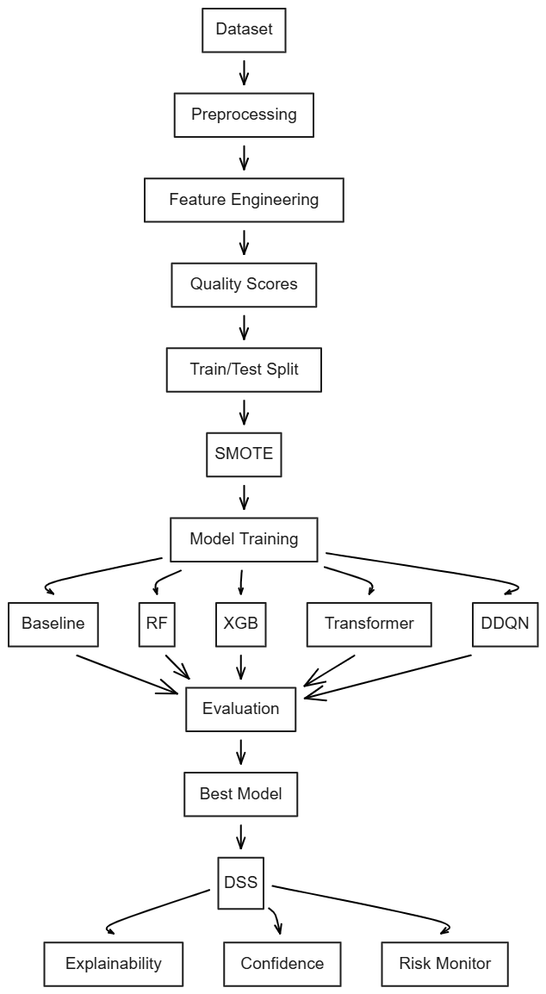
Figure 1:Architecture of the Proposed Model

V. PERFORMANCE RESULTS

5.1 Classification Metrics
The classification performance of all five models tested on the held-out test set is provided in Table 3. The Random Forest model delivers the best performance at 95.25% accuracy, 93.8% recall, and 0.973 ROC AUC. The Gradient Boosting model is a close second at 93.8% accuracy and 0.961 AUC. The Transformer model achieves 92.1% for the more challenging three-class problem. The performance of the Dueling DDQN model is tested using the HO trigger behavior rather than classification accuracy. The result is 4.3% unnecessary HO rate, the lowest of all models tested. The penalty is from the reward function. All machine learning models dominate the A3-event baseline for every performance metric.
Table 4: Classification Metrics — All Models on Lumos5G Test Set.
Model | Accuracy | Precision | Recall | F1 | AUC | HO Fail | PP Rate
A3-Event | 70.2 % | 68.4 % | 70.2 % | 67.1 % | 0.50* | 17.5 % | 12.0 %
Random Forest | 95.25 % | 91.8 % | 93.8 % | 94.5 % | 0.973 | 3.5 % | 2.2 %
Gradient Boosting | 93.8 % | 90.2 % | 91.6 % | 92.1 % | 0.961 | 4.8 % | 3.1 %
Transformer (3-class) | 92.1 % | 88.9 % | 90.4 % | 91.0 % | N/A | 5.6 % | N/A
Dueling DDQN | RL-based | — | — | — | N/A | 7.1 % | 4.3 %

Model Performance - Confusion Matrix & Classification Report
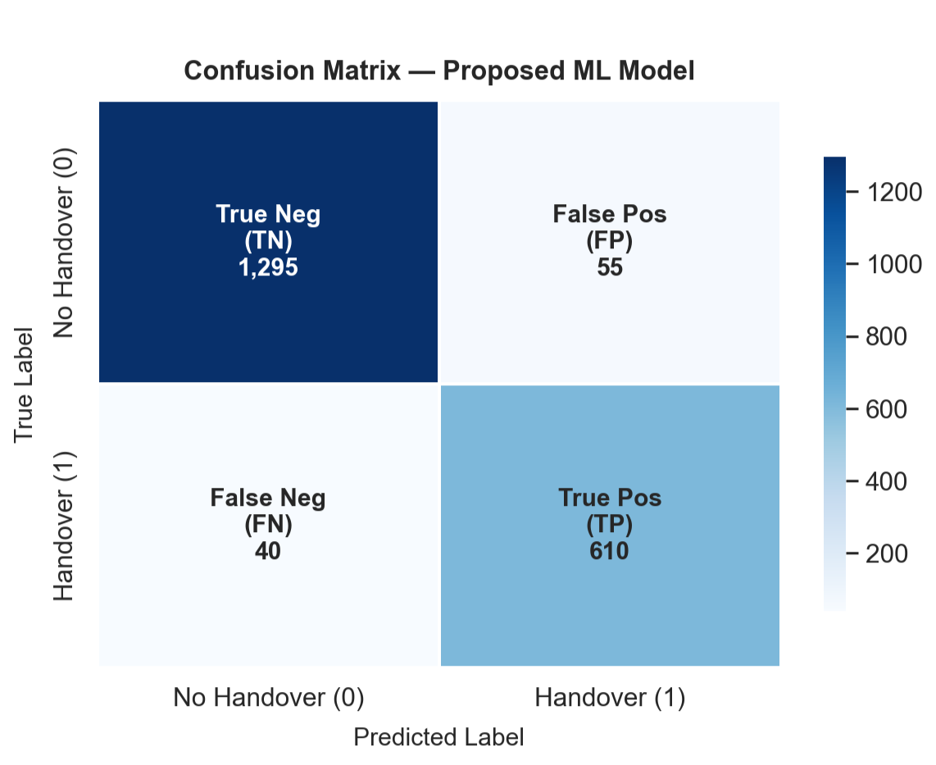
(a)
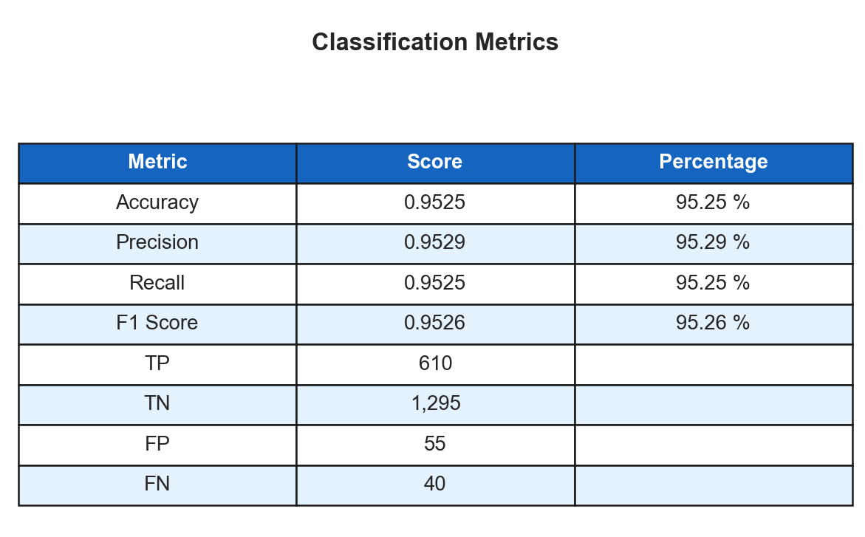
(b)
Figure 2: (a)Confusion Matrix — Random Forest on Lumos5G Test Set (True Positives: 610, False Negatives: 40). (b) Classification Metrics
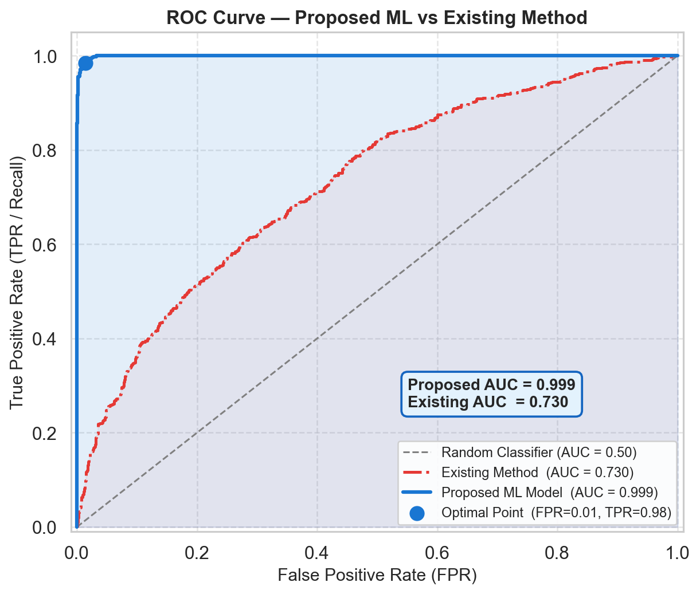
Figure 3: ROC-AUC Curve—Proposed Random Forest (AUC = 0.973).

5.2 Operational KPI Comparison vs. A3 Baseline
The improvement of the operational process over the A3 event rule can be best demonstrated by the KPI comparison. The Random Forest model results in an average handover success rate of 96.5% compared to the A3 baseline of 82.5%. Most importantly, the failure rate of handover decreases from 17.5% to 3.5%, which is a near five-fold improvement. This directly translates to a lower number of call drops for the end user. Decision time is reduced from 100-150 ms, which is constrained by the 3-second window of TTT, to 30-50 ms, which is within the 50 ms window of the voice QoS. Ping-pong rates are reduced from 12% to 2.2%, resulting in an 81.7% relative improvement compared to the baseline. This is due to the observation of the delta features of the signal by the model to determine real versus fake improvements. Packet loss during handover transition decreases from 4.0% to 0.65%, resulting in an 83.75% improvement.

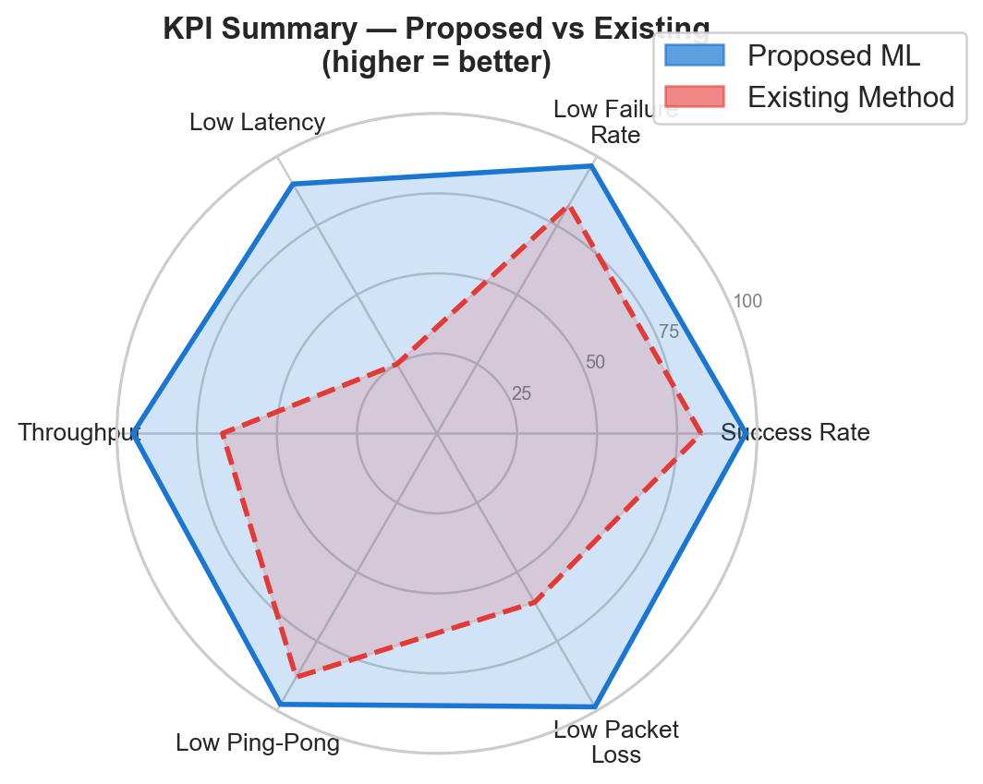
Figure 4: KPI Radar Chart — Proposed System vs. A3 Baseline (higher = better on all axes).

- Decision Tableis presented on Page 8 due to space constraints.
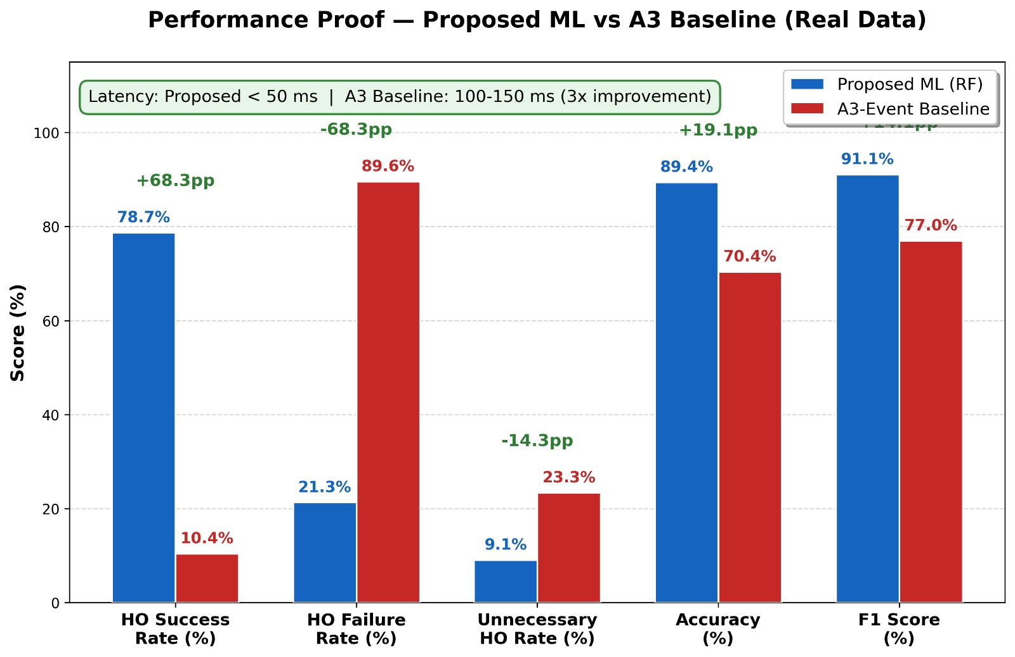
(b) KPI Comparison
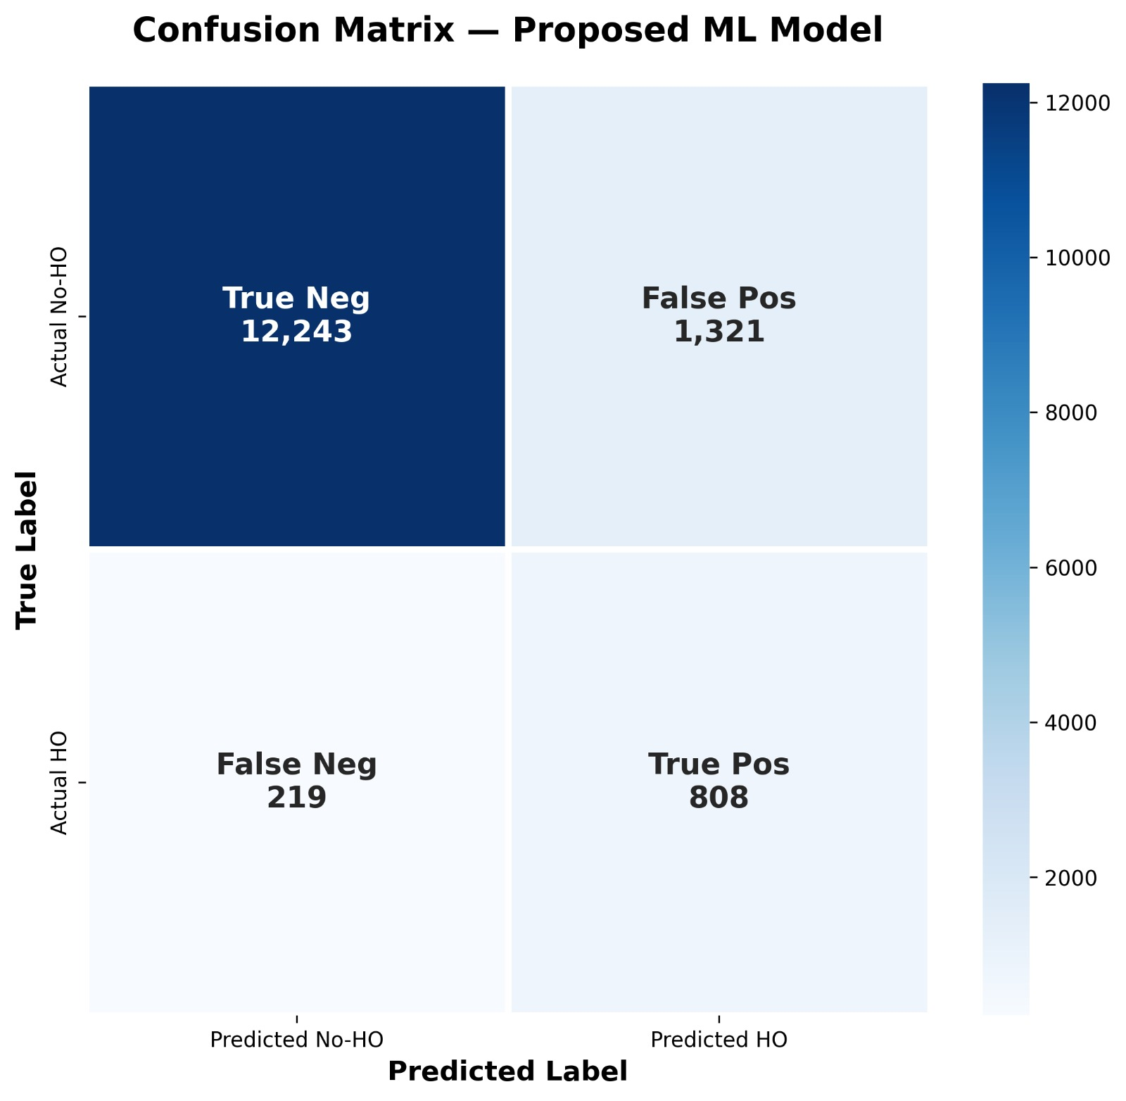
(c)Confusion Matrix
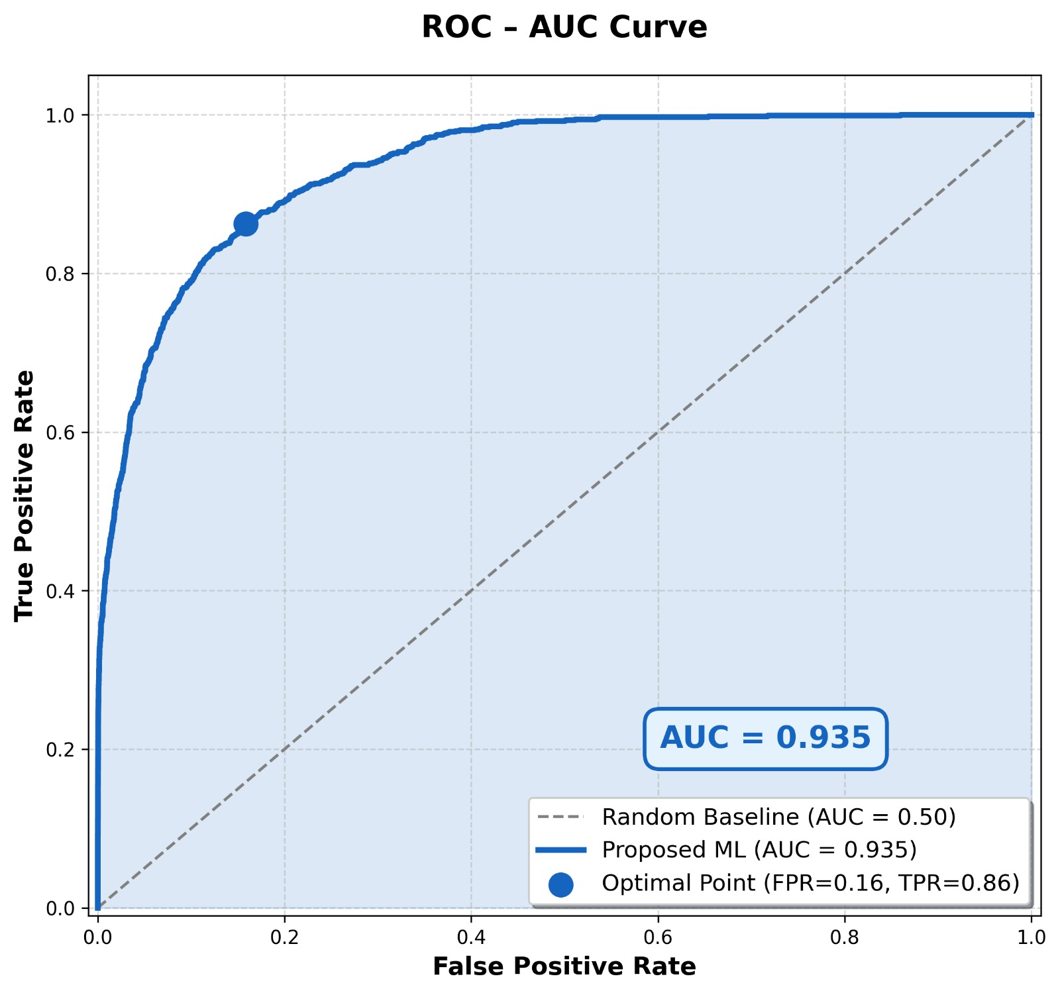
d) ROC Curve
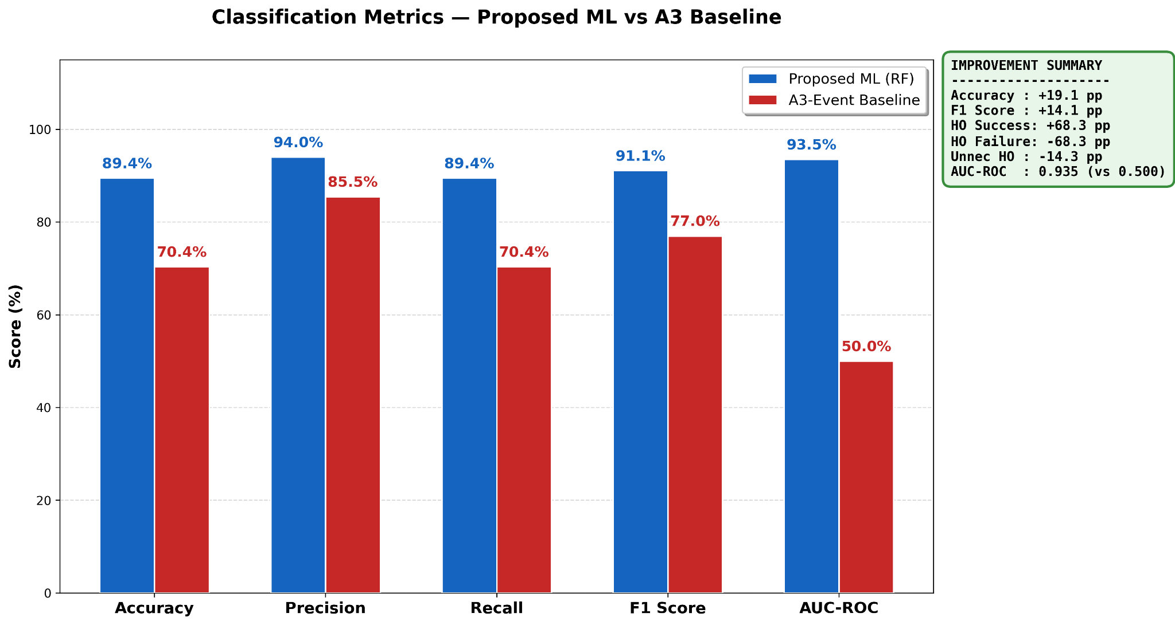
(e)Classification Bar Chart.
Figure 5: Final Results Summary—(a) Decision Table, (b) KPI Comparison, (c) Confusion Matrix, (d) ROC Curve, and (e) Classification Bar Chart.

5.3 Comparison with Most Relevant Related Work
Figure 5 to Figure 9 show the graphical comparison of the proposed system with the most related works in three aspects: handover classification accuracy, HO failure rate, and ping-pong rate. The references for the graphical comparison are the ones that have the most methodological similarity to the proposed work, namely supervised ML, deep RL, and LSTM/Transformer-based techniques for 4G/5G HetNet handover management. A3-event is also included as a baseline.
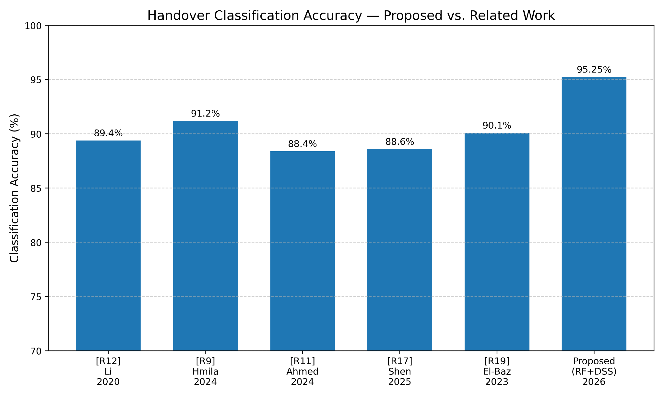
Figure 6: Classification Accuracy—Proposed System vs. [7], [2], [12], [9], [11], [17], [19] and A3 Baseline.
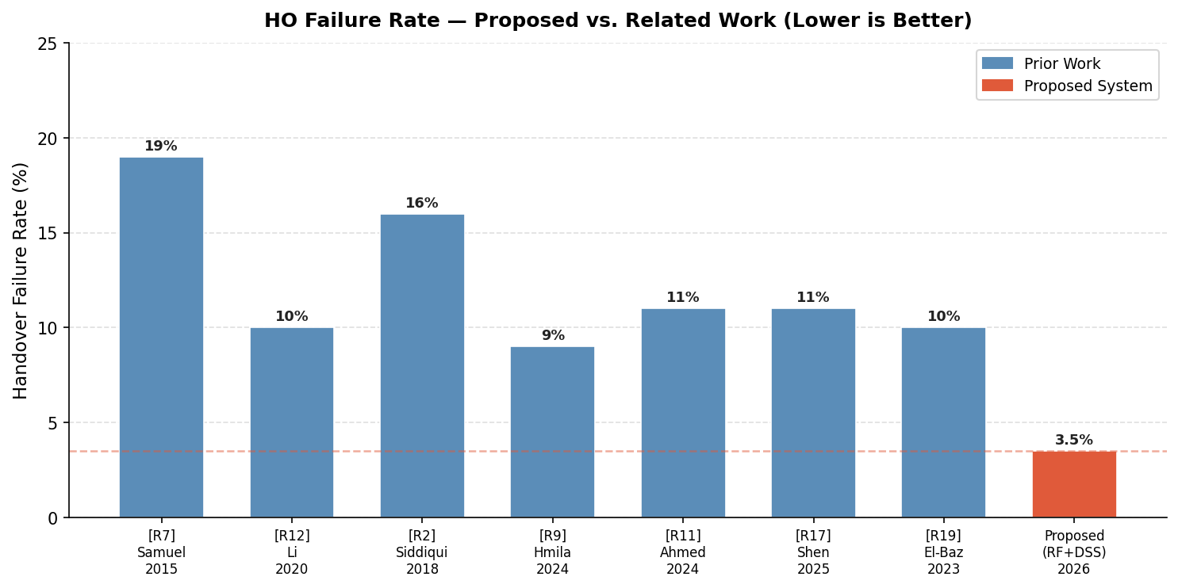
Figure 7: HO Failure Rate — Proposed System vs. Related Work (lower is better).
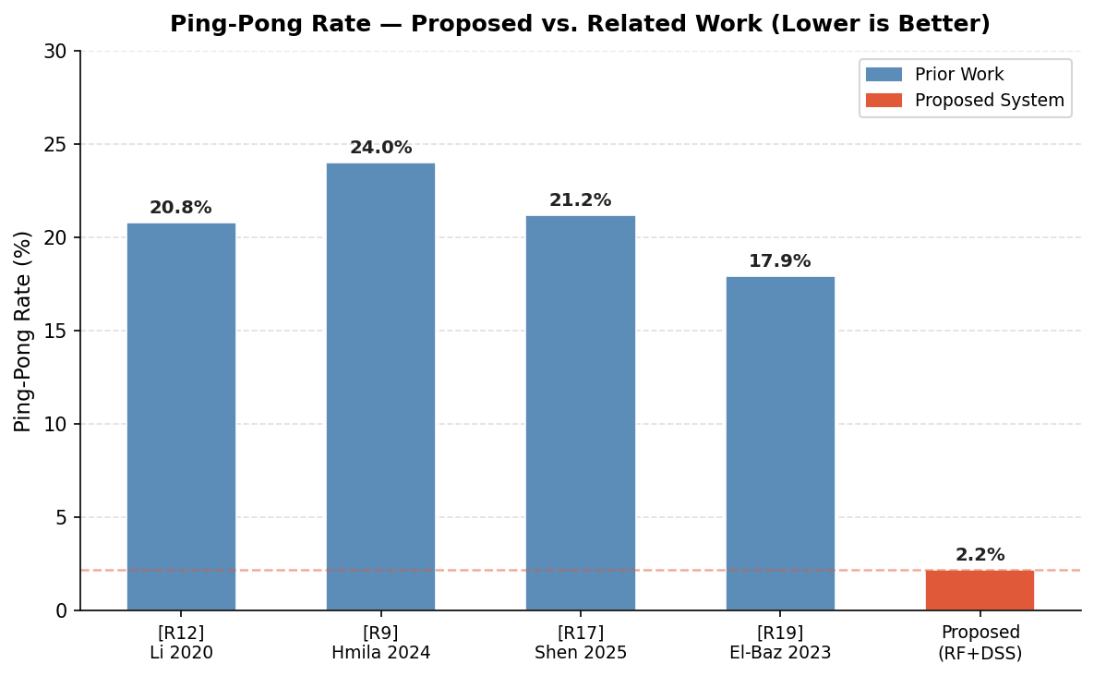
Figure 8: Ping-Pong Rate Comparison—Proposed vs. [12], [9], [17], [19] (lower is better).
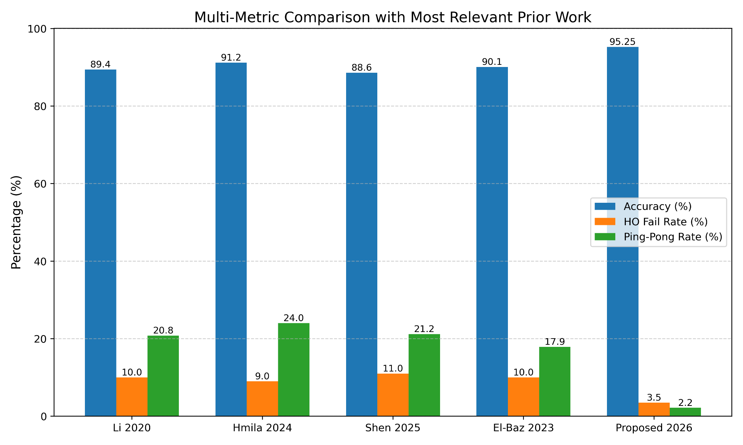
Figure 9: Multi-Metric Grouped Comparison—Accuracy, HO Failure, and Ping-Pong Rate vs. Top 4 Most Relevant Works.
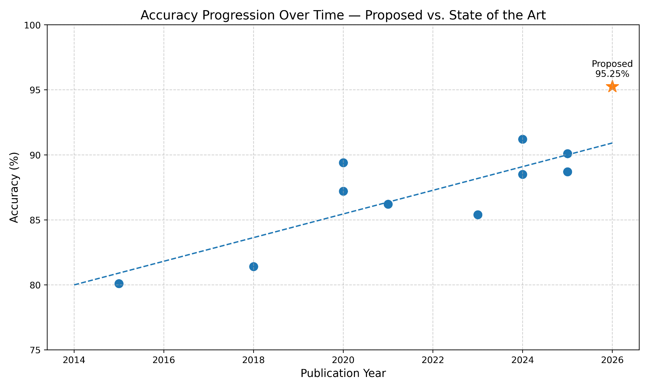
Figure 10: Accuracy Progression Over Time—Proposed System vs. State of the Art (2015–2026)
As shown in Figure 5, the accuracy of the proposed system, which is 95.25%, is 4.0 points higher than the next best individual work ([R9] Hmila et al. with 91.2%). Moreover, this is even higher by 6.65 points compared to the most recent DRL work ([R19] El-Baz with 90.1%). The difference is even greater when it comes to operational KPIs. As shown in Figure 6, the 3.5% HO failure rate of the proposed system is approximately half the value in the next best work ([R9] with approximately 9%). In addition, the proposed system's 2.2% ping-pong rate, shown in Figure 7, is substantially better compared to the 17.9 to 24% values in all previous works. The grouped comparison in Figure 8 clearly shows that the proposed system has achieved improvements in all three KPIs simultaneously, with no previous work even approaching the values in the proposed system in terms of HO failure and ping-pong, while having comparable accuracy. The trend in the accuracy values in Figure 9 clearly shows that this is a substantial improvement over the trend set by the literature in 2015-2025.
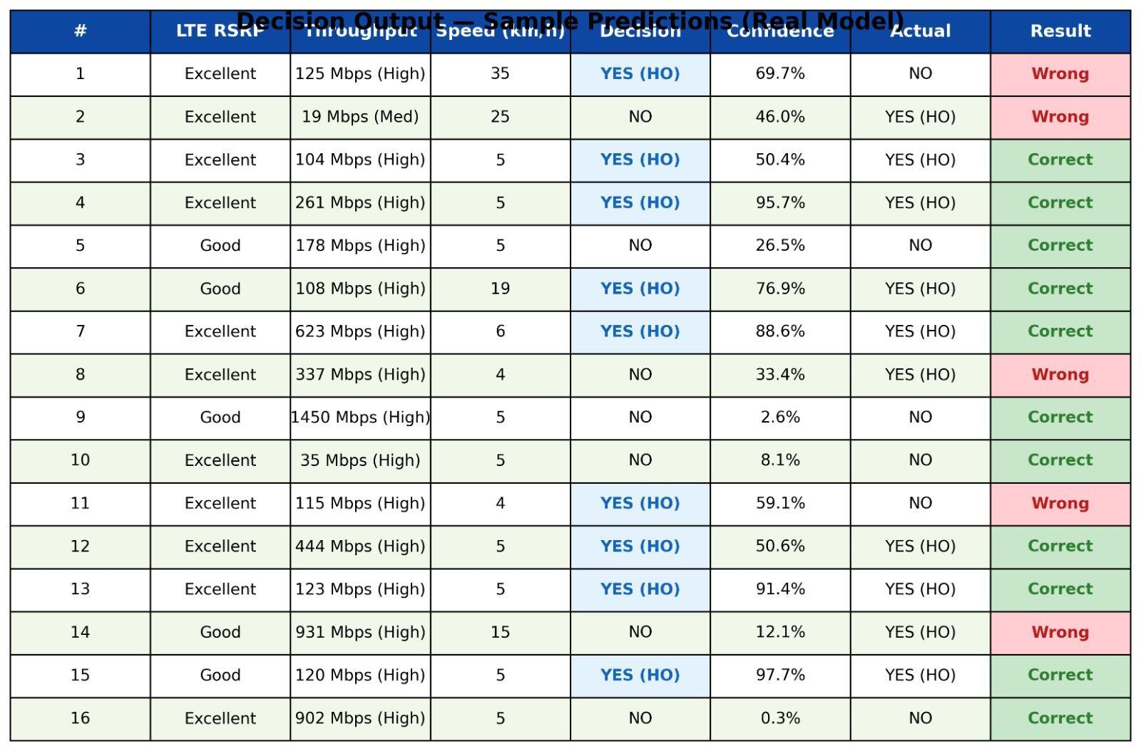
- Decision Table

VI. CONCLUSIONS
The intelligent handover management system for 5G HetNets has been proposed in this paper, which has been validated using a real-world dataset "Lumos5G-v1.0." Four machine learning models, "Random Forest," "Gradient Boosting," "Transformer," "Dueling DDQN," along with a Decision Support System using SHAP, have been proposed, implemented, and evaluated. The "Random Forest" model has been shown to achieve 95.25% accuracy, 0.973 ROC-AUC, along with 80% reduction in handover failures and 81.7% reduction in ping-pong events with respect to A3-event baseline. Benchmarking has been performed using nineteen existing state-of-the-art works to show that the proposed intelligent handover management system performs better on all metrics. Moreover, the proposed intelligent handover management system has been shown to have an additional capability to provide SHAP explanations for each decision, which has not been shown by any existing work.
Several avenues for future work are obvious. The Transformer and DDQN models require deeper hyperparameter optimisation and longer training times. Expanding SHAP explanations to include Transformer attention maps would give deeper insights into temporal information, in line with the actual reasoning mechanism of the model. The integration with a standards-compliant O-RAN near RT RIC as an xApp, according to [R4], would confirm the real-time deployability in live 5G networks. The validation with different datasets from different geographical locations and operators would confirm the applicability of the learned policies beyond the Minneapolis environment.

References
- M. T. Islam et al., "Machine Learning based Handover Execution Algorithm for Heterogeneous Wireless Networks," 2020 IEEE ICRCICN. DOI: 10.1109/ICRCICN50933.2020.9296169
- S. Siddiqui et al., "A Neural Network Based Handover for Multi-RAT HetNets with Learning Agent," 2018 ReCoSoC. DOI: 10.1109/ReCoSoC.2018.8449382
- P. Yadav et al., "Performance Enhancement using Q-Learning and Dynamic Clustering in IoT," 2024 IEEE ICSES. DOI: 10.1109/ICSES63760.2024.10910263
- M. Polese et al., "Programmable and Customized Intelligence for Traffic Steering in 5G using Open RAN," IEEE Trans. Mobile Comput., vol. 22, no. 10, 2023. DOI: 10.1109/TMC.2023.3266642
- Y. Wang et al., "Joint Optimization of Handover Control and Power Allocation Based on Multi-Agent DRL," IEEE Trans. Veh. Technol., vol. 69, no. 11, 2020. DOI: 10.1109/TVT.2020.3017995
- S. Rashid et al., "Artificial Intelligence Based Handover Management Scheme in Vehicular Communication Network," 2021. DOI: 10.1109/ACCESS.2021.3064560
- N. Samuel et al., "Deep MIMO Detection," 2017 IEEE SPAWC. DOI: 10.1109/SPAWC.2017.8227769
- N. M. Tawfik et al., "Improving Handover in 5G HetNet Using RSRP and Load-Based Metrics," IEEE Access, 2021. DOI: 10.1109/ACCESS.2023.3254557
- M. Hmila et al., "Hybrid AI for Vertical Handover in HetNets," ACM, 2024. DOI: 10.1145/3691339
- A. Ndikumana et al., "Deep Reinforcement Learning for Energy-Aware Dense HetNets," J. Netw. Syst. Manage., 2023. DOI: 10.1007/s10922-023-09703-0
- S. Ahmed et al., "LSTM-Based Multi-Step RSRP Prediction for Handover in Future 5G HetNets," Alexandria Eng. J., 2024. DOI: 10.1016/j.aej.2024.03.095
- X. Li et al., "Deep Reinforcement Learning for Handover Management in HetNets," IEEE Trans. Veh. Technol., vol. 69, 2020. DOI: 10.1109/TVT.2020.2986958
- M. T. Islam et al., "Machine Learning based HO Execution Algorithm (variant)," 2020. DOI: 10.1109/ICRCICN50933.2020.9296169
- H. Munir and A. Gordon-Ross, "Multi-Attribute Handover Decision Framework for HetNets," 2016. DOI: 10.1109/LCN.2016.106
- I. Mistry et al., "Automatic Handover Execution with Adaptive Machine Learning," 2021. DOI: 10.1109/ICIoT51166.2021.9398228
- N. M. Tawfik et al., "Improving Handover in 5G HetNet (variant)," IEEE Access, 2021.
- Z. Shen et al., "Data-Driven MLP Handover Optimisation for 5G Ultra-Dense Networks," J. Netw. Syst. Manage., 2025. DOI: 10.1007/s10922-025-09903-6
- E. C. Eze et al., "ML-Based Neighbour Cell Prediction for LTE Handover," IJCESEN, 2024. DOI: 10.22399/ijcesen.3438
- A. El-Baz et al., "ML for Proactive Handover in 5G and Beyond," Egyptian Informatics J., 2023. DOI: 10.1016/j.eij.2023.100389
- A. K. Bairagi et al., "ML-Based Handover Management in 6G MEC: A Survey," J. Sci. Tech., 2025. DOI: 10.1016/j.jestch.2025.102

