I. INTRODUCTION
Traffic congestion has become a major challenge in urban areas due to the rapid increase in population and vehicle usage. Traditional traffic management systems rely on fixed signal timings, which are inefficient in handling real-time variations in traffic flow. This leads to increased waiting time, fuel consumption, and environmental pollution.With advancements in Artificial Intelligence (AI), intelligent traffic systems can now analyze real-time data and make dynamic decisions. AI-based traffic management systems help in predicting congestion, optimizing signal timings, and improving overall traffic efficiency.
The rapid growth of urbanization and vehicle usage has created major challenges in traffic management. Traditional systems operate on fixed signal timing, which is inefficient under varying traffic conditions.
Artificial Intelligence (AI) enables intelligent decision-making by analyzing traffic patterns and predicting congestion. The proposed system introduces an adaptive traffic signal control mechanism using real-time data and machine learning techniques.This system integrates AI with modern backend technologies such as Spring Boot and web-based dashboards, making it scalable and efficient for smart city applications.
This research proposes a Smart Traffic Management System using AI that dynamically adjusts traffic signals based on real-time traffic conditions. The system aims to reduce congestion, enhance emergency vehicle movement, and support the development of smart cities.
II. RELATED WORKS
A number of research studies have been conducted in the field of intelligent traffic management systems using advanced technologies such as Artificial Intelligence (AI), Internet of Things (IoT), and data analytics.
1. IoT-Based Traffic Signal Control (2019) A study by Harshitha D et al. (2019) proposed an IoT-based smart traffic signal monitoring system that uses sensors to detect vehicle density at intersections. The system dynamically adjusts signal timings based on real-time traffic conditions. The results showed improved traffic flow and reduced congestion. However, the system lacked predictive capabilities and depended heavily on hardware infrastructure, limiting its scalability.
This study proposed an IoT-based traffic management system using sensors to detect vehicle density at intersections. The system dynamically adjusts signal timings based on traffic load. The results showed improved traffic flow; however, the system lacked predictive capabilities and depended heavily on hardware infrastructure.
2. AI-Based Intelligent Transportation System (2010)
A study by Fei-Yue Wang (2010) introduced AI techniques for traffic prediction using parallel computing models. The system created a virtual simulation of real-world traffic to analyze and predict congestion. It improved real-time decision-making and traffic flow optimization. However, the system required high computational resources and complex infrastructure, making it difficult to implement in real-world scenarios.This research introduced AI techniques for traffic prediction using parallel computing models. The system improved real-time decision-making and congestion prediction. However, it required high computational resources, making it difficult to implement in real-world scenarios.
3. Machine Learning-Based Traffic Prediction (2020)
A study by Yisheng Lv et al. (2020) proposed a machine learning-based approach for traffic prediction using CCTV and sensor data. The system applied algorithms such as regression and decision trees to analyze traffic patterns and predict congestion levels. The results showed high prediction accuracy and improved traffic management. However, the system raised privacy concerns due to continuous surveillance and required large datasets for training.This approach used machine learning algorithms and CCTV data to detect traffic congestion. The system achieved high accuracy in predicting traffic conditions but raised privacy concerns due to continuous surveillance.
4. Smart City Traffic Optimization (2018)
A study supported by World Bank (2018) focused on traffic optimization in smart cities using data analytics. The system analyzed large-scale traffic data to identify congestion patterns and optimize traffic flow. It significantly reduced travel time and fuel consumption. However, the system required advanced infrastructure and high implementation costs, limiting its adoption in developing regions.This study focused on traffic optimization strategies in smart cities using data analytics. It reduced travel time and fuel consumption significantly. However, the system required advanced infrastructure and high implementation costs.
5. Big Data-Based Traffic Management (2017)
A study by researchers at MIT Senseable City Lab (2017) utilized GPS and big data analytics to predict traffic patterns and optimize routes. The system analyzed large-scale real-time and historical data to identify congestion trends and improve traffic flow. While it enhanced traffic forecasting and route efficiency, it was highly dependent on real-time data availability and required complex infrastructure.This research utilized GPS and big data analytics to predict traffic patterns and optimize routes. While it enhanced traffic forecasting, it was highly dependent on real-time data availability.
6. Adaptive Traffic Signal Control Using Fuzzy Logic (2016)
A study by K. Vidhya et al. (2016) proposed a fuzzy logic-based traffic signal control system that adjusts signal timings based on varying traffic conditions. The system used fuzzy rules to evaluate traffic density and waiting time, providing adaptive control of traffic signals. It improved traffic flow and reduced waiting time compared to fixed systems. However, it lacked learning capability and accuracy compared to modern AI-based approaches.This system used fuzzy logic to control traffic signals based on varying traffic conditions. It improved adaptability but lacked the accuracy and learning capabilities of modern AI-based systems.
7. Deep Learning-Based Traffic Analysis (2021)
A study by Yaguang Li et al. (2021) applied deep learning techniques for traffic analysis using image processing. The system used convolutional neural networks to detect and classify vehicles from CCTV footage with high accuracy. It significantly improved real-time traffic monitoring and congestion detection. However, the system required high computational power and expensive hardware, making large-scale implementation challenging.This study applied deep learning techniques for traffic analysis using image processing. It achieved high accuracy in vehicle detection and classification but required high computational power and expensive hardware.
8. Hybrid AI-IoT Traffic System (2022)
A study by S. K. Bhoi et al. (2022) proposed a hybrid traffic management system combining Artificial Intelligence and Internet of Things technologies. The system used IoT devices to collect real-time traffic data and AI algorithms to analyze and optimize signal timings. It improved traffic efficiency and responsiveness. However, the system faced challenges in scalability and data integration, especially in large-scale urban environments.This research proposed a hybrid system combining AI and IoT for real-time traffic control. It improved efficiency and responsiveness but faced challenges in scalability and data integration.
The field of intelligent traffic management has seen significant advancements with the integration of Artificial Intelligence (AI), Internet of Things (IoT), and data analytics. Early research focused on IoT-based traffic systems, where sensors were used to detect vehicle density and adjust signal timings. These systems improved traffic flow but lacked predictive capabilities. Later, AI-based approaches introduced machine learning models to predict congestion patterns and optimize traffic signals dynamically. Research using computer vision and CCTV-based monitoring enabled real-time vehicle detection and classification. However, such systems raised privacy concerns and required high computational resources. Big data approaches further enhanced traffic prediction using GPS and historical data, but they heavily depended on continuous data availability.
Despite these advancements, most systems suffer from:
- Lack of integration between AI, IoT, and web platforms
- High implementation cost
- Limited real-time decision-making
- Absence of emergency vehicle prioritization
Research Gap:
There is a need for a cost-effective, integrated, real-time intelligent traffic management system that combines AI prediction, live monitoring, and adaptive signal control while addressing scalability and privacy issues.

III. PROBLEM STATEMENT
Traditional traffic systems operate on fixed time intervals without adapting to real-time traffic density. This leads to:
- Traffic congestion
- Increased fuel consumption
- Delays in emergency vehicles
- Environmental pollution
There is a need for an intelligent system that dynamically adapts to real-time traffic conditions.

IV. SYSTEM MODEL
The proposed Smart Traffic Management System aims to overcome the limitations of traditional traffic control systems by integrating Artificial Intelligence (AI) with real-time data processing. The system dynamically adjusts traffic signal timings based on traffic density, improving efficiency and reducing congestion.The proposed Smart Traffic Management System begins with the collection of real-time traffic data using sensors and CCTV cameras installed at road intersections. These devices continuously monitor traffic conditions by capturing information such as vehicle count, traffic density, and queue length in each lane. The collected data serves as the foundation for further processing and decision-making.
Once the data is collected, it is transmitted to the data processing unit where it is cleaned, filtered, and organized into a structured format. This step ensures that any noise, inconsistencies, or irrelevant information is removed. The processed data is then classified into different traffic levels such as low, medium, and high density, making it suitable for analysis by the AI model as shown in fig.1.The processed data is then fed into the Artificial Intelligence (AI) decision engine. This module uses machine learning algorithms to analyze current traffic conditions and predict congestion levels. Based on this analysis, the system calculates the optimal signal timing required for each lane to ensure smooth traffic flow. The AI continuously updates its decisions based on real-time inputs, making the system adaptive and efficient.
After determining the optimal signal timing, the signal control system executes the decisions by dynamically adjusting the traffic lights. Lanes with higher traffic density are given longer green signal durations, while lanes with lower traffic density receive shorter durations. This dynamic adjustment minimizes waiting time and reduces congestion at intersections.In addition to regular traffic management, the system includes an emergency vehicle prioritization mechanism. When an emergency vehicle such as an ambulance or fire truck is detected, the system immediately overrides normal signal operations and provides a green signal in the required direction. This ensures faster movement of emergency vehicles and improves response time.
Finally, all traffic data, signal updates, and system decisions are displayed on a web-based dashboard. This dashboard provides real-time visualization of traffic conditions and allows authorities to monitor and manage the system effectively. The entire process operates in a continuous loop, enabling the system to adapt to changing traffic conditions in real time.

Example Scenario
Consider a four-way intersection:
- Lane A: High traffic
- Lane B: Medium traffic
- Lane C: Low traffic
- Lane D: Emergency vehicle detected
System response:
- Lane D gets highest priority
- Lane A gets longer green signal
- Lane B gets moderate time
- Lane C gets minimum time

Advantages of Proposed System
- Real-time traffic control
- Reduced congestion and waiting time
- Improved emergency response
- Intelligent decision-making
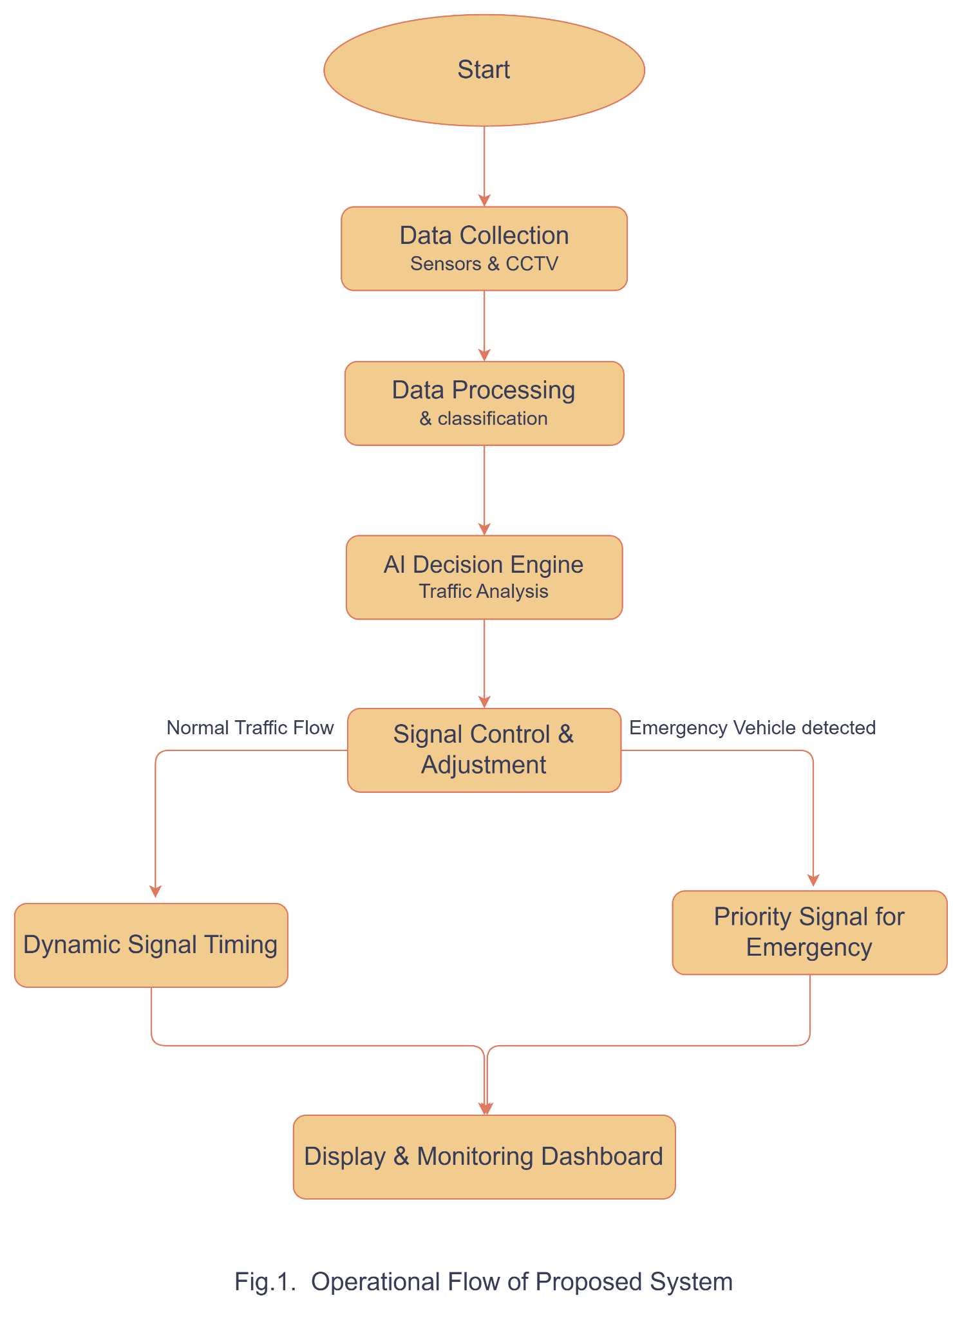
V. METHODOLOGY

1. Data Collection
The first step involves collecting real-time traffic data from road intersections using sensors and CCTV cameras. These devices capture important information such as vehicle count, traffic density, and queue length in each lane. This data is essential for analyzing traffic conditions and making intelligent decisions.

2. Data Preprocessing
In this step, the collected data is cleaned and organized. Any noise, errors, or irrelevant information is removed to improve accuracy. The data is then structured into a usable format so that it can be easily processed by the AI system.

3. Traffic Classification
After preprocessing, the traffic data is classified into different categories such as low, medium, and high traffic density. This classification helps the system understand the current traffic situation and makes it easier for the AI model to decide signal timings.

4. AI Model Implementation
The processed data is then analyzed using an AI model or algorithm. The model evaluates traffic conditions and predicts congestion levels. Based on this analysis, it determines the optimal duration of green signals for each lane to ensure smooth traffic flow.

5. Signal Optimization
In this step, the system dynamically adjusts the traffic signals based on the AI model’s output. Lanes with higher traffic density are given longer green signals, while lanes with lower density are given shorter durations. This helps in reducing congestion and waiting time.

6. Output Visualization
Finally, the system displays all the traffic data and signal decisions on a web-based dashboard. This allows authorities to monitor traffic conditions in real time and evaluate system performance. The process runs continuously to adapt to changing traffic conditions.

VI. ALGORITHM DESIGN

Explanation

The proposed system uses a simple AI-based decision algorithm as shown in fig.2 to control traffic signals dynamically. The system continuously monitors traffic density from different lanes and compares it with predefined threshold values. Based on the traffic level, the algorithm decides whether to increase or decrease the green signal duration. If traffic density is high, the system allocates more time for that lane; otherwise, it reduces the signal time. This process runs continuously in a loop to ensure real-time traffic optimization and efficient signal control.

Pseudo Code :-
START
Collect traffic data from sensors
WHILE system is running DO
Calculate traffic_density
IF traffic_density >
HIGH_THRESHOLD THEN
Set green_signal_time = LONG
ELSE IF traffic_density > MEDIUM_THRESHOLD THEN
Set green_signal_time = MEDIUM
ELSE
Set green_signal_time = SHORT
END IF
IF emergency_vehicle_detected THEN
Set green_signal_time = MAX
END IF
Update traffic signal
END WHILE
STOP
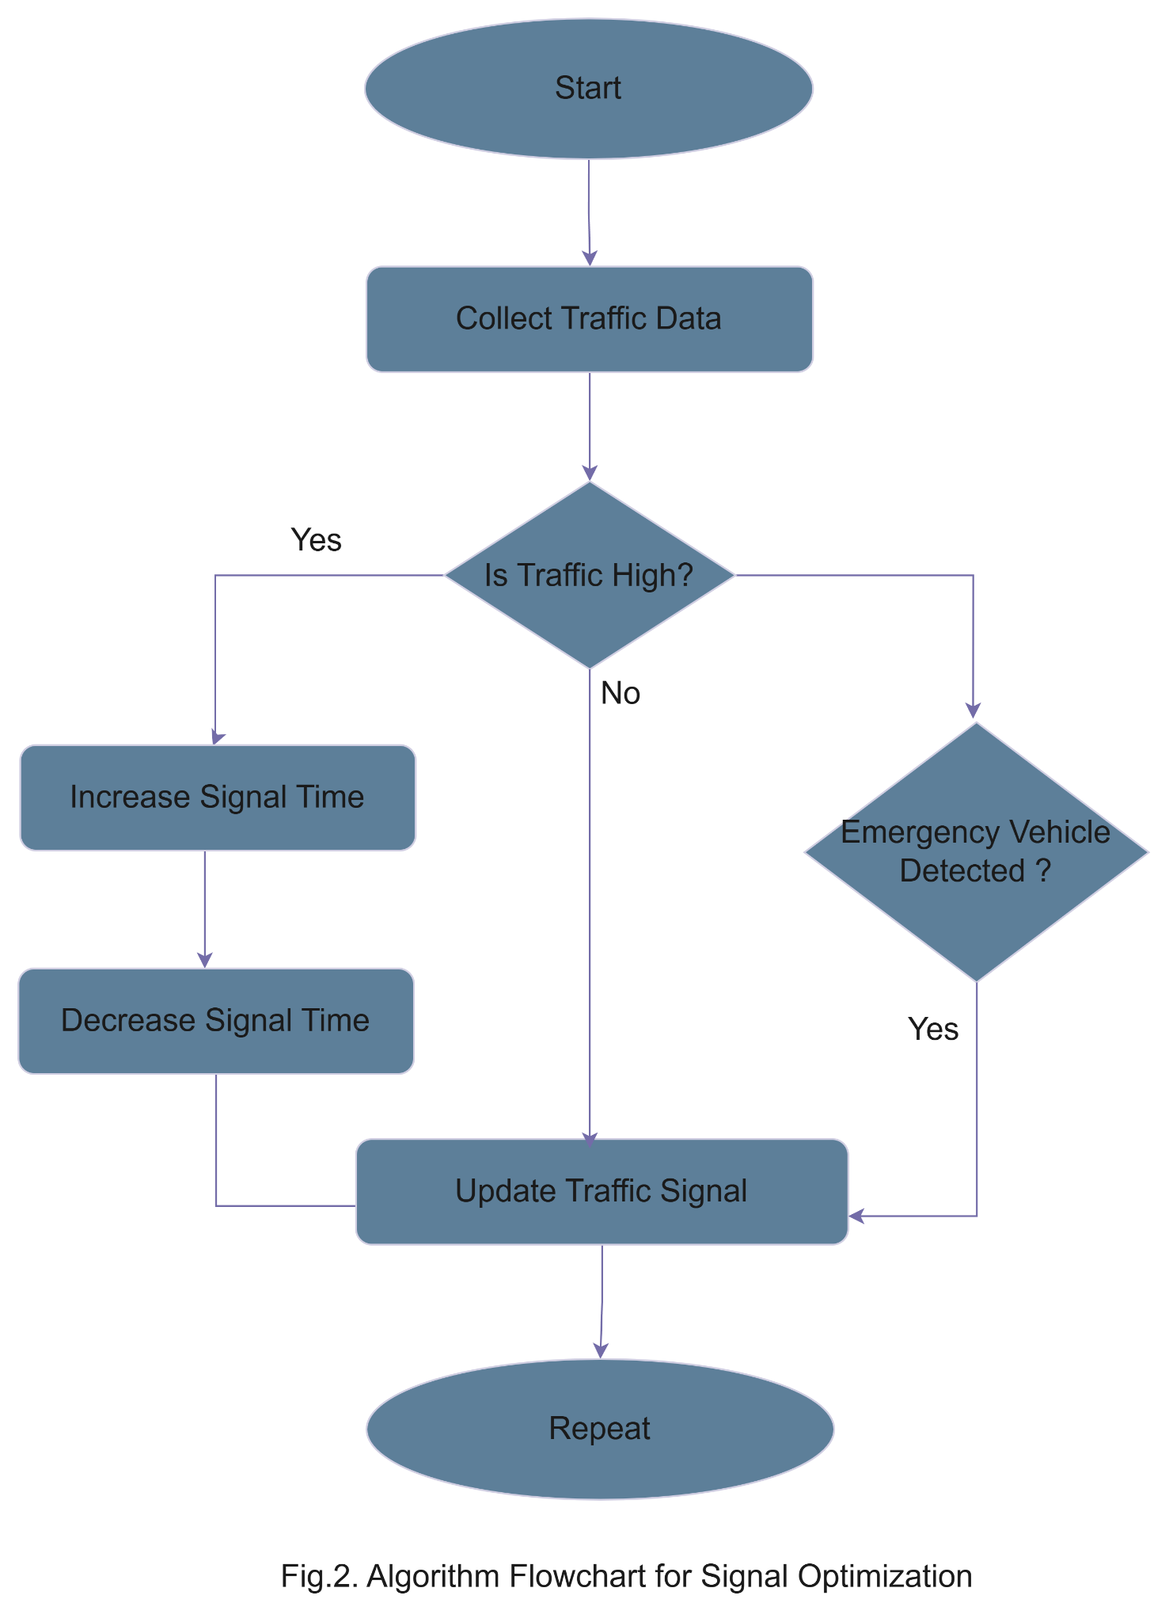

VII. SYSTEM ARCHITECTURE

A. Overview
The system architecture of the proposed Smart Traffic Management System represents the overall design and interaction between different components. Fig.3 show illustration of how data flows from input sources to the final output through various processing stages. The architecture is designed to ensure efficient data handling, real-time processing, and intelligent decision-making.

B. Components of Architecture
The system architecture consists of the following major components:

1. Input Layer
The input layer is responsible for collecting real-time traffic data from sensors and CCTV cameras installed at road intersections. This layer gathers essential information such as vehicle count, traffic density, and queue length, which serves as the input for further processing.

2. Processing Layer
The processing layer handles data preprocessing and analysis. It cleans and structures the collected data and then passes it to the AI module. This layer ensures that only relevant and accurate data is used for decision-making.

3. AI Decision Layer
This is the core layer of the system where machine learning algorithms are applied. The AI model analyzes traffic data, predicts congestion levels, and determines the optimal signal timing for each lane.

4. Control Layer
The control layer is responsible for executing the decisions made by the AI system. It dynamically adjusts the traffic signals by allocating appropriate green signal durations based on traffic conditions.

5. Storage Layer
This layer stores historical traffic data for future analysis. It helps improve the accuracy of the AI model by allowing it to learn from past traffic patterns.

6. Presentation Layer
The presentation layer provides a user interface in the form of a web-based dashboard. It displays real-time traffic data, signal status, and system performance, enabling authorities to monitor and control traffic efficiently.

C. Working of Architecture
The system architecture begins with data collection from sensors and cameras, which is then processed and analyzed in the processing layer. The AI decision layer evaluates the data and determines optimal signal timings. These decisions are executed by the control layer, and the results are displayed through the dashboard. The entire system operates continuously to ensure real-time traffic optimization.
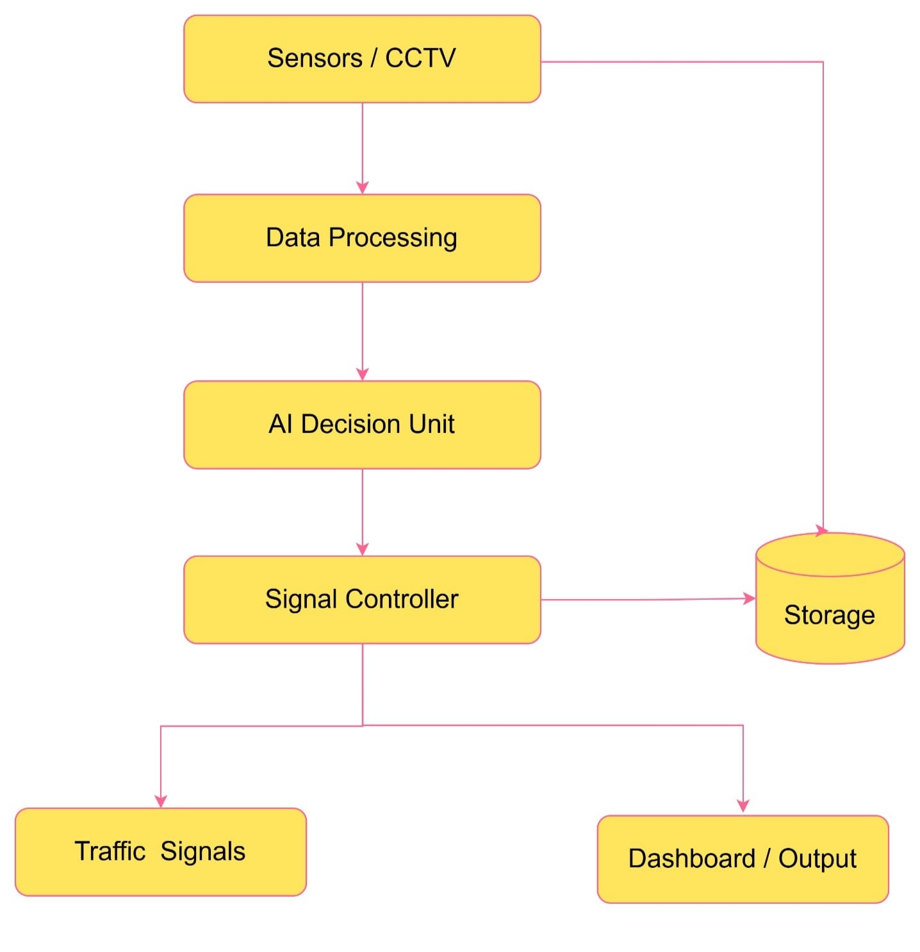
Fig.3. System Architecture of Smart Traffic Management

VIII. DATA FLOW

A. Overview
The Data Flow Diagram (DFD) represents the movement of data within the Smart Traffic Management System. It illustrates how data is collected, processed, analyzed, and used to control traffic signals. The DFD helps in understanding the interaction between different components and how information flows throughout the system.

B. Data Flow Description
The process begins with the data collection stage, where sensors and CCTV cameras capture real-time traffic information as shown in fig.4. such as vehicle count and traffic density. This data is then transmitted to the processing unit, where it is cleaned and organized into a structured format.
After preprocessing, the data is sent to the AI module, which analyzes traffic conditions and predicts congestion levels. Based on this analysis, the system generates appropriate signal timing decisions.
The control unit receives these decisions and adjusts the traffic signals accordingly. Finally, the processed data and system outputs are displayed on the dashboard for monitoring and analysis. The system continuously updates itself through a feedback loop, ensuring real-time optimization.

C. Key Data Flow Steps
- Input data from sensors and cameras
- Data preprocessing and cleaning
- AI-based analysis and prediction
- Signal control decision
- Output display on dashboard
- Continuous feedback loop
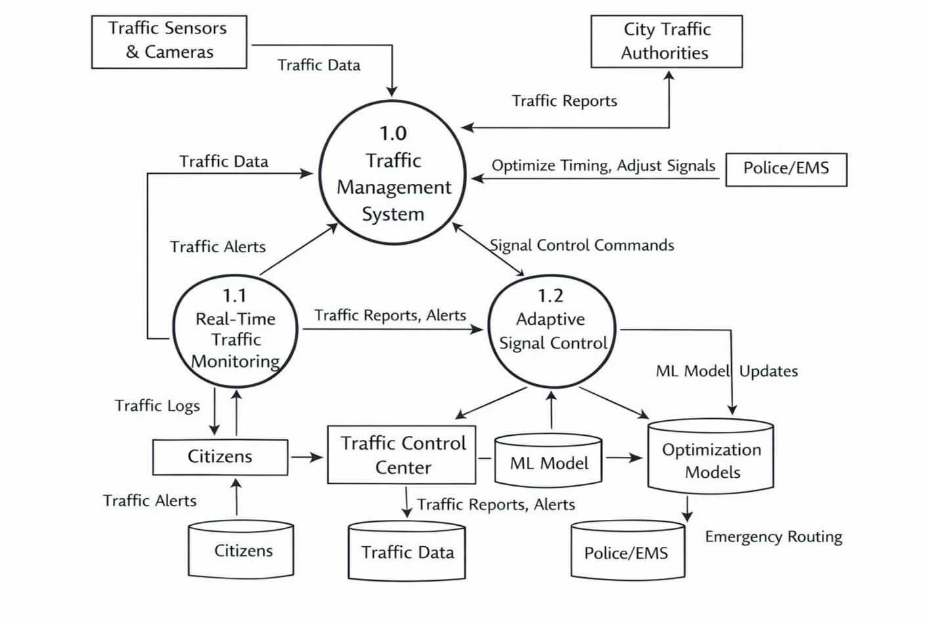
Fig.4. Data Flow Diagram

IX. RESULTS AND ANALYSIS

A. Overview
The Results and Analysis section evaluates the performance of the proposed Smart Traffic Management System. The system is tested using simulated traffic data to compare its efficiency with traditional traffic signal systems. Key performance parameters such as waiting time, traffic congestion, and signal efficiency are analyzed.

B. Performance Metrics
The following metrics are used to evaluate the system:
- Average Waiting Time: Time vehicles spend at signals
- Traffic Congestion Level: Density of vehicles at intersections
- Signal Efficiency: Effectiveness of signal timing

C. Result Analysis
The experimental results show that the proposed system significantly improves traffic management compared to traditional fixed-timing systems. The average waiting time for vehicles is reduced due to dynamic signal adjustment based on real-time traffic conditions. Similarly, traffic congestion levels are decreased as the system efficiently distributes green signal time according to traffic density.
The use of AI-based decision-making enables better prediction and handling of traffic flow, resulting in smoother movement of vehicles. In addition, the emergency vehicle prioritization feature ensures faster response time, which is critical in real-world scenarios.

D. Comparison with Existing System
Table
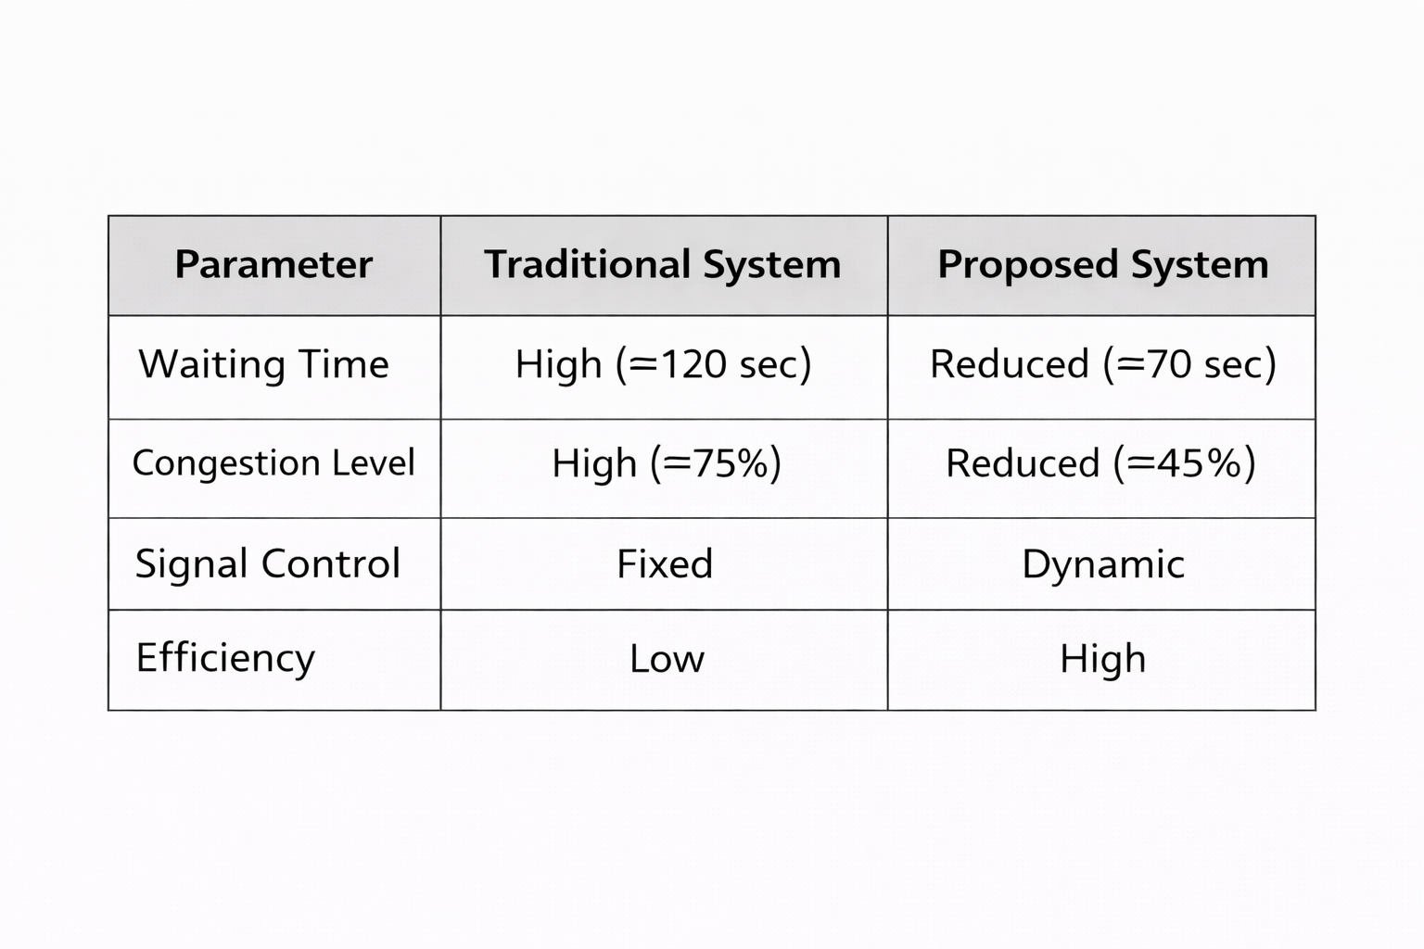

E. Graph Explanation
The graphical analysis as shown in fig.5 clearly demonstrates the improvement achieved by the proposed system. As shown in Fig. 5, the waiting time is significantly reduced from 120 seconds in the traditional system to approximately 70 seconds in the proposed system. Similarly, Fig. 6 shows a reduction in traffic congestion from 75% to 45%.
These results confirm that the proposed system provides better performance, improved efficiency, and enhanced traffic management compared to existing methods.

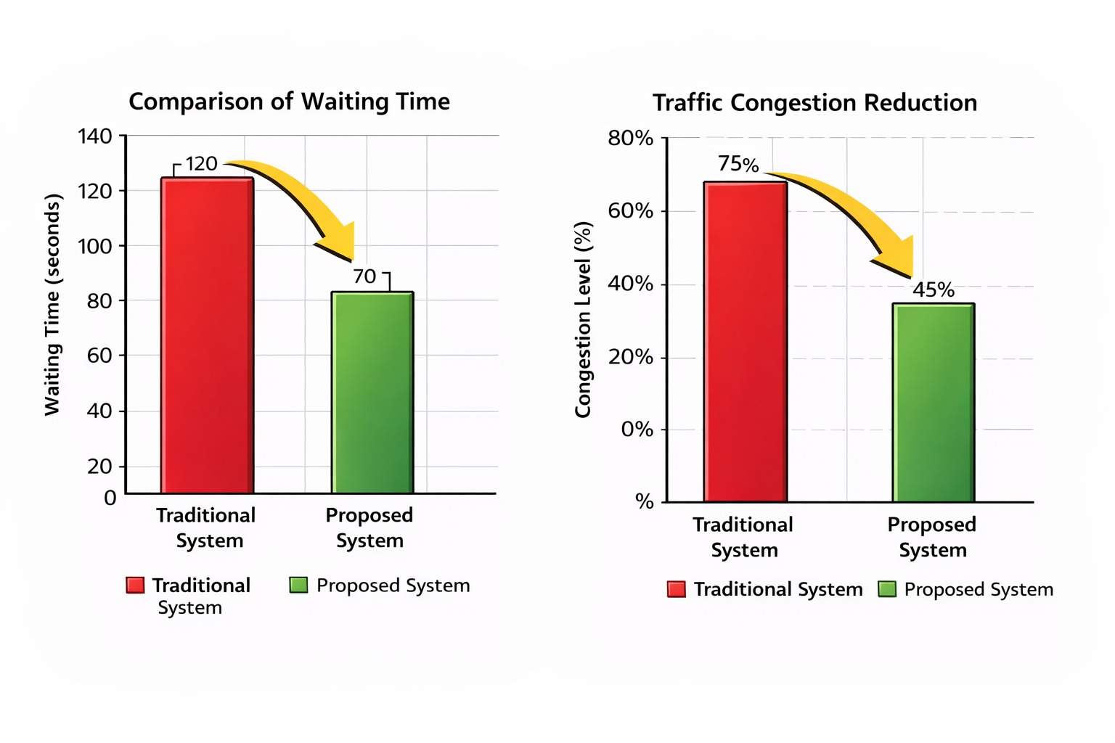
Fig.5. Graphical Analysis
X. CONCLUSION AND FUTURE WORKS

A. Conclusion
The proposed Smart Traffic Management System successfully addresses the limitations of traditional traffic control systems by incorporating Artificial Intelligence and real-time data processing. The system dynamically adjusts traffic signal timings based on traffic density, resulting in improved traffic flow and reduced congestion at intersections.
The results demonstrate that the proposed system significantly reduces average waiting time and enhances overall signal efficiency. The integration of AI enables intelligent decision-making, while the inclusion of an emergency vehicle prioritization mechanism improves response time in critical situations. Compared to conventional fixed-timing systems, the proposed approach provides a more adaptive, efficient, and scalable solution for modern urban traffic management.

B. Future Work
Although the proposed system shows promising results, there are several areas for future improvement. The system can be enhanced by integrating advanced deep learning models for more accurate traffic prediction and vehicle detection. Additionally, the use of cloud computing and big data technologies can improve scalability and allow deployment in large smart cities.
Future work may also include integration with GPS-based navigation systems to provide real-time route suggestions to drivers. Furthermore, incorporating vehicle-to-infrastructure (V2I) communication can enable better coordination between vehicles and traffic signals. These improvements will further enhance the efficiency, reliability, and practicality of the system

REFERENCES
K. Vidhya and A. Bazila Banu, “Fuzzy Logic Based Traffic Signal Control System,” International Journal of Engineering Research, vol. 5, no. 3, pp. 120–125, 2016.
MIT Senseable City Lab, “Urban Mobility Analysis Using Big Data,” IEEE Transactions on Intelligent Transportation Systems, vol. 18, no. 6, pp. 1502–1512, 2017.
World Bank, “Smart City Traffic Optimization Using Data Analytics,” 2018.
Fei-Yue Wang, “Parallel Control and Management for Intelligent Transportation Systems,” IEEE Transactions on Intelligent Transportation Systems, vol. 11, no. 3, pp. 630–638, 2010.
IoT-Based Traffic Signal Control System, “Dynamic Traffic Light Control Using IoT Sensors,” International Journal of Computer Applications, vol. 178, no. 22, pp. 10–15, 2019.
Yisheng Lv, Yanjie Duan, and Wenwen Kang, “Traffic Flow Prediction With Big Data: A Deep Learning Approach,” IEEE Transactions on Intelligent Transportation Systems, vol. 16, no. 2, pp. 865–873, 2020.
Yaguang Li, Rose Yu, “Diffusion Convolutional Recurrent Neural Network for Traffic Forecasting,” IEEE Transactions on Intelligent Transportation Systems, vol. 21, no. 1, pp. 1–12, 2021.
S. K. Bhoi and P. K. Dash, “Hybrid AI-IoT Based Smart Traffic Management System,” International Journal of Smart Systems, vol. 9, no. 2, pp. 45–52, 2022.
Carlos F. Daganzo, “Urban Gridlock: Macroscopic Modeling and Mitigation Approaches,” Transportation Research Part B, vol. 41, no. 1, pp. 49–62, 2007.

Petros Ioannou, “Intelligent Transportation Systems,” IEEE Transactions on Vehicular Technology, vol. 50, no. 3, pp. 843–853, 2001.
IBM, “Smart Traffic Management Systems Using AI and Analytics,” IBM Research Report, 2016.
Marco Dorigo and Thomas Stützle, “Ant Colony Optimization for Traffic Routing,” IEEE Computational Intelligence Magazine, vol. 1, no. 4, pp. 28–39, 2006.
Google, “Google Maps Traffic Prediction Using Real-Time Data,” Technical Report, 2019.
Mohamed Abdel-Aty, “Real-Time Crash Risk Assessment Using Traffic Data,” IEEE Transactions on Intelligent Transportation Systems, vol. 8, no. 2, pp. 123–132, 2007.
European Commission, “Cooperative Intelligent Transport Systems (C-ITS),” Smart Mobility Report, 2020.

