Assessing the Feasibility and Implementation of Smart Grids in Malawi: Challenges,
Solutions, and Economic Benefits

Henry Utonga*, Dr. Jack Bbabbi **‡

*Master of Business Administration in Project Management, UNIMA ECAMPUS, Malawi
**Master of Business Administration in Project Management, UNIMA ECAMPUS, Malawi
(henryutonga@gmail.com, jack.bbabbi@gmail.com)

‡ Henry Utonga; Dr Jack Bbabbi
Tel: +265991922611

ABSTRACT
Smart grids have been proposed and actively recommended as solutions to the increasing number of problems in the power sector with respect to energy access, reliability, and sustainability in developing countries. However, it would be a very common misconception to consider that all countries are at par with readiness for the shift of this technology. This study investigates if it would be appropriate and cost-effective for the transformation of Malawi's already energy-stricken electricity infrastructure, complemented by low transmission levels. It discusses possible pluses and minuses associated with smart-grid implementation-the groundwork for comparing traditional power grid upgrades with the transformation of smart-grid-puts them in the context of building new power stations. It further develops a mathematical model for determining the right path to take; a model which compares under various socio-economic contexts and electricity demand prerequisites for Malawi to find which option would be the best fit. The study develops a contextualized framework that enables policymakers, stakeholders, and energy planners alike in Malawi and similar contexts to have the requisite data for future investment decisions. It goes even further and discusses a cost-benefit analysis that sheds light on the conditions under which building a new plant would be more feasible than implementing a smart grid.
Keywords: Keywords: Smart grids, energy access, Malawi energy infrastructure, smart grid implementation, financial viability.

INTRODUCTION
The cardinal centrepiece for economic growth in conjunction with social development and poverty alleviation is energy accessibility which needs to be reliable and sustainable and affordable to all. Lack of adequate energy access continues to constrain development in sub-Saharan Africa and the rest of the world. There is continuous power shortage in the impoverished southeast African country called Malawi, alongside outdated electrical systems and scarce power grid coverage. An immediate energy transformation in Malawi is much needed because less than 15% of residents are connected to the national grid while regular electricity blackouts bring about major disruptions in collective personal life and economic operations (World Bank 2021). The smart grid stands as the present major solution as it represents a modern electric control system which obtains handles and functions data about system user behaviours to enhance energy efficiency reliability and sustainability (Amin and Wollenberg, 2005).
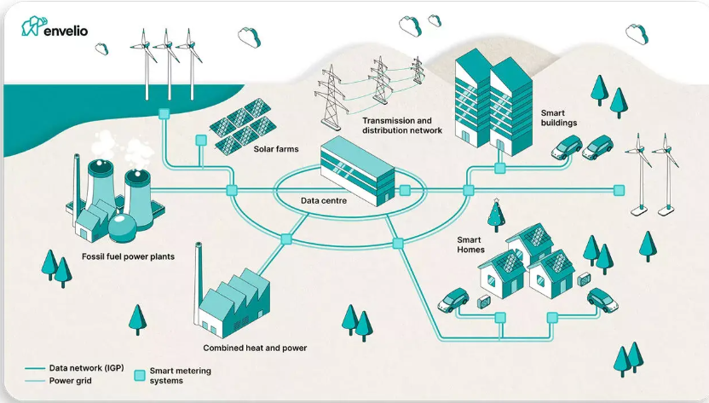
Figure 1. Conceptual illustration of a smart grid infrastructure. Adapted from Envelio, 2024. Retrieved from https://envelio.com/smart-grid
Smart grids tackle many drawbacks of conventional power systems by linking them with modern communication systems that monitor real-time data and have self-operating management regimes. Smart grids improve predictive modelling capabilities which can be combined with loss-reduction systems helping different power sources with wind and solar connections to the electrical network (Fang et al. 2012). Further, smart grids provide an incentive for developing countries to modernize their energy systems by the benefits they present to the energy supply improvement effort. Simply stated, global interest in smart grids ignores hard realities since many countries lack basic readiness for this change. Four of the major barriers that accompany smart grid adoption are poor infrastructure that accompanies many costs, regulatory issues, and insufficient technology preparedness (IEA 2020). Malawi has problems for example of smart grid implementation concerning an inclined electricity generation capacity and major population areas nearly all are rural without electricity service.
The energy policy worldwide says smart grids are a cure for energy poverty, no matter which country they are implemented in. The universal application of such a classic dictum cannot be proved with this study under all circumstances. Malawi finds smart grids a dilemma, given that the bigger dilemma is whether to upgrade the already existing electricity transmission network or to set up new power plants. This complicated matter therefore requires a multifactor consideration, reaching beyond technology to include cultural, economic, and environment-related deeply context-specific analysis. The big-cost deterring factor that may impede smart grid technology implementation in Malawi is investment and technology capability for maintenance and support services.
Thus, the research fills one of the early knowledge gaps by determining under what construction approach Malawi smart grids could financially fare better than construction of new power plants. The research develops a cost-benefit analysis-based decision framework for Malawi to assess when smart grids are justified against new power generation plant construction. This method would provide a sophisticated understanding across countries, while avoiding the endorsement of a blanket solution.
The results bear practical significance in Malawi but will generate key new insights into sustainable energy development across all Global Southern countries. Many economies from the lower and middle-income spectrum stand between two options since they seek to increase their power usage and need to switch to greener energy systems while dealing with their restricted government budgets. Furthermore, this study shows that any expenses on smart grids are justified by the proposed argument as possible investments (UNDP 2022). The work provides valid implications for the design and formulation of domestic policies and international development initiatives, based upon the economic and energy setting of Malawi.
Malawi is suffering from several energy problems, which arise from the current national energy situations. Their electrical power generation depends mostly on hydropower since that resource is generating 80% of their electricity output. The national grid is subject to major stability risks underlies with its dependence on hydro during both dry seasons and periods of rain shortages (ESCOM 2021). Because of an increasing population coupled with urbanization, together with expanding numbers of small industries and institutions, the region finds an increasing demand for electric power. The country has failed to keep sufficient power generation capabilities. The power distribution network experiences old equipment together with heavy technical energy losses and inadequate supply of power to the rural areas. The need for change is immediate due to these hindrances; however, finding the best solutions is incredibly difficult. The table below illustrates the energy situation in Malawi and its history in relation to projections.
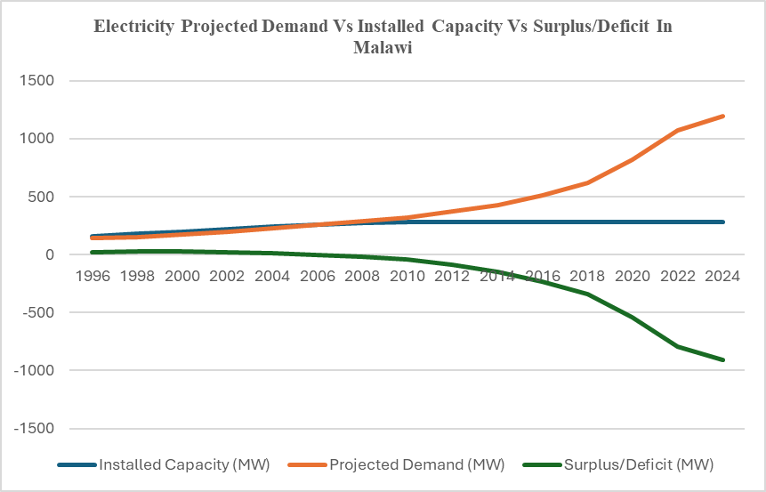
Figure 2: Projected demand vs supply growth in power generation in Malawi (Mhango, 2015)
In conjunction with international partners, the Malawian government has implemented several projects aimed at establishing better power distribution systems across the nation. The Malawi Electricity Access Project (MEAP) works to grow the power grid network, while independent power producer (IPP) projects seek to expand energy resources in the country (World Bank, 2021). However, remarkable as they are, they do not address the underlying structural problems faced by the grid. Under such circumstances, the smart grid modernization concept is timely, though it deserves a thorough investigation.
Organizations can determine if smart grids yield improved financial and operational results versus new power infrastructure through decision criteria based on formulaic recommendations as the core principle demonstrates. The analytical framework includes five vital variables for assessment: population density, energy consumption patterns, infrastructure age, investment costs and maintenance expenses and energy loss rates.
The methodology of the study focuses on quantitative models, supplemented by qualitative data from case study analysis and policy practice data, to frame its methodology. By reviewing Malawi's access historical energy data and financial statistics, it builds an evaluation procedure around interviews with stakeholders in Malawi's energy industry. The operators should go ahead and build such an analytical decision-support tool for the countries who find themselves dealing with a similar energy crisis.
Developing nations, however, must tread cautiously in implementing smart grid technologies as the characteristics of national infrastructure demand an individual evaluation. The smart grid is deemed successful if there is technological advancement and economic capability alongside institutional preparedness and development targets. Thus, this research underpins the smart grid suitability assessment for Malawi with evidence through cost modelling.
METHODOLOGY
Investigating the Root Causes of Inadequate Electricity Access in Malawi
The poor integrated electricity demand planning is one of the leading causes of electricity inadequacies in Malawi. The missing or outdated strategic forecasting and long-term projections allow neither utility companies nor the government to link the supply with the rising demand of population and economy. Research has found that accurate demand side modelling is necessary to ensure that energy systems are responsive and sustainable (Kemausuor et al., 2015). Without such foresight Malawi’s power infrastructure falls behind in handling developmental needs.
Ineffective policy implementation and poor institutional coordination form the other major problem. Even though Malawi has come up with strategic documents like Malawi Energy Policy and wedged itself with Sustainable Development Goal 7 (access of affordable, reliable and modern energy), then execution is a big bottleneck. Dissipation of roles between the Electricity Supply Corporation of Malawi (ESCOM), the Electricity Generation Company (EGENCO), and regulatory bodies cause delays and overlap of effort (Matinga & Clancy, 2021). In addition, investment frameworks continue remaining unattractive because of inconsistent regulatory methods, as well as poor enforcement of energy sector laws.
Intervention by politics intensifies technical and managerial absence of efficiency. Malawi’s Power sector contracts are typically plagued with political agendas that either lead to cover the costs of projects or non-sustainable Power Purchase Agreements (PPAs). According to a report from the African Energy Commission (AFREC, 2020), most of the energy deals done in sub–Saharan Africa are facing elite capture, meaning that projects drive political return rather than developmental benefits. In Malawi, the outcome is grid expansion and tariff plans which serve political cycles rather than consumer protection or economic rationality.
Further, this infrastructure is aged and inefficient, and it has high transmission and distribution losses (estimated to be above 20 percent in some places) (IRENA, 2022). The limited capacity of real time monitoring and lack of adoption of smart grid technology restricts load balancing and timely actioning of fault. These inefficiencies lower public confidence and restrains private sector engagement.
Malawi also has no functional demand side management (DSM) strategies. Within the DSM there exist programs such as time-of-use pricing, smart metering and user education to change electricity use patterns. Such are essential in controlling peak demand and load distribution. Nevertheless, the legacy grid system in Malawi does not possess the infrastructure necessary to put in place such measures (Ahlborg et al 2015).
Further, rural-urban gaps in electricity access are continually growing. The inrush of infrastructure of grids into urban centres has left rural communities under the energy poverty and limiting agricultural productivity, health service delivery, and education outputs. Expansion of access in rural areas without decentralized techniques like mini-grids and solar home systems is financially and logistically difficult.
Malawi’s hydropower dependency, which renders it the biggest contributor (eighty percent) of the national generation mix, leaves its energy supply exposed to climatic variability. Hydropower is highly threatened with changing rainfall patterns and growing drought events caused by climate change (Zhou et al., 2021). Energy diversification continues to be slow even with the enormous solar and biomass potential of the country.
We conducted interviews with Malawi’s top e energy experts which was followed by a survey summarising the interview discussions on root causes of electricity challenges and the feasibility of using smart grids in Malawi. The report from the findings highlights the main discoveries from the interviews and the survey, intended to study how people experience electricity issues, as well as people’s opinions about the chances and positive effects of installing smart grids in the country. The interviews were conducted with people who have knowledge about energy, governing bodies, and infrastructure construction.

RESULTS
Political Influence: According to the surveys, many respondents think that political factors play a key part in deciding electricity-related matters. That means using tariffs and arranging energy partnerships mainly for political reasons and not for the country’s benefit.
Regulatory Weakness: A lot of experts agree that lack of enforcement of electrical regulations causes poor service in the sector.
Policy Gaps: Improving how policies are carried out and updating regulations was seen as necessary for increasing access to and better quality of electricity.
Smart Grid Potential: Many respondents think that smart grids can make the system more efficient and build reliability. Even if the opinions differed on how efficient it is, most experts support adopting smart grids.
Strategic Planning: The majority of those who took part thought that drawing up a national smart grid plan and relying on data will be important for making future energy systems stronger.

Survey Results Overview
The chart below includes information about how people generally agreed to the survey questions:
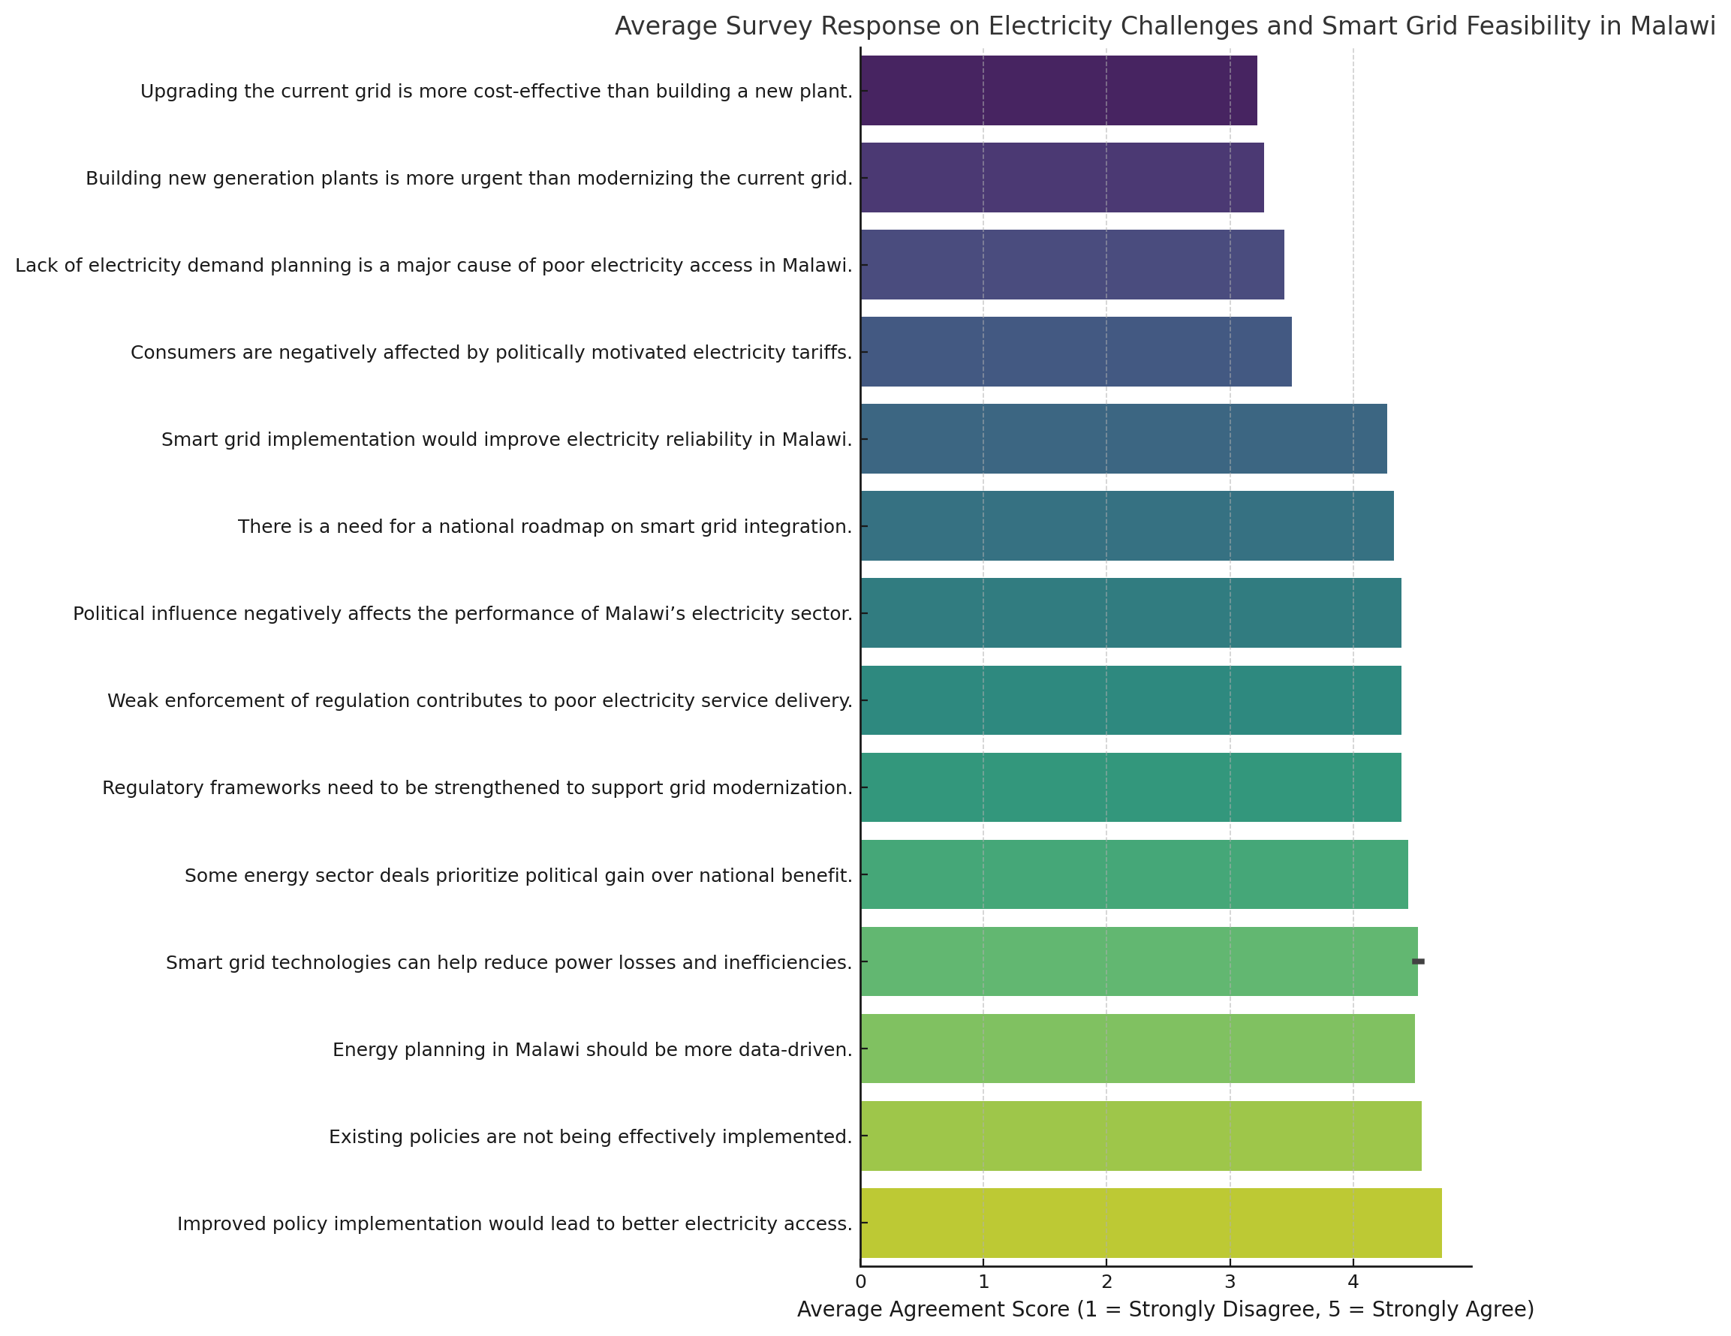
Figure 3: Results of the survey on the causes of electricity shortages and way forward in Malawi
Besides, the feedback from the expert community shows that political economy barriers still disappoint reforms. Political will in enforcing cost-reflective tariffs, attracting independent power producers (IPPs), and bringing energy contracts under scrutiny is usually absent. The limited technical capacity in energy institutions to negotiate fair deals or capacity to adopt modern planning tools makes these problems more difficult to address.
Additionally, the lack of longitudinal studies and continuous monitoring of past reforms, or adjusting strategies, complicates evaluation of previous reforms or strategy. The energy sector remains reactive instead of proactive with no strong data and feedback mechanism.
Malawi’s electricity problem is not only a technical problem, but also a symptom for an underlying challenge in governance, policy and institutions. To resolve this crisis, a multi-doc plan is needed which involves strong demand forecasting, better regulatory enforcement, less political interference and infrastructure modernization and inclusive stakeholder energy planning. Only by having such systemic reform can Malawi access electricity universally and power its hopes for development.
From the results of the survey, one area highlights the national debate on the best way to attain reliable and sustainable electricity access follows the chronic energy crisis in Malawi despite the politically generated challenges. At the heart of this debate lies the question of whether the country should spend on the construction of an entirely new power plant or upgrade its grid networks with integration of DSM practices. From the survey, even experts are divided on the best solution when it comes to addressing the electricity problem.
Comparative Analysis of Building a New Power Plant Versus Upgrading the Existing Grid with Demand-Side Management Considerations
The Malawi setting, the extension of generation represented by the construction of a new plant would seem a simple fix. A new plant whatever it is hydro, thermal or renewable can provide for significant capacity increases that will alleviate some of the supply shortfalls. Building new generation facilities, however, is a capital-intensive activity, time consuming and full of political and environmental controversies. It also imposes a long-term financial burden on public finances, in the cases when projects are funded from unsustainable loans or public-private partnerships not oriented at national interests (World Bank, 2020).
By comparison, modernization of the current grid is a more economical, modular and scalable option. It is characterized by modernization of transmission lines, the implementation of smart metering, automation of substation control and minimization of technical and commercial losses. A most powerful upgrade arises from the use of demand-side management (DSM) strategies.
DSM means policies and technologies that motivate consumers to change their electricity usage patterns by, for example, rationing the demand during high load periods and by increasing efficiency within homes, businesses and public institutions. These include time-of-use tariffs, energy efficient appliances and incentive-based load shifting program (IEA 2021).
On an economic basis, DSM improvements can provide great returns at a tiny fraction of the cost of building new generation facilities. Based on international case studies from Kenya, SA and Rwanda, investment in DSM and grid modernisation has meant that benefit in system levels have been realised such as loss reductions, improved reliability and increased customer satisfaction (GIZ, 2022). In Malawi’s case, expert responses gathered during field research indicated that lack of demand planning and DSM implementation has worsened the power reliability problems required in that country. Respondents identified weak institutional planning, absence of investment in energy efficiency, and poor public awareness as the main barriers.
Policy coherence and governance are another main issue to consider in this comparative analysis. Historically, giant power plant projects in Malawi have been plagued by corruption, delay and politically inspired decision making. Proceeding to grid upgrades and DSM initiative, they are in general decentralized, locally manageable functions, minimizing exposure to top-down political meddling. Moreover, grid modernization has a better congruence with Malawi’s obligations pursuant to the Sustainable Development Goals as well as the Southern African Development Community (SADC) energy protocols that call for inclusive affordable and sustainable access to energy.
Nonetheless, it is important to appreciate that there are obstacles to upgrading the grid. It needs high technical capacity as well as regulatory reform and change in behaviour particularly by consumers. Furthermore, the advantages of DSM will take time to produce, and they are often compounded by poor enforcement and a lack of cross-cutting sector participation. Nevertheless, the long-term benefits of grid modernization and DSM, especially the postponement of new expensive generation needs, are beyond measure.
Although the need to escalate electricity provision in the Malawi state is incontestable, a pathway to this urgent need should be economically feasible, sustainable, and institutionally prepared. Construction of a new power plant might provide temporary assistance but might reproduce previous failures that were associated with mismanagement and inefficiency. On the other hand, the installation of upgraded grid infrastructure with embedded DSM strategies is a more pragmatic and sustainable solution yet. Not only is it in synergy with the world energy transition, but it also promotes Malawi maximization of its current resources; limits costs; and progresses toward universal provision of electricity among other benefits.

A Mathematical Model For The Decision-Making Framework
When Malawi pursues sustainable energy development, experts are presented with a difficult question to answer. Is it better to build new energy-producing facilities or to equip the old grid with technology to make it smart? With engineering and financial formulas, the analysis edges out what the costs, revenues, savings, ROI, and NPV will be for each option. With these calculations, it is possible to decide on the most efficient and eco-friendly way to meet the country’s energy requirement.

Regional Cost Variations and Context-Specific Financial Considerations
In the case of addressing economic feasibility of utilization of smart grid or development of new power plants, it is essential to keep in mind that prices do not tend to be equal in all nations or regions. International energy investment deposits tend to ignore major regional differences in labor, materials, freight and regulation costs. As an example, power infrastructure costs are likely to be significantly different in Europe or North America and in sub-Saharan Africa as a result of the various aspects of labor, environmental regulations, and the time it takes to obtain permits etc. (World Bank, 2020). On the other hand, high prices of foreign machinery and few manufacturing capabilities in Africa may increase some parts of the project, offsetting project parts of these advantages in labour costs.
Intelligent meters, sensors, automation systems etc., that are components of smart grids may be charged according to the forces in international markets, but transport, installation and even maintenances costs can be quite different in a local environment. In Malawi, the cost of logistics to implement a project on a smart grid may be very high due to poor transport infrastructure, and long supply lines especially in the rural or remote locations. Cost-benefit models are thus required to be regionally adjusted to prevent the misleading conclusion generated out of generic/global assumptions.
Furthermore, in addition to the technology (e.g., hydro, solar, coal), the price of constructing the power plant of certain type also depends on the resource supply within the region and geotechnical factors. Such as an example, the PV solar can be more affordable where the solar irradiance and land area are plentiful, whereas hydroelectric facilities in regions where rainfall variability is prominent, such as Malawi, are at an increased long-term risk even though the initial capital is low (Zhou et al., 2021). Therefore, such a decision to upgrade the grid or to construct new capacity should also capture the geography and climate exposure of the country.
Lastly, any energy investing decisions need to consider the issues of purchasing power and affordability at a local level. An option that might be economically viable in high-income economies in low-income economies may be unsustainable without concessional finance or third-party donor finance. Thus, the assessments of costs should be based on the realities of a region since they need to be tailored to the region based on economic variables necessary to adjust, average household income, energy affordable levels, and current tariffs.
As a final point, care should be taken to ensure that Malawi does not fall into the risk of universal models of energy policy and planning. It is important to have a finalized perception of local cost constructions, impediments to the use of technology, and affordability. With the feasibility study of smart grid and power plant based on the Malawi economic and infrastructural circumstances, due to the uniqueness of the situation in the country during the formulation of the policies, this will help improve the accuracy and fairness of investment decisions.

Cost of Building a New Power Plant
The cost of constructing a new power plant is calculated using the formula:

Cplant = Pnew × Ctype ​
Where:
- Pnew is the additional power capacity required (in megawatts, MW)
- Ctype​ is the cost per megawatt depending on the type of plant (Hydro, Solar, or Coal)

This formula is straightforward multiplication: We begin by figuring out the added electricity demand, and then we multiply it by the per-MW cost of the technology we picked. If there is a need for 100 MW and the solar plants need $1.5 million each, adding all the plants would cost $150 million.

Cost of Upgrading to a Smart Grid
The smart grid upgrade requires spending on the communication network and installing intelligent meters. It is calculated as:
Csmart​ = Cinfra ​+ (Nmeters​×Cmeters​)
Where:
- Cinfra​ is the cost of deploying communication and control infrastructure. This cost takes into consideration:
  - The enclosure cost
  - The renting the transmission medium
  - The I/O device cost
  - The Smart Grid Electricity Management System cost
- Nmeters​ is the number of customers to install smart meters for
- Cmeters​ is the cost per smart meter
The formula allows us to recognize the constant cost of updating the main network, along with a cost connected to the customers. With smart meters, smart grid systems can manage loads on the fly and keep an eye on energy use as it happens.

Annual Revenue from New Power Plant
For a new power plant, the annual estimate of revenue can be determined as:
Rplant​ = Pnew ​× H × Ttariff​
Where:
- H is the number of hours the plant operates per year
- Ttariff​ is the electricity tariff per kilowatt-hour (kWh)
According to the formula, the plant maximizes outputs and offers electricity at a standard rate to get the most profit. It estimates the amount of income that the plant can bring in on a yearly basis considering that the revenue is attained as the plants operates per hour.

Annual Savings from Smart Grid
The smart grid helps to decrease both technical and non-technical energy losses by continually monitoring and controlling the grid. Annual savings are calculated as:
Ssmart​ = D × H × Ttariff​ × Ssavings​
Where:
- D is the current electricity demand (MW)
- Ssavings​ is the percentage reduction in losses due to smart grid improvements
While it is like the revenue model, it swaps out revenue with the money saved. It determines the monetary and energy value of the losses avoided due to robberies, inefficient use of power, and power cuts.

Return on Investment (ROI)
Return on Investment is a measure of profitability and is computed separately for each option.
For a new power plant:
ROIplant = (Rplant / Cplant) × 100
For a smart grid:
ROIsmart = (Ssmart / Csmart) ×100

This let you see how much benefit you are getting each year, relative to the immediate money you invested.

Net Present Value (NPV)
NPV includes the value of time in money and determines the total value of all the future profits or savings from a project over its life.
NPV = ∑ (Rₜ / (1 + r)ᵗ) − C
Where:
- Rt​ is the revenue or savings in year t
- L is the lifespan of the project in years
- r is the discount rate
- C is the initial investment
It guarantees that future benefits from projects like power plants or smart grids are valued according to their present benefit, which is very helpful when making decisions.

Decision Rule
To determine the direction to take, the rule below passes the final judgement:
- If:
NPVsmart > NPVplant
And
ROIsmart > ROIplant​
→ Then invest in the smart grid
- Else:
NPVsmart < NPVplant
or
ROIsmart < ROIplant​
→ Build a new power plant (type depends on feasibility: Hydro, Solar, or Coal)
Following this rule, both the immediate profit and the future benefits of an investment are taken care of before making any strategic decision.
CONCLUSION
A clear structure and an analysis for reviewing the two most important energy investment decisions that Malawi is currently considering is offered in the equation above. constructing power plants from the latest generation or moving towards using a smart grid. Well-structured cost and benefit analyses have demonstrated the ways in which each option affects our finances over time, efficiency, and sustainability of energy resources.
Although it costs a lot to build a new power plant based on its technology, efficient operation can bring in significant profits. But the investment needed to upgrade to a smart grid is significant, but by doing so, digital control, real-time monitoring, and the ability to decrease losses of all types is obtained—which lowers the operational costs annually.
Utilizing ROI and NPV on every scenario can help us see the real benefits gained and lost over time, not just the expense involved. ROI measures the profits you earn in one year, whereas NPV considers future earnings and whether the company can stay financially stable in the future. They guarantee that the chosen strategy is not just cost-effective now but also brings good results in the future.
Ultimately, the decision rule points out that, if the smart grid gives higher financial results than building a new plant, it is the best option to invest in. The conclusion fits well in Malawi because frequent electricity losses, poor energy infrastructure, and low demand management deter the growth of the energy sector there. With modern technology, a smart grid can address issues related to the power system.
Using cost-benefit models gives decision-makers a straightforward and repeatable way to decide on the best energy investment. Following this approach, Malawi can choose solutions that better the economy while still ensuring its energy security for a long time.
References
- International Renewable Energy Agency (IRENA). (2022). Malawi Energy Profile. https://www.irena.org/
- Kemausuor, F., Obeng, G. Y., Brew-Hammond, A., & Duker, A. (2015). A review of trends, policies and plans for increasing energy access in Ghana. Renewable and Sustainable Energy Reviews, 47, 353–363. https://doi.org/10.1016/j.rser.2015.03.025
- Matinga, M., & Clancy, J. (2021). Energy sector reform and politics of electricity planning in Malawi. Energy Research & Social Science, 76, 102063. https://doi.org/10.1016/j.erss.2021.102063
- World Bank. (2022). Malawi Energy Access and Connectivity Report. https://www.worldbank.org/en/country/malawi/publication/energy-access
- Zhou, W., Tol, R. S. J., & Kirkpatrick, C. (2021). Electrification in sub-Saharan Africa: The importance of policy and climate adaptation. Energy Economics, 94, 105071. https://doi.org/10.1016/j.eneco.2020.105071
- GIZ. (2022). Smart grid implementation in Sub-Saharan Africa: Lessons from regional pilots. Deutsche Gesellschaft für Internationale Zusammenarbeit.
- International Energy Agency (IEA). (2021). Demand-side management: A critical tool for the energy transition. https://www.iea.org/reports/demand-side-management
- World Bank. (2020). Electricity access in Malawi: Policy, financing and governance review. Washington, D.C.: World Bank Group.
- Envelio. (2024). Smart grid – Digital grid planning and operation. https://envelio.com/smart-grid

