The mediating role of environmental attitude on organic preferences due to environmental ethics and awareness: A Study in Sikkim

Abstract
With the current condition of the increasing environmental crisis, it has become crucial to change ways as a society and an individual on how we approach our environment specifically through our conscious consumption patterns. This study is a quantitative study which is conducted in Sikkim which is the nation’s first organic state. This study has considered households from the four districts of Sikkim – East, west, north south. The objective of the study is to assess the factors that influence the Environmental Attitude which might eventually influence the organic preference of the people of Sikkim, inclusive of both rural and semi urban population. This study has utilised Structural Equation Modelling for the analysis of the data. The result indicates a strong significant positive association between Environmental Attitude and Organic Preference. It is also observed that Environmental Awareness and Environmental Ethics have positive association with positive Environmental Attitude. Hence showing that increased environmental awareness and environmental ethics among the consumers will lead to consumers opting for organic products
Keywords: Environmental Attitude; Environmental Awareness; Environmental Ethics; Organic Preference; Theory of Planned Behaviour

- INTRODUCTION
One of the most important and vital processes for survival of humanity is food production through farming. It is expected that the world population would reach 9.1 billion people by 2050(United Nations [UN],2015). Thus, to feed the growing world's population, the agricultural sector was required to boost food production by 70%. According to the Food and Agriculture Organization of the United Nations [FAO], 2015, this increase included 0.47 billion tons of beef and 3 billion tons of grain. Chemical fertilizers were used as part of the agricultural adjustments to speed up growth/yield of the produce (Chakrabarty et al., 2014). Because of this, by the year 2000, over 5 million tons of agricultural chemicals were utilized yearly (Fernando, 2017). Therefore, the massive annual use of pesticides and fertilizers have increasingly accumulated and contaminated the ecology. The prolong exercise of such chemicals does not just impact the human body but also has a high negative impact on the ecosystem, with the long tenure the soil loses its natural fertility, water sources get polluted and various other environmental crisis arises too. Therefore, a viable answer to these environmental and human issues is to replace conventional methods with organic farming in order to eliminate the usage of pesticides (Sharma and Singhvi, 2017).
"Organic farming is a system which avoids or largely excludes the use of synthetic inputs (such as fertilizers, pesticides, hormones, and feed additives) and to the maximum extent rely upon crop rotations, crop residues, animal manures, organic waste, mineral grade rock additives, and biological system of nutrient mobilization and plant protection," according to the United States Department of Agriculture. If no legally forbidden compounds have been used in the land where the crops have cultivated, the agricultural product is considered to be organic. It is required that the soil be certified as organic and that no chemical substances have been used for approximately three years prior to harvest. This farming method aims to minimise soil contamination and water wastage while increasing the soil fertility by various techniques like seed rotation, green manure, biological pest control etc. (Pacho, 2020; Singh, 2020). Focusing on the production processes rather than the final result is one of the primary traits of organic farming methods (El-Hage Scialabba, 2003; Council of the European Union, 2018). With the growing concern over healthy lifestyle especially around the COVID 19, there has been a significant increase in the consumption pattern of the organic products, organic food has gained attention due to its nutritional value, health benefits and environment friendly nature (Grzybowska-Brzezinska et al., 2017). Furthermore, organic products’ commercial attractiveness is influenced by elements including taste, freshness and sensory appeal (Agovino et al., 2017). Consumer perceptions of organic foods are complex and impacted by a number of factors, despite their increasing popularity (Malissiova et al., 2022; Nadricka et al., 2020). While some customers put their health and well – being first, others are driven by concerns about environmental sustainability, animal welfare or just a desire for better, healthier food options (Madureira et al., 2021; Nunes et al., 2021). Recent decades have seen consumers realize that their purchases directly affect the environment (Diagourtas et al., 2023). India ranks 4th globally in terms of agricultural land under organic farming with 5.91 million hectares of land under organic farming and 4.43 million farmers practicing organic farming and is also the largest producer of organic products, according to IFOAM 2024-25. The Indian organic food market was valued at $820 million in 2022 and is expected to reach $2.6 billion by 2028, growing at a CAGR of 20-25% (IFOAM 2024-25). Indian states like Madhya Pradesh, Gujarat, Karnataka, Rajasthan and Maharashtra are the top ranking in terms of the land under organic farming while Sikkim has been titled the first 100% organic state of India. On January 19, 2016, Prime Minister Narendra Modi praised the Sikkim government for successfully implementing the transition to a fully organic state by announcing that Sikkim was the first state in the nation to practice organic farming. The journey began in 2003 with the State Legislative Assembly passing a resolution to fully adopt organic farming (Hand Book on Agriculture,2019-2020, p.12). It took 12yrs, for Sikkim to fully convert to organic state which was done in a stage wise phase. Initially various subsidies were provided by the government to the farmers to reduce the usage of fertilisers and afterwards a permanent ban was installed on the movement and sales of the chemical fertilisers and pesticides in the state (Raut et al., 2018). This left the farmers with little option but to switch to organic farming, the States’s traditional farming style until artificial fertilizers were introduced with the green revolution. In addition to restricting the use of chemical fertilizers, the state government of Sikkim designated the agricultural land as having organic certification. Currently 80,000 million of the nation’s 1.24 million tons of organic produce come from Sikkim (Das & Bhattacharyya, 2018).

- THEORETICAL FRAMEWORK & LITERATURE REVIEW
The OECD (Organisation for Economic Co-operation and Development) has established the standard definition of sustainable consumption, which has been adopted in international policy arenas as a way to align economic development with environmental policy in recent years (Seyfang, 2006). According to OECD (2002, p.9), sustainable consumption is the use of goods and related products that address basic needs and improve quality of life while minimizing the use of natural resources and toxic materials as well as the emissions of waste and pollutants over the life cycle, so as not to jeopardize the needs of future generations. The theoretical framework for this study is based on the Theory of Planned Behaviour (TPB). According to Ajzen (1991), intention is an outcome of attitude, social norms and perceived behavioural control that may ultimately lead to human behaviour. Many studies have utilised the TPB model by combining various other determinants while extending the original TPB model(Ahmed et al., 2021; Alam et al., 2023) specifically to understand whether consumers intention leads to pro environmental consumer behaviour. The TPB model has also been extensively used to explain consumers decision making process in relation to organic products/organic preferences (Yadev&Pathak,2017; Ahmedet.al.,2021). Since this study aims to explain consumer decision related to organic products/organic preferences, the researcher felt that using TPB model would do justice to the study. In order to investigate the effects of various environmental constructs like Environmental awareness, Environmental Ethics and Environmental Attitude on consumers’ intention for Organic Preferences, this study has taken these factors into consideration which is shown in figure 1.
Figure_1. Conceptual Model for the study
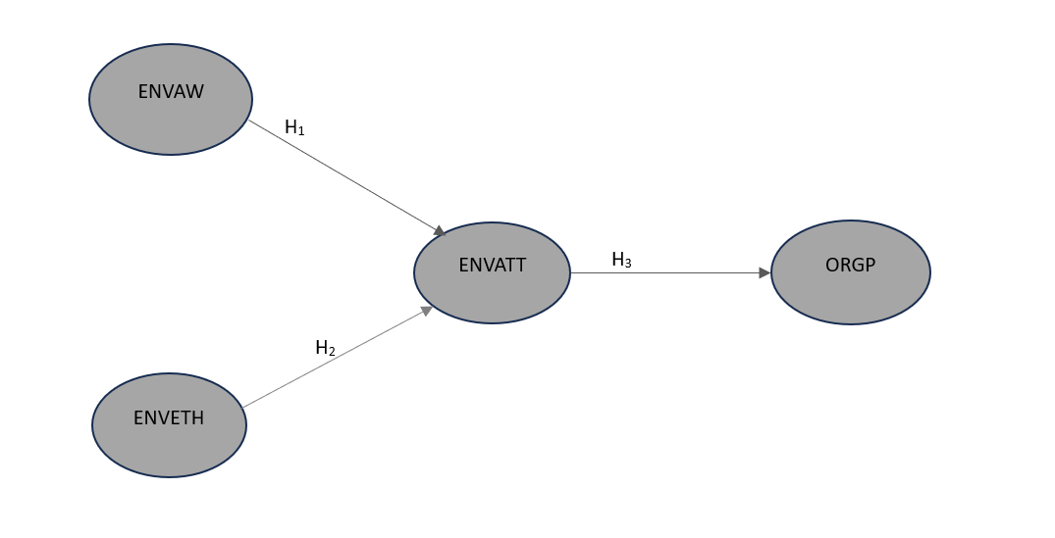
2.1Environmental Awareness (ENVAW)
Environmental Awareness refers to comprehending the impact of human behaviour on the environment, both positively and negatively, and how it might impact and disbalance the natural balance (Zsoka et al.,2013). It is a degree of understanding and knowledge of the outside world in which individuals live and work, which frequently affect how they grow and act (Handoyo et al., 2021). The goal of Environmental Awareness is to increase the general understanding of the environmental issues and their causes by transforming values, perception and skills necessary to address them. According to Steg and Vlek (2009), fostering a loving sense of community requires Environmental Awareness. It is also widely accepted that Environmental Awareness makes people more likely to act in ways that are Environment benign i.e., when people are conscious of how their own behaviours or actions affect the environment, they may feel bad about damaging their own surroundings (Fu et al., 2020). Many studies have found that Environmental Awareness was seen to influence the consumption pattern and frequency of organic products, the more knowledgeable the consumer were about the organic products the higher the chances of them being influenced to purchase/consume organic products(Shao,2016;Xu et al., 2020). It has been observed that a favourable Environmental Attitude was cultivated with higher Environmental Awareness/ knowledge among pupils in Libyan Secondary Schools by, Azam & Dbab, (2021), similarly sensitivity towards various environmental issues was linked to positive attitude towards eco-friendly behaviours and intentions among the nursing students by Evcimen et.al., 2025. Thus, fostering Environmental Awareness among the population plays a critical role in enhancing Environmental Attitude towards environment friendly practices and encourages opting for more environment friendly behaviour. Based on the literature the following hypothesis was formulated
H₁: There is significant association between ENVAW and ENVATT
2.2 Environmental Ethics (ENVETH)
The field of environmental ethics studies the moral dilemmas raised by human interactions with their surroundings, asking what we should do, is the focus of ethical inquiries, and ethical statements are prescriptive rather than descriptive or predictive (Tsai&Tsai;2008). Environmental ethics as a modern field emerged in the 1970s. In 1971, the first academic conference on environmental ethics was held at the University of Georgia, and in 1978, the first journal on the subject was founded. The 1980s saw a sharp rise in environmental ethics research, publications, and education (Palmer et al., 2014). In their investigation into the factors influencing pro-environmental behaviour using the theory of planned behaviour (TPB), Aziz et al. (2021) demonstrated that environmental ethics significantly affect attitudes, perceived behavioural control, and subjective norms. They also found that attitudes directly influenced pro-environmental behavioural intentions (PEIs), which was also observed in Sheng & Chen's (2010) study, which found that environmental ethics had a greater effect on environmental attitude than moral intensity did on environmental issues. Through acceptance of Environmental Ethics as an individual, the consumers can lead on to making environment friendly choices in their day-to-day routine which might lead to conserving the resources and reducing the stress on the environment. The following hypothesis is formulated based on the literature:
H₂: There is significant association between ENVETH and ENVATT
  - Environmental Attitude (ENVATT)
Ajzen et al. (2021) TPB define an attitude as a psychological consensus based on an evaluation of how individuals respond to support or oppose a course of action. Accessible beliefs regarding behaviour and the consequences of such behaviour are a conjunction of attitude towards behaviour. According to Alam et al. (2023), environmental attitudes are significant factors in studies of green behaviour and continue to play a role in how social psychology, the conative impact, and the belief between stimulus and reaction affect individual behaviour.
Many studies in regards to green consumption and green marketing shows that environmental attitude can affect people’s behaviour to a larger extend and even serve as a mediating factor in influencing the consumers intention (Kirmani and Khan, 2018; Tang and Lam, 2017; Varshneya et al., 2017). In their investigation into the relationship between Environmental Attitude and Pro-Environmental Consumer Behaviour, Casaló & Escario (2018) found that although Environmental Attitude and Pro-Environmental Consumer Behaviour are related, this relationship only exists when the attitudes are very strong, which indicates Pro-Environmental Consumer Intention may result in Pro-Environmental Consumer Behaviour. Consumers with enhanced Environmental Attitude can make purchase decisions that might lead to sustainability of resources, like when a consumer who opts for organic products will encourage his friends and family to consume/choose more organic products, this might eventually contribute to the generation of more awareness/acceptance of organic products or environment friendly products. Based on the literature the following hypothesis is formulated:
H₃: There is significant association between ENVATT and ORGP
  - Consumer’s intention towards organic product/organic preferences (ORGP)
Ajzen (2022), defined behavioural intention as an individual’s readiness to engage in a certain behaviour, which is thought to be the direct cause of behaviour. It is believed that intentions, which also act as markers of people’s readiness to put in the greatest amount of effort and do their utmost to carry out the behaviour, reflect the motivational factors that drive a behaviour (Costa et al., 2021). The more strongly someone desires to engage in a behaviour, the more often that behaviour would be executed; in other words, the more strongly someone intends to engage in behaviour, the more probable that action will be conducted (Yang et al., 2021). Expanding on this notion, several theorists have suggested that the closest cognitive antecedent of actual behavioural performance is the desire to do a behaviour rather than attitude (e.g., Fishbein & Ajzen, 1975; Fisher & Fisher, 1992; Gollwitzer, 1993). Zhao et.al., (2025) in their investigation of green consumerism found that green attitude along with perceived behavioural control significantly influenced green consumerism intention which is backed by several other literatures (Xiao et.al., 2023; Guan et.al., 2024). Hence, it is crucial to consider consumers intention towards organic preferences to understand the factors that actually leads to consumption of organic products since intention will eventually lead to behaviour as per the TPB.
3. Methodology
3.1 Study Area
Unobstructed consumption of the natural resources is the main source of environmental degradation, consumer need to be more aware of their actions and stick to sustainable consumption to retain the balance in the environment. Thus, it is essential to study the impact of Environmental Awareness, Environmental Ethics and Environmental Attitude, which might lead to intentions in consumers to opt for organic products as a sustainable consumption in current environmental crisis. For this study Sikkim was considered as the study area, with the population of 6,10,577 (Census, 2011) out of a total area of 7096 km² (7,09,600 ha), only 10.47% is used for farming, while the rest is uncultivable, cultural waste, permanent pastures, forest and barren land. In North, South and West Sikkim, nearly 85% of the population lives in rural areas, compared to the national average of 75%. Over 60% of the state’s population relies on agriculture and related activities for a living (Rao,2017). As the first 100% organic state in India, Sikkim provides important context for the study by focusing on customer’s attitudes to prefer organic products.
3.2 Sampling Technique
The data was collected from the four districts of Sikkim – East, West, North and South district (Census 2011), using the Stratified Random Sampling technique. From each district two locations were selected randomly – a rural and a semi urban area thus a total of eight locations were randomly selected. A total of 550 sample was taken for the study, as per Cochran formula (1977) a sample size of 385 would suffice. The details regarding each location are provided in table 1:
Table 1. Study area details
Sl. No. | Location | District | Area | Sample size
1 | Gangtok | East | Semi Urban | 130
2 | Naitam Pabyuk | East | Rural | 85
3 | Gyalshing | West | Semi Urban | 115
4 | Sreebadam | West | Rural | 70
5 | Namchi | South | Semi Urban | 60
6 | Parbing | South | Rural | 40
7 | Mangan | North | Semi Urban | 25
8 | Hee Gyathang | North | Rural | 25
Total |  |  |  | 550

3.3 Measurement tools
The study has utilised a well-established measuring scale for the three of its constructs which are Environmental Awareness, Environmental Ethics and Environmental Attitude while a scale was developed for the construct Organic Preferences. Structured questionnaire was distributed to the households which had at least three house members. A close-ended structured questionnaire was employed to generate data with items as shown in table 2, the questionnaire is based on a five-point Likert scale (1 – strongly disagree - 5 – strongly agree). In order to check for question wording, ease of understanding, and other inconsistencies a pilot study was conducted prior to the actual data collection in the month of April – May, 2024. While the final data collection was done from October (2024) – January (2025).

Table 2. Scales
Citation | Construct |  | Items
Yigit &  Kiyici (2022) | Environmental Awareness | ENVAW1 | I don’t think scientists are exaggerating the phenomenon of global warming.
Yigit &  Kiyici (2022) | Environmental Awareness | ENVAW2 | It is not futile for environmental organizations to carry out activities on waste management for a sustainable environment.
Yigit &  Kiyici (2022) | Environmental Awareness | ENVAW3 | The fact that the air temperatures are different from the seasonal norms is a matter to be taken into consideration.
Yigit &  Kiyici (2022) | Environmental Awareness | ENVAW4 | If I had the chance to hunt all individuals of an animal species, I would not.
Yigit &  Kiyici (2022) | Environmental Awareness | ENVAW5 | Empty tin cans can be recycled.
Yigit &  Kiyici (2022) | Environmental Awareness | ENVAW6 | Sustainable environment is important for non-human creatures.
Samitha et.al., (2021) | Environmental Attitude | ENVATT1 | It is our duty to protect the environment for the future generation.
Samitha et.al., (2021) | Environmental Attitude | ENVATT2 | Environmental protection must start from every home level.
Samitha et.al., (2021) | Environmental Attitude | ENVATT3 | Environmental education is required to preserve the environment.
Samitha et.al., (2021) | Environmental Attitude | ENVATT4 | Environment conservation is important to ensure the quality of life.
Samitha et.al., (2021) | Environmental Attitude | ENVATT5 | Practicing eco-friendly activities increases the pride of people.
Samitha et.al., (2021) | Environmental Attitude | ENVATT6 | Constant damage to the environment causes erratic variations in climatic factors.
Dunlap et. al., (2000) | Environmental Ethics | ENVETH1 | Humans don’t have the right to modify the natural environment to suit their needs.
Dunlap et. al., (2000) | Environmental Ethics | ENVETH2 | When humans interfere with nature it often produces disastrous consequences.
Dunlap et. al., (2000) | Environmental Ethics | ENVETH3 | Humans are severely abusing the environment.
Dunlap et. al., (2000) | Environmental Ethics | ENVETH4 | The earth doesn't have plenty of natural resources even if we just learn how to develop them.
Dunlap et. al., (2000) | Environmental Ethics | ENVETH5 | Plants and animals have as much right as humans to exist.
Dunlap et. al., (2000) | Environmental Ethics | ENVETH6 | The balance of nature is not strong enough to cope with the impacts of modern industrial nations.
Researcher | Organic Preference | ORGP1 | I procure organic products whenever I can
Researcher | Organic Preference | ORGP2 | I advocate for organic products
Researcher | Organic Preference | ORGP3 | I promote organic products to my friends and relatives
Researcher | Organic Preference | ORGP4 | I procure organic products even when prices are higher than non-organic products
Researcher | Organic Preference | ORGP5 | In last five years my procurement of organic products has increased
Researcher | Organic Preference | ORGP6 | Organic products are good for earth

4.Results
The study had utilised three pre-validated scales and one original scale developed by the researcher thus, the analysis has been divided into various sections – EFA, CFA, SEM and mediation analysis for validity, reliability, model fitness and hypothesis testing.

Table 3. Socio-demographic information of the respondents
Variables | Frequency | Percentage (%)
Age  21 to 30 yrs  31 to 40 yrs  41 to 50 yrs  above 51 yrs | 131  220  143  56 | 23.8  40.0  26.0  10.2
Gender  Male  Female  Others | 254  295  1 | 46.2  53.6  0.2
Family Dynamics  - to 5 members  more than 5 members | 320  230 | 58.2  41.8
Income Distribution  income below 25,000  25,001 to 50,000  50,001 to 75,000  above 75,000 | 163  218  131  38 | 29.6  39.6  23.8  6.9
Education Qualification  high secondary  senior secondary  under graduate  post graduate  others | 15  57  183  214  81 | 2.7  10.4  33.3  38.9  14.7

Table 3. provides details about the socio-demographic segmentation of the respondents. The highest number (220,40.0%) of the respondents fell under the age group of 31 to 40 yrs., with more percentage (53.6%) of female respondents. The maximum number (214) of respondents had an education qualification of post-graduation with the maximum respondents (218) falling under the income level of 25,001 to 50,000. CFA was performed on the data as shown in figure 2, to check whether the data fits a predefined structure and to test the construct reliability, convergent, divergent/discriminant validity along with testing the model fitness of the data. Four steps were followed: i) construct reliability was calculated for the assessment of the internal consistency, acceptable value being >0.70. ii) the indicator reliability of an adequate loading of > 0.4. iii) assessment of the convergent validity through Average Variance Extracted (AVE) with adequate threshold > 0.50. iv) assessment of divergent/discriminant validity through Fornell-Lackerand Heterotrait Monotrait Ratio (HTMT). Along with these four steps Cronbach Alpha was also calculated to assess the internal consistency.

Figure_2. Confirmatory Factor Analysis

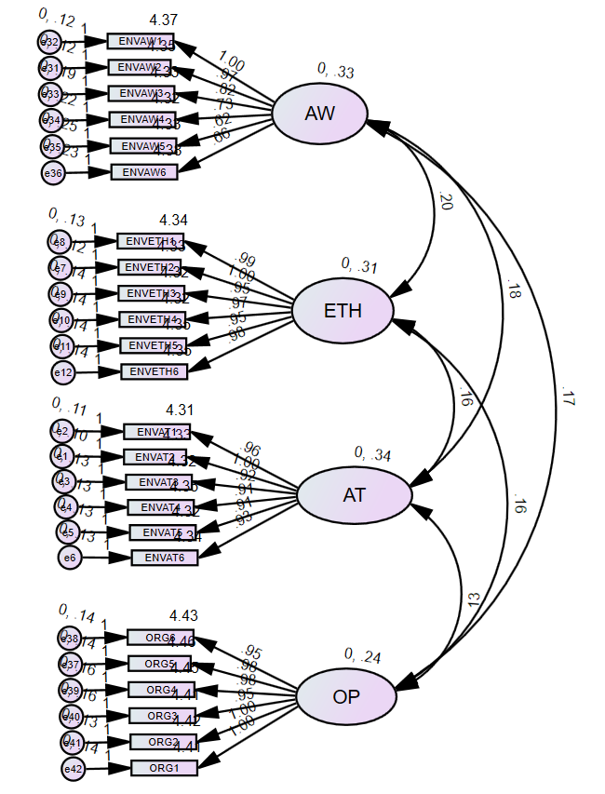
Note: AW- Environmental Awareness; ETH – Environmental Ethics; AT – Environmental Attitude; OP – Organic Preference
Table 4. Internal consistency assessment through Cronbach Alpha and Construct Reliability
Construct | Factor loadings | Cronbach Alpha | Composite Reliability
Environmental Awareness  ENVAW1  ENVAW2  ENVAW3  ENVAW4  ENVAW5  ENVAW6 | 0.851  0.848  0.732  0.664  0.580  0.620 | 0.866 | 0.866
Environmental Ethics  ENVETH 1  ENVETH 2  ENVETH 3  ENVETH 4  ENVETH 5  ENVETH 6 | 0.838  0.848  0.815  0.823  0.818  0.830 | 0.929 | 0.929
Environmental Attitude  ENVATT 1  ENVATT 2  ENVATT 3  ENVATT 4  ENVATT 5  ENVATT 6 | 0.862  0.875  0.831  0.835  0.823  0.836 | 0.937 | 0.937
Organic Preference  ORGP 1  ORGP 2  ORGP 3  ORGP 4  ORGP5  ORGP 6 | 0.802  0.805  0.765  0.776  0.795  0.785 | 0.907 | 0.908

From table 4 we observe that all the factor loadings are >0.5 which indicates that the factors sufficiently capture the variance of the variable, each observed variable has a strong relationship with its latent construct. The construct reliability and Cronbach alpha values are all >0.7, which indicates that the constructs have good internal consistency. This suggests that the indicators reliably measure the same underlying concept.
Table 5. Convergent and Discriminant Validity analysis
Variables | AVE | MSV | MSV(H) | ENVATT | ENVETH | ENVAW | ORGP
ENVATT | 0.712 | 0.285 | 0.938 | 0.844
ENVETH | 0.687 | 0.391 | 0.930 | 0.501 | 0.829
ENVAW | 0.523 | 0.391 | 0.892 | 0.534 | 0.625 | 0.723
ORGP | 0.621 | 0.368 | 0.908 | 0.451 | 0.565 | 0.606 | 0.788

Table 5 shows the output of the assessment of the convergent, discriminant /divergent validity. All the constructs have AVE>0.5 indicating that they have acceptable convergent validity, which suggests that the items that are supposed to measure the same construct are indeed strongly correlated. The discriminant validity confirms if a construct is truly distinct from other constructs, which is assessed through two methods a) Fornell and Larcker and Heterotrait-Monotrait Ratio (HTMT). The square root of AVE (Average Variance Extracted) is greater than the inter-construct correlations (off diagonal values) along with the MSV(H) (Maximum Shared Variance) <0.90 indicating a good discriminant validity. Model fit indices; CMIN/DF = 3.147, NFI (Normed Fit Index) = 0.920, CFI (Comparative Fit Index) = 0.944, RMSEA (Root Mean Square Error of Approximation) = 0.063 and PCLOSE = 0.000 which indicated a reasonable model fit (Saha & Jha, 2022). Structural Equation Model (SEM) is a powerful multivariate statistical technique used for analysing multiple relationships simultaneously while providing strong validation for theoretical models. Hypothesis testing using SEM includes checking the standardized path coefficient (βvalue), p-value and critical ratio (t-value). The standardized path coefficient (β) should range from – 1 to +1, p-value <0.05 and critical ration >1.96. The figure 3 below shows the SEM analysis.
Figure_3. Structural Equation model
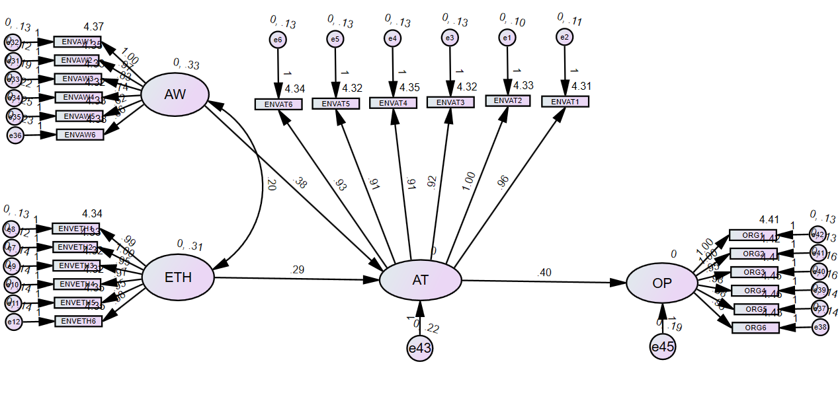Note: AW- Environmental Awareness; ETH – Environmental Ethics; AT – Environmental Attitude; OP – Organic Preference
Table 6. SEM Path analysis
Designation in the SEM diagram | Estimate | S. E | C.R (t-value) | p-value | β-value
ENVATTENVAW | 0.380 | 0.055 | 6.871 | *** | 0.372
ENVATTENVETH | 0.291 | 0.055 | 5.329 | *** | 0.280
ORGPENVATT | 0.400 | 0.038 | 10.406 | *** | 0.471
Hypothesis testing: Table 6 shows the standardised path coefficients and test result of the paired variables. The test result shows that all three hypotheses are supported with significant p-value and β-value i.e., there is significant association between ENVAW and ENVATT, between ENVETH and ENVATT and between ENVATT and ORGP. Indicating that the data fits the model as well as all the path are supported and significant which is also backed by the existing theory.
Table 7. Mediation Analysis
Path | Total effect | p-value | Direct Effect | p-value | Indirect effect | p-value
ENVETH<ENVATT<ORGP | 0.262 | 0.001 | 0.235 | 0.001 | 0.027 | 0.014
ENVAW<ENVATT<ORGP | 0.517 | 0.001 | 0.466 | 0.001 | 0.051 | 0.024

Mediation Analysis: To determine the mediating role of ENVATT a mediating study was conducted. Table 7 shows the result of the mediating analysis which shows that ENVATT is partially mediating the relationship between ENVAW & ORGP, i.e., both direct (β= 0.466, p-value = 0.001) and indirect (β= 0.051, p-value = 0.024) paths are significant. Similarly, ENVATT is partially mediating the relationship between ENVETH & ORGP i.e., both direct (β= 0.235, p-value = 0.001) and indirect (β = 0.027, p-value = 0.014) paths are significant.
5. Discussion
From table 6 the following results were obtained:
H₁: there is significant association between ENVAW and ENVATT
Environmental Awareness (ENVAW) has a positive and significant impact on Environmental Attitude (ENVATT) which is indicated by the estimate = 0.380, p-value <0.001 and β-value = 0.372. Thus, the hypothesis is supported and it signifies that there is a significant positive association between ENVAW and ENVATT, which is similar to the findings by Evcimen, (2025) wherein when Environmental Awareness education was provided to the nursing students, their Environmental Attitude positively had an increment. This implies that 1 unit increase in ENVAW leads to a 0.372 standard unit increase in ENVATT. This significant influence indicates that the more aware the population is in regards to the various environmental issues and crisis the positive will be the attitude of the population towards the eco-friendly behaviours which in turn could lead to actions that might help in sustaining the environment.
H₂: there is significant association between ENVETH and ENVATT
Environmental Ethics (ENVETH) has a positive and significant effect on Environmental Attitude (ENVATT), which is evident from estimates = 0.291, p-value <0.001 and β-value = 0.280 which is similar to the result of Aziz et.al., (2021). Thus, the hypothesis is supported and it signifies that there is a significant positive association between ENVETH and ENVATT which implies that 1 unit increase in ENVETH results in a 0.280 standard unit increase in ENVATT. From the above results, it is only evident that Environmental Ethics needs to be fostered among the population specially from household level. The more conscious an individual is about their actions towards the environment the eco-friendly attitude they carry which can be projected into actions through the means of consumption patterns.
H₃: there is significant association between ENVATT and ORGP
Environmental Attitude (ENVATT) has a strong positive effect on Organic Preference (ORGP) that is implied by estimate = 0.400, p-value <0.001 and β-value = 0.471. Thus, the hypothesis is strongly supported and it signifies a strong positive association between Environmental Attitude (ENVATT) and Organic preference (ORGP) which can be interpreted as 1 unit increase in ENVATT leads to a 0.471 standard unit increase in ORGP. This result highlights that, a positive attitude towards environment leads to strong influence in the consumption of Organic products which is backed by Zhao, (2025).
ENVATT partially mediates the relationship between ENVAW & ORGP and between ENVETH & ORGP which is also supported by other studies (Çabuk et al., 2014; Carrión-Bósquez et al., 2024). Since ENVATT partially mediates in both the paths, it can be implied that ENVATT does explain the influence of ENVAW and ENVETH on Organic Product Preference in consumers as well as ENVAW and ENVETH also have direct influence on ORGP. Especially the indirect effect of ENVETH on ORGP via ENVATT is found to be statically significant along with a strong and significant direct effect, which indicates that consumers ethics significantly influence their attitude towards the environment sustainability as well as independently motivate them to engage in eco friendly consumption behaviours. Similarly, ENVAW has both direct and indirect strong significant influence on ORGP thus it underscores the importance of Environmental Awareness in promotion of Organic Product Consumption among the consumers through shaping a positive attitude or through direct behavioural outcome, which aligns with the TPB model (Ajzen, 1991) that states the crucial role of a positive ecofriendly attitude in obtaining a sustainable consumption behaviour. This result provides a crucial look into how various factors like Environmental Awareness, Environmental Ethics influences Attitude of consumers towards Organic Products which could further be utilised by the policy makers to increase the consumption percentage of organic products by making the consumers more aware about the various benefits of Organic farming and organic products both in terms of environment sustainability and public health.
6. Conclusion
Finding Environmental Attitude – influencing factors that could affect the population’s preference for organic products was the primary goal for this study. According to the results, Environmental Awareness and Environmental Ethics significantly improved Environmental Attitude, which in turn lead to an individual’s preference for organic products. Ahmed et.al., (2024) likewise found that Environmental Attitude positively impacted young consumer’s intention to purchase organic food. The study conducted by Wierzbiński et al. (2021) revealed that the consumption of organic food, particularly among young polish, has increased dramatically due to growing Environmental Awareness, which was corroborated by Akhatr et al. (2021).
There were also certain limitations to this study like the research was carried out in Sikkim, India’s first organic state. This factor facilitates easier access to organic products along with increased public awareness regarding its benefits. Thus, the findings may differ in other locations where the organic products are not easily accessible. Similarly, since these organic products are locally produced, there may be a predisposition among consumers who favours supporting local businesses. As the study relied on respondents’ declarations, it’s possible that only those responses were provided that were deemed acceptable by the society. Additionally, the study mostly used pre-validated scales, the result of which may have differed based on the location and cultural customs: hence, there may have been some biasness in the responses collected.
For the future researchers, they may consider all six districts of Sikkim, considering the current trend of nuclear families and movement due to urbanisation many households may have members of less than 3 members thus more crucial data can come out of such studies. Also, comparative studies could be explored among the household with at least 3 members and household with less than 3 members which can provide a deeper insight into the variation/ similarity in consumption patterns towards organic products.

7. Reference
Agovino, M., Crociata, A., Quaglione, D., Sacco, P., & Sarra, A. (2017). Good taste tastes good. Cultural capital as a determinant of organic food purchase by Italian consumers: Evidence and policy implications. Ecological Economics, 141, 66-75.
Ahmed, N., Li, C., Khan, A., Qalati, S. A., Naz, S., & Rana, F. (2021). Purchase intention toward organic food among young consumers using theory of planned behavior: role of environmental concerns and environmental awareness. Journal of Environmental Planning and Management, 64(5), 796-822.
Ajzen, I. (1991). The theory of planned behavior. Organizational behavior and human decision processes, 50(2), 179-211.
Ajzen, I. (2022). Reporting Behaviour of People with Disabilities in relation to the Lack of Accessibility on Government Websites: Analysis in the light of the Theory of Planned Behaviour. Disability, CBR https://doi.org/10.47985/dcidj.475 and Inclusive Development, 33(1), 52–68.
Ajzen, I., Lohmann, S., & Albarracin, D. (2021). The Influence of Attitudes on Behavior. The Handbook of Attitudes, May, 187–236. https://doi.org/10.4324/9781410612823-13
Akhtar, R., Sultana, S., Masud, M. M., Jafrin, N., & Al-Mamun, A. (2021). Consumers’ environmental ethics, willingness, and green consumerism between lower and higher income groups. Resources, Conservation and Recycling, 168, 105274.
Alam, M. N., Ogiemwonyi, O., Hago, I. E., Azizan, N. A., Hashim, F., & Hossain, M. S. (2023). Understanding consumer environmental ethics and the willingness to use green products. Sage Open, 13(1), 21582440221149727.
Azam, S. M. F., & Dbab, I. F. (2021). Environmental Awareness, Knowledge and Attitude of Libyan Secondary School JAAR American Journals. Journal of American Academic Research (JAAR), 9(3).
Aziz, F., Rami, A. A. M., Zaremohzzabieh, Z., & Ahrari, S. (2021). Effects of emotions and ethics on pro-environmental behavior of university employees: A model based on the theory of planned behavior. Sustainability (Switzerland), 13(13). https://doi.org/10.3390/su13137062.
Çabuk, S., Tanrikulu, C., & Gelibolu, L. (2014). Understanding organic food consumption: attitude as a mediator. International Journal of consumer studies, 38(4), 337-345.
Carrión-Bósquez, N. G., Ortiz-Regalado, O., Veas-González, I., Naranjo-Armijo, F. G., & Guerra-Regalado, W. F. (2024). The mediating role of attitude and environmental awareness in the influence of green advertising and eco-labels on green purchasing behaviors. Spanish Journal of Marketing-ESIC.
Carvalho, F. P. (2017). Pesticides, environment, and food safety. Food and energy security, 6(2), 48-60.
Chakrabarty, T., Akter, S., Saifullah, A. S. M., Sheikh, M. S., & Bhowmick, A. C. (2014). Use of fertilizer and pesticide for crop production in agrarian area of Tangail district, Bangladesh. Environment and Ecology Research, 2(6), 253-261.
Cochran, W. G. (1977). Sampling Techniques (3rd ed.). New York: John Wiley &Sons.
Costa, C. S. R., Costa, M. F. da, Maciel, R. G., Aguiar, E. C., & Wanderley, L. O. (2021). Consumer antecedents towards green product purchase intentions. Journal of Cleaner Production, 313(August 2020). https://doi.org/10.1016/j.jclepro.2021.127964.
Council of the European Union (2018): REGULATION (EU) 2018/848 OF THE EUROPEAN PARLIAMENT AND OF THE COUNCIL of 30 May 2018 on organic production and labelling of organic products and repealing Council Regulation (EC) No 834/2007. Official Journal of the European Union, pp. 1-92.
Das, J., & Bhattacharyya, D. (2018). An Enquiry into the Challenges of Organic Farming in Sikkim. Business Studies, 2, 105–113.
Diagourtas, G., Kounetas, K. E., & Simaki, V. (2023). Consumer attitudes and sociodemographic profiles in purchasing organic food products: evidence from a Greek and Swedish survey. British food journal, 125(7), 2407-2423.
Dunlap, R. E., Van Liere, K. D., Mertig, A. G., & Jones, R. E. (2000). New trends in measuring environmental attitudes: measuring endorsement of the new ecological paradigm: a revised NEP scale. Journal of social issues, 56(3), 425-442.
El-Hage Scialabba, N., Hattam, C. (2003): Agricultura orgánica, ambiente y seguridad alimen taria. Https://Www.Fao.Org/3/Y4137s/Y4137s00.Htm. Last accessed: 15 May 2024.
Evcimen, H., Çiftci, N., & Yıldız, M. (2025). Effect of Environmental Awareness‐Based Education on Environmental Attitudes of Nursing Students: A Randomized Controlled Study. Public Health Nursing, 42(1), 411-418.
Fishbein, M., & Ajzen, I. (1975). Belief, attitude, intention, and behavior: An introduction to theory and research. Reading, MA: Addison-Wesley.
Fisher, J. D., & Fisher, W. A. (1992). Changing AIDS-risk behavior. Psychological Bulletin, 111, 455–474.
Food and Agriculture Organization of the United Nations, 2015. How to Feed the World in 2050. Retrieved from. https://www.fao.org.
Fu, L., Sun, Z., Zha, L., Liu, F., He, L., Sun, X., & Jing, X. (2020). Environmental awareness and pro-environmental behavior within China’s road freight transportation industry: Moderating role of perceived policy effectiveness. Journal of Cleaner Production, 252, 119796.
Gollwitzer, P. M. (1993). Goal achievement: The role of intentions. European Review of Social Psychology, 4, 141–185.
Grzybowska-Brzezinska, M., Grzywinska-Rapca, M., Zuchowski, I., & Bórawski, P. (2017). Organic food attributes determing consumer choices.
Guan, D., Lei, Y., Liu, Y., & Ma, Q. (2024). The effect of matching promotion type with purchase type on green consumption. Journal of Retailing and Consumer Services, 78, Article 103732. https://doi.org/10.1016/j.jretconser.2024.103732
Handoyo, B., Astina, I. K., & Mkumbachi, R. L. (2021). Students’ environmental awareness and pro-environmental behaviour: Preliminary study of geography students at state university of malang. IOP Conference Series: Earth and Environmental Science, 683(1). https://doi.org/10.1088/1755-1315/683/1/012049.
Kirmani, M. D., & Khan, M. N. (2018). Decoding willingness of Indian consumers to pay a premium on green products. South Asian Journal of Business Studies, 7(1), 73-90.
Madureira, T., Nunes, F., Veiga, J., & Saralegui-Diez, P. (2021). Choices in sustainable food consumption: How Spanish low intake organic consumers behave. Agriculture, 11(11), 1125.
Malissiova, E., Tsokana, K., Soultani, G., Alexandraki, M., Katsioulis, A., & Manouras, A. (2022). Organic food: A Study of consumer perception and preferences in Greece. Applied Food Research, 2(1), 100129.
Nadricka, K., Millet, K., & Verlegh, P. W. (2020). When organic products are tasty: Taste inferences from an Organic= Healthy Association. Food Quality and Preference, 83, 103896.
Nunes, T., Madureira, F., Veiga, J., & Saralegui-Diez, P. (2021). Choices in Sustainable Food Consumption: How Spanish Low Intake Organic Consumers Behave. Agriculture 2021, 11, 1125.
Nunes, F., Madureira, T., & Veiga, J. (2021). The organic food choice pattern: are organic consumers becoming more alike? Foods, 10(5), 983.
OECD, 2002. Policies to Promote Sustainable Consumption: An Over view, ENV/EPOC/WPNEP (2001)18/FINAL. OECD, Paris.
Office of the Registrar General & Census Commissioner, India. (2011). A-01: Number of villages, towns, households, population and area (India, states/UTs, districts and Sub-districts) – Census of India 2011. Ministry of Home Affairs. https://censusindia.gov.in/census.website/data/census-tables
Pacho, F. (2020). What influences consumers to purchase organic food in developing countries? British Food Journal, https://doi.org/10.1108/BFJ-01-2020-0075
Palmer, C., McShane, K., & Sandler, R. (2014). Environmental ethics. Annual Review of Environment and Resources, 39, 419–442. https://doi.org/10.1146/annurev-environ-121112 094434
Rao, B. S. (2017). Study of organic cultivation in Sikkim. 1–45.
Raut, V., Raut, D. D., & Deshpande, S. (2018). A boost of organic farming to farmers. Gujarat J Ext Educ, 29(2), 159-162.
Saha, S. K., & Jha, A. (2022). Impact of reminder on medication adherence: A structural equation model, based on study in Sikkim, India. Bioscience Journal, 38.
Sasmitha, R., Iqshanullah, A. M., Arunachalam, R., & Shanjeevika, A. (2021). Scale construction to measure the attitude of hilly tribes towards environmental conservation. Indian Journal of Extension Education, 57(2), 26-30.
Seyfang, G. (2006). Ecological citizenship and sustainable consumption: Examining local organic food networks. Journal of rural studies, 22(4), 383-395.
Sharma, N., & Singhvi, R. (2017). Effects of chemical fertilizers and pesticides on human health and environment: a review. International journal of agriculture, environment and biotechnology, 10(6), 675-680.
Shao, J. (2016). Are present sustainability assessment approaches capable of promoting sustainable consumption? A cross-section review on information transferring approaches. Sustainable Production and Consumption, 7, 79-93.
Sheng, C. W., & Chen, M. C. (2010). The influence of environmental practices on ethical attitudes: internal principles vs external factors. Social Responsibility Journal, 6(4), 510–521. https://doi.org/10.1108/17471111011083400
Singh, Jagpal (2020). A comparative analysis of organic and inorganic farming: An empirical study of rural Punjab. Ph D(Commerce) Thesis. PG & Research Department of Commerce LRG Government Arts College for Women. Tirupur, Tamil Naidu. www.shodhganga.inflibnet.ac.in.
Steg, L., & Vlek, C. (2009). Encouraging pro-environmental behaviour: An integrative review and research agenda. Journal of Environmental Psychology, 29(3), 309–317. https://doi.org/10.1016/j.jenvp.2008.10.004.
Tang, C. M. F., & Lam, D. (2017). The role of extraversion and agreeableness traits on Gen Y’s attitudes and willingness to pay for green hotels. International Journal of Contemporary Hospitality Management, 29(1), 607-623.
Tsai, C. W., & Tsai, C. P. (2008). Impacts of consumer environmental ethics on consumer behaviors in green hotels. Journal of Hospitality & Leisure Marketing, 17(3-4), 284-313.
United Nations, 2015. Population Pyramids of the World from 1950 to 2100. World Population Prospects. Retrieved from. https://un.org.
Varshneya, G., Pandey, S. K., & Das, G. (2017). Impact of social influence and green consumption values on purchase intention of organic clothing: a study on collectivist developing economy. Global business review, 18(2), 478-492.
Wierzbiński, B., Surmacz, T., Kuźniar, W., & Witek, L. (2021). The role of the ecological awareness and the influence on food preferences in shaping pro-ecological behavior of young consumers. Agriculture, 11(4), 345.
Willer, H., Trávníček, J., & Schlatter, B. (2025). The World of Organic Agriculture. Statistics and Emerging Trends 2025.
Xiao, J., Yang, Z., Li, Z., & Chen, Z. (2023). A review of social roles in green consumer behaviour. International Journal of Consumer Studies, 47(6), 2033–2070. https:// doi.org/10.1111/ijcs.12865
Xu, X., Wang, S., & Yu, Y. (2020). Consumer’s intention to purchase green furniture: Do health consciousness and environmental awareness matter?. Science of the Total Environment, 704, 135275.
Yadav, R., & Pathak, G. S. (2017). Determinants of consumers' green purchase behavior in a developing nation: Applying and extending the theory of planned behavior. Ecological economics, 134, 114-122.
Yang, M. X., Tang, X., Cheung, M. L., & Zhang, Y. (2021). An institutional perspective on consumers’ environmental awareness and pro-environmental behavioral intention: Evidence from 39 countries. Business Strategy and the Environment, 30(1), 566–575. https://doi.org/10.1002/bse.2638
YİĞİT, E. A., & KIYICI, F. B. (2022). The Environmental Awareness in the Context of Sustainable Development: A Scale Development Study. Sakarya University Journal of Education, 12(3).
Zhao, X., Fan, L., & Xu, Y. (2025). An investigation of determinants of green consumption behavior: an extended theory of planned behavior. Innovation and Green Development, 4(1), 100198.
Zsóka, Á., Szerényi, Z. M., Széchy, A., & Kocsis, T. (2013). Greening due to environmental education? Environmental knowledge, attitudes, consumer behavior and everyday pro-environmental activities of Hungarian high school and university students. Journal of cleaner production, 48, 126-138.

