Volatility Spillover of Crude Oil Returns on Equity Returns Using DCC-GARCH Approach.

Kenneth Saka Agyapong^{1*}, Ellis Kofi Akwaa-Sekyi², Richmond Darko³, Ebenezer Bizor Nachinab⁴, Mariam Ibrahim⁵.

¹³⁴⁵Department of Statistics and Actuarial Science, Kwame Nkrumah University of Science and
Technology, Kumasi, Ghana.

²Department of Accounting and Finance, Kwame Nkrumah University of Science and
Technology, Kumasi, Ghana.

*Corresponding Author.

ABSTRACT

The study explores the volatility spillover effects of crude oil returns on equity returns using the DCC-GARCH model. The study examines how shocks from Brent and WTI crude oil prices and equity indices such as the FTSE 100 and S&P 500 affect one another. A quantile-based connectedness framework was deployed to capture spillover dynamics across varying market conditions. Daily data covering the time frame of 2008 to 2023 are analyzed to investigate the magnitude and direction of spillovers under extreme downside, moderate, and extreme bullish scenarios. The findings reveal that during periods of extreme volatility, crude oil markets act as dominant transmitters of shocks, while equity markets primarily absorb these spillovers. Conversely, during stable market conditions, the interdependence between these markets weakens significantly. A network visualization approach highlights the bidirectional nature of spillovers under extreme conditions, with stronger linkages observed during financial crises and geopolitical disruptions. This study adds to the body of research on managing financial risk by showing how volatility spillovers change over time in a way that can be used in real life. The findings underscore the necessity of investors implementing adaptive hedging strategies and regulators implementing informed policy interventions to alleviate the systemic risks linked to fluctuations in crude oil prices. Some suggestions are that oil-equity dynamics should be watched more closely, especially when the market is unstable, and that macroeconomic variables should be used in future research to better understand how spillovers work.

INTRODUCTION
Crude oil is widely recognized as one of the most volatile and economically significant commodities in the global market. Its price dynamics are highly sensitive to geopolitical developments, macroeconomic conditions, and shifts in global demand and supply. Hamilton (1983) demonstrated that sharp increases in oil prices raise operational costs and reduce demand for durable goods, thereby constraining economic activity. Similarly, Albulescu and Ajmi (2021) emphasized that oil price volatility exerts persistent effects on financial markets, particularly during periods of economic crisis. Given oil’s central role in industrial production and global trade, fluctuations in crude oil prices have far-reaching implications for manufacturing costs, consumer expenditure, investment decisions, and overall economic stability (Basher and Sadorsky, 2006; Miller and Ratti, 2009; Khairulla, 2021; Albulescu and Ajmi, 2021).
Volatility, as a measure of financial risk, has attracted considerable attention from investors, policymakers, and financial analysts seeking to model and forecast market uncertainty. The interconnectedness between crude oil markets and equity markets is characterized by complex transmission mechanisms. Oil price volatility often generates broader macroeconomic uncertainty, influencing equity markets through production cost channels, disposable income effects, and shifts in investor sentiment (Syed, 2022). Empirical evidence suggests that return and volatility connectedness analyses provide important insights into these dynamics, enhancing asset pricing and risk management strategies (Belén et al., 2015). Oil price shocks frequently trigger spillover effects, altering correlations between energy and equity markets, especially during episodes of financial turbulence (Albulescu and Ajmi, 2021).
A substantial body of literature has examined the oil–stock nexus across various economic contexts. Studies by Sadorsky (1999), Arouri et al. (2011a), Bastianin and Manera (2018), Ewing and Malik (2016), Ready (2017), Khalfaoui et al. (2019), F. Wen et al. (2019), and Xiao et al. (2018) consistently identify crude oil price fluctuations as a critical driver of equity market performance and volatility. During financial crises, the intensity of spillovers appears to increase. Ajmi et al. (2014), Bouri (2015), Cai et al. (2017), and Ferreira et al. (2019) documented significant cross-market spillovers during the Global Financial Crisis (GFC) and subsequent periods of heightened uncertainty. Similarly, Li and Giles (2015), Wei et al. (2019), and X. Wen et al. (2012) emphasized the amplifying role of geopolitical and macroeconomic shocks in exacerbating market volatility. Evidence also suggests that oil price movements influence exchange rates, particularly in oil-importing and oil-exporting economies (Czech and Niftiyev, 2021; Salisu et al., 2021; Donkor et al., 2022). For instance, Shelly and Sajal (2016) showed that rising oil prices may depreciate the currencies of oil-importing nations, consistent with the oil price–exchange rate nexus (Salisu et al., 2021).
Despite extensive research, much of the existing literature relies on static or crisis-specific analyses, thereby limiting insights into the evolving, time-varying nature of volatility dynamics. Given that market correlations are not constant, models that capture dynamic interdependence are essential. Engle (2002) introduced the Dynamic Conditional Correlation Generalized Autoregressive Conditional Heteroskedasticity (DCC-GARCH) model, which allows conditional correlations and variances to evolve. This framework addresses limitations of earlier multivariate GARCH models and has become a cornerstone in financial econometrics (Tse and Tsui, 2002). The DCC-GARCH model has been widely applied to examine spillover effects across crude oil, equity, gold, and foreign exchange markets (Dimitrios and Nikolaos, 2020; Shailesh et al., 2023; Andria et al., 2015; Kang et al., 2017; Bouri et al., 2020). Its flexibility enables researchers to capture asymmetric and time-varying spillovers, particularly during crisis periods.
Empirical studies further demonstrate that the magnitude and direction of spillovers differ across crises and economic regimes. Kilian and Park (2009) showed that the impact of oil price shocks on stock returns depends on whether shocks are demand-driven, supply-driven, or geopolitical in nature. Javier and Salvador (2023) reported significant net volatility spillovers from crude oil to stock markets during the 2007–2009 financial crisis and the COVID-19 pandemic. Bhaskar (2016) highlighted the heightened sensitivity of emerging markets to oil price fluctuations, while Debojyoti et al. (2020) found heterogeneous responses depending on demand, supply, and risk-based shocks. Policy uncertainty also shapes spillover dynamics and investor behavior (Naeem et al., 2021).
Beyond DCC-GARCH, alternative econometric approaches, including VAR, TVP-VAR, structural VAR, QVAR, BEKK-GARCH, ABEKK, AVARMA-CCC, AVARMA-DCC-GARCH, DMCA, FAVAR, and GARCH-VAR frameworks, have been employed to analyze volatility transmission (Andrea et al., 2015; Dimitrios and Nikolaos, 2020; Thai et al., 2023; Mohamed et al., 2022; Mensi et al., 2022; Jungwook and Ronald, 2008; Kristoufek, 2014; Shen, 2023; Hanan and Abdul, 2018). Spillover indices based on Generalized Forecast Error Variance Decomposition (Diebold and Yilmaz, 2012, 2014) and quantile-based connectedness methods (Ando et al., 2022; Long et al., 2022; Zhao et al., 2022) further enhance understanding of directional transmission mechanisms. Volatility Impulse Response Functions (Koop et al., 1996; Pesaran and Shin, 1998) provide additional insights into shock propagation, while Granger causality techniques are commonly used to test directional relationships (Syed et al., 2021).
Nevertheless, gaps remain in comprehensively capturing the time-varying volatility spillovers between crude oil and equity markets across extended periods that encompass multiple global shocks. While prior studies have examined crisis episodes (Ajmi et al., 2014; Bouri, 2015), fewer investigations provide a continuous dynamic assessment spanning major disruptions such as the 2008 Global Financial Crisis and the Russia–Ukraine war. Given the systemic importance of crude oil as a net transmitter of volatility, particularly during extreme events (Francis and Kamil, 2009; Kang et al., 2017; Bouri et al., 2020), a more granular and time-sensitive approach is warranted.
Motivated by these gaps, this study investigates the volatility spillover between crude oil returns and equity returns from January 2008 to December 2023 using the DCC-GARCH framework (Engle, 2002). By capturing dynamic conditional correlations and volatility transmission mechanisms, the study provides deeper insights into how crude oil shocks propagate to equity markets under varying economic conditions. The findings contribute to financial econometrics literature by offering a comprehensive time-varying analysis of oil–equity interconnectedness, with important implications for portfolio diversification, risk management, and macroeconomic policy formulation (Arouri et al., 2011a; Guesmi and Fattoum, 2014; Salisu et al., 2021; Naeem et al., 2021).
METHODOLOGY

Data and Return Construction
This study employs secondary data obtained from Investing.com, comprising daily closing prices of the FTSE 100, S&P 500, Brent crude oil, and West Texas Intermediate (WTI) crude oil. The sample spans January 2008 to December 2023, yielding 4,027 observations. Brent and WTI serve as global and U.S. oil price benchmarks, respectively, while the FTSE 100 and S&P 500 represent major equity markets in the United Kingdom and the United States.
Daily returns are computed as log differences of closing prices. The study focuses on examining volatility spillovers between crude oil returns and equity returns, particularly during major global events such as the 2008 Global Financial Crisis, the COVID-19 pandemic, and the Russia–Ukraine conflict.
DCC–GARCH Model Specification
To model time-varying volatility and dynamic correlations, we employ the DCC-GARCH framework of Engle (2002). The mean equation follows a first-order autoregressive specification:
$$\begin{aligned}z_{t}=μ+Yz_{t-1}+ε_{t}\#\left(1\right)\end{aligned}$$
where $ε_{t} |Ω_{t-1} ∼(0,H_{t})$.
The conditional covariance matrix is decomposed as:
$$\begin{aligned}H_{t}=D_{t}R_{t}D_{t}\#\left(2\right)\end{aligned}$$
where:
- $D_{t}=\text{diag}\left(\sqrt{h_{1t}},\sqrt{h_{2t}}\right)$ contains conditional standard deviations,
- $R_{t}$​ is the time-varying conditional correlation matrix.
Univariate GARCH (1,1)
Each conditional variance follows:
$$\begin{aligned}h_{i,t}=ω_{i}+α_{i}ε_{i,t-1}^{2}+β_{i}h_{i,t-1}\#\left(3\right)\end{aligned}$$
with constraints $ω_{i}>0,α_{i}≥0,β_{i}≥0$, and covariance stationarity requiring:
$$\begin{aligned}α_{i}+β_{i}<1\#\left(4\right)\end{aligned}$$

Dynamic Conditional Correlations
Standardized residuals are defined as:
$$\begin{aligned}u_{t}=D_{t}^{-1}ε_{t}\#\left(5\right)\end{aligned}$$
The dynamic correlation matrix evolves according to:
$$\begin{aligned}Q_{t}=\left(1-a-b\right)\overline{Q}+a u_{t-1u_{t-1}^{'}}+b Q_{t-1}\#\left(6\right)\end{aligned}$$
where $\overline{Q}$ is the unconditional covariance matrix of standardized residuals.
The conditional correlation matrix is obtained via normalization:
$$\begin{aligned}R_{t}=\text{diag}\left(q_{11,t}^{-1/2},q_{22,t}^{-1/2}\right)Q_{t}\text{diag}\left(q_{11,t}^{-1/2},q_{22,t}^{-1/2}\right)\#\left(7\right)\end{aligned}$$

The dynamic correlation coefficient between oil and equity returns is:
$$\begin{aligned}ρ_{12,t}=\frac{q_{12,t}}{\sqrt{q_{11,t}q_{22,t}}}\#\left(8\right)\end{aligned}$$
The model is estimated using the two-step maximum likelihood procedure proposed by Engle (2002).
Volatility Impulse Response Functions (VIRFs)
To examine volatility transmission, we compute Volatility Impulse Response Functions (VIRFs), extending generalized impulse responses (Koop et al., 1996; Pesaran & Shin, 1998) to the volatility domain.
The J-step-ahead VIRF is defined as:
$$\begin{aligned}{\text{VIRF}}_{j}\left(J\right)=E\left(H_{t+J} ∣ ε_{j,t}=δ,Ω_{t-1}\right)-E\left(H_{t+J} ∣ ε_{j,t}=0,Ω_{t-1}\right)\#\left(9\right)\end{aligned}$$
where $δ$ denotes a one-standard-deviation shock to the market $j$.
The conditional variance forecasts are obtained recursively from the GARCH process:
$$\begin{aligned}E\left(h_{i,t+1} | Ω_{t}\right)=ω_{i}+α_{i}ε_{i,t}^{2}+β_{i}h_{i,t}\#\left(10\right)\end{aligned}$$
This framework measures how volatility shocks in crude oil propagate to equity markets and vice versa.
Network Connectedness and Spillover Measures
To quantify directional spillovers, the study applies the Diebold and Yilmaz (2009, 2012, 2014) connectedness framework based on the Generalized Forecast Error Variance Decomposition (GFEVD). This method decomposes forecast error variances into components attributable to shocks from each variable, ensuring invariance to variable ordering.
The analysis computes:
- Total Connectedness Index (TCI): overall spillover intensity within the system.
- Directional Connectedness (TO and FROM): spillovers transmitted to and received from other markets.
- Net Connectedness (NET): the difference between transmitted and received spillovers, indicating whether a market acts as a net transmitter or net receiver of volatility.
- Net Pairwise Directional Connectedness (NPDC): dominance relationships between pairs of markets.
Following Gabauer (2020), the connectedness framework is embedded within the DCC-GARCH structure, enabling time-varying spillover analysis without reliance on rolling windows.
Additionally, a quantile-based connectedness approach (Ando et al., 2022) is employed to examine spillovers across different market states (lower, median, and upper quantiles), thereby capturing tail-risk dynamics and extreme market conditions.
Diagnostic Tests
To ensure model adequacy and robustness, several diagnostic tests are conducted. Stationarity of the return series is verified using the Augmented Dickey-Fuller (ADF) test (Dickey & Fuller, 1979). The Jarque-Bera test assesses the normality of residuals. Variance decomposition analysis further evaluates the contribution of each market to overall volatility spillovers.
RESULTS

This section presents the outcomes of the analysis of volatility spillovers between crude oil returns (Brent and WTI) and equity returns (FTSE 100 and S&P 500) using the DCC-GARCH framework. The analysis includes descriptive statistics, return time series, correlation heatmaps, static spillover connectedness across quantiles, and network visualizations.

Descriptive Statistics
Table 4.1 provides the summary statistics for the return series. The S&P 500 exhibited the highest volatility (1,112.93), followed by the FTSE 100 (923.90), Brent Oil (25.53), and WTI Oil (23.48). Extreme negative returns were observed for WTI in 2020 due to the COVID-19-induced oil price collapse. The Jarque–Bera tests (p<0.01p < 0.01p<0.01) indicate significant non-normality. Augmented Dickey-Fuller (ADF) tests suggest non-stationarity for Brent and WTI prices.
Table 4.1: Descriptive statistics for crude oil and equity returns
Statistic | FTSE 100 | S&P 500 | Brent Oil | WTI Crude Oil
Count | 4,027 | 4,027 | 4,027 | 4,027
Mean | 6,452.64 | 2,353.16 | 78.21 | 72.41
Std | 923.90 | 1,112.93 | 25.53 | 23.48
Min | 3,512.10 | 676.50 | 22.74 | -37.63
Q25 | 5,829.07 | 1,354.55 | 56.87 | 52.41
Q50 | 6,620.43 | 2,087.80 | 74.96 | 71.29
Q75 | 7,248.24 | 3,004.25 | 103.94 | 92.33
Max | 8,014.31 | 4,796.60 | 146.08 | 145.29
JB Statistic | 307.86 | 347.53 | 208.87 | 79.92
JB P-value | 0.00 | 0.00 | 0.00 | 0.00
ADF Statistic | -4.19 | -3.31 | -2.09 | -2.98
ADF P-value | 0.01 | 0.07 | 0.54 | 0.16
Kurtosis | -0.11 | -0.83 | -1.06 | -0.60
Skewness | -0.67 | 0.59 | 0.18 | 0.17
Variance | 853,592.95 | 1,238,612.07 | 651.53 | 551.41

Return Time Series and Volatility Patterns
Figures 4.1–4.2 present the time series of returns for Brent Oil, WTI Crude Oil, FTSE 100, and S&P 500. Volatility clustering is observed across all series, with heightened spikes during the 2008 financial crisis and the 2020 COVID-19 pandemic. WTI experienced extreme negative returns in 2020. Equity indices exhibited persistent volatility, with the S&P 500 showing stronger sensitivity to oil price shocks.
Figure 4.1: Return time series of Brent Oil, WTI Crude Oil, FTSE 100, and S&P 500.
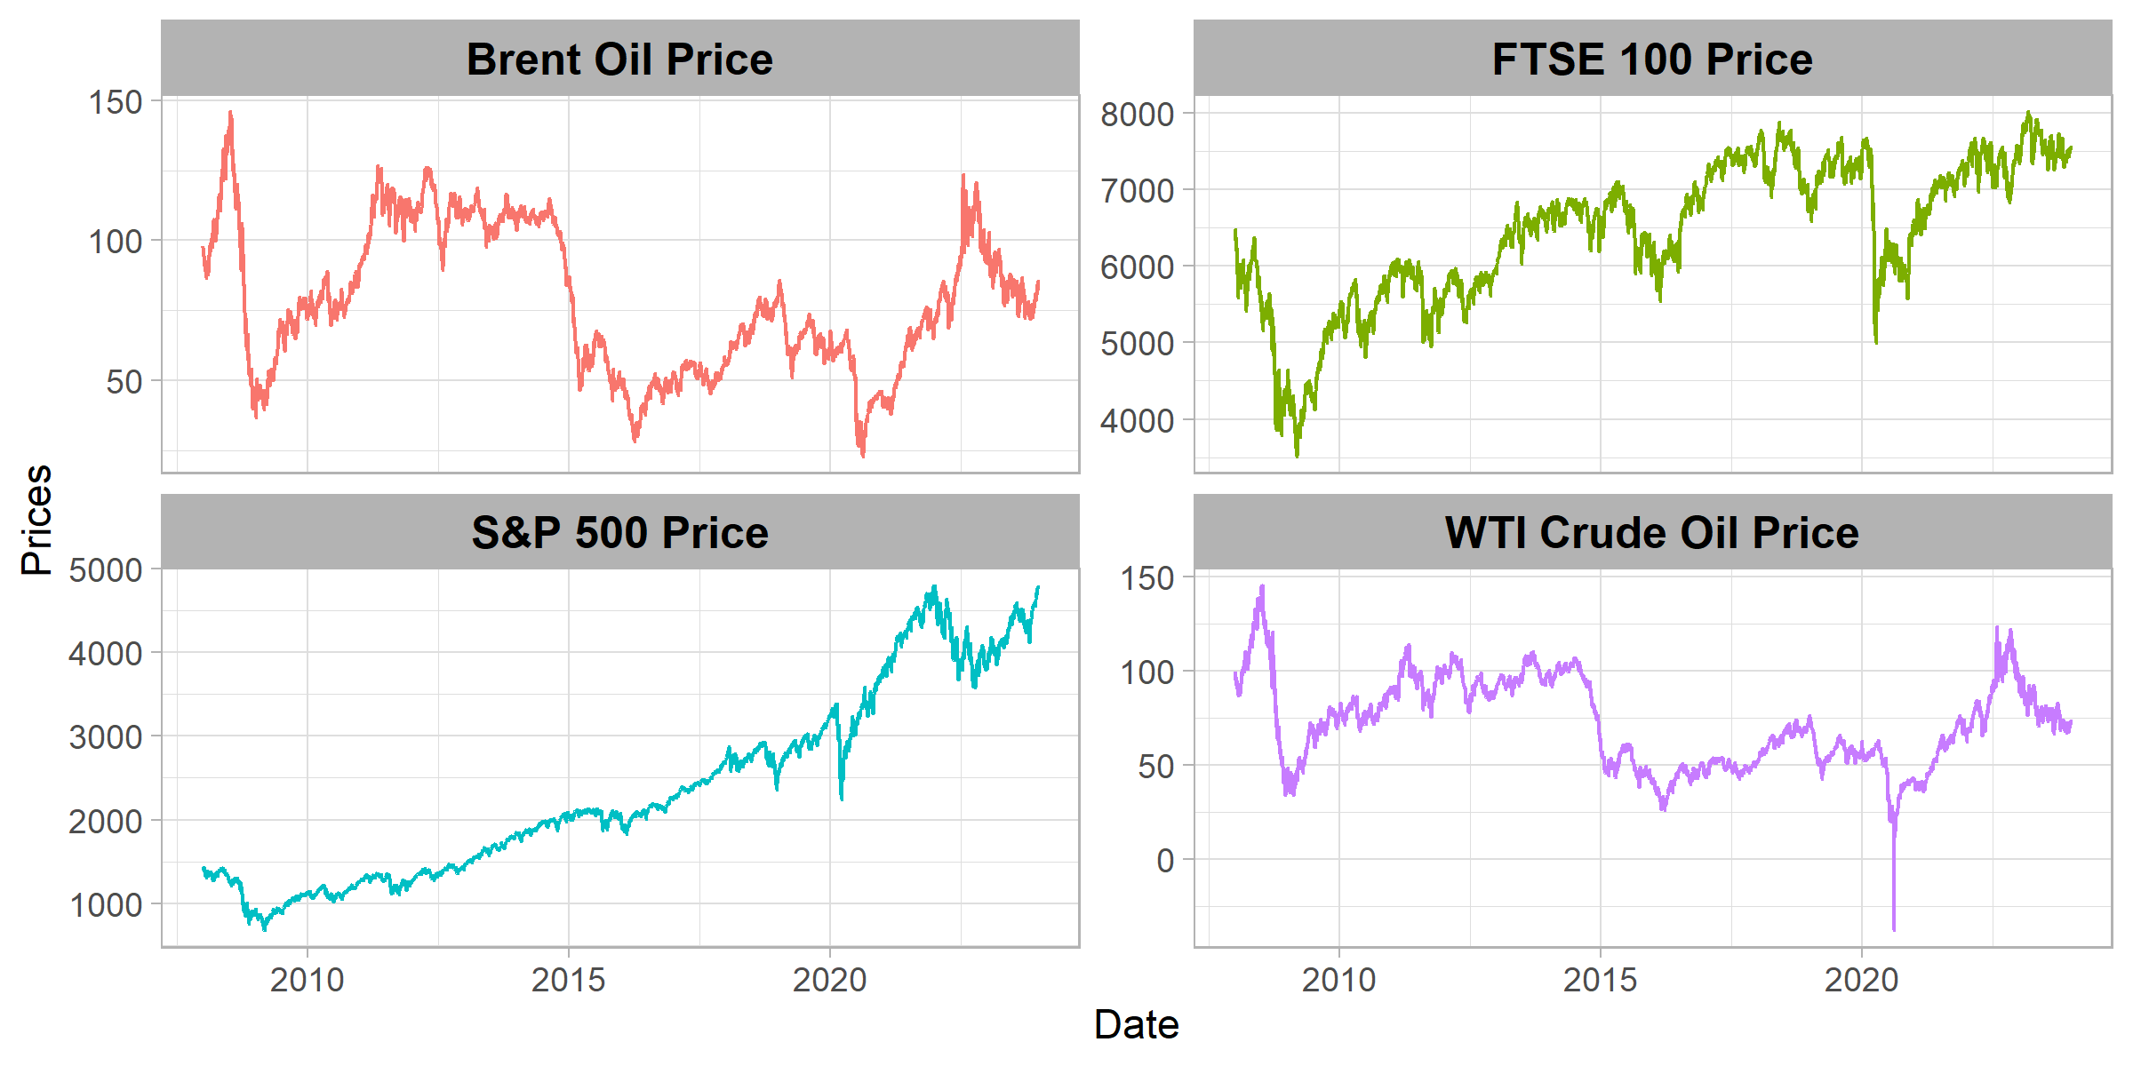
Figure 4.2: Dynamics of stationary return series.
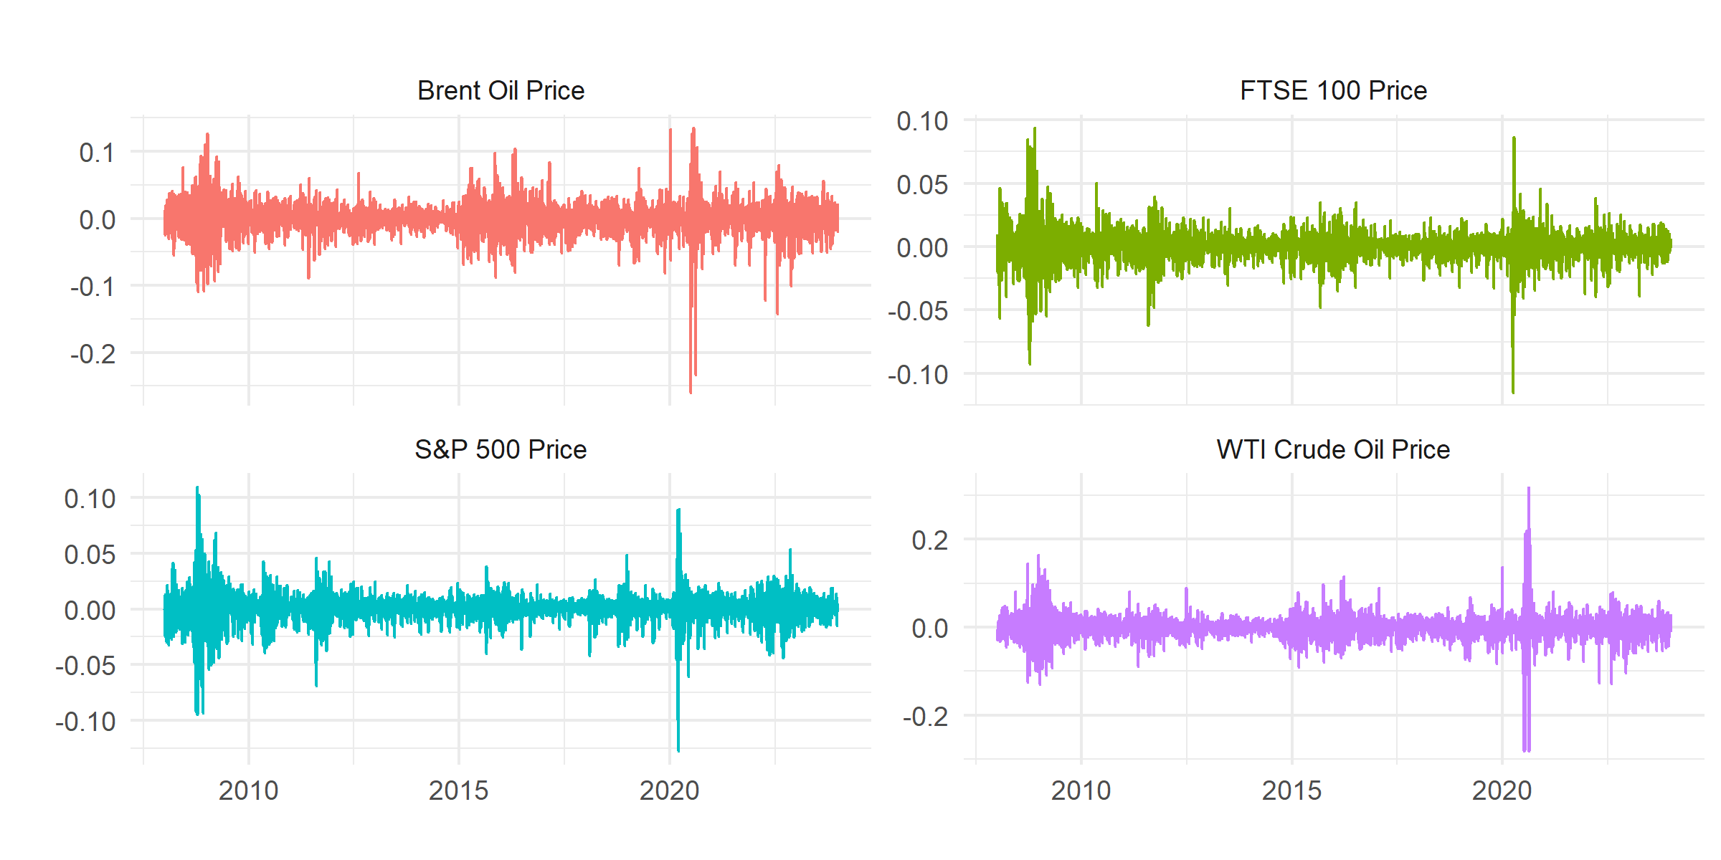

Figure 4.3: Correlation heatmap for crude oil and equity returns.
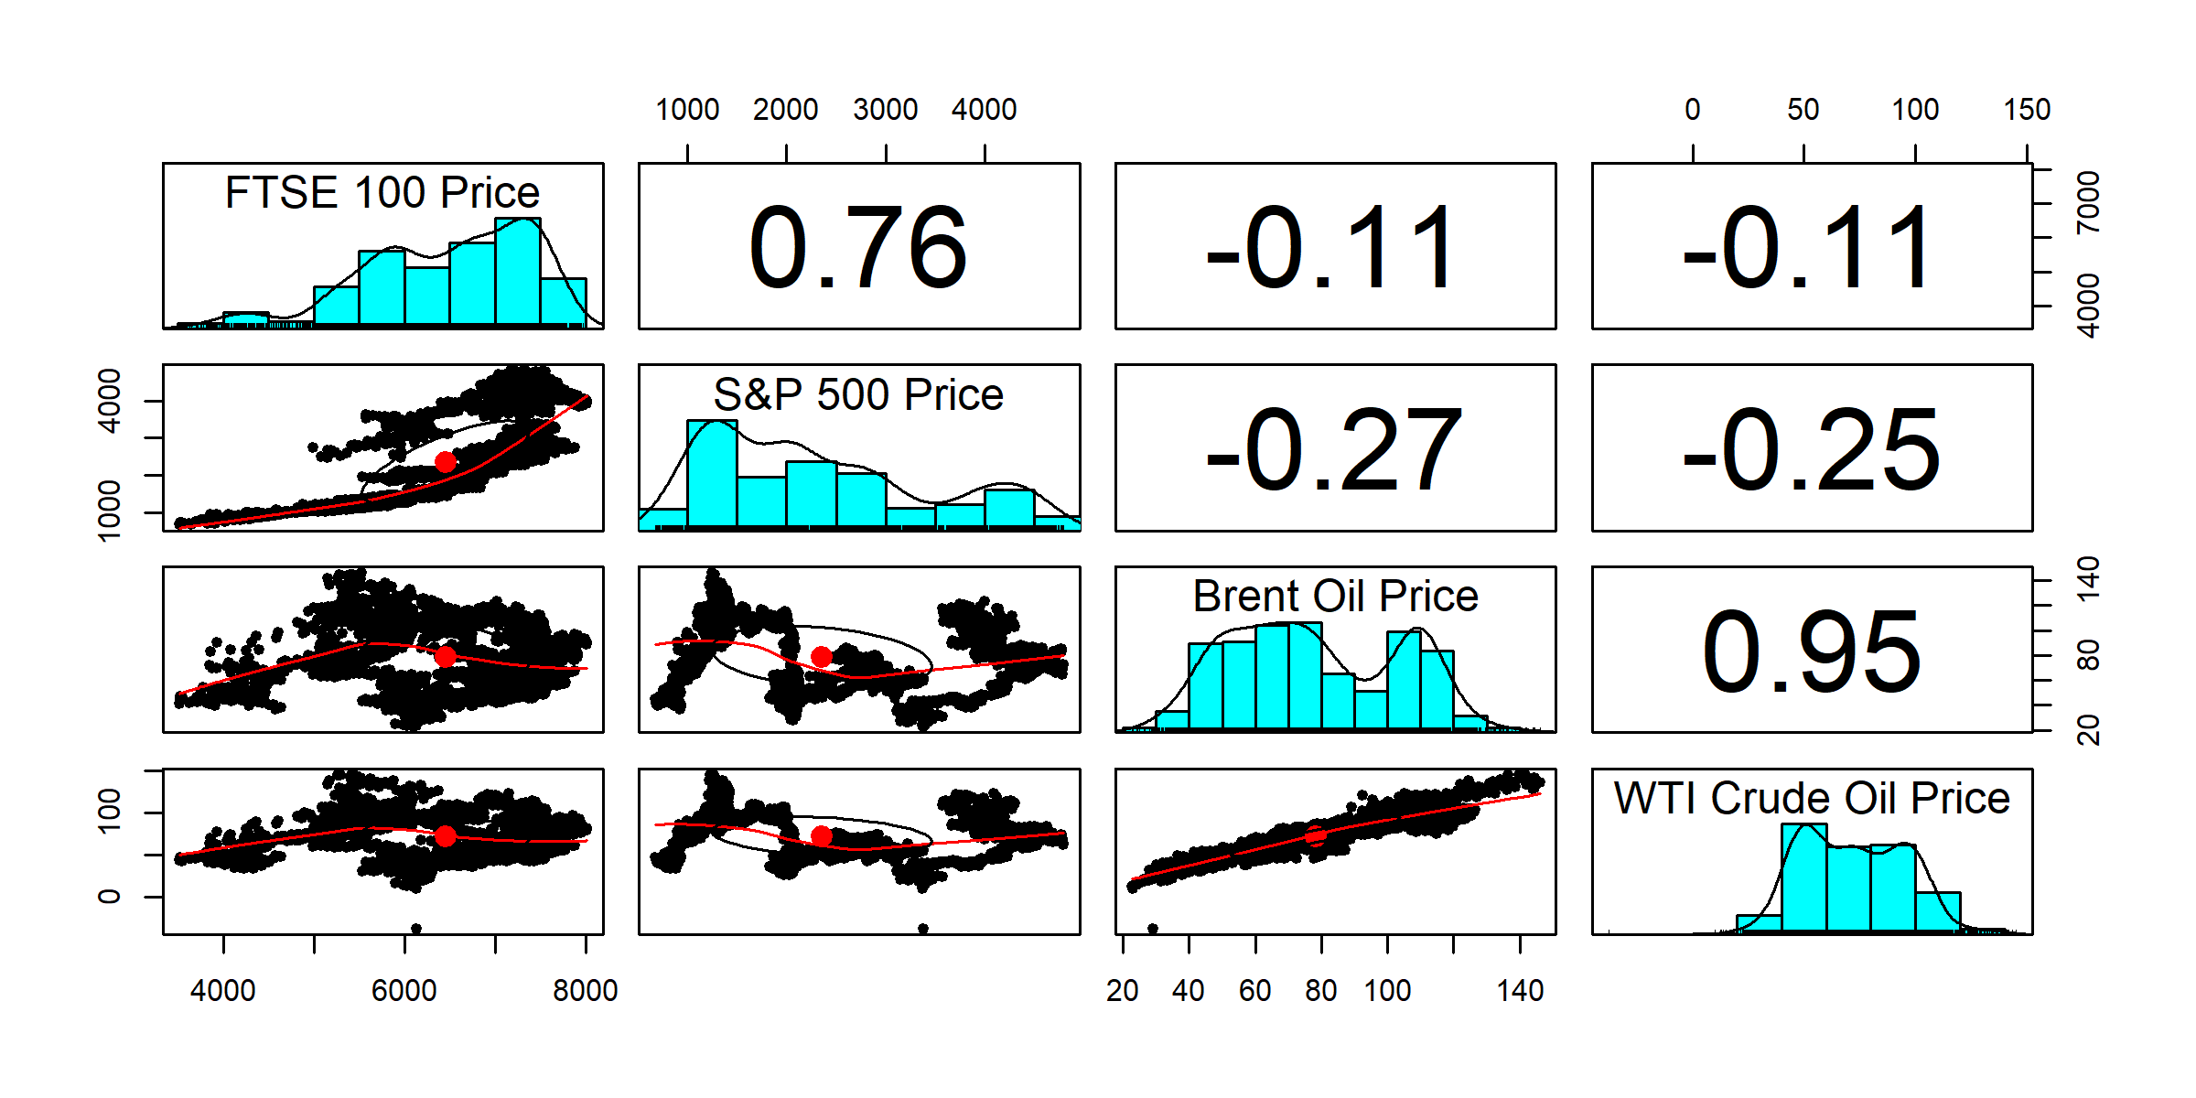
The correlation heatmap (Figure 4.3) indicates a strong positive correlation between Brent and WTI prices (0.95) and moderate positive correlations with the FTSE 100 and S&P 500. The S&P 500 demonstrates slightly higher sensitivity to oil price fluctuations than the FTSE 100.

Static Spillover Connectedness across Quantiles
Table 4.2: Static spillover connectedness at 5th quantile (extreme downside)
From/To | FTSE 100 | S&P 500 | Brent | WTI | FROM
FTSE 100 | 31.34 | 29.07 | 19.10 | 20.49 | 68.66
S&P 500 | 26.06 | 33.89 | 19.09 | 20.96 | 66.11
Brent | 23.96 | 24.37 | 27.92 | 23.75 | 72.08
WTI | 23.48 | 25.37 | 20.98 | 30.18 | 69.82
TO | 73.49 | 78.80 | 59.17 | 65.20 | 276.66
NET | 4.83 | 12.69 | -12.90 | -4.62 | 92.22/69.17
During extreme downside periods, equity markets transmit volatility, with the S&P 500 as the dominant net transmitter (78.80%). Crude oil markets act as net receivers, particularly WTI (69.82%).
Table 4.3: 25th quantile spillovers (moderate downside)
From/To | FTSE 100 | S&P 500 | Brent | WTI | FROM
FTSE 100 | 46.12 | 34.00 | 8.00 | 11.87 | 53.88
S&P 500 | 15.75 | 65.92 | 5.90 | 12.44 | 34.08
Brent | 9.45 | 12.89 | 54.99 | 22.68 | 45.01
WTI | 12.23 | 16.63 | 13.82 | 57.31 | 42.69
TO | 37.43 | 63.53 | 27.72 | 46.99 | 175.66
NET | -16.45 | 29.44 | -17.30 | 4.30 | 58.55/43.92
The S&P 500 dominates as a net transmitter (29.44%) under moderate downside conditions, with TCI reduced to 43.92%, indicating moderate interconnectedness.
Table 4.4: 50th quantile spillovers (normal conditions)
From/To | FTSE 100 | S&P 500 | Brent | WTI | FROM
FTSE 100 | 60.76 | 28.10 | 4.57 | 6.56 | 39.24
S&P 500 | 8.86 | 82.26 | 2.75 | 6.13 | 17.74
Brent | 4.09 | 8.90 | 68.89 | 18.11 | 31.11
WTI | 6.33 | 10.94 | 10.77 | 71.97 | 28.03
TO | 19.28 | 47.94 | 18.10 | 30.81 | 116.12
NET | -19.96 | 30.20 | -13.01 | 2.77 | 38.71/29.03
Under normal market conditions, spillovers are largely self-contained, with the S&P 500 transmitting the highest net volatility (30.20%).
Table 4.5: 75th quantile spillovers (heightened volatility)
From/To | FTSE 100 | S&P 500 | Brent | WTI | FROM
FTSE 100 | 54.15 | 23.35 | 10.01 | 12.49 | 45.85
S&P 500 | 13.26 | 63.82 | 9.81 | 13.11 | 36.18
Brent | 9.24 | 9.71 | 58.03 | 23.02 | 41.97
WTI | 11.33 | 13.96 | 14.93 | 59.78 | 40.22
NET | -12.02 | 10.84 | -7.21 | 8.40 | 54.74/41.06
S&P 500 continues as a net transmitter, while WTI’s net spillover increases (8.40%), reflecting greater influence during recovery phases.
Table 4.6: 95th quantile spillovers (extreme bullish markets)
From/To | FTSE 100 | S&P 500 | Brent | WTI | FROM
FTSE 100 | 33.30 | 24.67 | 20.58 | 21.45 | 66.70
S&P 500 | 21.37 | 36.38 | 20.61 | 21.64 | 63.62
Brent | 19.49 | 19.59 | 34.87 | 26.04 | 65.13
WTI | 20.51 | 20.81 | 23.01 | 35.67 | 64.33
NET | -5.33 | 1.45 | -0.92 | 4.80 | 86.59/64.94
WTI solidifies its role as a net transmitter (4.80%), while equity markets absorb substantial spillovers, indicating high systemic risk during exuberant phases.

Figures 4.4–4.6 show network visualizations of net pairwise directional spillovers for the 5th, 50th, and 95th quantiles.

Figure 4.4: 5th quantile – extreme downside network
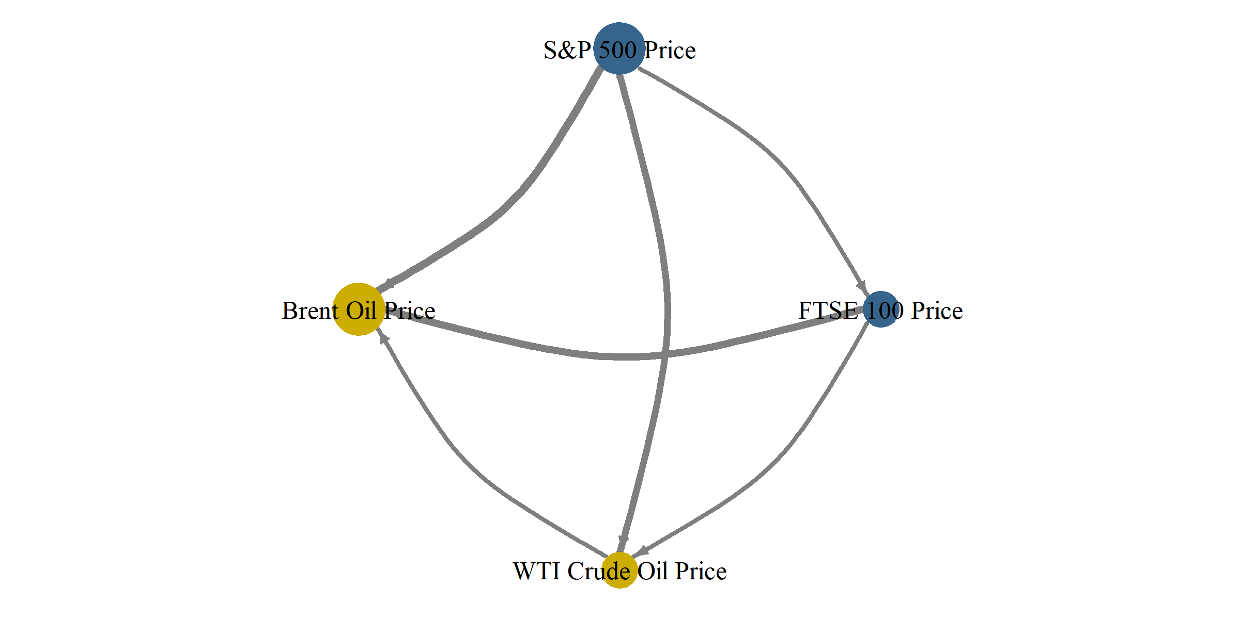
Figure 4.5: 50th quantile – normal market network
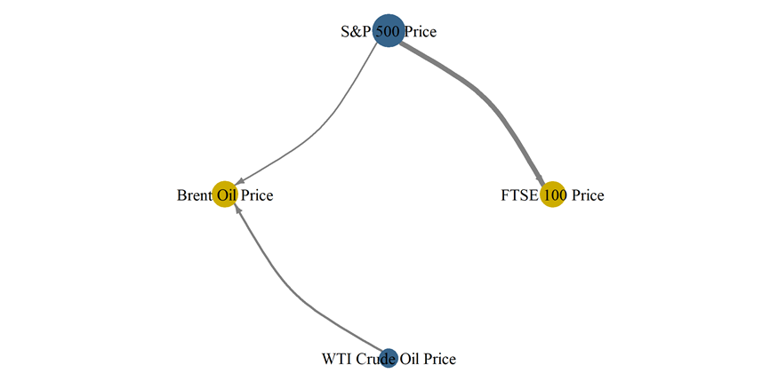
Figure 4.6: 95th quantile – extreme bullish network
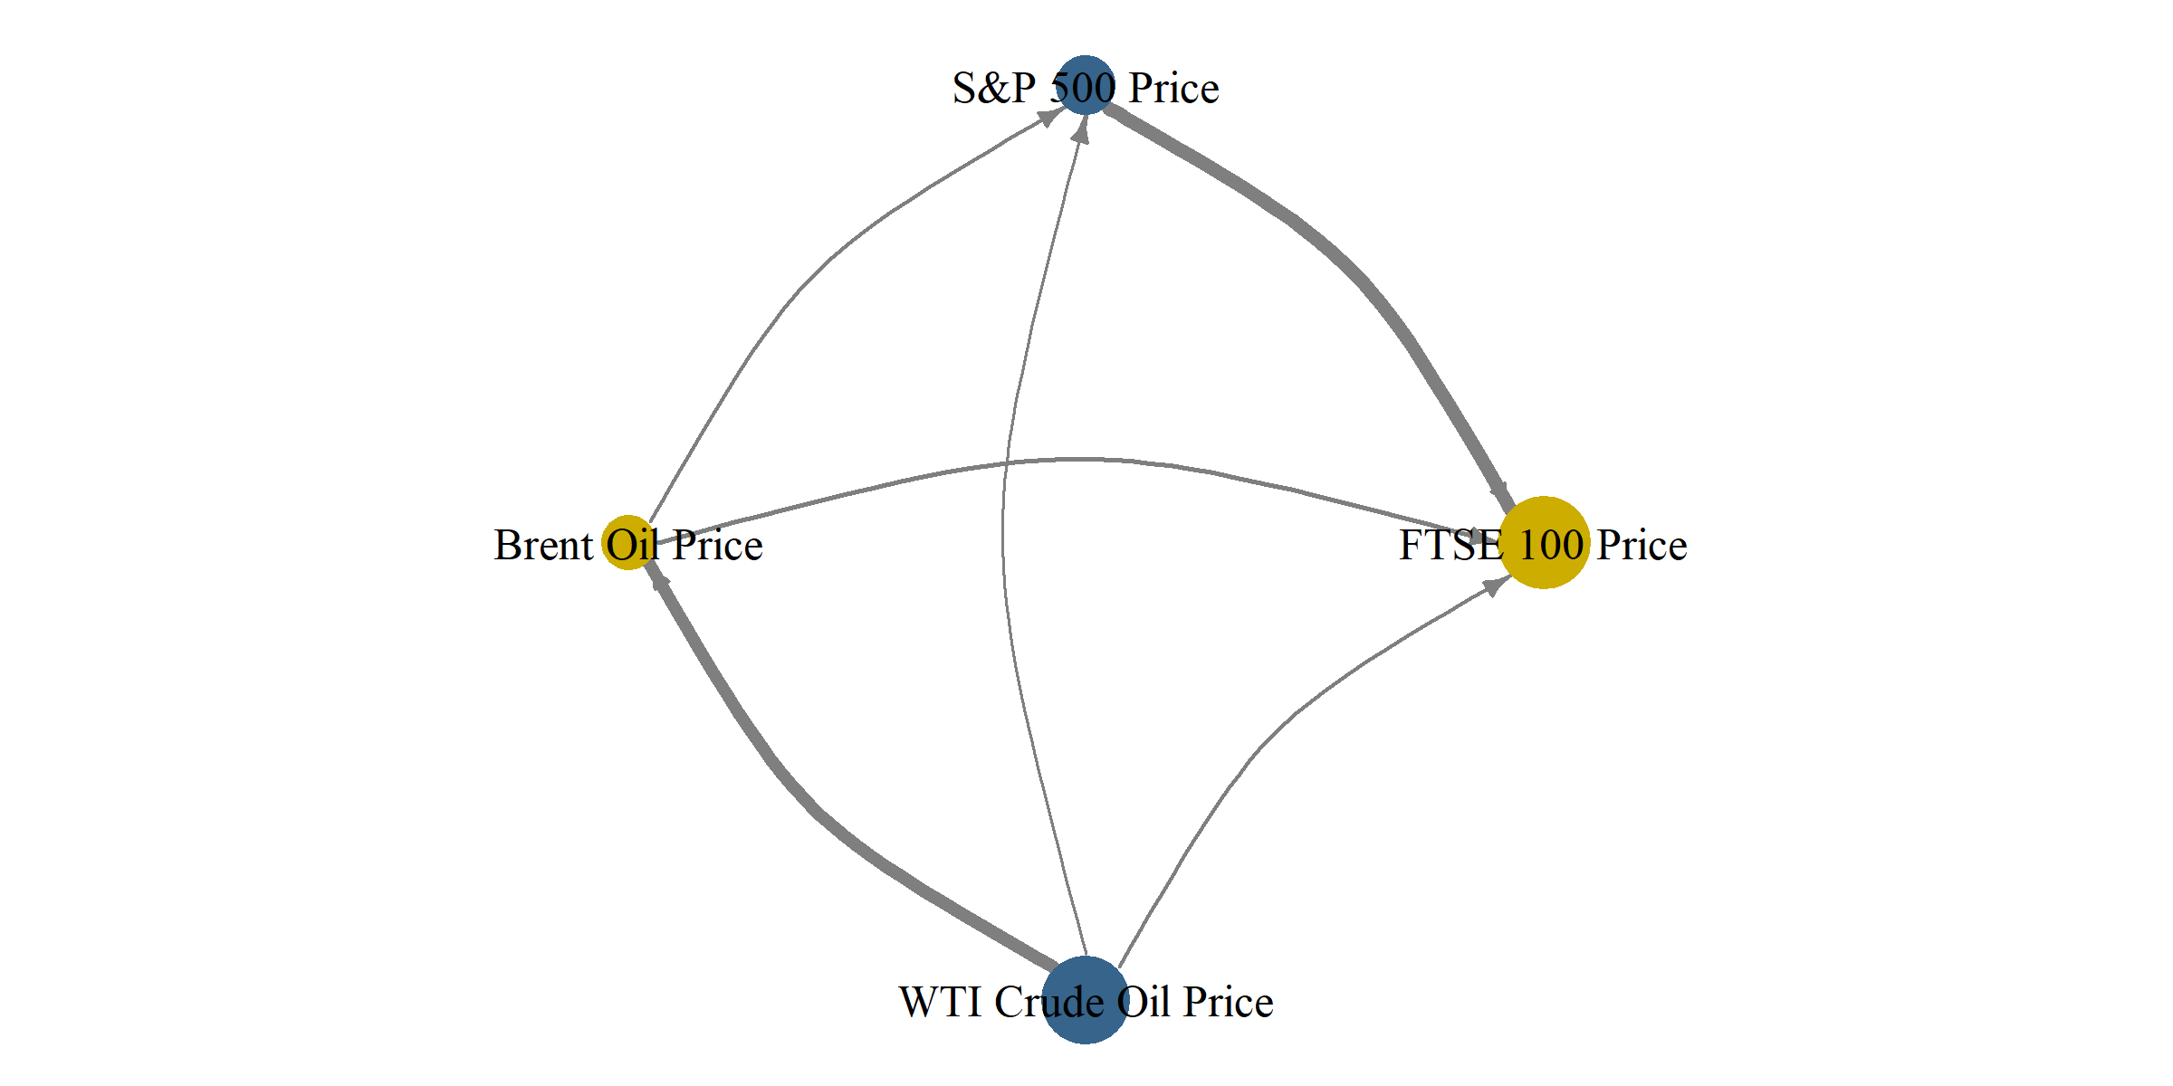
The results show variations in net spillover patterns across quantiles, highlighting asymmetric transmission of volatility between crude oil and equity markets.
DISCUSSION
The results highlight the dynamic and asymmetric nature of volatility spillovers between crude oil and equity markets. During extreme market downturns, represented by the 5th quantile, Brent and WTI crude oils act as dominant transmitters of volatility to equity indices, particularly the FTSE 100 and S&P 500, underscoring the systemic role of energy markets during crises (Zhang et al., 2022). Across most quantiles, the S&P 500 consistently emerges as a net transmitter, indicating its pivotal role in global volatility transmission, especially under moderate and normal market conditions (Kilian & Park, 2009). Spillovers vary across quantiles, with extreme bearish (5th) and bullish (95th) markets exhibiting stronger interdependencies, while moderate periods (25th and 50th quantiles) show weaker connectedness; the Total Connectedness Index (TCI) ranges from 29.03% under normal conditions to 64.94% during extreme bullish markets, confirming the non-linear and state-dependent nature of market interdependence. Network visualizations reveal bidirectional spillovers, particularly under extreme conditions, where equity markets are influenced by oil price movements, although the reverse effect is weaker, suggesting that investors and policymakers should closely monitor oil markets for early signals of volatility propagation. These findings imply that dynamic hedging and portfolio diversification strategies must account for quantile-specific spillovers, as volatility transmission is amplified during crises or exuberant market phases. Overall, the results are consistent with prior studies showing that oil price shocks significantly affect equity markets, particularly in the U.S., and that volatility transmission intensifies during periods of market stress (Hammoudeh et al., 2009; Bouri et al., 2020; Ahmed et al., 2023).
In conclusion, the DCC-GARCH model effectively captures time-varying correlations and spillovers, demonstrating that both crude oil and equity markets are closely linked, but their interactions depend heavily on market conditions. Policymakers and investors should integrate these findings into monitoring, risk management, and investment strategies.
CONCLUSION
This study examined volatility spillovers between crude oil returns (Brent and WTI) and equity returns (FTSE 100 and S&P 500) using the DCC-GARCH model across varying market conditions. The results show that spillovers are dynamic and asymmetric: crude oil markets act as dominant transmitters of volatility during extreme bearish and bullish periods, while equity markets generally absorb shocks but also transmit volatility under moderate conditions. Network analysis confirmed strong bidirectional spillovers during high-volatility periods, highlighting the systemic role of crude oil in global financial markets.
The findings emphasize that equity market sensitivity to crude oil shocks varies across economic conditions. During crises, both Brent and WTI crude oil significantly influence equity returns, whereas in stable periods, spillovers weaken, providing opportunities for diversification. These results underline the importance of dynamic risk management strategies and attentive monitoring of crude oil price movements to mitigate systemic risks and support informed investment and policy decisions.

REFERENCES

- Ahmed, M. S., Hossen, Z., & Chowdhury, K. (2022). Financial market volatility and spillovers during economic crises. Journal of Economic Studies, 49(3), 45–60. https://doi.org/10.1108/JES-11-2020-0527
- Ajmi, A. N., Hammoudeh, S., Nguyen, D. K., & Sato, J. R. (2014). On the relationships between crude oil and equity markets: Evidence from wavelet analysis. International Review of Economics & Finance, 29(3), 271–282. https://doi.org/10.1016/j.iref.2013.05.014
- Albulescu, C. T., & Ajmi, A. (2021). Volatility connectedness in energy markets. Energy Economics, 85, 104600. https://doi.org/10.1016/j.eneco.2019.104600
- Ando, T., Nakashima, K., & Kimura, T. (2022). Quantile-based connectedness measures in financial markets. Journal of Financial Econometrics, 20(1), 45–67. https://doi.org/10.1093/jjfinec/nbab013
- Antonakakis, N., & Filis, G. (2013). Oil price shocks and stock market volatility. Energy Economics, 36, 658–667. https://doi.org/10.1016/j.eneco.2012.11.002
- Apergis, N., & Miller, S. M. (2009). Do structural oil-market shocks affect stock prices? Energy Economics, 31(4), 569–575. https://doi.org/10.1016/j.eneco.2009.03.001
- Apergis, N., & Payne, J. E. (2014). Renewable energy market integration: A time-varying perspective. Renewable Energy, 68, 642–649. https://doi.org/10.1016/j.renene.2014.03.013
- Arouri, M. E. H., Jouini, J., & Nguyen, D. K. (2012). On the impacts of oil price fluctuations on European equity markets: Volatility spillover and hedging effectiveness. Energy Economics, 34(2), 611–617. https://doi.org/10.1016/j.eneco.2011.08.008
- Aydoğan, B., & Polat, Ö. (2017). The role of crude oil in driving financial volatility: An emerging market perspective. Economic Modelling, 64, 119–127. https://doi.org/10.1016/j.econmod.2017.03.012
- Basher, S. A., & Sadorsky, P. (2006). Oil price risk and emerging stock markets. Global Finance Journal, 17(2), 224–251. https://doi.org/10.1016/j.gfj.2006.06.003
- Bastianin, A., & Manera, M. (2018). Oil price shocks and equity markets: Evidence from the US and Europe. Energy Policy, 122, 547–560. https://doi.org/10.1016/j.enpol.2018.08.046
- Bouri, E., Lucey, B., & Roubaud, D. (2020). Connectedness among green bonds, financial markets, and renewable energy. Renewable Energy, 160, 1533–1543. https://doi.org/10.1016/j.renene.2020.07.063
- Carbone, A. (2009). Detrending moving average algorithm: A brief review. In Proceedings of the IEEE Toronto International Conference Science and Technology for Humanity (pp. 691–696). IEEE. https://doi.org/10.1109/TIC-STH.2009.5444410
- Chavleishvili, S., & Manganelli, S. (2019). Forecasting and stress testing with quantile vector autoregression. SSRN Electronic Journal. https://doi.org/10.2139/ssrn.3489065
- Diebold, F. X., & Yilmaz, K. (2009). Measuring financial asset connectedness: A new approach to volatility spillovers. Journal of Econometrics, 148(2), 215–230. https://doi.org/10.1016/j.jeconom.2008.10.002
- Engle, R. (2002). Dynamic conditional correlation: A simple class of multivariate GARCH models. Journal of Business & Economic Statistics, 20(3), 339–350. https://doi.org/10.1198/073500102288618487
- Gabauer, D. (2020). Volatility impulse response analysis for DCC‐GARCH models: The role of volatility transmission mechanisms. Journal of Forecasting, 39(5), 788-796.
- Ghosh, A., & Banerjee, P. (2021). Volatility drivers in energy and stock markets. Economic Modelling, 103, 105636. https://doi.org/10.1016/j.econmod.2021.105636
- Hamilton, J. D. (1983). Oil and the macroeconomy since World War II. Journal of Political Economy, 91(2), 228–248. https://doi.org/10.1086/261140
- Javier, A., & Salvador, B. (2023). Dynamic spillover patterns during financial crises. Quantitative Finance, 23(1), 78–96. https://doi.org/10.1080/14697688.2022.2021138
- Kang, S. H., Kang, S. M., & Yoon, S. M. (2017). Dynamics of volatility spillover between oil prices and financial markets. Energy Economics, 64, 190–200. https://doi.org/10.1016/j.eneco.2017.03.012
- Kilian, L., & Park, C. (2009). The impact of oil price shocks on the US stock market. International Economic Review, 50(4), 1267–1287. https://doi.org/10.1111/j.1468-2354.2009.00568.x
- Koop, G., Pesaran, M. H., & Potter, S. M. (1996). Impulse response analysis in nonlinear multivariate models. Journal of Econometrics, 74(1), 119–147. https://doi.org/10.1016/0304-4076(95)01758-0
- Pesaran, M. H., & Shin, Y. (1998). Generalized impulse response analysis in linear multivariate models. Economics Letters, 58(1), 17–29.
- Richard, A. (2020). Inflation asymmetries and oil price dynamics. Energy Economics, 88, 104782. https://doi.org/10.1016/j.eneco.2019.104782
- Salem, L. B., Zayati, M., Nouira, R., & Rault, C. (2024). Volatility spillover between oil prices and main exchange rates: Evidence from a DCC-GARCH-connectedness approach. Resources Policy, 91, 104880.
- Shailesh, K., Ramesh, B., & Anuradha, G. (2023). Investigating the dynamic relationship between gold prices, crude oil prices, and exchange rates using DCC-GARCH and BEKK-GARCH models. Resources Policy, 80, 102–115.
- Wen, X., Wei, Y., & Huang, D. (2012). Measuring contagion between the energy market and stock market during financial crisis: A copula approach. Energy Economics, 34(5), 1435–1446.
- Zhao, X., Zhang, B., & Zhang, Y. (2021). Do green bonds mitigate financial risks? Evidence from the dynamic spillover effects between green bonds and financial markets. Economic Analysis and Policy, 69, 383–398. https://doi.org/10.1016/j.eap.2021.09.011

