  - “Climate- Adaptive Sustainable Interior Design: A Study of
Indian Homes”
Manmeet Kaur
Student, School of Interior Design, Semester 6, AAFT University of Media and Arts
manmeetkaurarora2929@gmail.com

Mr. Satyam Vishwakarma
Head of Department, School of Interior Design, AAFT University OF Media and Arts
Satyam.v@aaft.edu.in

ASTRACT
The development of sustainable interior design is considered as an imperative answer to the growing environmental issues, urban sprawl and energy waste in residential buildings. The diverse climate of India has a major impact on the design and performance of interior spaces. This research critically reviews the sustainable interior design solutions and practices in an Indian home with specific reference to climate. It investigates climate-responsive design, passive design, sustainable material usage, energy saving, and biophilic interior strategies. It also examines how traditional Indian space wisdom and contemporary sustainability practices can be combined to create thermally comfortable, environmentally efficient, and healthier spaces for occupants. Drawing from theoretical frameworks and existing literature, the article argues for and investigates the extend to which various methods of promoting sustainable interiors and transferable across Indian climatic zones. Results show a high relevancy of passive cooling technology and natural ventilation, as well as local materials use and the biophilic approach as major instruments to mitigate the environmental impact and enhance indoor environmental quality. Nevertheless, barriers such as lack of awareness, financial barriers, and urban space constraints continue to impede execution. The study finds that sustainable interior design for the Indian home should be integrate factors of climatic response, cultural relevance and technological advances for achieving viable as well as functional living environments.
KEYWORDS: Sustainable Interior design, Climate-Responsive Design, Indian Residential Interiors, Passive Design Strategies, Thermal Comfort, Biophilic Interiors, Eco-Friendly Materials. Energy Efficiency
Conceptual Definitions
Sustainable interior design – A method of designing interiors with low negative impact on the environment, utilizing sustainable materials and systems, as well as mindful planning over comfort and wellness of occupants.
Climate-responsive Design – The local climate conditions such as temperature, humidity, sunshine, ventilation and airflow are considered in designing for development of passive building and interior solutions for climate-responsive building and interiors.
Passive Design Strategies –Design approaches that utilize passive solar energy, natural ventilation, thermal mass and other design features to maintain comfort without the need for mechanical systems and equipment.
Thermal comfort –The occupant’s thermal sensation at the thermal environment expressed as a substitute in terms of temperature, humidity, airflow, and heat balance.
Biophilic Design -An approach to interior design that brings in natural elements like plants, daylight, natural materials and organic textures to enhance the human connection to nature.
Eco-friendly materials – Materials that are more sustainable in production, use and disposal (which tend to be recycled, renewable, non-toxic or sourced locally).
Cross Ventilation-Cross Ventilation is a natural ventilation method of bringing air into the building through one opening in the opposite direction.

Daylighting- Daylighting refers to the practice of using natural light to illuminate the internal spaces of buildings, with the aim of minimizing the use of artificial light sources and energy.
Carbon footprint – The sum of greenhouse gases directly or indirectly related to an individual, activity or business.
Energy efficient- The process of using less energy to provide the same service.
Indoor air quality (IAQ)- Ventilation, pollutants, humidity, and venom emissions define the air quality in a building.
Vernacular Architecture- These are local regional material and methods based on climate, local custom and works of previous generations.
Smart sustainable Homes- Smart sustainable homes are homes equipped with technology, automation, and sustainable practices that maximize energy efficiency and environmental sustainability.
Sustainable Development-Development that meets the needs of the present without compromising the ability of future generations to meet their own needs in terms of environment, society and economy,
INTRODUCTION

Sustainable interior design is an evolving discipline that focuses on the design of internal environments that meet practical needs without imposing needless burden on environment or its resources while providing a high level of comfort to the occupants. This growing awareness of climate change, resource exhaustion, environmental pollution and energy use have heavily impacted the way on of modern living space designing. Sustainable living environments are becoming a reality as designer place emphasis on green products, energy efficient systems, cost-effective processes and sustainable spatial solutions. The interior design sectore makes a large contribution to global material usage, carbon emissions and has a significant impact on indoor environment quality, among others. As a result, sustainable interior design craves the position of ‘environmentally considered approach’ instead of an optional design ideaology. It is an attempt to harmonize visual quality with functional effectiveness, environmental responsibility and human emitter within the area of interior
Sustainability in interior design

In India, a wave of change is sweeping through the residential interiors on the back-drop of urbanisation, evolving lifestyles and heightened green consciousness. The result is an increase in energy usage and environmental impact because many modern Indian homes are heavily dependent upon electric lighting, mechanical cooling and heating, and man-made building materials. Sustainable domestic interiors attempted to challenge those problems through climate- sensitive design, regional materials, passive environmental methods. Traditional Indian residential architecture was sustainable by design in principle, layout and in practice utilizing courtyards, jaalis, verandahs and natural ventilation patterns. These devices were, by default, designed to respond to the climate and have efficient use of resources. Modern sustainable interior design is now challenged with reading such long- standing traditions and building upon them with new technologies and materials.
Climate responsiveness in interior spaces

Various climatic conditions prevailing in india such as hot-humid, warm-humid, composite, temperate and cold-climates. The interior design of building should be customized according to the local climate responses Biederman(1975) stated that interior area layout should be matched the climate- environment, material, air circulation and illumination should be adapt to climate. Systems such as cross ventilation, daylighting, thermal insulation, heat mitigation, that have proven to be effective in the past, continue to minimize utilization of mechanical systems. These effectual climate adapting solution increases thermal comfort, using less energy and having a lower environmental impact.

Table 1: Major climatic zones of India and corresponding interior solutions
Zone Detail | Details | Interior solutions
Hot-Dry | High temperature, low Humidity | Thick wall, thermal insulation, courtyard
Warm-Humid | High humidity and rainfall | Cross Ventilation, lightweight material
Composite | Seasonal Variation | Flexible Ventilation Systems
Cold Climate | Low temperature | Insulated interior heat-retaining material
Temperate | Moderate climate | Daylight optimization natural ventilation

Scope and significance of the study
This research investigates sustainable interior design solutions within Indian dwellings across different climate zones . the study consider climate-responsive interiors, sustainable material, passive designs strategies, as well as integration of biophilic elements. The value of the research lies in exploring ways in which interior design can assist in enhancing environmental sustainability without compromising cultural or climate adaptability .Findings this study emphasizes the need to incorporate traditional Indian design knowledge within contemporary eco-friendly paradigms, to develop healthier and sustainable living in residential spaces.
Conceptual Understanding of Sustainable Interior Design
Sustainable interior design is the design of a space considering the environmental impact of the processes used within it. It concentrates on minimizing environmental effects through energy efficiency, resource preservation, indoor air quality, and long-term viability. Sustainable interiors emphasize renewable materials, recycled content, low VOC finishes, and flexible space solutions.
Climatic -Responsive Interior planning
Climate-responsive interior design is the ability to design indoor spaces that satisfy regional climate needs. It seeks to promote indoor natural climates as opposed to secluding them with mechanical means. Indoor orientation, flow of ventilation, thermal conductivity of the materials, and organization of spaces within the building, are all essential factors for climate-responsive design. The diversity of Indian climate call for developing different interior modalities. For example, thick insulating materials and shaded interiors work well in hot-dry and warm-wet climates need ventilation and moisture- resistant materials.
Passive Design Strategies
Passive design strategies take advantage of natural environmental conditions to maintain indoor comfort. These approaches minimize reliance on mechanical cooling, heating, and lighting. passively. common techniques include: cross ventilation, daylight maximinsation, heat insulation, solar shading, heat reduction via material use, spatial orientation, heat transfer principles can like be used to describe thermal comfort in indoor environments.
Biophilic and Eco-Conscious Interior
Biophilic interior design focuses on bringing natural elements into the built environment for psychological and physical wellness. Biophilic and eco-conscious interiors feature indoor plants and daylight, natural textures and sustainable materials that enhance the human connection with nature.
Literature Review
Sustainable interior design in mid- twentieth century grew out of the widespread environmental movements worldwide. Energy efficiency- centric sustainable design was expanded to incorporate environmental stewardship human wellness, material lifecycle consideration, and resource use. Modern sustainable interior design are based on circular design systems, and restorative processes and are environmental friendly.
Ancient Indian Climate and the implications on Design
Traditional Indian homes were designed to be cool in the summer and warm in winter through simple passive architecture principles. Airflow and daylighting through courtyard and jaalis screens, which act as filters of sunlight and also help in ventilation. Verandahs serve as thermal transitional zones between the indoor and outdoor environments. Locally sourced material such as terracotta, lime plaster, bamboo, and natural stone were used liberally as they are thermally efficient and well suited to the environment. The vernacular practices evidence the egological intelligence woven into traditional Indian homes.
Sustainable Residential Interiors of the Future
Contemporary residential interiors are increasingly using sustainable materials, energy efficient lighting, modular furniture, and environmental technology. Designers are using reclaimed and recycled materials, low- VOC finishes and other sustainable options such as bamboo flooring, to minimize environmental impact. Biophilic design, passive cooling strategies, and daylight-responsive design solutions are becoming more essential in urban residential developments, and increasingly in other segments of the residential market. The leading interpretations of modern sustainable interior design seek to strike a balance between the advancement of technology and the preservation of the environment.
Gap in Research on Indian Interior Sustainability
The prior literature concentrates mainly on the challenges of sustainable architecture and green building solutions with less critical attention has been given to the practice of sustainable interior design in homes, which is paper fills. In addition, the literature examining the interconnection between interior sustainability and varied climate zones of India are almost non- existent. In so doing, this paper addresses a notable gap in research by focusing on climate adaptive interiors in the domestic sphere in India.
Research Objective
To investigate sustainable interior design strategies in Indian homes. Indian cool climate on interior planning of the house hold. passive and green building principles in the sustainable interior. To study the barriers and potential prospects for implementing sustainable interior design in the Indian context.
Statement of the Problem
Although there are increasing positive environmental perspectives in the value uncertain modern Indian homes, still depend on high energy use systems and harmful- to the environment material that do not adequately adapt to climate conditions. Urban dwelling typically emphasize style rather than sustainable principles, compromising energy use and thermal comfort, and resulting in poor indoor environmental quality. This underutilisation of climate sensitive interior design patterns emphasizes the need of analytical studies on sustainable residential interiors in the Indian climate conditions.
Table 2: Sustainable Materials Used in Residential Space Design
Material | Sustainability Benefits | Climatic Suitability
Bamboo | Renewable and biodegradable | Warm-humid region
Terracotta | Natural thermal Insulation | Hot-Dry region
Reclaimed wood | Reduces Deforestation | Composite Climate
Lime Plaster | Breathable and eco-friendly | Humid Climate
Natural Stone | Thermal mass properties | Hot and Composite Climate

Research Methodology
Research study uses qualitative to analytical research methodology that is based on the examination of sustainable interior solutions in Indian urban homes.
Sources of Data Collection
The study is based on both primary and secondary data
Primary data
Primary data was obtained by a survey among the person’s interested in residential interior design, sustainable interior design and climate- responsive living, through a Google form questionnaire. the questionnaire was based on the following: knowledge of sustainable interiors, material selection , daylight and ventilation usage, energy conservation, and the shifting perception of environmentally friendly residential space
The Questions in the Google form were
Question 1:Have you heard of what sustainable interior design?
Question 2: Have you ever incorporated sustainable or green products into your homes?
Question 3:Would you rather have natural light during the daytime rather than artificial light?
Question 4:Are you ready to pay for sustainable interior design enhance comfort and quality of life?
Question 5: In your opinion, does sustainable interior design enhance comfort and quality of life?
Question 6: Have you practiced any Indian traditions at home?
Question 7:Do you think indoor plants make a difference in sustainability and the interior look?
Question 8: Would you use recycled or recycled furniture in the interior of your home?
Question 9: Do you own a home that has solar panels?
Question 10:Should interior design sustainability practice also be made mandatory for upcoming residential projects in India?
Secondary data was collected from:
Secondary data was collected from: the research journals book, scholarly articles, sustainable design reports, and online academic bulletins containing information on sustainable interior design and climate responsive architecture
Sample Selection
Survey responses were obtained from people who used to live, be studying in, or were acquainted with the concepts of interior and sustainability. The survey captured 53 responses from responses from individual form various residential and educational fields.
Method of Analysis
Among the collected survey responses were processed under two interpretative techniques, the comparative and the percentage one, in order to extract the most common environmentally friendly indoor trends and climate responsive behaviour.
Scope and Limitation
The investigation is based on Indian context and it is restricted to residential interface, for example living room focused by sustainable design strategies across varied climatic zones. Constraints on time availability of data forced the researcher to depend on secondary information and not on primary data.
Analysis of Sustainability
Green products such as bamboo, reclaimed wood, terracotta, lime plaster, and natural stone can be used for environmental sustainability and thermal value . supporting local economics usimg local materials also the helps reduce transport emissions.
Energy-efficient interior strategies Energy-efficient interiors employs a multitude of strategies including: LED lighting systems, maximum use of natural daylight, reflective surfaces, and smart technology solutions to lower in house electricity consumption. Passive cooling techniques further decrease the use of air conditioning.
Natural Ventilation and Thermal Comfort
Natural ventilation systems are effective at improving indoor air quality and controlling thermal conditions through the manipulations of air flow. Elements of Indian traditional design like jaalis, and courtyard are still viable passive cooling techniques even within modern interior design and housing.

Biophilic Integration in Residential Spaces
Biophilic designs promotes mental well being through presence of indoor plants, organic texture, aquatic elements and visual access to nature . this approaches enhance environmental quality and occupant comfort and health.
Findings and discussions Interpretation
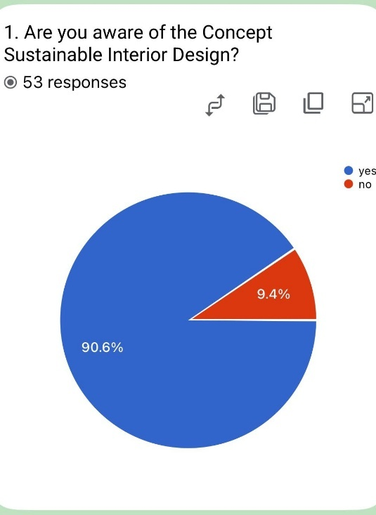
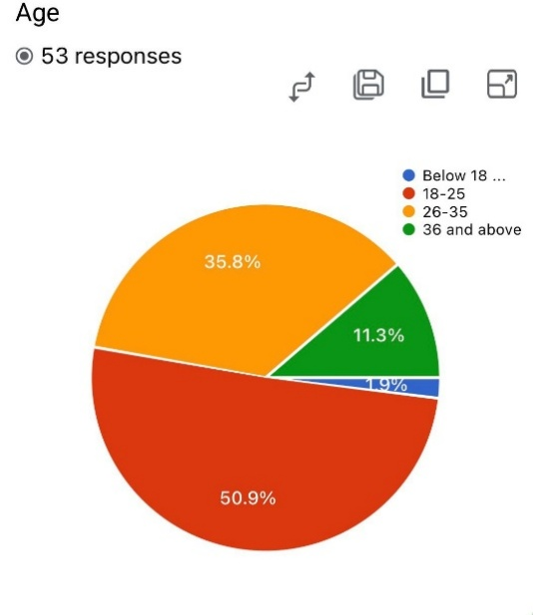

The survey answers were mostly from respondent pf age between 18-25 years 50.9% and them 26-35 years 35.8% . the findings imply that the more active participation and awareness of younger generation with sustainable interior practices could be due to the influence of their great environment consciousness as new residential users and design conscious people.

The results of the survey shows that 9.4 % of the participants had heard of term sustainable interior design ,90.6% of them however knew about it. The outcome reflects an enhance awareness of the younger generation.

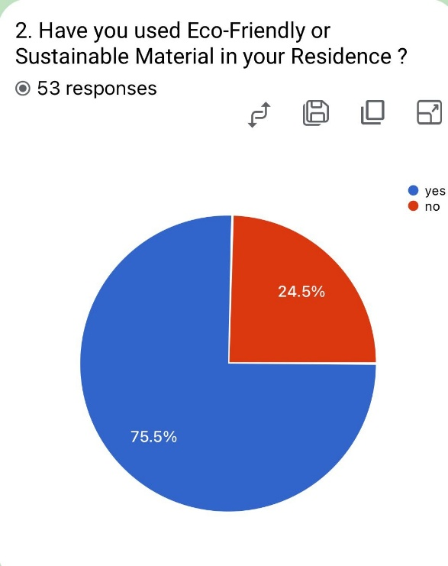

The survey shows that three quarter 75.5% of respondents have done at least one of these in their homes while the remaining 24.5% have not. This shows a progressive knowledge of application in the use of eco-materials at home.

In Addition, 92.5% of the participants have conviction of preferring natural daylight over artifitial light in day time.

It was found that 88.7% are prepared to pay for a sustainable interior solution if it was to provide long-term benefits.

.

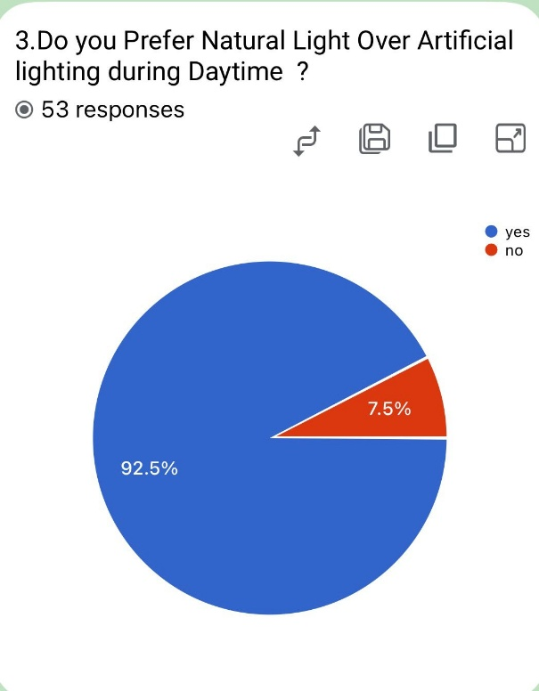

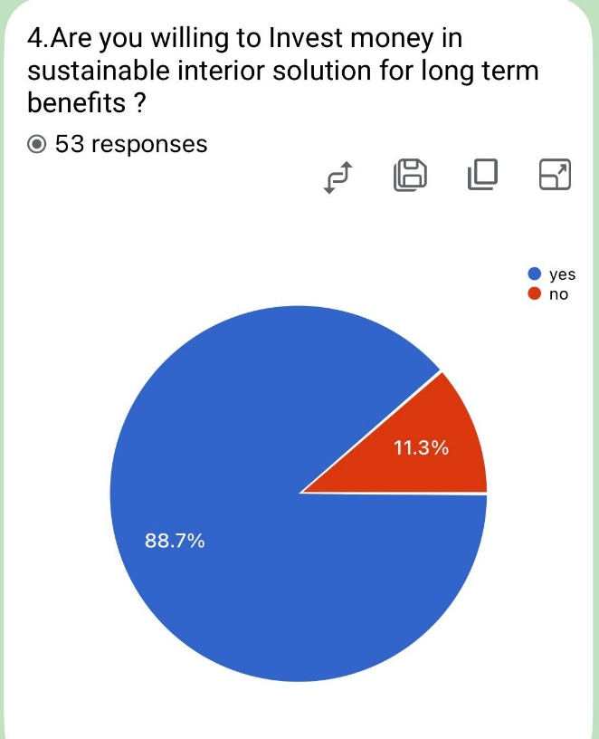

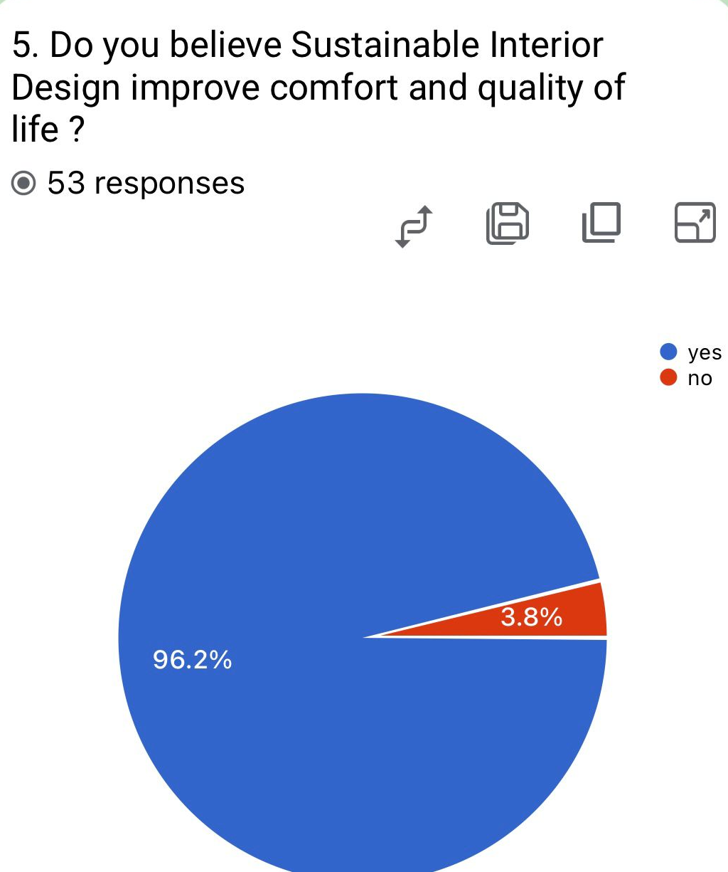

The survey findings reveal that 96.2% of respondents believe sustainable interior design contributes to comfort and quality of life. This reflects an increasingly occupant well-being, psychological comfort, and healthier residential living environments.

The survey finding demonstrate that 81.1% of respondant have incorporated traditional practices at home ad rest 18.9% respondant have not.

Additionally, 92.5% of respondents believe that indoor plants can enhance both sustainability and aesthetics in interior spaces.

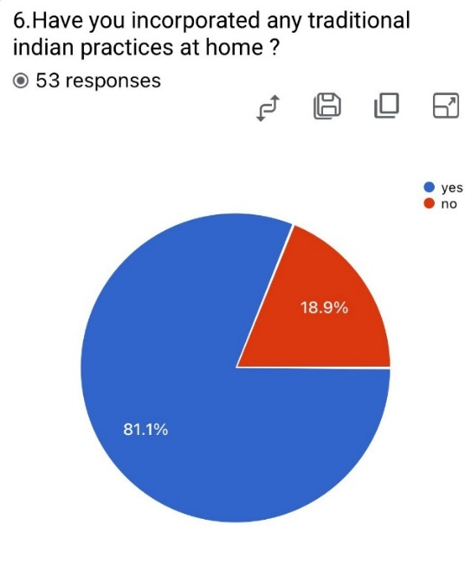

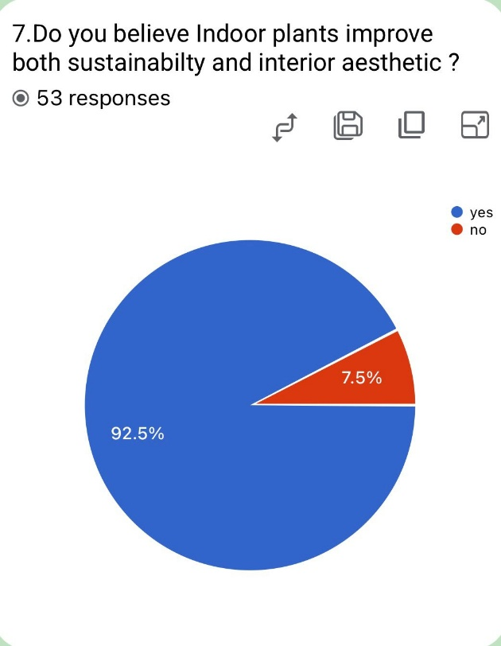

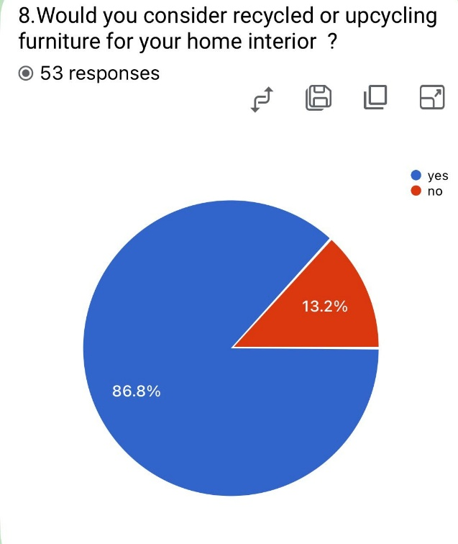

The survey results show that 86.8% of respondents preference to use recycled materials in residential areas. This is indicative of an increased consciousness about waste minimization and sustainable living. This outcomes demonstrate a growing level of acceptance among the general public for environmentally friendly interior solutions.

The survey findings indicates that 50.9% have installed solar panel at homes and rest 49.1% have not taken steps towards the sustainability.

The result shows that 79.2 % of respondents have agreed to make sustainable design be compulsory in future residential in India.

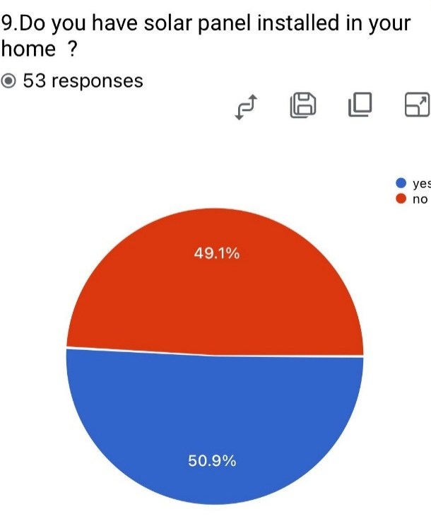

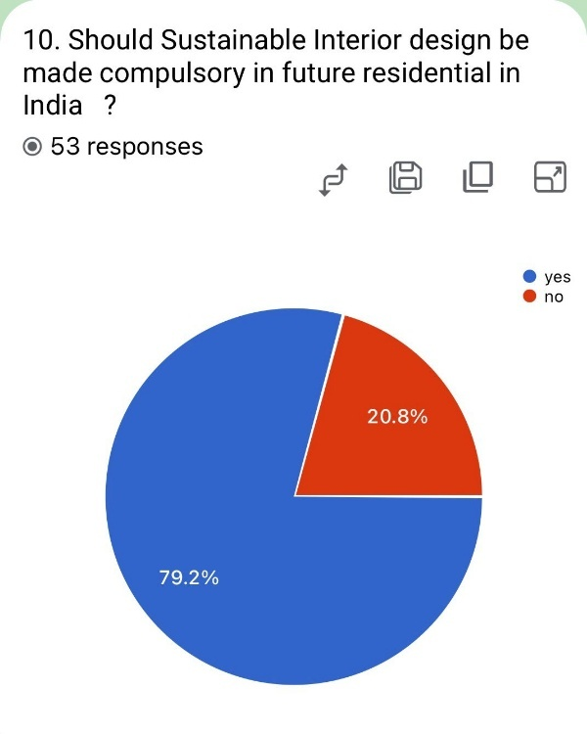

Overall survey analysis
Results from the main survey indicate that the residents as well educated and view positively sustainable interior design practice applied in their homes. Just over half of respondents were aware of sustainable interior design principle and they are preferred climate-aware options including natural light and ventilation , recycled materials and eco friendly interior options. The results also reveal the participants are more open to paying for sustainable interior solution as they offer long lasting environmental and practical advantages. this came in response to the positive attitudes towards waste reduction and responsible sourcing within home interiors.
Key Findings
The research demonstrates that the climate-adaptive interior design can reduce energy consumption and enhance thermal comfort. Sustainable materials and passive environmental measures have a positive effect on environmental sustainability
Environmental and functional impact
Sustainable interiors have been shown to enhance indoor environmental quality, lower carbon emissions and improve occupant health and well being. by combining traditional Indian climatic approaches with contemporary technology, an environmentally responsive residence was achieved
Challenges in implementation
Barriers identified are the high perception of investment, lack of public awareness, the pressure of urban living , no availability of sustainable materials, and lack of know-how.
Future opportunities
New opportunities for the future are smart sustainable technology, circular design system, modular and reusable furniture, renewable materials development and more evolved biophilic design techniques.
Conclusion
Sustainable interior design and practice of Indian design philosophy in India design in India are significant instruments to propagate eco friendly energy saving and socially energy saving and socially responsible way of living. The research indicates that designing spaces with climatic consideration, passive strategies, sustainable materials and biophilic design principle contribute positively to achieving thermal comfort, to reducing energy consumption, to improving indoor air quality, and to the well being of building occupants these not only to mitigate environmental damage but to also provide solutions to adapt to India's diverse geography and create l, sustainable spaces. It also concludes that of lot of traditional. Indian homes design is actually smart ecological design and is climate adaptable. courtyards, natural ventilation and local material have been great climate responsive solutions fostering environmental sustainability and resources efficiency. Blending these old age design concept with contemporary sustainability and creative solutions can results in homes that are green , culturally sensitive, economically viable and practically sustainable. the survey results further indicate that there is an increased knowledge and willingness to use sustainable interiors. this is all part of growing demand for green living and responsible home design with requirements for natural light, recycled materials, renewable energy systems and health driven interiors, it is clear that sustainability is making such strong inroads into home design that is becoming a fundamental decision making factor. therefore, sustainable interior design should not be regarded as a merely a passing trend or a popular style, yet critical design direction of conscious focused interior procedures can greatly reduce damages to the environment for decades or even centuries. Further the Research outlines that the future of India.
List of abbreviations
HVAC-heating, ventilation and air conditioning
VOC-volatile Organic compound
LED-light emitting diode
IGBC-Indian Green Building Council
Reference
1. Climate Responsive Architecture, Baker, N., Yannas, S.& SV. (2001).Climate-responsive architecture: A design handbook for energy-efficient building. Tara McGraw-Hill Publishing Company.
2. Manual of Tropical Housing and Building, Ingersoll TG, Mayhew, A, & Szokolay, SV. (2010). Manual of tropical housing and building: Climate design. Universities Press.
3. Sustainable design: A critical guide (2013). sustainable design: a critical guide. Princeton Architectural Press.
4. The Philosophy of Sustainable Design (2004). The philosophy of sustainable design. Ecotone Publishing.
5. Biophilic Design: The Theory, Science, and Practice of Bringing Buildings to Life, Heerwaagen, J. J., M. Mador, m (2008). biophilic design. The theory, science and practices of bringing buildings to life. wiley.
6. Interior design illustrated. (2018), Interior Design Illustrated (4TH ed.). Wiley.
7. Sustainable Construction: Green Building Design and Delivery. (2016). Sustainable construction: p=green building design and delivery (4th d).Wiley.
8. Priya R & Sharma, V (2021). Climate-responsive interior strategies in Indian residential architecture International Journal of Interior Architecture and Spatial Design,7(2),44-58
9. Mehta, S. (2020). Passive cooling technique in traditional Indian residential spaces. Journal of Sustainable Build Environment ,9(4),211-215
10. Kaur, P, & Singh, A (2022). Sustainable material application in contemporary Indian interior. Asian Journal of Interior Design Studies,5(1),67-79.
11. Rao, N (2023). biophilic design and occupants' well-being in residential interiors. International Journal of Environmental Design,12(3),98-113.
12. Jain, R. &Kulkarni, (2021). Energy efficiency lighting systems and residential sustainability in India, Journal of Green Design and Technology,6(2),85-101
13. Sharma, D & Patel, (2024). vernacular interior practices and sustainability in Indian housing. Journal of Environmental Design,12(3),98-113.
14 Indian Green Building Council. (2023). green interior guidelines and sustainable building practices. IGBC Publications.
15. World Green Building. (2021). Health, Well-being, and productivity in sustainable buildings, World GBC.
16. Bureau of Energy Efficiency. (2023). Energy conservation guidelines for residential sectors. Government of India.
17. Council of Architecture India. (2022). Guidelines for climatic -responsive residential design. COA Publications.
18. United Nations Environment Programme (2022).2022 global status report for building and construction. UNEP

