Ethnomedicinal plants used from the God’s pharmacy by the tribes of Santhal Pargana ,Jharkhand Ranchi
Jharkhand
Elisha Hansdak and Neeta Lal*
University Department of Zoology, Ranchi University

Abstract
Santhal Pargana division is located in the eastern part of Jharkhand. Santhal tribes are found in very large numbers in this division . Apart from this, Pahadia, Mahalis, Kols ,Bhumij and Karmali tribes also resides in this region .Information about how ethnomedicinal plants are used medicinally was collected by us during field survey from elders of Tribal communities ,Herbal practitioners, farmer and village’s people .During this survey we studied 33 species of medicinal plants belong to 25 families. All these medicinal plants are used to treat different diseases. The plants studied have been arranged according to their family , botanical name, local name and parts used. People living in remote areas and forests in santhal pargana still follow this traditional method to cure many diseases. The main motive of this study is that ,along with increasing luxury we should maintain our traditional culture heritage. There are some new formulas in the ethnomedicinal plants studied which are not recorded in any literature.
Keywords:- Ethnomedicinal ,Traditional, Tribal, Pahadia, Herbal

Introduction
Medicinal plants have been traditionally used by tribal people for medicines for centuries . Tribal people are dependent on wild plant species for food, medicines and shelter [1] [2]. In many developing countries like India rural and indigenous communities consider herbal medicines [3] .Medicinal plants have been used for many diseases for over 100 years. Medicinal plants are available at low cost and have very few side effects . Many herbal medicines are useful for multiple parts of the body at the same time .Many Ethnobotanists have worked in this field like [4], [5],[6] [7],[8]and [9]. Ethnomedicinal studies are important for conservation and sustainable utilization of bio-resources [10], [11]. According to WHO ,80% of the world population and 60% of people in india use herbal medicines [12]. People refer to the forest as God’s own pharmacy. 70% of the total population in this Jharkhand state is dependent on traditional healers and herbs to maintain their health.[13].
Most of the people living in villages use medicinal plants as medicines .Most of the people in santhal pargana live in rural areas. Most villages are quite far from the city .There is no CHC and PHC near the village. They have to go to the hospital for immediate treatment after waiting for a long time. Tribal people fully depend on medicinal plants for minor diseases. Knowledge about medicines from medicinal plant continue to be transfered from generation to generation in tribal people .In every village ,at least one member of every family has some knowledge about some medicinal plant. Those who continue to make medicines for people are called Janguru, Kubraj, Guruharam ,Ojha ,Vaidya and Manjhi. Traditional medicine is usually prepared from the complete plant or different parts of the plant like bark, root ,leaves, fruit and flower etc.
Santhal pargana is one of the 5 divisions of Jharkhand state. These are 6 districts included in this division, Godda,Deoghar,Dumka,Jamtara,Sahebganj and Pakur. It’s administrative district is Dumka. Here one finds rich cultural diversity of different indigenous and tribal communities like Santals, Paharias, Mahalis, Karmalis, Kols and Bhumis. These tribes live near forest areas . Rich phyto-diversity of dry deciduous tropical forest is found in this region. Primary occupation of tribal people is cultivation. Gradually ethnomedicinal plants are getting extinct due to deforestation and urbanization etc. Medicinal plants are important for biodiversity and ecosystem, because apart from being important for the health of humans and animals. ,it is also important commercially .Documentation and safety of medicinal plant is important for next generation.
Methodology
A Survey has been conducted in 2022-2023 for information about ethnomedicinal plant medicine. For this study, 13 villages of santhal pargana’s were identified ,where some of our known people live so that it becomes easier for us to conduct field survey .After this we visited different villages in different months and conducted field survey .Data were collected by interviews of herbal practitioner,village’s people, traditional healer ,elders of villages and farmers. The herbal practitioners are called Janguru ,Ojha, Guruharam ,Kubraj, Vaidya and Manjhi. After this the plants were identified by tribal people in the garden, forest and field. After that an idea has been developed from them about the formula for making medicine . The collected plant materials were identified by Kanjilal, Maheshwari, Kurian and Kritikar and Basu about the parts of the medicinal plants which are used and what it is called in the local language and which medicinal plant is used to cure which disease. All the information have been tabulated given in below Table 1.
Result and Discussion
During this study ,33 medicinal plants were recorded which belonged to 25 families. All the information collected in this study is given in table 1 .Medicinal plants have great potential to cure the disease. All plants have been alphabetically arranged ,using standard format like botanical name, common name, family and parts used for disease. Medicinal plants are an important source of drugs in the traditional system of medicine. Most of the people in the village depend on medicinal plants to cure their disease . People here cultivate some medicinal plant and grow some on their own randomly. India is a developing country . This region of a state like Jharkhand has not yet been able to achieve much development. Due to which the people here depend on medicinal plant for primary treatment. In this area,if the people suddenly fall ill ,they have to travel several kilometers to reach the hospital for treatment,that is why people use medicinal plants as primary treatment . Medicinal plants have been used as medicine since ancient times . This is an important component of india’s health care system. All medicinal plants are gradually being eliminated due to some activities like deforestation ,habitat destruction and urbanization. All medicinal plants need protection ,care ,documentation and safety. Some medicinal plants are seasonal . Whichever plant has been documented in this study has great importance in ethnomedicinal preparation . This traditional herbal knowledge requires proper documentation in studies areas ,otherwise it will become extinct from the society forever

Family Name | Botanical Name | Common Name | Parts used | Ethnomedicinal uses
Cucurbitaceae | Momordica | Karela | Fruit | Diabetes
Fabaceae | Derris indica | Karanj | Seed | Abscess Pustule and Sore
Moringaceae | Moringa oleifera | Munga and  Sajna | Leaves | Blood Pressure
Costaceae | Chamaecostus  cuspidatus | Costum | Leaves and  Roots | Diabetes and Diuretic
Gentianaceae | Swartia L. | Chirata | Whole  plant | Malaria, Sore and Digestion problem
Crassulaceae | Kalanchoe  brasiliensis | Tilchatta | Leaves | Diarrhea and Scorpion bite
Cucurbitaceae | Melothria pendula | Kundri | Leaves | Draining pus from ear
Araceae | Typhonium trilobatum (L.) schott | Nirbis | Leaves | Back pain
Solanaceae | Datura L. | Datura | Leaves | Back pain
Oleaceae | Nyctanthes  arbor -tristis | Saparom | Leaves | Piles and Arthritis
Acanthaceae | Justicia adhatoda | Basok | Whole  plant | Malaria ,Sore and Cough
Asteraceae | Vernon amygdalina | Harhat Sakam | Whole  plant | Jaundice, Gastric and Diuretic
Asparagaceae | Dracaen trifasciata | Bing dare | Leaves | Ear infection
Menispermaceae | Tinospora cordifolia | Giloy | Whole  plant | Diabetes
Lamiaceae | Ocimum tenuiflorum | Tulsi | Leaves | Fever ,Cold and Cough
Apocynaceae | Catharanthu roseus | Sadabahar | Whole  plant | Diabetes, Cancer,Menorrhagia and  dysentry
Asteraceae | Tagetes L. | Genda | Leaves | Piles
Asphodelaceae | Aloe.vera | Ghritkumari | Whole  plant | Skin condition such as burn ,rashes  wounds
Rutacea | Citrus hystrix | Dabha | Fruit and  leaves | Kids pneumonia and cough
Rutacea | Aegle marmelos | Sinja and Bel | Whole  plant | Diarrhoea and skin disease
Myrtaceae | Psidium guajava | Amrud | Whole  plant | Diarrhea,ulcers and diabetes
Anacardiaceae | Spondias mombin | Amra | Whole  plant | Dysentry,Diuretic ,Gonorrhoea and emetic
Rutaceae | Bergera koenigii | Currypatta | Leaves | Antioxidant
Meliaceae | Azadirachta indica | Neem | Whole  plant | skin disease and teet problem
Caricaceae | Carica papaya | Papita | Leaves and  Fruit | Malaria and Jaundice
Dipterocarpaceae | Shorea robusta | Sarjom and Sal | Fruit and  Bark | Fruit use for Goat's Dysentry and Bark use for bone fracture of human
Myrtaceae | Syzygium cumini | Jamun | Bark and  Fruit | Stomach ach and Dysentry
Anacardiaceae | Mangifera indica | Aam | Whole  plant | Piles ,Jaundice, Leucorrhoea and  Diarrhoea
Sapotaceae | Mahuca longifolia | Matkom and Mahua | Fruit | Stomach ach
Poaceae | Oryza sativa | karhani (Black rice) | Seed | Arthritis
Apocynaceae | Calotropis | Akwan | Whole plant and plant's insect called Poekilocerus pictus | Plant use for piles and grasshoper poekilo cerus pictus used as a treatment epilepsy disease
Lamiaceae | Vitex negundo | Sindwar | Whole plant | Skin disease and Breast disease
Moraceae | Ficus racemosa L. | Dumbari ,Lowa | Fruit | Diabetes

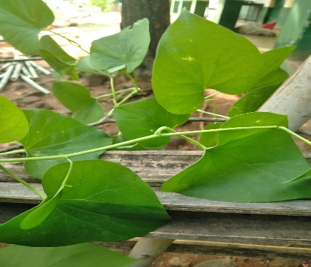
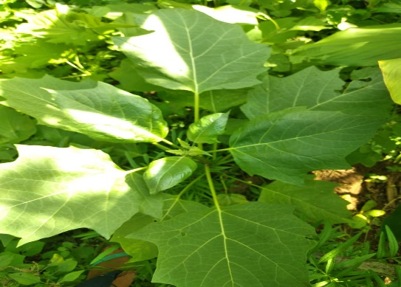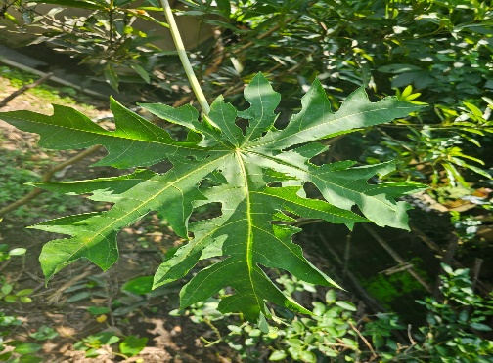
Tinospora cordifolia Datura stramonium Carica papaya
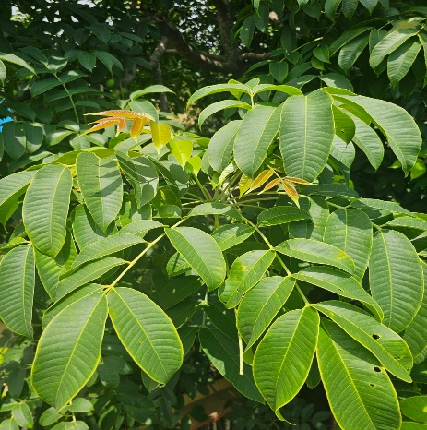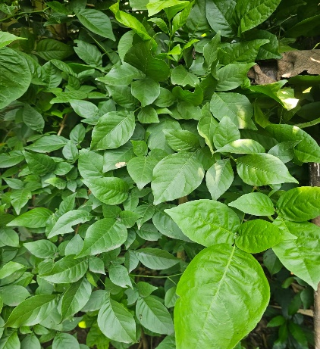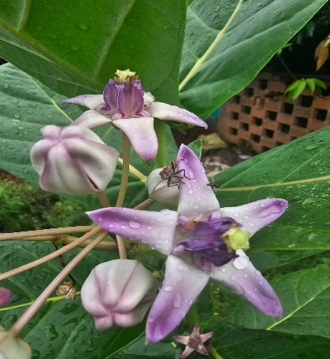
Spondias mombin Aegle marmelos Calotropis gigantea

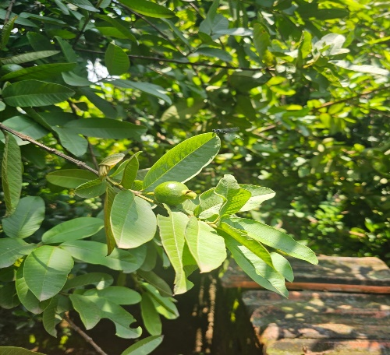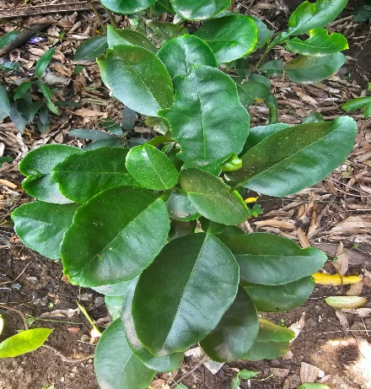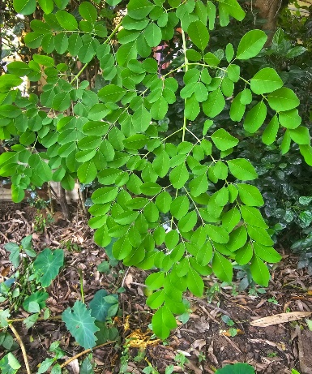
Psidium guajava Citrus hystrix Moringa oleifera
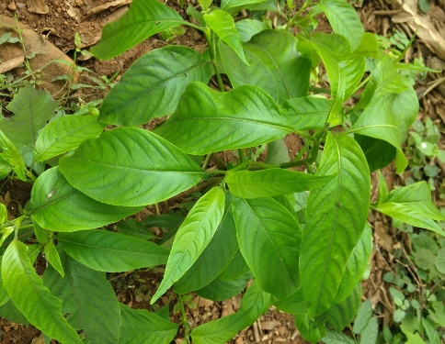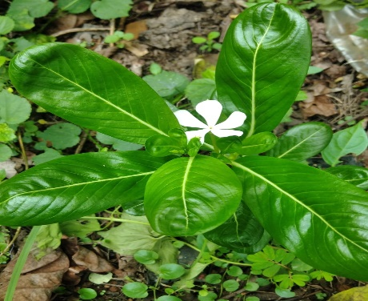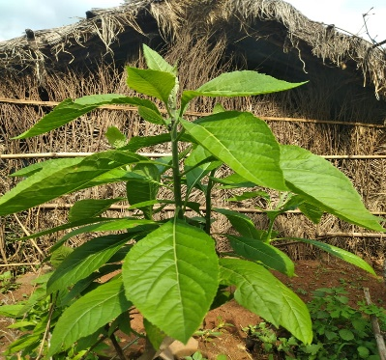
Justicia adhatoda Catharanthus roseus Vernonia amygdalina
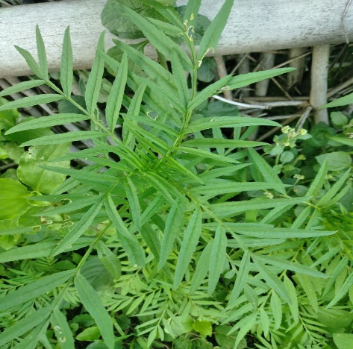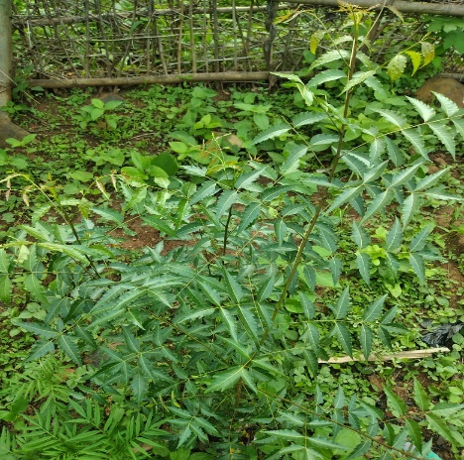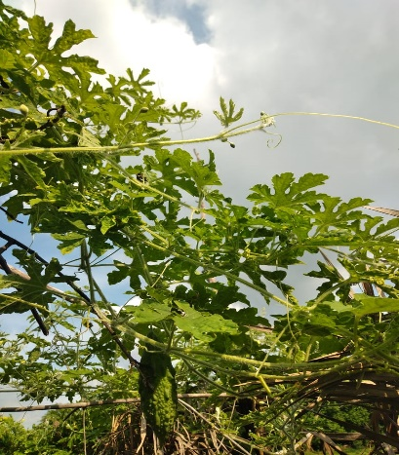
Tagetes erecta Azadirachta indica Momordica charantia
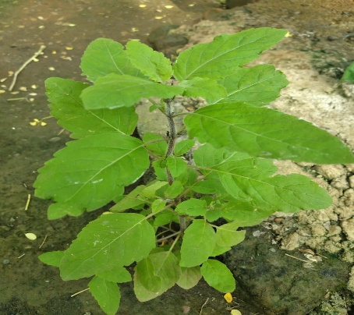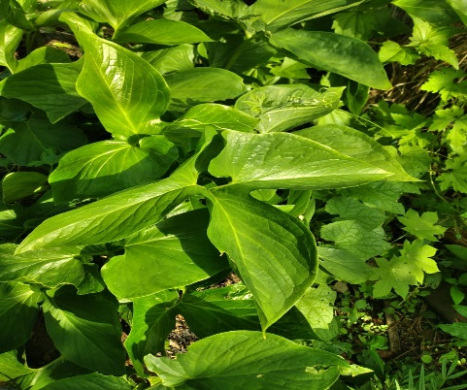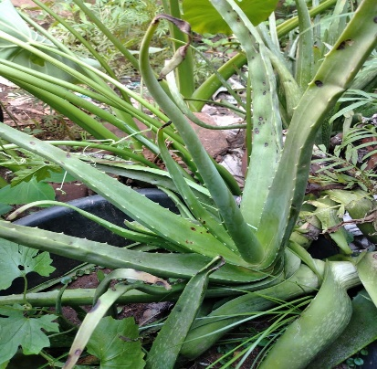
Ocimum tenuiflorum Typhonium trilobatum (L) Schott Aloe vera
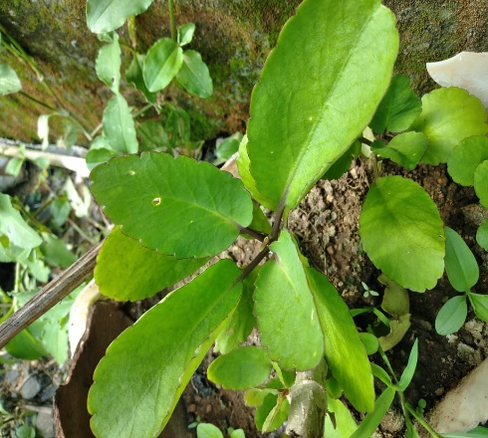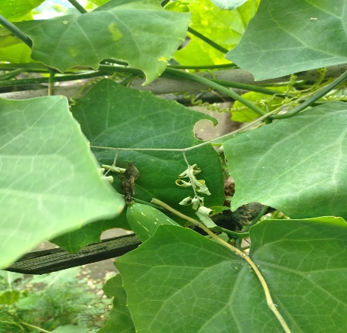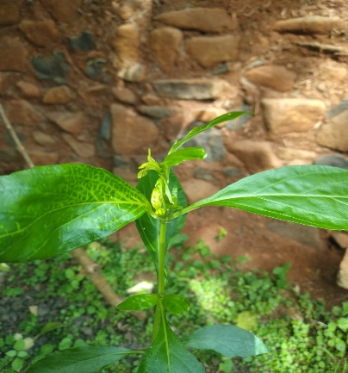
Kalanchoe brasiliensis Melothria pendula Swertia L.
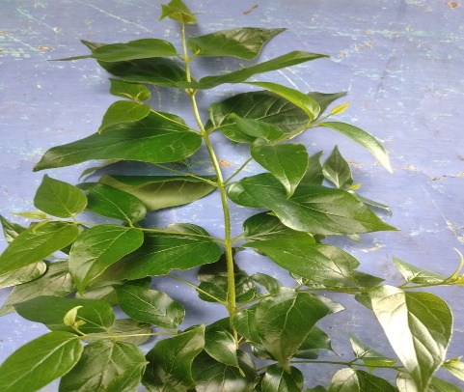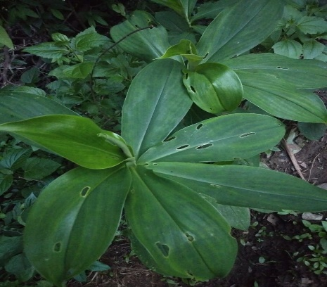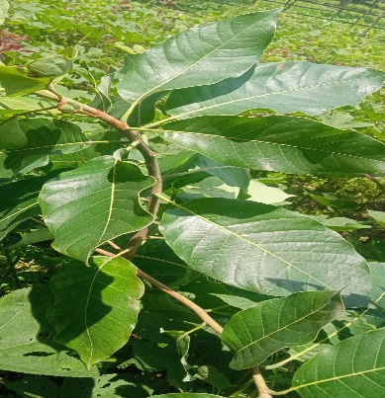
Nyctanthes arbor -tristis Chamaecostus cuspidatus Madhuca longifolia
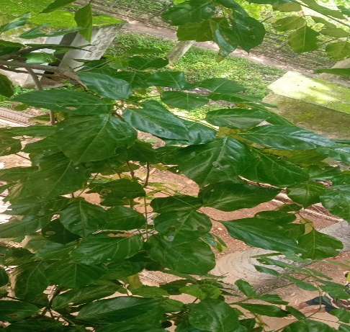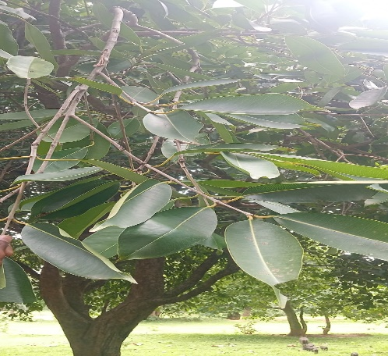
Derris indica Syzygium cumini

Conclusion
Most of the tribal people of this region use ethnomedicinal plants to cure their diseases. In this study,35 medicinal plants have been studied which are used by tribal people to cure diseases . It is important that tribal people should know about the value of their indigenous knowledge and identify the plant species and do their proper documentation and the traditional method should be preserved which can help the society .

References:-
- Reddy (2012).Wild edible plants of Chandrapur district ,Maharashtra, India; Indian Journal of Natural Products and Resources, Vol. 3(1) 110-117.
- Bhogaonkar P., Marathe V., Khsirsagar P . (2010). Documentation of Wild Edible Plants of Melghat Forest , Dist. Amravati, Maharashtra State, India, Ethnobotanical leaflets 14 (7) 51-58.
- Ghosh, A. 2003. Herbal Folk remedies of Bankura & Midinapur districts , West Bengal (India). Indian J. Trad. Knowl., 2: 393-396.
- Jain, S.K.1998. Some aspects of Biodiversity and Indian Traditions. Indian Journal of History of Science, 1:33.
- Verma, S.K. Sriwastawa, D.K. & Pandey, A.K.1999. Ethnobotany of Santhal Pargana, Narendra Publication, Delhi.
- Roychaudhary, P.C.1957. Bihar District Gazetteers, Hazaribagh
- Kumar, S. 2014. Ethnobotanical studies in India, Deep Publications, New Delhi.
- Hembrom, P.P. 1991. Tribal Medicine in Chotanagpur and Santhal Pargana of Bihar State Ethnobotany 3: 36-39.
- Bodding, P.O. 1925, Studies in Santal Medicine and Connected Folklore- II, Santals and Diseases. Mem. Asiatic Society of Bengal, 10(2): 134-426.
- Rao, R. R. 1996. Traditional knowledge and sustainable development : key role of ethnobiologist. Ethnobotany, 8:14-24.
- Pei Shang-Ji, 2001. Ethnobotanical Approaches of Traditional Medicine Studies: Some Experiences from Asia, 39: 74-79.
- WHO. 2002. World health Organization, Traditional Medicine Strategy Report ,Document WHO/EDM/TRH/2002.1
- Tomar, J.B., 25-27 Dec. 2002. Tribal medicinal plants of Jharkhand and their uses. Proc.Natl. Sem. ISM & H.; R.K. Ashrama, Narenderpur,pp.76-87
- Jha, S. K., Jain, P., & Sharma, H. P. (2015). Xenobiotic degradation by bacterial enzymes. Int. J. Curr. Microbial. App. Sci, 4(6),48-62.
- Khatoon, N., Jain , P.,& Choudhary, A.K.(2015) Phytochemical studies on seed and leaf extracts of solanum torvum sw. :Indo American Journal of Pharmaceutical Research, 5(5).
- Basri, F., Sharma, H. P., Firdaus, S., Jain, P., & Ranjan, A. (2014). A review of ethnomedicinal plant-Vitex negundo Linn. International Journal of Advanced Research., 2(3), 882-894.

