Groundwater Contamination and Health Implications in Ranbir Singh Pura: A Comprehensive Assessment
Somalya Dogra¹, Navdeep Singh¹*
^{1*} Dept. of Chemistry, School of Chemical Engineering and Physical Sciences, Lovely Professional University, Jalandhar, Punjab, India.
¹*Email-navdeep.24963@lpu.co.in
ABSTRACT: Groundwater samples of Ranbir Singh Pura area, Jammu and Kashmir State, India, were analysed for 15 physico-chemical parameters [pH, EC (electrical conductivity), temperature, turbidity, TH (total hardness), TDS (total dissolved solids), TA (total alkalinity), Cl⁻ (chloride), Na⁺ (sodium), K⁺ (potassium), Ca²⁺ (calcium), Mg²⁺ (magnesium), SO₄²⁻ (sulphate), NO₃⁻ (nitrate), F⁻ (fluoride)] and 7 heavy metals [Iron (Fe), Zinc (Zn),Chromium (Cr), Copper (Cu) and Lead (Pb)] , with the objective of analysing the groundwater quality of the study region for drinking usage as well as the health impacts caused by drinking contaminated groundwater on the health of local people. 25 sampling locations have been chosen for groundwater analysis. Some parameters were assessed onsite while others were analysed in the laboratory. Results were then compared with BIS-2012 and WHO- 2011 drinking water standards. Most samples based on major element composition and Water Quality Index (WQI) belong to ‘safe’ category. Based on heavy metal evaluation index (HEI), they are found to be highly contaminated with Chromium (Cr), Copper (Cu) and Lead (Pb). Heavy metal pollution index (HPI) indicates pollution from Cr. Carcinogenic Risk (CR) values for Chromium (Cr), Arsenic (As) and Lead (Pb) in all age groups (men, women and children) cross the threshold. Average Hazard Index (HI) in male, female and children are 48.32, 56.99 and 65.32 respectively. Nitrate Pollution Index (NPI) shows no nitrate contamination in study region. Different health indices indicate the contamination of Cr, Cu and Pb is significant in the study area. Water must be treated before consumption and regular monitoring of groundwater of study area was recommended.
KEYWORDS: nitrate pollution index, water quality index, carcinogenic risks, hazard quotient, groundwater.
- INTRODUCTION: Groundwater is the purest form of water and is reported to satisfy a third of world population for drinking¹. Unfortunately, this precious resource is getting polluted either by natural processes or anthropogenic activities such as urbanisation, over usage of pesticides and fertilizers in the farms, industrial wastewater containing heavy metals etc². The contaminants affect the growth of plants, effect on animal and human health. Heavy metals are considered as pollutants because of their residence time in the environment and their ability to cause health risks³.
Groundwater contaminated with heavy metals can cause nervous, haematological and reproductive disorders, cardiovascular diseases, impact on kidneys and liver damage ⁴. It has been reported by various studies that the ill impacts of polluted groundwater on health of humans are cancer-causing and are very hard to analyse⁵. Groundwater contaminated with heavy metals not only affects human health but also causes harmful effects to the soil which hampers plant growth and soil fertility⁶. The present study, therefore, has been carried out to evaluate the harmful effects of drinking contaminated groundwater on the health of people, as well as, its suitability for irrigation.
- MATERIALS AND METHODS
  - Study area: The study has been carried out in the Ranbir Singh Pura (R. S. Pura) area in the Union Territory of Jammu and Kashmir (J&K). R. S. Pura is a town in Jammu district located at 32.63°N 74.73°E and has a population of nearly 2 lakhs. It is an area known for its intense agricultural activity and is growing world-famous Basmati rice. 25 sites were selected for the study of groundwater quality and is shown in Fig. 1.
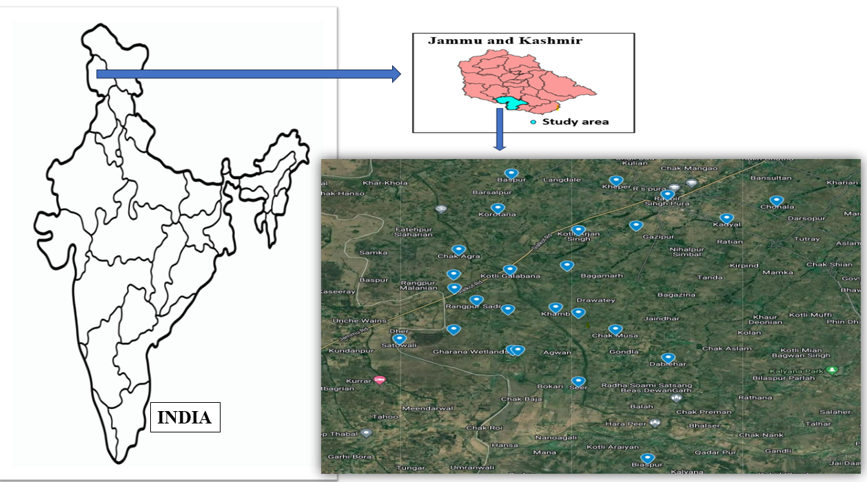

Fig. 1: Map showing the location and sites of study area.

  - Sample collection and analytical procedure: Samples were collected from groundwater (wells, tubewells, handpumps, motors, borewells) at 25 localities during pre- and post- monsoon seasons of 2022 following the procedure given by the American Public Health Association (APHA) (Table 1). Some parameters were recorded on site and others analysis was carried out in laboratory within 12-24 hrs after sample collection. Water samples were acidified to preserve them for heavy metals analysis⁷. Analytical methods used for determination of physico-chemical parameters and heavy metals concentration are listed in Table 2.
Table 1: Sampling Sites with latitude, longitude and source of water collection.
Sampling Site | Name of Sampling site | Latitude | Longitude | Source of water collection
S1 | Khamb | 32.59963⁰ | 74.740015⁰ | Handpump
S2 | Sunderpur | 32.59456⁰ | 74.75461⁰ | Handpump
S3 | Musa Chak | 32.58641⁰ | 74.73254⁰ | Motor
S4 | Agra Chak | 32.41234⁰ | 74.73451⁰ | Motor
S5 | Dablehar | 32.603052⁰ | 74.733087⁰ | Handpump
S6 | Seer | 32.603145⁰ | 74.733451⁰ | Handpump
S7 | Chohala | 32.609114⁰ | 74.738634⁰ | Handpump
S8 | Gagian | 32.609453⁰ | 74.738649⁰ | Motor
S9 | R.S.Pura | 32.607633⁰ | 74.736345⁰ | Handpump
S10 | Purana Pind | 32.601718⁰ | 74.72904⁰ | Handpump
S11 | Satraiyan | 32.601452⁰ | 74.74584⁰ | Handpump
S12 | Badyal Qazian | 32.41256⁰ | 74.78459⁰ | Handpump
S13 | Biaspur | 32.552505⁰ | 74.767842⁰ | Motor
S14 | Satowali | 32.64587⁰ | 74.74125⁰ | Handpump
S15 | Suchetgarh | 32.64578⁰ | 74.54891⁰ | Motor
S16 | Mottey | 32.75983⁰ | 74.74589⁰ | Handpump
S17 | Rangpur Sadrey | 32.64578⁰ | 74.71234⁰ | Handpump
S18 | Abdulliyan | 32.65874⁰ | 74.79484⁰ | Bore well
S19 | Khana Chak | 32.62345⁰ | 74.64875⁰ | Bore well
S20 | Kotli Gala Bana | 32.65871⁰ | 74.78543⁰ | Handpump
S21 | Kotli Arjan Singh | 32.620908⁰ | 74.756392⁰ | Motor
S22 | Gharana | 32.66478⁰ | 74.76658⁰ | Motor
S23 | Nari | 32.627383⁰ | 74.766378⁰ | Tubewell
S24 | Kheper | 32.627606⁰ | 74.766788⁰ | Tubewell
S25 | Jassore | 32.631173⁰ | 74.773998⁰ | Motor

Table 2: Analytical methodology used for physico-chemical parameters and heavy metals.
S.no. | Parameter | Analytical methods
1. | pH | pH meter  (Ionix imported pH meter)
2. | Electrical Conductivity  (EC) | Electrical Conductivity Meter  (Ampereus EC meter)
3. | TDS | TDS meter  (Ampereus TDS meter)
4. | Total Hardness (TH) | EDTA Titration Method
5. | Total Alkalinity (as CaCO3) | Titrimetric Method
6. | Turbidity | Turbidity meter  (ARGLabs digital turbidity meter)
7. | Chloride (Cl⁻) | AgNO3 Titration Method
8. | Fluoride (F⁻), Nitrate (NO₃⁻), Iron (Fe²⁺) | UV Spectrophotometric  Method
9. | Sulphate (SO₄²⁻) | Argentometric Method
10. | Sodium (Na⁺) & Potassium (K⁺) | Flame photometric method
13. | Zinc (Zn), Arsenic (As), Chromium (Cr), Lead (Pb), Copper (Cu), Nickel (Ni) | Atomic Absorption Spectrophotometry (AAS)  (Model AA303)

- RESULTS AND DISCUSSION:
  - Suitability of groundwater for drinking: pH of the groundwater of the study area is in the range of 6.00-7.13 i.e., slightly acidic to neutral in nature. EC in the pre-monsoon samples is in the range 356-1172 μS/cm and in the post-monsoon samples it is between 394-1037 μS/cm. EC of all the samples except for Sample (collected at Satowali) is within permissible limit for drinking water. High EC in the groundwater occurs due to excessive salts, minerals and ions which lead to the high salinity⁸. TDS values of pre-monsoon & post-monsoon groundwater samples are in the range 208- 596 mg/L and 197– 814 mg/L respectively. The TDS values are well within the permissible limits given by the BIS-2012 & WHO for drinking water. 65-185 mg/L is the range of total alkalis (TA) in post-monsoon samples and ranged 100-250 mg/L in the pre-monsoon samples. TA values are well within permissible limits. The groundwater of the area is of bicarbonate (HCO₃⁻) type. Total hardness (TH) of water of the study area is in the range 200-560 mg/L during the pre-monsoon, while it is 183-520 mg/L in the post-monsoon. Ca²⁺ concentration varies from 47.09-117.75 mg/L and 42.13-117.74 mg/L in the pre- and post-monsoon seasons respectively. 72% of samples are reported with higher Ca concentration in both the seasons. Na⁺, NO₃⁻, Cl⁻, SO₄²⁻, F⁻ are found to be within the permissible limits for both pre- and post-monsoon seasons. Potassium and magnesium concentrations exceed the acceptable limits. Graphical presentation of physico-chemical parameters for both seasons is given in Fig. 2.
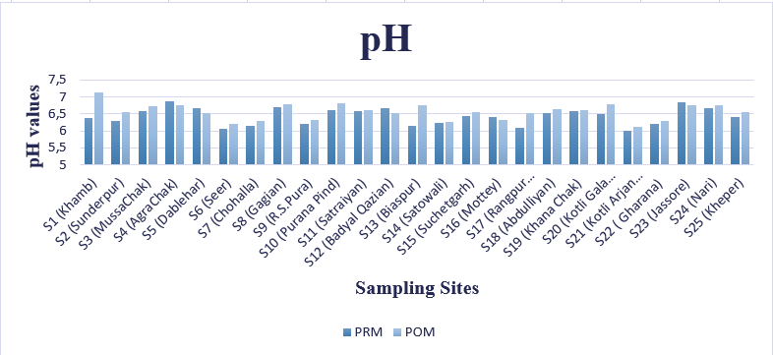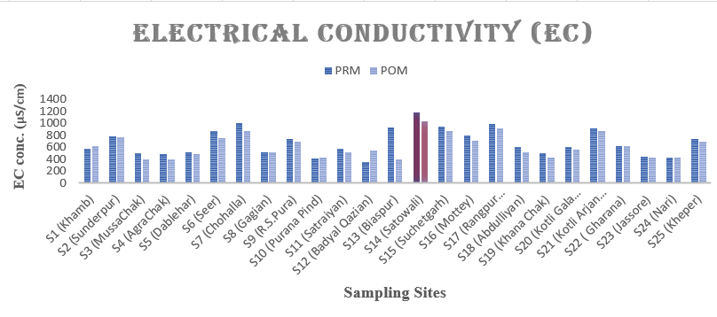
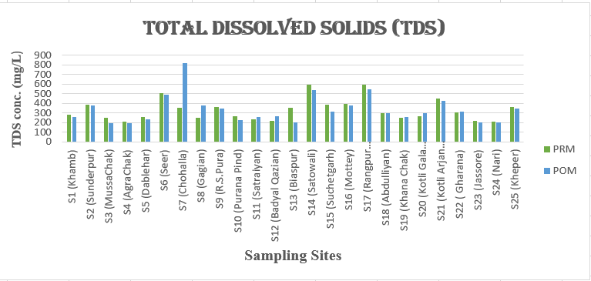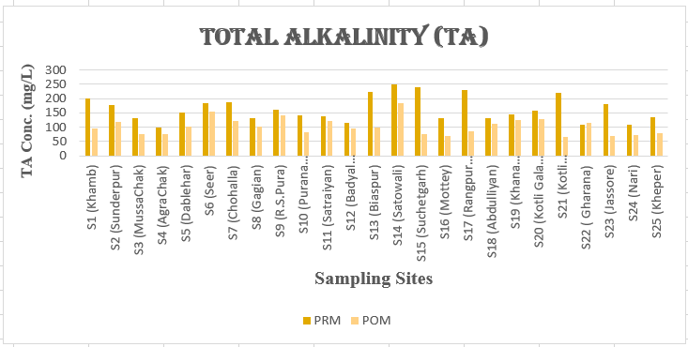
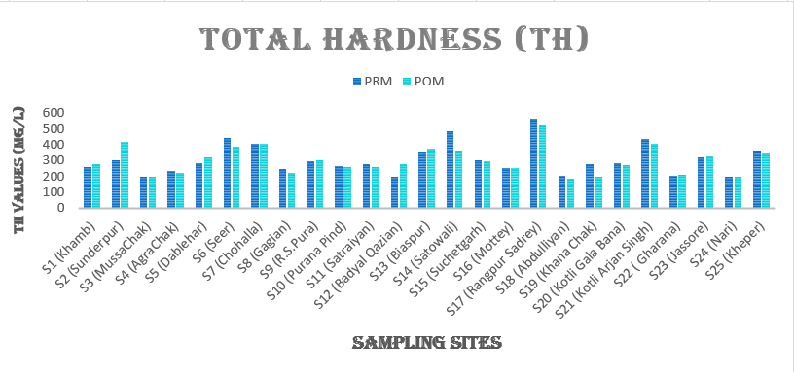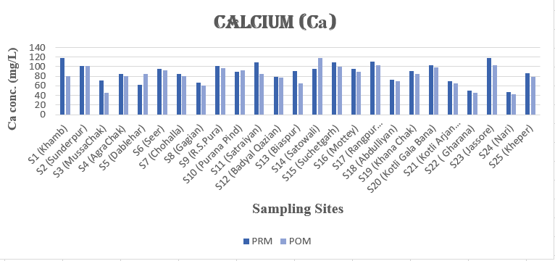
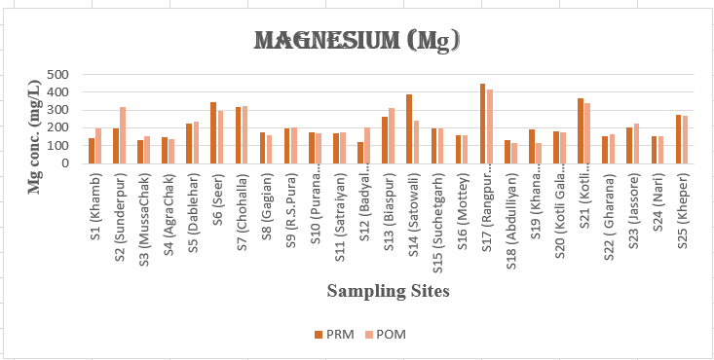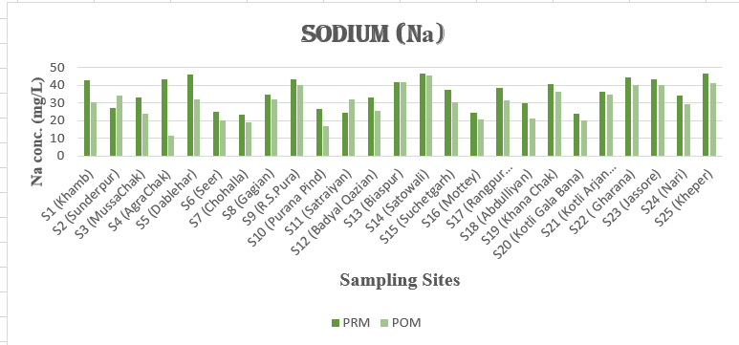
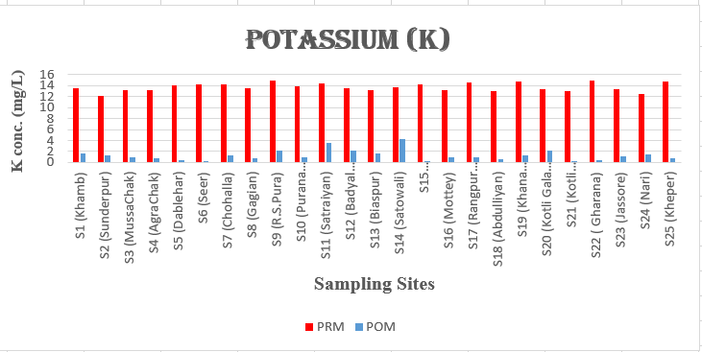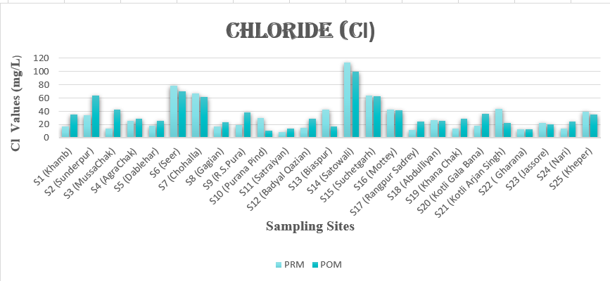
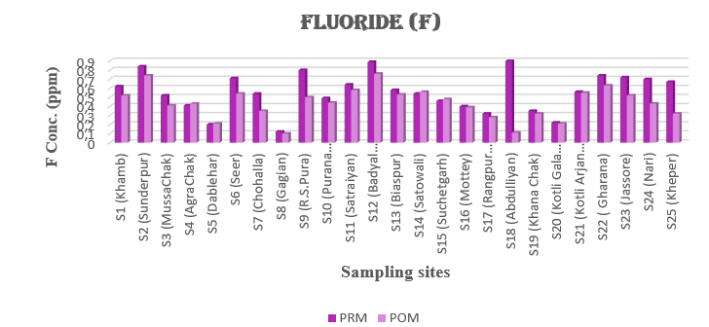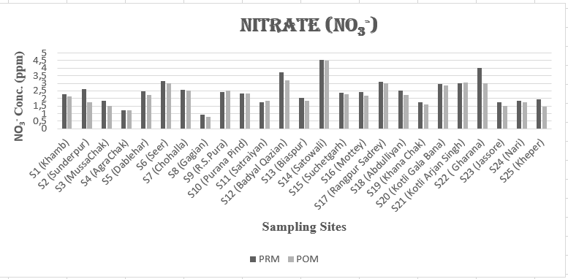
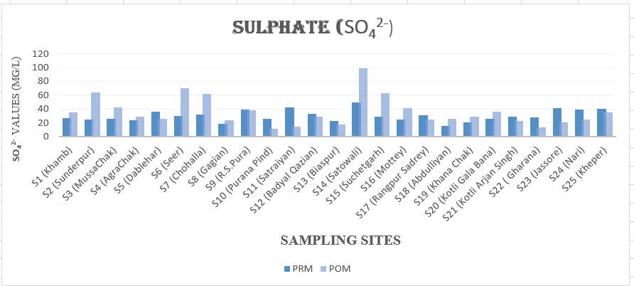
Fig. 2. Comparison of Physico-chemical parameters of groundwater in study area for pre- and post-monsoon seasons.
  - Water Quality Index (WQI): WQI is a tool to classify the groundwater quality for drinking suitability. Based on WQI, drinking water can be classified into ‘excellent’, ‘good’, ‘poor’, ‘very poor’, ‘unsuitable’ categories. The WQI values for each class respectively are <50, 50-100, 100-200, 200-300, >300⁹. Among pre-monsoon samples (PRM), out of 25 samples, 36% fall under ‘Good category’; 60% under ‘Poor category’ and 4% under ‘Very poor category’. In post-monsoon (POM) season, 52% water samples fall under ‘Good category’ and rest under ‘Poor category’ (48%). Comparison of WQI values for both seasons is graphically presented in Fig. 3.
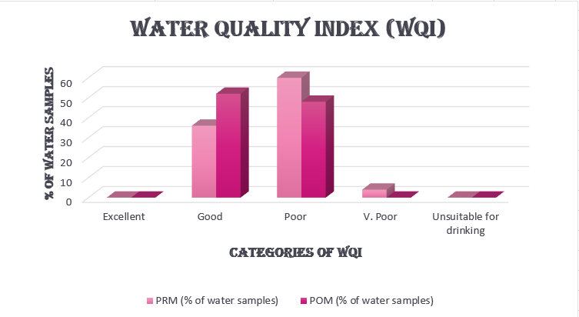
Fig. 3. Classification of water samples in study area as per WQI for pre- and post-monsoon seasons.
  - Heavy metals assessment:
    - Heavy metal analysis: Heavy metals determined in the groundwater samples of the study area include Fe, Zn, Pb, Cr, Cu, Ni and As. Fe concentration ranged from 0.3 -0.94 ppm and 0.01-0.53 ppm for the pre-monsoon and post- monsoon samples respectively. Increased concentration of Fe during the pre-monsoon time is attributed to leaching through the thick layers of soil¹⁰. Zn concentration in the study area ranged between 0.11-0.25 ppm in the pre-monsoon samples while 0.05-0.16 ppm in the post-monsoon season. Concentration of Zn in the water samples falls within the acceptable limit given by BIS-2012. Concentration of Cu ranges from 0.04-0.25 ppm during pre-monsoon season with 76% of the samples exceeding permissible limit. In the post-monsoon samples. Cu concentration is in the range 0.01-0.19 ppm with 68% having Cu exceeding the acceptable limit. In the pre- and post- monsoon seasons, at many sampling sites, Pb concentration is below detection limit but wherever detected, its value exceeds the acceptable limits. Cr concentration ranges from 4.03-5.03 ppm in the pre-monsoon and 2.31-4.58 ppm in the post-monsoon samples exceeding permissible limits for Cr. Ni in samples of both pre- and post-monsoon seasons is below detection limit. Concentration of As in groundwater of the study area ranges from 0.01-0.04 ppm and 0.01-0.03 ppm in the pre-monsoon and post-monsoon seasons respectively. 28% and 36% of pre- and post- monsoon samples respectively have As above the permissible limit.

    - Human Health Risk Assessment (HHRA): This evaluation method assesses the impact of consumption of contaminated groundwater on human health. The health effects can be categorized as carcinogenic and non-carcinogenic risks¹¹. The impact of drinking contaminated water on the health can be calculated using formula:
ADD= $\frac{Cw*IR*EF*ED}{Bw*AT}$
Where, ADD is average daily dose (mg/kg/day), Cw- observed concentration of metal, IR- rate of ingestion, EF- frequency of exposure, ED- duration of exposure, Bw- body weight, AT- average time of exposure. Standard values for the above-mentioned parameters are well established in literature¹².
In the study area, Cr is the dominant contaminant posing maximum risk to all population groups – men, women and children. For PRM season, ADD values of Cr for men, women and children ranged from 15.5 x 10⁻² to 26.1 x 10⁻²; 18.3× 10 ⁻² –22.8× 10 ⁻² & 20.9× 10 ⁻² –26.1× 10 ⁻² respectively while for POM season, ADD of Cr ranged from 8.8 × 10 ⁻² – 17.6 × 10 ⁻²; 10.5 × 10 ⁻² – 20.8 × 10 ⁻² & 12 × 10 ⁻² – 23.8 × 10 ⁻ for men, women and children respectively. Apart from Cr, Zn is another element affecting human health followed by Fe, Cu, As and Pb. ADD values of heavy metals for pre- and post- monsoon season are given in Table 3.
Table 3: Average Daily dose (ADD) values in different age groups for Pre- and post-monsoon seasons.
Heavy Metals | ADD (Men) |  | ADD (Women) |  | ADD (Children)
Heavy Metals | PRM | POM | PRM | POM | PRM | POM
Iron (Fe) | 1.1×10⁻² - 3.6× 10⁻² | 3.8 × 10 ⁻⁴ - 20.3 × 10 ⁻⁴ | 1.3×10⁻²- 4.2× 10⁻² | 4.5 × 10 ⁻⁴ – 24.19× 10 ⁻⁴ | 1.5×10⁻²- 4.8×10⁻² | 5.2 × 10 ⁻⁴ – 27.6 × 10 ⁻⁴
Zinc (Zn) | 4.2 × 10 ⁻³ – 9.6× 10 ⁻³ | 1.9 × 10 ⁻³ – 6.2 × 10 ⁻³ | 5 × 10 ⁻³ – 11.3× 10 ⁻³ | 2.3 × 10 ⁻³ – 7.3 × 10 ⁻³ | 5.7× 10 ⁻³ – 13× 10 ⁻³ | 2.6 × 10 ⁻³ – 8.3 × 10 ⁻³
Lead (Pb) | 1.9× 10 ⁻³ – 3.1× 10 ⁻³ | 3.8 × 10 ⁻⁴ -11.5 × 10 ⁻⁴ | 2.3× 10 ⁻³ – 3.6 × 10 ⁻³ | 4.5 × 10 ⁻⁴ – 13.6 × 10 ⁻⁴ | 2.6× 10 ⁻³ – 4.2× 10 ⁻³ | 5.2 × 10 ⁻⁴ – 15.6 × 10 ⁻⁴
Copper (Cu) | 1.5× 10 ⁻³ – 9.6× 10 ⁻³ | 3.9 × 10 ⁻⁴ – 73.1 × 10 ⁻⁴ | 1.8× 10 ⁻³ – 11.3× 10 ⁻³ | 4.6 × 10 ⁻⁴ – 86.4 × 10 ⁻⁴ | 2.08× 10 ⁻³ –13× 10 ⁻³ | 5.2 × 10 ⁻⁴ – 98.8 × 10 ⁻⁴
Arsenic (As) | 3.8× 10 ⁻⁴ – 15.3 × 10 ⁻⁴ | 3.9 × 10 ⁻⁴ -11.5 × 10 ⁻⁴ | 4.5 × 10 ⁻⁴ – 18.2 × 10 ⁻⁴ | 4.6 × 10 ⁻⁴ – 13.6 × 10 ⁻⁴ | 5.2× 10 ⁻⁴ – 20.8× 10 ⁻⁴ | 5.2 × 10 ⁻⁴ – 15.6 × 10 ⁻⁴
Chromium (Cr) | 15.5× 10 ⁻² –19.3× 10 ⁻² | 8.8 × 10 ⁻² – 17.6 × 10 ⁻² | 18.3× 10 ⁻² –22.8× 10 ⁻² | 10.5 × 10 ⁻² – 20.8 × 10 ⁻² | 20.9× 10 ⁻² –26.1× 10 ⁻² | 12 × 10 ⁻² – 23.8 × 10 ⁻²

    - Carcinogenic risks (CR): The intake of heavy metals through drinking water can increase the chances of cancer as well as non-cancer risks on human health¹³. Carcinogenic Risks can be calculated by using the following equation:
CR = CSF*CDI
Where CSF is the cancer slope factor and differs from metal to metal; CDI is chronic daily intake of a particular metal. Safe CR limits range between 10⁻⁶ to 10⁻⁴ as recommended by USEPA¹⁴. If CR value exceeds 10⁻⁴, then the risks will not be acceptable. In such cases, the drinking water can have severe health hazards and needs treatment before consumption¹⁴.
Results show that CR values for Pb, Cr and As in all age groups are exceeding the limits set by USEPA, and therefore, pose threats to the human health¹⁵. CR values are in excess in all age groups, but are found to be highest in case of children, as compared to adults- both men and women. High Cr concentration in the study area can be due to presence of Cr naturally in soil, pesticides, manures and municipal sewage.CR values for Pb, As and Cr for different age groups are listed in Table 4.
Table 4: Cancer Risk (CR) range for different heavy metals in various age groups of the study area.
Heavy Metals | CR Values (Men) |  | CR values (women) |  | CR Values (children)
Heavy Metals | PRM | POM | PRM | POM | PRM | POM
Lead | 1.6 × 10⁻² – 2.6 × 10⁻² | 3.3 × 10⁻³ – 9.8 × 10⁻³ | 1.9× 10⁻² – 3.1 × 10⁻² | 3.9× 10⁻³ – 11.6 × 10⁻³ | 2.2 × 10⁻² – 3.5 × 10⁻² | 4.4 × 10⁻³ –13.2 × 10⁻³
Chromium | 0.063 × 10² - 0.079 × 10² | 36.4 × 10⁻¹ – 72.2 × 10⁻¹ | 0.076 × 10² – 0.093 × 10² | 43.1 × 10⁻¹ – 85.4 × 10⁻¹ | 0.086 × 10⁻² – 0.112 × 10⁻² | 49.2 × 10⁻¹ – 97.6× 10⁻¹
Arsenic | 57 × 10⁻² – 231 × 10⁻² | 5.8 × 10⁻¹ – 17.3 × 10⁻¹ | 68 × 10⁻² – 272 × 10⁻² | 6.8 × 10⁻¹ – 20.5 × 10⁻¹ | 78 × 10⁻² – 312 × 10⁻² | 7.8 × 10⁻¹ – 23.4× 10⁻¹

    - Non-carcinogenic risks: To determine the non-carcinogenic risk in different age groups of the population, Target Hazard Quotient (THQ)/ Hazard Quotient (HQ) and Hazard Index (HI) are calculated¹⁶. THQ is the ratio between the average daily dose (ADD) and reference dose (RfD) of each heavy metal. HI is the sum total of all the THQs of each heavy metal. THQ and Total THQ (HI) can be calculated by using the following equations:
THQ= ${ADD}/{RfD}$
Total THQ (HI) = ∑ THQ
where RfD is the oral reference dose (μg/Kg/day) and is the daily exposure of the population over a lifetime without any risk of deleterious effects¹⁷. If HQ < 1, then exposed population is assumed to be safe and if HQ > 1, then population will have some chronic effect and needs treatment¹⁸.
In the pre-monsoon season, high concentrations of Zn, Fe, Cu and Pb was reported in the study area. It is observed that in case of iron, men and women are found to be safe, but children come under the risk category. HQ values for men, women and children in case of zinc are found to be in safe category, while HQ values for copper and lead in all three population groups are found in the risk range. In the post-monsoon season, contamination of Copper, Arsenic and Lead has been reported in the groundwater of the study area and their concentrations are seen exceeding the limits in all age groups. However, it has been reported that the values for THQ in case of children are higher, which indicates that children are under greater risk because of their low immunity and unhygienic water drinking habits. RfD and HQ for different population groups of the study area are given in Table 5.
Table 5: RfD and HQ values for different population groups in study area.
Heavy Metal | RfD | HQ (Men) |  | HQ(Women) |  | HQ (Children)
Heavy Metal | RfD | PRM | POM | PRM | POM | PRM | POM
Iron | 0.7 | 0.78 | 0.34 | 0.93 | 0.41 | 1.06 | 0.47
Zinc | 0.3 | 0.53 | 0.30 | 0.63 | 0.35 | 0.72 | 0.40
Copper | 0.04 | 2.32 | 1.89 | 2.75 | 2.24 | 3.15 | 2.56
Lead | 0.0035 | 5.38 | 2.42 | 6.36 | 2.86 | 7.28 | 3.27
Arsenic | 0.0003 | 35.89 | 41.03 | 42.42 | 48.48 | 48.53 | 55.47
Chromium | 0.003 | 1561 | 1165 | 1844 | 1376 | 2110 | 1575

    - Heavy metal pollution index (HPI): This index assesses the pollution of heavy metal in groundwater. HPI classifies water into different categories on the basis of concentration of different metals in the groundwater¹⁹. If the value for HPI is greater than 100, then the groundwater is contaminated with the heavy metals. In the pre- monsoon season, HPI for Cr is found to be (9740.8), for lead (188) and for other metals viz., Cu, Zn & As, HPI, the values are 2.73, 48.38 and 16.97 respectively. Results of HPI indicate that water in the study area is contaminated with Cr and Pb during pre-monsoon season. While during post-monsoon season, it is contaminated with- Cr (7240.8) and Fe (120.45). No contamination of Cu (1.99), Zn (49.08) and Pb (88) has been found, as the HPI values for these heavy metals are less than 100.
    - Heavy metal evaluation index (HEI): HEI is another index calculated for estimating heavy metal contamination in groundwater samples. It is calculated using the following equation²⁰:
HEI= $\sum_{i=1}^{n}{\frac{Hc}{Hmax}}$
Where Hc is the i^{th} metal concentration and Hmax is the maximum allowable limit of i^{th} metal. The classification of contamination based on Heavy Metal Evaluation Index (HEI) is as follows: low if it is <10, medium if it is in the range 10-20, and high if it is >20 ²¹. During pre-monsoon season, groundwater of the study area is found to be highly contaminated with the iron (HEI= 47.5), copper (HEI= 48.4), lead (HEI= 49) and chromium (HEI= 2435.2) while for zinc (HEI= 0.83) and arsenic (HEI= 2.6) low contamination is observed. In post-monsoon samples, high contamination of arsenic (HEI=32), copper (HEI=1817.4), lead (HEI=22) and chromium (HEI=39.4) has been observed as the HEI values for these metals are greater than 20. Medium contamination of iron (HEI=20) and low contamination of zinc (HEI=0.46) is observed. Overall, the groundwater of the study area is found to be contaminated with copper, lead and chromium.
    - Nitrate Pollution Index (NPI): It is used to calculate the nitrate contamination in groundwater. It is calculated by using equation:
NPI= ${(Cs-HAV)}/{HAV}$
Where Cs- observed nitrate value in the sample and HAV is the human acceptable limit (20 mg/L) for nitrate. Water, based on NPI, is classified as ‘clean’, ‘lightly contaminated’, ‘moderately contaminated’, significantly contaminated’, ‘very significantly contaminated’ if NPI values are < 0, 0 - 1, 1.1 - 2, 2.1 - 3, > 3 respectively. In present study, NPI values for pre-monsoon water samples vary from -0.95 to -0.77 with a mean of -0.88. By contrast in the POM samples, the values are in the range -0.96 to -0.78 with a mean value of -0.89. These values imply that the groundwater of the study region is clean on the basis of NPI. NPI values are graphically presented in Fig. 4.
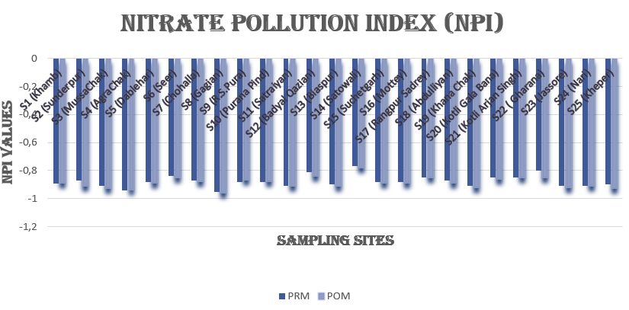
Fig. 4: NPI values in groundwater of study area for pre- and post-monsoon seasons.
- STATISTICAL ANALYSIS:
  - Pearson’s Correlation: Correlation matrix is used to explain the relationship among different parameters. Statistically, it helps us to understand how two variables are associated²². Pre-monsoon samples show positive correlation of 0.97 amongst EC, TDS, TA, TH, Cl and Mg. Negative correlation is observed between pH and EC, TDS, TA, TH, Mg, NO₃⁻ and Fe. Hardness in the groundwater is in the form of MgCl₂, CaCl₂ and MgCO₃. For post-monsoon season samples, perfect positive correlation is observed between Cl⁻ and SO₄²⁻ which indicates that Cl⁻ is significantly related with SO₄²⁻ in the groundwater of the study area. Positive correlation is observed between different parameters such as EC, TDS, TH, TA, Cl⁻, Mg²⁺, NO₃⁻ & SO₄²⁻ while strong negative correlation is observed between pH and EC, TDS, Cu, TH, Cl⁻, Mg²⁺, NO₃⁻ & SO₄²⁻. Relationship among different physico-chemical parameters for pre- and post-monsoon seasons is shown in Fig. 5.
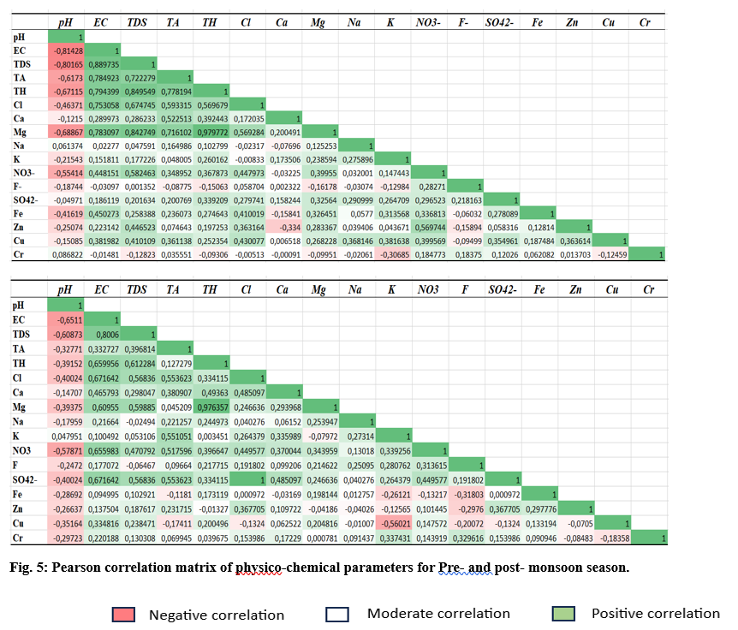
  - Principal Component Analysis (PCA): PCA determines the variable that has the greatest contribution to the water contamination²³. In the present study, first two principal components (PCs) were chosen for both seasons to explain variances. For pre-monsoon season, 33.4% and 10.85% variances are explained by PC1 and PC2 respectively, and in post-monsoon season, 28.61% & 14.61% variances are explained by PC1 and PC2 respectively (Table 6). The factor loadings are classified based on absolute loading values. Loading values > 0.75, 0.75–0.50 and 0.50–0.30 are categorised as ‘strong’, ‘moderate’ and ‘weak’ respectively²⁰. It was found that PC1 of pre-monsoon samples dominantly contains EC, TDS, TA, TH, Cl⁻, Mg²⁺, NO₃⁻, Cu, Pb while PC1 of post-monsoon samples contains EC, TDS, TA, TH, Cl⁻, Ca²⁺, Mg²⁺, NO₃⁻, SO₄²⁻ as dominant variables (Table 7). It is concluded that these variables are totally hydro-chemical and they are considered as originated from geogenic processes. PC2 of pre-monsoon season contains Zn & Pb and for post-monsoon season it contains K⁺ and Pb indicating the usage of fertilisers & pesticides in the agricultural fields and also the pressure of anthropogenic sources. PC1 & PC2 accounted for 44.26% of pre-monsoon and 49.23% of post-monsoon of total variances and are presented in the form of biplots (Fig. 6). Scree plots (Fig. 7) represent the change in the eigen values with respect to the cumulative variability of all the components for pre-monsoon and post-monsoon samples.
Table 6: Eigenvalues, Variability and cumulative percentage for Pre- and post-monsoon season.
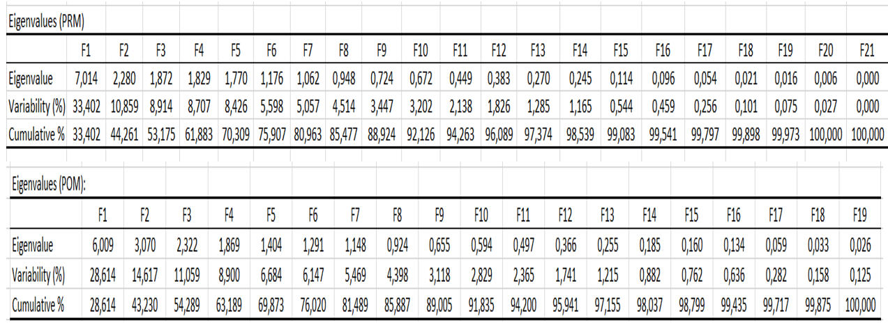
Table 7: Factor loading values of physico-chemical parameters for Pre- and post-monsoon season.
Variables | Pre-monsoon season (PRM) |  |  | Post-monsoon season (POM)
Variables | Factor loading values |  |  | Factor loading values
Variables | F1 | F2 | F3 | F1 | F2 | F3
pH | -0,758 | 0,176 | 0,200 | -0,627 | 0,415 | -0,044
EC | 0,893 | -0,252 | -0,063 | 0,885 | -0,264 | 0,084
TDS | 0,926 | -0,118 | -0,133 | 0,777 | -0,340 | -0,089
Temp. | 0,095 | -0,003 | -0,127 | -0,462 | -0,053 | -0,158
Turbidity | 0,296 | -0,017 | 0,652 | -0,098 | 0,052 | 0,794
TA | 0,791 | -0,368 | 0,023 | 0,619 | 0,376 | -0,154
TH | 0,871 | -0,319 | -0,087 | 0,686 | -0,402 | 0,233
Cl⁻ | 0,782 | -0,019 | 0,208 | 0,805 | 0,168 | -0,317
Ca²⁺ | 0,245 | -0,696 | 0,134 | 0,641 | 0,294 | -0,045
Mg²⁺ | 0,875 | -0,188 | -0,123 | 0,595 | -0,514 | 0,267
Na⁺ | 0,160 | 0,266 | 0,202 | 0,223 | 0,031 | 0,409
K⁺ | 0,271 | 0,141 | -0,193 | 0,343 | 0,702 | -0,074
NO₃⁻ | 0,635 | 0,359 | 0,259 | 0,738 | 0,091 | 0,195
F⁻ | -0,051 | -0,083 | 0,606 | 0,273 | 0,220 | 0,443
SO₄²⁻ | 0,379 | 0,100 | 0,606 | 0,805 | 0,168 | -0,317
Fe | 0,460 | 0,220 | -0,029 | 0,020 | -0,603 | -0,429
Zn | 0,464 | 0,714 | -0,153 | 0,221 | -0,161 | -0,686
Cu | 0,525 | 0,408 | 0,112 | 0,115 | -0,531 | 0,397
Pb | 0,558 | 0,671 | -0,117 | 0,175 | 0,696 | 0,045
Cr | -0,077 | 0,050 | 0,561 | 0,223 | 0,148 | -0,134
As | 0,443 | 0,052 | -0,204 | 0,402 | 0,518 | 0,238

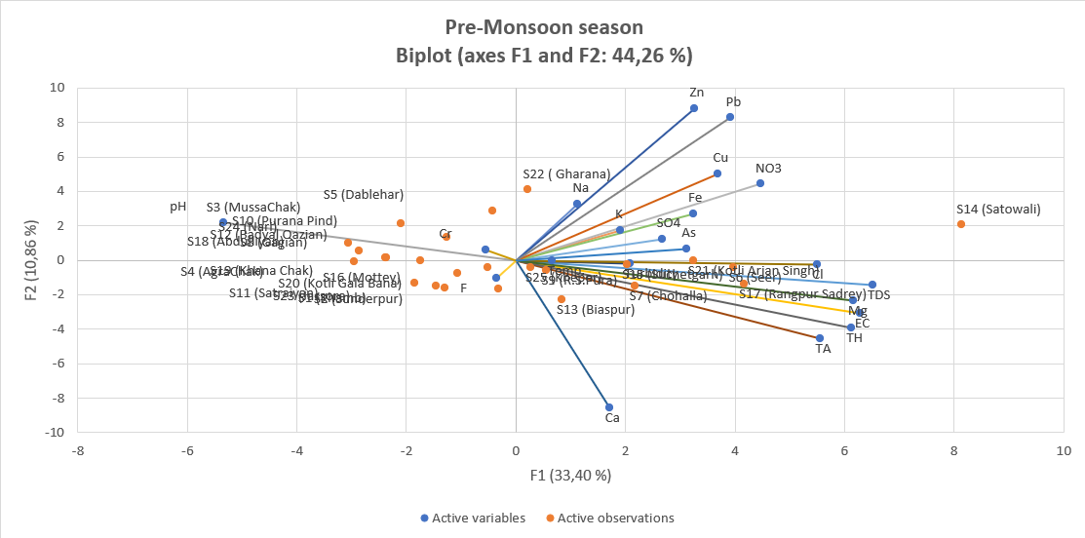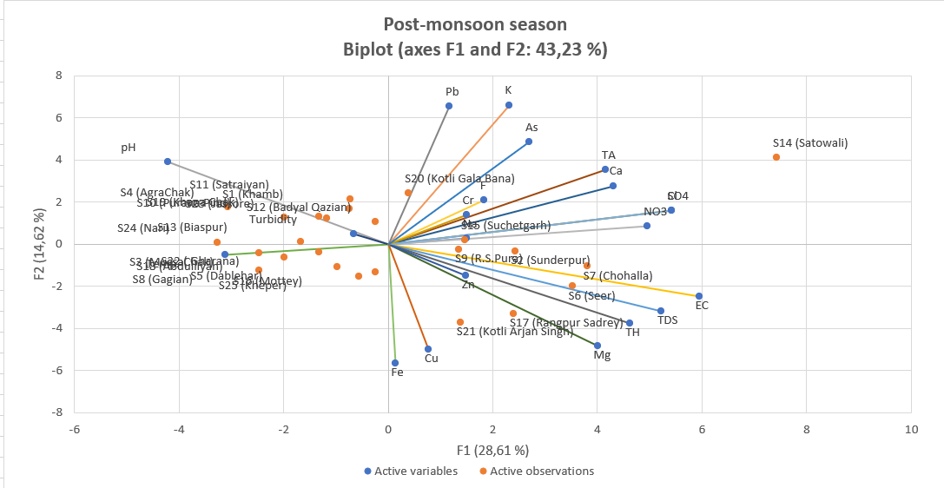

Fig. 6. Biplots of water quality parameters for Pre- and Post-monsoon season.
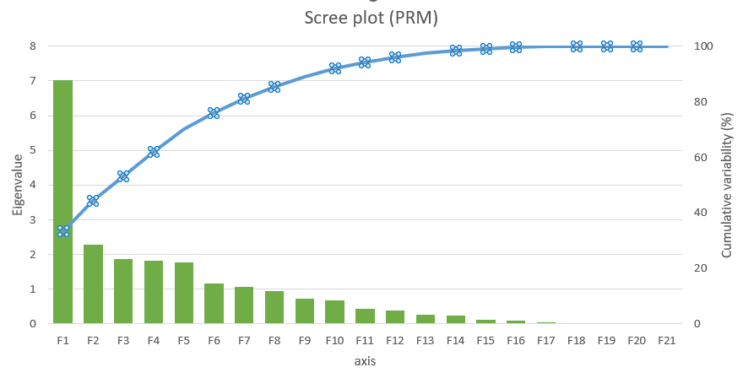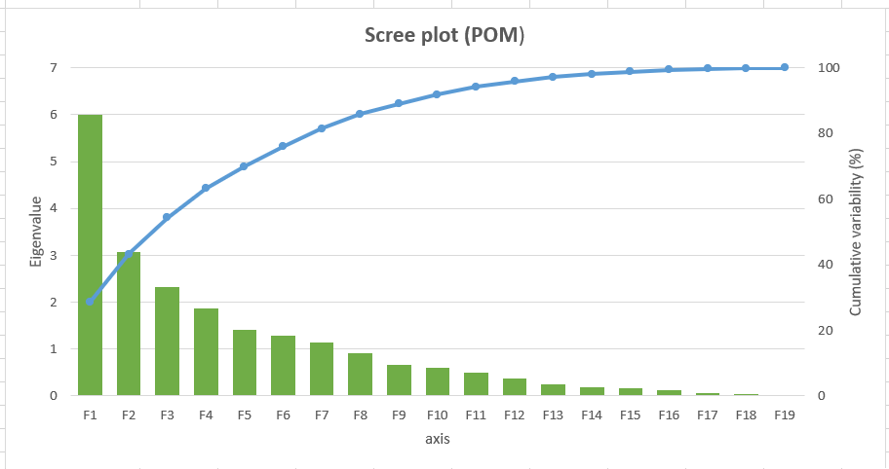
Fig. 7. Scree plots for Pre- and Post-monsoon season.
- CONCLUSION: Groundwater is one of the vital natural resources needed for human survival. Results of present study provides insight of the quality of ground water for drinking purposes and health risk that can arise from drinking contaminated groundwater. Groundwater of the study area- Ranbir Singh Pura area in Jammu and Kashmir is reported to be slightly alkaline to neutral in nature. 40% of the water samples surpass permissible limit (i.e., 600 mg/L) of TH for drinking water. 48% of pre-monsoon and 44% of post-monsoon samples have iron in excess of permissible limit. Concentrations of Pb, Cr and As, wherever determined, are also in excess. Na⁺, Cl⁻, NO₃⁻, F⁻, SO₄²⁻, TA & Zn are within safe limits and conform to the thresholds given in BIS & WHO standards. Higher concentrations of Cr, Mg, As & Pb are present at all sampling sites. According to WQI, 36%, 60% and 4% of pre-monsoon samples are categorized under good, poor & very poor category respectively. 52% & 48% of the water samples of the study area are categorized under good and poor category respectively, based on the WQI. Heavy metal contamination due to Cr, Cu, Pb is reported based on HEI. Pb and Cr contamination is confirmed according to Heavy metal Pollution index also. As the concentrations of Cr, Pb and As exceed the safe limits, effects of these elements are reported for men, women & children. Sampling site (Satowali) represent water with the highest risk arising from heavy metal contamination. The heavy metals can have chronic health impacts on the local people. Carcinogenic Risk (CR) values are observed to be higher in case of children which may be due to their weak immunity, lack of knowledge and awareness, and use of unclean hands while eating and drinking. The present study suggests continuous monitoring and assessment of groundwater quality in the study area and recommends treating the water before using it for drinking purposes.
REFERENCES
- Kouser, B., Bala, A., Verma, O., Prashanth, M., Khosla, A., & Pir, R. A. Hydrochemistry for the assessment of groundwater quality in the Kathua region, Jammu and Kashmir, India. Applied Water Science, 2022, 12 (143),1-22, https://doi.org/10.1007/s13201-022-01673-9
- Sudan, S. Assessment of Ground water quality: A Case Study of Jammu District. International Journal of Science & Research, 2018, 7, 1151- 1162. 10.21275/ART20177253
- Khadse, K. G., Patni, M. P., & Labhasetwar, K. P. Water quality assessment of Chenab River and its tributaries in Jammu Kashmir (India) based on WQI. Sustainable Water Resource Management, 2016, 2, 121- 126. 10.1007/s40899-016-0046-7
- Kaur, M., Kumar, A., Mehra, R., & Kaur, I. Quantitative Assessment of exposure of heavy metals in ground water & soil on human health in Reasi district, Jammu. Environmental geochemistry & health, 2020, 42, 77-94. https://doi.org/10.1007/s10653-019-00294-7(.0123456789)
- Adimalla N, Li P, Venkatayogi S, Hydrogeochemical Evaluation of Groundwater Quality for Drinking and Irrigation Purposes and Integrated Interpretation with Water Quality Index Studies, Environmental Processes, 2018, 4, 1-22. https://doi.org/10.1007/s40710-018-0297-4
- Sharma N, Vaid V, Shram S. K., Assessment of groundwater quality for drinking and irrigation purpose using hydrochemical studies in Dera Bassi town and it surrounding agricultural area of Dera Bassi Tehsil of Punjab, India, Springer Nature Applied Sciences, 2021, 3 (45), https://doi.org/10.1007/s42452-021-04199-y
- Ahada, S. P. C., & Suthar, S. Assessing groundwater hydrochemistry of Malwa Punjab, India. Arabian Journal of Geosciences, 2018, 17, 1-15. https://doi.org/10.1007/s12517-017-3355-8
- Saraswat, C., Kumar, P., Dasgupta, R., Avtar, R., & Bhalani, P. Sustainability assessment of the groundwater quality in the Western India to achieve urban water security. Applied Water Sciences, 2019, 73, 1-17. https://doi.org/10.1007/s13201-019-0956-2
- Li P, Karunanidhi D, Subramani T and Srinivasamoorthy K, Sources and Consequences of Groundwater Contamination, Archives of Environmental Contamination and Toxicology, 2021, 80, 1-10.
- Tegegne A. M, Lohani T. K and Eshete A. A, Evaluation of groundwater quality for drinking and irrigation purposes using proxy indices in the Gunabay watershed, Upper Blue Nile Basin, Ethiopia, Heliyon, 2023, 45, 1-16. https://doi.org/10.1016/j.heliyon.2023.e15263
- Rao, N. S. Seasonal variation of groundwater quality in a part of Guntur District, Andhra Pradesh, India. Environmental Geology, 2006, 49, 413-429. 10.1007/s00254-005-0089-9
- Khanoranga and Khalid. S, An assessment of groundwater quality for irrigation and drinking purposes around brick kilns in three districts of Balochistan province, Pakistan, through water quality index and multivariate statistical approaches, Journal of Geochemical Exploration, 2019, 197, 14-26. https://doi.org/10.1016/j.gexplo.2018.11.007
- Paneerselvam, B., Karuppannan, S., & Muniraj, K. Evaluation of drinking and irrigation suitability of groundwater with special emphasizing the health risk posed by nitrate contamination using nitrate pollution index (NPI) and human health risk assessment (HHRA). Human and Ecological Risk Assessment: An Inter12national Journal, 2020, 27 (3), 1-25. https://doi.org/10.1080/10807039.2020.1833300
- Raja, V., Laxmi, R. V., Sekar, C. P., Chidambaram, S., & Neelakantan, M. A. Health risk assessment of heavy metals in groundwater of industrial township Virudhunagar, Tamil Nadu, Indi., Archives of Environmental Contamination and Toxicology, 2021, 80, 144–163. https://doi.org/10.1007/s00244-020-00795-y
- Chakraborti, D., Rahman, M. M, Mukherjee, A., Alauddin, M., Hassan, M., Dutta, R. N., Pati, S., Mukherjee, S.C., Roy, S., Quamruzzman, Q., Rahman, M., Islam, T., Sorif, S., Selim, Md., Islam, M.R and Hossain, M. M., Groundwater arsenic contamination in Bangladesh—21 years of research, Journal of Trace Elements in Medicine and Biology, 2015, 3 (1), pp: 37–248.
- Abdelhafez, A. A., Abbas, M. H. H., Kenawy, M. H. M., Noureldeen, A., Darwish, H., Ewis, A. M. G., & Hamed, M. H. Evaluation of underground water quality for drinking and irrigation purposes in New Valley Governorate, Egypt. Environmental Technology and Innovation, 2021, 22. https://doi.org/10.1016/j.eti.2021.101486
- Alidadi, H., Sany, S. B. T., Oftadeh, B. Z. G., Md. T., Shamszade, H., & Fakhari, M. Health risk assessments of arsenic and toxic heavy metal exposure in drinking water in northeast Iran. Environmental Health and Preventive Medicine, 2019, 24 (59.) https://doi.org/10.1186/s12199-019-0812-x
- Mjemah I. C and Mariki E. E, Hydrochemical Characteristics of Groundwater and its Suitability for Drinking and Irrigation Uses in Makutupora Sub-basin, Tanzania, 8th Brunei International Conference on Engineering and Technology 2021, AIP Conf. Proc. 2643, 030014-1–030014-8; https://doi.org/10.1063/5.0110669
- Boateng T. K, Opoku F, Acquaah S. O, Akoto O, Groundwater quality assessment using statistical approach and water quality index in Ejisu-Juaben Municipality, Ghana, Environmental Earth Science, 2016, 45 (489), pp: 1-14.
- Shil, S., Singh, U. K., & Mehta, P. Water Quality assessment of a tropical river using water quality index (WQI), multivariate statistical techniques and GIS. Applied Water Science, 2019, 9 (168). https://doi.org/10.1007/s13201-019-1045-2
- Gautam, D., Vaid, U. and Khaki, Q. Z, Suitability evaluation of groundwater for drinking and agriculture purpose in Una District, Himachal Pradesh, India, IOP Conf. Series: Earth and Environmental Science, 2023, 1110 (2023) 012019. doi:10.1088/1755-1315/1110/1/012019
- Acharya, S., Sharma, S. K., & Khandegar, V. Assessment of groundwater quality by water quality indices for irrigation and drinking in South West Delhi, India. Data in Brief, 2018, 18, 2019-2028. https://doi.org/10.1016/j.dib.2018.04.12
- Kumari, M., & Rai, S. C. Hydrogeochemical evaluation of groundwater quality for Drinking and Irrigation purposes using Water Quality Index in semi-arid region of India. Journal Geological Society of India, 2020, 95, 159-168. DOI: 10.1007/s12594-020-1405-4

