Enhancing Records Management Practices in Student Organizations: A Study of East West University Clubs

Abstract
Purpose
This study aims to examine the record-keeping practices of student clubs at East West University (EWU), identify key challenges in managing institutional records, and propose practical strategies to strengthen documentation processes for improved continuity and operational efficiency.
Design/methodology/approach
A quantitative research design was adopted using a structured, close-ended questionnaire administered to executive members of 15 active student clubs. Data were analyzed using descriptive statistics to explore storage practices, documentation formats, responsibility distribution, and perceived challenges in record management.
Findings
The results reveal significant gaps in club documentation, including the absence of standardized procedures, lack of designated record keepers, inconsistent storage methods, and reliance on personal devices or informal digital platforms. More than half of the respondents reported having no formal record-keeping system, and almost all respondents agreed that improved management practices are necessary. Only 12.5% updated records regularly. The findings underscore the need for centralized digital repositories, clear role assignments, formal handover procedures, and training in records management.
Originality
This study addresses a largely unexplored area within Bangladeshi higher education by providing empirical insights into student club documentation practices and highlighting the importance of structured record management for student-run organizations.
Research limitations/implications
The study is limited to 15 clubs within a single private university, restricting generalizability. Future research may include multiple universities and a broader range of club members.
Practical implications
The study offers actionable recommendations for creating centralized storage, standardized templates, training programs, and improved administrative oversight.
Social implications
Strengthening record-keeping practices enhances transparency, accountability, institutional memory, and students’ professional skills in documentation and digital literacy.
Keywords: Records management, Student clubs, Documentation practices, Institutional memory, Digital repository, Higher education.

Introduction
Records constitute the documented evidence of activities, decisions, and transactions created or received by individuals, groups, or institutions during their operational processes. Within higher education settings, records encompass a wide range of materials—administrative files, event documentation, financial reports, audiovisual content, membership records, official correspondence, and digital communications—that collectively support governance, transparency, accountability, and the preservation of institutional memory (Upward, 2019; Shepherd & Yeo, 2003). Effective records management, as outlined in ISO 15489, involves the systematic creation, organization, storage, retrieval, use, and long-term preservation of records across their lifecycle. Such management ensures the authenticity, reliability, integrity, and accessibility of information, enabling institutions to function smoothly, meet legal requirements, and maintain continuity over time (ISO 15489-1, 2016; Evans et al., 2014).
Student organizations form an essential component of university life, playing a vital role in shaping students’ leadership abilities, communication skills, teamwork, creativity, and social engagement. University clubs, in particular, serve as platforms for experiential learning beyond the classroom, offering opportunities for event planning, project management, community service, and peer collaboration (Kuh, 2009; Tieu et al., 2010). In the course of their activities, these clubs generate substantial volumes of records—membership databases, meeting minutes, financial statements, event reports, volunteer lists, photographs, certificates, and communication logs. Maintaining these records effectively is critical not only for daily operations but also for long-term knowledge transfer, historical documentation, and institutional learning (Ngoepe & Ngulube, 2013).
However, despite their importance, record-keeping practices within student-run organizations are often inconsistent and poorly structured. Unlike formal administrative units, student clubs typically operate with frequent leadership turnover, informal management systems, and limited awareness of standardized documentation procedures (Harris & Taylor, 2018). Many clubs rely heavily on personal devices, fragmented social media archives, and ad hoc digital storage practices, making information retrieval difficult and increasing the risk of losing vital institutional data (Jones, Smith, & Carter, 2020). The absence of well-defined documentation roles, lack of training in records management principles, and inadequate digital storage infrastructure further compound these challenges (Asogwa, 2012; Mnjama & Wamukoya, 2007).
At East West University (EWU), student clubs under the Career Counseling Center (CCC) play a major role in organizing events, competitions, educational programs, and outreach activities. Yet, like many student organizations globally, these clubs face persistent challenges in managing their records in a systematic and sustainable manner. Records are frequently scattered across individual members’ devices, personal email accounts, and uncoordinated cloud folders, or stored informally through social media platforms such as Facebook and Messenger—patterns consistent with findings from global studies on student organizations (Kim & Park, 2020; Nwankwo & Ogar, 2019). Committee transitions often result in lost documents, conflicting versions of files, and disruptions in operational continuity. Additionally, the lack of standardized templates, structured handover processes, and centralized digital repositories weakens the overall institutional memory of the university’s co-curricular ecosystem (Williams, 2021).
In this context, the present study investigates the current state of records management within EWU student clubs, identifies the key operational and technological barriers they encounter, and proposes practical strategies to strengthen documentation practices. This research is particularly significant because limited scholarly attention has been given to student club records management in Bangladesh, despite the growing importance of co-curricular activities in university development and student success (Rahman & Hassan, 2020). By examining real-life documentation practices and challenges through empirical data, the study contributes to an emerging area within information studies and higher education management.
Furthermore, the study offers actionable recommendations for policymakers, faculty moderators, and club executives, emphasizing the need for centralized digital solutions, formal record-keeping policies, standardized formats, proper handover mechanisms, and capacity-building initiatives. Through these contributions, the research aims to promote more sustainable, transparent, and technology-driven records management practices that can improve operational continuity, enhance efficiency, and preserve the institutional heritage of student organizations at East West University and beyond.
Research Objectives
- To examine the existing record-keeping practices of student clubs at East West University, including the types of records maintained and the formats used.
- To identify the key challenges faced by student clubs in managing records, with particular focus on storage methods, documentation consistency, accessibility, and responsibility assignment.
- To propose practical and sustainable strategies to enhance records management processes, with the aim of strengthening institutional memory, operational continuity, and overall administrative efficiency.

Research Questions
RQ1: What are the current record-keeping practices followed by student clubs at East West University?
RQ2: What challenges do student clubs face in managing their records, particularly in relation to storage, consistency, and responsibility?
RQ3: What practical strategies can be implemented to strengthen records management for improving institutional memory and operational efficiency in student clubs?

Literature Review
Records represent information created, received, processed, and maintained as evidence of activities carried out by individuals or institutions. They serve as the backbone of every organizational function, ensuring that daily operations, administrative decisions, and historical activities are properly documented for future reference (Edem, 2002; Akubo, 2004; Igwoku, 2008). Scholars commonly classify records into two major formats: manual (paper-based) and electronic (digital). Manual records rely on physical files, paper forms, registers, and handwritten documentation, whereas electronic records are created and stored using computers, cloud systems, and information management technologies. As early as the 1990s, Akube (1991) emphasized that regardless of format, records serve as essential tools for planning, communication, evaluation, and institutional memory.
A broad range of literature highlights the importance of implementing systematic records management practices within organizations. Durosaro (2002) and Edem (2002) argued that proper documentation ensures institutional stability, reduces errors, and provides accurate information for decision-making. Akubo (2004), Asogwa (2004), and Oniyade (2004) further explained that records function as a safeguard against mismanagement by offering verifiable evidence during audits, policy reviews, and internal assessments. Egwunyenga (2005) and Weggant (2005) similarly asserted that organizations with strong record-keeping systems experience greater administrative efficiency, enhanced transparency, and improved service delivery. These studies collectively underscore that effective records management is not merely a supporting function but a fundamental component of organizational governance.
In recent decades, international standards have played a crucial role in shaping records management practices. ISO 15489-2 emphasizes the need for structured policies, staff responsibilities, retention schedules, and documented procedures for handling records across their lifecycle (ISO 15489-2, 2001b). This standard reinforces the idea that institutions must design proactive strategies to ensure that records remain authentic, reliable, and accessible. Princeton University (2023) aligns with this view by defining university records management as a systematic process of controlling the creation, maintenance, use, and disposal of records through consistent institutional guidelines.
(Gayathri & Varshameena, 2025) emphasized on Cloud based storage systems. According to them, it will improve information accessibility and safety. In addition, (Díaz Calderón et al., 2025) another paper showed that digital transformation has improved record keeping system but lack of technological infrastructure hinders this system (Díaz Calderón et al., 2025).

Conversely, many studies document the consequences of inadequate records management. Akubo (2004), Mbiti (2006), and Davis (2007) reported frequent loss of information, duplication of files, and misplacement of essential documents in institutions lacking formal record-keeping systems. Fasasi (2010) observed that poor records management can result in financial loss, administrative delays, and weakened accountability, especially in academic environments. These problems become particularly severe in contexts where staff transition frequently, or where records rely heavily on informal documentation practices.
The challenges identified above closely resemble the realities faced by student clubs at East West University (EWU). Student organizations often operate without structured administrative frameworks, trained personnel, or standardized methods of keeping records. As a result, records such as membership lists, event reports, financial statements, and communication logs are easily lost, duplicated, or stored inconsistently.
A large body of African and Asian studies provides additional insights into these challenges. Baje (1998) highlighted the absence of proper storage facilities in many administrative offices, leading to deterioration and destruction of physical records. Kemoni and Wamukoya (2000) found that even where electronic records existed, institutions lacked adequate infrastructure to manage them effectively. Egunleti (2001), Ogundele (2001), and Oketunji (2002) reported that many organizations did not possess clear retention schedules or filing guidelines, resulting in unorganized and difficult-to-retrieve records. These studies reveal that record-keeping problems are not restricted to student organizations alone—they reflect broader structural deficiencies in documentation culture.
Further contributions by Fadokun (2004), Miller (2004), and Egwunyenga (2005) show that inadequate funding, limited ICT tools, and a lack of professional training contribute to weak record-keeping systems across educational settings. Iwhiwhu (2005) explained that in many institutions, leadership transitions are a critical point at which records become vulnerable; files may be lost, destroyed, or transferred informally, leading to gaps in continuity. Lawal (2007) and Ojedokun (2008) emphasized that the absence of documentation policies leaves record-keeping to individual discretion, resulting in inconsistent practices.
Later studies reiterate similar challenges. Egwunyenga (2009) discussed the impact of poor records management on educational planning and institutional development, noting that schools cannot make strategic decisions without reliable information. Ezeani (2010) identified lack of ICT skills, weak digital infrastructure, and low organizational commitment as major barriers to efficient documentation. Asogwa (2012) added that despite technological advancements, many institutions still rely on outdated manual systems that are vulnerable to loss, damage, and human error. Seniwoliba, Mahama, and Abilla (2017) further emphasized the need for professional development programs and policy reforms to strengthen record-keeping across academic and administrative units.
Taken together, these studies reveal several recurring themes:
- Lack of formal policies and retention schedules
- Inadequate training in records management principles
- Dependence on personal or informal storage systems
- Absence of technology-supported documentation platforms
- Record loss during leadership changes or staff turnover
- Weak institutional culture regarding documentation and accountability
These findings resonate strongly with the challenges experienced by EWU student clubs. As student-led organizations with limited administrative structure, they frequently encounter issues such as missing event records, inconsistent financial documentation, lack of secure storage, and fragmentation of information across personal devices and social media applications. The literature demonstrates that these problems are not isolated but part of a global pattern in environments where documentation practices are informal or underdeveloped.
Thus, this study positions itself within an established body of scholarship by applying these well-documented challenges to a new and underexplored context: student club record management in a Bangladeshi private university. While much of the existing literature focuses on government agencies, schools, and academic institutions, very little research has examined student organizations specifically—highlighting the significance and originality of the present study.
This study is guided by the Records Life Cycle Theory, which explains that records pass through several stages including creation, maintenance, use, storage, and preservation or disposal. The theory is highly relevant to student club documentation because clubs continuously generate records through events, meetings, financial activities, and communication processes. Effective management across each stage ensures accessibility, continuity, institutional memory, and organizational accountability. The application of this framework helps explain how improper storage, lack of designated responsibility, and weak documentation procedures can negatively affect the preservation and retrieval of organizational records.
Research Gap
Most existing studies on records management focus on departmental or library records, while very little research examines how university student clubs manage their documentation. Yet student clubs play a vital role in institutional activities and generate important operational records. Due to frequent leadership changes and informal practices, their record-keeping challenges remain largely unaddressed in the literature.
This study attempts to address that gap by providing real-life evidence on the current practices and challenges faced by student clubs at East West University, and by highlighting the need for training and formal record management procedures within student organizations.
Research Design
This study adopted a quantitative research design to examine the record-keeping practices and challenges faced by student clubs at East West University, Dhaka, Bangladesh. A structured questionnaire was used as the primary data collection instrument, enabling the researchers to gather measurable, comparable, and statistically analyzable data from respondents.
The quantitative approach allowed for a systematic assessment of record formats, storage methods, responsibility distribution, and perceived challenges. By collecting responses from executive members directly involved in documentation, the study was able to generate objective insights into current practices and identify patterns across different clubs.
This design ensured consistency in data collection and provided a clear foundation for analyzing trends in records management within student organizations.
Population and Sampling
The population of this study comprised all 15 active student clubs at East West University and the active members of those clubs. And the samples are the executive members of those clubs who are directly involved in managing club records. This included individuals responsible for maintaining both digital and physical documentation.
The study population consisted of:
- 15 student clubs, and
- 24 executive and general members engaged in record-keeping activities.
To ensure relevant and accurate data, purposive sampling was employed. A total of 30 participants were selected based on their direct involvement with club documentation processes. This sampling strategy was appropriate because it allowed the study to gather insights from those who possess firsthand experience and knowledge of the record management systems within their respective clubs.
Data Collection
Data for this study were collected using a structured, close-ended questionnaire developed based on existing literature and expert consultation. The questionnaire incorporated Likert-scale items to allow for statistical measurement and comparison of respondents’ perceptions and practices. The data was collected through a Google Form. All collected data were analyzed using descriptive statistics method and identify trends in record-keeping behaviors among student clubs.
The survey focused on the following key areas:
- Storage practices used for maintaining records
- Formats of record management (manual or electronic)
- Assignment of responsibilities for documentation
- Challenges encountered in managing and preserving records
This structured quantitative approach enabled the study to obtain objective, measurable insights into the record-keeping practices of student clubs at East West University.

Findings
Role of the Club
The respondents represented a diverse range of executive positions within student clubs at East West University. Approximately 8.3% of participants were presidents, 8.3% general secretaries, 8.3% vice presidents, and 8.3% treasurers. Additionally, 16.7% were sub-executive members, 29.2% were general members, and 20.8% held other executive roles.
This distribution indicates that the survey captured insights from individuals across multiple levels of responsibility, ensuring a comprehensive understanding of how records are managed within clubs. The presence of both senior and junior members suggests that record management activities are not limited to top leadership but involve a wider group within the organization.

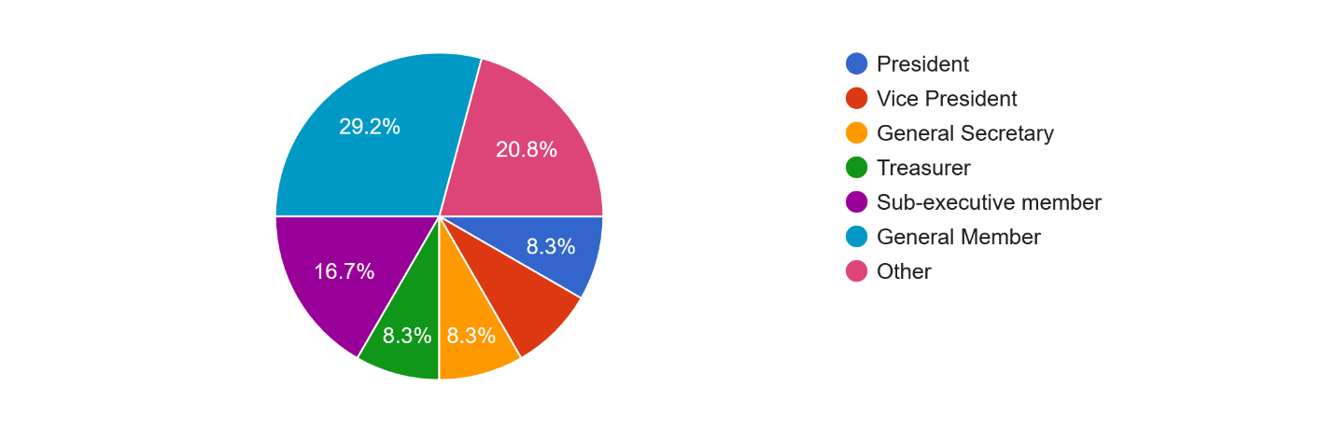
Figure 1: Role of the club
Record-Keeping Practices (Types of Records)
Figure 2 illustrates the types of records commonly maintained by student clubs.
The clubs maintain a variety of records, including membership lists, financial documents, event reports, images, certificates, and communication logs. However, the responses show inconsistency in what different clubs consider important to document.
While some clubs maintain comprehensive records, others only keep basic information. This variation reflects a lack of standardized record-keeping guidelines across the university’s clubs, leading to uneven documentation practices.
87.5% of the respondents maintain the event records and 83.3% of the respondents maintain the member lists. Approximately 70.8% of the clubs maintain their financial records and only 37.5% of the clubs maintain their meeting minutes. Additionally, 58.3% of the clubs maintain inventory or asset records and 8.3% of the clubs maintain other records as well.

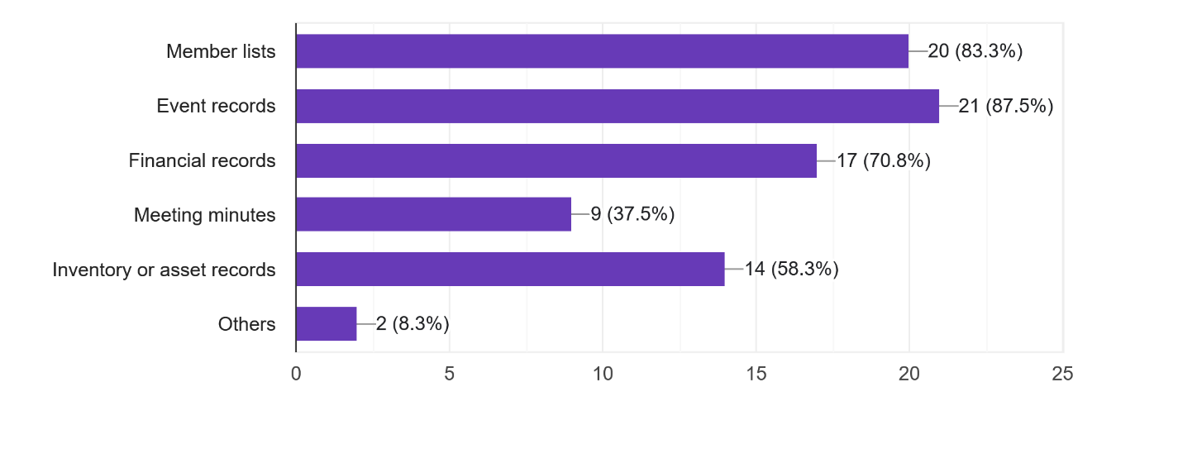
Figure 2: Record keeping practices (types of records)
Place Where Records Are Stored
Figure 3 illustrates the locations where student clubs usually store records.
The majority of respondents reported storing records in mobile phones, personal laptops, social media platforms, and Google Drive rather than in official club repositories.
This finding highlights a key challenge: records are scattered across personal devices, making them vulnerable to loss during leadership transitions or device damage. Very few respondents mentioned using a centralized or secure storage system, indicating a lack of institutional structure for data preservation. The survey shows that 87.5% of the clubs stored the records in google drive, 62.5% of those stored in excel/ word files on personal devices, 41.7% of the clubs stored in printed documents. Additionally, 33.3% of the clubs stored their records in social media platforms and 20.8% of the clubs stored in WhatsApp/messenger chats.

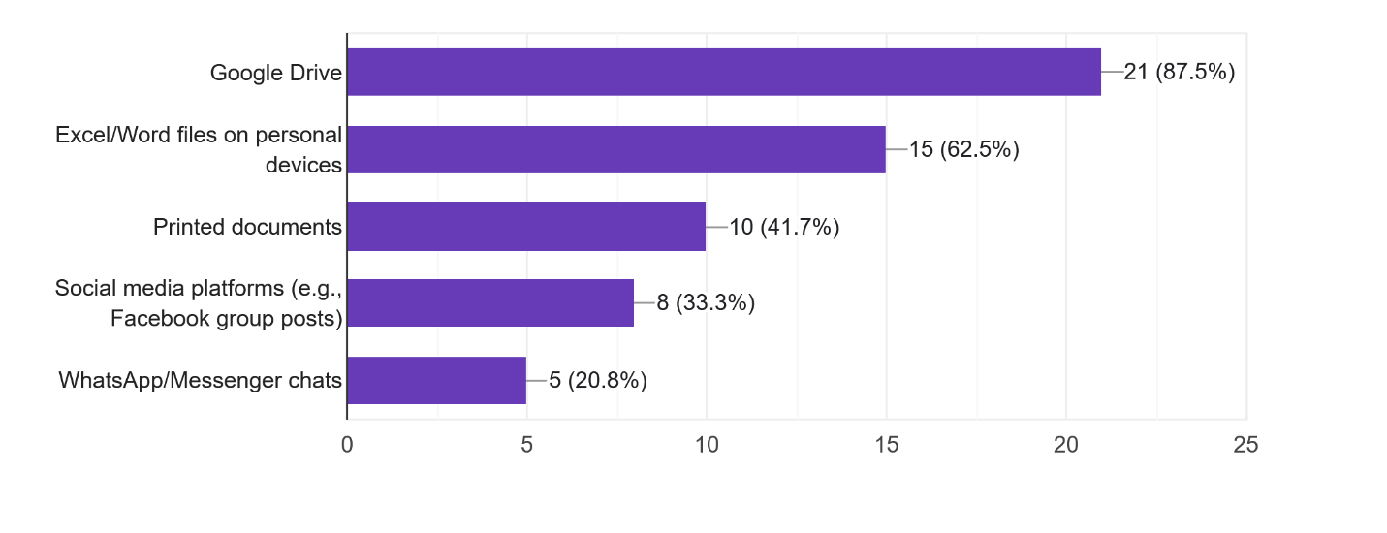
Figure 3: The place where they store records

Responsibility for Managing Records
The results show that record management responsibilities are often shared informally among executive members, including presidents, general secretaries, and volunteers.
This lack of a clearly designated record keeper leads to inconsistencies in how records are created, stored, and maintained. When responsibilities are unclear or fluctuate from one person to another, documentation becomes fragmented and prone to loss.
The survey shows that only 12.5% of the clubs have their designated record keeper. 25% of the clubs manages their records by the president and general secretary. Additionally, 20.8% of the clubs shared their records among all the members and 16.7% of the clubs doesn’t have any specific person for record keeping.
Responsible for managing the records | Frequency | Percentage (%)
Designated Record keeper | 3 | 12.5
General secretary | 6 | 25.0
No specific person | 4 | 16.7
President | 6 | 25.0
Shared among all | 5 | 20.8
Total | 24 | 100.0

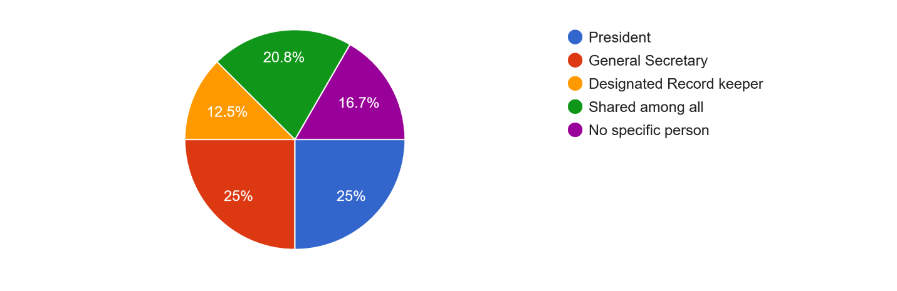
Figure 4: Responsible for managing records

Following Formal Procedure for Managing Records
More than half of the respondents stated that their clubs do not follow any formal procedures for managing records. 54.2% of the respondents stated that their clubs do not follow any formal procedures and only 45.8% of the respondents mentioned about formal procedures.
This suggests an absence of written guidelines, standardized templates, or official documentation policies within most clubs. Without formal procedures, record-keeping depends largely on individual habits, leading to irregularities and inefficiencies.
Response | Frequency | Percentage (%)
Yes | 11 | 45.8
No | 13 | 54.2
Total | 24 | 100

Figure 5: Following formal procedure for managing records

Challenges of Record Management
Respondents identified multiple challenges, including:
- Lack of proper storage
- Inconsistent documentation
- Limited digital tools
- Loss of records during leadership transitions
- No assigned responsibility for record management
These challenges indicate systemic weaknesses in organizational practices. The findings underscore the need for training, digital solutions, and structural reform to support better record-keeping.

Statements | Strongly Disagree (%) | Disagree (%) | Neutral (%) | Agree (%) | Strongly Agree (%)
There is a lack of proper storage systems. | 8.3 | 12.5 | 8.3 | 58.3 | 12.5
Records are often lost during committee transitions. | 4.2 | 20.8 | 16.7 | 41.7 | 16.7
There is no standard format for record keeping | 4.2 | 33.3 | 16.7 | 33.3 | 12.5
Documentation is inconsistent. | 0 | 16.7 | 37.5 | 33.3 | 12.5
Digital tools for recordkeeping are limited | 4.2 | 8.3 | 20.8 | 45.8 | 20.8
Members lack knowledge or training on record management | 4.2 | 4.2 | 41.7 | 33.3 | 16.7
There is insufficient faculty oversight. | 0 | 8.3 | 41.7 | 37.5 | 12.5

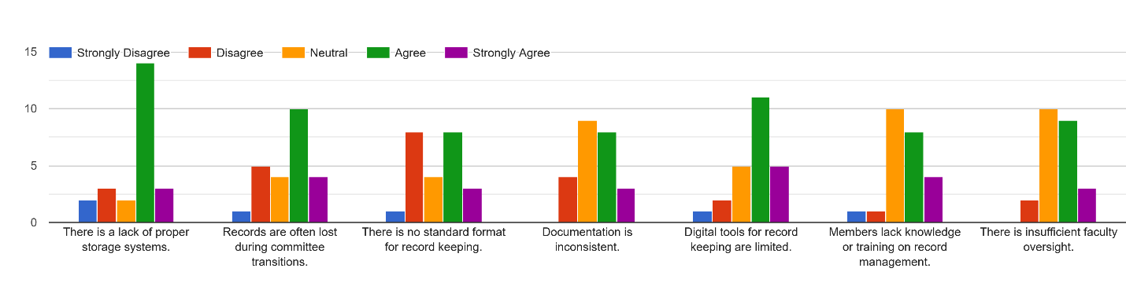
Figure 6: Challenges of record management
Record Update Timing
Only 12.5% of respondents update records monthly, while others do so irregularly—some only before events or during committee changes.
This reveals that record updates are not routine, which increases the likelihood of outdated, incomplete, or inaccurate documentation.

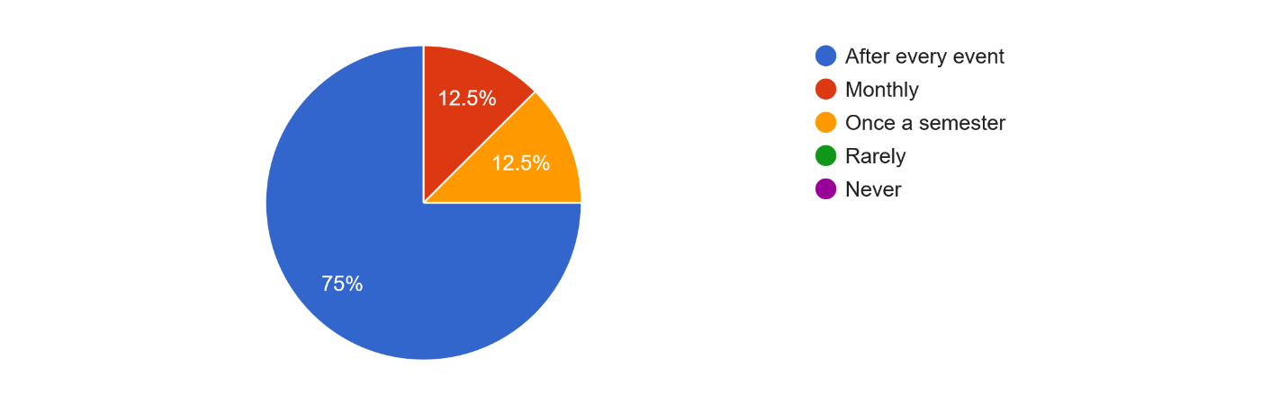

Figure 7: Record update timing
Losing Important Documents
A significant proportion of respondents reported that clubs frequently lose important documents, such as financial reports, event details, and member lists.
This loss is mainly due to the absence of central storage, the use of personal devices, and informal handover processes. Frequent document loss disrupts continuity and reduces institutional memory.

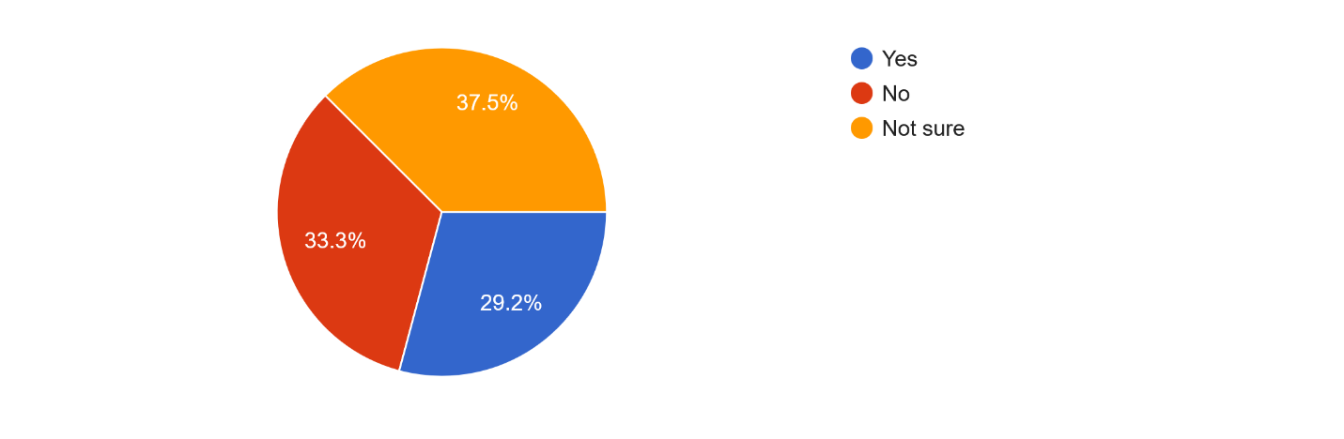
Figure 8: Losing important documents
Possible Solutions for Better Record Management
Respondents recommended several improvements, including:
- Centralized digital storage
- Standardized templates
- Formal handover processes
- Training on record management
- Clear allocation of responsibilities
These suggested solutions indicate that club members recognize the need for systematic reform and are willing to adopt improved practices if supported institutionally.
Statements | Strongly Disagree (%) | Disagree (%) | Neutral (%) | Agree (%) | Strongly Agree (%)
A centralized digital platform for all clubs would improve record management. | 0 | 4.2 | 8.3 | 50.0 | 37.5
Training/workshops on record management would enhance efficiency. | 4.2 | 0 | 8.3 | 50.0 | 37.5
Standard record-keeping templates would help maintain consistency. | 0 | 0 | 12.5 | 54.2 | 33.3
Faculty or administrative guidance would strengthen documentation. | 0 | 8.3 | 12.5 | 62.5 | 16.7
Cloud storage access would ensure better record security. | 0 | 4.2 | 8.3 | 45.8 | 41.7

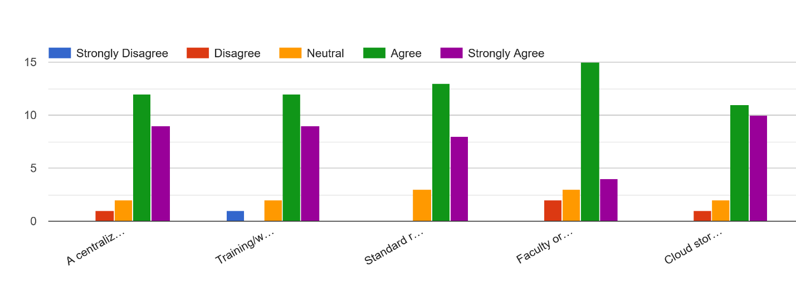
Figure 9: Possible solutions for better record management
Opinion on Better Record Management
An overwhelming majority (almost all respondents) agreed that clubs need better record management systems.
This strong consensus underscores the urgency of implementing structured documentation practices. Members believe that improved record-keeping will enhance transparency, efficiency, and the overall functioning of student clubs.
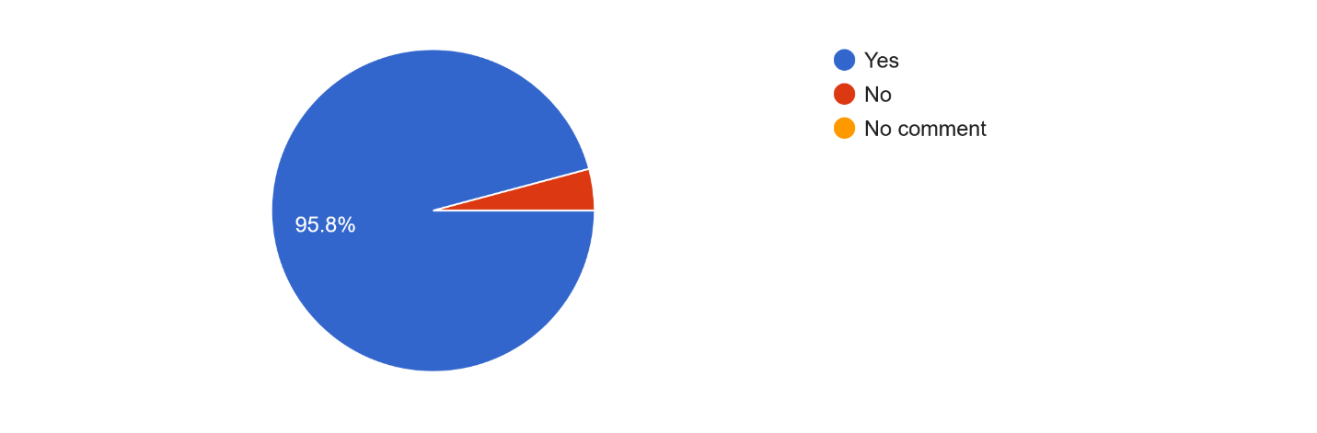
Figure 10: Opinion for better record management
Discussion
The findings of this study reveal several critical challenges in the records management practices of student clubs at East West University. One of the most prominent issues is the absence of a clearly designated person responsible for maintaining records. Without defined documentation roles, record-keeping becomes inconsistent and dependent on individual initiative rather than organizational procedures. This lack of ownership results in fragmented documentation, poor retrieval, and a higher likelihood of information loss.
Another significant challenge is the absence of standardized record formats across clubs. Respondents reported variations in how records are created, stored, and organized, indicating that student clubs rely heavily on personal preferences rather than established institutional guidelines. Such inconsistency reduces the reliability of documentation and complicates the process of handing over records during leadership transitions.
The study also highlights a lack of proper storage systems, with many records being stored on personal devices, social media platforms, or scattered digital spaces rather than in a centralized repository. This issue is further compounded by the fact that a majority of respondents acknowledged losing important documents during executive committee transitions, demonstrating the vulnerability of records when storage depends on individuals rather than institutional systems.
Although each club has a faculty moderator, the findings show that moderators’ involvement alone is not sufficient to ensure proper documentation. Students expressed the need for clearer guidelines, structured processes, and regular supervision from faculty to develop systematic record-keeping practices. This indicates a gap between existing support mechanisms and the level of administrative structure required for effective records management.
The quantitative results reinforce these challenges. Notably, almost all respondents of respondents agreed that their clubs need better records management practices, signaling a strong, shared recognition of the problem among club members. Additionally, more than half of the respondents mentioned that they do not follow any formal procedure for maintaining records, highlighting the urgent need for institutional guidelines. Only 12.5% reported updating records on a monthly basis, suggesting that documentation efforts are irregular and often reactive rather than proactive.
A recurring issue across student clubs is their limited use of digital record management tools. Many clubs lack access to specialized software or platforms, relying instead on WhatsApp, Messenger, or personal Google Drives. This lack of structured digital tools significantly increases the risk of record loss and reduces the ability to retrieve information efficiently. Respondents consistently indicated that improved digital solutions—such as centralized cloud storage—would support more secure and systematic record-keeping.
Overall, the study underscores that the challenges faced by EWU student clubs are not merely administrative oversights but reflect broader structural and procedural gaps. Despite these limitations, the study also identifies possible solutions and opportunities for improvement. Respondents proposed key strategies such as centralized digital repositories, standardized documentation templates, formal handover processes, and training for student executives. These recommendations demonstrate students’ readiness to adopt better practices if supported by appropriate institutional systems.
Importantly, this study contributes new insights to the limited body of literature on student club record management in Bangladesh. By examining real-life scenarios and students’ perceptions, the study provides evidence that enhanced record management is essential not only for operational efficiency but also for preserving institutional memory and ensuring continuity across leadership cycles. The findings have implications for other universities as well, suggesting that student clubs require structured administrative frameworks, digital tools, and ongoing training to maintain accurate and reliable records.
In summary, the discussion highlights that effective records management in student clubs is crucial for transparency, accountability, and sustainability. By addressing the identified gaps through systematic policies, digital solutions, and capacity-building initiatives, East West University—and similar institutions—can significantly strengthen the operational efficiency and long-term documentation practices of their student organizations.
Proposed Records Management Model for EWU Student Clubs
Based on the findings and discussion, a structured records management model is proposed to improve documentation practices, ensure continuity during leadership transitions, strengthen institutional memory, and enhance operational efficiency within EWU student clubs.
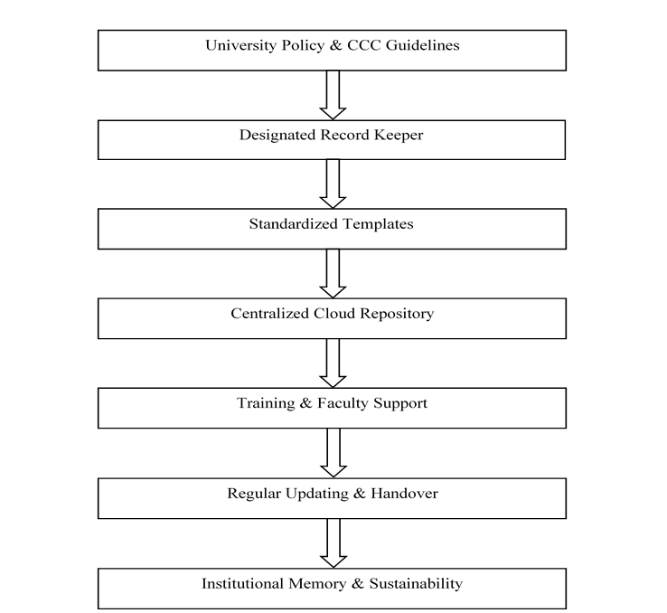
Figure 11: Proposed EWU Student Club Records Management Model

Recommendations
Based on the findings of this study, several recommendations are proposed to strengthen records management practices within student clubs at East West University:
- Establish a Centralized Digital Repository
A unified digital repository should be developed under the Career Counseling Center (CCC) to store all club documents in a secure, organized, and accessible manner. Centralization will reduce the risk of losing records stored on personal devices and ensure continuity during leadership transitions.

- Implement a Formal Handover Process
Each club should adopt a structured handover procedure at the end of every executive committee term. This process should include transferring digital files, passwords, financial records, and event documents to the incoming committee to ensure smooth and consistent record continuity.
- Create a Designated Record Keeper Position
Student clubs should introduce a specific role—such as “Documentation and Records Secretary”—responsible for maintaining, organizing, and updating records. This individual should receive basic training in record management principles to ensure accuracy and consistency.
- Adopt Secure Digital Tools and Platforms
To support efficient documentation, clubs should utilize secure digital tools such as Google Workspace, OneDrive, or institution-supported platforms. These tools facilitate safe storage, easy retrieval, and collaborative access, reducing dependence on personal devices.
- Provide Workshops and Training Programs
The Career Counseling Center and faculty moderators should arrange regular training sessions on digital documentation, record preservation, and data security. Such capacity-building initiatives will raise awareness and enhance students’ skills in maintaining institutional records.
- Develop and Enforce Data Security Policies
The university should establish clear guidelines regarding data protection, access control, and ethical handling of club records. Club members should be required to follow these policies to ensure confidentiality, integrity, and responsible use of information.
- Introduce Standardized Templates and Formats
Standardized templates for event reports, financial summaries, membership lists, and meeting minutes should be provided to all clubs. This will promote uniformity, simplify documentation processes, and improve record accuracy.
- Increase Faculty Oversight and Monitoring
Faculty moderators should be more actively involved in overseeing the documentation practices of their assigned clubs. Regular monitoring and feedback can help reduce record loss, improve accountability, and ensure adherence to proper documentation procedures.

Practical Implications:
For Student Clubs:
This study reinforces the importance of systematic record-keeping, enabling clubs to adopt organized, consistent, and accountable documentation practices. Improved record management supports smoother operations, better event planning, and stronger continuity across leadership transitions.
For University Administration:
The findings provide valuable insights for developing institutional policies, digital platforms, and capacity-building initiatives that support sustainable documentation. Administrators can use these insights to introduce centralized storage systems and formal guidelines for student organizations.
For Faculty Advisors:
The study highlights the essential role of faculty moderators in monitoring, guiding, and supporting record-keeping activities. Active oversight ensures that important documents are preserved, properly organized, and accessible for future reference.
For Students’ Future Careers:
Enhanced record management skills—including organization, documentation, data handling, and digital literacy—are transferable and highly valued in professional environments. Participation in improved documentation processes prepares students for workplace expectations.
For Institutional Memory:
Accurate and well-maintained records contribute to a long-term archive of club achievements, events, and contributions. Strengthening institutional memory enhances East West University’s historical documentation, reputation, and legacy.
Limitations
This study provides a practical overview of the records management practices of student clubs; however, several limitations should be acknowledged. First, the research focused on only 15 selected clubs at East West University, which limits the generalizability of the findings to all clubs within the institution. Second, although the study included presidents, general secretaries, vice presidents, and treasurers, it did not capture the perspectives of all executive or general members who may also engage in record-keeping activities. Third, as the study was conducted within a single university context, the results may not fully represent student club record management practices in other higher education institutions.
Future research could expand the scope by including additional universities, a larger number of clubs, and a wider range of executive members to provide a more comprehensive understanding of the challenges and practices associated with student club records management.
Conclusion
The findings of this study confirm that student clubs at East West University face significant challenges in maintaining effective record-keeping practices. These challenges include the absence of standardized procedures, inadequate storage systems, and inconsistent documentation due to frequent leadership changes. The results clearly indicate that improved training, the adoption of centralized digital repositories, and the establishment of formal record management processes are essential to enhance operational efficiency and ensure continuity within the clubs.
Despite its limitations, this study provides valuable insights for future research on records management in student organizations. It offers a foundation for strengthening existing practices at East West University and can serve as a reference for other universities seeking to improve their own documentation systems. Implementing the recommended strategies will not only help preserve institutional memory but also promote greater transparency, accountability, and organizational effectiveness across student clubs.
References
- Harris, D., & Taylor, L. (2018). Improving records management in student organizations: A Case Study. Journal of Library and Information Science, 12(3), 45-60
- Jones, R., Smith, A., & Carter, P. (2020). Digital tools for student clubs: Enhancing Record-Keeping Practices. Journal of Higher Education Administration, 15(1), 29-40.
- Williams, J. (2021). Cloud storage and records management in student clubs. International Journal of Information Systems, 22(4), 118-130
- Chang, M., & Lee, S. (2021). The Importance of Standardized Templates in Record-Keeping. Journal of Management and Technology, 18(2), 75-88.
- Smith, P. (2019). Records Management: Challenges and Solutions in Student Organizations. University Management Review, 28(2), 22-35
- Mezbah-ul-Islam, M., & Akter, R. (n.d.). Preservation of archives: A case study of Bangladesh National Archives.
- Edem, D. (2002). Federal Republic of Nigeria. Effective record keeping in school
in Nigeria. National Policy on Education-Abuja NERDC.
- Akubo, A. (2004). Proper record keeping and effective management. Lagos: Concept
Publications Limited.
- Igwoku, I. F. (2008). An Analysis of Record Management Strategies in Western
Nigeria. M. Ed. Dissertation, Unpublished. Abraka: Delta-State University.
- Akube, A.U. (1991). Classroom organization and management: A 5-point strategy.
Ibadan: Wisdom Publishers Ltd.
- Durosaro, D. O. (2002). Management of school records. In The Craft of Educational
Management. Duosaro, F.O. & Ogunsaju, S. (eds.) Indemac, Ilorin.
- Egwunyenga, E. J. (2005). Essentials of school administration. Benin City: Justice
Jeco Publishers.
- ISO 15489-2 (2001b), Information and Documentation – Records Management. Part 2: General, International Standards Organization, Geneva, available at: www.iso.ch (accessed 1 September 2025).
- Baje, E. N. (1998). Records management Programme in Oyo State Civil Service, a
study of Governor’s office. Unpublished MAS thesis, Ibadan, 36.
- Kemoni, H., & Wamukoya, J. S. (2000). “Preparing for the management of
electronic records at Moi University, Kenya: a case study”. African Journal of Library,
Archives & Information Science, 10(2), 125-38.
- Fadokun J. B. (2004). Deregulation and Professional Development in School Personnel.
Lecture presented at the National Institute for Educational Planning and Administration,
Ondo. August 16-18.
- Díaz Calderón, R. R., Pérez Vargas, C. G. A., Torres Serna, H. A., & Pérez, G. H. (2025). Digital transformation in public records management. Public Administration Issues, 6, 79–96. https://doi.org/10.17323/1999-5431-2025-0-6-79-96
- Gayathri, S., & Varshameena, M. (2025). Cloud computing adoption in educational institutions. International Journal of Scientific Research & Engineering Trends, 11(6).

