Topic- Sustainable and ergonomical packaging solution towards Hindu worship rituals (a case study of redefining community performance in Kashi Vishwanath Temple, Varanasi, India).

Introduction:

It is estimated that 13% to 18% of India's population is dependent on the economy supported by temples (Choksey D 16.01.2024). There are over three million temples small and big spread across India. Many of them are eminent and many of the well-known and historic temples are getting a facelift as a part of “pilgrimage rejuvenation and spiritual augmentation drive” (https://tourism.gov.in 06.06.2024 and Choksey D 16.01.2024). Estimated daily pilgrims to various temples across India is in millions going by the number of temples in the country (Rathore M 2024). In India the temple economy amounts to approx. INR 3.02 lakh crores (over 3.5 billion USD), summing up to approx. 2.3% of the country’s GDP and offering employment and occupation to millions (Iyer S S, et. al., 2024). The temples are intricately, socially and culturally woven towards a long-term sustainable relationship with local enterprises, initiatives and activities (Bhatia J S, 2024). Heritage tourism, hospitality industry, regional handicrafts, regional festivals are fostered towards employment, revenue generation, inclusive growth and socio- economic empowerment (Iyer S S, et. al., 2024 and Purnamawati et al., 2023).
The absolute gamut of temples in the country emphasizes their importance as not just places of spiritual significance but also as economic, cultural and social hubs. The temples are ideally administered by trusts (trustee board) or government administration with sizable funds towards maintenance and development. The vision is to manifest tourists other than the daily local footfall and contribute to the pilgrimage tourism (Iyer S S, et. al., 2024 and Swain et al., 2023).
For example, Puri, Amritsar, Tirupati and Madurai are examples of city of shrines in India. These cities ensure substantial pilgrimage tourism. In case of Tirumala Tirupati Devasthanams, the authority which takes care of the administration of the Venkateswara Temple in Tirupati, declared a phenomenal ₹3,000 crores (over 351 million US Dollars) as its earnings for the year 2019-20. It may be noted that the temple not just is the only beneficiary. The revenue flows into the particular geographical region, into its micro and small businesses including hospitality industry, unorganized handicraft sector etc. (Bhatia J S, 2024).
The Chief Executive Officer of Shri Kashi Vishwanath Temple Trust in Varanasi admitted that there are over 3 million footfalls to the Kashi Vishwanath Temple annually and thereby the local area. During the year 2023-24 financial year approx. Rs 85 crore (approx.. 9.9 million US Dollar) is revenue generated through donations and offerings. In addition to it the micro and small-scale enterprises in the vicinity is also benefitted e.g. the unorganized textile industry (handloom), stone craft industry etc. (Shetty J G et.al., 2024).
In Hindu conviction puja or in other words worship is a ceremony which is done in reverence of the deity, with offerings. It is believed that the deity accepts it. Part of the offering is taken back by the devotees as consecrating (Gaur A et al 2019). The offerings are varied and comprise flowers, water, milk, fruits, sweets, incense sticks, lamp etc. While visiting a temple, devotees invariably purchase offering from the temple side shops. The offerings are contained in a basket as a package. The baskets are most often made of plastic. The worship baskets are minimal and lack attention to detail. Primarily the focus is towards convenience and affordability.
There are many notable temples in India e.g., the Kashi Vishwanath temple in Varanasi, Tirupati Balaji Temple in Chittoor, Kamakhya Devi Temple in Guwahati, Chintaman Ganesh Temple in Sehore etc, wherein carrying the offerings in plastic baskets as packaging is a regular practice.
There is no doubt packaging is intended towards containing, safeguarding, ease in transportation and handling and also to promote sales. Packaging is also mighty entirety of experience: one that is evocative, emotional, useful, enjoyable and memorable. It should have the ability to reciprocally reinforce the mood or rather augment the emotions. Packaging solution come together when the envisaged and contextual components are clearly interrelated (Samara T 2007).
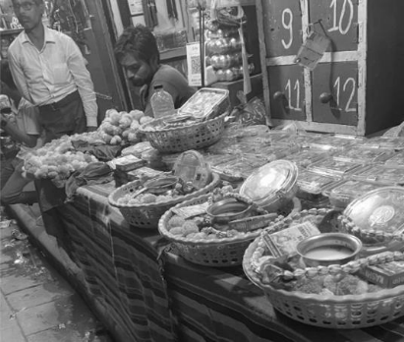
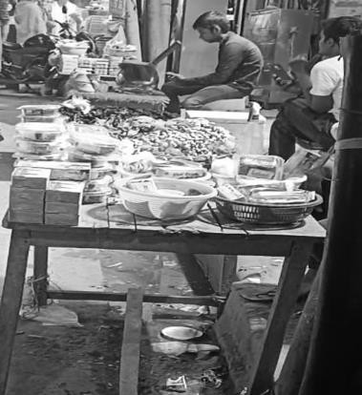
Fig 1: Vendor shop near Kashi Vishwanath Temple, Varanasi. The offerings for worship ceremony are in plastic baskets.
Fig 2: A smaller temple in Bhopal. The offerings for worship ceremony are in plastic baskets for devotees.

The industrially made plastic baskets used to carry offerings, fail to symbolize the inner desires of the social culture of a respective region. There is no individuality or emotional belonging with the ritual of worship prevailing in the plastic basket and at the same time it is unable to indulge the user or the person offering prayer with the traditional or folk feel with sanctity.
In context to user interface, the structure is such that it occupies both the hands or at least one hand while carrying it to worship. Physiologically the fatigue while carrying for relatively longer period needs addressal due to the existing basket structure and affordance.
There is an opportunity to re-evaluate equitable habits, human needs and aspirations, and set objectives which give precedence to ecological sustainability and social sustenance. A solution needs to be identified which is inclusive and encompasses all factors.
Sustainable packaging may be classified into environmental wellbeing, human and social wellbeing or empowerment and economic growth (Otto S, et. al., 2021). Endeavour is required to maintain a healthy ecosystem. Many authors mention that achieving absolute sustainability is a real challenge in context to the situation (Álvarez-Chávez et. al., 2012). The challenge in this study is to extend the efforts to achieve maximum sustainability with products developed from eco-friendly or natural resources. It is intended to empower a particular social segment providing them social safety net with economic benefits to the stakeholders.
The resilience towards so called “plastic bashing” to the ecosystem with conscious effort regarding sustainable packaging alternatives is not only from design or production perspective but also from the user’s perspective. The users are more aware in present times (Otto S, et. al., 2021).
The unorganized craft sector is the largest employment generator second only to agriculture in the country. It encompasses marginalized sections in the society comprising its workforce as largely economically disadvantaged (Banerjee A and Mazzarella F 2022).
Most of the craft practices and craftsmanship in India is practiced in sustainable way. It is not only pertaining to ecological wellbeing but also setting up a social empowerment and economic safety net and wellbeing. But due to lack of education and awareness in the crafts persons and lack of outreach in larger geographical span the crafts persons receive negligible recognition or financial benefits. There is a Dissonance between income per head and motivation (freedom) of crafts persons (Banerjee A and Mazzarella F 2022 and Halder, S et al 2020).
However there have been few exceptions e.g. Fabindia. Founded in 1960. Presently it connects over fifty thousand crafts persons in different craft pockets providing a long term sustainable chain to the crafts persons sharing benefits (https://www.fabindia.com/ 2025).

Methodology:

The following steps were undertaken:

- Group interview process as a participatory approach: It was participatory (through direct communication with smaller groups of consumers and shopkeepers e.g. 5-8). A sample of approx. 370 people in Varanasi, Bhopal, Ujjain, Guwahati, Chennai, Omkareshwar, Mathura and Puri (who are frequent visitors of temples and carry the offerings in plastic baskets). Primary data was collected from consumers belonging to varied socio-economic background, varying between age group of 15-55 and both males and females.
- Observation process: Many consumers were keenly observed in Varanasi performing the worship while carrying the offerings in plastic baskets as packaging. It was a time taking process and was possible because one of the authors was from Varanasi.
- Classification of undesirable features: Establishing undesirable features or drawbacks and problems existing with the plastic baskets as packaging.
- Focus group discussion and brainstorming process: It was conducted with the help of experts (shop keepers, temple priests, designers, craft practitioners and entrepreneurs) to produce ideas. Focus group discussion and brain storming process was conducted to invite number of ideas, perceptions and opinions so that later they may be evaluated and improved upon (Jones C. J 1970).
- Case studies: Study of various strategic social system models and validation of the focus group discussion and brain storming exercise.
- Role play: The prototypes were evaluated in comparison to the existing basket structures applying factors related to physical and cognitive ergonomics.

Group interview process: The following points are vital outcome:
- The customers/ visitors may be classified as pilgrimage tourists and local regular devotees.
- The pilgrimage tourists feel that there is a lack of novelty associated with the plastic basket.
- The local and regular devotees do wish the geographical identity of the place is enhanced. The user experience to improve as well.
- Mostly the carrying activity of the baskets demand both hands at the job. It needs to be more ergonomical.
- The shopkeepers are of the opinion that plastic baskets are make shifter (jugaad) because it doesn’t reflect with the use that it is put into. However, the plastic baskets are prevailing for long.
- The plastic baskets lack identity. The same baskets are used by vegetable vendors in local
street market.
- Plastic packaging contributes to environmental pollution.
- Associating harmful materials like plastic with spiritual practices raises ethical concerns.
- Shopkeepers welcome the thought of alternative packaging solutions which is made for the purpose and if possible eco-friendly.

The undesirable features: In other words, the drawbacks and problems identified with plastic baskets as packaging are as follows:
- Lack of option offered to the devotees or in other words consumers. The existing packaging concept is monotonous. It misses the mark towards making the experience evocative, emotional, useful, enjoyable and memorable.
- Lack of an inclusive social system. Akin if not equivalent respect for all jobs associated with different castes and tribes in the society is not prevalent.
- Growth and urbanization backed by technology and supply transportation has paved ways for the industrially made products almost everywhere, raising question over sustainable social approach (Halder, S et al 2020).
- Lack of entrepreneurial ability across different sections in the society based on human/ community capabilities.
- Enhancement is required in governmental interventions as well as support from local administrative authorities, temple trust etc. It is essential towards securing economic facilities and social opportunities.
SWOT analysis of the plastic baskets was done. It is mentioned in Fig 3 below.
- It is weather proof.
- It is industrially made hence the form/structure is consistent.
- Low cost of baskets.
- Light weight and easy to carry, using both hands.
- It has the capability to safely contain.
- The supply chain of plastic baskets is already strengthened.
Strength
- It doesn’t evoke the spiritual emotion.
- In the whole process of offering prayers, the plastic baskets become insignificant. It lacks individuality.
- Requires both the hands to carry it.
- The social culture of the region is not reflected.
- There is fatigue while carrying for relatively longer period
Weakness
- Set precedence to ecological sustainability.
- To set an enterprise, which has potential to generate employment in thousands.
- The reflection of the society, through packaging can reach larger geographical span.
- Should be easier to handle. May be using single hand.
- There should be elements to evoke in
pilgrimage tourism.
Opportunity
- It is non- biodegradable.
- Government may put forward restriction towards usage of certain plastics.
Threat

Fig 3: SWOT analysis of the plastic baskets used to offer prayers on temples.
Focus group discussion and brainstorming process: The process (Jones C. J 1970) was conducted predominantly to envisage appropriate strategies so that consumer/ devotees can relish the experience more. The effort was also towards social and economic strengthening of the ecosystem, understanding the setbacks or problems at present day. A number of ideas were obtained from a group of shop keepers, temple priests, designers, craft practitioners and entrepreneurs. The ideas obtained largely revolved around the following:

  - Multiple options of packaging catering to various kinds of consumers.

  - Encouraging local craft with sustainable material.

  - Product design and development with local craft.

  - Making the crafts persons aware and expand their product line.

  - Cooperative societies which coordinate with temple trust, shop keepers and crafts persons.
  - Redefining the identity of craft clusters.
Systems thinking is an approach towards seeing the entirety (Checkland. P. 1999). The reflections in the focus group discussions can be taken into account as individual systems.
There is correlation and reciprocity that can be envisioned among different ideas or rather systems. And each of the system is a group of elements in interaction (Bertalanffy, L. V. 1968).
Case study- “Lord Jagannath temple in Puri, Odisha”. The offering (prasad) of the deity is served in earthen pots, palm leaf baskets. Earthen pots created by crafts persons are put in application in the temple’s kitchen to prepare the consecrated food. On or about five thousand fresh clay pots of varied sizes are put in application on a regular basis (https://gaatha.org/Craft-of-India/temple-pottery-puri 2022). It provides a long-term sustainable chain to the informal economy of terracotta craft cluster in collaboration with the temple economy.
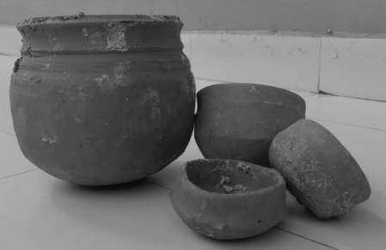

“Lingaraj Temple in Bhubaneswar, Odisha”. The offering (prasad) of the deity is served in earthen pots, palm leaf baskets similar to Lord Jagannath temple in Puri, Odisha.
Fig 4: Terracotta pots in Puri Jagannath temple.
Fig 5: Palm leaf baskets in Lingaraj and Lingaraj temple.

Upon studying the undesirable features, focus group discussion and case studies it is aimed to intervene and foster conscience in the socio-ecological system, promote reusable alternatives, and engage local crafts persons to champion sustainable practices in religious rituals thereby reinforcing religious identity. The system should be replicable.
Strategy was developed to first observe and gauge the following:

- Is there any craft cluster in the nearby vicinity to suffice the need? If so, in that case what craft, their history and evolution and present state. What is the acceptance of craft presently in the society.
- If there is scope partnering with local artisans to advocate for eco-friendly alternatives, sustaining traditional craftsmanship and creating economic opportunities.
- To understand the conscience amongst crafts persons towards developing extended line of products and meeting deadline attaining quality bench mark. In other words, assessing the conscience, ability and performance of the crafts persons.
- Scope towards promoting a culture of sustainability through extended utility and long-term value for consumers.
Recce was done in Varanasi and nearby areas with visits. The region is rich in various traditional craft practices. They are mentioned below in Table 1 (https://varanasi.nic.in/art-craft-varanasi 2024).

Sl. No | Name of the place | Distance from Varanasi in  Kilometres | Craft Practice |  | Number of Crafts persons involved
1 | Varanasi | Nil | Glass beads craft |  | Approx. 1700
1 | Varanasi | Nil | Soft stone jali work |  | Approx. 800
1 | Varanasi | Nil | Wood Lacquerware |  | Approx. 400
1 | Varanasi | Nil | Banarasi Sarees |  | More  lakhs | than | 4
2 | Gazipur | Approx. 85 | Jute wall hangings |  | Approx. 500
3 | Mirzapur | Approx. 70 | Terracotta |  | Approx. 200
3 | Mirzapur | Approx. 70 | Handmade durries |  | More  lakhs | than | 2
4 | Sant Ravidas Nagar/  Bhadohi | Approx. 65 | Handmade carpet |  | More than 2.5 lakhs
5 | Prayagraj | Approx. 90 | Moonj  basketry | grass | Approx. 300
6 | Azamgarh | Approx. 95 | Terracotta |  | Approx. 300

Table 1: Brief of craft practices and clusters in and around Varanasi.

One common observation regarding all the craft clusters mentioned in Table 1 above is that the number of crafts persons have reduced considerably post lockdown during Covid 19 pandemic. The skilled artisans who didn’t have workshops/ looms at home and used to get engaged in other people’s workshop got affected. Most of the crafts persons got engaged in alternative source of earning e.g. daily wage labourers. Due to lock down and post lock down during Covid 19 pandemic the craft products didn’t find any takers.

Moonj grass, (botanical name - Saccharum munja) basketry craft cluster is profound in Prayagraj, a place approx. 90 kms from Varanasi. Bio-geographical and natural resource influence has enabled this craft to flourish in the region. Hereditarily the intangible asset of skill is passed through generations. The craft is practised by the women belonging to Muslim religion all through the year (https://odopup.in/en/article/district-profile-allahabad/ 2020).

The present product line of the moonj grass basketry craft is chapati (whole wheat thin bread made in Indian households) storage basket, fruit baskets and other utility baskets and containers of different size. They are sold in the local markets directly or through traders. The existing product structures fortify that with little changes it may suffice the need of offering basket (as a package). When the authors visited the cluster, the crafts persons showed willingness to accept the changes required. The price point of the baskets in quantity of 1000 may vary between approximately Rs 150/- (1.79 USD) to Rs 250/- (2.99 USD) with and without handle respectively.
The traditional skills of coiling technique used in the craft are passed through generations as legacy. However, it doesn’t have historical influence. The craft practice and the cluster are approximately a century old. It echoes the journey of the women in the community in transfiguring the wild grass into products of lifestyle requirement with quality. The craft is an embodiment of the social sustenance and women empowerment. The Uttar Pradesh state Government under the initiative of “One District One Product” (ODOP) initiative, an endeavour to promote regional opportunities across all districts, has recognized moonj grass basketry craft for Prayagraj district (https://www.india.gov.in/spotlight/one-district-one-product-odop 2023 and https://odopup.in/en/page/district-wise-products 2022).

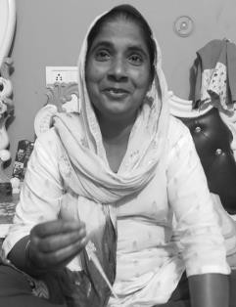
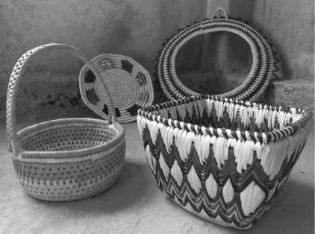
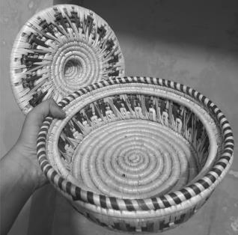
Fig 6: Crafts Person practicing the moonj grass basketry craft.
Fig 7: Crafts Person practicing the moonj grass basketry craft.
Fig 8: Existing fruit basket and other basket structures in the cluster.
Fig 9: Existing chapati storage basket.

The earning by the women in the family is secondary and helps substantiate the expenses. However, it is less. An artisan earns Rs 7000/- (83.61 USD) per month at an average which is Rs 84000/- (1003.31 USD) per annum. The per capita income in the India for the year 2018-19 was one lakh twenty-six thousand four hundred and eight rupees. It flourished over 79% to two lakhs twenty-six thousand five hundred and ninety in 2024. The growth is enormous. On the contrary the crafts persons are forced to switch skills and getting engaged as daily wage labourers or house help for economic and social security of their respective families (Source: Various crafts persons from different villages in Prayagraj 2024, https://www.business-standard.com 2019 and https://www.imf.org 2024). The existing economy in the clusters is found to be affecting a number of factors in their lifestyle including their employment freedom (Halder, S et al 2020).
SWOT analysis of the moonj grass basketry craft and cluster is done. It is mentioned in Fig 10 below.
- The material and process involved is ecologically sustainable.
- Raw material is plentily available in surrounding ecosystem round the year.
- As it is handmade different structures can be constructed without capital investment.
- Light weight and easy to carry using one hand (with handle).
- It is a secondary source of earning in the family, by women.
- It upholds peace and security with women empowerment while articulating social culture.
- Lack of employment freedom.
- Lack of social safety net as a part of protective and economic security (Halder, S et al 2020).
- The crafts persons lack education, awareness and entrepreneurship abilities.
- Even though the earning is secondary, but it is less.
Strength
Weakness
- Set precedence to ecological sustainability, social sustainability and economic security.
- Needful product design and development may evoke the spiritual emotion in the products to be offered.
- It will have individuality and simultaneously be connected with the ritual of worship.
- The enterprise has the potential to generate employment in thousands.
- The reflection of the society, through packaging can reach larger geographical span.
- Should be easier to handle.
Opportunity
Threat
- Cost of the baskets are relatively higher than the plastic baskets.
- Proactive support from local administrative authorities securing economic facilities lacks.
- Lack of motivation because of the income has resulted in the craft to be practiced less sincerely and as a recreational activity.

Fig 10: SWOT analysis of the moonj grass basketry craft and cluster.

A pilot design and development activity was initiated by the authors in the cluster. The concepts are developed giving significance to ergonomical aspects e.g. controllability, tolerance, simplicity and affordance. Few concepts were shared with the crafts persons which are mentioned below in Fig 11, Fig 12, Fig 13 and Fig 14.

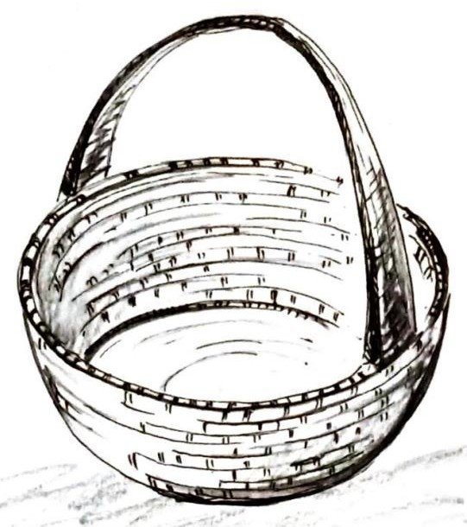
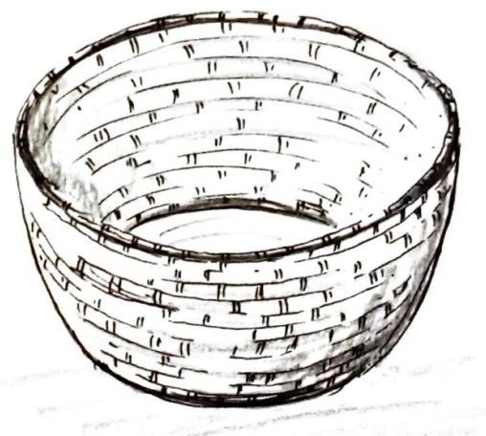
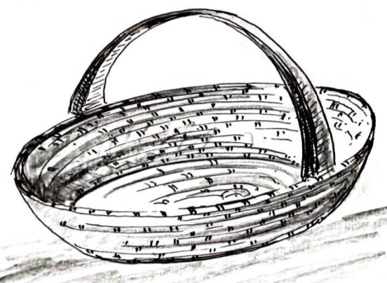
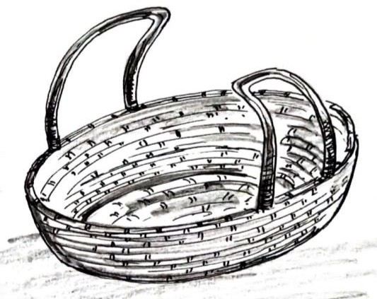
Fig 11: Circular cross section, tapered basket with handle. 12 inches diameter.
Fig 12: Circular cross section, tapered
basket without handle. 12 inches diameter.
Fig 13: Elliptical cross section, tapered basket with single handle. 14 inches x 10 inches.
Fig 14: Elliptical cross section, tapered basket with dual handle. 14 inches x 10 inches.

Concepts were developed keeping ergonomics in priority. The fatigue while carrying the basket for relatively longer duration shall be reduced. The point of contact is reduced from two hands in existing baskets to two to three fingers only with the handles.
Interaction was done with over 85 crafts persons regarding their willingness to make the concepts and their feedback. The product concepts in Fig 11, Fig 12, Fig 13 and Fig 14 didn’t deviate much from the existing line of products. The concepts found acceptance in the crafts persons group. Prototype of Fig 14 was developed (depicted in
Fig 15 and Fig 16). In the prototype the tilak (sectarian mark of Hindus) in red is proposed by the crafts persons. The price of the basket was amicably decided with the crafts persons i.e. Rs 250/- (2.99 USD). At an average one crafts person could make 5 baskets in a day. It may vary a bit, depending upon skill and experience.
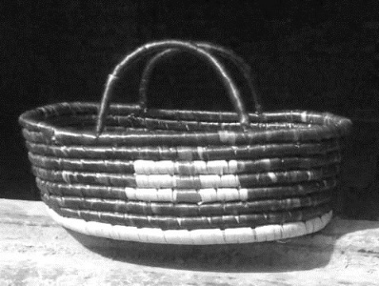
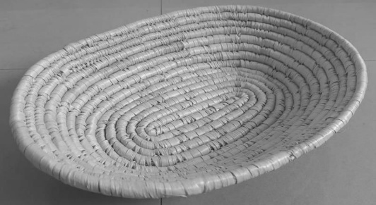
Fig 15: Initial mock-up of the elliptical base basket without a handle.
Fig 16: Prototype of elliptical cross section, tapered basket with dual handle. The tilak (sectarian mark of Hindus) in red is proposed by the crafts persons.

Role play: The prototypes were evaluated in comparison to the existing basket structures applying factors related to physical and cognitive ergonomics. There is physiological and biomechanical advantage associated with the proposed sample in Fig 16. Posturally it requires two to three finger to carry, making it simpler providing better controllability to the user. In other words it is less complex to use in comparison to the existing baskets (ref Fig 1 and Fig 2), where in ideal circumstance two hands are required. Affordance is profound. The handles communicate how the product should be used.
The prototype was taken to Varanasi, Kashi Vishwanath Temple. The intention was to check acceptance and seek feedback from the other stake holders i.e. shopkeepers selling offering baskets, regular devotees and pilgrimage tourists. The prototype found acceptance across the board.
There are over 750 shops big and small, surrounding the Kashi Vishwanath Temple selling worship offerings in baskets. Feedback was taken from 107 of them. The shopkeepers showed acceptance to the concept. It is eco-friendly. It will add variety to their product line. It has the ability to indulge the user or the person offering prayer with the traditional or folk feel with sanctity. But they found it expensive in comparison to their existing plastic baskets viz. Rs 50/- (0.60 USD). These baskets will largely attract pilgrimage tourists. They opined they can keep few i.e. approximately 15- 20 pieces, at their shops to begin with and offer in two ways. Firstly, if a devotee wants to purchase it with the offerings (and wants to retain the basket as a souvenir), its an outright gain. Secondly, devotees may be asked to keep a security deposit of a particular amount. Upon return of the basket after temple visit the shopkeeper will return the security deposit to the devotee.
The pilgrimage tourists from India and abroad acknowledged it as a utilitarian souvenir. It is pragmatic to fit into most homes and lifestyle. They lauded the cultural celebration of the region especially the tilak (sectarian mark of Hindus). The regular devotees/ visitors to the temple also appreciated it. They welcomed the change in offering.
During the design and development activity six undesirable aspects or problems were encountered in the craft cluster and the craft practice. The problems are found to be interdepended. The undesirable aspects or problems were broadly classified as following:
- Societal aspects
- Consciousness and knowledge aspects
The labyrinth in Fig 17 below depicts the interdependency and connectedness of the undesirable aspects or problems.
Societal structure is patriarchal. The crafts persons don’t get to travel to enhance awareness about various markets.
Lack of entrepreneurial ability depending on the working of markets (Halder, S et al 2020).
Lack of standard operational system with set standards for quality, lead time etc.
Less social acceptance of the craft community amongst other communities.
Lack of formal education doesn’t help.
Awareness towards menstrual
Hygiene and medical facilities.
Societal Aspects
Consciousness and
Knowledge aspects

Fig 17: Interdependency and connectedness of the undesirable aspects or problems.
A focus group discussion and brain storming exercise was conducted with seven members/ experts. One entrepreneur, one startup owner, two shopkeepers, one government administrator and two management students. The entire scenario with regards to the craft, craft cluster the existing market and prospect market was explained to the members. The intention was to receive different views towards the long-term socio-economic sustainability of a craft cluster providing eco- conscious and efficient solution to present day needs. Their views are as follows:
- Introduction of frugal tools (jugaad) to enhance capability and capacity of crafts persons.
- Technological intervention to increase production.
- Consolidated system to coordinate operation and marketing.
- Educating the crafts persons regarding menstrual hygiene and health care.
- Product line should increase. Unusual application of the craft or application of the craft in unusual product area may be considered, provided there is acceptance in the crafts persons.
- Trust in the system and in the elements of the system and proficiency are vital factors.

Result:

An enterprise can be envisaged as a consolidated system, which as a part of systemic application, can be implemented as follows:

Awareness and capacity amelioration.
- Operation and Marketing coordination.

Awareness and capacity amelioration: It will focus on the following aspects:

  - Health and hygiene.
  - Basic education for an analytical mind.
  - Capability and capacity enhancement through tools and technology.
  - Expansion in product line.
  - Disciplined performance and commitment.

It will involve experts across various fields e.g. industrial/ product design, sociology, medical practice, agriculture experts (for resource management), etc.
Operation and Marketing coordination: It will focus on the following aspects:

  - Coordination with crafts persons in the cluster as a part of human resource management.
  - Ensuring job allocation to be even and rational.
  - Setting quality benchmarks amicably.
  - Agreeing upon lead time.
  - The system will ensure consistent and sufficient order to engage the crafts persons.
  - Finding fresh avenues for the products.
  - It will plan growth opportunities and strategize sales.


The objective of the socio- ergonomical consolidated system is to ensure confidence and dignity amongst the crafts persons enhancing their conscience, awareness and performance. It intends to empower them socially and economically. It will eventually result in developing trust in the system. Fig 18 below depicts how the proposed consolidated system addresses the undesirable aspects or problems in the ecosystem of the craft cluster. It also depicts certain progressive attainments.
Dignified subsistence (Halder, S et al 2020)
Health and hygiene
Education and
rationality
Introduction of tools and frugal technology
Decision making and entrepreneurial ability
Awareness and capacity
amelioration.
Systematized operation and marketing system
Operation and marketing
coordination.
Awareness in society regarding the craft and culture
Social acceptance
Social and economic
empowerment
Employment freedom (Halder, S et al 2020)
Ecological
sustainability

White box denotes the undesirable aspects or problems in the ecosystem being addressed.
Grey box denotes certain progressive attainments.

Fig 18: Consolidated system model addressing the undesirable aspects and certain progressive attainments. It shows the interrelation in the elements.
The socio- ergonomical system model is a proposal towards micro enterprise. In accordance with the provision of Micro, Small & Medium Enterprises Development (MSMED) Act, India, 2006 a micro enterprise is defined as an infrastructure/ setup where the investment in plant and machinery or equipment does not exceed one crore rupees (USD 119117) and turnover does not exceed five crore rupees (USD 595585). The ministry of Micro, Small & Medium Enterprises (MSME), is aiding deeply the craft and cluster (https://msme.gov.in 2023).
Discussion:
The socio-ergonomical system model assures of the following:
Employment and economic opportunities: It encompasses the opportunities that are seen as prospect for utilizing economic entitlement in context to human efforts, entrepreneurial ability, fostering production, industries, etc., depending on the working of markets.
- Potential in the social ecosystem: It deals with the steps towards capacity and capability enhancement of people towards better and dignified living e.g. social acceptance, educational facilities, awareness, health and medical care,
- Self-assurance (in a community: It refers to the arrangements of a social safety net to prevent economic vulnerability and deprivation.
The aforementioned three points are vital expressions of freedom in any society (Sen, A 2000).
The Micro, Small & Medium Enterprises (MSMEs) are widening their domain across various sectors and have been contributing significantly to the growth of entrepreneurial endeavours through business innovations. They are reaching out to the domestic and global markets. Most importantly in a developing economy like India MSMEs play a vital role towards employment. It helps in reducing regional imbalances, assuring more equitable distribution of national income and wealth (https://msme.gov.in 2023).
The system model as a micro enterprise is a replicable model which can be initiated in different places of the country collaborating with local craft in various materials and temple economy e.g., Tirupati Balaji temple in Chittoor, Kamakhya Devi temple in Guwahati, Chintaman Ganesh temple in Sehore etc.
Conclusion:
The proposed system model is intended towards a better socio- ergonomical environment by empowering the crafts persons with social safety net as a part of economic security and dignified subsistence along with employment freedom preserving the traditional knowledge. It also addresses social acceptance as well as health and hygiene, basic education, frugal technological advancement (as required) and entrepreneurial skills. It must synchronise and be integral part of the crafts person’s life and livelihood and soak in their culture and ecosystem to gain build trust. With assured returns the system is an apposite investment in research, innovation, quality of life and ecological sustainability with the ergonomical worship baskets. The products offer ergonomically better controllability and affordance.With an increase in product line (by understanding the crafts persons acceptance towards the proposed product concepts), innovation in product development as per modern lifestyle and the targeted market, it promises to offer returns to the investors.
Declarations:
All authors declare that they have no conflicts of interest.

Reference:

  - Gaur A et al 23 September 2019, “Prasada: Divine Food Offering”, Britannica, T. Editors of Encyclopaedia, Source: Encyclopaedia Britannica. https://www.britannica.com/topic/prasada [06.06.2024].
  - Choksey D 16.01.2024, ” importance of temple economy and what to expect from Reliance in Q3,” Source: https://economictimes.indiatimes.com/markets/expert-view/deven-choksey- on-importance-of-temple-economy [07.07.2024]
  - 06.06.2024, “PRASHAD Scheme”, Source: https://tourism.gov.in/prashad-scheme
[07.07.2024].
  - Rathore M 2024, “Estimated daily pilgrims India 2022, by select temple”, Source: https://www.statista.com/statistics/1371111/india-estimated-daily-pilgrims-by-select-temple/ [07.06.2024]
  - Iyer S S, et. al., 2024, “Templenomics, the future of vibrant Bharat (India),” Publisher: Revista de Education, ISSN: 0034-8082.
  - Purnamawati I G A, et.al., 2023, “Strengthening the role of corporate social responsibility in the dimensions of sustainable village economic development,” Published by: Heliyon, 9(4). DOI:https://doi.org/10.1016/j.heliyon.2023.e15115.
  - Swain G, et. al., 2023, “Puri Jagannath Temple: Navigating the Spiritual Tourism Landscape: Opportunities and Challenges”Published by: International Journal of Research in Humanities & Social Sciences, Vol. 11, Issue 11, https://www.raijmr.com/ijrhs/wpontent/uploads/2024/02 /IJRHS_2023_vol11_issue_11_05.pdf [12th January 2025].
  - Bhatia J S, 2024, “Temple Economy in India: Driving Local Prosperity and National Progress,” https://in.linkedin.com/in/jatinbhatia7, [12th January 2025].
  - Shetty J G et.al., 2024, “Analyzing An Impact of Temple Economics on GDP and Creating An Employment Opportunity in Indian Economy,” Published in: International Journal for Multidisciplinary Research (IJFMR), E-ISSN: 2582-2160, Volume 6, Issue 4.
  - Samara T 2007, “Design Elements A Graphic Style Manual”, Publisher: Rockport Publishers, Inc., USA, ISBN-13: 978-1-59253-261-2, ISBN-10: 1-59253-261-6, pp 189-232.
  - Otto S, et. al., 2021, “Food packaging and sustainability–Consumer perception vs. correlated scientific facts: A review,” Published by: Journal of Cleaner Production, Elsevier, https://doi.org/10.1016/j.jclepro.2021.126733, Volume 298, 126733.
  - Álvarez-Chávez et. al., 2012, “Sustainability of bio-based plastics: General comparative analysis and recommendations for improvement,” Published by: Journal of Cleaner Production, Elsevier, https://doi.org/10.1016/j.jclepro.2011.10.003, Volume 23, Issue 1.
  - Banerjee A and Mazzarella F 2022, “Designing Innovative Craft Enterprises in India: A Framework for Change Makers,” She Ji: The Journal of Design, Economics, and Innovation, https://doi.org/10.1016/j.sheji.2022.04.001, Volume 8, Issue 2.
  - 2025, https://www.fabindia.com/ [2nd June 2025].
  - Jones C. J 1970, ‘Design Methods’, Publisher: John Wiley & Sons, Inc, New York and Chichester, ISBN 0-471-28496-3, pp 190- 358.
  - Halder, S et al 2020, “Strategy for bamboo craft in rural and semi-urban central India (a case study from Betul, Central India)”, Journal: Performance Improvement, Publisher: Wiley, USA, Volume: 59 Issue: 9.
  - Checkland, P 1999,’ Systems Thinking, Systems Practice: Includes a 30-Year Retrospective’, Publisher: Wiley; 1 edition, ISBN-10: 9780471986065, ISBN-13: 978-0471986065.
  - Bertalanffy, L Von 1968, ‘General System Theory: Foundations, Development,
Applications’, Publisher: George Braziller, New York.
  - 2022, “Temple Pottery – Puri”, Source: https://gaatha.org/Craft-of-India/temple-pottery- puri, [24th July 2024].
  - 2020, “Prayagraj Moonj Products”, By One District One Product, Department of MSME and Export Promotion, Uttar Pradesh, Source: https://odopup.in/en/article/district-profile- allahabad [25th July 2024].
  - 2024, “Varanasi”, Source: https://varanasi.nic.in/art-craft-varanasi [26.07.2024].
  - 2023, “One District One Product”, Source: https://www.india.gov.in/spotlight/one-district- one-product-odop [27th July 2024].
  - 2022, “One District One Product, Uttar Pradesh”, https://odopup.in/en/page/district-wise-
products [27th July 2024].
  - Sen, A 2000, ‘Development As Freedom’, Publisher: Oxford University Press (Oxford India Paperbacks), ISBN-13: 978-0-19-565526-1, ISBN-10: 0-19-565526-5, pp. 239- 298.
  - 2023, “Annual Report 2022-23”, Published by: Government of India, Ministry Micro, Small and Medium Enterprises Udyog Bhavan, New Delhi, Source: https://msme.gov.in/, pp 8-59 [10.08.2024].

