Impact of Group Study vs. Solo Study on Academic Performance: A Quantitative Analysis

Cort Dafydd C. Mejia¹, Rhonnielyn Breenett S. Bagares², April Preciouse Mae J. Paring³, Samson L. Mangin⁴, Angieross Sharon R. Valenzuela⁵, Euler Yoland Guerrero⁶,

¹²³⁵Department of Senior High School, AMCC – Academy, Adventist Medical Center College, Iligan City, Philippines

⁴⁶Department of General Education, School of Applied Health and Sciences,
Adventist Medical Center College, Iligan City, Philippines

mejia.cortdafydd@amcc.edu.ph
bagares.rhonnielynbreenett@amcc.edu.ph
paring.aprilpreciousemae@amcc.edu.ph
mangin.samson@amcc.edu.ph
valenzuela.angierosssharon@amcc.edu.ph
guerrero.euleryoland@amcc.edu.ph

Abstract

This study examined the impact of group study and solo study on the academic performance of Senior High School students at Adventist Medical Center College Academy during the First Semester of School Year 2025–2026. Using a quantitative comparative descriptive research design, data were collected from forty (40) Grade 11 and Grade 12 students through survey questionnaires and midterm examination scores. Participants were categorized based on their preferred study method, either group study or solo study. Academic performance was analyzed using descriptive statistics and an Independent Samples T-test to determine significant differences between the two groups. Results showed that students studying alone obtained mean scores of 85.89 for Grade 11 and 87.55 for Grade 12, while students studying in groups obtained mean scores of 84.86 and 88.50 respectively. Statistical analysis revealed no significant difference between the academic performance of students who studied alone and those who studied in groups. The findings suggest that both study methods are equally effective and that academic performance may depend more on individual learning habits and motivation rather than study preference alone. The study recommends flexible learning environments that support both independent and collaborative study approaches.

Keywords: Group Study, Solo Study, Academic Performance, Study Habits, Quantitative Research

INTRODUCTION

In today’s competitive academic environment, students constantly search for effective study strategies that improve comprehension, retention, and overall academic performance. Among the most common approaches are group study and solo study. Group study promotes collaboration, peer interaction, and shared learning experiences that may enhance understanding through discussion and explanation. Conversely, solo study emphasizes independence, concentration, and self-regulated learning, allowing students to control pacing and personal study strategies. Educational institutions increasingly encourage collaborative learning through peer activities and teamwork. However, many students continue to achieve academic success through independent study practices. This contrast creates uncertainty among students, educators, and parents regarding which study method contributes more effectively to academic achievement.

The study is anchored on Morton Deutsch (1949) Social Interdependence Theory, which emphasizes cooperation and shared responsibility in group learning, and Barry J. Zimmerman (2000) Self-Regulated Learning Theory, which highlights independent planning and monitoring of learning tasks. And Jean Piaget (1970) Constructivist Theory further supports the idea that knowledge develops through both social interaction and personal experience. Given increasing academic demands and time constraints faced by students, identifying effective study strategies becomes essential. Selecting an unsuitable study method may lead to reduced academic performance and increased stress. Therefore, this study aims to quantitatively analyze the academic performance of students who engage in group study compared to those who study alone.

METHODS

This study utilized a quantitative comparative descriptive research design to determine differences in academic performance between students who preferred group study and those who preferred solo study. The design allowed comparison between naturally occurring groups without manipulation of variables.

Convenience sampling was employed to select participants based on accessibility and willingness to participate. A total of forty (40) Senior High School students from Grade 11 and Grade 12 of Adventist Medical Center College Academy participated in the study during the First Semester of School Year 2025–2026.

Data collection involved a survey questionnaire used to determine participants’ preferred study method. Students were categorized into either group study or solo study groups based on their responses. Midterm examination scores were collected with participants’ consent and served as the primary indicator of academic performance.

Ethical considerations were strictly observed. Participation was voluntary, and informed consent was obtained prior to data collection. Confidentiality of personal and academic information was maintained throughout the research process. Data analysis involved descriptive statistics to summarize exam score performance and Independent Samples T-test analysis to determine whether significant differences existed between the academic performance of the two study groups.

RESULTS AND DISCUSSIONS

The study involved forty (40) Senior High School students evenly distributed across Grade 11 and Grade 12 levels. Students who preferred solo study demonstrated strong academic performance. Grade 11 students studying alone obtained a mean exam score of 85.89, while Grade 12 students obtained a mean score of 87.55. The relatively low variability in scores indicated consistent academic outcomes among solo learners.

Students who preferred group study also demonstrated stable academic performance. Grade 11 group study participants obtained a mean score of 84.86, while Grade 12 students achieved a slightly higher mean score of 88.50. Although moderate variations were observed in some cases, overall performance remained consistent. Independent Sample T-test analysis revealed no statistically significant difference between the academic performance of students who studied alone and those who studied in groups. For Grade 11 students, the p-value of 0.72 indicated that differences in mean scores were not statistically meaningful. Similarly, Grade 12 students showed a p-value of 0.736, further confirming the absence of significant differences between study methods.

These findings suggest that academic success may depend more on individual learner characteristics such as motivation, discipline, and prior knowledge rather than study method preference alone. Collaborative learning may enhance discussion and peer support, while solo study promotes focus and independent mastery of concepts. Both approaches therefore provide valuable benefits depending on learning context and student preference.

The results align with previous studies indicating that both collaborative and individual learning strategies can effectively support academic achievement when appropriately applied.

Table 1. Summary Statistics of Exam Scores of Grade 11 Students Studying Solo

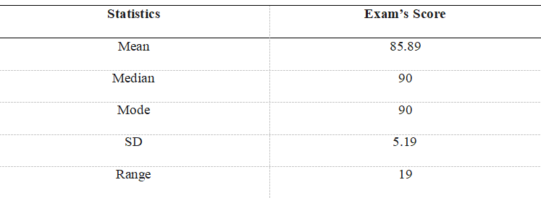

Table 2. Summary Statistics of Exam Scores of Grade 12 Students Studying Solo

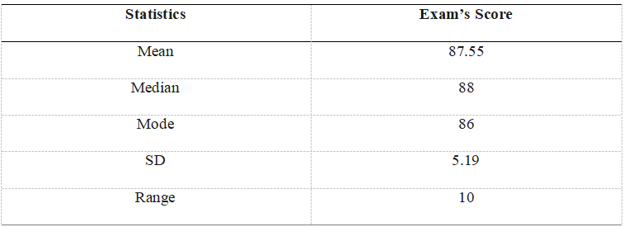

Table 3. Summary Statistics of Exam Scores of Grade 11 Students Studying in Groups

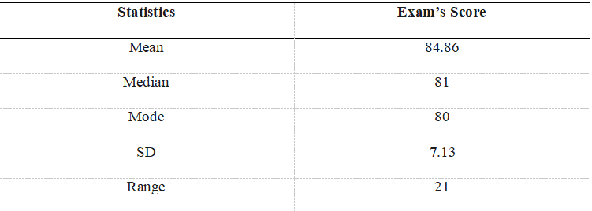

Table 4. Summary Statistics of Exam Scores of Grade 12 Students Studying in Groups
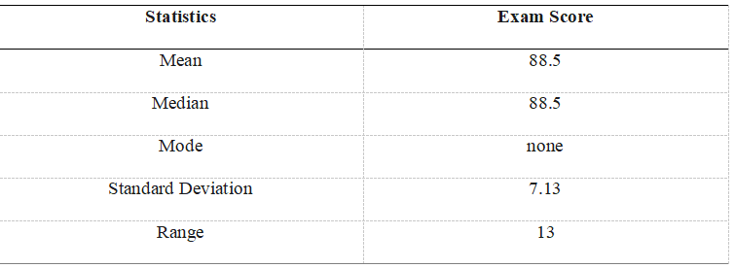

Table 5. Independent Sample T-test Analysis of Grade 11Students’ Exam Scores

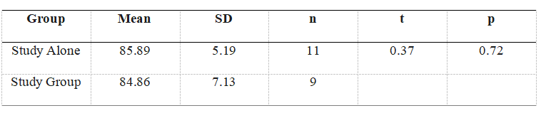

Table 6. Independent Sample T-test Analysis of Grade 12 Students’ Exam Scores

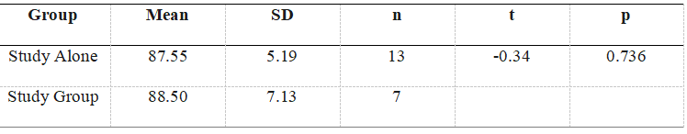

CONCLUSIONS AND RECOMMENDATIONS

The study concluded that there is no statistically significant difference in the academic performance of Senior High School students who engage in group study compared to those who study alone. Although slight differences in mean exam scores were observed, statistical analysis confirmed that these variations were not meaningful.

The findings indicate that students can achieve comparable academic success using either study method. Academic performance appears to depend more on personal learning habits, motivation, and effective time management rather than the choice between collaborative or independent study. It is recommended that students adopt flexible study strategies by combining solo study for individual understanding and group study for discussion and review. Teachers are encouraged to guide students in selecting appropriate study approaches depending on learning objectives and subject requirements. School administrators may also provide environments that support both quiet individual study and collaborative learning spaces.

Future researchers may expand this study by including larger populations, additional variables such as motivation and learning environment, and long-term academic performance indicators.

ACKNOWLEDGMENT

We, the researchers, would like to express our sincere gratitude to the administration of Adventist Medical Center College Academy for granting us permission to conduct this study. We also extend our heartfelt appreciation to our research adviser, teachers, and panelists for their guidance, support, and valuable insights throughout the research process. Finally, we are deeply thankful to the participating students whose cooperation and involvement greatly contributed to the successful completion of this study.

REFERENCE

Almonia, A. L. (2024). Effectiveness of collaborative and individualized learning on the learners’ achievement in science among pupils. Integrated Science Education Journal, 5(2), 115–124. https://doi.org/10.37251/isej.v5i2.482

Ape, A. M., Fedelino, M. B., Galeja, E. A. M., Lopez, M. P. P., & Rebano, K. O. (2022). Effectiveness of group and self-studying on students’ academic performance among selected third year students at Bestlink College of the Philippines. AARESEARCH Journal, 3(2). https://ojs.aaresearchindex.com/index.php/aasgbcpjmra/article/view/13443

Bang-As, E. P., & Toles, E. N. (1998, March 31). Group study vs. individual study: A
comparison of effective study technique. https://repository.upv.edu.ph/items/31db0c52- 59fa-4341-a661-1a17ef5b5fd3

Debjani, L. (2025). Impact of learning approaches on academic performance: A study of individual and group learners in first-year MBBS. European Journal of Cardiovascular Medicine. https://doi.org/10.5083/ejcm/25-01-31

De Weerdt, D., Simons, M., & Struyf, E. (2025). Team teaching or solo teaching? A qualitative evaluation by primary education students. The Journal of Educational Research, 1–27. https://doi.org/10.1080/00220671.2025.2566708

Deutsch, M. (1949). A theory of co-operation and competition. Human Relations, 2(2), 129–152. https://doi.org/10.1177/001872674900200204

Hsiung, C. (2012). The effectiveness of cooperative learning. Journal of Engineering Education, 101(1), 119–137. https://doi.org/10.1002/j.2168- 9830.2012.tb00044.x

Johnson, D. W., & Johnson, R. T. (2021). Learning together and alone. In Routledge eBooks (pp. 44–62). https://doi.org/10.4324/9781003106760-3

Kirschner, F., Paas, F., & Kirschner, P. A. (2009). From cognitive load theory to collaborative loadtheory.https://www.researchgate.net/publication/324757820

KITE E-Learning Solutions, Inc. (n.d.)(2024). Philippine EJournals|. https://www.ejournals.ph/article.php?id Jean Piaget’s theory of cognitive development | History | Research Starters | EBSCO Research. (n.d.).EBSCO.https://www.ebsco.com/research-starters/history/jean-piagets- theory-cognitive-development

Khodabandelou, R., & Karimi, L. (2011). The effect of cooperative and individual learning on academic achievement in information technology fundamental. Sultan Qaboos University House of Expertise.

Lin, C., Barrett, N. E., & Liu, G. (2020). English outside the academic sphere: A mobile-based context-aware comparison study on collaborative and individual learning. Journal of Computer Assisted Learning, 37(3), 657–671. https://doi.org/10.1111/jcal.12514

Mbalamula, Y. S. (2018). Effect of group versus individual assessments on coursework among undergraduates in Tanzania: Implications for continuous assessments in universities. Pedagogical Research, 3(1 https://doi.org/10.20897/pr/85171

Mendoza, K. (2025). Studying In Groups vs. Studying Alone: Which is Better? Oxford Learning. https://oxfordlearning.com/studying-alone-vs-studying-in-a-group/?

Morrison, D., et al. (2026). Effect of peer group activity-based learning on students’ academic performance in chemical bonding. European Journal of Education.
https://doi.org/10.24018/ejedu.2026.7.1.31037

Pai, H. H., Sears, D. A., & Maeda, Y. (2015). Effects of small-group learning on transfer: A meta-analysis.https://www.researchgate.net/publication/273328417

Retnowati, L., Ayres, P., & Sweller, J. (2017). Collaborative learning effects when students have complete or incomplete knowledge https://www.researchgate.net/publication/327015868

Tran, V. D. (2014). The effects of cooperative learning on the academic achievement and knowledge retention. https://www.researchgate.net/publication/313385388

Weldon, M. S., & Bellinger, K. D. (1997). Collective memory: Collaborative and individual processes in remembering. Journal of Experimental Psychology: Learning, Memory, and Cognition, 23(5), 1160–1175. https://doi.org/10.1037/0278-7393.23.5.1160

KITE E-Learning Solutions, Inc. (n.d.)(2024). Philippine EJournals|. https://www.ejournals.ph/article.php?id Jean Piaget’s theory of cognitive development | History | Research Starters | EBSCO Research. (n.d.).EBSCO.https://www.ebsco.com/research-starters/history/jean-piagets- theory-cognitive-development

Zimmerman, B. J. (2000). Attaining Self-Regulation A Social Cognitive Perspective. In M. Boekaerts, P. R. Pintrich, & M. Zeidner (Eds.), Handbook of Self- Regulation (pp. 13-39). San Diego, CA Academic Press. - References - Scientific Research Publishing. (n.d.).

