A study on the influence of AI on time optimization of HR functions

*Rishashri M, MSW HRM student, Madras School of Social Work
**Mr. Vasantha Jayaseelan, Assitant Professor, Madras School of Social Work

Abstract:
This study examines the influence of Artificial Intelligence (AI) on time optimization within Human Resource (HR) functions, focusing on how AI-driven tools enhance efficiency and organizational outcomes. With HR departments increasingly expected to act as strategic partners, the integration of AI helps automate repetitive tasks such as recruitment, payroll, and performance management, thereby reducing time consumption and improving decision-making. Using a descriptive research design, data was collected from 70\ HR professionals in IT companies in Chennai through a structured questionnaire. The study highlights that AI significantly improves time efficiency, enabling HR professionals to focus more on strategic and employee-centric roles. It also addresses concerns related to adoption, ethical considerations, and human acceptance, emphasizing the need for a balanced, human-centered approach. Overall, the research contributes to understanding how AI-powered time optimization can transform HR functions and support organizational effectiveness.
Keywords: Artificial Intelligence, Time Optimization, Human Resource Management

Introduction:
Artificial Intelligence (AI) is the current growing technology in the digital world. It resembles human intelligence through machines or computers. It does everything exactly same as human brain which is carried out through a machine. AI can even bring creativity; problem solving and make decisions. Artificial intelligence can also respond to human beings by understanding them. This advanced technology is going to be the new technological revolution. Before the emergence of Artificial Intelligence, there was the invention of Machine Learning which can make decision and predict based on data given which is dependent on the algorithm. The algorithm can make conclusion based on the human provided data. Machine learning was discovered before artificial intelligence.
Machine Learning are of various types. Some of the Machine Learning types are logistic regression, linear regression, support vector machines, clustering, etc. the type of Machine Learning is chosen based on the type of data they need to predict or make decision. Most popular type of Machine Learning is Neural Network. In neural network the nodes are interconnected which processed together to analyse complex data. The other common Machine Learning is Supervised Learning. It is paired label sets that analyse data.
After Machine Learning, there emerged Deep Learning. Deep Learning is nothing but the extended version of Machine Learning. They have multiple layered neural networks that closely knit together to do the task. They somewhat resemble the decision-making power of the human brain. This Deep Learning technology has many layers and so they are advanced than Machine Learning. Because Deep Learning has a lot of hidden layers, they can make interpretation and take decisions even if the data is not properly given. They can make their own prediction which slightly look the same way in which the human brain works. Most of the AI used in current days have Deep Learning algorithm. Deep learning can be used in areas where we need to make accurate pattern, fast decision and draw relationship even if we have a lot of data.
The advanced model of Deep Learning is Generative AI. This is also known as “Gen AI”. When an individual uses a prompt in Gen AI, they can receive long text, quality images, good video and audio content and even creative contents. This is very convenient and recent form of Artificial Intelligence used by many individuals. These generative models are previously used to analyse data but as times pass by now Gen AI is used to generate data.
Gen AI works on the basis of 3 phases. First a training is been given to the AI to create a fundamental model. This serves as foundation for the AI. The common training model given to most AI is large language model. There are sperate models for images, videos, audios, etc. to train the algorithm, the trainer uses a large number of unstructured raw data. When training is given continuously to the neural network creates a systematic pattern in relation to the data given and based on it the algorithm can create a content autonomously. Then the AI is now capable to generate content by reading the prompt or request given by the individual. The training process in time consuming and expensive, but it is the fundamental in developing any AI and this is a very essential phase. Only when the training is done properly the AI can perform accurately.
Then comes the Tuning. In tuning the AI will be capable enough to adapt to specific application. This is the second phase. Tuning can be done in many ways. Most prominent types of tuning are fine tuning and reinforcement learning with human feedback. In fine tuning the algorithm give specific labelled data. This helps to receive correct answer in the wanted format. This helps in creating more reliable data and so make the AI more efficient. The other type of tuning, which is Reinforcement Learning with Human Feedback (RLHF), here the individual using it gives feedback on the relevance of the content generated by the Artificial Intelligence and based on the feedback the AI can improve itself. This is very simple and easy as people have to talk back to the algorithm by correcting the chatbot.
The Last Phase is Generation and more tuning. This ensures the AI works more accurately and there is no error or at least minimized error. In this phase the developer asses the output to ensure the algorithm gives more accurate and relevant content. It is the phase where evaluation takes place. This is very important in fine tuning the artificial intelligence. Here they also use a unique technique called Retrieval Augmented Generation (RAG) in which the algorithm can rely upon outside source and not just on the data given while training. This helps in more refine and accurate output.

Benefits of Artificial Intelligence:
Artificial Intelligence has lot of benefits in day-to-day life. But some of the common benefits includes doing repetitive task. Artificial Intelligence can automate repetitive digital task such as collection of data, entering and preprocessing. They also assist in better decision making. They help in taking more accurate and reliable data driven decisions. We might forget to consider certain aspects but when using AI, the decisions made are more reliable. And so, the benefit of AI in making decision is very prominent.
Using Artificial Intelligence definitely contribute in minimizing the errors made by humans. Through proper steps and processes they have the ability to reduce the errors that might occur if the same task is done by humans. The algorithm keeps on increasing its accuracy and therefore the errors are reduced. The other important benefit of using Artificial intelligence is, it has zero error. This can be used in diffusing bomb, going to space or can even go deep into the sea. One best example in manufacturing sector is that, AI can be used in the risky production line. They can perform task and reduce human errors and accidents. This is one big benefit of the use of AI.
AI is enthusiastic all the time. They can work 24/7. They usually don’t get tired and so AI can be used efficiently in areas we need work all the time. They can do multi task with minimized errors. Another key benefit is personalization; AI tailors services and recommendations based on user’s behaviour. AI reduces the operational costs and boosts productivity. By automating routine work, AI reduces cost and increases efficiency. AI can be used to improve safety. These are some of the benefits of Artificial Intelligence.

Evolution of Artificial Intelligence
AI has evolved due to advancement of technology. In 1940s to 1950s, Alan Turing, John McCarthy generated an idea of “Machine Learning”. In 1956 the term artificial intelligence was coined by Dartmouth Conference by John McCarthy and his colleagues. This was the beginning for AI research. The early years of AI focused on reasoning, problem saving, simple task and logic theorist. However, due to lack of computational power and practical applications, progress was slow, leading to first “AI winter” in 1970s, when funding and interest in AI research declined. The 1980s saw the rise of “expert systems” that used rules to replicate human decision making in specific domains. Although these systems showed promise, they were rigid and expensive, which led to a second AI winter by the late 1980s. A major shift occurred in the 1990s and early 2000s when researchers began focusing on machine learning – using statistical meths and data driven approaches instead of hard coded logic. This era saw the emergence of algorithms like decision trees, neural networks and support vector machines. The real transformation came in the 2010s with the availability of big data, increased computing power and the advancement of deep learning. Deep learning is a subset of machine learning involving multi-layer neural network. AI systems began achieving impressive results in image recognition, natural language processing and speech synthesis and real-world application of virtual assistants. In recent years, AI has moved towards generative models, capable of creating human like text, images, music and videos. At the same time ethical concerns around bias, job displacement, privacy and misuse of AI have sparked global debates on AI safety, governance and regulation. The current focus is on responsible and explainable AI. A future possibility where machines could exhibit human level intelligence. Overall, AI has evolved from theoretical ideas to becoming one of the most transformative technologies of the 21st century, deeply embedded in our daily lives and continuing to shape the way we work, communicate and live.

Human Resource Management
Human Resource Management is referred to management of organization’s work force. They are responsible for creating and overseeing policies for the workforce. The term “Human Resource Management” was first used in 1900s. human resource is a strategic approach to manage workforce. The main goal of HRM is to effectively use the human resource and enhance their performance to the maximum that they contribute to the organization. The functions of human resource management are aligned in such a way that it effectively uses the human resources in an organisation. It uses strategic approaches to manage workforce.
It is also concerned with policies and governing systems to ensure smooth organisation in the workplace. Since business stated growing and lot of changes has evolved over period there came a need for effective human resource management. They need to look at proper organization of human resource in an organisation. Human resource is an essential department in any organisation since the success of the organisation solely depends on its workforce. Thus, human resource management is an essential role in a business organisation. Earlier human resource management was only for recruitment and payroll but the emerging trends made human resource management focus on strategies for workforce and also to the contribution of success of the organisation. The human resource management functions are evolving continuously.

Functions of Human Resource Management
Functions of Human Resource Management is classified in Managerial functions and Operational functions. The Managerial functions involve in the management activities like Planning, Organizing, Directing and Controlling. Planning is the process of forecasting the future needs and framing steps to prepare to work on those needs. Organizing is the process of creating tasks that aligns with the goals to be achieved. When these tasks are carried out the goals can be achieved. Directing is the process of guiding and motivating to take up task that is aligned with the goals. Employees often lose motivation and therefore it is necessary to guide them whenever necessary, motivate them to reach the goal. Controlling is overseeing what is being carried out and corrections are made whenever necessary to achieve the goal. These are the managerial functions of Human Resource Management. They are called as managerial functions since they are employed to manage the task to achieve the desired goals.
Operational functions of Human resource management comprise of functions that Human Resource carry out. Recruitment is the process of seeking candidates and choosing the right candidate at the right place and at right time. Training and Development is an other operational function of Human Resource Management. It is the process by which training is given to the employees to equip them with skills necessary to do the task. It helps in enhancing the existing abilities. Training and development help in doing the task better and also helps the person to grow professionally. Performance Appraisal is the process to evaluating the performance of the employees and giving them proper feedback. This process helps in improvement of the employees. Performance Appraisal is done on proper intervals. It is very essential to track the improvement or performance lag of an employee. Compensation and benefits is the process of fixing salary for employees and also determine other benefits for a particular role looking at the market value and the role of a particular employee. Employee Relations focus on having a healthy relationship between employer and employee. Human resource information system is using technology to maintain employee records. Every organisation has a unique HRIS software. This helps in maintaining employee records properly. These are the managerial and operational functions of Human Resource Management.

Statement of the problem
In today’s fast and competitive business world organizations are under immense pressure to maximize efficiency, reduce operational costs and enhance productivity. Human Resource departments are now expected to act as strategic partners in driving organizational success. However, many HR functions continue to go down by time consuming and manual processes such as recruitment, payroll, training, and performance management which often results in delayed decision-making and inefficiencies. This creates a barrier in achieving organizational goals and maintaining long-term sustainability.
The emergence of Artificial Intelligence (AI) presents a transformative opportunity for HR functions to evolve. AI-powered tools offer automation, real-time data processing, predictive analytics and intelligent decision-making capabilities. These technologies have the potential to drastically reduce the time spent on repetitive HR tasks, allowing professionals to redirect their focus toward strategic and people-centric initiatives. Despite the growing availability of AI solutions, many organizations especially in developing countries are still in the early stages of adoption or lack a clear understanding of its tangible benefits.
Furthermore, while many studies have examined AI adoption in general business contexts, there is limited empirical research that specifically focuses on how AI-driven time optimization impacts various HR functions and contributes to organizational effectiveness. This lack of specific data and understanding poses a challenge for HR leaders who are uncertain about investing in or relying on AI technologies to enhance their processes.
Another important concern is the human element whether employees and HR professionals feel displaced, empowered, or burdened by AI adoption. While technology may offer speed, its success also depends on the cultural and behavioural acceptance of AI within the organization. Hence, a deeper investigation is needed to explore not only the technical outcomes of AI but also the human response it invokes within HR settings.
Therefore, this study aims to fill this critical gap by assessing the real-time impact of AI-powered time optimization on HR operations and analysing how such optimization translates into improved organizational performance. By doing so, the research intends to offer actionable insights to HR professionals, organizational leaders, and policymakers for making informed decisions about AI integration in human resource management.

Need / Importance / Significance of the study
The importance of this study if focused on demand of the innovation which is the main factor behind the technology growth. Everyone knows time is very precious and we all work towards using the time efficiently. When we use AI in certain functions of Human Resource Management, reduces time and this is really a game changer. This can reduce a lot of time and make the work efficient in very less time and this strengthen HR capabilities. Many organisations understand the benefits of using Artificial intelligence in their regular functioning and few adopt these practices, few delay to adopt or implement. The study focuses on the ways in which Artificial intelligence can support an organisations HR function to transform and create an organization efficiency.
HR professional has multiple roles to look. The handle roles from recruitment to compliance and lack of technological support and thus this consumes a lot of time particularly for an HR professional as they mostly rely on manual tasks. Usage of AI can contribute a lot in time optimization and can provide faster activities and enable the professional to focus more on other roles such as employee engagement and retention strategy building. This strategy of using Artificial intelligence in certain aspects of HR functions that are routine and doesn't require much attention can enable them to save a lot of time and ultimately contribute to organizational effectiveness.
Additionally, this research holds importance for organizational decision-makers who are hesitant about investing in AI due to lack of clarity or fear of job displacement. By showcasing evidence-based outcomes this study can encourage responsible AI adoption that enhances both technological and human potential.
This study contributes to the relatively underexplored field of AI in HR-specific time management. Most literature either discusses AI in broad business contexts or focuses on automation in isolation. This research narrows the lens to examine AI through the specific function of time optimization in HR, which contributes to more studies in this area of study.
Ultimately, this study is significant not only for business growth but also for employee wellbeing and satisfaction. When HR functions become more efficient and strategic, employees benefit from faster services, better communication, and more focused developmental support. Therefore, understanding the role of AI in optimizing time within HR is not just a technological advancement it’s a human centred move toward building better, smarter, and more sustainable workplaces.Review of literature:
Bain (2025) A study by Brain and Company conducted a study on how generative AI is helping Human Resources focused on doing a single task into using strategic way to do the task. Using their Generative AI Workforce Impact Explorer tool saves labour time by 15 to 20% on average across HR functions. HR business partners could save up to 15%, talent acquisition teams up to 20% and HR operations up to 35% of the usual time. These efficiencies allow HR professionals to focus more on other roles such as culture designers and strategic advisers while operational teams can focus more on data analysis. Certain routine activities such as job postings, filtering CVs, scheduling interviews, reducing bias in hiring, summarizing employee engagement, workforce planning and generating actionable HR data like survey analysis and dashboards. The company emphasizes that adopting generative AI isn’t just about automation but represents a strategic way to increase the value of the organization.

Erik (2025) Using artificial intelligence in human resources can help transform organizational functions such as recruitment, employee engagement, performance, and workforce planning. By using AI, machine learning, chatbots, and analytics, it helps streamline administrative tasks, such as resume screening, job description creation, onboarding, and analysis, which helps the HR team reduce time-consuming tasks and focus more on strategic initiatives, focusing on talent development and inclusivity in an organization. At the same time, ethical concerns, such as algorithm bias, data privacy, and governance, are crucial for successful adoption, requiring clear policy and regular audits. It also requires transparency and long-term strategic alignment. Real-world examples show companies are licensing payroll and improving candidate matching, while HR professionals are encouraged to adopt artificial intelligence to support business goals and employee well-being. Thus, using artificial intelligence in human resource management facilitates many time-consuming and repetitive tasks and enables more focus on strategic alignment, which promotes business growth.

Gartner (2025) Generative AI adoption in HR has increased from around 19% in mid-2023 to 61% by January 2025. This leads HR leaders to shift from pilot projects toward strategic deployment by creating new roles like AI product leaders, GenAI experts, HR technologists, establishing an AI centre of excellence and prioritizing high-value applications such as AI agents for service delivery, AI-generated learning content and AI-driven candidate matching. They must also prepare for workforce transformation, as 37% of employees are expected to be affected by GenAI within two to five years, while Gartner predicts a stable overall job count through 2026 and the creation of over half a billion new jobs by 2036, if the organisation adapts responsibly.

HR Convo (2025) The article suggests that incorporating Artificial Intelligence in Human Resource Management can have a significant change in the Human Resource Functions in an organization. This reduces the workload carried by an individual and helps in making more automations thus reducing time. This also helps in making informed decision. AI can be used to screen resumes, Schedule interviews, can assist in providing a personal onboarding experience which can save both time and cost. This article also highlights that AI can also help in tracking employee sentiments, identify pattern in workplace behaviour, it also helps in providing retention strategies. Moreover, repetitive task improves the organizational efficiency and more accuracy in HR operations. Thus, the article highlights the enhance efficiency in using AI in HR functions for time optimization.

IBM (2025) IBM highlights how Artificial Intelligence particularly through its watsonx platform and AI agents is changing HR by automating routine tasks like onboarding, payroll and leave management using chatbots and AI tools freeing HR professionals to concentrate on strategic, human centred roles. Chatbots can reduce time spent on routine tasks by up to 75%, and supports a lot of platforms including Slack, WhatsApp and internal HR systems. IBM’s AI tools these tools adopt transparency, fairness and human overlooking ensuring managers remain decision makers while AI serves as a guide in talent sourcing, bias detection, salary recommendations and pay transparency. The result has shown improvements such as 10% rise in hiring quality and a 33% reduction in attrition.

SHRM (2025) In 2025, AI use in HR has grown sharply. Use of AI now involved in about 43% of HR work compared to 26% last year with the biggest impact seen in recruitment tasks like writing job ads, scanning resumes and finding candidates, which saves time and improves hiring quality. Beyond hiring, AI is being used to automate routine tasks, analyse HR data for better decisions, engage employees, predict future skill needs and proactively find talent. However, experts stress that humans must remain in control to ensure fairness, transparency and legal compliance, especially in decisions affecting people’s careers. To support this, SHRM’s AI and HR initiative promotes combining AI tools with human judgment while encouraging organizations to train employees, communicate openly about AI changes, and build a culture where technology and people work together effectively. This is the how AI can be used in Human Resource practice for better efficiency.

Adecoo Group (2024) The article says that employees using artificial intelligence in their daily routine saves 1 hour per day. Time saving is consistent among industries that use artificial intelligence in their regular daily routine. Artificial Intelligence can be used in such industries that as routine works to be done in regular order time saving is consistent where there is highest number of energy, utility and financial services and low number of industries working on aerospace or defence use artificial intelligence in their operational process. The time saved by using this artificial Intelligence can be used in creative task and also strategic thinking. Use of this can also improve work life balance of the employees and maintain same work load or shift to personal activities. This can bring a proper job satisfaction to employees since there were a lot of time saved because of using this artificial intelligence in routine task. AI is delivering a proper work efficiency across sector is the key information conveyed through this article.

Ali Fenwick et, al (2024) The role of Human Resource Management has undergone a lot of transformation over the past two decades. It has evolved into a more data driven and cross functional approach. In the era of artificial intelligence, HRM now extends into designing systems that enhance process efficiencies, enable advanced analytics and contribute to organizational value creation. The authors outline three phases of AI integration in HR. They are technocratic, integrated and fully embedded. These phases have its own technical, human and ethical challenges. They emphasize the need for human centric design in HR technologies. The paper proposes as a futuristic framework of HR’s strategies and functions need a human-centred approach to bridge humans and machines effectively in the workplace.

Methodology:
3.1. Title of the Study
A study on the influence of AI powered time optimization on HR functions.

3.2. General and Specific Objectives
General objective:
- To examine how AI powered time optimization influences HR functions and organizational outcomes.
Specific objectives:
- To study the demographic profile of the respondents.
- To evaluate the relationship between use of AI in HR functions and time efficiency.

3.3. Field of Study
The study was conducted among HR professionals working in medium and large IT companies located in Chennai. Chennai was chosen because of its dense concentration of firms with HR technologies and the easy accessibility for the researcher.

3.4. Pilot Visit
A pilot visit was conducted with two organizations and an interaction was held with their HR teams to understand current AI use, feasibility of data collection and permission procedures.

3.5. Research Design
Descriptive research design was adopted. Descriptive research design is a systematic methodology used to describe the characteristics of a population, event or phenomenon.

3.6. Selection of Sample
Population/Universe: HR professionals employed in registered IT organization in Chennai.
Sampling frame: HR professionals from IT companies in Chennai.
Sampling technique: Purposive Sampling technique was used. Purposive sampling, also known as judgmental or selective sampling, is a non-probability sampling technique in which researchers select participants based on their knowledge, relevance or expertise concerning the research topic. Purposive sampling because HR professionals who use AI can be more suitable to be the respondents of the study.
Sample size: 100 respondents.
Inclusion criteria: HR professionals in IT company.

3.7. Tools of Data Collection
A self-structured questionnaire based on the objectives.

3.8. Sources of Data
Primary data: Collected directly from HR professionals working in IT sector.
Secondary data: Published literature, articles, research papers, website articles, journals, etc on AI in HR functions.

3.9. Pre-testing
The questionnaire was pre-tested with 10 HR professionals similar to the target sample. Items will be checked for clarity, length and relevance

3.10. Data Collection
Data was collected using printed questionnaire. This will be circulated among the HR professionals working in IT sector to collect data for the research.

3.11. Definition of Terms
Artificial Intelligence is a branch of computer science that focuses on creating systems or machines capable of performing tasks that normally require human intelligence.
Human Resource Management is the process of planning, organizing, directing, and controlling the functions of procurement, development, compensation, integration, maintenance, and separation of human resources to achieve organizational goals effectively.

3.12. Analysis
Data was analysed using SPSS and Microsoft Excel.

3.13. Limitations and Scope of the Study
The study was limited to HR professionals in Chennai, which may restrict generalization. Results were based on self-reported perceptions and so it might vary with different population.

TABLE 1: AGE OF THE RESPONDENTS

S.NO | AGE | FREQUENCY | PERCENTAGE
1 | 18-24 | 25 | 35.7
2 | 25-34 | 45 | 64.3
 | TOTAL | 70 | 100

CHART 1: AGE OF THE RESPONDENTS

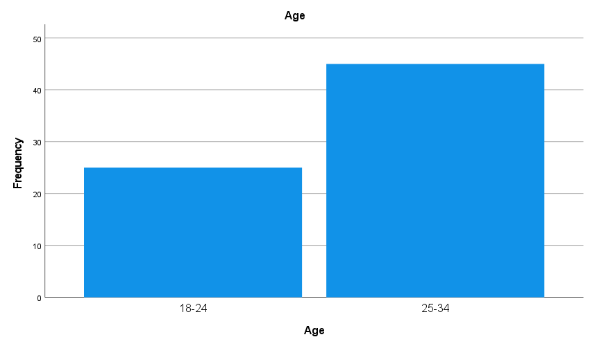

The above table and charts show that majority of the respondents (64.3%) belong to the age group 25-34 age and a small size (35.7%) of the respondents belong to the age group 18-24 age.

TABLE 2: GENDER OF THE RESPONDENTS

S.NO | GENDER | FREQUENCY | PERCENTAGE
1 | Male | 36 | 51.4
2 | Female | 34 | 48.6
 | TOTAL | 70 | 100

CHART 2: GENDER OF THE RESPONDENTS

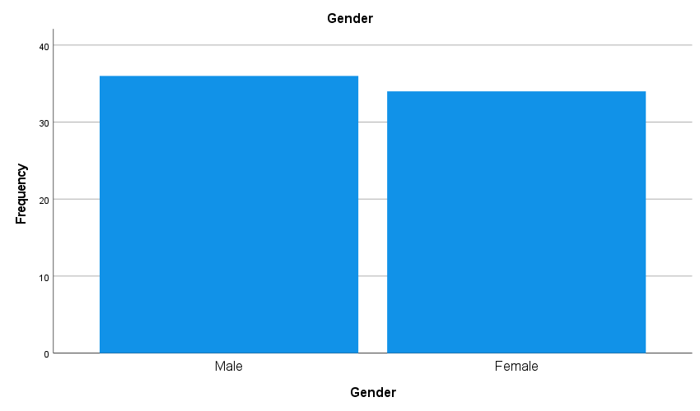

The above table and charts show that more than half of the respondents (51.4%) are Male and almost half of the respondents (48.6%) are Female.

TABLE 3: QUALIFICATION OF THE RESPONDENTS

S.NO | QUALIFICATION | FREQUENCY | PERCENTAGE
1 | UG | 9 | 12.9
2 | PG | 61 | 87.1
 | TOTAL | 70 | 100

CHART 3: QUALIFICATION OF THE RESPONDENTS

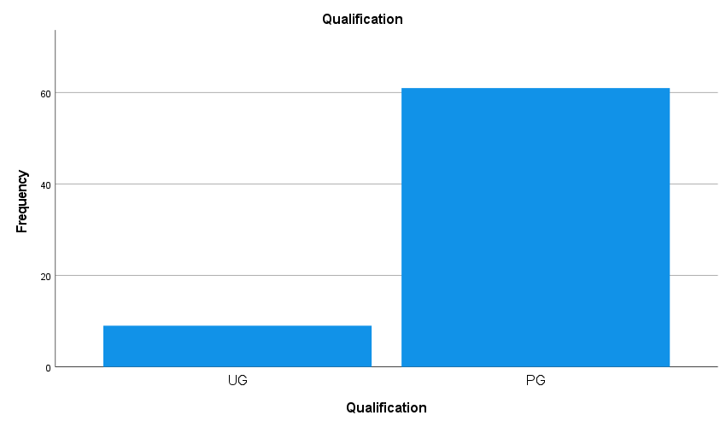

The above table and charts show that a sizeable majority of the respondents (87.1%) has postgraduate qualification and a meagre (12.9%) of the respondents has undergraduate qualification.

TABLE 4: CURRENT ROLE OF THE RESPONDENTS

S.NO | CURRENT ROLE | FREQUENCY | PERCENTAGE
1 | HR trainee | 35 | 50
2 | HR BP | 32 | 45.7
3 | HR manager | 3 | 4.3
 | TOTAL | 7 | 100

CHART 4: CURRENT ROLE OF THE RESPONDENTS

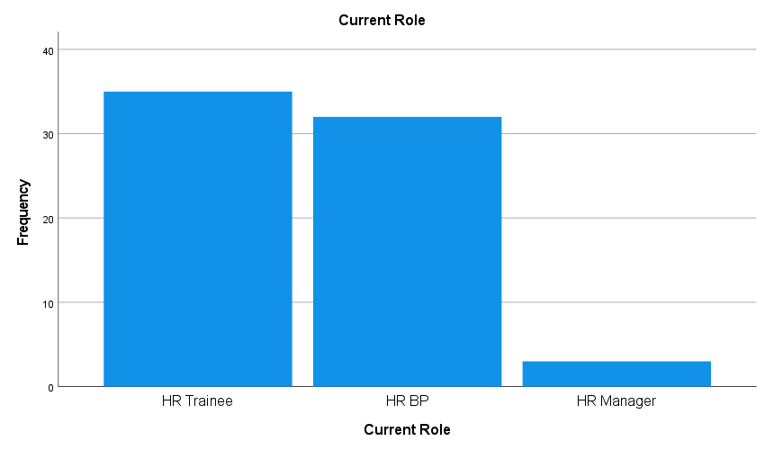

The above table and charts show that half of the respondents (50%) are HR Trainees, almost half of the respondents (45.7%) are HRBP and a meagre (4.3%) of the respondents are HR Manager.

TABLE 5: YEARS OF EXPERIENCE OF THE RESPONDENTS

S.NO | YEARS OF EXPERIENCE | FREQUENCY | PERCENTAGE
1 | Less than 2 years | 22 | 31.4
2 | 2-5 years | 47 | 67.1
3 | 6-10 years | 1 | 1.4
 | TOTAL | 70 | 100

CHART 5: YEARS OF EXPERIENCE OF THE RESPONDENTS
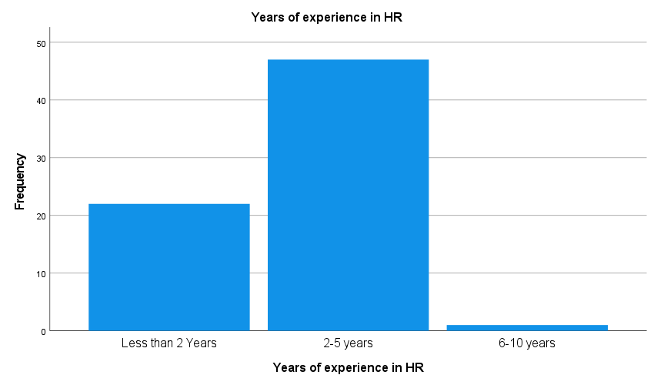

The above table and charts show that majority of the respondents (67.1%) have 2-5 years of experience, a small size (31.4%) have less than 2 years of experience and a meagre (1.4%) of the respondents have 6-10 years of experience.

TABLE 6: WORK MODE

S.NO | WORK MODE | FREQUENCY | PERCENTAGE
1 | On site | 64 | 91.4
2 | Remote | 4 | 5.7
3 | Hybrid | 2 | 2.9
 | TOTAL | 70 | 100

CHART 6: WORK MODE

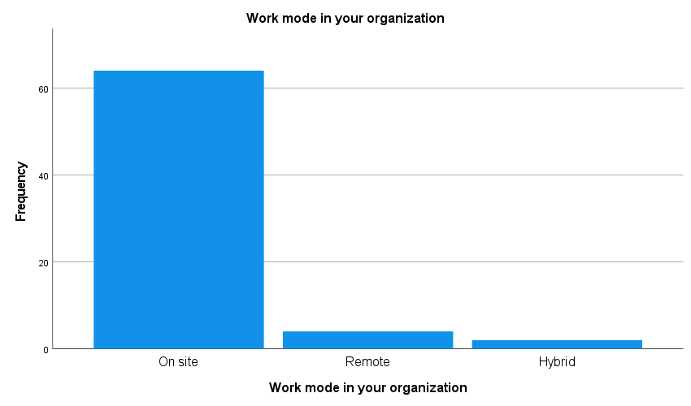

The above table and charts show that almost all of the respondents (91.4%) work on-site, a meagre (5.7%) of the respondents work in remote mode and a meagre (2.9%) of the respondents work in hybrid mode.

TABLE 7: AI HAS SIMPLIFIED MASS CAMPUS HIRING AND LATERAL HIRING IN IT COMPANIES

S.NO | AI HAS SIMPLIFIED MASS CAMPUS HIRING AND LATERAL HIRING IN IT COMPANIES | FREQUENCY | PERCENTAGE
1 | Strongly disagree | 4 | 5.7
2 | Disagree | 1 | 1.4
3 | Neutral | 7 | 10.0
4 | Agree | 38 | 54.3
5 | Strongly disagree | 20 | 28.6
 | TOTAL | 70 | 100

The above table show that more than half (54.3%) of the respondents agree that AI has simplified mass campus hiring and lateral hiring in IT companies, a small size (28.6%) of the respondents strongly agree, a meagre (10%) of the respondents are neutral, a meagre (5.7%) of the respondents strongly disagree and a meagre (1.4%) of the respondents disagree that AI has simplified mass campus hiring and lateral hiring in IT companies.

TABLE 8: AI TOOLS HAVE REDUCED HIRING LIMITATIONS IN IT SECTOR

S.NO | AI TOOLS HAVE REDUCED HIRING LIMITATIONS IN IT SECTOR | FREQUENCY | PERCENTAGE
1 | Strongly disagree | 1 | 1.4
2 | Disagree | 3 | 4.3
3 | Neutral | 7 | 10.0
4 | Agree | 41 | 58.6
5 | Strongly disagree | 18 | 25.7
 | TOTAL | 70 | 100

The above table show that more than half (58.6%) of the respondents agree that AI tools have reduced hiring limitations in IT sector, a small size (25.7%) of the respondents strongly agree, a meagre (10%) of the respondents are neutral, a meagre (49.3%) of the respondents disagree and a meagre (1.4%) of the respondents strongly disagree that AI tools have reduced hiring limitations in IT sector.

TABLE 9: AI-POWERED LEARNING MANAGEMENT SYSTEMS HAVE MADE SKILL UPGRADATION FASTER

S.NO | AI-POWERED LEARNING MANAGEMENT SYSTEMS HAVE MADE SKILL UPGRADATION FASTER | FREQUENCY | PERCENTAGE
1 | Strongly disagree | 3 | 4.3
2 | Disagree | 2 | 2.9
3 | Neutral | 11 | 15.7
4 | Agree | 30 | 42.9
5 | Strongly disagree | 24 | 34.3
 | TOTAL | 70 | 100

The above table show that almost half (42.9%) of the respondents agree that AI-powered learning management systems have made skill upgradation faster, a small size (34.3%) of the respondents strongly agree, a meagre (15.7%) of the respondents is neutral, a meagre (4.3%) of the respondents strongly disagree and a meagre (2.9%) of the respondents disagree that AI-powered learning management systems have made skill upgradation faster.

TABLE 10: AI-ENABLED PERFORMANCE MANAGEMENT SYSTEM HELPS MANAGE REMOTE/HYBRID IT EMPLOYEES EFFICIENTLY

S.NO | AI-ENABLED PERFORMANCE MANAGEMENT SYSTEM HELPS MANAGE REMOTE/HYBRID IT EMPLOYEES EFFICIENTLY | FREQUENCY | PERCENTAGE
1 | Strongly disagree | 2 | 2.9
2 | Disagree | 3 | 4.3
3 | Neutral | 3 | 4.3
4 | Agree | 36 | 51.4
5 | Strongly disagree | 26 | 37.1
 | TOTAL | 70 | 100

The above table show that more than half (51.4%) of the respondents agree that AI-enabled performance management system helps manage remote/hybrid IT employees efficiently, a small size (37.1%) of the respondents strongly agree, a meagre (4.3%) of the respondents is neutral, a meagre (4.3%) of the respondents disagree and a meagre (2.9%) of the respondents strongly disagree that AI-enabled performance management system helps manage remote/hybrid IT employees efficiently.

TABLE 11: RESUME SCREENING THROUGH AI SAVES SIGNIFICANT TIME COMPARED TO MANUAL SCREENING

S.NO | RESUME SCREENING THROUGH AI SAVES SIGNIFICANT TIME COMPARED TO MANUAL SCREENING | FREQUENCY | PERCENTAGE
1 | Strongly disagree | 3 | 4.3
2 | Disagree | 1 | 1.4
3 | Neutral | 10 | 14.3
4 | Agree | 30 | 42.9
5 | Strongly disagree | 26 | 37.1
 | TOTAL | 70 | 100

The above table show that almost half (42.9%) of the respondents agree that resume screening through AI saves significant time compared to manual screening, a small size (37.1%) of the respondents strongly agree, a meagre (14.3%) of the respondents is neutral, a meagre (1.4%) of the respondents disagree and a meagre (4.3%) of the respondents strongly disagree that resume screening through AI saves significant time compared to manual screening.

TABLE 12: CHATBOTS AND AI-BASED EMPLOYEE HELPDESKS SAVE HR TIME IN RESPONDING TO EMPLOYEES

S.NO | CHATBOTS AND AI-BASED EMPLOYEE HELPDESKS SAVE HR TIME IN RESPONDING TO EMPLOYEES | FREQUENCY | PERCENTAGE
1 | Strongly disagree | 2 | 2.9
2 | Disagree | 2 | 2.9
3 | Neutral | 9 | 12.9
4 | Agree | 35 | 50.0
5 | Strongly disagree | 22 | 31.4
 | TOTAL | 70 | 100

The above table show that half (50%) of the respondents agree that chatbots and AI-based employee helpdesks save HR time in responding to employees, a small size (31.4%) of the respondents strongly agree, a meagre (12.9%) of the respondents is neutral, a meagre (2.9%) of the respondents disagree and a meagre (2.9%) of the respondents strongly disagree that chatbots and AI-based employee helpdesks save HR time in responding to employees.

TABLE 13: AI REDUCES TIME IN MANAGING EMPLOYEE ATTENDANCE AND SCHEDULING

S.NO | AI REDUCES TIME IN MANAGING EMPLOYEE ATTENDANCE AND SCHEDULING | FREQUENCY | PERCENTAGE
1 | Strongly disagree | 3 | 4.3
2 | Disagree | 1 | 1.4
3 | Neutral | 10 | 14.3
4 | Agree | 26 | 37.1
5 | Strongly disagree | 30 | 42.9
 | TOTAL | 70 | 100

The above table show that almost half (42.9%) of the respondents strongly agree that AI reduces time in managing employee attendance and scheduling, a small size (37.1%) of the respondents agree, meagre (14.3%) of the respondents is neutral, a meagre (1.4%) of the respondents disagree and a meagre (4.3%) of the respondents strongly disagree that AI reduces time in managing employee attendance and scheduling.

TABLE 14: AI SAVES TIME IN TRAINING EMPLOYEES

S.NO | AI SAVES TIME IN TRAINING EMPLOYEES | FREQUENCY | PERCENTAGE
1 | Strongly disagree | 2 | 2.9
2 | Disagree | 4 | 5.7
3 | Neutral | 7 | 10.0
4 | Agree | 34 | 48.6
5 | Strongly disagree | 23 | 32.9
 | TOTAL | 70 | 100

The above table show that almost half (48.6%) of the respondents agree that AI saves time in training employees, a small size (32.9%) of the respondents strongly agree, a meagre (10%) of the respondents is neutral, a meagre (5.7%) of the respondents disagree and a meagre (2.9%) of the respondents strongly disagree that AI saves time in training employees.

TABLE 15: AI-BASED PERFORMANCE MANAGEMENT SYSTEMS SAVE SIGNIFICANT TIME COMPARED TO TRADITIONAL APPRAISAL METHODS

S.NO | AI-BASED PERFORMANCE MANAGEMENT SYSTEMS SAVE SIGNIFICANT TIME COMPARED TO TRADITIONAL APPRAISAL METHODS | FREQUENCY | PERCENTAGE
1 | Strongly disagree | 2 | 2.9
2 | Disagree | 2 | 2.9
3 | Neutral | 8 | 11.4
4 | Agree | 35 | 50.0
5 | Strongly disagree | 23 | 32.9
 | TOTAL | 70 | 100

The above table show that half (50%) of the respondents agree that AI-based performance management systems save significant time compared to traditional appraisal methods, a small size (32.9%) of the respondents strongly agree, a meagre (11.4%) of the respondents is neutral, a meagre (2.9%) of the respondents disagree and a meagre (2.9%) of the respondents strongly disagree that AI-based performance management systems save significant time compared to traditional appraisal methods.

TABLE 16: AI-BASED COMPENSATION SYSTEMS REDUCE TIME TAKEN FOR SALARY AND INCENTIVE DECISIONS

S.NO | AI-BASED COMPENSATION SYSTEMS REDUCE TIME TAKEN FOR SALARY AND INCENTIVE DECISIONS | FREQUENCY | PERCENTAGE
1 | Strongly disagree | 1 | 1.4
2 | Disagree | 3 | 4.3
3 | Neutral | 10 | 14.3
4 | Agree | 30 | 42.9
5 | Strongly disagree | 26 | 37.1
 | TOTAL | 70 | 100

The above table show that almost half (42.9%) of the respondents agree that AI-based compensation systems reduce time taken for salary and incentive decisions, a small size (37.1%) of the respondents strongly agree, a meagre (14.3%) of the respondents is neutral, a meagre (4.3%) of the respondents disagree and a meagre (1.4%) of the respondents strongly disagree that AI-based compensation systems reduce time taken for salary and incentive decisions.

MAJOR FINDINGS:

To study the demographic profile of the respondents
- Majority of the respondents (64.3%) belong to the age group 25-34 age.
- More than half of the respondents (51.4%) are Male.
- Majority of the respondents (87.1%) has postgraduate qualification.
- Half of the respondents (50%) are HR Trainees.
- Majority of the respondents (67.1%) have 2-5 years of experience.
- Almost all of the respondents (91.4%) of the respondents work on-site.

To evaluate the relationship between use of AI and time efficiency
- More than half (54.3%) of the respondents agree that AI has simplified mass campus hiring and lateral hiring in IT companies.
- More than half (58.6%) of the respondents agree that that AI tools have reduced hiring limitations in IT sector.
- Almost half (42.9%) of the respondents agree that AI-powered learning management systems have made skill upgradation faster.
- More than half (51.4%) of the respondents agree that AI-enabled performance management system helps manage remote/hybrid IT employees efficiently.
- Almost half (42.9%) of the respondents agree that resume screening through AI saves significant time compared to manual screening.
- Half (50%) of the respondents agree that chatbots and AI-based employee helpdesks save HR’s time in responding to employees.
- Almost half (42.9%) of the respondents strongly agree that AI reduces time in managing employee attendance and scheduling.
- Almost half (48.6%) of the respondents agree that AI saves time in training employees.
- Half (50%) of the respondents agree that AI-based performance management systems save significant time compared to traditional appraisal methods.
- Almost half (42.9%) of the respondents agree that AI-based compensation systems reduce time taken for salary and incentive decisions.

SUGGESTION:
The findings of this study indicate that the integration of Artificial Intelligence (AI) into HR functions significantly enhances time efficiency across various operational areas. HR activities such as recruitment, resume screening, interview scheduling, attendance management, payroll processing and responding to routine employee queries are traditionally time-consuming and manual in nature. The adoption of AI-powered systems, including Applicant Tracking Systems, automated attendance software and AI-enabled chatbots can reduce administrative workload and processing time. By automating repetitive and data-intensive tasks, AI enables HR professionals to allocate more time toward strategic functions such as employee engagement, workforce planning, training and organizational development. Thus, AI contributes not only to operational efficiency but also to the strategic contribution of the HR function.
The successful implementation of AI in HR requires organizational readiness and capacity building. The study suggests that management should invest in structured training programs to enhance digital competencies among HR professionals. Resistance to technological change, fear of job displacement and lack of technical knowledge may hinder effective adoption. Therefore, pilot testing of AI tools within specific HR functions, is recommended. This would allow organizations to measure time savings, assess cost–benefit outcomes and address practical challenges before large-scale implementation.
At the same time, ethical and governance considerations must be prioritized while adopting AI in HR practices. Organizations must ensure data privacy, confidentiality and transparency in AI-based decision-making processes. Mechanisms should be established to monitor and minimize algorithmic bias, particularly in recruitment and performance evaluation. Importantly, AI should function as a decision-support system rather than a replacement for human judgment. The human aspects of HR, including empathy, interpersonal communication and emotional intelligence, remain critical for effective people management. Therefore, a balanced integration of AI efficiency with human expertise is essential to achieve sustainable improvements in time efficiency and overall organizational effectiveness.

SUMMARY:
AI-powered time optimization influences Human Resource (HR) functions in organizations. Artificial Intelligence helps HR departments save time by automating routine tasks such as resume screening, scheduling interviews, monitoring attendance and analysing employee performance. By reducing manual work, AI allows HR professionals to focus more on important activities like employee development, engagement and strategic decision-making. The study also highlights that AI improves productivity in HR processes. Overall, the study shows that AI-powered time optimization positively supports HR functions and helps organizations manage their workforce more effectively.

CONCLUSION:
This study concludes that the integration of Artificial Intelligence (AI) in HR functions has a significant positive influence on time efficiency. The findings indicate that AI-powered tools help reduce the time spent on repetitive and administrative tasks such as resume screening, interview scheduling, attendance management, payroll processing and responding to routine employee queries. By automating these processes, HR professionals are able to minimize manual errors, improve accuracy and complete tasks more quickly. As a result, HR departments can shift their focus from operational activities to more strategic and value-added functions such as employee engagement, talent development and organizational planning.

BIBLIOGRAPHY:
Agenda, A. I. (2022). Artificial intelligence in human resources management: A review and research agenda. Pacific Asia Journal of the Association for Information Systems, 14(6). https://aisel.aisnet.org/pajais/vol14/iss6/1/
AIHR. (2025). AI and automation in HR: Impact, adoption and future outlook. https://www.aihr.com/blog/ai-and-automation-in-hr/
Anderson, K. (2024). How artificial intelligence is transforming HR. IHRIM. https://www.ihrim.org/2020/02/how-artificial-intelligence-is-transforming-hr/
Aon. (2024, May 9). How artificial intelligence is transforming human resources and the workforce. https://www.aon.com/en/insights/articles/how-artificial-intelligence-is-transforming-human-resources-and-the-workforce
Ayondo, O., Karaarslan, E., & Narin, N. G. (2024). Artificial intelligence, VR, AR and metaverse technologies for human resources management. arXiv. https://arxiv.org/abs/2406.15383
Belagalla, N. (2025). The role of artificial intelligence in transforming human resource management: Opportunities and challenges. Journal of Information Systems Engineering & Management.
Chowdhury, S. R. (2024). Artificial intelligence enabled human resource management: A review and future research avenues. Archives of Business Research. https://journals.scholarpublishing.org/index.php/ABR/article/view/17050
Colvin, C. (2024, January 23). How AI can save HR time on the job, according to one practitioner. HR Dive. https://www.hrdive.com/news/ai-save-time-hr-tasks/704940/
Convo, H. (2025, May 19). Automating HR processes: How AI is saving time and reducing costs. HR Convo.ai. https://hrconvo.ai/ai-in-hr-process-automation/
Fenwick, A. (2024). Revisiting the role of HR in the age of AI: Bringing humans and machines closer together in the workplace. Frontiers in Research. https://pmc.ncbi.nlm.nih.gov/articles/PMC10822991/
Gartner. (2025). AI in HR: Position your organization for success. https://www.gartner.com/en/human-resources/topics/artificial-intelligence-in-hr
GeeksforGeeks. (n.d.). AI in manufacturing: Revolutionizing the industry. https://www.geeksforgeeks.org/artificial-intelligence/ai-in-manufacturing-revolutionizing-the-industry/
GeeksforGeeks. (n.d.). Evolution of AI. https://www.geeksforgeeks.org/artificial-intelligence/evolution-of-ai/
Google Cloud. (n.d.). What is artificial intelligence? https://cloud.google.com/learn/what-is-artificial-intelligence

