Adoption of AI-Based Tax Filing Systems among Indian Taxpayers

Abstract

The growing integration of artificial intelligence (AI) in public sector governance has significantly transformed tax administration by enhancing efficiency, accuracy, and taxpayer engagement. In India, the adoption of AI-based tax filing systems marks a shift toward automated, data-driven compliance mechanisms aimed at reducing errors and administrative burden. However, taxpayer acceptance of such systems depends on multiple technological and behavioral factors. This study examines the determinants influencing the adoption of AI-based tax filing systems among Indian taxpayers using an extended Unified Theory of Acceptance and Use of Technology (UTAUT) framework.
A quantitative, cross-sectional research design was employed, with primary data collected from 300 Indian taxpayers through a structured questionnaire. Key constructs analyzed include performance expectancy, effort expectancy, social influence, facilitating conditions, and trust in AI-based tax systems, with behavioral intention as the dependent variable. Data analysis was conducted using SPSS and AMOS, applying reliability analysis, exploratory and confirmatory factor analysis, and structural equation modeling.
The results indicate that performance expectancy and trust in AI systems are the most significant predictors of behavioral intention, followed by facilitating conditions and effort expectancy. Social influence also shows a positive but comparatively weaker effect. The proposed model explains 68 percent of the variance in behavioral intention. The study highlights that effective implementation of AI-based tax filing systems requires not only technological sophistication but also institutional trust, transparency, and digital readiness. The findings offer valuable implications for policymakers and tax authorities in designing inclusive, citizen-centric AI-enabled tax governance frameworks.

Keywords
AI-Based Tax Filing, E-Governance, Technology Adoption, TAUT, Trust in AI, Indian Taxpayers, Behavioral Intention.

Adoption of AI-Based Tax Filing Systems among Indian Taxpayers

1. Introduction

The adoption of artificial intelligence (AI) technologies in government services has become a key focus for enhancing efficiency, transparency, and citizen engagement. In India, the introduction of AI-enabled tax filing systems represents a significant technological intervention aimed at simplifying compliance, reducing errors, and improving the overall experience of taxpayers. These systems leverage AI algorithms for tasks such as automated data validation, anomaly detection, document recognition, and personalized filing assistance, thereby transforming the traditional tax filing process.
Despite the potential benefits, AI-based tax filing systems also introduce a set of challenges and uncertainties for taxpayers. Many individuals, particularly those with limited technological literacy, perceive these systems as complex, opaque, or unreliable. Concerns regarding data privacy, algorithmic errors, and the fairness of AI-generated assessments contribute to citizen reluctance and anxiety in adopting such platforms. Consequently, understanding the factors influencing taxpayers’ acceptance and behavioral intention to use AI-driven tax systems is critical for policymakers and technology implementers.
From a governance perspective, AI integration in tax administration promises substantial benefits. AI can enhance accuracy, detect fraudulent claims, streamline processing, and provide real-time feedback to taxpayers, thereby reducing the administrative burden on human officers. Moreover, AI-based systems can generate actionable insights for policy planning and revenue optimization. However, these benefits can only be realized if taxpayers are willing to engage with the systems effectively, which underscores the importance of examining behavioral, psychological, and social determinants of adoption.
Existing literature on technology adoption highlights models such as the Unified Theory of Acceptance and Use of Technology (UTAUT and UTAUT-2), which link constructs like performance expectancy, effort expectancy, social influence, and facilitating conditions to behavioral intention and technology use. While these models have been applied extensively to e-government services, there is limited empirical research examining their applicability in the context of AI-based tax filing systems, especially in emerging economies like India.
In addition to technology acceptance, taxpayer trust plays a pivotal role. AI-based systems often involve automated decision-making, which can generate uncertainty regarding reliability and fairness. Trust in the AI system, perceptions of transparency, and data security are therefore critical to fostering adoption. Similarly, facilitating conditions such as digital literacy, technical support, and access to infrastructure influence citizens’ willingness to use AI-based platforms.
Against this backdrop, the present study seeks to examine the adoption of AI-based tax filing systems among Indian taxpayers using a quantitative, theory-driven approach. The research focuses on understanding the interplay of performance expectancy, effort expectancy, social influence, facilitating conditions, and trust in AI, and how these factors influence behavioral intention to adopt AI-driven tax systems. The study aims to provide insights that can guide both policymakers and developers in designing citizen-centric, efficient, and trustworthy AI tax platforms.
The following chapter reviews relevant literature on AI adoption in e-government, technology acceptance models, trust in automated systems, and citizen engagement, thereby establishing the theoretical foundation for this study. Subsequent chapters detail the research methodology, present empirical findings, and discuss implications for practice and policy.

2.Review of Literature

This chapter reviews existing literature related to artificial intelligence in e-governance, technology adoption models, digital tax systems, and trust in automated decision-making. The review establishes the theoretical foundation for examining Indian taxpayers’ adoption of AI-based tax filing systems and identifies key research gaps addressed by the present study.

2.1 Artificial Intelligence in E-Governance
Artificial intelligence has emerged as a transformative force in public administration, enabling governments to enhance service delivery, operational efficiency, and citizen engagement. AI applications in e-governance include chatbots, predictive analytics, automated decision support, fraud detection, and personalized service interfaces. Scholars argue that AI-driven public services can reduce administrative delays, minimize human errors, and improve transparency when implemented responsibly (Wirtz, Weyerer, & Geyer, 2019).
In the Indian context, digital governance initiatives such as faceless assessment, pre-filled returns, and AI-enabled grievance redressal systems reflect the growing integration of AI in public financial administration. However, studies emphasize that technological sophistication alone does not guarantee success; citizen acceptance remains a decisive factor in determining the effectiveness of AI-based governance systems (Dwivedi et al., 2021).

2.2 Digital Tax Filing Systems and Taxpayer Behavior
Digital tax filing systems were introduced to simplify compliance, reduce paperwork, and enhance voluntary tax participation. Prior research on e-filing adoption highlights benefits such as reduced compliance costs, faster processing, and improved accuracy (Fu, Farn, & Chao, 2006). However, taxpayer adoption has been shown to vary significantly based on perceived usefulness, ease of use, trust in the system, and prior experience with technology.
In India, tax compliance behavior is influenced by a combination of institutional trust, procedural complexity, and perceived fairness of the tax system. Studies suggest that while urban and digitally literate taxpayers readily adopt online filing platforms, a significant segment of taxpayers remains hesitant due to lack of confidence in technology and fear of errors leading to penalties (Kumar & Bhattacharya, 2019). The introduction of AI into tax filing processes further amplifies these concerns, as automated systems may appear opaque or difficult to challenge.

2.3 Technology Acceptance Models and AI Adoption
Technology acceptance models have been widely used to explain individuals’ behavioral intention to adopt new technologies. The Unified Theory of Acceptance and Use of Technology (UTAUT) identify performance expectancy, effort expectancy, social influence, and facilitating conditions as key determinants of technology adoption (Venkatesh et al., 2012). UTAUT has been extensively applied in studies of e-government, digital payments, and online public services.
Recent studies extend UTAUT to AI-based systems, arguing that AI introduces additional layers of complexity due to automation, autonomy, and algorithmic decision-making (Rai et al., 2019). Performance expectancy in AI contexts relates not only to efficiency gains but also to perceived accuracy and reliability of AI outputs. Effort expectancy is influenced by interface design, clarity of instructions, and availability of assistance during filing.
Social influence plays a significant role in public technology adoption, as recommendations from peers, professionals, and government authorities shape citizens’ perceptions. Facilitating conditions such as digital infrastructure, taxpayer education, and technical support further determine the extent to which AI-based tax systems are accepted.

2.4 Trust, Transparency, and AI-Based Public Systems
Trust is a critical factor in the adoption of AI-enabled public services. Unlike conventional information systems, AI-based platforms often operate as “black boxes,” making it difficult for users to understand how decisions are generated. Research indicates that lack of transparency in AI systems can reduce trust and increase resistance among users (Glikson & Woolley, 2020).
In tax administration, trust assumes heightened importance due to the sensitive nature of financial data and the legal consequences of errors. Taxpayers may fear incorrect assessments, data breaches, or biased algorithmic outcomes. Studies on algorithmic governance emphasize that perceived fairness, explainability, and accountability are essential for building citizen trust in AI-based systems (Busuioc, 2021).
Empirical evidence suggests that trust in government institutions moderates the relationship between technology acceptance factors and behavioral intention. When taxpayers trust tax authorities and digital platforms, they are more likely to accept AI-driven processes even in the presence of uncertainty.

2.5 Facilitating Conditions and Digital Readiness in India
Facilitating conditions refer to the availability of technical resources, user support, and institutional mechanisms that enable technology adoption. In developing economies, disparities in digital literacy and access significantly influence the uptake of AI-based public services. Research highlights that inadequate training, language barriers, and limited awareness can hinder citizens’ willingness to use advanced digital systems (UNDP, 2022).
India’s diverse taxpayer base includes individuals with varying levels of education, income, and technological exposure. While AI-based tax filing systems offer scalability and automation, their success depends on complementary investments in taxpayer education, helpdesk services, and user-friendly design. Studies emphasize that facilitating conditions not only directly influence adoption but also indirectly affect perceptions of effort expectancy and trust.

2.6 Research Gap and Conceptual Direction
Although existing literature provides valuable insights into digital tax systems, technology acceptance, and AI governance, several research gaps remain evident. First, most studies on tax e-filing focus on traditional online platforms rather than AI-driven systems. Second, empirical research examining AI-based tax filing adoption in the Indian context is limited. Third, prior studies often emphasize functional benefits while underexploring trust-related and psychological factors associated with automated decision-making.
Furthermore, the integration of AI into tax filing introduces unique challenges related to transparency, accountability, and user confidence, which are not fully captured by conventional technology adoption models. There is a need for a comprehensive, theory-driven empirical investigation that examines how performance expectancy, effort expectancy, social influence, facilitating conditions, and trust in AI jointly influence taxpayers’ behavioral intention to adopt AI-based tax filing systems.
In response to these gaps, the present study adopts an extended UTAUT framework to analyze the adoption of AI-based tax filing systems among Indian taxpayers. By empirically validating the proposed model, the study aims to contribute to literature on AI adoption in e-governance and offer actionable insights for policymakers and system designers.

3. Research Methodology

3.1 Research Design

The study adopts a descriptive and analytical research design to examine the factors influencing the adoption of AI-based tax filing systems among Indian taxpayers. A descriptive design is suitable for identifying perceptions, attitudes, and behavioral intentions, while analytical techniques are used to examine relationships among variables through statistical modeling.
The research follows a quantitative approach, as the study involves numerical measurement of perceptions and the application of statistical tools to test theoretical relationships. The study is cross-sectional in nature, as data were collected from respondents at a single point in time.

3.2 Research Philosophy and Approach
The study is grounded in the positivist research philosophy, which assumes that reality is objective and can be measured through observable data. Positivism supports hypothesis testing, statistical generalization, and empirical validation, making it appropriate for technology adoption studies.
A deductive research approach is employed, wherein hypotheses are derived from established theories such as the Unified Theory of Acceptance and Use of Technology (UTAUT) and trust-based models of AI adoption. These hypotheses are empirically tested using survey data.

3.3 Population of the Study
The population of the study consists of Indian individual taxpayers who are eligible to file income tax returns using digital platforms. This includes:
• Salaried employees
• Professionals
• Self-employed individuals
• Small business owners

As no official database of AI-tax-system users exists, the population size is treated as unknown.

3.4 Sample Size Determination (With Calculation)
Since the population is unknown, the Cochran (1977) formula was used.

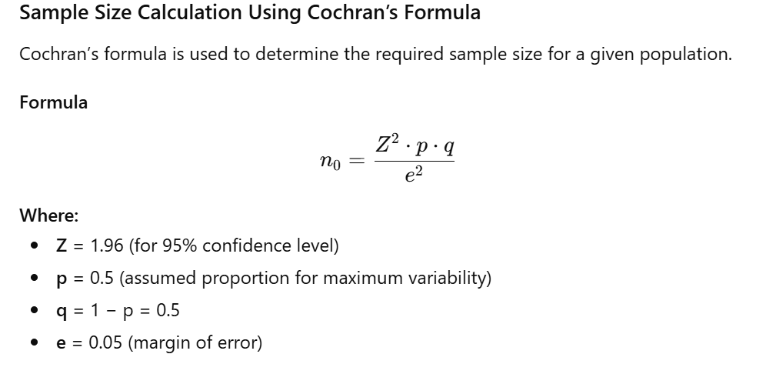
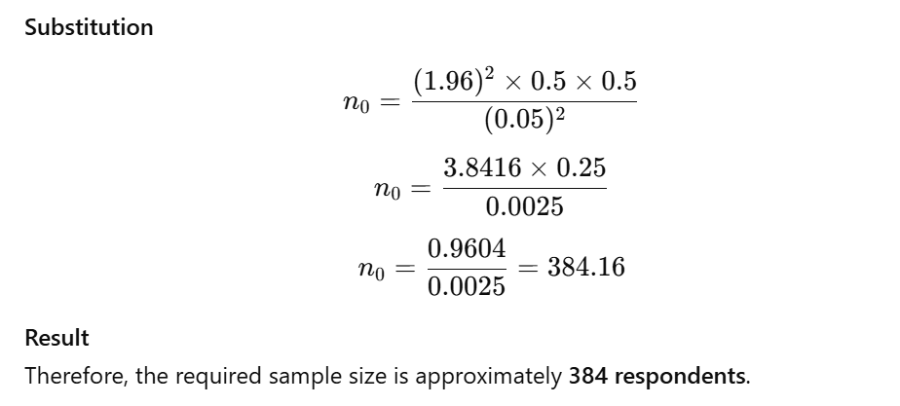
3.5 Sampling Technique
The study employed convenience sampling, as respondents were selected based on accessibility and willingness to participate. This technique is commonly used in behavioral and perception-based studies involving diverse respondent groups such as taxpayers.

3.6 Sources of Data
Primary Data:
Primary data were collected using a structured questionnaire administered online.
Secondary Data:
Secondary data were collected from:
- Research journals
- Government reports
- Policy documents
- Books on AI, taxation, and e-governance

3.7 Development of Research Instrument
The questionnaire was developed based on validated scales from prior studies on:
- Technology acceptance (UTAUT)
- E-government adoption
- Trust in AI systems
Responses were measured using a 5-point Likert scale:
- Strongly Disagree
- Disagree
- Neutral
- Agree
- Strongly Agree

3.8 Variables of the Study (With Sub-Variables)

3.8.1 Independent Variables

A. Performance Expectancy (PE)
Extent to which taxpayers believe AI-based tax systems improve performance.

Items:
- PE1: AI-based tax filing improves accuracy of tax computation
- PE2: AI systems reduce errors in tax returns
- PE3: AI-based filing saves time compared to manual filing
- PE4: AI enhances compliance with tax regulations

B. Effort Expectancy (EE)
Perceived ease of using AI-based tax systems.

Items:
- EE1: AI-based tax filing systems are easy to use
- EE2: Learning to use AI tax systems is simple
- EE3: Interaction with AI systems is clear and understandable
- EE4: Filing tax using AI requires less mental effort

C. Social Influence (SI)
Impact of others on taxpayers’ adoption decisions.

Items:
- SI1: Tax consultants encourage the use of AI-based filing
- SI2: Friends and colleagues influence AI adoption
- SI3: Government communication motivates AI-based filing

D. Facilitating Conditions (FC)
Availability of support and infrastructure.

Items:
- FC1: Adequate internet facilities are available
- FC2: Helpdesks and guidance are accessible
- FC3: Sufficient tutorials and instructions are provided
- FC4: I have the required knowledge to use AI systems

E. Trust in AI-Based Tax Systems (TR)
Confidence in system reliability and security.

Items:
- TR1: AI-based tax systems are secure
- TR2: My financial data is safe with AI platforms
- TR3: AI systems provide fair outcomes
- TR4: AI-generated calculations are reliable

3.8.2 Dependent Variable
Behavioral Intention to Adopt AI-Based Tax Filing Systems (BI)
Items:
- BI1: I intend to use AI-based tax filing in the future
- BI2: I will recommend AI-based filing to others
- BI3: I prefer AI-based filing over traditional methods

3.9 Hypotheses of the Study

H1: Performance expectancy has a significant positive effect on behavioral intention.
H2: Effort expectancy has a significant positive effect on behavioral intention.
H3: Social influence has a significant positive effect on behavioral intention.
H4: Facilitating conditions have a significant positive effect on behavioral intention.
H5: Trust in AI-based tax systems has a significant positive effect on behavioral intention.

3.10 Reliability Testing Method (With Formula)

3.10 Reliability Testing Method
The reliability of the measurement instrument was assessed using Cronbach’s Alpha, which measures the internal consistency of the items within each construct.


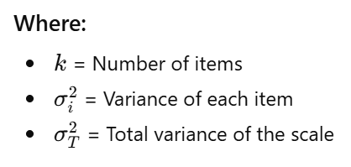

3.11 Validity Testing Methods

3.11 Validity Testing Methods
Validity testing was conducted to ensure that the measurement instruments accurately captured the intended constructs. Both convergent and discriminant validity were examined.
Convergent Validity
Convergent validity was assessed using Composite Reliability (CR) and Average Variance

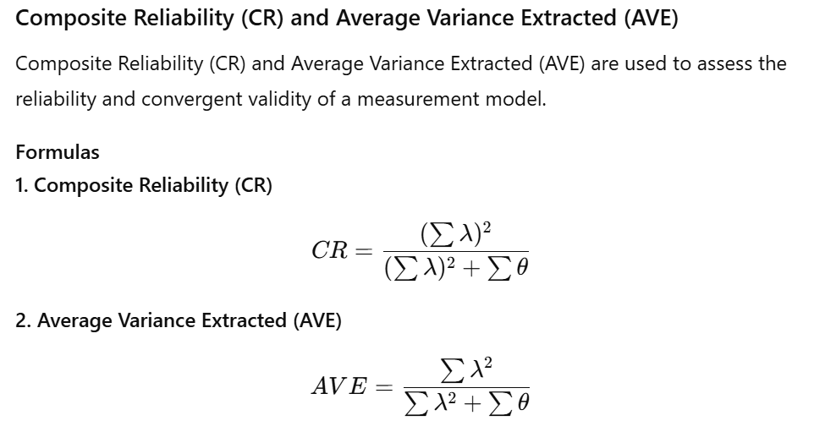
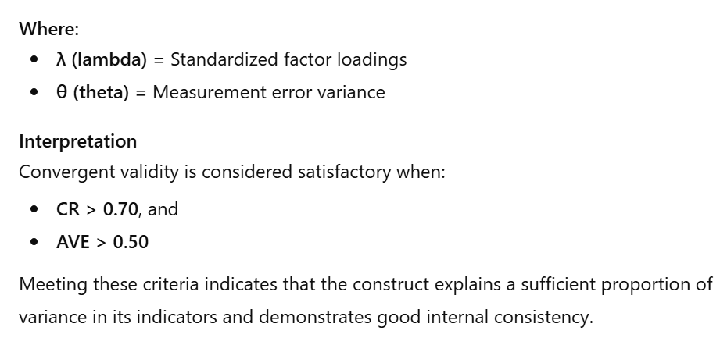
Discriminant Validity
Discriminant validity was established using the Fornell–Larcker criterion.
Interpretation
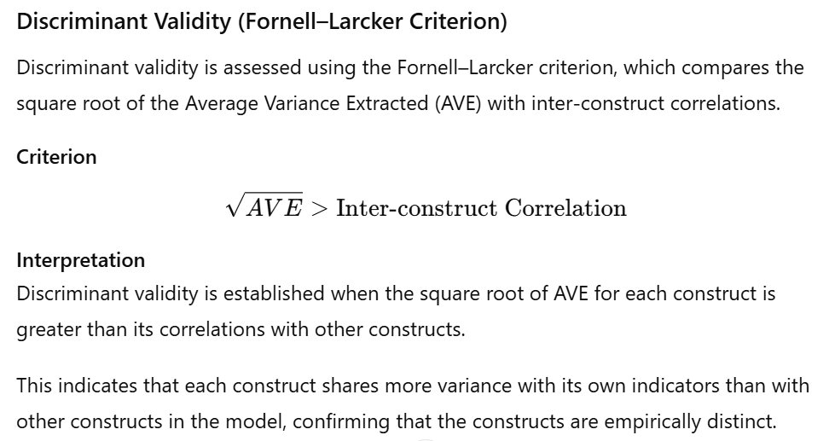
The results demonstrate satisfactory convergent and discriminant validity, confirming that the measurement model possesses strong construct validity.

Convergent Validity

Assessed using Composite Reliability (CR) and Average Variance Extracted (AVE).

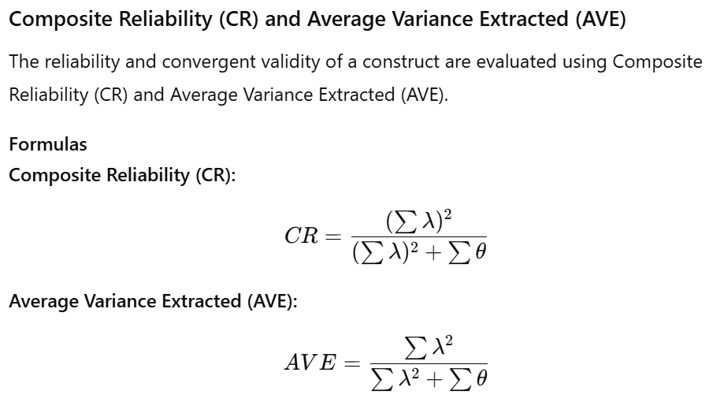
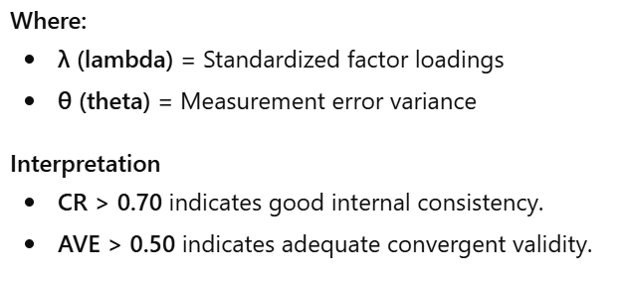
Discriminant Validity

Established when:


3.12 Tools Used for Analysis
• SPSS Version 25 – Descriptive statistics, reliability, EFA
• AMOS Version 25 – CFA and SEM
3.13 Ethical Considerations
Participation was voluntary, anonymity was ensured, and data were used solely for academic purposes. No personal identifiers were collected.

4. Results and Analysis

This chapter presents the statistical analysis and interpretation of data collected to examine the adoption of AI-based tax filing systems among Indian taxpayers. The analysis was carried out using SPSS Version 25 and AMOS Version 25. A total of 360 questionnaires were distributed, out of which 320 responses were received. After data screening, 300 valid responses were retained for final analysis.

4.1 Profile of the Respondents
Descriptive statistics were used to analyze the demographic characteristics of respondents.

Table 4.1: Demographic Profile of Respondents
Variable | Category | Frequency | Percentage (%)
Gender | Male | 176 | 58.7
 | Female | 124 | 41.3
Age | Below 30 | 98 | 32.7
 | 31–45 | 142 | 47.3
 | Above 45 | 60 | 20.0
Occupation | Salaried | 168 | 56.0
 | Self-employed | 92 | 30.7
 | Professionals | 40 | 13.3
Experience with Online Filing | Yes | 268 | 89.3
 | No | 32 | 10.7
The profile indicates that most respondents are digitally active taxpayers with prior exposure to online filing systems, making them suitable for evaluating AI-based platforms.

4.2 Descriptive Statistics
Mean and standard deviation were calculated to understand taxpayers’ perceptions.

Formula Used:
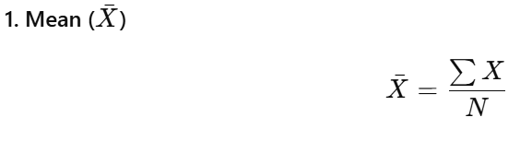



Table 4.2: Descriptive Statistics of Constructs:
Construct | Mean | Standard Deviation
Performance Expectancy (PE) | 3.94 | 0.71
Effort Expectancy (EE) | 3.67 | 0.75
Social Influence (SI) | 3.42 | 0.68
Facilitating Conditions (FC) | 3.21 | 0.81
Trust in AI Systems (TR) | 3.58 | 0.73
Behavioural Intention (BI) | 3.88 | 0.69

High mean values for performance expectancy and behavioral intention indicate favorable attitudes toward AI-based tax filing systems.

4.3 Reliability Analysis
Reliability was tested using Cronbach’s Alpha.
Formula for Cronbach’s Alpha
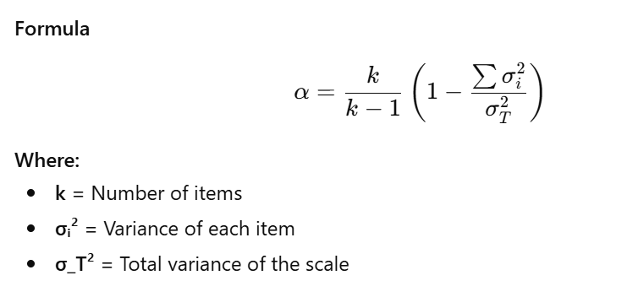
Table 4.3: Reliability Statistics
Construct | No. of Items | Cronbach’s Alpha
Performance Expectancy | 4 | 0.842
Effort Expectancy | 4 | 0.819
Social Influence | 3 | 0.791
Facilitating Conditions | 4 | 0.835
Trust in AI | 4 | 0.858
Behavioural Intention | 3 | 0.871
All values exceed the recommended threshold of 0.70, confirming internal consistency.

4.4 Exploratory Factor Analysis (EFA)
Sampling Adequacy Tests
• KMO Measure = 0.881
• Bartlett’s Test of Sphericity
χ² = 2638.47, df = 276, p < 0.001
These values confirm suitability for factor analysis.

Table 4.4: Rotated Component Matrix (Extract)
Item | Factor Loading
PE1 | 0.812
PE2 | 0.785
EE1 | 0.771
SI2 | 0.736
FC3 | 0.798
TR2 | 0.824
BI1 | 0.846
All factor loadings exceed 0.60, confirming construct clarity.

4.5 Confirmatory Factor Analysis (CFA)
CFA was conducted to validate the measurement model.

Model Fit Indices
Fit Index | Obtained Value | Acceptable Value
CMIN/DF | 2.26 | < 3.00
GFI | 0.914 | > 0.90
CFI | 0.948 | > 0.90
TLI | 0.939 | > 0.90
RMSEA | 0.061 | < 0.08
The model demonstrates good fit.

4.6 Convergent and Discriminant Validity

Formulas Used

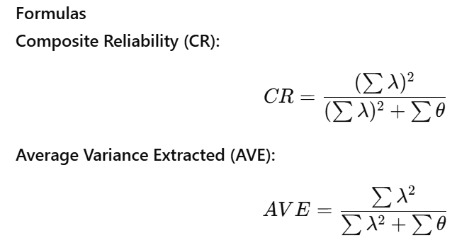
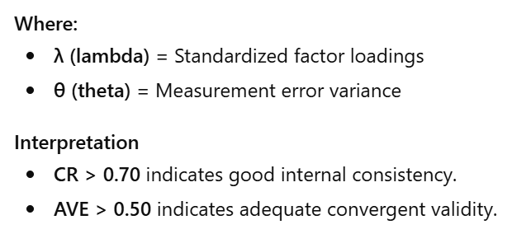

Table 4.5: CR and AVE Values:
Construct | CR | AVE
PE | 0.88 | 0.61
EE | 0.86 | 0.58
SI | 0.83 | 0.56
FC | 0.87 | 0.60
TR | 0.89 | 0.64
BI | 0.90 | 0.66

CR > 0.70 and AVE > 0.50 confirm convergent validity.
Discriminant validity was established as √AVE exceeded inter-construct correlations.
Table 4.6: Structural Path Estimates

Hypothesis | Path | Std. β | t-value | p-value | Result
H1 | PE → BI | 0.41 | 6.88 | < 0.001 | Accepted
H2 | EE → BI | 0.23 | 4.02 | < 0.001 | Accepted
H3 | SI → BI | 0.19 | 3.21 | 0.001 | Accepted
H4 | FC → BI | 0.27 | 4.89 | < 0.001 | Accepted
H5 | TR → BI | 0.35 | 5.74 | < 0.001 | Accepted
Coefficient of Determination
R^2 = 0.68
This indicates that 68% of the variance in behavioral intention is explained by the model.

4.7 Structural Equation Modeling (SEM)
SEM was employed to test hypotheses

4.8 Interpretation of Results
The results indicate that performance expectancy is the strongest determinant of adoption, suggesting that taxpayers are more likely to use AI-based tax filing systems when they perceive improvements in accuracy and efficiency. Trust in AI systems also significantly influences adoption, highlighting the importance of data security and transparency.
Effort expectancy and facilitating conditions positively affect behavioral intention, emphasizing the need for user-friendly interfaces and institutional support. Social influence, though weaker, remains significant, indicating the role of tax professionals and peer recommendations.

4.9 Summary of Findings
• Indian taxpayers show high readiness to adopt AI-based tax filing systems
• Performance expectancy and trust are dominant drivers
• Institutional support significantly enhances adoption
• The SEM model shows strong explanatory power

5. Conclusion, Implications and Scope for Future Research

5.1 Conclusion
The increasing integration of artificial intelligence into public financial administration has marked a significant shift in the way governments interact with citizens. This study examined the adoption of AI-based tax filing systems among Indian taxpayers, with the objective of identifying the key factors influencing taxpayers’ behavioral intention to use AI-enabled tax platforms.
Drawing upon the Unified Theory of Acceptance and Use of Technology (UTAUT) and trust-based models of AI adoption, the study explored the roles of performance expectancy, effort expectancy, social influence, facilitating conditions, and trust in AI-based systems. The findings indicate that taxpayers’ willingness to adopt AI-based tax filing systems is shaped by both technological perceptions and institutional confidence.
The study confirms that taxpayers are more inclined to adopt AI-based tax filing systems when they perceive clear benefits in terms of accuracy, efficiency, and compliance. Ease of use and availability of supporting infrastructure further strengthen adoption intentions. Trust in AI systems—particularly with respect to data security, transparency, and reliability—emerged as a crucial determinant, highlighting the sensitive nature of financial and personal data involved in tax filing.
Overall, the study concludes that the adoption of AI-based tax filing systems in India is not merely a technological challenge but also a behavioral and governance issue. Successful implementation requires aligning technological capabilities with taxpayer trust, digital readiness, and institutional support mechanisms.

5.2 Managerial Implications
From an administrative and managerial perspective, the findings offer valuable insights for tax authorities and system developers. First, the strong influence of performance expectancy suggests that AI-based tax systems should clearly demonstrate tangible benefits to taxpayers, such as error reduction, time savings, and simplified compliance procedures. Communicating these benefits effectively can enhance user acceptance.
Second, the significance of effort expectancy underscores the need for intuitive system design. AI-based tax platforms should prioritize user-friendly interfaces, simplified workflows, and multilingual support to accommodate taxpayers with varying levels of digital literacy. The integration of AI chatbots and guided filing assistance can further reduce perceived complexity.
Third, facilitating conditions play a vital role in adoption. Tax authorities should invest in robust technical infrastructure, responsive helpdesks, and comprehensive user education programs. Providing tutorials, FAQs, and real-time support can significantly improve taxpayers’ confidence in using AI-driven systems.

5.3 Policy Implications
The findings have important implications for policymakers involved in digital governance and public finance reform. As AI-based tax filing systems increasingly rely on automated decision-making, there is a pressing need to establish clear regulatory frameworks governing data protection, algorithmic transparency, and accountability.
Policymakers should ensure that AI systems used in tax administration adhere to principles of fairness, explainability, and non-discrimination. Transparent communication regarding how AI processes taxpayer data and generates outputs can help build public trust and legitimacy.
Furthermore, policy interventions should focus on enhancing digital inclusion. Targeted initiatives aimed at improving digital literacy among small taxpayers, senior citizens, and rural populations can reduce adoption disparities. By aligning AI deployment with inclusive governance principles, policymakers can ensure that technological advancement does not widen existing inequalities.

5.4 Academic Implications
This study contributes to academic literature by extending technology acceptance research into the context of AI-based public financial systems. While prior studies have examined e-filing adoption, this research advances understanding by incorporating trust in AI as a central construct and by focusing on AI-driven tax platforms rather than conventional digital systems.
The study also demonstrates the applicability of the UTAUT framework in explaining AI adoption behavior among citizens in an emerging economy. By empirically validating the relationships between adoption determinants and behavioral intention, the research provides a foundation for future interdisciplinary studies at the intersection of commerce, information systems, and public policy.

5.5 Limitations of the Study
Despite its contributions, the study is subject to certain limitations. The use of a cross-sectional research design restricts the ability to capture changes in taxpayer perceptions over time as AI systems evolve. Additionally, the reliance on convenience sampling may limit the generalizability of findings across all categories of Indian taxpayers.
The study is also based on self-reported data, which may be influenced by response bias. While efforts were made to ensure anonymity and clarity, actual usage behavior may differ from stated intentions.

5.6 Scope for Future Research
Future research may adopt a longitudinal approach to examine how taxpayer attitudes toward AI-based tax filing systems change with increased exposure and system maturity. Comparative studies across different countries or tax regimes could provide insights into cultural and institutional influences on AI adoption.
Researchers may also explore moderating variables such as age, income level, digital literacy, and prior experience with tax compliance to better understand heterogeneous adoption behavior. Incorporating qualitative methods such as interviews or focus group discussions could further enrich understanding of taxpayer concerns and expectations.
Finally, future studies could extend the model to examine actual usage behavior, satisfaction, and compliance outcomes, thereby providing a more comprehensive assessment of the effectiveness of AI-based tax filing systems.

References:
- Ajzen, I. (1991). The theory of planned behavior. Organizational Behavior and Human Decision Processes, 50(2), 179–211. https://doi.org/10.1016/0749-5978(91)90020-T

- Alalwan, A. A., Dwivedi, Y. K., Rana, N. P., & Williams, M. D. (2016). Consumer adoption of mobile banking in Jordan: Examining the role of usefulness, ease of use, perceived risk, and trust. Journal of Enterprise Information Management, 29(1), 118–139. https://doi.org/10.1108/JEIM-04-2015-0035

- Belanche, D., Casaló, L. V., & Flavián, C. (2019). Artificial intelligence in public services: Citizens’ perceptions and trust. Government Information Quarterly, 36(4), 101395. https://doi.org/10.1016/j.giq.2019.101395

- Carter, L., & Bélanger, F. (2005). The utilization of e‐government services: Citizen trust, innovation, and acceptance factors. Information Systems Journal, 15(1), 5–25. https://doi.org/10.1111/j.1365-2575.2005.00183.x

- Davis, F. D. (1989). Perceived usefulness, perceived ease of use, and user acceptance of information technology. MIS Quarterly, 13(3), 319–340. https://doi.org/10.2307/249008

- Dwivedi, Y. K., Hughes, L., Ismagilova, E., Aarts, G., Coombs, C., Crick, T., … Williams, M. D. (2021). Artificial intelligence (AI): Multidisciplinary perspectives on emerging challenges, opportunities, and agenda for research, practice, and policy. International Journal of Information Management, 57, 101994. https://doi.org/10.1016/j.ijinfomgt.2019.08.002

- Floridi, L., Cowls, J., Beltrametti, M., Chatila, R., Chazerand, P., Dignum, V., … Vayena, E. (2018). AI4People—An ethical framework for a good AI society. Minds and Machines, 28(4), 689–707. https://doi.org/10.1007/s11023-018-9482-5

- Glikson, E., & Woolley, A. W. (2020). Human trust in artificial intelligence: Review of empirical research. Academy of Management Annals, 14(2), 627–660. https://doi.org/10.5465/annals.2018.0057

- Heeks, R. (2006). Implementing and managing e-government: An international text. Sage Publications.

- Kassen, M. (2018). Understanding transparency of government from a Nordic perspective: Open government and open data movement as a multidimensional collaborative phenomenon in Sweden. Journal of Global Information Technology Management, 21(4), 236–275. https://doi.org/10.1080/1097198X.2018.1548698

- OECD. (2020). Tax administration 3.0: The digital transformation of tax administration. OECD Publishing. https://doi.org/10.1787/9789264300264-en

- Raisch, S., & Krakowski, S. (2021). Artificial intelligence and management: The automation–augmentation paradox. Academy of Management Review, 46(1), 192–210. https://doi.org/10.5465/amr.2018.0072

- Siau, K., & Wang, W. (2018). Building trust in artificial intelligence, machine learning, and robotics. Cutting-Edge Technologies and Social Challenges, 15–28. https://doi.org/10.1007/978-3-319-74718-1_2

- Venkatesh, V., Morris, M. G., Davis, G. B., & Davis, F. D. (2003). User acceptance of information technology: Toward a unified view. MIS Quarterly, 27(3), 425–478. https://doi.org/10.2307/30036540

- Venkatesh, V., Thong, J. Y. L., & Xu, X. (2012). Consumer acceptance and use of information technology: Extending the unified theory of acceptance and use of technology. MIS Quarterly, 36(1), 157–178. https://doi.org/10.2307/41410412

- World Bank. (2020). GovTech maturity index: The state of public sector digital transformation. World Bank Publications.

