Adopting Digital Technologies to solve waste management issues in rural urban areas: An analysis of Kampala City, Uganda

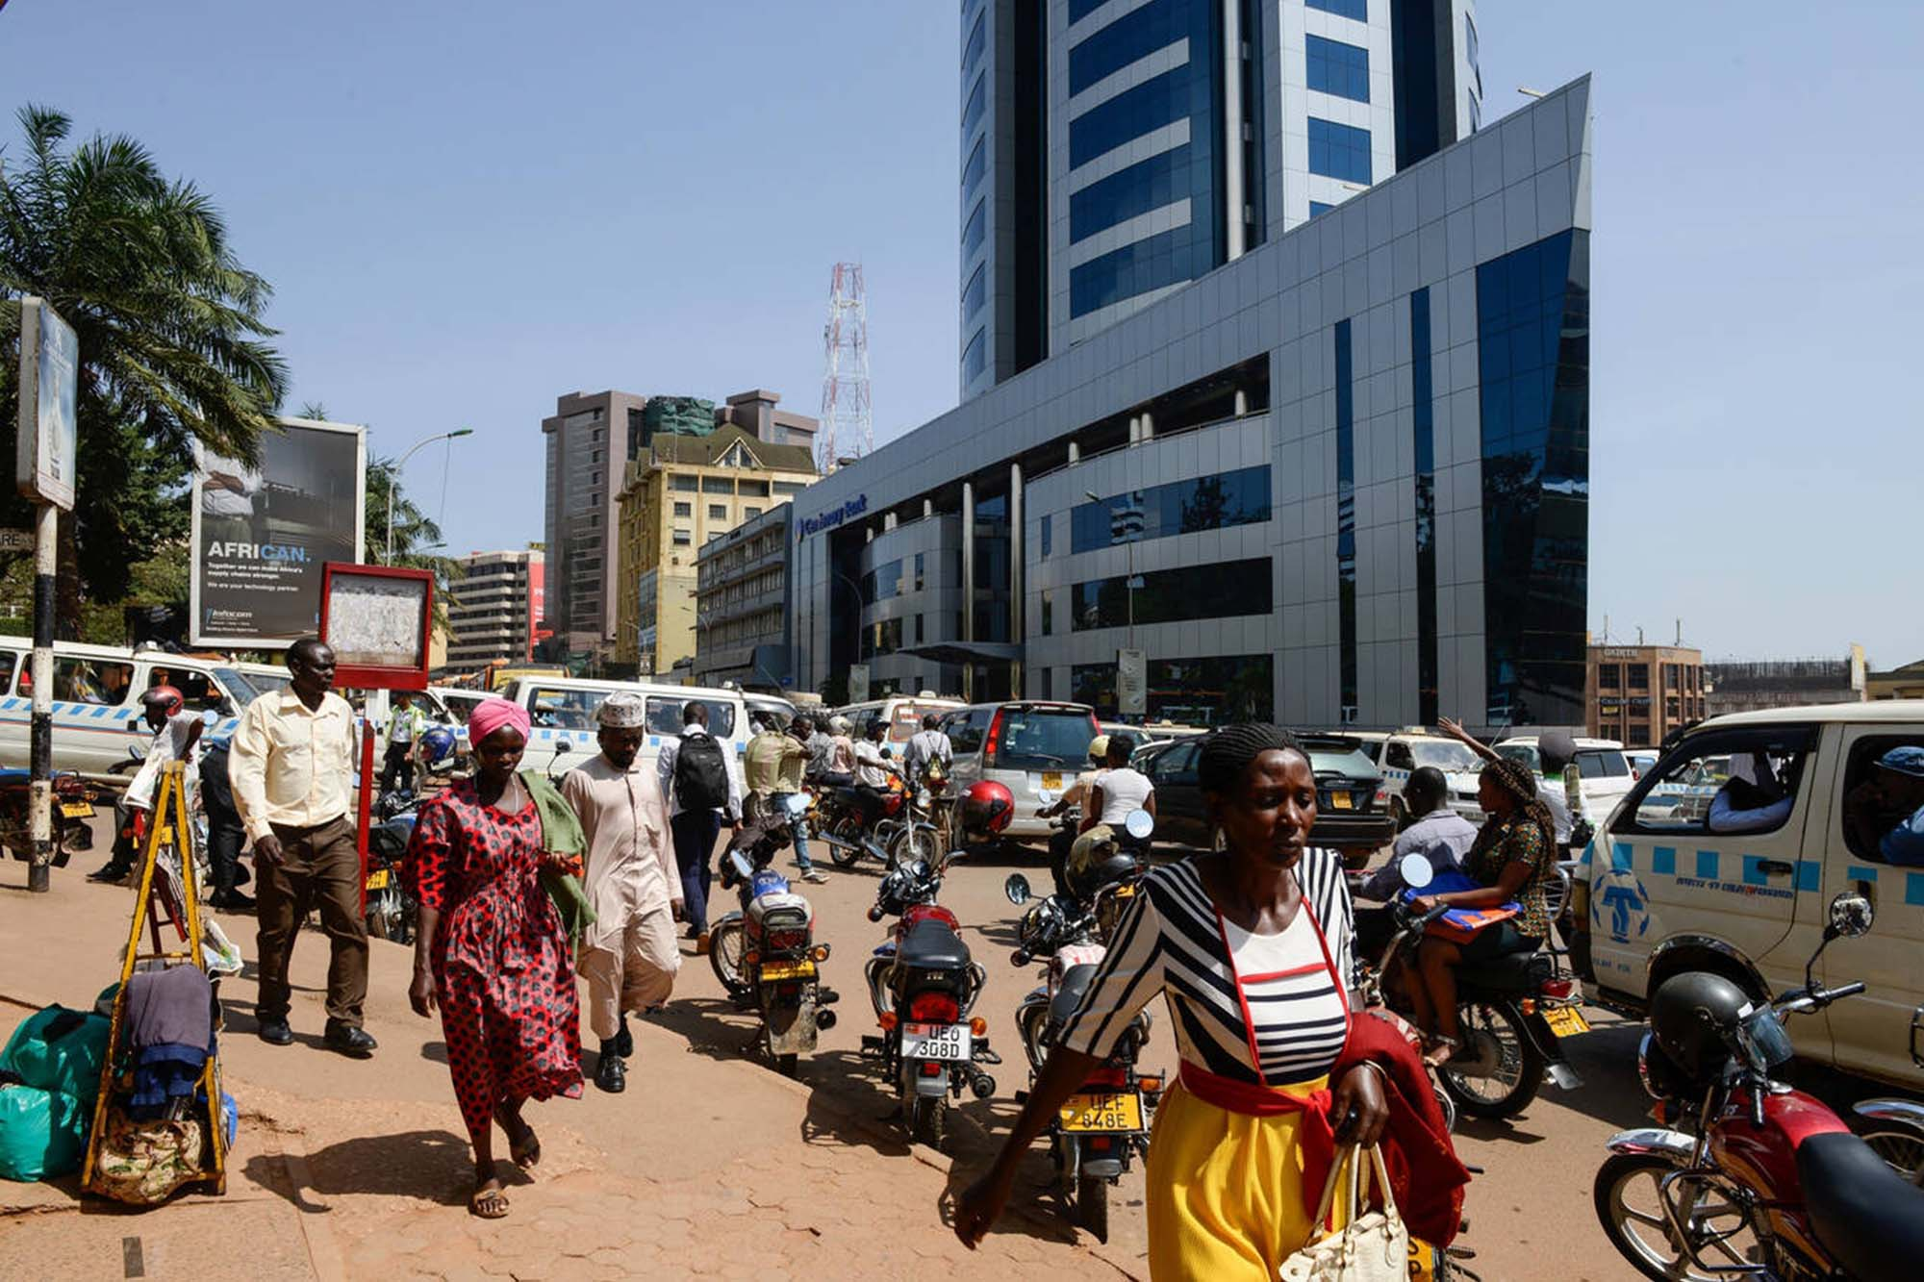
Author: Ahanga Ambrose Hans - PMP
Administration Department, Uganda Management Institute
P.O Box 20131, Jinja Road, Kampala (Uganda)
E-mail: ahangah@umi.ac.ug, ahangah@gmail.com
Tel: (+256)782-650-522, Mobile: (+256)782-650-522

Co-Author: Mbabazi Gorret
Tiger Technical Co. (U) Limited
P.O Box 146893, Kampala (Uganda)
E-mail: mbabazigorett@gmail.com
Tel: (+256)775-400-667, Mobile: (+256)706-129-652

Abstract
Urban waste management presents still major difficulties, especially in fast-growing cities like Kampala. This paper looks at how using digital technologies might help rural-urban communities better manage their waste. Data came from secondary sources, field observations, and questionnaires. With 60% of issues still unresolved, Kampala City struggles greatly with waste management. Just 28,000 tons of municipal garbage find their way to landfills every month, or only 40% of all created waste.
The waste situation in Kampala has gotten rather bad. Previously managing 1,400 to 1,700 tons of waste daily, Kiteezi landfill, the main disposal site for the city, exceeded its capacity since 2009 and collapsed in 2024, with 64% efficiency, the waste collecting system lets most of the trash go unharmed. For locals, this poses serious health hazards as well as environmental ones. Given Africa's urban population is predicted to rise from 470 million in 2015 to 1.2 billion by 2025, the scenario could get more difficult.
This study will explore how digital technologies might transform waste management in Kampala City. To address mounting urban waste issues, smart solutions including loT-enabled recycling bins and mobile apps now link homeowners with collectors. We will discuss how artificial intelligence can be used in recycling centers, how block chains provide waste handling transparency, and how data analytics might forecast waste trends to help to allocate resources more effectively.
Results point to low waste collecting frequency, high organic waste composition, and inadequate recycling programs. Modern ideas come from digital technologies including smart bins, GIS tracking, and mobile waste collecting apps. Proposed to maximize operations is an integrated solid waste management model. The findings of this study end with suggestions for community involvement techniques and digital infrastructure acceptance.
Keywords
Solid Waste Management, Digital Technologies, Waste Collection, Recycling, Kampala City, Urban Waste Challenges.

1.0 Introduction
1.1 Overview
Particularly in fast expanding cities like Kampala, Uganda's capital and economic center, waste generation in urban and peri-urban communities has grown to be a major problem. The volume and complexity of waste produced have sharply changed as the population of the city rises from natural growth and rural-urban migration. Rising residential, commercial, and industrial activity brought about by urbanization all help to produce growing waste streams. If improperly handled, these varied wastes-organic matter, plastics, metals, e-waste, and hazardous materials have significant environmental and public health hazards.
Mostly dependent on manual collecting, transportation, and open dumping, traditional waste management systems are showing to be ever less successful. Many urban authorities, including the Kampala Capital City Authority (KCCA), deal with issues including irregular waste collecting schedules, poor route optimization, inadequate data for planning, little community involvement, and limited financial resources. Waste thus frequently accumulates in inappropriate places, clogging drainage systems, driving the spread of diseases, and so degrading the urban environment.
These inefficiencies are probably going to get worse without the integration of contemporary technological interventions, so endangering the quality of life for city dwellers. For these problems, digital technologies present transforming answers. Real-time tracking of collecting vehicles, waste generation pattern-based optimization of collection routes, and predictive analytics for future waste volumes are just a few of the ways smart waste management systems can enable Modernizing waste management practices depends on technologies including Geographic Information Systems (GIS), Internet of Things (IoT) devices, mobile apps for citizen reporting, and data-driven decision-making platforms becoming ever more important.
Adoption of these digital technologies might transform waste collecting, sorting, treatment, and disposal in cities like Kampala. Moreover, they can encourage community involvement by letting locals report waste hotspots using mobile apps and access knowledge on correct waste disposal techniques. By using technology, one can also support regulatory compliance and openness, so guaranteeing that contractors and service providers provide effective waste management solutions.
In essence, tackling waste generation issues in urban and peri-urban areas such as Kampala calls for a change from conventional approaches to creative, technologically advanced answers. Apart from improving efficiency and effectiveness, digitalization helps to build better, cleaner, healthier, and more sustainable metropolitan surroundings.
1.2 Problem Statement
Among a growing population, fast urbanization, and economic development. Kampala deals with mounting waste levels. Notwithstanding these advances, the city's waste management system has not changed at a commensurate rate, hence there is a notable discrepancy between waste creation and efficient waste handling. In urban and peri-urban areas, limited capacity for timely collection, inadequate transportation systems, poorly managed disposal sites, and insufficient public awareness have all helped to highlight a waste crisis growingly obvious.
Particularly in heavily populated informal communities where waste collecting services are erratic, this situation poses significant public health hazards including the spread of diseases such as cholera, typhoid, and respiratory infections. Environmental damage has also become more severe; open waste disposal blocks drainage systems, causing regular flooding in rainy seasons, and uncontrolled burning of waste fuels greenhouse gas emissions and air pollution. Moreover, unorganized garbage covers public areas and streets, aggravating urban congestion and so reducing the city's aesthetic and financial worth.
Should not be given immediate attention, the waste management issues of Kampala could compromise more general urban development objectives. Adoption of digital technologies offers a chance to modernize the system by changing waste handling methods, improving operational effectiveness, and safeguarding of public health and the environment.
1.3 Goals of the Study
To evaluate Kampala's waste collecting frequency and composition.
To pinpoint the difficulties with waste management.
To investigate how systems of waste management might be improved by digital technologies.

1.4 Validity of the Research
Benefiting urban planners, legislators/policy makers, and environmental preservationists, this study will help to design a sensible, technologically supported waste management system for Kampala
2.0 Current Waste Management Challenges in Kampala City
Waste management challenges facing Kampala City compromise public health and environmental responsibility. Waste generation and population increase go hand in hand; for every percentage increase in population, waste produced almost exactly increases [1]. Waste generation from 0.26 to 0.47 kg/capita/day has been pushed by this correlation. From 227,516 to 481,081 tons [1], annual waste totals have surged by 48%.
2.1 Frequency of Waste Collection and Disposal
Division | Frequency (times per week)
Central | 4
Nakawa | 3
Rubaga | 2
Makindye | 2
Kawempe | 1
Graph: Waste Collection Frequency per Division
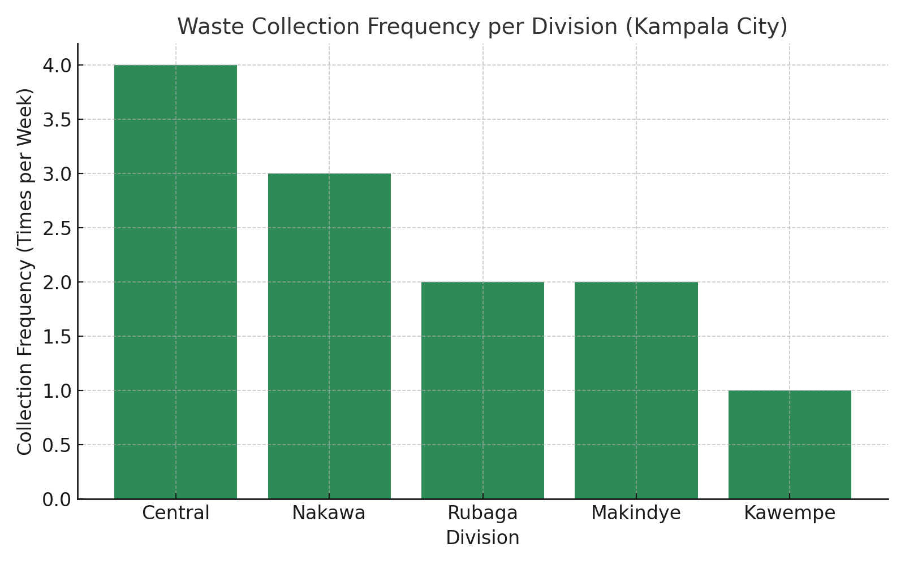
2.2 Overwhelming waste generation rates and collection gaps
Kampala's garbage situation has gotten to be rather serious. From 30% to 64% [1], collection efficiency rises; still, the city produces almost 2,500 tons of trash every day. Just 1,200 tons [2] are gathered by garbage trucks Serious environmental hazards arise from the uncollected garbage ending up at illegal dump sites and drainage channels.
Every city division manages different waste levels. With 5,120 tons monthly, the Central Division leads the list; Nakawa Division ranks lowest at 3,472 tons [1]. Living in informal settlements presents the most difficulties since they usually turn to open dumping or burning without appropriate collecting systems [3].
Roads filled with potholes slow down transportation
- Urban sprawl makes many areas hard to reach
- Private Several factors create these collection gaps
- companies don't stick to collection schedules
- Refuse skips and collection points sit too far from homes
Residents claim sometimes contracted waste collectors fail to show up for a month even after payment [2]. This unreliable service encourages households to dispose of trash incorrectly, so aggravating environmental issues.
2.3 Limited technological integration and infrastructure
The waste management system of Kampala requires immediate attention. The primary disposal site for the city, the Kiteezi landfill, filled beyond capacity in 2015. Still, daily intake of garbage exceeds 1,200 tons [1]. This overuse affects surrounding towns and results in garbage leaking into subterranean water [1].
Changing seasons bring more issues for the landfill. While dry seasons produce dust that aggravates workers and residents nearby, rain makes roads unusable [4]. The site does not adequately treat leachate, which contaminates nearby flora and animals and pollers water supplies [4].
One of Kampala's main challenges still is waste separation. People hardly separate recyclable products at home, thus the city recycles just 4% of its waste [1]. Since collection handlers mix separated and unseparated waste together, everything must once more be sorted at the landfill [3]. This fast fills disposal sites and makes recycling more difficult.
Though it lacks the means to reach this target, KCCA wants to manage 85% of produced waste by 2025 [3]. recyclable items head straight for disposal sites without transfer stations [5]. Digital monitoring systems that might simplify tracking and collecting are also much needed in the city.
2.4 KCCA - Kampala City Council Authorities' financial limitations
Waste management consumes roughly 20% of Sub-Saharan African city budgets, including those of Kampala. This makes extra investment difficult [1]. As waste volumes increase faster than accessible resources, costs keep rising [5].
Waste collection expenses most affect low-income households. For three bags a week, premium collection services run roughly UGX 30,000 (USD 8.21) monthly. Monthly basic "bring-to-truck" services run between UGX 3,000-5,000 (USD 0.82-1.37). Many households in unofficial communities cannot afford these costs [2].
Results of KCCA's public-private cooperation approach are mixed. In wealthier areas, private operators now manage one-third of gathered waste [6]. They do, however, operate without exclusive zones, thus several collectors serve the same streets [6]. Limited resources make hiring technical staff and waste managers challenging. Data collecting and service planning are thus impacted [4].
By means of private sector engagement and possible commercial use of waste products, KCCA strives to enhance solid waste management [6]. Though we still have a long road ahead, we can build on our advancement. The city still struggles with public knowledge of appropriate waste management, infrastructure, and institutional capacity [3].

3.0 Digital Monitoring Systems to Capture Real-Time Waste
Through up-to-date monitoring systems, digital technology offers reasonably priced solutions to handle solid waste management issues in Kampala. By offering accurate data, these technologies enable to close important waste collecting gaps. They maximize paths and help to make better decisions grounded on data.
3.1 Waste bins with IoT enabled fill-level sensors
Modern smart bins feature complex sensors that track fill levels all through the day. These sensors gauges' distances inside containers using ultrasonic technology. This lets one track bin capacity exactly [7]. Beyond fill levels, the sensors compile information. They generate 3D topology maps of bin contents [8] by detecting bin orientation, temperature changes. Early warning systems created by this thorough surveillance help to prevent littering issues and overflowing garbage [7].
Smart sensors send data over Sigfox, NB-IoT, LoRaWAN, and GPRS [3] among other loT networks. This builds an ecosystem whereby physical garbage containers interact with central management systems. The end effect is a linked network sharing vital information [1].
Global estimates indicate that smart bin numbers will reach 2.4 million by 2025, thus the market for smart bins is expanding faster. This shows a 29.8% [1] increase rate of growth. Within six months of smart bin installation, Wyndham City in Australia cut garbage truck trips by 80%.
3.2 GPS tracking for effective garbage truck collecting and navigation
GPS fleet tracking systems are altering waste collecting processes. These systems real-time track street sweepers, trash trucks, and other maintenance vehicles [5]. Authorities in waste management get significant operational data including:
- Preventive notifications and maintenance requirements
- Approaches of fuel consumption
- Driver conduct and route adherence
- Vehicle locations and active or idle state
With this visibility, fleet managers can better decide how resources are allocated and where to route. Should a collection truck fail to maintain service, a nearby available vehicle can rapidly take over [5].
One especially noteworthy advantage of GPS tracking is route optimization. By means of data analysis from smart bins and traffic patterns, these systems determine the most effective collecting paths [1]. Trucks can concentrate on areas near almost full bins rather than adhering to set routes that might call for gathering half-empty bins. One of waste collecting's main costs, fuel consumption is cut by this smart routing [5]. Through performance issue alerts, GPS tracking also helps to manage maintenance. Businesses learn about vehicle condition and can address issues before breakdowns start [5]. This proactive strategy lowers repair costs and increases the lifetime of vehicles [9].
3.3 Waste management authorities' data visualizing dashboards
Powerful cloud-based dashboards used in modern waste management systems help to convert raw sensor and GPS data into valuable knowledge. These instruments enable authorities to arrange, track, and plan daily waste collecting operations [3].
On interactive digital maps with color-coding for fill levels, the dashboards display all under monitored bins [3]. Authorities can view information on every bin including capacity, waste type, last measurement, GPS location, and collecting plans [3]. This real-time perspective points up areas requiring quick attention. By means of historical data, these systems can forecast when particular bins would reach capacity. This lets managers set ahead of time collections [3]. Advanced systems find ways to improve by comparing planned against actual paths [3].
Performance metrics of the dashboards enable authorities to review important indicators including average fill rates at collection time, diversion rates, and collecting frequencies [3]. Many systems stress pickups of bins less than 80% full in order to maximize timing for collecting [3]. Together, smart bins, GPS tracking, and data visualization build a comprehensive digital monitoring system addressing waste management issues in Kampala. The system closes holes in collecting and guarantees timely service. It maximizes limited infrastructure by means of efficiency gains. By means of improved routing and resource use, the system also reduces operating expenses, so relieving financial burden.
4.0 Mobile Applications Revolutionizing Urban Waste Collection
For cities with significant smartphone usage, mobile apps have transformed waste management. These tools link neighbors straight to service providers. Consequently, the simplified and more dependable collecting process produced by this approach surpasses conventional systems
4.1 On-demand waste collection apps connecting residents with collectors
These days, mobile platforms are efficient instruments to address issues with waste collecting in cities. Location tracking allows apps such as WasteBazaar to link local waste collectors and haulers with city dwellers [10]. Regardless of the municipal collecting plans, this on-demand system will react fast to waste management needs. The convenience really makes a difference. Users are free to ignore set plans that might not fit their needs. These systems let them request services right away as needed. Real-time dumpster rental quotes from Thumbster let builders place orders any time [11]. Within 24 hours, RTS picks up unanticipated trash ranging from construction waste to furniture [12]. These tools serve purposes beyond only convenience. They design formal structures that attract once excluded stakeholders. Waste Bazaar links consumers, small businesses, and unofficial waste workers into its formal value chain [10]. If you have been working outside of coordinated waste management systems, this strategy increases service delivery and generates employment.
4.2 Integrating digital payments for waste services
For independent haulers and small companies especially, cash transactions dominated conventional waste management [13]. Tracking, verifying, and financial management suffered as a result. These problems can be resolved with digital payments today.
Modern waste management apps support multiple payment methods:
- Direct debit from bank accounts through ACH or PAD systems
- Credit or debit card processing
- Digital wallet options including Venmo, PayPal, Apple Pay, and Google Pay[14]

Digital solutions benefit both providers and customers. Combining payment methods with processors on one platform helps waste management businesses maximize their operations [6]. They are not required to manually enter transactions on several systems. Everything rests in one spot [6]. Consumers reap just as many advantages. Mobile tools enable them to interact with waste management businesses anywhere. They can view collecting schedules, check their account status, or get support [15]. Among other digital chores, residents find handling their garbage services simple.
4.3 User comments systems raising the caliber of services
Urban waste management benefits most when users share correct information and participate Mobile apps enable this by means of clever feedback systems enhancing the quality of services.
Recycle Coach lets neighbors interact with city officials personally. The problem-reporting features of the app track location so users may document illegal dumping or missed collections [16]. They can post images providing cities precise information on service issues [16].
Education depends much on these feedback systems. Mobile apps alert users about particular rules, contamination problems, and recycling practices [17]. Many apps involve users and assist them in understanding appropriate recycling by using games, quizzes, or tutorials [18]. Better awareness and knowledge retention follow from this approach [18].
To keep becoming better, the apps also compile useful information. Authorities of waste management can investigate user involvement, comments, and trends in recycling [17]. This evidence-based knowledge enables them to improve their approaches for serving metropolitan areas. Mobile apps provide Kampala's waste management problems a workable, growing answer. They establish channels of feedback, simplify payments, and link all the people engaged. These digital solutions fit more perfectly the problems of urban waste.
4.4 Effective Waste Transportation: Smart Route Optimization
Fifty to seventy percent of all waste management costs go toward transportation. Creation of environmentally friendly urban waste systems depends much on route optimization [4]. Smarter transportation options are needed for the waste collecting issues in Kampala City in order to lower running costs and raise service quality.
4.5 Dynamically planned routes powered by artificial intelligence
Effective route planning determines whether waste collecting succeeds or not. Adaptive systems that maximize collecting depending on container fill patterns, vehicle capacity, and operational constraints have replaced set collecting schedules by artificial intelligence algorithms [2]. These sophisticated systems prioritize full containers using the Vehicle Routing Problem (VRP) framework and include partially filled ones for best efficiency [19].
Particularly effective are deep reinforcement learning methods. Travel distances, container overfilling, and truck overloading (2) are three main metrics they simultaneously minimize The outcomes are remarkable, one case study revealed an artificial intelligence-powered planning system developed ideal paths in under five seconds, enabling rapid adaptations [2]
These sophisticated routing algorithms balance several complex factors
- Container fill levels and patterns
- Truck capacity limitations
- Driver schedules and constraints
- Historical collection data
- Municipal service requirements
Traditional fixed-route collection wastes resources on needless trips to half-full containers. Al-powered systems direct resources where they matter most
4.6 Study of traffic patterns lowering fuel consumption
Waste collecting effectiveness suffers in Kampala from traffic congestion. Smart routing systems search traffic patterns and waste bin locations to design ideal collecting paths avoiding congested areas [20]. Test implementations show encouraging results with an 11.3% drop in daily travel distance per garbage truck [21].
An important outlay in waste management is fuel [4]. By better planning, smart routing systems including traffic data can help to reduce these expenses.
Modern systems mix agent-based modeling with GIS. By functioning as an intelligent agent in a multi-agent system, every traffic participant helps to enable comprehensive traffic analysis [21].
Eco-routing strategies look beyond distance alone to increase fuel economy. Good driving habits including proper clutch use, engine management, and low idle time can save 3-5 liters of fuel per 100 km according to research [22]. Applications in smart routing follow these ideas. Trucks empty and lighter help to increase fuel efficiency by starting their collecting paths at their farthest points [23].
4.7 Collection's real-time adjustment features
Systems of route optimization show great adaptability to changing surroundings. Modern systems use traffic feeds, GPS, and loT sensor data-up to-date to change paths during active collecting [24]. These variations explain unexpected traffic, sudden road closures, or vehicle problems [25].
To reduce waste and preserve service quality, the technology recalues paths depending on present conditions [25]. Turn-by-turn navigation, traffic alerts, and job updates let collection drivers access updates via mobile apps. This makes following best paths simple even as they evolve [26].
This adaptable strategy guarantees trucks visit bins at the appropriate moment instead of adhering strictly to timetables. Studies reveal these systems can reduce collecting distances by 41%, so saving almost 500 km yearly in one case 121. About 250 kg distance reduced fuel use and carbon emissions [2], this decrease in Similar sophisticated systems in Kampala could address operational and environmental issues as well as change waste transportation efficiency.
5.0 Block Chain Technology for Open Waste Management
Systems of waste management all around have transparency issues. Nobody really knows what happens to garbage following points of collection. By means of permanent digital records tracking waste movement, block chain technology offers a solution. Through improved responsibility, this invention could change Kampala's solid waste practices.

5.1 Digital waste tracking from collecting to disposal
Acting as a shared digital ledger, a block chain logs transactions concurrently on several computers. Once these records are created, none can alter them. This makes it ideal for waste tracking in which openness counts most. From the time waste is generated until its disposal, the technology logs every step.
Digital asset tokens relate to particular waste products. These tokens provide digital identity you can monitor anywhere for physical waste. To update the block chain, operators scan QR codes or RFID tags on garbage cans. Handling details, storing location data, and processing information, the system manages location.
Helsinki is updating their waste management using block chains now. Part of their climate action plan, the city wants to address supply chain tracking problems. By means of instantaneous monitoring, their system enables businesses and individuals to take more accountability.
5.2 Smart contracts for recycling verification
Block chains enable smart contracts, so enabling automation beyond simple tracking. These are self-running agreements entered into the system free from middlemen.
In waste management, smart contracts serve multiple important purposes:
- Check proper waste disposal before paying service providers
- Make sure environmental rules are followed automatically
- Give tokens as rewards for proven recycling
- Help recycling companies work with processors to share materials
Smart contracts could allow Kampala's recycling facilities to show that items wind up in recycling rather than landfills. This is important since every day Americans toss roughly 728,000 tons of trash into landfills. Similar issues confront growing African cities.

5.3 Establishing responsibility along the waste value chain
Permanent records of block chains alter the way waste management assigns responsibility. Once materials enter the system, old tracking systems lose view of them. Block chains maintain everything visible, hence fixing this. Every link in the chain becomes accountable, not only manufacturers; the system generates what professionals refer to as a "indisputable record." Better recycling results from this shared responsibility since all participants have to be honest about their activities.
Block chains could help Kampala address illegal dumping, afflicting the waste system of the city. The technology immediately notes illegal disposal. Protected data helps citizens, NGOs, and government officials hold individuals accountable and monitor waste management practices.
Greater responsibility enhances public confidence. The openness of the system helps people, especially in areas of uncertainty, believe in waste management once more. By means of statistics, citizens can confirm where their waste ends whether it is recycled or correctly disposed of.
6.0 Waste Sorting and Recycling Center Technologies Driven by Artificial Intelligence
Recycling centers are being transformed by artificial intelligence technologies into highly sophisticated hubs capable of remarkably exact processing of mixed waste streams. These innovations could help Kampala's recycling facilities increase material recovery rates and produce more valuable recycled outputs.
6.1 Automated waste classification computer vision systems
Modern recycling facilities use advanced computer vision technology to recognize waste products based on their distinct properties. Sensors and cameras record finely detailed pictures of waste objects running along conveyor belts. By means of their form, color, texture, and other visual characteristics, smart algorithms examine these images and identify particular materials [1]
Classification of computer vision moves at amazing speed. The systems process up to 200 objects per frame [27] and precisely identify objects in milliseconds. Real-life sorting decisions as materials pass through processing plants depend on this fast identification.

These systems keep improving in their performance. A few systems reach identification rates above 95% [1]. For example, Everest Labs has developed a database including more than 5 billion recyclable objects to feed its algorithms. Their Recycle OS system can exactly distinguish between several waste categories [1].
6.2 Robotic sorting systems for maximum recyclability
Robotic systems address material physical separation following classification. Reacting to computer vision inputs, robotic arms with specialized grippers physically remove targeted objects from mixed waste streams. These systems keep constant performance all day [27] and run nonstop without becoming tired.
This is a significant matter since robotic sorters cut labor and disposal costs by 40-60% while raising material recovery rates by up to 40% [27]. Some systems operate at rates humanly incapable of matching:
- AMP's robotic systems make thousands of picks per minute
- Modern sorters process materials on conveyor belts at speeds of 600 feet per minute
- Advanced systems handle up to 6,000 objects hourly [28]
By replacing physically demanding and hazardous tasks that human workers used to complete, these technologies help to create safer workplaces [27].
6.3 Machine learning for ongoing enhancement of sorting accuracy
The bases of contemporary waste sorting systems are machine learning techniques. Experience helps them to keep improving at their work. These systems examine enormous waste image datasets in order to find trends and enhance their identification ability [1].
By means of continuous learning, artificial intelligence systems adjust to changes in waste composition and learn to recognize new packaging forms as they manifest themselves in the waste stream [29]. This adaptability is particularly important in cities like Kampala, where waste streams vary alongside consumption trends.

Training these systems calls for large-scale labeled datasets. Many times, companies creating cutting-edge sorting technologies maintain their own databases including billions of waste item images [1]. Designed especially for waste classification, the YOLOv8 model performs remarkably with an average precision of 96.5% in several waste categories [5].
Cleaner recycled materials and purer recyclable outputs follow from these machine learning advances [1]. The thorough data these systems gather provides insightful information about waste trends, so enabling recycling facilities to simplify their operations [1].
7.0 Data Analytics for Forecast of Waste Generation
The life-blood of good solid waste management in cities is using knowledge to guide decisions. When waste generation is precisely projected, city authorities can design facilities, allocate resources, and schedule future disposal needs.
Predictive modeling of seasonal waste trends
Many variables affect waste generation all year long, thus predictive analytics are a great tool for gaining understanding. Time series analysis methods including ARIMA (AutoRegressive Integrated Moving Average) and SARIMA (Seasonal ARIMA) enable waste production's seasonal trends and patterns to be found [9]. These models efficiently [30] predict future waste volumes based on past trends by analyzing temporal data.
Support vector machines, random forests, and neural networks among advanced machine learning algorithms displayed better performance in capturing non-linear relationships between variables [9]. In one implementation [31] the ANN (Artificial Neural Network) model outperformed conventional linear regression by a lot (R³-0.6973) and attained a correlation coefficient of R²-0.9923.
7.2 Demographic analysis for targeted waste management strategies
Waste generating patterns are essentially shaped by demographic elements. Waste generation directly relates to population increase. Studies reveal that for every percentage rise in population, waste generation rises by almost 0.9%. Planning long-term waste management depends on population projections, which are therefore absolutely essential.

Several demographic variables affect waste generation:
- Education levels above high school
- Median age of residents
- Employment rates
- Urban population percentage 1221
Proper analysis of these demographic indicators helps one to precisely estimate the production of municipal solid waste [32]. Forecasts of demographic development can combine nationally. locally, and micro-regional levels [3].
7.3 Optimization of resource allocation grounded on data insights
Big data analytics allows exact forecasts of future waste volumes, so guiding resource allocation. Based on projected patterns, cities can guarantee affordable services [9] and enhance the deployment of collecting fleets. These realizations stop infrastructure miscalculations that might become expensive, either overcapacity or underutilization of facilities [9].
Information-driven solutions allow quick responses to developing problems and instantaneous waste level monitoring [30]. Through constant analysis, waste management authorities can spot infrastructure investment requirements years ahead of their critical importance [30]. Accurate predictions help to lower expenses related to last-minute infrastructure developments and emergency response [9].

8.0 Digital Platforms Creating the Recycling Symbol Economy for Kampala
In the waste system of Kampala, digital platforms generate fresh economic possibilities. Technology transforms trash into something worth having. These systems establish recycling markets in once unexplored areas and link waste producers with processors.

8.1 Online markets for recyclables.
Digital markets provide venues for companies to list and locate items usually intended for disposal [33]. Between buyers and sellers networks, these sites arbitrate deals. They are quite important in guiding toward ideas of the circular economy [34]. These systems allow construction companies to link those with extra building supplies to contractors requiring affordable inputs [33]. Transparency elements in these markets help to monitor materials all through the value process. This fosters confidence among participants—which is essential for businesses subject to more environmental standards [33]. Businesses can show they comply with rules and build effective supply chains with efficient resource loops.
8.2 Online incentive systems encouraging environmentally friendly behavior
Systems of reward-based recycling inspire individuals to adopt environmentally friendly behavior. Programs like "Wastepays" let collectors accumulate green points redeemable for either cash or insurance [35]. Studies including 26 interviews and app usage tests reveal that game components greatly increase recycling behavior. Leaderboards, points, and badges help green practices to be more enjoyable [36]. These systems serve purposes beyond waste collection. They promote appropriate sorting. The Smart City project of KCCA calls for three groups of waste sorting: glass or metals, non-biodegradable plastics, and biodegradable organic materials [37]. This sorting facilitates better handling of particular waste categories for specialized collectors.
8.3 Linking recyclable companies with waste generators
Acting as "circularity brokers," digital platforms connect waste producers with recycling businesses [34]. With its distributed collection approach, Ecoplastile demonstrates how this works. Using digital systems, they have brought in over 3,150 waste collectors—95% migrants and refugees [35]. In addition, 542+ Wastepays agents—mostly young people and women (75%), have launched small plastic collecting companies using the platform [35]. KCCA seeks to increase recycling rates to at least 5% (38,325 tons) of city waste [38]. This represents a departure from conventional collection-and-dumping techniques to systems emphasizing waste sorting and recycling [37]. These ideas complement Kampala's Smart City Agenda, which advances infrastructure, technology, and human welfare [39].

9.0 Conclusion
Digital technologies provide workable answers to apparently insurmount waste management problems in Kampala. Today the city deals with important problems. Only 64% of waste makes it to collecting facilities; Kiteezi landfill runs above capacity; municipal budgets suffer under rising waste levels. Digital innovations show amazing chances to transform this state of affairs.
Digital monitoring systems and IoT-enabled bins have completely changed waste collecting dynamics. Real-time data these systems offer eliminates guesswork from route planning. Mobile apps establish close relationships between collectors and residents. For underprivileged areas where conventional collecting systems prove inadequate, this helps Smart route optimization technologies advance these systems even more and lower fuel consumption while optimizing collecting efficiency. Better transparency and responsibility added by block chain technology increases value. This distributed ledger system will enable every participant in waste management procedures to take responsibility. It greatly lessens the rampant illegal dumping that afflicters Kampala's districts. AI-powered sorting systems reach material recovery rates never possible with human methods and multiply recycling efficiency. For long-term planning especially, data analytics tools show great value. Before events start, predictive modeling enables authorities to forecast seasonal fluctuations, demographic changes, and resource needs. These technological ecosystems are completed by digital recycling systems. Through accessible markets, they transform trash items into valuable commodities so generating economic possibilities within waste streams.
Kampala is right in front of us. Integration of technologies might transform the waste management strategies in the city. Although implementation difficulties exist, these digital solutions solve the whole waste management process—from generation to disposal or recycling. These technologies are most suited as an integrated system than as separate solutions. Their combined results are more than their individual contributions produce. The way these digital tools can fit local circumstances will determine Kampala's waste management future. Success calls for cooperation amongst municipal authorities, technology companies, waste collectors, and citizens. With careful application of digital waste management technologies, the city can yet become a cleaner, healthier place.

10. References
[1] Kesari, G. (2024, May 31). Turning trash into treasure: How AI is revolutionizing waste sorting. Forbes. https://www.forbes.com/sites/ganeskesari/2024/05/31/turning-trash-into-treasure-how-ai-is-revolutionizing-waste-sorting/
[2] Data Science Society. (n.d.). Smart waste collection with AI empowered planning. https://www.datascience.ch/case-studies/smart-waste-collection-with-ai-empowered-planning
[3] Wang, X., Li, H., Chen, Y., & Zhang, S. (2025). Intelligent optimization of municipal solid waste management using AI techniques. Energy, 304, 127603. https://www.sciencedirect.com/science/article/abs/pii/S0360544225015373
[4] Zorpas, A. A., et al. (2023). Smart waste management: Challenges and opportunities. Environmental Science and Pollution Research. https://link.springer.com/article/10.1007/s11356-023-29045-z
[5] Shaikh, F. (2024). Intelligent solid waste classification system using deep learning (Master’s thesis, Purdue University). Hammer Research Repository. https://hammer.purdue.edu/articles/thesis/INTELLIGENT_SOLID_WASTE_CLASSIFICATION_SYSTEM_USING_DEEP_LEARNING/23786484
[6] Waste Today Magazine. (2024). Integrated payments system for waste management companies. https://www.wastetodaymagazine.com/news/integrated-payments-system-waste-management-companies/
[7] Sensoneo. (n.d.). Smart waste management solution for cities. https://sensoneo.com/smart-waste-management-solution-for-cities/
[8] Nordsense. (n.d.). The ultimate guide to smart waste management. https://nordsense.com/the-ultimate-guide-to-smart-waste-management/
[9] Singh, R., & Patel, V. (2024). Application of big data analytics to forecast future waste trends and inform sustainable planning. ResearchGate. https://www.researchgate.net/publication/382637569
[10] WasteBazaar. (n.d.). WasteBazaar [Mobile app]. Google Play. https://play.google.com/store/apps/details?id=com.wastebazaar.wastebazaar
[11] Builder Online. (2024). On-demand waste management: There's an app for that. https://www.builderonline.com/building/trades-subcontractors/on-demand-waste-management-theres-an-app-for-that_o
[12 ] RTS. (n.d.). Waste management app. https://www.rts.com/services/waste-management-app/
[13] PYMNTS.com. (2024). TruckPay CEO: Trash sector cashes in on digital payments. https://www.pymnts.com/digital-payments/2024/truckpay-ceo-trash-sector-cashes-in-on-digital-payments/
[14] Village of Roscoe, Illinois. (2024). Changes to waste management’s payment platform effective August 2024. https://www.roscoeil.gov/community/page/changes-waste-managements-payment-platform-effective-august-2024
[15] Kubra. (2024). The role of digital solutions in streamlining waste management payments. https://www.kubra.com/blog/the-role-of-digital-solutions-in-streamlining-waste-management-payments
[16] Recycling Today. (2024). Recycle Coach app connects residents with waste. https://www.recyclingtoday.com/news/recycle-coach-app-connects-residents-with-waste/
[17] Kumar, P., & Smith, L. (2024). The impacts of curbside feedback mechanisms on recycling performance of households in the United States. ResearchGate. https://www.researchgate.net/publication/384695263
[18] WJBPHS. (2024). Waste management in urban settings: Challenges and innovations. West Journal of Behavioral Public Health Studies. https://wjbphs.com/sites/default/files/WJBPHS-2024-0102.pdf
[19] Environmental Engineering Research. (2024). Solid waste management policies in developing nations. Environmental Engineering Research. https://www.eeer.org/journal/view.php?number=1366
[20] Smith, J., & Tan, K. (2022). Smart solutions for sustainable solid waste management. Cleaner Waste Systems, 6, 100110. https://www.sciencedirect.com/science/article/pii/S2665917422002410
[21] Wilson, D. C., & Velis, C. A. (2016). Waste management: Still a global challenge. Waste Management, 56, 1–3. https://www.sciencedirect.com/science/article/abs/pii/S0956053X16306195
[22] Zhang, Y., & Zhao, L. (2021). Circular economy practices in municipal waste management. Journal of Cleaner Production, 280, 124507. https://www.sciencedirect.com/science/article/abs/pii/S0959652621000512
[23] Waste360. (2024). Smart routes for a sustainable future: Revolutionizing waste management with cloud technology. https://www.waste360.com/smart-waste-technology/smart-routes-for-a-sustainable-future-revolutionizing-waste-management-with-cloud-technology
[24] Reen. (n.d.). AI-powered advanced routing for waste collection. https://reen.com/blog/ai-powered-advanced-routing/
[25] Dynoroute. (n.d.). Power of real-time data in waste management route optimization. https://www.dynoroute.com/blog/power-of-real-time-data-in-waste-management-route-optimization/
[26] NextBillion.ai. (2024). Waste collection route optimization: The next frontier. https://nextbillion.ai/blog/waste-collection-route-optimization
[27] EverestLabs. (2024). How robotic sorters are redefining recycling. https://www.everestlabs.ai/news-announcements/how-robotic-sorters-are-redefining-recycling
[28] Standard Bots. (2024). Recycling robots: Everything you need to know in 2024. https://standardbots.com/blog/recycling-robots-everything-you-need-to-know-in-2024
[29] Prism Sustainability Directory. (2024). AI-driven waste sorting accuracy improvements. https://prism.sustainability-directory.com/scenario/ai-driven-waste-sorting-accuracy-improvements/
[30] WJARR. (2024). Applications of AI in municipal waste management. World Journal of Advanced Research and Reviews. https://wjarr.com/sites/default/files/WJARR-2024-2229.pdf
[31] Costa, M., & Filho, W. L. (2021). Sustainable smart waste management systems. Processes, 9(11), 2045. https://www.mdpi.com/2227-9717/9/11/2045
[32] Waste360. (2024). Using demographics to predict future waste generation. https://www.waste360.com/industry-insights/using-demographics-to-predict-future-waste
[33] FIARE. (n.d.). How does a circular economy marketplace reduce business waste management costs? http://fiare.com/articles/how-does-a-circular-economy-marketplace-reduce-business-waste-management-costs/
[34] Smith, J., & Tan, K. (2022). Corporate sustainability through waste management innovations. Organization & Environment, 36(1), 62–81. https://journals.sagepub.com/doi/10.1177/10860266221130717
[35] EcoPlastile. (n.d.). EcoPlastile: Turning plastic waste into construction materials. https://ecoplastile.com/
[36] Müller, F., & Zhang, T. (2024). Recycling plastics for the construction sector: An economic analysis. Resources, Conservation and Recycling, 206, 107387. https://www.sciencedirect.com/science/article/pii/S0921344924006980
[37] AllAfrica. (2024, August 30). Uganda: Smart waste management programs launch in Kampala. https://allafrica.com/stories/202408300064.html
[38] Kampala Capital City Authority (KCCA). (2024). Kampala Smart City Waste Management Initiatives. https://www.kcca.go.ug/news/858/
[39] Kampala Capital City Authority (KCCA). (2024). KCCA Smart City Ambassadors lead waste management and sanitation drive. https://www.kcca.go.ug/news/871/KCCA-SMART-CITY-AMBASSADORS-LEAD-WASTE-MANAGEMENT-AND-SANITATION-DRIVE

