Ethnobotanical Study of Medicinal Plants Used for the Treatment of Dental problem by Tribal Communities of Bastar District, Chhattisgarh, India

Abstract

The present study focuses on the ethnobotanical knowledge of medicinal plants used by tribal communities of Bastar District, Chhattisgarh, for the treatment of dental problems. Tribal populations possess rich traditional knowledge regarding herbal remedies for toothache, gum infections, mouth ulcers, bleeding gums, and bad breath. The study documents important medicinal plant species, their local names, plant parts used methods of preparation, and therapeutic applications in oral healthcare. Information was collected through field surveys, interviews, and discussions with traditional healers, elderly villagers, and local herbal practitioners. The findings reveal that several plant species are commonly used in indigenous dental treatment because of their antimicrobial, anti-inflammatory, analgesic, and healing properties. The study highlights the importance of preserving traditional ethnomedicinal knowledge and conserving medicinal plant diversity for future healthcare and pharmacological research.
Keywords: Ethnobotany, Medicinal Plants, Dental Problems, Tribal Communities, Bastar District, Traditional Knowledge, Oral Healthcare

1. Introduction
India is well known for its rich biodiversity and traditional healthcare systems. Tribal communities have depended on medicinal plants for the treatment of various diseases since ancient times. Ethnobotany plays an important role in documenting the relationship between indigenous people and plant resources. Traditional medicinal knowledge is particularly valuable in remote tribal areas where access to modern healthcare facilities is limited.
Bastar District of Chhattisgarh is inhabited by several tribal communities such as Gond, Maria, Muria, Halba, Bhatra, and Dhurwa tribes. These communities possess extensive knowledge regarding the medicinal use of local plants. Dental problems such as toothache, gum swelling, mouth ulcers, bleeding gums, and dental infections are commonly treated using herbal remedies prepared from forest plants.
The use of medicinal plants for oral healthcare reflects the rich ethnobotanical heritage of Bastar. However, modernization and changing lifestyles are causing the gradual loss of traditional knowledge. Therefore, documentation of ethnomedicinal practices is essential for cultural preservation, biodiversity conservation, and future pharmaceutical research.

2. Objectives of the Study
- To document medicinal plants used by tribal communities for dental problems.
- To identify plant species and plant parts used in traditional oral healthcare.
- To preserve traditional ethnobotanical knowledge of Bastar tribes.

3. Study Area
Bastar District is located in the southern part of Chhattisgarh, India. The region is characterized by dense forests, rich biodiversity, and tribal dominance. The climate is tropical with moderate to high rainfall, supporting diverse vegetation including medicinal plant species.

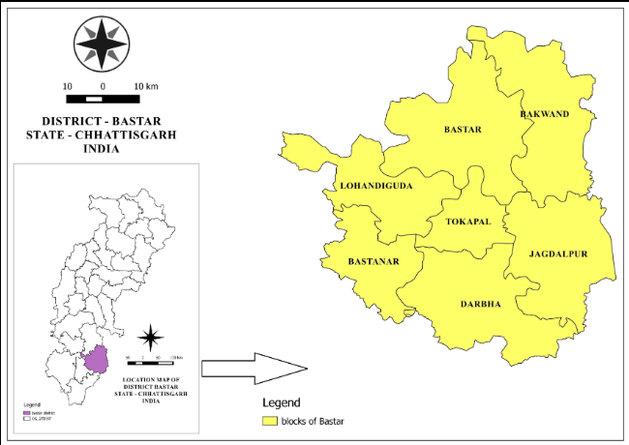

4. Methodology
The present study was conducted through ethnobotanical field surveys in selected tribal villages of Bastar District. Information was collected from tribal healers, elderly persons, local herbal practitioners, and villagers using interviews, questionnaires, and group discussions.

Methods Used:
- Field visits to tribal villages
- Personal interviews with traditional healers
- Documentation of local plant names
- Collection and identification of plant specimens
- Photography of medicinal plants
- Observation of preparation methods
Plant specimens were identified using standard floras and botanical references.

Medicinal Plant No. –1
Botanical Name - Azadirachta indica | 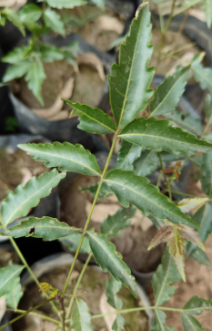
Vernacular Name – Neem
Chhattisgarhi Name – Neem
Family – Meliaceae
Habit – Tree
Useful Plant Part- Leaves, Stem
Therapeutic Methodology - For ten to fifteen days, chew the new leaves, stem, or twig and use it as a toothbrush and gargle three times a day.
Availability of the plant- Common

Medicinal Plant No. –2
Botanical Name - Vitex negundo | 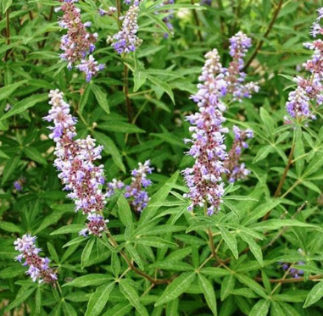
Vernacular Name – Nirgundi

Chhattisgarhi Name – Nigurndi

Family – Lamiaceae
Habit – Tree
Useful Plant Part- Leaves, Stem
Therapeutic Methodology - For a week, chew the leaves and gargle with the leaf extract twice a day. Twigs and new stems are chewed and used as toothbrushes.

Medicinal Plant No. –3
Botanical Name – Anacyclus pyrethrun | 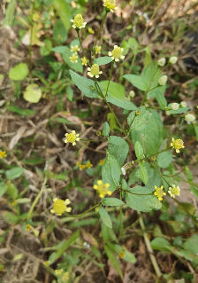
Vernacular Name – Akarkara
Chhattisgarhi Name – Akarkara
Family – Asteraceae
Habit – Herb
Useful Plant Part- Inflorescence
Therapeutic Methodology - For a week, the inflorescence was chewed and its decoction was gargled twice a day.

Availability of the plant- Common
Availability of the plant- Indigenous plant

Medicinal Plant No. –4

Botanical Name - Achyranthes aspera. | 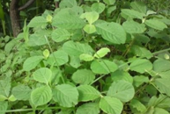
Vernacular Name – Apamarg
Chhattisgarhi Name – Chitchita
Family – Amaranthaceae

Habit – Herb
Useful Plant Part- Stem
Therapeutic Methodology - For eight to ten days, the new stem was chewed and gargled three times a day.
Availability of the plant- Abudent

Medicinal Plant No. –5
Botanical Name - Sida acuta Burm. | 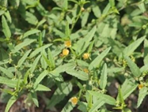
Vernacular Name – Bala
Chhattisgarhi Name – Balihari
Family – Malvaceae
Habit – Herb
Useful Plant Part- Stem
Therapeutic Methodology - A fresh stem or twig is chewed and used as a toothbrush.
Availability of the plant- Abundant

6. Traditional Methods of Preparation
Tribal communities prepare herbal medicines using simple traditional techniques. Common preparation methods include:
- Chewing fresh twigs for cleaning teeth.
- Preparing leaf paste for gum infections.
- Boiling bark extracts for mouthwash.
- Applying powdered plant material directly on affected areas.
- Using plant oils and decoctions for pain relief.
Neem twigs are commonly used as natural toothbrushes because of their antibacterial properties. Clove is used to relieve toothache because it contains eugenol, a natural analgesic compound.

7. Socio-Cultural Importance of Medicinal Plants
Medicinal plants are deeply associated with the cultural traditions and daily life of Bastar tribes. Traditional healers hold respected positions in society because of their knowledge of herbal medicine. Ethnomedicinal knowledge is usually transferred orally from one generation to another.
Many tribal families prefer herbal treatment because:
- It is affordable and easily available.
- Plants are collected from nearby forests.
- Traditional remedies are considered safe and effective.
- Cultural beliefs support natural healing methods.

8. Importance of Ethnobotanical Knowledge
Ethnobotanical knowledge contributes significantly to:
- Primary healthcare in rural and tribal areas.
- Conservation of medicinal plants.
- Development of herbal medicines.
- Scientific research in pharmacology.
- Preservation of tribal cultural heritage.
Several modern medicines have originated from traditional medicinal plant knowledge. Therefore, tribal ethnomedicinal practices represent valuable scientific resources.

9. Challenges and Threats
Traditional ethnobotanical knowledge is facing several threats:
- Deforestation and habitat destruction
- Overexploitation of medicinal plants
- Urbanization and modernization
- Decline in interest among younger generations
- Lack of proper documentation
The gradual disappearance of traditional healers may result in the permanent loss of valuable indigenous knowledge.

10. Conservation Strategies
The following measures are important for preserving ethnobotanical heritage:
- Documentation of traditional knowledge
- Conservation of forest biodiversity
- Cultivation of medicinal plants
- Awareness programs among tribal youth
- Community participation in conservation activities
- Promotion of sustainable harvesting practices
11. Conclusion
The tribal communities of Bastar District possess rich ethnobotanical knowledge regarding medicinal plants used for dental problems. Various plant species are traditionally used for treating toothache, gum infections, mouth ulcers, and oral diseases. These herbal remedies are economical, accessible, and culturally accepted within tribal societies.
The study highlights the importance of documenting and conserving indigenous medicinal knowledge before it disappears due to modernization and environmental degradation. Scientific validation of these traditional remedies may contribute to the development of effective herbal medicines and sustainable healthcare systems in the future.

Reference
- Singh, H. B., & Jain, S. K. (1987). Ethnobotany and its relevance in conservation. Journal of Economic and Taxonomic Botany, 10, 1–6.
- Rao, R. R. (1997). Biodiversity in India: Floristic aspects. Bishen Singh Mahendra Pal Singh Publishers.
- Gadgil, M., & Vartak, V. D. (1976). Sacred groves of India. Economic Botany, 30(2), 152–160.
- Harshberger, J. W. (1896). The purposes of ethnobotany. Botanical Gazette, 21(3), 146–154.
- Jain, A., & Tripathi, R. (2012). Traditional knowledge of medicinal plants for oral health among tribes of Bastar, Chhattisgarh. Journal of Medicinal Plant Research, 6(15), 2920–2926.
- Verma, S., & Patel, M. (2013). Ethnobotanical study of medicinal plants used for dental problems in Bastar. Indian Journal of Plant Sciences, 2(3), 98–104.
- Singh, J. S., Singh, S. P., & Gupta, S. R. (2014). Ecology, environmental science and conservation. S. Chand Publishing.
- Sen, A., & Roy, D. (2016). Traditional dental care practices among tribal populations in Bastar. Indian Journal of Dental Research, 27(3), 310–315.
- Kumar, V., & Choudhary, S. (2017). Ethnobotanical study of plants used in oral health care by tribes of Bastar, Chhattisgarh. International Journal of Botany Studies, 2(4), 56–62.
- Das, P., & Sahu, R. (2019). Ethnobotanical documentation of plants used for dental care in Bastar district. Ethnobotany Research & Applications, 17, 1–10.
- Patel, R., & Tiwari, A. (2022). Ethnomedicinal plants used for dental problems by tribal communities of Chhattisgarh. International Journal of Herbal Medicine, 10(4), 45–52.
- Jain, S. K., & Srivastava, S. (2023). Ethnobotanical survey of medicinal plants used by tribal communities in Bastar, Chhattisgarh. Journal of Ethnopharmacology, 305, 116–125.
- Sharma, R., & Verma, P. (2024). Traditional knowledge of medicinal plants for oral health care among tribes of central India. Indian Journal of Traditional Knowledge, 23(2), 356–364.
- Rana, S. (2025). The medicinal plants: Indigenous use and cultural significance in Bastar district, Chhattisgarh. International Journal of Research in Agronomy, 8(10), 268–274.
- Dubey, S., Pani, A., Chauhan, N.S., Shah, K., Singh, A., et al. (2025). Quantitative ethnomedicinal survey of indigenous communities in Chhattisgarh, India. Genetic Resources and Crop Evolution. Springer. https://doi.org/10.1007/s10722-025-02637-z
- Dubey, S., Pani, A., Chauhan, N. S., Shah, K., Singh, A., et al. (2025). Quantitative ethnomedicinal survey of indigenous communities in Chhattisgarh, India. Genetic Resources and Crop Evolution. Springer. https://doi.org/10.1007/s10722-025-02637-z
- Bala, D. (2026). Ethnobotanical studies of medicinal plants used by tribal communities in Uttar Bastar, Chhattisgarh, India. International Journal of Science, Strategic Management and Technology, 2(3). https://doi.org/10.55041/ijsmt.v2i3.012
- Singh, R., & Patel, M. (2026). Contemporary insights into ethnic communities of medicinal plant knowledge: An ethnobotanical evaluation from Chhattisgarh, India. Genetic Resources and Crop Evolution. Springer. https://doi.org/10.1007/s10722-026-02729-4

